INTERNATIONAL SALE CONTRACT MODEL


This model of International Sale Contract is designed for the international sale of different types of products: raw materials, manufacturing parts, consumer goods, equipment/machinery, etc.; it is used by companies positioned in different countries for the sale and purchase of goods. This Model Contract is intended to be used for the sale of products from business to business, not to end clients, and where each operation represents a sale in itself, that it is to say, it is not a long term agreement for the supply of products. To ensure a contract that best suits the needs of sellers and buyers includes several alternatives to choose from for certain specific aspects of the contract such as, price, form and date of payment, delivery period, applicable law, etc.)

INTERNATION SALE CONTRACT

DATE: ..............................................................................................................................................

BETWEEN:

................................. [company legal name] whose registered office is at .....................................
[address, city and country] and registration/fiscal number is .............................., represented by

............................................................. [surname and first name, position] (hereinafter referred
to as “the Seller”),

AND:

................................. [company legal name] whose registered office is at .....................................
[address, city and country] and registration/fiscal number is .............................., represented by

............................................................. [surname and first name, position] (hereinafter referred
to as “the Buyer”).

Both Parties declare an interest in the sale and purchase of goods under the present Contract and undertake to observe the following agreement:

- PRODUCTS

Under the present Contract, the Seller undertakes to provide, and the Buyer to purchase:

Alternative A. The following Products and quantities: ...................................................................

Alternative B. The Products and quantities as set out in Annex 1 of the present Contract.

1

- PRICE

The total price of the Products which the Buyer undertakes to pay the Seller shall be ....................
[write in numbers and letters]. The aforementioned price:

Alternative A. Is the sum total of the prices of all Products and quantities as set out in Clause 1.

Alternative B. Is the sum total of the prices of all Products and quantities as set out in Annex 1.

Both Parties undertake to renegotiate the agreed price when affected by significant changes in the international market, or by political, economic or social situations in the country of dispatch or destination of the Product, which may damage the interests of either party.

3. DELIVERY CONDITIONS

The Seller shall deliver the Products to ................... [mention the place: warehouse, port, airport,

etc.], ..................... [city and country], under conditions .............. [mention Incoterm]. The goods

shall be delivered at the agreed place, and to the transport agent designated by the Buyer, at least twenty-four hours before the deadline established in the present Contract. Should the Buyer fail to take charge of the goods on arrival, the Seller shall be entitled to demand the fulfillment of the Contract and payment of the agreed price.

- PACKAGING

The Seller undertakes to deliver the Products hereunder, suitably wrapped and packaged for their specific characteristics and for the conditions of transport to be used.

- MEANS OF PAYMENT

The Buyer undertakes to pay the total price which appears in the present Contract. Payment of said price shall be effected by:

Alternative A. Cash, check or bank transfer to the account and bank branch designated by the Seller.

Alternative B. Bill of exchange or direct debit to the account and bank branch designated by the Buyer.

Alternative C. Irrevocable and guaranteed letter of credit payable to the account and bank branch designated by the Seller.

- DATE OF PAYMENT

The price shall be paid on the following terms:

Alternative A. ....... %, being ..................... [write in numbers and letters], on signing the present
Contract; and the rest, being .................... [write in numbers and letters], on delivery of the
goods.

2

Alternative B. ........ %, being ..................... [write in numbers and letters], on submitting

documents of property to the transport agent designated by the Buyer; and the rest, being
.................... [write in numbers and letters), within .......... calendar days of receipt of the goods
by the Buyer.

Alternative C. Within .......... calendar days of receipt of the goods by the Buyer.

- DELIVERY PERIOD

The Seller undertakes to deliver the goods within .......... calendar days of receipt of:

Alternative A. The signing of the present Contract.

Alternative B. The confirmation in writing of the order in question, once all payment conditions established in the present Contract have been fulfilled.

Alternative C. The notification of the opening of a letter of credit by the Buyer.

The established delivery period may be modified by either party in case of Force Majeure or unforeseen circumstances which prevent its fulfillment.

- DELIVERY DELAYS

The Seller shall not be held liable for damages caused to the Buyer by delays in delivery, unless such delays be directly attributable to the Seller without justified cause.

- CONTRACTUAL RESPONSIBILITY

The Seller guarantees that the goods supplied shall be free of foreign bodies or faults. To this end, it undertakes to replace at no additional cost any faulty part and to make good any operational defects, on condition that the Buyer notifies the Seller of such faults within a period of ....... calendar days from the receipt of the goods at their destination. Should such defects be

evident at the time of receipt of the goods, the Buyer should give immediate notification to the Seller. In all cases, the Vendor shall be entitled to check the foreign bodies or defects alleged by the Buyer in any way it sees fit. The above conditions shall not apply to defects or damages to the goods caused by negligence or inappropriate handling by the Buyer.

............................................................................................................................................

This is a sample of 3 pages out of 8 of the International Sale Contract Template.

To get more information about this contract click here:
 INTERNATIONAL SALE CONTRACT

3

USER GUIDE

Contracts drafted by the legal experts of Global Negotiator cover all relevant aspects that are negotiated and agreed in the different types of business between companies. However, when these contracts are used you should take into account some recommendations common to all of them that are described in this User Guide.

DATE

The date when the contract comes into force is the one that appears in its header, as mentioned in the final paragraphs of the contract, before signatures (This Contract comes into force on the date written above).

In some contracts -for example in the Supply Contract- the date of coming into force is also mentioned in one of the clauses. In these cases, you have to verify that the two dates inserted in the contract (in the heading and in the corresponding clause) are the same, in order to avoid discrepancies.

PARTIES

Be sure to insert in the first page of the contract the full details of the Parties:

- When a Party is a company you must insert the following information: legal name, legal form (limited, incorporated, etc.), full address, registration data and fiscal identification number.

- When a Party is an individual that works as independent professional (for example a commercial agent) you must insert the following information: full name, profession, full address and fiscal identification number.

CLAUSES

Clauses with different alternatives: choose the most favorable

In the most important clauses of each contract (exclusivity, payment terms, applicable law and competent jurisdiction, etc.) several drafting alternatives are proposed so you can choose the most appropriate to each situation. Therefore, the user before submitting the contract to the other Party must choose the alternatives that seem best suited to their interests, and eliminate the rest.

Clauses with blank spaces to be completed

In several clauses of the contract blank spaces appear with dots (.......................) that the user

has to complete inserting text. Following the dots, between brackets, you will see the data and explanations to insert the text.

- When the text between brackets is in normal letters (the same as the contract) and separated by "," or the word "o", the user must insert one of the options suggested.

4

Example of blank space (........) with options to select between brackets:

Orders handled before completion of the present Contract which produce sales transactions within .......... [1, 2, 3, 6] months shall entitle the Agent to receive the corresponding commission.

In this case the user must choose between options 1, 2, 3 or 6 months and insert one in the blank space (........).

- When the text between brackets is in italics the user has to insert the data and information requested and eliminate the bracketed text.

Example of blank space - (.........) to insert text:

Both parties, by mutual consent, resolve to refer any dispute to the Rules of Conciliation and Arbitration of the International Chamber of Commerce by one or more arbitrators appointed in

accordance with said Rules. The place of arbitration shall be ........... [city and country]. In this case the user must insert in the blank space (...........) the city and country chosen to conduct the arbitration and afterwards eliminate the bracketed text [city and country].

Notices Clause

Sometimes it may happen that the official address of the Parties which appear at the beginning of the contract is different from which is to be used for communications between the Parties during the terms of the contract. In this case the user should include at the end of the contract a Notices Clause.

Example of Notices Clause:

Notices. - In order to comply with their contractual obligations, the Parties establish the following address for the provision of notices related to this contract:

- Party 1 ............................................................. [insert full address].
- Party 2 ............................................................. [insert full address].

ANNEXES

The contracts incorporate some Annexes, each of them, referenced to the corresponding Clause. Annexes are drafted in commonly used formats, although the user must adapt these formats and the text inserted in them to each particular situation.

SIGNATURES

People who sign

Persons signing the contract on behalf of the company must have the authority to do so and preferably, be entitled on the basis of a power of attorney. Below the signature, in addition to the full name of the person that signs his/her position must be inserted. When one of the Parties who signs is a natural person (for example a commercial agent in an Agency Contract) obviously he or she is the person that has to sign the contract.

5

The laws of some countries require that contracts, to be valid, shall be signed in front of witnesses or a public notary. Therefore, before signing a contract you should be informed about the requirements that may exist in each country.

Place and date of signature

Usually contracts are signed by both Parties on the same date and place. Nevertheless, in international contracts, due to physical distance, it is common that each of the Parties sign in different dates and places. This contract provides for both alternatives so it comes to choosing the most appropriate to each situation.

Number of copies

Usually, the Parties sign two copies of the contract, each Party retaining one of them, but can also arise the need to sign more copies. In this case all you have to do is mention explicitly the number of copies to be signed in the paragraph that is included at the end of the contract (Both Parties declare their conformity to the present contract, which is signed in ...... copies, each of which shall be considered an original).

GENERAL RECOMMENDATIONS

The Parties must sign all pages of the contract, including Annexes, so they are also valid. It is better to use ball point or pen (not pencil) in a color other than black (e.g.: blue); this makes it easier to distinguish an original document from a photocopy.

It is preferable (although no mandatory) to express sums of money and percentages in words and figures. Of course, the words and figures for a given amount must match exactly. You also must insert the currency in which the amounts are expressed. It is advisable to use the rules establish by ISO that name each currency by three capital letters (EUR for euro, USD for dollar, GBP for sterling pound, JPY for Japanese yen, etc. - you can get the acronyms of every currency in the website www.oanda.com).

Once you have chosen the best alternatives of each clause and have completed the blank spaces you should revise the whole contract to remove remaining paragraphs and correct any errors.

6

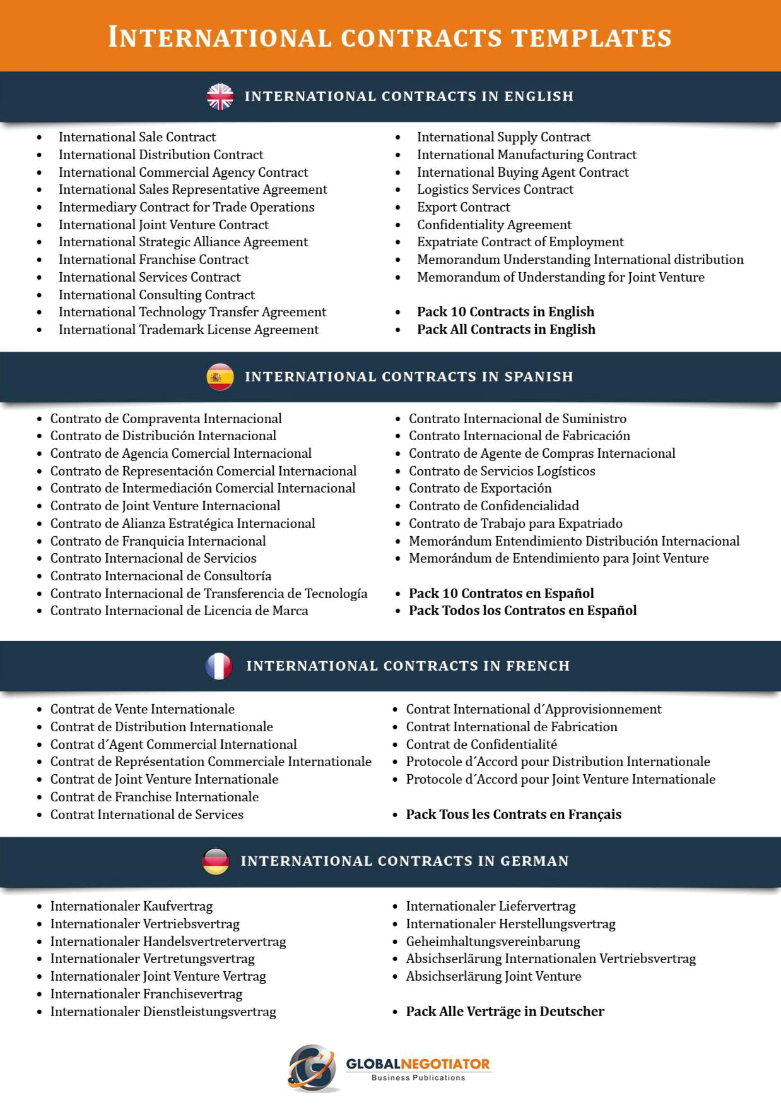

7

