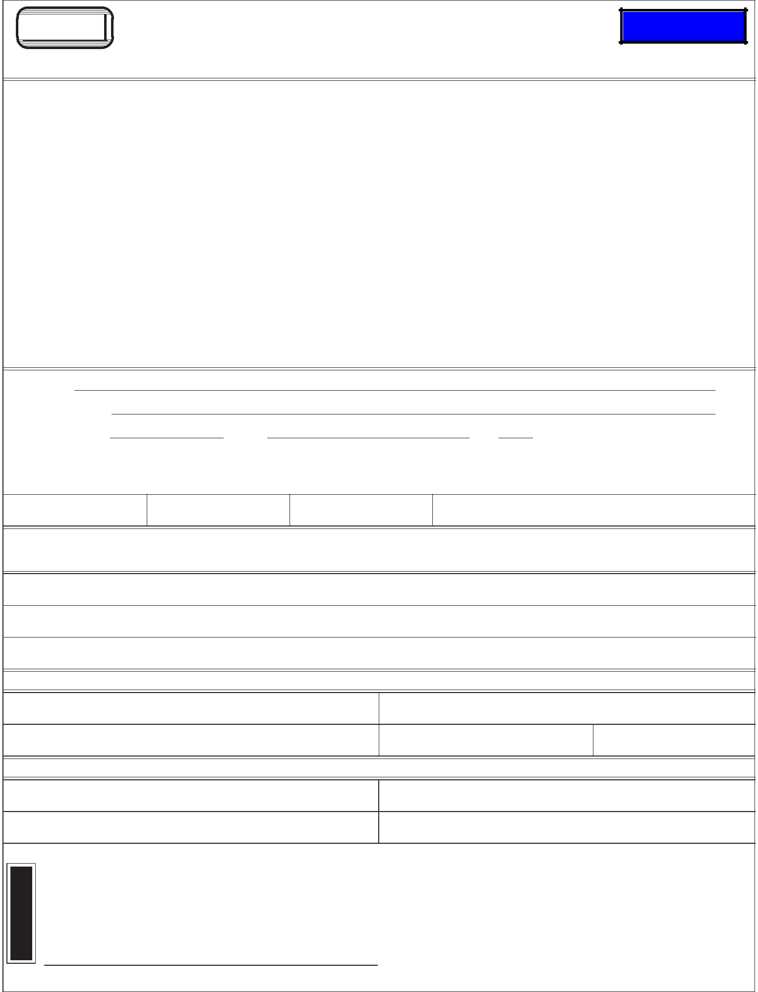
DMV
INHERITANCE AFFIDAVIT
DEPARTMENT OF TRANSPORTATION

DRIVER AND MOTOR VEHICLE SERVICES

1905 LANA AVE NE, SALEM OR 97314

Clear Form

If a deceased owner’s estate is not probated, their interest in a vehicle may be assigned through the use of this affidavit signed by all the heirs of the owner(s) stating the name of the person to whom the ownership interest has been assigned. (ORS 803.094)

This form must be completed by the heir(s) and submitted to DMV with the title (if available), application for title, and title transfer fee.

•

•

DMV must receive an affidavit completed and signed by all heirs. Heirs are determined according to ORS Chapter 112. DMV cannot determine the heirs for you. You may wish to seek legal counsel to determine who the heirs are.

If there is more than one heir, the heirs may either complete and sign the same affidavit or complete and sign separate affidavits. Each affidavit must indicate to whom ownership of the vehicle is assigned.

•
•

•

If there are no other heirs, leave the space provided below for listing heirs blank.

If the heir is a minor or is incapacitated, the parent or guardian must sign for the heir. (Example: Jane Q. Public, age 10, by John Q. Public, parent.) If the guardian signs, a copy of the court papers showing guardianship must be submitted with the affidavit.

The affidavit must be signed before a notary. (The notary does not have to be from the State of Oregon.)

I/We,

declare that

died on the day of , 20 ; and that the estate has not

and will not be probated.

At the time of death, the deceased was the owner of the following described vehicle:

PLATE NUMBER YEAR MAKE VEHICLE IDENTIFICATION NUMBER

.KUVCNNJGKTU (Any heirs not signing this affidavit must complete a separate affidavit.) I certify if there are nonames listed below, there are no other heirs.

I/we release any and all claim to the following party:

NAME OF PERSON TO WHOM OWNERSHIP OF THE VEHICLE HAS BEEN ASSIGNED. ADDRESS

CITY STATE ZIP CODE

ALL HEIRS MUST SIGN BELOW

SIGNATURE OF HEIR SIGNATURE OF HEIR

X X

SIGNATURE OF HEIR SIGNATURE OF HEIR

X X

State of _______________________ County of _______________________
N
- Subscribed and sworn before me this _________ day of __________, 20 ___
T
- by ___________________________________________________________.
R
- _{X}

SIGNATURE OF NOTARY PUBLIC

735-516 (-§) |  | STK# 300165

