 |  |  |  |  | Sacramento County Public Law Library
 |  |  |  |  | & Civil Self Help Center
 |  |  |  |  |  |  | 609 9th St.
 |  |  |  |  | Sacramento, CA 95814
www.saclaw.org |  |  |  |  |  | (916) 874-6012
>> Home >> Law 101
 |  |  |  |  |  |  | Solicitar
COMPLETING AND RECORDING DEEDS
 |  |  |  |  |  |  | esta guía en
Adding or Changing Names on Property
 |  |  |  |  |  |  | español


This Guide includes instructions and sample forms. The Guide and related forms may be downloaded from: www.saclaw.org/recording-deeds


BACKGROUND

Any time you make a change to the ownership of real estate, you must record a deed with the County Recorder. This Step-by-Step guide outlines the requirements and provides samples with instructions.

California mainly uses three types of deeds: the “grant deed,” the “quitclaim deed,” and the new “revocable transfer on death” deed.

The grant deed is used when a person who is on the current deed transfers ownership or adds a new owner. The grantor (donor or seller) promises that all rights to the property are being transferred—there are no hidden owners or easements.

The quitclaim deed is used when someone, who may or may not be named on the prior deed, gives up their ownership rights in favor of another person. The grantor is not promising anything other than that they are giving up their own rights, if any. A quitclaim deed is often used in divorces, when one spouse gives up any potential community property interest.

The revocable transfer on death deed is used to leave property to heirs without the need for probate. The grantor names the intended heirs as “beneficiaries.” The deed has no effect until the grantor dies, when the beneficiaries record an affidavit to receive the property. See the chart “What Deed Do I Need” at the end of this guide for more information.

New Way to Avoid Probate:

Transfer on Death Deeds

On Jan. 1, 2016, a new type of deed took effect in California: the Revocable Transfer on Death (TOD) deed, also called a beneficiary deed.

You can use it to name beneficiaries who will receive the property when you die, without the need for probate. This is meant to replace the common practice of adding your heirs to your home as joint tenants.

A joint tenant deed does avoid probate, but it can cause problems of its own. Your “heirs” now legally own part of the home, so their creditors can lien the house, you need their permission to sell or refinance, and it ultimately can lead to higher taxes. You will probably need to file a gift tax return this year. And you can’t change your mind.

With the TOD deed, you can revoke it at any time. Your heirs do not own any of the property during your life, avoiding the above problems. And when you pass away, the transfer is treated as an inheritance, not a gift, so it gets more favorable tax treatment.

Note: Do not use a “deed of trust” or “trust deed” to transfer property. A deed of trust is never used to transfer ownership (not even to a trust!). It is used, along with a promissory note, to create a

Disclaimer: This Guide is intended as general information only. Your case may have factors requiring different procedures or forms. The information and instructions are provided for use in the Sacramento County Superior Court. Please keep in mind that each court may have different requirements. If you need further assistance consult a lawyer.

www.saclaw.org Completing and Recording Deeds

>>Home >>Law 101

mortgage. For more information on deeds of trust, see the Step-by-Step guide on our website at www.saclaw.org/deed-of-trust.

STEP BY STEP INSTRUCTIONS

STEP 1: Locate the Current Deed for the Property

You will need to copy the legal description of the property and current ownership information onto the new deed exactly. If you do not have a copy of the current deed, you can purchase one from the Recorder’s Office. In Sacramento, this costs $1 per page; most deeds are only one page long. You can contact the Sacramento office at (916) 874-6334 or visit one of the office locations (see www.ccr.saccounty.net/ for addresses and more information).

STEP 2: Determine What Type of Deed to Fill Out for Your Situation

As discussed above, to transfer ownership or add someone to title, you will choose between a “grant deed” and a “quitclaim deed.” To add a beneficiary to receive the property when you die, use a “revocable TOD deed.” See the chart “What Deed Do I Need” at the end of this guide for more information.

STEP 3: Determine How the New Owners Will Take Title

There are several options for how to “take title” to the property. If there is more than one owner, the form of title has important effects on who can sell the property and who will inherit it.

Common forms are “as joint tenants,” “as community property with right of survivorship” (for married couples or domestic partners), and “as trustee” if the property is in a trust. See the chart “How to Take Title” at the end of this guide for more information.

STEP 4: Fill Out the New Deed (Do Not Sign)

The deed should be filled out online, typed, or neatly written in dark blue or black ink. You will need the following information:

- Assessor’s Parcel Number.
- Document Transfer Tax or exemption: Whenever property is sold, this tax is added. Some transfers are exempt. See “Document Transfer Tax” at the end of this guide for more information.
- Names of “grantors” (the current owner(s) signing the deed) or of the disclaiming party(ies).
- Names of “grantees” (all new and continuing owners).

The deed I need
is not on your list!

This guide covers the most common types of deeds in California: grant, quitclaim, and TOD. These are not the only types of deeds. Two other well-known types are “interspousal” and “warranty” deeds. We don’t list them here.

Warranty deeds are very rare in California and usually not appropriate. The special feature of warranty deeds is that the grantor promises to pay for any lawsuits or damages due to undisclosed ownership disputes. Today this is virtually always handled by title insurance, so warranty deeds are unneeded and potentially confusing.

Transfers between spouses do not need to be labeled “interspousal deed,” and again such a label may be confusing. A deed between spouses may be a quitclaim deed, as in a divorce, or a grant deed, for example adding a new spouse to the title of a house. You can label them interspousal if you wish, as long as the language within the deed is correct for what you want to do.

If you are making an unusual transfer (such as easements or mineral rights), stop into the Law Library and the Law Librarian can help you find books with sample language.

www.saclaw.org/recording-deeds | 2

www.saclaw.org Completing and Recording Deeds

>>Home >>Law 101

- Grant deed only: Form of title the grantees will use.
- The legal description of the property. This must match the current deed exactly. Attach the legal description as an exhibit if it is too long for the page.

Sample completed deeds with more detailed instructions are available at the end of this guide.

STEP 5: Current Owner(s) or Disclaiming Party(s) Sign in Front of a Notary

New owners do not need to sign. The notary will charge a fee for this service. You can find notaries at many banks, mailing services, and title companies. The Law Library maintains a list of local notaries; ask at the Reference Desk if you are interested.

STEP 6: Fill Out the Preliminary Change of Ownership Report (PCOR) if Needed

The PCOR is used by the Assessor’s Office, but you turn it in at the Recorder’s Office along with the deed. Each county creates its own form. You can download a Sacramento copy at bit.ly/PCOR-Sac. Note: This is not needed for TOD Deed.

STEP 7: Record the Deed (and File the PCOR if Needed) at the Recorder’s Office

The Recorder’s Office charges a recording fee (currently $21/first page plus $3 for additional pages). Current Sacramento fees are available at the County Clerk/Recorder’s website at www.ccr.saccounty.net/Pages/Fees.aspx. The deed will be recorded the same day it is received at the Recorder’s Office. Note: this must take place within 60 days of notarization for Transfer-on-Death deeds.

STEP 8: File Reassessment Exclusion Claim, if Any, at the Assessor’s Office

When property changes hands, it is “reassessed” for tax purposes, often causing a sizeable increase in property tax for the new owner.

Certain transfers are excluded from reassessment, including:

- Parent to child or child to parent (“Prop 58” exclusion)

- Grandparent to grandchild (but not vice versa)

- Transfers between spouses or registered domestic partners during marriage or as part of a property settlement or divorce
- Changes in method of holding title that do not change ownership interests (for instance, changing joint tenants into tenants in common)

If your transfer is excluded from reassessment, you may need to file a claim with the County Assessor. For more information in Sacramento, call the Assessor’s office (916-875-0750) or visit www.assessor.saccounty.net.

FOR HELP

Senior Legal Hotline

Toll Free: (800) 222-1753; Sacramento County: (916) 551-2140 www.seniorlegalhotline.org/
Free legal assistance for Sacramento residents age 60 and over on almost any civil issue, including property transfers and deeds.

www.saclaw.org/recording-deeds | 3

www.saclaw.org Completing and Recording Deeds

>>Home >>Law 101

FOR MORE INFORMATION

On the Web:

Sacramento County Clerk-Recorder’s Office
www.ccr.saccounty.net/

Sacramento County Assessor’s Office
www.assessor.saccounty.net

“Transfer-on-Death Deeds for Real Estate”
Nolo.com
http://www.nolo.com/legal-encyclopedia/transfer-death-deeds-real-estate
Self-help information about transfer-on-death deeds and other ways to avoid probate.

At the Law Library:

“Adding Your Kids to Your Deed” (pamphlet) Sacramento County Public Law Library http://saclaw.org/wp-content/uploads/adding-kids-to-deed.pdf
This pamphlet discusses California’s new “Transfer on Death Deed,” which may be used to name beneficiaries to inherit your home without probate.

Deeds for California Real Estate KFC 170 .Z9 R36

This book, published by Nolo Press, a respected publisher of self-help legal books, is a guide to choosing the right kind of deed, completing the required forms, and filing them. It also discusses related legal issues such as disclosure requirements, community property issues, and tax and estate planning. It contains forms for most transfers of property.

Electronic Access: From any computer (Law Library or home) via the Legal Information Reference Center. Instructions are available on our website at www.saclaw.org/nolo-ebooks.

IF YOU HAVE QUESTIONS ABOUT THIS GUIDE, OR IF YOU NEED HELP FINDING OR USING THE MATERIALS LISTED, DON’T HESITATE TO ASK A REFERENCE LIBRARIAN.

H:\public\LRG-SBS\SbSs\Deeds\sbs-completing-and-recording-deeds.docx Revised 1/16 kf

www.saclaw.org/recording-deeds 4

www.saclaw.org Completing and Recording Deeds

>>Home >>Law 101

ATTACHMENTS: FORMS AND INSTRUCTIONS

Deeds must be in a format that the Sacramento County Clerk/Recorder’s Office will accept.
Customizable templates may be downloaded from these links:

- Grant Deed

- Quitclaim Deed

- Revocable TOD (Transfer on Death) Deed aka Beneficiary Deed

Download the blank forms from these links.

You may also need:

- PCOR (Preliminary Change of Ownership Report)

Download the PCOR from this link or the Sacramento County Assessor’s website.

Sample filled-in forms with instructions are attached.

Grant deed: In the sample grant deed, Herbert Husband is adding his wife Wanda Wife to the title of their house, as community property with right of survivorship. You can adapt this to fit any situation where property is being transferred using a grant deed by filling in language that fits your situation.

Quitclaim deed: in the sample quitclaim deed, Ernesto Exspouse is disclaiming any rights to a piece of real estate in favor of his ex, Ellen, as part of their divorce. Similar language will work in any situation where one person is giving up all rights to property.

Transfer on death deed: In the sample TOD deed, Sara Sample wants her children, Dora and Saul, to receive her house after she passes away, but she wants to be able to sell it or change her plans if necessary.

www.saclaw.org/recording-deeds 5

Signature of Declarant or Agent determining tax
www.saclaw.org Completing and Recording Deeds

Sample>>Home >>GrantLw101Deed with Instructions
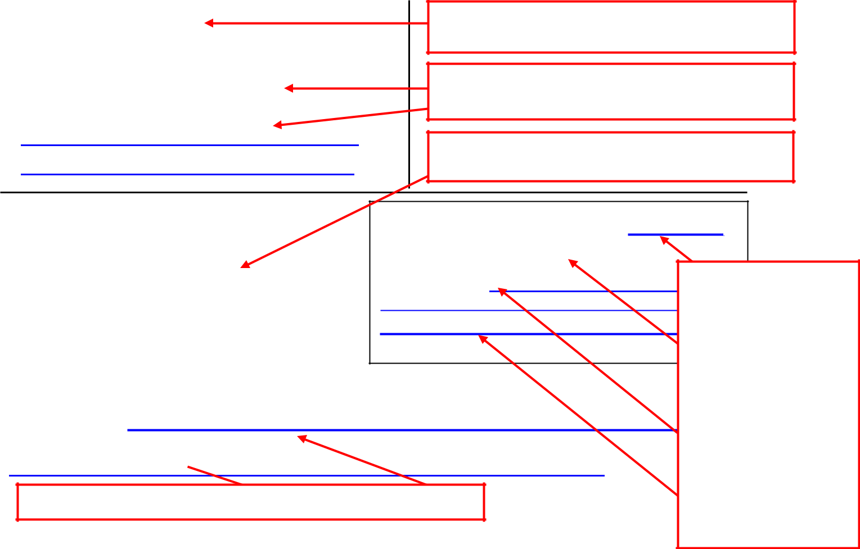

Recording requested by (name):

Herbert Husband and Wanda Wife

And when recorded, mail this deed and tax
statements to (name and address):
Herbert Husband and Wanda Wife
123 Main St. | .
Sacramento CA 95814 | .

The name of the person who will be turning the deed in to the Recorder’s Office.

The name and address of the person who will receive the new deed and all tax statements.

The APN (Assessor’s Parcel Number) of the property. This is on the current deed.

GRANT DEED |  | DOCUMENTARY TRANSFER TAX $0
 |  | EXEMPTION (R&T CODE) 11911
APN: 123-34-5678 |  | .EXPLANATION Gift

Herbert Husband

For a valuable consideration, receipt of which is hereby acknowledged,

GRANTOR(S) Herbert Husband

- (Owner(s) who are signing deed)
a married man
- Enter the name or names of the current owners, and form of title.

.

.

- In. the first line, enter the amount of Doc.
Transfer. Tax due.

- If .you are paying $0, put the Cal. Rev. & Tax code exempting you in the 2nd line.
Otherwise leave
- blank.
  - If you are paying $0, explain why briefly. Otherwise leave blank.

  - You (or your agent if any) sign the last line.

hereby grant(s) to GRANTEE(S)Herbert Husband and Wanda Wife

Enter the name or names of all new owners (including current if they are staying on title).
New Owner(s))

as community property with right of survivorship


Enter the form of title in which the new owners will hold the property.

title)
Enter the city and county where the property is located.

the following real property in the City of Sacramento , County of Sacramento ,

California: (insert legal description)
Lot 14 of Blackacre Addition to the City of Sacramento, as delineated on the map of said addition, recorded January 30, 1965, in Book 625, Page 013065. Or: attach a copy marked “Exhibit A” and write “See Exhibit A.”

Date: |  |  |  |  |  |  | Enter the exact legal description of the
Date: |  | Sign in front of notary. |  |  |  |  | Enter the exact legal description of the
Date: |  |  |  |  |  |  | property as shown on the current
 |  |  | (Signature of declarant) |  |  |  | deed.
 |  |  | Herbert Husband |  |  |  | OR: attach as Exhibit A (photocopy the
 |  |  |  |  |  |  | any) and type.or write “See Exhibit A”
 |  |  |  |  |  |  | exhibit attached to the current deed, if
 |  |  | (Typed or written name of declarant) |  |  |  | in this space.
 | www.saclaw.org/recording-deeds |  |  |  |  |  | 6

www.saclaw.org Completing and Recording Deeds

>>Home >>Law 101

Sample Quitclaim Deed with Instructions
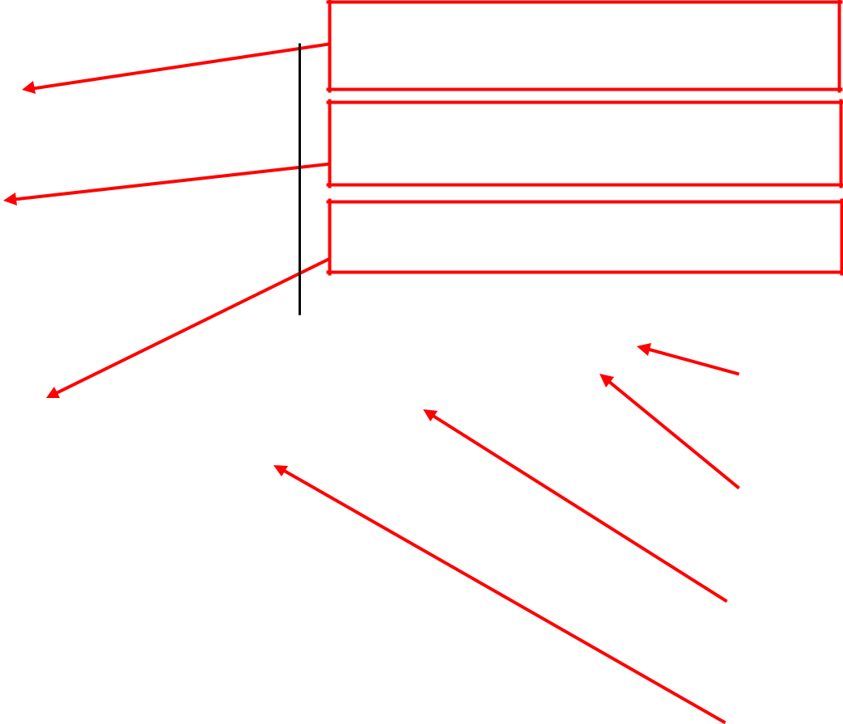

Recording requested by (name):
Ernesto Exspouse

And when recorded, mail this deed and tax statements to (name and address):

Ellen Exspouse
123 Main St.
Sacramento, CA

95814

The name of the person who will be turning the deed in to the Recorder’s Office.

The name and address of the person who will receive the new deed and all tax statements.

The APN (Assessor’s Parcel Number) of the property. This is on the current deed.

 |  | QUITCLAIM DEED
 |  |  |  |  |  |  |  |  |  |  | DOCUMENTARY TRANSFER TAX $0 |  |  |  |  |  |  |  |  |  | • In the first line, enter the
 |  |  |  |  |  |  |  |  |  |  | EXEMPTION (R&T CODE) 11927 |  |  |  |  |  |  |  |  |  | amount of Doc. Transfer
 |  |  |  |  |  |  |  |  |  |  | EXPLANATION Dissolution of Marriage
 |  |  |  |  |  |  |  |  |  |  |  |  |  |  |  |  |  |  |  |  | Tax due.
 |  | APN: 151-0134-005-0000 |  |  |  |  |  |  |  |  | _________________________________________
 |  |  |  |  |  |  |  |  |  |  | _________________________________________
 |  |  |  |  |  |  |  |  |  |  | Signature of Declarant or Agent determining |  |  |  |  |  |  |  |  |  | • If you are paying $0, put
 |  |  |  |  |  |  |  |  |  |  |  |  |  |  |  |  |  |  | tax
 |  |  |  |  |  |  |  |  |  |  |  |  |  |  |  |  |  |  |  |  | the Cal. Rev. & Tax code
 |  |  |  |  |  |  |  |  |  |  |  |  |  |  |  |  |  |  |  |  | exempting you in the 2nd
 |  | For a valuable consideration, receipt of which is hereby acknowledged,
 |  |  |  |  |  |  |  |  |  |  |  |  |  |  |  |  |  |  |  |  | line.
 |  | Ernesto Exspouse |  |  |  |  |  |  |  |  |  |  |  |  |  |  |  |  |  |  | • If you are paying $0,
 |  |  |  |  |  |  |  |  |  |  |  |  |  |  |  |  |  |  |  |  | explain . briefly in the 3rd
 |  |  |  |  |  |  |  |  |  | (Disclaiming Party(ies)) |  |  |  |  |  |  |  |  |  |  | and 4th lines.
 |  | hereby quitclaim(s) to |  |  | Ellen Exspouse. |  |  |  |  |  |  |  |  |  |  |  |  |  |  |  | • You (or your agent if any)
 |  |  |  |  |  |  |  |  |  |  |  |  |  |  |  |  |  |  |  |  | sign the last line.
 |  |  |  |  |  | (Property Owner(s))
 |  | the following real property in the City of Sacramento |  |  |  |  |  |  |  |  |  |  |  |  |  | , County of
 |  | Sacramento
 |  |  |  |  |  |  |  |  | , California: (insert legal description)
 |  |  |  |  |  |  |  |  |  |  |  |  |  |  |  |  |  |  |  |  | Enter the city and county
 |  |  |  |  |  |  |  |  |  |  |  |  |  |  |  |  |  |  |  |  | where the property is
 |  |  |  |  |  |  |  |  |  |  |  |  |  |  |  |  |  |  |  |  | located.
 |  |  |  | Lot 14 of Blackacre Addition to the City of Sacramento, |  |  |  |  |  |  |  |  |  |  |  |  |  |  |  |  | as
 |  |  |  | delineated on the map of said addition, recorded January 30,
 |  |  |  | 1965, in Book 625, Page 013065. Or: attach a copy marked
 |  |  |  | “Exhibit A” and write “See Exhibit A.”
 |  |  |  |  |  |  |  |  |  |  |  |  |  |  | Enter the exact legal description of the
 |  |  |  |  |  |  |  |  |  |  |  |  |  |  | property as shown on the current
 |  |  |  |  |  |  |  |  |  |  |  |  |  |  | deed.
 |  |  |  |  |  |  |  |  |  |  |  |  |  |  | OR: attach the description on a
 |  |  |  |  |  |  |  |  |  |  |  |  |  |  | separate piece of paper labeled
 |  |  |  |  |  |  |  | Sign in front of notary.
 |  |  |  |  |  |  |  |  |  |  |  |  |  |  | “Attachment A” and type or write “See
 |  | Date: _____________________ |  |  |  |  |  | _____________________________________________
 |  |  |  |  |  |  |  |  |  |  |  |  |  |  | Description in Attachment A” in this
 |  |  | Only disclaiming person(s) |  |  |  |  | (Signature of declarant) |  |  |  |  |  |  | space.
 |  |  | must sign.
 |  |  |  |  |  |  |  | Ernesto Exspouse |  |  |  |  |  |  |  |  |  |  |  |  |  | e
 |  |  |  | www.saclaw.org/recording-deeds |  |  |  |  |  |  |  |  |  |  |  |  |  |  | 7


PROPERTY DESCRIPTION
www.saclaw.org Completing and Recording Deeds

>>Home >>Law 101

Sample TOD Deed with Instructions: Children as Beneficiaries

Recording requested by (name):
Sara Sample |  | .
And when recorded, mail this deed and tax
statements to (name and address):
Sara Sample |  |  |  | .
123 Main Street |  | .
Sacramento, CA |  |  | .
95814 |  |  | .


The name of the person who will be turning the deed in to the Recorder’s Office.


The name and address of the person who will receive the stamped deed and future tax statements.

The APN (Assessor’s Parcel Number) of the property. This is on the current deed.

SIMPLE REVOCABLE TRANSFER ON DEATH (TOD) DEED

Assessor’s Parcel Number (APN): 0000-123-45-6789.

This document is exempt from documentary transfer tax under Rev. & Tax. Code § 11930. This document is exempt from preliminary change of ownership report under Rev. & Tax. Code § 480.3.

NOTICE: THIS DEED MUST BE RECORDED ON OR
BEFORE 60 DAYS AFTER THE DATE IT IS SIGNED AND NOTARIZED

Use this deed to transfer the residential property described below directly to your named beneficiaries when you die. YOU SHOULD CAREFULLY READ ALL OF THE INFORMATION ON THE OTHER PAGES OF THIS FORM. You may wish to consult an attorney before using this deed. It may have results that you do not want. Provide only the information asked for in the form. DO NOT INSERT ANY OTHER INFORMATION OR INSTRUCTIONS. This form MUST be RECORDED

on or before 60 days after the date it is signed and notarized or it will not be effective. ^{Enter the exact legal}

description of the property as shown on the current deed.

Print the legal description of the residential property affected by this deed: | OR: attach the description
Lot 14 of Blackacre Addition to the City of Sacramento, as delineated in
 | on a separate piece of
the map of said addition, recorded January 30, 1965, in Book 625, Pagepaper labeled “Attachment
013065. Or: attach a copy marked “Exhibit A” and write “See | A” and type or write “See
Exhibit A.” | Description in Attachment
BENEFICIARY(IES) | A” in this space.

Print the FULL NAME(S) of the person(s) who will receive the property on your death (DO NOT use general terms like “my children”) and state the RELATIONSHIP that each named person has to you (spouse, son, daughter, friend, etc.):

Dora Sample, my daughter, and Saul Sample, my son 

TRANSFER ON DEATH

List the beneficiaries and relationship to you.

I, Sara Sample , transfer all of my interest in the described property to the named beneficiary(ies) on my death. I may revoke this deed. When recorded, this deed revokes any TODWrite deedyour namethat Iasmadeshownbeforeonyoursigningcurrent deedthis.deed.


Sign and print your name below (your name should exactly match the name shown on your title documents):

Date: Nov. 12, 2015 |  |  | Sign in front of notary. | _______________
 |  |  | ______________________ | _______________

(Signature of declarant)
Sara Sample

.(Typed or written name of declarant)

NOTE: This deed only transfers MY ownership share of the property. The deed does NOT transfer the share of any co-owner of the property. Any co-owner who wants to name a TOD beneficiary

must executewww.sandclawRECORD.org/recordingaSEPARATE-deeds deed . | 8

www.saclaw.org Completing and Recording Deeds

>>Home >>Law 101

What deed do I need?

Gift of
property

Sale of
property

Grant Deed Move
property in or out of a trust

Update after
name change

Avoiding |  |  |  | Revocable
probate |  |  |  | TOD Deed

Giving up |  |  |  | Quitclaim
rights to a |  |  |  | Quitclaim
rights to a |  |  |  | Deed
property |  |  |  | Deed

www.saclaw.org/recording-deeds

Used when changing title to real estate you own


Common uses:

- Sale or gift of real estate

- Add another owner to title

- Transfer property into or out of a trust

- Change form of title for co-owners (example: change joint tenants to community property)

- Update owner’s name after a legal name change

Used to name beneficiaries to receive (“inherit”) real estate after the owner’s death, without probate

Used to waive a claim or possible claim to real estate, whether or not you are currently on title

Common uses:

- After a divorce, to transfer property entirely into one spouse’s name
- During marriage, to waive any possible claim to other spouse’s separate property

- To waive potential inheritance rights

9

www.saclaw.org Completing and Recording Deeds

>>Home >>Law 101

What form of title should I use? Some common answers:

My co-owners and I are not married or registered domestic partners (for example, siblings, business partners, and unmarried couples):

 | Choose between: |  |  | Who can sell or mortgage the property? |  |  | If you die:
 | “as joint tenants” |  |  | Any owner can give, sell, or mortgage their |  |  | The other owner(s) get
 |  |  |  | share without permission; the new owner is |  |  | your share automatically
 |  |  |  | automatically a tenant in common
 | “as tenants in |  |  | Any owner can give, sell, or mortgage their |  |  | You can leave your share
 | common” |  |  | share without permission |  |  | to someone else

We are married (or registered domestic partners) and we own the property together:

 | Choose between: |  |  | Who can sell or mortgage the property? |  |  | If you die:
 | “as community |  |  | Both spouses must sign off on a gift, sale |  |  | Your spouse gets your
 | property with right of |  |  | or refinance |  |  | share automatically
 | survivorship”
 | “as community |  |  | Both spouses must sign off on a gift, sale |  |  | You can leave your share
 | property” |  |  | or refinance |  |  | to someone else

We are married (or registered domestic partners), but the property belongs only to me:

 | Form of title |  |  | Who can sell or mortgage the property? |  |  | If you die:
 | “as a married |  |  | You control the property |  |  | Your heirs inherit the
 | man/woman as |  |  | Note: if you make payments or home |  |  | property (probably
 | his/her sole and |  |  | Note: if you make payments or home |  |  | requires probate)
 | his/her sole and |  |  | improvements while married, it may |  |  | requires probate)
 | separate property” |  |  | improvements while married, it may
 | separate property” |  |  | become partly community property
 | I (or we) are putting the property into a living trust:
 | Form of Title |  |  | Who can sell or mortgage the property? |  |  | Effect of death
 | To the trustee, “as |  |  | The trustee |  |  | Death of trustee:
 | trustee of the |  |  | Note: If you refinance, you may need to |  |  | substitute a new trustee
 | ________________ |  |  | Note: If you refinance, you may need to |  |  | Death of trustor: The
 | ________________ |  |  | take the property out of the trust |  |  | Death of trustor: The
 | Trust, dated _______” |  |  | take the property out of the trust |  |  | trustee distributes property
 |  |  |  | temporarily |  |  | per terms of trust

www.saclaw.org/recording-deeds | 10

prior name
www.saclaw.org Completing and Recording Deeds

>>Home >>Law 101

Common Title Phrases

Updating title after name change:


new name Janet Smith-Jones, who acquired title under the former name of Janet Smith, hereby grants

to Janet Smith-Jones

Single person:

David Jones, an unmarried man or Janet Smith, an unmarried woman

Married/domestic partner who owns property separate from spouse:

Janet Smith-Jones, a married woman, as separate, not community property

Tenants in common:

Janet Smith and Robert Johnson as tenants in common

Joint tenants:

Janet Smith and Robert Jones as joint tenants with right of survivorship

Community property:

Janet Smith-Jones and David Smith-Jones, husband and wife, as community property or

Janet Smith and Darla Jones, registered domestic partners, as community property

Community property with right of survivorship:

Janet Smith-Jones and David Smith-Jones, husband and wife, as community property with right of survivorship

or

Janet Smith and Darla Jones, registered domestic partners, as community property with right of survivorship

Trust:

Janet Smith [name of trustee] as trustee of the Janet Smith Family Trust dated July 2, 2012 [exact name and date on trust documents]

Partnership:

Elm Street Books, a partnership [exact name on file as fictitious business name, if any] or
Janet Smith and Mark Baker, a partnership [names of partners]

Note: in most cases, any partner can sign deeds.

Corporation or LLC:

Elm Street Books, Inc. or Acme Roofers, a California Limited Liability Company [exact name on documents filed with Secretary of State]

Note: For corporations, the board of directors usually must approve real property transactions, and an authorized officer will sign.
For LLCs, the owners (members) must approve real property transactions, and authorize a member to sign.

www.saclaw.org/recording-deeds | 11

www.saclaw.org Completing and Recording Deeds

>>Home >>Law 101

Document Transfer Tax

A Document Transfer Tax must be paid whenever property is sold. Contact your County Recorder for current rates. In Sacramento County, you can find the current rate at http://www.ccr.saccounty.net/Pages/FAQ.aspx.

Exemptions: Many transactions in which no money changes hands qualify for an exemption. The most common exemptions are listed below. Enter the R&T code and explanation in the Documentary Transfer Tax Box.

Gift (transferring property, or adding someone to property, without compensation):

Exemption (R&T Code): “R&T 11911”
Explanation: “Gift.”

NOTE: “compensation” is not always money. For instance, forgiving a loan, trading for other property, or providing services would be considered compensation.

Living Trust (transfer into or out of revocable living trust): Exemption (R&T Code): “R&T 11930” Explanation: “Transfer into or out of a trust”

Name Change (confirming name change after marriage or court-ordered name change):

Exemption (R&T Code): “R&T 11911”
Explanation: “This conveyance confirms a change of name, and the grantor and grantee are the same party.”

Conveyances in dissolution of marriage:

Exemption (R&T Code): “R&T 11927”
Explanation: “Dissolution of marriage.”

Changing Manner in Which Title is Held (e.g., transfer between individuals and partnership):

Exemption (R&T Code): “R&T 11925”
Explanation: “Grantors and grantees are comprised of the same parties and their proportional interest remains the same immediately following transfer.”

Mortgages and Liens Exceed Fair Market Value:

Exemption (R&T Code): “R&T 11911”
Explanation: “Liened to full value.”

Additional exemptions may be available if these do not apply. See the list of “Transfer Tax
Exemptions under Revenue & Taxation Code” handout, available on the website of the Sacramento
County Clerk/Recorder Department at
www.ccr.saccounty.net/Documents/TransferTaxExemptions.pdf.

www.saclaw.org/recording-deeds | 12

