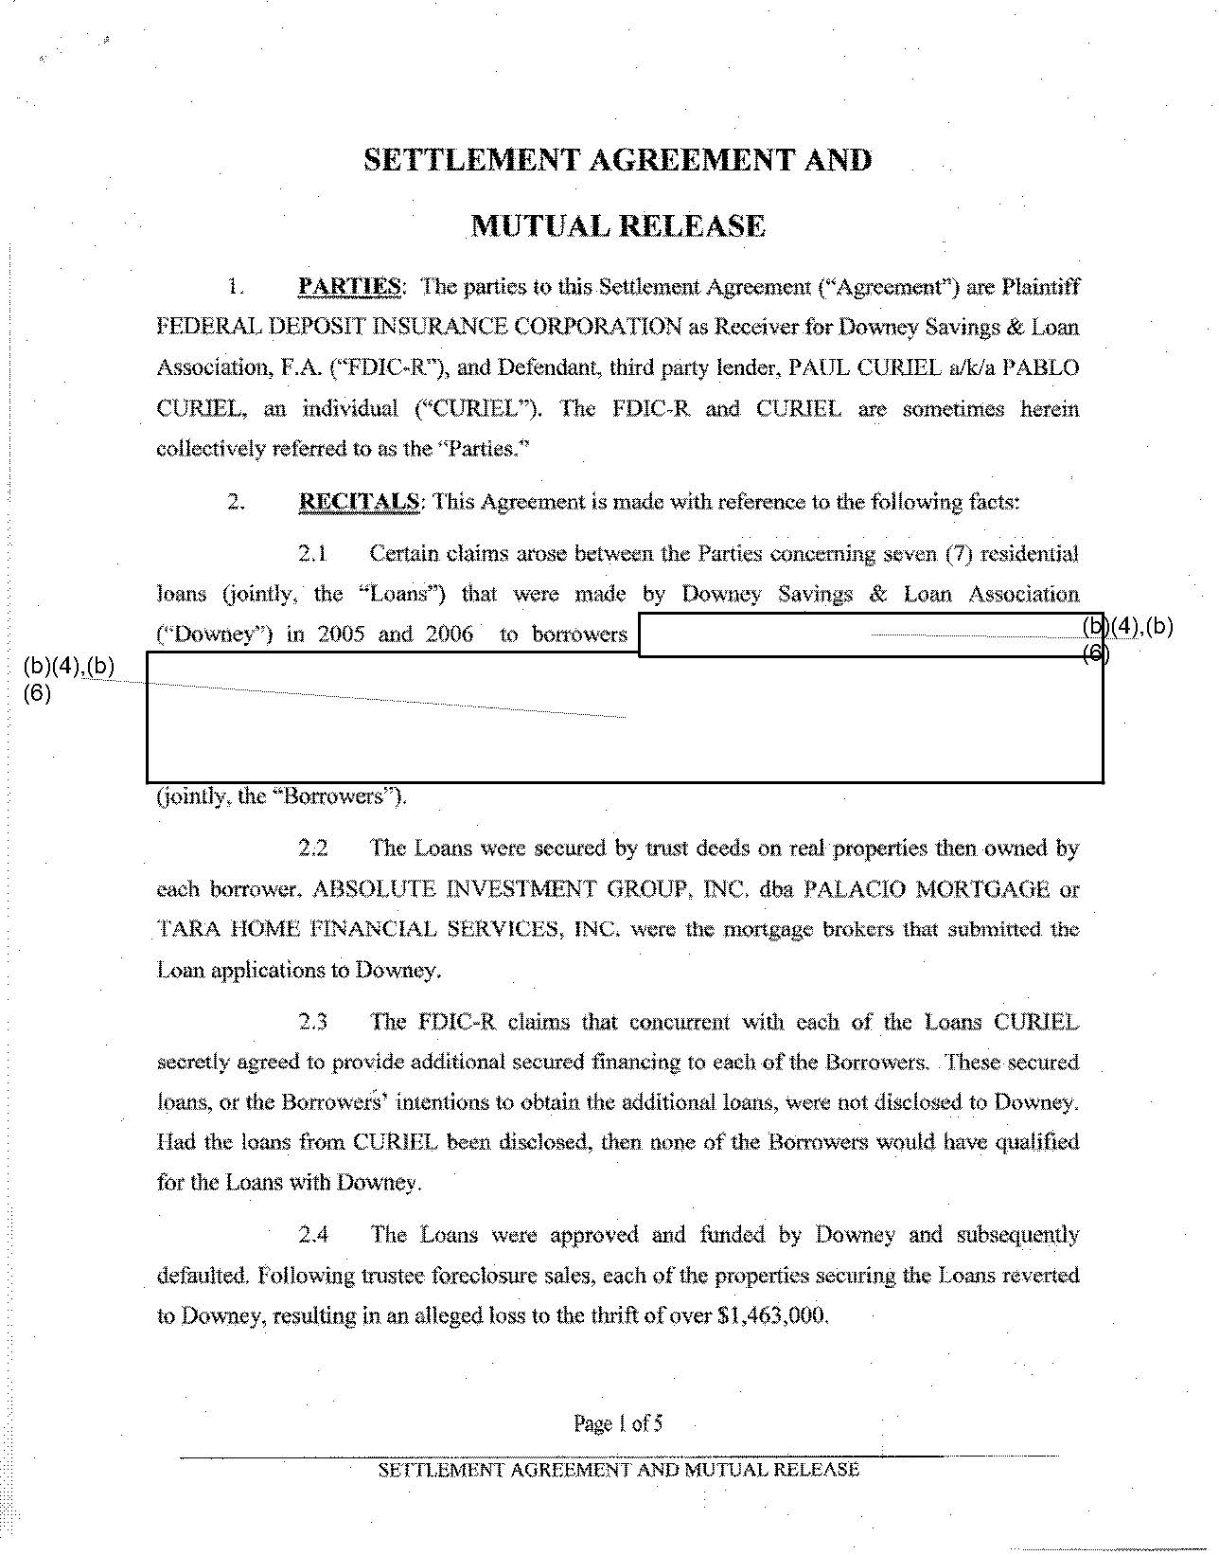
t$:

SETTLEMENT AGREEMENT AND

MUTUAL RELEASE

- PARTIES: The parties to this Settlement Agreement ("Agreementrt) are Plaintiff FEDERAl., DEPOSIT INSUil~"N'CE CORPOR.ATION as Recciverfor Do~ney Savings & Loan Association, F.A. ("FDlC..R"), and Defendant, third party lender, PAUL CURJEL a/kla PABLO CURIEL, an individual c~curuEL"). The FDIC~R and CURlEL are sometimes herein collectively referred to as the ~'Parties.·~

- RECITALS: This Agreement is made wlth reference to the foHoV~.ing facts:

2.1 Certain claims arose between the Parties concerning :)f.tven (7) rcsidentiul

loans Gointly~ · the '"'Loanst') that were made by Downey Savings & Loan Association

e·Downey·~) in 2oos and 2oo6 · to borrowers 1 ~~

(b)(4),(b)
(6) .....

(joinlly~ the •'Bon:owers~').

J4J.(b)

22 The Loans were secured by tru.~t deeds on real properties then o\\ned by

each borrower. ABSOLUTE INVESTMENT GROUP~ INC. dba PALACIO MORTGAGE or

. TARA HOME FINANCIAL SBRVICESt INC. were the mortgage brokers that sub:rnittcd.thc

Loan applicati.ons to Downey.

2.3 The FDIC-R claims that concurrent -with each of the Loans CURIEL

secretly agreed to provide additional secured financing to each of the Borrotv-ers. These secured

Jnans, o.r the Borrowers~ intentions to obtain the additional loans, were not disclosed to Downey. Had the loans from CURIEL been disclosed, then none of the Borrowers would have quaiJfied
for the Loans ~ith Downey.

2.4 The Loans were approved and funded by Downey and subsequen.tly

. defaulted. Following trustee foreclosure sales, each of the properties seeuring the Loans reverted
. . .
to Do""-:ney, resulting in an alleged loss to the thrift of ()ver $1,463,000.

Pagel of5
... ..,.;.. .....

SErn;EMENT AGREEMENT AND MUTIJAL RELEASE

.......................................______

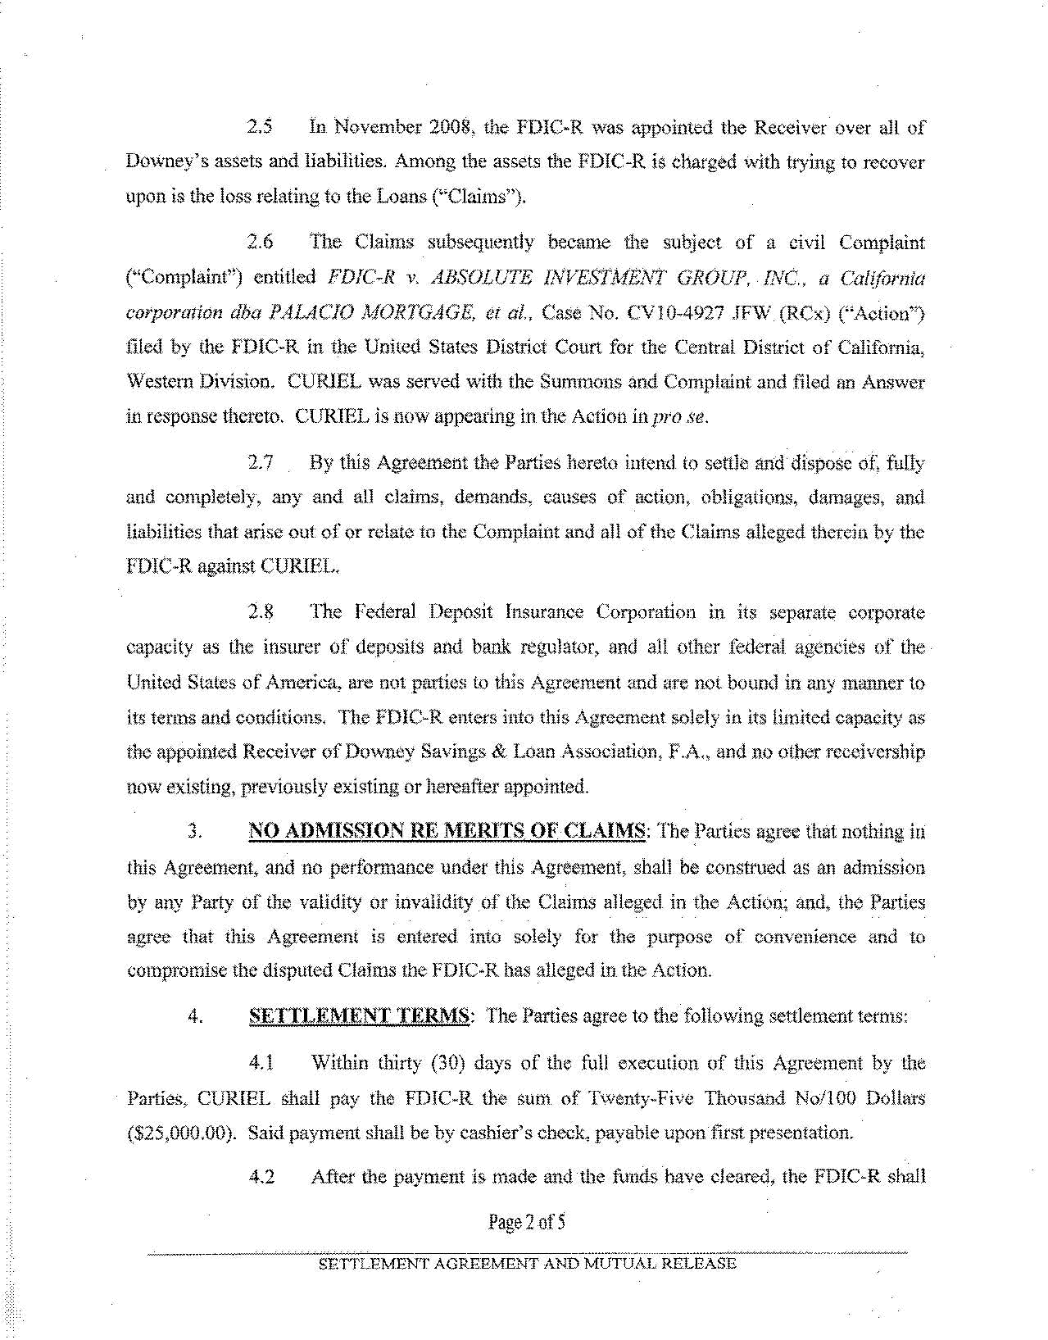
2.5 1n November 2008~ the FDIC-R was appointed the Receiver over all of Downey's assets and liabilities. Among the assets the FDIC-R is charged \v:ith trying to recover upon is the loss relating to the Loans ('-"Claims").

2.6 The Claims subsequently became the subject of a civil Complaint ("Complaint'~) entitled FDIC·~R v. ABSOLUTE INVESTlvfENT GR()UP,. INC., a California

corporatiOn dba PALACIO A10RTGAGE~ et al., Case No. CVI0~4927 JF\'\l. (RCx) ('~Action')

filed by the FDIC-R in the United States District Court for the Central District of California}

Western Division. CURlEL was served with the Summons and Compl.aint and filed an Answer in response thereto. CURlEL is now appearing in the Action in prose.

2.7 By this Agreement the .Parties hereto intend to settle and· dispose of~ fully

and completely, any and all claims~ demands, causes of action~ obliga.t.ic:ms, damages~ and

liabilities that arise out of or relate to the Complait1t and all of the Claims alleged therein. by the

FDIC-R against CURlEL,

2.8 The Federal Deposit Insurance Corporation in its sepamtQ corporate

capacity as the insurer of deposits and bank regulator> and aU other federal agencies of the ·

United States of America~ are not parties to this Agreement and ~re not bound in any manner to

its terms and conditions. TI1e FDIC~R enters into this Agreement solely in its limited capaclty as

the appoinied Receiver of Downey Savings & Loan Association~ F.A.~ and no other receivership

now existing, previously existing or hereafter appointed.

- NO ADMISSION RE MERITS OF CLAil\fS: The parties agree that nothing hi

this Agreement~ and no pertbrmance under this Agreement} shall be construed as an admission

by any Party of the validity or invalidity of the Claims alleged in the Action; and~ the Parties

agree that this Agreement is entered into solely for the purpose of convenience and to

compromise the disputed Claims the FDlC·R has alleged in the Action.

  - SETTLEJ\.fENT TER1\1S; The Parties agree to the following settlement terms:

4.1Within thirty (30) days of the full execution of this Agreement by the

- Partiesfr CURIEL shall pay the FDIC-R the sum of Twenty-Five Thousand No/100 Dollars ($25i000.00). Said payment shall be by cashier's check. payable upon first presentation. ·

4.2 After the payment is made and the funds bave cleared~ the FDIC~R shall

Page2of5

-·--···----~~~~::::::::::'"=:-~• · ----·····....--··-·············--··---·-·····----·-~-.--------,--
SETTLEMENT AGREEMENT AND MUTUAL RELEASE

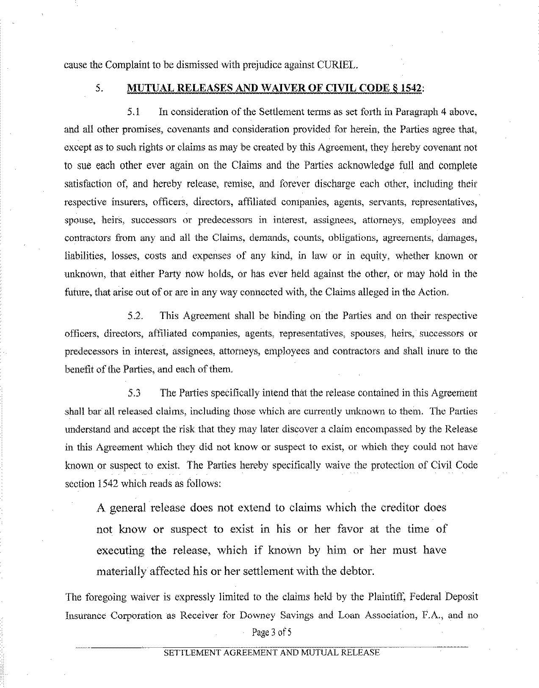
cause the Complaint to be dismissed with prejudice against CURIEL.

- MUTUAL RELEASES AND WAIVER OF CIVIL CODE § 1542:

5.1 In consideration of the Settlement teoos as set forth iu Paragraph 4 above.

and all other promises, covenants and consideration provided fat herein, the Parties agree that,

except as to such rights or claims as may be created by this Agreement~ they hereby covenant not

to sue each othet ever again on the Claims and the Parties acknowledge full and complete

satisfaction of~ and hereby release, remise, and forever discharge each other, including their

:respe{,-tive insurers, officers~ directors, affiliated companies, agents, servants, representatives,

sp,)use. heirs~ successors or predecessors in interest. assignees. atto.rneys, employees and

contractors from any and all the Claims, demands} counts, obligations. agreements, damages;

liabilities. losses, costs and expenses of any kind~ in law or in equity. whether known or

unknovvn, that either Party rtow holds, or has ever held against the other~ ot may hold in the future, that arise out of or are in any way COl'l.il.ecteclv.-ith~ the Claims alleged in the Action.

5.2. This Agreement shall be binding on the Parties and on their respective

officers, directors~ affiliated companies, agents, representatives~ spouses, he.irs, successors or

pred.ecessors in interest. a.~si.gnees, attorneys~ employees and contractors and shall inure to the

benefit of the Parties, and each ofthem,

5.3 The Parties speCifically intend that the release contained in this Agreement

shall bar all released claims, including thm;e which are currently unkn<.)Wn to thei:n. The Purti.es

understand and accept the risk that they may later discover a claim encompassed by the Rel.ea.<;,e

in this Agreement which they did not know or suspect to exist~ or whiCh they could not have

kno\\-11 or suspect to exist. The Parties hereby specifically waive the protection of Civil Code
. ... . ...

section 1542 which reads as follows:

A general release does not extend to claims which the creditot does

not know or suspect to .exist in his or her favor at the time of

executing the release, which if known by him or her must have materially affected his or her settlement with the debtoL

The foregoing waiver is expressly limited to the claims held by the Plaintiff. Federal beposit

Insutance Corporation as Receiver for Downey Savings and Loan Association, F.A., and no

Page 3 of5

SElTLEMENT AGifEE-MENT AND MUTUAL RELEASE----------

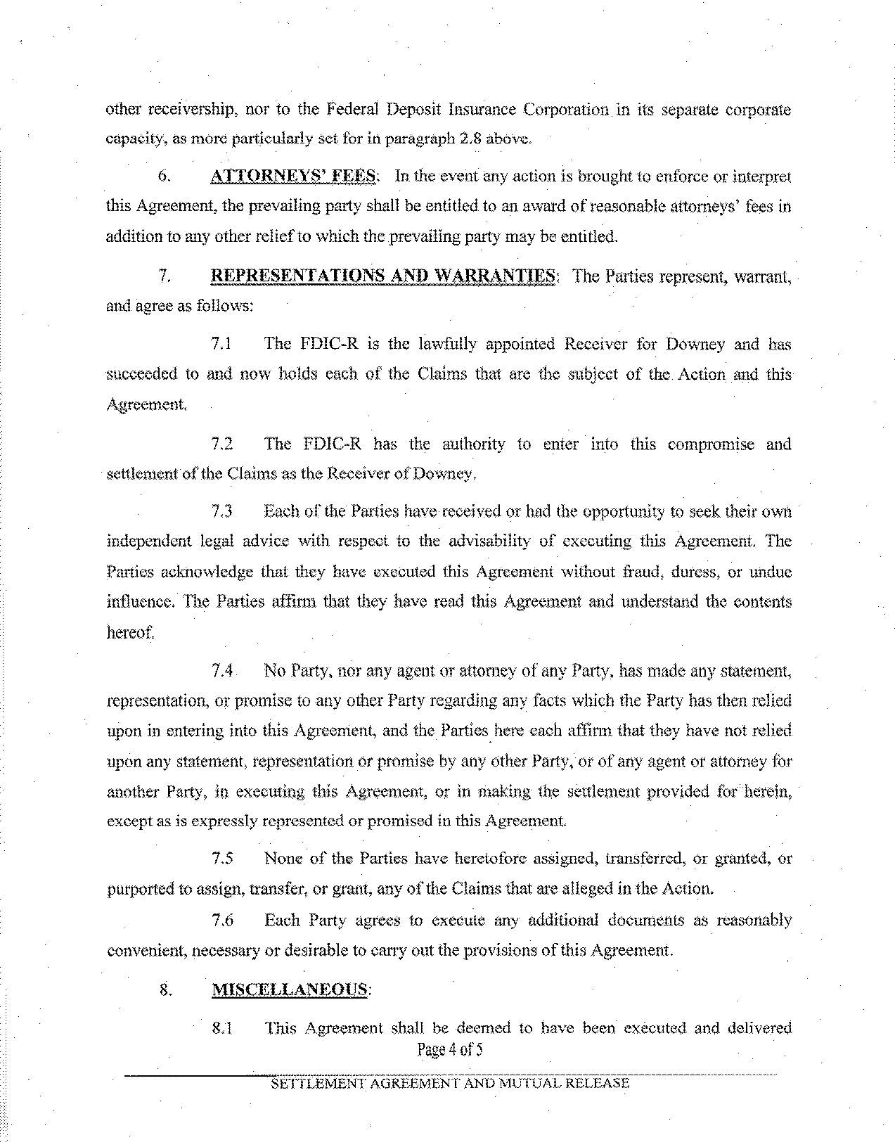
other receivership, nor to the Federal Deposit Insurance Corporation in its separate corporate

capacity, as more particularly set for in paragraph 2.8 abow.

. . .

- ATTORNEYS' FEES: In the eveiit any action is brought to enforce or interpret this Agreement, the prevailing party sball be entitled to an award of reasonable attorneys, fees in

addition to any other relief to which the .prevailing party may be entitled.

- REPRESENTATIONS AND WARRANTIES: The Parties represent, warrant,. and agree as follows:

7.1 The FDIC-R is the lawfully appointed Receiver for Dovmey and has succeeded to and now holds each of the Claims that are the subject of the. Action and this

Agreement

7.2 The FDIC-R has the authority to enter· into this compromise and ·settlement of the Claims as the Receiver ofDoVr-ney,

7.3 Each of the Parties have received or had the opportunity to seek their o\vn ·

independent legal advice with respect to the advisability of executing ihls Agreement The
. .
'Parties acki1owledge that they have executed this Agreement without fraud} dutcssi or undue influence.· The Parties afl:im1 that they have read this Agreement and understand the contents

hereof.

7.4. No Party. nor any agent or attomey of any Pa1ty~ has made any statement,

representation, or promise to any other Party regarding any facts which the Party has then relied

upon in entering into this Agreement, and the Parties. he.re each affinn that they have not relied.

upon any statement~ representation or promise by any other Party, or of any agent or attorney for

another Party, in executing this Agreerne.nt. or in rilaking tb.e settlement provided fot herein~ ·

except as is expressly represented or promised in this Agreement

. . . . . .

7.5 None· of the Parties have heretofore assigned, transferred, or granted, or

purported to assign, transfer, or grant. any of the Claims that are alleged in the Action.

7.6 | Each Partv aotees~ | to execute anv additional documents• | as | ..
7.6 | ;,t | ... |  | reasonablv
convenient, necessary or desirable to carry out the provisions ofthis Agreement.

- MISCELLANEOUS:

8.1This Agreement shall be deemed to have been executed and delivered

Page 4 of5

·sE:1tf[fi!YffitrCr\dRfJ3MEN-:r:-XN"o-~~.f01-;uA'CR"E.i"EA.se----··---------·······-··..·························
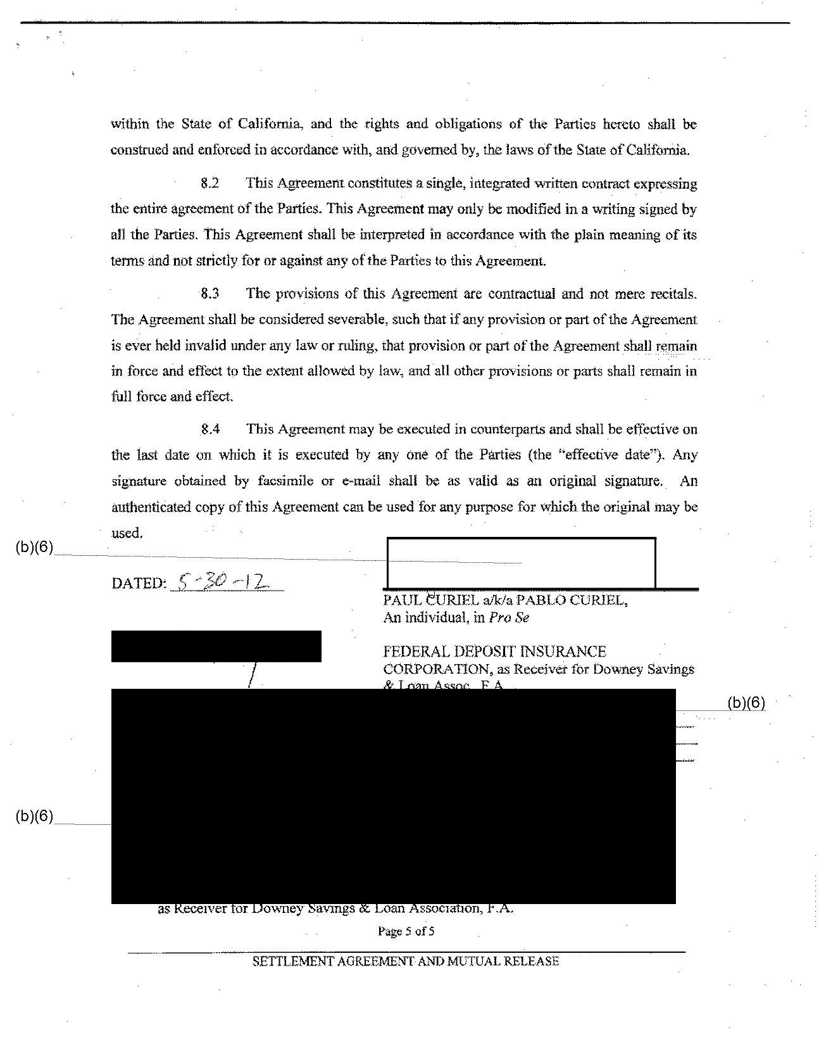
within the State of California, and the tights and obligations of the Parties hereto shall be

construed and enforced in accordance with, and governed by. the laws of the State of Califoniia.

8.2 This Agreement constitutes a single, integrated ""'-ritten contract expressing the entire agreement of the Patties. This Agreement may only be modified in a writing signed by

all the Parties. Thls Agreement shall be interpreted in accordance with the plain meaning ofits

tenns and not strictly for or against any of the Patties to this Agreement.

8.3 The provisions of this Agreement are contractual and not mere recitals.

The Agreement .shall be considered severable, such that if any provision or part of the Agreem.ent is ever held invalid tmder any law or ruling, that provision or part of the Agreement shall r:~tl1ain in force and eftect tl) the extent allowed by law, and all other provisions or parts shall remain in full force and effect .

.8.4 This Agreement may be executed in counterparts and shall be effective on

the last date on whjch it is executed by any one of the Parties (the "effective date"). Any

signature obtained by facsimile or e-mail shall be as valid as an original signature.. An

authenticated copy of this Agreement can be used for any purpose for which the original may be used.

(b)(6) .................................

DATED:_5~ ~-J L
PAUL 8URIEL a/kla PABLO CURIEL,
An individual, in Pro Se

FEDERAL DEPOSIT INSURANCE
CORPORATION, as Receive:t for Downey SavingS
- Loan Assoc. F.A. .
................................................................................... 1 (1?.1(§1

APPROVED AS TO FORM:

HERSHORIN & HEN~-b,t:~-

(b)(6)

ox
omeys for Plaintiff,
ederal Deposit Insurance Corporation
as Receiver for bo\-\ney Savings & Loan Association, F .A.

Page 5 of5

SETTLEMENT AGREEMENT Al"'D MUTUAL RELEAS:S

