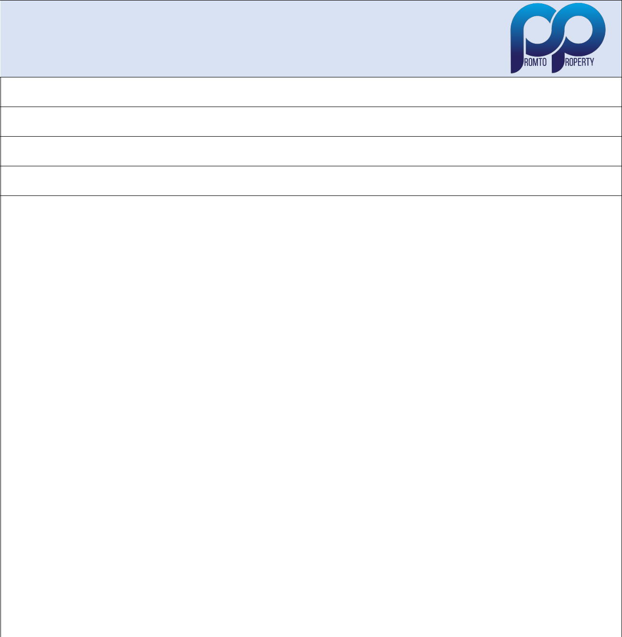
NEW TENANT INFORMATION SHEET

Body Corporate Managed by Promto Property Management Services cc

011 867 5508 | info@promto.co.za

Complex Name:

Unit Nr:

2 Numbers for Tenants

Date of Occupation:

 |  |  |  | Tenant 1
 | Name |  |  |  | Surname
 | Contact Number |  |  |  | Cell Number
 | Identify Number
 | Email Address
 |  | Copy of green bar-coded ID or ID |  | Signature:
 |  | card to accompany this form |  | Date:
 |  |  |  | Tenant 2
 | Name |  |  |  | Surname
 | Contact Number |  |  |  | Cell Number
 | Identity Number
 | Email Address
 |  | Copy of green bar-coded ID or ID |  | Signature:
 |  | card to accompany this form |  | Date:
 | Number of vehicles?

Conditions:

- This document must reach Promto Property 48 hours prior to new tenants moving in to ensure the intercom system is updated. No updates can be done on a Friday for tenants moving in on a Saturday / Sunday.

- Adhere to the delivery vehicle weight restrictions and off load in such a manner not to block or restrict normal traffic flow or access into other properties.

- Confirm if your complex is pet friendly, NO Pets allowed prior to permission obtained from body corporate.

- Adhere to parking rules and ensure neighbourly conduct.

- Garages are not to be used for storage but for it’s intended purpose of parking a vehicle inside.

- No numbers will be loaded without confirming the acceptance of the body corporate conduct rules.

- Copies of ID’s required for each tenant’s number to be loaded.

- By submitting this document, I confirm that I have read and understand the conduct rules for the body corporate and that I will be bound by it.

- Failure to abide by the rules could mean fines being issued or legal action being instituted as guided by the conduct rules.

Regards Promto Property

