
Access the Rest of the Interview Guide

IB Interview Guide, Module 4: Equity Value, Enterprise Value, and Valuation Metrics and Multiples

Table of Contents:

Overview & Key Rules of Thumb 2
Key Rule #1: Equity Value and Enterprise Value: Meaning and Calculations 2
Key Rule #2: How Events Impact Equity Value and Enterprise Value 18

Key Rule #3: Why the Concept of Enterprise Value Doesn’t Hold Up in Real Life 27
Key Rule #4: The Equity Value Calculation 31
Key Rule #5: Other Dilutive Items: RSUs, Convertible Bonds, and More 36
Key Rule #6: The Equity Value to Enterprise Value “Bridge” 43
Key Rule #7: Income Statement Valuation Metrics: EBIT, EBITDA, and Net Income 45
Key Rule #8: Cash Flow Statement Valuation Metrics: FCF, FCFF, and FCFE 53
Key Rule #9: Valuation Multiples: How to Pair Metrics with Eq Val & TEV 60

Key Rule #10: How to Use Multiples in Real Life 69
Key Rule #11: Equity Investments and Noncontrolling Interests in Enterprise Value .. 77
Key Rule #12: Pensions in Enterprise Value 82
Key Rule #13: Operating Leases and Capital Leases in Enterprise Value 86
Key Rule #14: Net Operating Losses (NOLs) and Other Items 92
Interview Questions 95
The Concepts of Equity Value and Enterprise Value 95
How Events Impact Equity Value and Enterprise Value 100
Valuation Multiples 107
Calculating Equity Value and Enterprise Value 116

1 of 121 https://breakingintowallstreet.com

Access the Rest of the Interview Guide

Overview & Key Rules of Thumb

Questions about Equity Value, Enterprise Value, and valuation metrics and multiples are some of the most common ones in interviews.

Unfortunately, most guides, textbooks, and websites do a very poor job of explaining these topics.

With accounting, sometimes the explanations are not great, but the information is correct.

But with Equity Value and Enterprise Value, the information is often WRONG.

For example, if someone asked you what “Enterprise Value” meant, what would you say?

From the Google search results, a reasonable answer might be: “Market Capitalization, plus Debt, Noncontrolling interests, and Preferred Stock.”

Other sources give definitions such as: “Enterprise Value represents the ‘theoretical takeover price’ of a company.”

All these definitions are wrong, incomplete, or misleading.

The REAL definition of Enterprise Value is: “The value of a company’s core business operations to ALL the investors in the company.”

In the sections below, we’ll expand on this definition, explain how to pair Equity Value and Enterprise Value with operating metrics to create valuation multiples, and explain how Equity Value and Enterprise Value change after specific events.

Key Rule #1: Equity Value and Enterprise Value: Meaning and Calculations

These concepts go back to that all-important formula:

Company Value = Cash Flow / (Discount Rate – Cash Flow Growth Rate), where Cash Flow Growth Rate < Discount Rate.

The accounting lessons dealt with the Cash Flow part of that formula.

Equity Value and Enterprise Value deal with the Company Value part.

Specifically, how do you measure “Company Value”?

That is tricky to answer because companies are worth different amounts to different types of investors.

2 of 121 https://breakingintowallstreet.com

Access the Rest of the Interview Guide

It’s also tricky to answer because “the market” may say a company is worth one amount, but its intrinsic value may be different.

So, there are at least two ways you can measure a company’s value:

- “Market Value” – What is the company worth right now according to the stock market, its current owners, or its current investors?

- Implied or “Intrinsic” Value – What should the company be worth according to your analysis and views?

Why might the Market Value be different from the Implied Value?

Let’s say you’re analyzing a company that has $100 in cash flow.

Both you and the company’s current owners believe the appropriate Discount Rate is 10% because similar companies are expected to generate annualized returns of 10% over the long term.

However, you disagree about the expected growth rates. You believe the company’s cash flow will grow at 4%, but the current owners think it will grow at 5%.

As a result, the company’s value is different for each group:

Implied Value for YOU = $100 / (10% – 4%) = $1,666.

Market Value = $100 / (10% – 5%) = $2,000.

The owners want $2,000 for the company, or they won’t sell it.

But you believe that the company is too expensive and that its intrinsic value is quite a bit lower. As a result, you won’t buy the company at their asking price of $2,000.

That’s the main reason why a company’s Market Value often differs from its Implied Value: you believe the company’s future growth will be one number, but “the market,” or other investors, believe something else.

You might also disagree about the Discount Rate or even the company’s Cash Flow. But most valuation differences boil down to disagreements about future growth rates.

Beyond this issue of Implied Value vs. Market Value, another problem is that “Company Value” might refer to different investor groups.

A company might have funded its operations with just Equity, a combination of Debt and Equity, Debt + Equity + Preferred Stock, or other combinations of capital.

3 of 121 https://breakingintowallstreet.com

Access the Rest of the Interview Guide

So, does “Company Value” refer to just the amount attributable to Equity investors (common shareholders)? Or does it include all the investor groups?

This question creates the main two measurements of “Company Value”: Equity Value and Enterprise Value.

- Equity Value: The value of EVERYTHING a company has (Net Assets, or Total Assets – Total Liabilities), but only to EQUITY INVESTORS (common shareholders).

- Enterprise Value: The value of the company’s CORE BUSINESS OPERATIONS (Net Operating Assets, or Operating Assets – Operating Liabilities), but to ALL INVESTORS (Equity, Debt, Preferred, and possibly others).

The “Equity Value” view of a company like Target looks like this:
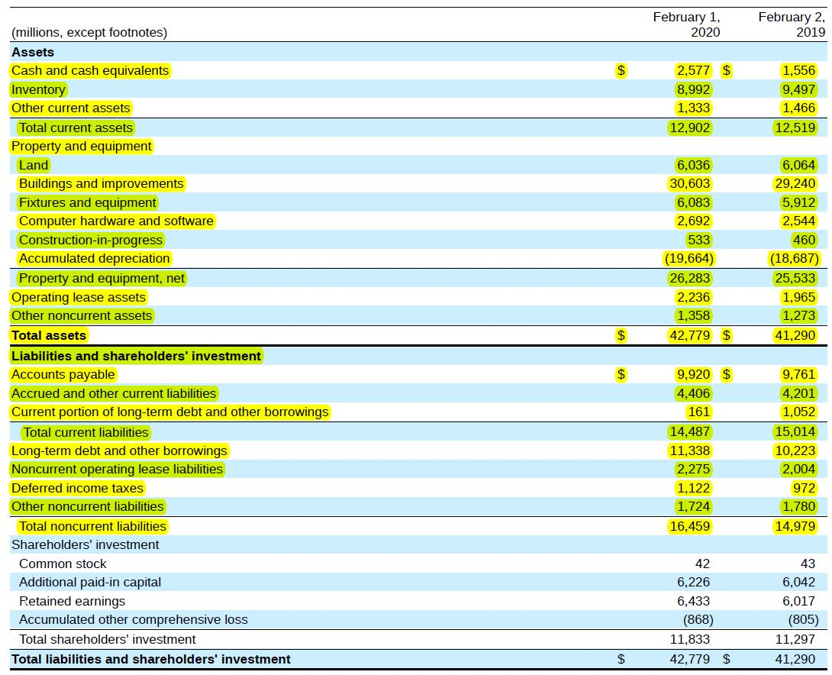

4 of 121 https://breakingintowallstreet.com

Access the Rest of the Interview Guide

Equity Value represents EVERYTHING: Total Assets – Total Liabilities.

And the “Enterprise Value” view looks like this:
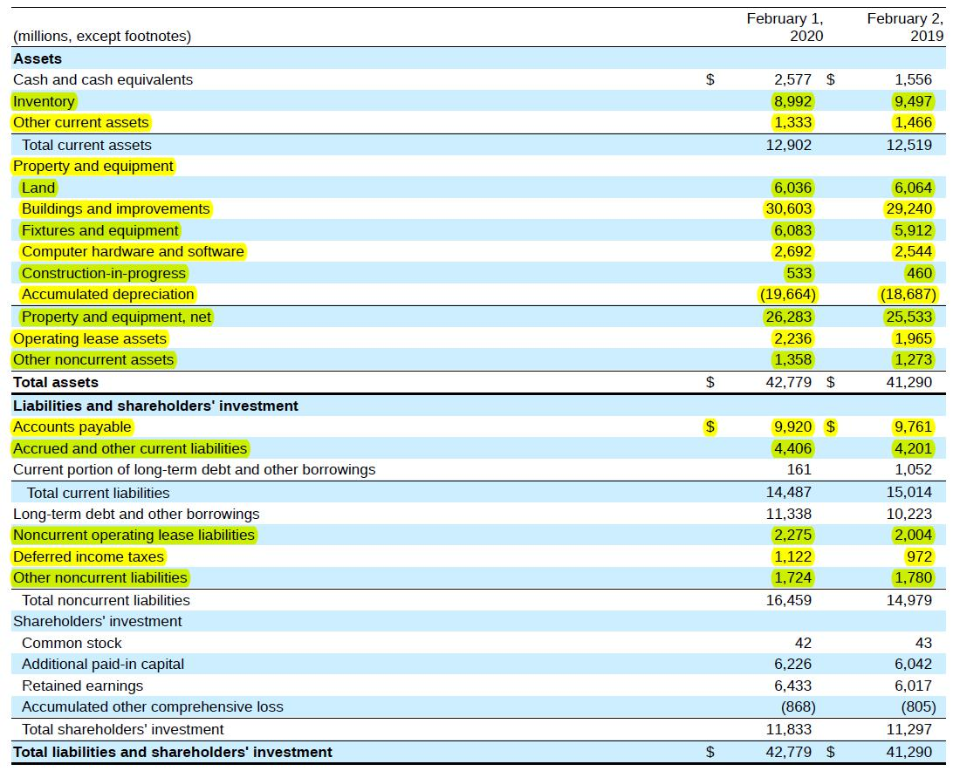

Enterprise Value excludes Non-Operating Assets, such as Cash and Financial Investments, as well as Non-Operating Liabilities, such as Debt.

Equity Value is known colloquially as “Market Capitalization” or “Market Cap,” and for public companies, it’s equal to Current Share Price * Shares Outstanding.

People often use Equity Value or Market Cap when discussing company valuations, and journalists usually write about it because it’s simple and easy to calculate.

But there is a big problem with it: if a company’s capital structure (the percentage of Equity vs. Debt) changes, Equity Value will also change!

5 of 121 https://breakingintowallstreet.com

Access the Rest of the Interview Guide

On the other hand, Enterprise Value will not change – or at least, not change as much – even if the company’s capital structure changes.

For example, consider these three capital structures for the same company:
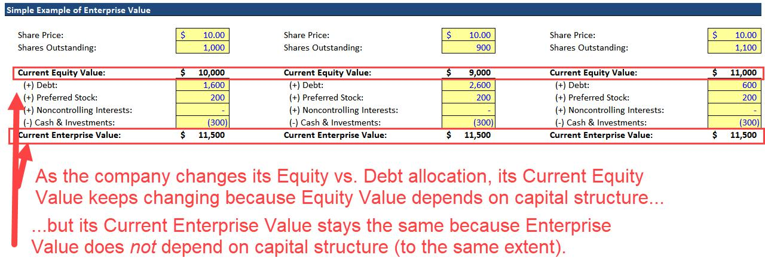

That is the real significance of Enterprise Value: it doesn’t suddenly change even when the company’s Equity and Debt percentages change.

So, we often use Enterprise Value when analyzing companies because it lets us reach conclusions without worrying about the companies’ capital structures.

One real-life analogy to explain Equity Value and Enterprise Value is buying a house with different amounts for the mortgage and down payment.

For example, if you buy a $500K house using a mortgage for 50% of it, the “Equity Value” and “Enterprise Value” look like this:
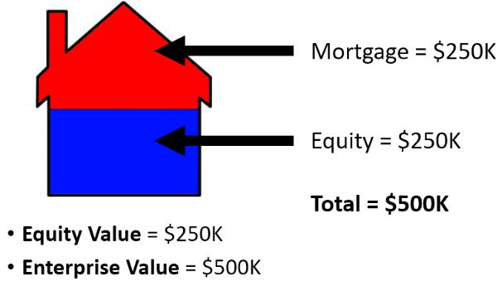

If you changed the terms and put down only 20% upfront, it would look like this:

6 of 121 https://breakingintowallstreet.com

Access the Rest of the Interview Guide
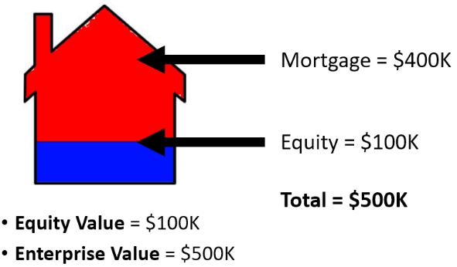

And then if you paid for the house 100% with the down payment, it would look like this:
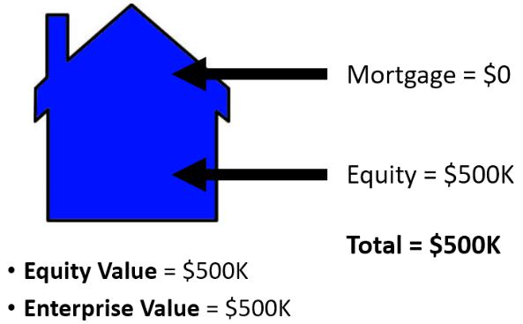

Regardless of how you finance the purchase of the house, its “Enterprise Value” stays the same at $500K.

And that is why Enterprise Value is essential for valuing companies as well. It doesn’t work exactly as shown above, but the idea is quite similar.

Why Define the Metrics This Way? And Why Do We Need Both of Them?

One common question we get goes like this:

“Why do you pair Total Assets – Total Liabilities with Common Shareholders (Equity Value), but Operating Assets – Operating Liabilities with All Investors (Enterprise Value)? Isn’t this pairing arbitrary? If so, couldn’t you create other pairings?”

No, it’s not arbitrary. You can understand the pairing with the following logic:

- A company can generate Equity internally from its Net Income (Net Income flows into

Retained Earnings in Common Shareholders’ Equity), but it can also raise Equity from outside investors by issuing stock.

7 of 121 https://breakingintowallstreet.com

Access the Rest of the Interview Guide

- On the other hand, a company cannot generate Debt, Preferred Stock, and other funding sources internally – it must ask outside investors for these funds.

- A company is unlikely to raise capital from outside investors to acquire Non-Core or Non-Operating Assets, such as a side business selling ice cream if it’s a software company.

- However, since Equity may be generated internally or raised externally, the company could use it for anything: both Operating Assets and Non-Operating Assets.

So, we pair Enterprise Value with Net Operating Assets and Equity Value with Net Assets.

In real life, this logic does not necessarily hold up 100%.

For example, companies might issue Debt to acquire side businesses that have nothing to do with their core operations.

However, the convention is to follow the logic above to standardize these metrics and make it easier to compare companies.

We need both Equity Value and Enterprise Value when analyzing companies because:

- One analysis might produce the Implied Equity Value, while another might produce the Implied Enterprise Value – and we need to move between them with a “bridge.”

- No single investor group is an island – actions taken by one affect everyone else! For example, if a company raises Debt, that affects the risk and potential returns for common shareholders as well.

A specific example of point #1 is that if we’re analyzing a company from the perspective of common shareholders, we often use the Discounted Cash Flow (DCF) analysis to estimate what its share price should be.

However, the DCF usually produces the company’s Implied Enterprise Value.

Therefore, we need to jump across the “bridge” from Enterprise Value to Equity Value so that we can divide Equity Value by the share count to get the Implied Share Price.

How to Calculate Current Equity Value and Current Enterprise Value

You usually start this process by calculating a company’s Current Equity Value.

8 of 121 https://breakingintowallstreet.com

Access the Rest of the Interview Guide

There are three main methods you can use to calculate it:

- Method #1: Shares Outstanding * Current Share Price (for publicly traded companies).

- Method #2: Market Value of Total Assets – Market Value of Total Liabilities (technically,

“Market Value of Everything on the L&E Side Except for Common Shareholders’ Equity”).

- Method #3: The company’s valuation in its last round of funding, or its valuation in an outside appraisal (for private companies).

We almost always use Method #1 for public companies and Method #3 for private companies because it’s difficult and time-consuming to estimate the Market Value of every single Asset and Liability on the company’s Balance Sheet.

Here’s a simple example of how to calculate Equity Value for a public company:
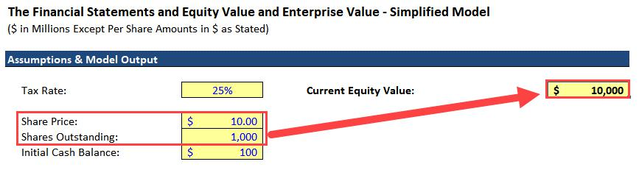

We multiply the Current Share Price of $10.00 by the Shares Outstanding of 1,000 to get the Current Equity Value of $10,000.

To move across the bridge to Enterprise Value, we can refer back to the definition:

- Enterprise Value: The value of the company’s CORE BUSINESS OPERATIONS (Net Operating Assets, or Operating Assets – Operating Liabilities), but to ALL INVESTORS (Equity, Debt, Preferred, and possibly others).

Written as a formula, the definition would look like this:

- Enterprise Value = (Market Value of Assets – Non-Operating Assets) – (Market Value of Liabilities – Liability and Equity Items That Represent Other Investor Groups)

“Other Investor Groups” means “groups besides the common shareholders.”

Rearranging the terms, we get:

9 of 121 https://breakingintowallstreet.com

Access the Rest of the Interview Guide

- Enterprise Value = Market Value of Assets – Market Value of Liabilities – Non-Operating Assets + Liability and Equity Items That Represent Other Investor Groups

The first two terms of this formula are also used in Method #2 of calculating Equity Value:

- Equity Value = Market Value of Assets – Market Value of Liabilities So, we can substitute this into the Enterprise Value formula:

- Enterprise Value = Equity Value – Non-Operating Assets + Liability and Equity Items That Represent Other Investor Groups

Since the starting point for Current Enterprise Value is Current Equity Value, you subtract Non-Operating Assets and add Liability & Equity Items That Represent Other Investor Groups to make this move. Here’s a simple example:
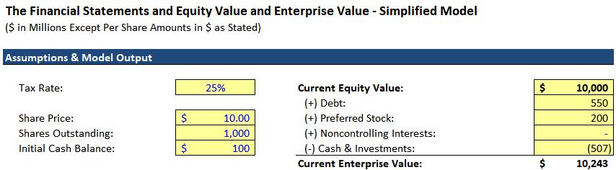

We’ll cover “Noncontrolling Interests” later in this guide; don’t worry about them for now.

In this example, the only Non-Operating Asset is Cash.

Technically, some amount of Cash is always operational because companies need a minimum amount to pay for the day-to-day running of the business.

However, this minimum amount varies widely between different companies and industries, so the standard treatment is to simplify it and assume that all Cash is “Non-Operating.”

Doing so also makes it easier to compare companies and get a quick read of each company’s valuation.

Other examples of Non-Operating Assets include:

- Financial Investments, such as stocks and bonds.

10 of 121 https://breakingintowallstreet.com

Access the Rest of the Interview Guide

- Owned Properties from which the company earns rental income (rather than using the properties internally and generating no income from them).

- Side Businesses that earn income for the company (e.g., an ice cream or Japanese whiskey business owned by a software company).

- Assets Held for Sale and Assets Associated with Discontinued Operations.

- Equity Investments or Associate Companies, which represent minority stakes in other companies (the Parent Company owns < 50% of these other companies).

- Net Operating Losses (NOLs), which are a component of the Deferred Tax Asset.

An Asset is Non-Core or Non-Operating if the company does not need that Asset to sell products/services and deliver them to customers.

What about “Liability & Equity Line Items That Represent Other Investor Groups?”

You add these items when moving from Equity Value to Enterprise Value, and the most common examples are Debt and Preferred Stock.

These both represent “other investor groups” because companies cannot generate Debt or Preferred Stock internally: they must contact investors, ask to borrow the funds, and promise to pay them Interest or Preferred Dividends each year in exchange for the money.

Other items in this category include:

- Capital Leases – Debt-like obligations with Interest payments that are used specifically to acquire plants, property, and equipment (PP&E).

- Noncontrolling Interests – These represent the unowned portions of majority-owned companies. If Company A owns 80% of Company B, it will consolidate Company B’s financials with its own but also record a Noncontrolling Interest for the 20% of Company B that it does not own.

These count as “another investor group” because if a company owns more than 50% of another company, it has effective control of that other company and can draw on all its resources, including those linked to the minority shareholders of this other company.

You also count these in Enterprise Value for comparability purposes (see the section on Equity Investments and Noncontrolling Interests).

11 of 121 https://breakingintowallstreet.com

Access the Rest of the Interview Guide

- Unfunded Pensions – If a company has a defined-benefit pension, meaning it’s required to pay retired employees a fixed amount each year, then it will have Pension Assets and Pension Liabilities. Pension Assets represent the investments set aside for these retirement payments, and Pension Liabilities represent the Present Value of the expected future obligations. If the Liabilities exceed the Assets, the pension is unfunded, and only that portion (Pension Liabilities – Pension Assets) should be added in the Enterprise Value bridge.

The employees act as “another investor group” in this case. In exchange for lower salaries/benefits in the present, they accept promised payments from the company once they retire. It’s similar to Debt, but over a much longer-term time frame. For more, see the section on Pensions.

- (Potentially) Operating Leases – In 2019, the accounting rules for Operating Leases changed, and they now appear on-Balance Sheet. Under IFRS, you normally add them when calculating Enterprise Value because of how the lease expense is presented on the Income Statement, but under U.S. GAAP, it could go either way as long as you’re consistent with the valuation multiples. For more on Leases, please see the section on Operating and Capital Leases.

There are some other potential items in this category that might represent “other investors groups” as well, which we discuss in Key Rule #14.

What About Private Companies?

The examples above use public companies with easy-to-determine Share Prices and Share Counts.

If you’re working with private companies – ones not listed on the stock market – not that much changes.

The concepts of Equity Value and Enterprise Value still apply, as does the distinction between Current Value and Implied Value.

The main difference is that you can’t calculate Current Equity Value by using the company’s Share Price and Shares Outstanding because its shares are not publicly traded.

12 of 121 https://breakingintowallstreet.com

Access the Rest of the Interview Guide

So, you have to rely on the valuation at which the company most recently raised money, the price at which it was acquired, or another external number to estimate its Current Equity Value.

As a result, you can’t calculate its Current Enterprise Value in a straightforward way.

In practice, you often skip Current Equity Value and Current Enterprise Value for private companies and just estimate Implied Equity Value and Implied Enterprise Value.

If you’re a banker advising a public company, you might compare the company’s Current Share Price to its Implied Share Price – what you think it should be worth.

But if you’re advising a private company, you might skip the comparison and simply tell the client what you think it should be worth.

Equity Value and Enterprise Value: Implications and Myths

The definitions of Equity Value and Enterprise Value have far-reaching implications.

We’ll explore those implications in this section and then bust some common myths:

Implication #1: Current Equity Value Cannot Be Negative, But Current Enterprise Value Can Be Negative

A company’s Current Share Price cannot be negative, and its Share Count also cannot be negative. So, it’s mathematically impossible for Current Equity Value to be negative.

Yes, Net Assets on the Balance Sheet could be negative, but the Market Value of Net Assets is extremely unlikely to be negative unless it’s a distressed company.

On the other hand, Current Enterprise Value could easily be negative. For example, what if the company’s Current Equity Value is $100 million, but it has $200 million in Cash and no Debt?

Its Current Enterprise Value is negative $100 million.

This scenario is rare; it’s most common for pre-bankruptcy companies that are burning through cash at high rates and that are likely to die soon.

A Negative Enterprise Value lets you buy Cash at a discount… assuming the company survives!

Implication #2: Both the IMPLIED Equity Value and IMPLIED Enterprise Value Can Be Negative

13 of 121 https://breakingintowallstreet.com

Access the Rest of the Interview Guide

As a simple example, if a company’s Cash Flow is currently negative $100, and the Discount Rate is 3%, with a Cash Flow Growth Rate of 2%:

Company Value = ($100) / (3% – 2%) = ($10,000)

Assuming that this is the cash flow to ALL investors (Unlevered Free Cash Flow) and that the Discount Rate is WACC, then the company’s Implied Enterprise Value is negative $10,000.

If the company has $500 in Cash and no Debt, then its Implied Equity Value will also be negative.

You back into Implied Equity Value in this case, so there’s no reason why it can’t be negative.

While this scenario is THEORETICALLY possible, it’s extremely unlikely in real life unless you’re analyzing distressed or highly speculative companies (e.g., tech or biotech startups).

So, if you got this result in a valuation, you might just set the Implied Share Price to $0.00 and assume the company is worthless.

Implication #3: IN THEORY, Financing Events Do Not Affect Enterprise Value; Only Changes to the Company’s Core Business (i.e., Net Operating Assets) Affect Enterprise Value

If a company with an Equity Value of $1,000 and Enterprise Value of $1,200 issues $100 of Common Stock, what happens to both metrics?

You know from the Accounting lessons that issuing $100 of Common Stock results in $100 of additional Cash on the Assets side of the Balance Sheet and $100 in additional Common Shareholders’ Equity on the L&E side.

Common Shareholders’ Equity increases by $100, so Equity Value increases by $100.

To move from Equity Value to Enterprise Value, you subtract Non-Operating Assets, and you add L&E Line Items That Represent Other Investor Groups.

Equity Value is $100 higher, but you subtract the extra $100 of Cash since Cash is a Non-Operating Asset.

There are no other, new investor groups to add.

These changes cancel each other out, and Enterprise Value stays the same.

That is extremely important.

14 of 121 https://breakingintowallstreet.com

Access the Rest of the Interview Guide

According to the theory behind it (the Modigliani–Miller theorem), financing events do NOT affect Enterprise Value.

Here are a few examples (“TEV” = Enterprise Value):

- Issuing Debt: Won’t impact TEV; Cash and Debt both increase and offset each other.

- Repaying Debt: Won’t impact TEV; Cash and Debt both decrease and offset each other.

- Issuing Stock: Won’t impact TEV; Cash and Equity Value both increase and offset each other.

- Repurchasing Shares: Won’t impact TEV; Cash and Equity Value both decrease and offset each other.

- Issuing Dividends: Won’t impact TEV; Cash and Equity Value both decrease and offset each other.

In these examples, there’s also a much simpler explanation: Net Operating Assets do not change. Cash, Debt, and Common Stock are all Non-Operating in nature.

Enterprise Value changes only if a company’s Net Operating Assets (i.e., its core business operations) changes.

Here are a few examples, all assuming that Cash on the Assets side balances the change:

- PP&E Increases: PP&E is an Operating Asset. No Operating Liabilities change, so Net Operating Assets (NOA) increases, and Enterprise Value increases.

- Inventory Increases: Inventory is an Operating Asset. No Operating Liabilities change, so Net Operating Assets (NOA) increases, and Enterprise Value increases.

- Accounts Receivable Decreases (due to cash collection): AR is also an Operating Asset, and no Operating Liabilities change. NOA decreases, so Enterprise Value decreases.

- Deferred Revenue Increases: This is an Operating Liability. No Operating Assets change, so when Deferred Revenue goes up, NOA goes down. Therefore, Enterprise Value decreases.

15 of 121 https://breakingintowallstreet.com

Access the Rest of the Interview Guide

In these specific examples, Equity Value does not change because Cash, not Common Shareholders’ Equity, balances each change.

However, if these changes had been funded by a Stock Issuance or something else that affected Common Shareholders’ Equity, then Equity Value would have changed.

To summarize:

- Equity Value changes only if Common Shareholders’ Equity changes; if it does, both CSE and Equity Value change by the same amount (at least in a simplified “interview question” setting).

- Enterprise Value changes only if Net Operating Assets changes; if it does, both NOA and TEV change by the same amount (at least in a simplified “interview question” setting).

You can sometimes shorten the Equity Value rule to “Do Net Assets change?” but be careful – if the company has Preferred Stock, Noncontrolling Interests, or anything else in Equity but not Common Shareholders’ Equity, that shortcut won’t work.

Finally, note that these principles are true in theory, but not in real life all the time (please see Key Rule #3).

Myths About Equity Value and Enterprise Value

Before moving on, let’s destroy some common myths about Equity Value and Enterprise Value that you’ll see on Investopedia, Wikipedia, online forums, and other “sources”:

MYTH #1: Enterprise Value is the “Cost to Acquire a Company”

NO! As stated above, Enterprise Value is the value of a company’s core business operations to all the investors in the company.

When a company wants to acquire 100% of another company, at the minimum, it must pay for all the other company’s shares outstanding.

So, the minimum purchase price is the other company’s Equity Value.

Past that, it gets tricky because not all acquisitions treat Debt and Cash the same way.

In most cases, the seller’s Debt must be “refinanced” (i.e., replaced with new Debt, or completely repaid) in an acquisition.

16 of 121 https://breakingintowallstreet.com

Access the Rest of the Interview Guide

However, this same condition isn’t necessarily true of the other Debt-like items that you add when moving from Equity Value to Enterprise Value.

And if the buyer simply replaces the seller’s Debt with new Debt, is the buyer really “paying” for the seller’s Debt?

Also, the acquirer doesn’t necessarily “get” all the seller’s Cash for itself because the seller still needs a certain amount for day-to-day operations.

Finally, the acquirer may have to pay additional fees to close the deal, and these fees are not reflected in the seller’s Enterprise Value at all.

MYTH #2: Enterprise Value is the “True Value” of a Company

This statement might seem true at first, but it’s missing one critical component: to whom?

Enterprise Value might be the “true value” of a company to all the investors in aggregate, but if you’re a common shareholder, it’s certainly not the company’s true value to you.

Going back to the home-buying analogy with the $250K mortgage and $250K down payment, how much is that new house worth to you?

You might be tempted to say, “$500K,” but think about what would happen if you tried to sell the house right after you bought it.

You’d only get $250K in proceeds because you’d have to repay the $250K mortgage. Even if the home sells for $500K total, you only get $250K from the sale.

MYTH #3: Debt “Adds” to Enterprise Value, and Cash “Subtracts” from Enterprise Value

No, no, and no.

Debt doesn’t “add to” a company’s Enterprise Value. You add Debt when you move from a company’s Equity Value to its Enterprise Value.

Similarly, Cash doesn’t “subtract from” a company’s Enterprise Value.

You subtract Cash when you move from a company’s Equity Value to its Enterprise Value.

This distinction may seem trivial, but the difference is huge.

17 of 121 https://breakingintowallstreet.com

Access the Rest of the Interview Guide

If you say that Debt “adds to” Enterprise Value, you’re implying that Debt issuances can change a company’s Enterprise Value – which is not true!

If you get this distinction wrong, you’ll incorrectly think that simple issuances of Debt and Equity change a company’s Enterprise Value.

But they do not. Only changes to a company’s core business affect its Enterprise Value.

(In reality, there may still be a small effect from financing changes, but far less of an effect than there is on Equity Value.)

MYTH #4: You Subtract Cash When Calculating Enterprise Value Because It’s “The Opposite” of Debt

No, no, no, and no.

You subtract Cash when moving from Equity Value to Enterprise Value because it is a Non-Operating or Non-Core Asset.

In other words, the company doesn’t need its full Cash balance to continue selling/delivering products and services to customers.

On the other hand, it does need its Inventory and its PP&E to keep doing these activities – so you don’t add or subtract those items.

Technically, you should subtract only the excess Cash balance, but in practice, everyone simplifies this and subtracts the entire balance.

Finally, there’s another reason why Cash is not “the opposite” of Debt: many forms of Debt do not allow early repayment.

Even if a company has a huge Cash balance, it can’t necessarily use it to repay Debt.

Return to Top.

Key Rule #2: How Events Impact Equity Value and Enterprise Value

Common interview questions about Enterprise Value and Equity Value include the following:

- “What happens to a company’s Enterprise Value if it raises $100 of Debt?”

- “What happens to a company’s Equity Value if it issues $100 in Dividends?”

18 of 121 https://breakingintowallstreet.com

Access the Rest of the Interview Guide

- “A company has excess Cash. How do its Equity Value and Enterprise Value change if it chooses to repurchase Stock vs. repay Debt?”

- “A CEO finds $100 of Cash on the street and adds it to the company’s bank account.

How do Equity Value and Enterprise Value change?”

These questions always refer to the Current Equity Value and Current Enterprise Value, so you only think about changes to the company’s Balance Sheet – not its future cash flows.

You can answer 99% of these questions with a simple, 2-step process:

- Does Common Shareholders’ Equity (CSE) change?

If so, then Equity Value changes by the amount that CSE changes. If not, then Equity Value does not change.

You can also think of this as, “Do Net Assets change?” but be careful because if there are Noncontrolling Interests or Preferred Stock, Net Assets no longer equals CSE!

Items that affect CSE include Net Income, Dividends, Stock Issuances, and Stock Repurchases.

- Do Net Operating Assets (NOA) change?

If so, then Enterprise Value will change by the amount that NOA changes. It doesn’t matter which investor group was responsible because Enterprise Value reflects all investors.

Let’s go through a few examples in different categories to illustrate the thought process (TEV = Enterprise Value, Eq Val = Equity Value, CSE = Common Shareholders’ Equity, and NOA = Net Operating Assets). We assume a 25% tax rate in each example:

Category #1: Capital Structure Changes

Single-step changes here are fairly simple, but multi-step ones can be tricky. It’s easiest to think about the net effect on CSE and NOA rather than explaining each step in the process.

1a) Company Issues $100 of Common Stock and Does Nothing With It

Eq Val increases by $100, and TEV stays the same.

19 of 121 https://breakingintowallstreet.com

Access the Rest of the Interview Guide
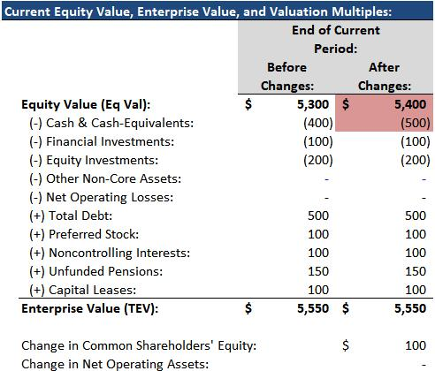

1) Does CSE change? Yes, it’s up by $100. Therefore, Eq Val increases by $100.

2) Does NOA change? No, because the proceeds go into Cash, which is Non-Operating, and no Operating Liabilities change. Therefore, TEV does not change.

1b) Company Issues $100 of Common Stock and Uses the Proceeds to Issue $50 of Dividends

This one is the same as above, but Eq Val increases by only $50, while TEV remains the same.

- Does CSE change? Yes, it’s up by $50. Therefore, Eq Val increases by $50.

- Does NOA change? No, because the proceeds go into Cash, and the Dividends come out of Cash, and Cash is Non-Operating. Therefore, TEV does not change.

1c) Company Issues $100 of Common Stock to Fund a $100 Acquisition
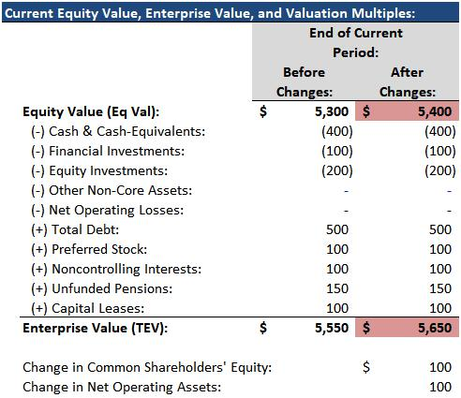

Eq Val increases by $100, and TEV increases by $100.

1) Does CSE change? Yes. It’s up by $100 because of the Stock Issuance, so Eq Val is up by $100.

2) Does NOA change? Yes, because these Acquired Assets are operational (the split between Existing Assets and Goodwill/Intangibles is irrelevant), and no Operating Liabilities change. NOA is up by $100, so TEV is up by $100.

20 of 121 https://breakingintowallstreet.com

Access the Rest of the Interview Guide

1d) Company Issues $100 of Debt and Does Nothing With the Proceeds

Nothing changes; both Eq Val and TEV stay the same.

- Does CSE change? No. Debt issuances do not affect CSE, so Eq Val stays the same.

- Does NOA change? No, because the proceeds go into Cash, and Cash is Non-Operating. Debt is also a Non-Operating Liability. Therefore, TEV does not change.

1e) Company Issues $100 of Debt to Fund a $100 Common Stock Repurchase

Eq Val decreases by $100, and TEV stays the same.
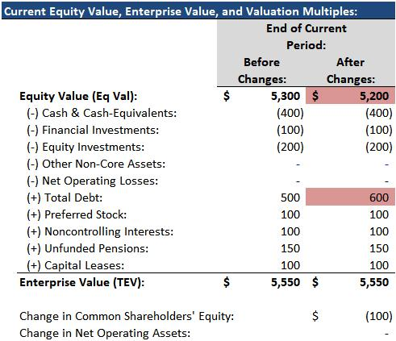

1) Does CSE change? Yes, it decreases by $100 because of the Stock Repurchase, so Eq Val decreases by $100.

2) Does NOA change? No, because nothing that changes here (Debt, Cash, and Equity) is an Operating Asset or Liability. Therefore, TEV stays the same.

1f) Company Issues $100 of Debt to Purchase $100 of Financial Investments

Both Eq Val and TEV stay the same.

- Does CSE change? No, because Debt issuances do not affect CSE. Therefore, Eq Val stays the same.

- Does NOA change? No, because nothing that changes here (Debt, Cash, and Financial Investments) counts as an Operating Asset or Liability. Therefore, TEV stays the same.

1g) Company Issues $100 of Preferred Stock to Fund a $100 Common Stock Repurchase

21 of 121 https://breakingintowallstreet.com

Access the Rest of the Interview Guide

This one is the counter-example to the intuition that a change in Net Assets will also affect Equity Value – because Net Assets here do not change, but Equity Value does!

Eq Val decreases by $100, and TEV stays the same.
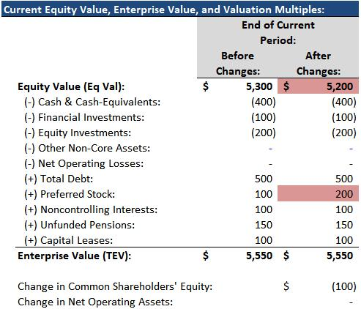

1) Does CSE change? Yes, because the $100 Stock Repurchase reduces CSE by $100. Therefore, Eq Val decreases by $100.

2) Does NOA change? No. Preferred Stock, Cash, and CSE are all Non-Operating, so no Operating Assets or Liabilities change, and, therefore, TEV stays the same.

This example shows why it’s better to use Common Shareholders’ Equity – not Net Assets – when determining whether or not Equity Value changes.

Category #2: Operating Asset and Liability Changes

With these types of events, Enterprise Value often changes – but you need to be careful with the “Net” part of “Net Operating Assets.”

In other words, if an Operating Asset and an Operating Liability both increase by the same amount, Enterprise Value will not change!

Also, if you get a multi-step question about something like Inventory or Deferred Revenue, the net effect by the end is that Enterprise Value tends to stay the same.

For example, if a company purchases Inventory and then sells it to generate Net Income, its Equity Value increases, but its Enterprise Value remains the same at the end of the process.

2a) CapEx Increases by $100, Boosting Net PP&E

Eq Val stays the same, and TEV increases by $100.

22 of 121 https://breakingintowallstreet.com

Access the Rest of the Interview Guide
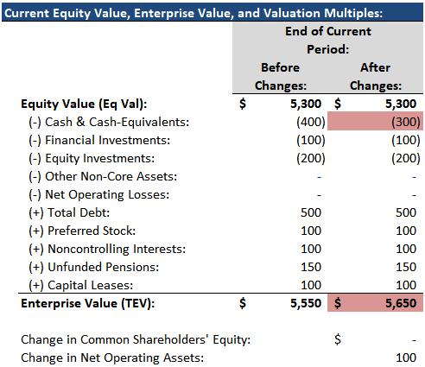

1) Does CSE change? Cash is used to purchase the PP&E, so CSE does not change. Therefore, Eq Val does not change.

2) Does NOA change? Yes. Net PP&E is an Operating Asset, and it increases by $100; no Operating Liabilities change, so NOA increases by $100, and TEV increases by $100.

2b) Inventory Increases by $100 (Step 1)

This explanation is almost the same as the one above: Cash moves into an Operating Asset (Inventory) and CSE does not change, so Eq Val stays the same, and TEV increases by $100.

2c) Company Sells $100 of Inventory for $200 of Finished Goods (Step 2)

In the second step of this process, the company sells the goods and recognizes $200 in Revenue and $100 in COGS on the Income Statement. Pre-Tax Income increases by $100, and Net Income increases by $75 at a 25% tax rate.
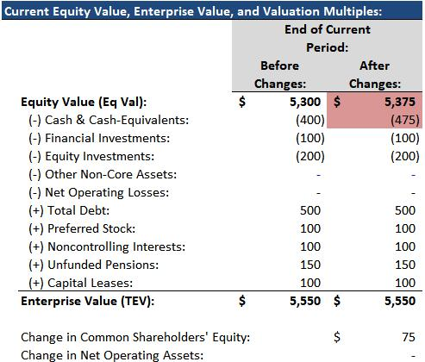

On the Cash Flow Statement, the only net change from Step 1 through Step 2 is that Cash increases by $75 due to the additional Net Income (Inventory goes up by $100 and then down by $100, so the two changes cancel each other out).

On the Balance Sheet, Cash is up by $75 on the Assets side, and CSE is up by $75 on the L&E side.

23 of 121 https://breakingintowallstreet.com

Access the Rest of the Interview Guide

So, the cumulative change from Step 1 through Step 2 is that Eq Val increases by $75, and TEV stays the same.

- Does CSE change? Yes. It is up by $75, so Eq Val is up by $75.

- Does NOA change? No. Only Cash and CSE change (cumulatively from Step 1 through Step 2), and they are both Non-Operating, so TEV stays the same.

2d) Deferred Revenue Increases by $100

Eq Val stays the same, and TEV decreases by $100.
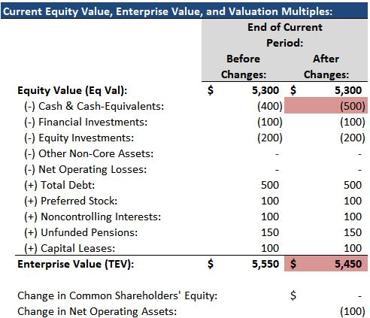

1) Does CSE change? There are no changes on the Income Statement because the DR has not been recognized as Revenue yet, so Net Income does not change. Nothing else affects CSE, either, so Eq Val stays the same.

2) Does NOA change? Yes. DR is an Operating Liability, but Cash is not an Operating Asset, so NOA falls by $100. Therefore, TEV decreases by $100.

Note that this is only the intermediate step of this process.

If you traced it all the way through to the recognition of the Deferred Revenue as Revenue on the Income Statement, representing the product/service delivery, then Eq Val would increase, and TEV would stay the same from start to finish of the 2-step process.

Category #3: Unusual Events on the Income Statement

These questions can be more difficult because you might have to trace the changes through all the financial statements to determine the answer.

24 of 121 https://breakingintowallstreet.com

Access the Rest of the Interview Guide

Therefore, we recommend ignoring issues such as Book vs. Cash Taxes to simplify these questions as much as possible.

This last category of questions is also rare, so you should not devote much time or effort to it.

3a) A CEO Picks Up $100 in Cash on the Street

Eq Val increases by $75, and TEV stays the same.

This change would be recorded as a $100 “Extraordinary Gain” on the Income Statement.

Technically, it would not affect the company’s Cash Taxes, but we are ignoring that detail.

Net Income increases by $75, assuming a 25% tax rate, and nothing else changes on the CFS, so Cash on the Assets side is up by $75, and CSE on the L&E side is also up by $75.
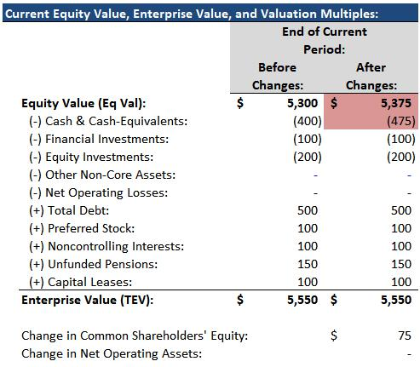

1) Does CSE change? Yes. It’s up by $75 because of the increased Net Income, so Eq Val increases by $75.

2) Does NOA change? No. Cash and CSE are not Operating Assets or Liabilities, so NOA stays the same, and so does TEV.

3b) Company Records a $100 Goodwill Impairment

Eq Val decreases by $75, and TEV decreases by $100.

Pre-Tax Income falls by $100, so Net Income is down by $75 at a 25% tax rate (once again, we’re ignoring the Book vs. Cash Tax differences to simplify this question).

On the CFS, Net Income is down by $75, but the Goodwill Impairment is non-cash, so you reverse it and add back $100. Cash at the bottom is up by $25.

On the BS, Cash is up by $25, and Goodwill is down by $100, so the Assets side is down by $75.

25 of 121 https://breakingintowallstreet.com

Access the Rest of the Interview Guide

Liabilities stay the same, but CSE is down by $75 due to the reduced Net Income.
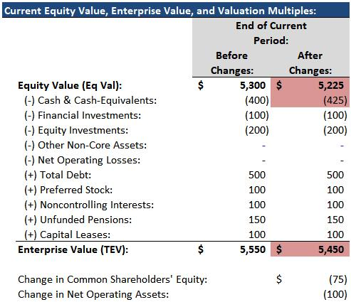

1) Does CSE change? Yes. It’s down by $75 because of the reduced Net Income, so Eq Val decreases by $75.

2) Does NOA change? Yes. Goodwill is an Operating Asset, and it falls by $100; nothing else that changes is an Operating Asset or Liability, so TEV decreases by $100.

3c) Preferred Dividends Increase by $10

Eq Val decreases by $10, and TEV stays the same.

Preferred Dividends appear toward the bottom of the Income Statement and reduce Net Income to Common (or whatever the very bottom Net Income is called) by $10.

Nothing else on the CFS changes, so Cash is down by $10. On the Balance Sheet, Cash is down by $10, and CSE is also down by $10 because of the reduced Net Income to Common.
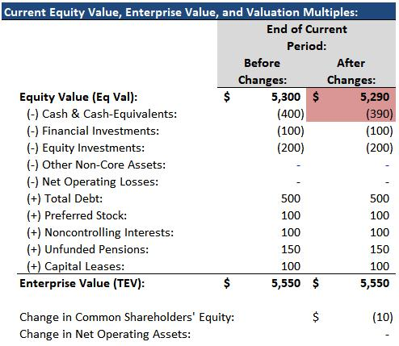

1) Does CSE change? Yes, because Preferred Dividends are deducted from Common Shareholders’ Equity. So, CSE is down by $10, and so is Eq Val.

2) Does NOA change? No. Cash and Equity are not part of Net Operating Assets, so TEV stays the same.

Note that Preferred Stock on the Balance Sheet does not change when a company issues Preferred Dividends!

26 of 121 https://breakingintowallstreet.com

Access the Rest of the Interview Guide

Return to Top.

Key Rule #3: Why the Concept of Enterprise Value Doesn’t Hold Up in Real Life

In the first section, we stated that Enterprise Value is not affected by financing changes – only operational ones – but that Equity Value may be affected by both.

But that’s not quite true.

In real life, Enterprise Value will be LESS affected by financing changes than Equity Value, but there will still be SOME impact.

The reasoning goes back to that all-important formula:

Company Value = Cash Flow / (Discount Rate – Cash Flow Growth Rate), where Cash Flow Growth Rate < Discount Rate.

Let’s say that “Cash Flow” is “Unlevered Free Cash Flow,” or Free Cash Flow to Firm, meaning that it’s available to ALL the investors in the company.

Therefore, you reflect all investors in the Discount Rate, so you use the Weighted Average Cost of Capital (WACC).

“Company Value” will be the company’s Implied Enterprise Value:

Implied Enterprise Value = Unlevered FCF / (WACC – Unlevered FCF Growth Rate)

A company has Unlevered FCF of $100, and it’s growing by 3% per year. WACC is 10%.

If the company now raises additional Debt or Equity, repays Debt, or repurchases Stock, its WACC will change.

WACC is equal to the “cost” of each part of a company’s capital structure times the percentage of capital in that part:

WACC = Cost of Equity * % Equity + Cost of Debt * % Debt + Cost of Preferred * % Preferred

If a company switches to different amounts of Debt, Equity, and Preferred Stock, those percentages will all change, which means that WACC will change.

But there’s more to it than that: at different levels of Debt and Equity, the Costs of Debt and

Equity also change (we’ll ignore Preferred Stock for simplicity):

27 of 121 https://breakingintowallstreet.com

Access the Rest of the Interview Guide
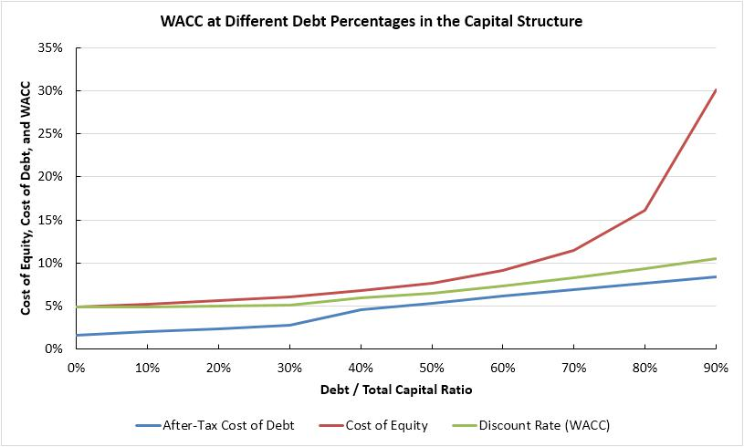

These “Costs” are guesstimates – they’re not based on a specific set of rules, but on what happens in real life as companies take on more Debt.

Debt investors (lenders) expected lower returns than Equity investors since they earn only a fixed interest rate; even if a company doubles its cash flow, Debt investors do not benefit.

Also, Interest Expense is tax-deductible to the company, making it less expensive to pay.

For these reasons, Debt is “cheaper” than Equity.

Since Debt is cheaper than Equity, more Debt may reduce WACC… up to a certain point. But:

- As the company takes on more Debt, the Cost of Debt will keep rising because the company becomes riskier and riskier for new lenders; and

- The Cost of Equity will also rise for the same reason: more Debt means higher risk for the common shareholders as well.

With more Debt, the company stands a higher chance of going bankrupt, which increases the risk for all the investors. Here’s a table with the data in the graph above:

28 of 121 https://breakingintowallstreet.com

Access the Rest of the Interview Guide
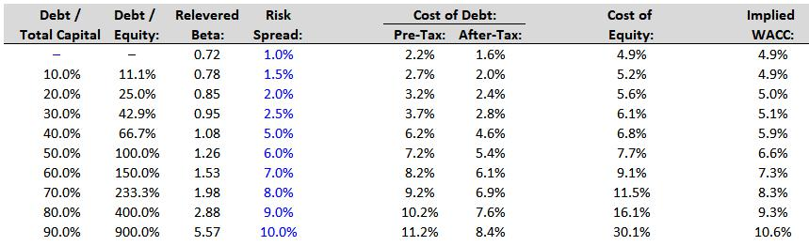

As a result, this graph for Implied Enterprise Value at different levels of Debt and Equity is not quite accurate:
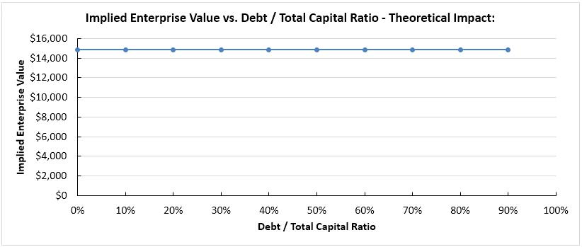

In reality, the graph would look more like this one:
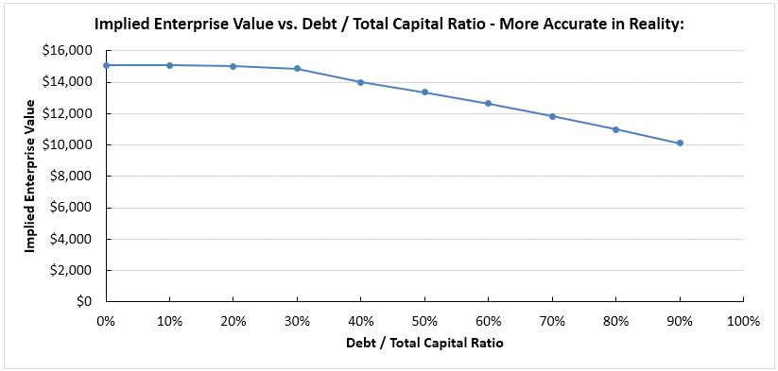

29 of 121 https://breakingintowallstreet.com

Access the Rest of the Interview Guide

The company’s Implied Enterprise Value doesn’t change that much over reasonably low levels of Debt – but it starts to fall rapidly at much higher Debt percentages.

The table below shows the difference between assuming that WACC stays the same at different Debt and Equity levels (“Accounting” Enterprise Value) and assuming that it changes (Implied Enterprise Value):
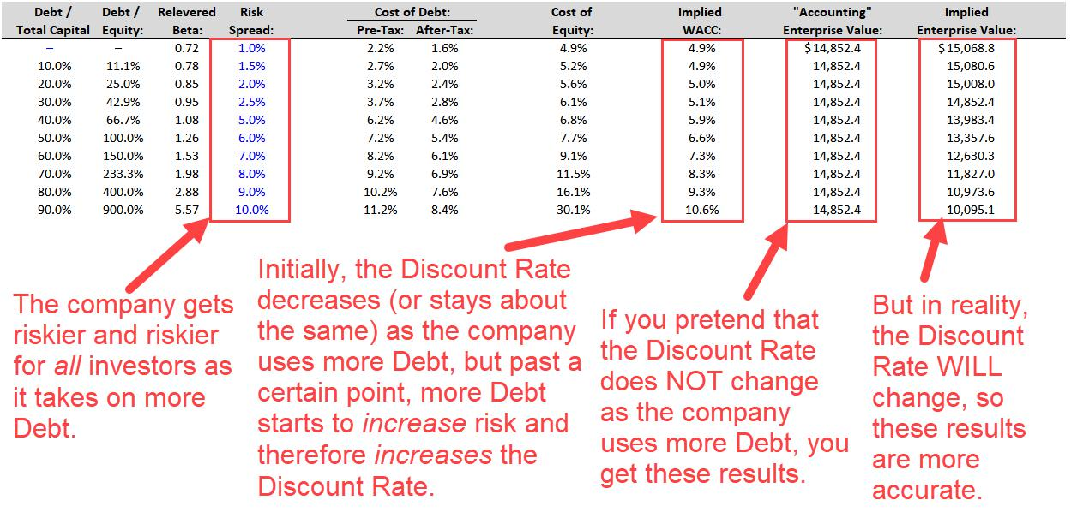

This concept applies more to the Implied Enterprise Value than to Current Enterprise Value.

If a company raises more Debt in real life, its Current Enterprise Value will probably not change overnight. But if it is expected to have more Debt going forward, its Current Enterprise Value will start to change.

Qualitatively, here’s why capital structure affects the Discount Rate and, therefore, affects

Implied Enterprise Value:

- Taxes – Interest paid on Debt is tax-deductible, but Common Dividends and Preferred Dividends are not. Since the tax treatments differ, Enterprise Value is NOT affected in the same way by additional Debt vs. additional Equity.

30 of 121 https://breakingintowallstreet.com

Access the Rest of the Interview Guide

- Bankruptcy Risk – Debt and some types of Preferred Stock increase the chances of a company going bankrupt because of the Interest Expense (or mandatory Preferred Dividends) and the requirement to repay the principal in the future. If a company raises

Equity, there’s no added risk of bankruptcy because it won’t owe cash payments to anyone; Common Dividends are “optional” and can always be cut.

- Agency Costs – Debt investors want to earn their interest and receive their money back at the end. Since Debt investors cannot earn more than the interest rate, they want the company to be as conservative as possible and focus on paying them back. But Equity investors want the company to grow because they have unlimited upside. These conflicting agendas mean that Debt is not equivalent to Equity.

- Efficient Markets – This idea that Debt, Equity, and Preferred Stock are equivalent assumes that the markets are efficient and that companies’ share prices always reflect all relevant information. But these assumptions are often wrong, especially for smaller, lesser-known companies in obscure markets.

The Bottom Line: This section is not meant to “disprove” the concept of Enterprise Value.

Enterprise Value is critical because it does represent the value of a company’s core business operations to all the investors in the company.

But in real life, it’s not really “capital structure-neutral,” as some sources claim.

Instead of saying, “Enterprise Value stays the same regardless of capital structure, but Equity Value changes as the capital structure changes,” it’s better to think of it as:

“Enterprise Value is less affected by capital structure than Equity Value.”

Return to Top.

Key Rule #4: The Equity Value Calculation

If a company is public – you can buy its shares on the stock market, and the company issues reports on its financial performance – then you can calculate its Equity Value with Common Shares Outstanding * Current Share Price.

However, it gets more complex than that in real life because the company might also have dilutive securities that could potentially create more shares if the company’s share price reaches certain levels.

31 of 121 https://breakingintowallstreet.com

Access the Rest of the Interview Guide

For example:

- The company decides to pay its employees using stock options. The company’s share price is $10.00 right now, but if it reaches $20.00, the employees can pay the company $20.00 per option to get one new share. So, if the company’s share price increases to $2000 or more, employees might start exercising their options and creating new shares.

- The company issues a convertible bond to fund an expansion effort. Right now, the company’s share price is $50.00. But if it reaches $100.00, the convertible bond investors can “convert” the bond into new shares.

- The company issues restricted stock units (RSUs) to employees. These are like normal shares of the company, but they have restrictions on when employees receive them and when they can sell them.

Companies issue these types of securities because they reduce cash operating expenses.

Instead of paying higher cash salaries to employees, companies can offer lower salaries and more in RSUs or stock options.

Those might cost the company in the future IF its share price increases, but in the short term, cash expenses decrease.

If you are pressed for time, you do not need to follow the detailed calculations shown in this section or the next one; instead, you can just retrieve the company’s estimate for its “diluted share count” from its filings.

For example, for Target, we could look in the company’s 10-K, search for “diluted,” and use the following 515.6 million number instead of doing any math:
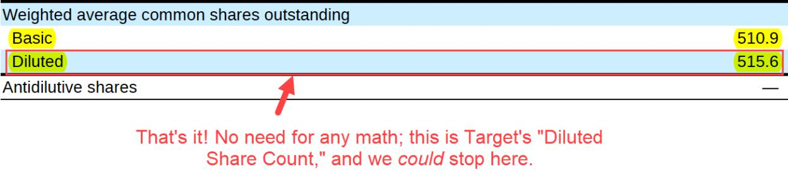

However, you still need to be familiar with this process for two reasons:

1) It’s a common topic in interviews, especially entry-level investment banking interviews.

32 of 121 https://breakingintowallstreet.com

Access the Rest of the Interview Guide

2) You will have to calculate Diluted Shares manually on the job.

The Step-by-Step Calculations for Target and Vivendi

Start by looking up the company’s common shares outstanding at the end of its most recent reporting period. U.S. companies list this number on the first page of their 10-K or 10-Q:

Non-U.S. companies do not list anything on the first pages of their annual or interim reports, so you’ll have to search for terms like “shares outstanding” to find the numbers.

Once you have the number, you should search for “exercise price” or “strike price” in the same filing to find the company’s stock options granted to employees:
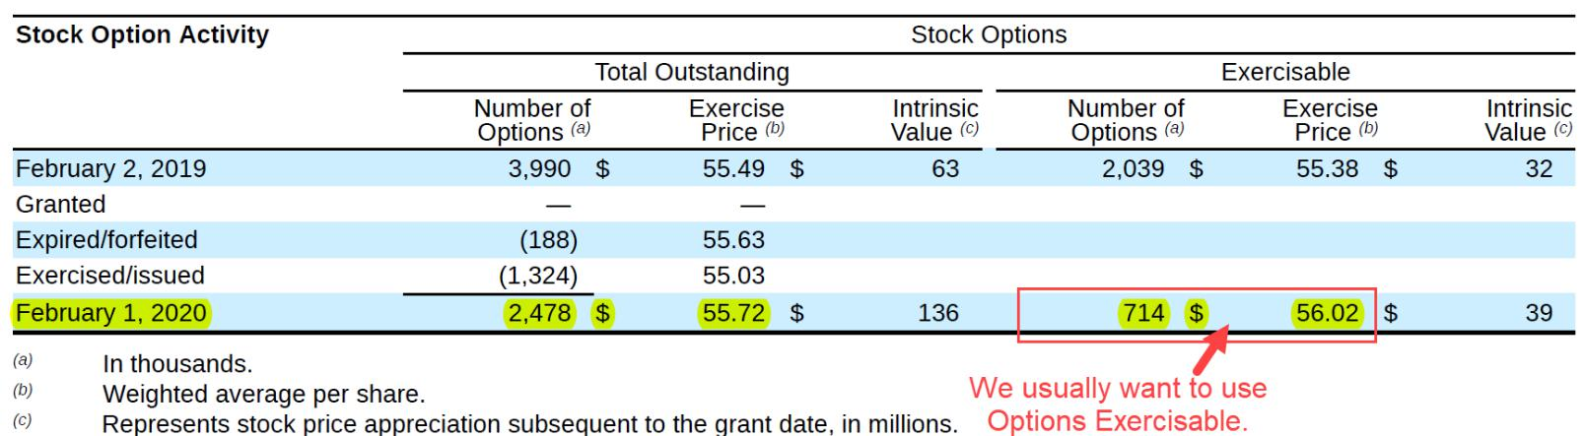

Then, you use the Treasury Stock Method (TSM) to calculate the dilution from these options.

To do this, you write an Excel formula that does the following:

- If the Current Share Price is below the Exercise Price, do nothing and set dilution to 0.

- If the Current Share Price exceeds the Exercise Price, employees pay the company Exercise Price * # Options to exercise their options and receive one new share per option.

33 of 121 https://breakingintowallstreet.com

Access the Rest of the Interview Guide

- Then, the company uses the proceeds to repurchase some of these newly created shares at the same Current Share Price.

This method is not an accurate representation of reality.

Employees will not necessarily exercise all their options as soon as they can do so, and the company won’t necessarily use all the proceeds to repurchase shares.

However, everyone still uses the TSM to standardize the calculation and make it easier to compare different companies. Here’s the calculation for Target:
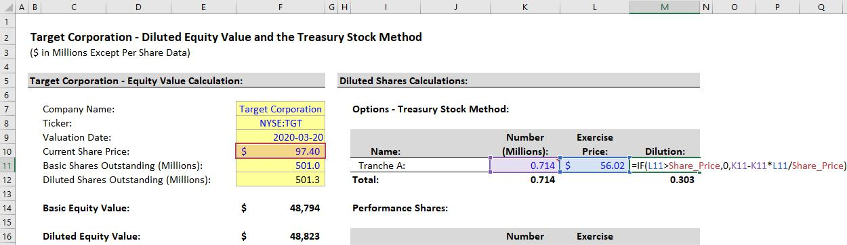

The arithmetic goes like this:

- Newly Created Shares: 0.714 million

- Company Gets Cash Proceeds: $56.02 * 0.714 million = $39.998 million

- Company Repurchases Shares: $39.998 million / $97.40 = 0.411 million shares.

- Net Dilution: 0.714 million – 0.411 million = 0.303 million.

Vivendi lists multiple tranches of options, but the principles are the same; you just calculate

Dilution for all the tranches and add them up:

34 of 121 https://breakingintowallstreet.com

Access the Rest of the Interview Guide
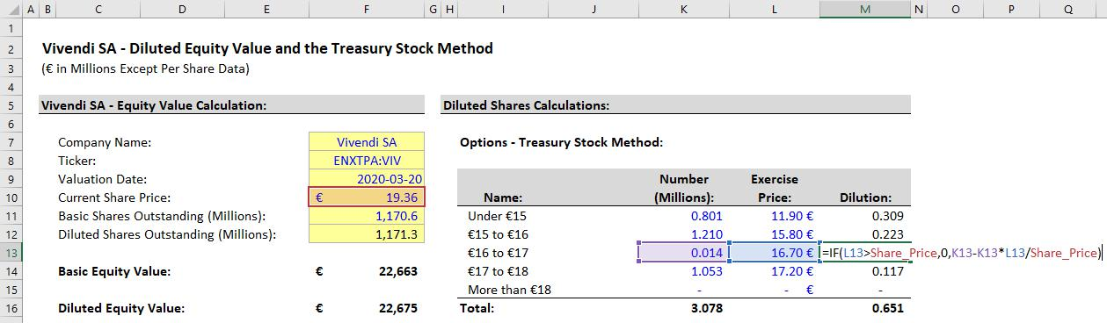

If one of Vivendi’s option tranches had an Exercise Price above €19.36, there would be 0 Dilution from it because those options would not be exercisable.

The same Treasury Stock Method applies to warrants granted to employees as well.

You never factor in options written on existing shares by other parties in the financial markets.

Only options that the company grants directly to employees count because they’re the only one that create new shares.

In interviews, the numbers will never be as ugly as the ones used above.

A realistic interview question might be: “A company’s current share price is $20.00. It has 10 million shares and 1 million options with an exercise price of $10.00. What is its Diluted Equity Value?”

To answer that, assume that all 1 million shares get created. The company receives 1 million * $10.00, or $10 million, in proceeds. At a share price of $20.00, it can buy back half of those shares, or 500,000. So, the company ends up with 10.5 million diluted shares.

Therefore, Diluted Equity Value = 10.5 million * $20.00 = $210 million.

Other Notes, Private Companies, and More

You do not complete this same process for private companies because they do not list their options outstanding in public filings, and they don’t even have “Current Share Prices.”

You almost always focus on Implied Equity Value and Enterprise Value when analyzing private companies, and you rarely divide Implied Equity Value by the Share Count to get the Implied Share Price, so this level of precision is unnecessary.

35 of 121 https://breakingintowallstreet.com

Access the Rest of the Interview Guide

If a company has multiple share classes, take the Current Share Price * Share Count of each class and sum them up to determine its Equity Value.

But be careful: if it’s a foreign company listed in the U.S. with ADRs (American Depository Receipts), ignore the ADRs because they represent shares already listed on the company’s home exchange. Just get the company’s information from its home exchange in that case.

If a public company has negative Net Income, it will not list its “Diluted Shares” in its filing because securities like options will be anti-dilutive to EPS.

Think about the math if a company has negative $10 million in Net Income, 100 million in Basic Shares, and 105 million in Diluted Shares: ($10 million) / 105 million is less negative than ($10 million) / 100 million.

You won’t be able to check your work with these companies, and you’ll have to calculate the Diluted Shares yourself.

Return to Top.

Key Rule #5: Other Dilutive Items: RSUs, Convertible Bonds, and More

Once you have the company’s option and warrant information and the Diluted Shares from those, you can proceed to the next step: looking for other dilutive securities.

These include Restricted Stock, RSUs, Performance Shares, Convertible Bonds, and variations.

Restricted Stock and Restricted Stock Units (RSUs) are both “incentive compensation” granted to employees, usually with requirements that employees stay for a certain number of years before they can receive or sell the shares.

The difference is that Restricted Stock is usually included in the company’s Common Share Count, while RSUs are not.

Therefore, you should search for and add RSUs to the Diluted Share Count, but you can ignore normal “Restricted Stock.”

There are also legal and tax differences, but they are unimportant for valuation purposes.

Here’s an example for Target:

36 of 121 https://breakingintowallstreet.com

Access the Rest of the Interview Guide
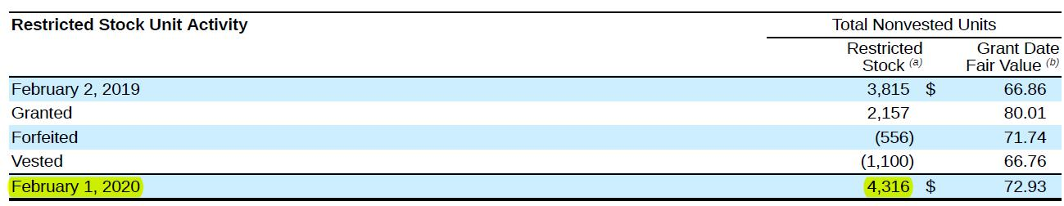

These are “Restricted Stock Units,” so you add them to the Diluted Share Count.

There may be restrictions on them right now, but eventually, they will create dilution.

Performance Shares or “Stock Appreciation Rights” (SARs) are another class of restricted securities that may create dilution, but the restriction here is a “performance goal” rather than time.

For example, if an executive receives Performance Shares, they might be able to sell them once the company’s Share Price reaches a certain level, or once the company reaches a certain Revenue or EBITDA target.

In theory, you could check these performance goals and count 100% of the Performance Shares if the goals are satisfied, and none of the Performance Shares if they’re not.

In real life, however, companies do not disclose the details of these goals, so you usually add all the Performance Shares or ignore them all.

We choose to add Target’s Performance Shares, which makes our estimate of Diluted Shares higher and therefore more conservative (i.e., a lower Implied Share Price):
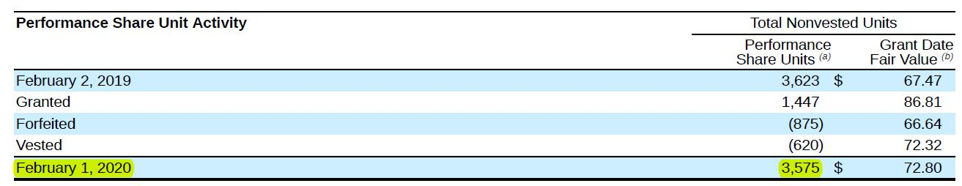

37 of 121 https://breakingintowallstreet.com

Access the Rest of the Interview Guide

So far, we have ~509 million of Diluted Shares for Target vs. their estimate of ~516 million:
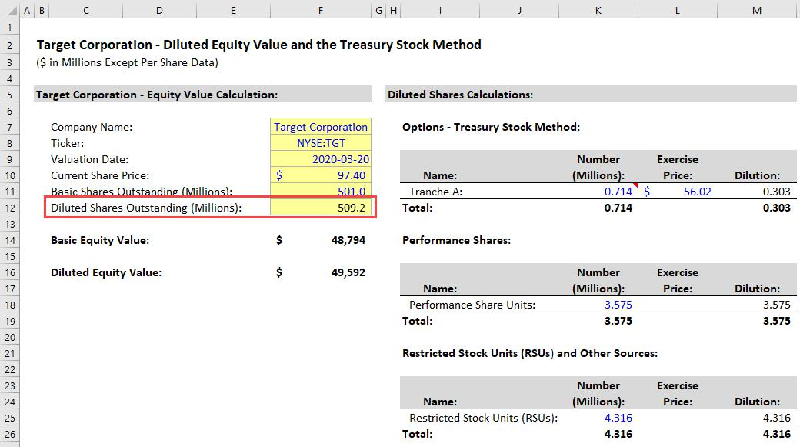

Our estimate will never match the company’s 100% because the company’s estimates are typically based on older Share Prices and “average” Share Counts over years or quarters.

However, we’re within ~1% of their number, which is good enough.

Also, the company may still have additional dilutive securities beyond options, RSUs, and Performance Shares, and if it does, our estimate will be off.

The final type of dilutive security is the Convertible Bond.

These are an alternate form of Debt, where the company pays much lower interest rates in exchange for giving the bondholders the option to “convert” their bonds into new shares in the future – if the company’s Share Price reaches a certain level (the “Conversion Price”).

This Conversion Price is usually a modest premium to the company’s Current Share Price, such as 20-30%.

For companies, Convertible Bonds are “cheaper Debt”; for investors, Convertible Bonds are “hedged Equity”.

Even if a company’s share price stagnates or falls significantly, the Convertible Bond investors will probably get their principal back, which creates some downside protection.

38 of 121 https://breakingintowallstreet.com

Access the Rest of the Interview Guide

With Convertible Bonds, you use an “all or nothing” approach (also called the “If Converted” method) to estimate the Dilution.

If the company’s Current Share Price exceeds the Conversion Price, then you assume that all the bonds convert into shares.

If it does not, then you assume that nothing converts, and you count the Convertible Bonds as Debt instead.

To calculate the number of Dilutive Shares, take the Bond Principal and divide it by the Conversion price.

For example, here’s some information on Zendesk’s Convertible Bonds:
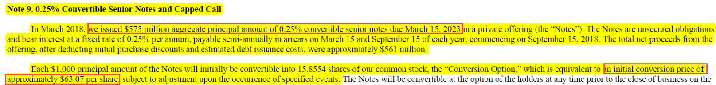

This part gives us the Conversion Price of $63.07 and the Bond Principal of $575 million.

To calculate the Dilutive Shares from this Convertible Bond, $575 million / $63.07 = 9.117 million.

So, the formula is easy: IF(Current_Share_Price >= 63.07, 9.117, 0)

If there are no Dilutive Shares from this bond, you should count its Fair Market Value of $793 million when adding Debt in the Enterprise Value bridge:

This calculation is simple, but it’s often more complex because when companies issue Convertible Bonds, they often do so with “Capped Call” or “Note Hedge” transactions.

Our first clue that Zendesk has done something like this is in this section of their annual report, which shows only ~1.3 million “shares related to convertible senior notes”:

39 of 121 https://breakingintowallstreet.com

Access the Rest of the Interview Guide
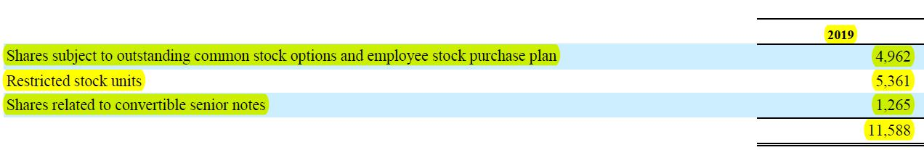

This discrepancy is big compared with our estimate of ~9.1 million shares.

If you keep reading, you’ll find where the company describes its “Capped Call” transactions:

In a “Capped Call” transaction, the company purchases Call Options on its own stock at the Conversion Price, and then it sells Warrants on its own stock at a higher price.

So, if its Share Price reaches the Conversion Price, resulting in ~9.1 million new shares, the company immediately exercises all its Call Options to buy back all the newly created shares, cancelling out the dilution.

If the Share Price keeps climbing and eventually reaches the Warrant Exercise Price, new shares will be created, resulting in some dilution (but less than the ~9.1 million new shares).

So, you apply the Treasury Stock Method (TSM) only to the Warrants to calculate the dilution.

Here’s the full example for Zendesk:

40 of 121 https://breakingintowallstreet.com

Access the Rest of the Interview Guide
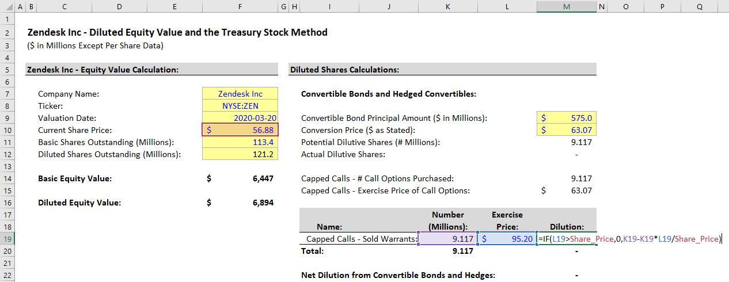

In this case, the company’s Current Share Price is $56.88, so there’s no dilution because it’s below both the Warrant Exercise Price and the Conversion Price.

There would be dilution only if the Current Share Price exceeded the Warrant Exercise Price of $95.20.

We are simplifying this treatment a bit because the initial dilution from the Convertible Bond doesn’t always “cancel out”; companies might purchase different numbers of Call Options, and they might sell different numbers of Warrants.

But this is a decent rule of thumb that you can use to approximate the diluted shares from “hedged” Convertible Bonds.

The result is the company’s Diluted Share Count, which includes its Basic Shares plus the potential shares from Options, Warrants, Convertible Bonds, RSUs, Performance Shares, and other sources.

Zendesk has no dilution from its Convertible Bonds, so the full calculation is quite simple:

41 of 121 https://breakingintowallstreet.com

Access the Rest of the Interview Guide
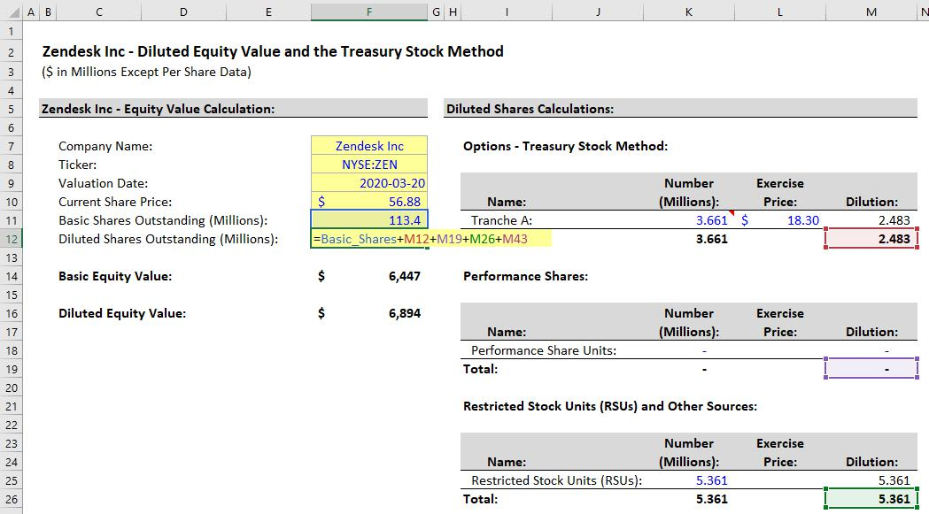

The Diluted Equity Value, or Current Share Price * Diluted Shares Outstanding, doesn’t “mean” anything specific; it’s just a more accurate calculation.

When you value a company using your views to determine its Implied Enterprise Value and Implied Equity Value, you use the Diluted Share Count to back into the company’s Implied Share Price.

For example, if the company’s Implied Equity Value is $100 million, its Implied Share Price will be different if you use its Diluted Share Count of 1.22 million rather than its Basic Share Count of 1.19 million.

Dilutive securities also exist for private companies, but you don’t think about them quite as much because you often stop at the company’s Implied Enterprise Value or Implied Equity Value rather than going all the way to Implied Share Price.

Return to Top.

42 of 121 https://breakingintowallstreet.com

Access the Rest of the Interview Guide

Key Rule #6: The Equity Value to Enterprise Value “Bridge”

When you’re analyzing public companies, you normally start by calculating the Equity Value for each company and then using it to calculate Enterprise Value.

This process should not be difficult if you follow the formula for Enterprise Value in Key Rule #1:

- Enterprise Value = Equity Value – Non-Operating Assets + Liability and Equity Items That Represent Other Investor Groups (i.e., ones besides Common Shareholders)

Ideally, you will use the market values of these items, but if they’re not available, the book values fine for everything except Equity Value.

Common examples of items in each category include:

- Non-Operating Assets: Cash, Financial Investments, Rental Properties (if it’s not a real estate company), Side Businesses, Assets Held for Sale, Discontinued Operations, Equity Investments or Associate Companies, and Net Operating Losses (NOLs) (a component of the Deferred Tax Asset).

- Liability and Equity Items That Represent Other Investor Groups (i.e., ones beyond common shareholders): Debt, Preferred Stock, Capital Leases, Noncontrolling Interests, Unfunded Pensions, and (potentially) Operating Leases.

If you find something not on this list that you want to add or subtract, you should proceed very carefully because there are not that many “special items.”

The company’s Balance Sheet is your starting point for this exercise, but you’ll need to go beyond it to find items like the Fair Market Value of Debt, details on the Pension Plans, and the Net Operating Losses embedded in the Deferred Tax Asset.

Here are the examples we use for Target, Zendesk, and Vivendi:

43 of 121 https://breakingintowallstreet.com

Access the Rest of the Interview Guide
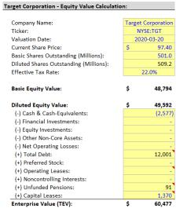

This one for Target is a fairly standard bridge. A few notes:

• Debt: The company initially grouped Debt and Capital Leases on its Balance Sheet, so we separated them and found the Fair Market Value of the Debt portion, which is used in this bridge.

• Pensions: We count only the unfunded or underfunded portion, which equals MAX(0, Pension Liabilities – Pension Assets). We also multiply by (1 – Tax Rate) since contributions into pension plans are tax-deductible in the U.S.

• Operating Leases: We choose not to count this as “another investor group” here; it could go either way under U.S. GAAP, as long as
you’re consistent in the valuation multiples.

For Zendesk, we use the following bridge:

• Net Operating Losses: We found these by searching for the Deferred Tax Asset disclosures. They’re considered “non-operating” because they’re not required to run the business and do not flow through the statements automatically, as other components of the DTA do. Technically, we should adjust the NOLs and remove the portion that is unlikely to be utilized, but we’ll get to this in Key Rule #14.
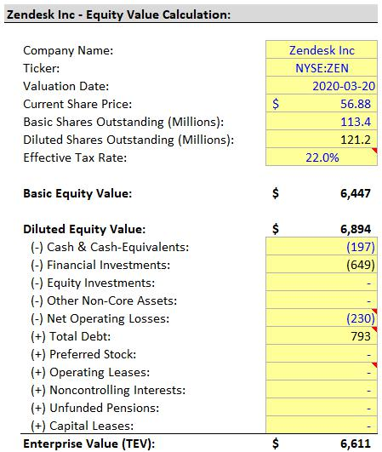

• Total Debt: Remember from the previous section that the company’s Convertible Bonds do not create dilution in this case. Therefore, we count the entire Fair Market Value of the Convertible Bonds as Debt in the Enterprise Value calculation.

44 of 121 https://breakingintowallstreet.com

Finally, we use this bridge for Vivendi:
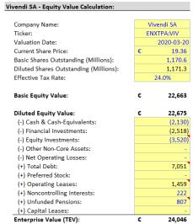
Access the Rest of the Interview Guide

- Equity Investments and Noncontrolling

Interests: We took both of these directly from the Balance Sheet because the company did not disclose their Fair Market Values in a straightforward way.

- Total Debt: We took the Balance Sheet number and replaced portions of it with the Fair Market Value numbers the company disclosed.

- Unfunded Pensions: Similar to Target, this is MAX(0, Pension Liabilities – Pension Assets). But we do not multiply by (1 – Tax Rate) here, under the assumption that contributions into European pension plans are not tax-deductible.

- Operating Leases: Yes, we count them as “another investor group” here. The reason is that under IFRS, companies must split the rental expense into Interest and Depreciation elements on the Income Statement, so Operating Leases must be included in Enterprise Value – or multiples such as TEV / EBITDA will be inconsistent.

We occasionally get questions about other items that might potentially be counted in this Enterprise Value bridge, but there’s rarely a good reason to include other items.

Goodwill & Other Intangibles should never be in here, nor should DTAs (except for the NOLs) or DTLs; Industry-Specific Assets are operational, so they should also not be here.

Sometimes people will add items like Legal and Restructuring Liabilities, and you may need to look at an item like “Provisions” in more detail to see what’s in it.

For more on these items, please see Key Rule #14.

Return to Top.

Key Rule #7: Income Statement Valuation Metrics: EBIT, EBITDA, and Net Income

45 of 121 https://breakingintowallstreet.com

Access the Rest of the Interview Guide

Equity Value and Enterprise Value are useful when you create a long-term cash flow analysis for a company (i.e., a Discounted Cash Flow or DCF), and you want to compare the company’s Implied Value to its Current Value.

But they’re not that useful for comparing different companies.

For example, consider these two companies:

- Company A – Current Eq Val of $500 million; Current TEV of $800 million.

- Company B – Current Eq Val of $100 million; Current TEV of $300 million.

Which company is more expensive?

You might say, “Company A” because its Current Equity Value and Current Enterprise Value are both higher.

But it’s not a fair comparison because Company A could also be much bigger than Company B.

For example, what if Company A has $100 million in EBITDA and $300 million in Revenue, and Company B has $10 million in EBITDA and $30 million in Revenue?

If you take both companies’ Enterprise Values and divide them by these metrics, you get these results:

- Company A – TEV / EBITDA = 8.0x; TEV / Revenue = 2.7x.

- Company B – TEV / EBITDA = 30.0x; TEV / Revenue = 10.0x.

Now, Company B seems more expensive because its TEV-per-EBITDA and TEV-per-Revenue numbers are both higher.

This concept is similar to how a house’s asking price might be $2 million, and another’s might be $500K.

By itself, that doesn’t mean anything because one house might be a lot bigger than the other.

What matters are the per-square-foot or per-square-meter prices.

If the $2 million house has 20,000 square feet, its asking price is $100 per square foot.

And if the $500K house has 2,500 square feet, its asking price is $200 per square foot.

Which one seems more expensive now?

Of course, even those numbers may not tell the whole story.

46 of 121 https://breakingintowallstreet.com

Access the Rest of the Interview Guide

For example, what if the $100-per-square-foot home is in an area with gang violence, while the $200-per-square-foot home is in a safe area with no crime?

Sure, the $100-per-square-foot home is “cheaper,” but would you want to live there?

It works the same way with companies: to compare them, you need to create “multiples” that value them on a per-unit basis.

And as with houses, these multiples are a starting point for the analysis but don’t tell you the full story.

Here are a few examples of common valuation multiples:

- TEV / Revenue – Enterprise Value / Revenue

- TEV / EBIT – Enterprise Value / EBIT

- TEV / EBITDA – Enterprise Value / EBITDA

- P / E – Equity Value / Net Income or Price per Share / Earnings per Share

Just like you can’t compare the price of a home in Manhattan to the price of a home in Biwabik, Minnesota, you also can’t compare companies of significantly different sizes in different industries.

The companies must be similar for a comparison of the multiples to be meaningful.

So, if you’re looking at a set of mid-size European manufacturing companies with EBITDA between €100 million and €500 million, multiples like TEV / EBITDA and P / E are meaningful.

But you can’t compare a pre-revenue biotech startup to Pfizer – it’s meaningless because the companies are so different.

Revenue, EBIT, EBITDA, EBITDAR, and Net Income

In theory, we could calculate “Cash Flow” for each company in a set and then create “Cash Flow Multiples.” After all:

Company Value = Cash Flow / (Discount Rate – Cash Flow Growth Rate), where Cash Flow Growth Rate < Discount Rate

But there are a few problems with this approach:

- It creates comparability issues because companies use slightly different accounting methods and set up their Cash Flow Statements differently.

47 of 121 https://breakingintowallstreet.com

Access the Rest of the Interview Guide

- So, you have to “clean” and “normalize” each company’s Cash Flow Statement to calculate its Cash Flow, which requires human discretion and a lot more time and effort

– which may not be viable in a quick, time-pressured analysis.

Therefore, to simplify the task and get comparable numbers, we often use metrics and multiples based on the Income Statement and a partial Cash Flow Statement.

Examples include Revenue (also called “Net Sales” or “Turnover”), Net Income (“the bottom line”), EBIT, EBITDA, and EBITDAR.

You should already know what these metrics mean from the accounting lessons and guides, but in the context of valuation, you can think of them as attributes of a property.

We mentioned that TEV / EBITDA is like a “per-square-foot” price for a property; by that analogy, EBITDA is like the number of square feet.

EBIT, EBITDA, EBITDAR, and Net Income all measure a company’s profitability, and the corresponding valuation multiples measure the company’s price in relation to its profits.

By contrast, Revenue measures a company’s sales, so the corresponding TEV / Revenue multiple measures the company’s price in relation to its sales.

Part 1: How to Calculate Each Metric

Revenue = Revenue, Net Sales, or Turnover at the top of the Income Statement.

EBIT = Operating Income on the Income Statement, adjusted for non-recurring charges.

EBITDA = EBIT + Depreciation & Amortization, always taken from the Cash Flow Statement.

EBITDAR = EBITDA + Rent or Lease Expense on the Income Statement.

Net Income = Net Income on Income Statement (the very bottom one or "Net Income to Common," after Preferred Dividends and Equity Investment/NCI Net Income).

Revenue, EBIT, EBITDA, and EBITDAR all pair with Enterprise Value, but they may use slightly different versions of Enterprise Value depending on the accounting system.

For example, when you use EBITDAR, you must add Operating Leases to Enterprise Value and count them as “another investor group.”

And when using EBITDA under IFRS, you must do the same thing in the Enterprise Value calculation (see this section for more).

48 of 121 https://breakingintowallstreet.com

Access the Rest of the Interview Guide

Net Income is the only common Income Statement-based metric that corresponds to Equity Value (P / E is the multiple).

Below, you can see example calculations for Target and Zendesk:
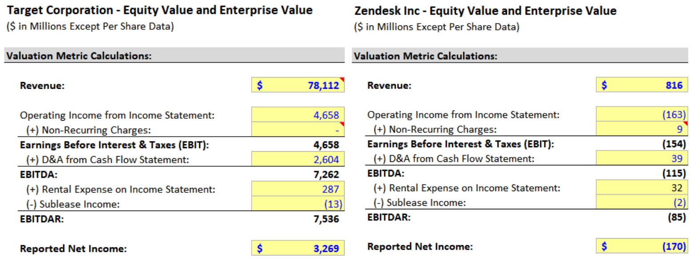

These calculations are very straightforward; you just input simple numbers from the Income Statement and Cash Flow Statement.

You may need to dig through the filings to find the non-recurring charges in the footnotes, but that is not necessary for a quick analysis.

To do a quick assessment, look at the IS and CFS and see if anything listed under Operating Expenses or Non-Cash Adjustments on the CFS appears to be “non-recurring” (i.e., it occurred only once in the past 4-5 years) and if so, add it back.

Vivendi’s calculations are a bit different because of how the lease expense is recorded on the statements under IFRS:

49 of 121 https://breakingintowallstreet.com

Access the Rest of the Interview Guide
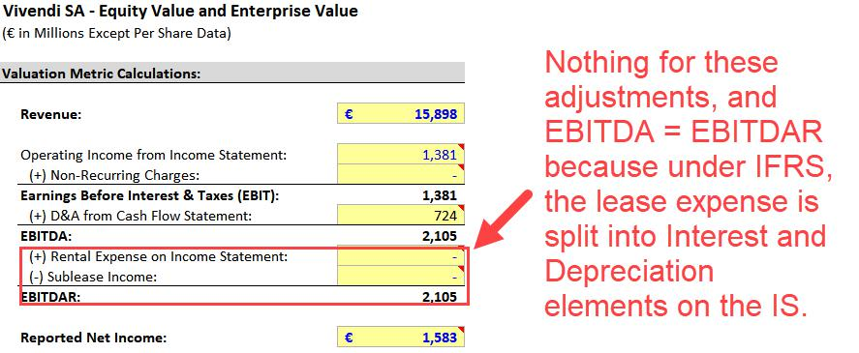

Revenue, EBIT, EBITDA, EBITDAR, and Net Income differ in 5 key respects:

- To Whom is the Money is Available? – Equity investors, Debt investors, and the government? Just Equity investors? Equity investors and Debt investors? Someone else?

- Operating Expenses (OpEx) vs. Capital Expenditures (CapEx) – Some metrics deduct both of these, some deduct neither, and others deduct only one.

- Rent/Lease Expense – Some metrics deduct this in full, some do not deduct anything, and some deduct only part of it. Also, it differs under U.S. GAAP and IFRS.

- Interest, Taxes, and Non-Core Business Activities – Some metrics deduct (or add) all of these, while others completely exclude them.

- When They’re Useful – Sometimes you WANT to reflect the impact of CapEx, and sometimes you don’t. The same applies to interest and taxes.

We’ll explain these differences below and then give you a summary chart:

Part 1: To Whom is the Money Available?

Equity investors, Debt investors, Preferred investors (if they exist), and the government all have claims on Revenue, EBIT, EBITDA, and EBITDAR.

That’s because no one has been “paid” yet; for example, a company’s Operating Income (EBIT) is still available to everyone since it’s above Interest Expense, Dividends of all types, and Taxes.

50 of 121 https://breakingintowallstreet.com

Access the Rest of the Interview Guide

With Net Income (to Common), only Equity investors have a claim because Debt investors have been paid with Interest, and the government has been paid with Taxes.

And Preferred Investors, if they exist, have been paid with Preferred Dividends.

Part 2: Operating Expenses (OpEx) vs. Capital Expenditures (CapEx)

Revenue deducts neither OpEx nor CapEx since it is simply the top-line sales of the business.

EBIT deducts OpEx and the after-effects of CapEx (since Depreciation is within OpEx), but not CapEx directly.

EBITDA deducts OpEx but no CapEx (neither the immediate spending nor the after-effects).

EBITDAR also deducts OpEx but not CapEx.

Net Income deducts OpEx and the after-effects of CapEx, but not direct CapEx spending.

Part 3: Rent/Lease Expense

Revenue – The rental expense is never deducted under any accounting system.

EBIT – Full deduction for the rental expense under U.S. GAAP; under IFRS, only the Depreciation element is deducted.

EBITDA – Full deduction for the rental expense under U.S. GAAP; under IFRS, nothing is deducted because both the Interest and Depreciation elements are “added back” or excluded.

EBITDAR – Under both accounting systems, no rental expense is deducted because each line item (Rent, Interest element, and Depreciation element) is “added back” or excluded.

Net Income – Full deduction for the entire rental expense under both accounting systems.

Part 4: Interest, Taxes, and Non-Core Business Activities

Revenue, EBIT, EBITDA, and EBITDAR are all the same here: none deduct the Net Interest Expense or Taxes, and none add non-core business income or subtract non-core expenses.

On the other hand, Net Income is the opposite: it deducts Net Interest Expense and Taxes, and it adds non-core business income and subtracts non-core expenses.

Part 5: When They’re Useful

Revenue is most useful when the company has negative numbers for EBIT and EBITDA, as well as negative cash flow figures. Zendesk falls into this category: there’s no other way to value the company, so we have to use TEV / Revenue multiples.

51 of 121 https://breakingintowallstreet.com

Access the Rest of the Interview Guide

EBIT is sometimes closer to Free Cash Flow (Cash Flow from Operations – CapEx) because both metrics reflect the partial impact, or “after-effect,” of CapEx.

So, if CapEx is more important for the company, or you want to reflect its partial impact because CapEx drives value in the sector, then EBIT may be more useful.

EBITDA is sometimes closer to Cash Flow from Operations because both metrics completely exclude CapEx.

So, you might use EBITDA when CapEx is less significant, or when you want to normalize otherwise similar companies that happen to have different CapEx and D&A policies.

EBITDAR is used primarily to normalize companies with different types of leases (Operating vs.

Capital) and to normalize companies following U.S. GAAP vs. IFRS.

Net Income is not great for comparing companies, and it’s also not great for approximating their cash flows, so it’s useful mostly as a very quick metric that requires no calculations.

Here’s a summary of the key points in this section (see the accompanying Excel file as well):
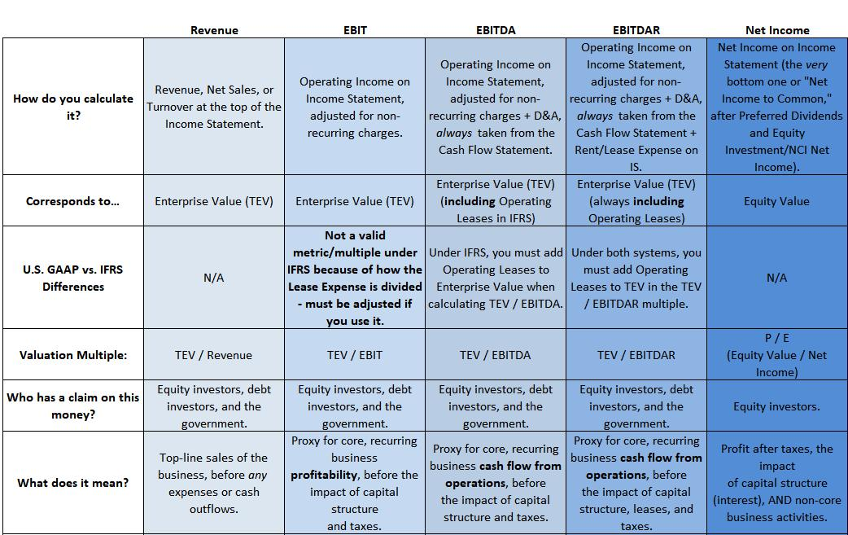

52 of 121 https://breakingintowallstreet.com

Access the Rest of the Interview Guide
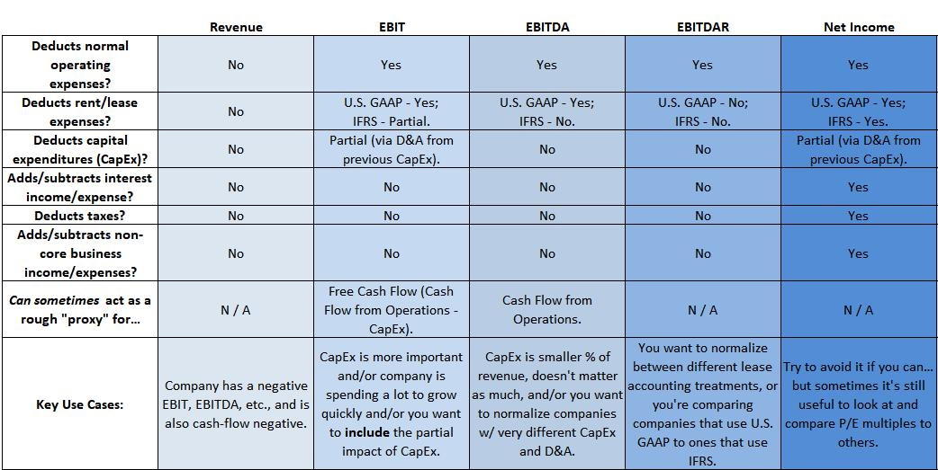

Return to Top.

Key Rule #8: Cash Flow Statement Valuation Metrics: FCF, FCFF, and FCFE

All company valuation comes down to that all-important formula:

Company Value = Cash Flow / (Discount Rate – Cash Flow Growth Rate), where Cash Flow Growth Rate < Discount Rate.

So, Cash Flow-based metrics and multiples must be the best, most relevant ones, right?

In theory, yes.

Interview questions on how to calculate Free Cash Flow, Unlevered Free Cash Flow, and Levered Free Cash Flow are common.

And you need to know these metrics when completing a Discounted Cash Flow (DCF) analysis, building leveraged buyout (LBO) models, and estimating a company’s ability to repay debt.

But these metrics are NOT that useful when you’re comparing a company to its peers and valuing it using multiples from its peers.

53 of 121 https://breakingintowallstreet.com

Access the Rest of the Interview Guide

The biggest problem is that there’s huge variability across Cash Flow Statements in different regions, industries, and accounting systems.

As a result, you often need to adjust the numbers for comparative purposes.

For example, many online sources state that “Free Cash Flow” is defined as Cash Flow from Operations minus CapEx.

But is that the case for all companies?

No!

Under IFRS, many companies start the Cash Flow from Operations section of their Cash Flow Statements with something other than Net Income, such as EBIT or Pre-Tax Income.

So, you may have to adjust the CFO figure and deduct Net Interest Expense, Taxes, and other items if they’re not included within CFO. Here it is for Vivendi:
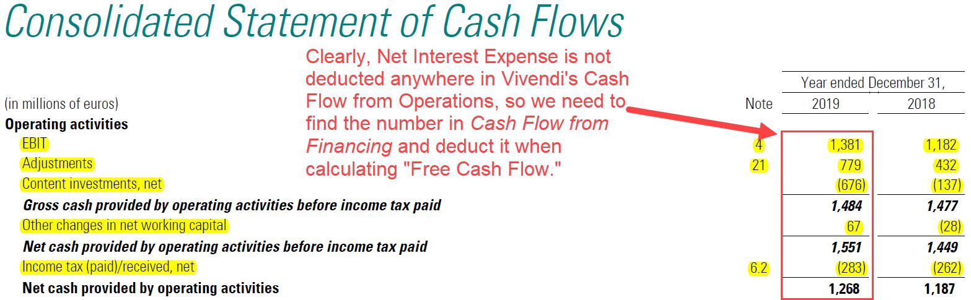

How to Calculate FCF and Its Variations

There are three major types of Free Cash Flow, and each one attempts to answer the same question:

How much discretionary cash flow does a company generate?

Metrics such as EBIT and EBITDA were “approximations” of this cash flow, while Free Cash Flow-based metrics move us closer to the real thing.

After the Cash Flow from Operations section, most of the items in Cash Flow from Investing and Financing are “optional,” with a few exceptions, such as CapEx.

54 of 121 https://breakingintowallstreet.com

Access the Rest of the Interview Guide

That’s why you calculate “Free Cash Flow” by taking Cash Flow from Operations and subtracting CapEx (possibly with adjustments): it tells you how much cash flow the company’s core business is generating on a recurring, predictable basis.

But FCF also reflects the company’s capital structure, and you don’t necessarily want to do that.

The three main types of Free Cash Flow differ based on:

- Investor Groups – Do you want “discretionary cash flow” that’s available only to Equity

Investors (Equity Value), or to All Investors (Enterprise Value)?

- Treatment of Debt – Do you want a metric that deducts Debt Principal Repayments (and possibly adds Debt Issuances), or one that completely ignores those items because you want to assess how much Debt a company could repay?

If you want discretionary cash flow available to All Investors, then the metric is Unlevered Free Cash Flow, also abbreviated to UFCF or called “Free Cash Flow to Firm” (FCFF).

To calculate this one, you do not start with CFO because you must exclude or “add back” the Net Interest Expense (and Preferred Dividends and Other Income/Expenses, if applicable).

Instead, the starting point is EBIT * (1 – Tax Rate), also known as Net Operating Profit After Taxes (NOPAT).

On the other hand, if you want discretionary cash flow available only to Equity Investors, then there are two options: Free Cash Flow (FCF) and Levered Free Cash Flow (LFCF), also called Free Cash Flow to Equity (FCFE).

The main difference is that FCF does not deduct Debt Repayments or add Debt Issuances, while LFCF may do one or both of those (there is disagreement about how to calculate it).

- Free Cash Flow: Cash Flow from Operations – CapEx (but if CFO does not deduct Net Interest Expense, Taxes, All Lease Expenses, etc., then you must adjust it by doing so).

- Unlevered Free Cash Flow: Net Operating Profit After Taxes (NOPAT) + D&A and sometimes other non-cash adjustments +/- Change in Working Capital – CapEx.

- Levered Free Cash Flow: Net Income to Common + D&A and sometimes other non-cash adjustments +/- Change in Working Capital – CapEx – (Mandatory?) Debt Repayments + Debt Issuances (?).

55 of 121 https://breakingintowallstreet.com

Access the Rest of the Interview Guide

We use question marks in the last definition because people disagree about the calculation:

- Should Levered FCF subtract all Debt Repayments or only the Mandatory ones? What if you can’t tell what’s Mandatory vs. Optional?

- And should it also add Debt Issuances? Or just Debt Issuances that were required to fund the business? Can you tell what was required vs. optional?

This disagreement is one reason why we recommend against using Levered FCF.

Free Cash Flow (FCF) by itself is often used in standalone financial statement analysis, in transaction models for M&A and LBO deals, and to estimate a company’s ability to repay Debt, issue Dividends, and acquire assets or companies.

The FCF calculation is straightforward for most companies:
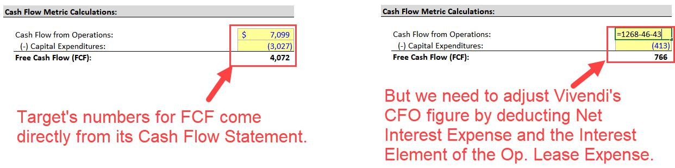

If the company’s Cash Flow from Operations includes a lot of “strange” items beyond the normal D&A add-back, Deferred Taxes, and Change in Working Capital, then you may need to remove some of those as well.

At a certain point, though, all these adjustments defeat the purpose of FCF: it’s supposed to be a quick-and-simple metric.

Unlevered Free Cash Flow represents discretionary cash flow available to All Investors, as if the company did not pay Interest on Debt or Preferred Dividends.

We use it primarily in the Discounted Cash Flow (DCF) analysis when valuing a company based on its future cash flows.

UFCF completely ignores Net Interest Expense, Preferred Dividends, and Other Income / (Expenses) and includes only the company’s core business revenue and expenses.

56 of 121 https://breakingintowallstreet.com

Access the Rest of the Interview Guide

The main components are:

- Revenue

- COGS and Operating Expenses

- Taxes

- Depreciation & Amortization (and sometimes other non-cash adjustments, such as Deferred Taxes)

- Change in Working Capital

- Capital Expenditures

You ignore Net Interest Expense, Other Income / (Expense), most non-cash adjustments, most of the CFI section, and the entire CFF section on the CFS.

Besides Depreciation & Amortization, the main, other non-cash adjustment is Deferred Income Taxes. Here’s the UFCF calculation for Target:
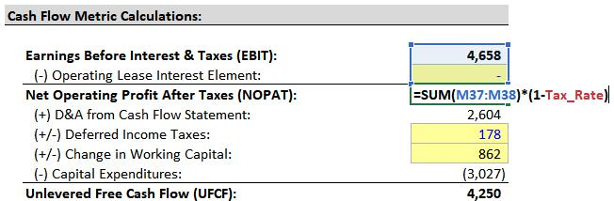

We pulled most of these numbers from the company’s annual Cash Flow Statement.

You always ignore the company’s historical Taxes and recalculate them based on EBIT. Since UFCF ignores capital structure, you must also ignore the tax benefit of Interest Expense.

Under IFRS, the main issue is that if you start this calculation with EBIT, it won’t deduct the full Lease Expense (just the Depreciation element).

So, you need to adjust EBIT by deducting the Interest element and then calculate NOPAT and

UFCF from there, as in the example for Vivendi below:

57 of 121 https://breakingintowallstreet.com

Access the Rest of the Interview Guide
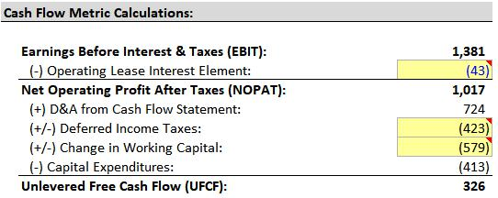

Outside of these changes, you should rarely adjust much else:

- Stock-Based Compensation: This is not a real non-cash expense and should not be added back in UFCF because it changes the company’s diluted share count.

- Impairments, Gains/Losses, Write-Downs: No need for adjustments because you should have already excluded these or added them back in EBIT.

- Purchase of Intangibles or Internal IP/Software Costs: If these are actual recurring items in the CFI section, yes, you can deduct them… and the same goes for the FCF Calculation.

- Amortization of Debt Discounts / Premiums and Issuance Fees: Do not add or subtract these items because they typically appear in Interest Expense, so they do not affect Operating Income in the first place.

- Income or Dividends from Associates / Equity Investments / JVs: Do not add or subtract these because they’re unrelated to the company’s core business.

Finally, Levered Free Cash Flow, also known as Free Cash Flow to Equity, or FCFE, has two key differences compared with Unlevered FCF:

- Net Income to Common is the starting point, not NOPAT.

- Debt Repayments and Debt Issuances should factor in… somehow. People disagree on the treatment, with some arguing that you should subtract only Mandatory Debt Repayments, some saying it should be all Debt Repayments, and some arguing for subtracting Repayments and adding Issuances as well.

58 of 121 https://breakingintowallstreet.com

Access the Rest of the Interview Guide

If you choose to subtract Debt Issuances and add Debt Repayments, here are the calculations for Target and Vivendi:
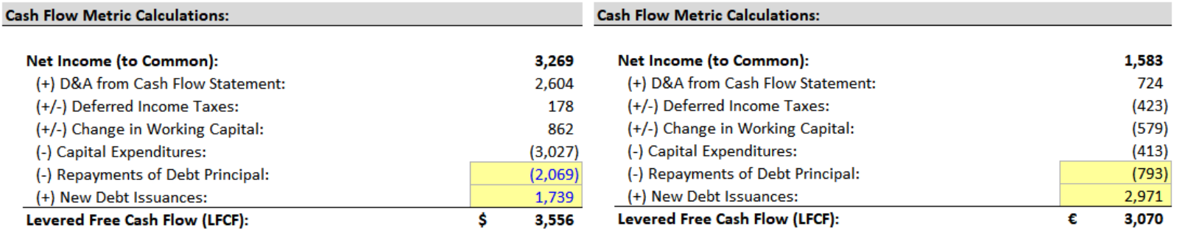

Here’s a chart to summarize the differences between these different types of Free Cash Flow:
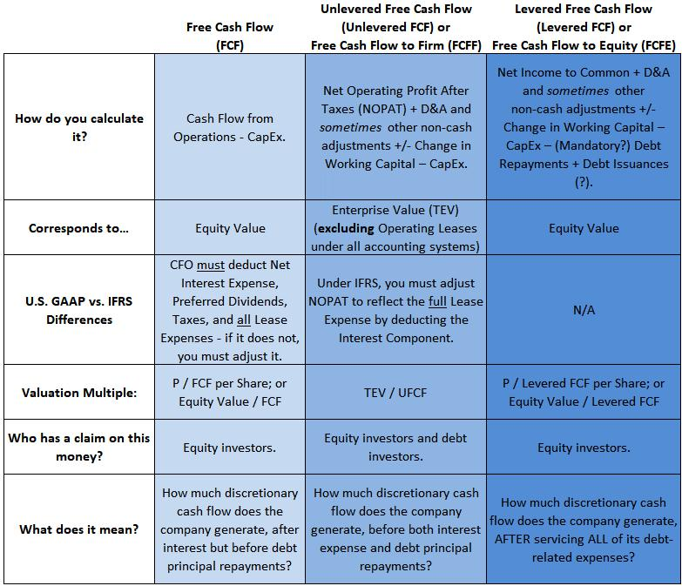

59 of 121 https://breakingintowallstreet.com

Access the Rest of the Interview Guide
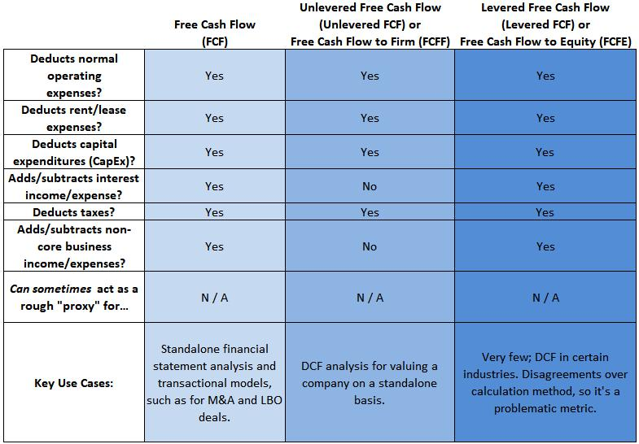

Return to Top.

Key Rule #9: Valuation Multiples: How to Pair Metrics with Eq Val & TEV

To create valuation multiples, you take Enterprise Value or Equity Value and divide them by metrics such as Revenue, EBIT, EBITDA, EBITDAR, Net Income, or Unlevered Free Cash Flow.

How do you decide whether to pair a metric with Equity Value or Enterprise Value?

There are three simple rules to follow:

- Rule #1: If a metric deducts Net Interest Expense (and Preferred Dividends, if applicable), use Equity Value in the numerator of any multiple with this metric in the denominator.

- Rule #2: If the denominator of a TEV-based multiple does not deduct an Income Statement expense, then the numerator should add its corresponding Balance Sheet line item (and vice versa).

60 of 121 https://breakingintowallstreet.com

Access the Rest of the Interview Guide

- Rule #3: Stick to Equity Value, Enterprise Value Including Operating Leases, and Enterprise Value Excluding Operating Leases, and avoid “half-pregnant” metrics and multiples.

These rules may seem simple, but they can be tricky to apply in real life.

Rule #1: Net Interest Expense Deductions

To understand this one, think about “who gets paid” at each step down a company’s Income Statement.

As you move down the Income Statement, you start eliminating different investor groups as they receive payment, and you start reflecting the impact of Non-Operating Assets.

For example, once the company records Interest Expense, that’s it for the Debt investors – after this line item is subtracted, they cannot receive further payment.

No, Debt Principal Repayments on the CFS do not count as “payment” because those are just a return of the Debt investors’ original money – not a return on it.

And after Preferred Dividends are subtracted at the bottom of the Income Statement, that’s it for the Preferred Stockholders – they cannot receive any further payment.
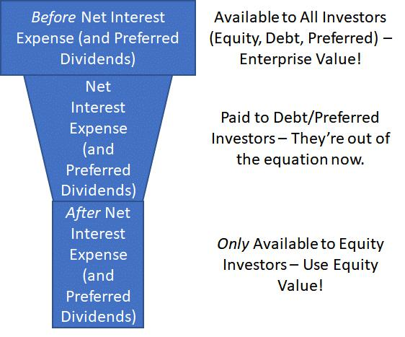

You can think of this concept using the funnel structure on the right:

If a metric does not deduct Net Interest Expense or Preferred Dividends, then you pair it with Enterprise Value.

If a metric does deduct Net Interest Expense and Preferred Dividends, then you pair it with Equity Value.

After both of those have been subtracted, the remaining cash flow is available only to the

Equity Investors, which is why metrics in this category pair with Equity Value.

This rule also explains why you never subtract Common Dividends in any financial metric that’s used in valuation multiples: no investors would be left after doing so!

61 of 121 https://breakingintowallstreet.com

Access the Rest of the Interview Guide

Rule #2: Numerators and Denominators

The easiest way to understand this rule – if the denominator of a TEV-based multiple does not deduct an expense on the Income Statement, then the numerator should add its corresponding Balance Sheet line item (and vice versa) – is with a few examples.

For example, think about Enterprise Value and the TEV / EBITDA multiple and Debt.

EBITDA excludes or adds back the Interest Expense, so Enterprise Value adds the company’s Debt, which is the Balance Sheet line item that corresponds to Interest Expense.

Or, think about the Enterprise Value + Operating Leases metric in the numerator, which pairs with EBITDAR in the denominator.

The denominator excludes or adds back the Rental Expense, so the numerator adds its corresponding Balance Sheet line item: Operating Leases.

Under IFRS, EBITDA excludes or adds back the full Rental Expense in the form of their Interest and Depreciation elements, so the TEV numerator adds the Operating Leases.

This rule applies to the rest of the items in the TEV bridge as well. A few examples include:

- Preferred Stock: Preferred Dividends are excluded in TEV-based metrics because Preferred Stock is added in the TEV calculation.

- Capital Leases: Interest on Capital Lease Liabilities is excluded in TEV-based metrics because Capital Leases are added in the TEV calculation.

Rule #3: Don’t Use “Half-Pregnant” Multiples

Could you ever be half-pregnant in real life? No!

You’re either pregnant, or you’re not pregnant.

In the same way, you should avoid using multiples that correspond to something “halfway” between Equity Value and Enterprise Value.

As an example of this rule, let’s say that a company has Equity, Debt, Cash, and Preferred Stock.

Its Income Statement has all the standard items, including Operating Income, Net Income, and Net Income to Common.

62 of 121 https://breakingintowallstreet.com

Access the Rest of the Interview Guide

In this scenario, you could use Equity Value and pair it with Net Income to Common.

However, you should NOT use just Net Income and pair it with Equity Value + Debt – Cash.

Technically, the numerator and denominator match up – but it will be very confusing to anyone looking at your work.

What does Equity Value + Debt – Cash (without the Preferred Stock addition) mean?

Is that “Half Enterprise Value?” “Special Enterprise Value?” “Kardashian Enterprise Value?”

Equity Value and Enterprise Value are standard numbers that everyone knows how to calculate, so you shouldn’t deviate from them for the sake of “doing something different.”

The only exception to this rule is that you may treat Operating Leases differently in Enterprise Value depending on the accounting system.

Under U.S. GAAP, you use Enterprise Value Including Operating Leases with EBITDAR, and Enterprise Value Excluding Operating Leases with EBIT and EBITDA.

And under IFRS, EBITDA already excludes the full Lease Expense, so it pairs with Enterprise Value Including Operating Leases.

Here are examples of the Valuation Multiple calculations and pairings for Target:
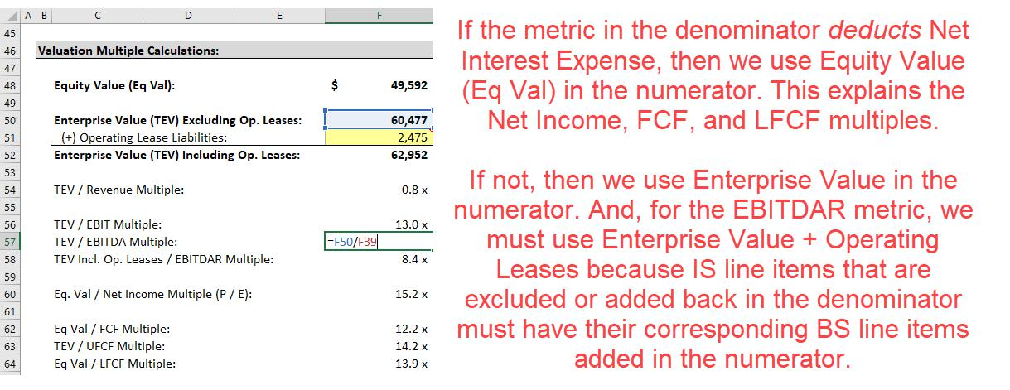

And here are the same calculations for Vivendi:

63 of 121 https://breakingintowallstreet.com

Access the Rest of the Interview Guide
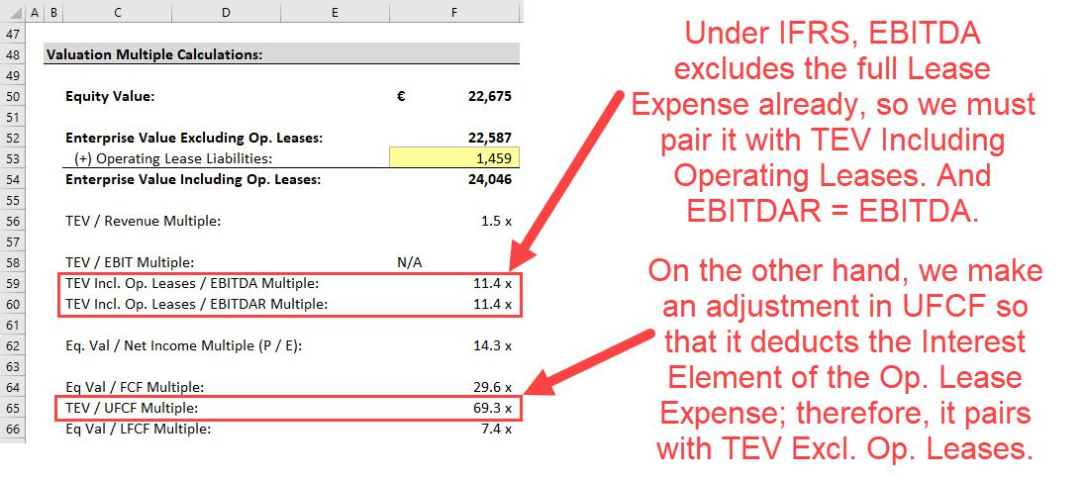

Balance Sheet Metrics and Multiples

In addition to the Income Statement and Cash Flow Statement-based metrics and multiples, there are also Balance Sheet-based metrics and multiples.

The most common Balance Sheet-based metrics are:

- Book Value: Total Assets – Total Liabilities (“Net Assets”).

- Net Operating Assets: Operating Assets – Operating Liabilities.

- Invested Capital: Book Value of Equity + Debt + Preferred Stock + Other Investor Groups + Operating Leases (possibly).

Pairing these metrics is straightforward because they go right back to the definitions of Equity Value and Enterprise Value:

- Book Value: It always pairs with Equity Value to create the Equity Value / Book Value, or P / BV, multiple, since Equity Value represents Net Assets. Technically, you should use “Common Book Value” and exclude Preferred Stock and NCI if the company has them.

64 of 121 https://breakingintowallstreet.com

Access the Rest of the Interview Guide

- Net Operating Assets: It always pairs with Enterprise Value to create the TEV / NOA multiple, since Enterprise Value represents Net Operating Assets.

- Invested Capital: It always pairs with Enterprise Value to create the TEV / IC multiple, since Enterprise Value represents All Investor Groups.

And… that’s it.

The only tricky point once again relates to Operating Leases: if you count them in Invested Capital, you must also count them in Enterprise Value (and vice versa).

The TEV / IC multiple tells you how valuable a company is relative to the cumulative capital it has raised (or generated) over time.

For example, if a firm has raised and generated $1,000 total of Equity, Debt, and Preferred Stock, is its Enterprise Value now more or less than that?

TEV / IC tells you how efficiently a company is using its capital, and it tends to correlate with the Return on Invested Capital (ROIC).

The P / BV, or Equity Value / Book Value, multiple is common for certain types of companies.

The idea is similar to the TEV / IC multiple, but P / BV corresponds only to Equity Investors.

It tells you how efficiently the company has used its Equity, both internally generated and externally raised, to grow.

However, the P / BV multiple means little for most companies because their market values are NOT linked directly to the Balance Sheets.

P / BV is most meaningful for commercial banks and insurance firms, which have different accounting and valuation methodologies and are Balance Sheet-driven.

P / BV for commercial banks and insurance firms is correlated with Return on Equity (ROE), which is defined as Net Income / Average Equity (or Net Income to Common / Average Common Shareholders’ Equity if there’s Preferred Stock).

Companies that generate higher Net Income relative to their Equity have higher ROE figures and tend to trade at higher P / BV multiples (in theory).

Industry-Specific Metrics and Multiples (OPTIONAL)

Finally, industry-specific metrics and multiples also exist.

65 of 121 https://breakingintowallstreet.com

Access the Rest of the Interview Guide

Sometimes, they exist because nothing else works: If a biotech or technology startup has no revenue yet, you can’t use TEV / EBITDA or TEV / Revenue to value it.

You have to use some other metric, such as Unique Visitors, Monthly Active Users, or Registered Users.

Other times, they exist because modified financial metrics may be more meaningful, or because operational metrics are just as relevant as financial ones.

Most industries use standard valuation multiples, but a few use very different ones:

- The MOST Different Sector: Commercial Banks and Insurance Firms. There are MANY different metrics and multiples, you don’t use the DCF, and Enterprise Value is not a meaningful concept.

- Moderately Different: Metals & Mining, Oil & Gas, and Real Estate and REITs (real estate investment trusts). Enterprise Value is still valid, and standard multiples apply, but there are also new multiples and new methodologies.

- Somewhat Different: Healthcare, Airlines, Power & Utilities, and Cleantech. The multiples are standard, but many operational metrics are different.

- Quite Standard: Consumer/Retail, Restaurants, Chemicals, Construction, Transportation, Technology, and Media/Telecom.

Here is a quick summary of each segment:

Financial Institutions (FIG)

For commercial banks and insurance firms, the concept of “Enterprise Value” is invalid because you can’t separate “Operating Assets” and “Operating Liabilities” from Total Assets and Total Liabilities. A Loan or Investment is a Non-Operating Asset to a normal company, but it’s an Operating Asset to a bank.

You rely on the P / E, P / BV, P / TBV (Equity Value / Tangible Book Value) multiples, the Dividend Discount Model (DDM) rather than the DCF, and for life insurance, the Embedded Value methodology (a super-long-term variant of the DCF).

For the other sectors within financial institutions – asset management firms, investment banks, brokerages, and fin-tech companies – all the standard metrics, multiples, and methodologies apply, the DCF still works, and Enterprise Value is still meaningful.

66 of 121 https://breakingintowallstreet.com

Access the Rest of the Interview Guide

Metals & Mining

You still use standard multiples here, but Reserves, Resources, and Production are very important operational metrics as well.

“Reserves” have a higher probability of being extracted than Resources, and Resources can be split into Inferred, Measured, and Indicated.

Mining companies that operate in different segments (e.g., gold, zinc, and copper) often convert everything into “Mineral Equivalent” Resources and Reserves.

You can then use valuation multiples like Enterprise Value / Mineral Equivalent Reserves or Enterprise Value / Mineral Equivalent Production.

The NAV Model, which is a super-long-term DCF without a Terminal Value (you assume the mine runs out of resources that are “economically viable to extract”), is also common.

Oil & Gas

Just like in mining, you can make multiples out of metrics like Reserves and Production: TEV / Proved Reserves and TEV / Daily Production, for example.

Some “upstream” (exploration & production) companies capitalize the cost of all exploration, while others expense the unsuccessful portion, so you use EBITDAX (EBITDA + Exploration Expense) to normalize these treatments.

For midstream companies (pipeline companies that transport oil), “Distributable Cash Flow” is important because these companies are structured as Master Limited Partnerships (MLPs).

Downstream companies (ones that refine oil and gas and turn it into fuel) use the standard metrics and multiples.

Real Estate and REITs

Most segments – gaming, lodging, and homebuilding – use standard metrics and multiples.

Real Estate Investment Trusts (REITs) are companies that buy, sell, develop, and renovate properties constantly, and act like “private equity firms for properties.”

Since massive Depreciation and constant Gains and Losses on property sales distort their Net Income figures, you use Funds from Operations (FFO), which equals Net Income + D&A – Gains + Losses, instead of Net Income.

FFO deducts Net Interest Expense, so the multiple is Equity Value / FFO.

67 of 121 https://breakingintowallstreet.com

Access the Rest of the Interview Guide

There’s also Adjusted Funds from Operations (AFFO), which is similar to FFO but which adjusts for Recurring Maintenance CapEx, the Amortization of Lease Intangibles, the Straight-Lining of Rent, and other non-cash items.

There is a Net Asset Value (NAV) model for REITs as well, but it’s based on valuing each property individually and determining the REIT’s value from that. So, it’s a Balance Sheet valuation rather than a super-long-term DCF.

Healthcare

There are no major valuation differences, but you’ll see far-in-the-future DCF analyses for startup biotech firms that are not yet generating revenue. For more established companies, you’ll see different operational metrics, such as $ per Patient and # of Beds.

Airlines

Under U.S. GAAP, EBITDAR and TEV Including Operating Leases / EBITDAR are common because some airlines rent their planes, some own them, and some do a mix of both (under IFRS, the normal TEV Including Operating Leases / EBITDA multiple works fine).

The operational metrics are also different: Revenue per Available Seat Mile (RASM) or per Kilometer, the Load Factor, Revenue Passenger Miles (RPM) or Kilometers, and the Passenger Count all matter a lot.

Power & Utilities

You use standard multiples, but the metrics differ: one key one is Megawatt (MW) Supply, defined as Existing Generation – Expected Retirements + Expected Additions + Net Imports.

You also pay attention to Cost Recovery, Plant Availability and Reliability, and Outage Rates.

Cleantech

Similar to traditional Power & Utility companies, power generated and related metrics are quite important, and many asset prices are quoted on a $ per KW or $ per MW basis.

Consumer/Retail

The valuation multiples are all standard, and EBITDAR and the matching valuation multiple are both common under U.S. GAAP when some companies rent their stores, and others own them.

Important operating metrics include Same-Store Sales, Inventory Turnover, Sales per Store, and Sales per Square Foot or Square Meter.

Chemicals

68 of 121 https://breakingintowallstreet.com

Access the Rest of the Interview Guide

The valuation multiples are very standard; a key operating metric is production capacity.

Construction Services

The valuation multiples are standard, but the key operating metrics include the Backlog (how much work has been signed but not yet completed), Option Years (years of potential work over the minimum in the Backlog), and the Book to Bill Ratio (the ratio of work a company is signing vs. delivering).

Transportation & Logistics and Maritime/Shipping

The multiples are all standard, but valuation can get tricky because many shipping companies are structured as MLPs. So, you have to think about Distributable Cash Flow and which sets of investors are entitled to different cash flows from the company.

Key metrics include Shipping Capacity, Contract Length, Utilization Rates, Average Length of Haul, # of Drivers or # of Ships, and Revenue per Mile or Kilometer.

Technology

The multiples are standard for established companies, but for pre-revenue startups and mobile/gaming companies, you’ll see metrics like Unique Visitors, Monthly Active Users, Mobile Users, and Subscribers, all of which pair with Enterprise Value.

Media / Telecom

The standard multiples all apply, but # Subscribers is a vital operational metric, and TEV / Subscribers is a common multiple. Other key metrics include Average Revenue per User (ARPU), Subscriber Penetration, Renewal Rates, # Access Lines, and Access Line Growth.

Return to Top.

Key Rule #10: How to Use Multiples in Real Life

So far, we’ve calculated metrics for Target, Vivendi, and Zendesk based on the last full fiscal year for each company.

But there are also other metrics and multiples that are based on different periods, such as the last twelve months (LTM) or trailing twelve months (TTM), as well as future periods, such as next year or the year after that (“forward multiples”).

Historical multiples are useful because they represent what happened in real life, but they can be distorted by acquisitions, divestitures, changes in accounting policies, and so on.

69 of 121 https://breakingintowallstreet.com

Access the Rest of the Interview Guide

Forward multiples are useful because they represent consensus expectations for a company, and company valuation is based on expectations of future performance.

So, when you value a company, you normally look at both historical multiples and forward multiples based on metrics such as EBITDA and Net Income.

When you do this, you always pair these metrics with the company’s Current Equity Value or Current Enterprise Value. You never “project” Equity Value or Enterprise Value.

That’s because Current Eq Val and Current TEV represent past results as well as future expectations as of the valuation date.

To project them, you’d have to jump into the future, find future expectations in the future, and then bring that knowledge back to the valuation date.

If you’ve discovered how to time travel successfully, go ahead.

If, however, you are similar to most humans in that you cannot violate the space-time continuum, never project Current Equity Value or Current Enterprise Value.

LTM Multiples, also called “Trailing Twelve Months” or TTM Multiples, are useful when part of the company’s current fiscal year has passed, and results are available for at least one quarter.

For example, it’s currently May, and the company announced Q1 results in April. Or it’s October, and the company has announced Q1, Q2, and Q3 results.

It’s more accurate to use these LTM figures rather than the full fiscal year ones if something major happened in the first few quarters of the year, such as higher/lower revenue growth or margins, an acquisition, a major geopolitical event, or a pandemic.

Let’s say that it’s currently August 2020, and we want to calculate the LTM EBITDA for a company based on the Q1 and Q2 results of 2020.

You do the following to set this up:

- Start with the 2019 numbers, i.e., the company’s EBITDA for the full year from January 1, 2019 to December 31, 2019.

- Then, add the EBITDA for the first two quarters of 2020 (January 1 through June 30).

- And subtract the EBITDA for the first two quarters of 2019 (January 1 through June 30). Here it is in Excel:

70 of 121 https://breakingintowallstreet.com

Access the Rest of the Interview Guide
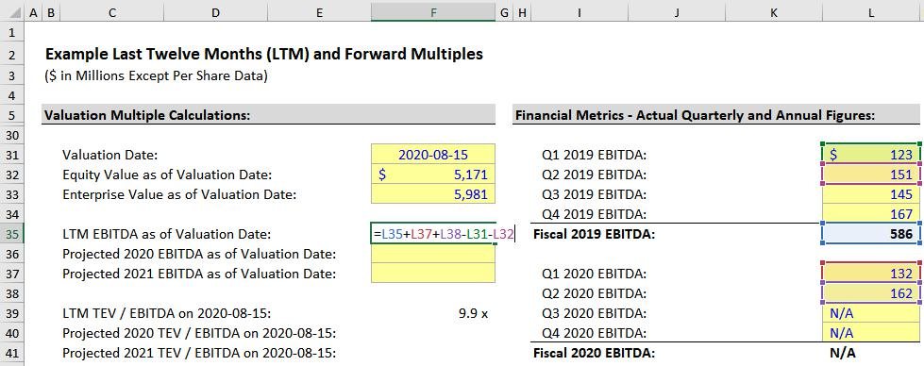

You could also calculate the LTM EBITDA by summing up EBITDA in the individual quarters: Q3 2019 + Q4 2019 + Q1 2020 + Q2 2020.

However, it’s usually easier to add and subtract partial periods because you’ll have to review fewer filings if you do it that way.

Once you have these figures for the company, you might now look up consensus estimates for its projected EBITDA for 2020 and 2021.

If you are at a bank, you could do this via services like Capital IQ, FactSet, or Bloomberg; if not, you could try to find estimates on Google/Yahoo Finance, Finviz, Zacks, or Motley Fool.

Here’s what the forward multiples look like:

71 of 121 https://breakingintowallstreet.com

Access the Rest of the Interview Guide
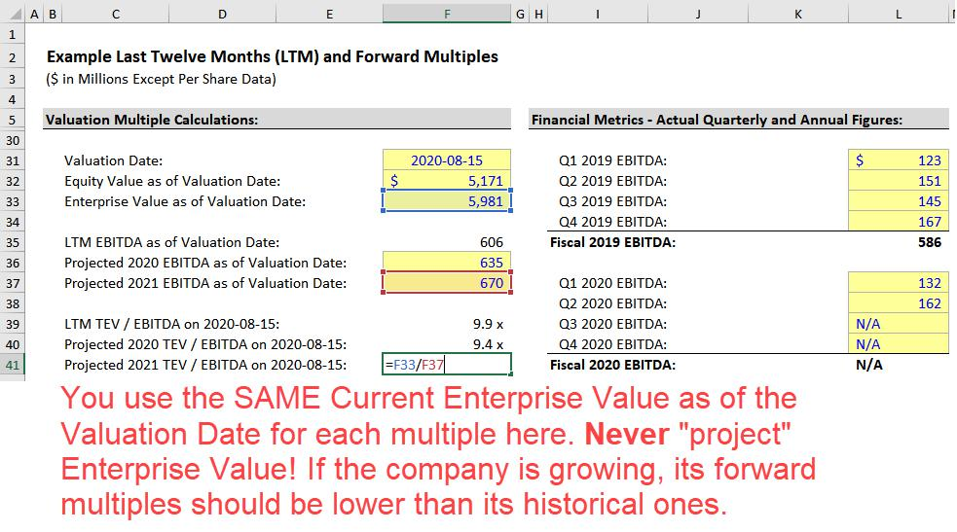

The LTM EBITDA Multiple is 9.9x, the Year 1 Forward Multiple is 9.4x, and the Year 2 Forward Multiple is 8.9x, which are all perfectly normal.

You always use the same Enterprise Value in the numerator (or the same Equity Value for P / E and other multiples), but the denominator keeps growing, so the valuation multiples should be lower in the future.

That doesn’t make the analysis “misleading” because you do the same thing for every company you’re analyzing.

The forward multiples for all companies should be lower than their historical multiples, assuming the companies are growing.

The Endgame of Valuation Multiples

In Key Rule #7, we mentioned that a “valuation multiple” is similar to the per-square-foot or per-square-meter price of a house.

But multiples are also “shorthand” for full valuation.

Going back to the all-important formula:

72 of 121 https://breakingintowallstreet.com

Access the Rest of the Interview Guide

Company Value = Cash Flow / (Discount Rate – Cash Flow Growth Rate), where Cash Flow Growth Rate < Discount Rate

In a valuation, you select companies that are similar to the subject company (the one you are analyzing) in terms of financial metrics (Revenue, EBITDA, etc.), geography, and industry.

By doing so, you make sure the companies in this set have similar Discount Rates and Cash Flow figures.

If that’s true, then differences in each company’s Cash Flow Growth Rate should explain the differences in their valuation multiples.

So, if one company has a higher expected growth rate than the others in the set, then it should trade at higher multiples.

This is a very rough rule that fails to hold up in real life for many reasons, but it is a useful starting point in valuations.

Think of it as the “first clue on the crime scene” in a murder mystery: you won’t solve the entire case with this one clue, but you might figure out if you’re on the right track.

To illustrate this concept, we’ll start by walking through a theoretical example to show why growth rates and valuation multiples are related. Then, we’ll look at real multiples for Target, Zendesk, and Vivendi.

Let’s say that a company has $100 in Cash Flow, it’s not growing at all, and it has no expectations of future growth:
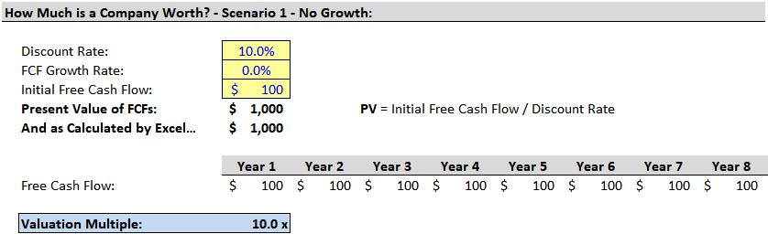

Company Value = $100 / 10% = $1,000, so the Valuation Multiple = $1,000 / $100 = 10x.

Now, let’s say there’s 3% growth each year:

73 of 121 https://breakingintowallstreet.com

Access the Rest of the Interview Guide
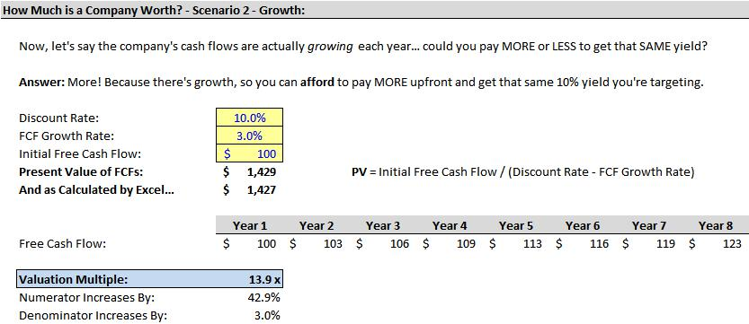

In this case, Company Value = $100 / (10% – 3%) = $1,429, so the Valuation Multiple = $1,429 / $103 = 13.9x.

We’re using the Year 2 Free Cash Flow because multiples are based on future expectations.

The higher multiple indicates that you’d be willing to pay more for the company if its cash flows were growing more quickly.

And now let’s say the company grows even more quickly – at 5% per year rather than 3%:
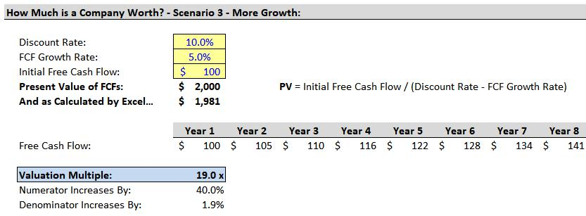

The multiple increases once again!

Since the Company Value = $100 / (10% – 5%) = $2,000, the Valuation Multiple = $2,000 / $105

- 19.0x.

74 of 121 https://breakingintowallstreet.com

Access the Rest of the Interview Guide

As with many of these concepts, this one does not always hold up in real life.

One problem is that valuation multiples are usually based on Income Statement metrics like Revenue, EBIT, EBITDA, and Net Income, but the company’s value depends on its Cash Flow and Cash Flow Growth Rate.

When there are big discrepancies between cash flow and metrics such as EBIT and EBITDA, this rule won’t work as well.

Another problem is that this rule assumes the Discount Rate stays the same.

But the Discount Rate is quite subjective, and even if you’ve picked companies of similar sizes in the same industry, the Discount Rate may not be the same, or even similar, for all of them.

For example, maybe you’ve picked U.S.-based retailers with revenue between $200 and $500 million for your set of comparable companies.

That seems reasonable, but are they all truly comparable? What if one company is spending half as much on CapEx, but growing at the same rate as the others?

Or what if one retailer specializes in a geography or sub-industry that is declining?

In those cases, the individual companies’ Discount Rates might differ substantially.

Finally, non-financial factors also influence valuation multiples.

For example, what if a company just reported earnings far below expectations because of an expense associated with a recent lawsuit?

The company’s stock price might plummet, reducing its valuation multiples, even though nothing about its expected long-term performance has changed.

Or what if one company just recruited a top executive from a competitor, or announced plans to develop a new product that might take the market by storm?

Those factors are difficult to quantify in a company’s cash flow or cash flow growth rate, but they could all affect its multiples.

Real-Life Valuation Multiples for Target, Zendesk, and Vivendi

If we apply these same concepts to the companies used in this guide, we get the following results after selecting comparable companies and running the numbers:

75 of 121 https://breakingintowallstreet.com

Access the Rest of the Interview Guide
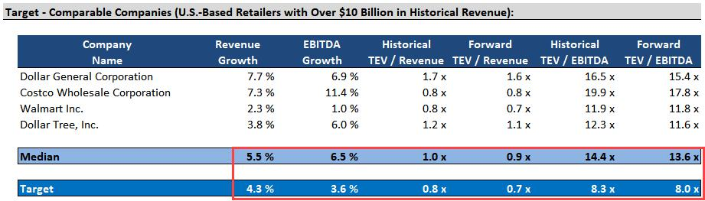

From these numbers, Target looks "appropriately valued" – it's growing at lower rates than its peer companies, and its revenue and EBITDA multiples are also lower by about the same proportions.

A full analysis might yield a different conclusion, but a 30-second glance at the numbers tells us that the company is probably not dramatically mispriced.
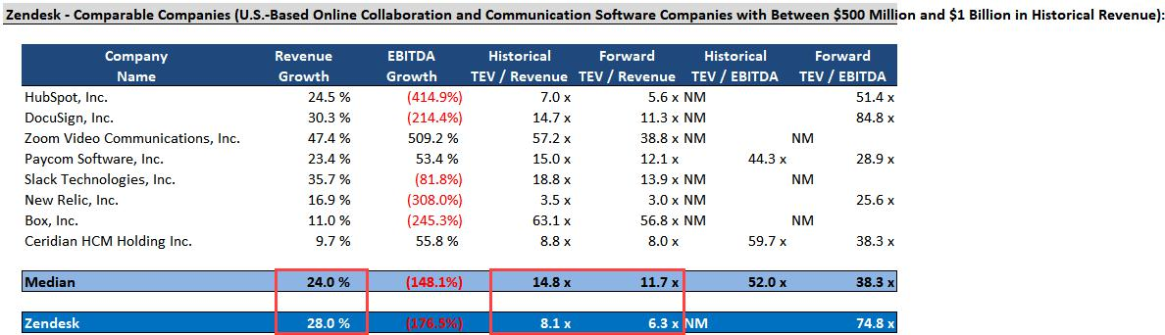

With Zendesk and its comparable companies, EBITDA multiples are meaningless because most of these high-growth software companies have negative or near-zero EBITDA figures.

Zendesk looks significantly undervalued here because its Revenue Growth is higher than those of its peer companies, but both its Revenue multiples are significantly lower.

This one result doesn’t “prove” that Zendesk is undervalued, but it means that we might want to investigate it and conduct a more detailed analysis.

Finally, Vivendi’s results look like this:

76 of 121 https://breakingintowallstreet.com

Access the Rest of the Interview Guide
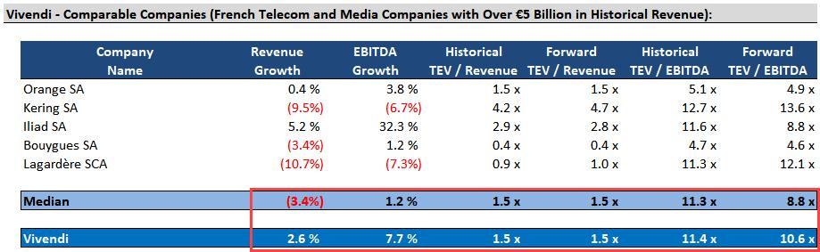

Vivendi looks undervalued here because it is growing more quickly than its peer companies, but its Revenue multiples are the same; only its Forward EBITDA multiple is higher.

However, it doesn’t seem quite as undervalued as Zendesk. It’s worth a more detailed analysis, but it’s also a complicated case because Vivendi is a huge conglomerate, which means that we may need to analyze each segment separately.

Return to Top.

Key Rule #11: Equity Investments and Noncontrolling Interests in Enterprise Value

Equity Investments are Assets that represent a company’s minority stakes in other companies.

For example, Company A owns 30% of Company B. Company A records an Equity Investment or “Associate Company” on the Assets side of its Balance Sheet for this 30% stake.

The financial statements of Company A and Company B are not consolidated in this case; they are kept separate, and there are only a few adjustments for the Net Income and Dividends from Company B.

Noncontrolling Interests are line items within Equity that represent what a company does not own when it owns a majority, but less than 100%, of another company.

For example, Company A owns 70% of Company B. Company A records a “Noncontrolling Interest” for the 30% it does not own on the L&E side of the Balance Sheet under Equity.

The financial statements are fully consolidated in this case, as if Company A owned 100% of Company B and had all its Assets, Liabilities, Revenue, Expenses, and so on.

77 of 121 https://breakingintowallstreet.com

Access the Rest of the Interview Guide

However, Company A owns only 70% of Company B, so on its Income Statement, it adjusts by deducting 30% * Company B’s Net Income. On its Cash Flow Statement, it ensures that only 70% * Company B’s Dividends are shown as cash inflows.

In the Equity Value to Enterprise Value bridge, you subtract Equity Investments and add Noncontrolling Interests.

The simplest explanation for the first one is that Equity Investments are Non-Core or Non-Operating Assets.

The Parent Company owns less than 50%, so it cannot “control” these other companies.

Therefore, its stakes are considered non-core to its business.

The simplest explanation for the second one is that Noncontrolling Interests represent another investor group, beyond the common shareholders.

When the Parent owns over 50% of another company, it controls it, and the minority shareholders have relatively limited power.

So, effectively, the minority shareholders in that other company become an “investor group” in the Parent Company.

If you’re interviewing for entry-level roles, you should probably stop here and resist the urge to explain these concepts in more detail, because they get confusing and difficult to describe.

If, however, you’re aware of the risks, and you want to go beyond these simple explanations, read on.

The secondary reason why you subtract Equity Investments and add Noncontrolling Interests in the TEV bridge is for comparability.

Unless you make this adjustment, Enterprise Value and metrics such as EBITDA will not reflect the same percentages of the other, partially-owned companies.

By itself, Equity Value (Market Cap) implicitly includes the values of these partial stakes.

These partial stakes count as Assets, and Current Equity Value means “the market value of Net Assets to Common Shareholders” – so they must be in there.

But because of accounting rules, you will see either 0% or 100% of the other companies’ EBIT and EBITDA in the Parent Company’s metrics.

That creates a problem because an “unadjusted” Enterprise Value will include the real ownership percentage of the other companies – whether it’s 30%, 70%, or something else.

78 of 121 https://breakingintowallstreet.com

Access the Rest of the Interview Guide

Theoretically, we could fix this problem by adjusting the financial metrics, but in practice, it’s much easier to adjust by adding and subtracting items in the Enterprise Value calculation.
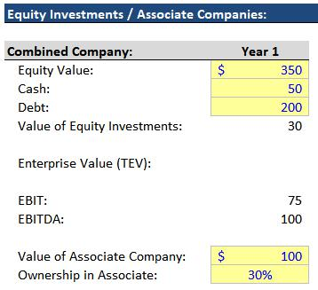

On the left is a specific example, starting with a Parent Company with an Equity Value of $350 that has a 30% stake in a $100 Associate Company.

This $350 Equity Value already includes the $30 Value of Equity Investments.

If we calculated Enterprise Value with $350 – $50

- $200 = $500, it would still include the 30% stake in the Associate Company.

But EBIT and EBITDA would include 0% of that Associate Company, which creates a mismatch.

Here’s what the “Combined” Income Statement looks like in this scenario:
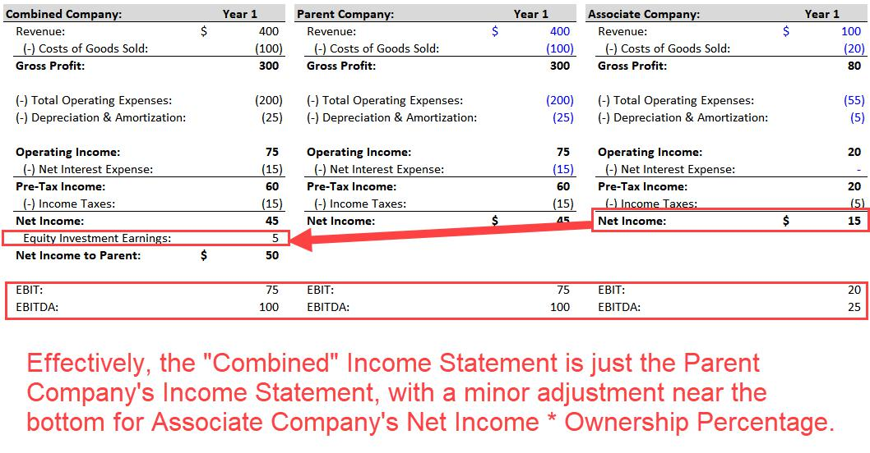

79 of 121 https://breakingintowallstreet.com

Access the Rest of the Interview Guide

To fix this issue, therefore, we subtract the $30 of Equity Investments in the Enterprise Value calculation, which ensures that the numerator of TEV / EBITDA includes 0% and the denominator also includes 0% of these other companies:
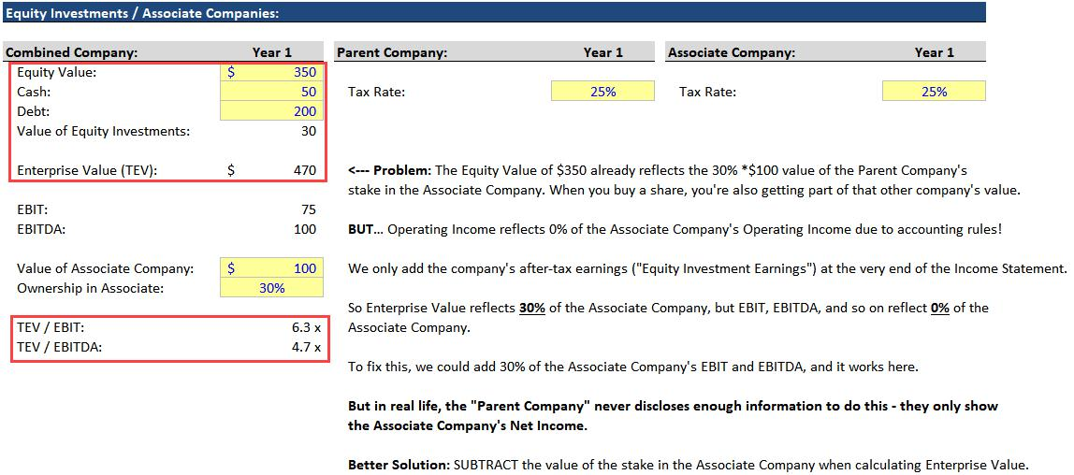

With Noncontrolling Interests, it’s the opposite problem: metrics such as EBIT and EBITDA include 100% of the Majority-Owned Company’s EBIT and EBITDA, but the Parent Company owns less than 100% of the Majority-Owned Company.

Here’s an example with the same numbers, but with the assumption that the Parent Company owns 70% of the other company instead:
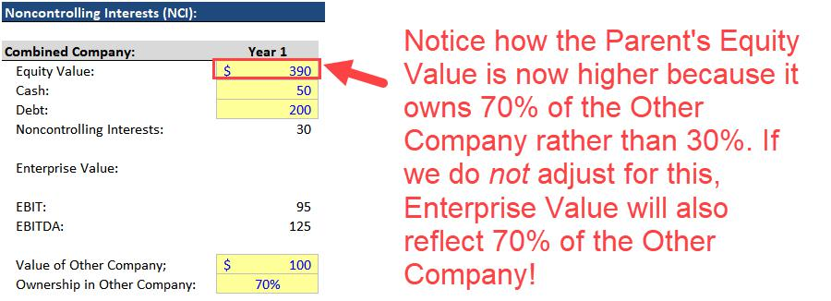

80 of 121 https://breakingintowallstreet.com

Access the Rest of the Interview Guide

When the Parent Company owns a majority of the Other Company, the financial statements are consolidated 100%, with a deduction for Other Company’s Net Income * (1 – Ownership Percentage) at the bottom.

Here’s the Income Statement:
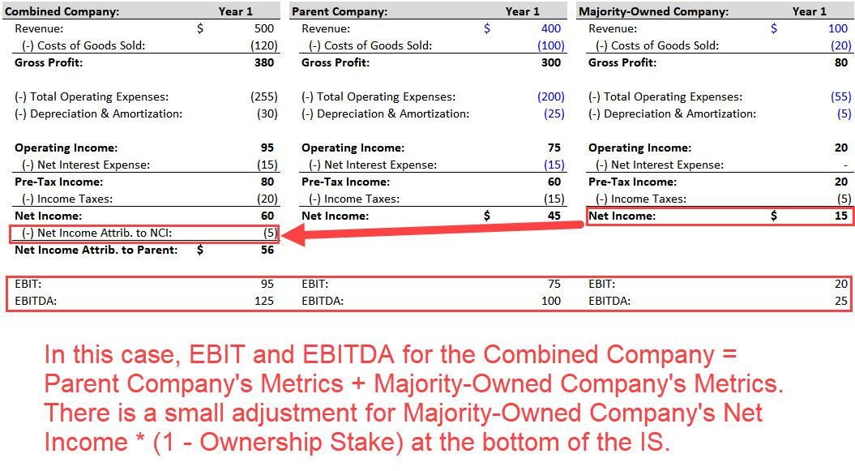

To fix this issue, we add the Noncontrolling Interests to Enterprise Value so that it includes 100% of the Majority-Owned Company rather than 70%:

81 of 121 https://breakingintowallstreet.com

Access the Rest of the Interview Guide
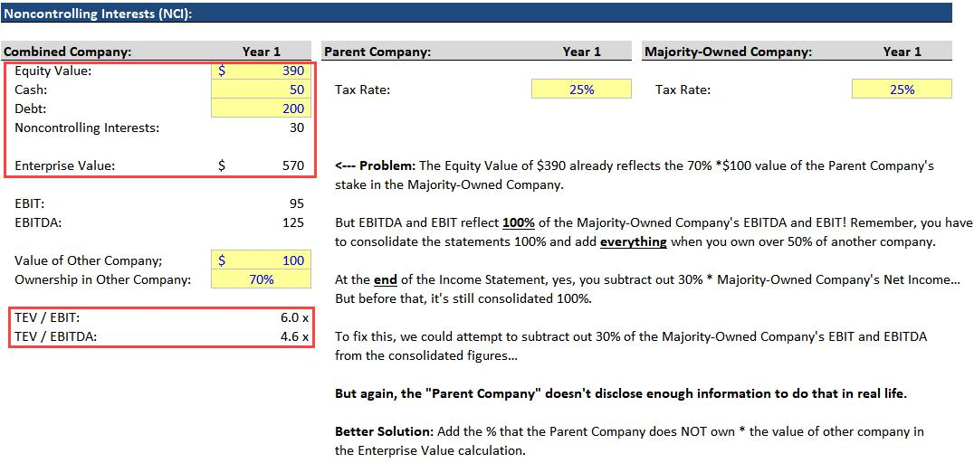

The adjustments for both Equity Investments and Noncontrolling Interests are about ensuring consistency in the numerators and denominators of valuation multiples.

If EBITDA includes 0% of a 30%-owned company’s EBITDA, then Enterprise Value must also include 0% of the 30%-owned company’s value, which means you need to subtract Equity Investments.

And if EBITDA includes 100% of a 70%-owned company’s EBITDA, then Enterprise Value must also include 100% of the 70%-owned company’s value, which means you need to add the Noncontrolling Interests.

Return to Top.

Key Rule #12: Pensions in Enterprise Value

Company pension plans may factor into the Enterprise Value calculation and valuation multiples as well.

Here is the short version of how they work:

82 of 121 https://breakingintowallstreet.com

Access the Rest of the Interview Guide

- Only “Defined-Benefit” Pension Plans Matter – These are plans where the company promises to pay retired employees specific amounts in the future, and the company is responsible for setting aside the funds and investing them appropriately.

Defined-Contribution Pensions, such as the 401(k) plan in the U.S. do not factor into Enterprise Value at all because they do not appear on the Balance Sheet. They are the responsibility of employees, and even if the company “matches” employee contributions, that match is a single Operating Expense on the Income Statement with no corresponding Balance Sheet line item.

- Add the Un(der)funded Pension When Calculating Enterprise Value – In other words, MAX(0, Pension Liabilities – Pension Assets). Companies do not receive any “credit” for a properly funded pension!

The employees represent “another investor group” in this case because they agree to work for lower compensation today in exchange for payments much later on, effectively funding the company’s present-day operations.

- Tax-Adjust the Un(der)funded Pension If Contributions Into the Plan Are Tax-Deductible – For example, in the U.S., contributions into most defined-benefit pension plans are tax-deductible (meaning they reduce Cash Taxes). As a result, we multiply MAX(0, Pension Liabilities – Pension Assets) by (1 – Tax Rate) when adding it to Enterprise Value. The treatment varies in other countries.

- Exclude or “Add Back” the Financial Components of the Pension Expense in TEV-Based Metrics – The Pension Expense on the Income Statement is normally split into components such as the Service Cost, Interest, Expected Return, Amortization of Losses, Amortization of Prior Service Cost, Settlement Charges, and so on.

Only the Service Cost is operational, so only the Service Cost should be deducted in TEV-based metrics such as EBIT and EBITDA. The other components of the Pension Expense are all “financial” in nature.

Pension accounting is confusing, but as a quick review, here are the line items that normally affect the Pension Plan Assets and Projected Benefit Liabilities (Pension Liabilities):

83 of 121 https://breakingintowallstreet.com

Access the Rest of the Interview Guide
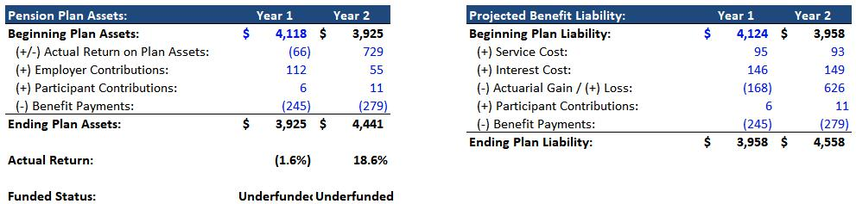

And then on the Income Statement and Cash Flow Statement, here are the standard components of the Pension Expense:
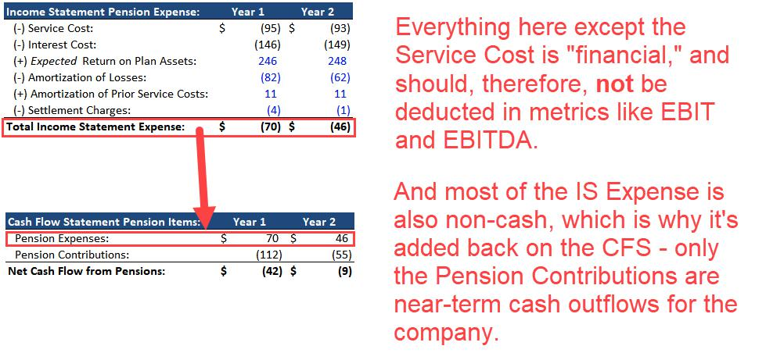

The biggest issue is that companies don’t always explain where the different components of the Pension Expense show up on the Income Statement.

If that’s the case, then you’ll need to dig through the filings to make sure that your calculations for EBIT and EBITDA are correct.

U.S.-based companies generally put the Service Cost within Operating Expenses and place everything else within Interest Expense or Other Expenses, but under IFRS, the treatment varies widely.

84 of 121 https://breakingintowallstreet.com

Access the Rest of the Interview Guide

For example, here are Vivendi’s Pension Expense disclosures:
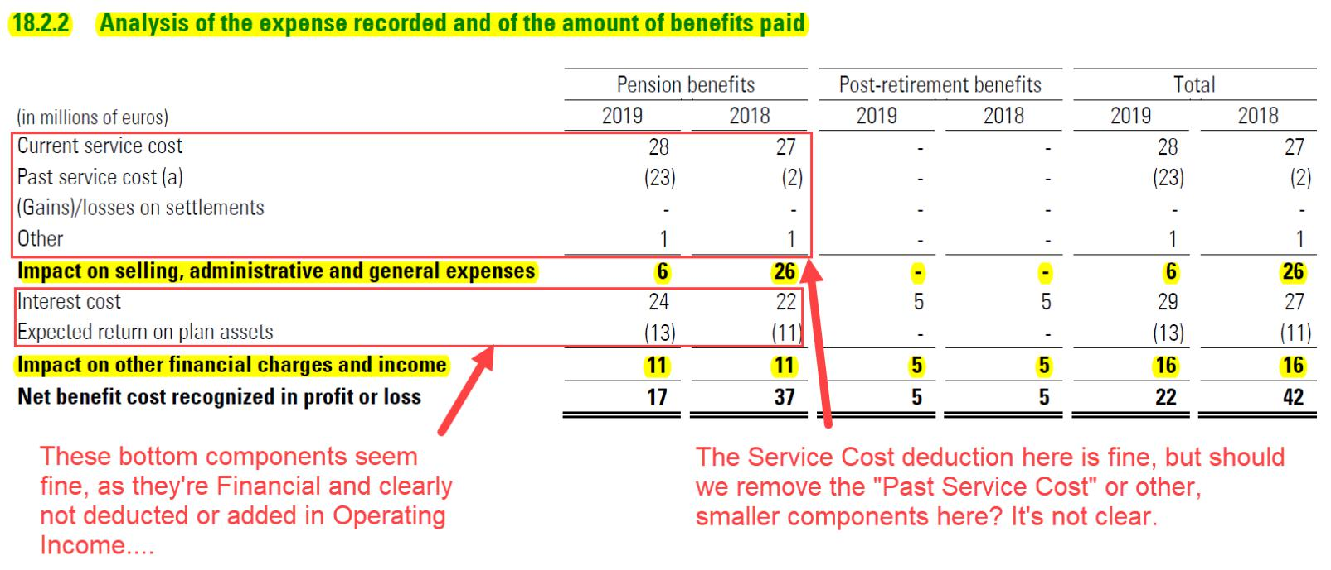

If you wanted to change this treatment in Enterprise Value and valuation multiples by not including the Un(der)funded Pension, then you would have to deduct the entire Pension Expense (all components) in metrics like EBIT and EBITDA.

However, this is a bad idea because the financial portion of the Pension Expense fluctuates significantly based on market conditions, so you’ll get more consistent numbers if you exclude it in the first place (or “add it back” if the company has classified it as an Operating Expense).

Other than the adjustment for taxes, is it worth trying to re-value the Un(der)funded Pension itself?

For example, if the company’s assumed Rate of Return on its Pension Assets is unrealistic, and its Pension Liabilities are understated, should you increase the Un(der)funded Pension?

No, this adjustment is probably not worth it, unless the Liability is massive (e.g., > 20% of Enterprise Value) and it’s also very distorted.

Otherwise, it’s difficult to explain and justify your calculations, especially since most companies do not disclose enough information to calculate these pension items from the ground up.

You’re extremely unlikely to receive questions about how pension-related line items affect

Equity Value and Enterprise Value, but just in case, here’s a summary:

85 of 121 https://breakingintowallstreet.com

Access the Rest of the Interview Guide

- Increasing the Financial Components of the Pension Expense will reduce Equity Value, but not Enterprise Value, since these are considered non-operational.

- Increasing the Service Cost Component will reduce both Equity Value and Enterprise Value since operational items affect both these metrics.

Both the Financial Components and the Service Cost are added back on the Cash Flow Statement, but the Financial Components are usually not Cash-Tax-Deductible, which means the company’s Deferred Tax Asset will increase.

And since this increase does not represent a Net Operating Loss, the additional DTA is considered operational.

- Pension Payments to Employees do not affect anything because they’re deducted from both the Pension Assets and the Pension Liabilities. Therefore, Net Assets, Net Operating Assets, Common Shareholders’ Equity, and the Funded Status of the plan all stay the same.

- Pension Contributions generally won’t affect Enterprise Value, but if these contributions “flip a plan” from Underfunded to Funded, they might make TEV increase because Net Pension Assets, when the plan is Funded, count as Net Operating Assets. But when the plan is Underfunded, they do not. Equity Value will change only if these contributions are funded with a Common Stock issuance.

Do NOT worry about these items too much because they are exceptionally unlikely interview questions.

Make sure you understand the basics for including Un(der)funded Pensions in TEV, and how to ensure that metrics such as EBIT and EBITDA deduct only the Service Cost.

Return to Top.

Key Rule #13: Operating Leases and Capital Leases in Enterprise Value

We’ll start this section with Capital Leases because they’re much simpler to explain.

Capital Leases are Debt-like items that companies use to acquire equipment, property, factories, and other PP&E.

There are Interest Expense and Depreciation associated with Capital Leases and their corresponding Assets, and metrics like EBITDA already exclude or “add back” these expenses.

86 of 121 https://breakingintowallstreet.com

Access the Rest of the Interview Guide

Therefore, you should always add Capital Leases in the Enterprise Value bridge and count them as Debt-like items; this also ensures consistency in the valuation multiples.

Some people argue that Capital Leases are “operational” in nature, but this point is irrelevant because if you ignore them in TEV, then you’ll get inconsistent valuation multiples.

Operating Leases are trickier because their accounting and valuation treatment has changed over time.

For many decades, companies under all accounting systems worldwide recorded their Operating Leases off-Balance Sheet, and hardly anyone included them in Enterprise Value.

You capitalized the Operating Leases by multiplying the annual rental expense by 7-8x and added them to Enterprise Value only if you were using metrics like EBITDAR that excluded the entire Rental Expense.

But in 2019, the accounting rules changed under both U.S. GAAP and IFRS, and companies began to record Operating Leases directly on their Balance Sheets on the Liabilities & Equity side, along with “Right-of-Use” (ROU) Assets on the other side.

By itself, that change is not a big deal because you could still choose to include or exclude Operating Leases in Enterprise Value.

But the problem is that companies now record the Lease Expense itself differently under U.S.

GAAP and IFRS, which creates consistency problems with standard valuation multiples.

Under IFRS, the Lease Expense is split into Interest and Depreciation elements, but under U.S.

GAAP, it’s still recorded as a Lease or Rental Expense.

Despite these changes, though, most companies’ Net Income and Net Change in Cash figures stay nearly the same because it’s the same total expense; it’s just presented differently.

This makes it a frustrating accounting rule because it creates the need for extra adjustments without changing the substance of valuation at all.

Here’s the pre-2019 version, along with the IFRS and U.S. GAAP versions, of the Income Statement for a hypothetical airline company:

87 of 121 https://breakingintowallstreet.com

Access the Rest of the Interview Guide
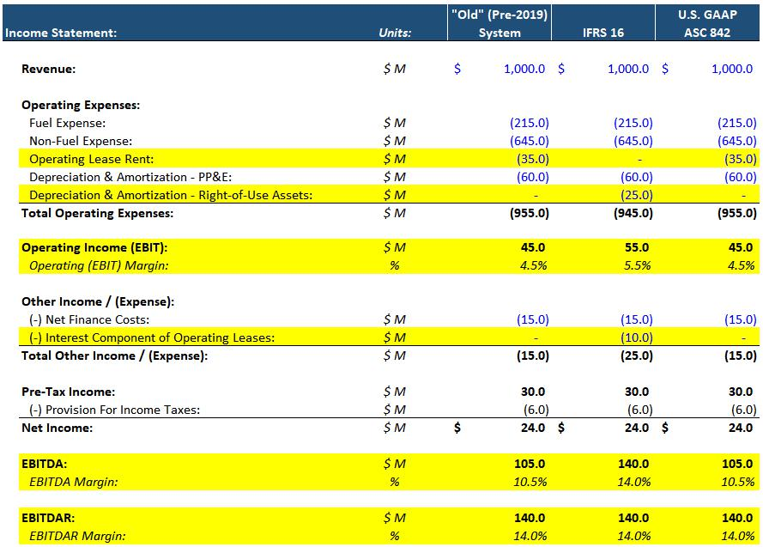

On the Balance Sheet, the Assets side now has Right-of-Use Assets or Operating Leases Assets, and the L&E side now has Operating Lease Liabilities.

Here’s the Cash Flow Statement:

88 of 121 https://breakingintowallstreet.com

Access the Rest of the Interview Guide
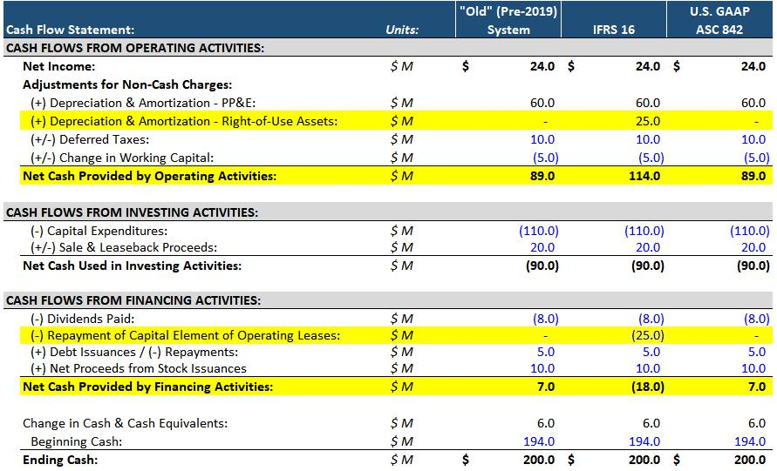

These changes are cosmetic: the statements look different, but the Net Change in Cash stays the same, and a DCF valuation of the company also stays the same.

The valuation implications are as follows:

- Both Systems: If you add Operating Leases in the TEV bridge, then you must pair TEV with metrics that exclude or “add back” the full Lease Expense. If you do not add Operating Leases, then you must pair TEV with metrics that deduct the full Lease Expense.

- U.S. GAAP: We normally do not count Operating Leases in the TEV bridge so that EBIT and EBITDA remain valid metrics in the TEV / EBIT and TEV / EBITDA multiples. If you do count Operating Leases, then you must use EBITDAR and TEV Including Operating Leases / EBITDAR instead.

- IFRS: When you use EBITDA, you must pair it with TEV Including Operating Leases. EBITDA and EBITDAR are now the same. And EBIT is a problematic metric because it deducts only part of the full Lease Expense (the Depreciation element), so EBIT multiples are invalid unless you adjust EBIT.

89 of 121 https://breakingintowallstreet.com

Access the Rest of the Interview Guide

Here’s a summary of the proper valuation multiples for this hypothetical airline, with Operating Leases added in the TEV bridge vs. no addition:
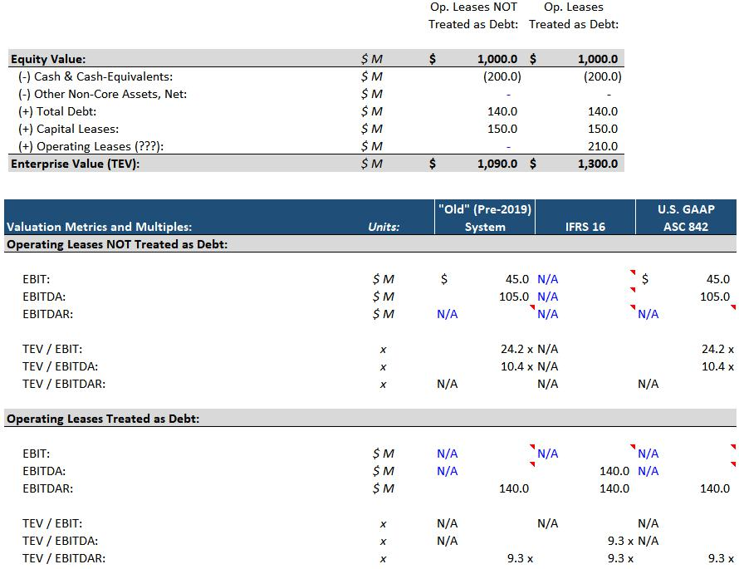

You also need to be careful with Returns-based metrics such as Return on Invested Capital (ROIC) and Return on Capital Employed (ROCE).

If you count Operating Leases in Invested Capital or Capital Employed (e.g., Invested Capital = Average Shareholders’ Equity + Debt – Cash + Operating Leases), then the EBIT number used to calculate NOPAT in ROIC must exclude or add back the Interest element of the Lease Expense.

This applies even if the company follows U.S. GAAP; it’s required for comparability between other companies with Operating Leases.

U.S.-based companies need to estimate this number based on their total Lease Expense.

You can see an example for Target here:

90 of 121 https://breakingintowallstreet.com

Access the Rest of the Interview Guide
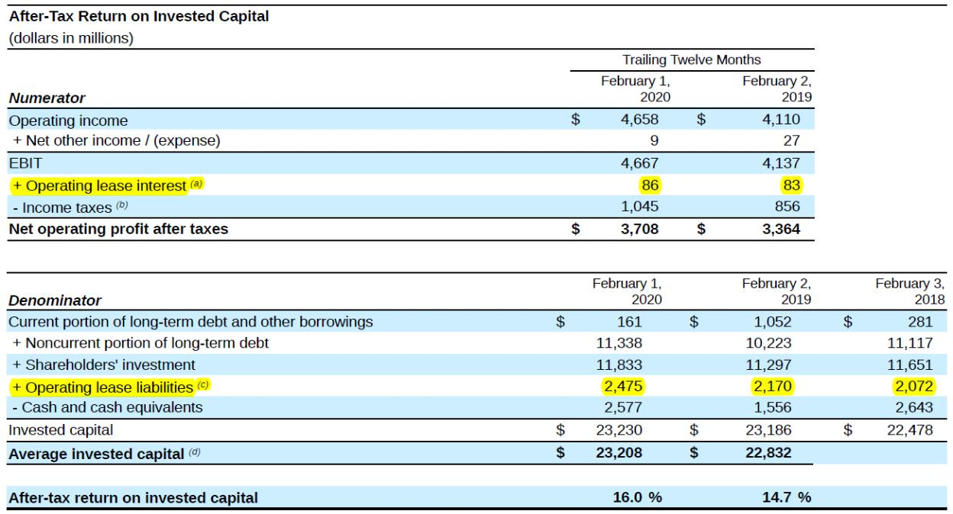

On the other hand, if you do not count Operating Lease Liabilities in Invested Capital, then you do not need to adjust EBIT.

The usual assumption with Operating Lease Assets and Operating Lease Liabilities is that they change by roughly the same amount in each period.

So, if a company signs a new lease and records a $100 Lease Liability, it should also record a $100 Lease Asset.

Under U.S. GAAP, these both count in the Net Operating Assets calculation, so TEV does not change. Eq Val also does not change because CSE stays the same.

If the Lease Asset and Liability change by different amounts, then both Eq Val and TEV could potentially change.

Under IFRS, these changes do affect TEV because the Lease Assets are operational, but the Lease Liabilities are not.

Finally, since Capital Leases are similar to Debt, they impact TEV if they’re used to acquire

Operating Assets, such as PP&E (which they usually are). Equity Value won’t change because

CSE stays the same.

Return to Top.

91 of 121 https://breakingintowallstreet.com

Access the Rest of the Interview Guide

Key Rule #14: Net Operating Losses (NOLs) and Other Items

This last section of the guide will cover Net Operating Losses, along with a few other miscellaneous items that may factor into the Enterprise Value bridge.

Net Operating Losses (NOLs) accumulate when a company records negative Pre-Tax Income.

The off-Balance Sheet NOL increases by –Pre-Tax Income, and the Deferred Tax Asset increases by –Pre-Tax Income * Tax Rate.

When the company finally records positive Pre-Tax Income, it can use these NOLs to reduce its Taxable Income, thereby reducing its Cash Taxes.

In models, we always set Book Taxes on the Income Statement equal to Pre-Tax Income * Tax Rate; we adjust for NOLs later in the Book vs. Cash Tax Schedule.

Here’s a quick example of how NOL accumulation and usage works:
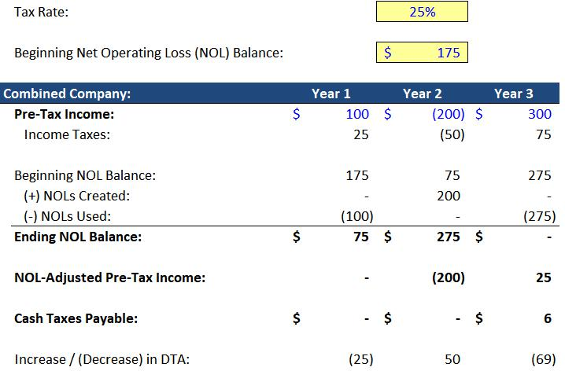

In the Enterprise Value bridge calculation, you subtract the on-Balance Sheet NOLs within the DTA, counting them as Non-Operating Assets.

The logic is that the NOLs are not core to the company’s business because they’re not required to sell and deliver products and services.

By contrast, other components of the DTA are closer to being “core” to the business:

92 of 121 https://breakingintowallstreet.com

Access the Rest of the Interview Guide
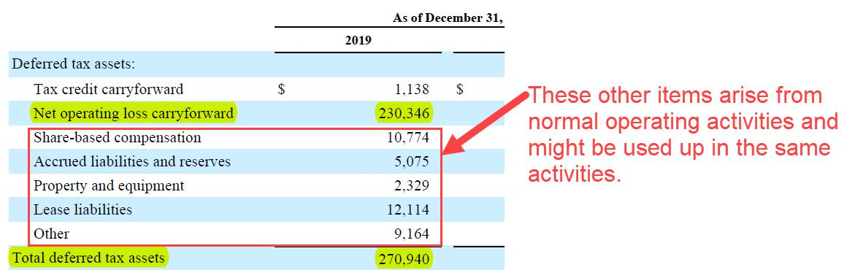

Also, NOLs are often worth something to acquirers in M&A deals because the acquirers may be able to use the NOLs to reduce their own taxes.

In real life, you often adjust the NOL balance if the company has recorded a “Valuation

Allowance” netted against the DTA:
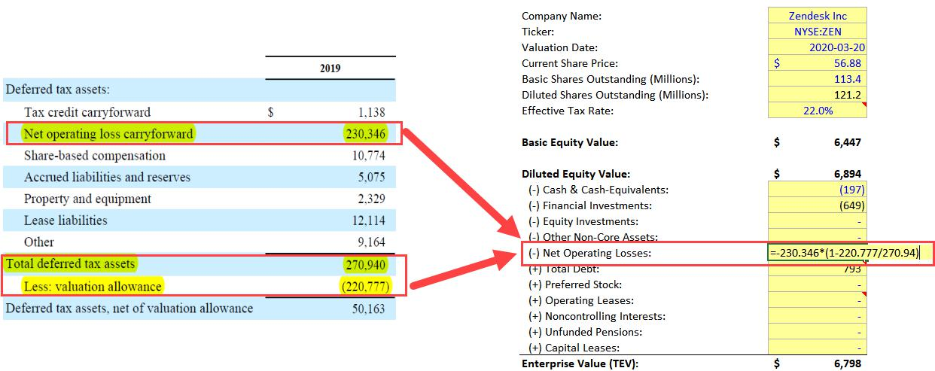

This “Valuation Allowance” means that the company does not expect to realize the benefits of the full DTA before it expires; usually, this is because the company will have extremely negative Pre-Tax Income for the near future.

Besides NOLs, we often get questions about the following items in the TEV bridge:

- Goodwill & Other Intangible Assets: Remember that these get created when a company acquires other companies. So, if the acquired companies are still part of this

93 of 121 https://breakingintowallstreet.com

Access the Rest of the Interview Guide

company’s operations, then these items count as Operating Assets! Therefore, you should not adjust for these in the TEV bridge.

- Industry-Specific Assets (e.g., “Content Assets” for Vivendi or Netflix): These almost always count as Operating Assets, so there’s no adjustment for them in the Enterprise

Value bridge.

- “Provisions” and “Other Liabilities”: These items have vague names, so you need to check what’s in them before you do anything. If these items include Debt, other interest-bearing borrowings, or Un(der)funded Pensions, you should add those components in the bridge. But if these items are related to simple timing differences or unknown and uncertain future expenses, you should not add them.

- Legal & Restructuring Liabilities: Yes, these items do represent possible future cash outflows, but unlike with Debt, Preferred Stock, Capital Leases, and Unfunded Pensions, there’s no ongoing “Interest” component.

Also, do they truly represent “other investor groups”? Maybe if the company has some massive Liability here that will require it to raise Debt or other outside funding in the future, you could count it, but it’s still a bit questionable. We rarely count these items in the TEV bridge.

- Deferred Tax Liabilities (DTLs): You do not include these in the bridge because DTLs are operational and correspond to timing differences that will reverse in the future. They also don’t represent another investor group: what company ever says, “Let’s raise money for a new factory by… changing around some of our tax policies!” Even if that could work, it might take years to see results.

So, not only is the intent different, but the timing is also highly uncertain because DTLs do not necessarily reverse on a predictable schedule (for example, think about a DTL created due to the creation of Indefinite-Lived Other Intangible Assets in an acquisition).

Finally, there’s no “comparability” argument for adding these, as there is with Operating Leases and Noncontrolling Interests.

Return to Top.

94 of 121 https://breakingintowallstreet.com

Access the Rest of the Interview Guide

Interview Questions

Questions about valuation are among the most common ones in investment banking interviews, second only to questions about accounting.

While many valuation questions concern specific methodologies, such as the DCF analysis, many are also about the underlying concepts: Equity Value, Enterprise Value, and valuation multiples.

You used to be able to memorize a few multiples and the Enterprise Value calculation to answer these questions, but now you need to understand the concepts at a deeper level.

The Concepts of Equity Value and Enterprise Value

- What do Equity Value and Enterprise Value MEAN? Don’t explain how you calculate them – tell me what they mean!

Equity Value represents the value of EVERYTHING a company has (its Net Assets) but only to EQUITY INVESTORS (i.e., common shareholders).

Enterprise Value represents the value of the company’s CORE BUSINESS OPERATIONS (its Net Operating Assets) but to ALL INVESTORS (Equity, Debt, Preferred, and possibly others).

- Why do you use both Equity Value and Enterprise Value? Isn’t Enterprise Value more accurate?

Neither one is “better” or “more accurate” – they represent different concepts, and they’re important to different types of investors.

Enterprise Value and TEV-based multiples have some advantages because they are not affected by changes in the company’s capital structure as much as Equity Value and Eq Val-based multiples are affected.

However, in valuation, one methodology might produce Implied Enterprise Value, while another might produce Implied Equity Value, so you will need to move between them to analyze a company.

Finally, you use both of them because actions taken by one investor group affect all the other groups. If a company raises Debt, that also affects the risk and potential returns for common shareholders.

95 of 121 https://breakingintowallstreet.com

Access the Rest of the Interview Guide

- Why do you pair Net Assets with Common Shareholders in Equity Value, but Net Operating

Assets with All Investors in Enterprise Value? Isn’t that an arbitrary pairing?

No. The logic is that Common Shareholders’ Equity can be generated internally (via Net Income) or raised externally (Stock Issuances), so the company can use it for both Operating and Non-Operating Assets.

But if the company raises funds via outside investors (Debt, Preferred Stock, etc.), then most likely it will use those funds to pay for Operating Assets, rather than spending the money on random Non-Operating Assets (such as a whiskey side business for a software company).

This rule does not always hold up in real life, but this is the basic rationale.

4. What’s the difference between Current Enterprise Value and Implied Enterprise Value?

Current Enterprise Value is what “the market as a whole” thinks the company’s core business operations are worth to all investors; Implied Enterprise Value is what you think the core-business operations are worth based on your views and analysis.

You calculate Current Enterprise Value for public companies by starting with Current Equity Value, subtracting Non-Operating Assets, and adding Liability and Equity line items that represent other investor groups (i.e., ones beyond the common shareholders).

But you calculate Implied Enterprise Value based on valuation methodologies such as the Discounted Cash Flow (DCF) analysis, comparable public companies, and precedent transactions.

- Why might a company's Current Enterprise Value be different from its Implied Enterprise Value?

Remember that Company Value = Cash Flow / (Discount Rate – Cash Flow Growth Rate), where Cash Flow Growth Rate < Discount Rate.

Everyone agrees on a company’s current Cash Flow, but you might disagree with the market on the Discount Rate or Cash Flow Growth Rate.

In most cases, your view of a company’s value will be different than the market’s view because you believe its cash flow will grow at a faster or slower rate.

96 of 121 https://breakingintowallstreet.com

Access the Rest of the Interview Guide

- Why do you subtract Cash, add Debt, and add Preferred Stock when moving from Equity

Value to Enterprise Value in the “bridge”?

You subtract Non-Operating Assets because Enterprise Value reflects only Net Operating Assets. Cash and Investments are examples of Non-Operating Assets, but Equity Investments (Associate Companies), Assets Held for Sale, and Assets Associated with Discontinued Operations also count.

You add Liability & Equity line items that represent other investor groups beyond the common shareholders because Enterprise Value represents All Investors. Debt and Preferred Stock are the most common examples, but Underfunded Pensions, Capital Leases, and Noncontrolling Interests also qualify.

- You're about to buy a house using a $600K mortgage and a $200K down payment. What are the real-world analogies for Equity Value and Enterprise Value in this case?

The “Enterprise Value” here is the $800K total price of the house, and the “Equity Value” is the $200K down payment you’re making.

8. Could a company's Equity Value ever be negative?

Trick question. A company’s Current Equity Value cannot be negative because it is based on Shares Outstanding * Current Share Price, and neither of those can be negative. It also can’t be negative for private companies.

However, its Implied Equity Value could be negative because you use your views and assumptions to calculate that. If the company’s Implied Enterprise Value is $0, for example, and it has more Debt than Cash, then its Implied Equity Value will be negative.

Note, however, that you typically say its Equity Value is $0 in cases like this.

9. Could a company's Enterprise Value ever be negative?

Yes. Both Current and Implied Enterprise Value could be negative – for example, a company might have Cash that exceeds its Current Equity Value and no Debt. And your Implied Enterprise Value might be the same as, or close to, its Current Enterprise Value.

97 of 121 https://breakingintowallstreet.com

Access the Rest of the Interview Guide

Once again, you often say the company’s Enterprise Value is simply $0 in cases like this.

- Why do financing events such as paying Dividends or issuing Debt not affect Current Enterprise Value?

Current Enterprise Value changes only if Net Operating Assets change.

Paying Dividends reduces the company’s Cash and Common Shareholders’ Equity, and issuing Debt increases the company’s Cash and Debt. None of these is an Operating Asset or Liability, so Current Enterprise Value cannot possibly change.

- You estimate a company’s Implied Value with Company Value = Cash Flow / (Discount Rate – Cash Flow Growth Rate), where Cash Flow Growth Rate < Discount Rate.

Will this give you the company’s Implied Equity Value or Implied Enterprise Value?

It depends on the type of Cash Flow and the Discount Rate you are using. If you’re using Cash Flow Available to All Investors (i.e., Unlevered FCF or Free Cash Flow to Firm) and WACC for the Discount Rate, then this formula will produce the Implied Enterprise Value.

If you’re using Cash Flow Available ONLY to Equity Investors (i.e., Levered FCF or Free Cash Flow to Equity) and Cost of Equity for the Discount Rate, then this formula will produce the Implied Equity Value.

12. If financing events do not affect Current Enterprise Value, what DOES affect it?

Only changes to the company’s Net Operating Assets (i.e., changes to its “core business”) affect Enterprise Value.

For example, if the company purchases PP&E using Cash, or it raises Debt to purchase PP&E or Inventory, both of those will increase Current Enterprise Value.

- Is it possible for a single change to affect both Current Equity Value and Current Enterprise Value?

Yes. For this to happen, Net Operating Assets must change, and Common Shareholders’ Equity must also change.

98 of 121 https://breakingintowallstreet.com

Access the Rest of the Interview Guide

So, for example, if the company issues $100 of Common Stock to fund the purchase of $100 in PP&E, both Eq Val and TEV will increase by $100.

- Why does Enterprise Value NOT necessarily represent the "true cost" to acquire a company?

First, because the treatment of the seller’s existing Debt and Cash differs based on the terms of the deal. The buyer may not necessarily “repay” the seller’s Debt – it could instead refinance it and replace it with new Debt – and it may not “get” all the seller’s Cash.

Also, the buyer has to pay additional fees for the M&A advisory, accounting, and legal services, and the financing to acquire another company, and those are not reflected in its Enterprise Value.

- In theory, if Companies A and B are the same in all respects, but Company A is financed with 100% Equity, and Company B is financed with 50% Equity and 50% Debt, then their Enterprise Values will be the same.

Why is this NOT true in reality?

Because a company’s capital structure, whether current, optimal, or targeted, affects the Discount Rate used to calculate the Implied Enterprise Value (and the Discount Rate “the market as a whole” uses for the company’s Current Enterprise Value).

Not only do the percentages of Equity, Debt, and Preferred Stock affect WACC, but the Cost of each one also changes as the company’s capital structure changes.

For example, going from no Debt to a small amount of Debt may initially reduce WACC because Debt is cheaper than Equity. But past a certain point, additional Debt will increase WACC because the risk to all investors starts increasing at that stage.

Enterprise Value is LESS affected by capital structure changes than Equity Value, but there will still be some effect.

- What about private companies? How do the concepts of Equity Value and Enterprise Value work there?

99 of 121 https://breakingintowallstreet.com

Access the Rest of the Interview Guide

Eq Val and TEV still apply to private companies, but you cannot calculate Current Equity Value with Current Share Price * Shares Outstanding because private companies do not have publicly traded shares.

All you can do is look at the company’s most recent valuation in a fundraising (e.g., for a tech startup) or some other outside appraisal of the company to estimate its Current Equity Value.

This also makes it difficult to calculate Current Enterprise Value, so you often focus on Implied Equity Value and Enterprise Value rather than comparing your estimates to what the market thinks the company is currently worth.

Return to Top.

How Events Impact Equity Value and Enterprise Value

These questions are simple to answer if you remember the two key rules:

- Does Common Shareholders’ Equity (CSE) change?

If so, then Equity Value changes by the amount that CSE changes. If not, then Equity Value does not change.

You can also think of this as, “Do Net Assets change?” but be careful because if there are Noncontrolling Interests or Preferred Stock, Net Assets no longer equals CSE!

Items that affect CSE include Net Income, Dividends, Stock Issuances, and Stock Repurchases.

- Do Net Operating Assets (NOA) change?

If so, then Enterprise Value will change by the amount that NOA changes. It doesn’t matter which investor group was responsible because Enterprise Value reflects all investors.

You could also get questions about how valuation multiples change, but these questions are a bit pointless because the historical financial metrics (Revenue, EBITDA, Net Income, etc.) will not change immediately after a capital raise, acquisition, or another event takes place.

So, you can answer any question about valuation multiples by explaining what happens to Equity Value and Enterprise Value (e.g., if TEV increases, then TEV / EBITDA also increases).

The sample questions and answers below use the following terminology and assumptions:

- TEV = Enterprise Value

- Eq Val = Equity Value

100 of 121 https://breakingintowallstreet.com

Access the Rest of the Interview Guide

  - CSE = Common Shareholders’ Equity

  - NOA = Net Operating Assets

  - Tax Rate = 25%

- A company issues $200 in Common Shares. How do Equity Value and Enterprise Value change?

CSE increases by $200, so Eq Val increases by $200.

NOA does not change because neither Cash nor CSE is operational, so TEV stays the same.

Alternatively, in the TEV formula, the extra Cash offsets the higher Equity Value.

- A company issues $200 in Common Shares, and it uses $100 from the proceeds to pay Dividends to the common shareholders. How does everything change?

CSE increases by $100 after both changes, so Eq Val increases by $100.

NOA does not change because neither Cash nor CSE is operational, so TEV stays the same.

Alternatively, in the TEV formula, the extra Cash offsets the higher Equity Value.

- The company decides to use the $200 in proceeds from new Common Stock to acquire another business for $100 instead. How does everything change?

CSE increases by $200 from this issuance, so Eq Val increases by $200.

Of this $200 in proceeds, $100 remains in Cash, and $100 is allocated to Acquired Assets from the other business.

These Acquired Assets are Operating Assets, and no Operating Liabilities change, so NOA increases by $100. TEV, therefore, increases by $100.

- What if the company uses that same $100 from new Common Stock to acquire an Asset rather than an entire company?

CSE still increases by $200, so Eq Val is up by $200.

101 of 121 https://breakingintowallstreet.com

Access the Rest of the Interview Guide

If this Asset is considered “Operating” or “Core,” such as a factory, then NOA increases by $100, so TEV also increases by $100.

If not – for example, the Asset is a short-term investment – then NOA does not change, and TEV stays the same.

- What happens if this company issues $200 in Debt to fund a $100 Asset acquisition instead?

The main difference is that Eq Val no longer changes because CSE does not change as a result of a Debt issuance.

If this $100 Asset is Operational, NOA increases, so TEV increases by $100; if not, TEV stays the same.

- A company issues $200 of Debt to fund a $200 Equity Purchase Price acquisition of a company with $150 in Common Shareholders’ Equity.

How do Equity Value and Enterprise Value change, considering that the acquirer must create Goodwill?

The $50 of Goodwill here does not affect anything because Goodwill is an Operating Asset. $200 of Acquired Company Assets vs. $150 of Acquired Company Assets and $50 of Goodwill make the same impact on both Eq Val and TEV.

This $200 Debt Issuance does not affect CSE, so Eq Val stays the same.

TEV increases by $200 because NOA increases by $200 (Operating Assets increase by $200, and no Operating Liabilities change).

- A company issues $100 in Preferred Stock to purchase $50 of PP&E. How do Equity Value and Enterprise Value change?

CSE does not change because Preferred Stock issuances flow into Preferred Stock within Equity, not Common Shareholders’ Equity. Therefore, Eq Val stays the same.

NOA increases by $50 because the PP&E is an Operating Asset, and no Operating Liabilities change, so TEV increases by $50.

102 of 121 https://breakingintowallstreet.com

Access the Rest of the Interview Guide

- Now the company issues $100 in Preferred Stock to repurchase $50 of Common Stock. How do Equity Value and Enterprise Value change?

CSE decreases by $50 because of this repurchase, so Eq Val decreases by $50.

NOA does not change because Cash, Preferred Stock, and CSE are all Non-Operating, so TEV stays the same.

- A company issues $150 of Debt and $50 of Common Stock to acquire $175 of PP&E and $25 of Short-Term Investments. How do Equity Value and Enterprise Value change?

CSE increases by $50 because of the Common Stock Issuance, so Eq Val increases by $50.

The $175 of PP&E counts as an Operating Asset, and no Operating Liabilities change (Debt is Non-Operating), so NOA increases by $175, and TEV also increases by $175.

10. Current Equity Value represents the Market Value of ALL Assets.

But if that’s the case, why doesn’t a $100 Debt issuance boost Equity Value? The company receives $100 in extra Cash from this issuance, which should boost its Total Assets.

This is a trick question because the interviewer makes two mistakes in the premise:

- Equity Value represents Net Assets, not Total Assets.

- And Current Equity Value represents the Net Assets’ market value only to Equity Investors.

So, Eq Val does not change in this scenario because Common Shareholders’ Equity does not change, so nothing related to point #2 changes. And Net Assets doesn’t even change, going along with point #1.

- A company purchases $100 of Inventory using Cash. How do Equity Value and Enterprise Value change?

There are no changes on the Income Statement in this initial step because the Inventory has not yet been sold.

On the Balance Sheet, CSE stays the same in this initial step, so Eq Val stays the same.

103 of 121 https://breakingintowallstreet.com

Access the Rest of the Interview Guide

NOA increases by $100 since Inventory is an Operating Asset, and no Operating Liabilities change, so TEV increases by $100.

- Now assume the Inventory is sold for $200 and walk me through how the *entire* process from beginning to end affects Equity Value and Enterprise Value.

On the Income Statement, Revenue is up by $200, and Pre-Tax Income is up by $100 (due to the $100 of Inventory now being recognized as COGS). Net Income increases by $75 at a 25% tax rate.

On the CFS, Net Income is up by $75, and there are no other changes (Inventory went up and now goes down), so Cash is up by $75 at the bottom.

On the Balance Sheet, Cash is up by $75 on the Assets side, and CSE is up by $75 on the L&E side.

Since CSE is up by $75, Eq Val increases by $75.

NOA does not change because Cash is not an Operating Asset and no Operating Liabilities change, so TEV stays the same.

Intuition: This 2-step process represents the company generating Net Income and letting it sit in Cash; that process does not make its core business more valuable, so TEV does not increase.

- A company collects $200 of cash from a customer upfront for a service that it has not yet delivered. How do Equity Value and Enterprise Value change?

This change is recorded as a $200 increase in Cash on the Assets side of the Balance Sheet, and a $200 increase in Deferred Revenue on the L&E side.

CSE does not change because there’s no Net Income generation yet, and there are no Dividends, Stock Issuances, or Stock Repurchases, so Eq Val stays the same.

NOA decreases by $200 because the Deferred Revenue is an Operating Liability, and no Operating Assets change. Therefore, TEV decreases by $200.

- Now, the company delivers the service to the customer and recognizes the $200 as Revenue, along with $100 in Operating Expenses. Walk me through how the *entire* process from beginning to end affects Equity Value and Enterprise Value.

104 of 121 https://breakingintowallstreet.com

Access the Rest of the Interview Guide

On the IS, Pre-Tax Income is up by $100, and Net Income is up by $75 at a 25% tax rate. On the CFS, Net Income is up by $75, and nothing else changes (DR went up and now goes down), so Cash is up by $75.

On the BS, Cash is up by $75 on the Assets side, and CSE is up by $75 on the L&E side.

Since CSE is up by $75, Eq Val increases by $75.

NOA does not change because Cash is Non-Operating, and no Operational Liabilities have had a cumulative change, so TEV stays the same.

Intuition: This 2-step process represents the company generating Net Income and letting it sit in Cash; that process does not make its core business more valuable, so TEV does not increase.

- A CEO finds $100 of Cash on the street and adds it to the company’s bank account. How do Equity Value and Enterprise Value change?

This event would be recorded as a $100 Extraordinary Gain on the Income Statement.

If you ignore Taxes completely, Net Income increases by $100, Cash increases by $100, and on the Balance Sheet, Cash is up by $100 on the Assets side, and CSE is up by $100 on the L&E side.

CSE is up by $100, so Eq Val increases by $100.

NOA does not change because no Operating Assets or Liabilities change, so TEV stays the same.

If you factor in Taxes and assume a 25% rate, Net Income and Cash increase by $75 instead, so Eq Val increases by $75, and TEV remains the same.

TEV would change only if you assumed that the Extraordinary Gain does not affect Cash Taxes, in which case the DTA would decrease by $25, reducing TEV by $25 (we don’t recommend mentioning this in interviews because it’s more advanced and will lead to harder questions).

Intuition: “Finding” a Non-Operating Asset on the street does not make a company’s core business more valuable.

- A company experiences a disaster at one of its factories and records a $100 PP&E Write-Down. It also decides to issue $50 in Common Stock to get the funds required to replace this factory in the future. How do Equity Value and Enterprise Value change?

105 of 121 https://breakingintowallstreet.com

Access the Rest of the Interview Guide

The PP&E Write-Down reduces Pre-Tax Income by $100 and Net Income by $75 at a 25% tax rate.

On the CFS, Net Income is down by $75, but the Write-Down is non-cash, so you add back $100.

You also reflect the $50 Stock Issuance in CFF, so Cash at the bottom increases by $75.

(We’re ignoring Cash vs. Book Taxes in this question and assuming the Write-Down is deductible for both, for simplicity.)

On the BS, Cash is up by $75, and Net PP&E is down by $100, so the Assets side is down by $25.

The L&E side is also down by $25 due to the $75 Net Income reduction and $50 Stock Issuance.

CSE is down by $25, so Eq Val is down by $25.

NOA is down by $100 due to the $100 PP&E Write-Down, and no Operating Liabilities change, so TEV decreases by $100.

Intuition: Changes to Operational line items can affect both TEV and Eq Val, but the impact on Eq Val may be “reduced” if the company also changes its capital structure at the same time.

- A company has excess Cash. How do Equity Value and Enterprise Value change if the company uses the Cash to repay Debt vs. repurchase Common Stock?

NOA does not change in any case because nothing here is operational, so TEV stays the same.

In the first case – Debt repayment – CSE does not change because Debt issuances and repayments do not affect it, so Eq Val does not change.

In the second case – a Common Stock repurchase – CSE decreases, so Eq Val decreases.

- A company issues a press release indicating that it expects its revenue to grow at 20% rather than its previous estimate of 10%. How does everything change?

This change relates more to the company’s Implied or Intrinsic value. Since the company expects higher sales growth, both its Implied Enterprise Value and Implied Equity Value will increase because they are both based on the company’s expected future cash flows.

Current Eq Val and Current TEV may also increase if the company’s share price instantly jumps up, but you can’t link the change to one specific line item on the Balance Sheet changing; there won’t be an immediate change on the BS right after this announcement.

106 of 121 https://breakingintowallstreet.com

Access the Rest of the Interview Guide

Return to Top.

Valuation Multiples

Questions about valuation multiples may seem easy at first glance, but they can be surprisingly tricky if you don’t understand the fundamental concepts.

For example, do you understand how a valuation multiple is both shorthand for a cash flow-based valuation, and also a way to compare different companies?

Do you understand the trade-offs of different metrics and multiples? What about the exceptions and special cases, such as differences under U.S. GAAP vs. IFRS?

Test yourself with the full set of questions below:

1. What IS a valuation multiple?

A valuation multiple is shorthand for a company’s value based on its Cash Flow, Cash Flow Growth Rate, and Discount Rate. You could value a company with this formula:

Company Value = Cash Flow / (Discount Rate – Cash Flow Growth Rate), where Cash Flow Growth Rate < Discount Rate

But instead of providing all that information, valuation multiples let you use a number like “10x” and express it in a condensed way.

You can also think of valuation multiples as “per-square-foot” or “per-square-meter” values when buying a house: they help you compare houses or companies of different sizes and see how expensive or cheap they are, relative to similar houses or companies.

2. How do you use valuation multiples in real life?

Most often, you use them in “Comparable Company Analysis” or “Public Comps” when you find public companies similar to the one you’re analyzing and use their multiples to value your company.

For example, you might screen companies by geography, industry, and financial size so that they are similar to your company.

107 of 121 https://breakingintowallstreet.com

Access the Rest of the Interview Guide

Then, you look at the growth rates of various metrics and their corresponding multiples to see how your company is currently priced.

For example, if the median EBITDA growth of this set of companies is 10%, and your company is growing at 20%, but your company’s TEV / EBITDA and the median TEV / EBITDA of the set are similar, then perhaps your company is undervalued.

If the companies are truly comparable, then they should have similar Discount Rates and Cash Flow figures. So, the differences in Cash Flow Growth Rates should explain most of the difference in the multiples.

- Why are valuation multiples and growth rates often NOT as correlated as you might expect?

The first problem is that company valuation is based on cash flow, which is different from metrics like EBIT and EBITDA (which are just approximations of cash flow).

So, even if a company’s EBITDA growth is 10%, its Cash Flow growth might be 5% or 20% or (5%) due to items like Taxes, the Change in Working Capital, and so on.

Also, it’s difficult to find 100% comparable companies in most industries, so there will usually be differences in the Discount Rates because the risk and potential returns will differ.

Finally, “current events” always affect the multiples, even if they don’t change a company’s long-term performance. For example, legal troubles, a newly announced product, or a new executive could all change a company’s short-term market valuation.

- You’re valuing a mid-sized manufacturing company. This company’s TEV / EBITDA multiple is 15x, and the median TEV / EBITDA for the comparable companies is 10x. What’s the most likely explanation?

The most likely explanation is that the market expects this company’s cash flows to grow more quickly than those of the comparable companies. For example, other companies might be expected to grow at 5%, but this company might be expected to grow at 15%.

The Discount Rate is unlikely to differ by a huge amount because these companies are all about the same size and are in the same industry, which means the risk and potential returns should be similar.

108 of 121 https://breakingintowallstreet.com

Access the Rest of the Interview Guide

“Current events” could also affect the multiples, but it’s hard to say what they might be without additional information.

- Would you rather buy a company trading at a 10x TEV / EBITDA multiple, or one trading at a 5x multiple?

It depends on how each company compares to its peers, or comparable companies, in terms of growth rates and multiples.

If the 10x company is growing at the same rate as its peer companies, but the peer companies are trading at multiples in the 13x-16x range, then the 10x company looks like a good deal.

And if the 5x company is growing more slowly than its peer companies, despite trading in the same range (4-6x EBITDA), then the 5x company might be expensive for the growth it offers.

When you buy companies, you always try to find ones that are undervalued – which means similar or lower multiples than peer companies, despite the same or higher growth.

6. Walk me through how you calculate EBIT and EBITDA for a public company.

With EBIT, you start with the company’s Operating Income on its Income Statement and then add back any non-recurring charges that have reduced Operating Income.

With EBITDA, you do the same thing and then add Depreciation & Amortization from the company’s Cash Flow Statement so that you get the all-inclusive number (D&A on the Income Statement is often embedded fully or partially in other line items there).

You do not add back items like the Amortization of Debt Issuance Fees or the Amortization of Debt Discounts because they are typically components of the Net Interest Expense on the IS.

- Is anything different under U.S. GAAP vs. IFRS for these calculations? Do the multiples differ at all?

The main difference is that under U.S. GAAP, both EBIT and EBITDA fully deduct the Lease or Rental Expense, but under IFRS, they do not – because the Lease Expense is split into Interest and Depreciation elements.

EBIT under IFRS deducts part of the Lease Expense, while EBITDA adds back or excludes the entire Lease Expense.

109 of 121 https://breakingintowallstreet.com

Access the Rest of the Interview Guide

You still use Enterprise Value in the numerator of these valuation multiples, but under IFRS, you must add Operating Leases to Enterprise Value, and EBIT is no longer a valid metric (unless you adjust it).

Under U.S. GAAP, no adjustment for Operating Leases is required, and TEV / EBIT and TEV / EBITDA are both valid multiples as-is.

- How do you calculate “Free Cash Flow” (just FCF, not Levered or Unlevered FCF), and what does it mean? Are there any differences under U.S. GAAP vs. IFRS?

Free Cash Flow is defined as Cash Flow from Operations – Capital Expenditures, assuming that Cash Flow from Operations deducts the Net Interest Expense, Taxes, and the full Lease Expense.

It tells you how much Debt principal the company could repay, or how much it could spend on activities such as acquisitions, dividends, or stock repurchases.

The main difference under the two accounting systems is that IFRS-based companies often start their Cash Flow from Operations sections with something other than Net Income, which means you may need to adjust CFO by subtracting the Net Interest Expense, the Interest element of the Lease Expense, or other items from elsewhere on the Cash Flow Statement.

- How do you calculate Unlevered FCF and Levered FCF, and how do you use them differently than normal Free Cash Flow?

Unlevered Free Cash Flow equals Net Operating Profit After Taxes (NOPAT) + D&A and sometimes other non-cash adjustments +/- Change in Working Capital – CapEx.

Levered Free Cash Flow equals Net Income to Common + D&A and sometimes other non-cash adjustments +/- Change in Working Capital – CapEx – (Mandatory?) Debt Repayments + Debt Issuances (?).

You normally use UFCF in DCF valuations because it lets you evaluate a company while ignoring its capital structure; FCF is more useful for standalone company analysis and determining a company’s Debt repayment capacity.

LFCF is not useful for much of anything because people disagree about the basic definition, but you could use it in a Levered DCF, and it may better represent the Net Change in Cash.

110 of 121 https://breakingintowallstreet.com

Access the Rest of the Interview Guide

- If a company’s cash flow matters most, why do you use metrics like EBIT and EBITDA in valuation multiples rather than FCF or UFCF?

Mostly for convenience and comparability. FCF and UFCF measure a company’s cash flow more accurately, but they also take more time to calculate since you need to review the full Cash Flow Statement and possibly adjust some of the items.

Also, the individual items within FCF and UFCF vary quite a bit between different companies, regions, industries, and accounting systems, so you often need to normalize these figures, which requires discretion and explanation.

- How do you decide whether to use Equity Value or Enterprise Value when you create valuation multiples?

If the financial metric in the denominator of the valuation multiple deducts Net Interest Expense, then it pairs with Equity Value because the Debt Investors can no longer be “paid” after they earn their interest; only Equity Investors can earn something now.

If the metric does not deduct Net Interest Expense, then it pairs with Enterprise Value. This rule applies to both financial metrics (EBIT, EBITDA, etc.) and non-financial ones (Unique Users, Subscribers, etc.).

- If a company has both Debt and Preferred Stock, why is it NOT valid to use Net Income rather than Net Income to Common when calculating its P / E multiple?

You can use Equity Value or Enterprise Value in multiples, but you shouldn’t create multiples that are based on metrics in between Equity Value and Enterprise Value.

If you use Net Income rather than Net Income to Common, you’ll have to use Equity Value + Preferred Stock in the numerator – which is halfway to Enterprise Value, but missing the adjustments for Debt, Cash, etc.

This numerator will confuse anyone looking at your analysis, so you should stick with the standard Equity Value metric and pair it with Net Income to Common.

13. Should you use Equity Value or Enterprise Value with Free Cash Flow?

111 of 121 https://breakingintowallstreet.com

Access the Rest of the Interview Guide

It depends on the type of Free Cash Flow. If the FCF metric deducts Net Interest Expense, i.e., it is either “Free Cash Flow” or Levered FCF, use Equity Value.

If it does not deduct the Net Interest Expense, i.e., it is Unlevered FCF, use Enterprise Value.

14. What are the advantages and disadvantages of TEV / EBITDA vs. TEV / EBIT vs. P / E?

First, note that you never look at just one multiple when valuing companies. You want to evaluate companies across different multiples and methodologies to get the big picture.

But the interviewer will probably be annoying and press you on this point, so you can say that TEV / EBITDA is better in cases where you want to exclude the company’s CapEx and capital structure completely.

TEV / EBIT is better when you want to ignore capital structure but partially factor in CapEx (via the Depreciation, which comes from CapEx in previous years).

So, TEV / EBITDA is more about normalizing companies and more useful in industries where CapEx is not a huge value driver, while TEV / EBIT is better when you want to link CapEx to the company’s value (e.g., for an industrials company).

The P / E multiple is not that useful in most cases because it’s affected by different tax rates, capital structures, non-core business activities, and more; you use it mostly as a “check,” and since it’s a standard multiple everyone knows.

15. In the TEV / EBITDAR multiple, how do you adjust Enterprise Value?

If the denominator of a valuation multiple excludes or adds back an expense on the Income Statement, then the numerator should add the Balance Sheet item corresponding to that expense.

EBITDAR is EBITDA + Rental Expense, so it adds back the Rental Expense.

Therefore, in TEV, you must add the company’s on-Balance Sheet Operating Leases.

Under IFRS, EBITDAR = EBITDA because companies do not record the Rental Expense at all, so (TEV + Operating Leases) / EBITDAR = (TEV + Operating Leases) / EBITDA.

16. If EBITDA decreases, how do Unlevered FCF and Levered FCF change?

112 of 121 https://breakingintowallstreet.com

Access the Rest of the Interview Guide

EBITDA = Revenue – COGS – Operating Expenses Excluding D&A.

If EBITDA decreases, it means that Revenue has dropped, or that COGS or Operating Expenses have increased.

Unlevered FCF and Levered FCF also add and subtract all these items, plus more.

As a result, both Levered FCF and Unlevered FCF will also decrease since the Operating Income that flows into both of them will be lower.

Technically, the FCF figures might stay the same if changes in D&A, the Change in Working Capital, or CapEx offset the drop in Operating Income.

But that’s not the main point of the question; the point is that a decrease in Operating Income will also reduce UFCF and LFCF, assuming everything else stays the same.

17. What are some different ways you can calculate Unlevered FCF?

If you assume that metrics like EBIT and EBITDA have been adjusted for non-recurring charges and that Cash Flow from Operations (CFO) deducts Net Interest Expense, Taxes, the full Lease Expense, and other standard items:

- Method #1: EBIT * (1 – Tax Rate) + D&A and Possibly Other Non-Cash Adjustments +/-Change in Working Capital – CapEx.

- Method #2: (EBITDA – D&A) * (1 – Tax Rate) + D&A and Possibly Other Non-Cash Adjustments +/- Change in Working Capital – CapEx.

- Method #3: CFO – (Net Interest Expense and Other Items Between Operating Income and Pre-Tax Income) * (1 – Tax Rate) – CapEx.

In Method #3, you’re reversing the Net Interest Expense, which is why that term has a negative sign in front.

- When you calculate Unlevered FCF starting with EBIT * (1 – Tax Rate), or NOPAT, you’re not counting the tax shield from the interest expense. Why? Isn’t that incorrect?

No, it’s correct. If you’re ignoring the company’s capital structure, you have to ignore EVERYTHING related to its capital structure. You can’t say, “Well, let’s exclude interest… but let’s still keep the tax benefits from that interest.”

113 of 121 https://breakingintowallstreet.com

Access the Rest of the Interview Guide

The tax savings from the interest expense do not exist if there is no interest expense.

- When you create “forward multiples” based on projections for metrics such as Revenue and EBITDA, how do you adjust Enterprise Value? Do you project it forward as well?

No. You never “project” Equity Value or Enterprise Value when calculating multiples for use in Public Comps or Comparable Company Analysis.

Instead, you always use each company’s Current Equity Value or Current Enterprise and divide them by the historical metrics and the projected metrics.

In other words, the numerator stays the same for both historical and projected metrics.

This is because Current Eq Val and Current TEV represent past performance as well as the market’s future expectations for the company.

- Two companies have the same P / E multiples but different TEV / EBITDA multiples. How can you tell which one has higher Net Debt, assuming that each one has only Equity, Cash, and Debt in its capital structure?

You might be tempted to say, “The one with the higher EBITDA multiple,” but that’s wrong because the companies could be different sizes.

For example, if both companies have P / E multiples of 15x, but one has Net Income of $10, and one has Net Income of $100, the Equity Values are $150 and $1,500.

If the TEV / EBITDA multiples are 20x for the first one and 10x for the second one, and EBITDA is $20 for the first one and $200 for the second one, the TEVs are $400 and $2,000.

So, the first one has a Net Debt of $250, and the second one has a Net Debt of $500.

But if you change the company sizes so that the first one has Net Income of $150 and EBITDA of $300, and the second one has Net Income of $100 and EBITDA of $200, you’ll get the opposite result: the first one now has higher Net Debt.

If you constrain the companies and say that their Net Income and EBITDA figures are the same, then yes, the company with the higher TEV / EBITDA multiple will have the higher Net Debt.

114 of 121 https://breakingintowallstreet.com

Access the Rest of the Interview Guide

- Two companies have the same amount of Debt, but one has Convertible Debt, and the other has traditional Debt.

Both companies have the same Operating Income, Tax Rate, and Equity Value. Which company will have a higher P / E multiple?

Since the interest rates on Convertible Debt are lower than the rates on traditional Debt, the company with Convertible Debt will have a lower interest expense and, therefore, a higher Net Income.

Therefore, it will have a lower P / E multiple than the company with traditional Debt because both companies have the same Equity Value.

Advanced Note: Technically, you should record the “Amortization of the Convertible Bond Discount” on the Income Statement, which reflects how the Liability component of a Convertible Bond is worth less than that of an equivalent, traditional Bond because of the lower interest rate. If you do this, then the Net Incomes of both companies will be much closer, so the P / E multiples may be almost the same.

- A company is currently trading at 10x TEV / EBITDA. It wants to sell an Operating Asset for

2x the Asset’s EBITDA. Will that transaction increase or decrease the company’s Enterprise

Value and its TEV / EBITDA multiple?

The sale will reduce the company’s Enterprise Value because the company is trading an Operating Asset for Cash, which is a Non-Operating Asset.

Even though the company’s Enterprise Value decreases, its TEV / EBITDA multiple increases because the Asset’s multiple was lower than the entire company’s multiple.

Pretend that the company’s total EBITDA was $100, and that this Asset contributed $20 of that EBITDA. Therefore, the company’s Enterprise Value before the sale was $1,000.

The company now sells the Asset for $40. After the sale, the company’s Enterprise Value falls by $40, and its EBITDA falls by $20. So, its new TEV / EBITDA is $960 / $80, or 12x.

Return to Top.

115 of 121 https://breakingintowallstreet.com

Access the Rest of the Interview Guide

Calculating Equity Value and Enterprise Value

- Is it accurate to subtract 100% of the Cash balance when moving from Equity Value to Enterprise Value?

No, but everyone does it anyway. A portion of any company’s Cash balance is an “Operating Asset” because the company needs a minimum amount of Cash to continue running its business.

So, technically, you should subtract only the Excess Cash, i.e. MAX(0, Cash Balance – Minimum Cash).

However, companies rarely disclose this number, and it varies widely between different industries, so everyone subtracts the entire Cash balance.

- Why do you NOT subtract Goodwill when moving from Equity Value to Enterprise Value? The company doesn't need it to continue operating its business.

Goodwill reflects the premiums paid for previous acquisitions – if you subtracted it, you’d be saying, “Those previous acquisitions are not a part of this company’s core business anymore.”

And that’s true only if the company has shut down or sold those companies, in which case it should have removed all Assets and Liabilities associated with them.

- Why do you subtract only part of a company's Deferred Tax Assets (DTAs) when calculating Enterprise Value?

Deferred Tax Assets contain many different items, some of which are related to simple timing differences or tax credits for operational items.

But you should subtract ONLY the Net Operating Losses (NOLs) in the DTA because those are considered Non-Operating Assets (and they have some potential value to acquirers in M&A deals); they’re less related to operations than the rest of the items in a DTA.

You may also reduce the NOL in proportion to the Valuation Allowance / DTA, as the Valuation Allowance indicates that the company does not expect to realize the full benefits of the DTA.

4. How do you factor in Working Capital when moving from Equity Value to Enterprise Value?

116 of 121 https://breakingintowallstreet.com

Access the Rest of the Interview Guide

You don’t. Equity Value represents Net Assets to Common Shareholders, and Enterprise Value represents Net Operating Assets to All Investors.

Each item in Working Capital counts in both Net Assets and Net Operating Assets, so you don’t adjust anything because both Eq Val and TEV include the full value of Working Capital.

NOTE: By “Working Capital” here, we mean “Operating Working Capital,” i.e., the Working Capital number excluding Cash, Debt, etc.

- Why do you subtract Equity Investments, AKA Associate Companies, when moving from Equity Value to Enterprise Value?

First, they’re Non-Operating Assets since the Parent Company has only minority stakes in these companies and, therefore, cannot control them.

Second, you subtract them for comparability purposes. Metrics like EBITDA, EBIT, and Revenue include 0% of these companies’ financial contributions, but Equity Value implicitly includes the value of the stake (e.g., 30% of the Associate Company’s Value if the Parent owns 30% of it).

Therefore, you subtract the Equity Investments when moving from Equity Value to Enterprise Value to ensure that the numerator of TEV-based multiples – Enterprise Value – completely excludes Equity Investments, matching the metrics in the denominator that also exclude them.

- Why do you add Noncontrolling Interests (NCI) when moving from Equity Value to Enterprise Value?

First, these Noncontrolling Interests represent another investor group beyond the common shareholders: the minority shareholders of the Other Company in which the Parent Company owns a majority stake. The Parent Company effectively controls this Other Company now, so it counts these minority owners as an investor group.

Second, you add NCI for comparability purposes. Since the financial statements are consolidated 100% when the Parent Company owns a majority stake in the Other Company, metrics like Revenue, EBIT, and EBITDA include 100% of the Other Company’s financials.

Equity Value, however, includes only the value of the actual percentage the Parent owns.

So, if a Parent Company owns 70% of the Other Company, the Parent Company’s Equity Value will include the value of that 70% stake. But its Revenue, EBIT, and EBITDA include 100% of the Other Company’s Revenue, EBIT, and EBITDA.

117 of 121 https://breakingintowallstreet.com

Access the Rest of the Interview Guide

Therefore, you add the 30% the Parent Company does not own – the Noncontrolling Interest – when you move from Equity Value to Enterprise Value so that Enterprise Value reflects 100% of that Other Company’s value.

Doing so ensures that metrics such as TEV / Revenue and TEV / EBITDA include 100% of the Other Company in both the numerator and the denominator.

- Should you add on-Balance Sheet Operating Leases in the Equity Value to Enterprise Value bridge?

Under U.S. GAAP, you could either add them or ignore them. If you add them, however, you have to pair TEV Including Operating Leases with EBITDAR; multiples such as TEV / EBIT and TEV / EBITDA are no longer valid because the denominators deduct the full Rental Expense.

Under IFRS, you pretty much have to add the Operating Leases in the TEV bridge because metrics such as EBITDA already exclude the Interest and Depreciation elements of the Lease Expense.

It’s questionable whether or not Operating Leases represent “another investor group,” so this adjustment is made mostly for comparability and consistency.

8. At a high level, how do Pensions factor into the Enterprise Value calculation?

Only Defined-Benefit Pension plans factor in because Defined-Contribution Plans do not appear on the Balance Sheet.

You should add the Unfunded or Underfunded portion, i.e., MAX(0, Pension Liabilities – Pension Assets), in the TEV bridge because the employees represent another investor group in this case.

They agree to lower pay and benefits today in exchange for fixed payments once they retire, and the company must fund the pension and invest the funds appropriately.

If contributions into the pension plan are tax-deductible, then you should also multiply the number by (1 – Tax Rate) in the bridge.

- What is the difference between Basic Equity Value and Diluted Equity Value? What do they mean?

118 of 121 https://breakingintowallstreet.com

Access the Rest of the Interview Guide

Basic Equity Value is Common Shares Outstanding * Current Share Price, while Diluted Equity Value includes the impact of dilutive securities, such as options, warrants, RSUs, and convertible bonds, and is Diluted Shares Outstanding * Current Share Price.

Companies create and issue these dilutive securities to incentivize employees to stay at the company (and to raise funds, in the case of convertible bonds).

Basic vs. Diluted Equity Value does not “mean” anything in particular, but Diluted Equity Value is a more accurate measure of what the company’s Net Assets are worth to common shareholders.

- A company has 100 shares outstanding, and its current share price is $10.00. It also has 10 options outstanding at an exercise price of $5.00 each. What is its Diluted Equity Value?

Its Basic Equity Value is 100 * $10.00 = $1,000. To calculate the diluted shares, note that the options are all “in the money” – their exercise price is less than the current share price.

When these options are exercised, 10 new shares are created, so the share count increases to 110.

The investors paid the company $5.00 to exercise each option, so the company gets $50 in cash. It uses that cash to buy back 5 of the new shares, so the diluted share count is 105, and the Diluted Equity Value is $1,050.

- A company has 1 million shares outstanding, and its current share price is $100.00. It also has $10 million of convertible bonds, with a par value of $1,000 and a conversion price of $50.00.

What are its diluted shares outstanding and Diluted Equity Value?

First, note that these convertible bonds are convertible into shares because the company’s share price is above the conversion price. So, you do count them as additional shares.

These convertible bonds will create $10 million / $50.00 = 200,000 new shares.

You don’t use the Treasury Stock Method with convertibles because the investors don’t pay the company to convert the bonds into shares; they paid for the bonds upon the first issuance.

So, the diluted shares are 1.2 million, and the Diluted Equity Value is $120 million.

119 of 121 https://breakingintowallstreet.com

Access the Rest of the Interview Guide

- A company has 10,000 shares outstanding and a current share price of $20.00. It has 100 options outstanding at an exercise price of $10.00.

It also has 50 Restricted Stock Units (RSUs) outstanding.

Finally, it also has 100 convertible bonds outstanding at a conversion price of $10.00 and par value of $100.

What is its Diluted Equity Value?

Since the options are in-the-money, you assume that they get exercised, so 100 new shares are created.

The company receives 100 * $10.00, or $1,000, in proceeds. Its share price is $20.00, so it can repurchase 50 shares with these proceeds. There are now 50 net additional shares outstanding.

You add the 50 RSUs as if they were common shares, so now there’s a total of 100 additional shares outstanding.

The company’s share price of $20.00 exceeds the conversion price of $10.00, so the convertible bonds can convert into shares.

Divide the par value by the conversion price to determine the shares per bond:

$100 / $10.00 = 10 new shares per bond

There are 100 individual convertible bonds, so you get 1,000 new shares.

These changes create 1,100 additional shares outstanding, so the diluted share count is now 11,100, and the Diluted Equity Value is 11,100 * $20.00, or $222,000.

- This same company also has Cash of $10,000, Debt of $30,000, and Noncontrolling Interests of $15,000. What is its Enterprise Value?

You subtract the Cash, add the Debt, and then add Noncontrolling Interests:

Enterprise Value = $222,000 – $10,000 + $30,000 + $15,000 = $257,000.

- A company issued a convertible bond in a “capped call” transaction where it also purchased call options on its own stock at an exercise price equal to the conversion price and sold warrants on its stock at a higher exercise price.

120 of 121 https://breakingintowallstreet.com

Access the Rest of the Interview Guide

How would you estimate the dilution in this case?

In capped call transactions, the call options typically offset all the initial dilution from the convertible bond. New shares get created, but then the company exercises its call options to repurchase them.

Then, you apply the Treasury Stock Method to the warrants sold at the higher exercise price, such as $100 if the conversion price is $60 or $70.

So, if the company’s current share price is $40, there will be no dilution until it reaches $100 – at which point you will use the TSM to calculate the dilution from the warrants.

Note: This logic may not hold up if the company purchases a different number of call options, such as 1,000 when the potentially dilutive shares from the convertible bond are 1,100 or 1,200. So, we are making some simplifying assumptions here, but this is the basic idea.

Return to Top.

121 of 121 https://breakingintowallstreet.com

