Suggested Answers to Question ‐ BVM

FINAL EXAMINATION

[GROUP-IV]

SUGGESTED ANSWER TO QUESTIONS

DECEMBER 2011

PAPER -18 : BUSINESS VALUATION MANAGEMENT

Time Allowed : 3 Hours Full Marks: 100


The figures in the margin on the right side indicate full marks.

Answer Question No 1 which is compulsory carrying 25 marks and any five from the rest.

Question :

1. (a) State whether the following statements are true or false: | [1×5=5]

- The CAPM assumes perfect market competition.

- If expected rate of return is more than required rate, stock should be sold.

- For trading investments, the valuation is at market value.

- Intrinsic value of a share decreases after a bonus issue.

- In a synergistic merger, the post-merger value exceeds the sum of the separate companies’ pre-merger values.

(b) Fill in the blanks by using words/phrases given in the brackets: [1×10=10]

(i) EVA is ........................related to shareholders’ value. (directly / inversely)

(ii) Under DCF valuation technique, higher rates of discount will be used for ....................project.

(safe / risky)

(iii) One way to increase EVA is to maintain the same operating income with ................capital.

(more / less)

(iv) A type of merger ......................., takes place when two companies in unrelated lines of

business with nothing in common join hands. (Vertical Integration / Horizontal Integration / Conglomerate)
(v) .................................is the present value of expected future cash flows that will result from the

combined operations and additional benefits expected to accrue. ( Discount Cash Flow Value/Synergy Value/Value Gap/Purchase Price)
(vi) LIFO as a method of inventory valuation............................allowed as per Indian Accounting

Standard. ( Is / Is not)

1

Suggested Answers to Question ‐ BVM

- The commonly used basis for revaluation of freehold land would be ............................

(current replacement price / present value of future earnings).

- If EPS of a company is ` 15 and the PE ratio is 10, then market value of the share of this

company will be `............................(150/1.5/25)

(ix) If a firm defers taxes, the taxes paid in the current period will be at a rate.......................than

the marginal tax rate. (lower / higher)

(x) Key to income based approach of valuation is ...............................(capitalization rate/ internal

rate of return)

(c) In each of the questions given below one out of the four options is correct. Indicate the correct

answer: [2×5=10]

(i) An investment is risk free when actual returns are always.......................the expected returns.

(a) equal to

(b) less than

(c) more than

(d) depends upon circumstances

(ii) In valuing a firm, the .....................tax rate should be applied to earnings of every period.

  - marginal

  - effective

  - average

  - maximum

- X Ltd. currently pays a dividend of ` 1 per share and has a share price of ` 20. If the dividend is expected to grow @ 12% pa forever. What is firm’s required return on equity using dividend discount model?

  - 17.6%

  - 16.17%

  - 11.67%

  - 20%

- If the expected rate of return on a stock exceeds the required rate

  - The stock is experiencing super normal growth

  - The stock should be sold

  - The company is not probably trying to maximize price per share

  - The stock is a good buy

2

Suggested Answers to Question ‐ BVM

- Mr. Bhupati deposits ` 2,00,000 in a bank account which pays 10% interest. How much can he withdraw annually for a period of 15 years? [PVIF A (10%, 15 years) = 7.606]
  - ` 26,295

  - ` 29,625

  - ` 22,569

  - None of the above

Answer to Question No 1(a)

- True

- False

- True

- True

- True

Answer to Question No 1(b)

- Directly

- Risky

- Less

- Conglomerate

- Synergy Value

- Is Not

- Current replacement price

- ` 150

- Lower

- Capitalization rate

Answer to Question No 1(c)

(i) | Equal to | (a)
(ii) | Marginal | (a)
(iii) | 17.6% | (a)
(iv) The stock is a good buy |  | (d)
(v) | ` 26,295 | (a)

3

Suggested Answers to Question ‐ BVM

Question :
2. (a) | What do you understand by free cash flows? |  | [5]
(b) | Give the Steps of calculating economic value added. |  | [5]
(c) | What is ‘Asset-based approach’ towards business valuation? |  | [5]

Answer to Question No 2(a)

Free cash flow is the post tax cash flow generated from operations of the company after providing for increase in investments in fixed capital and increase in net working capital required for operations of the firm. Thus it is the cash flow available for distribution to shareholders (by way of dividend and buyback of shares) and lenders (by way of interest payment and debt repayment). Symbolically, free cash flow = Net income (+) Depreciation (+/-) Non Cash items (-) changes in working capital (-) Capital Expenditure (+) (new debt issues- repayment of debt) (-) preference dividends.

Answer to Question No 2(b)

EVA is a performance yard-stick that measures the creation of shareholder value. EVA is calculated by deducting cost of capital ( both equity and debt) from operating profit. There are four steps in calculation of EVA.

- Calculation of NOPAT (Net Operating Profit After Tax)

- Calculation of Total Invested Capital (TC)

- Determination of WACC (Weighted Average Cost of Capital)

- Calculation of EVA = NOPAT-TC × WACC%

Answer to Question No 2(c)

‘Assets-based approach’ towards business valuation.

Valuation in this case is simply the difference between the assets and liabilities as per the balance sheet adjusted for some accounting principles.

Two methods used in ‘assets – based approach’ are:

- The liquidation value: It is the sum of estimated realizable sales value of the assets owned by a company less the liabilities taken at the actual amounts payable.
- Replacement Cost: The current cost of replacing all the assets of a company less the liabilities taken at the actual amounts payable.

Asset based approach is not an alternative to the other popular methods of Valuation like;

- Discounted cash flow valuation

- Relative valuation

- Contingent claim valuation.

4

Suggested Answers to Question ‐ BVM

This approach is commonly used by Property and investment companies, asset based trading companies such as hotels and property Developers, underperforming trading companies with strong asset base to cross check the asset value, and to work out break up valuation.

Question :

- (a) Dominating Limited is planning to acquire Weak Limited and it is expected that the deal would be finalized after one year. The management of Dominating Limited is trying to get an estimate of share prices of Weak Limited after one year.

Assume that the company contacts you and provides the following necessary information:

  - Beta of Weak Limited = 1.25

  - Expected Return on the Market Index = 16.50%

  - Risk Free Rate = 8%

  - Expected Dividend Payment by the end of the year by Weak Limited = ` 5 per share on a face value of ` 10 each

  - Share price of Weak Limited at present = ` 70

You are required to determine the expected price of Weak Limited after one year. | [6]
(b) Suggest any three adjustments you will like to make in financial statements before calculating
EVA. | [3]

- Solid Limited is in the Pharmaceutical Industry and has a business strategy of growing inorganically. For this purpose, it is contemplating to acquire Fluid Limited which has a strong hold in cardiac segment. Solid Limited has 30 crores shares outstanding which are trading on an average price of `300 while Fluid Limited has outstanding shares 20 crores and are selling at an average price of `195 per share. The EPS are `12 and `6 for Solid Limited and Fluid Limited respectively. Recently, the management of both the companies had a meeting wherein number of alternative proposals were considered for exchange of shares. They are-

  - Exchange Ratio should be in proportion to the relative EPS of two companies.

  - Exchange Ratio should be in proportion to the relative Prices of two companies.

  - Exchange Ratio should be 3 shares of Solid Limited for every 5 shares of Fluid Limited.

You are required to estimate EPS and Market Price assuming the P/E of Solid Limited after merger

will remain unchanged, under each of the three options. |  | [6]
Answer to Question No 3(a) |  | [6]
Cost of Equity as per CAPM = 8%+(16.50%-8%)X1.25
= 18.625%

5

Suggested Answers to Question ‐ BVM

Price After One Year = Price at Present × (1+cost of equity)-Dividend payment

- 70 × (1+18.625%) - 5

  - ` 78.04

Answer to Question No 3(b)

Some adjustments to Net Profit as per financial statements before calculating EVA:

- Add back provision for bad debts

- Add back provision for deferred tax

- Add back (Capitalise) interest on operating lease

- Add back goodwill w/off

- Add back accounting depreciation

- Deduct economic depreciation based on life and user of assets

- Add back expenditure on research and development, employee training etc.

Answer to Question No 3(c)

 |  | Solid Limited |  |  |  | Fluid Limited
EPS (Rs) |  |  | 12 |  |  | 6
No of Outstanding Shares (in crores) |  |  | 30 |  |  | 20
Net Profit (in Rs crores) |  |  | 360 |  |  | 120
Net Profit (in Rs crores) after Acquisition |  |  | 480
Price of Share |  |  | 300 |  |  | 195
P/E Ratio |  |  | 25.00 |  |  | 32.50
 | Alternative-I |  |  | Alternative-II |  | Alternative-III
 | (Basis –EPS) |  |  | (Basis–Prices) |  | (Basis –3 shares
 |  |  |  |  |  | for 5 shares)
Exchange Ratio (No. of Shares of Solid | 0.50 |  |  | 0.65 |  | 0.60
Limited for each share of Fluid Limited |  |  |  | 0.65 |  | 0.60
New Shares to be issued (in crores) | 10 |  |  | 13 |  | 12
Total No of Shares after Acquisition (in crores) | 40 |  |  | 43 |  | 42
EPS (in `) after Acquisition Given `480 crores | 12.00 |  |  | 11.16 |  | 11.43
of Profit after Acquisition |  |  |  | 11.16 |  | 11.43
Given the P/E Ratio of 25, the share Price of | 300.00 |  |  | 279.07 |  | 285.71
Solid Limited will be-(in `) |  |  |  | 279.07 |  | 285.71

6
Suggested Answers to Question ‐ BVM

Question :

4. (a) The following is the data regarding two Companies ‘X’ and ‘Y’ belonging to the same risk class.

 | Company X | Company Y
No. Of ordinary shares | 90,000 | 1,50,000
Face value of share | ` 10 | ` 10
Market price per share | ` 1.20 | ` 1.00
6% Debentures | ` 60,000
Profit before interest | ` 18,000 | ` 18,000

All profits after debentures interest are distributed as dividends.

Examine how under Modigliani and Miller approach an investor holding 10 per cent of shares in

company X will be better off in switching his holdings to company Y. | [10]

- S. K. Lab a pharmaceutical company in Western India was expected to have revenues of ` 50 lakhs in 2003 and report net income of ` 9 lakhs in that year.

The firm had a book value of assets of ` 110 lakhs and a book value of equity of ` 58 lakhs at the end of 2002. Its market capitalization was ` 85 lakhs.

The firm was expected to maintain sales in its niche product, a multivitamin tablet and grow at 5% a year in the long term, primarily by expanding into the generic drug market. The beta of S.K. Lab traded in Mumbai Stock Exchange was 1.25.

The return on 10 year GOI bond in India in 2002 was 7% and the risk premium for stocks over bond is assumed to be 3.5%.

Do you consider the market price as the fair value of the shares of S.K. Lab? | [5]

Answer to Question No 4(a)
(1) Investors current position in firm X with 10% equity holdings:
(i) | Investments (9000 shares × ` 1.20) |  | ` 10,800/-
(ii) | Dividend income 0.10 (18000-3600) |  | ` 1440/-

7

Suggested Answers to Question ‐ BVM

- Investor sells his holdings of firm X for ` 10,800 and creates a personal leverage by borrowing `6,000 (60,000 × 0.10). Thus, the total amount available with him is ` 16,800.

- He purchases 10% equity holdings of company Y for `15,000 (15000 shares × Re 1), his dividend income is ` 1,800 (` 1,8000 × 0.10).

(4)

Gross Income | ` 1,800
(-) Interest on personal borrowing (0.06×6000) | ` 360
 | ` 1,440

He breaks even by investing in firm Y. But in the process he reduces his investment outlay by `1,800 (`16,800 - `15000). Therefore he is better off by investing in firm Y.

Alternatively:

By investing ` 16,800 he could augment his income to ` 1,656

Dividend income from firm Y = 18,000 (16,800/1,50,000) = ` 2,016

Less Interest on personal borrowing ` 360

Net Income = ` 1,656

Decision: He is better off by investing in firm Y.

Answer to Question No 4(b)

SK Lab

Expected net income = ` 9 lakhs

Return on equity = 9/58 = 15.52%

Cost of equity = 7% + 1.25 (3.5%) = 11.375%

Price to book value ratio = (0.1552 - 0.05) / (0.11375 - 0.05) = 1.65

Estimated Market Value of equity = BV equity × price to BV ratio = 58 × 1.65 = ` 95.70 lakh

Hence the market price of total shares of S K Lab at ` 85 lakhs is undervalued.

Question :

5. (a) What is partial Selloff? | [4]

(b) A Ltd. Plans to acquire B Ltd. The following information is available:

8
Suggested Answers to Question ‐ BVM

Particulars

Total Current earnings (E)

Number of outstanding shares (S)

Market Price Per share (P)

- Ltd. (`)

` 50 million 20 Million ` 30


  - Ltd.( `)

- 20 Million

10 Million

- 20

- What is the maximum exchange ratio acceptable to the shareholders of A Ltd. if the PE ratio of the combined entity is 12 and there is no synergy gain?

- What is the exchange ratio acceptable to the shareholders of B Ltd. if the PE ratio is 11 and there is synergy benefit of 5%?

- Assuming that there is no synergy gain, at what level of PE multiple will the lines indicating


earnings ratio 1 and earnings ratio 2 intersect? | [4+4+3=11]

Answer to Question No 5(a)

A partial selloff, also called slump sale, involves the sale of a business unit or plant of one firm to another. It involves the purchase of a business unit or plant of one firm by another. It is the mirror image of a purchase of a business unit or plant. From the seller’s perspective, it is form of contraction; from the buyer’s point of view, it is a form of expansion. For example, when Coromondal Fertilizers Limited sold its cement division to India Cements Limited, the size of Coromondal Fertilizers contracted whereas the size of India Cements Ltd. Expanded.

Answer to Question No 5(b)

(i) Maximum exchange ratio from the point of the shareholders of A Ltd.:

ER1 = + = + ₃₀ =0.80

- Exchange ratio from the point of the shareholders of B Ltd.: ER₂ =

=
= | 70 | X .
= |  |  | = 0.657
= | . |  | = 0.657

(iii) Assuming that there is no synergy gain, the lines ER₁ and ER₂ will intersect at the weighted

9

Suggested Answers to Question ‐ BVM

average of the two price-earnings multiples, wherein the weights correspond to the respective earnings of the two firms.
 | PE₁₂ = |  |  |  |  | PE₁+ |  |  |  | PE₂
 | = |  |  |  |  | ×12+ |  |  |  |  | × 10 = 11.43
 | Question :
 | 6. The Balance Sheet of PQR Ltd as on 31st March 2011 is an under: |  |  |  |  |  |  |  |  |  |  |  |  |  | [15]
 |  |  |  |  |  |  |  |  |  |  |  |  |  | Assets
 | Liabilities |  |  |  |  |  |  |  |  |  |  |  | ` (lacs) | Assets | ` (lacs)
 | Equity Shares of ` 10 each |  |  |  |  |  |  |  |  |  |  |  | 3000 | Goodwill | 744
 | Reserves (including provision for |  |  |  |  |  |  |  |  |  |  |  | 1000 | Premises and Land at | 400
 | Taxation of ` 300 Lacs) |  |  |  |  |  |  |  |  |  |  |  |  | cost
 | 5% Debentures |  |  |  |  |  |  |  |  |  |  |  | 2000 | Plant & Machinery | 3000
 | Secured Loans |  |  |  |  |  |  |  |  |  |  |  | 200 | Motor Vehicles | 40
 |  |  |  |  |  |  |  |  |  |  |  |  |  | (purchased on
 |  |  |  |  |  |  |  |  |  |  |  |  |  | 01.10.2010)
 | Sundry Creditors |  |  |  |  |  |  |  |  |  |  |  | 300 | Raw Materials at cost | 920
 | Profit & Loss A/c |  |  |  |  |  |  |  |  |  |  |  |  | Work in Progress at | 130
 | Balance from previous |  |  |  |  |  |  |  |  |  |  |  |  | cost
 | B/s |  |  |  |  |  |  | 32
 | Profit for the year |  |  |  |  |  |  |  |  |  |  |  | 1,132 | Finished Goods at | 180
 | ( after taxation) |  |  |  |  |  |  | 1100 |  |  |  |  |  | cost
 |  |  |  |  |  |  |  |  |  |  |  |  |  | Book Debts | 400
 |  |  |  |  |  |  |  |  |  |  |  |  |  | Investment(meant for | 1600
 |  |  |  |  |  |  |  |  |  |  |  |  |  | replacement of plant
 |  |  |  |  |  |  |  |  |  |  |  |  |  | and machinery)
 |  |  |  |  |  |  |  |  |  |  |  |  |  | Cash at Bank and | 192
 |  |  |  |  |  |  |  |  |  |  |  |  |  | Cash in Hand
 |  |  |  |  |  |  |  |  |  |  |  |  |  | Discount on | 10
 |  |  |  |  |  |  |  |  |  |  |  |  |  | Debentures
 |  |  |  |  |  |  |  |  |  |  |  |  |  | Underwriting | 16
 |  |  |  |  |  |  |  |  |  |  |  |  |  | Commission | 16
 | Total |  |  |  |  |  |  |  |  |  |  |  | 7632 |  | 7632


10
Suggested Answers to Question ‐ BVM

The resale value of Premises and land is `1200 lacs and that of plant and Machinery is ` 2400 lacs. Depreciation @ 20% is applicable to Motor Vehicles. Applicable depreciation on Premises and Land is 2%, and that on plant & Machinery is 10%. Market value of the Investments is ` 1500 lacs. 10% of book debts is bad. In a similar company the market value of the equity shares of the same denomination is `25 per share and in such company dividend is consistently paid during last 5 years @ 20%. Contrary to this, PQR Ltd. though currently paying same dividend as the comparable company, it is having a marked upward or downward trend in case of dividend payment in the past.
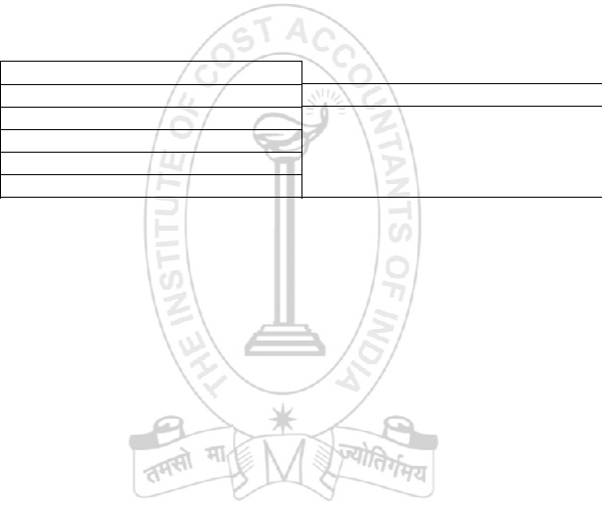

Past 5 years, profits of the company were as under:

Year(s)

2005-06

2006-07

2007-08

2008-09

2009-10

- (in lacs)

67

-1305 (loss)

469

546

405

The unusual negative profitability of the company during 2005-06 and 2006-07 was due to the lock out in the major manufacturing unit of the company which happened in the beginning of the second quarter of the year 2005-06 and continued till last quarter of 2006-2007.

Value the Goodwill of the company on the basis of 4 years’ purchase of the Super Profit. ( Necessary assumption for adjustment of the Company’s inconsistency in regard to the dividend payment may be made by the examinee).

Answer to Question No 6:

(1) Calculation of capital employed

PQR Ltd.

Present Value of the assets: | ` ( in lacs) | ` (in lacs)
Premises and land | 1,200
Plant & Machinery | 2,400
Motor Vehicles (book value less depreciation for ½ year) | 36
Raw materials | 920
Work-in Progress | 130
Finished Goods | 180
Book debts (400*90%) | 360

11

Suggested Answers to Question ‐ BVM

 | Investments |  | 1,500
 | Cash in Bank and Cash in hand |  | 192 | 6,918
 | Less Liabilities
 | Provision for taxation |  | 300
 | 5% debentures |  | 2,000
 | Secured Loans |  | 200
 | Sundry Creditors |  | 300 | 2,800
 | Total Capital employed on 31.03.2007 |  |  | 4,118
(2) | Profit available for shareholders for the year 2010-2011
 |  |  | ` ( in lacs) | ` (in lacs)
 | Profit for the year as per Balance Sheet |  |  | 1,100
 | Less Depreciation to be considered
 | Premises and land |  | 24*
 | Plant & Machinery |  | 240*
 | Motor Vehicles |  | 4 | 268
 |  |  |  | 832
 | Less Bad debts |  |  | 40
 | Profit for the year 2010-11 |  |  | 792
(3) | Average capital employed
 |  |  |  | ` (in lacs)
 | Total capital employed |  |  | 4,118
 | Less: ½ of profit for the current year ( Refer point 2) |  |  | 396
 | Average capital employed |  |  | 3,722
(4) | Average profit to determine Future Maintainable Profits:
 | Profit for the year |  | Rs. (in lacs)
 | 2010-11 |  | 792
 | 2009-10 |  | 405
 | 2008-09 |  | 546
 | 2007-08 |  | 469
 | Total |  | 2,212
 | Average profit |  | 2,212/4= 553

12

Suggested Answers to Question ‐ BVM

- Calculation of General Expectation:

PQR Ltd. Pays `2 as dividend (20%) for each share of `10. Hence on basis of similar Company the Market value of equity share denomination is `25 which fetches dividend of 20% on face value.
Therefore, share of `10 (Face value of shares of PQR Ltd) is expected to fetch (20/25)×10 = 8% return.

Since PQR Ltd is not having a stable record in payment of dividend in the past, in its case the expectation may be assumed to be slightly higher, say 10%.

- Calculation of super profit:

  - (in lacs)
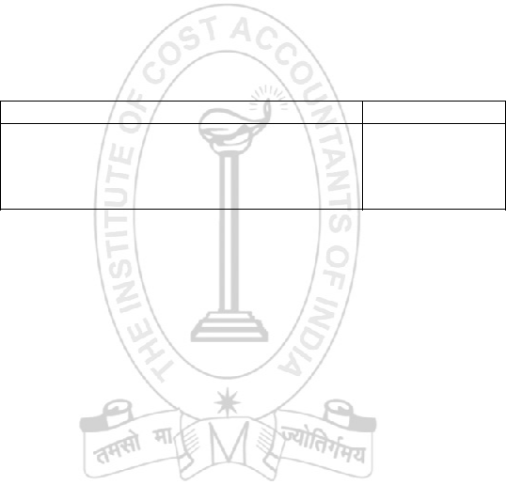

Future maintainable profit (see point 4) | 553
Normal Profit (10% general expectation, of average capital | 372.2
employed as computed in point 3)
Super Profit | 180.8

- Valuation of Goodwill:

Goodwill at 4years’ purchase of Super Profit is 723.20

Notes:

  - It is evident from the Balance Sheet that depreciation was not charged to Profit & Loss account, and is therefore charged on adjusted asset values.
  - It is assumed that provision for taxation already made is sufficient.

  - While considering past profits for determining average profit, the years 2005-06 and 2006-07 have been left out, as during these years, normal business was hampered.

Question : | [15]

- Crystal (India) Limited has changed its focus from “ Profit Maximization” to “ Value Maximization” and accordingly, it is changing its whole strategic road-map for future. In this exercise, they have to see what divisions are creating value and what are destroying value so that it should divest from value destroying divisions.

13

Suggested Answers to Question ‐ BVM

Assume that you have been assigned to estimate the value of one of their divisions-Engineering Division. For that you have been provided the following necessary information:

(` in lacs)

 |  |  | Actual
 |  |  | 2010-11 | 2011-12 | 2012-13
A. Partial Profit and Loss |  |  | Account
Net Sales |  |  | 1000.0 | 1050.0 | 1102.5
Less | Operating Cost |  | 810.5 | 850.5 | 893.0
except Depreciation
Operating |  | Profit | 189.5 | 199.5 | 209.5
(Without Depreciation)
Less Depreciation |  |  | 59.0 | 62.0 | 65.0
Earnings |  | before | 130.5 | 137.5 | 144.5
Interest and Taxes
B.Partial |  | Balance
Sheet
Assets:
Inventories |  |  | 300.0 | 315.0 | 330.8
Debtors |  |  | 80.0 | 84.0 | 88.2
Cash | and | Bank | 10.0 | 10.5 | 11.0
Balance
Total Current Assets |  |  | 390.0 | 409.5 | 430.0
Net Fixed Assets |  |  | 590.0 | 619.5 | 650.5
Liabilities:
Creditors |  |  | 50.0 | 52.5 | 55.1
Outstanding Expenses |  |  | 60.0 | 63.0 | 66.2
Total Current Liabilities |  |  | 110.0 | 115.5 | 121.3
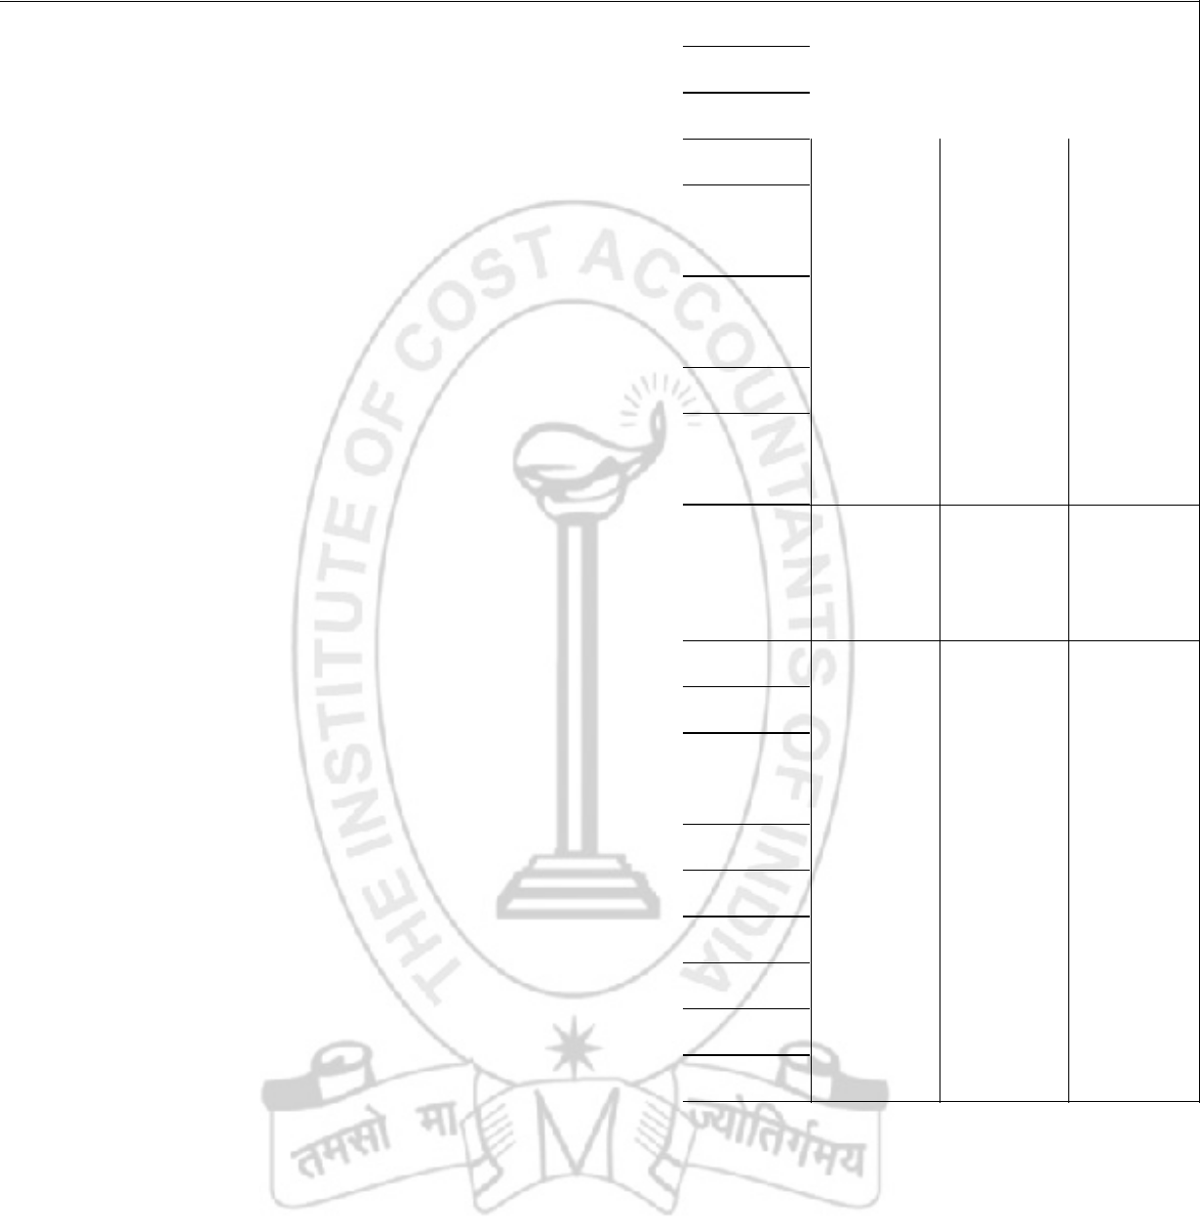

Projected
2013-14
2013-14 | 2014-15 | 2015-16 | 2016-17
1157.6
1157.6 | 1215.5 | 1276.5 | 1300.0
937.7
937.7 | 984.6 | 1033.8 | 1046.8
219.9
219.9 | 230.9 | 242.7 | 253.2
68.3
68.3 | 71.7 | 75.3 | 78.5
151.6
151.6 | 159.2 | 167.4 | 174.7

347.3 | 364.7 | 382.9 | 400.0
92.6
92.6 | 97.2 | 102.1 | 118.5
11.6
11.6 | 12.2 | 12.8 | 13.1
451.5
451.5 | 474.1 | 497.8 | 531.6
683.0
683.0 | 717.1 | 753.0 | 777.5
57.9
57.9 | 60.8 | 63.8 | 66.7
69.5
69.5 | 72.9 | 76.6 | 78.5
127.4
127.4 | 133.7 | 140.4 | 145.2

After 2016-17, it is expected that the cash flows will grow at a growth rate of 8%. The Company pays tax at the rate of 40% and it has cost of funds of 14%.

Using the Free Cash Flow Valuation Method, you are required to determine the value of the division.

Years | 1 | 2
Discount Factor @14% | 0.8772 | 0.7695

3

0.6750

4 | 5 | 6
0.5921 | 0.5194 | 0.4556

14

Suggested Answers to Question ‐ BVM

 | Answer to Question No 7:
 |  |  |  |  |  | CRYSTAL (INDIA) LTD |  |  |  |  |  | (` In lakh)
 |  |  |  |  | Actual |  |  |  |  | Projected
 |  |  |  |  |  |  |  |  |  | 2013-14
 |  |  |  |  | 2010-11 |  | 2011-12 | 2012-13 |  | 2013-14 | 2014-15 | 2015-16 | 2016-17
 | Calculation of Free Cash
 | Flows
 |  |  |  |  | 280.00 |  | 294.00 | 308.70 |  | 324.10 | 340.40 | 357.40 | 386.40
 | Net Working capital |  |  |  | 280.00 |  | 294.00 | 308.70
 | Net Fixed assets |  |  |  | 590.00 |  | 619.50 | 650.50 |  | 683.00 | 717.10 | 753.00 | 777.50
 |  |  |  |  |  |  |  |  |  | 1007.10
 | Net Operating Capital |  |  |  | 870.00 |  | 913.50 | 959.20 |  | 1007.10 | 1057.50 | 1110.40 | 1163.90
 | Increase in Net
 | Operating Capital (A) |  |  |  |  |  | 43.50 | 45.70 |  | 47.90 | 50.40 | 52.90 | 53.50
 | Net Operating Profit After
 | Tax
 | [NOPAT=EBITX(1-t) (B) |  |  |  | 78.30 |  | 82.50 | 86.70 |  | 90.96 | 95.52 | 100.44 | 104.82
 |  |  |  |  |  |  |  |  |  | 43.06
 | Free Cash Flows |  |  |  |  |  | 39.00 | 41.00 |  | 43.06 | 45.12 | 47.54 | 51.32
 | (B-A)
 |  |  |  |  |  |  |  |  |  | 0.6750
 | Discount Factor @ 14% |  |  |  |  |  | 0.8772 | 0.7695 |  | 0.6750 | 0.5921 | 0.5194 | 0.4556
 | Present Value of Free Cash |  |  |  |  |  | 34.21 | 31.55 |  | 29.07 | 26.77 | 24.69 | 23.38
 | Flow
 | Total of Present Value |  |  |  | 169.61
 | Value of Division at the end of the
 | 2016-17 using a Constant Growth
 | Model = 104.82X(1+0.08)/ (0.14 - 0.08) |  |  |  |  |  | 1886.76
 | Present value of the above
 | = 1886.76X0.4556
 |  |  |  |  |  |  | 859.61
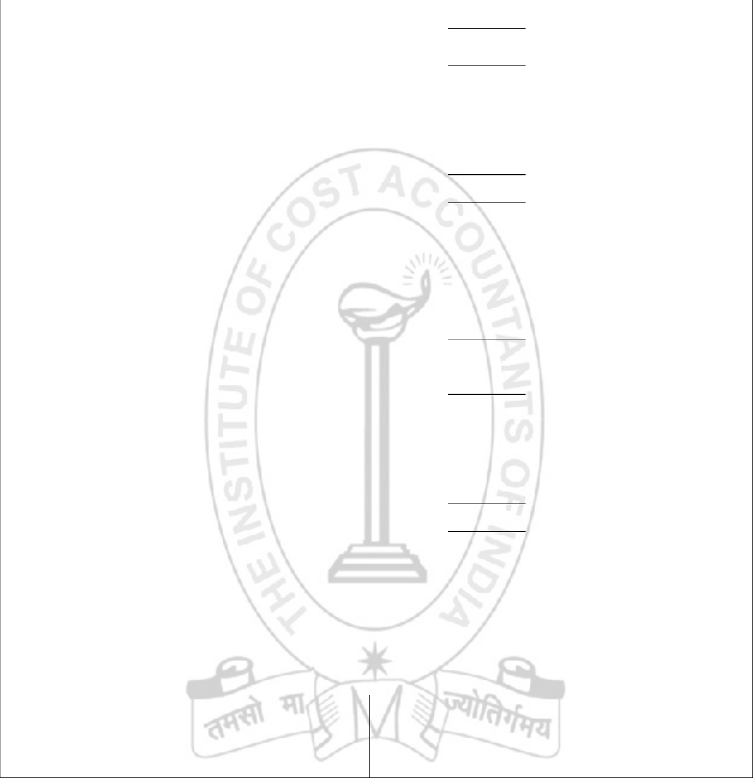

Therefore, the total value of the Engineering Division
(169.61+859.61) = 1029.22

Question :

8. (a) What ate the defensive strategies available to a Company in case of hostile takeover? | [5]

- Fair Ltd is considering takeover of White Ltd and Black Ltd. The financial data for the three companies are as follows:

15

Suggested Answers to Question ‐ BVM

Particulars |  | Fair Ltd | White Ltd | Black Ltd
Equity Share Capital of |  | 900 | 360 | 180
`10 each (` Million) |  | 900 | 360 | 180
Earnings (` Million) |  | 180 | 36 | 36
Market price of | each | 120 | 74 | 92
share (`) |  | 120 | 74 | 92

You are required to calculate:-

- Price Earning Ratios

- Earning per share of Fair Ltd after acquisition of White Ltd and Black Ltd separately.

(iii) Will you recommend the merger of either/both of the companies? Justify your answer. | [10]

Answer to Question No 8(a):

The defensive strategies available in case of hostile takeover may be preventive measures and active measures.
  - Preventive measures are undertaken to reduce the chances of hostile takeover bids. They are as follows:-

    - Poison pill is a tactic to make a takeover more expensive or unattractive so that task of the bidder becomes more difficult.

    - Golden parachutes – Unacceptably high compensation packages that must be paid to the senior managers in case of termination, so raider loses interest.

    - Shark repellents – Amendments made in company charter to forestall takeover attempts.

    - Crown jewel option – is to sell the valuable assets of the firm at below market price.

- Active measures are employed when hostile bids are launched.

    - White Knight - A friendly party saves the company from hostile takeover.

    - Greenmail – Premium paid by a target company to buy back its stock from a potential acquirer.

    - Standstill agreements – Target company reaches a contractual agreement with potential buyer that buyer will not increase his holding in the target firm for a particular period.

16
Suggested Answers to Question ‐ BVM

D. Capital Structure Changes – These includes ownership reorganization, employee stock ownership plans, leveraged buyouts etc.
- Pac – Man defence – The company under attack turns table by bidding for the acquirer company.
- Litigation – One of the most common antitakeover measures and used as a delaying tactic.

- Trigger the application of state anti-takeover laws.


Answer to Question No 8(b):

(i) Calculation of P/E ratio:-

Particulars | Fair Ltd
Earnings (` Million) | 180
No of Shares (Million) | 90
EPS (`) | 2
Market Price per share (`) | 120
P/E Ratio | 60

White Ltd

36

36

1

74

74

Black Ltd.

36

18

2

92

46

(ii) EPS of Fair Ltd after acquisition of White and Black Ltd separately.

Particulars | Fair Ltd
Value of shares (` Million) | 10,800
No of Shares of Fair Ltd to be
given (Millions)
Shares to be issued
Total earnings after acquisition (`
Million)
Total Number of shares after
acquisition
EPS after acquisition

White Ltd

2,664

2,664/120

22.2

216

112.2

1.93

Black Ltd.

1,656

1,656/120

13.8

216

103.8

2.08

- EPS of Fair Ltd. after acquisition with Black Ltd is higher than EPS of Fair Ltd. itself as well as

EPS if Fair Ltd acquires White Ltd. Hence, merger with only Black Ltd is suggested to increase the value to shareholders of Fair Ltd.

17

