DATE __________________ CUSTOMER NUMBER ____________________

TENANT INFORMATION FORM

I / We _______________________________________________________________________, prospective

tenant(s) / buyer(s) for the property located at ________________________________________________ ,

Managed By: _______________________________ Owned By: _____________________________________ ,

Hereby allow TENANT CHECK LLC and or the property owner / manager to inquire into my / our credit file, criminal, and rental history as well as any other personal record, to obtain information for use in processing of this application. I / we understand that on my / our credit file it will appear the TENANT CHECK LLC has made an inquiry. I / we cannot claim any invasion of privacy or any other claim that may arise against TENANT CHECK LLC now or in the future.

 |  | PLEASE PRINT CLEARLY
TENANT INFORM ATION: |  |  | SPOUSE / ROOM M ATE:
SINGLE_________ |  | MARRIED __________ | SINGLE_________ |  | MARRIED __________
SOCIAL SECURITY #: |  |  | SOCIAL SECURITY #:
FULL NAME: |  |  | FULL NAME:
DATE OF BIRTH: |  |  | DATE OF BIRTH:
DRIVER LICENSE #: |  |  | DRIVER LICENSE #:
CURRENT ADDRESS: |  |  | CURRENT ADDRESS:
 |  | HOW LONG? |  |  | HOW LONG?
LANDLORD & PHONE: |  |  | LANDLORD & PHONE:
______________________________________________________________ |  |  | ______________________________________________________________
PREVIOUS ADDRESS: |  |  | PREVIOUS ADDRESS:
 |  | HOW LONG? |  |  | HOW LONG?
EMPLOYER: |  |  | EMPLOYER:
OCCUPATION: |  |  | OCCUPATION:
GROSS MONTHLY INCOME: |  |  | GROSS MONTHLY INCOME:
LENGTH OF EMPLOYMENT: |  |  | LENGTH OF EMPLOYMENT:
WORK PHONE NUMBER: |  |  | WORK PHONE NUMBER:
HAVE YOU EVER BEEN ARRESTED? |  |  | HAVE YOU EVER BEEN ARRESTED?
(CIRCLE ONE) | YES | NO | (CIRCLE ONE) | YES | NO
HAVE YOU EVER BEEN EVICTED? |  |  | HAVE YOU EVER BEEN EVICTED?
(CIRCLE ONE) | YES | NO | (CIRCLE ONE) | YES | NO
SIGNATURE: |  |  | SIGNATURE:
PHONE NUMBER: |  |  | PHONE NUMBER:
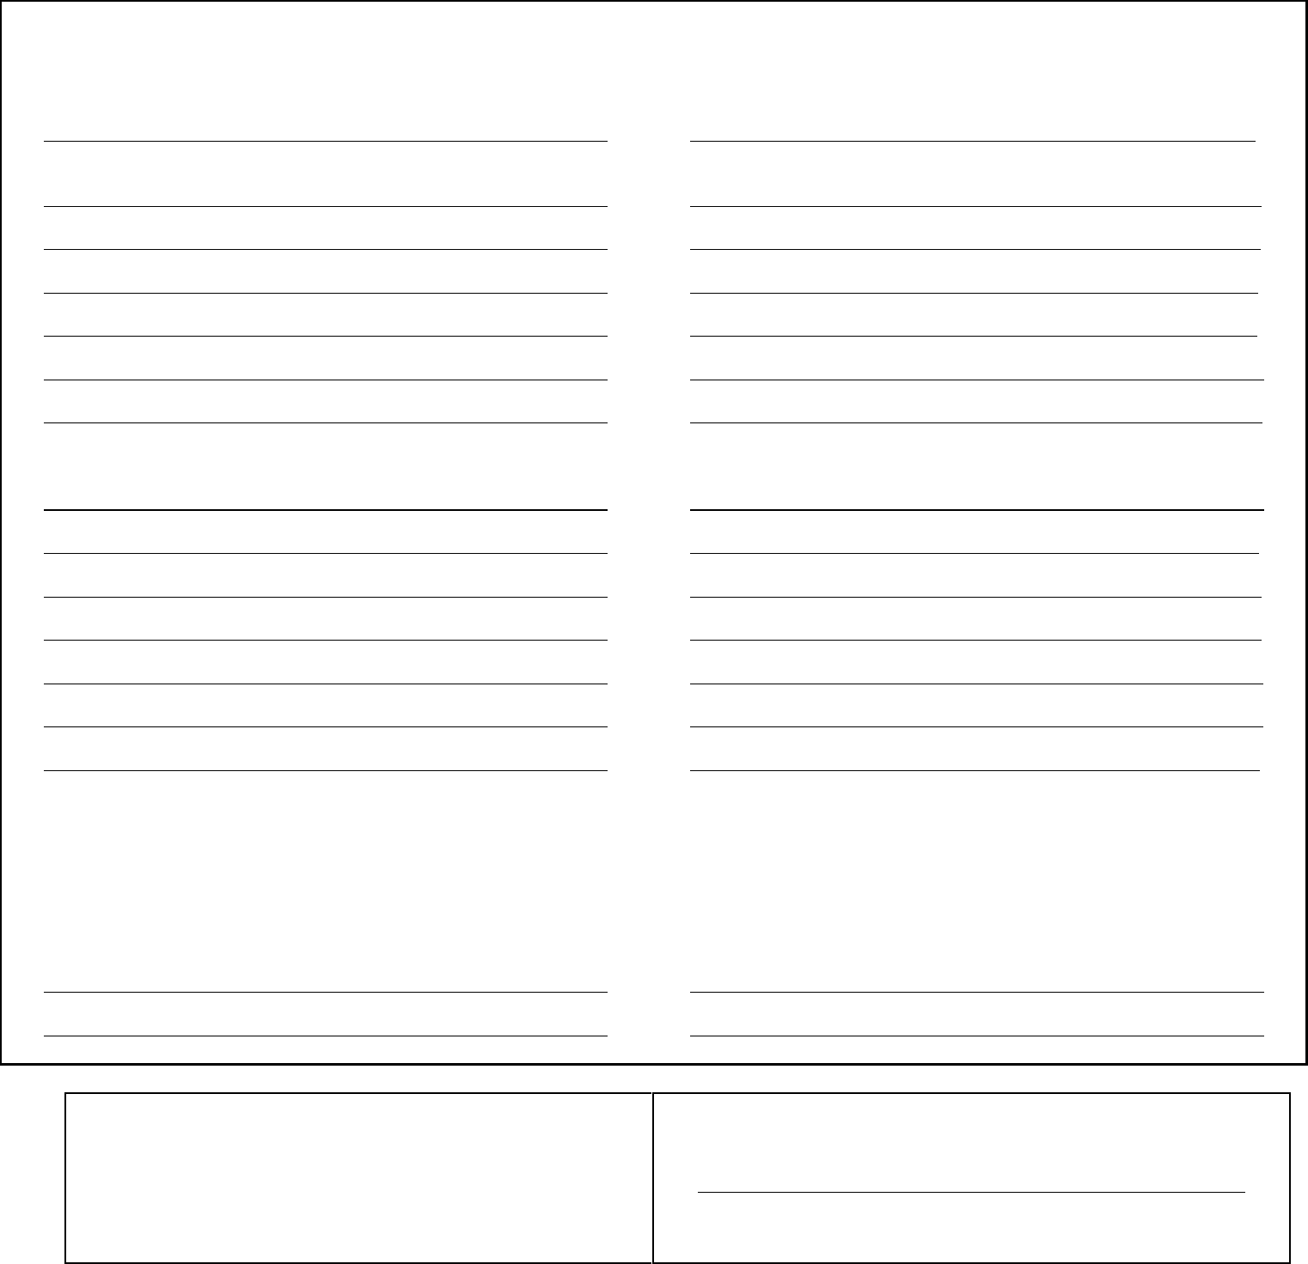

TENANT CHECK HOURS OF OPERATION: | IF THE WRONG SOCIAL SECURITY NUMBER IS SUBMITTED, A
MONDAY - FRIDAY : 9:00 a.m. - 5:30 p.m. | SECOND APPLICATION FEE WILL BE CHARGED TO RE-PULL THE
SATURDAY : 11:00 a.m. - 4:00p.m. | REPORT.
ALL ORDERS RECEIVED AFTER 3:00 p.m. (2:00 p.m. on Sat.)WILL BE PROCESSED THE
NEXT BUSINESS DAY | A CREDIT REPORTING SERVICE PROVIDING CREDIT REPORTS FOR
email@tenantcheckllc.com | REALTORS / PROPERTY MANAGERS / APARTMENT COMPLEXES /
email@tenantcheckllc.com | MOBILE HOME PARKS / CONDOMINIUM ASSOCIATIONS / EMPLOYERS

FEDERAL LAW REQUIRES THE END USER TO MAINTAIN THIS FORM FOR A PERIOD OF FIVE YEARS (tenant check application rev. 03/2015)

