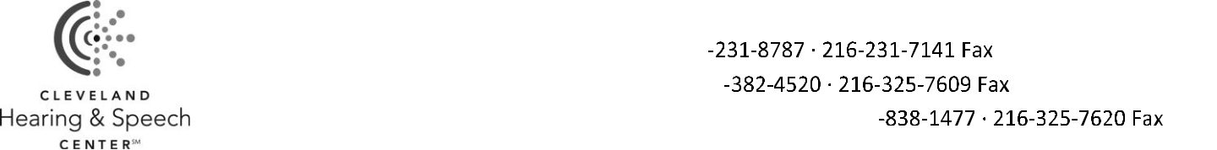

AGREEMENT TO PAY / INSURANCE RELEASE FORM


Patient Name: ______________________________________________________________ DOB: _________________________

Responsible Party Name________________________________________________ Relationship: _________________________

- “I acknowledge receiving a copy of the Notice of Privacy Practices.”

Thank you for choosing Cleveland Hearing & Speech Center (CHSC) as your provider of services. We appreciate the opportunity and privilege of participating in your care. With respect topayment of services, please review the following policies.

- Fees are charged for the professional services rendered. You, as the responsible party, accept complete financial responsibility for payment of all services provided.

- You are expected to pay all deductibles, co-‐pays, co-‐insurance amounts and non-‐covered services at the time of service. If you have a high deductible plan ($1000 or more) you are required to pay for services at the time of service until the deductible is met. CHSC offers an automatic payment option for your convenience, please ask the office manager for details. We will bill your insurance company for all covered services.

- You are financially responsible for payment in full for any services that are denied as a non-‐covered service, not medically necessary, or if you failed to notify us of changes in insurance coverage, or if you did not obtain a referral or authorization as required by your insurance company.

- You are responsible for notifying CHSC immediately of any changes in your insurance policy and for obtaining insurance related referrals and/or authorizations.

- If payment on a claim we submit is not received from Medicare, Medicaid, private insurance companies, or other third party payers within 90 days, you are responsiblefor payment of the balance in full at that time. If your insurance company makes a payment after 90 days, you will be issued a refund within 30 days of payment equal to the amount paid by the insurance company.

- If CHSC is a not a participating provider (out of network) with your insurance company, you are responsible for payment in full at the time of service. We will submit a claim to your insurance company on your behalf. If your insurance company makes a payment on the claim, you will be issued a refund check within 30 days of receipt of payment equal to the amount paid by the insurance company.

- CHSC may release patient information to third party payers and anyone assisting us in obtaining payment, including billing, coding, and collection agents and to the provider’s attorneys and consultants.

- CHSC reserves the right to discontinue services if you do not pay for your services.

- I understand that CHSC cannot guarantee payment from participating insurance providers for services. Therefore, if my insurance carrier denies payment, I agree to befully responsible for payment.

- I request that payment under my third party payer(s) be made directly to CHSC and I authorize them to submit a claim to the third party payer(s) on my behalf. I understand and agree to CHSC’s policies as stated here.

___________________________________________________________ Responsible Party Signature

_________________________ Date

Agreement to Pay-‐Insurance Release 3

