An Alternative Approach to Estimating Foreclosure and

Short Sale Discounts*

† ‡ § ¶
James N. Conklin, N. Edward Coulson, Moussa Diop, and Nuno Mota

January 25, 2022

Abstract

Existing studies generally document large price discounts for foreclosures and short sales, implying large inefficiencies in real estate markets. We consider an alternative approach that leverages the expertise and local market knowledge of residential real estate appraisers. Our approach deals with omitted property characteristics and locational factors that likely plague existing estimates of foreclosure and short sale discounts. Using traditional approaches on a large nationally representative sample of residential real estate appraisals, we find discounts of approximately 20%, consistent with the existing literature. However, after implementing our methodology the foreclosure and short sale discounts are drastically reduced to roughly 5%.

*We thank Mike Eriksen, Kris Gerardi, Michael LaCour-Little, Lauren Lambie-Hanson, Ruchi Singh and Patrick Smith for valuable comments. The views presented in this document are those of the authors and do not represent those of their respective institutions.
- Terry College of Business, University of Georgia, Athens, GA
- Paul Merage School of Business, University of California, Irvine, Irvine, CA
- Sol Price School of Public Policy, University of Southern California, Los Angeles, CA

  - Fannie Mae, Washington, DC

- Introduction

The size of price discounts associated with forced sales of real estate assets remains an unset-tled question.¹ In their widely-cited study of forced sales of Massachusetts properties, Campbell, Giglio, and Pathak (2011) document astonishingly large foreclosure discounts of 27% on average, with much larger discounts recorded for low-price houses and in low-price neighborhoods. Dis-counts of similar magnitudes have been documented in other U.S. contexts (Doerner and Leventis, 2015; Donner, 2020; Forgey, Rutherford, and VanBuskirk, 1994; Mehrotra, Nowak, and Smith, 2021; William and Marvin, 1996), as well as Sweden (Donner, Song, and Wilhelmsson, 2016), Germany (Just et al., 2019), and Italy and Poland (Renigier-Biłozor et al., 2018). Many studies find price discounts of 20% or more, especially for foreclosure sales. Even though there is wide agreement that forced property sales likely cause non-trivial price discounts, there is no consensus on the exact magnitude of these discounts and even more modest estimates of 12 to 15% found in the literature seem implausibly large (Clauretie and Daneshvary, 2009).²

Hedonic (log) sales price regressions are generally used to identify forced sale discounts by including a forced sale indicator as well as a large number of covariates that attempt to control for key property and neighborhood characteristics. A primary concern, of course, is whether char-

- In what follows we use the terms “forced sale” and “distressed sale” interchangeably to refer collectively to foreclosure and short sales. We define foreclosure and short sales in a manner consistent with most of the literature. A foreclosure refers to a property sold as real estate owned (REO) – when the lender forecloses on the property, takes ownership, and sells it on the market. A short sale is a lender approved pre-foreclosure sale where the lender’s net proceeds are generally less than the mortgage balance. The definition of a distressed sale is not universal across studies and early work in this area was not always consistent about the definition of distress, and the distinction between different types of distressed sales (Doerner and Leventis, 2015). Most studies (including our own) use post-foreclosure REO sales to estimate the foreclosure discount, however, Chinloy, Hardin, and Wu (2017) also explore discounts associated with foreclosure auctions. Other studies make no distinction between REO sales and short sales and thus estimate an average of the two discounts (Conklin, Coulson, and Diop, 2021). Furthermore, earlier studies may have had difficulty identifying distressed sales due to data limitations (Doerner and Leventis, 2015). Therefore, caution is required when comparing our discounts to earlier studies.

²Clauretie and Daneshvary (2009) and Carroll, Clauretie, and Neill (1997) find smaller discounts likely due to sample selection. Harding, Rosenblatt, and Yao (2012) find that the majority of real estate owned (REO) purchases do not earn economically significant excess returns, but this says little about the level effect of foreclosures, with which the research is generally concerned.

1

acteristics that are unobservable to the econometrician covary with both forced sales and prices. Indeed, this concern speaks to the definition of the forced sale discount itself. Generally, one can think of four broad reasons why the coefficient of the forced sale indicator would be negative in a hedonic regression:

- Foreclosed homes are likely of lower quality, on average, or are in less desirable locations, than arm’s length transactions. This difference in quality is not always observable to the econometrician and would thereby confound estimates of the discount. Indeed, after a thor-ough review of the extant literature, Frame (2010) suggests that omitted covariates likely result in the considerable variations in foreclosure discounts found in published studies.³ Clearly, such quality differences are not part of the distressed discount, in so far as they are not a causal impact from the distressed state of the property. Regression models of the foreclosure discount therefore need careful and complete specification in order to avoid omitted variable bias in the estimate of the forced sale parameter.

- However, there may be differences in condition or quality that are caused by the distress itself. This may come about because the distressed owner has less financial stake in the upkeep of the property and so may neglect routine maintenance, and in the limit, abandon the property and create conditions for vandalism of the structure (Lambie-Hanson, 2015). While this may be properly thought of as part of the distressed discount, differences in condition are often not available to the outside observer.

- Sales of distressed property are often from sellers with greater urgency than in the usual

arm’s-length transactions. Distressed sellers are usually financial institutions who have little

³Frame (2010) also points to sample differences as a driver of discrepancies in estimated discounts. He suggests that studies using repeat sales are likely to yield more accurate estimates. However, while a repeat sales estimator can remove the impact of time-invariant unobservable house characteristics, such an approach may not necessarily yield accurate discount estimates because property quality is likely to change over time, in the wake of rehabilitation of distressed housing units.

2

wish to carry real assets in their portfolio and are motivated for rapid disposition of property. There is a well-known tradeoff between the sale price of homes and time on the market (Haurin et al, 2010) and this may contribute to the lower transaction prices of distressed property (Clauretie and Daneshvary, 2009).⁴

- Finally, there is potential for “foreclosure stigma”. A distressed property may sell for a lower price simply because of fear of hidden damage or other negative indicators in the unit. The problem of asymmetric information on property quality is well-known (Lopez, 2021; Stroebel, 2016) and may be even more pronounced in distressed sales (Goodwin and Johnson, 2017).

Any given estimate of the distressed discount will have to reckon with whether said discount includes any or all of the above contributors to the conditional price differential between distressed and non-distressed properties, and whether such contributors are a causal impact of distress.⁵

We provide an alternative methodology to estimating distress discounts, which while related to traditional regression methods, employs a novel matching technique to these traditional pro-cedures. In doing so, we are able to shed light on the sources and size of the contributors to distressed sale discounts. We employ a data set from a large secondary market purchaser of mort-gages, which contains not only data on property transactions but also on the professional appraisal typically required by the mortgage lender. These appraisals use recent transactions of comparable properties – comparables, or “comps” – to provide information on the market value of the subject property. The key to our estimation procedure is that these comps, which include distressed sales, are selected precisely because they are good matches to the subject property on a large number of

- In short sales further issues that may discourage investor activity, hence lead to discounts, include the potential low level of engagement of the borrower and the possibility for multiple lien encumbrances, which the foreclosure process would clear but a short sale would not.

⁵In addition to differences in controls, there would seem to be significant geographic heterogeneity in the discount estimates. The sample of Campbell, Giglio, and Pathak (2011) is limited to the Boston area while lower-end estimates of Carroll, Clauretie, and Neill (1997) and Clauretie and Daneshvary (2009) are from Las Vegas. Note as well the significant geographic variation estimated in Zhou et al. (2015).

3

dimensions. Properly matching comparables to subject properties is a core function of appraisers, and local market expertise is required to ensure that the properties are similar along dimensions that are difficult for an outsider to observe. Thus, within a given appraisal, the properties are not only a good match to the subject property, but also to each other. In our procedure, we will, in essence, compare transaction prices of arm’s length comps with forced sale comps within the same appraisal, which allows us to estimate forced sale discounts which are (largely) free of bias from omitted property and location characteristics. Our procedure is thus akin to a matching estimator, where the matching is accomplished not by a statistical procedure but by a local expert.⁶

The data set consists of residential property appraisals conducted in all 50 states from 2013 to 2017, which coincides with the recovery from the 2008 housing market crash. It contains infor-mation on roughly 7.3 million home appraisals associated with home purchase loan applications based on 28 million comparable property sales, including both forced and arm’s-length sales. The data link each appraisal to the comparables used by the appraiser, contain the sales price, charac-teristics, and location of comparables, and, unlike most available data, capture the condition and quality of these properties. Furthermore, the data distinguish foreclosure from short sales in the comparable transactions, thus allowing us to compare the price impacts of these two main channels used to dispose of distressed real estate properties.

We estimate a sequence of regression models that provide increasingly stringent controls, in order to mirror previous work in this area, and then ending with our appraiser-based matching model. The foreclosure and short sale discount estimates significantly drop from 34% and 16%, respectively, to roughly 15% after progressively accounting for neighborhood attributes and time-varying trends with location (census tract) and time (year) fixed effects; property characteristics; and property conditions, quality, and location and view desirability. This 15% figure matches some of the most conservative estimates found in the literature. By using appraisal fixed effects, which

⁶The most common appraisal forms (1004, 1073, 1004C, 1025, and 1004D) require the appraiser to certify that “I selected and used comparable sales that are locationally, physically, and functionally the most similar to the subject property” (Fannie Mae, 2020; FHA, 2020).

4

eliminate unobservable differences in property location, characteristics, quality and condition, we substantially lower the foreclosure and short sale price discount estimates to roughly 5%. We note that the size of the short sale discount is nearly identical to the foreclosure discount, which stands in stark contrast with findings in the existing literature. Further robustness checks indicate that (while we do not measure seller urgency directly) the discount is not due to differential liquidity. Our final estimates of distressed sales discounts therefore most likely measure market stigma. Further robustness checks indicate that our estimates are largely (and rather surprisingly) invariant to choice of submarket and other sample segmentation. Therefore, we conclude that the use of our appraisal fixed effects resolves the puzzle of widely varying estimates of previous research.

A potential issue with our methodology is the possibility that appraisers may select only par-ticularly high-value distressed properties as comps, which would mechanically bias the discounts towards zero. We believe this is not a major concern in our study for two reasons. First, Conklin, Coulson, and Diop (2021) establish that there are only modest observable differences between distressed and non-distressed comps within the same appraisal. Therefore, except for being dis-tressed, distressed comps are good matches to non-distressed comps. Second, in this study we examine whether discounts vary with market liquidity. In relatively illiquid markets, where com-parable sales transactions are scarce, the appraiser is not afforded the luxury to select only favorable comps. Thus, if this type of selection is at play, we would expect larger distress sale discounts in illiquid markets. However, we find no evidence that distress discounts vary with market liquidity.

Our approach yields much smaller forced sale discount estimates than are typically documented in the literature, which is important for several reasons. First, it has implications for real estate mar-ket efficiency. Large forced sale discounts seem to imply great inefficiencies in real estate markets. In contrast, our results suggests these inefficiencies may be much smaller than previously imag-ined. Second, our findings are closely related to the literature that documents the negative spillover effects of distressed sales have on the prices of nearby properties.⁷ These negative externalities are

⁷See Frame (2010) for a critical review of this literature. In a recent contribution, Biswas et al. (2021) provide

5

often used as justification for government intervention in housing and mortgage markets. However, these spillover effects presuppose a large forced sale discount, so understanding the size and source of the discount has important policy implications. Third, our estimates are relevant to mortgage credit risk modelling. A key input in these models is loss conditional on default, which depends critically on forced sale discounts. Finally, previous studies document significantly smaller dis-counts for short sales relative to foreclosures, which seems to imply that short sales are a dominant loss-mitigation tool from the lender’s perspective. In contrast, we find that the foreclosure and short sale discounts are similar in magnitude, which may help explain why short sales are not more prevalent.⁸

The rest of the paper is organized as follows. The next section presents a short accounting of both econometric and appraiser estimates of the forced sale discount. Section 3 describes the data used in this study. Next, Section 4 presents our empirical findings. Section 5 concludes.

- Estimating forced sale discounts

The vast majority of econometric estimates, such as those discussed in the previous section, arise in a regression model that includes a distressed indicator typically specified as:

P_{i} = X_{i h} + _{h}D_{i} | (1)

where for convenience we use a linear model, P_{i} is the sale price of property i, X_{i} is a vector of property characteristics, _{h} is the vector of characteristic prices as estimated by a hedonic re-gression, D_{i} is a dummy identifying distressed properties (comps), _{h} is the hedonic regression estimate of the distress discount. For convenience we suppress the error term.

evidence that spillover effects are driven in large part by disamenities associated with lack of property maintenance on REO properties.

⁸Zhang (2019) provides a borrower-driven explanation for the low incidence of short sales – free rent during the foreclosure process.

6

We will estimate the above equation and employ a variety of specifications for the X vector in order to approximate models from previous research. These specifications will include a baseline unconditional forced sale differential (i.e. X is empty), as well as specifications that will sequen-tially add hedonic characteristics, time and location effects, and less common controls such as view, condition and quality.

The appraiser has her own model of the price determination process of a subject property.

P_{s} = X_{s a} + _{a}D_{s} + u_{s} | (2)

where the s subscript refers to “subject property” – i.e. the one being appraised – and where the parameters with the a subscripts reflect the weights used by an appraiser in the appraisal process. There is also an additional term, u_{s}, which represents attributes of the location that are observed by the appraiser but not by the econometrician. As a rule, the appraiser does not actually observe u_{s}, but can account for its influence by the use of comparable sales.

The appraisal process thus begins with an appraiser’s selection of a small number of recent sales in the same development or neighborhood as the subject property. Recency is an important feature of the comps, as it allows for the appraiser to ignore local price trends, but this is observable to the econometrician and controlled for by the use of time fixed effects. Also, with fine enough geographic controls, the econometrician can observe the impact of neighborhood or location ef-fects. The u_{s} thus are accounting for more fine-grained site impacts or other unobservables. What is important is that the comparable properties are chosen precisely because the property features that are made manifest in the u terms are the same in the subject property and on that account the same as in the other comps that are used in the subject property appraisal.

Now consider a regression that uses as observations all of the comparable property sales – and

7

not the subject properties themselves – from all of the appraisals in our data set:

P_{ij} = X_{ij h} + _{h}D_{ij} + u_{j} + !_{ij} | (3)

where P_{ij} and X_{ij} are the transaction price and characteristics of the i^{th} comparable property from j^{th} appraisal. In this model the u_{j} terms become appraisal-level fixed effects. These appraisal fixed effects can account for the aforementioned unobservables that are common to all the prop-erties used as a comparable for a given appraisal. If the regression estimate of the forced sale discount from the same set of comparables using (1) is biased because of omitted characteristics, the inclusion of the appraisal fixed effects in regression (3) will remove a great deal of that error.

We stress that the unit of observation in both of our regression models (equations 1 and 3) is a comparable transaction. The subject property plays no role except as a focal point for appraiser’s matching procedure.

- Data

Our data come from a large secondary market purchaser of residential mortgage loans and include information on comparable transactions used to estimate values of subject properties in residential appraisals. A large share of financial institutions rely on the collateral valuation and mortgage underwriting platform of the data provider, which results in broad market coverage across the United States, including appraisals commissioned in all 50 states from 2013 to 2017. The database contains information on more than 28 million comps used in 7.3 million individual residential appraisals associated with home purchase loan applications. A sales transaction is often used as a comp in multiple appraisals, so the comps consist of 11.6 million separate sales transactions on 10.6 million unique properties.⁹

⁹The data contain a unique property identifier as well as the quarter-year when the comparable transaction occurred.
We consider each comparable property/transaction quarter combination as a unique sales transaction.

8

The data record basic characteristics of the comparable homes collected by the appraiser in-cluding information commonly used in hedonic valuation models (e.g., square footage., age, num-ber of bedrooms, number of bathrooms, etc.) as well as other characteristics not typically captured in standard housing databases (condition, quality, location and view). The data also includes a unique appraisal identifier linking each comp to a specific appraisal, which is essential for our matching estimator. The appraiser also records whether the comparable transacted as real estate owned (REO), a short sale, or an arm’s length transaction. The comparable transaction’s sale price is also recorded,

Appendix Table A.1 describes the home characteristics used in our study. We exclude ob-servations with missing housing characteristics as well as those missing a geographic identifier (census tract). We include only transactions classified as arm’s length, real estate owned, or short sales.¹⁰ We impose the following restrictions for homes to be included in our analysis: between 500 and 10,000 square feet of gross living area (GLA); lot size between 500 and 1,000,000 square feet; homes aged less than 150 years; less than 15 rooms total; less than nine bedrooms; sales price between $50,000 and $1,425,000; and sold between 2012 and 2017.¹¹ These data cleaning procedures drop 2.8% of of the original sample. The final cleaned sample includes 27,515,395 comparable home transactions.

Table 1 reports descriptive statistics by transaction type.¹² The table shows that arm’s length transactions have the highest average price ($276,000), followed by short sales ($232,000) and foreclosures ($183,000). Consistent with the literature, foreclosures and short sales appear to have systematic differences from arm’s length transactions with respect to observable characteristics that are typically included in hedonic valuation models, particularly in square footage, lot size and

¹⁰99.2% of the comps fall into one of these three transaction categories. The excluded categories are court ordered sales, estate sales, relocation sales, and non-arms length sales.

- Comparable transactions must occur prior to the appraisal, which explains why the comparable transaction year can differ from the appraisal year.

- Appendix Table A.2 presents more extensive descriptive statistics (mean, standard deviation, minimum and max-imum) for the full sample.

9

the existence of a basement. Foreclosures and short sales also differ from arm’s length transactions on characteristics that are typically not observable to researchers. Notably, they are in worse con-dition with lower construction quality. There are two important caveats with respect to condition and quality, as well as location and view. First, although the ratings definitions for these fields are clearly defined for the Uniform Appraisal Dataset (UAD), they are somewhat subjective in na-ture.¹³ Second, although many lenders and secondary market participants require that the appraiser inspects the comparable sales from at least the street,¹⁴ the appraiser typically does not perform an onsite interior inspection of the comps. Thus, one might wonder how interior condition and quality are determined. Conversations with industry professionals indicate that appraisers typi-cally rely on information reported on the multiple listing service (MLS), including photos and text descriptions.¹⁵ It is also common for the appraiser to contact the comp’s listing agent for additional information.

Table 1 clearly shows that there are observable differences in characteristics across transaction types, which may also indicate that there are important differences in unobservables as well. In the next section we address this using our matching estimator.

- Results

In this section we discuss our results and compare our foreclosure and short sale discount estimates with those in the literature. Table 2 presents estimates of the price discounts. The dependent

- See HUD (2015) for a description of the standardized ratings for quality, condition, location and view.

¹⁴The scope of work statement in the appraisal often includes the following language: “The appraiser must, at a minimum...inspect each of the comparable sales from at least the street.” For example, see the Uniform Residential Appraisal Report form available from Fannie Mae at https://singlefamily.fanniemae.com/media/ 12371/display.

- It is possible that the appraiser conducted the appraisal when the comp transacted as a subject property. In this case, the appraiser likely has information collected on the comp during a visual inspection stored in an internal database. The appraiser could use this information in subsequent valuations where this transaction is used as a comp. Conversations with appraisers suggest that this method is rarely, if ever, used in practice. Rather, they rely on MLS info, public records, or communications with other industry participants to source comp information even in these instances.

10

variable is the natural logarithm of the home sale price. For the sake of concision, we report the coefficient estimates for the foreclosure and short sale indicators in Table 2 – the coefficients on the other housing characteristics are of less interest, but we report them in Appendix Table A.3.

The model in column (1) of Table 2 includes only the foreclosure and short sale indicators and thus it estimates the unconditional effects of these variables on sale price. The coefficient on foreclosure is precisely estimated at -0.412, meaning that on average foreclosures sell at a discount of 1 exp( 0.412) = 34%. The short sale coefficient is precisely estimated at 0.172, corresponding to a price discount of 16%. This model has obviously no explanatory power because the price difference between distressed and non-distressed sale prices is unlikely to be solely caused by the distressed nature of the sale. There are a number of other differences in the two samples, and the next several columns attempt to control for these differences.

First, foreclosures and short sales likely occur in areas that differ systematically from locations where only arm’s length transactions are observed. For example, neighborhoods with volatile house prices or where individuals are particularly sensitive to employment shocks are more likely to have distressed sales. Additionally, time-varying national macroeconomic trends likely impact the prevalence of foreclosures and short sales. To address these issues, column (2) includes census tract and year/quarter dummies. This model shows a strong explanatory power. Relative to column

(1), the foreclosure coefficient is nearly halved, but it remains economically significant. The short sale coefficient in column (2) is similar to column (1). These new distress discount estimates suggest that foreclosures may be more clustered than short sales.

As we showed in Table 1, foreclosure and short sales are different, on average, in their observ-able housing characteristics. To control for this, in column (3) we include housing characteristics in our model. The foreclosure coefficient declines slightly to -0.200, which corresponds to an 18% price discount. The short sale discount is similar in magnitude. Basically, after finely controlling for location and national price trends, the inclusion of property characteristics only marginally im-proves the accuracy of our distress discount estimates. Notice that these price discounts are in line

11

with estimates from previous studies that control for property characteristics (Campbell, Giglio, and Pathak, 2011; Chinloy, Hardin, and Wu, 2017; Forgey, Rutherford, and VanBuskirk, 1994; Shilling, Benjamin, and Sirmans, 1990).

Properties sold through foreclosure or short sale are likely of inferior condition and quality, but these characteristics are generally unobservable to the econometrician (Lambie-Hanson, 2015). A unique feature of our data is that the condition and construction quality of the property are reported by the appraiser.¹⁶ We also observe whether the property has a beneficial (or adverse) view, or lo-cation, relative to the subject property. After controlling for condition, quality, location and view in column (4), both the foreclosure and short sale coefficients decline, and converge in magnitude. Controlling for these “observable” property quality and condition decreases the foreclosure dis-count by 16.7% (from 18% to 15%) and the short discount by 14.6% (from 16.4% to 14%). These estimates indicate that observable quality and condition differences between foreclosed and short-sale properties are not as large as generally expected, at least once other observables have been controlled for.

Recall that in performing the appraisal, the appraiser chooses comps that are similar to the subject property in terms of location, housing characteristics, condition, etc. The comps should also be similar along dimensions that are unobservable to researchers as well. We account for this matching by including individual appraisal fixed effects in column (5). The R-squared increases dramatically to 98%, which seems to suggest that the matching procedure by the appraiser is quite effective. Note that accounting for the appraiser’s matching also results in a dramatic decline in the estimated discounts. The foreclosure and short sale discounts are 4.5% and 5%, respectively, or roughly one third the size of those in column (5). Our previous estimations only control for observable differences between distressed and non-distressed properties. The addition of appraiser fixed effects allows to control for “unobservable” differences in property location, characteristics,

- Clauretie and Daneshvary (2009) estimate the foreclosure discount including dummies to account for property condition (excellent, good, fair and poor), as reported by the listing agent at the time of listing.

12

and condition by relying on appraisers’ property matching expertise. These smaller estimates sug-gest that omitted variables likely cause an overstatement of the foreclosure and short sale discounts observed in many earlier studies.¹⁷

Figure 1 presents the estimates of _{h} for both foreclosures and short sales as a sequence of symbols from left to right corresponding to columns 1 through 5 of Table 2. It will be seen that the values decline in absolute value in sequence.

It is important that we ascertain that our sample is devoid of selection problems that might cloud our findings. Under the reasonable assumption that the properties being appraised likely represent a random sample of distressed and arm’s length transactions, the main concern then is whether the selection of comps introduces bias in the models that use appraiser fixed effects. Appraisers do not necessarily select comps randomly, even within the subset of transactions meeting the requirement of recency and similarity to the subject property. They may succumb to price anchoring when selecting comps on purchase loans. This is not necessarily the case; what appears to be price anchoring could simply be matching on quality. However price anchoring in and of itself could lead to a downward bias in our distress discount estimates, especially in thick markets where appraisers may have access to a larger pool of transactions from which to select comparables.¹⁸ But even without intentionally matching on price, appraisers may select distressed comps that happen to be of a quality that will not lower the appraisal. Again, this would lead to larger estimates of distress

¹⁷A potential concern is that the distress dummies are picking up a “lowest price comp” effect, rather than true distress discounts. By definition, the lowest price comp within an appraisal has a sales price below the average comp sales price within that same appraisal. If distress comps are always (or usually) the lowest price comps within appraisals, then our regression results may simply capture a lowest price comp effect. We provide two pieces of evidence to rule out this possibility. First, distress comps are not usually the lowest price comps in appraisals that include a distress comp – the majority of lowest price comps in these appraisals are actually arm’s length transactions. Second, for each appraisal that contains a distress comp, we calculate the percentage difference between the lowest comp sales price and the average comp sales price. We plot the distribution of these differences by the transaction type in Figure A.1 in the appendix. If our estimated discounts were just capturing the lowest price comp effect, then we would expect the three distributions to be very similar. Clearly that is not the case, as the foreclosures and short sales distributions sit to the left of the arm’s length transactions distribution. These two pieces of evidence suggest that our observed distress discounts are not capturing a “lowest price comp” effect.

- Moreover, price matching will likely result in the selection of high-quality distressed comps, thus causing smaller discount estimates – selecting all comps, not just distressed ones, based on price would likely yield a similar outcome.

13

discounts in thinner markets where fewer comps are available.

To address these potential selection issues, we examine the impact of market thickness, the level of the activity in the local housing market, on our estimates of distressed sales discounts. Based on our previous discussion, we would expect the discount estimates found in thin markets to be greater in magnitude if our sample is plagued by these selection issues. For this exercise, we divide the sample into quintiles by market thickness, proxied by the number of comparable sales in the subject property’s neighborhood within the twelve months prior to the appraisal. This number is reported by the appraiser, and for most appraisals, it is significantly larger than the actual number of comps used in the appraisal. Note that this number is somewhat subjective as the appraiser reports what he deems as comparable sales. With this caveat in mind, it should still serve as a reasonable proxy for market thickness. Figure 2 shows foreclosure and short sale discounts by market thickness quintile. For all quintiles, the general pattern of estimated distressed sales discounts is as in Figure 1, thus suggesting that the appraiser’s selection of comps did not introduce significant selection bias in our analysis. Moreover, the consistency of our estimates across the market thickness quintiles suggests that market liquidity – time on market of comp sales – likely plays no major role in our estimates.¹⁹ Given the above catalog of contributors to foreclosure discounts, our conclusion is that given the wide set of controls in our final estimate, the most likely explanation for the 5% distress discount found in this study is market stigma.

Next, we check the robustness of our estimates along several other dimensions. In Figure A.2 we estimate _{h} separately for each year in our sample. While magnitudes for the first four models are somewhat different, by the time we get to the matching estimators the values are all very close to -.05. In Figure A.3 , similar results occur as we stratify the sample by census tract minority population share. Once our matching estimator is used, the discounts are nearly identical across tract minority share quintiles. In Figure A.4 we break out samples for each of the “Sand States” (Arizona, California, Florida and Nevada) and then the remainder of the states considered

¹⁹Days to sale is not reported for the comparable properties in our data.

14

together. There are some slight differences here as both California and Nevada have rather smaller discounts than the other states, but again, the general result remains.²⁰ Figure A.5 reports estimates separately for non-judicial (NJ) and judicial (J) foreclosure states.²¹ Results do not vary with this distinction.

In Figure A.6 , we divide the sample by quintiles in average tract price level (as measured by the American Community Survey). It might be thought that the small size of our discounts is driven by neighborhoods which are less susceptible to ill treatment of distressed property. Such a result was obtained in Campbell, Giglio, and Pathak (2011). Once appraisal fixed effects are included in the model, this is not the case. The discounts that we estimate remain quite small, and in fact there is no apparent pattern to the (small) sizes as we move from less expensive to more expensive neighborhoods.

It is important to note that in each of these figures, while the estimates that correspond to column 5 are extremely robust, with minuscule variation in the value of the estimates, those that correspond to columns 1 through 4 exhibit much greater variation. These results, which replicate estimation methods in previous studies of distressed discounts, are not robust at all, and indeed correspond to the wide variety of estimates seen in the previous literature.

- Conclusion

The previous literature on discounts for forced or distressed sales has exhibited a tremendous variety of estimate of that discount. We show that by including the information generated by appraisers in matching properties to each other, we account for unobservable characteristics of properties, and in so doing find that the estimated foreclosure and short sale discounts are reduced substantially – to less than 5%. This result is robust across a wide variety of subsamples.

²⁰The smaller distress discounts for Nevada align with the findings of Clauretie and Daneshvary (2009) and Carroll, Clauretie, and Neill (1997).

- State classification is based on Table 1 of Ghent and Kudlyak (2011).

15

There are a couple of important implications of this result. Perhaps most importantly, the large discounts seen in previous studies seemed to imply great inefficiencies in real estate markets. As noted, these large discounts may be due to inadequate controls for home condition, but even when these controls are included in our standard regression model, large discounts remain. It is only when the appraisal fixed effects are included that the distressed discount becomes small. As noted in the introduction, this has implications for real estate market efficiency, mortgage underwriting, and housing policy.

Second, previous studies show that the foreclosure discount is much larger than the short sale discount, which seems to imply that short sales are a dominant loss-mitigation strategy from the lender’s perspective. In contrast, we find that the short sale discount is nearly identical to the foreclosure discount, which may help to explain why short sales are relatively uncommon.

Finally, our results are congruent with the general feeling in the appraisal community that foreclosure, as such, has a relatively minor impact on appraisal quality. In another paper (Conklin, Coulson, and Diop, 2021) document the not-uncommon use of distressed property as comps, and how the use of these comps does not unduly affect property appraisals, despite the concern of some in the residential real estate sector.

16

References

Biswas, A., C. Cunningham, K. Gerardi, and D. Sexton. 2021. Foreclosure externalities and vacant property registration ordinances. Journal of Urban Economics 123:103335–.

Campbell, J. Y., S. Giglio, and P. Pathak. 2011. Forced sales and house prices. American Economic Review 101:2108–31.

Carroll, T., T. Clauretie, and H. Neill. 1997. Effect of foreclosure status on residential selling price:

comment. Journal of Real Estate Research 13:95–102.

Chinloy, P., W. Hardin, and Z. Wu. 2017. Foreclosure, reo, and market sales in residential real estate. The Journal of Real Estate Finance and Economics 54:188–215.

Clauretie, T. M., and N. Daneshvary. 2009. Estimating the house foreclosure discount corrected for spatial price interdependence and endogeneity of marketing time. Real Estate Economics 37:43–67.

Conklin, J. N., N. E. Coulson, and M. Diop. 2021. Distressed comps. Working Paper .

Doerner, W. M., and A. V. Leventis. 2015. Distressed sales and the FHFA house price index.

Journal of Housing Research 24:127–46.

Donner, H. 2020. Determinants of a foreclosure discount. Journal of Housing and the Built Environment 35:1079–97.

Donner, H., H.-S. Song, and M. Wilhelmsson. 2016. Forced sales and their impact on real estate prices. Journal of Housing Economics 34:60–8.

Fannie Mae. 2020. Lender Letter (LL-2020-04). Available at https://singlefamily.

fanniemae.com/media/22321/display .

17

FHA. 2020. Modified set of instruction, scope of work, statement of assumptions and limiting conditions, and certification for FHA desktop appraisal. Available at https: //www.hud.gov/sites/dfiles/SFH/documents/ModelApprDesktop_ OnlyCert_03_27_20.pdf .

Forgey, F., R. Rutherford, and M. VanBuskirk. 1994. Effect of foreclosure status on residential selling price. Journal of Real Estate Research 9:313–8.

Frame, W. S. 2010. Estimating the effect of mortgage foreclosures on nearby property values: A critical review of the literature. Economic review 95.

Ghent, A. C., and M. Kudlyak. 2011. Recourse and Residential Mortgage Default: Evidence from US States. Review of Financial Studies 24:3139–86. doi:10.1093/rfs/hhr055.

Goodwin, K. R., and K. H. Johnson. 2017. The short sale stigma. The Journal of Real Estate Finance and Economics 55:416–34.

Harding, J. P., E. Rosenblatt, and V. W. Yao. 2012. The foreclosure discount: Myth or reality? Journal of Urban Economics 71:204–18.

HUD. 2015. FHA single family housing appraisal report and data delivery guide. Working Paper, Department of Housing and Urban Development.

Just, T., M. Heinrich, M. A. Maurin, and T. Schreck. 2019. Foreclosure discounts for german housing markets. International Journal of Housing Markets and Analysis .

Lambie-Hanson, L. 2015. When does delinquency result in neglect? mortgage distress and prop-erty maintenance. Journal of Urban Economics 90:1–16.

Lopez, L. A. 2021. Asymmetric information and personal affiliations in brokered housing transac-tions. Real Estate Economics 49:459–92.

18

Mehrotra, A., A. Nowak, and P. Smith. 2021. The effect of securitization on asset price decisions.

Working Paper .

´
Renigier-Biłozor, M., M. Walacik, S. Zrobek,´ and M. d’Amato. 2018. Forced sale discount on property market–how to assess it? Land use policy 78:104–15.

Shilling, J., J. Benjamin, and C. Sirmans. 1990. Estimating net realizable value for distressed real estate. Journal of Real Estate Research 5:129–40.

Stroebel, J. 2016. Asymmetric information about collateral values. The Journal of Finance 71:1071–112.

William, H., and W. Marvin. 1996. The relationship between foreclosure status and apartment price. Journal of Real Estate Research 12:101–9.

Zhang, C. 2019. A shortage of short sales: Explaining the underutilization of a foreclosure alter-native .

Zhou, H., Y. Yuan, C. Lako, M. Sklarz, and C. McKinney. 2015. Foreclosure discount: definition and dynamic patterns. Real Estate Economics 43:683–718.

19

- Figures

Figure 1. Price Discount for Foreclosures and Short Sales
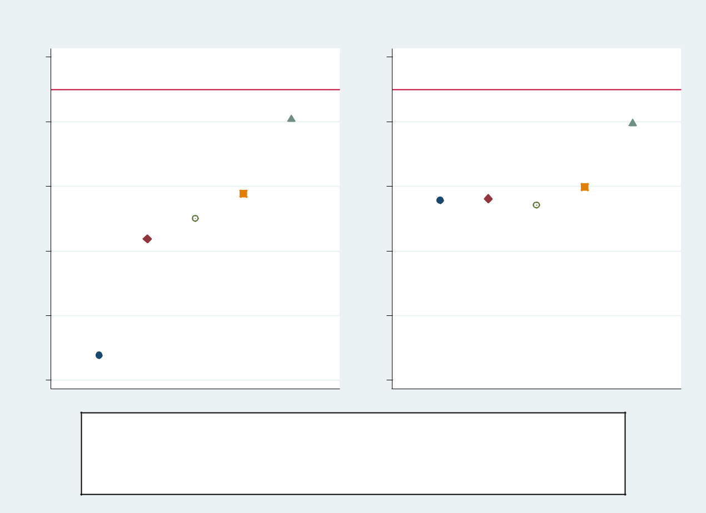

Foreclosure Discount | Short Sale Discount
.05 | .05
-.05 | -.05
-.15 | -.15
-.25 | -.25
-.35 | -.35
-.45 | -.45

No Controls Tract and Year FE

Hedonic Characteristics Condition, Quality, Location, View

Matching Estimator

Note: This figure presents coefficient estimates from Table 2. Moving from left to right within each panel corresponds to moving from left to right across columns in Table 2.

20

Figure 2. Price Discounts for Foreclosures and Short Sales by Market Thickness
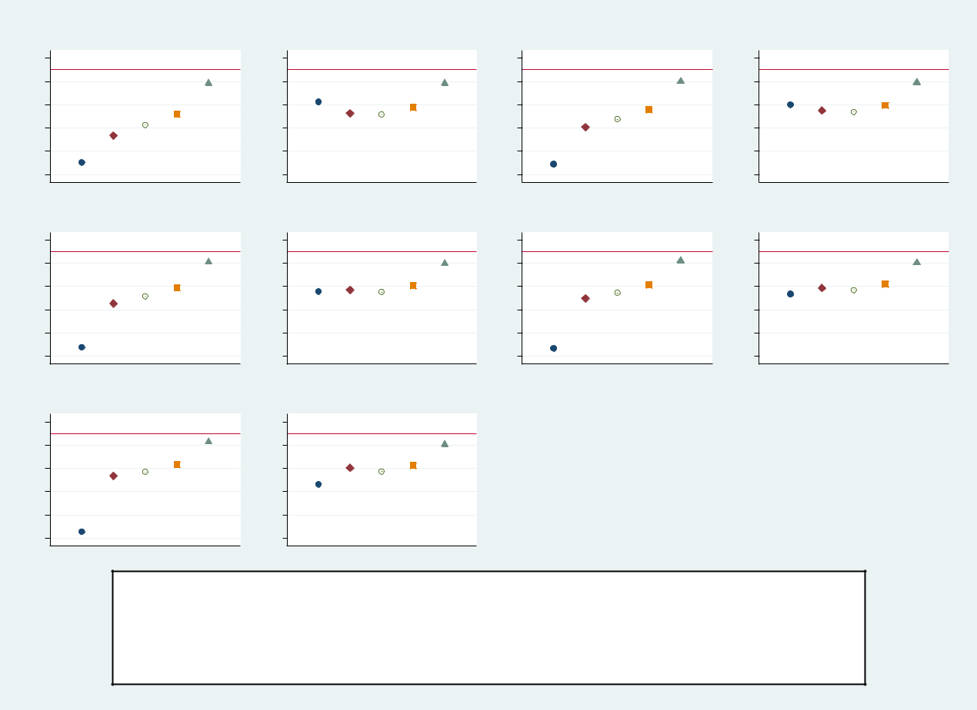

Foreclosure Discount (Q1) | Short Sale Discount (Q1) | Foreclosure Discount (Q2) | Short Sale Discount (Q2)
-.45 -.35 -.25 -.15 -.05 .05 | -.45 -.35 -.25 -.15 -.05 .05 | -.45 -.35 -.25 -.15 -.05 .05 | -.45 -.35 -.25 -.15 -.05 .05
Foreclosure Discount (Q3) | Short Sale Discount (Q3) | Foreclosure Discount (Q4) | Short Sale Discount (Q4)
-.45 -.35 -.25 -.15 -.05 .05 | -.45 -.35 -.25 -.15 -.05 .05 | -.45 -.35 -.25 -.15 -.05 .05 | -.45 -.35 -.25 -.15 -.05 .05
Foreclosure Discount (Q5) | Short Sale Discount (Q5)
-.45 -.35 -.25 -.15 -.05 .05 | -.45 -.35 -.25 -.15 -.05 .05

No Controls Tract and Year FE

Hedonic Characteristics Condition, Quality, Location, View

Matching Estimator

Note: This figure presents coefficient estimates of the foreclosure and short sale discounts by mar-ket thickness. The appraisal data includes the number of recent/nearby sales that are potential comps for the appraisal. We create quintiles based on this number, with Q1 and Q5 represent-ing the quintiles with the least and most potential comps available, respectively (Q2=quintile 2; Q3=quintile 3; Q4=quintile 4;). Moving from left to right within each panel corresponds to mov-ing from left to right across columns in Table 2.

21

- Tables

Table 1. Mean Values by Transaction Type

 | Transaction Type
 | Arm’s Length | Foreclosure | Short Sale
Ln(Sale Price) | 12.527 | 12.115 | 12.355
Foreclosure | 0 | 1 | 0
Short Sale | 0 | 0 | 1
Sq. ft. | 1990 | 1855 | 2007
Lot size | 21119 | 24906 | 22956
Age | 34 | 32 | 32
Rooms | 7 | 7 | 7
Bedrooms | 3 | 3 | 3
Full baths | 2 | 2 | 2
Half baths | 0 | 0 | 0
Basement | 0.421 | 0.339 | 0.338
Finished Basement | 0.285 | 0.195 | 0.222
Condition0 | 0.000 | 0.001 | 0.000
Condition1 | 0.002 | 0.040 | 0.020
Condition2 | 0.178 | 0.446 | 0.372
Condition3 | 0.649 | 0.471 | 0.545
Condition4 | 0.106 | 0.041 | 0.062
Condition5 | 0.065 | 0.001 | 0.001
Quality0 | 0.000 | 0.000 | 0.000
Quality1 | 0.014 | 0.032 | 0.023
Quality2 | 0.549 | 0.664 | 0.614
Quality3 | 0.404 | 0.289 | 0.336
Quality4 | 0.032 | 0.014 | 0.026
Quality5 | 0.002 | 0.001 | 0.001
Neutral location | 0.908 | 0.907 | 0.878
Beneficial location | 0.059 | 0.053 | 0.074
Adverse location | 0.033 | 0.039 | 0.049
Neutral view | 0.887 | 0.890 | 0.861
Beneficial view | 0.103 | 0.097 | 0.127
Adverse view | 0.010 | 0.014 | 0.012
N | 26,972,630 | 360,232 | 182,533

Note: Mean values by transaction type.

22

23
Table 2. Price Discount for Foreclosures and Short Sales

 | (1) | (2) | (3) | (4) | (5)
VARIABLES | ln(price) | ln(price) | ln(price) | ln(price) | ln(price)
Foreclosure | -0.412 | -0.232 | -0.200 | -0.162 | -0.046
 | (0.001) | (0.001) | (0.000) | (0.000) | (0.000)
Short Sale | -0.172 | -0.169 | -0.179 | -0.151 | -0.053
 | (0.001) | (0.001) | (0.000) | (0.000) | (0.000)
Observations | 27,515,395 | 27,512,618 | 27,512,618 | 27,512,618 | 27,490,406
Adjusted R-squared | 0.007 | 0.713 | 0.908 | 0.918 | 0.984
Tract FE | N | Y | Y | Y | N
Year/Qtr FE | N | Y | Y | Y | Y
Hedonic Characteristics | N | N | Y | Y | Y
CQLV | N | N | N | Y | Y
Appraisal FE | N | N | N | N | Y

Note: This table reports estimates and standard errors, in parentheses, of a regression with log sales price as the dependent variable. The sample includes all comparable properties. Foreclo-sure and short sale indicators are mutually exclusive.

A.1. Online Appendix

Figure A.1 . Lowest Price Comps in Appraisals that Use Distress Comps
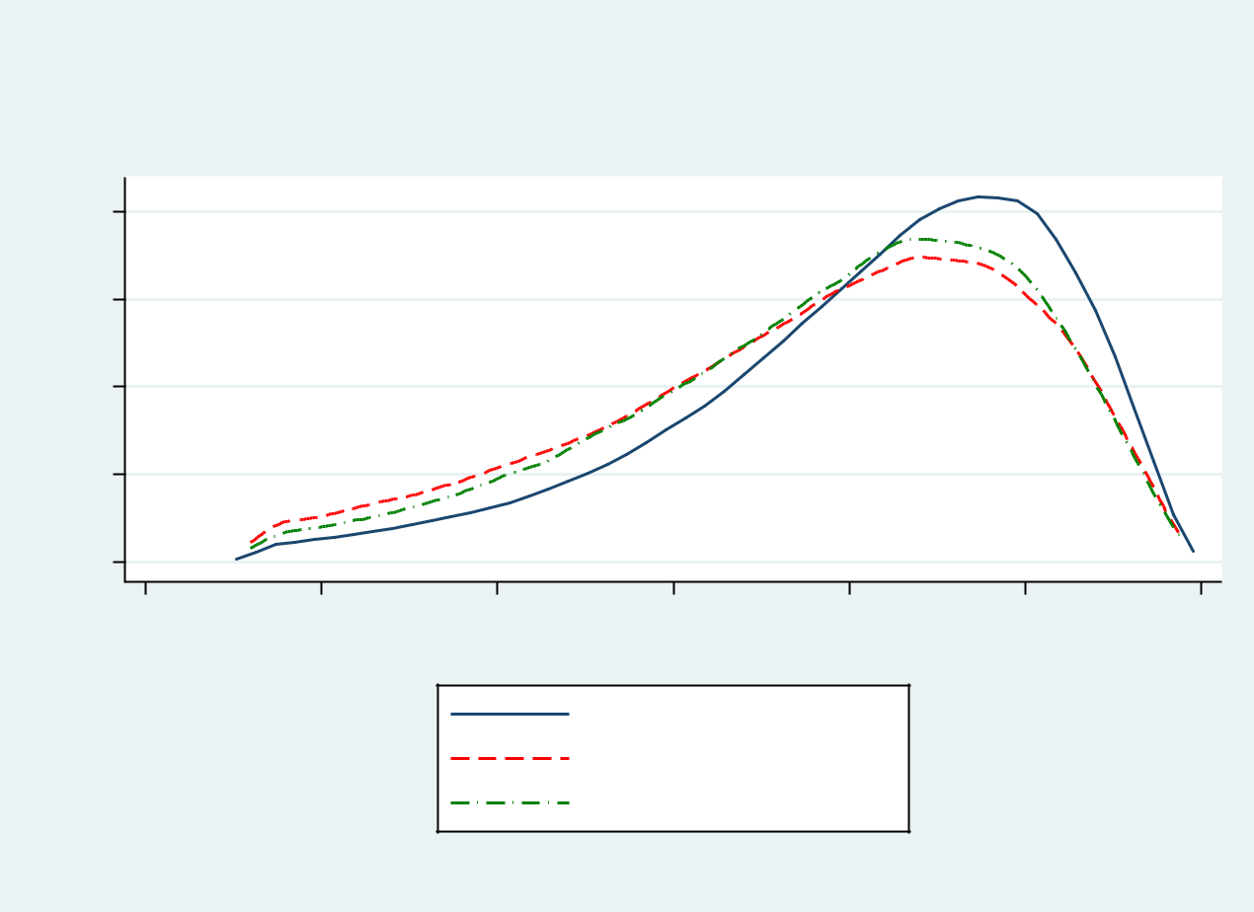

Lowest Price Comp
By Comp Type
% Below Average

8
6
Density4
2
0
-.3 | -.25 | -.2 | -.15 | -.1 | -.05 | 0
 | % Below Average = (price - avg price) / avg price

Arm's-Length Lowest

REO Comp Lowest

Short Comp Lowest

kernel = epanechnikov, bandwidth = 0.0040

Note: For each appraisal that contains a distress comp, we identify the lowest price comp and calculate the percentage difference between that comp’s price and the mean of the comp sales prices within the same appraisal. We then plot these low price comp percentage differences separately depending on the lowest priced comp’s transaction type (foreclosure, short sale, arm’s length).

24

Figure A.2 . Price Discounts for Foreclosures and Short Sales by Year
Foreclosure Discount (2013) | Short Sale Discount (2013) | Foreclosure Discount (2014) | Short Sale Discount (2014)
-.45 -.35 -.25 -.15 -.05 .05 | -.45 -.35 -.25 -.15 -.05 .05 | -.45 -.35 -.25 -.15 -.05 .05 | -.45 -.35 -.25 -.15 -.05 .05
Foreclosure Discount (2015) | Short Sale Discount (2015) | Foreclosure Discount (2016) | Short Sale Discount (2016)
-.45 -.35 -.25 -.15 -.05 .05 | -.45 -.35 -.25 -.15 -.05 .05 | -.45 -.35 -.25 -.15 -.05 .05 | -.45 -.35 -.25 -.15 -.05 .05
Foreclosure Discount (2017) | Short Sale Discount (2017)
-.45 -.35 -.25 -.15 -.05 .05 | -.45 -.35 -.25 -.15 -.05 .05
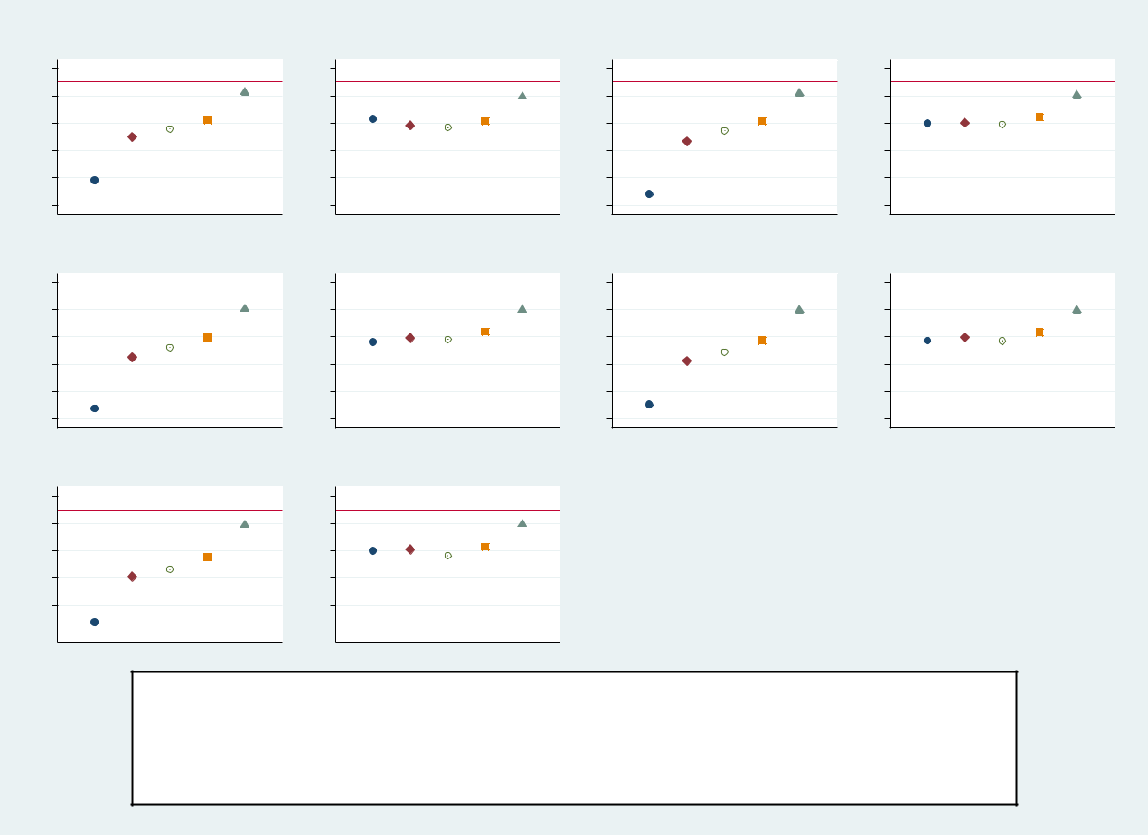

No Controls Tract and Year FE

Hedonic Characteristics Condition, Quality, Location, View

Matching Estimator

Note: This figure presents coefficient estimates of the foreclosure and short sale discounts by year of appraisal. Moving from left to right within each panel corresponds to moving from left to right across columns in Table 2.

25

Figure A.3 . Price Discounts for Foreclosures and Short Sales by Census Tract Minority Population

Share
Foreclosure Discount (Q1) | Short Sale Discount (Q1) | Foreclosure Discount (Q2) | Short Sale Discount (Q2)
-.45 -.35 -.25 -.15 -.05 .05 | -.45 -.35 -.25 -.15 -.05 .05 | -.45 -.35 -.25 -.15 -.05 .05 | -.45 -.35 -.25 -.15 -.05 .05
Foreclosure Discount (Q3) | Short Sale Discount (Q3) | Foreclosure Discount (Q4) | Short Sale Discount (Q4)
-.45 -.35 -.25 -.15 -.05 .05 | -.45 -.35 -.25 -.15 -.05 .05 | -.45 -.35 -.25 -.15 -.05 .05 | -.45 -.35 -.25 -.15 -.05 .05
Foreclosure Discount (Q5) | Short Sale Discount (Q5)
-.45 -.35 -.25 -.15 -.05 .05 | -.45 -.35 -.25 -.15 -.05 .05
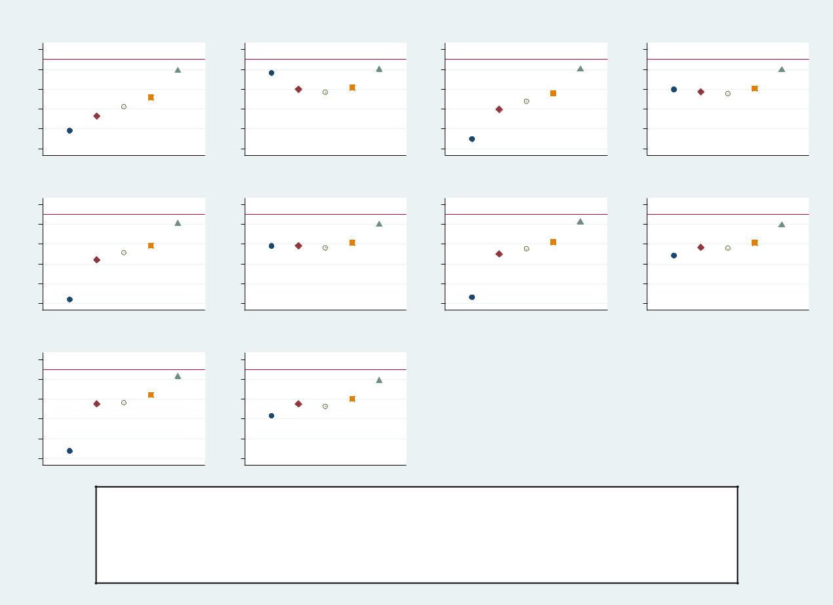

No Controls Tract and Year FE

Hedonic Characteristics Condition, Quality, Location, View

Matching Estimator

Note: This figure presents coefficient estimates of the foreclosure and short sale discounts by census tract minority population share. Minority share of the tract population is based on data from the 2010 Census, with Q1 and Q5 representing the quintiles with the lowest and highest minority population share, respectively (Q2=quintile 2; Q3=quintile 3; Q4=quintile 4;). Moving from left to right within each panel corresponds to moving from left to right across columns in Table 2.

26

Figure A.4 . Price Discounts for Foreclosures and Short Sales for Sand and Non-Sand States
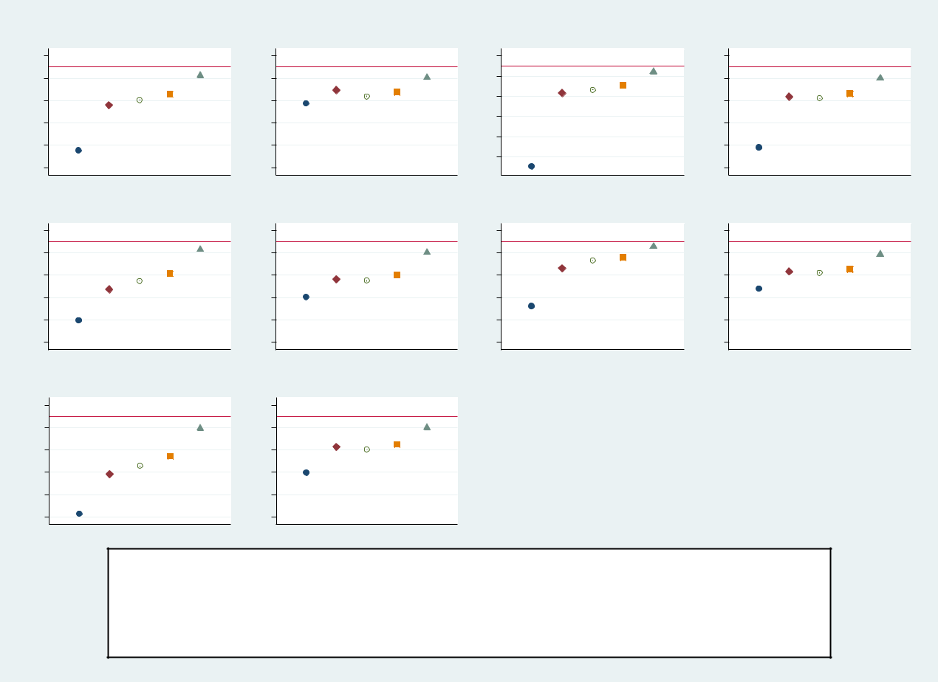

Foreclosure Discount (AZ) | Short Sale Discount (AZ) | Foreclosure Discount (CA) | Short Sale Discount (CA)
.45 -.35 -.25 -.15 -.05 .05 | .45 -.35 -.25 -.15 -.05 .05 | -.45-.35-.25-.15-.05 .05 | .45 -.35 -.25 -.15 -.05 .05
- | - |  | -
Foreclosure Discount (FL) | Short Sale Discount (FL) | Foreclosure Discount (NV) | Short Sale Discount (NV)
-.45 -.35 -.25 -.15 -.05 .05 | -.45 -.35 -.25 -.15 -.05 .05 | -.45 -.35 -.25 -.15 -.05 .05 | -.45 -.35 -.25 -.15 -.05 .05
Foreclosure Discount (O) | Short Sale Discount (W)
-.45 -.35 -.25 -.15 -.05 .05 | -.45 -.35 -.25 -.15 -.05 .05

No Controls Tract and Year FE

Hedonic Characteristics Condition, Quality, Location, View

Matching Estimator

Note: This figure presents coefficient estimates of the foreclosure and short sale discounts for Sand and Non-Sand States (AZ=Arizona; CA=California; FL=Florida; NV=Nevada; O=Other/Non-Sand States). Moving from left to right within each panel corresponds to moving from left to right across columns in Table 2.

27

Figure A.5 . Price Discounts for Foreclosures and Short Sales for Judicial and Non-judicial States
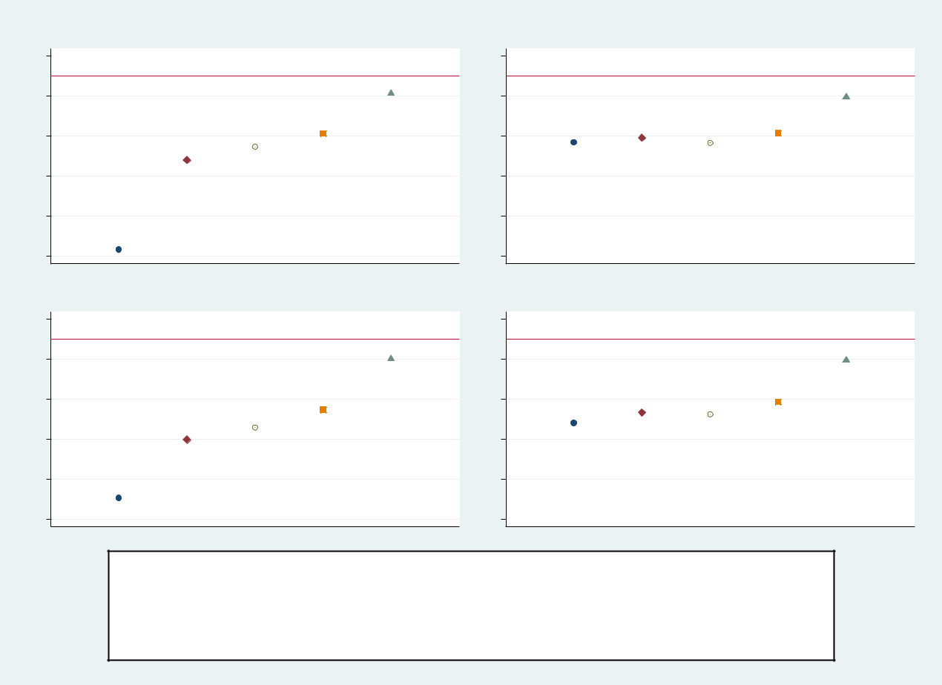

Foreclosure Discount (NJ) | Short Sale Discount (NJ)
.05 | .05
-.05 | -.05
-.15 | -.15
-.25 | -.25
-.35 | -.35
-.45 | -.45
Foreclosure Discount (J) | Short Sale Discount (J)
.05 | .05
-.05 | -.05
-.15 | -.15
-.25 | -.25
-.35 | -.35
-.45 | -.45

No Controls Tract and Year FE

Hedonic Characteristics Condition, Quality, Location, View

Matching Estimator

Note: This figure presents coefficient estimates of the foreclosure and short sale discounts for non-judicial (NJ) and judicial (J) states. State classification is based on Table 1 in Ghent and Kudlyak (2011). Moving from left to right within each panel corresponds to moving from left to right across columns in Table 2.

28

Figure A.6 . Price Discounts for Foreclosures and Short Sales by Tract Price Levels
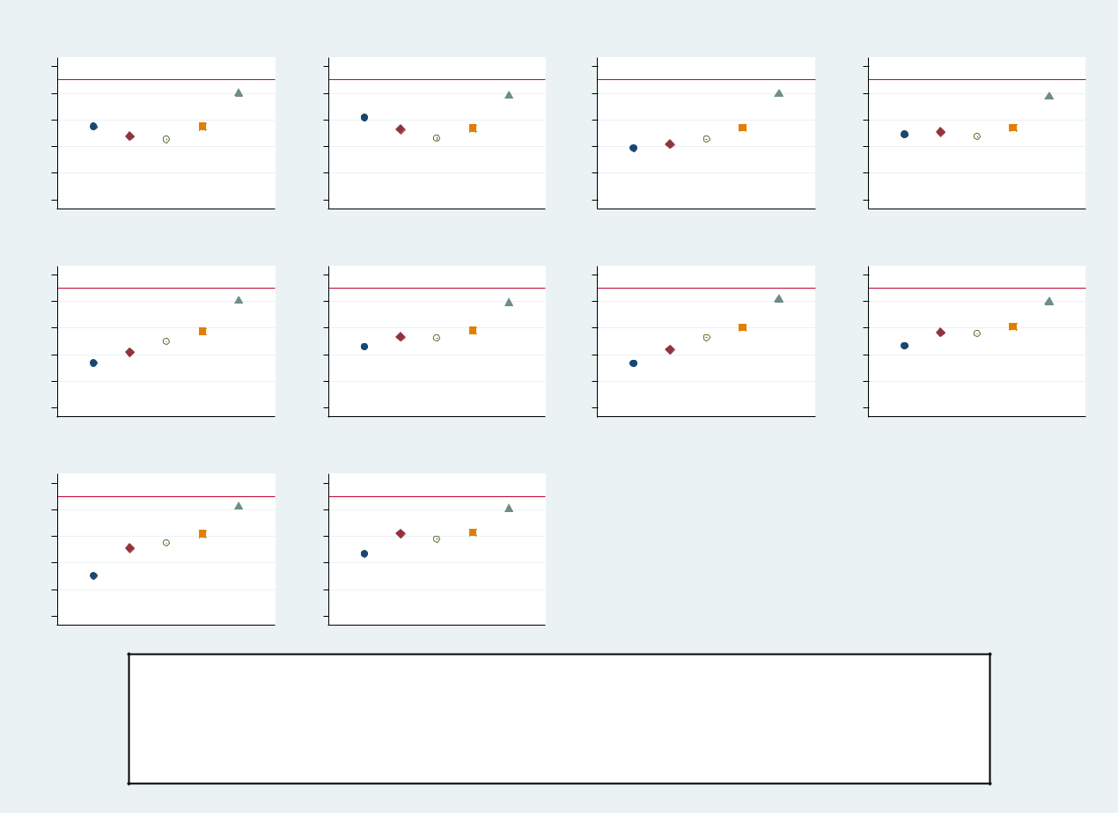

Foreclosure Discount (Q1) | Short Sale Discount (Q1) | Foreclosure Discount (Q2) | Short Sale Discount (Q2)
-.45 -.35 -.25 -.15 -.05 .05 | -.45 -.35 -.25 -.15 -.05 .05 | -.45 -.35 -.25 -.15 -.05 .05 | -.45 -.35 -.25 -.15 -.05 .05
Foreclosure Discount (Q3) | Short Sale Discount (Q3) | Foreclosure Discount (Q4) | Short Sale Discount (Q4)
-.45 -.35 -.25 -.15 -.05 .05 | -.45 -.35 -.25 -.15 -.05 .05 | -.45 -.35 -.25 -.15 -.05 .05 | -.45 -.35 -.25 -.15 -.05 .05
Foreclosure Discount (Q5) | Short Sale Discount (Q5)
-.45 -.35 -.25 -.15 -.05 .05 | -.45 -.35 -.25 -.15 -.05 .05

No Controls Tract and Year FE

Hedonic Characteristics Condition, Quality, Location, View

Matching Estimator

Note: This figure presents coefficient estimates of the foreclosure and short sale discounts across Census tract median house price quintiles. Each year we create Census tract median house price quintiles using ACS data, with Q1 and Q5 as the lowest and highest house price level quintile, respectively (Q2=quintile 2; Q3=quintile 3; Q4=quintile 4). Moving from left to right within each panel corresponds to moving from left to right across columns in Table 2.

29

 | Table A.1. Varibable Names
Variable Name | Description
Dependent Variable
Price | Sales price of the comp property.
Independent Variables of Interest
Foreclosure | Property sold as real estate owned (REO).
Short Sale | Property sold as a short-sale.
Hedonic Characteristics
Sq. ft. | Square footage of the subject property.
Sq. ft. sq. | Square footage squared.
Age | Age of the subject property in years.
Age sq. | Age squared.
Rooms | Number of rooms.
Bedrooms | Number of bedrooms.
Full baths | Number of full bathrooms.
Half baths | Number of half bathrooms.
Basement | Indicates the existence of a basement.
Finished Basement | Indicates the existence of a finished basement.
Condition, Quality, Location and View
Condition | Categorical variable defining condition of the property according to USPAP.
 | Original variable is re-scaled to 0-5 with 5 representing the best condition.
 | Condition enters regression models as a series of indicators.
Quality | Categorical variable defining construction quality of the property according to UPAP.
 | Original variable is re-scaled to 0-5 with 5 representing the highest level.
 | Quality enters regression models as a series of indicators.
Location | Location’s impact on value according to USPAP,
 | with the categories neutral, beneficial and adverse.
 | Location enters regression models as a series of indicators.
View | Property view’s impact on value according to USPAP,
 | with the categories neutral, beneficial and adverse.
 | View enters regression models as a series of indicators.
Note: Variable names and descriptions.

30

Table A.2. Descriptive Statistics

 | Mean | Std. Dev. | Min | Max
Ln(Sale Price) | 12.520 | 0.583 | 10.820 | 14.170
Foreclosure | 0.013
Short Sale | 0.007
Sq. ft. | 1988 | 803 | 500 | 10000
Lot size | 21181 | 52062 | 500 | 999702
Age | 34 | 27 | 0 | 150
Rooms | 7 | 2 | 1 | 15
Bedrooms | 3 | 1 | 0 | 8
Full baths | 2 | 1 | 1 | 9
Half baths | 0 | 1 | 0 | 9
Basement | 0.419
Finished Basement | 0.283
Condition0 | 0.000
Condition1 | 0.003
Condition2 | 0.183
Condition3 | 0.646
Condition4 | 0.105
Condition5 | 0.064
Quality0 | 0.000
Quality1 | 0.014
Quality2 | 0.551
Quality3 | 0.402
Quality4 | 0.031
Quality5 | 0.002
Neutral location | 0.908
Beneficial location | 0.059
Adverse location | 0.033
Neutral view | 0.887
Beneficial view | 0.103
Adverse view | 0.010
N |  | 27,515,395

Note: Descriptive statistics for sample of comps. These comps consist of 10,304,269 unique properties used in 7,202,278 sepa-rate appraisals. Only the mean is reported for indicator variables.

31

Table A.3. Price Discount for Foreclosures and Short Sales

 | (1) | (2) | (3) | (4) | (5)
VARIABLES | ln(price) | ln(price) | ln(price) | ln(price) | ln(price)
Foreclosure | -0.412 | -0.232 | -0.200 | -0.162 | -0.046
 | (0.001) | (0.001) | (0.000) | (0.000) | (0.000)
Short Sale | -0.172 | -0.169 | -0.179 | -0.151 | -0.053
 | (0.001) | (0.001) | (0.000) | (0.000) | (0.000)
Sq. ft. |  |  | 0.001 | 0.001 | 0.000
 |  |  | (0.000) | (0.000) | (0.000)
Sq. ft. sq. |  |  | -0.000 | -0.000 | -0.000
 |  |  | (0.000) | (0.000) | (0.000)
Lot size |  |  | 0.000 | 0.000 | 0.000
 |  |  | (0.000) | (0.000) | (0.000)
Lot size sq. |  |  | -0.000 | -0.000 | -0.000
 |  |  | (0.000) | (0.000) | (0.000)
Age |  |  | -0.005 | -0.003 | -0.001
 |  |  | (0.000) | (0.000) | (0.000)
Age sq. |  |  | 0.000 | 0.000 | 0.000
 |  |  | (0.000) | (0.000) | (0.000)
Rooms |  |  | 0.004 | 0.004 | 0.003
 |  |  | (0.000) | (0.000) | (0.000)
Bedrooms |  |  | -0.031 | -0.024 | -0.005
 |  |  | (0.000) | (0.000) | (0.000)
Full baths |  |  | 0.037 | 0.032 | 0.016
 |  |  | (0.000) | (0.000) | (0.000)
Half baths |  |  | -0.012 | -0.012 | 0.007
 |  |  | (0.000) | (0.000) | (0.000)
Basement |  |  | 0.098 | 0.097 | 0.041
 |  |  | (0.000) | (0.000) | (0.000)
Finished Basement |  |  | 0.110 | 0.103 | 0.039
 |  |  | (0.000) | (0.000) | (0.000)
Condition1 |  |  |  | 0.099 | 0.101
 |  |  |  | (0.004) | (0.002)
Condition2 |  |  |  | 0.253 | 0.224
 |  |  |  | (0.004) | (0.002)
Condition3 |  |  |  | 0.318 | 0.304
 |  |  |  | (0.004) | (0.002)
Condition4 |  |  |  | 0.366 | 0.361
 |  |  |  | (0.004) | (0.002)
Condition5 |  |  |  | 0.388 | 0.357
 |  |  |  | (0.004) | (0.002)
Quality1 |  |  |  | -0.012 | 0.068
 |  |  |  | (0.008) | (0.005)
Quality2 |  |  |  | 0.046 | 0.152
 |  |  |  | (0.008) | (0.005)
Quality3 |  |  |  | 0.086 | 0.230
 |  |  |  | (0.008) | (0.005)
Quality4 |  |  |  | 0.188 | 0.328
 |  |  |  | (0.008) | (0.005)
Quality5 |  |  |  | 0.263 | 0.434
 |  |  |  | (0.008) | (0.005)
Beneficial location |  |  |  | 0.071 | 0.060
 |  |  |  | (0.000) | (0.000)
Adverse location |  |  |  | -0.031 | -0.037
 |  |  |  | (0.000) | (0.000)
Beneficial view |  |  |  | 0.080 | 0.041
 |  |  |  | (0.000) | (0.000)
Adverse view |  |  |  | -0.034 | -0.029
 |  |  |  | (0.000) | (0.000)
Observations | 27,515,395 | 27,512,618 | 27,512,618 | 27,512,618 | 27,490,406
Adjusted R-squared | 0.007 | 0.713 | 0.908 | 0.918 | 0.984
Tract FE | N | Y | Y | Y | N
Year/Qtr FE | N | Y | Y | Y | Y
Hedonic Characteristics | N | N | Y | Y | Y
CQLV | N | 32 | N | Y | Y
CQLV | N | N | N | Y | Y
Appraisal FE | N | N | N | N | Y

Note: This table reports estimates and standard errors, in parentheses, of a regression with log sales price as the dependent variable. The sample includes all comparable properties. Foreclosure and short sale indicators are mutually exclusive.

