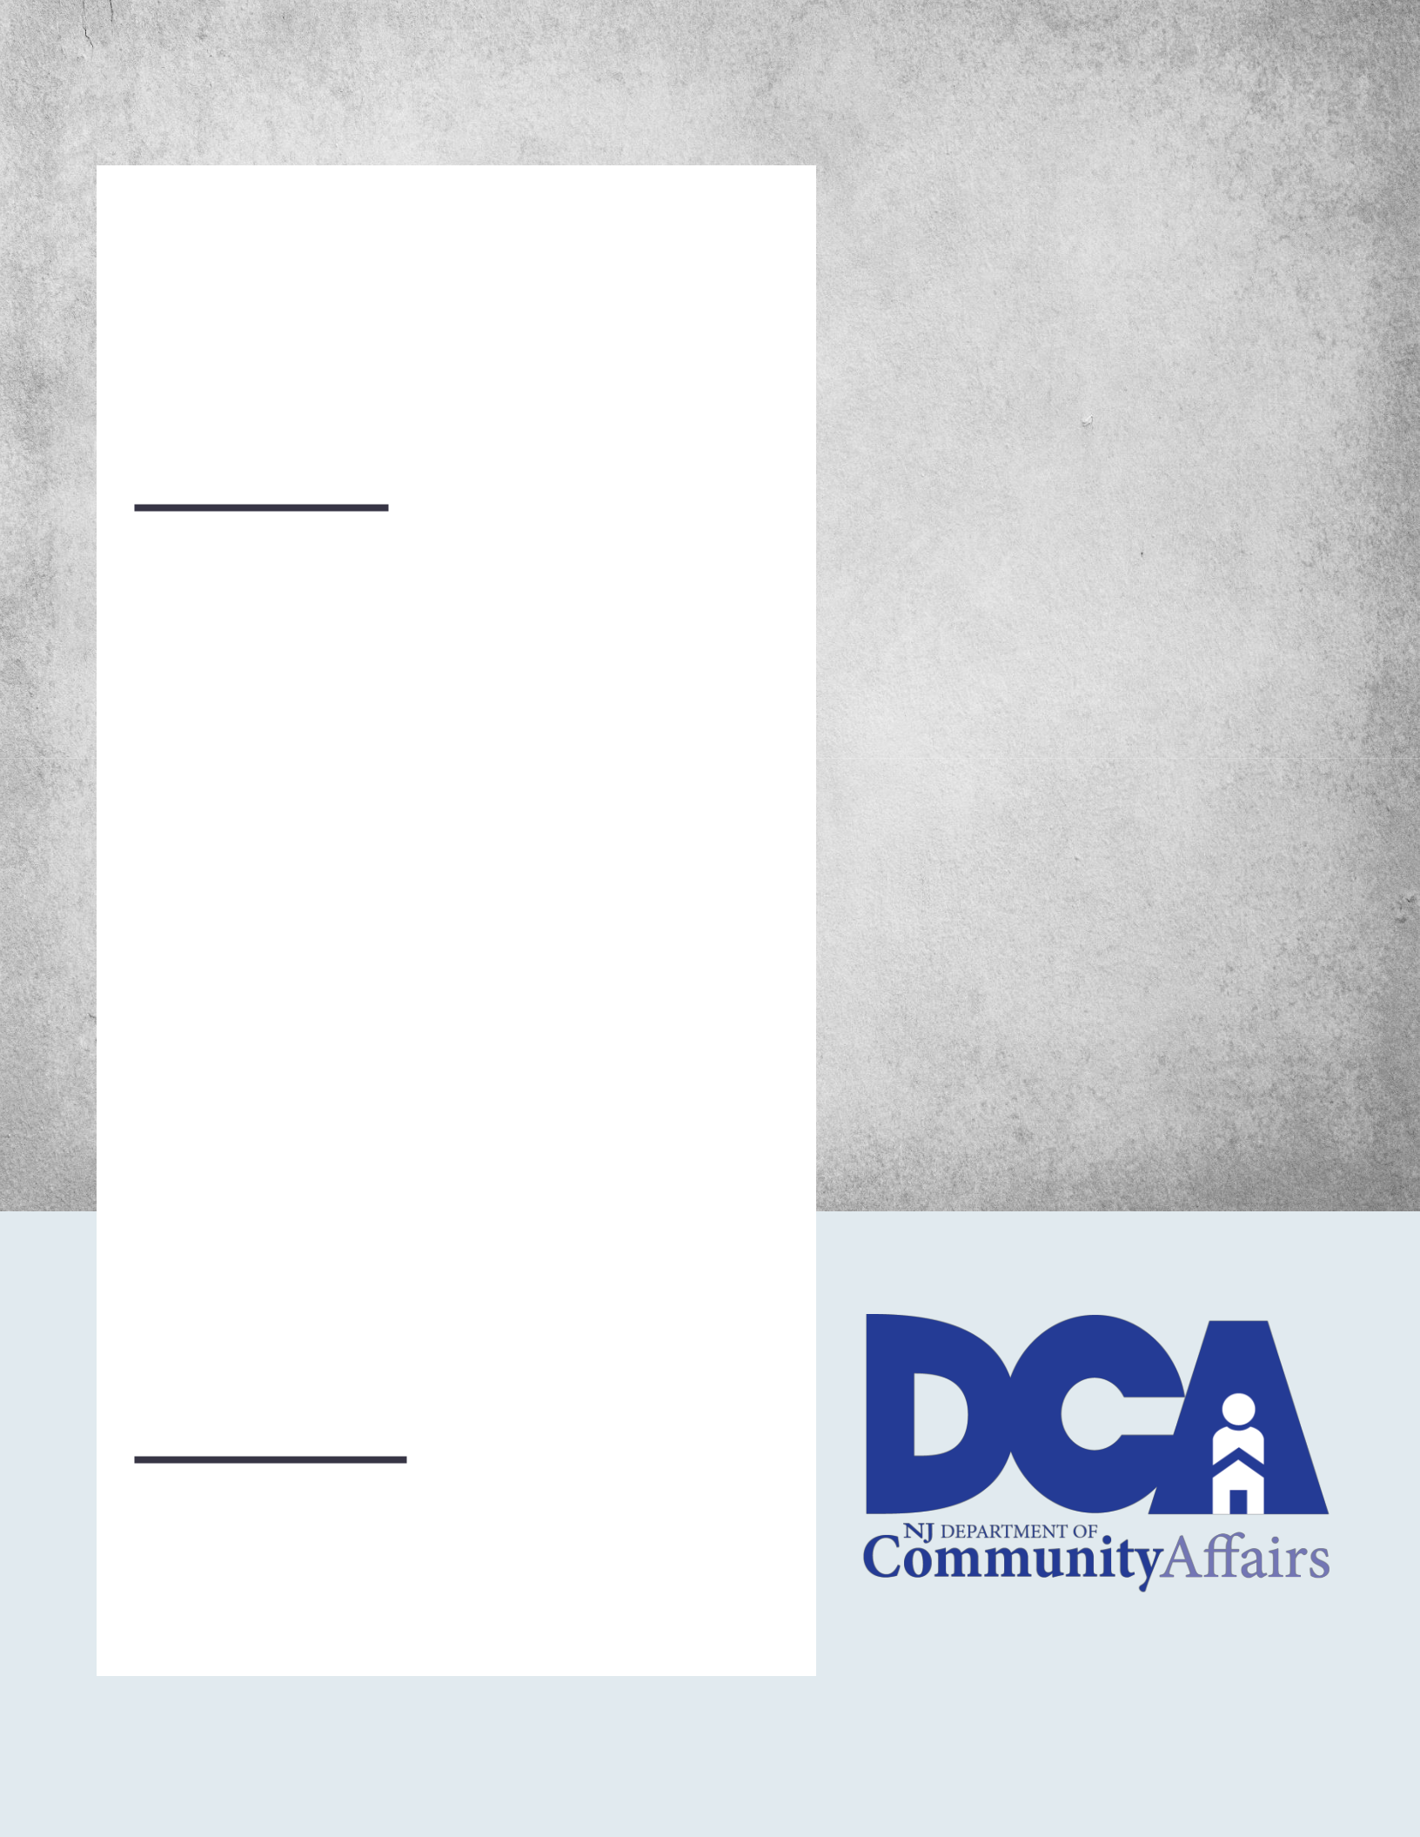

Lead-Based Paint in Rental Dwellings

A comprehensive guide to identifying and addressing lead-based paint hazards in rental dwellings

NEW JERSEY

DEPARTMENT OF COMMUNITY AFFAIRS Division of Codes and Standards REVISED SEPTEMBER 7, 2022 (Version 2)

1

NEW JERSEY DEPARTMENT OF COMMUNITY AFFAIRS

Guide to Lead-Based Paint in Rental Dwellings

- State of New Jersey Department of Community Affairs Division of Codes and Standards

P.O. Box 802

Trenton, NJ 08625-0802

Phone (609) 292-7899 • Fax (609) 633-6729

www.nj.gov/dca/division/codes

Revised September 7, 2022

2

Guide to Lead-Based Paint in Rental Dwellings

Foreword

This guide is intended to provide a comprehensive overview of lead-based paint hazards, how to inspect for such hazards, and how hazards can be mitigated or eliminated for compliance with P.L.2021, c.182. The guide is intended to serve owners and residents of rental dwellings throughout the State of New Jersey. It is written in five parts, each with different information to assist in understanding the many requirements associated with lead-based paint hazards in rental dwellings.

This guide shall act as the trainer’s manual pursuant to C.52:27D-437.17b(2) and the guidelines pursuant to C.52:27D-437.20b.

Nothing in this guidance shall be construed to supersede the Statute (P.L.2021, c.182) or the forthcoming regulations. If any discrepancies exist between the information in this document and the statute or regulations, the statute or regulations shall govern.

This guide is established in accordance with P.L.2021, c.182.


https://www.njleg.state.nj.us/Bills/2020/PL21/182_.PDF

3

Guide to Lead-Based Paint in Rental Dwellings

1.0.0 | Table of Contents
2.0.0 | Introduction
 | 2.1.0 | Definitions
 | 2.1.1 | Lead and its Associated Hazards
 | 2.2.0 | Lead-Based Paint
 | 2.2.1. Identifying Lead-Based Paint Hazards
3.0.0 | The Lead-Based Paint Inspection Law, P.L.2021, c.182
 | 3.1.0 | What is P.L.2021, c.182?
 | 3.2.0 | What Buildings are Required to Comply with P.L.2021, c.182?
 | 3.3.0 | Inspection Procedure and Responsibilities
 | 3.3.1. | Fees for Inspection
 | 3.3.2 | Timelines for Inspections
 | 3.3.3 | Visual Inspections
 | 3.3.4 | Dust-Wipe Sampling
 | 3.4.0 | Inspection Results
 | 3.4.1 | Lead-Safe Certificate
4.0.0 | Remediation of Lead-Based Paint Hazards
 | 4.1.0 | How to Proceed if Lead-Based Paint Hazards are Found
 | 4.1.1 | Who May Perform Work?
 | 4.2.0 | Interim Controls
 | 4.3.0 | Abatement
 | 4.4.0 | Post-Remediation Inspection
 | 4.5.0 | Grants and Loans for Remediation Work
5.0.0 | Record Keeping and Investigations/Enforcement
 | 5.1.0. Municipal Record Keeping
 | 5.2.0. Municipal Investigations
 | 5.3.0. Department of Community Affairs Investigations

Appendices

- Lead-Safe Certification

- Frequently Asked Questions

4

2.0.0 INTRODUCTION

2.1.0 Definitions

“Commissioner” means the Commissioner of the Department of Community Affairs.

“Department” means Department of Community Affairs.

“DOH” means the New Jersey Department of Health.

“Dust wipe sampling” means a sample collected by wiping a representative surface and tested in accordance with a method approved by the United States Department of Housing and Urban Development (HUD).

“Dwelling” means a building containing a room or rooms, or suite, apartment, unit, or space, that is rented and occupied or intended to be rented and occupied for sleeping and dwelling purposes by one or more persons.

“Dwelling unit” means a unit within a building that is rented and occupied or intended to be rented and occupied for sleeping and dwelling purposes by one or more persons.

"Interim controls" means a set of measures designed to reduce temporarily human exposure or likely exposure to lead-based paint hazards, including specialized cleaning, repairs, maintenance, painting, temporary containment, ongoing monitoring of lead-based paint hazards or potential hazards, and the establishment and operation of management and resident education programs and as it is defined under 42 U.S.C. § 4851b and regulations implemented pursuant thereto.

"Lead abatement" means a set of measures designed to permanently eliminate lead-based paint hazards in accordance with standards established by the Commissioner in N.J.A.C. 5:17.

“Lead abatement contractor” means a firm certified by the Department to perform lead abatement work pursuant to N.J.A.C. 5:17.

“Lead abatement worker” means an individual certified by the New Jersey Department of Health (DOH) to perform lead abatement work pursuant to N.J.A.C. 8:62.

5

“Lead-based paint” means paint or other surface coating material that contains lead in excess of 1.0 milligrams per centimeter squared or in excess of 0.5% by weight, or such other level as may be established by federal law.

"Lead-based paint hazard" means any condition that causes exposure to lead from lead-contaminated dust or lead-contaminated paint that is deteriorated or present in surfaces, that would result in adverse human health effects.

"Lead-based hazard control methods" means interim controls, as defined above. Note that this definition is specific to lead-based paint inspections in rental dwellings and is not to be confused with the lead hazard control work as defined within the Department’s regulations for Lead Hazard Evaluation and Abatement, N.J.A.C. 5:17.

“Lead evaluation contractor” means a firm certified by the Department to perform lead inspection and risk assessment work pursuant to N.J.A.C. 5:17. This includes the ability to perform dust wipe sampling.

“Lead inspector or risk assessor” means an individual certified by DOH to perform lead inspection and risk assessment work pursuant to N.J.A.C. 8:62. This includes the ability to perform dust wipe sampling.

“Lead free” means that a dwelling or dwelling unit has been confirmed to have fully abated all lead-based paint hazards or that no lead-based paint exists in the dwelling or dwelling unit.

“Lead safe” means that a dwelling has no outstanding lead-based paint hazards, but the dwelling is not necessarily lead free.

“Lead-safe certification” means the certification issued pursuant to the regulations promulgated pursuant to P.L.2021, c.182, which confirms that a periodic inspection, as defined below, was performed, and no lead-based paint hazards were found. This certification is valid for two years from the date of issuance.

6

"Multiple dwelling" means any building or structure and any land appurtenant thereto, and any portion thereof, in which three or more dwelling units are occupied or intended to be occupied by three or more persons living independently of each other. "Multiple dwelling" also means any group of ten or more buildings on a single parcel of land or on contiguous parcels under common ownership, in each of which two dwelling units are occupied or intended to be occupied by two persons or households living independently of each other, and any land appurtenant thereto, and any portion thereof. "Multiple dwelling" does not include those buildings and structures that are excluded by statute (See N.J.S.A. 55:13A-3(k)).

“Periodic lead-based paint inspection” means the initial inspection of all applicable dwelling units at the earlier of two years from the effective date of P.L.2021, c.182, July 22, 2022, or tenant turnover, and thereafter the earlier of three years or upon tenant turnover for the purposes of identifying lead-based paint hazards in dwellings subject to P.L.2021, c.182.

“Permanent local agency” means a local, municipal agency maintained for the purpose of conducting inspections and enforcing laws, ordinances, and regulations concerning buildings and structures within its jurisdiction. This may include local building agencies, health agencies, and housing agencies.

“Remediation” means interim controls or lead abatement work undertaken in conformance with this Chapter to address lead-based paint hazards.

Colloquially, remediation is often used synonymously with interim controls and does not include abatement; however, in the context of P.L.2021, c.182, remediation is defined as encompassing both interim controls and abatement.

“Tenant turnover” means the time at which all existing occupants vacate a dwelling unit, and all new tenants move into the dwelling unit or the time at which a new tenant enters a vacant dwelling unit.

“Visual assessment” means a visual examination for deteriorated paint or visible surface dust, debris, or residue.

7

2.1.1 Lead and its Associated Hazards

Lead is a naturally occurring element and heavy metal in our environment.

Historically, it was used in industrial processes and commercial products like gasoline, paint, cosmetics, spices, and pottery. This is because lead has many useful properties; it is moisture-resistant, does not rust, and is malleable and easy to work with.

Lead’s toxicity has been documented for centuries. Throughout the 20th century to present day, its harmful effects on human physiological and behavioral health have become increasingly understood by public health experts.

Lead exposure happens when people encounter lead in their environment. This can be through old household paint, contaminated soil, or other sources. Exposure is determined by measuring the concentration of lead in a person’s blood.

Lead exposure occurs when lead has been introduced into the bloodstream by ingestion or inhalation of lead dust. Our bodies cannot distinguish lead from other minerals, like iron or calcium, which our bodies need. Lead is then deposited in our organs as well as our brain and bone marrow.

The Centers for Disease Control (CDC) sets the threshold for elevated blood lead levels. Lead exposure can be of particular concern for children. Lead exposure in children can cause nervous system and kidney damage, as well as learning disabilities, attention-deficit disorder, and decreased intelligence. It can also cause behavior, speech, and language problems, hearing damage, decreased muscle and bone growth, and poor muscle coordination.

Children under the age of six and pregnant women are considered to be at the highest risk for exposure. This is because any lead that a pregnant woman is exposed to transfers to the fetus and would be present at birth. For small children putting their hands in their mouths is a normal part of learning development. Doors and windows with lead paint can release a fine lead dust when opened and closed, and young children can be exposed to lead in the normal course by putting hands with this almost invisible lead dust in their mouths. Children can also be exposed by eating lead-based paint chips that peel off the wall or chewing on windowsills, door frames, or any other surfaces containing lead-based paint.

8

2.2.0 Lead-Based Paint

In 1972, the State of New Jersey banned the use of lead-based paint. The Federal Government banned its use in residential properties in 1978.

Prior to this time, lead-based paint was commonly used because it was durable and long-lasting. Many homes and dwellings and childcare facilities built before 1978 may contain lead-based paint.

Because of this historical context, age of housing is one of the primary indicators of the presence of lead-based paint in the home or dwelling.

2.2.1 Identifying Lead-Based Paint Hazards

Deteriorating lead-based paint (peeling, chipping, chalking, cracking, or damaged paint) is a hazard and requires immediate attention. It may also be a hazard when found on surfaces that children can chew or that get a lot of wear-and-tear, such as windows and windowsills, doors and door frames, stairs, railings, banisters, and porches. Lead-based paint is less likely to be a hazard if it is in good condition, and the paint is not on an impact or friction surface.

Lead dust can form when lead-based paint is scraped, sanded, or heated. Dust also forms when painted surfaces bump or rub together. Lead chips and dust can reside on surfaces and objects that people touch. Settled dust can reenter the air when people vacuum, sweep, or walk through the affected area.

The only way to identify lead paint or dust hazards is to inspect for the presence of lead.

9

3.0.0 THE LEAD-BASED PAINT INSPECTION LAW, P.L.2021, c.182

3.1.0 What is P.L.2021, c.182?

P.L.2021, c.182 addresses lead-based paint hazards in residential rental property and establishes lead-based paint hazard control work programs, discussed in Section 4.5.0.

The law imposes an obligation on municipalities to perform or hire a certified lead evaluation contractor to perform inspections of certain single-family, two-family, and multiple rental dwellings for lead-based paint hazards, at times specified in the law.

A municipality shall permit dwelling owners/landlords to directly hire a certified lead evaluation contractor for this purpose. Municipalities may – and are encouraged to – perform supplemental inspections in some dwellings where the owner has directly hired a certified lead evaluation contractor to perform the periodic lead-based paint inspections to confirm that such inspections are being conducted in accordance with the legal requirements.

The municipality can prohibit dwelling owners from directly hiring a lead evaluation contractor if the owner has previously failed to have the periodic inspections completed or if there is a perceived or actual conflict of interest between the owner and their choice of lead evaluation contractor as determined by the municipality, and instead require owners to utilize municipal inspectors or lead evaluation contractors contracted by the municipality for this purpose.

If lead-based paint hazards are identified, then the owner of the dwelling shall remediate through abatement or lead-based paint hazard control mechanisms.

Individuals are certified as lead inspector/risk assessors, lead abatement workers, and lead abatement supervisors by the New Jersey Department of Health pursuant to their regulations at N.J.A.C. 8:62, adopted under the authority of N.J.S.A. 26:2Q-1, et seq.

Information on the requirements for an individual to be certified may be found online at: https://www.nj.gov/health/ceohs/lead/lead-workers-supervisors/.

Firms that perform lead evaluation or abatement services are certified by the Department of Community Affairs. This information may be found online at: https://www.nj.gov/dca/divisions/codes/offices/leadhazard_abatement.html.

10

3.2.0 Dwellings that Must be Inspected Pursuant to P.L.2021, c.182

In accordance with P.L.2021, c.182, single-family, two-family, and multiple rental dwellings must be inspected for lead-based paint hazards, except for the following:

- Dwellings that were constructed during or after 1978.

- Single-family and two-family seasonal rental dwellings which are rented for less than six-months duration each year by tenants that do not have consecutive lease renewals. This exemption for seasonal rental dwellings does not extend to seasonal multiple dwellings.

- Dwellings that have been certified to be free of lead-based paint pursuant to N.J.A.C. 5:17-3.16(b) either after an abatement is completed or an evaluation has confirmed that there is no lead-based paint in the dwelling.

- Multiple rental dwellings that have been registered with the Department of Community Affairs for at least ten years and have no outstanding lead violations from the most recent cyclical inspection performed on the multiple dwelling under the “Hotel and Multiple Dwelling Law” (N.J.S.A. 55:13A-1). Cyclical inspections currently occur every five years in multiple dwellings.

o This means that all multiple dwellings constructed prior to 1978 and

registered with the Department for at least ten years that have a certificate of inspection issued by the Department of Community Affairs, Bureau of Housing Inspection, are exempt from this requirement. A certificate of inspection means there are no outstanding violations.

o A multiple dwelling that has been registered with the Department for at least ten years with an open inspection that has no violations for paint is also exempt from this requirement.

  - Open inspections means that inspections are ongoing to remediate violations during a cyclical inspection. This is because, during cyclical inspections, the Department cites paint violations, which includes flaking, loose, or peeling paint on any interior surfaces rather than lead violations. To ensure periodic lead-based paint inspections occur where needed, any open paint violations in a dwelling unit must be inspected pursuant to P.L.2021, c.182.

- Dwellings with a valid lead-safe certificate issued pursuant to this law, P.L.2021, c.182. Lead-safe certificates are valid for two years from the date of issuance.

11

3.3.0 Periodic Inspection Procedure and Responsibility

3.3.1. Responsibility

In all cases, ensuring inspections occur is the responsibility of the municipality. Depending on the organization of the municipality, and the choice of the owners of rental dwellings, the responsibility for inspection varies, as shown in the figure below.

1. Municipal Inspector

- In a municipality that maintains a permanent local agency for the purpose of conducting inspections and enforcing laws, ordinances, and regulations concerning buildings and structures, such agency is responsible for performing the required inspections.

2. Lead Evaluation Contractor

- In a municipality that does not maintain a permanent local agency for the purpose of conducting inspections and enforcing laws, ordinances, and regulations concerning buildings and structures within the municipality, such agency must hire a lead evaluation contractor to perform the required inspections.

3. Landlord or Owner Choice

- Regardless of whether the municipality has a permanent local agency, if the landlord or owner so chooses, all municipalties must allow the dwelling owner or landlord to directly hire a lead evaluation contractor to perform the required inspection.

The Department interprets “permanent local agency” broadly to include the use of shared services agreements. Examples of how these services may be utilized include:

- Municipalities that have an existing contract with another municipality or county agency to perform inspections may utilize the shared services agreement to comply with the inspection requirements set forth in the Law.

- Municipalities that maintain a permanent local agency may still choose to enter into a shared services agreement with another municipality or county agency to perform inspections pursuant to the Law.

- Municipalities that do not maintain a permanent local agency may hire a lead evaluation contractor or enter into a shared services agreement with another municipality or county to perform inspections pursuant to the Law.

3.3.2 Procedure

12

All rental dwelling units required to be inspected pursuant to P.L.2021, c.182 must be inspected for lead-based paint within two years of the effective date of the law, July 2, 2022, or upon tenant turnover, whichever is earlier.

This means that the first inspection must take place no later than July 22, 2024.

During the periodic lead-based paint inspection, if any potential habitability issues are identified, the inspector may refer the dwelling to the relevant municipal office.

The periodic lead-based paint inspection applies to interior spaces within dwellings. This is interpreted to include any common areas that tenants of a rental dwelling have access to, including hallways and basements, in two-family and multiple dwelling rentals.

For dwellings located in a municipality in which less than three percent of children six years of age or younger tested have a blood lead level greater than or equal to five micrograms per deciliter, the inspection may be carried out through visual inspection, as explained in Section 3.3.4, below. However, these municipalities may elect to undertake dust wipe sampling, as explained in Section 3.3.5, below.

For dwellings located in a municipality in which at least three percent of children tested, six years of age or younger, have a blood lead level greater than or equal to five micrograms per deciliter, the inspection must be carried out through dust wipe sampling, as explained in Section 3.3.5, below.

Any municipal inspector performing the periodic lead-based paint inspections for purposes of enforcing the Act, must undertake training specific to the necessary inspections required under the Act. Visual Assessments require HUD visual assessment certification, a link for which is listed within Section 3.3.4, Visual Inspection. Dust wipe sampling must be performed by a dust wipe technician. More information and links regarding that technician training is available at Section 3.3.5, Dust Wipe Sampling. In addition, it is recommended that municipalities have a minimum of one staff who is certified as lead inspector/risk assessor, in accordance with Department of Health requirements set forth under N.J.A.C. 8:62.

13

3.3.3. Timeline to Follow After the Initial Inspection

For nonexempt units, after the initial inspection mentioned in Section 3.3.2 is conducted, units shall be inspected for lead-based paint hazards every three years, or upon tenant turnover, whichever is earlier.

An inspection upon tenant turnover is not required if the owner has a valid lead-safe certificate. Lead-safe certificates are valid for two years. Accordingly, if the lead-safe certificate has not expired upon tenant turnover, the next inspection will be three years from the prior inspection. If the lead-safe certificate has expired upon tenant turnover (i.e., more than two years after the issuance of the certificate, but before the three-year mark), an inspection will be necessary upon tenant turnover.

An inspection upon tenant turnover will reset the clock for the three-year inspection.

A chart with hypothetical timeframes is provided below to demonstrate how this inspection cycle may be structured. For ease of use, this chart only addresses inspections where no lead-based paint hazards are found, and no additional inspection is required. In all scenarios, the three-year inspection should be scheduled from the most recent inspection which resulted in a lead-safe certificate.
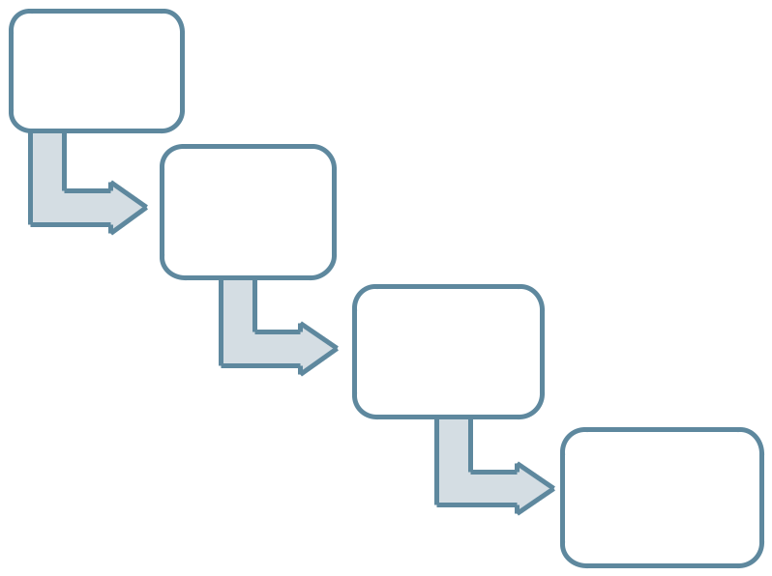

Initial
Inspection:

July 1, 2024

- The property is lead safe. A lead-safe certificate is issued and is valid for two years.

- The next inspection is scheduled for July 1, 2027.

The lead-safe
certificate
expires:

July 1, 2026

The tenant
moves:

October 1,
2026

- Because the lead-safe certificate is expired, an inspection is necessary.

- The property is still lead-safe. A lead-safe certificate is issued and is valid for two years.

The lead-safe | • The next inspection is scheduled for
certificate | October 1, 2029.
expires: •If the tenant moves November 1,

_{October 1, 2028} 2028, the dwelling will need to be inspected at that time.

To ensure compliance with the timeframes established within P.L.2021, c. 182, owners subject to P.L.2021, c.182 must notify municipalities of all tenant turnovers, especially in the event the lead-safe certificate has expired.

14

3.3.4 Visual Inspections

For municipalities that may perform visual assessments, the inspector should examine rental dwellings for deteriorated paint or visible surface dust, debris, or residue.

Paint is deteriorated when it is peeling, chipping, chalking, or cracking. Tack and nail holes, small hairline cracks, and other surface imperfections may not be considered deteriorated paint.

The inspector should look for deteriorated paint on all painted building components, especially any walls, window, or trim. Also, the inspector should look on surfaces that experience friction or impact. When two surfaces slide across each other or strike one another, the painted surface may become deteriorated. Examples of friction and impact surfaces are doors, windows, floors, and trim areas.

The inspector should look for paint chips or dust from painting activities that were not cleaned up and paint residue on the floors, which could be a hazard for small children.

HUD offers Visual Assessment Training online at:

https://apps.hud.gov/offices/lead/training/visualassessment/h00200.htm.

3.3.5 Dust Wipe Sampling

Dust wipe sampling is collected by wiping representative surfaces, including floors (both carpeted and uncarpeted), interior windowsills, and other similar surfaces, and testing in accordance with a method approved by HUD.

These samples must be undertaken properly to ensure that results are accurate. N.J.A.C. 5:17 contains requirements for dust wipe sampling. In addition, Appendix 13.1 of the HUD Guidelines for the Evaluation and Control of Lead-Based Paint Hazards in Housing provides the protocol for sample collection. This Appendix is available online at: https://www.hud.gov/sites/documents/LBPH-40.PDF.

It is recommended that the lead evaluation contractor or permanent local agency also perform a visual inspection when undertaking a dust wipe sampling.

3.4.0 Periodic Inspection Results – No Lead-Based Paint Hazards

15

If it is determined upon inspection that no lead-based paint hazards exist in a dwelling, the lead evaluation contractor or local enforcing agency shall certify the dwelling unit as lead-safe. The lead-safe certification is valid for a period of two years.

If, during the certification period, a lead evaluation contractor, lead inspector, risk assessor, a local health department, or a public agency conducts an independent inspection or risk assessment and determines that there is a lead-based paint hazard, the lead-safe certification issued is invalid, and the independent inspector or risk assessor shall inform the municipality of the results of the inspection.

If lead-based paint hazards exist, see Section 4.0.0.

3.5.0. Fees for Periodic Inspections

Municipalities must charge the dwelling owner a fee sufficient to cover the cost of inspection. For municipalities that must hire a lead evaluation contractor to perform the inspection, the fee should include the cost of hiring the lead evaluation contractor.

In addition, each municipality must assess an additional fee of $20 per unit inspected, which shall be deposited into the Lead Hazard Control Assistance Fund, unless the Department has already assessed this additional lead surcharge fee.

16

4.0.0 REMEDIATION OF LEAD-BASED PAINT HAZARDS

4.1.0 How to Proceed if Lead-Based Paint Hazards are Found

If lead-based paint hazards are found during an inspection, the owner of the dwelling unit must remediate the lead-based paint hazard by using lead-based paint hazard control methods (interim controls) or abatement. Colloquially, remediation is often used synonymously with interim controls and does not include abatement; however, in the context of P.L.2021, c.182, encompasses both interim controls and abatement.

If deteriorated paint is found during the course of a visual assessment, the owner of a dwelling may elect to order a dust wipe inspection to confirm the presence of lead-based paint.

The next two sections provide an overview for the acceptable interim control and abatement methods.

4.1.1. Who May Perform Remediation Work?

Remediation work must be performed by certified individuals in accordance with all applicable Federal and State regulations.

The New Jersey Department of Community Affairs certifies lead evaluation and abatement contractors. Information may be found online at: https://www.nj.gov/dca/divisions/codes/offices/leadhazard_abatement.html.

The New Jersey Department of Health licenses individual lead inspectors, risk assessors, and abatement workers. Information may be found online at: https://www.nj.gov/health/ceohs/lead/lead-workers-supervisors/#4.

The United States Environmental Protection Agency (EPA) certifies Renovation, Repair, and Painting (RRP) contractors. These firms are certified to perform RRP work that address lead-based paint in homes and childcare facilities. This work is often involved in interim control methods. Information may be found online at: https://www.epa.gov/lead/lead-renovation-repair-and-painting-program.

Interim controls that do not involve RRP work may be undertaken without specific certification.

17

4.2.0 Interim Controls

Interim Controls are measures designed to temporarily reduce human exposure to lead-based paint hazards.

It is easiest and most appropriate to use interim controls when fixtures are structurally sound and lead exposure comes primarily from deteriorating paint and excessive levels of lead in household dust. In many cases, resources will not be available to finance abatement, making interim controls the only feasible approach.

Interim controls may also be appropriate if the housing unit is slated for demolition or renovation within a few years and the investment in more costly abatement is not merited.

The HUD Guidelines for Evaluation and Control of Lead Based-Paint Hazards in Housing provides the extensive requirements for interim controls. It is available online at: https://www.hud.gov/program_offices/healthy_homes/lbp/hudguidelines.

Interim control measures include the following:

Paint Stabilization |  | Making surfaces smooth
Paint Stabilization |  | and cleanable

Correcting dust-

generating conditions

- All deteriorated paint on exterior surfaces should be stabilized in accordance with the HUD guidelines.

- All surfaces, such as floors, stairs, and interior windowsills, that are rough, pitted, or porous should be made smooth and easy to clean.

- Minor surface damage may be correctable by spackling and recoating. Otherwise, it may be necessary to cover or coat the surface with a material such as plastic, sheet vinyl, linoleum, etc.

18

- HUD guidelines include the necessary measures for correcting dust-generating conditions.

4.3.0 Abatement

In certain cases, interim controls are unlikely to be effective, especially if the building has substantial structural defects or if interior or exterior walls, or major components, are seriously deteriorated or subject to excessive moisture. In these situations, abatement is more appropriate in addressing lead-based paint hazards.

All abatement work must be undertaken in accordance with the State regulations for

Lead Hazard Evaluation and Abatement, which are described in N.J.A.C. 5:17, available

online at:

https://www.nj.gov/dca/divisions/codes/codreg/pdf_regs/njac_5_17.pdf.

Abatement includes:

Paint Removal

Building Component

Replacement

Enclosure

- This includes the removal of lead-based paint by mechanical methods. Examples include wet scraping, wet sanding methods, non-abrasive blasting, etc.

- This includes the careful removal of any building component which contains a lead-based paint hazard.

- These new components cannot be brought into the working area until all dust-generating activity is completed and has been cleaned to ensure the new component does not become exposed to lead hazards.

- This includes enclosing lead-based paint hazards behind other materials.

- Drywall, fiberboard, or its functional equivalent may be used for interior wall enclosures; moisture-resistant greenboard must be used in damp areas.

- Old flooring must be covered with one-half inch or thicker plywood before any other floor covering is added.

19

4.4.0 Post-Remediation Inspection

After remediation has been completed, whether through interim controls or abatement, the municipality or lead evaluation contractor must perform an additional inspection within 60 days of the initial periodic lead-based paint inspection to ensure there are no further lead-based paint hazards.

Upon conducting the reinspection in dwellings that have been remediated using interim controls, if no lead-based paint hazards are found, the municipality or inspector must certify the dwelling to be lead safe pursuant to P.L.2021, c.182 (see Section 3.4.0. for an example of a lead-safe certificate). The certificate would then be valid for two years.

If the dwelling has been remediated using abatement, pursuant to N.J.A.C. 5:17-9.1, and a lead abatement clearance certificate has been issued by the local enforcing agency, then the lead-free certificate issued at the final clearance inspection shall exempt the dwelling from future inspections pursuant to P.L.2021, c.182 (see Section 3.2.0).

4.5.0 Grants and Loans for Remediation Work

The Department of Community Affairs, Division of Housing and Community Resources, provides financial assistance in the form of grants or loans to eligible owners and occupants. Information about the various programs is available on the Department’s website at: https://www.nj.gov/dca/divisions/dhcr/offices/leadsafe.html.

20

5.0.0 RECORDKEEPING AND INVESTIGATIONS

5.1.0 Municipal Record Keeping

Municipalities will be required to keep track of all rental dwellings, their inspection schedule, and whether a lead-based paint hazard has been found.

In addition to the inspection schedule, municipalities must maintain a copy of any lead-safe certificates in their records for the property.

5.2.1 Municipal Investigations

Municipalities are authorized to conduct investigations and issue penalties to enforce a property owner’s failure to comply with the requirements of P.L.2021, c.182.

If a municipality determines that a property owner has failed to comply with the requirements of this law, the property owner must be given 30 days from the date of the determination to cure any violation by ordering the necessary inspection or by initiating remediation.

If the dwelling owner has not cured the violation within 30 days, the owner shall be subject to a penalty not to exceed $1,000 per week until the required inspection has been conducted or remediation efforts have been initiated. Remediation efforts are considered initiated when the owner has hired a lead abatement contractor or other qualified party to perform lead-hazard control methods.

5.2.2 Department of Community Affairs Investigations

When a complaint is filed with the Department of Community Affairs, or of the Commissioner’s own accord, the Commissioner is authorized to conduct investigations and issue penalties against a municipality for its failure to comply with the requirements of P.L.2021, c.182. The Department will give the municipality a period of 30 days to undertake necessary inspections and provide proof in the form of valid lead-safe certifications or notification that lead-based paint hazards exist in a dwelling and remediation will be initiated. If the municipality has not cured the violation within 30 days, they shall be subject to a penalty not to exceed $1,000 per week until the necessary action has been taken.

21

APPENDIX A. LEAD-SAFE CERTIFICATION
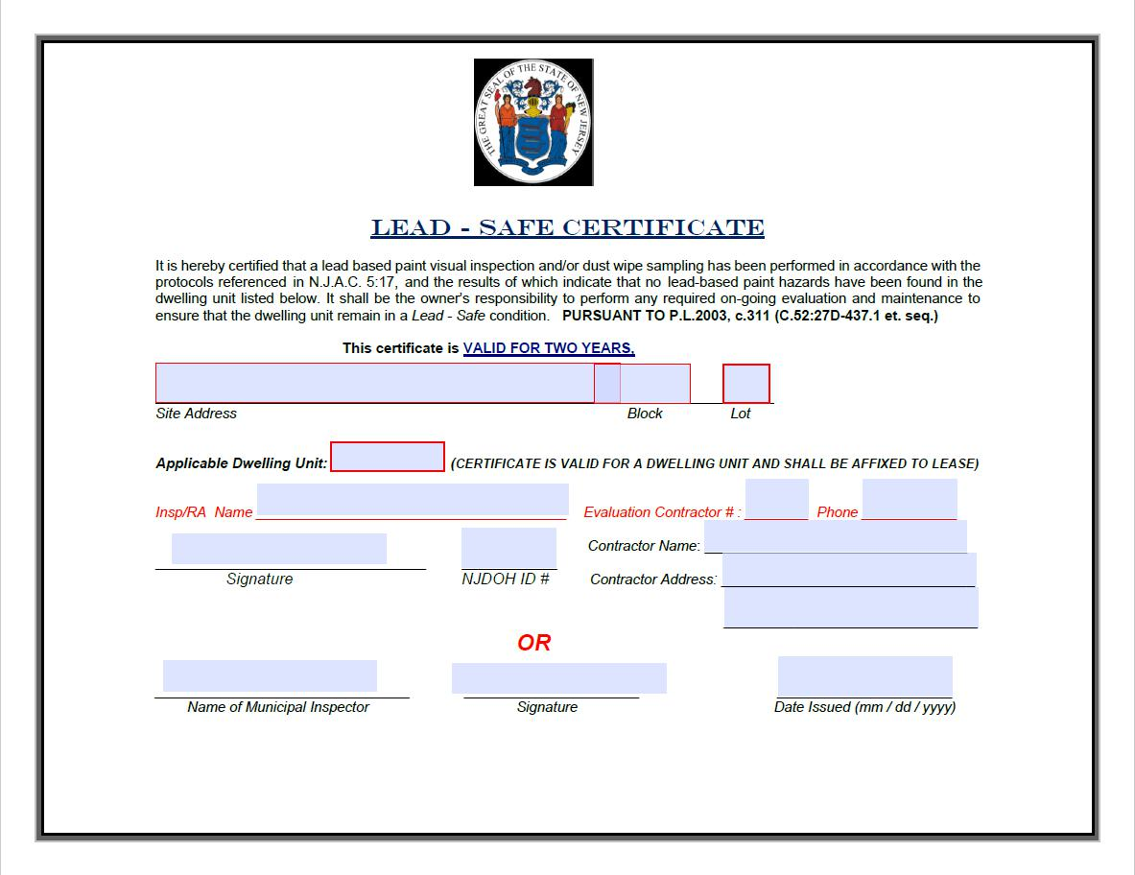

22

APPENDIX B. FREQUENTLY ASKED QUESTIONS

- What is lead and its associated hazards?

Lead is a toxic, naturally occurring element and heavy metal in our environment that was widely used in commercial products such as gasoline, paint, cosmetics, spices, and pottery. Lead exposure in children can cause nervous system and kidney damage, as well as learning disabilities, attention-deficit disorder, and decreased intelligence. It can also cause behavior, speech, and language problems, hearing damage, decreased muscle and bone growth, and poor muscle coordination.

- How does one identify lead-based paint hazards?

Lead-based paint is usually not a hazard if it is in good condition, and the paint is not on an impact or friction surface, such as a window. Deteriorating lead-based paint (peeling, chipping, chalking, cracking, or damaged paint) is a hazard and needs attention. Lead dust can form when lead-based paint is scraped, sanded, or heated. Dust also forms when painted surfaces bump or rub together. Lead chips and dust can reside on surfaces and objects that people touch.

- What are the requirements of municipalities under P.L. 2021, c. 182?

The law imposes an obligation on municipalities to perform or hire a certified lead evaluation contractor to perform inspections of certain single-family, two-family, and multiple rental dwellings for lead-based paint hazards every three years or upon tenant turnover where there is no valid lead-safe certification. As an alternative, municipalities must permit dwelling owners/landlords to directly hire a certified lead evaluation contractor for this purpose.

- What are the requirements of property owners under P.L. 2021, c. 182?

If lead-based paint hazards are identified, then the owner of the dwelling shall remediate the hazards through abatement or lead-based paint hazard control mechanisms. Property owners must also report all tenant turnover activity to the

23

municipality. Lastly, property owners must provide a copy of N.J.A.C. 5:28A, any lead-safe certifications, and the accompanying guidance document, Lead-Based Paint in Rental Dwellings, to any prospective owners of the dwelling during the real estate transaction, settlement, or closing.

- What dwellings are required to be inspected and what dwellings are exempt?

All single-family, two-family, and multiple rental dwellings must be inspected, with the exception of the following dwellings, which are exempt:

  - Dwellings that were constructed during or after 1978.

  - Single-family and two-family seasonal rental dwellings which are rented for less than six-months duration each year by tenants that do not have consecutive lease renewals.

  - Dwellings that have been certified to be free of lead-based paint pursuant to N.J.A.C. 5:17-3.16(b).

  - Multiple rental dwellings that have been registered with the Department of Community Affairs for at least ten years and have no outstanding lead violations from the most recent cyclical inspection performed on the multiple dwelling under the “Hotel and Multiple Dwelling Law” (N.J.S.A. 55:13A-1).
o This means that all multiple dwellings constructed prior to 1978 and

registered with the Department for at least ten years that have a certificate of inspection issued by the Department of Community Affairs, Bureau of Housing Inspection, are exempt from this requirement.

o A multiple dwelling that has been registered with the Department for at least ten years with an open inspection that has no violations for paint is also exempt from this requirement.

  - Dwellings with a valid lead-safe certificate issued pursuant to this law, P.L.2021, c.182. Lead-safe certificates are valid for two years from the date of issuance.

- What is the periodic inspection procedure?

24

For dwellings located in a municipality in which less than three percent of children tested, six years of age or younger, have a blood lead level greater than or equal to five micrograms per deciliter, the inspection may be carried out through visual inspection, as explained in Section 3.3.4.

For dwellings located in a municipality in which at least three percent of children tested, six years of age or younger, have a blood lead level greater than or equal to five micrograms per deciliter, the inspection must be carried out through dust wipe sampling, as explained in Section 3.3.5.

All rental dwelling units required to be inspected must be inspected for lead-based paint within two years of the effective date of the law, July 22, 2022, or upon tenant turnover, whichever is earlier. This means that the first inspection must take place no later than July 22, 2024.

After the initial inspection, all units shall be inspected for lead-based paint hazards every three years, or upon tenant turnover, whichever is earlier. An inspection upon tenant turnover is not required if the owner has a valid lead-safe certificate. Lead-safe certificates are valid for two years. If the lead-safe certificate has expired, and there will be a tenant turnover, an inspection will be necessary before the three-year inspection.

In all scenarios, the next inspection should be scheduled three years from the date of issuance of the most recent valid lead-safe certification.

- What is a visual assessment?

A visual assessment is an examination of all painted building components for deteriorated paint or visible surface dust, debris, or residue. The inspector should also look for paint chips or dust from painting activities that were not cleaned up and paint residue on floors.

- What are dust wipe samplings?

Dust wipe sampling is collected by wiping a representative surface, including floors (both carpeted and uncarpeted), interior windowsills, and other similar surfaces,

25

and testing in accordance with a method approved by the United States Department of Housing and Urban Development (HUD). These samples must be undertaken properly to ensure that results are accurate.

9. What does interim controls mean?

Interim controls are a set of measures designed to reduce temporarily human exposure or likely exposure to lead-based paint hazards, including specialized cleaning, repairs, maintenance, painting, temporary containment, ongoing monitoring of lead-based paint hazards or potential hazards.

10. What does abatement mean?

Lead abatement is a set of measures designed to permanently eliminate lead-based paint hazards.

11. Who can perform lead evaluation?

The New Jersey Department of Community Affairs certifies lead evaluation contractors. The New Jersey Department of Health licenses individual lead inspectors and risk assessors.

12. Who can perform lead remediation work?

The New Jersey Department of Community Affairs certifies lead abatement contractors; the New Jersey Department of Health licenses individual lead abatement workers; the United States Environmental Protection Agency (EPA) certifies Renovation, Repair, and Painting (RRP) contractors. These firms are certified to perform RRP projects that address lead-based paint in homes.

13. What is required for municipal record keeping to be in compliance with the Act?

Municipalities must maintain a record of all dwellings subject to this Chapter which shall include up-to-date information on inspection schedules, inspection results,

26

and tenant turnover. Municipalities must also maintain a record of all lead-safe certifications issued pursuant to this Chapter; any time a lead evaluation contractor performs the inspection, the lead evaluation contractor must provide a copy of any lead-safe certifications it issued to the municipality. Finally, municipalities must maintain a record of all lead-free certifications issued pursuant to N.J.A.C. 5:17.

14. What investigations are required under the Act?

Municipalities are authorized to conduct investigations and issue penalties to enforce a property owner’s failure to comply with the requirements of P.L.2021, c.182. If a municipality determines that a property owner has failed to comply with the requirements of this law, the property owner must be given 30 days to cure any violation by ordering the necessary inspection or by initiating remediation.

When a complaint is filed with the Department of Community Affairs, or of the Commissioner’s own accord, the Commissioner is authorized to conduct investigations and issue penalties against a municipality for its failure to comply with the requirements of P.L.2021, c.182. The Department will give the municipality 30 days to undertake necessary inspections and provide proof in the form of valid lead-safe certifications or notification that lead-based paint hazards exist in a dwelling.

15. What are the penalties for failure to comply with the Act?

If the dwelling owner has not cured the violation within 30 days, the owner shall be subject to a penalty not to exceed $1,000 per week until the required inspection has been conducted or remediation efforts have been initiated.

If the municipality has not cured the violation within 30 days, they shall be subject to a penalty not to exceed $1,000 per week until the necessary action has been taken.

27

