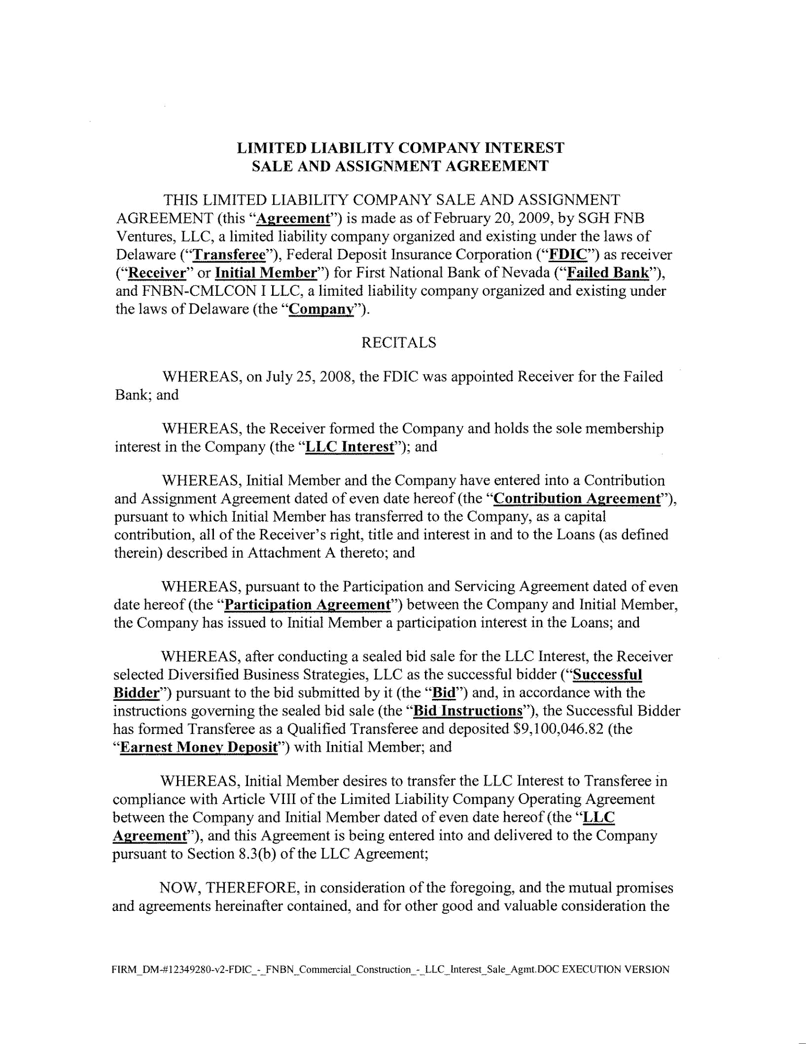

LIMITED LIABILITY COMPANY INTEREST

SALE AND ASSIGNMENT AGREEMENT

THIS LIMITED LIABILITY COMPANY SALE AND ASSIGNMENT AGREEMENT (this "Agreement") is made as of February 20, 2009, by SGH FNB Ventures, LLC, a limited liability company organized and existing under the laws of Delaware ("Transferee"), Federal Deposit Insurance Corporation ("FDIC") as receiver ("Receiver" or Initial Member") for First National Bank of Nevada ("Failed Bank"), and FNBN-CMLCON I LLC, a limited liability company organized and existing under the laws of Delaware (the "Company").

RECITALS

WHEREAS, on July 25, 2008, the FDIC was appointed Receiver for the Failed Bank; and

WHEREAS, the Receiver formed the Company and holds the sole membership interest in the Company (the "LLC Interest"); and

WHEREAS, Initial Member and the Company have entered into a Contribution and Assignment Agreement dated of even date hereof (the "Contribution Agreement"), pursuant to which Initial Member has transferred to the Company, as a capital contribution, all of the Receiver's right, title and interest in and to the Loans (as defined therein) described in Attachment A thereto; and

WHEREAS, pursuant to the Participation and Servicing Agreement dated of even date hereof (the "Participation Agreement") between the Company and Initial Member, the Company has issued to Initial Member a participation interest in the Loans; and

WHEREAS, after conducting a sealed bid sale for the LLC Interest, the Receiver selected Diversified Business Strategies, LLC as the successful bidder ("Successful Bidder") pursuant to the bid submitted by it (the "Bid") and, in accordance with the instructions governing the sealed bid sale (the "Bid Instructions"), the Successful Bidder has formed Transferee as a Qualified Transferee and deposited $9,100,046.82 (the "Earnest Money Deposit") with Initial Member; and

WHEREAS, Initial Member desires to transfer the LLC Interest to Transferee in compliance with Article VIII of the Limited Liability Company Operating Agreement between the Company and Initial Member dated of even date hereof (the "LLC Agreement"), and this Agreement is being entered into and delivered to the Company pursuant to Section 8.3(b) of the LLC Agreement;

NOW, THEREFORE, in consideration of the foregoing, and the mutual promises and agreements hereinafter contained, and for other good and valuable consideration the

FIRM_DM-#12349280-v2-FDIC _ -_FNBN _Commercial_Construction_-_LLC_Interest_Sale_Agmt. DOC EXECUTION VERSION

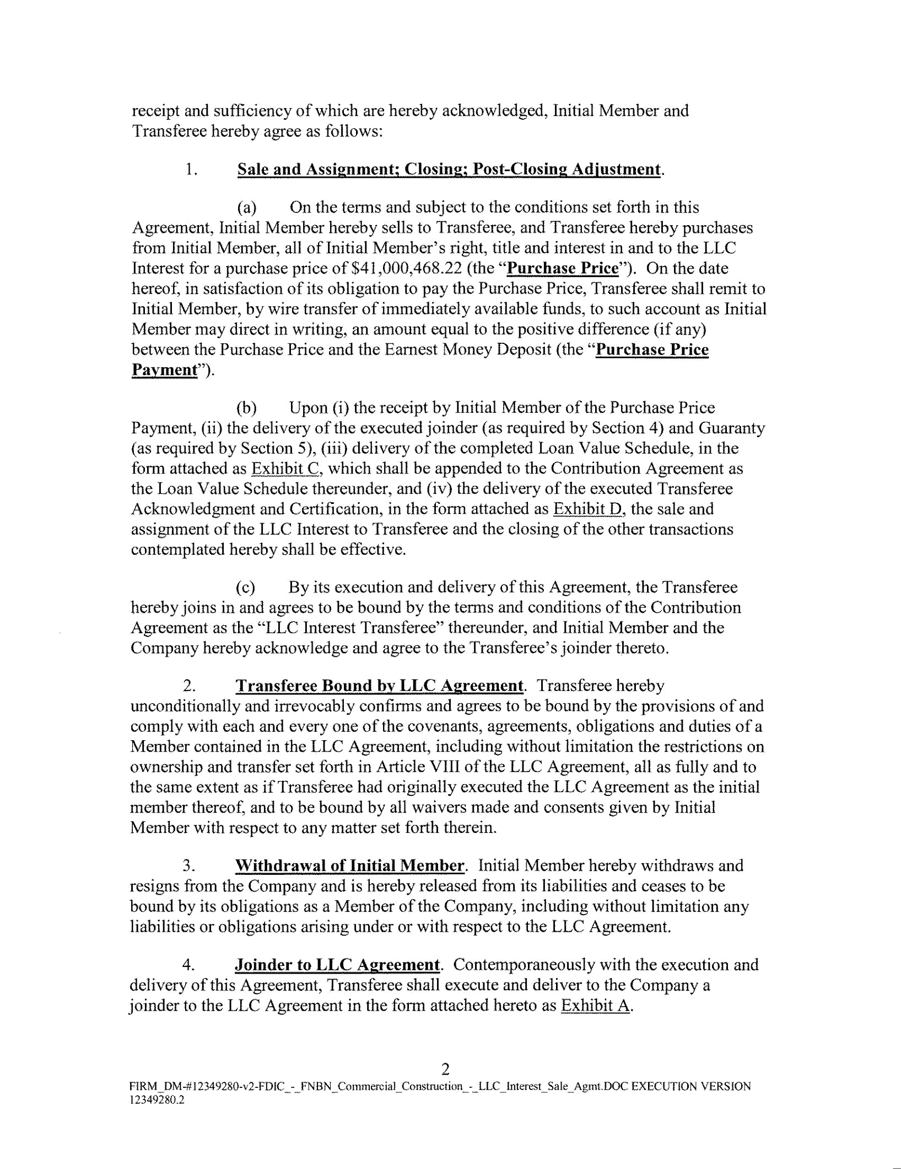
receipt and sufficiency of which are hereby acknowledged, Initial Member and

Transferee hereby agree as follows:

    - Sale and Assignment; Closing; Post-Closing Adjustment.

        - On the terms and subject to the conditions set forth in this Agreement, Initial Member hereby sells to Transferee, and Transferee hereby purchases from Initial Member, all oflnitial Member's right, title and interest in and to the LLC Interest for a purchase price of $41,000,468.22 (the "Purchase Price"). On the date hereof, in satisfaction of its obligation to pay the Purchase Price, Transferee shall remit to Initial Member, by wire transfer of immediately available funds, to such account as Initial Member may direct in writing, an amount equal to the positive difference (if any) between the Purchase Price and the Earnest Money Deposit (the "Purchase Price

Payment").

        - Upon (i) the receipt by Initial Member of the Purchase Price Payment, (ii) the delivery of the executed joinder (as required by Section 4) and Guaranty (as required by Section 5), (iii) delivery of the completed Loan Value Schedule, in the form attached as Exhibit C, which shall be appended to the Contribution Agreement as the Loan Value Schedule thereunder, and (iv) the delivery of the executed Transferee Acknowledgment and Certification, in the form attached as Exhibit D, the sale and assignment of the LLC Interest to Transferee and the closing of the other transactions contemplated hereby shall be effective.

      - By its execution and delivery of this Agreement, the Transferee hereby joins in and agrees to be bound by the terms and conditions of the Contribution Agreement as the "LLC Interest Transferee" thereunder, and Initial Member and the Company hereby acknowledge and agree to the Transferee's joinder thereto.

  - Transferee Bound by LLC Agreement. Transferee hereby

unconditionally and irrevocably confirms and agrees to be bound by the provisions of and comply with each and every one of the covenants, agreements, obligations and duties of a Member contained in the LLC Agreement, including without limitation the restrictions on ownership and transfer set forth in Article VIII of the LLC Agreement, all as fully and to the same extent as if Transferee had originally executed the LLC Agreement as the initial member thereof, and to be bound by all waivers made and consents given by Initial Member with respect to any matter set forth therein.

  - Withdrawal of Initial Member. Initial Member hereby withdraws and resigns from the Company and is hereby released from its liabilities and ceases to be bound by its obligations as a Member of the Company, including without limitation any liabilities or obligations arising under or with respect to the LLC Agreement.

- Joinder to LLC Agreement. Contemporaneously with the execution and delivery of this Agreement, Transferee shall execute and deliver to the Company a joinder to the LLC Agreement in the form attached hereto as Exhibit A.

2

FIRM_OM-# 12349280-v2-FDIC _-_FNBN_Commercial_Construction_-_LLC_Interest_Sale_Agmt.DOC EXECUTION VERSION

!2349280.2
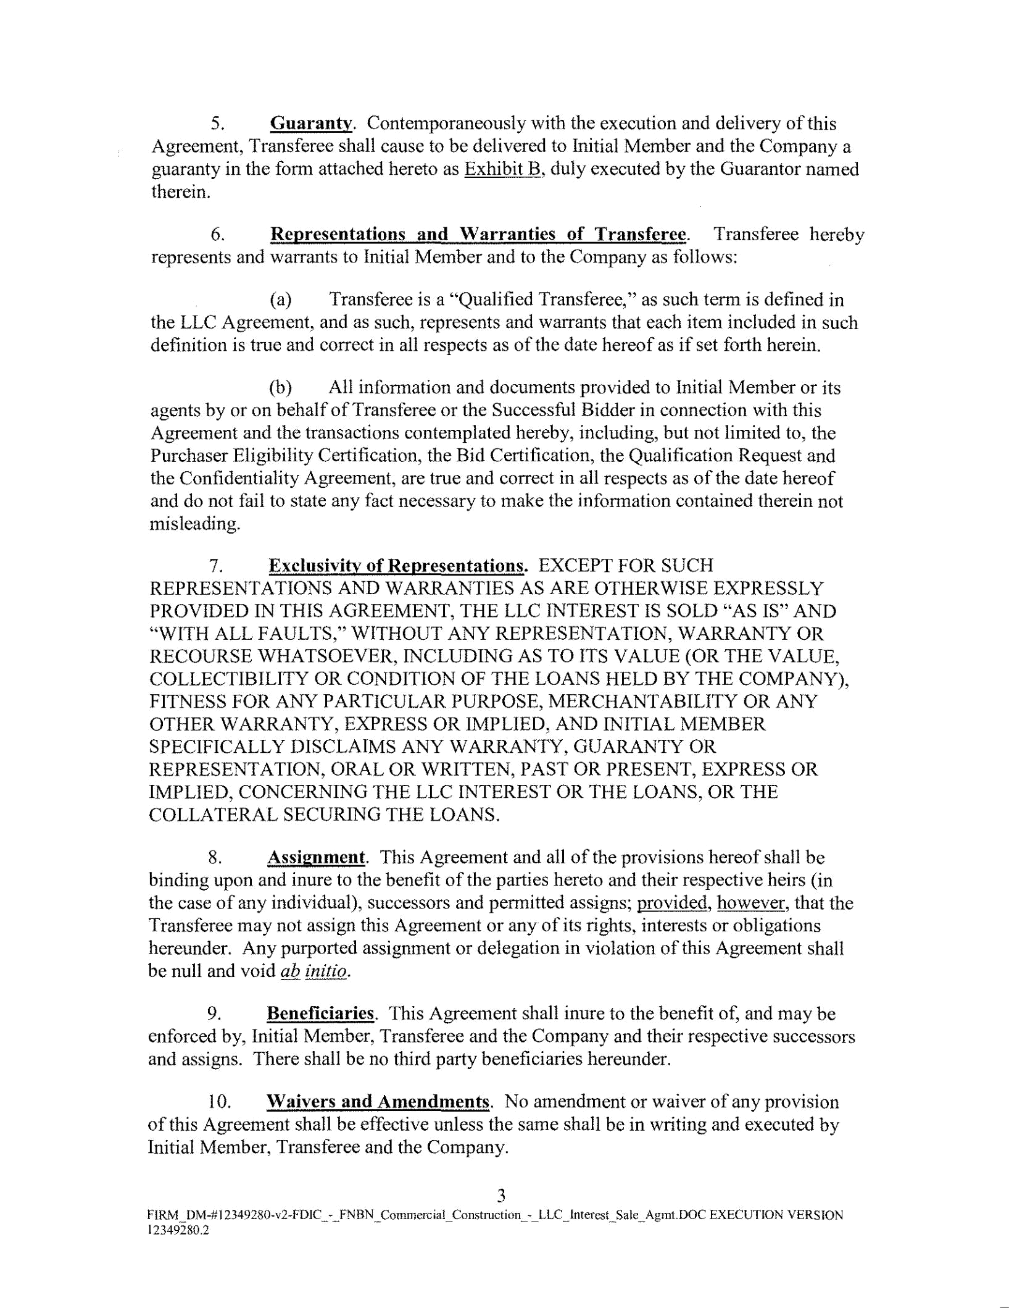
    - Guaranty. Contemporaneously with the execution and delivery of this Agreement, Transferee shall cause to be delivered to Initial Member and the Company a guaranty in the form attached hereto as Exhibit B, duly executed by the Guarantor named therein.

    - Representations and Warranties of Transferee. Transferee hereby represents and warrants to Initial Member and to the Company as follows:

      - Transferee is a "Qualified Transferee," as such term is defined in the LLC Agreement, and as such, represents and warrants that each item included in such definition is true and correct in all respects as of the date hereof as if set forth herein.

      - All information and documents provided to Initial Member or its agents by or on behalf of Transferee or the Successful Bidder in connection with this Agreement and the transactions contemplated hereby, including, but not limited to, the Purchaser Eligibility Certification, the Bid Certification, the Qualification Request and the Confidentiality Agreement, are true and correct in all respects as of the date hereof and do not fail to state any fact necessary to make the information contained therein not misleading.

  - Exclusivity of Representations. EXCEPT FOR SUCH REPRESENTATIONS AND WARRANTIES AS ARE OTHERWISE EXPRESSLY PROVIDED IN THIS AGREEMENT, THE LLC INTEREST IS SOLD "AS IS" AND "WITH ALL FAULTS," WITHOUT ANY REPRESENTATION, WARRANTY OR RECOURSE WHATSOEVER, INCLUDING AS TO ITS VALUE (OR THE VALUE, COLLECTIBILITY OR CONDITION OF THE LOANS HELD BY THE COMPANY), FITNESS FOR ANY PARTICULAR PURPOSE, MERCHANTABILITY OR ANY OTHER WARRANTY, EXPRESS OR IMPLIED, AND INITIAL MEMBER SPECIFICALLY DISCLAIMS ANY WARRANTY, GUARANTY OR REPRESENTATION, ORAL OR WRITTEN, PAST OR PRESENT, EXPRESS OR IMPLIED, CONCERNING THE LLC INTEREST OR THE LOANS, OR THE COLLATERAL SECURING THE LOANS.

  - Assignment. This Agreement and all of the provisions hereof shall be binding upon and inure to the benefit of the parties hereto and their respective heirs (in the case of any individual), successors and permitted assigns; provided, however, that the Transferee may not assign this Agreement or any of its rights, interests or obligations hereunder. Any purported assignment or delegation in violation of this Agreement shall be null and void ab initio.

- Beneficiaries. This Agreement shall inure to the benefit of, and may be enforced by, Initial Member, Transferee and the Company and their respective successors and assigns. There shall be no third party beneficiaries hereunder.

I0. Waivers and Amendments. No amendment or waiver of any provision of this Agreement shall be effective unless the same shall be in writing and executed by Initial Member, Transferee and the Company.

3

FIRM~DM-# 12349280-v2-FDIC~-_FN BN _Commercial_Construction_-_ LLC_Interest_ Sale_ AgmLDOC EXECUTION VERSION

12349280.2
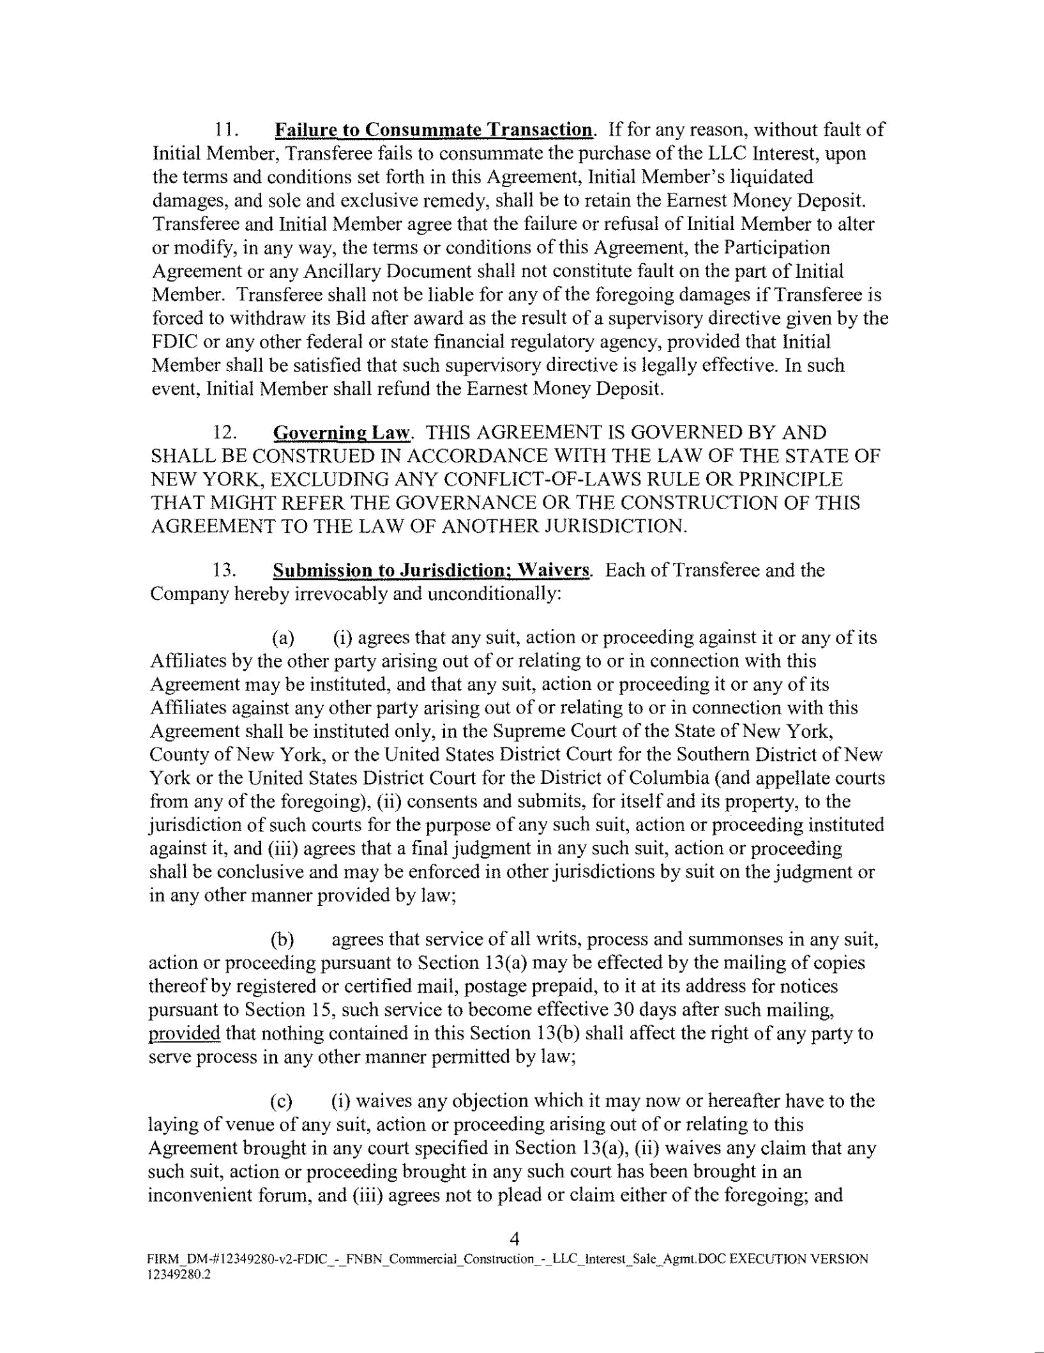
  - Failure to Consummate Transaction. If for any reason, without fault of Initial Member, Transferee fails to consummate the purchase of the LLC Interest, upon the terms and conditions set forth in this Agreement, Initial Member's liquidated damages, and sole and exclusive remedy, shall be to retain the Earnest Money Deposit. Transferee and Initial Member agree that the failure or refusal ofinitial Member to alter or modify, in any way, the terms or conditions of this Agreement, the Participation Agreement or any Ancillary Document shall not constitute fault on the part ofinitial Member. Transferee shall not be liable for any of the foregoing damages if Transferee is forced to withdraw its Bid after award as the result of a supervisory directive given by the FDIC or any other federal or state financial regulatory agency, provided that Initial Member shall be satisfied that such supervisory directive is legally effective. In such event, Initial Member shall refund the Earnest Money Deposit.

- Governing Law. THIS AGREEMENT IS GOVERNED BY AND SHALL BE CONSTRUED IN ACCORDANCE WITH THE LAW OF THE STATE OF NEW YORK, EXCLUDING ANY CONFLICT-OF-LAWS RULE OR PRINCIPLE THAT MIGHT REFER THE GOVERNANCE OR THE CONSTRUCTION OF THIS AGREEMENT TO THE LAW OF ANOTHER JURISDICTION.

- Submission to Jurisdiction; Waivers. Each of Transferee and the Company hereby irrevocably and unconditionally:

      - (i) agrees that any suit, action or proceeding against it or any of its Affiliates by the other party arising out of or relating to or in connection with this Agreement may be instituted, and that any suit, action or proceeding it or any of its Affiliates against any other party arising out of or relating to or in connection with this Agreement shall be instituted only, in the Supreme Court of the State of New York, County of New York, or the United States District Court for the Southern District of New York or the United States District Court for the District of Columbia (and appellate courts from any of the foregoing), (ii) consents and submits, for itself and its property, to the jurisdiction of such courts for the purpose of any such suit, action or proceeding instituted against it, and (iii) agrees that a final judgment in any such suit, action or proceeding shall be conclusive and may be enforced in other jurisdictions by suit on the judgment or in any other manner provided by law;

      - agrees that service of all writs, process and summonses in any suit, action or proceeding pursuant to Section 13(a) may be effected by the mailing of copies thereof by registered or certified mail, postage prepaid, to it at its address for notices pursuant to Section 15, such service to become effective 30 days after such mailing, provided that nothing contained in this Section 13(b) shall affect the right of any party to serve process in any other manner permitted by law;

    - (i) waives any objection which it may now or hereafter have to the laying of venue of any suit, action or proceeding arising out of or relating to this Agreement brought in any court specified in Section 13(a), (ii) waives any claim that any such suit, action or proceeding brought in any such court has been brought in an inconvenient forum, and (iii) agrees not to plead or claim either of the foregoing; and

4
FIRM DM-#12349280-v2-FDIC - FNBN Commercial Construction - LLC Interest Sale Agmt.DOC EXECUTION VERSION
I 2349l80.2 ~ ~ ~ ~ ~ ~ ~ ~ ~
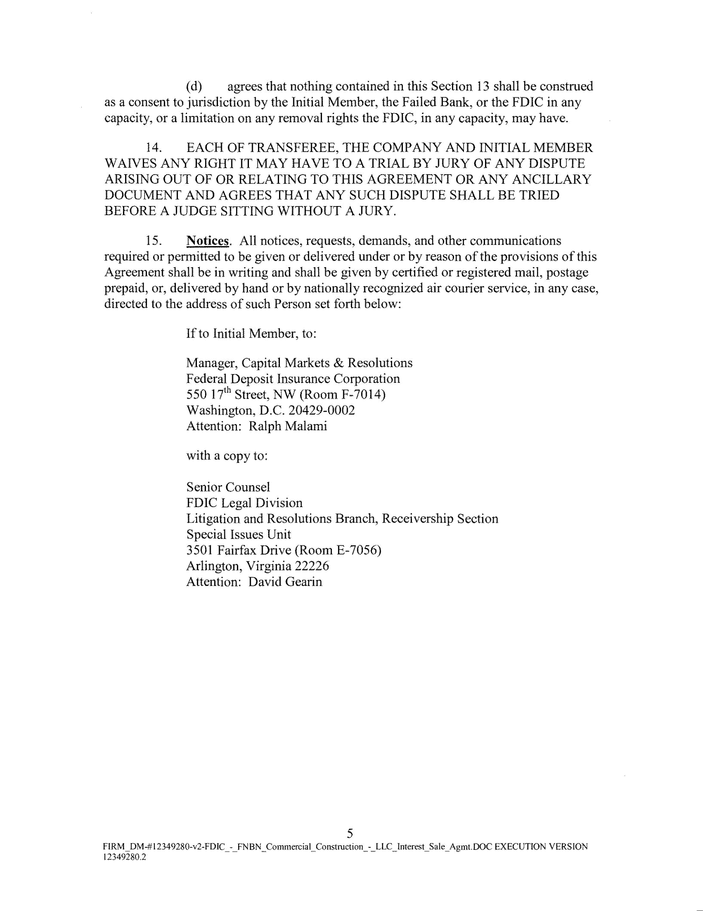
  - agrees that nothing contained in this Section 13 shall be construed as a consent to jurisdiction by the Initial Member, the Failed Bank, or the FDIC in any capacity, or a limitation on any removal rights the FDIC, in any capacity, may have.

- EACH OF TRANSFEREE, THE COMPANY AND INITIAL MEMBER W AlVES ANY RIGHT IT MAY HAVE TO A TRIAL BY JURY OF ANY DISPUTE ARISING OUT OF OR RELATING TO THIS AGREEMENT OR ANY ANCILLARY DOCUMENT AND AGREES THAT ANY SUCH DISPUTE SHALL BE TRIED BEFORE A JUDGE SITTING WITHOUT A JURY.

- Notices. All notices, requests, demands, and other communications required or permitted to be given or delivered under or by reason of the provisions of this Agreement shall be in writing and shall be given by certified or registered mail, postage prepaid, or, delivered by hand or by nationally recognized air courier service, in any case, directed to the address of such Person set forth below:

If to Initial Member, to:

Manager, Capital Markets & Resolutions

Federal Deposit Insurance Corporation

- 17'h Street, NW (Room F-7014) Washington, D.C. 20429-0002 Attention: Ralph Malami

with a copy to:

Senior Counsel

FDIC Legal Division

Litigation and Resolutions Branch, Receivership Section

Special Issues Unit

3501 Fairfax Drive (Room E-7056)

Arlington, Virginia 22226

Attention: David Gearin

5
FIRM_DM-# 12349280-v2-FDIC_-_FN BN _Commercial_Construction_--LLC_Interest_Sale_Agmt.DOC EXECUTION VERSION

12349280.2
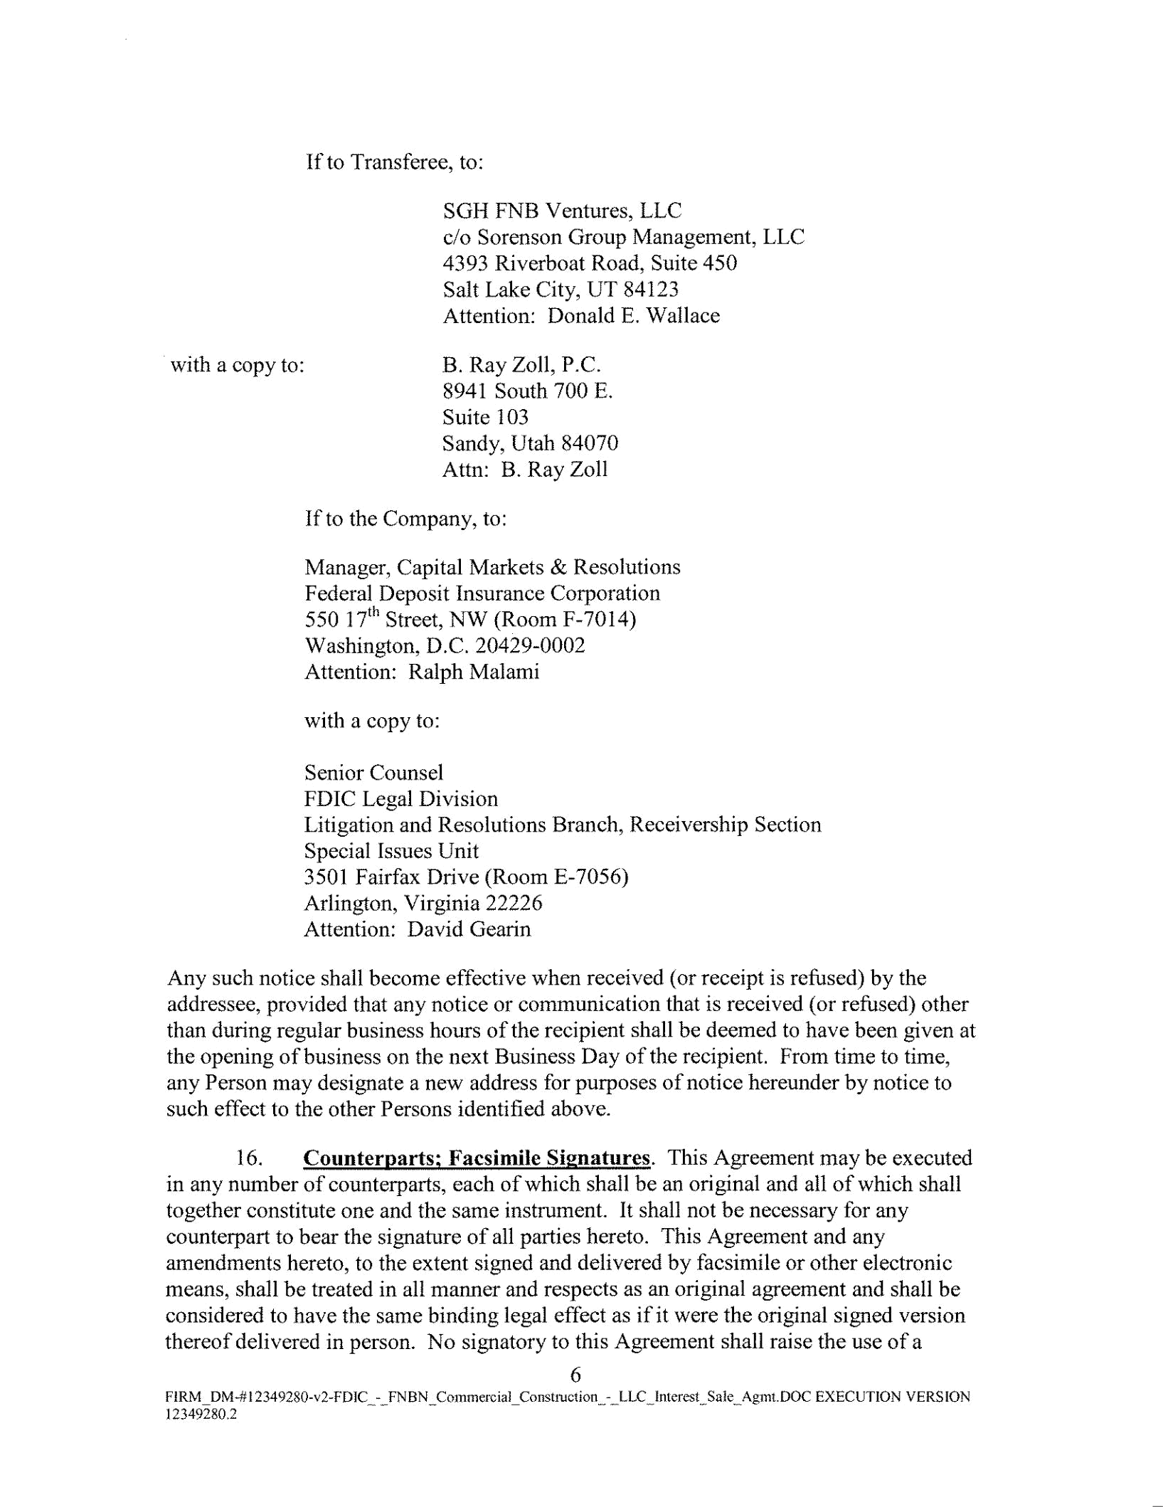
If to Transferee, to:

SOH FNB Ventures, LLC

c/o Sorenson Group Management, LLC

4393 Riverboat Road, Suite 450

Salt Lake City, UT 84123

Attention: Donald E. Wallace

with a copy to:

B. Ray Zoll, P.C.

8941 South 700 E.

Suite 103

Sandy, Utah 84070

Attn: B. Ray Zoll

If to the Company, to:

Manager, Capital Markets & Resolutions

Federal Deposit Insurance Corporation
- 17¹h Street, NW (Room F-7014) Washington, D.C. 20429-0002 Attention: Ralph Malami

with a copy to:

Senior Counsel

FDIC Legal Division

Litigation and Resolutions Branch, Receivership Section

Special Issues Unit

3501 Fairfax Drive (Room E-7056)

Arlington, Virginia 22226

Attention: David Gearin

Any such notice shall become effective when received (or receipt is refused) by the addressee, provided that any notice or communication that is received (or refused) other than during regular business hours of the recipient shall be deemed to have been given at the opening of business on the next Business Day of the recipient. From time to time, any Person may designate a new address for purposes of notice hereunder by notice to such effect to the other Persons identified above.

- Counterparts; Facsimile Signatures. This Agreement may be executed in any number of counterparts, each of which shall be an original and all of which shall together constitute one and the same instrument. It shall not be necessary for any counterpart to bear the signature of all parties hereto. This Agreement and any amendments hereto, to the extent signed and delivered by facsimile or other electronic means, shall be treated in all manner and respects as an original agreement and shall be considered to have the same binding legal effect as if it were the original signed version thereof delivered in person. No signatory to this Agreement shall raise the use of a

6

FIRM_OM-# 12349280-v2-FDIC_ --FNBN _Commercial_Construction_--LLC_Interest~Sale_Agmt.DOC EXECUTION VERSION 12349280.2

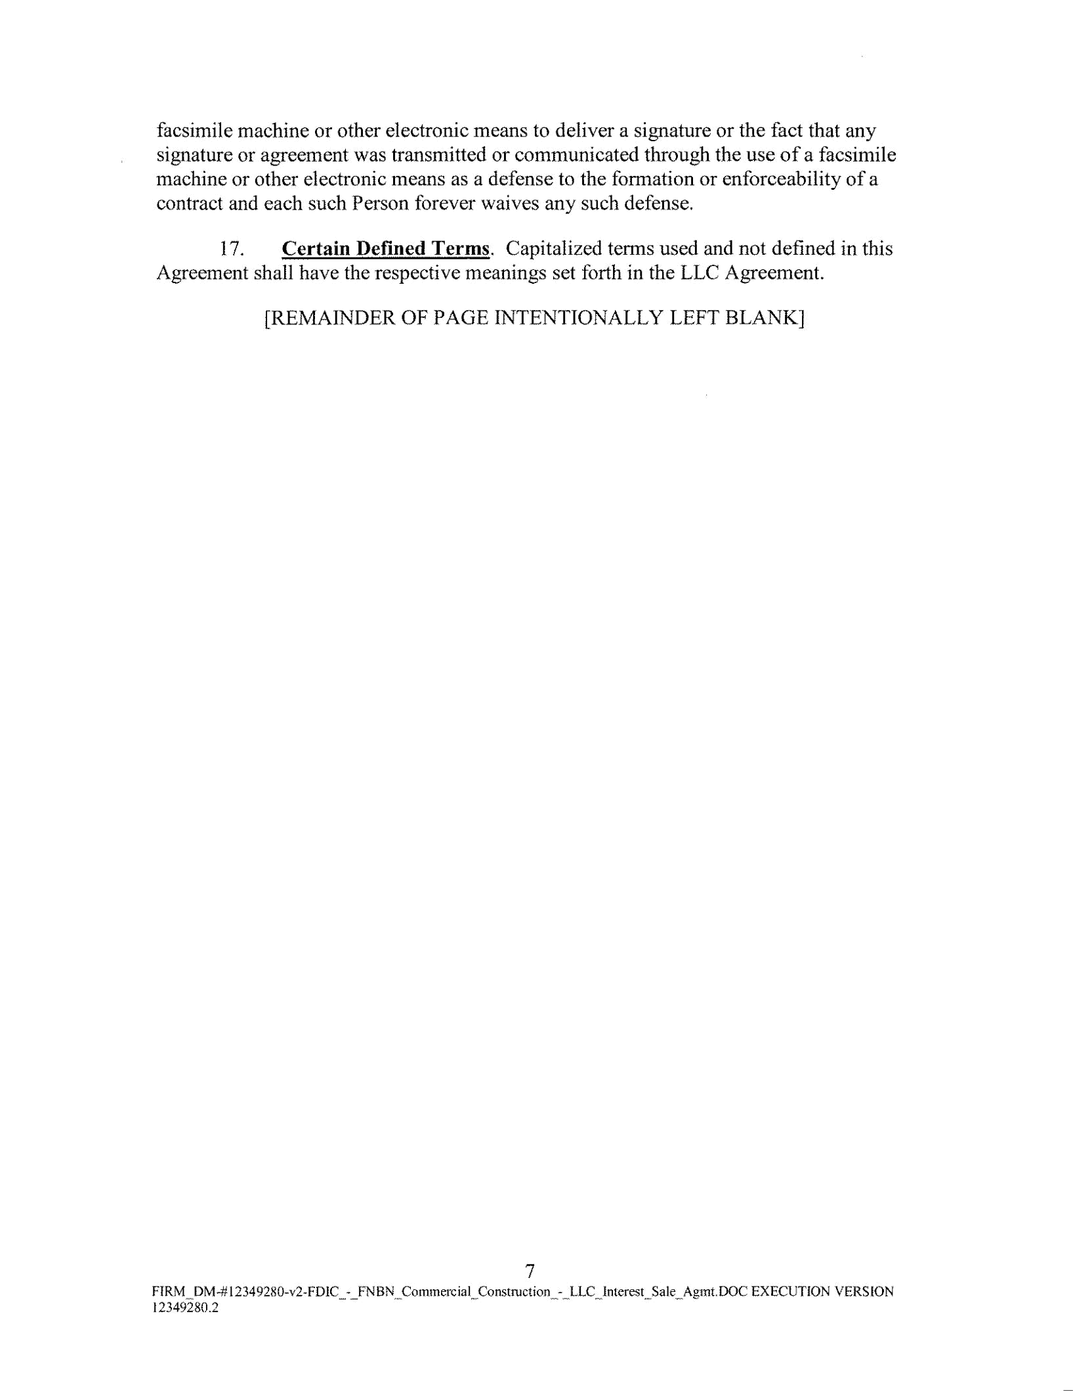
facsimile machine or other electronic means to deliver a signature or the fact that any signature or agreement was transmitted or communicated through the use of a facsimile machine or other electronic means as a defense to the formation or enforceability of a contract and each such Person forever waives any such defense.

- Certain Defined Terms. Capitalized terms used and not defined in this Agreement shall have the respective meanings set forth in the LLC Agreement.

[REMAINDER OF PAGE INTENTIONALLY LEFT BLANK]

7

FIRM~DM-#12349280-v2-FD1C_--FNBN__Commercial_Construction_-~LLC~Interest_Sale_ Agmt DOC EXECUTION VERSION

12349280.2
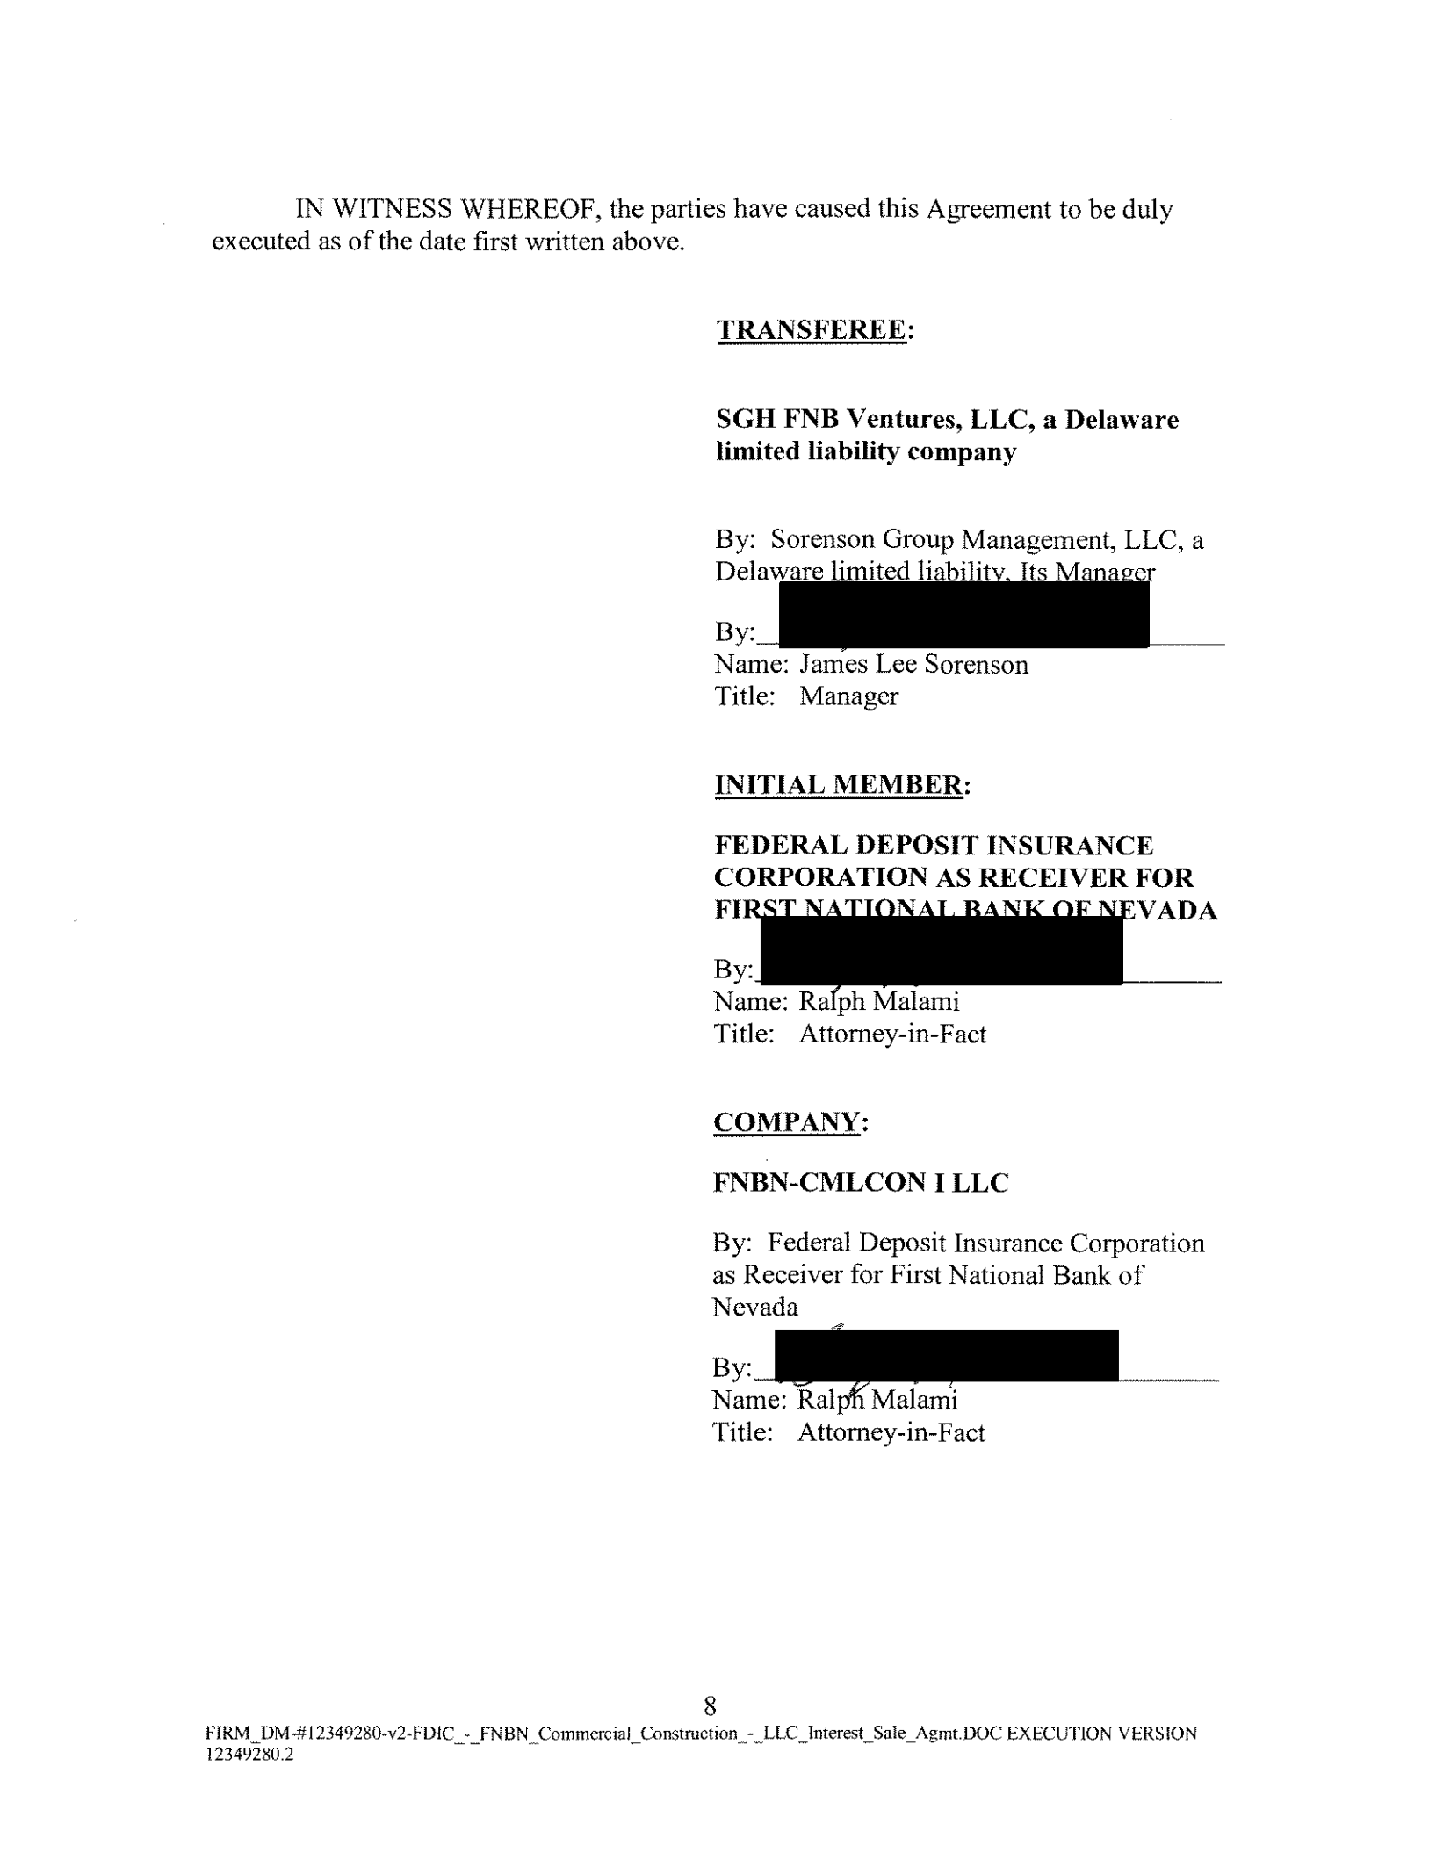
IN WITNESS WHEREOF, the parties have caused this Agreement to be duly executed as of the date first written above.

TRANSFEREE:

SGH FNB Ventures, LLC, a Delaware

limited liability company

By: Sorenson Group Management, LLC, a

DelawareJimited liability, Its Manager

By:

Name: Jarrt'es Lee Sorenson

Title: Manager

INITIAL MEMBER:

FEDERAL DEPOSIT INSURANCE

CORPORATION AS RECEIVER FOR

FIR EVADA

By
Name: Ra ph Malamt

Title: Attorney-in-Fact

COMPANY:

FNBN-CMLCON I LLC

By: Federal Deposit Insurance Corporation

as Receiver for First National Bank of

Nevada

~
Title: Attorney-in-Fact

8

FIRM_ DM-# 12349280~v2-FDIC~¥ _FN BN~Commercial_Construction_-_LLC_Interest_ Sale_Agmt.DOC EXECUTION VERS JON

12349280.2

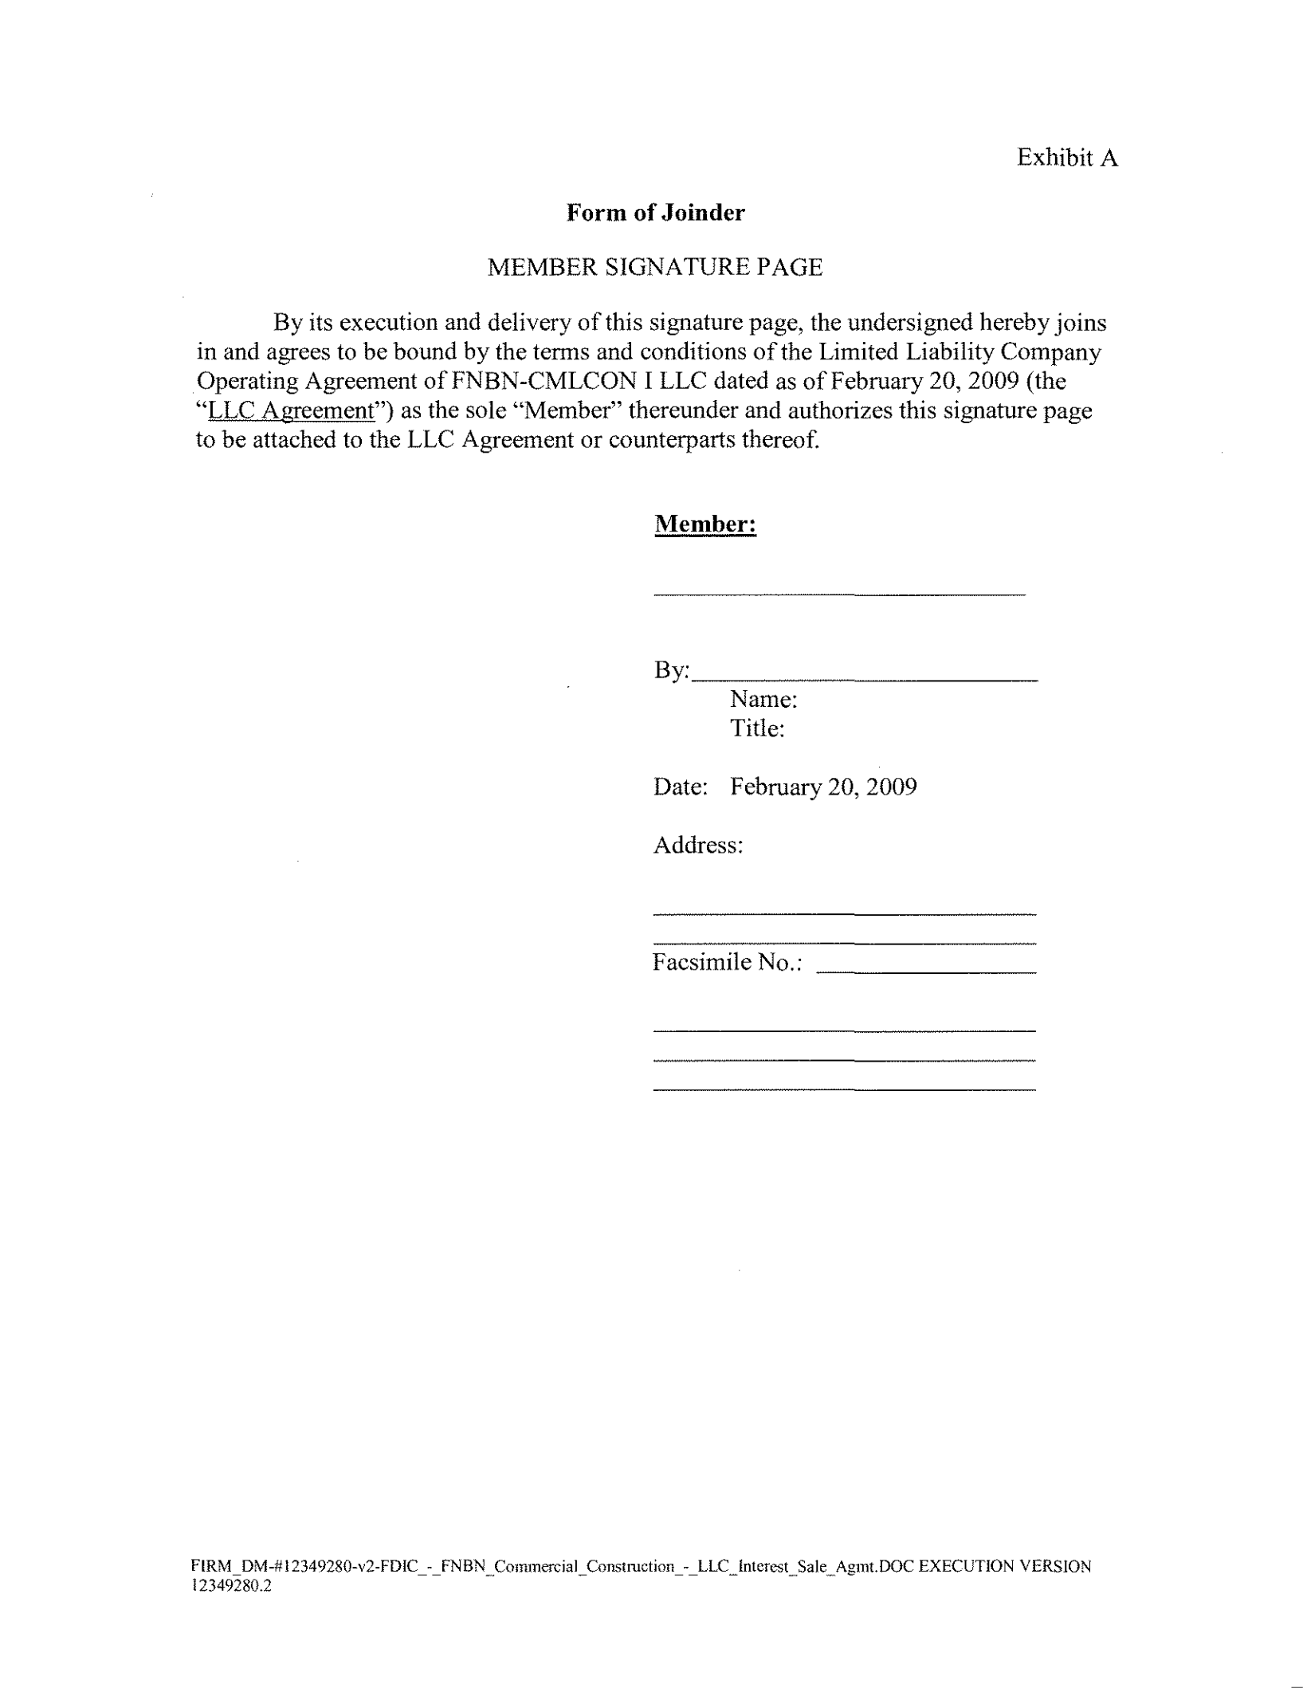
Exhibit A

Form of Joinder

MEMBER SIGNATURE PAGE

By its execution and delivery of this signature page, the undersigned hereby joins in and agrees to be bound by the terms and conditions of the Limited Liability Company Operating Agreement ofFNBN-CMLCON I LLC dated as of February 20, 2009 (the "LLC Agreement") as the sole "Member" thereunder and authorizes this signature page to be attached to the LLC Agreement or counterparts thereof.

Member:

By: ___________

Name:

Title:

Date: February 20, 2009

Address:

Facsimile No.:

FIRM_DM-# 12349280-v2-FDIC_-_ FNBN_ Commercial_Con<>truction_-_ LLC_Interest_ Sale_ Agmt.DOC EXECUTION VERSION

12349280.2
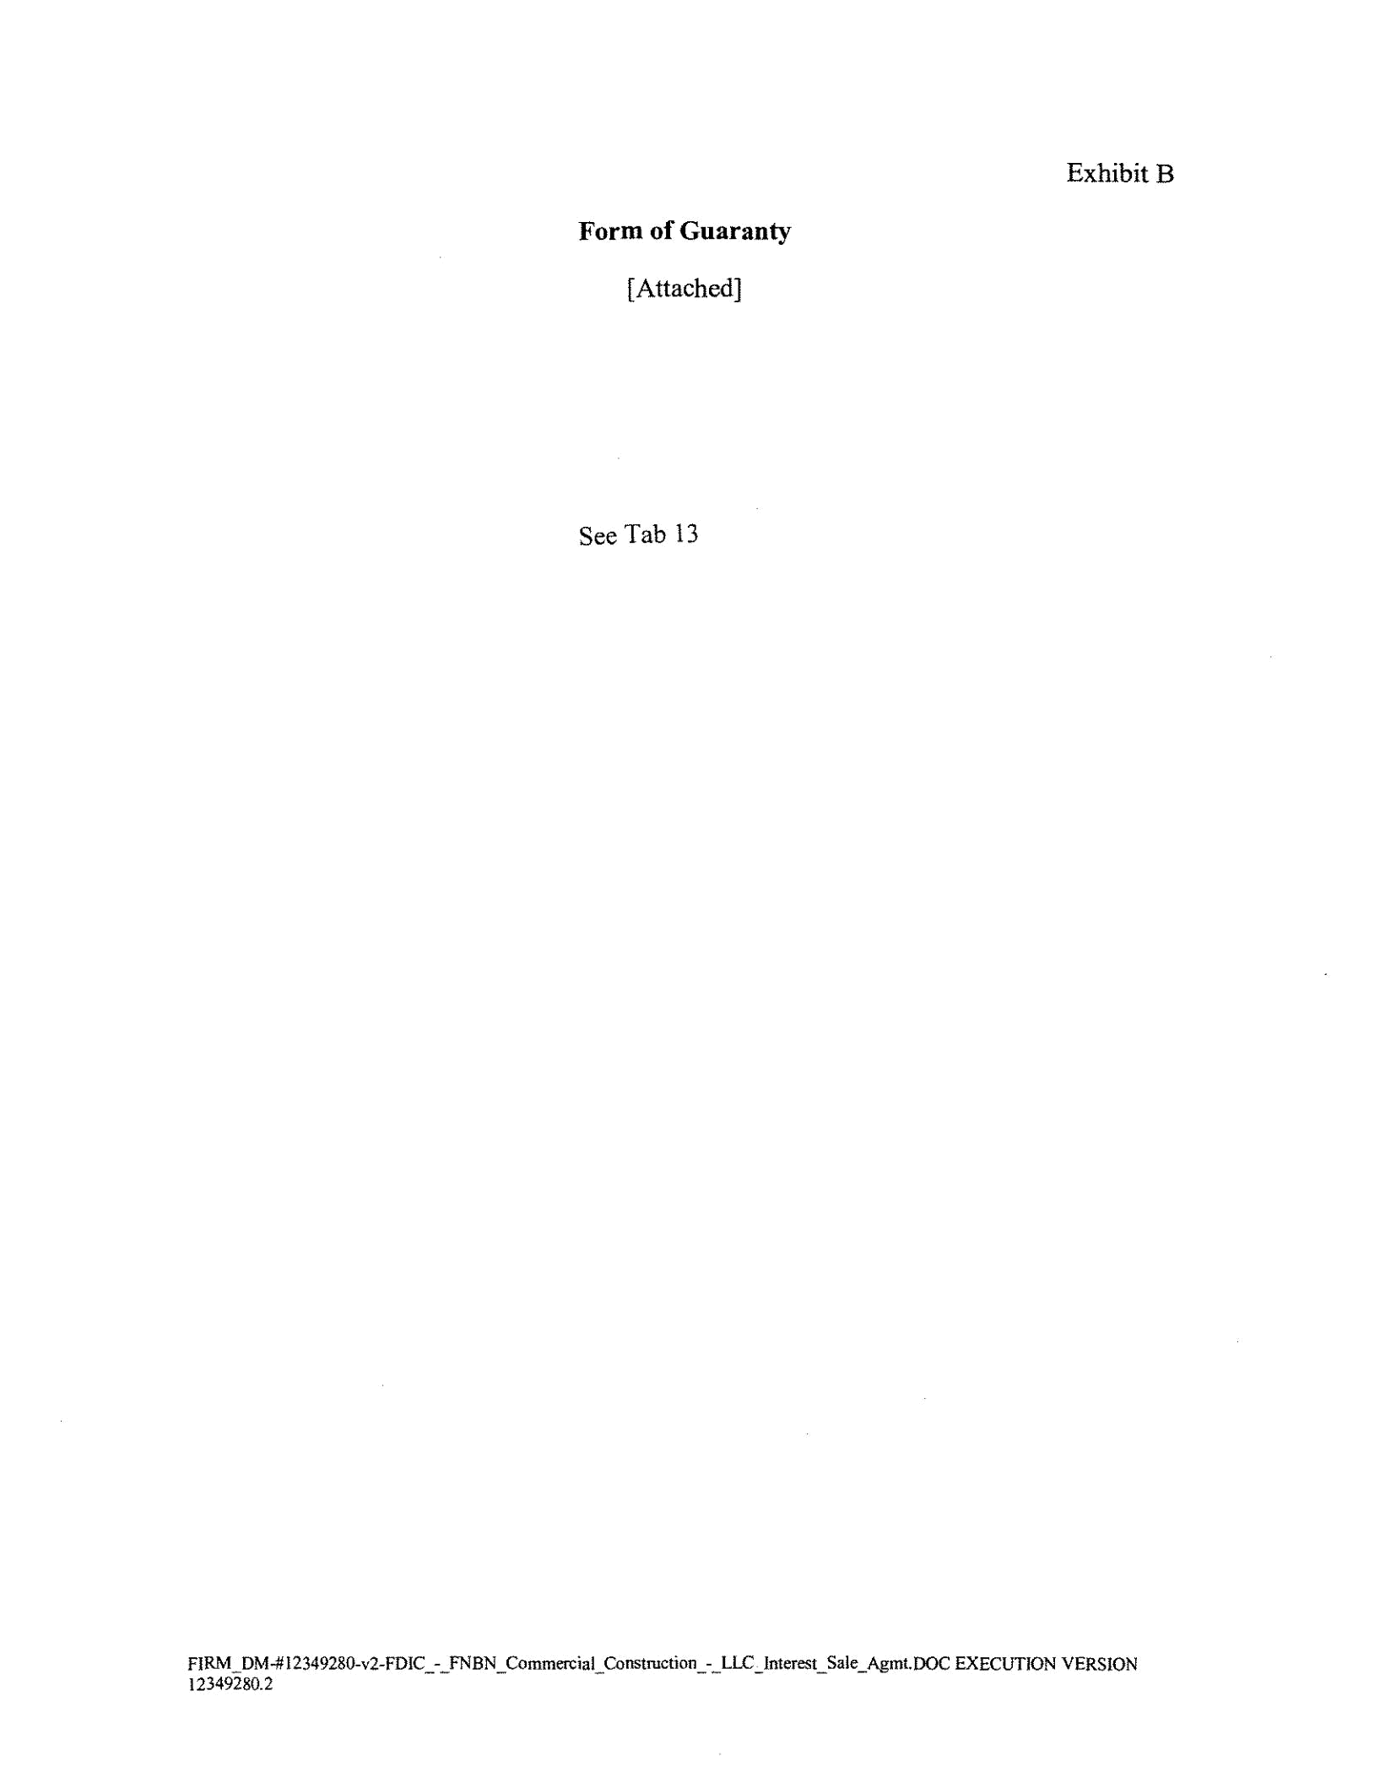
Exhibit B

Form of Guaranty

[Attached]

See Tab 13

FIRM DM..#l2349280-v2-FDIC - FNBN Commercial Construction - LLC Interest Sale Agmt.DOC EXECUTION VERSION
I23492so.2 -- - - -- - -
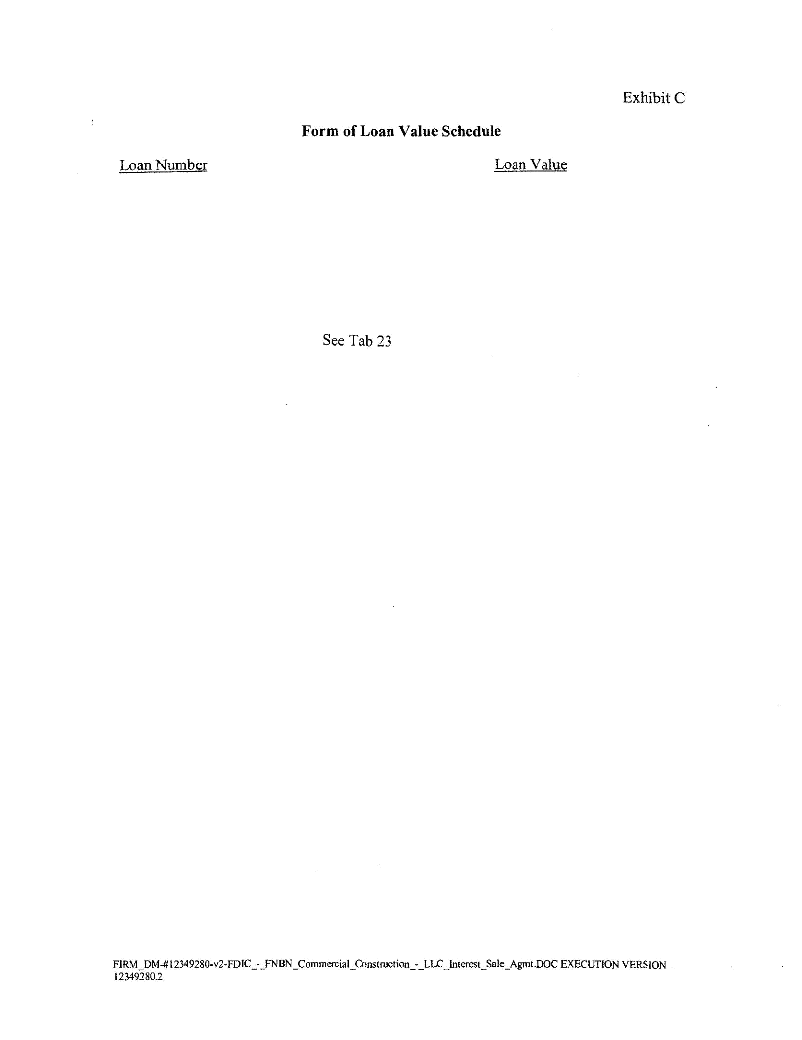
Exhibit C

Form of Loan Value Schedule

Loan Number Loan Value

See Tab 23

FIRM_OM-# l2349280~v2·FDIC_~_FNBN _Commercial_Construction_._LLC_Interest_Sale _Agmt.DOC EXECUTION VERSION

12349280.2

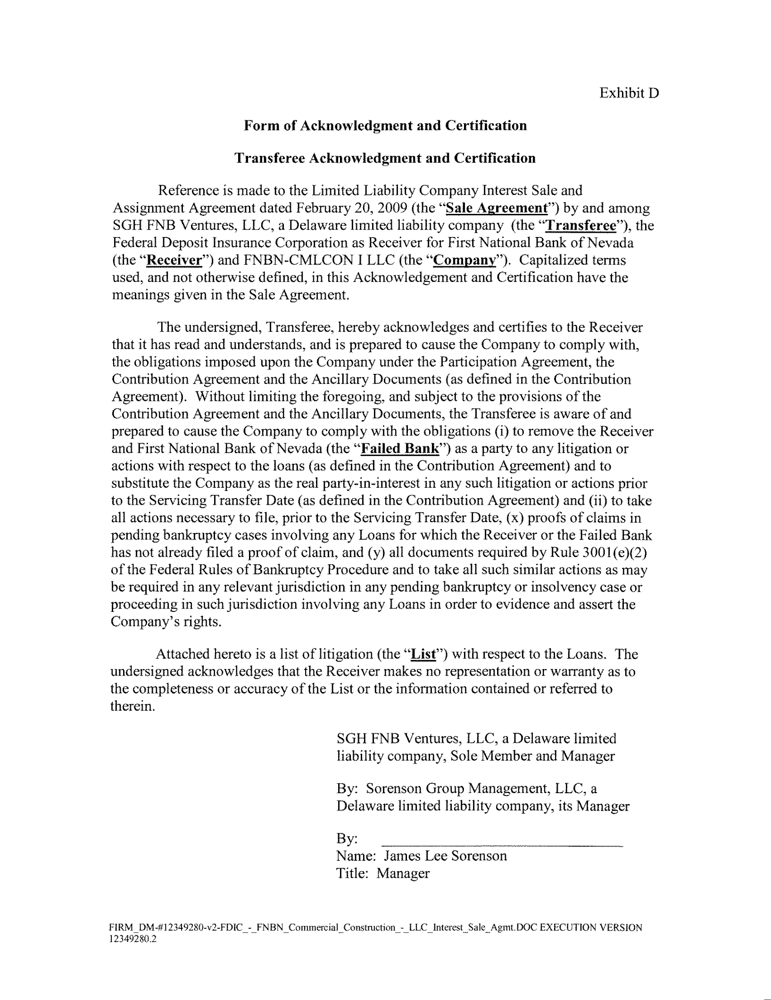
Exhibit D

Form of Acknowledgment and Certification

Transferee Acknowledgment and Certification

Reference is made to the Limited Liability Company Interest Sale and Assignment Agreement dated February 20, 2009 (the "Sale Agreement") by and among SGH FNB Ventures, LLC, a Delaware limited liability company (the "Transferee"), the Federal Deposit Insurance Corporation as Receiver for First National Bank of Nevada (the "Receiver") and FNBN-CMLCON I LLC (the "Company"). Capitalized terms used, and not otherwise defined, in this Acknowledgement and Certification have the meanings given in the Sale Agreement.

The undersigned, Transferee, hereby acknowledges and certifies to the Receiver that it has read and understands, and is prepared to cause the Company to comply with, the obligations imposed upon the Company under the Participation Agreement, the Contribution Agreement and the Ancillary Documents (as defined in the Contribution Agreement). Without limiting the foregoing, and subject to the provisions of the Contribution Agreement and the Ancillary Documents, the Transferee is aware of and prepared to cause the Company to comply with the obligations (i) to remove the Receiver and First National Bank of Nevada (the "Failed Bank") as a party to any litigation or actions with respect to the loans (as defined in the Contribution Agreement) and to substitute the Company as the real party-in-interest in any such litigation or actions prior to the Servicing Transfer Date (as defined in the Contribution Agreement) and (ii) to take all actions necessary to file, prior to the Servicing Transfer Date, (x) proofs of claims in pending bankruptcy cases involving any Loans for which the Receiver or the Failed Bank has not already filed a proof of claim, and (y) all documents required by Rule 300l(e)(2) of the Federal Rules of Bankruptcy Procedure and to take all such similar actions as may be required in any relevant jurisdiction in any pending bankruptcy or insolvency case or proceeding in such jurisdiction involving any Loans in order to evidence and assert the Company's rights.

Attached hereto is a list oflitigation (the "List") with respect to the Loans. The undersigned acknowledges that the Receiver makes no representation or warranty as to the completeness or accuracy of the List or the infom1ation contained or referred to therein.

SGH FNB Ventures, LLC, a Delaware limited

liability company, Sole Member and Manager

By: Sorenson Group Management, LLC, a

Delaware limited liability company, its Manager

By:

Name: James Lee Sorenson

Title: Manager

FIRM_DM-# 12349280-v2-FDIC_-_FNBN _Commercial_Construction_-_ LLC_Interest_ Sale_ Agmt. DOC EXECUTION VERSION

12349280.2
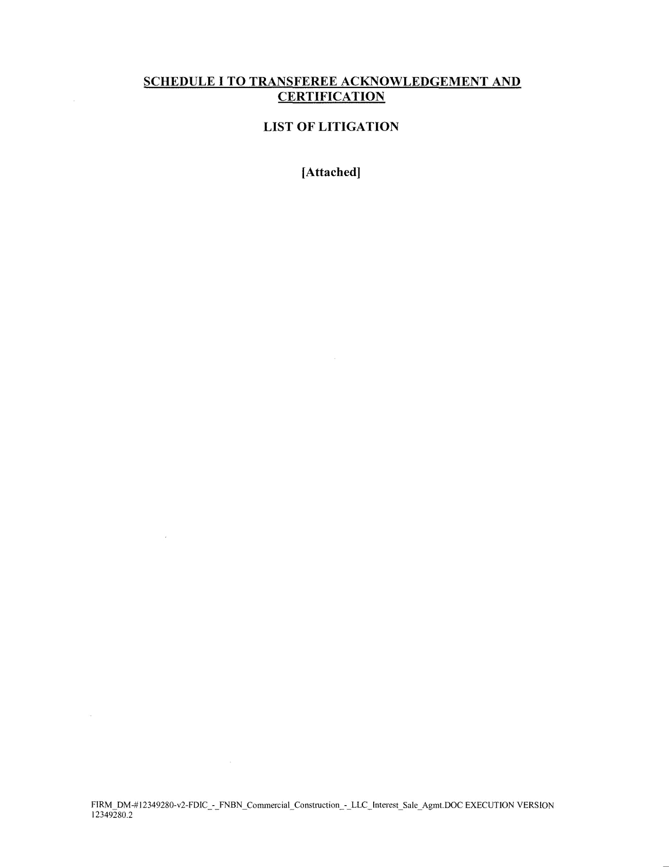
SCHEDULE I TO TRANSFEREE ACKNOWLEDGEMENT AND

CERTIFICATION

LIST OF LITIGATION

[Attached]

FIRM~OM-# 12349280-v2-FDIC_-_FNBN _Commercial_Construction_-_LLC _Interest_Sale_Agmt.DOC EXECUTION VERSION 12349280.2

