

To,
The South Indian Bank Ltd.,
Retail Banking Department, DEMAT Centre, Received Seal
- Floor, Shanu Tower, No. IV/461A, North Kalamassery, Ernakulam-683104,
Tel/ Fax: 0484-2933561, Email Id: demat@sib.co.in

 | (Individual)
Demat Account Application Form | (Individual)

Check List

Separate KYC forms required for each holders in case of joint demat account.

Colour Photograph ( Recent passport size colour 3.5x3.5 cm) of all the applicants affixed on KYC form and signed below.

KYC form attached is duly filled and signed by customer and branch official.

Proof of Identity ( PAN Card copy self attested and attested by Branch) of the applicant attached with the application and it is verified in person?

Verified Address Proofs supporting both correspondence & permanent address enclosed

- (voter’s ID card/Driving License/Passport, Latest Tel Bill/Electricity Bill within 2 months).
- For NRI Repatriable (Passport/International Driving license Mandatory) &
- For NRI Non Repatriable (Proof of Indian Address Mandatory)

All proofs must be Self attested and Branch attested

Attesting Officer's PPC & Name should be mentioned in the proofs & form

SB/CD A/C Statement of applicant with transaction & Cancelled Cheque Leaf attached?

Signatures are affixed by applicants in all the pages marked ‘X’ and Bank official marked ‘Y’ in Blue ink preferably and witnessed wherever necessary.( Witness in nomination form)

A copy of Rights and Obligations to be provided to the customer for reference.

All Columns in the application are filled in Block letters

Bank MICR code, IFSC code and account number in 16 digit format are entered properly in application form.
Account Canvassed by: (Mandatory)

Name & PPC

Designation & Branch

Signature of employee

--------------------------------------------------------- |  | Please tear here-------------------------------------------------------------
 |  | Acknowledgement Receipt
 | Application No.: |  | Date:
 | We hereby acknowledge the receipt of the Account Opening Application Form:
 | Name of the Sole / First Holder
 | Name of Second joint Holder
 | Name of Third joint Holder

Depository Participant Seal and Signature

www.southindianbank.com CIN : L65191KL1929PLC001017 Toll Free : 18008431800, 18004251809 Page 01 of 15

CENTRAL KYC REGISTRY | Know Your Customer (KYC) Application Form | Individual
ISO 3166 Country Code of Birth*

Important Instructions:

  - Fields marked with ‘*’ are mandatory fields.

  - Please fill the form in English and in BLOCK letters.

  - Please fill the date in DD-MM-YYYY format.

  - Please read section wise detailed guidelines / instructions at the end.

- List of State / U.T code as per Indian Motor Vehicle Act, 1988 is available at the end.

- List of two character ISO 3166 country codes is available at the end.

- KYC number of applicant is mandatory for update application.

- For particular section update, please tick ( ) in the box available before the section number and strike off the sections not required to be updated.


For office use only | Application Type* |  | New |  |  |  |  |  | Update
(To be filled by financial institution) | KYC Number |  |  |  |  |  |  |  |  |  |  |  |  |  |  |  | (Mandatory for KYC update request)
 | Account Type* |  | Normal |  |  |  |  |  | Simplified (for low risk customers) |  |  |  |  |  |  |  |  | Small
1. PERSONAL DETAILS (Please refer instruction A at the end)
Prefix |  | First Name |  |  |  |  |  |  |  |  |  |  |  | Middle Name |  |  |  | Last Name

Name* (Same as ID proof) Maiden Name (If any*) Father / Spouse Name* Mother Name*

Date of Birth* Gender* Marital Status* Citizenship*

Residential Status*

Occupation Type*

D | D |  |  |  | M | M |  |  |  | Y | Y | Y | Y |  | F- Female
 | M- Male |  |  |  |  |  |  |  |  |  |  |  |  |  | F- Female | T-Transgender
 | Married |  |  |  |  |  |  |  |  |  |  |  |  |  | Unmarried | Others
 | IN- Indian |  |  |  |  |  |  |  |  |  |  |  |  |  | Others (ISO 3166 Country Code |  |  |  |  |  | )
 | Resident Individual |  |  |  |  |  |  |  |  |  |  |  |  |  | Non Resident Indian
 | Foreign National |  |  |  |  |  |  |  |  |  |  |  |  |  | Person of Indian Origin
 | S-Service ( |  |  |  |  |  |  |  |  | Private Sector |  |  |  |  | Public Sector | Government Sector )
 | O-Others ( |  |  |  |  |  |  |  |  | Professional |  |  |  |  | Self Employed | Retired |  | Housewife |  |  |  | Student)
 | B-Business
 | X- Not Categorised |  |  |  |  |  |  |  |  |  |  |  |  |  |  | X |  | Signature /Thumb Impression

PHOTO


DO NOT SIGN ACROSS THE PHOTO

2. TICK IF APPLICABLE RESIDENCE FOR TAX PURPOSES IN JURISDICTION(S) OUTSIDE INDIA (Please refer instruction B at the end)

ADDITIONAL DETAILS REQUIRED* (Mandatory only if section 2 is ticked)

ISO 3166 Country Code of Jurisdiction of Residence*

Tax Identification Number or equivalent (If issued by jurisdiction)*

Place / City of Birth*

3. PROOF OF IDENTITY (PoI)* (Please refer instruction C at the end)

(Certified copy of any one of the following Proof of Identity[PoI] needs to be submitted)

A- Passport Number

B- Voter ID Card

C- PAN Card

D- Driving Licence

E- UID (Aadhaar)

F- NREGA Job Card Z- Others (any document notified by the central government) S- Simplified Measures Account - Document Type code

4. PROOF OF ADDRESS (PoA)*

Passport Expiry Date

Driving Licence Expiry Date

Identification Number

Identification Number

D D M M Y Y Y Y

D D M M Y Y Y Y

4.1 CURRENT / PERMANENT / OVERSEAS ADDRESS DETAILS (Please see instruction D at the end)

(Certified copy of any one of the following Proof of Address [PoA] needs to be submitted)

Address Type* Proof of Address*

Address

Line 1*

Line 2

Line 3

District*

Residential / Business |  |  |  |  |  |  |  |  |  |  | Residential |  |  |  |  |  |  |  |  |  | Business |  |  |  |  |  |  |  |  |  |  |  | Registered Office |  |  |  |  |  |  |  |  |  |  |  |  |  |  |  |  |  |  | Unspecified
Passport |  |  |  |  |  |  |  |  |  |  | Driving Licence |  |  |  |  |  |  |  |  |  | UID (Aadhaar)
Voter Identity Card |  |  |  |  |  |  |  |  |  |  | NREGA Job Card |  |  |  |  |  |  |  |  |  | Others |  |  |  |  |  |  |  |  |  |  |  |  |  |  | please |  |  |  |  | specify
Simplified Measures Account - Document Type code
 |  |  |  |  |  |  |  |  |  |  |  |  |  |  |  |  |  |  |  |  |  |  |  |  |  |  | City / Town / Village*
 |  |  |  |  |  |  |  | Pin / Post Code* |  |  |  |  |  |  |  |  |  |  |  |  | State / U.T Code* |  |  |  |  |  |  |  |  |  |  |  |  |  |  |  |  | ISO 3166 Country Code*

www.southindianbank.com CIN : L65191KL1929PLC001017 Toll Free : 18008431800, 18004251809 Page 02 of 15


4.2 CORRESPONDENCE / LOCAL ADDRESS DETAILS * (Please see instruction E at the end)

Same as Current / Permanent / Overseas Address details (In case of multiple correspondence / local addresses, please fill ‘Annexure A1’)

Line 1*

Line 2

Line 3

District*

Pin / Post Code*

City / Town / Village*

State / U.T Code* |  |  | ISO 3166 Country Code*

4.3 ADDRESS IN THE JURISDICTION DETAILS WHERE APPLICANT IS RESIDENT OUTSIDE INDIA FOR TAX PURPOSES* (Applicable if section 2 is ticked)

Same as Current / Permanent / Overseas Address details | Same as Correspondence / Local Address details

Line 1*

Line 2

Line 3

State*

ZIP / Post Code*

City / Town / Village* ISO 3166 Country Code*

5. CONTACT DETAILS (All communications will be sent on provided Mobile no. / Email-ID) (Please refer instruction F at the end)

Tel. (Off)

FAX

Tel. (Res)

Email ID

Mobile

6. DETAILS OF RELATED PERSON (In case of additional related persons, please fill ‘Annexure B1’ ) (please refer instruction G at the end)

Addition of Related Person | Deletion of Related Person | KYC Number of Related Person (if available*)

Related Person Type* | Guardian of Minor
 | Prefix | First Name

Name*

Assignee |  |  |  |  | Authorized Representative
 |  |  |  | Middle Name |  |  |  |  |  |  |  |  |  |  |  |  |  | Last Name

(If KYC number and name are provided, below details of section 6 are optional)

PROOF OF IDENTITY [PoI] OF RELATED PERSON* (Please see instruction (H) at the end)

A- Passport Number

B- Voter ID Card

C- PAN Card

D- Driving Licence

E- UID (Aadhaar)

F- NREGA Job Card Z- Others (any document notified by the central government) S- Simplified Measures Account - Document Type code

7. REMARKS (If any)

Passport Expiry Date

Driving Licence Expiry Date

Identification Number

Identification Number

D D M M Y Y Y Y

D D M M Y Y Y Y

8. APPLICANT DECLARATION

I hereby declare that the details furnished above are true and correct to the best of my knowledge and belief and I undertake to inform you of any changes
therein, immediately. In case any of the above information is found to be false or untrue or misleading or misrepresenting, I am aware that I may be held liable
for it. | [Signature / Thumb Impression]
I have consented to access my aadhar data from UIDAI. | [Signature / Thumb Impression]
I have consented to access my aadhar data from UIDAI. | X
I hereby consent to receiving information from Central KYC Registry through SMS/Email on the above registered number/email address. _{I} | X

Date :
D D M M Y Y Y Y

Place :

Signature / Thumb Impression of Applicant

9. ATTESTATION / FOR OFFICE USE ONLY

Documents Received |  |  |  | Certified Copies |  |  |  |  |  |  |  |  |  |  |  |  | Orginal Verified and Self-Attested Document Copies Received
 | IPV AND KYC VERIFICATION CARRIED OUT BY |  |  |  |  |  |  |  |  |  |  |  |  |  |  |  |  |  |  |  |  |  |  |  |  |  |  |  | INSTITUTION DETAILS
Date |  |  |  |  |  |  |  |  |  |  |  |  |  |  |  |  |  |  |  |  |  | Name
 |  | D | D |  |  | M | M |  |  | Y | Y | Y | Y |  |  |  |  |  |  |  |  | Name
Emp. Name |  |  |  |  |  |  |  |  |  |  |  |  |  |  |  |  |  |  |  |  |  | Br Code
Emp. Code
Emp. Designation |  |  |  |  |  |  |  |  |  |  |  |  |  |  |  |  |  |  |  |  |  |  |  |  |  |  |  |  |  |  | [Branch Seal]
Emp. Branch
 |  |  |  | [Employee Signature]
 | Y

www.southindianbank.com CIN : L65191KL1929PLC001017 Toll Free : 18008431800, 18004251809 Page 03 of 15


CENTRAL KYC REGISTRY | Instrucns / Check list / Guidelines for filling Individual KYC Applicn Form

General Instrucons:
- Fields marked with ‘*’ are mandatory fields.
- Tick ‘ ’ wherever applicable.
- Self-Cerficaon of documents is mandatory.

- Please fill the form in English and in BLOCK Leers.
- Please fill all dates in DD-MM-YYYY format.
- Wherever state code and country code is to be furnished, the same should be the two-digit code as per Indian Motor Vehicle, 1988 and ISO 3166 country code respecvely list of which is available at the end.
- KYC number of applicant is mandatory for updation of KYC details.

- For parcular secon update, please ck ( ) in the box available before the secon number and strike oﬀ the secons not required to be updated.
- In case of ‘Small Account type’ only personal details at secon number 1 and 2, photograph, signature and self-cerficaon required.

- Clarificaon / Guidelines on filling ‘Personal Details’ secon
  - Name: Please state the name with Prefix (Mr/Mrs/Ms/Dr/etc.). The name should match the name as menoned in the Proof of Identy submied failing which the applicaon is liable to be rejected.
  - Either father’s name or spouse’s name is to be mandatorily furnished. In case PAN is not available father’s name is mandatory.

- Clarificaon / Guidelines on filling details if applicant residence for tax purposes in jurisdicon(s) outside India
  - Tax idenficaon Number (TIN): TIN need not be reported if it has not been issued by the jurisdicon. However, if the said jurisdicon has issued a high integrity number with an equivalent level of idenficaon (a “Funconal equivalent”), the same may be reported. Examples of that type of number for individual include, a social security/insurance number, cizen/personal idenficaon/services code/number, and resident registraon number)

- Clarificaon / Guidelines on filling ‘Proof of Identy [PoI]’ secon

  - If driving license number or passport is provided as proof of identy then expiry date is to be mandatorily furnished.
  - Menon idenficaon / reference number if ‘Z- Others (any document nofied by the central government)’ is cked.
  - In case of Simplified Measures Accounts for verifying the identy of the applicant, any one of the following documents can also be submied and undernoted relevant code may be menoned in point 3 (S).
Document Code | Descrip on
- Identy card with applicant’s photograph issued by Central/ State Government Departments, Statutory/ Regulatory Authories, Public Sector Undertakings, Scheduled Commercial Banks, and Public Financial Instuons.

02 Leer issued by a gazeed oﬃcer, with a duly aested photograph of the person.

D Clarificaon / Guidelines on filling ‘Proof of Address [PoA] - Current / Permanent / Overseas Address details’ secon
- PoA to be submied only if the submied PoI does not have an address or address as per PoI is invalid or not in force.
- State / U.T Code and Pin / Post Code will not be mandatory for Overseas addresses.
- In case of Simplified Measures Accounts for verifying the address of the applicant, any one of the following documents can also be submied and undernoted relevant code may be menoned in point 4.1.
Document Code | Descrip on
- Ulity bill which is not more than two months old of any service provider (electricity, telephone, post-paid mobile phone, piped gas, water bill).
02 | Property or Municipal Tax receipt.
03 | Bank account or Post Oﬃce savings bank account statement.
04 | Pension or family pension payment orders (PPOs) issued to re red employees by Government Departments or Public Sector Undertakings, if
 | they contain the address.
- Leer of allotment of accommodaon from employer issued by State or Central Government departments, statutory or regulatory bodies, public sector undertakings, scheduled commercial banks, financial instu ons and listed companies. Similarly, leave and license agreements with such employers allong oﬃcial accommodaon.

06 Documents issued by Government departments of foreign jurisdicons and leer issued by Foreign Embassy or Mission in India.

E Clarificaon / Guidelines on filling ‘Proof of Address [PoA] - Correspondence / Local Address details’ secon
- To be filled only in case the PoA is not the local address or address where the customer is currently residing. No separate PoA is required to be submied.
- In case of mulple correspondence / local addresses, Please fill ‘Annexure A1’

F Clarificaon / Guidelines on filling ‘Contact details’ secon
- Please menon two- digit country code and 10 digit mobile number (e.g. for Indian mobile number menon 91-9999999999).
- Do not add ‘0’ in the beginning of Mobile number.

- Clarificaon / Guidelines on filling ‘Related Person details’ secon
  - Provide KYC number of related person if available.

- Clarificaon / Guidelines on filling ‘Related Person details – Proof of Identy [PoI] of Related Person’ secon
  - Menon idenficaon / reference number if ‘Z- Others (any document nofied by the central government)’ is cked.

www.southindianbank.com CIN : L65191KL1929PLC001017 Toll Free : 18008431800, 18004251809 Page 04 of 15


List of two – digit state / U.T codes as per Indian Motor Vehicle Act, 1988

State / U.T | Code |  | State / U.T | Code |  |  |  | State / U.T | Code
Andaman & Nicobar | AN |  | Himachal Pradesh | HP |  |  | Pondicherry |  | PY
Andhra Pradesh | AP |  | Jammu & Kashmir | JK |  |  | Punjab |  | PB
Arunachal Pradesh | AR |  | Jharkhand | JH |  |  | Rajasthan |  | RJ
Assam | AS |  | Karnataka | KA |  |  | Sikkim |  | SK
Bihar | BR |  | Kerala | KL |  |  | Tamil Nadu |  | TN
Chandigarh | CH |  | Lakshadweep | LD |  |  | Telangana |  | TS
Cha sgarh | CG |  | Madhya Pradesh | MP |  |  | Tripura |  | TR
Dadra and Nagar Haveli | DN |  | Maharashtra | MH |  |  | U | ar Pradesh | UP
Daman & Diu | DD |  | Manipur | MN |  |  | U | arakhand | UA
Delhi | DL |  | Meghalaya | ML |  |  | West Bengal |  | WB
Goa | GA |  | Mizoram | MZ |  |  | Other |  | XX
Gujarat | GJ |  | Nagaland | NL
Haryana | HR |  | Orissa | OR

List of ISO 3166 two- digit Country Code

 |  | Country |  | Country |  | Country |  | Country |  |  | Country |  | Country |  | Country |  | Country
 |  |  |  | Code |  |  |  | Code |  |  |  |  | Code |  |  |  | Code
 | Afghanistan |  |  | AF |  | Dominican Republic |  | DO |  | Libya |  |  | LY |  | Saint Pierre and Miquelon |  | PM
 | Aland Islands |  |  | AX |  | Ecuador |  | EC |  | Liechtenstein |  |  | LI |  | Saint Vincent and the Grenadines |  | VC
 | Albania |  |  | AL |  | Egypt |  | EG |  | Lithuania |  |  | LT |  | Samoa |  | WS
 | Algeria |  |  | DZ |  | El Salvador |  | SV |  | Luxembourg |  |  | LU |  | San Marino |  | SM
 | American Samoa |  |  | AS |  | Equatorial Guinea |  | GQ |  | Macao |  |  | MO |  | Sao Tome and Principe |  | ST
 | Andorra |  |  | AD |  | Eritrea |  | ER |  | Macedonia, the former Yugoslav Republic |  |  | MK |  | Saudi Arabia |  | SA
 |  |  |  |  |  |  |  |  |  | of
 | Angola |  |  | AO |  | Estonia |  | EE |  | Madagascar |  |  | MG |  | Senegal |  | SN
 | Anguilla |  |  | AI |  | Ethiopia |  | ET |  | Malawi |  |  | MW |  | Serbia |  | RS
 | Antarc | a |  | AQ |  | Falkland Islands (Malvinas) |  | FK |  | Malaysia |  |  | MY |  | Seychelles |  | SC
 | An gua and Barbuda |  |  | AG |  | Faroe Islands |  | FO |  | Maldives |  |  | MV |  | Sierra Leone |  | SL
 | Argen | na |  | AR |  | Fiji |  | FJ |  | Mali |  |  | ML |  | Singapore |  | SG
 | Armenia |  |  | AM |  | Finland |  | FI |  | Malta |  |  | MT |  | Sint Maarten (Dutch part) |  | SX
 | Aruba |  |  | AW |  | France |  | FR |  | Marshall Islands |  |  | MH |  | Slovakia |  | SK
 | Australia |  |  | AU |  | French Guiana |  | GF |  | Mar nique |  |  | MQ |  | Slovenia |  | SI
 | Austria |  |  | AT |  | French Polynesia |  | PF |  | Mauritania |  |  | MR |  | Solomon Islands |  | SB
 | Azerbaijan |  |  | AZ |  | French Southern Territories |  | TF |  | Mauri | us |  | MU |  | Somalia |  | SO
 | Bahamas |  |  | BS |  | Gabon |  | GA |  | Mayo | e |  | YT |  | South Africa |  | ZA
 | Bahrain |  |  | BH |  | Gambia |  | GM |  | Mexico |  |  | MX |  | South Georgia and the South Sandwich |  | GS
 |  |  |  |  |  |  |  |  |  |  |  |  |  |  | Islands
 | Bangladesh |  |  | BD |  | Georgia |  | GE |  | Micronesia, Federated States of |  |  | FM |  | South Sudan |  | SS
 | Barbados |  |  | BB |  | Germany |  | DE |  | Moldova, Republic of |  |  | MD |  | Spain |  | ES
 | Belarus |  |  | BY |  | Ghana |  | GH |  | Monaco |  |  | MC |  | Sri Lanka |  | LK
 | Belgium |  |  | BE |  | Gibraltar |  | GI |  | Mongolia |  |  | MN |  | Sudan |  | SD
 | Belize |  |  | BZ |  | Greece |  | GR |  | Montenegro |  |  | ME |  | Suriname |  | SR
 | Benin |  |  | BJ |  | Greenland |  | GL |  | Montserrat |  |  | MS |  | Svalbard and Jan Mayen |  | SJ
 | Bermuda |  |  | BM |  | Grenada |  | GD |  | Morocco |  |  | MA |  | Swaziland |  | SZ
 | Bhutan |  |  | BT |  | Guadeloupe |  | GP |  | Mozambique |  |  | MZ |  | Sweden |  | SE
 | Bolivia, Plurina onal State of |  |  | BO |  | Guam |  | GU |  | Myanmar |  |  | MM |  | Switzerland |  | CH
 | Bonaire, Sint Eusta us and Saba |  |  | BQ |  | Guatemala |  | GT |  | Namibia |  |  | NA |  | Syrian Arab Republic |  | SY
 | Bosnia and Herzegovina |  |  | BA |  | Guernsey |  | GG |  | Nauru |  |  | NR |  | Taiwan, Province of China |  | TW
 | Botswana |  |  | BW |  | Guinea |  | GN |  | Nepal |  |  | NP |  | Tajikistan |  | TJ
 | Bouvet Island |  |  | BV |  | Guinea-Bissau |  | GW |  | Netherlands |  |  | NL |  | Tanzania, United Republic of |  | TZ
 | Brazil |  |  | BR |  | Guyana |  | GY |  | New Caledonia |  |  | NC |  | Thailand |  | TH
 | Bri sh Indian Ocean Territory |  |  | IO |  | Hai |  | HT |  | New Zealand |  |  | NZ |  | Timor-Leste |  | TL
 | Brunei Darussalam |  |  | BN |  | Heard Island and McDonald Islands |  | HM |  | Nicaragua |  |  | NI |  | Togo |  | TG
 | Bulgaria |  |  | BG |  | Holy See (Va can City State) |  | VA |  | Niger |  |  | NE |  | Tokelau |  | TK
 | Burkina Faso |  |  | BF |  | Honduras |  | HN |  | Nigeria |  |  | NG |  | Tonga |  | TO
 | Burundi |  |  | BI |  | Hong Kong |  | HK |  | Niue |  |  | NU |  | Trinidad and Tobago |  | TT
 | Cabo Verde |  |  | CV |  | Hungary |  | HU |  | Norfolk Island |  |  | NF |  | Tunisia |  | TN
 | Cambodia |  |  | KH |  | Iceland |  | IS |  | Northern Mariana Islands |  |  | MP |  | Turkey |  | TR
 | Cameroon |  |  | CM |  | India |  | IN |  | Norway |  |  | NO |  | Turkmenistan |  | TM
 | Canada |  |  | CA |  | Indonesia |  | ID |  | Oman |  |  | OM |  | Turks and Caicos Islands |  | TC
 | Cayman Islands |  |  | KY |  | Iran, Islamic Republic of |  | IR |  | Pakistan |  |  | PK |  | Tuvalu |  | TV
 | Central African Republic |  |  | CF |  | Iraq |  | IQ |  | Palau |  |  | PW |  | Uganda |  | UG
 | Chad |  |  | TD |  | Ireland |  | IE |  | Pales | ne, State of |  | PS |  | Ukraine |  | UA
 | Chile |  |  | CL |  | Isle of Man |  | IM |  | Panama |  |  | PA |  | United Arab Emirates |  | AE
 | China |  |  | CN |  | Israel |  | IL |  | Papua New Guinea |  |  | PG |  | United Kingdom |  | GB
 | Christmas Island |  |  | CX |  | Italy |  | IT |  | Paraguay |  |  | PY |  | United States |  | US
 | Cocos (Keeling) Islands |  |  | CC |  | Jamaica |  | JM |  | Peru |  |  | PE |  | United States Minor Outlying Islands |  | UM
 | Colombia |  |  | CO |  | Japan |  | JP |  | Philippines |  |  | PH |  | Uruguay |  | UY
 | Comoros |  |  | KM |  | Jersey |  | JE |  | Pitcairn |  |  | PN |  | Uzbekistan |  | UZ
 | Congo |  |  | CG |  | Jordan |  | JO |  | Poland |  |  | PL |  | Vanuatu |  | VU
 | Congo, the Democra Republic of |  |  | CD |  | Kazakhstan |  | KZ |  | Portugal |  |  | PT |  | Venezuela, Bolivarian Republic of |  | VE
 | the
 | Cook Islands |  |  | CK |  | Kenya |  | KE |  | Puerto Rico |  |  | PR |  | Viet Nam |  | VN
 | Costa Rica |  |  | CR |  | Kiriba |  | KI |  | Qatar |  |  | QA |  | Virgin Islands, Bri sh |  | VG
 | Cote d'Ivoire !Côte d'Ivoire |  |  | CI |  | Korea, Democra c People's Republic |  | KP |  | Reunion !Réunion |  |  | RE |  | Virgin Islands, U.S. |  | VI
 |  |  |  |  |  | of
 | Croa a |  |  | HR |  | Korea, Republic of |  | KR |  | Romania |  |  | RO |  | Wallis and Futuna |  | WF
 | Cuba |  |  | CU |  | Kuwait |  | KW |  | Russian Federa on |  |  | RU |  | Western Sahara |  | EH
 | Curacao !Curaçao |  |  | CW |  | Kyrgyzstan |  | KG |  | Rwanda |  |  | RW |  | Yemen |  | YE
 | Cyprus |  |  | CY |  | Lao People's Democra c Republic |  | LA |  | Saint Barthelemy !Saint Barthélemy |  |  | BL |  | Zambia |  | ZM
 | Czech Republic |  |  | CZ |  | Latvia |  | LV |  | Saint Helena, Ascension and Tristan da |  |  | SH |  | Zimbabwe |  | ZW
 |  |  |  |  |  |  |  |  |  | Cunha
 | Denmark |  |  | DK |  | Lebanon |  | LB |  | Saint Ki s and Nevis |  |  | KN
 | Djibou |  |  | DJ |  | Lesotho |  | LS |  | Saint Lucia |  |  | LC
 | Dominica |  |  | DM |  | Liberia |  | LR |  | Saint Mar n (French part) |  |  | MF

www.southindianbank.com CIN : L65191KL1929PLC001017 Toll Free : 18008431800, 18004251809 Page 05 of 15

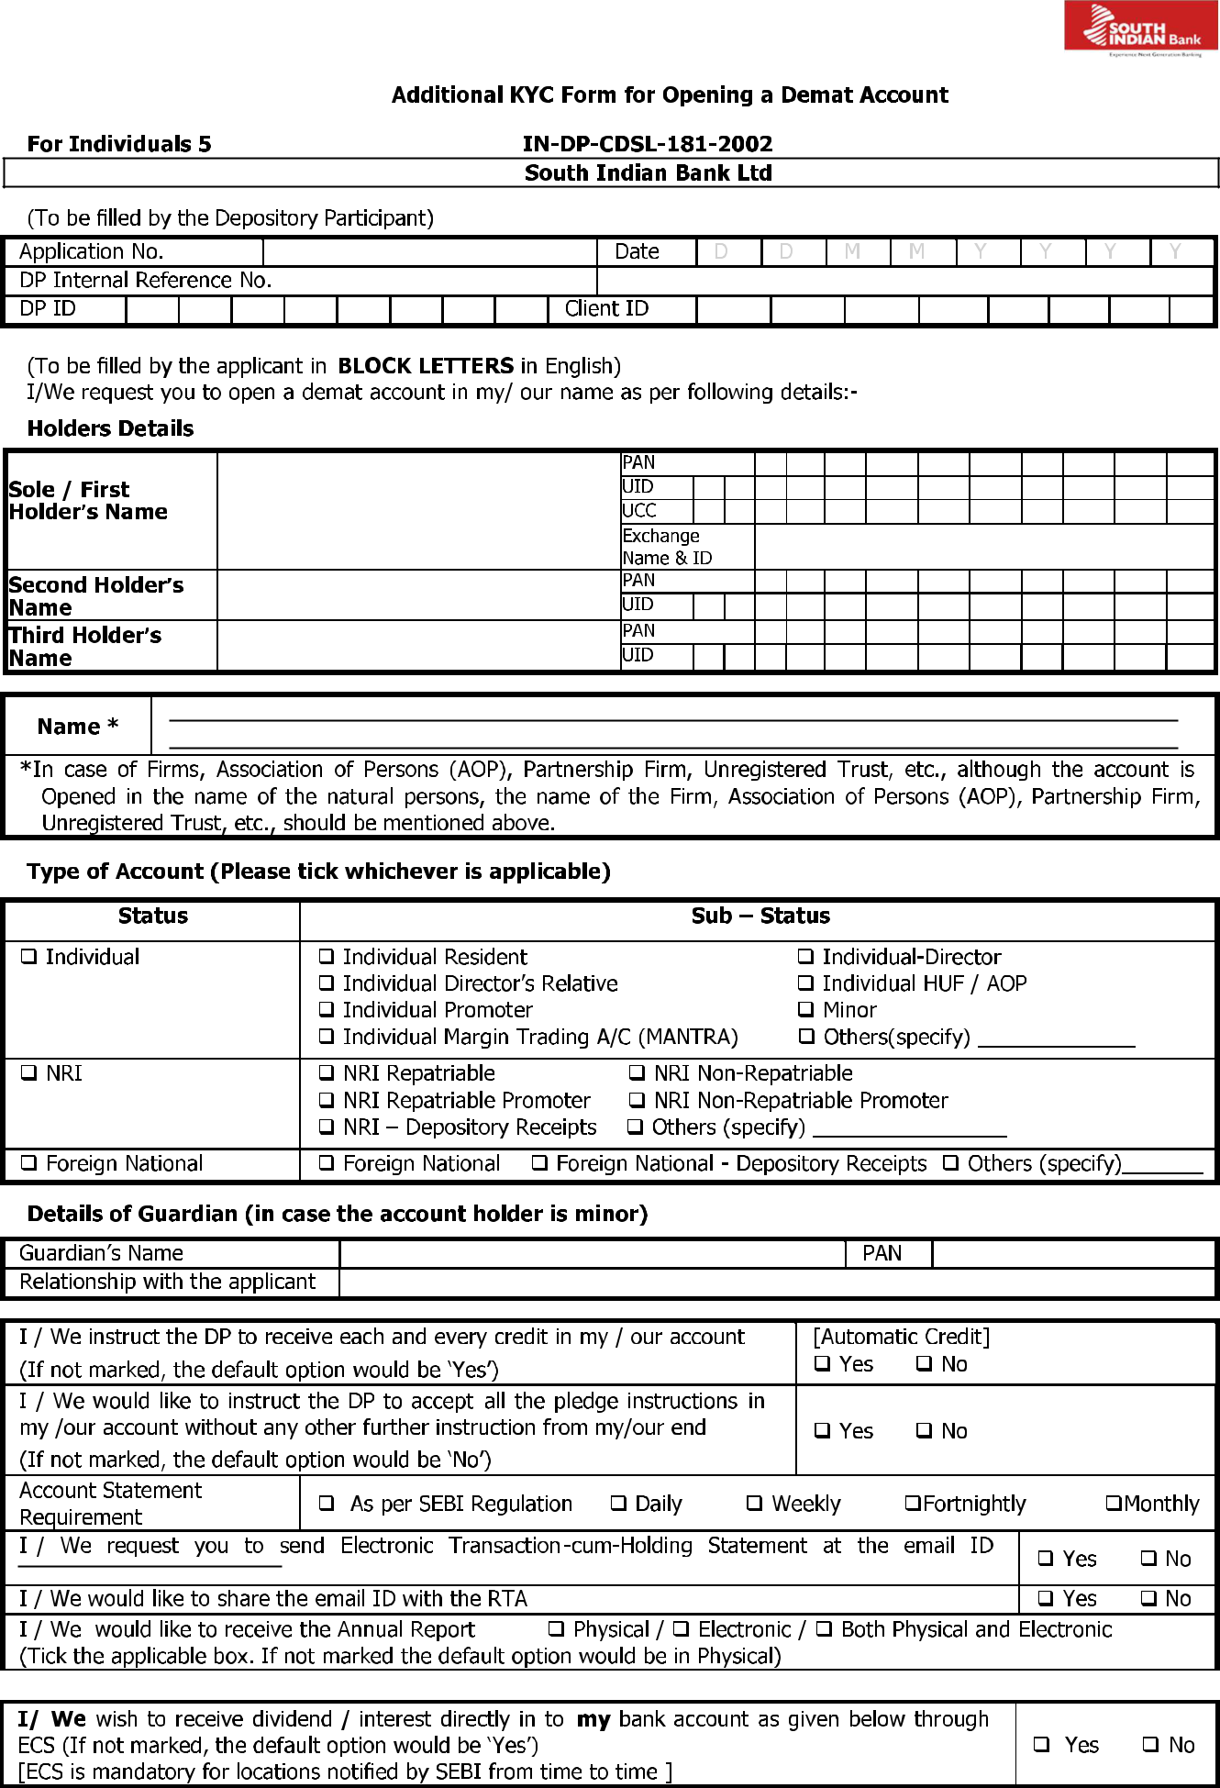

15

Bank Details [Dividend Bank Details]

Bank Code (9 digit MICR code)
IFS Code (11 character)
Account number
Account type |  |  |  | Saving |  |  |  |  |  | Current |  |  |  |  | Others (specify) ______________________
Bank Name
Branch Name
Bank Branch Address
City |  |  | State |  |  |  |  |  |  |  |  |  |  |  |  | Country |  |  |  |  | PIN code

- Photocopy of the cancelled cheque having the name of the account holder where the cheque book is issued, (or)

- Photocopy of the Bank Statement having name and address of the BO

- Photocopy of the Passbook having name and address of the BO, (or)

- Letter from the Bank.

In case of options (ii), (iii) and (iv) above, MICR code of the branch should be present / mentioned on the document.

 | Other Details |  | Income Range per annum:
 | Gross Annual Income |  | Up to Rs.1,00,000 Rs 1,00,000 to Rs 5,00,000 |  |  |  |  |  |  |  |  |  |  |  |  |  |  |  |  |  |  |  |  |  |  |  |  |  |  | Rs 5,00,000 to ` 10,00,000
 | Details |  | Rs 10,00,000 to Rs 25,00,000 |  |  |  |  |  |  |  |  |  |  |  |  |  |  |  |  |  | More than Rs 25,00,000
 |  |  | Net worth as on (Date) |  |  |  |  |  |  |  |  |  |  | D |  |  |  | D |  | M |  | M | Y |  |  |  |  | Y |  | Y |  |  |  | Y |  | Rs
 |  |  |  |  |  |  |  |  |  |  |  |  |  | [Net |  |  | worth |  |  | should not be older than 1 year]
 | Occupation |  | Private / Public Sector |  |  |  |  |  |  |  |  |  |  |  |  | Govt. Service |  |  |  |  |  |  |  |  |  | Business |  |  |  |  |  |  |  |  | Professional Agriculture
 |  |  | Retired |  |  |  |  |  |  | Housewife |  |  |  |  |  | Student |  |  |  |  |  |  |  |  |  | Others (Specify) __________________
 | Please tick , if applicable: |  |  |  |  | Politically Exposed Person (PEP) |  |  |  |  |  |  |  |  |  |  |  |  |  |  |  |  |  |  |  | Related to Politically Exposed Person (RPEP)
 | Any other information:
 | SMS Alert Facility |  |  | MOBILE NO. +91 __ __ __ __ __ __ __ __ __ __
 | Refer to Terms & |  |  | [(Mandatory , if you are giving Power of Attorney ( POA)]
 | Conditions |  |  | (if POA is not granted & you do not wish to avail of this facility, cancel this
 | given as Annexure - 2.4 |  |  | option).
 |  |  |  | I wish to avail the TRUST facility using the Mobile number registered for SMS Alert Facility. I
 |  |  |  | have read and understood the Terms and Conditions prescribed by CDSL for the same.
 | Transactions Using |  |  |  |  |  |  |  |  |  | Yes
 | Secured Texting Facility |  |  |  |  |  |  |  |  |  | No
 | (TRUST). Refer to
 |  |  |  | I/We wish to register the following clearing member IDs under my/our below mentioned BO ID
 | Terms and Conditions
 |  |  |  | registered for TRUST
 | Annexure – 2.6
 |  |  |  |  |  |  |  | Stock Exchange |  |  |  |  |  |  |  |  |  |  | Clearing Member |  |  |  |  |  |  |  |  |  |  |  |  | Clearing Member ID (Optional)
 |  |  |  |  |  |  |  |  |  |  | Name/ID |  |  |  |  |  |  |  |  |  |  | Name
 |  |  |  | To register for easi, please visit our website www.cdslindia.com.
 | Easi |  |  | Easi allows a BO to view his ISIN balances,
 |  |  |  |  |  |  |  |  |  |  |  |  |  |  |  |  |  |  |  |  |  |  |  | transactions and value of the
 |  |  |  | portfolio online.

www.southindianbank.com CIN : L65191KL1929PLC001017 Toll Free : 18008431800, 18004251809 Page 07 of 15

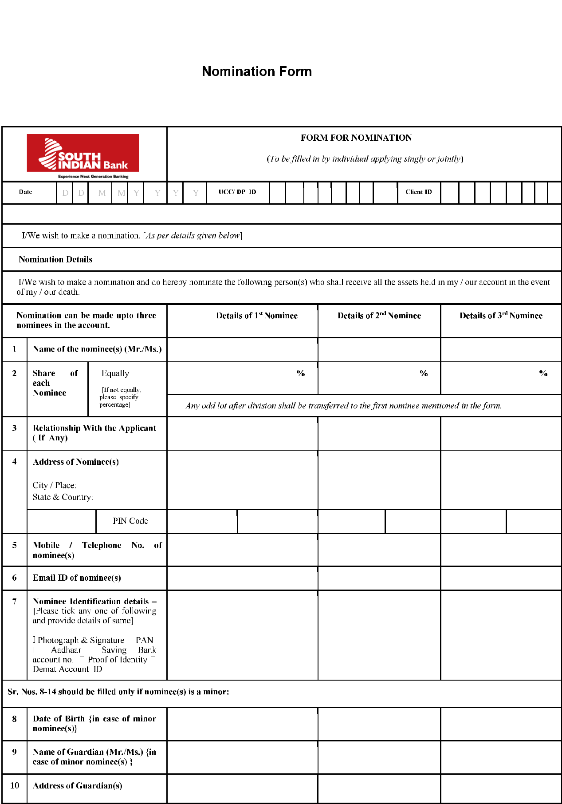

www.southindianbank.com CIN : L65191KL1929PLC001017 Toll Free : 18008431800, 18004251809 Page 08 of 15
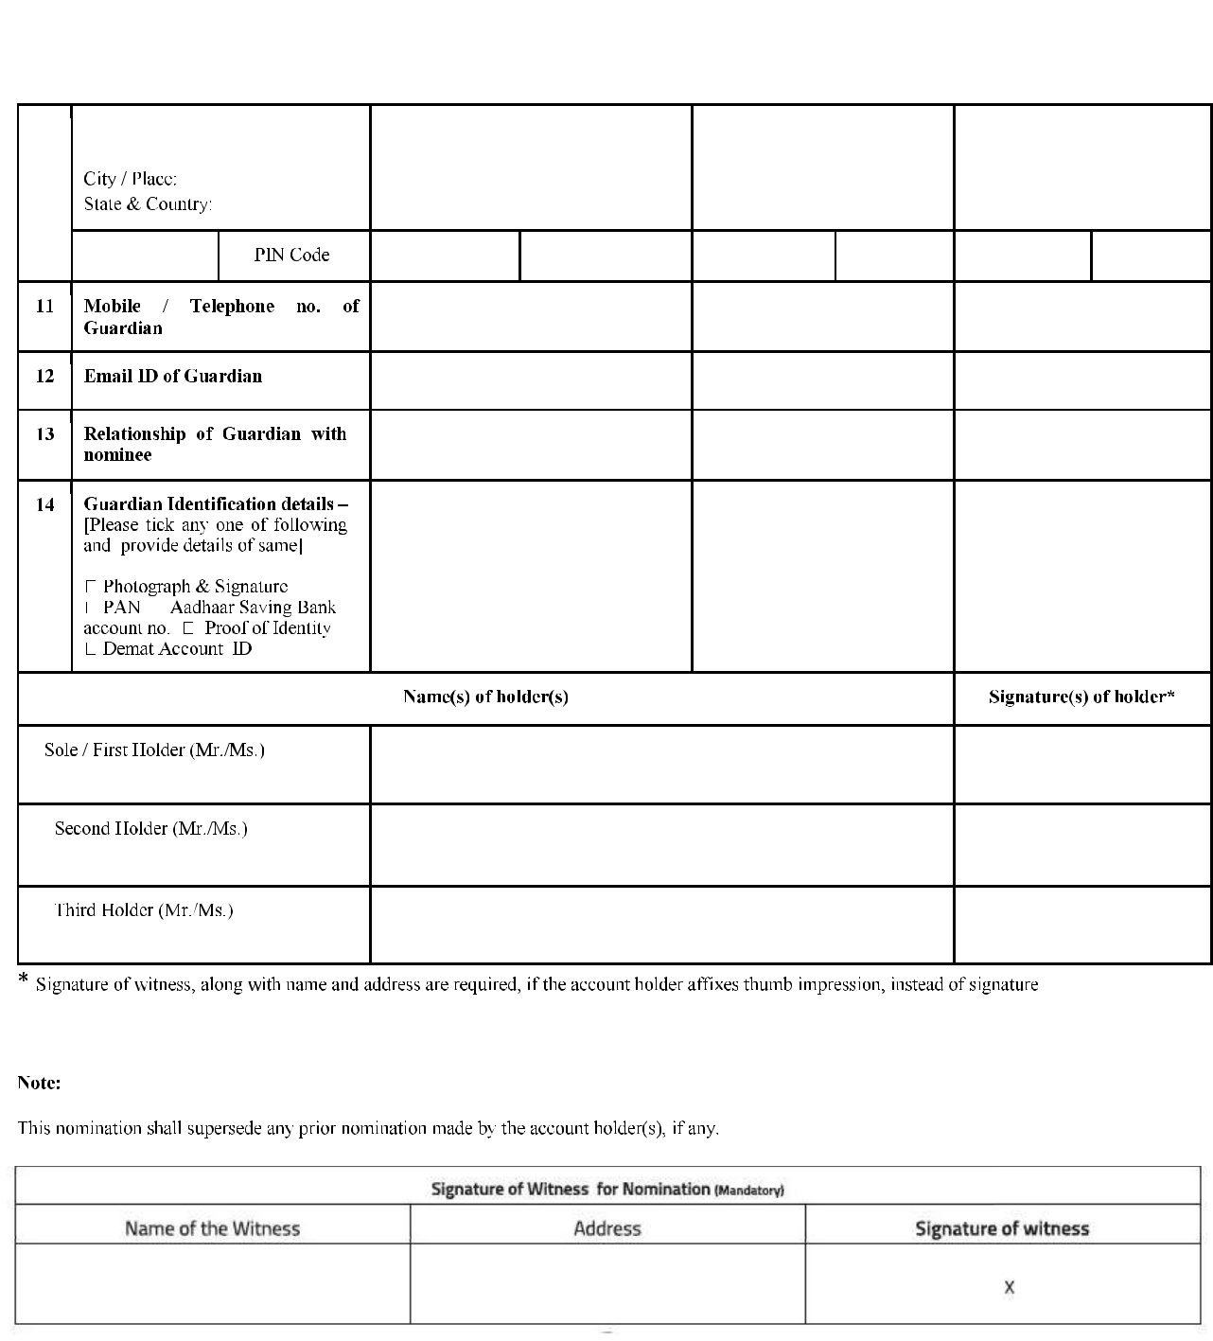

www.southindianbank.com CIN : L65191KL1929PLC001017 Toll Free : 18008431800, 18004251809 Page 09 of 15
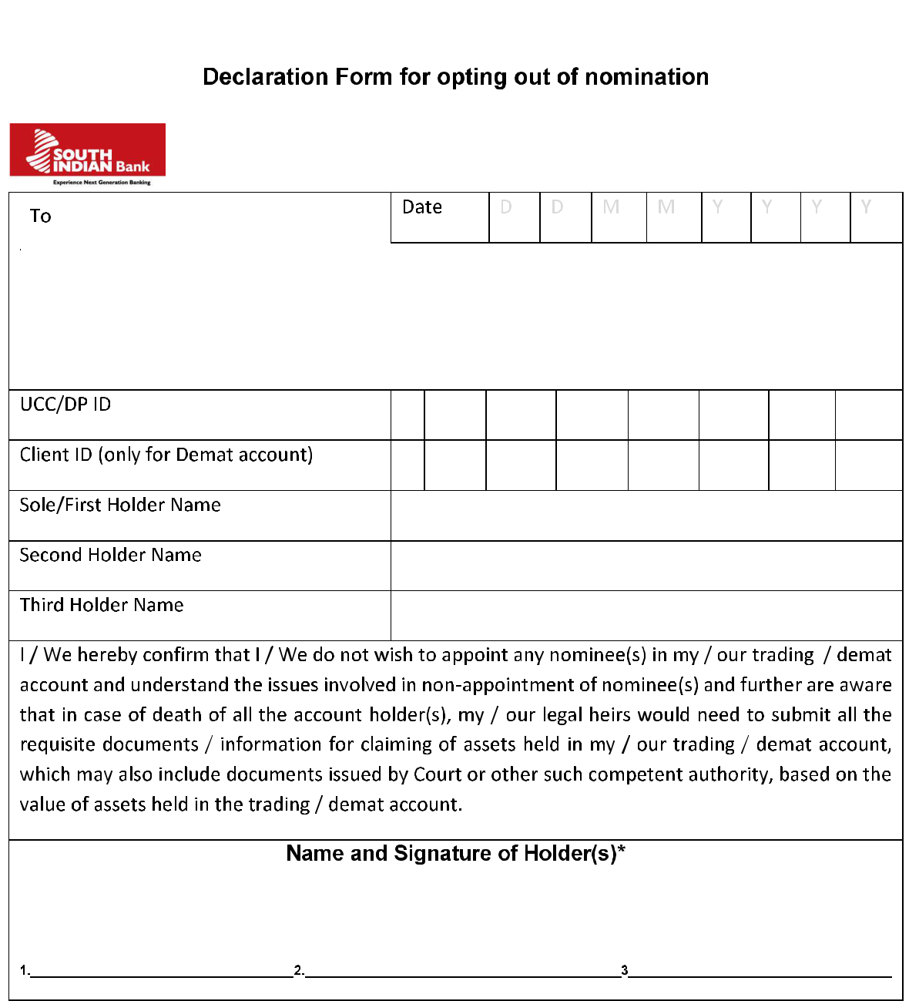

South Indian Bank Ltd
Demat Cell , 2nd Floor Shanu Tower
North Kalamassery
Ernakulam 683104
E mail : demat@sib.co.in


www.southindianbank.com CIN : L65191KL1929PLC001017 Toll Free : 18008431800, 18004251809 Page 10 of 15


* Marked is Mandatory field

Note: One witness shall attest signature(s) / thumb impression(s)

Details of the Witness

Name of witness

Address of witness

Signature of witness

For, NRIs

Witness

Foreign Address

City

Country

State

P.O BOX

I/We hereby declare that we have given the complete residential address as given above and we shall be informing the DP in case of any change in our address in future.

FEMA Declaration: I/We have complied with, and will continue to comply with FEMA Regulations and other applicable laws.

 | First/Sole Holder or | Second Holder | Third Holder
 | Guardian (in case of Minor) | Second Holder | Third Holder

Name

Signatures
 X

Rates and Charges for Demat Account:

I/We agree to the following Charges to be collected from my/our operative SB/CD A/c.
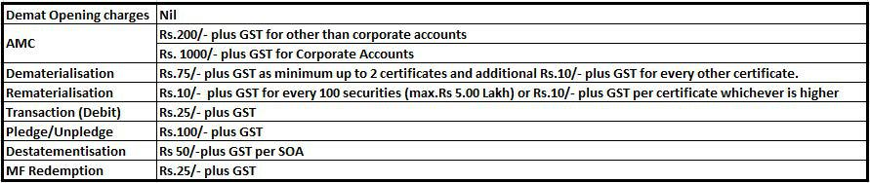

I/we agree for the periodic revisions also.

 | First/Sole Holder or | Second Holder | Third Holder
 | Guardian (in case of Minor) | Second Holder | Third Holder

Name

Signatures
X

Declaration:

I / We have received and read the Rights and Obligations document and terms & conditions and agree to abide by and be bound by the same and by the Bye Laws as are in force from time to time. I / We declare that the particulars given by me/us above are true and to the best of my/our knowledge as on the date of making this application. I/We agree and undertake to intimate the DP any change(s) in the details / Particulars mentioned by me / us in this form. I/We further agree that any false / misleading information given by me / us or suppression of any material information will render my account liable for termination and suitable action.

 | First/Sole Holder or | Second Holder | Third Holder
 | Guardian (in case of Minor) | Second Holder | Third Holder

Name

Signatures
X

www.southindianbank.com CIN : L65191KL1929PLC001017 Toll Free : 18008431800, 18004251809 Page 11 of 15


Rights and Obligations of Beneficial Owner and Depository Participant as prescribed by SEBI and Depositories
General Clause

- The Beneficial Owner and the Depository participant (DP) shall be bound by the provisions of the Depositories Act, 1996, SEBI (Depositories and Participants) Regulations, 1996, Rules and Regulations of Securities and Exchange Board of India (SEBI), Circulars/Notifications/Guidelines issued there under, Bye Laws and Business Rules/Operating Instructions issued by the Depositories and relevant notifications of Government Authorities as may be in force from time to time.
- The DP shall open/activate demat account of a beneficial owner in the depository system only after receipt of complete Account opening form, KYC and supporting documents as specified by SEBI from time to time.
Beneficial Owner information

- The DP shall maintain all the details of the beneficial owner(s) as mentioned in the account opening form, supporting documents submitted by them and/or any other information pertaining to the beneficial owner confidentially and shall not disclose the same to any person except as required by any statutory, legal or regulatory authority in this regard.

- The Beneficial Owner shall immediately notify the DP in writing, if there is any change in details provided in the account opening form as submitted to the DP at the time of opening the demat account or furnished to the DP from time to time.

Fees/Charges/Tariff

- The Beneficial Owner shall pay such charges to the DP for the purpose of holding and transfer of securities in dematerialized form and for availing depository services as may be agreed to from time to time between the DP and the Beneficial Owner as set out in the Tariff Sheet provided by the DP. It may be informed to the Beneficial Owner that "no charges are payable for opening of demat accounts”

- In case of Basic Services Demat Accounts, the DP shall adhere to the charge structure as laid down under the relevant SEBI and/or Depository circulars/directions/notifications issued from time to time.

- The DP shall not increase any charges/tariff agreed upon unless it has given a notice in writing of not less than thirty days to the Beneficial Owner regarding the same.
Dematerialization

- The Beneficial Owner shall have the right to get the securities, which have been admitted on the Depositories, dematerialized in the form and manner laid down under the Bye Laws, Business Rules and Operating Instructions of the depositories.

Separate Accounts

- The DP shall open separate accounts in the name of each of the beneficial owners and securities of each beneficial owner shall be segregated and shall not be mixed up with the securities of other beneficial owners and/or DP’s own securities held in dematerialized form.

- The DP shall not facilitate the Beneficial Owner to create or permit any pledge and /or hypothecation or any other interest or encumbrance over all or any of such securities submitted for dematerialization and/or held in demat account except in the form and manner prescribed in the Depositories Act, 1996, SEBI (Depositories and Participants) Regulations, 1996 and Bye-Laws/Operating Instructions/Business Rules of the Depositories.

Transfer of Securities

- The DP shall effect transfer to and from the demat accounts of the Beneficial Owner only on the basis of an order, instruction, direction or mandate duly authorized by the Beneficial Owner and the DP shall maintain the original documents and the audit trail of such authorizations.
- The Beneficial Owner reserves the right to give standing instructions with regard to the crediting of securities in his demat account and the DP shall act according to such instructions.

Statement of account

- The DP shall provide statements of accounts to the beneficial owner in such form and manner and at such time as agreed with the Beneficial Owner and as specified by SEBI/depository in this regard.

- However, if there is no transaction in the demat account, or if the balance has become Nil during the year, the DP shall send one physical statement of holding annually to such BOs and shall resume sending the transaction statement as and when there is a transaction in the account.
- The DP may provide the services of issuing the statement of demat accounts in an electronic mode if the Beneficial Owner so desires. The DP will furnish to the Beneficial Owner the statement of demat accounts under its digital signature, as governed under the Information Technology Act, 2000. However if the DP does not have the facility of providing the statement of demat account in the electronic mode, then the Participant shall be obliged to forward the statement of demat accounts in physical form.

- In case of Basic Services Demat Accounts, the DP shall send the transaction statements as mandated by SEBI and/or Depository from time to time.
Manner of Closure of Demat account

- The DP shall have the right to close the demat account of the Beneficial Owner, for any reasons whatsoever, provided the DP has given a notice in writing of not less than thirty days to the Beneficial Owner as well as to the Depository. Similarly, the Beneficial Owner shall have the right to close his/her demat account held with the DP provided no charges are payable by him/herto the DP. In such an event, the Beneficial Owner shall specify whether the balances in their demat account should be transferred to another demat account of the Beneficial Owner held with another DP or to rematerialize the security balances held.

- Based on the instructions of the Beneficial Owner, the DP shall initiate the procedure for transferring such security balances or rematerialize such security balances within a period of thirty days as per procedure specified from time to time by the depository. Provided further, closure of demat account shall

www.southindianbank.com CIN : L65191KL1929PLC001017 Toll Free : 18008431800, 18004251809 Page 12 of 15

not affect the rights, liabilities and obligations of either the Beneficial Owner or the DP and shall continue to bind the parties to their satisfactory completion.
Default in payment of charges

- In event of Beneficial Owner committing a default in the payment of any amount provided in Clause 5 & 6 within a period of thirty days from the date of demand, without prejudice to the right of the DP to close the demat account of the Beneficial Owner, the DP may charge interest at a rate as specified by the Depository from time to time for the period of such default.

- In case the Beneficial Owner has failed to make the payment of any of the amounts as provided in Clause 5&6 specified above, the DP after giving two days notice to the Beneficial Owner shall have the right to stop processing of instructions of the Beneficial Owner till such time he makes the payment along with interest, if any.

- Liability of the Depository

As per Section 16 of Depositories Act, 1996, 1. Without prejudice to the provisions of any other law for the time being in force, any loss caused to the beneficial owner due to the negligence of the depository or the participant, the depository shall indemnify such beneficial owner.

Where the loss due to the negligence of the participant under Clause (1) above, is indemnified by the depository, the depository shall have the right to recover the same from such participant.

Freezing/ Defreezing of accounts

- The Beneficial Owner may exercise the right to freeze/defreeze his/her demat account maintained with the DP in accordance with the procedure and subject to the restrictions laid down under the Bye Laws and Business Rules/Operating Instructions.

- The DP or the Depository shall have the right to freeze/defreeze the accounts of the Beneficial Owners on receipt of instructions received from any regulator or court or any statutory authority.

Redressal of Investor grievance

- The DP shall redress all grievances of the Beneficial Owner against the DP within a period of thirty days from the date of receipt of the complaint.

Authorized representative

- If the Beneficial Owner is a body corporate or a legal entity, it shall, along with the account opening form, furnish to the DP, a list of officials authorized by it, who shall represent and interact on its behalf with the Participant. Any change in such list including additions, deletions or alterations thereto shall be forthwith communicated to the Participant.
Law and Jurisdiction

- In addition to the specific rights set out in this document, the DP and the Beneficial owner shall be entitled to exercise any other rights which the DP or the Beneficial Owner may have under the Rules, Bye Laws and Regulations of the respective Depository in which the demat account is opened and circulars/notices issued there under or Rules and Regulations of SEBI.

- The provisions of this document shall always be subject to Government notification, any rules, regulations, guidelines and circulars/ notices issued by SEBI and Rules, Regulations and Bye-laws of the relevant Depository, where the Beneficial Owner maintains his/ her account, that may be in force from time to time.

- The Beneficial Owner and the DP shall abide by the arbitration and conciliation procedure prescribed under the Bye-laws of the depository and that such procedure shall be applicable to any disputes between the DP and the Beneficial Owner.

- Words and expressions which are used in this document but which are not defined herein shall unless the context otherwise requires, have the same meanings as assigned thereto in the Rules, Bye-laws and Regulations and circulars/notices issued there under by the depository and /or SEBI

- Any changes in the rights and obligations which are specified by SEBI/Depositories shall also be brought to the notice of the clients at once.
- If the rights and obligations of the parties hereto are altered by virtue of change in Rules and regulations of SEBI or Bye-laws, Rules and Regulations of the relevant Depository, where the Beneficial Owner maintains his/her account, such changes shall be deemed to have been incorporated herein in modification of the rights and obligations of the parties mentioned in this document.

I/We have received and read the copy of Rights and Obligations document

 | First/Sole Holder or | Second Holder | Third Holder
 | Guardian (in case of Minor) | Second Holder | Third Holder

Name

Signatures
 X

www.southindianbank.com CIN : L65191KL1929PLC001017 Toll Free : 18008431800, 18004251809 Page 13 of 15

Annexure 1a

Experience Next Generation Banking


Regd.Office, SIB House, T.B. Road

Mission Quarters, Thrissur, 680 001, Kerala

Branch

Br. Code

Account No.

Customer ID

FATCA/CRS - Self Declaration Form - Individual

(Mandatory for each Account/Joint Holder including POA, Guardian, Mandate holder, Beneficial Owner)

Note - The information in this section is being collected in order to fully comply with Foreign Account Tax Compliance Act (FATCA) / Common Reporting Standard (CRS) under Income Tax (11th Amendment) Rules, 2015 requirements. If you have any doubt/question about your tax residency, please contact your tax advisor

Details Of Account Holder (All fields are Mandatory)

1. Please fill in BLOCK letters only. 2. Please leave one box blank between words. 3. Tick () the appropriate boxes.

Title Code |  | Mr. |  | Mrs. |  | Miss.

Name of Account

Holder

Father’s Name

Mother’s Name

Spouse’s Name

Place of Birth

Country of Birth |  |  |  |  |  |  |  |  |  |  |  |  |  |  |  |  |  |  | ISO code

PAN

Aadhaar No

Identification Type

Document submitted as proof of identity of the individual. Permissible values are:
A - Passport B - Election ID Card C - PAN Card D - ID Card E - Driving Licence

G - UIDAI Letter H - NREGA job card Z – Others X – Not Categorised

Identification Number

Number mentioned in the identification document. This information is mandatory if PAN or Aadhaar number is not reported

Occupation Type

Permissible values are: S - Service B – Business O - Others X - Not Categorized Occupation

Please specify occupation of the Individual Nationality


ISO code

2 character Country Code (ISO 3166)

X

Signature

www.southindianbank.com CIN : L65191KL1929PLC001017 Toll Free : 18008431800, 18004251809 Page 14 of 15

FATCA/CRS - Self Declaration Form - Individual
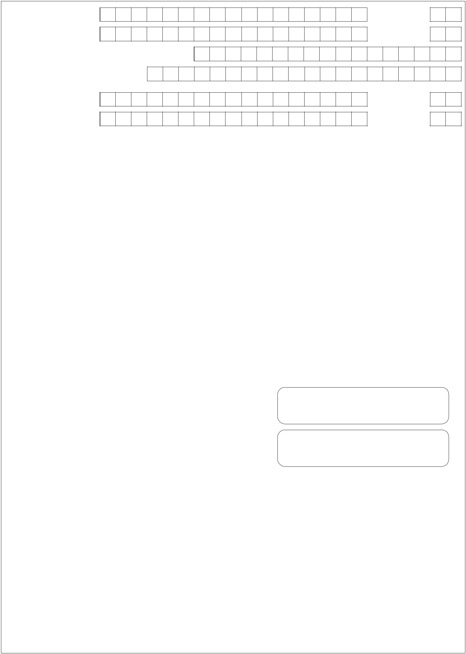

Country of Residence

as per tax laws

ISO code

ISO code

Foreign Tax Identification Number (TIN)

allotted by tax resident country

TIN Issuing Country

ISO code

ISO code

This attribute identifies the jurisdiction that issued the TIN. The Country Code as per ISO 3166 has to be mentioned. If Country Code is not available, use XX.

(If the country does not issue TIN or if a TIN cannot be obtained please provide an explanation in the box below)

Address Type
Indicates the type of the address. Permissible values are: 1- Residential Or Business |  |  |  | 2 – Residential
3 – Business |  | 4 – Registered Office | 5 – Unspecified

Part B - Declaration

- I hereby certify that I am not tax resident in, or citizen of, any other country besides those listed above.
- I declare that all statements made in this Declaration are, to the best of my knowledge and belief, correct and complete.

- I undertake to advise the bank promptly of any change in circumstances, which causes the information contained herein to become incorrect and to provide the bank with a suitably updated Declaration within 30 days of such change in circumstances.

- I authorize the bank to provide, directly or indirectly, to any relevant tax authorities/government authorities and/or other regulatory authorities locally/internationally or any party authorized to audit or conduct a similar control of the bank for tax purposes, the information contained in this Form and to disclose to such tax authorities or such party any additional information that the bank may have in its possession.

- I certify that I am authorized (POA holder) to sign for the individual who is the beneficial owner of all the income towhich this form relates and/or am using this form to document myself as an individual who is the Account Holder. In the event if the bank is put to any hardships or claims from any authoritiesdue to any false, untrue or misleading representation/
information furnished by me as containedherein, I shall | be solely liable and responsible for the same and I undertake
to indemnify Bank against any loss or damage suffered by the Bank.
Signature of | Customer | X

Date:
 |  |  |  |  |  |  | Seal & Signature of Branch Official |  |  | Y

Details under FATCA / Foreign tax laws(see instructions)

Instructions

Details under FATCA/Foreign Tax Laws: Towards compliance with tax information sharing laws, such as FATCA, we would be required to seek additional personal, tax and beneficial owner information and certain certifications and documentation from our account holders. Such information may be sought either at the time of account opening or any time subsequently. In certain circumstances (including if we do not receive a valid self-certification from you) we may be obliged to share information on your account with relevant tax authorities. If you have any questions about your tax residency, please contact your tax advisor. Should there be any change in any information provided by you, please ensure you advise us promptly, i.e., within 30 days. Towards compliance with such laws, we may also be required to provide information to any institutions such as withholding agents for the purpose of ensuring appropriate withholding from the account or any proceeds in relation thereto. As may be required by domestic or overseas regulators/ tax authorities, we may also be constrained to withhold and pay out any sums from your account or close or suspend your account(s).

If you are a US citizen or resident or green card holder, please include United States in the foreign country information field along with your US Tax Identification Number. Foreign Account Tax Compliance provisions (commonly known as FATCA) are contained in the US Hire Act 2010.

www.southindianbank.com CIN : L65191KL1929PLC001017 Toll Free : 18008431800, 18004251809 Page 15 of 15

