CONSUMER LOAN APPLICATION
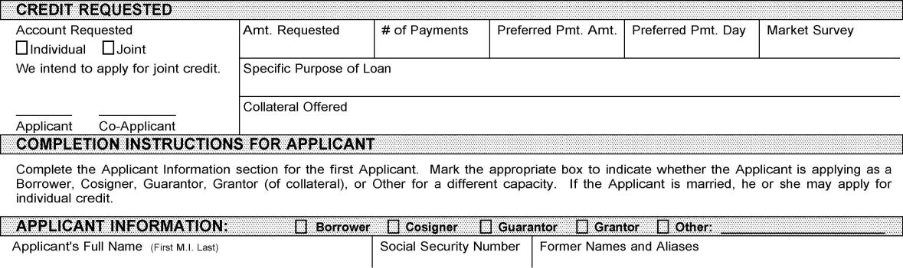

CREDIT REQUESTED

Account Requested Amt. Requested # of Payments Preferred Pmt. Amt. Preferred Pmt. Day Market Survey

Individual Joint

We intend to apply for joint credit. Specific Purpose of Loan

Collateral Offered

Applicant Co-Applicant

COMPLETION INSTRUCTIONS FOR APPLICANT

Complete the Applicant Information section for the first Applicant. Mark the appropriate box to indicate whether the Applicant is applying as a Borrower, Cosigner, Guarantor, Grantor (of collateral), or Other for a different capacity. If the Applicant is married, he or she may apply for individual credit.

APPLICANT INFORMATION:

Borrower

Cosigner

Guarantor

Grantor

Other: _________________________

Applicant's Full Name

(First M.I. Last)

Social Security Number
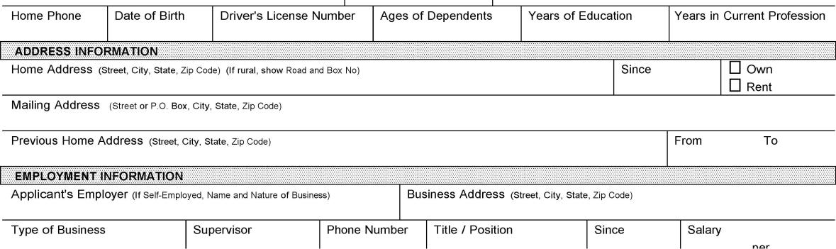

Former Names and Aliases

Home Phone

Date of Birth

Driver's License Number

Ages of Dependents

Years of Education

Years in Current Profession

ADDRESS INFORMATION

Home Address (Street, City, State, Zip Code) (If rural, show Road and Box No)

Since

Own

Rent

Mailing Address (Street or P.O. Box, City, State, Zip Code)

Previous Home Address

(Street, City, State, Zip Code)

From

To

EMPLOYMENT INFORMATION

Applicant's Employer (If Self-Employed, Name and Nature of Business)

Business Address

(Street, City, State, Zip Code)

Type of Business

Supervisor

Phone Number

Title / Position

Since

Salary

per
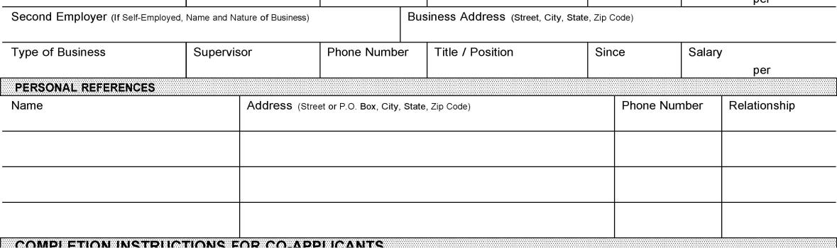

Second Employer

(If Self-Employed, Name and Nature of Business)

Business Address

(Street, City, State, Zip Code)

Type of Business

Supervisor

Phone Number

Title / Position

Since

Salary

per

PERSONAL REFERENCES

Name

Address

(Street or P.O. Box, City, State, Zip Code)

Phone Number

Relationship

COMPLETION INSTRUCTIONS FOR CO-APPLICANTS
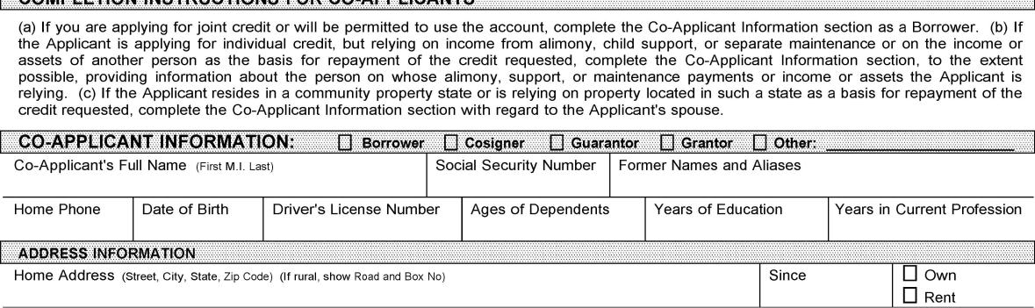

- If you are applying for joint credit or will be permitted to use the account, complete the Co-Applicant Information section as a Borrower. (b) If the Applicant is applying for individual credit, but relying on income from alimony, child support, or separate maintenance or on the income or assets of another person as the basis for repayment of the credit requested, complete the Co-Applicant Information section, to the extent possible, providing information about the person on whose alimony, support, or maintenance payments or income or assets the Applicant is relying. (c) If the Applicant resides in a community property state or is relying on property located in such a state as a basis for repayment of the credit requested, complete the Co-Applicant Information section with regard to the Applicant's spouse.

CO-APPLICANT INFORMATION:

Borrower

Cosigner

Guarantor

Grantor

Other: _________________________

Co-Applicant's Full Name

(First M.I. Last)

Social Security Number

Former Names and Aliases

Home Phone

Date of Birth

Driver's License Number

Ages of Dependents

Years of Education

Years in Current Profession

ADDRESS INFORMATION

Home Address (Street, City, State, Zip Code) (If rural, show Road and Box No)

Since

Own

Rent
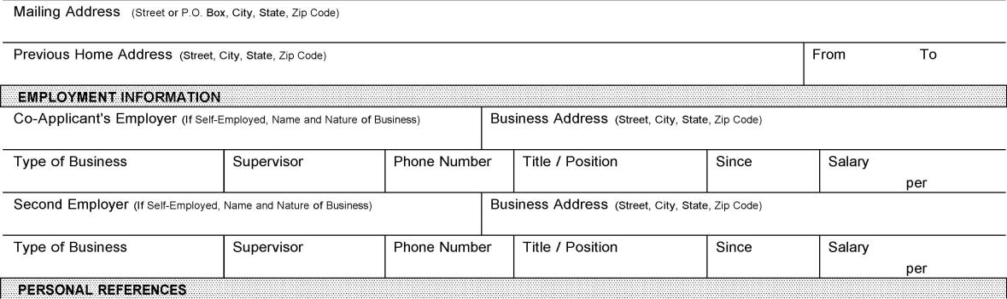

Mailing Address (Street or P.O. Box, City, State, Zip Code)

Previous Home Address

(Street, City, State, Zip Code)

From

To

EMPLOYMENT INFORMATION

Co-Applicant's Employer (If Self-Employed, Name and Nature of Business)

Business Address

(Street, City, State, Zip Code)

Type of Business

Supervisor

Phone Number

Title / Position

Since

Salary

per

Second Employer

(If Self-Employed, Name and Nature of Business)

Business Address

(Street, City, State, Zip Code)

Type of Business

Supervisor

Phone Number

Title / Position

Since

Salary

per

PERSONAL REFERENCES
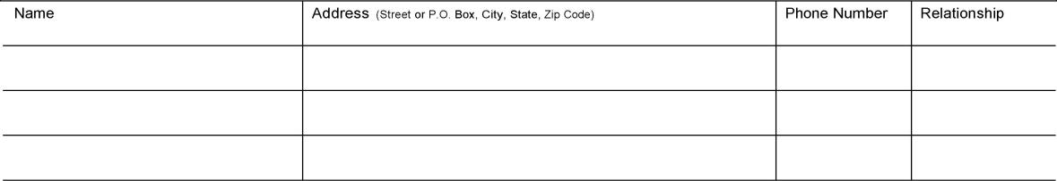

Name

Address

(Street or P.O. Box, City, State, Zip Code)

Phone Number

Relationship

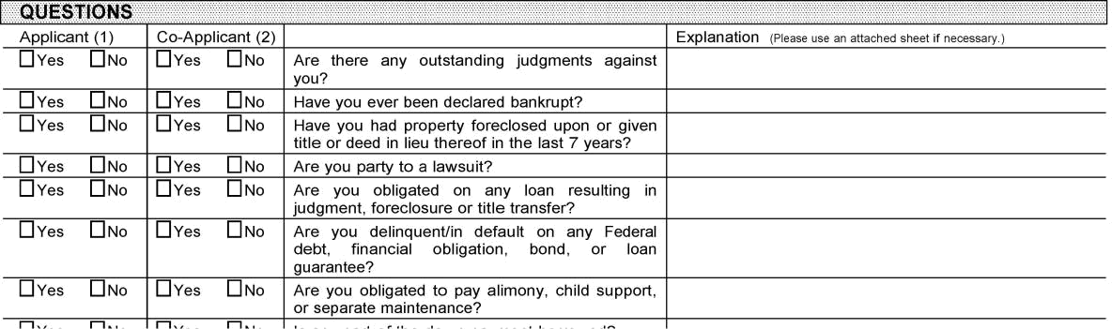
QUESTIONS

Applicant (1) |  | Co-Applicant (2) |  |  | Explanation (Please use an attached sheet if necessary.)
Yes | No | Yes | No | Are there any outstanding judgments against
 |  |  |  | you?
Yes | No | Yes | No | Have you ever been declared bankrupt?
Yes | No | Yes | No | Have you had property foreclosed upon or given
 |  |  |  | title or deed in lieu thereof in the last 7 years?
Yes | No | Yes | No | Are you party to a lawsuit?
Yes | No | Yes | No | Are you obligated on any loan resulting in
 |  |  |  | judgment, foreclosure or title transfer?
Yes | No | Yes | No | Are you delinquent/in default on any Federal
 |  |  |  | debt, financial obligation, bond, or loan
 |  |  |  | guarantee?
Yes | No | Yes | No | Are you obligated to pay alimony, child support,
 |  |  |  | or separate maintenance?
Yes | No | Yes | No | Is any part of the down payment borrowed?
Yes | No | Yes | No | Are you a co-maker or an endorser on a loan?
Yes | No | Yes | No | Have you ever had merchandise repossessed?
Yes | No | Yes | No | Have you ever been denied credit with this
 |  |  |  | lender?
Yes | No | Yes | No | Are you a U.S. citizen?
Yes | No | Yes | No | If no, are you a resident alien?
Yes | No | Yes | No | If no, are you a non-resident alien?
PREVIOUS CREDIT REFERENCES
Names Credit Listed In |  |  | Loan Purpose |  | Creditor Name and Address | Account Number Highest Balance Date Paid
App | CoApp | Other |  |  |  | $
App | CoApp | Other
App | CoApp | Other
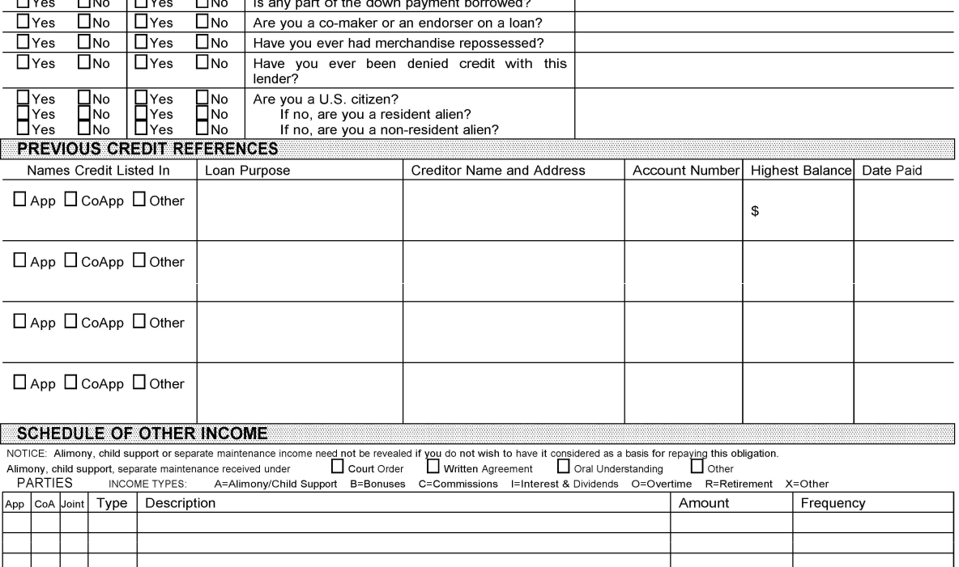

App CoApp Other

SCHEDULE OF OTHER INCOME

NOTICE: Alimony, child support or separate maintenance income need not be revealed if you do not wish to have it considered as a basis for repaying this obligation.

Alimony, child support, separate maintenance received under

Court Order

Written Agreement

Oral Understanding

Other

PARTIES

INCOME TYPES:

A=Alimony/Child Support B=Bonuses C=Commissions I=Interest & Dividends O=Overtime R=Retirement X=Other

App CoA Joint

Type Description

Amount
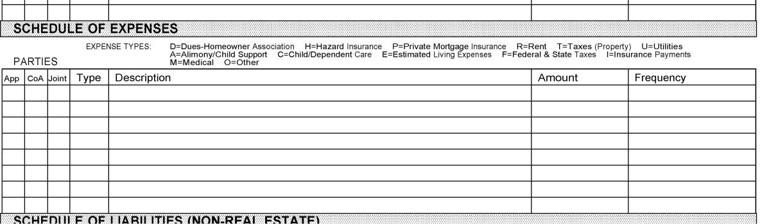

Frequency

SCHEDULE OF EXPENSES

 | EXPENSE TYPES: | D=Dues-Homeowner Association | H=Hazard Insurance P=Private Mortgage Insurance R=Rent T=Taxes (Property) | U=Utilities
PARTIES |  | A=Alimony/Child Support C=Child/Dependent Care E=Estimated Living Expenses F=Federal & State Taxes I=Insurance Payments
PARTIES |  | M=Medical O=Other
App CoA Joint | Type Description |  | Amount | Frequency

SCHEDULE OF LIABILITIES (NON-REAL ESTATE)
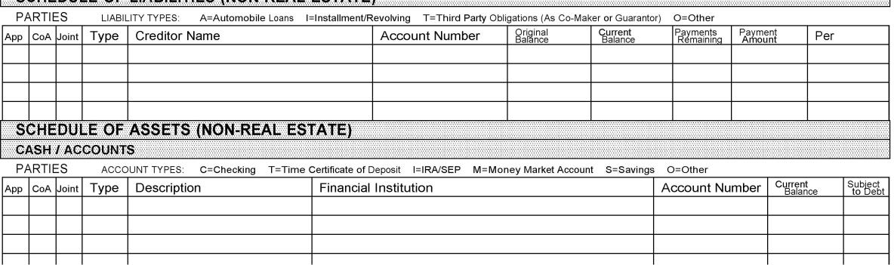

PARTIES | LIABILITY TYPES:A=Automobile Loans | I=Installment/Revolving T=Third Party Obligations (As Co-Maker or Guarantor) |  |  | O=Other
App CoA Joint | Type Creditor Name | Account Number | Original | Current | Payments | Payment | Per
App CoA Joint | Type Creditor Name | Account Number | Balance | Balance | Remaining | Amount | Per

SCHEDULE OF ASSETS (NON-REAL ESTATE)

CASH / ACCOUNTS

PARTIES | ACCOUNT TYPES: C=Checking | T=Time Certificate of Deposit I=IRA/SEP M=Money Market Account | S=Savings O=Other
App CoA Joint | Type Description | Financial Institution | Account Number | Current | Subject
 |  |  |  | Balance | to Debt
STOCKS / BONDS
App CoA Joint | Description | Broker / Company | Account Number | Value | Subject
 |  |  |  |  | to Debt
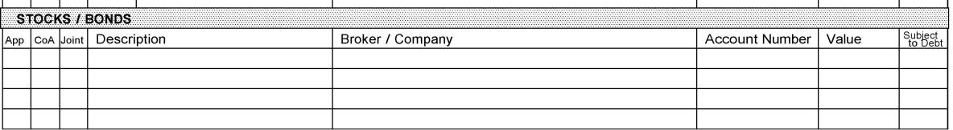

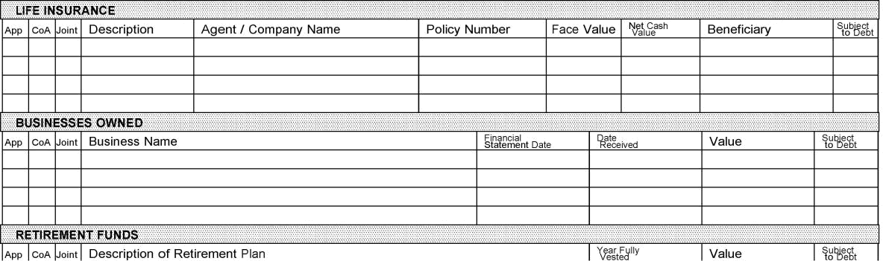
LIFE INSURANCE

App CoA Joint Description | Agent / Company Name | Policy Number | Face Value | Net Cash | Beneficiary | Subject
 |  |  |  | Value | Beneficiary | to Debt

BUSINESSES OWNED

App CoA Joint Business Name | Financial | Date | Value | Subject
App CoA Joint Business Name | Statement Date | Received | Value | to Debt

RETIREMENT FUNDS

App CoA Joint Description of Retirement Plan | Year Fully | Value | Subject
App CoA Joint Description of Retirement Plan | Vested | Value | to Debt
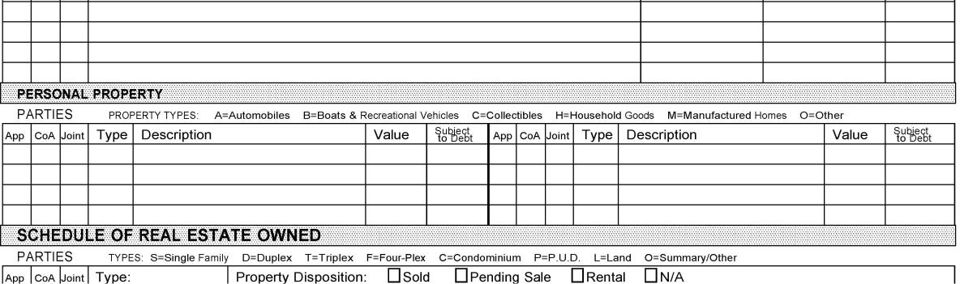

PERSONAL PROPERTY

PARTIES | PROPERTY TYPES: A=Automobiles | B=Boats & Recreational Vehicles C=Collectibles H=Household Goods M=Manufactured Homes |  |  | O=Other
App CoA Joint | Type Description | Value | Subject | App CoA Joint Type Description | Value | Subject
App CoA Joint | Type Description | Value | to Debt | App CoA Joint Type Description | Value | to Debt

SCHEDULE OF REAL ESTATE OWNED

PARTIES |  | TYPES: S=Single Family | D=Duplex T=Triplex F=Four-Plex |  | C=Condominium P=P.U.D. L=Land |  | O=Summary/Other
App | CoA Joint | Type: | Property Disposition: | Sold | Pending Sale | Rental | N/A
 |  | Description | Property Address |  | Date Acquired |  | Cost | Principal Residence
 |  |  |  |  |  |  |  | Yes | No
 |  | Current Market ValueTotal Mortgages & LiensGross Rental Income Taxes, Ins., Maint. |  |  |  |  | Net Rental Income
 |  | Creditor 1 Name and Address |  |  | Unpaid Bal. | Pmt. Amt. | Per | Lien Position | First Lien
 |  |  |  |  |  |  |  |  | Junior Lien
 |  | Creditor 2 Name and Address |  |  | Unpaid Bal. | Pmt. Amt. | Per | Lien Position | First Lien
 |  |  |  |  |  |  |  |  | Junior Lien
App | CoA Joint | Type: | Property Disposition: | Sold | Pending Sale | Rental | N/A
 |  | Description | Property Address |  | Date Acquired |  | Cost | Principal Residence
 |  |  |  |  |  |  |  | Yes | No
 |  | Current Market ValueTotal Mortgages & LiensGross Rental Income Taxes, Ins., Maint. |  |  |  |  | Net Rental Income
 |  | Creditor 1 Name and Address |  |  | Unpaid Bal. | Pmt. Amt. | Per | Lien Position | First Lien
 |  |  |  |  |  |  |  |  | Junior Lien
 |  | Creditor 2 Name and Address |  |  | Unpaid Bal. | Pmt. Amt. | Per | Lien Position | First Lien
 |  |  |  |  |  |  |  |  | Junior Lien
App | CoA Joint | Type: | Property Disposition: | Sold | Pending Sale | Rental | N/A
 |  | Description | Property Address |  | Date Acquired |  | Cost | Principal Residence
 |  |  |  |  |  |  |  | Yes | No
 |  | Current Market ValueTotal Mortgages & LiensGross Rental Income Taxes, Ins., Maint. |  |  |  |  | Net Rental Income
 |  | Creditor 1 Name and Address |  |  | Unpaid Bal. | Pmt. Amt. | Per | Lien Position | First Lien
 |  |  |  |  |  |  |  |  | Junior Lien
 |  | Creditor 2 Name and Address |  |  | Unpaid Bal. | Pmt. Amt. | Per | Lien Position | First Lien
 |  |  |  |  |  |  |  |  | Junior Lien
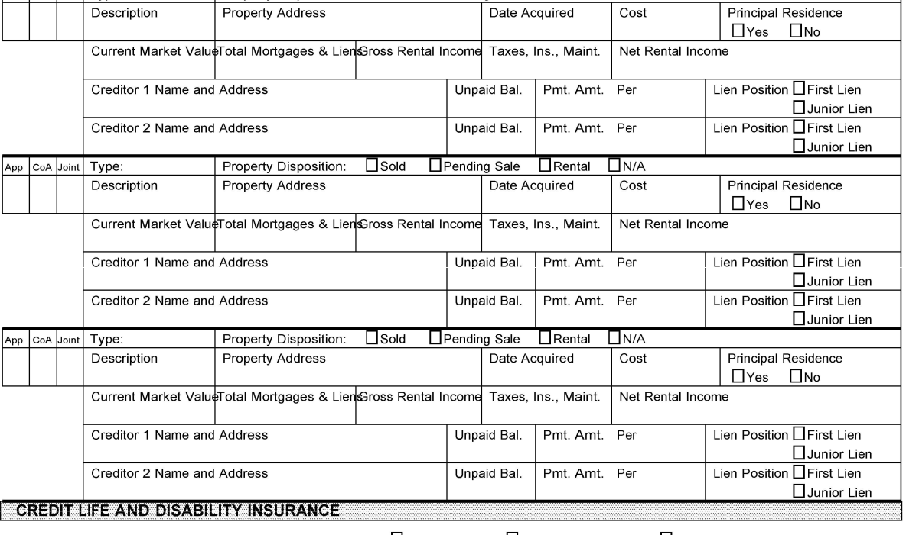
CREDIT LIFE AND DISABILITY INSURANCE

Applicant desires the following voluntary insurance:

Credit Life

Credit Disability

Involuntary Unemployment

Co-Applicant desires the following voluntary insurance:

Credit Life

Credit Disability

Involuntary Unemployment

APPLICANT SIGNATURE(S)

I/We hereby apply for the loan or credit described in this application. I/We certify that I/we made no misrepresentations in this loan application or in any related documents, that all information is true and complete, and that I/we did not omit any important information. I/We agree that any property securing the loan or credit will not be used for any illegal or restricted purpose. Lender is authorized to verify with other parties and to make any investigation of my/our credit, either directly or through any agency employed by Lender for that purpose. Lender may disclose to any other interested parties information as to Lender's experiences or transactions with my/our account. I/We understand that Lender will retain this application and any other credit information Lender receives, even if no loan or credit is granted. These representations and authorizations extend not only to Lender, but also to any insurer of the loan and to any investor to whom Lender may sell all or any part of the loan. I/We further authorize Lender to provide to any such insurer or investor any information and documentation that they may request with respect to my/our application, credit or loan.

APPLICANT:

X

X

Applicant

Date

Co-Applicant

Date

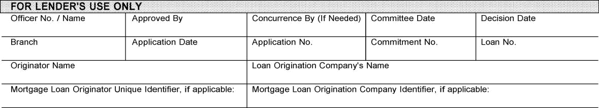
FOR LENDER'S USE ONLY

Officer No. / Name | Approved By |  |  | Concurrence By (If Needed) Committee Date |  |  | Decision Date
Branch | Application Date |  |  | Application No. |  | Commitment No. | Loan No.
Originator Name |  |  |  | Loan Origination Company's Name
Mortgage Loan Originator Unique Identifier, if applicable: |  |  |  | Mortgage Loan Origination Company Identifier, if applicable:
Decision and Comments: | Approved | Denied | Incomplete |  | Counteroffer | Conditional Approval | Withdrawal | Other: _______ ______

LaserPro, Ver. 19.2.0.042 Copr. Finastra USA Corporation 1997, 2019. All Rights Reserved. - P:\HARLAND\CFI\LPL\CFILNAP.FC

CONSUMER PROTECTION IN SALES OF INSURANCE DISCLOSURE

In connection with any insurance product or annuity solicited, offered or sold by or on behalf of Community State Bank or any of its affiliates, any related application for credit by you may not be conditioned on either:

- Your purchase of an insurance product or annuity from or on behalf of Community State Bank or any of its affiliates; or
- Your agreement not to obtain or a prohibition of your obtaining an insurance product or annuity from an unaffiliated entity. You are free to purchase insurance products and annuities from another source.

This disclosure is to advise you that the purchase of any insurance product from on or behalf of Community State Bank or any of its affiliates is not a deposit or other obligation of, or guaranteed by Community State Bank or an affiliate of Community State Bank.

The insurance product is not insured by the Federal Deposit Insurance Corporation (FDIC) or any other federal government agency of the United States, Community State Bank, or any affiliate of Community State Bank.

Oral disclosure was given to consumer(s) (not required transactions conducted electronically or
by mail). _______ _______
Initial Initial

Consumer(s) agree that by signing below they have received a copy of said disclosure.

___________________________________ Customer Signature

_______________
Date

___________________________________ Customer Signature

_______________

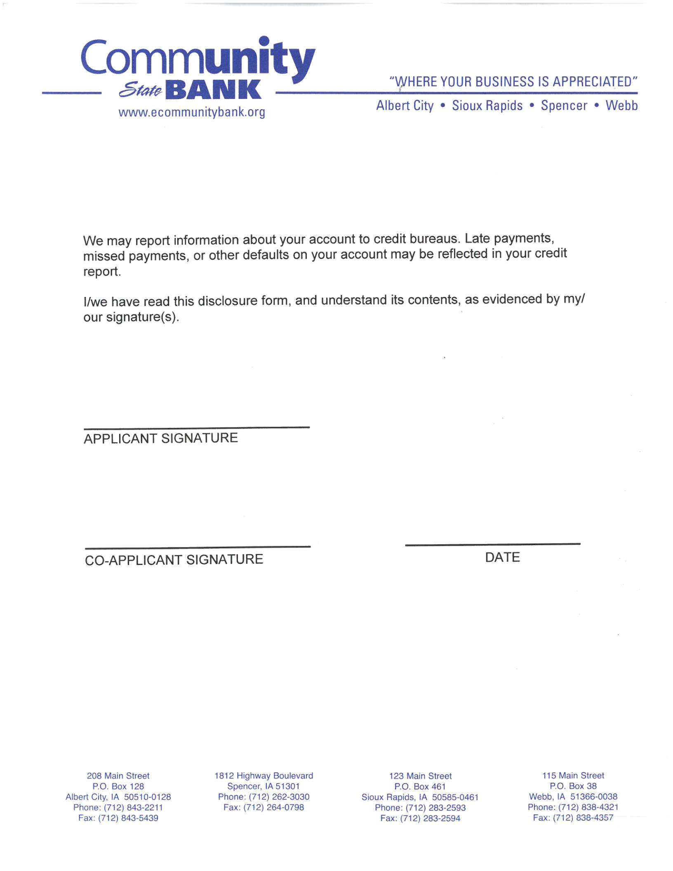
Date

