Submit by E-mail
Affidavit of Legal Interest
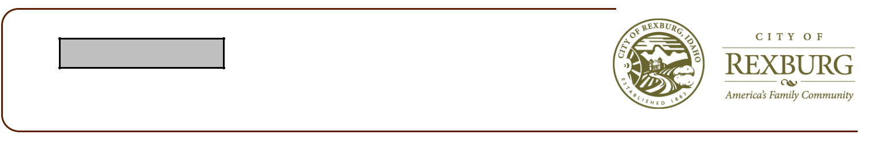

City of Rexburg

35 North 1st East Phone: 208.359.3020
Rexburg, ID 83440 www.rexburg.org Fax: 208.359.3022

State of Idaho
County of Madison

I, __________________________________, ____________________________________

Name Address

____________________________________, ____________________________________

City State

Being first duly sworn upon oath, depose and say:

(If Applicant is also Owner of Record, skip to B)

- That I am the record owner of the property described on the attached, and I grant my

permission to: __________________________ ______________________________

Name Address

to submit the accompanying application pertaining to that property.

- I agree to indemnify, defend and hold Rexburg City and its employees harmless from any claim or liability resulting from any dispute as to the statements contained herein or as to the ownership of the property which is the subject of the application.

Dated this ___________________________ day of _______________________, 20_________

_________________________________________________

Signature

Subscribed and sworn to before me the day and year first above written.

_______________________________________________

Notary Public of Idaho

Residing at: _______________________________

My commission expires: _____________________

