Unit Turn Checklist
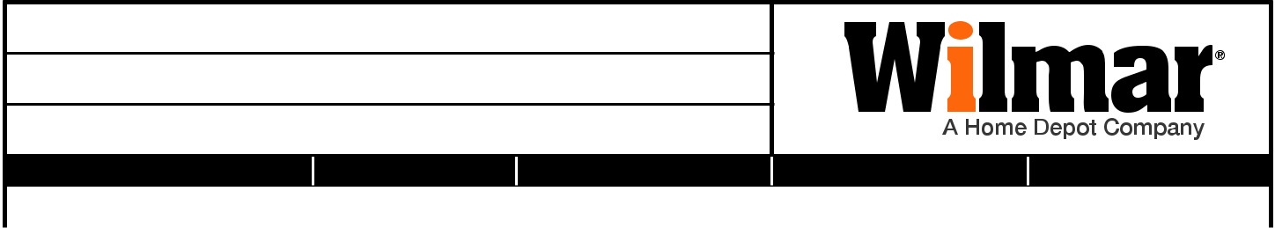

Sales Professional Name:

Sales Professional Mobile:

Sales Professional Email:

UNIT NUMBER | NUMBER OF BEDROOMS |  |  | NUMBER OF BATHROOMS |  |  | INSPECTION DATE | INSPECTED BY
ENTRYWAY | INSPECTED | REPAIR |  | REPLACE | PART NUMBER |  | QUANTITY | NOTES
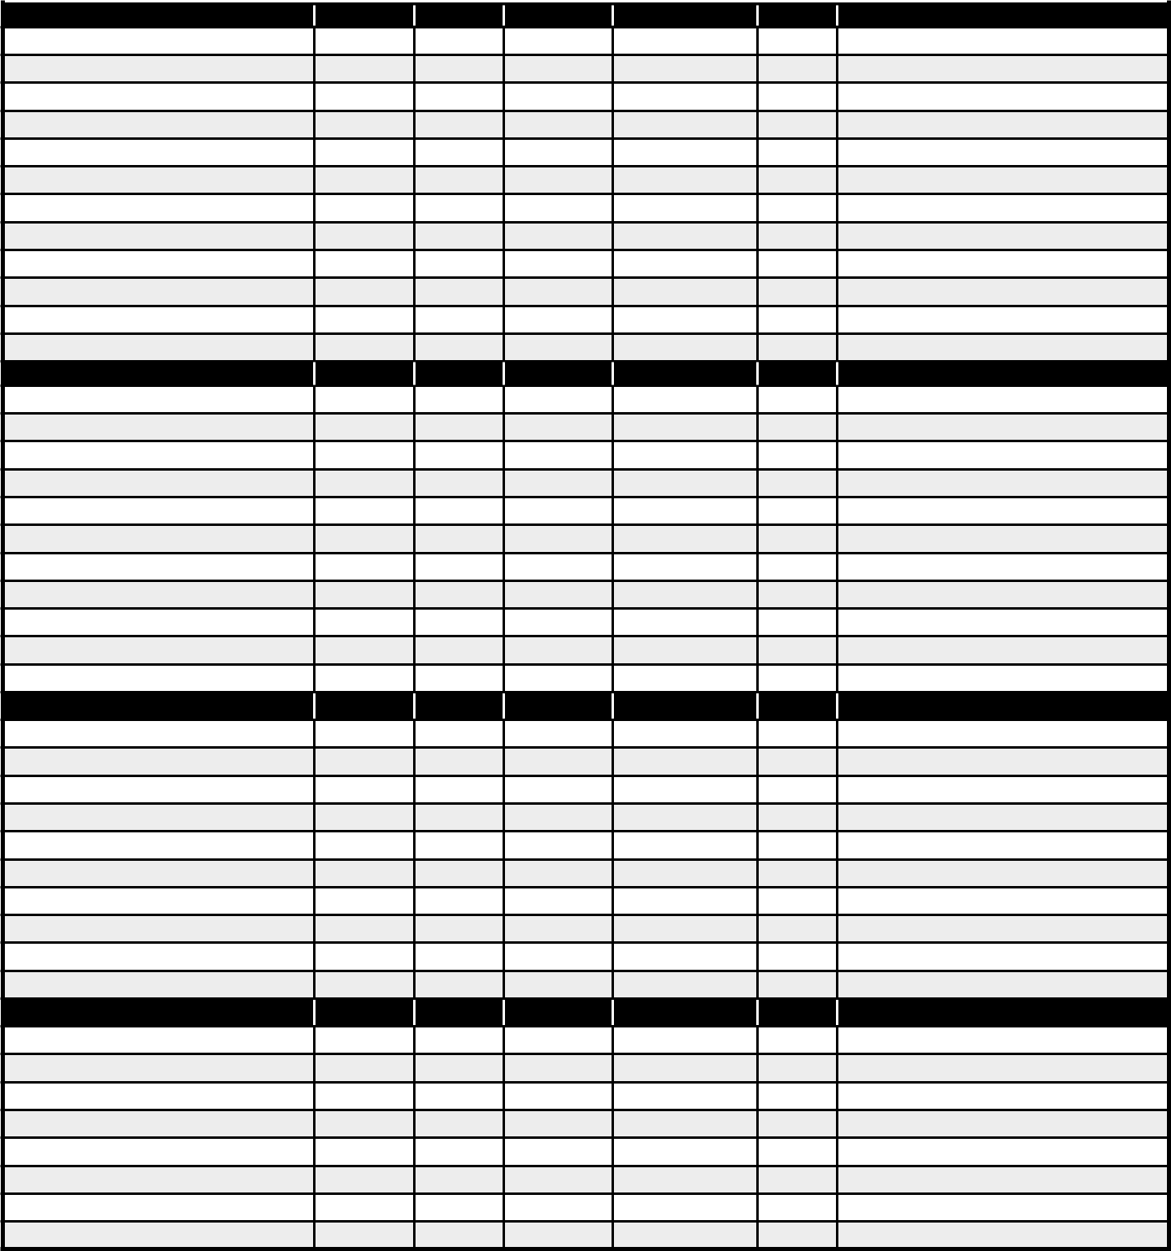

Deadbolt

Door Stop/Hinge/Closer

Door Sweep/Weather-strip

Entry Lock

Exterior Door

Exterior Lights

House/Unit Number

Lockset

Passage Lock

Peephole/Door Knocker

Screen/Security Door

Threshold

LIVING ROOM

INSPECTED

REPAIR

REPLACE

PART NUMBER

QUANTITY

NOTES

Blinds

Ceiling Fan

Ceiling Fan Light Kit

Cove Base/Base Trim

Crown Molding

Flooring

Light Bulbs

Light Fixtures

Smoke Alarm/CO2

Switch/Wall/Phone/Cable Plates

Window Screens

DINING ROOM

INSPECTED

REPAIR

REPLACE

PART NUMBER

QUANTITY

NOTES

Blinds

Ceiling Fan

Cove Base/Base Trim

Crown Molding

Flooring

Light Bulbs

Light Fixtures

Smoke Alarm/CO2

Switch/Wall/Phone/Cable Plates

Window Screens

KITCHEN

INSPECTED

REPAIR

REPLACE

PART NUMBER

QUANTITY

NOTES

Broiler Pan

Cabinet Door Hinges

Cabinets and Drawers

Countertops

Cove Base/Base Trim

Crown Molding

Drip Bowls

Faucet/Aerator/Handles


Phone: 800.345.3000

1

KITCHEN cont.
INSPECTED
REPAIR
REPLACE
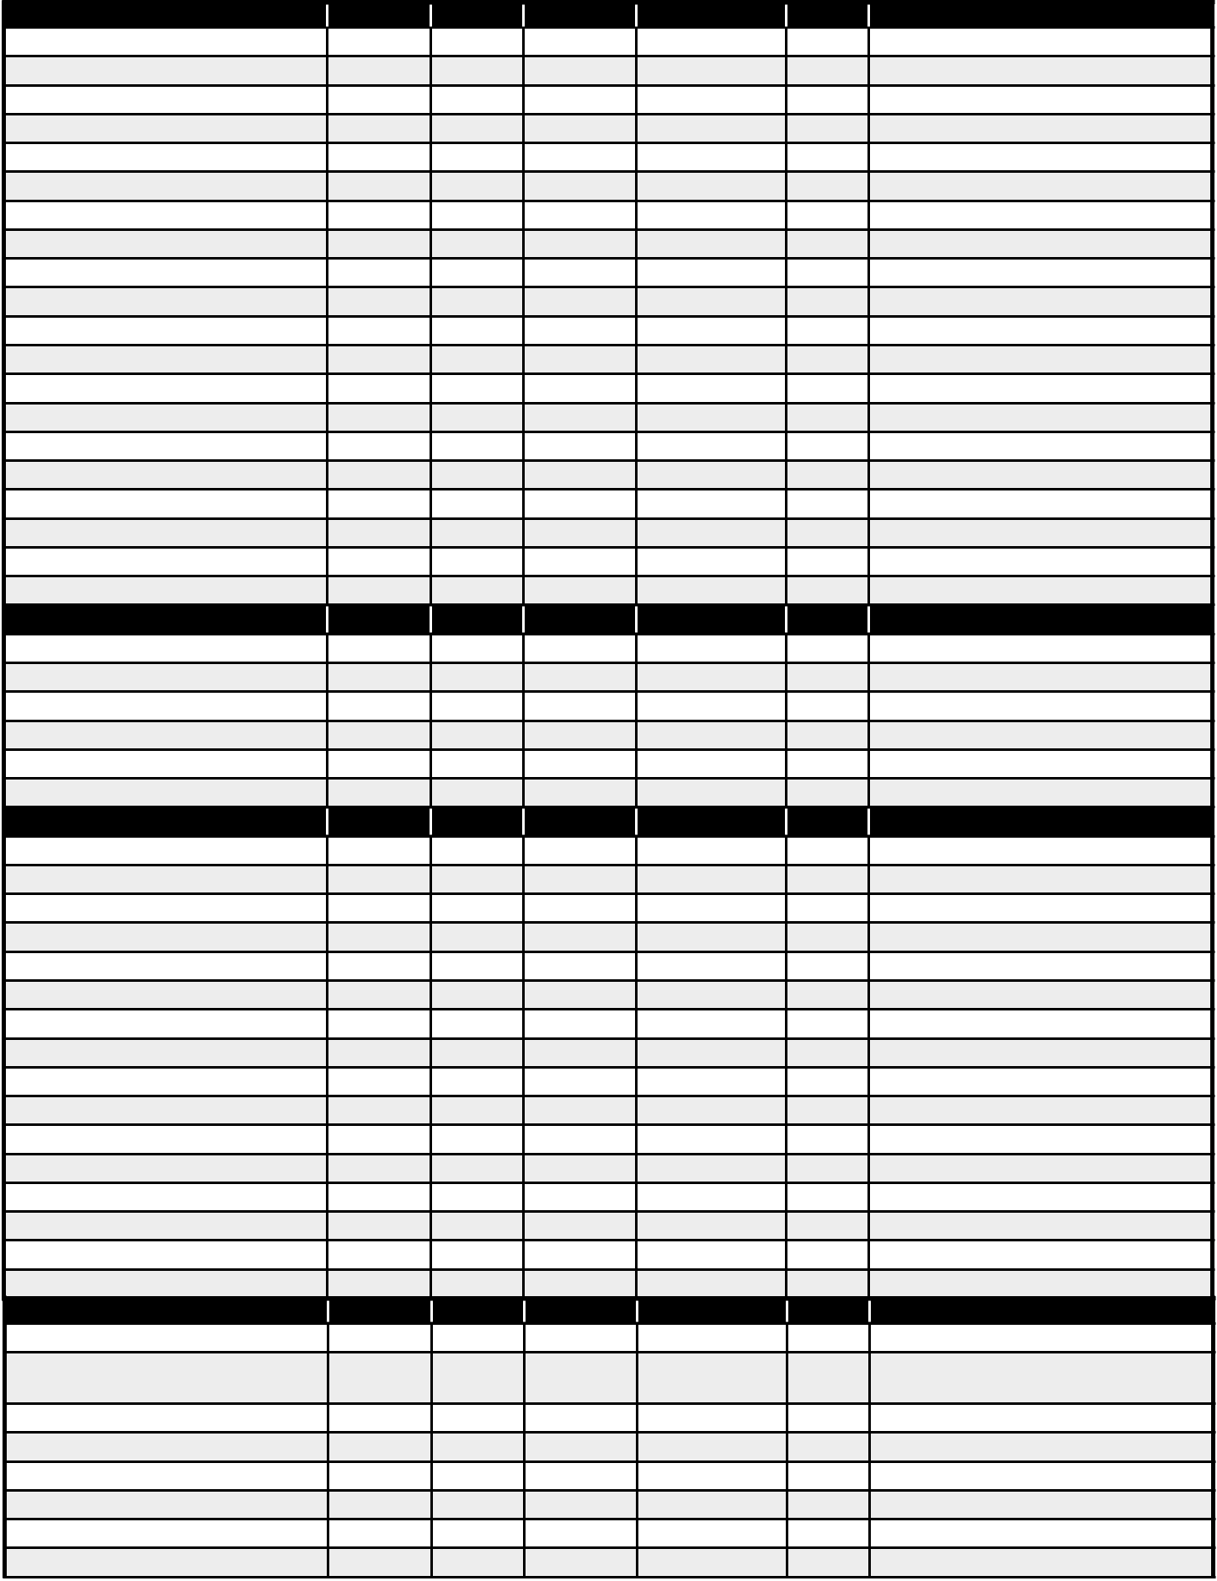
PART NUMBER
QUANTITY
NOTES

Fire Extinguisher 5lb.

Fire Stop

Flooring

Garbage Disposers

GFCI

Ice Cube Trays

Icemaker

Light Fixtures

Microwave

Microwave Plate

Oven Rack

Range

Range Elements

Range Hood

Refrigerator

Sink

Sink Basket/Strainer

Smoke Alarm/CO2

Supply Lines

Switch/Wall/Phone/Cable Plates

PATIO/BALCONY

INSPECTED

REPAIR

REPLACE

PART NUMBER

QUANTITY

NOTES

Door Sweep/Weather-strip

Exterior Door

Exterior/Light Fixtures

Lockset

Screen/Security Door

Threshold

BEDROOM(S)

INSPECTED

REPAIR

REPLACE

PART NUMBER

QUANTITY

NOTES

Blinds

Bypass Door/Bi-Fold Door

Ceiling Fan

Ceiling Fan Light Kit

Closet Rod/Rack

Close/Drawer Knobs

Cove Base/Base Trim

Crown Molding

Door Stop/Hinge/Closer

Flooring

Light Fixtures

Lockset

Privacy Lockset

Smoke Alarm/CO2

Switch/Wall/Phone/Cable Plates

Window Screens

BATHROOM(S)

INSPECTED

REPAIR

REPLACE

PART NUMBER

QUANTITY

NOTES

Angle Stop

Bath Hardware - End Brackets/ Soap

Holder/Toilet Paper Holder/Towel Holder

Cabinets and Drawers

Countertops

Cove Base/Base Trim

Door Stop/Hinge/Closer

Escutcheons

Exhaust Fan

2

Phone: 800.345.3000

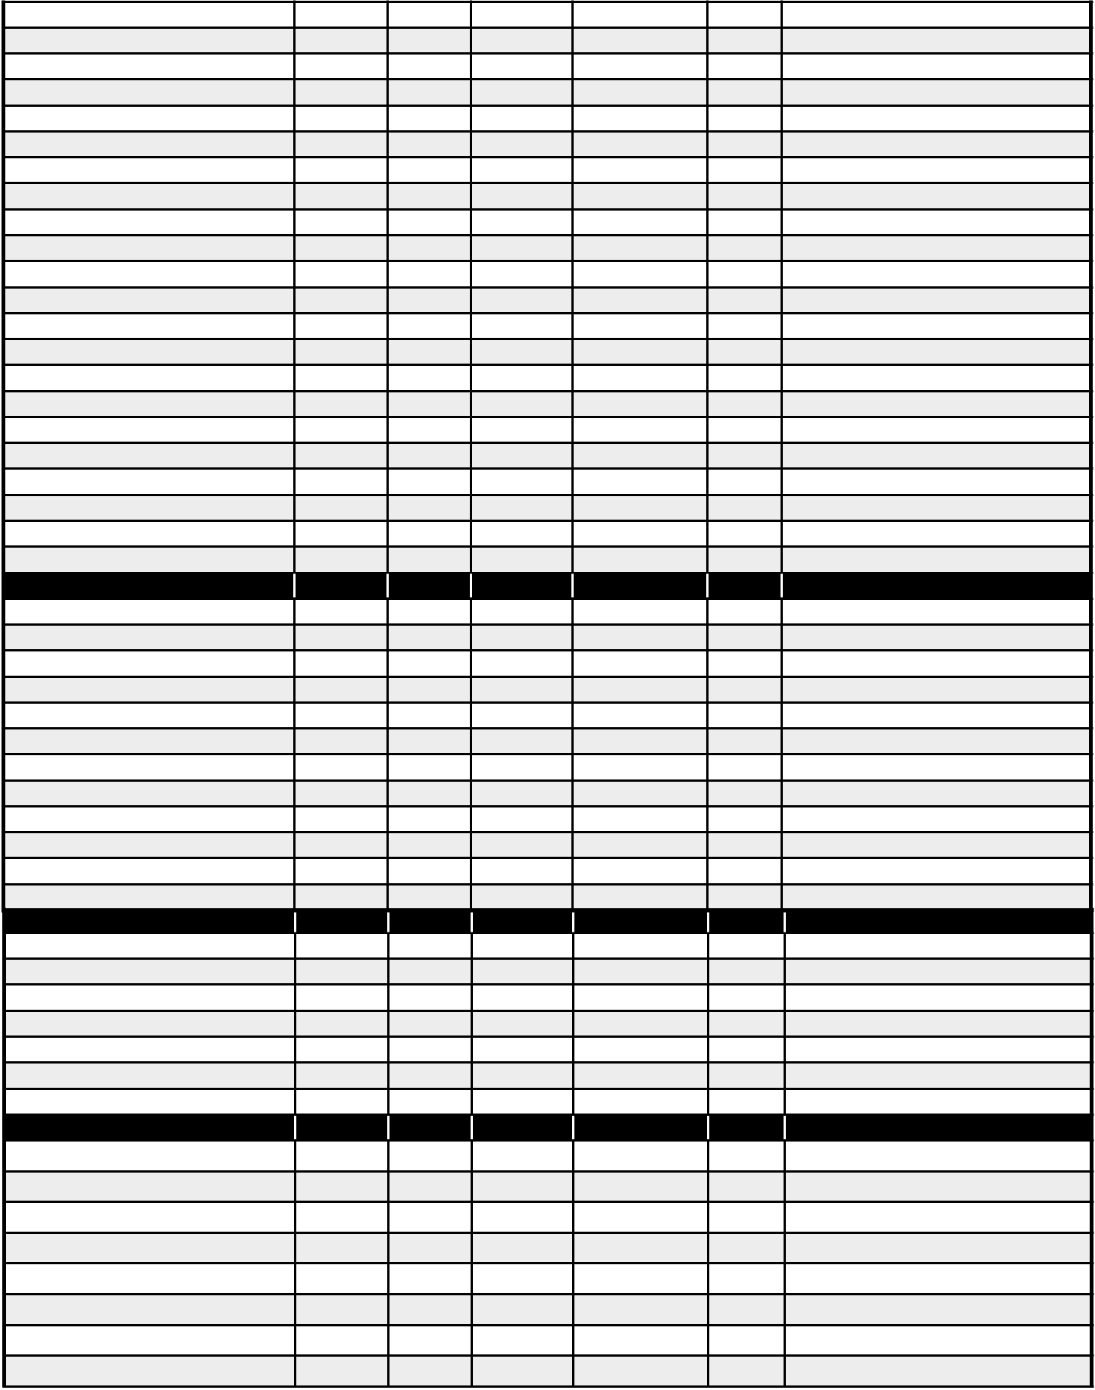
Faucet/Pop-Ups And Repair

Flooring

GFCI

Handles And Index Buttons

Heat Lamp

Interior Slab Door

Light Fixtures

Lockset

Medicine Cabinet

Mirror/Clips

P-Trap

Privacy Lockset

Shower Door

Showerhead

Sink

Supply Lines

Switch/Wall Plates

Toilet

Toilet Seats

Tub Spout

Tub Surround

Ceiling Fan Light Kit

GENERAL MAINTENANCE

INSPECTED

REPAIR

REPLACE

PART NUMBER

QUANTITY

NOTES

A/C Register

Air Conditioner

Air Filter/Sizes

Batteries

Carpet Cleaner/Vacuum

Caulk

Cleaning Chemicals and Supplies

Furnace/Gas or Electric/BTU

Garage Entry Door

Heater

Heat Pump

Heat Register

GENERAL MAINTENANCE cont.

INSPECTED

REPAIR

REPLACE

PART NUMBER

QUANTITY

NOTES

Light Bulbs

Paint

Primer

Smoke Alarms/CO Detectors

Thermostat

Wall Patch

Water Heater

MISCELLANEOUS

INSPECTED

REPAIR

REPLACE

PART NUMBER

QUANTITY

NOTES

3

Phone: 800.345.3000

