UNIT 19 UNDERSTANDING
BALANCE SHEET

Structure

19.0 Objectives
19.1 Introduction
19.2 Balance Sheet
19.3 Basic Concepts
19.4 Forms of Balance Sheet
19.5 Structure of Balance Sheet

B5 . 1 Assets

195.2 Liabilities

19.5.3 Equity

19.5.4 Reserve and Surplus
19.6 Analysis of Balance Sheet
19.7 Let Us Sum Up
19.8 Keywords
19.9 Answers to Check Your Progress Exercises

After going through this Unit, you should be able to:

explain the concept of Balance Sheet,

describe the formats and structure of Balance Sheet,
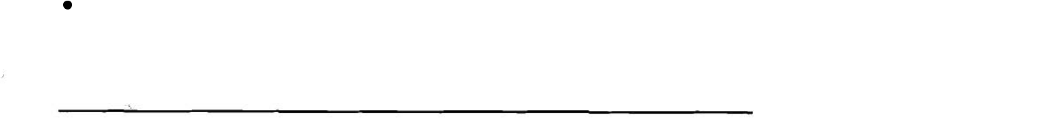

classify different assets, liabilities and capital that appear in the Balance Sheet, and

analyse the Balance Sheet.

- 19.1 INTRODUCTION
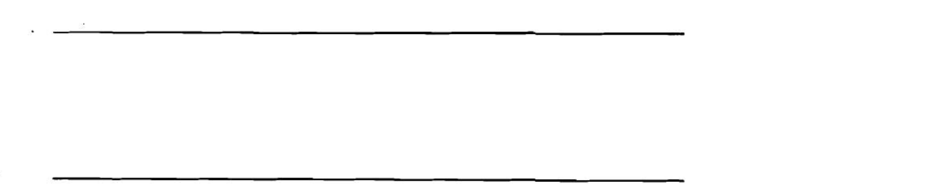

- i c i a l Statements are useful indicators of how a business has beendoing, whether it enjoys a healthy financial position or not, and its financial relationship with various parties at any particular time. It covers three important documents viz., Balance Sheet, Profit and Loss Account and Source and Application of Funds Statement. In this Unit you will learn the concept and structure of Balance Sheet in detail.

19.2 BALANCE SHEET
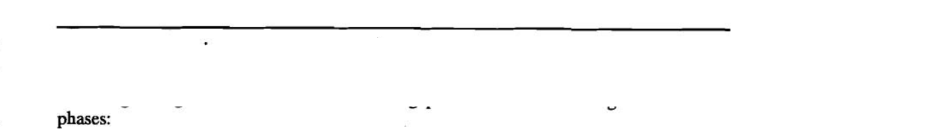

A business organisation conveys financial information to the users-through financial statements and reports. A financial statement is nothing but collection of data organised . according to logical and consistent accounting procedures. Accounting involves three
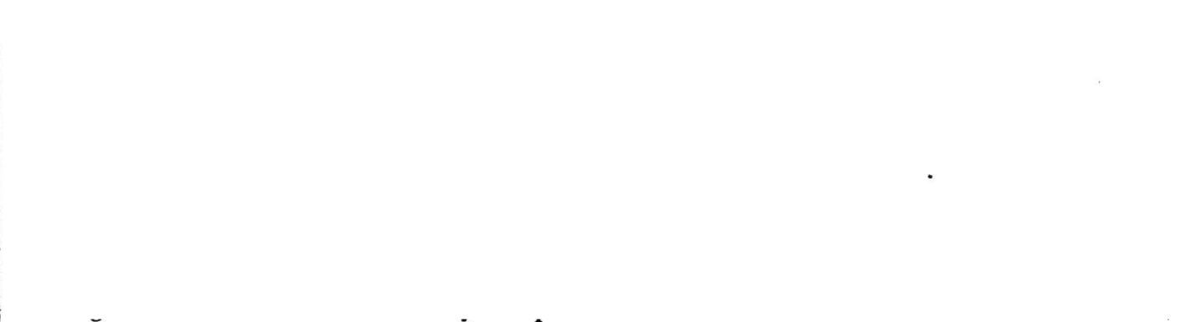

1) The recording of transactions in books of original entry also called journalising the
 |  | transactions.
 | 2) | The classification of these transactions in ledger.
 | 3) | The summarization of these records.
- | The preparation of financial statements takes place in third phase of accounting process.
- | According to accounting view the Balance Sheet is a ?:-t or summary of the balances of
 | various accounts after a formal closing of the books for a period. The balance of each
 | account indicates the position of that account and, therefore, the Balance Sheet may be
 | regarded as a master account or summary of the position of different accounts. |  | 13

Mhnaging Financial Operalions
- Balance Sheet shows on one side the various sources from which money used in the business came. These sources consist of the owner's capital, loans taken from various parties and the amounts due to other parties for goods purchased, expenses incurred, and the profit made in the business but not withdrawn. On the other side th&Balance Sheet shows in what way the money was used in the business. It consists of things (mwmed by it, such as permanent assets, stock, cash and also amounts yet to be received from other parties. A Balance Sheet is a photograph of the business at any point of time.

In specific term, the Balance Sheet:
- indicates the financial position of a business as on a date or at a point of time,

- shows the different sources from which money or money's worth was obtained for the business from its inception, and

  - shows the various forms in which money or money's worth has been employed in the business from its inception.

In short, you should keep in mind the following important aspects of Balance Sheet:

- A Balance Sheet is always prepared from the point of view of the firm, company or business, and not from that of its owners, creditors, directors or employees.

- The financial position of the business is shown in the amount of various assets like land, buildings, machinery, stock in trade, cash or any other thing of value.

- The financial relationship of the business is shown:


to its owners in the amount of capital, reserves and undistributed profits, to its creditors in the amount of loans due to them, and to its debtors in the amount due from them.

- A Balance Sheet always relates to a particular point of time or date and not a period.

- A Balance Sheet is always expressed in terms of money or money value.

- Since the amount obtained by the firm from various sources is shown on one side and the amount used for various purposes is shown on the other, the total money value on both sides of the Balance Sheet must be the same.

193 BASIC CONCEPTS

A Balance Sheet is a financial statement that shows the financial position of a fi-mas on a specific date, usually on the close of the accounting period. The Balance Sheet contains information about the resources and obligations of a business enterprise. In accounting
language, it shows the assets, liabilities and equity for the firm as on specific day.

The Indian Companies Act 1956, requires that Balance Sheet should give a true and fair view of the state of affairs of the company. In addition to this, contents and presentation of periodic final accounts of business are governed bybasic accounting concepts. The concepts which are central to the preparation of financial accounts and statements are:

Going concern,

Entity Concept,

Consistency,

Prudence,

Accruals, and

Dual Aspect.

Going Concern concept assumes that the business entity shall continue to exist and operate unless there is an evjd~nceto the contrary. This has an important implication for thevaluation
of assets and liabilities. Assets are normally carried in the books at their cost less depreciation, and not at their liquidation value. This reflects better value of assets. Likewise, liabilities also reflect what the business owns, not the liquidation value.

Consistency concept requires that the accounting treatment of items, in different periods, should be followed consistently.

Prudence (or conservatism) basis of accounts preparation requires, that: | .

- Profits will not be recognised until they are realised.

- Losses will be recognised as soon as they are apparent even though they have not been realised.

The rationale of this convention lies in considering the uncertainty of events.

Accruals (or matching) mean that income and the costs of earning that income should be identitied i.e. matched, when calculating the income of a period. Costs and incomes are to be recognised as incurred or earned - not when money is paid or received.

Entity Concept: In accounting, a business enterprise is considered to be a separate entity than the owners. Therefore, transactions are recorded from the view point of enterprise. Accordingly, when financial statements are prepared then the personal assets or liabilities of the owners are not considered.

As per Dual Aspect concept, assets equal liabilities. Assets indicate what business 'owns' while liabilities refers to what business 'owes'. The term liabilities includes capital and other liabilities of the firm.

19.4 FORMS OF BALANCE SHEET

As the Balance Sheet conveys the financial position of a firm, it should mention the name of firm and date to which it applies. This is termed as the heading of Balance Sheet. The Balance Sheet can be prepared in the Conventional 'T'Form or report form. The Exhibit-1 below shows the Conventional 'I* Form of a Balance Sheet.

Exhibit - 1

ABC Limited
Balance Sheet as on Dec. 31,1995.

Capital & Liabilities Amount Assets Amount
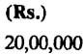
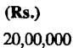

Share Capital | Fixed Assets
 | Land, Plant, Building,
 | Machinery etc.
Reserve & Surplus | Less | Depreciation
Long Term Loans:
Secured Loans
Unsecured Loans | Investments
 | (at cost)
Current Liabilities | Current Assets:
Provision for | Interest receivable
dividend | on Investments
~rovisioifor | Inventoq
taxation
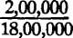
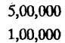
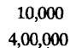

Debtors

und.m-
Bflhlce sheet
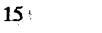

Managing E'Lnnnelal
Operations

Cash and Bank
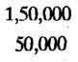
Balances

Advances

Other Assets M,OOo

The above form of Balance Sheet is called 'T' Form as it looks like the English alphabet 'T'.
On right side of this form we find assets of firm and the left side shows the liabilities of fum.

Exhibit-2 gives the report form of balance sheet. This form of Balance Sheet is followed by business entities to report their financial position on a specific date.

Exhibit - 2

ABC Limited
Balance Sheet as on December 31,1995.
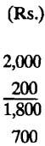

Funds Employed Land, Building, Plant and Machinery

Less Depreciation

Investment (at cost)

Current Assets:
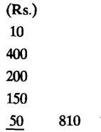

Interest Receivable

Inventory

Debtors

Cash and Bank Balance

Advances

Less Current Liabilities
and Provisions

Net Current Assets
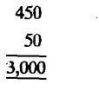

Other Assets

Total Net Assets

Financed By:

Share Capital
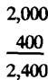

Reserve and Surplus

Shareholder's .Equity

Non-Current Liabilities:
Secured Loans | 500
Unsecured Loans | 100
Total Capital Employed
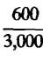

In the 'T' Form of balance sheet we find that the Assets sides and Liabilities sides are equal.
This follows from the accounting equation (Assets = Liabilities + Equity).

ICheckYourProgress-1
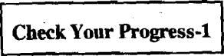

- Identify any two purposes of Balance Sheet.

.................................................

..................................................

.................................................

.................................................

.................................................

- What is Balance Sheet?

- What is financial statement?
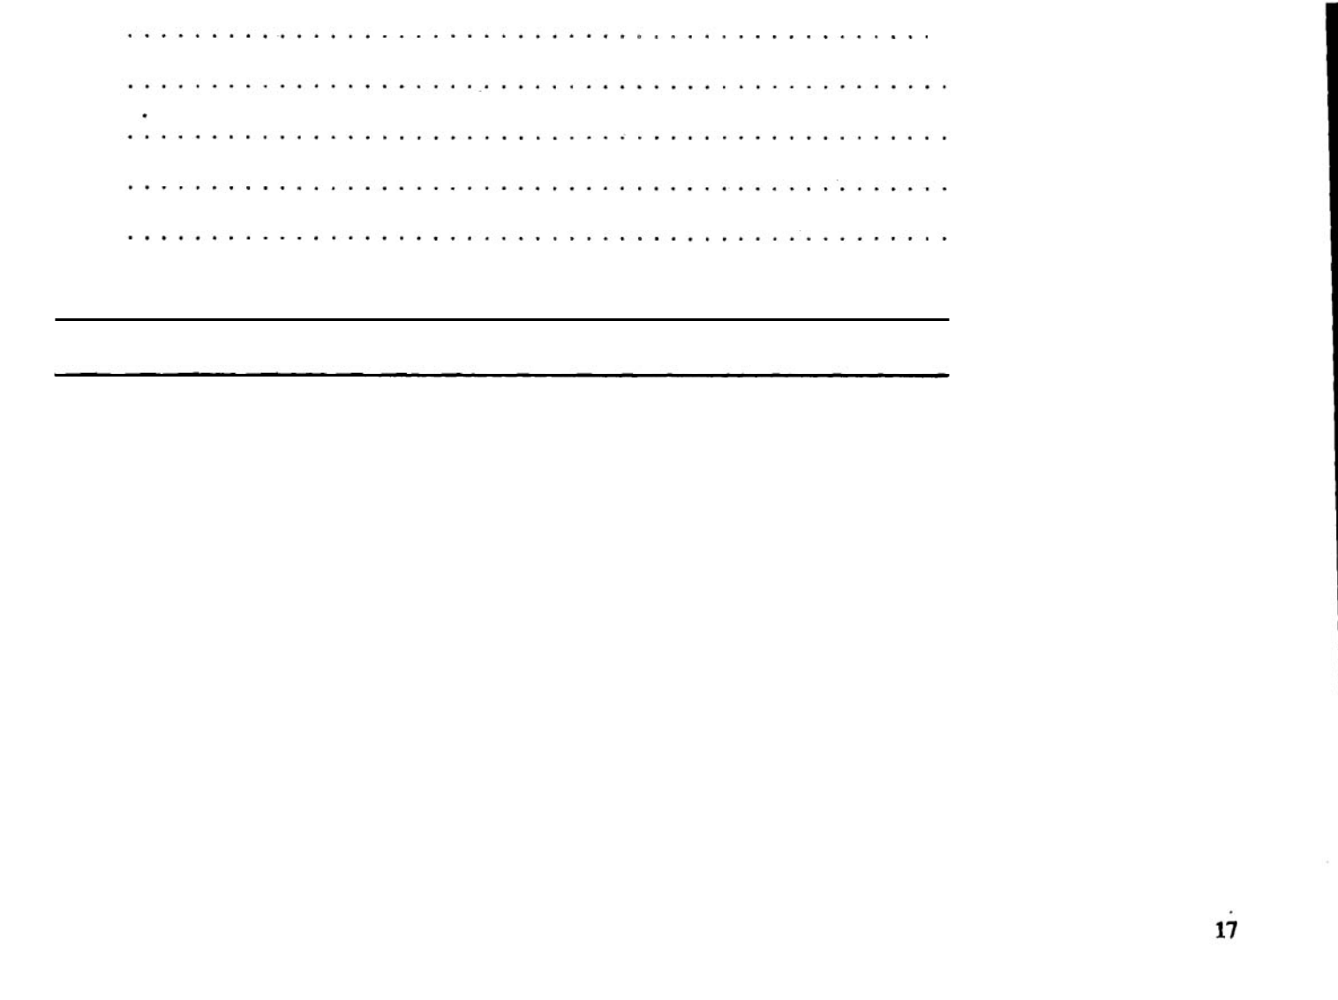

Uudenrlanding
Balance Shetl
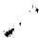

19.5 STRUCTURE OF BALANCE SHEET

The Balance Sheet lists assets, liabilities and capital separately. It is an accepted convention that the assets and liabilities are shown into sub-groups and listed in the order of their liquidity. Liquidity implies the length of time required to convert them into cash. Assets which are likely to be converted into cash in the near future are grouped as current assets, whereas assets which are held by a firm with the intention of using them more or less permanently fall into the category of fixed assets. Similarly, liabilities which are due for payment in the short run are termed as current liabilities and liabilities due for payment for more than one year (long term) are called long-term liabilities. Let us now discuss various items of the Balance Sheet.

-195.1 Assets

-4

Assets represents resources which are of some value to the firm. They have been acquired as a specific monetary cost by the firm for the conduct of its operations. Assets may be classified as (i) Fixed Assets, (ii) Investments, (iu) Current Assets, (iv) Other Assets.

- Fixed Assets

All those assets which are held by a firm with the intention of using them more or less
.perplanently for producing goods and services or for other regular use in basiness are

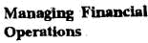
called fixed assets. Fixed assets are tangible, relatively long lived items owned by the business. The benefit of these assets are available not only in the accounting period in which the cost is incurred but over several accounting periods. Examples of fmed assets include - Land, Buildings, Plant and Machinery, Motor vehicles, Equipments, Furnitures and Fixtures etc. The fured assets are shown in Balance Sheet at their original cost. This is referred as Gross Block. From this accumulated depreciation on all the fixed assets till date is substracted. The Gross Block less accumulated depreciation gives the Net block. Before going to the another types of asset let us first discuss the meaning and methods of depreciation.

Depreciation

Depreciation represents fall in value of fvred asset as a result of its use. This fall in value may be due to wear and tear or technological obsolescence. This applies to all assets except land. An equipment becomes obsolete when the technology or method of production used by it become outdated due to availability of newer equipments and method of production. The obsolete equipments are avoided for the purpose of business profitability. The fmed assets on Balance Sheet are shown at their net values. There are several methods for calculation of depreciation. The important methods which are used for this include straight line method and reducing balance method.

- Straight Line Method

Under this method, the depreciation is charged on a uniform basis, considering the effective life of the asset and its residual value. For example, suppose a machine is purchased for Rs. 50,000 in 1980 expecting to have a useful life of 5 years. Assuming the residual value of machine after a period of 5 years shall be nil, the depreciation for each year shall be Rs. 50,000/5 = Rs. 10,000 a year.

- Reducing Balance Method

In reducing balance method a fmed percentage of the asset value at the beginning of the year is written off (i.e. deducted) as depreciation every year. Assuming that the same machine as above, has to be written off at 30% per annum, the deprecia-tion for diierent years shall be as:
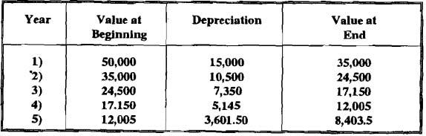
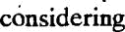

In case of reducing balanceumethodof depreciation, the percentage should be
. fmed such that at the end of expected life of asset, its book value is reduced to a sufficiently low figure which would represent the residual value.

A firm may choose either the straight line method or reducing balance method of depreciation for fmed assets. The method once chosen should be followed in subsequent years. However, if change in method of charging depreciation is made, it should be informed in the Balance Sheet. The income tax act provides for depreciation allowance calculated only on reducing balance method.

Investments

Investments represent the amount invested by a firm in long term securities like shares, debentures and bonds of other firms or government bodies for profits or control. These

investments are held for a period greater than one accounting period. The investments in the balance sheet are shown at actual cost or market value or the lesser of two depend in^
upon the policy adopted.
-

- Current Assets

Current assets are the resources of a firm which are either held in the form of cash or expected to be converted in to cash within the accounting period or the operating cycle of business. The accounting period is normally one year. The operating cycle is the time period taken to convert cash into inventory, selliig inventory and convert receivables (debtors) into cash. The components of current assets includes:


Cash,

Marketable securities,

Loans, Advances and Prepayments,

Sundry debtors or accounts receivables, and

Inventory.

Let us now discuss them in detail:

Cash: Cash refers to currency (legal tender), cheque or any other document that circulates as cash. It consists of funds that are immediately available for disbursement. It is the most liquid among current assets. It includes the total of cash in hand and in banks.
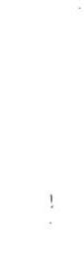

Marketable Securities: These are investments made by a firm in shares and debentures of corporations and other securities of relatively short period of time. These includes securities like treasury bills, notes, certificates of deposit and temporary investment of excess cash. These are valued at cost or current sale value, whichever is lower. These securities can be sold and bought on a stock exchange.

Notes Receivable: These represents promissory notes which a borrower or customer makes to pay specified amount on specific day.

Accounts Receivable: Accounts receivable are amounts owed to the company by debtors. In Balance Sheet you will also find the term sundry debtors which denotes the amount owed to the firm. This represents the amount usually arising out of normal commercial transactions. Infact, accounts receivables and sundry debtors represent unpaid customer accounts. These are also known as trade receivables, since they arise out of normal trading transactions. Sometimes debtors may default and subsequently become uncollectible. These losses are called bad debts. Debtors are shown in the, Balance Sheet at amount owed, less an allowance for bad debts.
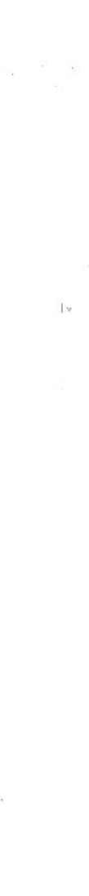

Inventory: Inventory consists of stock of raw materials, work-in-progress, finished goods, stores and spares. Inventory is usually valued on the basis of "lower of cost or market price". In valuing inventory at lower of cost or market price, care shol~ldbe taken to see that the valuation does not exceed the realisable value or selling price in the ordinary course of business. Besides current assets, other items of assets side are:

Loan and Advances : This shows the amount loaned to employees, advances given to suppliers and deposits made with other agencies.

Prepaid Items: In many situations, some of the items of expenses are usually paid in advance such as rent, taxes, subscriptions and insurance. These prepaiditems are shown in the current assets because had these payments not been made in advance, they would have been shown in the cash balance.

Deferred Charges: This represcds the pre-payments stretching beyond one year and so not classified as prepaid items.

Intangible Assets

Intangible Assets are assets or things of value without physical dimensions. They cannot be touched. Goodwill is the glariig example of intangible assets. Goodwill reflects the ability of a firm to earn profits in zreess of normal return. Other examples are firm's rights, patents, copy rights, trade marks etc. These are valuable for the firm.

Other Assets: Assets which cannot be included in any of the above categories are grouped as other assets. They represent usually deferred charges. Pre-payment for

UndcratPndiog
Balance Shed
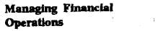
services or benefits for the period longer than the accounting period are referred to as deferred charges.

19.5.2 Liabilities

Liabilities are claims of outsiders against the business or debts of the firm. They are the amounts owed by the business to people who have lent money or provided goods or services on credit. Liabilities are divided into current and long term liability.

- Current Liabilities

Current Liabilities are debts of firm payable within an accounting period. Current assets are used to pay current liabilities. Current liabilities include creditors, bid payable, bank overdraft, tax payable, outstanding expenses and amount received in advance for goods or services to be supplied.

- Long Term Liabilities

A major part of the funds required by a business is obtained in the form of long term loans. You should recall that long-term liabilities are usually for more than one year. These liabilities may be secured or unsecured.

  - Long term secured loans cover mortgages and notes where a building or other assets are pledged as specific collateral for debt.

  - Long term unsecured loans include notes and bonds. Notes payable are promis-sory notes with maturities in excess of one year. When the note enters the final year, it is transferred to current liability.

Bonds are usually sold to public-in debenture form. A debenture is a long term obligation of firm to pay interest and return principal sum as per agreement. Debenture loan may be secured or unsecured.

19.5.3 Equity

The funds provided in business by the owners is called equity. Equity represents the , ownership rights in a company and arises from several sources. The contribution of owners to the company's funds is known as share capital. There are two types of shares:

1) Ordinary Shares

- Preference Shares

Preference shares carry the right of preferential treatment in regard to payment of dividends over ordinary shareholders. The terms of issue of preference shares usually stipulate the percentage of dividend payable. Once the preference dividend is paid, the residual profit belongs to ordinary shareholders. Similar preferential treatment is given in repayment of capital.

The Preference Shares may be cumulative and non- cumulative. When the right to receive dividend is cumulative, they are known as Cumulative Preference Shares. For example, if a company does not earn sufficient profit in a year to declare divide%d,then the company may skip payment of dividend that year, but in the corning years when company makes profit, the cumulative dividend will have to be paid to the preference shareholders. The arrears of 'cumulative preference dividend have to be cleared before making any dividend payment to ordinary shareholders. In non-cumulative shareholders, such right of cumulative payment of dividend is not available.

Another type of Preference Shares may be Redeemable and Irredeemable. Redeemable preference shares are the one which are paid back after a stipulated period. The preference shares which are not redeemable are known as Irredeemable Preference Shares.

%

In case of a company there will be certain additional items shown in the Balance Sheet. These are the following:

Authorised Capital: This represents the total amount of share capital which the company can raise through issue of shares. This amount is specified in the Memorandum of

Association. In fixing the amount of authorised capital, the management has to consider not only the short term requirement,but also the long term needs. At any time the company need not issue all the shares covered by the authorised capital. However, if a company finds that it requires additional capital, which is constrained by the authorisedcapital, then the company first has to modify it in the Memorandum of Association according to prescribed procedures.

Issued Capital: Issued capital is total number of shares issued by a company so far. Issued capital is usually less than authorised capital.

Subscribed Capital: When shares are issued to the public, the total number of shares taken up by various shareholders is referred as subscribed capital.

Paid-up Capital: The applicant for shares issued by a company may not be required to pay the entire amount at the time of application. The company may ask to pay in installments. The actual amount of money which has been paid by the shareholdersis called paid-up capital.

19.5.4 Reserves and Surplus

Reserve and Surplus are profits which have been retained in the fim. There are two types of reserves - revenue reserves and capital reserves. Revenue reserves represent accumulated retained earnings from the profits of normal business operations. These are held in various forms like general reserve, investment allowance reserve, dividend equalization reserve, etc. Capital reserves arise out of gains which are not related to normal business operations. For example, premium on issue of shares or gain on revaluation of assets. Let us elaborate upon different types of Reserves.

- Capital Reserve

When the assets of a company are revalued to a higher value then than the present net book value, difference between them is a notional gain and shown as Revaluation Reserve. Revaluation Reserve is a capital reserve. A company is prohibited to pay dividends from the capital reserve:

- Share Premium Account

When the shares of a profitable company are offered to public, the company may decide to offer the shares at a price higher than par value. Also at times the shares maybe issued at discount. The shares when offered at premium, the amount of premium collected is shown in a 'Premium Account'. Dividend cannot be paid from this reserve.

- General Reserve

The total earnings of a company after deducting dividends paid out and any losses suffered, is called retained earnings. Retained earnings can be appropriated to create reserves for such things as future declines in inventory value, future plant expansion. Sinking fund reserve or the retained earnings not transferred to any specific reserve account is appropriated to general reserve. In other words, undistributed profit not required to be transferred to any specific reserve account is usually accumulated in the General Reserve Account.
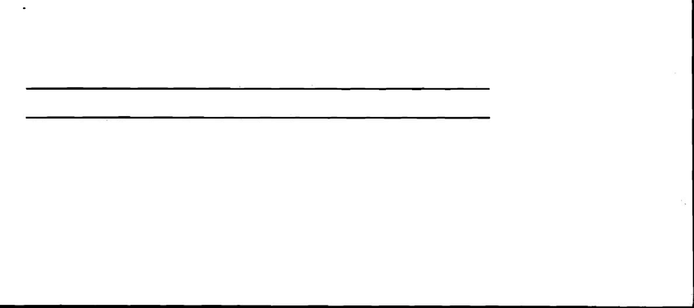

- - - -

19.6 ANALYSIS OF BALANCE SHEET

Analysis of Balance Sheet of a firm may be conducted internally or externally. In internal analysis the analyst is within the firm and has access to the books of accounts and other related information of business. Internal analysis is normally done by executives and employees of the firm. The government court agencies having regulatory and jurisdictional power also resort to internal analysis. On the other hand, external analysis is done by those who are outsiders to the firm i.e. investors, credit a g e n c i ~gn:~,.ernment agencies, etc. In external analysis, the only data available is the published Balance Sheet.

The analysis of Balarice Sheet can also be classified as Horizontal or Vertical analysis. Let us now discuss them in brief. -
undrrstandiqg
B B L P ~ SheetC~

a ~
Managing FbUlchd | Horizontal Analysis: When the balance sheets for a number of years are reviewed and
Opcm- | analysed, we call it horizontal analysis.
 | Vertical Analysis: | In this analysis, the quantitative relationship between different items of
 | a Balance Sheet pertaining to one accounting period is worked out. This analysis is useful in
 | comparing the performance of different companies belonging to the same industry.
 | You may recall that the Balance Sheet shows the financial status of a business at a given point
 | of time. Therefore, as a first step in analysis of Balance Sheet,we should see the information
 | concerning the sources of funds. Let us consider a portion of Balance Sheet of a b:
 | Liabilities | Amount | Assets | Amount
 | Total Non-current |  | Total Non-current
 | Liabilities | 2,00,000 | Assets | 4,00,000.
 | Total current |  | Total current
 | Liabilities | 1,00,000 | Assets | 1,00,000
 | Owner's Equity | 2,00,000
 | Total Equities | 5,00,000 | Total Assets | 5,00,000
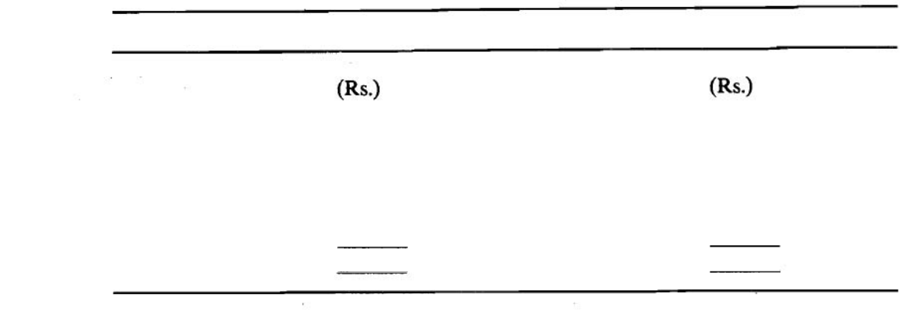

From the above figures, we can easily see the sources of total capital of Rs. 5,00,000 invested in business. Asset side gives information about the application of funds.

You should also remember that the Balance Sheet is used to measure the solvency and liquidity of a firm.. The ability to meet the current obligations when due is known as solvency. The ability to raise cash quickly to,avoid insolvency or for other purposes is known as liquidity position. The short term creditors are mainly interested in the liquidity position or short term solvency of firm. On the other hwd, the long term radiators look for long term solvency of fum. A firm should ensure that it does not suffer from lack of liquidity and also it should not be highly liquid. If the firm cannot meet due obligations, the creditors can refuse to provide further support. They can also go to court and legally take over the business to meet their claims. Another important consideration in insolvency is, even if suppliers and lenders can give extra time, but the employees may not give.

Let us consider a case as:
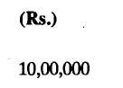

Assets

- Land, Building, Plant and Machinery

ii) | Ac,cumulatedDep. | (3,OwW
iii) |  | (3,OwW
iii) | Inventory | 5,00,000
iv) | Cash | Nil
 | Total Assets | 1200,000
 | Liabilities
 | Owner's Equity | 10,00,000
 | Non-current Liabiity | Nil
 | Other Current Liability | 1,50,000
 | Wages payable | %000
 | Total Equities | 12,00,000
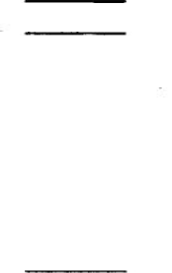

We can see from above, though the firm is insolvent, but could land into trouble. The firm has low proportion of debt, so that it can raise the fund easily, but suppose the firm could not raise it. The creditors may give some extra time, but the employees may ask for payment of their back wages immediately. Hence, the business entity requires to maintain adequate liquidity for smooth operations of the business. There are two important ratios which are used to evaluate the liquidity position of the firm. They are:

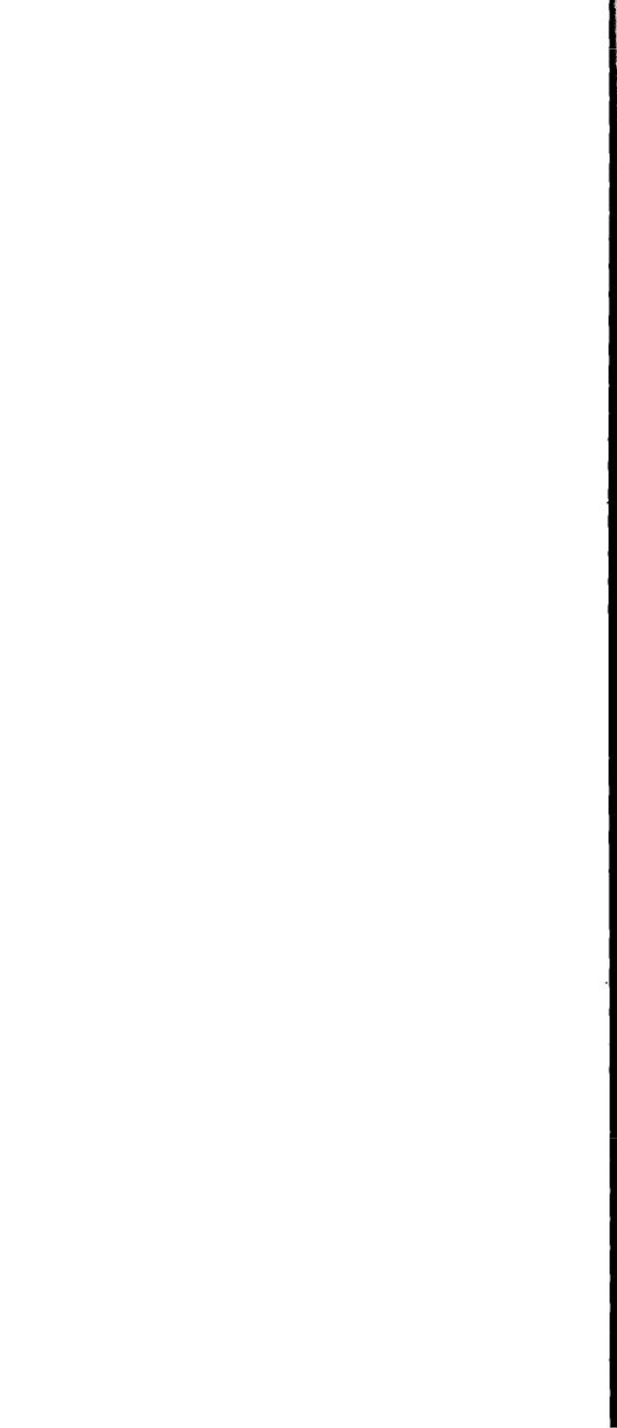
- Current Ratio

- Quick Ratio

Current Ratio is calculated by dividing the current assets by current liabilities:

Current Ratio | = . |  | Current Assets
 |  |  | Current Liabilities

Current Assets includes those assets which can be converted into cash within a year. Such as debtors, marketable securities, inventories, prepaid expenses.

Current liabilities include obligations which are likely to be matured within a year. These include creditors, bill payable, accrued expenses, income tax liabilities, bank over draft, long term debt maturing in current year.

The Current ratio is an indicator of the firm's ability to promptly meet its short term liabilities. Hence, it is used to assess the short term financial position. It shows the number of times the current assets are in excess over current liabilities. It isgenerally accepted that current assets should be two times the current liabilities. In such situation, the realisation from current assets will be sufficient to pay the current liabilities on time and enable the firm to meet other day to day expenses. Hence 2:l is considered a satisfactory ratio.

However, ratio of 2:l should be followed cautiously. The liquidity position of a firm depends upon the composition of current assets and not their absolute values. For example, if the inventory forms a large part of current assets, it will take time to convert inventory into cash.

In such cases another ratio called Quick ratio is considered as a better mean of evaluating the liquidity position.

Liquid Ratio | - |  | Liquid Assets
 |  |  | Current Liabilities

Liquid Assets includes cash, debtors and bill receivable. The inventory and prepaid expenses are included from current assets. Liquid ratio is worked out to test the short term liquidity
- of the firm in its correct form. The value of 1:l is considered fairly safe.

The working capital is also a measure of firm's liquidity. It is defined as excess of current assets over current liabilities.

Long term creditors are interested in the long term financial strength of a company. For this purpose, they calculate debt equity ratio. This ratio reflects long term financial soundness of the firm. The formula is:

Debt equity ratio = Long term debt

Shareholders equity

Here debt means long term loans i.e. debenture, loan from long term financial institutions. Equity means shareholders funds, i.e. preference share capital, equity share capital, reserves less losses and fictitious assets (like preliminary assets). The ratio of 2:l is acceptable.
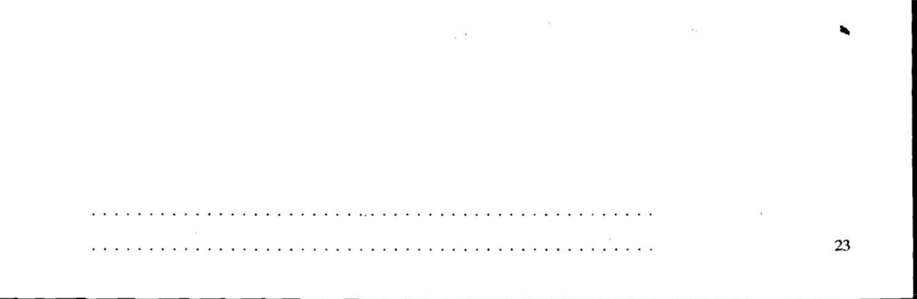

nCheckYourProgress-2
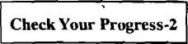
- What is intangible asset?

.................................................

Understanding
Balance Sheet

............................. ..................

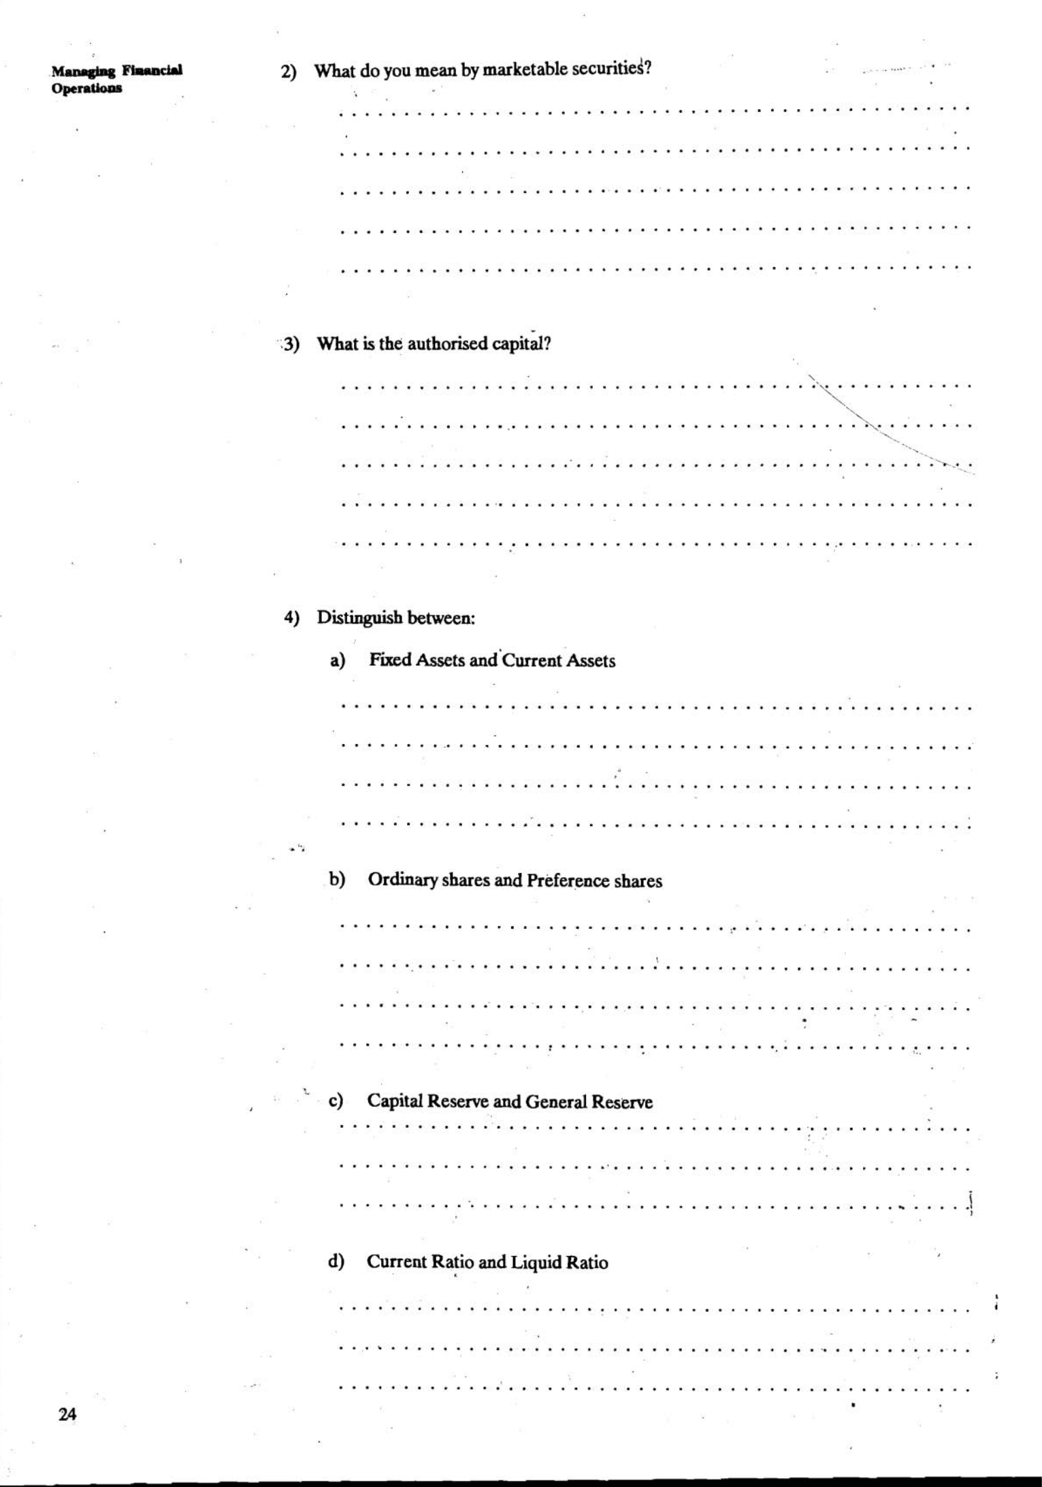
% ,&,A

19.7 LET US SUM UP
I

BalanceSheet is one of the three important financial statements prepared by a business entity. It is a snapshot of financial position of entity on a specific date. This statement shows the assets, liabilities and owner's contribution in company. The various assets and liability items which generally appear in a Balance Sheet have been mentioned in this Unit. Analysis of Balance Sheet becomes essential to assess the financial position of the business.

19.8 KEYWORDS

 |  | I
i Assets | : | Assets are valuable economic resources owned or controlled by
 |  | frrm having future usefulness.
' Fixed Assets | : | Tangible long-lived asset having a useful life of more than one year.
Current Assets | : | Current Assets are acquired with an intention of converting them
 |  | into cash of within the operating cyclr: or current accounting
 |  | period.
Liabilities | : | Liability refers to what a business owes to others (creditors).
Current Liabilities | : The liabilitieswhich due for payment within a period of one year.
Owner's ~ q u i & | : | The funds contributed by owners is referred as owner's equity. It
 |  | also includes the earning retained in business.
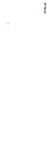

19.9 ANSWERS TO CHECK YOUR PROGRESS EXERCISES

EIzzlCheckYourProgress-1
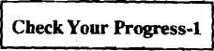
1) Read Sec. 19.2.

- Read Sec. 19.2.

- See Sec. 19.1.

- Read Sub-sec. 19.5.1.

- See Sub-sec. 19.5.1.

- Read Sub-sec. 19.5.3.

- (a) Read Sub-sec. 19.5.1.

    - See Sub-sec. 19.5.3.

    - Read Sub-sec. 19.5.4.

    - See Sec. 19.6.
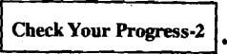

undCisi.eBtap
- Il.lmclshd
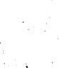
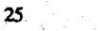

Managlog Financial opcreuo~ls

1- 26
!

UNIT 20 PROFITABILITY ANALYSIS

Structure

20.0 Objectives
20.1 Introduction
20.2 Cost Volume Profit Analysis

20.2.1 Fixed Cost

20.2.2 Variable Cost

20.2.3 Semi-vanable Cost

20.2.4 Assumptions of Cost Volume A n a l p s

20.3 Break Even Point
20.4 Break Even Chart
20.5 Profit - Volume Ratio
20.6 Margin of Safety
20.7 Cost Volume Profit Analysis for a Multi Product Firm
e20.8 Utility of Break Even Analysis
20.9 Let Us Sum Up
20.10 Keywords
20.11 Answers to Check Your Progress Exercises

20.0 OBJECTIVES

After going through this Unit, you should be able to:


explain the conceptual framework of cost volume profit analysis, discuss the utility of break even point, describe the uses of profit volume ratio, calculate the CVP for a multi product firm, and point out the utility of break even analysis.


20.1 INTRODUCTION

- business enterprise sets up its goals/objectives and directs its efforts towards the fulfilment of them. The primary or central objective of different enterprises may be as:

- A business enterprise seeks profits that will provide a socially acceptable rate of return on investment.

- A Government enterprise attempts to provide services to the citizens at an acceptable cost.

- A non-profit organisation works toward the satisfaction of a general or specific need to society.

The economic considerations are of secondary importance to the non-profit entity and this may be true in certain circumstances for both the business type entity and the non- profit entity. However, in most of the cases, the economic factors cannot be entirely ignored as long as resources are scarce in relation to human desire and needs. Profit is a signal for the allocation of resources and a yardstick for judgiug managerial efficiency. The management of a firm has to decide upon the quantum of profits and strive to achieve the target. In this Unit, you will learn the concept of cost volume profit analysis. In this connection break even point, break even chart and profit volume ratio will be discussed in detail.

-

