 | Student Direct Deposit
University
Return to: North Carolina Central
Student Accounting Office | Refund Form
Room 207 Hoey Admin. Bldg.
Address P. O. Box 19587
Durham, N.C. 27707 | Telephone: _919-530-5071
 | Fax: _919-530-7960

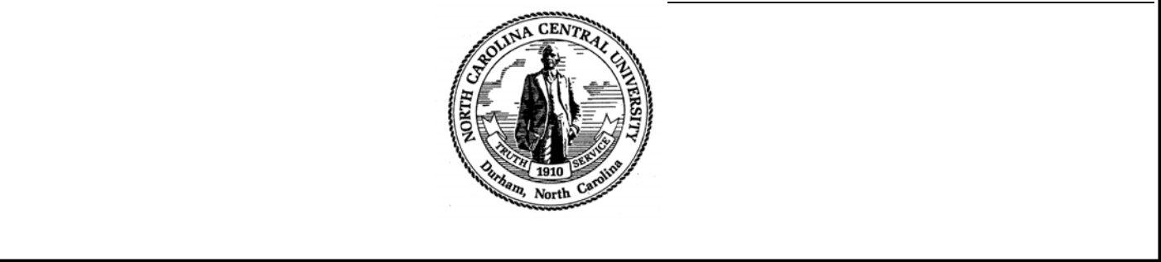

For your convenience and benefit, the State of North Carolina and North Carolina Central University offer payees the opportunity to receive future payments electronically, rather than by check. Your payments will be deposited into the checking or savings account of your choice. To receive payments electronically, you must print, complete this form, attach a voided check, and return the form and void check to the address above.

WE DO NOT ACCEPT STARTER CHECKS.

WE ACCEPT VOIDED CHECKS OR A LETTER

ON BANK LETTERHEAD WITH BANK OFFICIAL’S
PRINTED NAME AND SIGNATURE. BANK LETTER MUST INCLUDE THE STUDENT’S NAME, BANK ROUTING NUMBER, AND BANK ACCOUNT NUMBER. BANK LETTER MUST ALSO SPECIFY IF BANK ACCOUNT IS A CHECKING OR SAVINGS ACCOUNT.

PRINT the following information.

Student’s Name
Student’s Banner ID #
Bank Name
Bank Routing Number
( | ) Checking Account #
( | ) Savings Account # |  | LETTER IS REQUIRED FROM BANK ON BANK LETTERHEAD WITH
 |  |  | BANK OFFICIAL’S PRINTED AND SIGNED NAME, VERIFYING BANK |  |  | NAME.
 |  | ROUTING NUMBER, BANK ACCOUNT NUMBER AND STUDENT’S |  |  |  | NAME.

Student’s Mailing Address | __________________
Student’s Email Address
Student’s Telephone Number
Student’s Signature: |  | Date:

ATTACH VOIDED CHECK

THIS PART BELOW MUST BE COMPLETED BY ALL STUDENTS.

I acknowledge that electronic payments to the designated account must comply with the provisions of U.S. law, as well as the requirements of the
Office of Foreign Assets Control (OFAC).
Check one of the following:
______I affirm that, regarding electronic payments the State of North Carolina may remit to the financial institution for credit the account that I have
designated, the entire payment amount is not subject to being transferred to a foreign bank account.
______I affirm that, regarding electronic payments the State of North Carolina may remit to the financial institution for credit to the account that I
have designated, the entire payment amount is subject to be transferred to a foreign bank account. I understand that any electronic payments that may be remitted to me may be labeled with “IAT” International ACH Transaction as the standard entry class. I acknowledge that availability of funds credited to the account will be subject to my financial institution’s policies and procedures.

NOTES: Students, adding a class after receiving a refund, will be charged additional tuition and fees for the added class(es). Students, who drop a class after receiving their refund, are subject to owe money back to the university if their financial aid is reduced due to a lesser course load. Your authorized signature on this Electronic Payment Form authorizes the Student Accounting Department to cancel any previous banking information on your Student Account.

REVISED BY STUDENT ACCOUNTING DEPARTMENT ON 01/27/14

