
Property inspection

checklist.
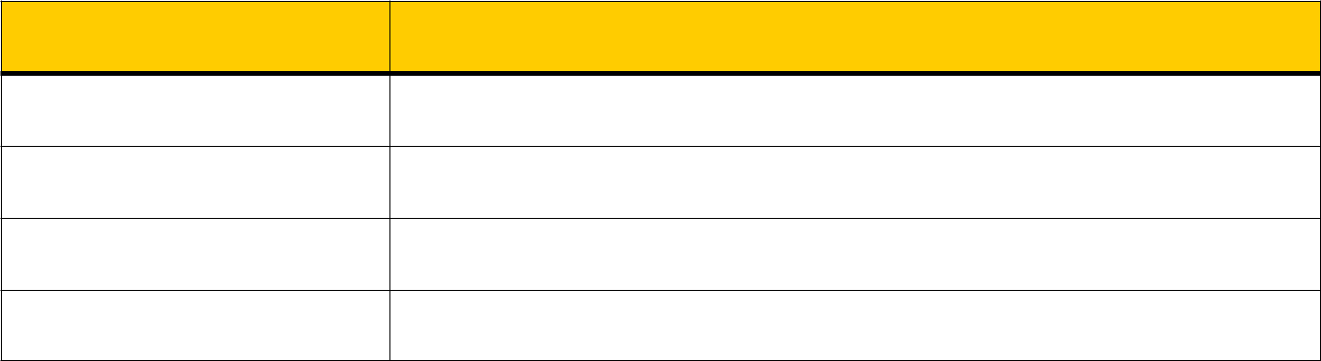

Item | Comments
Item | (Size & layout, décor, need for renovations? List as many pro’s and con’s as you can see.)

Address of property

Time & date inspected

Name of real estate agent

Contact details


Details of property

Kitchen

Living / lounge room

Dinning room

Bedroom #1

Bedroom #2

Bedroom #3

Bedroom #4

Bathroom #1

Bathroom #2

Bathroom #3

Laundry

Out door areas

Cupboard space

Inbuilt wardrobes

Garage

Appearance of building

Appearance of grounds

1

Details of property continued

Easy access to the property

General considerations

Internal décor & appearance

Need for renovations?

Air flow

Air conditioning

Insulation

Brightness

Nth, East. Sth, West position

Stairs

Security

Solar panels

Rain water tank

Fencing

Noise from neighbours

Noise from traffic

Railway / aircraft noise

Neighbouring facilities

Visitor parking

Other

2

Professional inspections


Building inspection

Foundations

Structural soundness

Cracks in walls & floors

Leaks in roof or walls

Exposed perimeters

on concrete floors

Mildew

Rising damp

Dry rot

Ventilation under dwelling

Locks on windows & doors

General condiiton

Weatherboard sag/rot

Mortar quality

Plumbing

Water pressure

Root damage from trees

Water tightness in garage

Dampness in bathrooms

Roof condition

Guttering

Flues

Chimneys

Flashings

Water staining on eaves

3
Professional inspections continued

Pest inspection

White ants / termites

Black ants

Spiders

Borers

Cockroach infestations

Flees

Rats & mice

Possums

Signs of past pest activity

Electrical & gas inspection

Wiring

Power points & switches

Safety overload switches

Fire alarm

Gas piping / leaks

Oven / stove quality

Water system & pressure

Other

4
Other things to check


General

RTA / state & Fed. Gov. for

Infrastructure plans

Water Rates

Land taxes

Crime Rate

Fire & flood risk

Units & townhouses

Management Committee details

Body corporate regulations

Minutes from body corporate

meetings

Insurances

Cost of levies

Level of funds for maintenance

Deeds

Policy on pets

Other


Additional notes

5

