REALTOR'S ASSIGNMENT OF CONTRACT Page 1 of 6

(This agreement will be part of the Contract of Purchase & Sale drafted by Real Estate Agents Using Standard MLS Contract or The new "Assignment of Contract of Purchase & Sale - New Development")

Dated this________________________

RE:__________________________________________________________________________ (Property Address)

Strata Lot #__________Full Legal Descrition_______________________________________________________

Between:

______________________________________________________________________resident of Vancouver. Province of British

Columbia (individually and collectively the "Assignor" (being the original buyer)

And:

____________________________________________________________________resident of Vancouver, Province of British

Columbia (individually and collective the "Assignee" (being the second buyer) IN CONSIDERATION of $________________[F]

(Assignee deposit) made payable to____________________________________________ (after 'subject' removal) deposit

and other good and valuable consideration, the receipt of which is acknowledged, the parties agree as follows:

- The Assignor assigns to the Assignee the Deposit of $ _______________________________[C] (deposit on original Contract of Purchase and Sale) and all interests in and to the, Interim Contract of Purchase and Sale dated __________ and such amendments and addenda made prior to this agreement (the "Purchase Agreement") for the purchase of the property as set out in such agreement (the ''Property''), made between the Assignor and

_______________________________________________________ (the "Seller"), annexed as Schedule "A" to this agreement including all rights of action or other rights accruing to the Assignor, or which after this assignment takes effect accrue to the Assignor under the contract. All deposits to be held by ___________________________________.

2 The Assignee agrees jointly and severally to perform such obligations as are required under the Purchase Agreement and to save harmless and indemnity the Assignor from And against all claims, losses and expenses thereunder.

New Purchase Price Calculations

3. Upon closing on this Assignment Contract Subject to the Purchase Agreement, the Assignee agrees to pay the Assignor

$_______________ [H] being the difference between the original purchase price $______________ [A] under "The Developer's

Purchase Agreement" and the price which the Assignee has agreed to pay for the property $___________________ [D] (the new

purchase price on the Contract of Purchase & Sale that has been drafted by the Realtor.

- The Assignee agrees to pay directly to the Seller's lawyer such funds as are stated on the Seller's Statement of Adjustments to close on the property under the Purchase Agreement and further agrees to pay the $_____________[H] (the difference between original purchase price and new purchase price) as contemplated in paragrah 3 to this agreement. The Assignee agrees to supply the Assignor with a copy of the Seller's statement of adjustments which shall include the above mentioned adjustments. This Statement of Adjustment has to be approved by the Assignor's Lawyer before completion of this Assignment Contract. (See Subject Claused Page 3)

Assignee Assignor

(1) Initial Initial
Page 2 of 6

Agreed Calculations of Assignor's Net Profit (Statement of Adjustments)

(note: All figures do not include GST, unless otherwise indicated)

Purchase Price by Assignee of this contact | $ __________________________ [D]
-Commission to be paid by Assignor to Real Estate Agents | – $ __________________________ [B]
(commission amount to include GST) | – $ __________________________ [C]
-Deosit paid by Assignor to Developer | – $ __________________________ [C]
(to be credited to Assignor on Statement of Adjustments) | – $ __________________________ [K]
-Funds to be paid to Seller (The Developer) | – $ __________________________ [K]
(on Building Completion Date or Occupancy) | = $ __________________________ [E]
Net Profit to Assignor on Assignment | = $ __________________________ [E]
Assignor to Receive on Completion Date of this Assignment Contract

$ _____________________ [E] Assignment Profit

- $ _____________________ [C] Deposit paid to Developer by Assignor

- $ _____________________ [J] Approximate Interest On Deposit From Developer (if applicable)

- $ _____________________ [G] Total Amount Due to Assignor on Assignment Completion and/or Completion date of bldg.

(Please Note: Assignor is responsible to pay to the developer "The Developer's Assignment Fee")

Optional - Partial Deposit:

Assignor will receive on ___________ (Date) The Amount of $___________ and the

Balance of $ ___________ on Completion Date (Occupancy) of Suite #_____ (Promissary Note Attached)

Assignee's Breakdown on Completion Date of this Assignment Contract

(note: All figures do not include 6% GST, unless otherwise indicated)

$ _____________________________ [C] Deposit that Assignee is Assuming (GST is not payable until building closing date)

- $ _____________________________ [E] Net Profit to Assignor

- $ _____________________________ [B] Commission to Realtors (that Assignor pays)

- $ _____________________________ (Subtotal) Total Due by Assignee on closing Date of Assignment Contract and/or building completion (occupancy)

– $ _____________________________ [F] Deposit paid By Assignee on This Contract

- $ _____________________________ [H] Due to Assignor on Completion Day of Assignment and/or Completion Date of Bldg.

Optional - Partial Deposit:

$ _____________________________ [M] Due to Assignor on Completion Day of Suite # _______ or Occupancy

Assignee Assignor

(2) Initial Initial
Page 3 of 6

Note: Assignor is responsible for any Assignment of Contract Fee charged by the Seller (Developer) and any Legal costs incurred to complete this Assignment. This Assignment Contract does not relieve the Assignor from the obligations to the original Contract of Purchase and Sale in the event the Assignee is unable to complete this Agreement.

*Completion of this Assignment Contract shall be______________________________ (Date)

(matching The Contract of purchase & Sale Drafted by the Realtor - If Applicable)

Subject Clauses:

- Subject to the Assignor & Assignee getting concent to the assignment from the developer by ______________________ .

- Subject to the Assignor and Assignee getting independent legal advice for this assignment contract by _______________.

- Subject to the Assignee approving the Developer's Disclosure Statement by ____________________________________. The above subjects are for the sole benefit of Assignor & Assignee.

WITNESS WHEREOF the parties have set their hands

THE ASSIGNOR (Original Buyer)

SIGNED SEALED AND DELIVERED

in the presence of

X_____________________________ _____________________________ X__________________________________

Signature Print Name Witness Signature

X_____________________________ ______________________________ X___________________________________

Signature Print Name Witness Signature

Address for Assignor:______________________________________________

phone # (Office, Fax or Cell)_________________________________________

THE ASSIGNEE (New Buyer)

SIGNED SEALED AND DELIVERED

in the presence of

x___________________________ _____________________________ x____________________________________

Signature Print Name Witness Signature

x___________________________ _____________________________ x_____________________________________

Signature Print Name Witness Signature Address for Assignee:______________________________________________ phone # (Office, Fax or Cell)_________________________________________

(3)

Assignee

Initial

Assignor

Initial

Please Note: GST is not calculated in these figures (except for GST on Commissins) Page 4 of 6

Deposit Assignment Options:

With regards to the release of the Assignment Amount to the Assignor here is a brief explanation of the three options available:

Option A - Protects the Assignee the most. The funds stay in trust until the project is complete. Commission is payable on completion.

Option B - Protects the Assignor. Once the deal is firm, the Assignment Amount is released and commission is payable.

This option makes sense if the project is well under way and committed by the developer.

Option C - The middle ground. Once the deal is firm, the Assignor gets back their deposit. The balance of the Assignment Amount is held in trust and released to the Assignor upon completion (and commission is payable at this time). If the transfer of the property at the Land Title Office does not happen by the latest date specified in the Contract, the Assignee at their option, may terminate the Assignment Agreement and have the Assignment Amount released to them.

Assignment contract Q&A:

Since the latest standard forms were released, several questions have been raised. These answers were provided by Ed Wilson, of Lawson Lundell LLP, who donated more than 60 pro-bono hours on this project. Ed has been the Canadian Bar Association, BC Branch’s representative on BCREA’s Standard Forms Committee for the past ten years.

Q. Why do Clause 5.16 of the new Assignment of Contract of Purchase and Sale (ACPS) (New Development) and Clause 4.13 of the ACPS (Non-Developer) provide that the Assignor will pay GST?

A. That section provides:

GST: The Assignment Amount is inclusive of any GST payable with respect to the Assignment Agreement, and the Assignor shall remit any GST payable.

Clauses 5.16 and 4.13 address the GST payable under the ACPS—not the GST payable under the original Contract of Purchase and Sale. When an assignee assigns a Contract and charges an Assignment Amount (the “profit” or “flip fee”), GST may be payable on the Assignment Amount.

Whether GST is payable on the Assignment Amount largely depends on the nature and intention of the Assignor. If this is an isolated transaction, and the Assignor entered into the Contract of Purchase and Sale intending to close on the transaction, the Assignment Amount is probably not subject to GST. If the Assignor entered into the Contract with the intention to flip the Contract, then the Assignment Amount is subject to GST.

Since whether the Assignment Amount is subject to GST depends on the nature and intention of the Assignor, the ACPS is structured to provide that the Assignment Amount includes GST. If the ACPS is subject to GST, the Assignor will have to remit the GST. For example, an Assignment Amount of $50,000 includes GST of approximately $3,000, so the “profit” is $47,000. If not subject to GST, the entire $50,000 is profit.

In any event, the Assignee has paid to the Assignor GST payable and, under the Excise Tax Act, the Assignor is responsible to remit the GST to the Canada Revenue Agency. As the Assignee has paid the GST to the Assignor (who is liable to remit it to the Canada Revenue Agency), the Assignee has no further liability with respect to the GST.

 | Assignee | Assignor
(4) | Initial | Initial

Q. Who remits the GST? Page 5 of 6

A. If the assignment is subject to GST, except in certain uncommon situations, the Assignor will have to remit the GST to the Canada Revenue Agency. Therefore, any Assignor has to consider whether the assignment is subject to GST and they should get legal or accounting advice in this regard (see Clause 5.22 (New Development) and Clause 4.19 (Non-Developer). If the assignment is subject to GST, the Assignor (or their legal or accounting advisors, if so retained) will have to complete the appropriate forms and remit the GST to the Canada Revenue Agency.

If the assignment is not subject to GST, then there is no GST to remit and no form to complete.

If the Assignor wants to net a specific amount from an assignment that is subject to GST, they will have to ensure that the Assignment Amount includes a sum to cover the GST. For example, if the Assignor wants to net $50,000 after paying the GST, the Assignment Amount will have to be increased to $53,000.

It should be noted that Clauses 5.16 and 4.13 have nothing to do with the GST under the original Contract. If the Contract is for a new home, that Contract is subject to GST, which is paid on closing. The GST under that Contract is forwarded to the developer on closing and the developer remits the GST to the Canada Revenue Agency.

Q. Shouldn’t Clause 5.2 of the ACPS (New Development), which provides that the Deposit will be held in trust pursuant to the Real Estate Services Act (RESA), instead refer to the Real Estate Development Marketing Act (REDMA), since it deals with deposits that relate to projects over five units?

A. The Deposit referred to in Clause 5.2 is the Deposit under the Assignment Agreement, not the deposit under the Contract. For example, a Contract to buy a $500,000 unit could provide that the deposit of $50,000 is to be paid to a lawyer in trust. Depending on the nature of the project, it may be subject to REDMA, in which case the lawyer would hold the deposit on behalf of the developer subject to the terms of REDMA. If the deposit was paid to a REALTOR®, the REALTOR&! reg; would hold it subject to the provisions of REDMA, but also subject to the provisions of RESA (i.e., as a stakeholder).

In the case of the deposit with respect to the Assignment (e.g., the Assignment Amount is $100,000, but a deposit of $10,000 is paid until the Assignee removes his subject when he increased it to the full $100,000), the REALTOR® would hold that deposit pursuant to RESA (i.e., as a stakeholder), not pursuant to REDMA.

Q. What is a deposit (protection) contract?

A. The “Deposit PROTECTION Contract” referred to in Clause 2 of the ACPS (New Development) is provided for under REDMA (see s. 19(1)). It allows the developer to make use of the deposits placed by purchasers in new projects.

Under REDMA, the deposit normally must be held by a lawyer, notary or REALTOR® until titles are raised (see s.18(1) of REDMA).

However, if a deposit protection contract is in place, the deposits may be released to the developer to fund the construction.

A deposit protection contract is a contract between the developer and an insurance company, wherein the insurance company agrees to refund the deposits to the purchasers if the developer fails to complete the project. The deposits are paid as usual into a lawyer’s or REALTOR®’s trust account, and the insurance company issues a policy in favour of the original purchaser. As construction proceeds, the lawyer or REALTOR® holding the deposit is authorized by the insurance company to release ! portions of the deposits in draws to the developer to fund construction. This significantly reduces the developer’s cost of borrowing.

If the original Contract is assigned as contemplated by the ACPS, the insurance company will insist on having a release signed by the original purchaser and the developer, stating that the original purchaser releases the insurance company of all liability under the deposit protection policy and they have assigned their interest in the deposit monies to the Assignee. If the insurance company does not get the release, the closings may be held up.

The question (“Is a deposit protection contract in place?”) is asked on the ACPS to flag the issue for the parties. If the answer is yes, the REALTOR® should get the form of release from the insurance company (the name of the insurance company will be in the REDMA Disclosure Statement), so the REALTOR® can have it signed when the ACPS is firm.

 | Assignee | Assignor
(5) | Initial | Initial

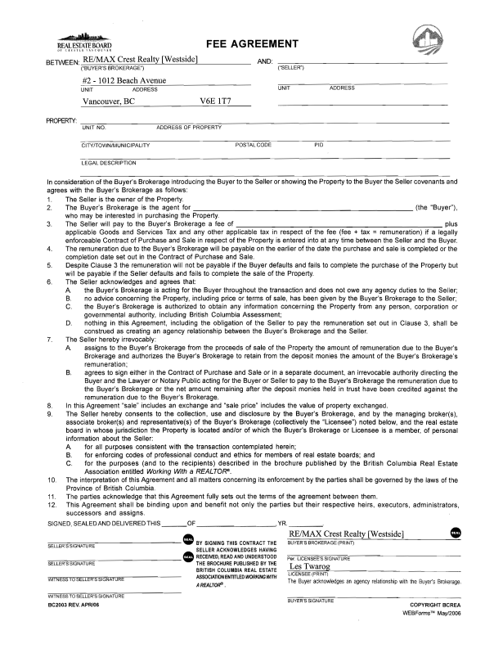
Page ___ of ___

(6)

Assignee Assignor

Initial Initial

