Property Tax Monthly Payment Plan Information Change Request Assessment and Taxation



1 Account Information

If the change applies to multiple accounts, including parking stalls, please list all the account numbers, or attach a detailed listing to the form.

Account

Property Address

First Name (Please Print) | Last Name (Please Print) | Contact Telephone Number(s)
First Name (Please Print) | Last Name (Please Print) | Contact Telephone Number(s)


2 Requested Change


CANCELLATION

I would like to cancel my Property Tax Monthly Payment Plan.

Effective: _____________________

Any outstanding property taxes must be paid within 30 days of the cancellation date to avoid penalties.

CHANGEOFBANKINGINFORMATION
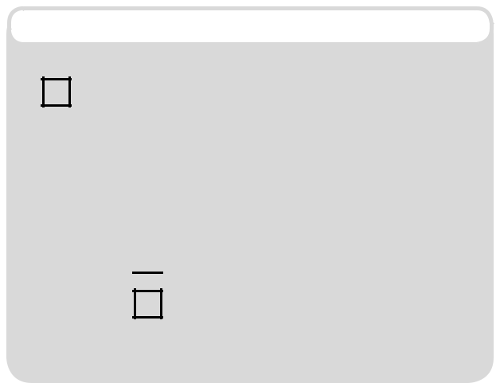

I would like to request a change to

my banking information.

Effective: _____________________

I am including a:

 Void Cheque

Preauthorization Form from

my Financial Institution

Ensure the City receives your cancellation or change of banking information at least two weeks prior to the next installment date.


4 SIGNATURE

Signature

Signature

Date

Date

Signators of a corporation are required to provide a corporate search, incumbancy certificate or affidavit of execution, indicating their authority to sign on behalf of the corporation, with this form.

WHAT IF ...

I need to change my mailing address. Most mailing addresses can be updated by contacting Alberta Land Titles, or visiting alberta.ca/land-titles. Address changes for manufactured homes, properties leased from government departments and business improvement area accounts can be made by emailing accountmaintenance@edmonton.ca.

My enrolment is cancelled. Your enrolment in the property tax monthly payment plan will be cancelled:
- within two weeks of the City receiving a written request,

- if the property is sold (upon receiving notification of a title change from

Alberta Land Titles), or

- if payments equaling two or more installments are not honoured by your bank.

BEFORE YOU SUBMIT THIS REQUEST:

- Complete the applicant information.

- Choose either Cancellation or Change of Banking Information.

- Indicate the effective date of the change.

- Sign the form.
WHERE DO I SEND MY

COMPLETED REQUEST?

You can submit your completed, signed form and banking information by:

EMAIL

monthlypaymentplan@edmonton.ca

EMAIL

P.O. Box 1935 Station Main Edmonton, AB T5J 2P3

INPERSON

Edmonton Service Centre 2nd Floor, Edmonton Tower 10111 104 Avenue

QUESTIONS? Visit edmonton.ca/taxes • email MonthlyPaymentPlan@edmonton.ca • call 311 (780-442-5311)

Personal information on this form is collected in accordance with City of Edmonton Bylaw 12914, as amended, and is protected by the Freedom of Information and Protection of Privacy Act (FOIP). If you have any questions about the collection and use of information, please contact 311 (780-442-5311 outside Edmonton).

