MassHealth DSRIP TA Program

Template and Guidance

for TA Project Scope of Work

Overview

The MassHealth DSRIP Technical Assistance (TA) Program is a statewide initiative to provide an array of resources and supports to the MassHealth Accountable Care Organizations (ACOs) and Community Partners (CPs). Through this program, ACOs and CPs may access technical assistance from qualified vendors that were selected to provide services categorized by nine TA Domains: actuarial & financial, care coordination/integration, community-based care and social determinants of health, consumer engagement, flexible services, health information technology/health information exchange, performance improvement, population health management, and workforce.

Below is the process to setup a TA project:

An ACO/CP will submit a TA application through the MA DSRIP TA Marketplace (https://www.ma-dsrip-ta.com/). In the TA application, the ACO/CP will specify and rank up to three TA Vendors with which it prefers to work with to implement the project.

After the TA application is submitted, MassHealth will review the TA application for approval. The proposed TA project should have realistic, time-bound, and measurable goals and deliverables and be consistent with priorities discussed with the MassHealth ACO/CP Contract Manager.

As the application is in review, the TA Managing Vendor (Abt) confirms availability of the preferred TA Vendor selected by the ACO/CP.

Upon approval of the TA application by MassHealth, the ACO/CP and TA Vendor are notified via email.

The TA Vendor works with the ACO/CP to develop the Scope of Work (SOW) (utilizing the SOW template) for the TA project. SOW and total cost must be agreed upon by both the TA Vendor and the ACO/CP. Funding available for the ACO/CP’s project is limited to the funds allocated by MassHealth for the designated TA Program year. Note that in Year 1 and Year 2, TA Cards overlap from January 1, 2019 – December 31, 2019 and funds can be combined.

The ACO/CP and TA Vendor will complete a signature form acknowledging that the ACO/CP and the TA Vendor have agreed to the TA project plan and total cost as presented in the SOW.

The SOW and signature form will be submitted by the TA Vendor to Abt and MassHealth for review and approval

The TA Vendor will also submit to Abt a TA project budget (utilizing the budget template) aligning with the SOW that complies with the labor rates in the TA Vendor’s Master Agreement.
Once MassHealth approves the Scope of Work and budget for the TA project, Abt Associates will issue a Task Order under the TA Vendor’s Master Agreement. TA Vendors may not begin work until the Task Order is finalized.

This document walks through the required content of the SOW and budget and provides the needed guidance for completing the SOW and budget templates.

Abt Associates Page 1

January 2019 (v1.1)

MassHealth DSRIP TA Program

Template and Guidance for TA Project Scope of Work

Developing the Scope of Work and Budget

Following MassHealth approval of the TA application, the selected TA Vendor is responsible for developing a Scope of Work and budget for the TA project utilizing the required templates. Vendors should work closely with the ACO/CP to ensure that the SOW addresses the ACO/CP’s needs and the goals they hope to accomplish through the TA project, as outlined in their TA application. In developing the SOW and budget, the vendor and ACO/CP are defining the tasks and timeline and negotiating the budget to implement and successfully complete the TA project.

Each ACO/CP has an allotment of funds from MassHealth that they may expend on TA projects. The budgeted costs of the TA project must be within the limits of the funds available to the ACO/CP, and an amount agreed upon by the ACO/CP. In developing the TA project budget, vendors are not expected to share detailed costing information (i.e. labor rates) with the ACO/CP; however, they may do so if they feel this is appropriate or helpful as they negotiate with ACOs/CPs. The SOW submitted to Abt Associates for approval must include summarized budget information presented in a delivery/milestone and payment schedule. TA Vendors must share applicable detailed costing information with Abt Associates which will be reviewed against the terms in the vendor’s Master Agreement with Abt Associates. Additional information regarding how Abt will handle the discounted rates that are triggered upon surpassing $350,000 worth of TA projects will be forthcoming in the first quarter of 2019.

Once the ACO/CP and the vendor agree on the SOW and budget, the ACO/CP and the vendor will need to sign a document affirming the SOW is acceptable to their respective organizations. Please see the signatory approval page at the end of this document. Vendors should submit the TA project SOW, the signed approval page, and the budget to Abt by email to MA_DSRIP_TA@abtassoc.com.

SOW and Budget Template

Below is guidance for completing the TA project SOW template. Each section should be brief and succinct. Use language and descriptions that would be clear and understandable to reviewers with varied backgrounds and experience with technical assistance projects. If it is necessary to include technical descriptions, include these in the References and Assumptions (Section 6). The goal of the SOW is to present a clear work plan for the TA project with realistic, time-bound and measurable goals and deliverables as well as start and end dates. Most sections of the SOW are required, but some sections are marked as not required. Although not required, it is recommended that these sections be completed if the ACO/CP and vendor feel the information is important to undertake and manage the TA project.

A template is available in MS Excel spreadsheet format to help create a detailed budget for the TA project. The template allows vendors to list labor categories or names for staff who will work on the project. The budget template may be edited by TA Vendors to better fit the tasks and subtasks defined for the TA project. Summary costs from the budget spreadsheet must be included in the SOW in a delivery/milestone and payment schedule.

Abt Associates Page 2

January 2019 (v1.1)

MassHealth DSRIP TA Program

Template and Guidance for TA Project Scope of Work

Scope of Work Template

The following guidance describes the sections to include in the TA project Scope of Work.

Technical Assistance (TA) Vendor: (Firm Name)

TA Vendor Contact Information: (TA Vendor Contact Name)

NAME
(TA Vendor Contact Email Address)

EMAIL ADDRESS
(TA Vendor Contact Phone Number)

PHONE NUMBER
ACO/CP Name: (Organization Name)

ACO/CP Address: (ACO/CP Mailing Address)

TA Application ID: (ID for TA Application, for example, A1001, C2018)

SOW Date: (Original date and if applicable, the date for the revised SOW)

SOW Revision Number: (For the original SOW, list “NA,” otherwise indicate a revision

number.)

TA project Title: (Title given to the TA project by the TA Vendor and the ACO/CP)

TA Domain (Identify one): (TA Domain was identified in the TA Application, Item 9)

1: Actuarial and Financial

2: Care Coordination/Integration

3: Community-Based Care and Social Determinants of Health

4: Consumer Engagement

5: Flexible Services

6: Health Information Exchange/Health Information Technology

7: Performance Improvement

8: Population Health Management

9: Workforce

ACO/CP Competency Area (Identify one or more): (Competency Areas were identified in the TA Application, Item 3)

- Respect, understand, and engage MassHealth members

- Honor, enlist, and develop provider and care team insights and capabilities

- Access, apply, and exchange data across all entities involved in MassHealth member wellness and care
- Develop and implement financial models that promote provider and staff buy-in and advance the achievement of quality benchmarks, appropriate utilization of care, and long-term organizational sustainability
- Provide coordinated care and/or complex care management that is highly responsive to MassHealth member needs and preferences
- Actively develop and maintain a foundation of, and disseminate up-to-date knowledge in, all areas relevant to building and running a high performing, sustainable MassHealth ACO or CP

Abt Associates Page 3

January 2019 (v1.1)

MassHealth DSRIP TA Program

Template and Guidance for TA Project Scope of Work

The main body of the SOW includes the following sections:

- Project Overview

- Project Goals and Objectives

- Tasks/Requirements

- TA Project Staff

- Project Schedule, Deliverables, and Payment Schedule

- References and Assumptions

- Communication Plan

- Notes or Miscellaneous Information

A description of these sections is provided below. For sections that are not applicable, simply state that the section is not applicable. Information for some sections could be found in the approved TA application. Please contact Abt Associates if you need a copy of the approved TA application.

1. Project Overview

This section should provide summary information about the proposed TA project using non-technical language and spelling out all acronyms. Descriptions should be clear and understandable to reviewers with varied backgrounds and expertise. Please briefly address how the project fits into the TA Domain and Competency Area(s) identified above. Please note that this project summary may be made publicly available for the purpose of sharing lessons learned from the MassHealth DSRIP TA Program. (Maximum of 200 words)

2. Project Goals and Objectives

Provide a brief statement of what is expected to be accomplished through this TA project. Include the TA project goals, and how the results or end products will be used by the ACO/CP. The TA project goals may be found in item 4 of the approved TA application.

This section should not include specific work tasks or a description of deliverable products since this will be included in the “Tasks/Requirements” section described below. (Maximum of 200 words)

3. Tasks/Requirements

This section defines the tasks the vendor must complete for the proposed TA project. The tasks will be determined by the vendor after collaboration with the ACO/CP and careful consideration of how to structure the TA project. This section should specify requirements and tasks clearly, including milestones, and identify any deliverables that will result from the completion of a task.

Number the tasks and if applicable, the subtasks, to identify the different work requirements. Also state where the work will occur, including whether it is onsite at the vendor’s office or facility, at the ACO/CP location, or another offsite venue. If performance will occur at multiple locations, this section should indicate which tasks will be completed where.

Abt Associates Page 4

January 2019 (v1.1)

MassHealth DSRIP TA Program

Template and Guidance for TA Project Scope of Work

Example: Task/Subtask Table with Milestones and Deliverables

Task/
Subtask | Task Name and Description | Location
Number | Task Name and Description | Location
1 |  | Vendor’s office
 |  | ACO/CP location
 |  | Other (Please describe)
1.1 |  | Vendor’s office
 |  | ACO/CP location
 |  | Other (Please describe)
1.2 |  | Vendor’s office
 |  | ACO/CP location
 |  | Other (Please describe)
2 |  | Vendor’s office
 |  | ACO/CP location
 |  | Other (Please describe)
3 |  | Vendor’s office
 |  | ACO/CP location
 |  | Other (Please describe)
3.1 |  | Vendor’s office
 |  | ACO/CP location
 |  | Other (Please describe)
3.2 |  | Vendor’s office
 |  | ACO/CP location
 |  | Other (Please describe)
3.3 |  | Vendor’s office
 |  | ACO/CP location
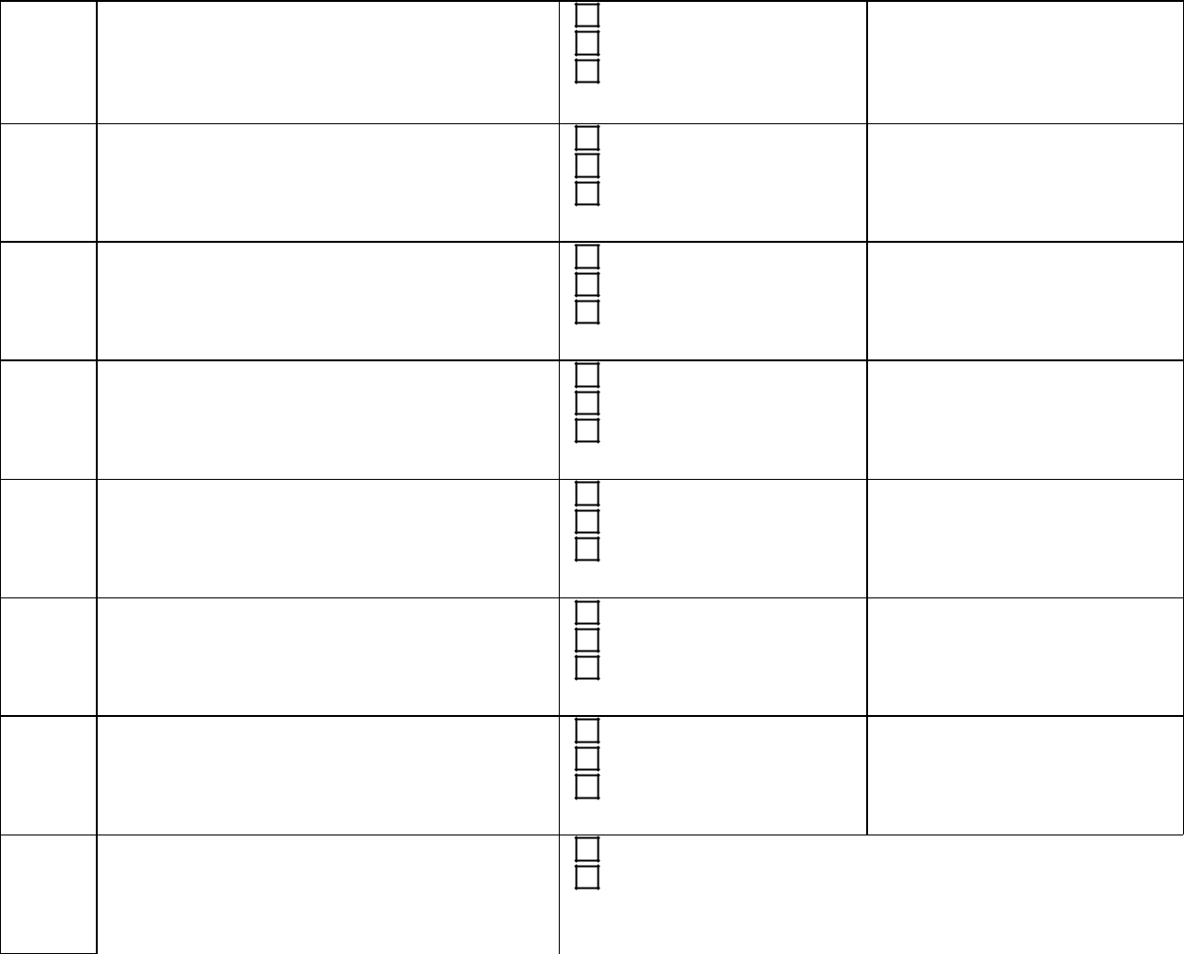
Other (Please describe)

Milestones/ Deliverables

Milestone 1 Deliverable 1

Deliverable 2

Milestone 2 Milestone 3

Deliverable 3

Milestone 4 Deliverable 4

Deliverable 5


4. TA Project Staff

- This section is not required. Although not required, it is recommended that information about project staffing be included if the ACO/CP and vendor feel the information is important to undertake and manage the TA project.

In this section, present the staff and the roles they will undertake in the TA project. A brief, 1-2 sentence statement about each staff member would help present staff qualifications and their appropriateness for the roles, but the key information to convey are the roles and chief responsibilities for each staff member in the TA project. Consider including an organization chart to show the structure and relationships of the TA project team.

All listed project staff should be in the Domain-level labor rate sheet included in Attachment B of the vendor’s Master Agreement with Abt Associates. If a project staff member is not listed by name in the

Abt Associates Page 5

January 2019 (v1.1)

MassHealth DSRIP TA Program

Template and Guidance for TA Project Scope of Work

labor rate sheet, identify their labor category so that the appropriate labor rate can be determined. Do not include the actual labor rates in this section.

5. Project Schedule, Deliverables, and Payment Schedule

This section should present the project schedule and a table of milestones, deliverables, and the payment schedule. Start by listing the planned or assumed project start and end dates, and state the length of the project in terms of weeks or months. Task Order contracts cannot be backdated to have a retroactive start date. Please use a future date as the start date. Once a SOW and budget receive all the required approvals, it may be necessary to revisit the project schedule to determine a valid project start date and milestone/deliverable due dates.

A table of milestones and deliverables should reflect information presented in the section of Tasks/Requirements (Section 3). The table should identify the task in which each milestone or deliverable is to be completed. List the planned milestone dates and deliverable due dates. This may be stated using actual dates, days or weeks after final approval of the TA project, or using some other method that clearly marks the required delivery dates. Identify to whom or where the vendor will submit each deliverable. Document the criteria for inspection and acceptance of the deliverable items or service. A representative from the ACO/CP will need to sign an approval form to confirm acceptance of each TA project milestone or deliverable.

This section should include the payment schedule. Identify the ordering period for the TA project:

Period 1: September 21, 2018 – December 31, 2019

Period 2: January 1, 2019 – December 31, 2019 (this overlaps with period 1)

Period 3: January 1, 2020 – December 31, 2020

Period 4: January 1, 2021 – December 31, 2021

Period 5: January 1, 2022 – June 30, 2022

Approved TA projects will become fixed price Task Orders to the vendor’s Master Agreement with Abt Associates. The payment schedule summarizes the budget for the TA project. The payment schedule may be presented as a list or in tabular format. For the payment schedule, identify the milestones and deliverables that trigger invoicing and payment, listing the total cost for each milestone or deliverable. All items in the payment schedule should also be included in the table of milestones and deliverables presented above. However, all items in the table of milestones and deliverables will not necessarily be in the payment schedule. Present the sum total of planned payments.

Abt Associates Page 6

January 2019 (v1.1)

MassHealth DSRIP TA Program

Template and Guidance for TA Project Scope of Work

Example: Payment Schedule with Milestones/Deliverables and Due Dates

Task/Subtask | Milestones/Deliverables | Due Date | Payment
Number | Milestones/Deliverables | Due Date | Payment
1.1 | Milestone 1 |  | $
 | Deliverable 1 |  | $
1.2 | Deliverable 2 |  | $
2 | Milestone 2 |  | $
 | Milestone 3 |  | $
3.1 | Deliverable 3 |  | $
3.2 | Milestone 4 |  | $
 | Deliverable 4 |  | $
3.3 | Deliverable 5 |  | $
Total Payments |  |  | $
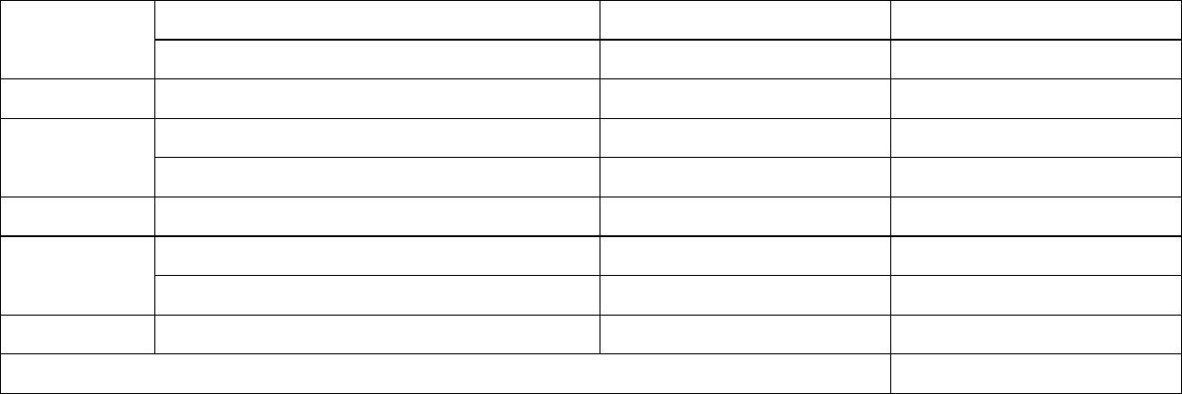

Budget Information

Detailed budget information does not need to be presented in the payment schedule. Detailed budget information must be submitted to Abt Associates and should be presented using the TA Vendor budget spreadsheet template. The template allows vendors to build up the total TA project budget at the task or subtask level using hourly staff labor rates. The hourly labor rates should come from the Domain-level labor rate sheets included in Attachment B of the vendor’s Master Agreement with Abt Associates. TA Vendors should use the discounted labor rates to develop the project budget. Each amount listed in the payment schedule should correspond to a task or subtask total in the budget spreadsheet. The spreadsheet will be used by Abt Associates to review compliance of costing against the Master Agreement. Additional information and instructions are presented in the Budget Development section of this guidance document.

Additional information regarding how Abt will handle the discounted rates that are triggered upon surpassing $350,000 worth of TA projects will be forthcoming in the first quarter of 2019. Because the detailed budget spreadsheet does not need to be part of the SOW that will be reviewed by the ACO/CP and by MassHealth, please send the completed budget spreadsheet in an email addressed only to Abt Associates (MA_DSRIP_TA@abtassoc.com).

6. References and Assumptions

If applicable, this section must include or reference applicable specifications, illustrations, diagrams, tables, charts, and similar elements in the SOW if they assist in describing the planned work or related requirements. This section also must express any assumptions upon which any aspect of this work is to be performed. Identify whether any work is predicated upon another. For example, if a work product cannot be delivered until another element of the work is approved, then state that. As appropriate, state any coordination requirements with other entities or suppliers.

Abt Associates Page 7

January 2019 (v1.1)

MassHealth DSRIP TA Program

Template and Guidance for TA Project Scope of Work

7. Communication Plan

- This section is not required. Although not required, it is recommended that the ACO/CP and TA Vendor create a communication plan if they feel it is important to undertake and manage the TA project.
This section should briefly describe how the TA Vendor will maintain communication with the ACO/CP on progress and status of the TA project. Examples of a communication plan could include but are not limited to:

Weekly Status Report Weekly Meetings
Monthly Progress Report

Project Management Team Meetings

- Notes or Miscellaneous Information

Include in this section any notes or miscellaneous information that is deemed important to the TA project but not included in any section above.

Abt Associates Page 8

January 2019 (v1.1)

MassHealth DSRIP TA Program

Template and Guidance for TA Project Scope of Work

Budget Development

The budget for the TA project may be created and developed using the budget template spreadsheet, TA project budget template Jan2019v1.1.xlsx. This template provides a basic format to use in creating the TA project budget. TA Vendors may modify the template, adding rows for additional staff and other direct costs (ODCs) and adding columns for additional tasks and subtasks as needed.

There are three sheets in the budget template spreadsheet:

- TA project info – Enter information to identify the proposed TA project. The information requested is the same as in the table of identifying information at the beginning of the SOW.
- task budget – This sheet is the main template for the TA project budget. Identify the TA Domain, the period, and project staff members and their associated discounted hourly labor rates. Under “Expense Category,” enter information to help identify the labor rate by labor category, labor subcategory and/or position in the labor rates sheets of the vendor’s Master Agreement.

- addl budget info – This sheet allows vendors to identify and summarize any other direct costs that are necessary for the TA project.
- Instructions – This includes summary budget development information from this section of the SOW guidance.

Domain-based Discounted Labor Rates

Each TA project will be identified as falling under one of nine TA Domains. Depending on the TA Vendor, the labor rate sheets in Attachment B of each TA Vendor’s Master Agreement with Abt Associates present discounted labor rates by labor category, labor subcategory, other category/position, and staff name. Budgets should be built using the Domain-specific, discounted labor rates. Staff and the labor rates presented in this project budget should match the information in the appropriate Domain-based labor rate sheet in the Master Agreement. Note that vendors may further discount labor rates in the budget by using the “Labor Discount” row of the budget template. If the vendor intends to use individual labor rates that are further discounted and do not match rates listed in the Master Agreement, please indicate that when submitting the detailed project budget information to Abt Associates. The fully loaded discounted labor rates from the vendor’s Master Agreement are intended to cover all costs to be incurred to complete the TA project. However, the budget shell does include rows for other direct costs that have been determined are necessary for the TA project. Please include details and justification for any other direct costs included in the TA project budget. These details may be entered into the additional budget information sheet (“addl budget info”) of the budget spreadsheet.

Additional information regarding discounted rates that will be triggered upon surpassing $350,000 worth of TA projects will be forthcoming in the first quarter of 2019.

Budget Totals and the Payment Schedule

When developing the project budget, vendors should determine the costs for each milestone or deliverable associated with a payment in the payment schedule presented in Section 5 (Project Schedule, Deliverables, and Payment Schedule) in the SOW. Use the column structure of the budget template to build up the labor hours and any other direct costs for each milestone or deliverable. In addition to reviewing the detailed budget spreadsheet to confirm the discounted labor rates are in the Domain-based labor rates in the vendor’s Master Agreement, the budget spreadsheet will also be compared with the payment schedule to confirm that budget totals match for milestones and deliverables.

Abt Associates Page 9

January 2019 (v1.1)

MassHealth DSRIP TA Program

Template and Guidance for TA Project Scope of Work

Approved TA project budgets will become fixed price Task Orders under the TA Vendor’s Master Agreement with Abt Associates. Detailed budget information should not be provided in the SOW. Instead, summary costs that represent the price for selected milestones and deliverables should be included in the payment schedule of the SOW (Section 5). As described above, the prices presented in the payment schedule should be easily identified in the TA project budget spreadsheet.

TA Vendors may use their own spreadsheet templates to create and develop the TA project budget and payment schedule as long as the tasks, staff and labor rates, and any other pricing information are clearly presented and the spreadsheet provides the same information that would be shown by using the TA project budget template file. The completed TA project budget spreadsheet will need to be submitted to Abt Associates for review and approval.

TA Project SOW and Budget Submission

Submission of the TA Project SOW and budget should be sent to Abt Associates in two separate emails. The SOW will be reviewed for approval by MassHealth and Abt, while the budget will only be reviewed by Abt. MassHealth may review the budget to clarify staff level of effort for the TA project.

Both emails should be sent to Abt Associates at MA_DSRIP_TA@abtassoc.com.

Email #1

- This email should be cc’d to ACO/CP and vendor staff.

  - TA Project SOW

  - Signed Accountable Care Organizations (ACOs)/Community Partners (CPs) and TA Vendor Approval Form

Email #2:

- This email need not be cc’d to ACO/CP staff.

  - TA Project budget spreadsheet for the TA Project SOW in Email #1.

Abt Associates Page 10

January 2019 (v1.1)

Technical Assistance (TA) Project Scope of Work and Budget

Accountable Care Organizations (ACOs) /Community Partners (CPs) and TA Vendor Approval Form

TA Application ID

(ID for TA Application, for example, A1002, C2018)

TA Project Title:

(Title given to the TA project by the TA Vendor and the ACO/CP)

SOW Date:

SOW Revision Number:*

(Original date, and if applicable, the date for the revised SOW) (For the original SOW, list “NA,” otherwise indicate a revision number)

TA Vendor Organization Name:

(TA Vendor Firm Name)

TA Vendor Contact Information:

(TA Vendor Contact Name)

NAME

(TA Vendor Contact Email Address)

EMAIL ADDRESS

(TA Vendor Contact Phone Number)

PHONE NUMBER

ACO/CP Organization Name:

(ACO/CP Name)

ACO/CP Contact Information:

(ACO/CP Contact Name)

NAME

(ACO/CP Contact Email Address)

EMAIL ADDRESS

(ACO/CP Contact Phone Number)

PHONE NUMBER

*For the original SOW, list “NA,” otherwise indicate a revision number.

By signing below, we confirm that the SOW and budget for the above referenced TA project has been reviewed by and is acceptable to our respective organizations. We are submitting the SOW and budget to MassHealth and Abt Associates for next steps in the TA project approval process.

(Please submit this form with the SOW by email to MA_DSRIP_TA@abtassoc.com.)

ACO/CP Representative Signature:

ACO/CP Representative Name:

Date:

TA Vendor Representative Signature:

TA Vendor Representative Name:

Date:

Abt Associates January 2019 v1.1

