DERINGER PROFORMA INVOICE

Reset


Save

Print
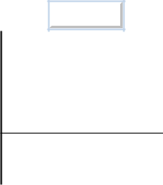

µ 6+,33(5¤(;3257(5¤6(//(5 | 7. REFERENCE NOS
§ ADDRESS
 | PAGE OF PAGES
 | 1 OF
3. PHONE # | 4. EMAIL ADRESS

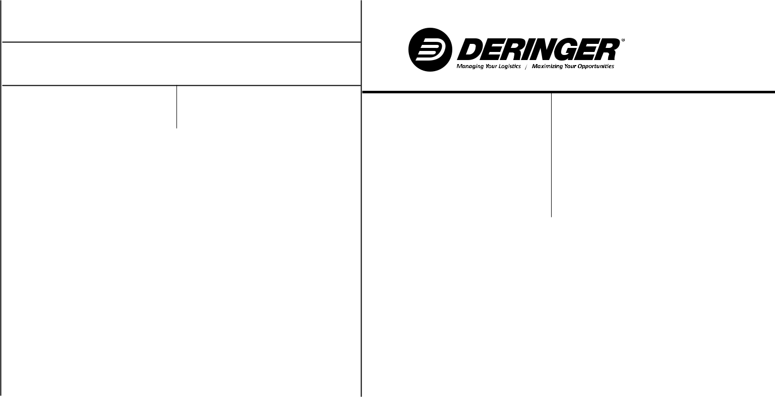
 |  |  |  |  | 13. CARRIER CODE (SCAC) |  |  |  |  |  |  | 14. SHIPMENT CONTROL NUMBER
5 CONSIGNEE |  |  |  |  | 15. ESTIMATED TIME OF ARRIVAL |  |  |  |  |  |  | 16. PORT OF ENTRY
6 ADDRESS |  |  |  |  | 17. ACCOUNT NUMBER |  |  |  |  |  |  | 18. COUNTRY OF EXPORT
7. IRS # |  |  |  | 8. EMAIL ADRESS | 19. BILL U.S. DUTY, MPF, AND/OR BROKERAGE TO:
 |  |  |  |  | CONSIGNEE |  | SHIPPER
 |  |  |  |  | BUYER |  | OTHER
9. BUYER |  |  |  |  | 20. NUMBER AND KIND OF PACKAGES |  |  |  |  |  |  | 21. SHIPPING WEIGHT |  |  | KGS
 |  |  |  |  |  |  |  |  |  |  |  |  |  |  | LBS
10 ADDRESS |  |  |  |  | 22. ESTIMATED FREIGHT CHARGES TO BORDER |  |  |  |  |  |  | 23. U.S. DUTY AND BROKERAGE INCLUDED
 |  |  |  |  |  |  | USD |  |  |  |  | IN INVOICE VALUE |  |  | YES
 |  |  |  |  |  |  | CAD |  |  |  |  |  |  |  | NO
11. IRS # |  |  |  | 12. EMAIL ADRESS | 24. IS FREIGHT INCLUDED IN INVOICE VALUE? |  |  |  |  |  |  | 25. PARTIES TO THIS TRANSACTION ARE:
 |  |  |  |  | YES AMOUNT |  | USD |  |  |  |  |  |  |  | RELATED
 |  |  |  |  | NO |  | CAD |  |  |  |  |  |  |  | NOT RELATED
CoM = COUNTRY OF MANUFACTURE OR GROWTH |  |  |  |  | DETAIL LINE ITEM INFORMATION
CoM |  | Part # |  | DESCRIPTION OF GOODS |  | HTS NUMBER |  |  |  |  | QUANTITY |  |  | UNIT PRICE | TOTAL PRICE

SHIPMENT NOTES:

If the production of these goods involved furnishings, goods, or services to the seller (e.g., assists such as dies, molds, tools, engineering work), and the value is not included in the invoice price, give explanation. If no assists, state so. This invoice must specifically state that the applicable duty or fees for ADD/CVD, MPF, HMF, beef, pork, and honey fees are included in the invoice price.

26. TERMS OF SALE, PAYMENT, AND DISCOUNT |  |  | 29. COMMENTS
F.O.B. | PLANT | DESTINATION, OR

 | TOTALS FROM ADDITIONAL | PAGE 2 |  | PAGE 3
 | PAGES

28. SOFTWOOD LUMBER ONLY |  |  | 29. INVOICE DATE | TOTAL INVOICE VALUE
 | USD | CAD |  | USD | CAD
 | EXPORT PRICE |  |  |  | 0.00
 | 27. DERINGER TO PROVIDE CARGO INSURANCE |  |  | YES | NO

To the best of my knowledge as the preparer, this invoice is true and complete and discloses true prices, values, quantities, rebates, drawbacks, fees, commissions, royalities, and any goods or services provided to the seller either free or at a reduced cost.

ATE | STATUS
REPARED | SHIPPER CLIENT
BY

