Payment Plan Request

Can I request a Payment Plan if I owe on my account?

Yes, you can request a Payment Plan if you owe on your account and need to make payments to pay tax, penalties, and interest.

Depending on the terms of the agreement, the payment plan will be auto-approved or manually approved or denied by DLI staff.

Please see “How do I request a Payment Plan if I owe on my account?” for more instructions on how to complete this request.

How do I request a Payment Plan if I owe on my account and want to be auto-approved?

If you have “FULL” access to this eServices account

- Log into UI eServices for Employers

- Click into the account you want to request the Payment Plan

- Click the “Account Services” tab

- Click the “Financials” tab

- Click the “Payment Plan Request” link

  - Choose “Payment Type” as “Electronic Payments”

  - Choose the first payment date between 5-30 days of today’s date

  - Type a “Down Payment Amount” if you’d like to make a down payment (Optional)

  - Enter a “Down Payment Date” (Required if Down Payment Amount is entered)

  - Choose “Number of Installments” or an “Installment Amount”

    - Number of Installments

      - Must be within 12 months to get auto-approval of the Payment Plan

      - The number you choose from the drop-down box will divide the estimated amount owing by the number of months you’d like to make payments. This will show your estimated amount due.

    - Installment Amount

      - Must be at least $50 per month to get auto approval of the Payment Plan

      - The number you type in will be divided into the estimated amount owing and show you the amount of months it will take to pay off the debt. If the number of months is over 12, the plan will not be auto-approved.

Last Updated: 02/21/2014 | 1

Payment Plan Request

Number of Installments within 12 months
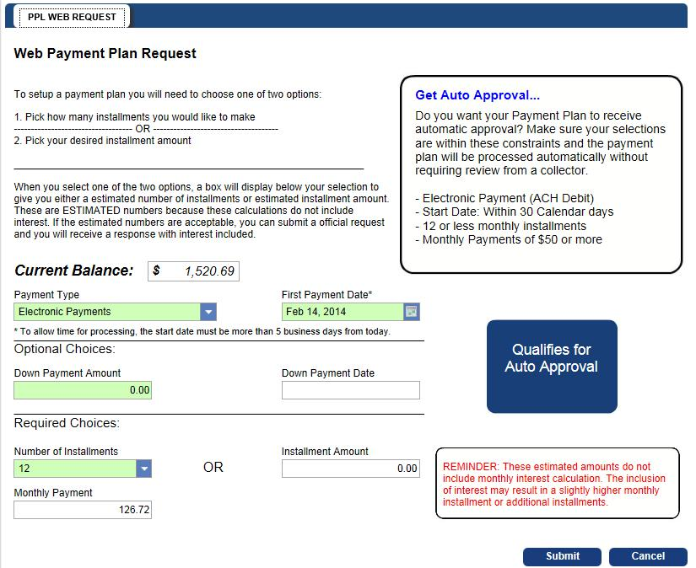

Last Updated: 02/21/2014 | 2

Payment Plan Request

Installment Amounts requiring 12 months or less to pay off debt
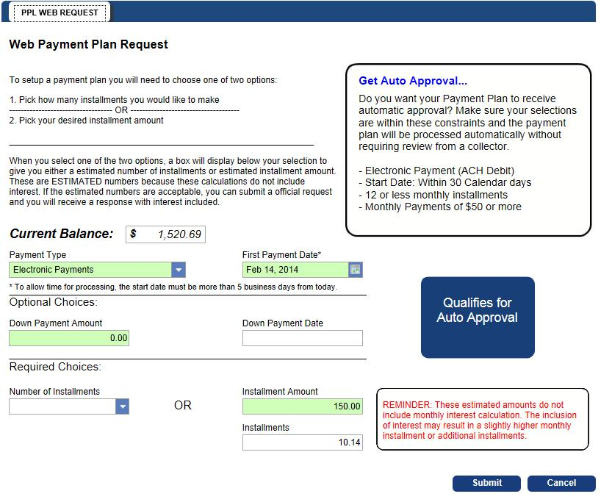

- Click “Submit”

- View and/or print confirmation page. A web message will be sent to your eServices account with the confirmation details contained on this page.

Note: Because the Payment Plan is auto-approved, you’ll receive an email to your preferred eServices email account requesting further steps to approve the Payment Plan.

- Following the instructions from the email and web message

  - Click into the “Requests” tab within your eServices account

  - Under the “Waiting to be Processed” tab, click the Confirmation # on the request titled

“Your Approved Payment Plan”

Note: If you do not want to continue with this agreement, click the “Cancel Request” tab at the top of the screen.

c. Click the “Change” tab

Last Updated: 02/21/2014 | 3

Payment Plan Request

- Read the Payment Plan Agreement Details

- If the details of the agreement are agreeable

  - Click the box to view the “Full Payment Schedule” (optional)

    - If you click this box, the “Payment Schedule” tab will be available at the top of the page to view the monthly installment amounts.
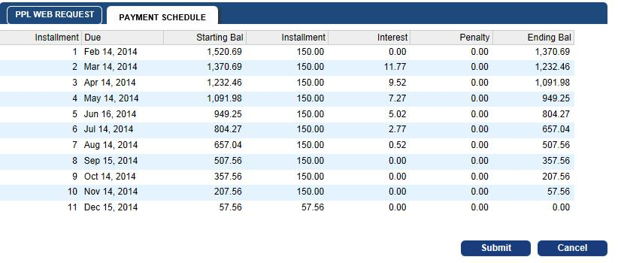

- Enter your Name in full

- Enter your banking information

- Check the box authorizing your consent to the agreement

  - You can print this page and the installment breakdown by using the print option within the Internet browser you are using

- Click “Submit”

- View or print confirmation page

Last Updated: 02/21/2014 | 4

Payment Plan Request
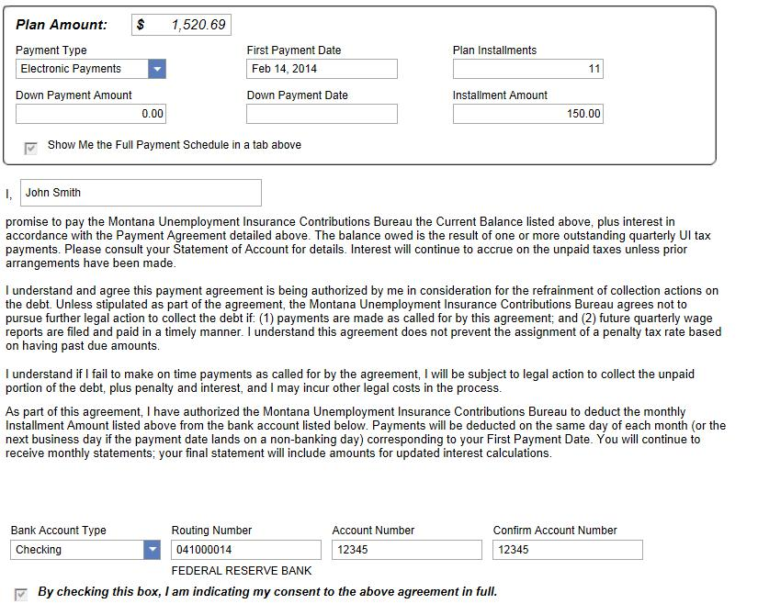

How do I request a Payment Plan if I owe on my account and don’t want to follow the constraints of an auto-approval plan?

If you have “FULL” access to this eServices account

- Log into UI eServices for Employers

- Click into the account you want to request the Payment Plan

- Click the “Account Services” tab

- Click the “Financials” tab

- Click the “Payment Plan Request” link

  - Choose a “Payment Type”

  - Choose the first payment date 30-90 days of today’s date

  - Type a “Down Payment Amount” if you’d like to make a down payment (Optional)

  - Enter a “Down Payment Date” (Required if Down Payment Amount is entered)

  - Choose “Number of Installments” or an “Installment Amount”

    - Number of Installments

      - Can be within 13-36 months

Last Updated: 02/21/2014 | 5

Payment Plan Request

  - Installment Amount

    - Must be at least $50 per month but this can extend the Payment Plan out to 36 months

- Enter a “Note”
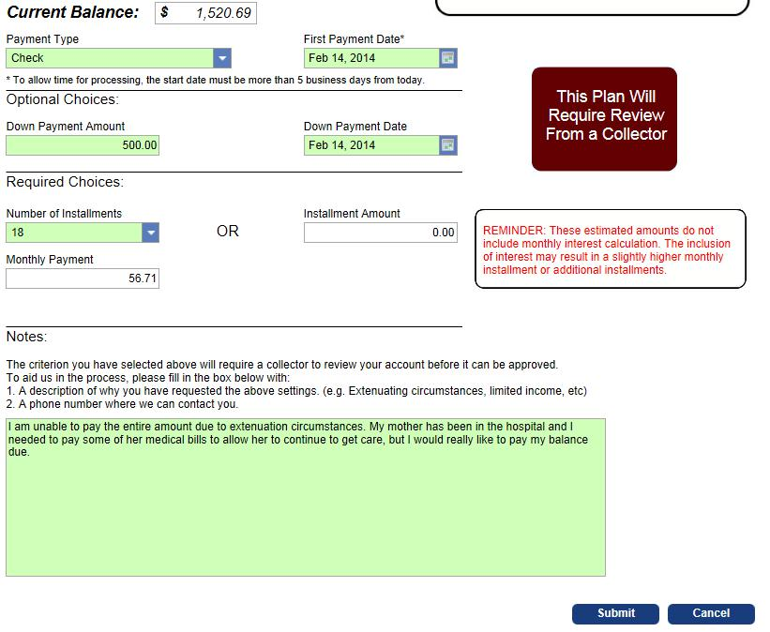

g. Press “Submit”

Note: You’ll receive an email to your preferred email account as well as a web message to your eServices account to complete the final approval steps if the plan is approved.

- Following the instructions from the email and web message

  - Click into the “Requests” tab within your eServices account

  - Under the “Waiting to be Processed” tab, click the Confirmation # on the request titled

“Your Approved Payment Plan”

Note: If you do not want to continue with this agreement, click the “Cancel Request” tab at the top of the screen.

Last Updated: 02/21/2014 | 6

Payment Plan Request

- Click the “Change” tab

- Read the Payment Plan Agreement Details

- If the details of the agreement are agreeable

  - Click the box to view the “Full Payment Schedule” (optional)

    - If you click this box, the “Payment Schedule” tab will be available at the top of the page to view the monthly installment amounts.
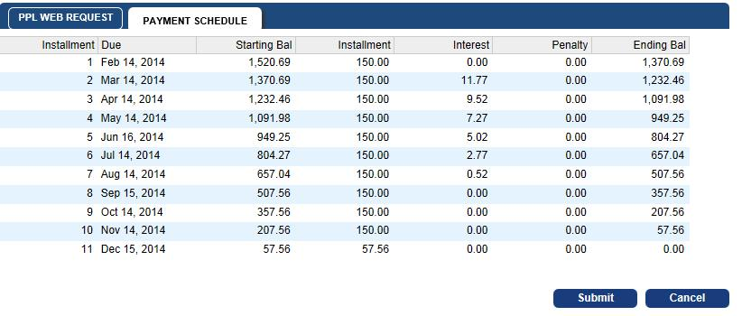

- Enter your Name in full

- Enter your banking information

- Check the box authorizing your consent to the agreement

  - You can print this page and the installment breakdown by using the print option within the internet browser you are using

- Click “Submit”

- View or print confirmation page

Last Updated: 02/21/2014 | 7

Payment Plan Request

Note: You may also receive an email and web message stating that the “Payment Plan agreement was Approved with Changes or Denied”. If the plan is “Approved with Changes”, follow the same steps to complete the approval process. If you were “Denied”, please see the web message describing why the plan wasn’t accepted.

Last Updated: 02/21/2014 | 8

