辻田祐子編『看護師の国際労働移動―フィリピンとインドの比較』調査研究報告書 アジア経済研究所 2018 年

Chapter 1

Nursing Graduates Working in the BPO Industry (Call Center) in the Philippines: Focus on their Choice of Job and Return to Nursing Profession

Ma. Reinaruth D. Carlos

Abstract

This chapter explores the rapidly growing business process outsourcing (BPO) industry, particularly call centers, as a major employment destination for nursing graduates in the Philippines, especially for those who took the course from around mid-2000s when the US and UK stopped actively recruiting foreign nurses. Specifically, it gives light on why call centers attract nursing graduates, and whether they want to return to the profession in the future. After presenting an overview of the expansion and contribution of the industry to the Philippine economy, it presents the partial results of a survey (n=208) implemented to nursing graduates. Our results show that they prefer to work in call centers mainly because of inter-industry wage gaps. Other reasons cited were perceptions towards the job as tough, influence of peers and motivation in taking up the nursing course. Many of the respondents also expressed their unwillingness to work as nurses even in the future.

The BPO industry has indeed played an important role as a major “buffer” to mitigate the negative impact of huge unemployment of nursing graduates. On a larger scale, it has become one of the pillars of economic growth in the country. However, while international demand for health- related BPO services increases, rapid advances in AI technology also threatens to replace workers especially in process-driven jobs in call centers. Under these circumstances, the crucial and pressing challenge for the Philippine society, therefore, is how to create a pool of flexible nursing graduates who can respond to changing international labor market demands and technology in this industry.

Keywords: Philippines, nursing graduates, BPO industry, call centers, non-nursing sectors

1

1. Introduction

Driven by intensified international recruitment of nurses by the UK and USA until mid-2000s, a large pool of nursing graduates, comprising of registered nurses (those who have obtained a Philippine nursing license) and unregistered (those who have not obtained a Philippine nursing license), developed in the Philippines.¹ Carlos, Roxas and Suzuki (2017) estimated the stock of registered nurses in the country to reach 864,757 (unadjusted for deaths and retirement) as of 2016. The Philippine Board of Nursing believes that in 2017, there are about 186,000 actively practising registered nurses in the Philippines and 280,000 Philippine-trained nurses working abroad (NZME, 2017). On the other hand, it is reported that 200,000 registered nurses became unemployed and another 200,000 took up jobs not related to healthcare in 2016 (Badilla, 2016). On the other hand, the number of unregistered (without nursing license) nurses is more difficult to estimate, but considering the number of graduates and the passing rate in the licensure examination, it can be roughly estimated that in the period 2005-2015, their number reached about 300,000.²

Given their magnitude, finding employment opportunities, either within the country or overseas, has become a major economic and social concern for the country. Those who pass the Philippine nursing license examination can either practice the profession, in what we call here the “nursing sector,” or work in the “non-nursing sector” which covers jobs other than those engaged in direct nursing bedside care, such as the caregivers and nursing

- For a detailed explanation of the labor market for nursing graduates and professional nurses in the Philippines, see Carlos, Roxas and Suzuki (2017).
- There are no estimates of nursing graduates who do not have a nursing license.

According to data obtained from the Philippine Commission on Higher Education (CHED), in the ten-year period 2005-2015, nursing schools produced 661, 077 graduates. Given that the average passing rate for the licensure examination is about 50% and excluding those who retook the examination, we can roughly estimate the number of unregistered (without a license) nurses to be around 300,000.

2

aides in the elderly care sector, customer services in front and back offices of companies, including hospitals, and those working in the BPO sector.

One of the major sectors that employ nursing graduates is the business process outsourcing (BPO) industry, which has seen exponential expansion since mid-1990s. The availability of manpower with clinical nursing background turned into an opportunity for overseas healthcare industry to look to the Philippines for medical information outsourcing and homecare call center (Magellan Solutions, 2015). In 2011 alone, Magellan Solutions (2015) reported that over 100,000 medical-related jobs were offered to nursing graduates in different BPO companies. The government also sees BPO sector as a viable way for nurses to earn a living. When the unemployment rate for nurses peaked around 2012, the Department of Labor and Employment (DOLE) called on jobless nurses to apply for health-related information outsourcing positions (Aning, 2012). With the booming BPO healthcare industry, nursing graduates have now more choices, both overseas and in the Philippines.

In this paper, we focus on the nursing graduates working in call centers (contact centers) ³ engaged in consumer product marketing and assistance, airline and hotel reservations, medical information management, IT technical support, and medical transcription. Using quantitative methodology, we investigate the nursing graduates’ perception about why they choose to work in this sector rather than practice their nursing profession; as well as whether and under what conditions they are willing to return to the profession. Our results will have important implications on the role of the BPO sector as a buffer in the unstable international labor market for professional nurses.

This paper is organized as follows: In the next section, we give a brief overview

- In the Philippines, a “call center” is the popular term used for those who work in contact centers and transcription services. Strictly speaking, a call center is a form of BOP in which the worker communicates only by voice using either the public switched telephone network or VoIP for calls. On the other hand, in a contact center, a worker also uses email, text chat, and web interfaces, in addition to phone calls, to communicate with clients or customers. In this paper, although majority of the nursing graduates are working in its

contact center and transcription sectors we will use the more general “BPO industry.”

3

of the BPO industry in the Philippines. Against the background of the expanding BPO industry, we introduce the methodology and details about the respondents in the sample in section 3. Here, we further divided the sample into those who hold a nursing license in the Philippines (registered nurses) and those who do not. In section 4, we show the results and discuss the preference in working in contact centers rather than in direct nursing bedside care. Section 5 will look into the perceptions of nursing graduates with regards to return to the profession. The summary of findings and conclusion are found in Section 6.

2. Overview of the BPO industry⁴

The BPO industry is one of the fastest growing business sectors in the Philippines. Its short history traces back to 1992 when the first call center was established by Accenture at a time when the country was experiencing double-digit unemployment rate (Magtibay-Ramos, Estrada & Felipe, 2007). Encouraged by the government’s active foreign investment incentives program for foreign investors, joint BPO companies were established in the following years. In 2003, Convergys Corporation, currently one of the biggest BPO companies in the country, opened two call centers in the Philippines as part of the firm’s global growth and income generation plan. The sector further expanded so that in 2011, the Economist (2012) reported that the Philippines is a world leader in BPO. In 2016, the Philippines ranked third, next to India and China, in terms of revenues in contact centers (Shead, 2017), accounting for 12.6% of the global BPO market (The Straits Times, 2017).

There are demand-side factors that contributed in the expansion of the BPO labor market. The biggest customers for the industry, the US companies, favor the Philippines as a destination because of its large and talented English-speaking labor pool and strong affinity for Western culture and business processes (IBPAP, 2013a,b). There is also increasing demand for BPO services, both health and non- health-related, from Europe, Australia and New Zealand.

As a result, the BPO industry has considerably contributed in the economic growth of the country. Projections on its revenues and employment show a stable increasing trend. The industry was estimated to generate 1.3 million direct jobs in 2016 and with sustained

- The author would like to acknowledge the research assistantship of Maria Nina I.

Adriano in data gathering in this section.

4

strong performance, it is expected to employ 1.4 million people in 2017 (Figure 1). Revenues were also projected to increase, reaching US$21.5 billion in 2015, US$25 billion in 2016; and US$ 28 billion in 2017 (Figure 2). It currently contributes 9% to the country’s GDP growth, and thus is regarded as one of the ten high priority development areas by the Philippine Development Plan (Shead, 2017).

Insert Figure 1 here.

Insert Figure 2 here.

Along with OFW remittances, the revenues from the BPO industry are a significant source of foreign exchange earnings. BPO revenues have been catching up with the OFW remittances and the gap between the earnings from these two sectors had been closing in. Lazo (2017) predicts that by 2018, BPO earnings will outpace overseas remittances and become the number one source of revenue for the country.

According to Shead (2017), the BPO industry can be divided into seven subsectors based on the kinds of business services: contact centers, data transcription services, animation services, software development services, back office operations (other BPOs), engineering development, and digital content services.⁵ Of these, contact centers are the most prominent subsector, making up four-fifths of the total Philippine BPO industry (The Straits Times, 2017). They also remain as the biggest employers (60%) and generated the most revenue (US$8.4 billion) in 2013 (Errighi, Khatiwada, & Bodwell, 2016). Contact centers, particularly the call center services, are cited as the most common form of BPO in the country because of English proficiency and good voice skills of Filipino workers (Asiatel Outsourcing, 2017).

Companies that outsource their business services come from a wide variety of industries, notably banking, retail, tourism and health/medical services (Errighi, Khatiwada, & Bodwell, 2016). Healthcare information management services (HIMS) catering to the health/medical services industry are one of the fastest-growing areas in the BPO industry. In addition to home care support in which call center agents answer phone queries from patients, health care professionals also work as medical transcriptionists,

- Errighi et al. (2016) lumped back office operations, engineering development, and

digital content services into Other BPOs category.

5

medical secretaries, medical coders and billers, medical assistants, medical representatives, and medical butlers. Nurses are preferred not only because of their western-based medical education and English language proficiency, but also their good communication skills (Alcances, 2015). The Healthcare Information Management Association of the Philippines (HIMAP) claims that a lot of these nurses passed the US licensure examination for registered nurses, which proves that they meet the US certification standards and are thus familiar with the US nursing procedures and processes.

The demand for nurses and workers with health/medical background for HIMS is expected to increase in the years to come. Jalandoni (2013) reported that in 2013, there was a need for 20,000 workers to cater to 200 BPO companies at that time. Based on reports released by HIMAP, this sector’s workforce of health care professionals was around 116,000 in 2015 with nurses as the majority group; and that the health information management sector will continue to expand its workforce in response to advances in modern technology and changes in the US healthcare system rules (Alcances, 2015). One major policy that influenced the industry is the US Affordable Care Act (Obamacare Plan) implemented from 2010. This act called on health insurers to lower their premiums and expand their coverage of uninsured Americans. Because of this move, health insurance companies were forced to transfer their contact centers, engaging in insurance claims processing, clinical support analysis, medical coding, and other non-core, business support jobs, to the Philippines (Martin, 2015). In addition, the increased healthcare spending in the United States can provide long-term career employment opportunities for allied healthcare professionals (Joson, 2014; Hernandez, 2016). One growing subsector is telehealth, described as “the use of a digital network to provide automated monitoring and treatment delivery to a patient who is in a different physical location than the medical expert providing treatment” (Divinagracia, 2015).

In the Philippines, the BPO sector is the preferred destination of many graduates obviously because it offers a much higher salary than the average wage of workers in other sectors. Bangko Sentral ng Pilipinas (Central Bank of the Philippines) estimated that in 2013, the annual average compensation in the sector per employee was $9,297 per year while the average daily wage in the rest of the country was $2,580 (P109,511.20 or P9,125.93 a month) per year (BSP, 2014) (Table 1). Specifically for contact centers, the average salary was P30,310.12 per month or $8,569 annually. The gap is smallest in the transcription subsector and widest in software development. However, the wage gaps have shrunk in 2009-2013 (Errighi et.al., 2016), with the gap in the contact center subsector registering the highest decline (Figure 3). Some possible reasons are the

6

increase in the supply of available workers and intensified global competition among host countries.

Insert Table 1 here.

Insert Figure 3 here.

Indeed, the outsourcing industry has expanded so that it is now one of the major propellers of the country’s economy. However, in order to sustain its growth, it must deal with three major and interlinked issues: skills shortage and low retention rate of employees; the need for infrastructures to accommodate more advanced technology, and challenges of artificial intelligence (AI). The industry workers’ turnover is high at 60% on the average, which means that a typical worker resigns from the job after 7 months (Lee, 2015), partly because of the stressful and demanding nature of the job and partly due to ease in finding a job within the same sector. As such, the industry has to constantly train new workers and exert greater efforts to recruit and keep them through attractive incentive packages. Moreover, AI devices such as “chat bots” are expected to replace 40,000 to 50,000 "low-skilled" or process-driven BPO jobs especially in call centers in the next 5 years. Thus, there is a need to retrain the workforce in mid- and high-skilled jobs with specialised expertise in areas like data analytics, machine learning and data mining (Lema, 2017).

3. Methodology

In order to assess the motivations of nursing graduates in working in the BPO industry as well as their perceptions regarding return to the nursing profession, a questionnaire survey of 208 nursing graduates working in call centers was administered in Metro Manila and Central Luzon in December, 2017 and February, 2018. The four-page questionnaire comprised of explanation about the research study and queries regarding the respondents’ personal, educational and job profiles, their motivations in working in the BPO sector, and also their perceptions regarding their current job, return to the profession and international migration. Consent on information and data use was also solicited from the respondents. The questionnaire was implemented using snowball sampling procedure and respondents were asked to answer either in paper form or google form. The answers were encoded in Excel and processed using SPSS.

The data was further divided into two categories, those with a Philippine nursing

7

license and those without one; and their descriptive statistics are presented in Table 2. The sample consists of 127 nursing graduates with a nursing license; of which 80 are female and 47 are male; and 81 without a nursing license; of which 58 are female, 22 are male and 1 would rather not say the gender. More than half of the respondents are single, and those who are married and separated comprise 22% and 25% respectively. The respondents are also relatively young, with more than 80% aged 30 years old and below for both categories. The average age of those with a nursing license (28.16 years old) is slightly higher than those without a nursing license (26.32 years old). These properties can be considered as representative of the the over-all trend of the workforce in this sector – high proportions of women, and of young and single workers.

Insert Table 2 here.

Further examination of the sample reveals three interesting characteristics of the respondents: First, 35 out of the 208 respondents have experience working overseas, with the average length of stay at 3.18 years (Table 3). Most of the 35 respondents went to the Middle East (Saudi Arabia, Israel and UAE), Africa, Europe and the USA; taking up various jobs such as nursing aides/caregivers/nursing assistants, call center agents, office staff and registered nurses. This suggests that the BPO industry is not only an option for nursing graduates who could not leave the country for overseas employment; but also for those who have returned from their stint overseas. This observation also reflects the competitiveness of this industry not only over the nursing and other non- nursing sectors within the country, but also compared to jobs in some overseas destinations like the Middle East.

Insert Table 3 here.

Second, our sample also reveals the variations in the occupations available to nursing graduates in this sector (Table 4). More than 43% of those with Philippine nursing license choose to work in non- health related jobs such as consumer product services, hotel and airline reservations (the workers are called customer services representatives or CSR) and IT support services staff; and the rest (65.7%) work in health-related jobs such as medical transcription, medical claims and billing as well as home care support. This suggests that Filipino nursing graduates are willing to take in jobs even if they are not in line with their professions and hints that there are varied reasons that they consider in

8

choosing their jobs, to be discussed below.

Insert Table 4 here.

Third, most of the respondents in both categories graduated between 2008-2012, the time when the number of graduates peaked resulting from strong demand for nurses in highly preferred destinations such as the USA and UK (Figure 4). Moreover, for those who graduated after 2011, there are more respondents without a Philippine nursing license compared to those with a Philippine nursing license who graduated. As there are no required skills or certification in order to work in this industry, fresh graduates tend to take up jobs while reviewing for the nursing licensure examination or waiting for the results of applications to work in hospitals, either in the Philippines or overseas. That nursing graduates work in the BPO industry during such period only and resign soon after is identified as one of the serious concerns of BPO managers who need to constantly train new workers to fill up positions vacated by these nursing graduates.

Insert Figure 4 here.

4. Nursing graduates’ preference to work in the BPO industry

What drives nursing graduates to work in call centers rather than as staff nurses in hospitals and other medical institutions? Our results, found in Figure 5, reveal that the top reason is the relatively high salary in the BPO industry. Almost all respondents in both categories chose “salary and benefits are higher in a call center” as one of the reasons for working in this sector (multiple answers). Indeed, nursing graduates in BPO companies receive better compensation package than entry-level nurses (Parrocha, 2014). Nurses at private hospitals in the country earn as low as P6,000, and entry-level nurses in government hospitals are given P19,077 to P20,585. On the other hand, based on random interviews with the respondents, customer support representatives in Manila earn an estimated monthly salary amounting to US$500 to US$600 while those based in other parts of the country receive US$300 to US$500 every month. Medical transcriptionists and IT support services staff gets more at around US$800 and US$900 every month, respectively. The salary increases depending on experience, skills set and leadership qualities (Shead, 2017).

Insert Figure 5 here.

9

The second reason cited by the respondents in both categories was “I am more interested in this current job than working as a staff nurse.” This reflects the trend observed from mid-2000s, when there was strong international demand for professional nurses, that to work overseas rather than the nature of the profession was the main motivation to take up the course. This is because in the Philippines, working as professional nurses overseas gives the nurse and his family opportunities for economic and social mobility (Ortiga, 2018). It was also during that period when family and relatives made the decision for the student on what course to take up in college. In fact, in the survey, more than 90 per cent of the respondents replied that taking up nursing was decided by the parents, particularly the mother (multiple answers).

Striking differences between the two categories of nursing graduates can be found for reasons 3, 4 and 5 (“working as a staff nurse is more physically and mentally demanding,” “I lacked requirements” and “I feel I am more effective in performing this job rather than working as staff nurse”) in which a much higher proportion of those without a Philippine nursing license chose these as reasons for working in the BPO industry. On the other hand, for reason 8 (“I was encouraged and inspired by friends who also work in a call center”) a 30% difference in the proportions was detected between the two categories (higher ratio for those with a nursing license group). From these results, it can be inferred that for those without a license, the choice relies heavily on the nature of the work itself; while for those with a license, working in BPO is rather more strongly influenced by human relationships with friends and/or coworkers.

On the other hand, only 11% of those without a nursing license (they are not qualified to work as staff nurse) and 2% of those with a nursing license indicated that they work in a call center because they could not find a job elsewhere or as a staff nurse. This number is small, suggesting that many respondents think that there are other alternative jobs waiting for them, and working in a call center is not the “last” option, but is rather the “best” choice.

That about half of the respondents (44% for those with a license and 52% for those without a license) chose “I did not want to take up nursing (BSN) in the first place” is revealing and suggestive of the attitude of nursing students regarding their motivations in taking up this course. As mentioned somewhere in this paper, the respondents belong to the generation of students from around 2004 when the choice of course in college is highly dependent on its demand overseas, and the decision to take up nursing is undertaken by family and relatives, rather than the student himself.

10

5. Perceptions on Return to Nursing Profession

Put on a wider perspective of the international labor market for professional nurses, with unstable and unpredictable demand vis-à-vis the shrinking supply of nurses in the Philippines (Carlos, Roxas and Suzuki, 2017), it is important to determine whether nursing graduates are willing to return to the profession and work as staff nurse. Table 5 captures the perceptions of the respondents regarding whether they plan to work in the nursing sector in the future. From this table, we can see that more than 90% of both categories of nursing graduates answered in the negative. This trend is easily understood in the case of respondents who do not possess a nursing license and are therefore not qualified to work as staff nurses. Further studies are necessary not only to explain why those with nursing license chose to work in BPO, and what conditions would make them change their mind.

Insert Table 5 here.

The issue of returning to the nursing profession is linked to the issue of “deskilling” and “reskilling” that nurses undergo when they work in the non-nursing sector. In this case, deskilling is defined as the decrease in the quality and usage of nursing skills, particularly those involved in the practice of nursing bedside care due to lack of usage or lack of opportunities in the BPO sector. Deskilling may also lower the chance of those without a nursing license to pass the licensure examination. At the same time, “reskilling” also happens for those who work in the BPO sector when they have to learn computer skills and office procedures not commonly used in the practice of nursing. It must be added that deskilling and reskilling issues can be more serious for those who are engaged in non- health related BPO jobs. The scope and depth of deskilling and reskilling will be important determinants of their return to the nursing profession.

Indeed, one reason why respondents with a nursing license do not have plans to return to the profession is their lack of confidence as professional nurses because they have not worked in the nursing sector for some time. The issue, therefore, is on how to provide them with training that can update them in nursing skills while working in the non-nursing sector. Starting in January, 2018, the Philippines’ Professional Regulations Commission requires that registered nurses present earned Continuous Professional Development (CPD) units before the renewal of Professional Identification Cards. Registered nurses must attend accredited programs in the following major areas: ethics and regulatory issuances, professional nursing practice, leadership and management,

11

education and research, and professional, personal, quality development and lifelong learning and may include in-service training programs, training programs for specialization and self-directed or lifelong learning activities (Professional Regulation Commission, 2017).

That most respondents think that they would not choose nursing as their profession, if given the chance to do so in the future, also suggests their weak commitment and probable discontent in the nursing profession, most probably because it failed to become their instrument in being able to work overseas. From Table 6, we can see that around 90% of respondents in both categories answered “no” when asked about whether they would still take up nursing in the future. Only 10% has expressed their intention to consider taking the course at their own will in the future.

Insert Table 6 here.

6. Implications and Summary

In this paper, we looked into the case of nursing graduates who are working in the BPO industry, particularly in contact centers and medical translation subsectors. Specifically, we explored the reasons why nursing graduates choose to work in this industry rather than practice their nursing profession in hospitals and other medical institutions. We also determined whether the nursing graduates currently working in the BPO industry have plans to return to the profession in the future.

Our overview of the BPO industry in the Philippines shows that it is an attractive employment destination for nursing graduates. It is one of the expanding business sectors in the Philippines, thus offering many job opportunities, both in health- and non-health related areas and both for those who have and do not have a Philippine nursing license. The average salary in this sector is at least more than twice as much as what a worker in other sectors receives. Because of the industry’s contribution to the economy, the Philippine government considers it as one of the priority industries. This, together with the increase in demand for services offered by BPO companies, specifically in call centers dealing with health information management and medical transcription, are cited as reasons for the further expansion and more employment opportunities for nursing graduates and Filipino workforce.

The results of the survey questionnaire confirm that given the current conditions in the domestic and international labor market for nursing graduates, as well as the perceptions of graduates towards the nature of the nursing job and their motivations in
12

taking up the nursing course, working in the BPO industry is a rational decision, especially for those who graduated from the time when the international demand began to decline in mid-2000s. The main reason for preference in the BPO industry is the high salary it offers compared to hospitals. In addition to this, the lack of interest in the nursing job, perception that nursing is physically and mentally demanding compared to their work in call centers, and unwillingness to take up the course in the first place also emerged as important factors. The results also reveal that most respondents in the survey do not have plans to return to the profession, most probably due to the same reasons as those given in choosing to work in the BPO industry.

This study suggests that for the generation of nursing graduates from around 2005, the expanding BPO industry, particularly the contact centers and medical transcription fields, will for some time continue to be an attractive place of work. Call centers play an important role as a major “buffer” to mitigate the negative economic impact of huge unemployment of those who graduated at the end of an overseas job trend. At the same time, however, it highlights the Philippine economy’s growing reliance on BPOs. While the demand for health- related BPO services such as health information management and medical transcription increases, rapid advances in AI technology also threatens to replace workers especially in process-driven jobs in call centers. Under these circumstances, the crucial and pressing challenge for the Philippine society, therefore, is how to create a pool of flexible nursing graduates who are able, willing and ready to shift between nursing and non-nursing sectors in response to changing international labor market demands and technology in this industry.

Acknowledgement: The survey is funded by IDE-JETRO.

13

References

Alcances, L. (2015). Why Healthcare Professionals Are Making the Big Shift. Healthcare Information Management of the Philippines (HIMAP). Retrieved from http://himap.ph/why-healthcare-professionals-are-making-the-big-shift/

Aning, J. (2012, March 5). Group slams Philippine labor chief over advice to nurses to work at BPOs. Tribune Business News.
Asiatel Outsourcing (2017). Types of BPOs in the Philippines. Retrieved from http://www.asiateloutsourcing.com/types-of-bpos-in-philippines/
Badilla, N. (2016, May 15). 200,000 registered nurses are jobless. Manila Times. Retrieved from http://www.manilatimes.net/200000-registered-nurses-are-jobless/262211/

Bangko Sentral ng Pilipinas (Central Bank of the Philippines) (2014). Results of the

2013 survey of information technology business process outsourcing (IT-BPO)

services. Retrieved from

http://www.bsp.gov.ph/downloads/Publications/2013/ICT_2013.pdf

Bird, M. and Ernst, C. (2009). Offshoring and employment in the developing world: Business process outsourcing in the Philippines. International Labour Organization Employment Working Paper No. 41. Retrieved from http://www.ilo.org/wcmsp5/groups/public/---ed_emp/---emp_elm/---

analysis/documents/publication/wcms_117922.pdf

Canivel, R. (2016, May 30). BPO firm offers jobs for PHL nurses. Business World.

Retrieved from:

http://bworldonline.com/content.php?section=Corporate&title=bpo-firm-offers-

jobs-for-phl-nurses&id=128207

Carlos, M.R.D., E. R. Roxas and Y. Suzuki (2017) Human Resources Development and International Mobility of Professional Nurses: The Philippine Perspective in: Human Resource Development and the Mobility of Skilled Labour in Southeast Asia: The Case for Nurses, Edited by Yuko Tsujita BRC (Bangkok Research Center) Research Report No.19. Retrieved from http://www.ide.go.jp/library/English/Publish/Download/Brc/pdf/19.pdf

Divinagracia, M. (2015). 4th International Conference on Nursing & Healthcare. DOI: 10.4172/2167-1168.C1.014

14

Errighi, L., Khatiwada, S. & Bodwell, C. (2016). Business process outsourcing in the Philippines: Challenges for decent work. Bangkok: International Labour Organization. Retrieved from http://www.ilo.org/wcmsp5/groups/public/---

asia/---ro-bangkok/---sro-

Hernandez, B. (2016, Jan 16). To bridge the knowledge gap. Philippine Daily Inquirer. Retrieved from http://opinion.inquirer.net/92073/to-bridge-the-knowledge-gap

IT and Business Process Management Association Philippines (IBPAP). (2013a). Philippine Information Technology and Business Process Roadmap 2012-2016. Retrieved from 050913_ Road_Map_2012-2016_General Public_.pdf

IT and Business Process Management Association Philippines (IBPAP). (2013b, Feb 27). Everest Study: Healthcare BPO 'a hidden jewel' for Philippines. Retrieved from http://www.ibpap.org/publications-and-press-statements/ibpap-news/119-everest-study-healthcare-bpo-a-hidden-jewel-for-phl

Jalandoni, A. (2013 August 28) Why Pinoy nurses are now working for BPOs. ABS-CBN News. Retrieved from http://news.abs-cbn.com/business/08/28/13/why-pinoy-nurses-are-now-working-bpos

Joson, S. (2014, Sep 16). Unemployment rate decrease due to job in the BPO sector.

Manila Standard Today. Retrieved from

https://www.microsourcing.com/news/201409/more-jobs-for-nurses-in-ph-

bpo.asp.

Joson, S. (2015, Oct 7). PH IT-BPO industry readies 6-year road map. Business World. Retrieved from http://www.bworldonline.com/
Lazo, K. N. (2017 January 27). BPO revenues to outpace OFW remittances by 2018 – ING Bank. Manila Times. Retrieved from http://www.manilatimes.net/bpo-revenues-outpace-ofw-remittances-2018-ing-bank/309043/

Lee, Don. (2015, Feb. 1). The Philippines has become the call-center capital of the world. Los Angeles Times. Retrieved from http://www.latimes.com/business/la-fi-philippines-economy-20150202-story.html
Lema, K. (2017, Nov. 9). Rise of the machines: BPOs brace for artificial intelligence. ABS-CBN News. Retrieved from http://news.abs-cbn.com/business/11/09/17/rise-of-the-machines-bpos-brace-for-artificial-intelligence

NZME Educational Media (2017,May 18). Filipino nurses: our fastest growing nursing workforce. Nursing Review. Retrieved from:

15

http://nursingreview.co.nz/filipino-nurses-our-fastest-growing-nursing-workforce/
Magellan Solutions (2015). Medical information outsourcing: Call center with nurses as agents. Retrieved from http://www.magellan-solutions.com/blog/call-center-with-agents-as-nurses/1-29-18

Martin, S. F. (2014, Sep 8). BPO firms recruiting nurses as clinical analysts –Romulo. http://newsbytes.ph/2014/09/08/bpo-firms-recruiting-nurses-as-clinical-analysts-solon-says/

Ortiga, Y.Y. (2018). Learning to Fill the Labor Niche: Filipino Nursing Graduates and the Risk of the Migration Trap. The Russell Sage Foundation Journal of the Social Sciences 4(1). 172-187. Russell Sage Foundation

Parrocha, A. N. (2014, Aug 29). There is good opportunity for nurses in BPO industry, says healthcare group. The Philippines News Agency
Professional Regulation Commission. (2017). Professional Regulatory Board Resolution no. 10 Series of 2017. Retrieved from http://prc.gov.ph/uploaded/documents/PRB%20of%20CUSTOMS%20BROKE R%202017-21_102317.pdf

Shead, B. (2017). Business process outsourcing in the Philippines. Retrieved from https://www.aseanbriefing.com/news/2017/04/17/business-process-outsourcing-philippines.html

The Straits Times. (2017, Nov. 10). Philippine outsourcing industry faces AI challenges. The Straits Times. Retrieved from http://www.straitstimes.com/asia/se-asia/philippine-outsourcing-industry-faces-ai-challenges

16

Tables and Figures

1,400,000

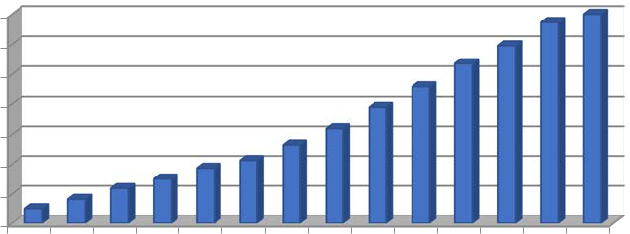
1,200,000

1,000,000

800,000

600,000

400,000

200,000

-

Figure 1: Estimated number of direct jobs generated by the IT-BPO industry.

Source: Compilation from DTI, IBPAP and NSCB data.

(in billion US$)

28

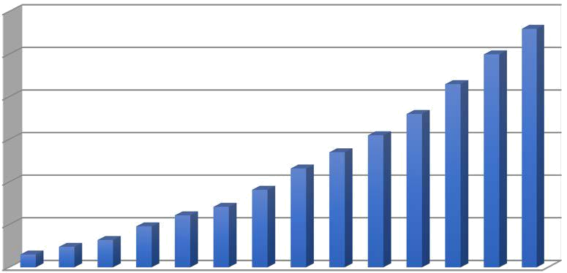

25

21.5

18
15.5
11.6 ^{13.5}
9.1

_{1.5} _{2.4} _{3.2} 4.8 ^{6.1} ^{7.1}

Figure 2: Estimated revenues generated by the IT-BPO industry (in billion US$)

Source: Compilation from DTI, IBPAP and NSCB data.

17
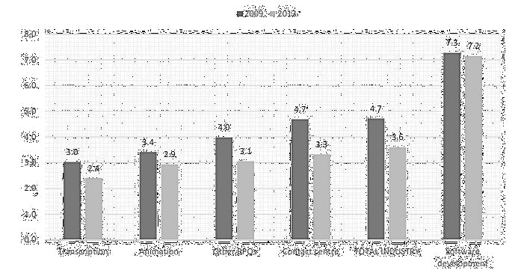

Figure 3: Ratio of Average Annual Wage in the BPO Subsectors to Average Annual Wage in the Philippines (2009-2013)

Source: Errighi et al. (2016).

25%
20%
15%
10%
5%
0%
with Phil. Nursing license | without Phil. Nursing license

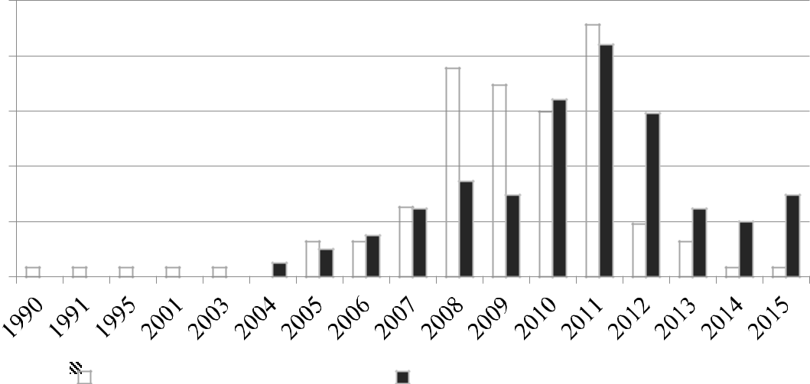

Figure 4: Year of Graduation of Respondents (in %, n=208)

Source: Compilation from survey data.

18

9. I did not want to take up nursing (BSN)
in the first place.

8. I was encouraged/inspired by friends who also work in a call center.

52%
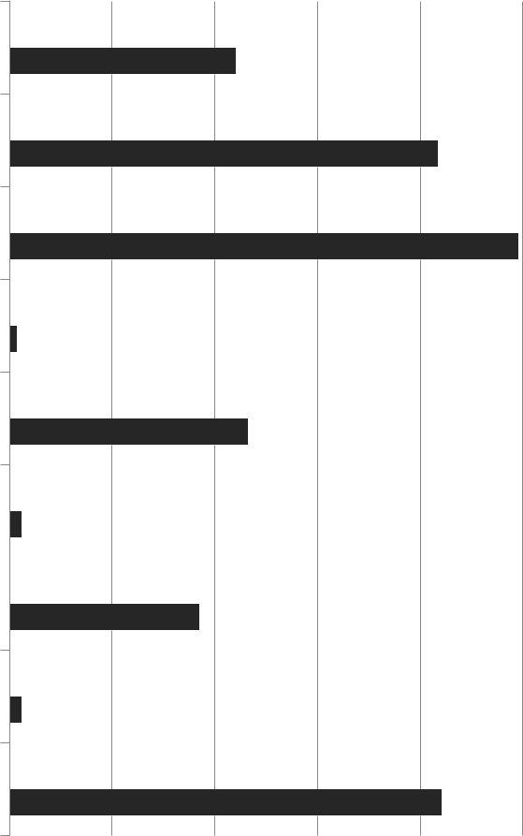
44%

51%
83%

7. Salary and benefits are higher in a call center.

6. I do not want to work night shifts.

5. I feel I am more effective in performing

this job rather than working as staff nurse.

4%
2%

46%
100%

99%

78%

4. | I lacked requirements (education,
training, experience, license, etc.) to…
3. | Working as a staff nurse is more
physically and mentally demanding.

2%

23%

37%

89%

2. I could not find a job / there was no available job as staff nurse.

1. I am more interested in this current job than working as staff nurse (direct…

without Phil. nursing license (n=81)

_{2%} 11%

85%

84%

with Phil. nursing license (n=127)

Figure 5: Reasons why respondents choose to work in BPO industry rather than in the nursing sector (i

Source: Compilation from survey data.

19

Table 1: Annual Average Compensation per Employee in Selected IT-BPO Subsectors

IT-BPO |  | 2013
Subsector
Subsector | US$ | PHP | Monthly
Contact Center | 8,569 | 363,721.49 | 30,310.12
Transcription | 6,198 | 263,081.55 | 21,923.46
Animation | 7,568 | 321,232.84 | 26,769.40
Software | 18,453 | 783,259.73 | 65,271.64
Development | 18,453 | 783,259.73 | 65,271.64
Other BPOs | 7,896 | 335,155.20 | 27,929.60
Total Industry | 9,297 | 394,622.32 | 32,885.19

Source: Bangko Sentral ng Pilipinas (Central Bank of the Philippines) (2014)

Table 2. Descriptive statistics: Gender, marital status and age (n=208)

 | Gender |  | Female |  | Male |  | Rather |  | Total
 | Gender |  | Female |  | Male |  | not say
 | With Philippine nursing |  | 80 |  | 47 |  | 0 |  | 127
 | license |  | 80 |  | 47 |  | 0 |  | 127
(%) |  | (63.0) |  | (37.0) |  | (0.0) |  | (100.0)
 | Without Philippine nursing |  | 58 |  | 22 |  | 1 |  | 81
 | license |  | 58 |  | 22 |  | 1 |  | 81
(%) |  | (71.6) |  | (27.2) |  | (1.2) |  | (100.0)
 | Total |  | 138 |  | 69 |  | 1 |  | 208

 |  | Marital Status | Single |  | Married |  | Widowed |  | Separated |  | Total
 |  | With Philippine nursing | 61 |  | 35 |  | 1 |  | 30 |  | 127
 |  | license | 61 |  | 35 |  | 1 |  | 30 |  | 127
 | (%) |  | (48.0) | (27.6) |  | (0.8) |  | (23.6) |  | (100.0)
 |  | Without Philippine nursing | 48 |  | 10 |  | 0 |  | 23 |  | 81
 |  | license | 48 |  | 10 |  | 0 |  | 23 |  | 81
 | (%) |  | (59.3) | (12.3) |  | (0.0) |  | (28.4) |  | (100.0)
 |  | Total | 109 |  | 45 |  | 1 |  | 53 |  | 208
 |  |  |  | 20

 | Age Bracket | 21-25 |  | 26-30 |  | 31-35 |  | 36-40
 | With Philippine nursing |  | 11 |  | 98 |  | 15 |  | 0
 | license |  | 11 |  | 98 |  | 15 |  | 0
(%) |  | (8.7) |  | (77.2) |  | (11.8) |  | (0.0)
 | Without Philippine nursing |  | 36 |  | 36 |  | 9 |  | 0
 | license |  | 36 |  | 36 |  | 9 |  | 0
(%) |  | (44.4) |  | (44.4) |  | (11.1) |  | (0.0)
 | Total |  | 47 |  | 134 |  | 24 |  | 0
(%) |  | (22.6) |  | (64.4) |  | (11.5) |  | (0.0)
 | Age Bracket | 41-45 |  | 46-50 |  |  | Total |  | Average
 | Age Bracket |  |  |  |  |  | Total |  | age
 | With Philippine nursing |  | 1 |  | 2 |  | 127 |  | 28.16
 | license |  | 1 |  | 2 |  | 127 |  | 28.16
(%) |  | (0.8) |  | (1.6) |  | (100.0)
 | Without Philippine nursing |  | 0 |  | 0 |  | 81 |  | 26.32
 | license |  | 0 |  | 0 |  | 81 |  | 26.32
(%) |  | (0.0) |  | (0.0) |  | (100.0)
 | Total |  | 1 |  | 2 |  | 208 |  | 27.44
(%) |  | (0.5) |  | (1.0) |  | (100.0)

Source: Computation from survey data.

Table 3. Descriptive statistics: Overseas work experience of respondents (n=208)

Have experience working overseas | Yes | No | Total
With Philippine nursing license | 25 | 102 | 127
(%) | (19.7) | (80.3) | (100.0)
Without Philippine nursing license | 10 | 71 | 81
(%) | (12.3) | (87.7) | (100.0)
Total | 35 | 173 | 208
(%) | (16.8) | (83.2) | (100.0)
Source: Computation from survey data.

21

Table 4. Descriptive statistics: Nature of current work of respondents (n=208)

Current work is health-related | Yes | No | Total
With Philippine nursing license | 72 | 55 | 127
(%) | (56.7) | (43.3) | (100.0)
Without Philippine nursing license | 7 | 74 | 81
(%) | (8.6) | (91.4) | (100.0)
Total | 79.0 | 129.0 | 208.0
(%) | (38.0) | (62.0) | (100.0)

Source: Computation from survey data.

Table 5. Plan to take up job as staff nurse in the future (n=208)

I want to take up job as a staff Yes No Total nurse in the future.

with Philippine Nursing license | 10 | 117 | 127
(%) | (7.9) | (92.1) | (100.0)
without Philippine Nursing license | 5 | 76 | 81
(%) | (6.2) | (93.8) | (100.0)
Total | 15 | 193 | 208
(%) | (7.2) | (92.8) | (100.0)

Source: Computation from survey data.

Table 6. Perception on taking up BS Nursing if given the chance to choose degree in college (n=208)

If given another chance to choose degree | Yes | No | Total
in college, it will still be BS Nursing. | Yes | No | Total
with Philippine Nursing license | 12 | 115 | 127
(%) | (9.4) | (90.6) | (100.0)
without Philippine Nursing license | 9 | 72 | 81
(%) | (11.1) | (88.9) | (100.0)
Total | 21 | 187 | 208
(%) | (10.1) | (89.9) | (100.0)

Source: Computation from survey data.

22

