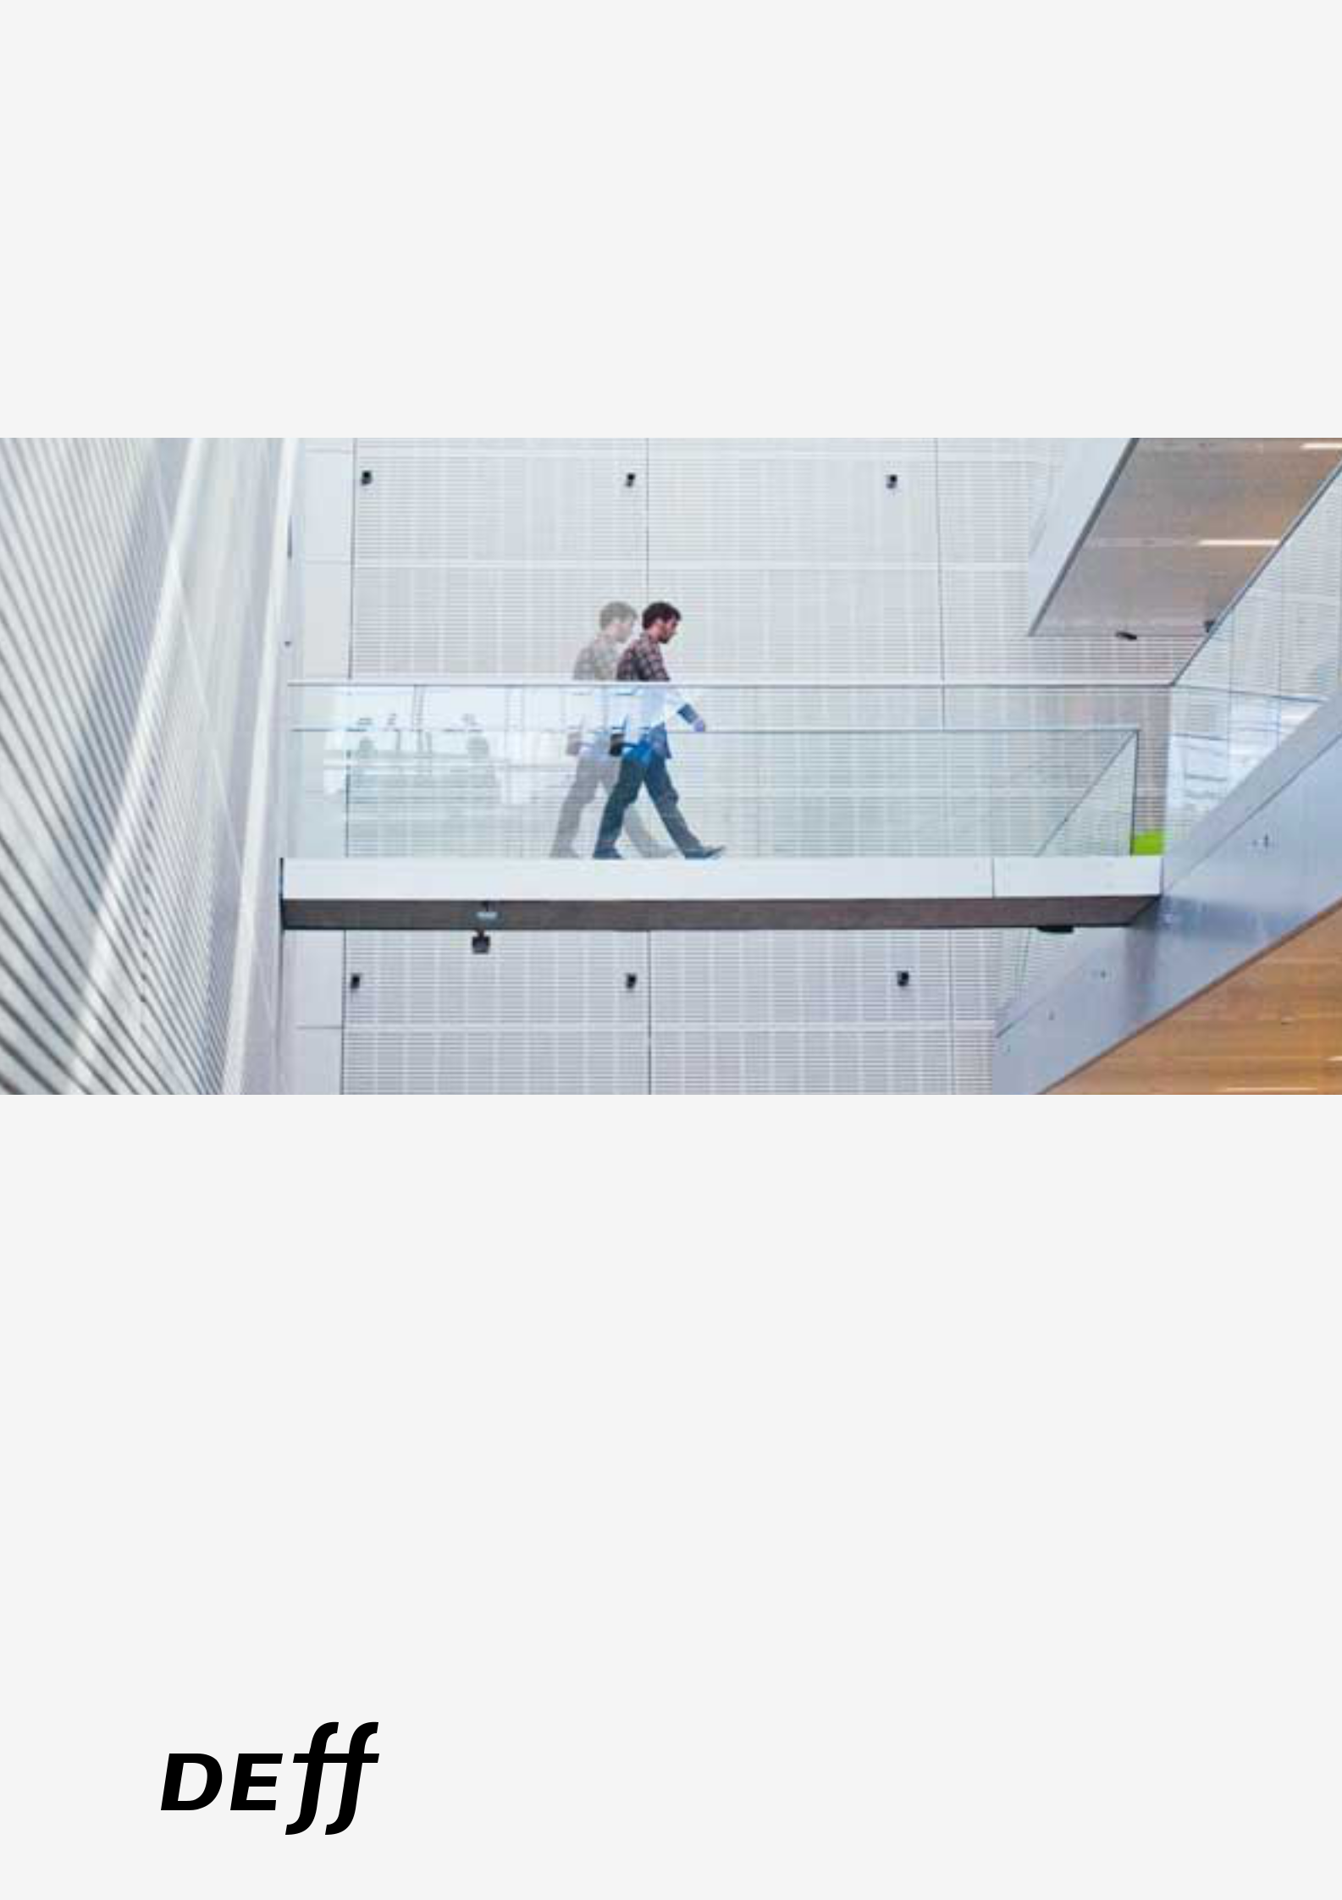
The Future of Research

and the Research Library

Denmark’s Electronic

Research Library

The Future of Research

and the Research Library

A Report to DEFF

Denmark’s Electronic Research Library

December 2009


Tandis que les siecles s'écoulent, la masse des ouvrages s'accroît sans cesse, & l'on prévoit un moment où il seroit presqu'aussi difficile de s'instruire dans une bibliotheque, que dans l'univers, & presqu'aussi court de chercher une vérité subsistante dans la nature, qu'égarée dans une multitude immense de volumes. (5:644)

"Encyclopédie", Encyclopédie, ou dictionnaire raisonné des sciences, des arts et des métiers, ed. Denis Diderot and Jean le Rond D'Alembert. University of Chicago: ARTFL Encyclopédie Projet (Winter 2008 Edition), (http://encyclopedie.uchicago.edu/)

"The amount of works is growing incessantly as the centuries pass and in a foreseable future it will be equally difficult to acquire information in a library as it will be to navigate the Universe, and almost as fast to search for an important truth in nature compared to loosing your barings in a multitude of large volumes."


1

Table of contents

Executive Summary . . . . . . . . . . . . . . . . . . . . . . . . . . . . . . . . . . . . . . . . . . . . . . . . . . . 3

Introduction . . . . . . . . . . . . . . . . . . . . . . . . . . . . . . . . . . . . . . . . . . . . . . . . . . . . . . . . . . 7

1. Challenges for the research library and the research library system . . . . . . . . . 10

2. Tendencies in the development of the research system

of importance to the research libraries . . . . . . . . . . . . . . . . . . . . . . . . . . . . . . . . . . 13

3. The structure of the research library system as a system

supporting research and information behaviour . . . . . . . . . . . . . . . . . . . . . . . . . . 20

4. Users of the system and their forms of usage . . . . . . . . . . . . . . . . . . . . . . . . . . . . 23

5. The culture and identity of the library and the librarian: The touching library. . 29

6. Value creation of the research library system in relation to its stakeholders . . 37

7. Scenarios and strategies for the development of the research library system . 42

8. Stakeholders and possible future action recommendations for the system . . . 44

9. Template/outline for/of a dynamic roadmap with forms of feedback . . . . . . . . . 46

10. Elements of a roadmap . . . . . . . . . . . . . . . . . . . . . . . . . . . . . . . . . . . . . . . . . . . . . 49

11. Appendix 1, DEFF and the Future of Research Libraries . . . . . . . . . . . . . . . . . . 55

12. Appendix 2, Trend- and network analysis - interviewees . . . . . . . . . . . . . . . . . . 58

13. Appendix 3, In-depth interviews - Interviewees . . . . . . . . . . . . . . . . . . . . . . . . . . 59

14. Appendix 4, Workshop 1 - List of participants . . . . . . . . . . . . . . . . . . . . . . . . . . 60

15. Appendix 5, Programme - Workshop 1 . . . . . . . . . . . . . . . . . . . . . . . . . . . . . . . . 61

16. Appendix 6, Workshop 2 - List of participants . . . . . . . . . . . . . . . . . . . . . . . . . . 62

17. Appendix 7, Programme - Workshop 2 . . . . . . . . . . . . . . . . . . . . . . . . . . . . . . . . 66

Appendices

Acknowledgement of people who supported the report Appendix: with workshop schedules and descriptions
Food for thoughts: Offers selected references used for further inspiration

2
Executive Summary

Massive technological changes in the area of research, knowledge production, publishing and communication are influencing the way research is done and the functions of the research library in supporting and facilitating research and learning. Digital technology in its many forms is at the centre of the changes. The old functions of the research library are thus served in new ways. New forms of research emerge and new ways of learning too, and consequently not only new ways of serving old functions but also new functions serving new needs. The demands thus put on the research library system do not always converge – on the contrary. With the new services new players appear, players providing services in different forms and arenas – as private companies or as new services from old organisations – for instance when universities establish new functions to fulfil their so-called third task of disseminating research to wider audiences.

There are several challenges to the research library system. Digital technology is one, but also challenges coming from changes in the research system and the educational system, especially the way learning is achieved and teaching is provided.

More and more emphasis is put on research groups providing information and communication as part of their task. Public and private organisations are becoming more intensive users of information and this is a challenge to the research library system. The research library has to become a global knowledge gateway.

New research forms appear – one example being the increase in interdisciplinary research. Research now tends to be done as cooperative projects that work in groups or teams, and new differentiated demands for information appear. Doctoral education as training for research careers is expanding.

With the development of the modern university system the modern research library also developed as a mediator in the processes of knowledge creation and knowledge use. The library was a place for knowledge representation – through classification – for dissemination and for archiving.

The research library has several types of users and usage. Some are directly aware of the functions of the library, but an increasing number is not. The researcher reading papers in an e-journal, access to which is provided by a library, is not necessarily noticing the essential function of the library. Indirect usage is also important when a function is performed, which is based essentially on knowledge and information provided through the available services of a research library.


3

In relation to its users the research library is thus both an infrastructure and a partner – a co-creator in the process of knowledge creation.

Three different aspects of the functions of the research library can be seen as providing potential scenarios. The library as a learning centre focusing on the provision of learning materials and support for learning processes. The library as a knowledge centre being a co-creator in the production of knowledge closely connected to active research groups. The library as a meta-knowledge institution working as a catalyst for knowledge synthesis, the organisation, evaluation and consolidation of knowledge.

The developments in the forms of research and education have consequences for the identity and culture of the library and the librarian. The librarian can be like an educator working closely with students and having an identity as a generic knowledge professional, or an identity as an ‘archive detective’ working as a more domain-specific knowledge co-creator. In being a knowledge gatekeeper the librarian - through selection - takes on an identity as part of a clearing house.

The research library is creating value as both infrastructure and as co-creator in relation to the knowledge production in society. The form of value creation is different in the two situations. Research libraries create both value to the public and to private users.

The present situation and the future development of the research library are shaped by a number of challenges. Some of the most important are:

- the linkages between the research library and the university

- the identity and scope of its activities

- the roles of infrastructure provider and co-creator of knowledge

- the public or private identity and role of the library

- the relation between a coordinated centrally provided set of services and services and functions decided on the basis of institutional autonomy

- organisational continuity or division of labour between old and newly created organisations

- centralised versus decentralised functions.

The stakeholders in the research library system are the public agencies responsible for the well-functioning of the research and higher education systems, typically ministries or government agencies. In their capacity as independent or autonomous agents on the knowledge scene universities are also extremely important as they formulate and implement strategies, and research libraries and the services connected to them are important in reaching the goals of their strategies. Research agencies – councils or foundations – that

4

fund research are a kind of stakeholder, seeing research libraries as important for implementation of their decisions although they seldom fund libraries directly, Finally interest groups like organisations representing knowledge-using organisations like research-based companies are stakeholders of increasing importance, but also with a more international rather than national perspective on the research library system.

The research library system and the tensions under which it is developing provide the basis for the strategic analysis that has to be made to create roadmaps. A dynamic roadmap is a learning tool. Tensions are negative or positive and have to be detected and monitored in relation to stakeholder, values and value creation and the type of processes involved.

The following are areas of importance:

- Identity of the research library – who are we now, who will we be in the future?

- Skills required for the research library. These skills range e.g. from IPR, preservation, to marketing, branding and business planning

- Partnerships desired in the research library - fostering partnerships between public and private as well as working across the organisation; what is the nature and governance of such partnerships?

- End users - a heightened understanding of the changing user base and meeting the users’ increasingly diverse needs; e.g. what are the (future) information needs of researchers and what will they need to undertake their research? What should the citizen expect?

- The role of the librarian - libraries are increasingly signing up people with skills in non-traditional library fields. Does this mean that librarians are becoming obsolete or do they have an alternative role that involves overseeing all these ‘specialisms’ or should they endeavour to develop these skills themselves?

- Payment models – who will pay for the services of the library of the future, will it be the public, private users, a mixture of both?

- Knowledge mediation selection – who will be responsible for the selection of knowledge in the libraries of the future (e.g. publishers determining copyright regulations, user votes); will the system be more centralised or decentralised?

- Multimedia content - what will be the dominant formats of publishing research (papers, books, pictures, videos, graphics etc).

The processes involved will be:

- Consolidation of present knowledge of the state or situation in a field

- List of major challenges

- Stakeholder identification and analysis

5

- Scenarios and criticism of scenarios – broadening and narrowing scenarios on the basis of judgements of relevance and potentials

- Analysis of the system of priorities and principles of prioritisation

- Understanding investment and returns

- Understanding the issues connected to decisions and implementations in a central/de-central perspective

- The interaction between centralised and decentralised processes

- Local, national and international alignments and coordination.

The space of the future development of the research library and the research library system is shaped by visions and decisions in the following areas:

Future competencies of the librarians

Partnerships

The population of users and their needs

The functions of the librarian

The systems and forms of funding

The ‘management’ of knowledge

The media and technology involved.

All these elements create a picture of the identity of the research library and an understanding of the potential trajectories available for its future development.

6

Introduction

The basic questions that we want to try to give answers to in this report are

- Is there a future for the research library?

- Which possible roles can the research library adopt?

- Can we draw a roadmap to help us move towards a new desired future?

We hope with this report to provide input to strategic thinking and development both at the level of DEFF as a central agency shaping the Danish research library sector and to work at the institutions and organisations that are part of the sector. The analysis should provide food for thought but also more concrete checklists of tensions, issues and processes that need to be handled. The process that underlies the writing of the report has already involved the sector in two workshops and has thus contributed to starting local processes of reflection. In an appendix we also give an example of a roadmap (in outline) based on one of the future potential roles for the research library that we see.

In the first four sections of the report we give an overview of the present situation of the research library system - challenges and tendencies. We also provide a historical background to give the basis for the identity of the research library and some of the concepts and positions that are often taken for granted because of the historical development and its track. In section 5 we provide an analysis of how the culture and identity of the research library shows itself in the interviews we have conducted. In the last five sections we provide elements of an analysis of the present situation with the aim of giving a set of questions and tools that have to be handled and used to tackle the challenges of the future. The focus is on value creation, stakeholders and decisions that have to be made to form a strategy and build a roadmap.

The report is written on the basis of a series of investigations and interviews and extensive desk-top research. The investigations consisted in a trend- and communication analysis done to describe and analyse the information and communication behaviour of a number of people connected as users, participants/employees or decision-makers to the research library system. Their behaviour was recorded on three randomly selected days and was followed up by interviews. Furthermore a number of in-depth interviews were carried out with people identified through the investigation or otherwise known as important resource persons in the field. A focus-group interview was done with three centrally placed persons from the research library sector.

7
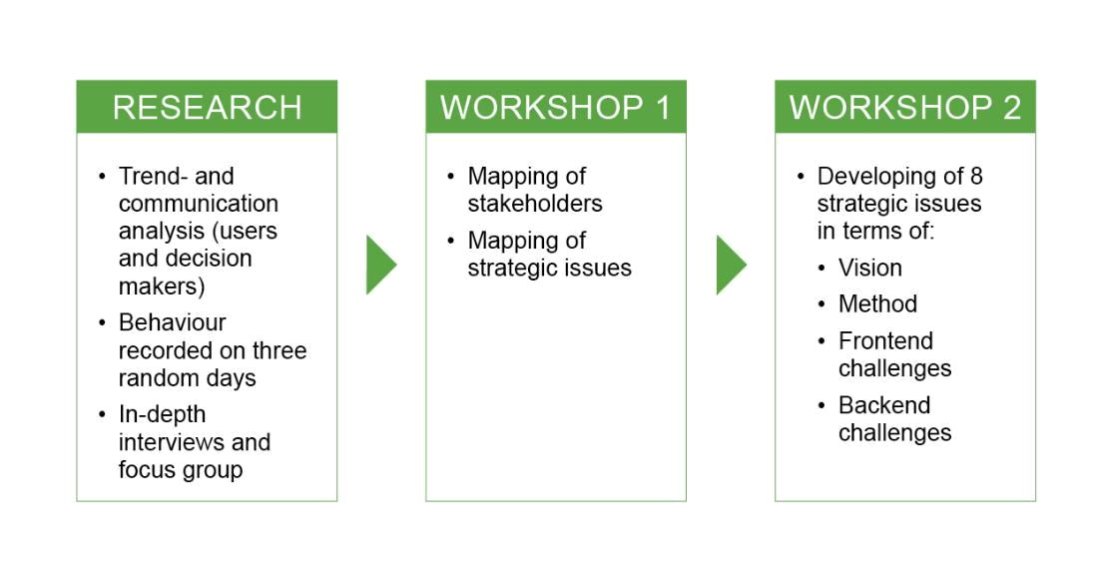

On the basis of a preliminary version of the report a first workshop was held in which strategic issues were identified. These formed the backbone for a second and larger workshop which drew on the wider knowledge network and had the aim of presenting visions of the library in a ten year perspective. The outputs from these workshops form the backbone of our considerations on stakeholders, new ways of value creation and how to use strategic roadmaps in crafting possible futures.

In the chapter on culture and identity we have quoted extensively from the interview material to give an impression of the kind of response we have got and how it can support our analysis. In the other chapters the form is of a more consolidating nature.

Throughout the work on this report we have received help and support from many people in and around the research library system – in Denmark, at the Nordic and international level. Many have contributed by being interviewed or by participating in workshops or giving other forms of feedback. The authors of the report have been professor Hans Siggaard Jensen, professor Volker Mahnke and associate professor Dorthe Staunæs from the Lime Guild. Head of Division, Libraries Jakob Heide has provided the figure on p. 19. We thank all that have contributed. In an appendix a list of all interviewed and all workshop participants is provided.

8
Content:

- Challenges for the research library and the research library system

- Tendencies in the development of the research system of importance to the research libraries

- The structure of the research library system as a system supporting research and information behaviour

- Users of the system and their forms of usage

- The culture and identity of the library and the librarian

- Value creation of the research library system in relation to its stakeholders

- Scenarios and strategies for the development of the research library system

- Stakeholders and possible future action recommendations for the system

- Template/outline for/of a dynamic roadmap with forms of feedback

- Elements of a roadmap

Appendices

9
- Challenges for the research library and the research library system

Advance in digital technology drives change

The major source of challenges for the research library and the system stems from the development of digital technology and the rapid uptake of this technology in society and particularly in the research and education system. This development has had and will have direct influence such as through the phenomena of the virtual journal, the e-book, the massive amounts of data in digital form and the general availability of enormous amounts of searchable information on the Internet via engines such as Google.

The development will have indirect influence because digital technology and its various spin-offs also have enormous influence on the way research is done, the way education is delivered, and the way large segments of people are working. Virtual books and journals and other forms of information using the variety of media available (such as sound and pictures and mixes) can be accessed from everywhere and they can be “housed” nearly everywhere – where there is a server.

Old functions served in new ways

An important point in the way digital technology has developed in relation to research is that many of the services and standards were developed “spontaneously” by active researchers that saw new possibilities of doing research and research cooperation. ArXiv is a good example. It was created in 1991 at Los Alamos National Laboratory as a way of making preprints electronically available to researchers in the field of high-energy physics. It created standards and services and was later expanded and became a source of the open access phenomenon and movement. The World Wide Web itself is another example, created at CERN to solve information problems in this research organisation and help handle its information interaction with the outside world. The year was 1992. The emerging services and standards also made it possible for commercial publishers to enter the digital age and create virtual journals services based on licenses and paid downloads of papers. This has created a whole new situation in the field of scientific publishing where the electronic journal is now the central phenomenon. Electronic books were emerging. Consequently, the traditional functions and services of the research library are changing.

New user needs emerge

As a consequence the whole concept of a library is changing as is the user-behaviour of the main user-groups of the research library system. But there are other sources of challenge. The forms of research and research education are changing. There is in the most developed countries a massive tendency to expand the research system and also research education. There is also a massive attempt to expand and improve higher education, and for many years hope has been put on the use of digital technology in this respect.

10
A very important function of the traditional research library has been to meet the needs of the students in a university, but what students need is subject to change. The majority of research libraries are university libraries (or connected closely to higher education institutions). The needs are different at different levels of higher education and at each level they are also changing. Students are becoming more demanding and see themselves more and more as customers. Nearly all educational activities today are supported by digital services and the support of students needs to be done through well-functioning systems that provide teaching material, access to material on the net, bibliographies, and assignments etc., all services that could be delivered through a library as a natural extension or development of its traditional services. At least they have to be provided by the teaching organisation. If the library is involved or central, it means that it may well need to develop into a learning centre.

Libraries co-evolve with the changing knowledge eco-system

The demands that are put on the research library from these developments do not always converge – on the contrary. The digital development alone has challenged the nature and identity of the library as a well-defined physical and organisational entity, and has therefore also created the need for a new focus on the various functions in relation to users that have to be fulfilled in today’s knowledge economy. Thus we need to look at what services are being rendered and what services are needed in the changing knowledge ecosystem rather than on the existing organisation known as the research library.

Historically a library was a building on campus housing books and journals and eventually a reading room and an organisation that provided access to the books and journals via various types of catalogues, some based on classification of the materials. This type of library continues to exist, but is unlikely to remain the dominant form we find in the digital age. To build a strategy for the library of the future requires a better understanding of what functions a library serves to create value for its stakeholders, where this value is created, and how value creation proceeds.

New players, new services

New players are appearing as important and can take over some of the functions or parts of these. Publishers can provide access to journals on-line via their own servers, and universities and scientific groups or societies can provide access to digital repositories of papers and books. Search and classification and even bibliographical overviews can be provided as services on the Internet, perhaps by purely commercial organisations such as Google. Books and journals can be freely uploaded to the net and made publicly available by services (and companies) such as scribd.com and issuu.com. The first electronic journal was made available by the IEEE.

Such digital developments have also created a demand for new services connected to new forms of material and media such as podcasts of lectures, videos, lecture notes that are on-

11
line and other teaching materials and materials for use in the research community. Such material has not traditionally been made available by the research library but is more and more important, especially in fulfilling the so-called third task of the university, the dissemination of research to a wider audience. Again much of this is done by research organisations themselves, but is obviously an extension to the traditional function and obligation of the research library.

Serving users digitally on the move

The development of digital technology and its tendency to encompass a multitude of different media and become ubiquitous (pervasive and mobile) also implies that the identity of the library viz a viz archives and museums is changing. Of course libraries can be seen as a form of archive, but this becomes more clear if the library stocks digital versions of papers, research notes, lecture notes, research data etc. etc., and not only published material in the old sense. Repositories are a form of archive, and an important initiative in the area of open access is even called the open archive initiative (OAI). A library is also of course a type of museum – especially if it holds a collection of rare old books and makes an exhibition of some of these. But museums are also developing and want to make their collections available in digital form such as through pictures or videos or in other ways (exhibitions in Second Life as an example). Whatever the role of the library in the new knowledge eco-system, one thing is exceedingly clear: services need to be accessible on the move, in real time, and everywhere.

Finally there is an important development in the form of the economy often signalled by the use of the term “knowledge economy”, which has to do with the increasing use of knowledge as a “production factor”, which means that larger and larger segments of the business and public system are dependent on the production and use of knowledge for its products and processes, for innovation. Thus there are four sources of challenges:

- the development of digital technology

- the development of the research system

- the development of the higher education system

- the development of the business system

The main challenges outlined above in relation to the development of digital technology and emerging user needs can thus be seen as (a) the changing nature of the traditional functions of the research library when research is published mainly in digital form, (b) the addition of new functions in relation to the digital development in research and teaching outside, (c) the changing identity of the library in relation to archives and museums, (d) the diffusion of functions away from the library to other organisations or entities such as research groups, universities or companies.

12
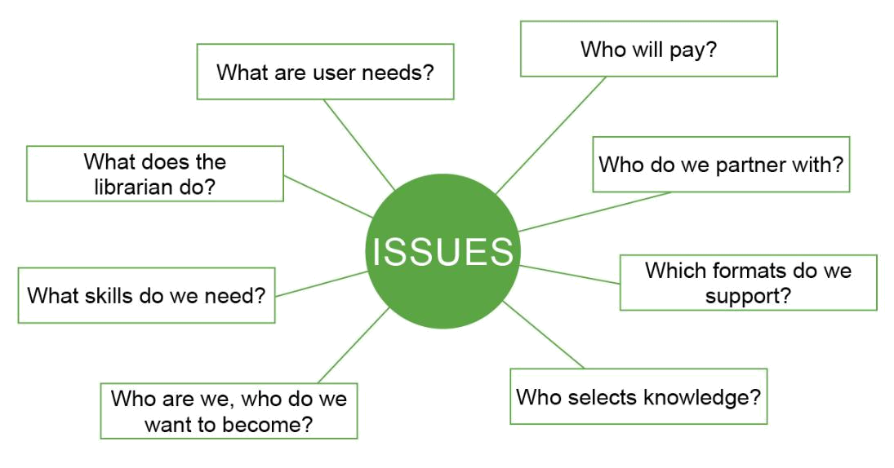

- Tendencies in the development of the research system of importance to the research libraries

Tendencies in the larger knowledge ecosystem influence the challenges outlined above. Depending on the speed of their development challenges might present themselves as opportunities and/or threats. In the current strategic discourse, however, such tendencies appear as weak signals that we crystallized from our data, workshops and discussions.

New forms of knowledge production and dissemination

The research system is changing. It is growing and becoming more central to the most advanced economies. It is becoming more and more international and based more and more on cooperative research projects. It is under a more and more explicit obligation to not only publish for other researchers but be available, relevant and creating value for society at large. To do all this researchers are using digital technology more and more to provide communication in the research groups and to larger audiences. There are millions of department and research project home-pages, and any research project of a certain size has its own homepage. A large group of people are employed by universities, departments, research groups and projects to do dissemination via the Web. Researchers are changing research behaviour as well: They are to a larger and larger extent using social networks (Web 2.0) as part of their work. Research projects are available also in Second Life. All this material is available outside the traditional research libraries and is searchable via search engines that are provided either commercially or as free open source software. An enormous amount of material is available in the family of Wikis, in public wikis and in blogs. All this is going on outside the traditional sphere of scientific or academic publishing and also outside the research libraries. The presentations of conferences are often freely available on the home-

13
page of the conference as are preprints of papers on the home-pages of departments or research projects. We will look more closely at the trends in the development of the research system, but the main challenge to the research libraries is that some of the traditional functions are being taken over or made superfluous and new demands are appearing – demands f.i. for research synthesis – that could in natural ways be the basis for new or changing functions of the research library. If we look at the knowledge system as a whole at least new needs are emerging, and the question is who will meet them. We can say that the library could potentially develop into a knowledge centre.

Increasing linkages between public and private user needs

Public policy is becoming more and more dependent on knowledge and the same holds for public administration. There is a growing tendency towards evidence-basing and in the day to day operation of the public sector access to relevant knowledge is taken for granted. Much working time is spent searching for information and creating overviews relevant to the problems that are being handled in a specific context. This means that the sharp division between generalists, specialists and librarians is breaking down.

A massive amount of research is being done in the knowledge-intensive private sector (of course much of it is targeted or applied research). In the private sector the production and use of knowledge is becoming more and more important as the ability to learn from experience in a conceptualising way and make use of available knowledge is central to private value creation. All public administration entities and all private knowledge intensive organisations thus have to have functions that make knowledge available and provide for the storage and retrieval of the knowledge produced in the organisation – even if that knowledge is not made publicly available.

Many public and private organisations thus continue to have their own libraries that were created to support their specific needs. Government research institutions would have libraries that had the function of closely following the knowledge development in their field as this could be important for society – take a field such as toxicology as an example – and private companies would need to follow the development of knowledge (and the knowledge thus available to their competitors) in the field where they were operating. These knowledge functions are of course under the exact same conditions that were outlined for the traditional research libraries due to changes in digital technology and in the research system (of which public government research institutions and research intensive companies are actually a part).

The needs of these types of organisations are for usable knowledge (f.i. knowledge that can be the basis for evidence-based policies) and knowledge that can be input to or part of innovation processes. The limitation of access to digital resources to students and faculty of universities for whom a library or set of libraries have licenses is of course a problem for these

14
types of users. Large organisations and companies will be able to make arrangements or just pay, but for the large number of SMEs it might be a problem. These users also typically have new types of needs connected to search and validation of knowledge, and to overview and synthesis.

A new mediator role between public and private research

The increasing stress on relations between academic research and research done in the private sector also means that different conceptions of knowledge come into action. This again influences the work of research libraries especially in the way knowledge is categorized and classified. The library typically has a disciplinary approach connected to the fact that it supports an institution built around departments that understand themselves in a disciplinary way. The focus in private research is more on problems and solutions – due to the close connection to innovation – and this gives a different focus. Also synthesis and trend analysis are important in research in private companies because they have to understand themselves as ultimately operating in a market and being under strategic constraints. By the way this is also increasingly the case for universities as a result of emerging patterns of competition (f.i. about rankings and for research funds).

The research library as innovation partner

There is one tendency in the development of the research system which seems to be dominant, and that is the convergence of the research and the innovation systems. Research is in most advanced economies seen as an important part of innovation, and the way it is important is not only the deliverance of basic new knowledge or through applied research, but as an active partner in the ongoing innovation in society. The output of research is not only new knowledge but new processes, products, business concepts, social institutions. At the same time the sources of innovation have also been broadened so as to include groups of users and interpretations of the needs of users and markets as understood by non-researchers. The knowledge system at large thus might be said to include the research system as other forms of knowledge also play important economic roles.

Thus in a way the research system is subsumed under the innovation system, as the basic reason for investment in research is the potential contribution to innovation. This is then again seen as the essential economic driver in the advanced knowledge economy. Innovation processes are highly dependent on information exchange and sharing, and part of that might be in the form of access to the research literature of the field in which innovation is going on, but that is only part of it. The innovation process consists of many types of sub-processes such as ideation (where new conceptions and models are formed), connections and search for other similar ideas and solutions, and tests and trials connected to criticism and evaluation of ideas and solutions. These processes do not go on in the formal way we find in the research system where conferences and publications create a system for presentation, communication and critical evaluation of new research findings. Ultimately innovations are

15
tested on the market (viz. the classical definition of innovation as an invention that is successful on the market). Supporting innovation processes is a new and important challenge for the information and knowledge system, and especially a new function or task that could be taken up by the research libraries.

The research library as a global knowledge gateway

The research system is constantly growing and getting more and more global and international, and it is more and more based on networks and project groups. All this means that communication is of great importance as well as making all relevant information in the research process available to all members. Furthermore researchers are under an increasing pressure to disseminate both their results and their research process to wider audiences of stakeholders. Thus research projects invest in information processes and information and knowledge collection and dissemination. An EU Framework project f.i. is obliged to use fairly large resources on dissemination such as running an advanced up to date home-page and provide open access to all its papers and results (such as software, videos etc.).

Research modes as service differentiation opportunities

Two sets of concepts have been particularly important in capturing the basic changes in the research system and shaping research policy. The research library of the future will relate to such development.

Triple helix and mode 1/mode 2 research

One is the model of the triple-helix. This model states that the interaction between research institutions, private knowledge based companies and government agencies is becoming more and more close, so close that they even tend to exchange roles in a dynamic interaction that is then called a helix. This is due to the increased emphasis on innovation and the result of the “fact” that innovation is furthered by such close interaction. Earlier the three types of institutions or sectors had clearly defined roles and their own areas to cover and there were clear boundaries. These are breaking down. Thus research of a basic nature could be done in private companies, and universities could act as a sort of private companies, just as government agencies could be doing research and not only using it.

The other model is the Mode 1 – Mode 2 model of the research system. This claims that there are two basically different forms of research and thereby research systems. The one is discipline based and related to a clear distinction between basic research, applied research and development. The other sees research as problem-based and inter- or even trans-disciplinary, and focused on the problems of application, so that research takes its point of departure in attempts – and problems – of application. The typical areas where it has been claimed that we see Mode 2 forms of research are IT research and management research, areas that are expanding and closely connected to the emergence of a knowledge economy. Mode 1 is then seen as the more traditional form of research in the highly developed industrial

16
society where typically natural science could be the basis for new industries – that is the basis for new products and processes (examples could be chemistry and the chemical industry and the physics of electricity and the electrical/electronic industry). The triple helix phenomenon of course expands the sphere of information handling to a larger sector than the traditional research institute or university. The Mode 2 type of research creates new demands on communication as the research process is more interactive and in close contact with the various relevant spheres of practice. Thus the research process is not “closed”, in the sense that at the end results are communicated in conferences or publications, but the “publication” is ongoing in the sense that the research process is more open to various stakeholders and interested parties.

Library services in the triple helix and mode 1/mode 2 research discourse

Typically new modes of research involve the use of new forms of communication and even new media. The classical medium of the research paper in a well-established journal is of course used, but many other forms of communications are also used to make early ideas, models and conceptualizations available for comment and discussion. We can say that the research process is opened up, and it starts to look like what we know from innovation processes. The increased focus on innovation also has meant that research in the traditional research sector has been changing. Such a concept as strategic research has appeared and this signifies that the old distinction between basic and applied research is not sufficient anymore. Research has to have an origin and a point connected to important social strategic issues and plans. Governments or other public bodies must have influence. This of course is a limitation of the old idea of autonomy and self-determination in the research sector – connected to the idea of academic freedom of the university. A large example of strategic research is the EU research programs that have the main aim of supporting industrial development in the EU rather than provide new important insights in basic phenomena in this world (providing such insights and knowledge is fine if it accompanies or secures the furtherance of industrial development). The information needs of research of this type are not met by securing a good disciplinary coverage that could support a disciplinary based university and its disciplinary degree programs. The problem based approach and the fuzzy disciplinarity – inter- or trans-disciplinary – makes it difficult to use a classification system for knowledge based on the idea that such a system is a mapping of the world or can be based on some form of basic ontology. It is rather process-based and at least more fleeting in its conception of basic categories. It is of course important also to notice that interdisciplinarity is not only a phenomenon we find in strategic research, also much research that is done only guided by the needs of the research community itself for new knowledge (as solutions to problems experienced with existing knowledge in the relevant part of the community) is interdisciplinary, because problems are seen as emerging not only at the core of a field of research but also in the “gaps” or on the borders between fields of research. This of course has in the history of science given rise to many new disciplines that are in their nature so to

17
say interdisciplinary – such as biochemistry or psycholinguistics. As a consequence of this development, the research library of the future has to deal with new communication challenges at the interface between disciplines and taking into account governments as a key stakeholder of research.

Doctoral education and differentiated research groups

The growth of the research system and its growing economic importance has implied an expansion of research education particularly doctoral education. The formal models of doctoral qualification emerged at the end of the 19th century when the research university became established and there was a need for human resources with clear qualifications to be both teachers and researchers. There was an established job market. In the last couple of decades new forms of doctoral training have emerged in the shape of doctoral schools. This means a new more formalized and scholastic form of research training where the old apprenticeship model is supplemented with taught elements and more organised cooperation. The doctoral student is not to be seen as the apprentice of a “Doktor-Vater”, (a father-son relationship) but as a member of a larger research group where one function is the training of new researchers. This “third cycle” as it is called in the Bologna-process is expanding and it puts new demands on the information and knowledge services of the research group and the institution hosting or housing it. Research libraries need to adapt with the changes of the system developing researchers.

When more and more research is done in teams or as part of research groups of a certain size this means that such teams and groups tend to have their own information services. We have already noticed that they have their own homepage or a place on the homepage of the relevant department, and they might have funding for information access and literature. The publication of their results is not necessarily a way of communicating these – they may already be available as preprints electronically – but rather a process of validation through the peer-reviewing of the material. Teams thus tend to decentralize a number of information processes but still leave the important validation aspect. A research team can not validate its own results. They have to be accepted and presented to a larger audience for discussion and/or have to be through a peer-reviewing process. In this way the publication is part of the knowledge-creating process which is not taken care of just through the posting on a homepage or in an institutional repository.

The current strategic discourse among opinion leaders and experts revealed the tendencies discussed above. As tendencies crystallize more sharply, questions about their systemic impact on the strategic development of the current library system will become more pressing.

In the following table we have tried to give a more schematic overview of the various concepts we have introduced.

18

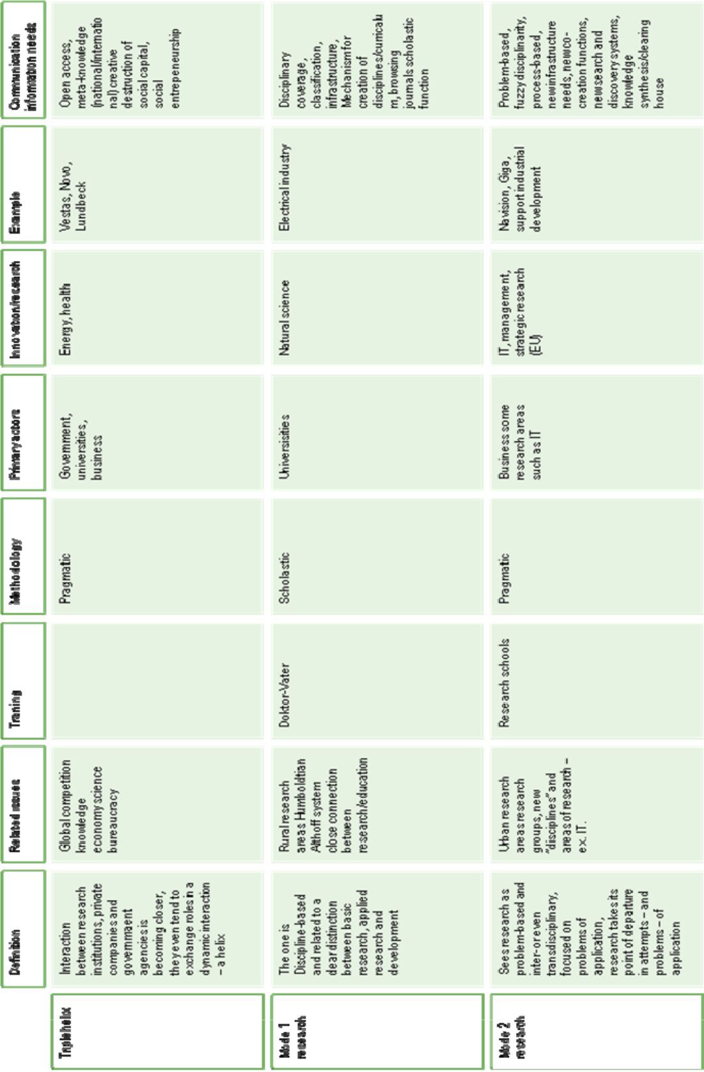

19
- The structure of the research library system as a system supporting research and information behaviour

The main characteristic of the research library system as an organisational system is that it has multiple stakeholders with differing and often diverging interests and “stakes”, and that it is multilayered. Its users have very different perceptions of the system and its parts, ranging from the situation where the system (or the individual library) is nearly invisible to the user to the situation where the library is the central workplace of the user.

The roots of research libraries: Knowledge-representation

The “ideal-type” of a research library is the library that is part of a research institution, typically a university. The researchers might have personal libraries, but the institution or parts of the institution has a library because of cost effectiveness. One book can serve several users. Historically the library has been a very central part of a university, and the first “modern” universities were known and had a reputation to a large degree due to their libraries. The best example is the Göttingen University in the middle of the 18th century. The modern concept of a library as a useful collection of books – rather than as a part of a “Wunderkammer” – has its origin in the 17th century where also the idea of the public library took hold. During the 17th century the various aspects of the collections of kings and princes were differentiated, and the institutional forms of the library, the archive, the museum were grounded. Libraries were organised typically after the way the university was organised in faculties and departments. People like the French royal librarian Gabriel Naudé (who wanted to open up the private royal collection for public use and minimize expenses on rare and beautiful books for the use of funds on useful books) and Gottfried Leibniz (who was most of his life a librarian) wanted to create a systematization of knowledge and thus a sort of virtual library mirroring the totality of reality. This would be a universal catalogue giving a map of everything in a structured conceptual space. Personal libraries and collections originated through bequests and other donations and had a tendency to be fragmented and not universal, whereas the ideal of the library was the universal representation of existing knowledge present both physically in the form of the books and collections of journals and virtually in the systematic catalogue. This became the central instrument of the library and potentially – if it could be developed as an universally agreed upon classification and categorisation – an instrument of general use in all research libraries.

The library as locus of knowledge

The library then became not only an archive where the books and journals owned by a university were housed, but also an institution where knowledge was ordered and organised and the various particular perspectives of the professors or the disciplines were made universal. We find the same intention in the works of the various groups of encyclopaedists, who conceived of the encyclopaedia as both a representation of the structure of knowledge and its actual content – represented in the case of the French Encyclopédie not only in words

20
but also in pictures and diagrams. The encyclopaedia was a form of synthesis of existing knowledge. The acquisition of books was to be based on a sort of validation. At the end of the 18th century review journals appeared that could guide this process – such as the Allgemeine Deutsche Bibliothek and the Göttinger gelehrten Anzeigen – where faculty would review new books and the library acquire those that were reviewed favourably. The Göttingen university faculty and the library were thus in close interaction, and what they read were made the content of the library and the content was what they read. The structure of the library mirrored the university and vice versa. But the library was the only place where knowledge in its totality was present. The library with its systematic catalogue, the encyclopaedia and the virtual library of the review journals were the backbone of the new research-based university that with the help of Wilhelm von Humboldt’s ideas and influence emerged in the 19th century.

Research libraries supporting de-centralized learning

At the end of the 18th century the universities of many German states – Hanover and Prussia as examples - were undergoing a general quality improvement that was part of a general improvement of the whole educational system. This was the start of general public education in a state-run formal educational system. Higher education was reformed and this especially was the case of secondary education. The “Gymnasium” was created in its modern form and later closely connected to the reform of the university. The university trained the new teachers and they were trained in the new established disciplines. The close connection between the faculties of the university and the disciplines of the school based on research was forged and a small group of students were given stipends to make study possible. They were grouped in the newly created “Seminars”, which became the origin of the disciplinary research-based departments. The Prussian state financed all this – paying the university, the students and the accompanying expansion and regimentation of the library as the central resource making the research basis of the educational processes possible. Other students paid fees, and primarily went to lectures, whereas the students in the seminars were required to write papers – papers that not only repeated the main points in the lectures. We still find this model in the French “Seminaire” and in the US “graduate seminar”, which is the basis of the American research university and its research training. The type of research was closely connected to educational needs, and was supposed to cover the disciplines in which degrees were given. Thus there was a generic and generalized obligation connected to the need to create curricula and get the research structure and the logic of research into synchronisation with the demands of scholastic reason underlying the establishment of degree programs. This is central to the understanding of the research and university function that we find today. In the work of Steve Fuller when he describes the central function of the university as the creative destruction of social capital – drawing on the conception of the entrepreneurial that we find in Joseph Schumpeter. It is of course also interesting and important to note that from the end of the 17th century the books of the libraries were unchained and could be read in reading rooms

– and of course later borrowed for reading at home.

21
Housing specialized knowledge domains

The German research-based – Humboldtian – university became the model for many universities. The model was later “extended” through the so-called Althoff system created by the Prussian minister for universities and research Friedrich Althoff, who created the model of research that became both extremely influential and successful. It consisted of research based universities doing basic research, applied science universities – especially technical universities that trained engineers – research institutions (the so-called Kaiser Wilhelm Institutes – Einstein was the director of the Institute of Physics – today called Max Plank Institutes) and research departments in private science-based companies like Siemens, Hoechst, Bayer, Bosch etc. that were typically established at the same time. The basic and applied universities trained researchers for careers in academia and in industry and there was a close interaction between particularly the applied universities (typical technical and commercial/business universities/schools) and private companies. Research became professionalized and more bureaucratic and in these fields the basic publication was not the monograph (if books were written they took the form of textbooks) but the scientific journal. In the natural sciences and mathematics and in medicine the German research system shaped the future and created the model. This was of course after the Second World War taken over by the US. Each discipline or sub-discipline would have a journal or set of journals with a fairly well-established non-formal hierarchy. The journal would be edited by recognized peers and have a number of contributing editors/reviewers. Just as reviews in the above-mentioned review journals were deciding library acquisition and often also the career of the author, then publication in journals after peer-review became essential for the status of researchers and their groups or departments. A department would need to either subscribe to the relevant journals or at least have access to them. The research library would have to subscribe to the journals that were needed by the research groups or departments in the university to which it belonged. Textbooks, and particularly graduate textbooks, were then statements of state-of-the-art in a given discipline or sub-discipline based on the current research literature as found in the relevant journals. What then became necessary was to create means of getting an overview of the research literature on a regular basis and phenomena like annual reviews appeared and at conferences tutorials were given on the latest results from the active research fields.

Research libraries as mediator in the knowledge creation and use

The role of the research library changed. The systematic catalogue was not essential to the classification of the collection of journals in the same way as was the case for books, and the acquisition was also different. Access to the relevant journals (and participation in the relevant conferences) was a condition of existence for active research groups in the university. The creation of overviews, annual reviews and particularly bibliographies was on the other hand essential to keep pace with the development in the field – as a research group got more and more specialized and thus knew more and more about less and less but had as university

22
researchers to keep up with developments in the discipline in which they were obliged to teach. For the researchers in the research and development departments of private science based companies this was of course different. They were focused on the solution of particular problems and only followed a field more generally – or science more broadly – to be able eventually to see new and surprising connections or potential solutions. Thus it was the pressure of innovation rather than the pressure of teaching that was the dominant driver besides the drive for problem solutions in the particular area in which the research was done. The two logics are important: the scholastic/academic and the pragmatic ¹

If we look at the present Danish situation we can describe it in the following way. There are a number of research libraries that can be considered as independent organisations from one perspective. They have a certain amount of autonomy and a set of functions that continues the classical tradition of the research library. They are also connected to or part of universities or government research institutions – although a number of these have recently been merged with universities and thus the libraries also have to be merged. The two largest research libraries – The Royal Library and the State and University Library – also have other broader functions. The universities founded after the 1960’s were all founded with their “own” research library. The libraries are thus part of the university sector in a number of ways. They are also part of the general library system and less closed than the typical research library we find in the US university system. The governance of the library system is in the Ministry of Culture which again is divided in an agency with operational responsibility and a ministerial department with political and strategic responsibility. The universities are under the Ministry of Science, Technology and Innovation. DEFF is a coordinating agency placed under the Ministry of Culture with functions in relation to also the Ministries of Science and of Education that funds common projects and has some operational tasks especially in connection with the procurement of national licenses. Some of the libraries are funded from the Ministry of Culture others via the university budgets in the Ministry of Science, Technology and Innovation.

4. Users of the system and their forms of usage

The functional evolution of the structure of the research library system is driven by the various types of users and usage. Its evolution is also co-determined by advance in the technological structure in which the library is embedded. Written books, printed books and journals and digital books and journals create different structures. Producers and providers of information materials are integrated in the system in different way. Printed materials are bought from publishers and the library gets ownership, whereas digital publications are typically licensed and thus there is access but no direct ownership. The same holds for repositories or other databases to which the library gives access. And of course access can often also be had without the function of the library.

23
A typology of users

The users can be grouped in several ways. There are “direct users” that have interaction with the library and its services. They can again be divided into those that have direct perception or awareness of the library and those that do not.
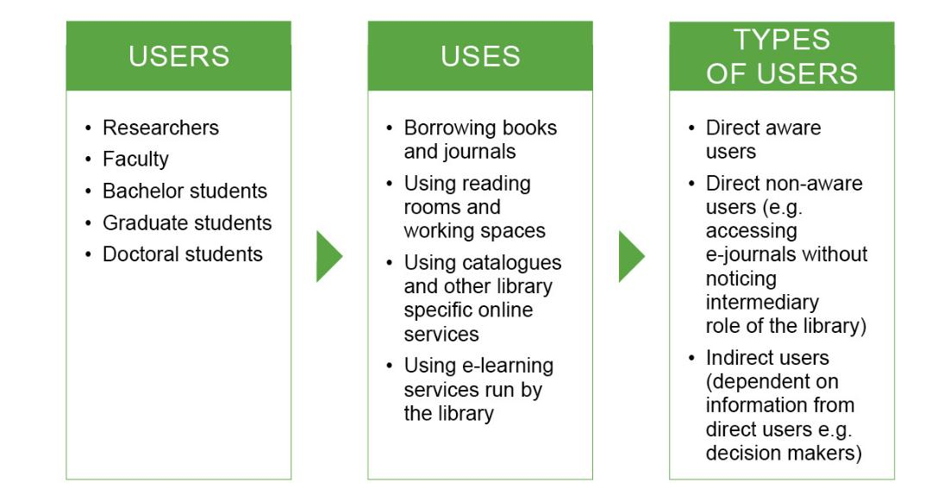

If we look at the stakeholder structure of the library system we can make a distinction between those stakeholders that are users and those that are not. The typical researcher, who is using the library services intensely, is a stakeholder and user, whereas the government bureaucrat making decisions or the research politician is not necessarily a user. The academic personnel having influence on the library are typically both user and stakeholder.

In the classical model of the research library outlined above the library was both an infrastructure in the sense that it was a repository of books and journals that was accessible via an ordering (through the catalogue and the physical ordering of the material) and a “mechanism” for the creation of the disciplines and the curriculum (through the categorization, classification of knowledge – what could be called the “virtual library”). In this sense it was a central part of the identity of the university as a university. We can describe these two aspects as the infra-structure aspect and the co-creation aspect. The infra-structure aspect looks at the library as a service that should fulfil the needs of its users and the aims of the stakeholders. The co-creation aspect points to the interaction between the library and the users – in the classical case the faculty of the university in which the research library is located. Through this interaction understanding of disciplines and curricula are created.

The co-creation aspect has been waning as there has been an increasing importance of the pragmatic research aspect in the university sector. The close connection between research

24
and teaching of the Humboldt tradition has been loosened and research in itself has been an important activity of the university. This has been particularly the case after the Second World War when large research supporting bodies were created that funded research without connection to education. Then government research institutions typically did not do education and the universities would have a research budget connected to education and then a research budget funded through research councils, foundations or through external contracts with government agencies or companies.

Infrastructure and knowledge-co-creation aspects

The technological development we see creates a focus on the balance between the infra-structure aspect and the co-creation aspect because many of the infrastructure functions can be handled in new ways and new co-creation functions appear due to the new information situation we find ourselves in with the Internet and the general digital development.

It is interesting to contrast the situation in the library system with the hospital system. They are both complex systems with “users” inside the system, because the service rendered is provided not only by contact but by interaction. There are complex decision processes in each system and a multitude of layers. Priorities have to be set and organisations developed. The main difference seems to be that there is a clearer focus on the function of the hospital in the sense that if new functions come up they are more easily spun off to new types of institutions like special hospitals, centres for care of the chronically ill, social services etc. etc. Thus the system differentiates and has a fairly large degree of division of labour and functions. The research library system seems in another way to accumulate functions rather than spin them off. With the emergence of larger and larger universities that take up functions from e.g. government research institutions this tendency is increasing.

The library system can of course be seen as an expanding set of libraries. The personal library of the researcher or student, the department or research group library, the institutional library, the national library and eventually international or supra-national libraries (such as are appearing on the Internet. (The Gutenberg Project could be an example). There is a strong tradition for coordination between department and institutional libraries and expanding coordination at the national level. The library system can also be seen as underlying several governance regimes. The needs and policies of the institution where the library is typically located are important, but so are needs and policies representing outside interests. These are typically voiced from more external governance agents – politicians and bureaucrats in agencies regulating or financing the library activities. The various decision-makers have of course different policy goals and interests. We will look at these when we analyse the issue of value creation and stakeholders in the system.

25
Changing uses of the research library system

We have already outlined a typology of users above: The direct and indirect users, the direct aware users and the – probably increasing group of – direct non-aware users. To these groups of users we should also add the users seeking information outside the library system searching with Google and using publicly or privately available databases and other resources. Studies of the information behaviour of researchers show that they read more papers from a wide range of sources. A key driver for this is the increasing role of Mode 2 research. But the usage of papers also changes. Less time is used reading a paper. The massive tendency is towards papers being available - and being read - electronically. Active researchers tend more and more to keep informed about the knowledge situation in their field through direct communications in their networks rather than reading journals. The way a researcher is keeping informed is moving from browsing relevant journals and proceedings to searching via the increasing number of tools with increasing quality available for this.² If we look at the tendencies in the usage that we have found in our interviews and in our analysis of communication in the relevant knowledge sector, it seems that we can outline three emerging and possible roles of the research library system. We will present these and they could form the basis for a description of potential developments of the research library system.

Emerging role #1: The research library as learning centre

One is connected to the increasing use of e-learning in the regular operation of higher education. This makes teaching material available in the form of bibliographies, lecture notes, texts, assignments and it transfers an amount of interaction between the teacher/s and the students to interaction via the net. This is both an operational and a archival situation. There has to be a day to day operational support and support in creating and maintaining content, and there has to be an archive of the various courses and activities. The research library is often a natural operator and thus expands it field of operation and needs new forms of competencies to be able to fulfil this new function. Or the alternative is that the university creates a new independent unit to take care of these new functions. But often the library and the new unit will of course have to cooperate rather closely. The other obvious fact is that if the library is involved it also implies very close cooperation with the involved faculty and the other bodies in the university responsible for degree programs and curriculum. The tendency can be characterized as a development of the research library in the direction of a learning centre.

26
Emerging role #2: The research library as virtual knowledge centre

The second role we see is the demand for the research sector for increased support and different organisation. The traditional function of the research library was to maintain a broad collection of current qualified knowledge in the fields of research and teaching of the university to which it was attached. This was earlier called the scholastic function. As mentioned with the development of the research system and increasing importance of the innovation and economic growth, the pragmatic function became more important. With the enormous growth of information available and the growth in publication especially on the net there is a growing need for support for the most active and important research areas. This is especially the case in areas that are newly formed and thus have not gone through centuries of consolidation of their conceptual and categorical structure as disciplines or research areas. This is fi. the case in the area of IT research. In the sociology of science there is a division of research areas into two types: the rural and the urban. The rural areas of research are like the fields in the countryside, there are certain research fields and typically in a university department there are professorships in the various fields. They are cultivated individually and the cooperation in the field is typically with other researchers in the same field at other institutions – nationally and internationally. This is a model of research as heavily partitioned. The urban type of research area is much more like a market. There is a focus on important and very live problems and much is happening and people are assembling. This is a model of research with a number of very active foci and problem areas where things are happening. At present we see this fi. in nanotechnology and areas of genetics and biotechnology. It was the case in nuclear physics back in the 1920’s when quantum mechanics was created. The rural model of research is closely connected to the scholastic logic, because the way a department was staffed with researchers was to support the curriculum of the degrees offered by a department by active researchers. Otherwise the teaching would not be research-based and thus not live up to the essential Humboldtian requirement of the unity of teaching and research. The urban model of research is much more connected to the idea of research as a driver of innovation. The active research areas and the groups involved - feverishly publishing preprints, papers and going to untold numbers of international conferences and seminars – need support. They either take care of that themselves or expect their institution to provide it. Alternatively it can be provided by national or international organisations or units. This creates a tendency for the research library to become a research area knowledge centre or at least house such centres.

Emerging role #3: The research library as catalyst for knowledge synthesis

The third tendency we see is the tendency for knowledge synthesis. This takes various forms. They all have to do with the meta-level of knowledge. Validation is an important aspect. This has to do with the quality dimension which was of central importance in the origin of the research library as outlined above. The validation issue actually is not so much a burning issue because of the collections or acquisitions of the library, but rather because of the

27
enormous amounts of available information outside the library. Thus it is often seen as a new function – even obligation – of the research library to assist in and secure some form of validation function. Synthesis in the form of establishing protocols of accepted research and consolidation of such research through some forms of review and assessment – such as goes on in clearing-houses and other organisations like the Cochrane and Campbell systems – is also a form of creation of meta-knowledge. Now we know what it is that we know – if we actually can conclude that we know something rather than that an issue is undecided. We can term this tendency the meta-knowledge centre tendency.

The three emerging roles involve different groups of users and technology need. For example, the learning centre has students as the primary users, and then there is a restructuring of the interaction between library staff and faculty involved, but the faculty are involved as teachers rather than as researchers. Thus the broad demands on the library to be able to secure curriculum and broad support of the needs of degree programs are in focus. The knowledge centre has researchers in general – that is researchers in the university sector, government research institutions or private companies – as users. The knowledge centre also has to have close contact with the organisations and the “science bureaucracy” in the active research areas they support. The tendencies in the research system that we looked at, such as Triple Helix and Mode 2 also point in this direction. Government agencies, companies, universities have to cooperate and need support and assistance in the active fields that they are engaged in. The relation between the library and the researchers of course become very close, and the library stops being an infrastructure and develops into a new type of unit that is typically a co-creator in the knowledge-production process. The users in the active research groups can often be direct but non-aware, in the sense that they have information needs but will typically get these solved, library or no library. The meta-knowledge tendency involves users that have increasing information needs and have to have overview of the available knowledge and its status in terms of validity and quality. These types of users are often indirect users in organisations where there are then direct users that provide information. Thus various forms of staff functions are relied on to provide this or it is bought from consulting companies or other information providers. The role of the library staff is here a new one in the sense that their expertise in various fields has to be developed to know not only what information is available but also the structure and personnel in the various fields. There has to be close cooperation with the fields as such, but this can not be solely through the faculty of the university in which the library may be located. Thus this points towards national or international organisation of such activities. Again it is important that research synthesis is not only an infrastructure activity but a co-creation process. The available resources for establishing overviews of existing research of course have to be available but they are increasingly available on databases and bibliographies found on the net in digital form.

28
The roles revealed above can be linked to different identities and models of the library and thus are a foundation for different future development paths. In ideal-type scenarios we could focus on one tendency and thus get a future model of the research library. In actual developments there would clearly be a mix of roles, identities, and technology. Thus a realistic scenario would be connected to an analysis of likely emergence of likely combinations of such central system elements. The meta-knowledge system appears as a radical development of a classical function of the library connected to the radically increased importance, amount and complexity of knowledge today.

- The culture and identity of the library and the librarian: the touching library

“Well I believe, I don’t believe, I don’t believe at all seen from an organisational angle that you would be able to accomplish anything at all if you are not out there in the offices face-to-face with people, you see? […] You have get out there and touch people, you know. If you want to accomplish something, you need to tell them to get out there and grab hold of the teachers (N: 1575-1586)”

Our belief about who we are does influence what we perceive as possible. In the interviews made with representatives from the research library sector we see a tendency towards a break-up of the organisational identity of the professional librarian. Although several of the interviewed persons refer to the task of the research library/academic librarian (B/b) as being “relatively simple” involving tasks such as providing literature for researchers and students, a closer study of the interview material, however, points to a broader set of a number of emerging professional identity. These are:
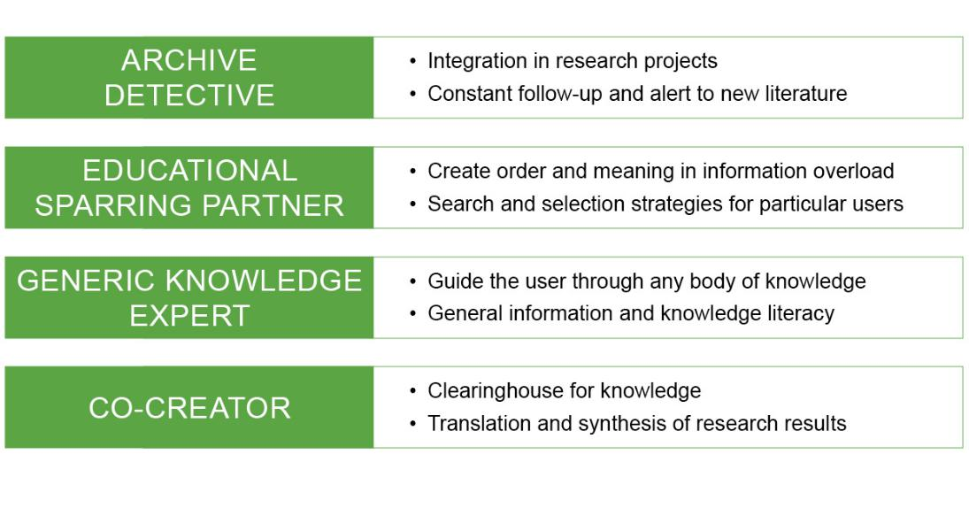

29
From knowledge and cultural communicators to archive detectives

The interview material points to the fact that there has been a shift from B/b as the traditional cultural communicator to being a contributor in ensuring a knowledge project, and that this shift has to do with the concurrent exploding growth and commercialisation of the volume of knowledge available in the form of texts and data. The libraries / librarians have to see themselves in the light of market conditions and have to form part of a special knowledge economy which delivers and sells services:

We have studied the identity of the public libraries and public librarians which is exciting, right? But the story of the research libraries is a quite different one […] in a way, if I am being quoted it should probably not always be 100% word-for-word […] earlier you had a different kind of hierarchy, and until, let’s say, the mid-nineties you had research librarians who were the professional specialists and the discipline specialists. It was back then where the librarian education was not an academic one, but a professional one, right?

Then you had the ones who knew something about the profession. Beneath those you had the librarians who only from 1985 received the same amount of theoretical education as the public librarians. They had, it was a librarian group which was highly based on the apprenticeship principle. And then you had some librarian assistants who were office-trained staff. And this means, if you look at the identity history, then it was the librarians, at least until the new education came in 85 I think, I think it was 85, 86, their identity was, now I am guessing a bit as no research has been made on this, but it must have been centred around library technical processes. That it was something you could, right […] it was very trade- oriented, right? Very trade-oriented, the catalogue had to be correct and the librarian reference had to be correct, right? Well, it was a bit technical and they were also a bit condescending perhaps, of the public libraries. The basic identity has probably, I think, changed from being a little technical oriented towards … to resemble that of the public libraries in the way you talk about service. (N: 1395-1467)

One of the persons interviewed describes the present professional identity like this:

The librarians are perhaps in a development, generally both the public librarians and perhaps also these, in a development stage where they perhaps move more towards becoming, eh not, not … well researchers. Not to say that they are researchers, but more some ones who find things, that is in the English sense of the word researchers (H: 1580-1584) A sort of detectives (1588).

The librarian thus becomes a sort of archive detective. We shall revert to that.

30
Even though B/b has traditionally been seen as very user-oriented, the challenge for B/b is to get in touch with the users and their needs, now more than ever:

Yes somebody who can understand and familiarize themselves with the users’ needs. Well, it is important that you can do that to be able to operate in a market. That you simply understand what is requested and that you do not deliver a service that is wrong compared to what is requested (H: 862-865)

There you can say [that] the users of the library and this includes both students and researchers and people in general, they have a very traditional picture what a library is, right? (N: 426-428) they don’t mind us doing all the other things, but this does not mean a lot to them (N: 432-433) […] that is the balance that you have to keep in a library including the research library, on one hand you have to be technologically advanced. On the other hand, you should not try to smoulder the users (N: 437-443). First and foremost, you cannot assume that the library means anything to them at all […] there is a strong tendency towards that assumption (N: 447-451).

What then characterizes the user and which user needs can be identified? First and foremost, it is difficult to describe one kind of user. We are talking about different users with different needs, each requiring a specific kind of librarian identity. As one of the interviewed persons put it, this is a demographic challenge to the research libraries, “as they have to serve a larger, a more heterogenic and I am tempted to say a less independent group of individuals “(M: 398-400). Going from a user group which mainly counted students and researchers employed in universities and other public research institutions, today the research libraries are also much used by policy makers and “ordinary people” who have e.g. fallen ill or have a sick child and who of own interest seek information within super specialized areas.

Further, it is B/b’s task to identify the differentiation of the individual user groups:

Researchers are not a group, right? There are researchers, middle-aged like myself, who has a … (not hear able), who have a very big information network and who receive relevant literature all the time, right? And then there are assistant professors who are building a qualification process or young associate professors who are building it up, they have very different information strategies, you can almost call it, right? But I think that we all have one thing in common, which is that it is completely impossible to get an overall view of (N: 832-848)

B/b must have diversity in mind and be able to contemplate what this diversity means to the contents and format of the service.

31
However, there are also a number of requests which straddle all these user groups and which all call for a more active, progressive and investigative research library. That is a research library which is not a passive communicative knowledge or data, but which is rather able to create relevant universes or scenarios of texts or data. It is a library which can touch and move the user towards what would be relevant for him/her in the given situation. Such a library must be cutting-edge as put by an informant and points to the fact that exactly the ability to change and adapt is carved in many research libraries and – into the self-knowledge of the librarians. Not to say that the library in itself creates change. More that the library is an early adapter which catches and appropriates tendencies – especially within the technological field:

Well, I have always considered the library administration, perhaps along with the tax authorities, I am not sure … as the public institution furthest ahead IT wise. If you check out the application of IT in the public sector, then that is the only place where they have made really well-working systems that cover nationally and are connected […] That is because the library administration, and here I speak of both research libraries and public libraries, have a very, very long tradition for being good, I will not say technologically innovative, but technologically very good at being adaptive (N:.208-227).

Apart from the technological ones addressed in other chapters, which innovative initiatives can be identified in the current identity formations which follow the change in the user mix and the commercialisation of knowledge and which fall under the identity as the touching library?

B/b must have a huge overview and at the same time be able to have a dialogue in which B/b is a qualified listener for the user’s need and thereafter put the need requested by the user into a bigger perspective:

So I believe that the libraries, the librarian have to take on a new role, they shall not, they shall not only find and seek literature, that too, but they must contextualize the literature, find out what it can be used for (M 1230-1233)

Again the point being that B/b must create contact and dialogue instead of being passive communicators - between itself and the user. The identity components in the touching library must thus be integrative with the user’s day-to-day life, form an educational part in the user relation and perform qualified selective research:

The new librarians are not researchers, but a kind of archive detectives who support and communicate with the researchers. This means that they have to establish new

32
cooperation relations; they should enter into close contact with new cooperation partners and possess good communicative skills.

Selection is not just selection. It requires a certain form of synthesizing and knowledge control:

Creating some pictures, that might be … so you are really saying, creating some pictures of how a relevant problem can be elucidated by drawing on available data. Well, or that they set up the registers in a new way (H: 425-427)

The consequence is then that the control, the social control which you can say that the

- the individual research communities sort of places over the knowledge which is shared between the individuals which are part of the society, well it will simply become poorer (H: 251-254) That kind of knowledge has exploded. And it would be impossible to imagine that kind of knowledge in the head of a man (H: 321-322)

In that perspective, the libraries come close to a sort of clearing houses performing ”translations” and syntheses of research results and publications. Which will help the researchers who .. ”In reality researchers are persons who just as much / to a high degree, are users of other persons’ knowledge that has been published or to which they have otherwise gained access” (H: 470-472).

The research libraries thus become ”a market place for knowledge” (H: 486), in which private companies and research libraries can draw knowledge out of research areas and pass it on. In this vision, knowledge becomes privatized, becomes a product and becomes adapted to the user’s need. A dramatic shift compared to the idea of noble knowledge sharing. Thus also a new user group to be found within the private sector’s research.

B/b as an integrated part of the user’s day-to-day life

This point applies differently to the individual target groups. In relation to the students, B/b must focus on the teaching. Apart from offering e-learning, end-notes courses and literature seeking etc, the integration in the student’s day-to-day life could be getting involved in special teams under the slogan “rent a librarian for a day”, where the librarian comes to the users and integrates his/her competences in the users’ tasks:

It could be an interest appetizer, but it cannot be more than an interest appetizer where you then have to interact with them. And there you will meet some resource problems and I only believe we will succeed, I only believe something like that can succeed if the teachers support it (N: 948-951)

33
Another way to get integrated in the students’ day-to-day lives is to offer up-to-date physical locations where the students can study with other students and in that way get a sense of a working day and a working community. In that way, the library will become more of a social zone, instead of the quiet room for lonely absorption which it is traditionally known for. The librarian must thus also change role in this room from being a sort of attendant (Staunæs & Khawaja 2007) to becoming a sort of facilitator of the study environment:

I think that they have to be kind of knowledge, as I put it … knowledge brokers. They have to do more than just saying “schyyy!” and well the old librarian whom we joke about, this kind of caricatured librarian who says “Schyy!” (M: 1577-1580)

they have to get out there, meaning, and they have done so a bit with the students at least at some of the research libraries, where you can say that the general, somewhat traditional lecture on information sources and search techniques becomes replaced by more consultant-like tasks in relation to project groups N: 896-901)

B/b as educational sparring partner

When B/b becomes an integrated part of the users’ day-to-day lives, the librarian has to change into becoming sort of an educationist. If this integration has to be successful, the key word is to – educational-wise – assist the user in creating order and meaning in the information overload which is hitting the user and thus together with the individual user to develop search and selection strategies adapted to this particular user.

Selecting knowledge offers is joining the battle for true knowledge

The explosive growth in knowledge offers and in the potential users of these knowledge offers, demands new selecting competences from B/b. Antennas are required to detect the user’s needs, but just as importantly to differentiate between the quality of the information (N: 1103-1141)

Getting access to, if that was the concrete case, the best national knowledge within my field of interest that would be interesting. If you worked within another field, it might be interesting to get access to the best international knowledge within that field, but of course with some kind of starting point in the national base (H: 950-954)

What is it then, and who is to evaluate what is the best knowledge. The research libraries and the librarians in such a situation, will have or may get an immense influence on which results will reach the users and this may not be consistent with what the researchers had. This question is reflected upon in different ways in the following quotes:

It is of course correct, if a research librarian, all, falls in love with a certain field, that he or she will say: ”This is the only right thing and if you want to know something about

34
this, this and this method describes it best and the reports you can find about it, are on shelf 4 and that is simply the right thing”, well then … then I think that you have a point that it may be a problem. But, but that is then, you could say, a challenge or requirement that you, as a knowledge communicator – do not judge what is the best knowledge to communicate, but instead offers knowledge opportunities. It seems .. if you have to .. and .. and .. well a valuable approach would be to say ”well, if you choose to look at the matter from this angle, I can recommend this, but if you wish to see different aspects, then you should perhaps look somewhere else and I can help you with that as well” (H: 1009-1021)

And that is the point, because that is exactly what I think the new potential user groups would be interested in. They are not interested in being told that if you need knowledge of this or that, then go to this room and then you have to spend the time finding the knowledge in there. The new potential users, e.g. private companies, they want to know which room to go to, but they also want to know which shelf and this and this material. And there you of course have to find a balance, because you have to boil it down to not only which shelf, but also which book, even this page and perhaps only this line on page 54. It is about finding the balance between the different interests, because you, of course, have to give, you can say, correct advice. And correct advice is based on offering the users more opportunities, but also that you, you can say, after a dialogue with a user identify what the user really needs.

From a librarian perspective, it is of course an interesting radical transformation of the professional identity, but also a radical transformation that appears to be a bit problematic. Yes, it may actually create nervousness from time to time to enter “the battle about finding the right knowledge”:

Then you will get more professional input from more professional traditions and more disciplines which you never had earlier, right? And that in itself makes it much more difficult, it makes it much more difficult as a research librarian to make a relevant evaluation and to identify the right knowledge, right? Because it is also one of the ways in which – you can say – both researchers and students can appear innovative […] Because it must be a bit of a task, where I as a librarian would be very nervous about doing something inappropriate or inconvenient. (N)

B/b as qualified, selective researcher or archive detective

In relation to the students as well as the researchers, a decisive change can take place including a higher integration of the library in the research and the actual research projects:

35
The research libraries, I think, should be, should be more outgoing in relation to, not institutes, but in relation to ongoing research projects […] yes and you can call that state of the art, it almost corresponds to a literature review of a scientific paper, right?

- what you need when you are in the middle of a more long-term project, is a constant follow-up on literature and good advice, right? They just have to send some links of interest to you from time to time, etc. And participate in some meetings, right?
- it would be wonderful if they had some standard literature reviews available within different subjects (N: 852-879)

Also, I don’t think that the library should in that way, as you can put it, actively communicate knowledge, but I do believe that it could be centre for a.. a.. a.. contact creation, or a visualization of what kind of knowledge is available without, so to speak, you could say communicate it, if you see what I mean. The research libraries should not as such go out, on behalf of you and explain the idea of your research results. I don’t believe that … But if somebody would be interested, let’s say the technology council or a ministry being interested in some area, let’s say your area which would typically be the Ministry of Education, well then it would be quite natural, I think that a research library, if they had the capacity and the competence, would contact the Ministry and say “please know that if you are looking for knowledge about our field which we think you may be interested in, meaning research-based knowledge, then we can offer you some services, we can, we can sort of categorize this knowledge for you. We may even be able to find relevant articles for you, which may be interesting for you to study closer, but I don’t think that the research libraries should play the role of explaining and thus interpret the contents of the articles. (H: 718-740).

That this close relation to the researchers is not without problems and may mean a serious change in the professional identity, the following quote speaks to:

That task that they should interact more, but it is also a question about, well you have to connect with influential people, right? It’s some of those university people, meaning that they have to sleep with the enemy, right? […] you have this professional identity

- then the others act inadequately in relation to your identity, norms and professional traditions (N: 1529-1550).

Four tendencies provide an opportunity for developing a new library organisation and for new librarians with quite different competences and altered identities. The key word for this identity and organisation change is “The touching library”, i.e. a research library which can touch and move its users through its competence to select and qualify knowledge, and which is touched and moved by its users in order to deliver the best possible product. Even though core elements of the touching library appear to remain central to current ideas about librarian

36
identities, we find that professional identities are always in the process of making, flexible, change-ready and in constant exchange with both text /data material as well as its user group. More specifically, we find self-perception of system insiders to be shaped by increasing awareness of the following manifestations of a changing context:

- First: an explosion in the text and information volume that can potentially be communicated.
- Second: an extension of the user group from including students and researchers to also include researchers from the private sector, policy-makers and ”the curious citizen who wishes to be well informed.”

- Third: a more complex differentiation and professionalization of the communicative tasks (as educational learning room/educationist, support researcher and finally knowledge communicator)

- Fourth: a number of new technologies, including technologies implicating a radical transformation of the social and professional contact between B/b and the users.

- Value creation of the research library system in relation to its stakeholders

Value creation is in the eye of the beholder in the systemic evolution of the research library.

Different identities lead to alternative ways of perceived value creation:

Where you can say, here is your package and then you can go and interact in that electronic space. And you have a package of literature. And then you can say fine, then the library has contributed a lot. But what you do, what then happens to some students is that they are now not forced to look for alternative literature. And then you get a problem in relation to what the research libraries consider their other very big task, i.e. providing the students with elements of something that make them resemble the librarians. If you put it a bit square, right? Well that is information literacy. It is really about making them resemble the librarians, i.e. a strong rational element. So that give some very interesting conflicts and I of course believe that both parts should be present, but you have to find some kind of balance, right? (N: 520-542)

The systemic evolution of the research library of the future is riddled with conflict of interest and interpretations that are related, but not exclusively explained by the changing identities:

37
The dilemma is that you on one hand do something for the user and make yourself indispensable, and on the other hand you create the user in your own picture and thus make yourself dispensable. They can seek their own information. But, and this is interesting, only within a certain context and in certain and not flexible ways which may be more adequate seeking ways today. The professional identity has shifted in the way that earlier you worked from rational and regular search patterns and only within a well-defined field. Today, the search is more “situational” (cf. N: 598-616), but also more user-oriented and that in relation to a differentiated user group. You, thus, have to establish whether it is a student on bachelor or PhD level and at the same time identify the special information available that would fit this specific user”… :

When we look at value creation we have to distinguish between instrumental values and intrinsic values. The instrumental values are means towards other values whereas intrinsic values are the ultimate values – values that are not valuable because of something else, but only so to say themselves. Returns to investments in ‘the library of the future’ derive from two main sources: Value to the public and value to private users. In creating public and private value, we also have to make a distinction between creation of value in the sense of a positive contribution – an increase (if the value domain can have a measure) – or a saving, in the sense of creation of opportunity for use of resources in alternative ways.
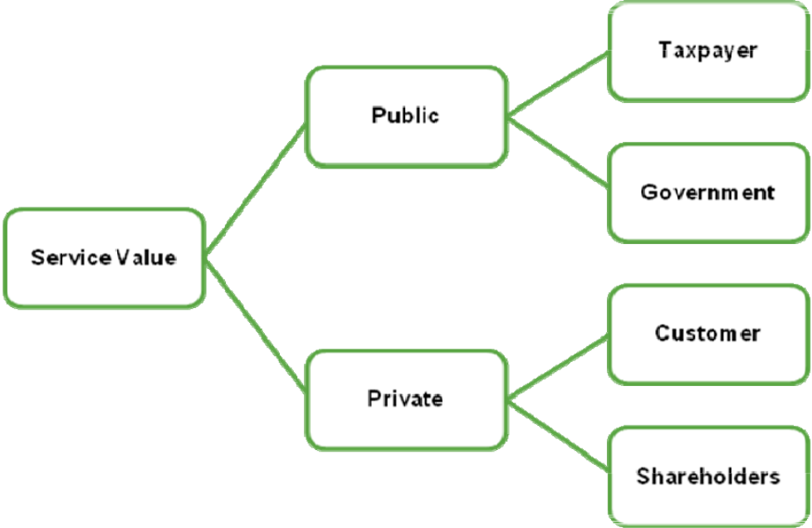

38
Value to the public

This type of value results e.g. from increasing services levels, system reputation (internationally, nationally), and, the integrity and reliability of research services made available to the public. Value to the public is often indirectly assessed through the externalities (positive spill-overs) that public good investments create. Ultimately, however, public value of research libraries is measured as contribution to intrinsic values shared in a society.

Value to private users

This type of value results from delivering specific services to private individuals and user groups that include, for example, access to data search services; coaching of learning processes; and, innovation partnering between research library experts and private companies. Value to private users is often manifested through time saving, increased innovation rates, accelerated product development that are made possible through investments in modern library facilities.

Interactions between value to the public and private value

Both types of value creation (public and private) are richly interrelated. For example, most organisations and systems consist of parts that form wholes. It is important to look at the value creation in a part-whole structure. The values of the parts need not converge with those of the whole or vice versa. Of course they can do – as when a member of an organisation shares the values of the organisation and acts upon them. Otherwise, trade-offs have to be made where the values of the member of an organisation are different – even contradictory – to the values of the organisation of which he or she is a member.

Value creation from infrastructure investments

The original form of value creation of the research library was based on minimizing expenditure for acquisition and availability of books and journals. By having a central store it was possible to acquire fewer entities and by making these available it was possible to maximise their use. Books were expensive and few could afford large private libraries. Thus there was great cost-effectiveness in the organisation of a central library for a population of users of a certain size. This form of cost-effectiveness is found also today in the acquisition of licenses for access to e-journals and databases, although here the physical aspect of the material being present is of course not an issue. The instrumental value in the availability of the materials in the library had to do with the function of the faculty and students of the university of which the library was a part. The main function of the university in which research libraries were created was to secure the development of qualified curricula for higher education with the aim of improving it – particularly secondary education. There were of course also collections of book connected to various scientific societies and other bodies doing research work, but they did not develop the model of the research library as an organisation based on the idea of a generalized model of knowledge. The improvement of

39
education is naturally a contribution to the development of society and thus based on basic political decisions.

With the development of research-based universities and research as a main and often nearly independent task the value creation of the research library is connected to the value of research. It has often been claimed that investment in research is a good investment. Not only does it give knowledge which is of intrinsic value, but it also contributes significantly to economic development. The provision of access to information is an important aspect of the research process – obviously. This tends though to make such access located in the form of an infrastructure. It is a service that the researchers need and draw on. We thus have to look at the way value creation takes place when it is created partly via an infrastructure. Here there is a division between the ways production factors operate. The infrastructure is created through a labour process that is independent of the labour process that ultimately creates the value. An example: building a road is an independent process that creates an infrastructure that can then be used by others driving on the road to do tasks and then create value. Operation of the infrastructure is also independent of the use of the infrastructure. This is different in the case of cooperation – or co-creation – where value creation takes place as a result of participation in a common labour process. The measure of value creation in an infrastructure is basically dependent on the use of the infrastructure. The cost of the infrastructure is often determined, whereas the contribution given through the use is not easy to determine. The infrastructure may have the status of simply being necessary and thus a cost that has to be met no matter the return if the activity has to be present. Infrastructure can also be graded and thus provide support to a larger or lesser degree (as when we decide on road capacity). In terms of support of research processes it is probably the case that there is a necessary lower limit to the infrastructure below which it is impossible for a research group to function. If support goes below this, it becomes a waste of resources.

Value creation from knowledge co-creation

In the case of co-creation we see a different form of value creation. This is actually the form we find in the cooperation between faculty and library in securing the possibility of a curriculum. Here the value creation takes place in two forms. The information resources have to be available – that is an infrastructure aspect – but they have to be put to use and the usage is not only done by the researchers. New roles and functions are created and cooperation is the dominant form of labour.

What we have seen in the in-depth interviews carried out in connection with this report is that the interviewed see a future role for the research library and a changing function for the librarian as a cooperator in the knowledge creation process due to the changing nature of research and the changing information situation.

40
The genesis of social capital: Increasing public and private usage

The British sociologist of science Steve Fuller has made a distinction between two ways in which research and universities create value. One is the direct creation of knowledge that can be used in making processes and products available on a market. This is the role of research in innovation. It contributes to the creation of financial capital. In this knowledge is seen as instrumental. The other way is through the creation of degree programs and public education and making knowledge publicly available. This he calls the creative destruction of social capital, because this is the condition for renewal of the knowledge we have understood as a connected world-view and totalizing set of concepts and categories. The narrow problem oriented approach has to be balanced by a different form of value creation that focuses on the more entrepreneurial aspect of the knowledge enterprise. According to Fuller this takes place when a university is both doing research and teaching³.

The concept of social capital here employed has to do with the advantage a group has qua its possession of certain knowledge over others. The purpose of creating knowledge in a private company is of course to create such advantage, and the purpose of much research policy at the national level is to create advantages for the nation. The creative destruction of this is then the function of making knowledge available in more general and public ways. The interesting “paradox” is that only if such knowledge is available can there be education in the sense that people are trained with knowledge that make them employable in a number of functions and not only as very narrowly focused specialists. Much of what goes on with open access, and with other open initiatives inspired by the open source movement, are of course also forms of creative destruction of social capital and thus attempts at the creation of value through the furthering of social entrepreneurship⁴. The processes we see in the publishing business and the news at the moment provide a good example of creative destruction. The availability of news freely on the net and the use of social networks to provide news is also a case of creative destruction of social capital, because it destroys the advantage certain groups have in relation to monopoly or control of information.

If we look at the situation of the immediate users of the library the value creation could be described in the following way. The students, faculty and researchers are users of the library and its services for the benefit of their careers. The students want to complete their education and the faculty and researchers want to pursue their jobs. The value created by the library for them is the benefit given to them in reaching these goals. The goals can be of different kinds. The student might be studying for a career of interest rather than a career on the job market, the researcher as well. The researcher might want to create and contribute to knowledge to gain status and reputation. All these are intrinsic or instrumental personal value. The organisation of all these personal activities has to be such that the outcome is the creation of value at a social level. This can be institutional or at the level of a society. At the institutional level the value is connected to the goals and obligations of the institution in which students,

41
faculty and researchers are working. These again can be intrinsic to the institution or instrumental – the institution being a part of a larger educational and research policy/strategy in the society of which it is part.

In the case of faculty and researchers the determination of value created is divided. The researcher is part of a research community that decides the value of the knowledge produced through a process of assessment and validation connected to publication. This is the peer-review process and is based on open public discussion. The researcher is also part of an institution which has a governance structure with goals and criteria of contribution and success. The two interact in the sense that what counts as a valuable contribution is decided outside the institution as a decision body (the vice-chancellor of a university has no way of deciding what is and is not knowledge in the way a CEO of a company can decide what is good or bad for the company). But the work of the researcher none the less has to be a contribution to the goals of the institution.

- Scenarios and strategies for the development of the research library system

Strategy emerges out of the discussion of tensions that influence the evolution of a system --- such as research libraries. The future development of the research library system involves several tension fields that need resolution over time as future strategy work proceeds. Future scenarios can be crafted by (1) using possible resolutions to the tension fields outlined below, and (2) through monitoring resulting value creation opportunities and threats that are associated with particular resolutions.

Tension one: Linkages between research library and university

The first tension is between the merger and even tighter connection between the library and university so that they form a common knowledge organisation and the opposite of this: the creation of more independent and larger information- or knowledge service institutions at the national (or potentially the international) level. This tension is also between taking up the challenges of meta-knowledge creation as a natural continuation of the identity of the research library or letting that be done by other organisations created specifically for such purposes.

Tension two: Specialization vs. integration of services. Should service portfolios be specialized or integrated? Services can be clustered either more fragmented according to research areas or disciplines or be integrated across disciplines. The learning centre tendency clearly connects to the scenario of a tighter and specialized connection whereas the knowledge and meta-knowledge centre tendency points in the direction of the creation of new forms of integrative organisations. The research library could focus on functions narrowly

42
connected to research or it could develop into a more general type of information institution with obligations that are broader – due to the whole digital development. Thus the library changes its identity and becomes part of a new type of institution that provides access to a broad cultural heritage and cultural production of which research and science is but one part.

Tension three: Infrastructure vs. knowledge co-creation services. The third tension is between perfecting the role and function of infrastructure and optimizing the form of value creation connected to this or changing the identity to become more of a co-creator in the knowledge production process. Do we seek an identity as an information provider or do we seek to become knowledge co-creators?

Tension four: Serving private and/or public user groups. A fourth tension is between the library as a public good and as a service provider of information on a market. This has to do with the provision free of services and functions or the creation of a market situation where services have to be provided at a cost to users.

Tension five: Seeking institutional autonomy vs. political direction. A fifth tension is between the library system as a national system providing the tools and possibilities for the realisation of a coordinated policy and practice on making research done at institutions available freely (open access) or letting such policies and practices be decided by the institutions themselves. This has to do with the interpretation of institutional autonomy and forms of cooperation.

Tension six: Organizational continuity vs. the creation of new institutions and organisations. The institutional development can be shaped by a wish to secure organisational continuity and thereby meet new demands by an internal development of the organisation and introduction of new competencies and capabilities, or it can be done by creating new organisations and thus increasing the division of labour. The considerations of what to do and not to do will be based both on the transaction costs involved in the different models and the political and ideological priorities - that is the values - involved in the different models.

Tension seven: Centralized vs. de-centralized provision of services. The various technological forces and tendencies we have outlined and analysed create a series of issues concerning the central vs. the de-central provision of services. Some are clearly best handled by centralisation because costs and transaction costs are minimized. This could be the case f.i. with licenses. Others are clearly de-central even by their very nature, f.i. the provision of physical learning spaces.

Scenarios can be constructed from such tension fields by profiling uncertainties related to combinations of resolution:

43
 | Scenario dimensions |  |  | Resolution of tensions |  |  |  | Threat or
 | Scenario dimensions |  |  |  |  |  |  | opportunity
 | Coupling to |  | Tight |  | Medium |  | Loose | From interview
 | universities
 | Specialization of |  | Low |  | Medium |  | High | From interview
 | services
 | Infrastructure |  | Low |  | Medium |  | High | From interview
 | orientation
 | Knowledge co- |  | Low |  | Medium |  | High | From interview
 | creation orientation
 | Private use orientation |  | Low |  | Medium |  | High | From interview
 | Public use orientation |  | Low |  | Medium |  | High | From interview
 | Autonomy orientation |  | Low |  | Medium |  | High | From interview
 | Seeking political |  | Low |  | Medium |  | High | From interview
 | direction

This table shows the tensions at the left. It would then be possible to make decisions on how to handle them. Some would give a high resolution, others a low resolution. This would depend on the strategic decisions made. As an example let us take the relation to the "mother"-university of a typical research library. If strategic decisions and other developments would mean that more and more functions will be performed centrally, then there is a high resolution of this tension. If the library is more and more involved in local processes of research and education and at the same time some functions are "transferred" to a central agency, then there is a low resolution. For the building of a roadmap thus these tensions have to be worked through. Also they have to be reconsidered when new situations or conditions appear. The actual conditions for the resolution would be given from the inputs at the right "From interview", which are inputs from the relevant stakeholders and actors - be it users, "owners", employees.

- Stakeholders and possible future action recommendations for the system

The stakeholders involved in the research library system are basically the same as those participating in the general knowledge system. This is of course the case because the research libraries are a central part of this general knowledge system. So we need to look at the general traits of the knowledge system. There are some fairly permanent features that we can count on. There will be large universities as a backbone of the knowledge system, and they will be foci of concentration in the sense that they take up more and more functions. There will also be a number of more specialized research-based institutions connected to specific sectors – fi. in the health sector and in relation to certain industries like the food industry. There will also be a number of research-based companies that do research that can be both of a basic nature and more connected to the innovation and development of the

44
company. The structure will typically be a number of large companies with big research budgets and a larger “swarm” of smaller companies based on a few projects. A large amount of research funding will be channelled through a formal research governance system where the basic principle is quality through competition. This system does not itself establish permanent institutions (although in some cases semi-permanent institutions often are established).

We can then see at least the following stakeholders being important: Ministries, universities, research organisations and organisations of general users.

Ministries: At the political level three types of policies are important in setting goals and voicing interests: The educational policies, the research policies and the innovation and industrial policies. In the case of educational policies the main determinants are probably quality and access and then cost. Another dimension could be the fields of study pursued which would then be typically related to the innovation and industrial policies. An example of an educational policy of importance here could be a development plan for e-learning in the tertiary sector as a means/ an attempt of/at increasing quality and access and lowering costs. In terms of research policy there can be different interests and goals. There is a dimension where one goal is for excellence and another for utility. There is another dimension where the underlying logic is the casino logic – invest in a number of projects and hope for one big win – and another is the more secure logic of well-founded projects that nearly guarantee relevant results. Like the difference between venture-capital and traditional bank-capital. In relation to the information system the policy requirement is for this to be furthering quality and efficiency, and thus lower costs in relation to output. Innovation and industrial policies will focus on the relationship between public and private research and the extended use and utility of the publicly funded systems for the private part of the knowledge system. The research-based part of business will be growing as more and more “traditional” industrial activity is placed in countries with lower production costs.

Universities: The interests of universities as institutions can be of several types. They may have clear goals as part of a strategy and thus the demands they put on the information system are related to these. This could f.ex. be a focus on specific areas of research. This would then have clear implications for the information services needed and could take the form of the building of knowledge centres in those areas. But universities may also have more diffuse goals connected to their function as an ideal type of institution – the university. A good recent example of this could be rankings. It seems that universities are competing for rank and that it is important for a university to improve its ranking (in some established system of ranking). This is a form of seeking excellence and thus the whole interest of the university would be shaped by the ranking criteria. This would imply that the demands on the

45
information system would be determined by these ranking criteria or methods of ranking (such as fi. the use of peer-reviews in the ranking).

Research councils have interests that relate to results. The publication and citation records of the research they fund are important. If there is a division between the research done as fundamental or basic and that done for strategic reasons then the strategic aims – if they are explicit – will be the criteria of success. Fundamental and basic research poses the “traditional” requirements on the information system whereas strategic research poses new challenges primarily because new actors typically will be present as partners in the research process. But in general it could be said that if the research funding organisations take the existence of a research system as a point of departure and do not themselves establish independent institutions or organisations, they also take the existence of information services for granted. They then look at the performance of the organisations as wholes, to see if their goals are met.

Many organisations in society outside the public sector have interests in the knowledge system. A typical group is the organisations representing the interests of the research and knowledge-based businesses. Some of these businesses are heavily dependent on public research and the possibility of recruiting research trained personnel; others are dependent but also doing research themselves. The organisations representing their interests will typically be voicing positions in the same areas of policy as ministries, education policy, research policy and innovation and industrial policy. But they are much more connected to the narrow interests of the various types of business, which again mainly are interested in business and growth in the areas where expansion is possible. The competition in the research and knowledge based business areas is fierce and international. This means that the whole idea of a national information system is less significant – or significant only in so far as it makes free access to resources possible.

- Template/outline for/of a dynamic roadmap with forms of feedback

A roadmap is a map charting the road from a place where one is to a place where one wants to go. A roadmap is a chart that is both a learning and a communication tool. It should secure focus on necessary processes of discussion and decision and at the same time be a source of common clarification. It is assumed in a roadmap that one knows where one wants to go. This is of course very often exactly what the problem is. So we can distinguish between two types of roadmaps: the one – a strategy roadmap – that should map to road towards a strategy, and the other – a development roadmap – that maps the steps in the realisation of the strategy. The two are of course connected because much analysis and many priorities will be common to both.

46

The process of dynamic road mapping for the library of the future
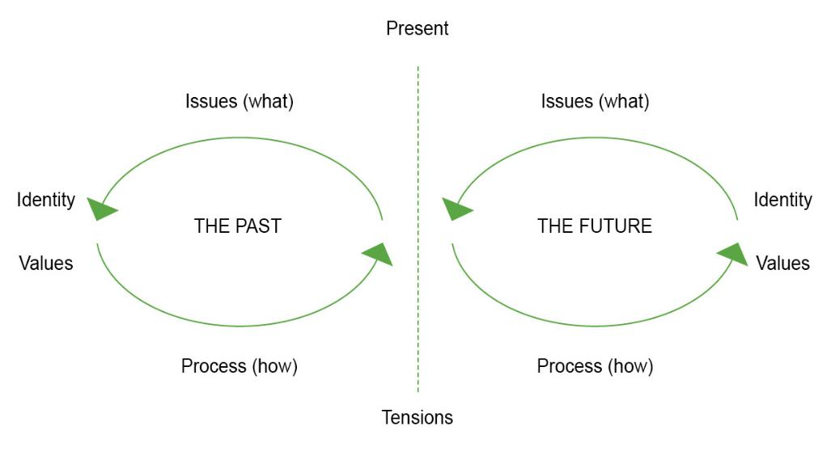

The roadmap allows a dynamic monitoring of tensions that emerge from differences of what processes we used and will use in the future, values we create today and values we will create in the future, differentiation who benefits today and in the future, and, the who contributes now and in the future. Values are here of two types: the values that underlie our processes and those that constitute the output we take as our aim. The first form are our norms and virtues that guide our processes, the second are those related to the basic reasons for our being in the first place.
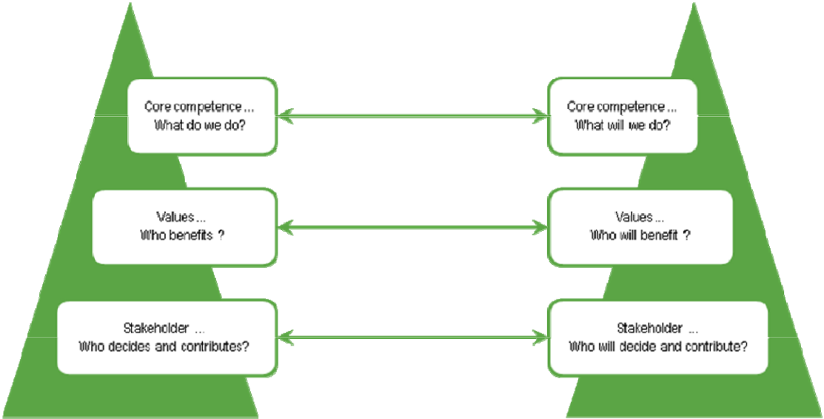

As illustrated in the figure above, a crucial challenge for thought-leaders involved in creating the library of the future is to detect tensions and distinguish between positive and negative tension in creating the library of the future as we also mentioned in the earlier chapter 7. A

47
tension analysis supports dynamic road mapping on the following levels: (1) it serves to identify key processes, (2) it shows how stakeholders are involved and (3) it forces one to be clear about how and which values are involved.

Issues for dynamic monitoring in a strategic roadmap

- Identity of the research library – who are we now, who will we be in the future?

- Skills required for the research library - considering the skills that are needed to meet this challenge. These skills range e.g. from IPR, preservation, to marketing, branding and business planning;

- Partnerships desired in the research library - fostering partnerships between public and private as well as working across the organisation; what is the nature and governace of such partnerships?

- End users - a heightened understanding of the changing user base and meeting their increasingly diverse needs; e.g. what are the (future) information needs of researchers and what will they need to undertake their research? What should the citizen expect?

- The role of the librarian - Libraries are increasingly signing up people with skills in non traditional library fields, does this mean that the librarians are becoming obsolete or do they have a changing role that involves overseeing all these specialisms or should they endeavour to develop these skills themselves?

- Payment models – who will pay for the services of the library of the future, will it be the public, private users, a mixture between both
- Knowledge mediation selection – who will be responsible for the selection of knowledge in the libraries of the future (e.g. publishers determining copyright regulations, user votes); will the system be more centralized or de-centralized?

- Multimedia content --- what will be the dominant formats of publishing research (papers, books, pictures, videos, graphics etc).

Phases in building a roadmap will be processes of the following sort:

- Consolidation of present knowledge of the state or situation in a field

- List of major challenges

- Stakeholder analysis

- Scenarios and criticism of scenarios – broadening and narrowing scenarios on the basis of judgements of relevance and potentials
- Analysis of the system of priorities and principles of prioritisation

- Understanding investment and returns

48
- Understanding the issues connected to decisions and implementations in a central-de-central perspective - centralized or de-centralized decision-making
- The interaction between central and de-central processes

- Local, national and international alignments and coordination

Some of the processes can be carried out on the basis of input from the outside and on the basis of consultations and advice, whereas others are totally dependent upon the decisions and understandings of the organisation or body building the roadmap and deciding on a strategy based on the understanding of the future potential scenarios.

An important feature of roadmaps is that they should be able to support the change from one scenario to another in the sense that they should provide a checklist of what is involved in such changes. Thus they should be tools making sure that the necessary questions are asked and at least given sufficient answers for outlining various scenarios.

As a communication tool the roadmap should create a common understanding of what are the fundamental concepts and categories involved in the processes of creating a strategy and implementing it.

10. Elements of a roadmap

The following section describes some of the element of a roadmap if it should be based on the perceptions and understandings of members of the research library community as it finds expression based on the reading of this report up to this point, and of course the shaping of the issues as they have been presented.. These elements would form basic elements of a strategy for the future development of the research library sector, and would contribute to the creation of a list of issues that should be handled both locally and at the central level. Thus it would be also an input to the future development of DEFF both as a network of cooperation and an agency with separate functions and funding. The following is a list of themes:

- Future competencies of the librarians

- Partnerships

- The population of users and their needs

- The functions of the librarian

- The systems and forms of funding

- The “management” of knowledge

- The media and technology involved

49
Competences:

Clearly the above has shown that the competences of the librarian are on the line. The connection between these competences and the organisational capability of the library and the library system to meet the challenges of the future is very tight. The university in contrast has been able to survive without radically changing the educational and didactic competences of its faculty as teachers, except in the rare few cases where institutions have been created on totally new platforms such as distance teaching universities. But technology is forcing itself on the library in a much more dominating way. New roles and a new understanding of professionalism are needed. Taking a proactive and offensive attitude is here a way forward. In the results from the working groups we get concepts such as offensive professionalism, facilitation and a need for a new focus on leadership to provide room for processes that are typically bottom-up, such as user- and employee-driven forms of innovation. Furthermore new identities for the library are constantly in play based on metaphors such as meeting spaces and culture-based communities - where culture is related to the knowledge cultures present in the communities of users served.

Partnerships:

Localizing the research library in a network of knowledge institutions is essential. This holds whether we are talking about a central national organisation or a mixed type of organization with central and de-central elements. And the network partners have to be knowledge organisations of different kinds and different levels. It is important that a central organisation or organisational element has partnership not only with central parts of other members of the knowledge networks in society. The library part of the knowledge networks needs to have a dynamic entrepreneurial culture independent of whether it functions more as an infrastructure or is placing emphasis on becoming a co-creator - and thus a different type of partner - in the knowledge production system. The issues at stake is the identity of the network member that handles the rights to knowledge of citizens - whether they are researchers, company innovators or just plain citizens - and secures common rights and services that both maximise the functionality of the research system and the classical democratic ideals of the informed citizenry. In a globalized world it is important to identify the relevant knowledge networks on a global scale.

Users:

The future users of the library belong to the so-called Google-generation. Their use patterns have been the subject of several studies. They have new digital and media literacies and new values related to the use of information and knowledge shaped by changes in the educational and research system. Old norms and values have to be rethought, and the essential values have to be more highly profiled. The library system has to be continuously aware of the pattern of usage - just as any Web-based company is constantly monitoring usage via Google

50
Analytics or similar services. The organisation has to be open for user-driven forms of innovation and development and thus be located in network places where this is possible.

Roles of the librarian:

The development of the roles of the librarian is of course intimately connected to the overall identity of the library and to the competences of the librarian. The classical roles related to the creation of order in the knowledge world will continue but new ones will appear. New roles in relation to the ability to carry out a continuous analysis of the knowledge environment in which one is operating and relating to this environment in forms of interaction and communication that mirror and reflect that situation in that environment. This can involve such functions as branding and research leadership at the "top" and design and programming at the "bottom", thus requiring a broad and flexible form of qualification of the librarian, performing both in leadership-like functions and more hands-on functions. The librarian also has to have the ability to constantly understand the relation between the various functions and the creation of value. Central values are here effectiveness and quality.

Funding and payment:

The trends and tendencies that we see in the library system will necessitate a reconsideration of the financial situation of the library and the library system. The basic ideal of the provision of services as a free commodity has to be reconsidered. Forms of user payment can be necessary and have to be considered. Patterns of usage also have to be understood to make informed decisions between forms of funding and payment such as payment related to usage or payment based on flat rates. In a system like the Danish system with public financing of universities and of most of the research done, it is still taken for granted that the funding for physical space and facilities is public and that a basic funding is secured for personnel. This will not preclude "external" funding for personnel connected to specific projects that the library is involved in.

The "management" of knowledge:

An important functionality of the research library and the librarian is to be able to follow and support the research workflow. This implies that knowledge selection is performed by users and user communities. This also implies a process where the library moves closer to the focal point in knowledge sharing and the management of knowledge. The library has to be able to do this and the research community has to want it. But the tendency in the knowledge system as it develops and the technology and information-markets involved sets the stage for it as does the development in the forms of scientific communication.

Media and technology:

With new media and technology the central classical functions of the librarian and the library are still:

51
- Selection

- Purchase

- Description

- Availability

in relation to information and knowledge resources. The actual content of the four classical functionalities will be shaped by the multi-media nature of the resources that have to handled. Material will not only be in printed forms but in all media forms. The organisation has to have the capability to handle fragmentation and inhomogeneity, which flow from the diversity of media. At the same time this diversity can create new opportunities and interesting challenges.

If we then look at the processes involved for understanding the past, present and future in relation to strategy formation we can say the following. We have a good understanding of the state and situation. Much research is done providing empirical and statistical information that is relevant. This information has to be interpreted in the light of the scenarios outlined. Three future identities have been described, and scenarios will be dependent upon how they interplay or dominate. Major challenges have been outlined in the form of tensions that set a stage for scenarios and strategy-building. The above outline based on this list of issues:

- Future competencies of the librarians

- Partnerships

- The population of users and their needs

- The functions of the librarian

- The systems and forms of funding

- The “management” of knowledge

- The media and technology involved

gives indications of how interpretations can influence decisions. Stakeholders have been identified. The broadening or narrowing of scenarios has to be done on the basis of judgements related to the present understanding of stakeholders and their perspectives, and the interplay with the actors in the knowledge system. The system’s interest, when voiced politically, is generally more of everything. The particular interests of the other actors will typically be that they want to take part in or take over parts of the scenarios that are close to their strategic goals. This reflects the simple fact that strategy formation in a politically dominated field is based on the conditions of strategic rationality. All actors make decisions based on their predictions and expectations of what others will do - and vice versa. The solution probably is to work more bottom-up and make piecemeal decisions - when possible - and create organisations that are open for user- and employee-driven developments and

52
innovations. Priorities have to be made relative to the conditions of funding. These again may be dependent on a series of functionalities. Basically they will have to reflect the satisfaction or dissatisfaction of users interpreted through a lens that again ranks the needs of various types of users. What is seen will reflect whose eyes it is and what lens is used. The three future identities described would each give the following first rank: students, researchers, advanced knowledge users in general. Understanding investment and returns again depends on these different perspectives. Improving education gives certain returns, improving research a different form and rate of return. Improving the availability of synthesized knowledge again a third.

When it comes to decisions concerning centralized or decentralized structures and localisation of functions and services it seems clear that consideration of costs, effectiveness and quality will be important. The tendencies that we see internationally, in the research literature and in interviews and workshop results, seem to point to a mixed structure where the physical existence of the research library is assumed, and new functions actually added in certain scenarios. It is clear that closer interaction with both teaching and research and establishment of partnerships will imply the existence of social networks that are not only carried by digital communication and contact. On the other hand it is also clear that such elements of networks will become more and more important - as we see it already in the way research groups function. Centralized structures and functions can be created through a bottom-up process, where institutions or organisations form alliances or partnerships, or create wholly new entities, or through centralized decisions - typically when funding is provided from government. The knowledge centre and the meta-knowledge models both seem to imply restructuring with some centralized entities emerging. This has been the case also in the areas where clearing-houses have actually been established or domain-specific knowledge has been created. Such initiatives require resources and will make sense only at a national or maybe even more at an international level. The local, national and international dimensions are important. There seems to be a double movement in the thinking around the research library. One movement is towards the local in the sense that the library becomes an integral or organic part in several local processes to the point where it is an important integrated part of education and research. This is actually a return to the classical model of the research library. The main difference is that then the basis was the physical collection of books and journals, today it would be the competences of the staff. The other movement is towards a more and more international and global situation where the availability of global information and knowledge services is taken for granted and the distinction between a library and non-library service is becoming meaningless.

53
- The presentation here is based on William Clark “Academic Charisma and the Origins of the Research University”, Chicago University Press 2006

- See the following paper:”Information Behaviour of the Researcher of the Future” http://www.ucl.ac.uk/infostudies/research/ciber/downloads/GG%20Work%20Package%20I.pdf

- See his ”The University as a Creative Destroyer of Social Capital” http://www.itas.fzk.de/tatup/043/full04a.htm

- The concept of creative destruction goes back to Joseph Schumpeter who used it to characterize innovation, which was seen as the creative destruction of a market. The new automobile destroyed the old market for horse carriages but to the advantage of the economy and to society. For a good discussion with examples see the paper by Sloth Andersen, Dahl, Lundwall & Reichstein ”Schumpeter’s process of creative destruction and the Scandinavian systems: a tale of two effects” http://www.business.aau.dk/evolution/esapapers/esa06/druid06.pdf

54
Appendix 1

DEFF and the Future of Research Libraries

The report on “The Future of Research and the Research Libraries” has been written without specifically analyzing the present or future role and identity of DEFF. Clearly there are some obvious consequences for DEFF in relation to the developments and potential scenarios outlined for the future of the research and research library systems. DEFF is both a network and cooperation between the research libraries in Denmark and an agency, acting through a secretariat. There seems thus to be at least three different roles in the future for DEFF. Aspects of these are already present in the activity we see that DEFF is engaged in.

The first role is the role of a policy-forming body for the research library system. In this role DEFF would have to make decisions in relation to the challenges developments in the research system poses. The second role is as a vehicle for specific projects of cooperation between the actors in the research library system. This would depend upon specific funding and decisions of the DEFF Board. The DEFF secretariat would here have a crucial role as project manager in interplay with the actors of the system. The third role – which would be in some ways new – would be as a facilitator for organizational development of the system and the institutions forming the system. Developments in relation to organization, capabilities and competences.

Which role or combinations of roles DEFF would play in the future depends of course on a number of strategic decisions. Such strategic decisions would result from decisions made both at the central and the local level. A learning oriented strategy process is a combination of top-down and bottom-up elements. Developing scenarios and working with roadmaps is an important part in such strategy processes and can be done at both central and local organizations. In a learning perspective the interplay between top-down and bottom-up is important and the process aims at a sort of equilibrium, which is a formulation of a common strategic perspective.

To exemplify how this could be done let us try to develop a concrete roadmap based on some decisions of a strategic nature concerning the future of the research library system. The inputs are based on the roles outlined in the report, the list of tensions and the types of processes that would need to be taken into consideration. Furthermore the elements of a roadmap outlined in section 10 have to be adressed. For this exercise, let us imagine a scenario where the first priority for the future of the system is to help improve the quality of Danish higher education. Thus the role of learning centre is the chosen role. This would imply that other functions are outsourced so that another organization would take over and do a lot of the things that is done by DEFF and the individual libraries. This could f.i. be the case if

55
another large library, such as the British Library would handle and secure access to scientific journals and provide access to electronic books etc. etc.. This of course would imply that other tasks are given to research organizations themselves (selection of books could be an example) or to a rudimentary staff at the libraries. The libraries themselves would have as a main task to support higher education and its quality improvement. Let us then look at a roadmap given these decisions. There is an interplay between the central tasks of deciding and implementing – the central action line – and the resolution of constant tensions – to the right – and constant updating – to the left – as indicated below. The tensions refer to the section 7 of the report and the processes to section 9. In total the various actions and processes should cover the themes outlined in section 10.

56
Learning Centre
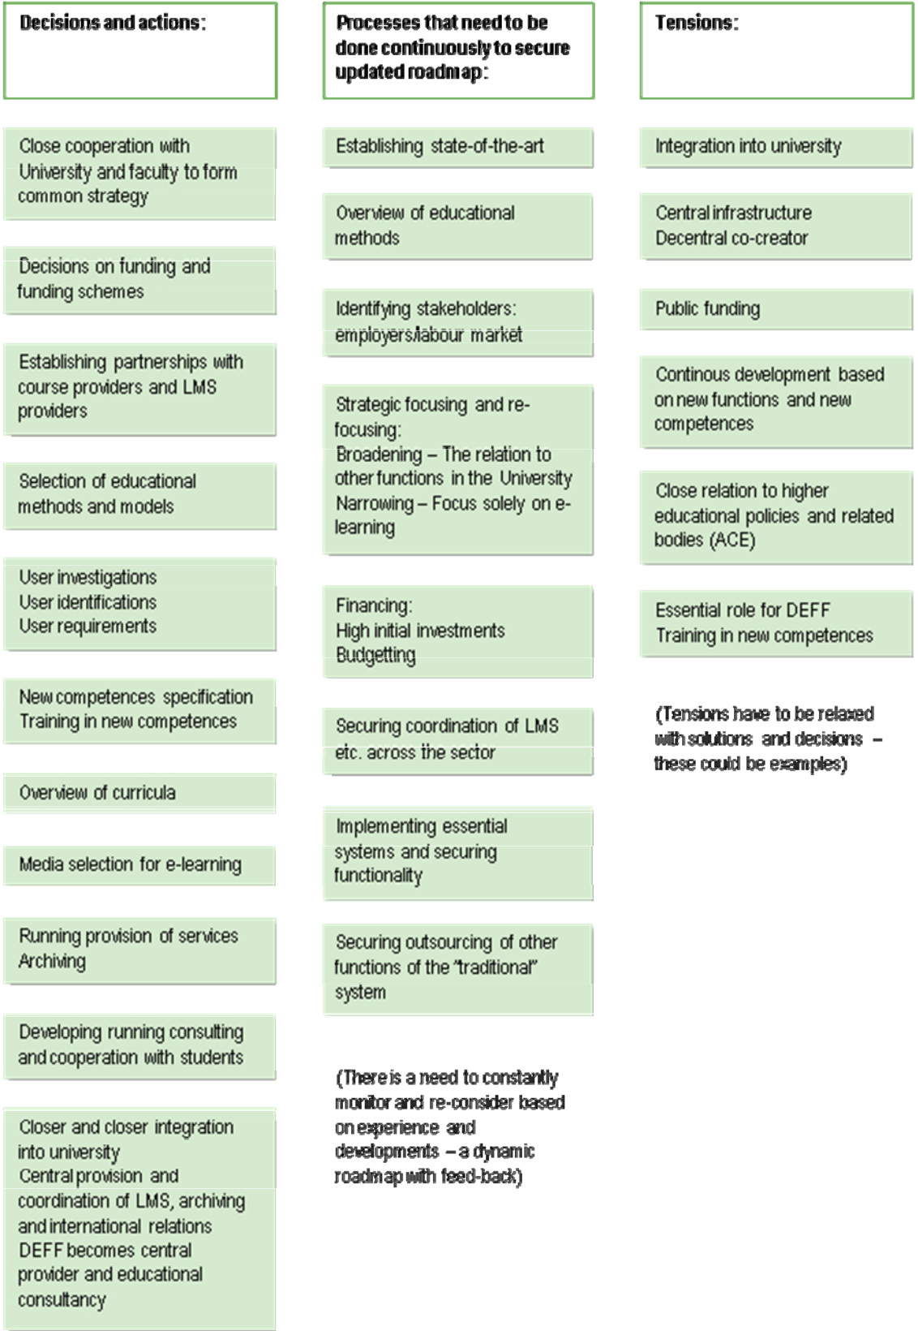

57
Appendix 2

Trend- and network analysis - Interviewees:

René Steffensen
CBS Bibliotek (Copenhagen Business School Library)

Knud Holck Andersen
Thisted Gymnasium (Thisted High School)

Claus Vesterager Petersen
Roskilde Universitetsbibliotek (Roskilde University Library)

Tina Pipa
Det Kongelige Bibliotek (The Royal Library of Denmark)

Mogens Hørder
Syddansk Universitet (University of Southern Denmark)

Henning Salling-Olesen
Roskilde Universitetscenter (Roskilde University Center)

Ole Wæver
Københavns Universitet, Institut for Statskundskab (University of Copenhagen, Department of Political Science)

Thomas Riis
CBS, Juridisk Institut (Copenhagen Business School, Department of Law)

Steen Kyed
Kulturministeriet (Danish Ministry of Culture)

Peter Uffe Meier
Københavns Universitet, Forsknings- og Innovationsstyrelsen ( University of Copenhagen, Danish Agency for Science, Technology and Innovation)

Bo Öhrström
Styrelsen for Bibliotek og Medier (Danish Agency for Libraries and Media)

René Birkemark Olesen
Styrelsen for Bibliotek og Medier (Danish Agency for Libraries and Media)

58
Appendix 3

In-depth interviews - Interviewees:

Morten Erlandsen
Digitale Samlinger (Danish Collection of Digital Publications)

Hans Müller Pedersen
Forsknings- og Innovationsstyrelsen (Danish Agency for Science, Technology and Innovation)

Niels Ole Pors
Danmarks Biblioteksskole (Royal School of Library and Information Science)

Birte Christensen-Dahlsgaard
Det Kongelige Bibliotek (The Royal Library of Denmark)

René Steffensen
CBS Bibliotek (Copenhagen Business School Library)

Mogens Sandfær
Danmarks Tekniske Universitetscenter (Technical Information Center of Denmark)

Clifford Lynch
The Coalition for Networked Information (CNI.org)

Magne Nylenna
Kunnskapscenter for Helsetjenesten (Norwegian Knowledge Center for the Health Services)

Chris Batt

Lorcan Dempsey

Michael Cotta-Schønberg

59
Appendix 4

Workshop 1 - List of participants:

Mai Buch

DEFF Steering Group

Bo Öhrström

Styrelsen for Bibliotek og Medier (Danish Agency for Libraries and Media)

Jakob Heide Petersen

Styrelsen for Bibliotek og Medier (Danish Agency for Libraries and Media)

René Birkemark Olesen

Styrelsen for Bibliotek og Medier (Danish Agency for Libraries and Media)

Hans Müller Pedersen

Forsknings- og Innovationsstyrelsen (The Danish Agency for Science, Technology and Innovation)

Niels-Henrik Gylstorff
Aalborg Universitetsbibliotek (Aalborg University Library)

Arne Sørensen
Statsbiblioteket (The State and University Library)

Mogens Sandfær
DTIC, Danmarks Tekniske Informations- og Videnscenter (Technical Information and Knowledge Center of Denmark)

Mai Aggerbeck

VIA University College campus Holstebro

60
Appendix 5

Programme - Workshop 1


09.00 -09.30

09.30 – 10.15

10.15 – 10.30

10.30 – 12.00

12.00 – 12.45

12.45 – 13.45

14.15 -14.45

15.15 -16.00

Introduction to workshop

(Preliminary report --- edition one)
(Structure of the day)
(Introduction round)

Identifying key uncertainties in the research ecosystem of the future

Break

From uncertainties to scenarios

Lunch

Crafting future narratives

Innovation in your organisation – and your week project on this course

From scenarios to visioning

Group work out

Break

Presenting scenarios for future libraries
(with Steering Committee)

61

Appendix 6

Workshop 2 - List of participants:

Claus Vesterager Pedersen

Roskilde Universitetsbibliotek (Roskilde University Library)

Niels-Henrik Gylstorff
Aalborg Universitetsbibliotek (Aalborg University Library)

Susanne Dalsgaard Krag
Aarhus Universitet, Det Samfundsvidenskabelige Fakultet (Aarhus University, Faculty of Social Sciences)

Birgit Rabitz

Herlev Hospitals fagbibliotek (Special Library of Herlev Hospital)

Aase Lindahl

Syddansk Universitet (The University of Southern Denmark)

Jette Fugl

Det Biovidenskabelige Fakultetsbibliotek (Faculty Library of Life Sciences)

Lene Stampe Mortensen

Roskilde Universitetsbibliotek (Roskilde University Library)

Kirsten Bisgaard

Forsvarsakademiets Informationsservice (Information Service of the Royal Danish Defense College)

Tove Bang
Aarhus School of Business, Aarhus Universitet (Aarhus School of Business, Aarhus University)

Lars Nondal

CBS Bibliotek (Copenhagen Business School Library)

Gert Poulsen

CBS, Copenhagen Busines School

Ingelise Stæhr

Syddansk Universitetsbibliotek (University Library of Southern Denmark)

Thorkil Damsgaard Olsen

Københavns Universitet (The University of Copenhagen)

Alfred Heller

Danmarks Tekniske Informations- og Videnscenter (The Technical Information and Knowledge Center of Denmark)

Karen Harbo
Biblioteket på Aarhus School of Business, Aarhus Universitet (The Library of Aarhus School of Business, Aarhus University)

Lone Jensen

Biblioteket på Aarhus School of Business, Aarhus Universitet (The Library of Aarhus School of Business, Aarhus University)

62
Tina Pipa

Københavns Universitets Biblioteks- og Informations Service, KUBIS, Det Kongelige Bibliotek (The Library and Information Service of Copenhagen University, The Royal Library of Denmark)

Lars Ole Sauerberg

Syddansk Universitet (The University of Southern Denmark)

Ole Michaelsen

Københavns Tekniske Bibliotek (Copenhagen Technical Library)

Ingbritt Butina

Det Kongelige Bibliotek (The Royal Library of Denmark)

Barbara Melchior

Københavns Universitets Biblioteks- og Informations-Service, KUBIS, Det Kongelige Bibliotek (The Library and Information Service of Copenhagen University, The Royal Library of Denmark)

Kurt Mathiesen

CBSchool Bibliotek (Copenhagen Business School Library)

Kasper Løvschall

Aalborg Universitetsbibliotek (Aalborg University Library)

Bente Østergaard

Statsbiblioteket (The State and University Library)

Søren Hansen

University College Sjælland (University College of Zealand)

Anne Ørbæk Jensen

Det Kongelige Bibliotek (The Royal Library of Denmark)

Tom Kenneth Poulsen

University College Lillebælt (University College of Lillebælt)

Gitte Behrens

Statsbiblioteket (The State and University Library)

Lone Madsen

Syddansk Universitetsbibliotek (University Library of Southern Denmark)

Peter Flodin

Professionshøjskolen Metropol (Metropol College of Professional Education)

Lars Kofod-Jensen
Professionshøjskolen Metropol (Metropol College of Professional Education)

Knud Holch Andersen
Thisted Gymnasium og HF Kursus (Thisted High School and Higher Preparatory Course)

Bertil Dorch

Københavns Universitets Biblioteks- og Informations-Service, KUBIS, Det Kongelige Bibliotek (The Library and Information Service of Copenhagen University, The Royal Library of Denmark)

63
Per Steen Hansen

VIA University College, Udviklingsdivisionen (VIA University College, Development Department)

Simone Schipp von Branitz Nielsen
Københavns Universitetsbibliotek (The Library of The University of Copenhagen)

Jakob Broberg Lind
Kulturministeriet (The Danish Ministry of Culture)

Birgitte Sass
University College Sjælland (University College of Zealand)

Ellen Vibeke Knudsen

Statsbiblioteket (The State and University Library)

Gina Bay

Aarhus Universitet, Institut for psykologi (Aarhus University, Department of Psychology)

Morten Thanning Vendelø

CBS, Copenhagen Business School

Stine Zink

Aarhus Universitet, Idrætsbiblioteket (The Library of Physical Education of Aarhus University)

Mai Aggerbeck

VIA University College, Campus Holstebro (VIA University College, Campus of Holstebro)

Stig Lynggaard Hansen

Danmarks Designskole (The Danish School of Art and Design)

Rikke Dahl Olesen

Danmarks Designskole (The Danish School of Art and Design)

Anja Møller Rasmussen

Nordic Institute of Asian Studies, NIAS

Ditte Jessing

Kunstakademiets Arkitektskoles Bibliotek (The Library of The School of Architecture of The Royal Danish Academy of Fine Arts)

Signe Kreutzer
Roskilde Handelsskole (Roskilde Business College)

Harald von Hielmcrone
Statsbiblioteket (The State and University Library)

Tommy Skovgaard Jensen
Statsbiblioteket (The State and University Library)

Birte Christensen-Dalsgaard
Det Kongelige Bibliotek (The Royal Danish Library)

Gitte Andersen

Danmarks Tekniske Informations- og Videnscenter (The Technical Information and Knowledge Center of Denmark)

Eli Greve

Syddansk Universitetsbibliotek (University Library of Southern Denmark)

64
Marianne Vadgaard Christensen

Statsbiblioteket (The State and University Library)

Gitte Bruun Jensen

Danmarks Tekniske Informations- og Videnscenter (The Technical Information and Knowledge Center of Denmark)

Bo Öhrström
Styrelsen for Bibliotek og Medier (Danish Agency for Libraries and Media)

René Olesen
Styrelsen for Bibliotek og Medier (Danish Agency for Libraries and Media)

Jakob Nedergaard Mortensen

Styrelsen for Bibliotek og Medier (Danish Agency for Libraries and Media)

Lise Mikkelsen

Styrelsen for Bibliotek og Medier (Danish Agency for Libraries and Media)

Anne Sandfær

Styrelsen for Bibliotek og Medier (Danish Agency for Libraries and Media)

Eva Bye Andersen

Københavns Tekniske Bibliotek (Copenhagen Technical Library)

65
Appendix 7

Programme - Workshop 2


09.30

10.15

10.45

11.00

11.30

12.00

13.00

14.10

14.30

15.00

Introduction to workshop

Vision for the future

Identification of central challenges

Prioritisation and sequence

Preparation of presentation

Lunch

Presentation and feedback

Analysis of input and formulation of viewpoints

Interviews and documentation

Summing up

66



The Future of Research

and the Research Library

Published 2009 by

Denmark’s Electronic Research Library/

Danish Agency for Libraries and Media

H. C. Andersens Boulevard 2

DK-1553 Copenhagen V

Denmark

Tel. +45 33 73 33 73

deff@bibliotekogmedier.dk

www.deff.dk

www.bibliotekogmedier.dk

Coverphoto: Tobias Toyberg

ISBN: 978-87-92057-82-2

