
Example of a Residential Lease with Option to Purchase

About this Tool

Description:

This example of an agreement between a developer and a lease-purchaser is intended to illustrate how NSP grantees, subrecipients and developers are using lease-purchase programs. It is intended to be used with the following companion documents: “Sample Residential Lease with Option to Purchase, Annotated” and its attachments: “Move in Notice (Guideform Notice to Prospective Tenant),” “Lease-Purchaser Guide,” and “Maintenance Checklist,” “Sample Lease-Purchase Policies and Procedures Manual,” “Sample Lease-Purchase Developer Agreement,” “Sample Lease-Purchase Financial Pro Forma,” and “Guidance on Lease Purchase Qualification Criteria.”

How to Adapt this Document:

This document provides an example of a residential lease with an option to purchase, and is not intended to be used as-is. NSP grantees should determine if the underlying program design is suitable for their own circumstances. For further guidance, NSP grantees should consult the series of sample NSP Toolkit documents that are listed above.

Source of Document:

This document was developed by Colorado Rural Housing Development Corporation.

Disclaimer:

This document is not an official HUD document and has not been reviewed by HUD counsel. It is provided for informational purposes only. Any binding agreement should be reviewed by attorneys for the parties to the agreement and must conform to state and local laws.

This resource is part of the NSP Toolkits. Additional toolkit resources may be found at www.hud.gov/nspta

U.S. Department of Housing and Urban Development | 1
Neighborhood Stabilization Program

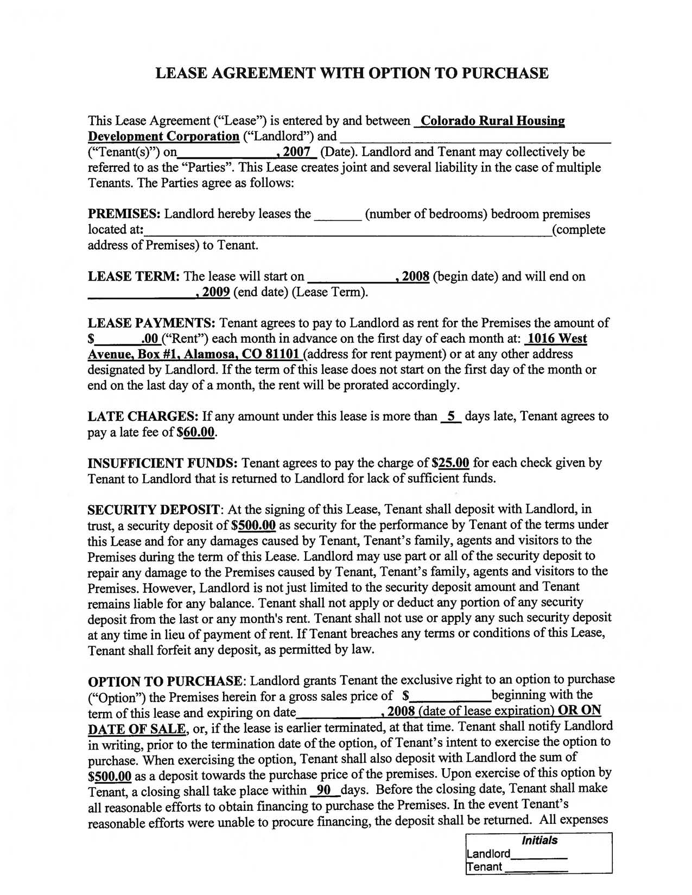
LEASE AGREEMENT WITH OPTION TO PURCHASE

This Lease Agreement ("Lease") is entered by and between Colorado Rural Housing

Development Corporation ("Landlord") and ----:--::-------:::---:----::--=-____--:-:----:____
("Tenant(s)") on , 2007 (Date). Landlord and Tenant may collectively be

referred to as the "Parties". This Lease creates joint and several liability in the case of multiple

Tenants. The Parties agree as follows:

PREMISES: Landlord hereby leases the ___ (nwnber of bedrooms) bedroom premises

located at: (complete address of Premises) to Tenant.

LEASE TERM: The lease will start on _____.1..':.:20~0:.::::8 (begin date) and will end on
______--.1..:'2::.:0~0;.::.9 (end date) (Lease Term).

LEASE PAYMENTS: Tenant agrees to pay to Landlord as rent for the Premises the amount of

$ .00 ("Rent") each month in advance on the first day of each month at: 1016 West Avenue, Box #1, Alamosa, CO 81101 (address for rent payment) or at any other address designated by Landlord. If the term ofthis lease does not start on the first day of the month or end on the last day of a month, the rent will be prorated accordingly.

LATE CHARGES: If any amount under this lease is more than i days late, Tenant agrees to pay a late fee of $60.00.

INSUFFICIENT FUNDS: Tenant agrees to pay the charge of $25.00 for each check given by Tenant to Landlord that is returned to Landlord for lack of sufficient funds.

SECURITY DEPOSIT: At the signing of this Lease, Tenant shall deposit with Landlord, in trust, a security deposit of $500.00 as security for the performance by Tenant of the terms under this Lease and for any damages caused by Tenant, Tenant's family, agents and visitors to the Premises during the term ofthis Lease. Landlord may use part or all of the security deposit to repair any damage to the Premises caused by Tenant, Tenant's family, agents and visitors to the Premises. However, Landlord is not just limited to the security deposit amount and Tenant remains liable for any balance. Tenant shall not apply or deduct any portion of any security deposit from the last or any month's rent. Tenant shall not use or apply any such security deposit at any time in lieu of payment of rent. If Tenant breaches any terms or conditions of this Lease, Tenant shall forfeit any deposit, as permitted by law.

OPTION TO PURCHASE: Landlord grants Tenant the exclusive right to an option to purchase

("Option") the Premises herein for a gross sales price of $ beginning with the
term of this lease and expiring on date ,2008 (date oflease expiration) OR ON

DATE OF SALE, or, if the lease is earlier terminated, at that time. Tenant shall notify Landlord in writing, prior to the termination date ofthe option, of Tenant's intent to exercise the option to purchase. When exercising the option, Tenant shall also deposit with Landlord the swn of $500.00 as a deposit towards the purchase price ofthe premises. Upon exercise of this option by Tenant, a closing shall take place within -2!Ldays. Before the closing date, Tenant shall make all reasonable efforts to obtain financing to purchase the Premises. In the event Tenant's reasonable efforts were unable to procure financing, the deposit shall be returned. All expenses

Initials
Landlord____

enant
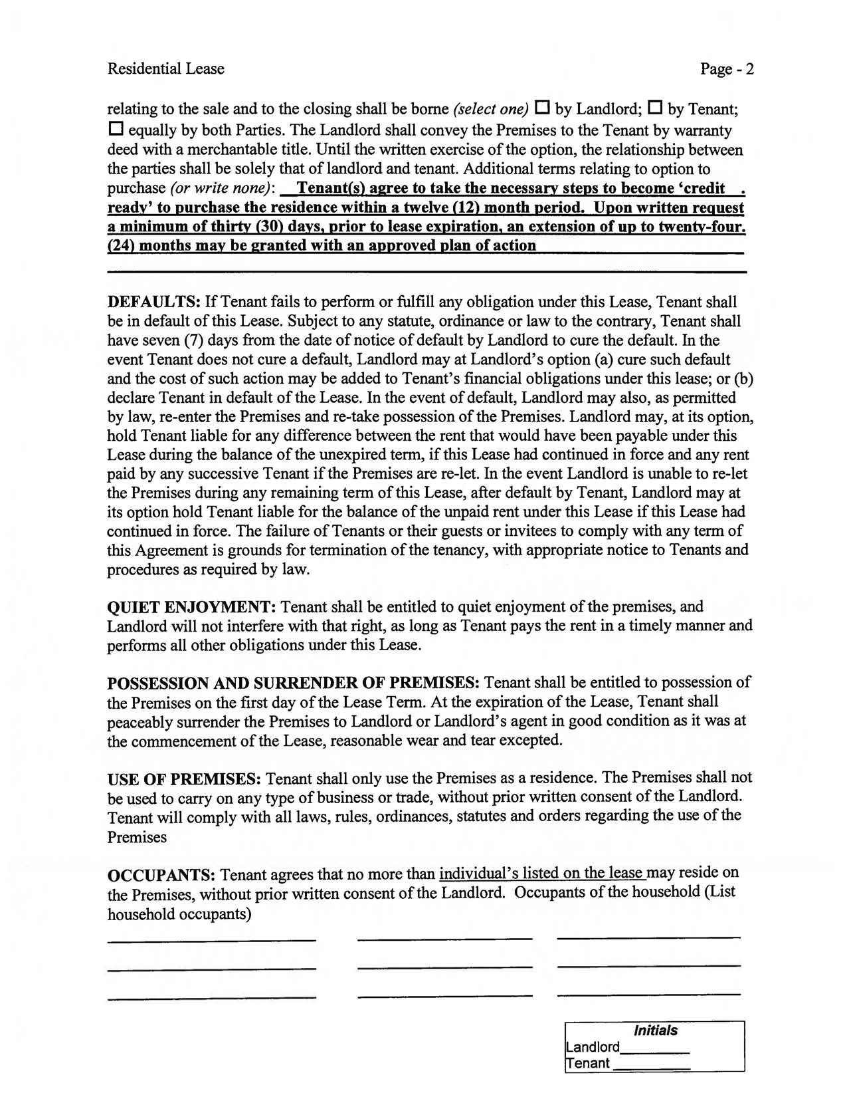
Residential Lease Page - 2

relating to the sale and to the closing shall be borne (select one) 0 by Landlord; 0 by Tenant; o equally by both Parties. The Landlord shall convey the Premises to the Tenant by warranty deed with a merchantable title. Until the written exercise of the option, the relationship between the parties shall be solely that of landlord and tenant. Additional terms relating to option to purchase (or write none): Tenant(s) agree to take the necessary steps to become 'credit. ready' to purchase the residence within a twelve (12) month period. Upon written request

- minimum of thirty (30) days, prior to lease expiration, an extension of up to twenty-four. (24) months may be granted with an approved plan of action

DEFAULTS: If Tenant fails to perform or fulfill any obligation under this Lease, Tenant shall be in default of this Lease. Subject to any statute, ordinance or law to the contrary, Tenant shall have seven (7) days from the date of notice of default by Landlord to cure the default. In the event Tenant does not cure a default, Landlord may at Landlord's option (a) cure such default and the cost of such action may be added to Tenant's financial obligations under this lease; or (b) declare Tenant in default of the Lease. In the event of default, Landlord may also, as permitted by law, re-enter the Premises and re-take possession of the Premises. Landlord may, at its option, hold Tenant liable for any difference between the rent that would have been payable under this Lease during the balance of the unexpired term, if this Lease had continued in force and any rent paid by any successive Tenant if the Premises are re-Iet. In the event Landlord is unable to re-Iet the Premises during any remaining term of this Lease, after default by Tenant, Landlord may at its option hold Tenant liable for the balance of the unpaid rent under this Lease if this Lease had continued in force. The failure of Tenants or their guests or invitees to comply with any term of this Agreement is grounds for termination of the tenancy, with appropriate notice to Tenants and procedures as required by law.

QUIET ENJOYMENT: Tenant shall be entitled to quiet enjoyment of the premises, and Landlord will not interfere with that right, as long as Tenant pays the rent in a timely manner and performs all other obligations under this Lease.

POSSESSION AND SURRENDER OF PREMISES: Tenant shall be entitled to possession of the Premises on the first day of the Lease Term. At the expiration of the Lease, Tenant shall peaceably surrender the Premises to Landlord or Landlord's agent in good condition as it was at the commencement of the Lease, reasonable wear and tear excepted.

USE OF PREMISES: Tenant shall only use the Premises as a residence. The Premises shall not be used to carryon any type of business or trade, without prior written consent of the Landlord. Tenant will comply with all laws, rules, ordinances, statutes and orders regarding the use of the Premises

OCCUPANTS: Tenant agrees that no more than individual's listed on the lease may reside on the Premises, without prior written consent of the Landlord. Occupants of the household (List household occupants)

Initials
Landlord____

enant
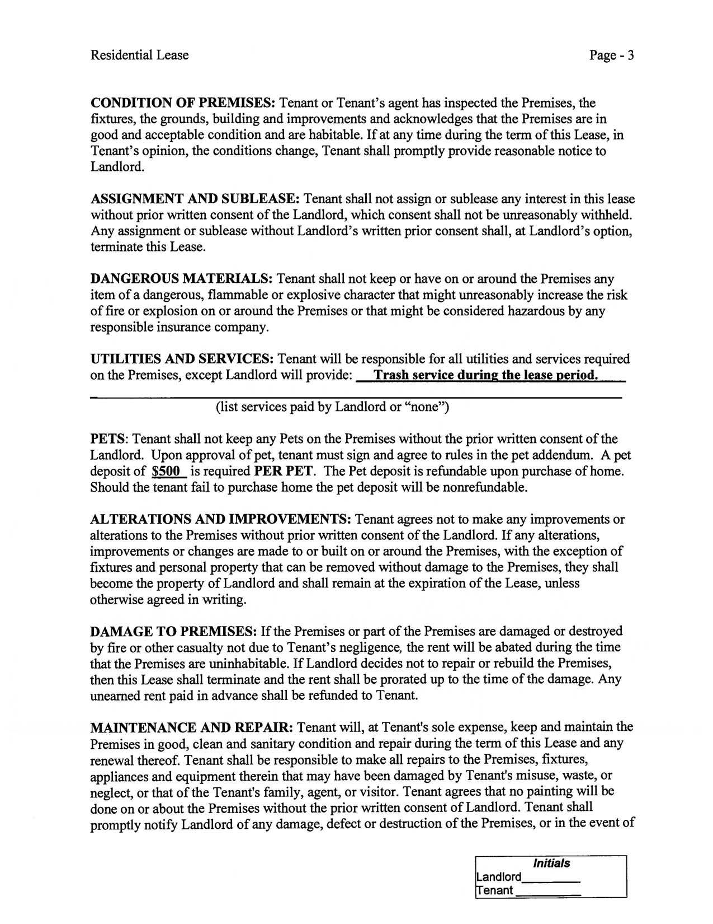
Residential Lease Page - 3

CONDITION OF PREMISES: Tenant or Tenant's agent has inspected the Premises, the fixtures, the grounds, building and improvements and acknowledges that the Premises are in good and acceptable condition and are habitable. If at any time during the term of this Lease, in Tenant's opinion, the conditions change, Tenant shall promptly provide reasonable notice to Landlord.

ASSIGNMENT AND SUBLEASE: Tenant shall not assign or sublease any interest in this lease without prior written consent of the Landlord, which consent shall not be unreasonably withheld. Any assignment or sublease without Landlord's written prior consent shall, at Landlord's option, terminate this Lease.

DANGEROUS MATERIALS: Tenant shall not keep or have on or around the Premises any item of a dangerous, flammable or explosive character that might unreasonably increase the risk of fire or explosion on or around the Premises or that might be considered hazardous by any responsible insurance company.

UTILITIES AND SERVICES: Tenant will be responsible for all utilities and services required
on the Premises, except Landlord will provide: Trash service during the lease period.

(list services paid by Landlord or "none")

PETS: Tenant shall not keep any Pets on the Premises without the prior written consent of the Landlord. Upon approval of pet, tenant must sign and agree to rules in the pet addendum. A pet deposit of $500 is required PER PET. The Pet deposit is refundable upon purchase of home. Should the tenant fail to purchase home the pet deposit will be nonrefundable.

ALTERATIONS AND IMPROVEMENTS: Tenant agrees not to make any improvements or alterations to the Premises without prior written consent of the Landlord. If any alterations, improvements or changes are made to or built on or around the Premises, with the exception of fixtures and personal property that can be removed without damage to the Premises, they shall become the property of Landlord and shall remain at the expiration of the Lease, unless otherwise agreed in writing.

DAMAGE TO PREMISES: If the Premises or part of the Premises are damaged or destroyed by fire or other casualty not due to Tenant's negligence, the rent will be abated during the time that the Premises are uninhabitable. If Landlord decides not to repair or rebuild the Premises, then this Lease shall terminate and the rent shall be prorated up to the time of the damage. Any unearned rent paid in advance shall be refunded to Tenant.

MAINTENANCE AND REPAIR: Tenant will, at Tenant's sole expense, keep and maintain the Premises in good, clean and sanitary condition and repair during the term of this Lease and any renewal thereof. Tenant shall be responsible to make all repairs to the Premises, fixtures, appliances and equipment therein that may have been damaged by Tenant's misuse, waste, or neglect, or that of the Tenant's family, agent, or visitor. Tenant agrees that no painting will be done on or about the Premises without the prior written consent of Landlord. Tenant shall promptly notify Landlord of any damage, defect or destruction of the Premises, or in the event of

Initials
Landlord____

enant
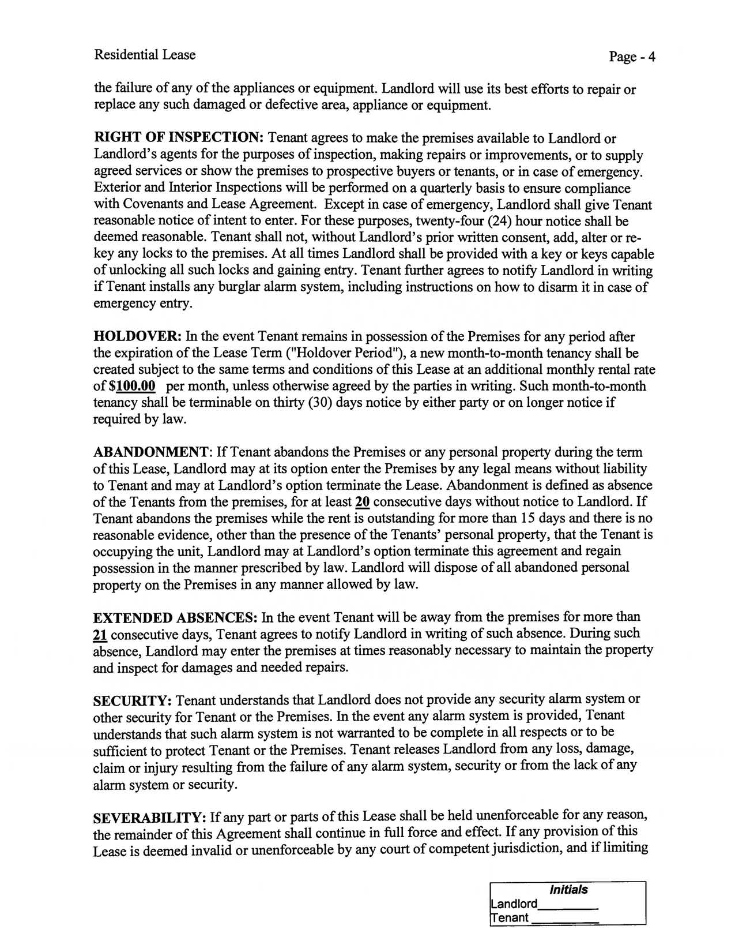
Residential Lease _{Page - 4}

the failure of any of the appliances or equipment. Landlord will use its best efforts to repair or replace any such damaged or defective area, appliance or equipment.

RIGHT OF INSPECTION: Tenant agrees to make the premises available to Landlord or Landlord's agents for the purposes of inspection, making repairs or improvements, or to supply agreed services or show the premises to prospective buyers or tenants, or in case of emergency. Exterior and Interior Inspections will be performed on a quarterly basis to ensure compliance with Covenants and Lease Agreement. Except in case of emergency, Landlord shall give Tenant reasonable notice of intent to enter. For these purposes, twenty-four (24) hour notice shall be deemed reasonable. Tenant shall not, without Landlord's prior written consent, add, alter or re key any locks to the premises. At all times Landlord shall be provided with a key or keys capable of unlocking all such locks and gaining entry. Tenant further agrees to notify Landlord in writing if Tenant installs any burglar alarm system, including instructions on how to disarm it in case of emergency entry.

HOLDOVER: In the event Tenant remains in possession of the Premises for any period after the expiration of the Lease Term ("Holdover Period"), a new month-to-month tenancy shall be created subject to the same terms and conditions of this Lease at an additional monthly rental rate of$100.00 per month, unless otherwise agreed by the parties in writing. Such month-to-month tenancy shall be terminable on thirty (30) days notice by either party or on longer notice if required by law.

ABANDONMENT: If Tenant abandons the Premises or any personal property during the term of this Lease, Landlord may at its option enter the Premises by any legal means without liability to Tenant and may at Landlord's option terminate the Lease. Abandonment is defined as absence of the Tenants from the premises, for at least 20 consecutive days without notice to Landlord. If Tenant abandons the premises while the rent is outstanding for more than 15 days and there is no reasonable evidence, other than the presence of the Tenants' personal property, that the Tenant is occupying the unit, Landlord may at Landlord's option terminate this agreement and regain possession in the manner prescribed by law. Landlord will dispose of all abandoned personal property on the Premises in any manner allowed by law.

EXTENDED ABSENCES: In the event Tenant will be away from the premises for more than 21 consecutive days, Tenant agrees to notify Landlord in writing of such absence. During such absence, Landlord may enter the premises at times reasonably necessary to maintain the property and inspect for damages and needed repairs.

SECURITY: Tenant understands that Landlord does not provide any security alarm system or other security for Tenant or the Premises. In the event any alarm system is provided, Tenant understands that such alarm system is not warranted to be complete in all respects or to be sufficient to protect Tenant or the Premises. Tenant releases Landlord from any loss, damage, claim or injury resulting from the failure of any alarm system, security or from the lack of any alarm system or security.

SEVERABILITY: If any part or parts of this Lease shall be held unenforceable for any reason, the remainder of this Agreement shall continue in full force and effect. If any provision of this Lease is deemed invalid or unenforceable by any court of competent jurisdiction, and if limiting

Initials
Landlord____

enant
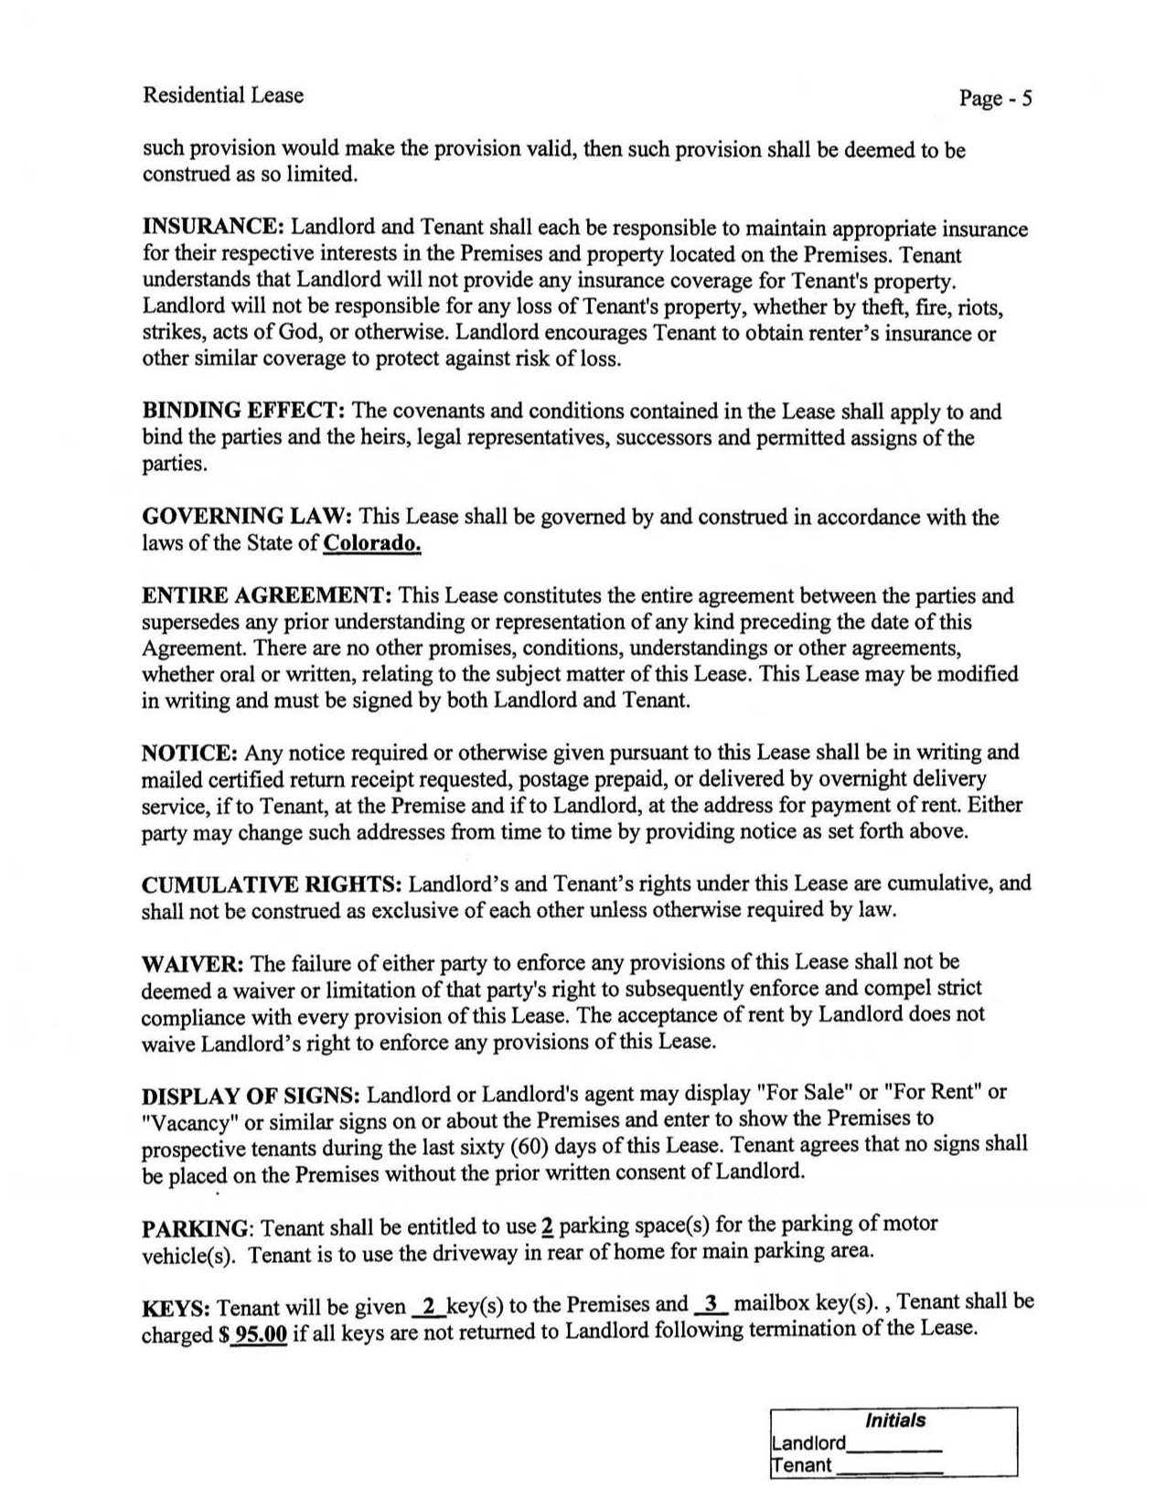
Residential Lease _{Page - 5}

such provision would make the provision valid, then such provision shall be deemed to be construed as so limited.

INSURANCE: Landlord and Tenant shall each be responsible to maintain appropriate insurance for their respective interests in the Premises and property located on the Premises. Tenant understands that Landlord will not provide any insurance coverage for Tenant's property. Landlord will not be responsible for any loss of Tenant's property, whether by theft, fire, riots, strikes, acts of God, or otherwise. Landlord encourages Tenant to obtain renter's insurance or other similar coverage to protect against risk of loss.

BINDING EFFECT: The covenants and conditions contained in the Lease shall apply to and bind the parties and the heirs, legal representatives, successors and permitted assigns of the parties.

GOVERNING LAW: This Lease shall be governed by and construed in accordance with the laws of the State of Colorado.

ENTIRE AGREEMENT: This Lease constitutes the entire agreement between the parties and supersedes any prior understanding or representation of any kind preceding the date of this Agreement. There are no other promises, conditions, understandings or other agreements, whether oral or written, relating to the subject matter of this Lease. This Lease may be modified in writing and must be signed by both Landlord and Tenant.

NOTICE: Any notice required or otherwise given pursuant to this Lease shall be in writing and mailed certified return receipt requested, postage prepaid, or delivered by overnight delivery service, if to Tenant, at the Premise and if to Landlord, at the address for payment of rent. Either party may change such addresses from time to time by providing notice as set forth above.

CUMULATIVE RIGHTS: Landlord's and Tenant's rights under this Lease are cumulative, and shall not be construed as exclusive of each other unless otherwise required by law.

WAIVER: The failure of either party to enforce any provisions of this Lease shall not be deemed a waiver or limitation of that party's right to subsequently enforce and compel strict compliance with every provision of this Lease. The acceptance of rent by Landlord does not waive Landlord's right to enforce any provisions of this Lease.

DISPLAY OF SIGNS: Landlord or Landlord's agent may display "For Sale" or "For Rent" or "Vacancy" or similar signs on or about the Premises and enter to show the Premises to prospective tenants during the last sixty (60) days of this Lease. Tenant agrees that no signs shall be placed on the Premises without the prior written consent of Landlord.

PARKING: Tenant shall be entitled to use ~ parking space(s) for the parking of motor vehic1e(s). Tenant is to use the driveway in rear of home for main parking area.

KEYS: Tenant will be given -Lkey(s) to the Premises and 2- mailbox keyes). , Tenant shall be charged $ 95.00 if all keys are not returned to Landlord following termination of the Lease.

Initials
Landlord____

enant
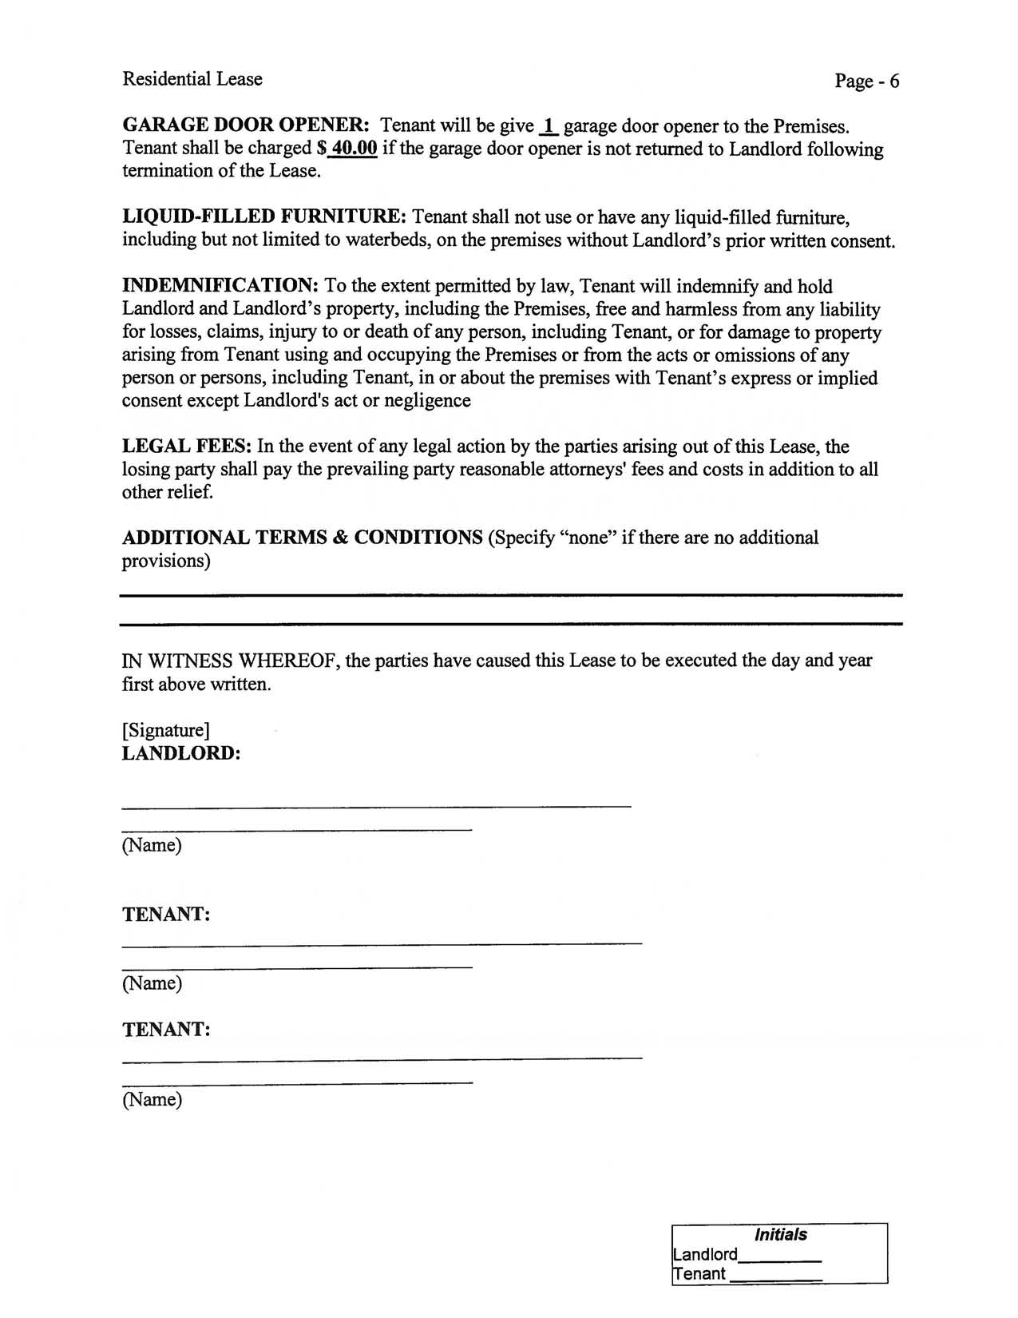
Residential Lease Page - 6

GARAGE DOOR OPENER: Tenant will be give..!.. garage door opener to the Premises. Tenant shall be charged $ 40.00 if the garage door opener is not returned to Landlord following termination of the Lease.

LIQUID-FILLED FURNITURE: Tenant shall not use or have any liquid-filled furniture, including but not limited to waterbeds, on the premises without Landlord's prior written consent.

INDEMNIFICATION: To the extent permitted by law, Tenant will indemnify and hold Landlord and Landlord's property, including the Premises, free and harmless from any liability for losses, claims, injury to or death of any person, including Tenant, or for damage to property arising from Tenant using and occupying the Premises or from the acts or omissions of any person or persons, including Tenant, in or about the premises with Tenant's express or implied consent except Landlord's act or negligence

LEGAL FEES: In the event of any legal action by the parties arising out of this Lease, the losing party shall pay the prevailing party reasonable attorneys' fees and costs in addition to all other relief.

ADDITIONAL TERMS & CONDITIONS (Specify "none" if there are no additional provisions)

IN WITNESS WHEREOF, the parties have caused this Lease to be executed the day and year first above written.

[Signature]
LANDLORD:

(Name)

TENANT:

(Name)

TENANT:

(Name)

Initials
Landlord____

enant
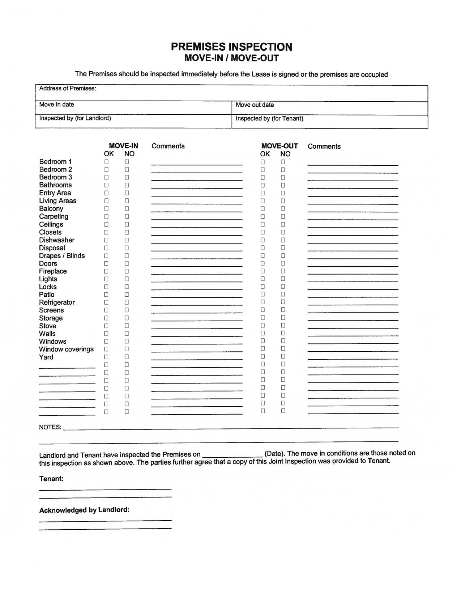
PREMISES INSPECTION

MOVE-IN I MOVE-OUT

The Premises should be inspected immediately before the Lease is signed or the premises are occupied

Address of Premises:
Move In date |  |  | Move out date
Inspected by (for Landlord) |  |  | Inspected by (for Tenant)

 |  |  |  | MOVE-IN |  | Comments |  |  |  |  |  |  | MOVE-OUT Comments
Bedroom 1 |  |  | OK |  | NO |  |  |  |  |  |  |  | OK | NO
 |  |  | 0 |  | 0 |  |  |  |  |  |  | 0 |  | 0
Bedroom 2 |  |  | 0 |  | 0 |  |  |  |  |  |  | 0 |  | 0
Bedroom 3 |  |  | 0 |  | 0 |  |  |  |  |  |  |  | 0 | 0
Bathrooms |  |  | 0 |  | 0 |  |  |  |  |  |  |  | 0 | 0
Entry Area |  |  | 0 |  | 0 |  |  |  |  |  |  | 0 |  | 0
Living Areas |  |  | 0 |  | 0 |  |  |  |  |  |  | 0 |  | 0
Balcony |  |  | 0 |  | 0 |  |  |  |  |  |  | 0 |  | 0
Carpeting |  |  | 0 |  | 0 |  |  |  |  |  |  | 0 |  | 0
Ceilings |  |  | 0 |  | 0 |  |  |  |  |  |  | 0 |  | 0
Closets |  |  | 0 |  | 0 |  |  |  |  |  |  | 0 |  | 0
Dishwasher |  |  | 0 |  | 0 |  |  |  |  |  |  | 0 |  | 0
Disposal |  |  | 0 |  | 0 |  |  |  |  |  |  | 0 |  | 0
Drapes I Blinds |  |  | 0 |  | 0 |  |  |  |  |  |  | 0 |  | 0
Doors |  |  | 0 |  | 0 |  |  |  |  |  |  | 0 |  | 0
Fireplace |  |  | 0 |  | 0 |  |  |  |  |  |  | 0 |  | 0
Lights |  |  | 0 |  | 0 |  |  |  |  |  |  | 0 |  | 0
Locks |  |  | 0 |  | 0 |  |  |  |  |  |  | 0 |  | 0
Patio |  |  | 0 |  | 0 |  |  |  |  |  |  | 0 |  | 0
Refrigerator |  |  | 0 |  | 0 |  |  |  |  |  |  | 0 |  | 0
Screens |  |  | 0 |  | 0 |  |  |  |  |  |  |  | 0 | 0
Storage |  |  | 0 |  | 0 |  |  |  |  |  |  | 0 |  | 0
Stove |  |  | 0 |  | 0 |  |  |  |  |  |  |  | 0 | 0
Walls |  |  | 0 |  | 0 |  |  |  |  |  |  |  | 0 | 0
Windows |  |  | 0 |  | 0 |  |  |  |  |  |  |  | 0 | 0
Window coverings |  |  | 0 |  | 0 |  |  |  |  |  |  | 0 |  | 0
Yard |  |  | 0 |  | 0 |  |  |  |  |  |  | 0 |  | 0
 |  |  |  | 0 | 0 |  |  |  |  |  |  |  | 0 | 0
 |  |  |  | 0 | 0 |  |  |  |  |  |  |  | 0 | 0
 |  |  |  | 0 | 0 |  |  |  |  |  |  |  | 0 | 0
 |  |  |  | 0 | 0 |  |  |  |  |  |  |  | 0 | 0
 |  |  |  | 0 | 0 |  |  |  |  |  |  |  | 0 | 0
 |  |  |  | 0 | 0 |  |  |  |  |  |  |  | 0 | 0
 |  |  |  | 0 | 0 |  |  |  |  |  |  |  | 0 | 0

NOTES:

Landlord and Tenant have inspected the Premises on (Date). The move in conditions are those noted on this inspection as shown above. The parties further agree that a copy of this Joint Inspection was provided to Tenant.

Tenant:

Acknowledged by Landlord:

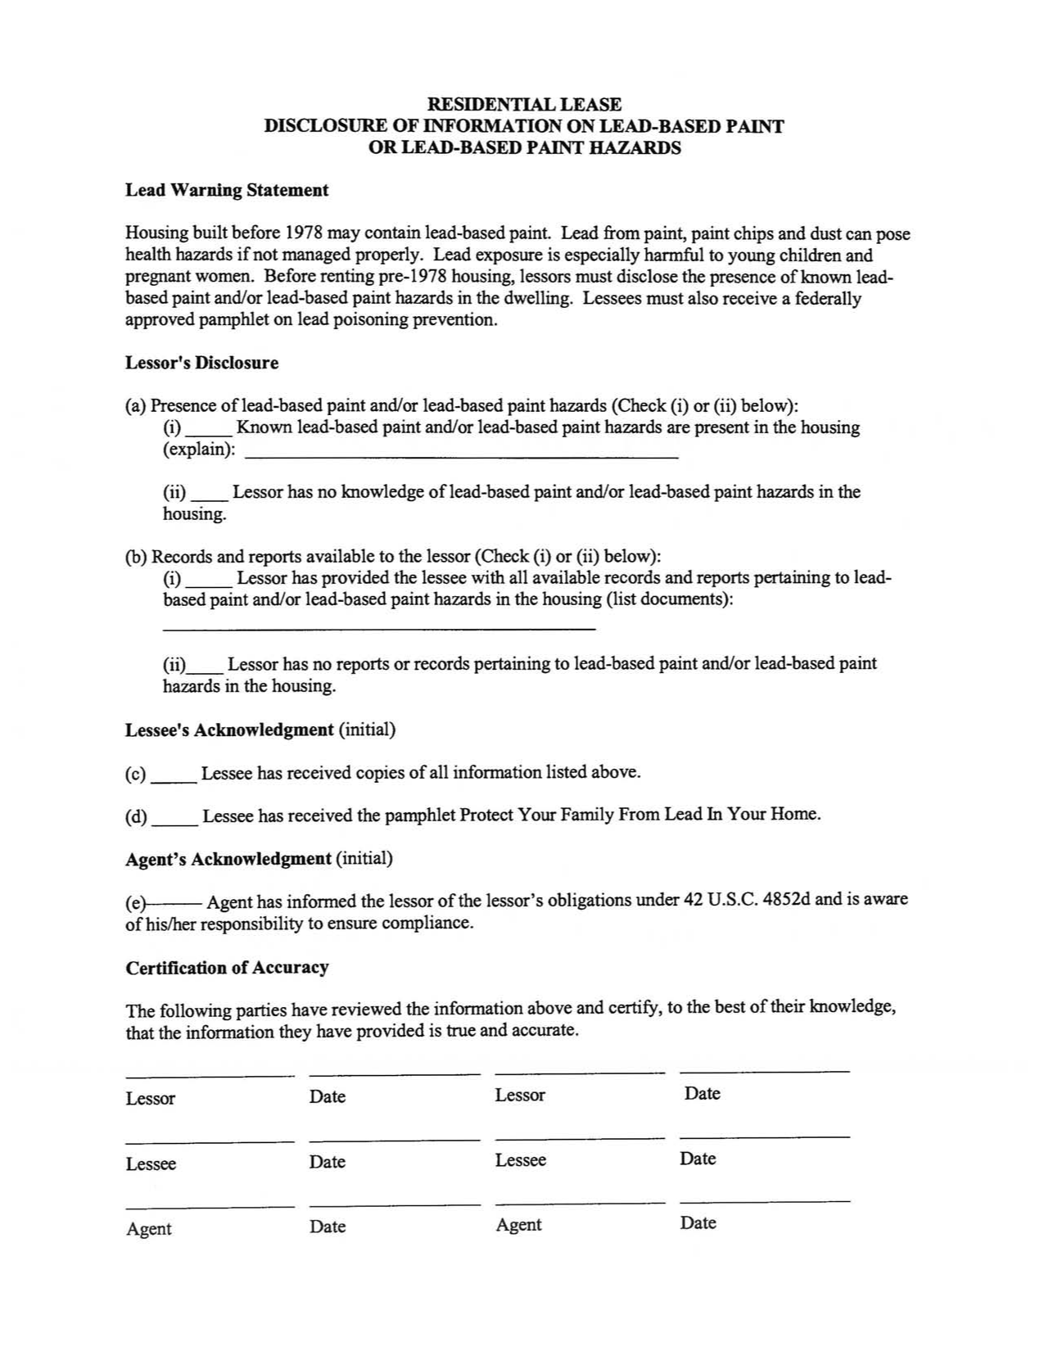
RESIDENTIAL LEASE

DISCLOSURE OF INFORMATION ON LEAD-BASED PAINT

OR LEAD-BASED PAINT HAZARDS

Lead Warning Statement

Housing built before 1978 may contain lead-based paint. Lead from paint, paint chips and dust can pose health hazards if not managed properly. Lead exposure is especially harmful to young children and pregnant women. Before renting pre-1978 housing, lessors must disclose the presence of known lead based paint and/or lead-based paint hazards in the dwelling. Lessees must also receive a federally approved pamphlet on lead poisoning prevention.

Lessor's Disclosure

- Presence oflead-based paint and/or lead-based paint hazards (Check (i) or (ii) below):

  - __ Known lead-based paint and/or lead-based paint hazards are present in the housing (explain): ___________________

  - __ Lessor has no knowledge oflead-based paint and/or lead-based paint hazards in the housing.

- Records and reports available to the lessor (Check (i) or (ii) below):

  - __ Lessor has provided the lessee with all available records and reports pertaining to lead based paint and/or lead-based paint hazards in the housing (list documents):

(ii)__ Lessor has no reports or records pertaining to lead-based paint and/or lead-based paint hazards in the housing.

Lessee's Acknowledgment (initial)

- __ Lessee has received copies of all information listed above.

- __ Lessee has received the pamphlet Protect Your Family From Lead In Your Home. Agent's Acknowledgment (initial)
- Agent has informed the lessor of the lessor's obligations under 42 U.S.C. 4852d and is aware ofhislher responsibility to ensure compliance.

Certification of Accuracy

The following parties have reviewed the information above and certify, to the best of their knowledge, that the information they have provided is true and accurate.

Lessor Date Lessor ^{Date}

Lessee Date Lessee ^{Date}

Agent Date Agent ^{Date}

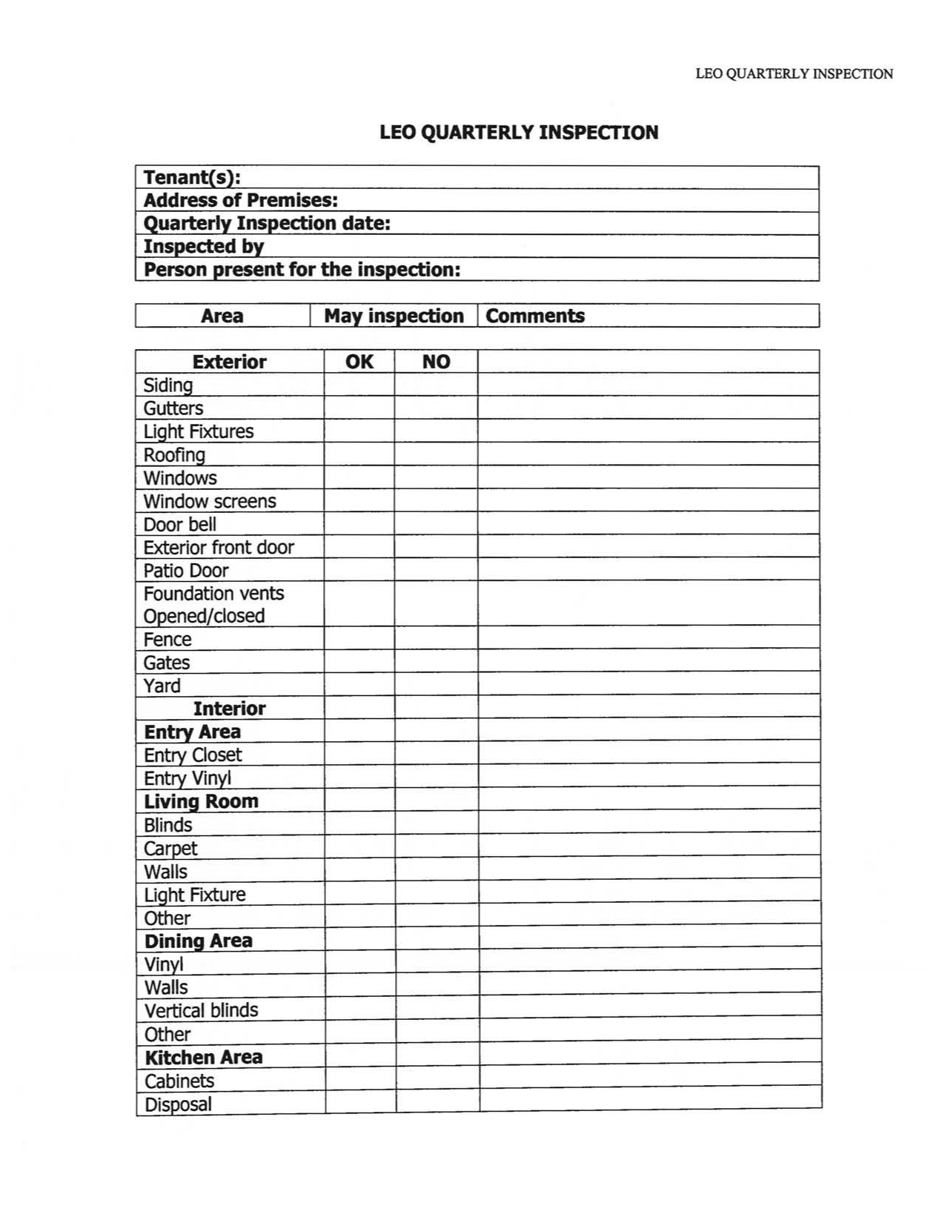
LEO QUARTERLY INSPECTION

LEO QUARTERLY INSPECTION

Tenant(s):

Address of Premises:

Quarterly Inspection date:

Inspected by

Person present for the inspection:

Area | May inspection I Comments
Exterior | OK | NO

Siding

Gutters

Light Fixtures

Roofing

Windows

Window screens

Door bell

Exterior front door

Patio Door

Foundation vents

Opened/closed

Fence

Gates

Yard

Interior

Entry Area

Entry Closet

Entry Vinyl

Living Room

Blinds

Carpet

Walls

Light Fixture

Other

Dining Area

Vinyl

Walls

Vertical blinds

Other

Kitchen Area

Cabinets

Disposal
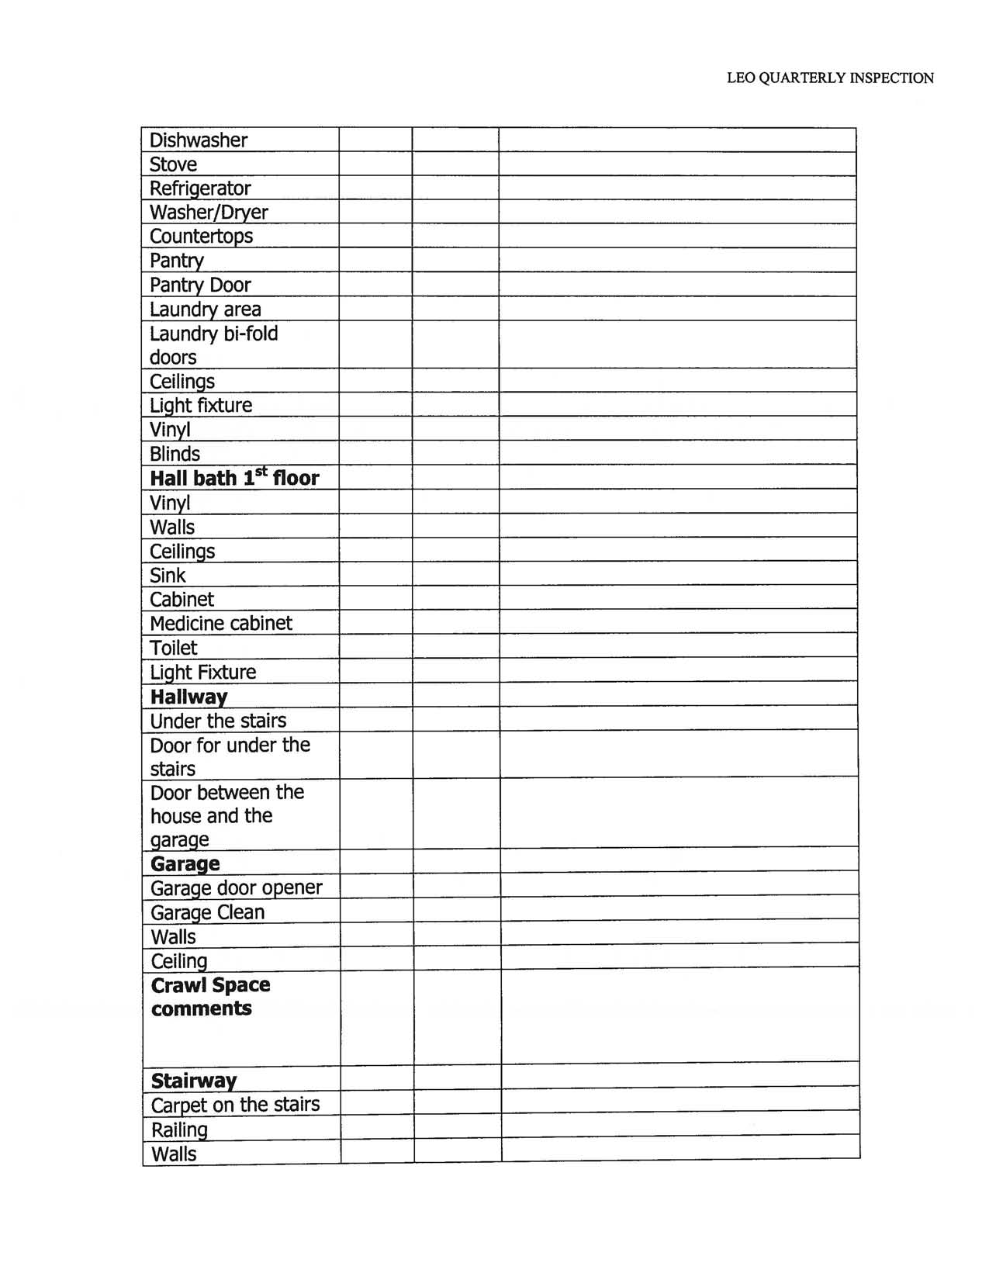
LEO QUARTERLY INSPECTION

Dishwasher

Stove

Refrigerator

Washer/Dryer

Countertops

Pantry

Pantry Door

Laundry area

Laundry bi-fold

doors

Ceilinqs

Light fixture

Vinyl

Blinds
Hall bath 1st floor
Vinyl

Walls

Ceilings

Sink

Cabinet

Medicine cabinet

Toilet

Light Fixture

Hallway

Under the stairs

Door for under the

stairs

Door between the

house and the

garaqe

Garage

Garage door opener

Garage Clean

Walls

Ceiling

Crawl Space

comments

Stairway

Carpet on the stairs

Railinq

Walls
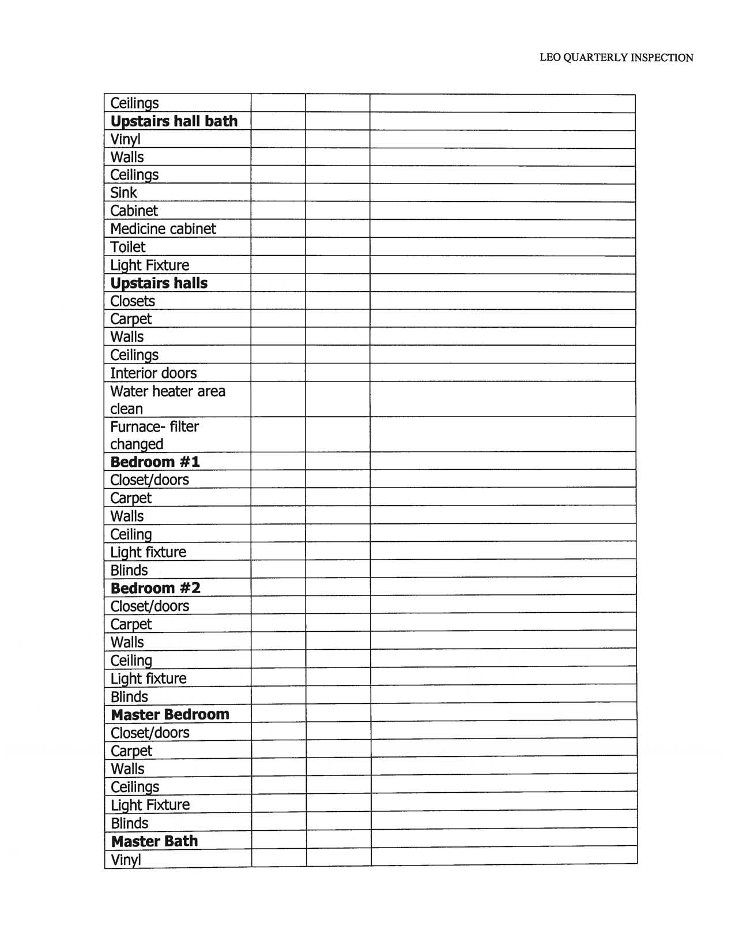
LEO QUARTERLY INSPECTION

Ceilings

Upstairs hall bath

Vinyl

Walls

Ceilings

Sink

Cabinet

Medicine cabinet

Toilet

Light Fixture

Upstairs halls

Closets

Carpet

Walls

Ceilings

Interior doors

Water heater area

clean

Furnace- filter

changed

Bedroom #1

Closet/doors

Carpet

Walls

Ceiling

Light fixture

Blinds

Bedroom #2

Closet/doors

Carpet

Walls

Ceiling

Light fixture

Blinds

Master Bedroom

Closet/doors

Carpet

Walls

Ceilings

Light Fixture

Blinds

Master Bath

Vinyl

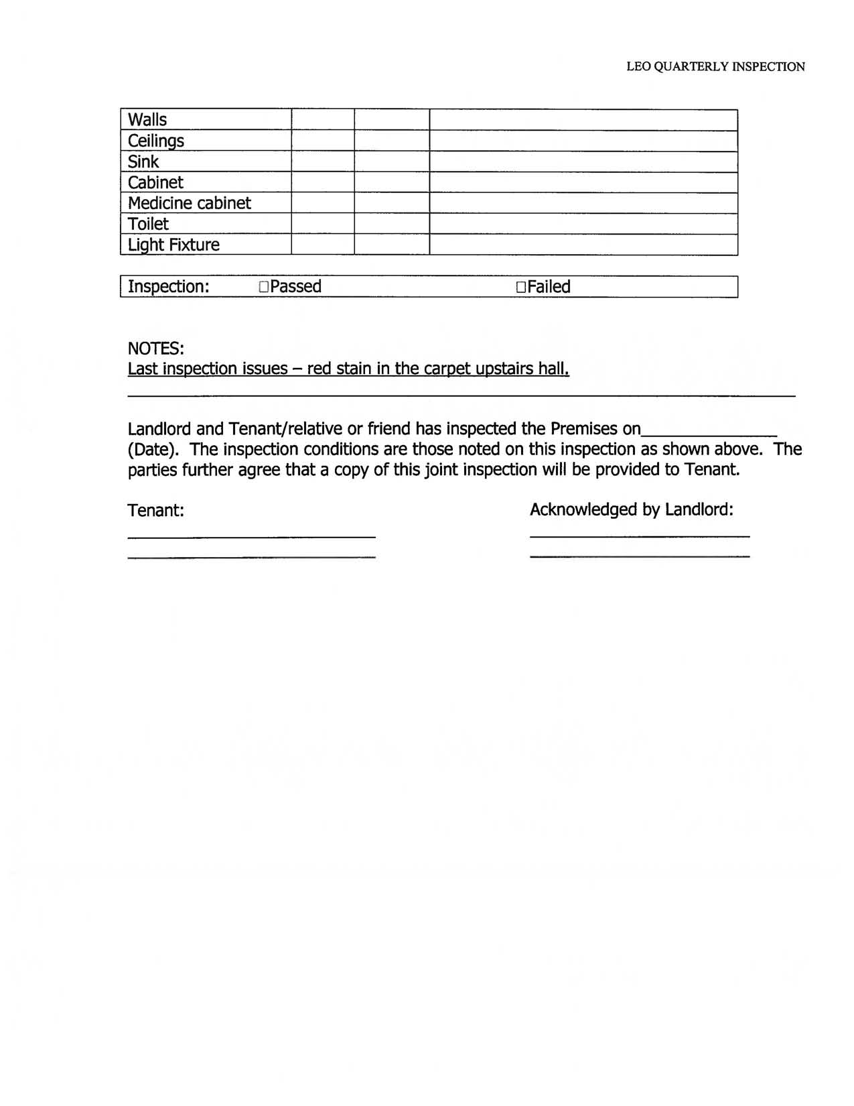
LEO QUARTERLY INSPECTION

Walls

Ceilings

Sink

Cabinet

Medicine cabinet

Toilet

Light Fixture

IInspection: oPassed DFailed

NOTES:

Last inspection issues - red stain in the carpet upstairs hall.

Landlord and Tenant/relative or friend has inspected the Premises on______

(Date). The inspection conditions are those noted on this inspection as shown above. The parties further agree that a copy of this joint inspection will be provided to Tenant.

Tenant: Acknowledged by Landlord:

