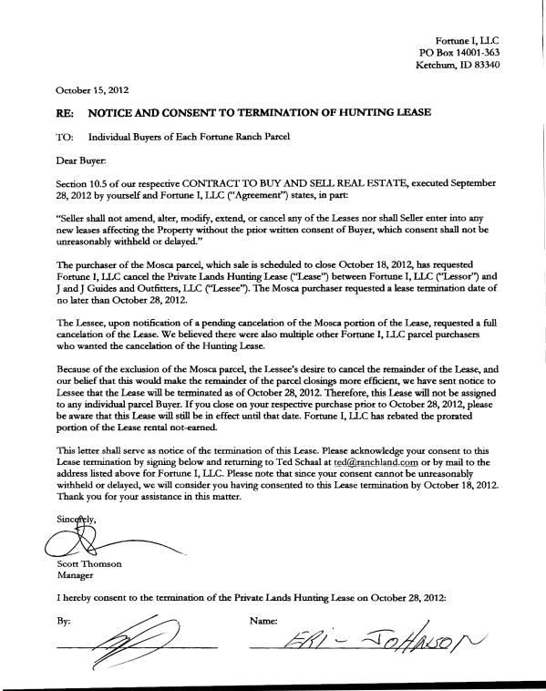
Fortune I, LLC

PO Box 14001-363

Ketchum. ID 83340

October 15, 2012

RE: NOTICE AND CONSENT TO TERMINATION OF HUNTING LEASE

TO: Individual Buyers of Each Fortune Ranch Parcel

Dear Buyer:

Section 10.5 of our respective CONTRACT TO BUY AND SElL REAL ESTATE, executed September 28, 2012 by yourself and Fortune I, LLC ("Agreement'') states, in part:

''Seller shall not amend, alter, modify, extend, or cancel any of the Leases nor shall Seller enter into any new leases affecting the Property without the prior written consent of Buyer, which consent shall not be unreasonably withheld or delayed."

The purchaser of the Mosca parcel, which sale is scheduled to close October 18, 2012, has requested Fortune I, LLC cancel the Private Lands Hunting Lease ("Lease") between Fortune I, LLC ("Lessor'') and J and J Guides and Outfitters, LLC (''Lessee''). The Mosca purchaser requested a lease termination date of no later than October 28,2012.

The Lessee, upon notification of a pending cancelation of the Mosca portion of the Lease, requested a full cancelation of the Lease. We believed there were also multiple other Fortune I, LLC parcel purchasers who wanted the cancelation of the Hunting Lease.

Because of the exclusion of the Mosca parcel, the Lessee's desire to cancel the remainder of the Lease, and our belief that this would make the remainder of the parcel closings more efficient, we have sent notice to Lessee that the Lease will be terminated as of October 28, 2012. Therefore, this Lease will not be assigned to any individual parcel Buyer. If you close on your respective purchase prior to October 28, 2012, please be aware that this Lease will still be in effect until that date. Fortune I, LLC has rebated the prorated portion of the Lease rental not-earned.

This letter shall serve as notice of the termination of this Lease. Please acknowledge your consent to this Lease termination by signing below and returning to Ted Schaal at tecl@_ranchland.!;om or by mail to the address listed above for Fortune I, LLC. Please note that since your consent cannot be unreasonably withheld or delayed, we will consider you having consented to this Lease termination by October 18,2012. Thank you for your assistance in this matter.

Scott Thomson

Manager

- hereby consent to the termination of the Private Lands Hunting Lease on October 28, 2012:

By: Name:

