

Farmers Balance Sheet

Accounting Year End:


for more FREE proforma templates visit:

www.farming4Prophet.co.uk

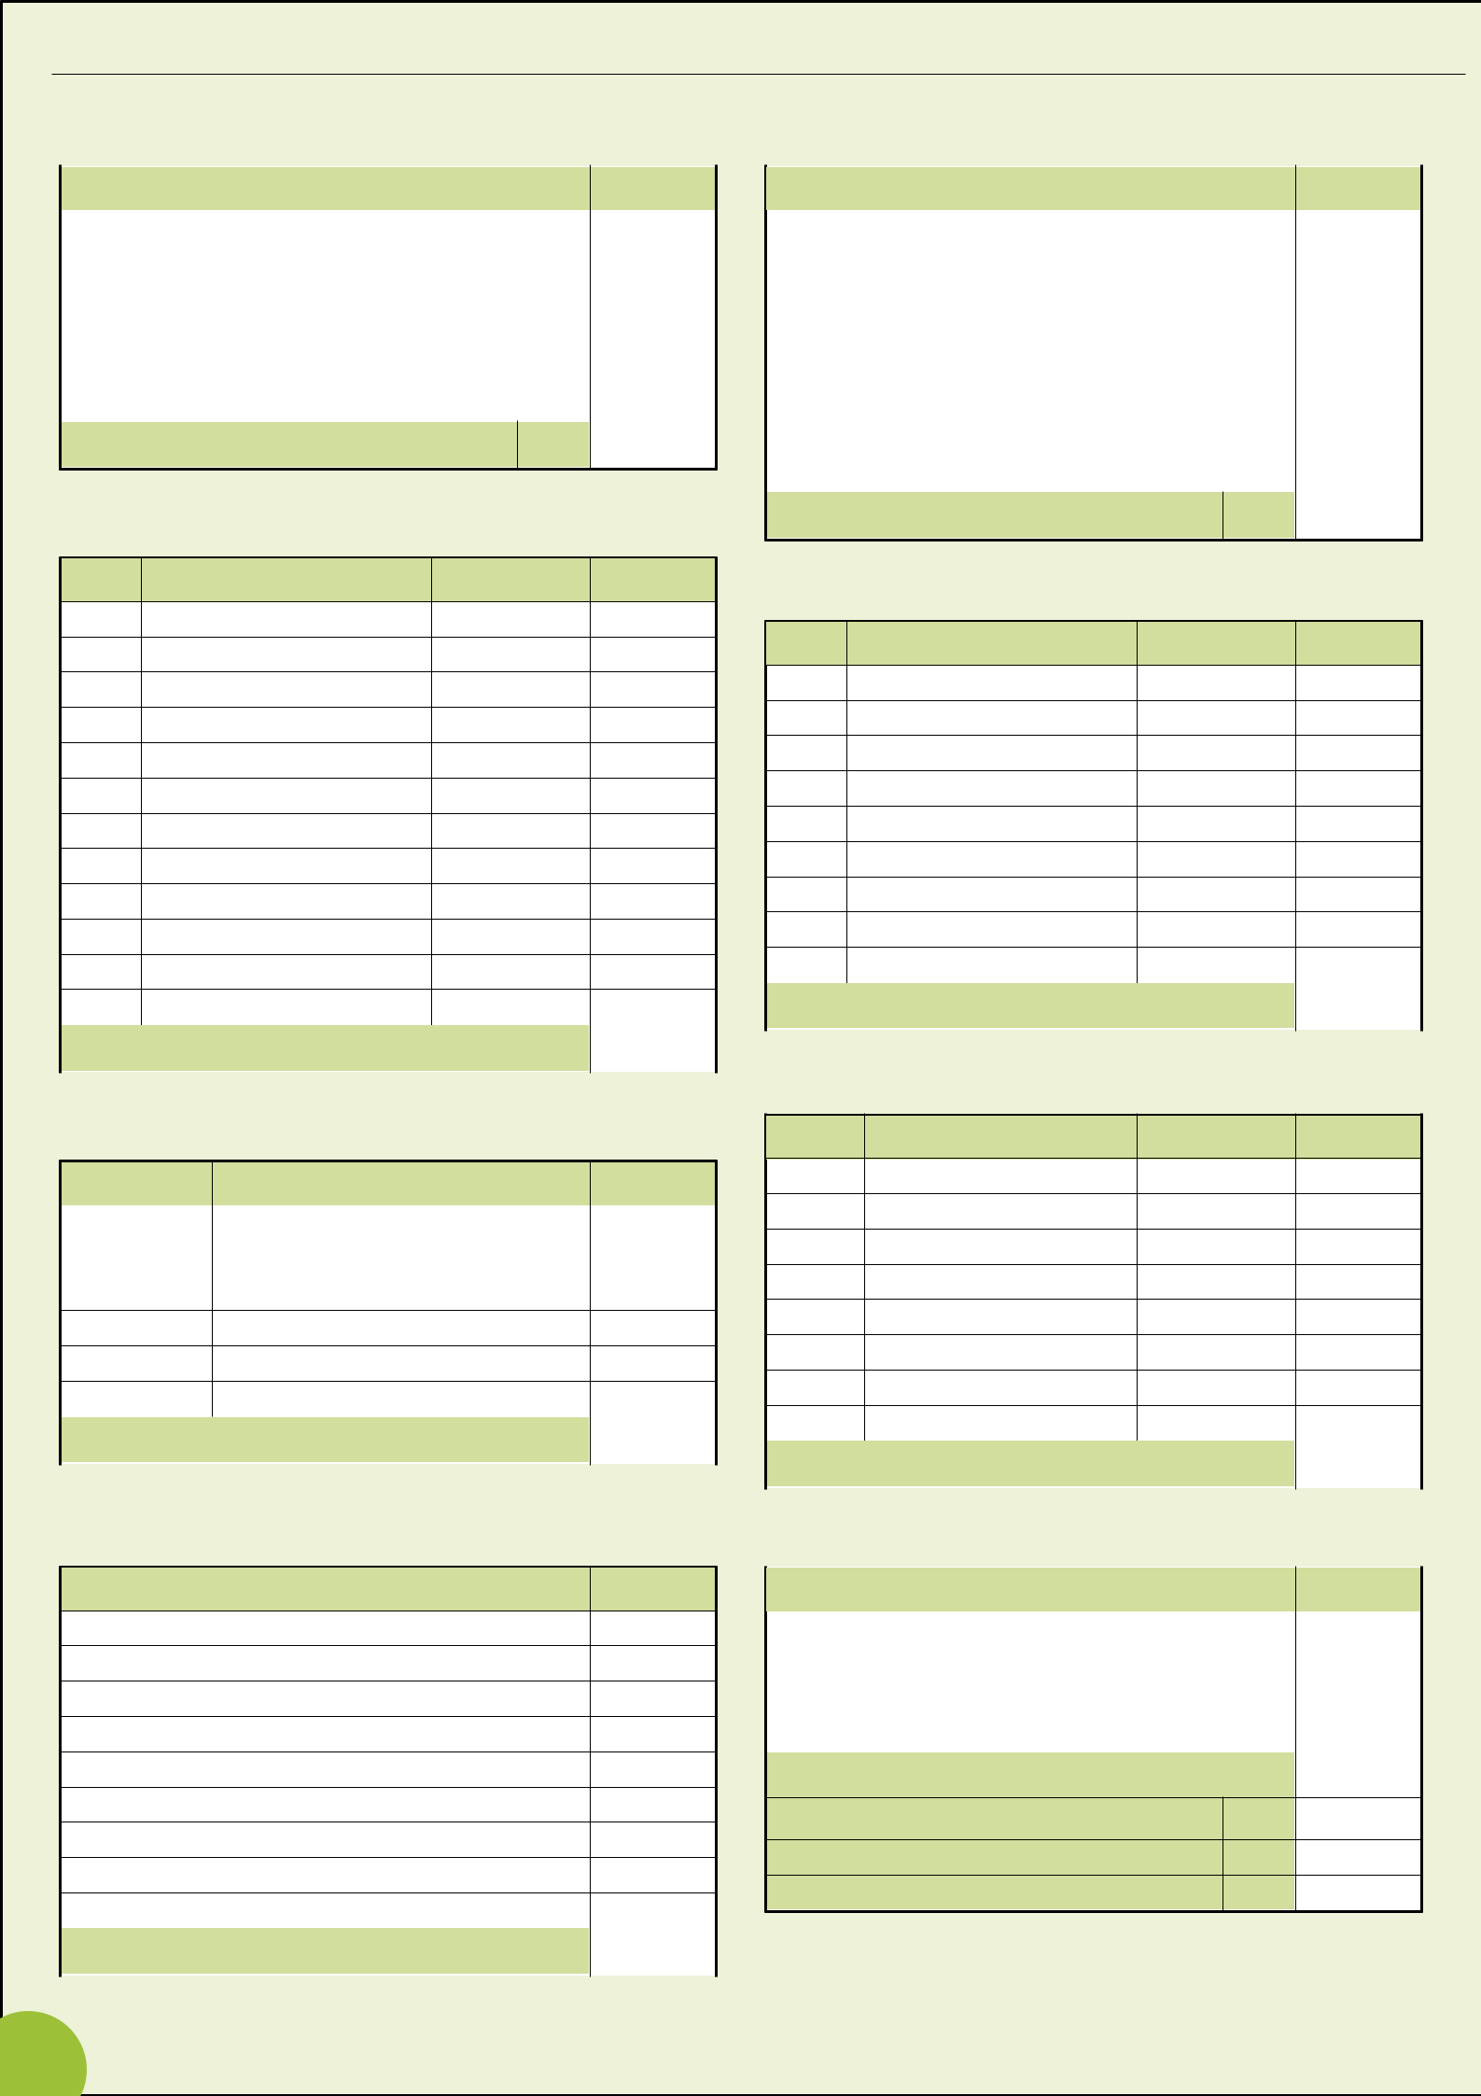
ASSETS: current value of livestock, crops, stores and equipment (for Land Valuation, see Page 4)

BREEDING LIVESTOCK

No. | Description | £ per head | Total £

TOTAL VALUE: Breeding Livestock 205

OTHER LIVESTOCK

No. | Description | £ per head | Total £

TOTAL VALUE: Other Livestock | 208

GOODS IN STORE

Quantity | Item | Total £
 | Fertiliser
 | Feed
 | Fuel

TOTAL VALUE: Goods in Store | 211

MACHINERY

Items | Total £

Tractors

Vehicles

Harvesters

Other Equipment

Fixed Equipment

TOTAL VALUE: Machinery | 203

LONG TERM CROPS

Ha | Crops | £ per Ha | Total £

TOTAL VALUE: Long Term Crops | 204

GROWING CROPS

Ha | Crops | £ per Ha | Total £

TOTAL VALUE: Growing Crops | 210

HARVESTED CROPS

Tonnes | Crops | £ per tonne Total £

TOTAL VALUE: Harvested Crops | 209

DEBTORS (money owed to the business) and PREPAYMENTS

Owed by | Item | Total £

Prepayments

TOTAL DEBTORS & PREPAYMENTS 213

BANK BALANCE 214

CASH IN HAND 215

2

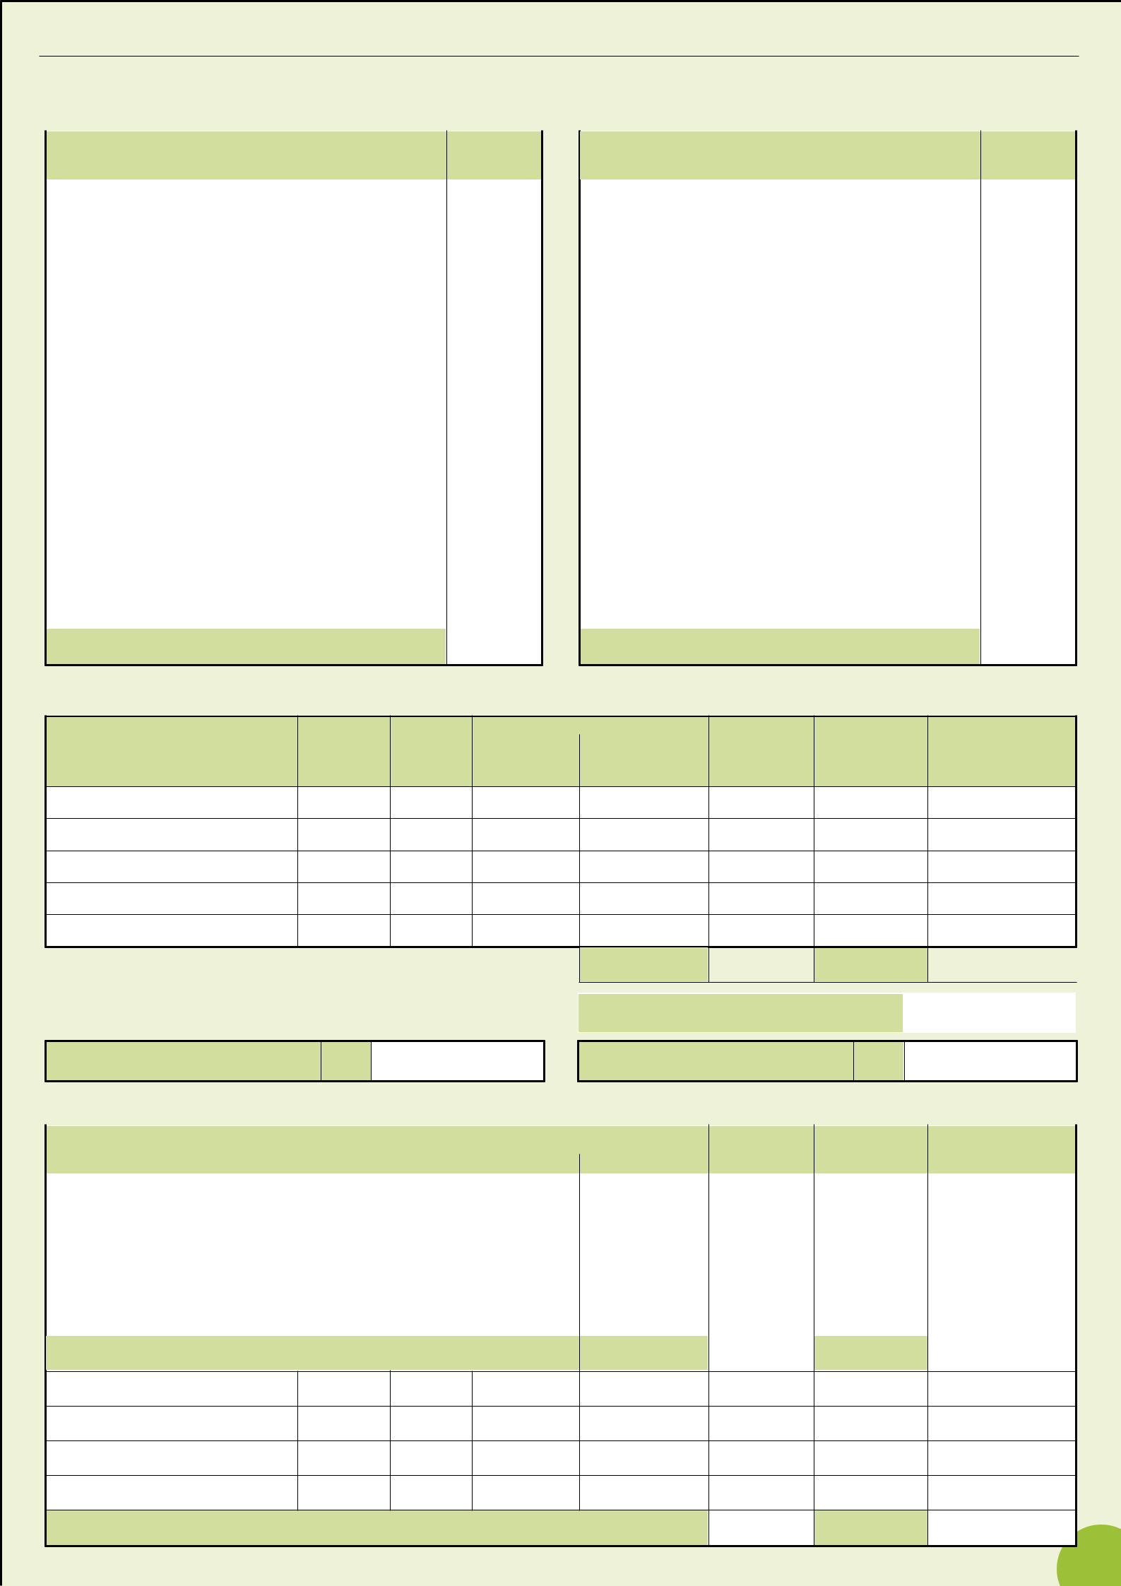
LIABILITIES: money owed by the business

CREDITORS

Money owed for goods/services supplied to the business

Supplier | Item | Date | Amount
 |  | Due | £

UNPRESENTED CHEQUES

Cheque No. | Item | Amount
 |  | £

TOTAL CREDITORS (1)

HIRE PURCHASE & LEASE AGREEMENTS

TOTAL UNPRESENTED CHEQUES (2)

Item

Purchase Cost
Date £

Payment Details

Amount £ | Frequency

ANNUAL

COST
£

Date of Final Payment

AMOUNT OUTSTANDING (HP only) £

TOTAL  TOTAL (3)

TOTAL (1) + (2) + (3) | 370

TAX OWED

371

BANK OVERDRAFT

372

HIRE PURCHASE & LEASE AGREEMENTS

 | Lender | Security | Start | Payment Details | ANNUAL | Interest | AMOUNT
 |  | Held | Date | Amount £ Frequency | COST £ | Rate | OUTSTANDING £
Mortgages
and Bank
Loans

Private

Loans

TOTAL

TOTAL (377)

TOTAL

TOTAL (378)

3

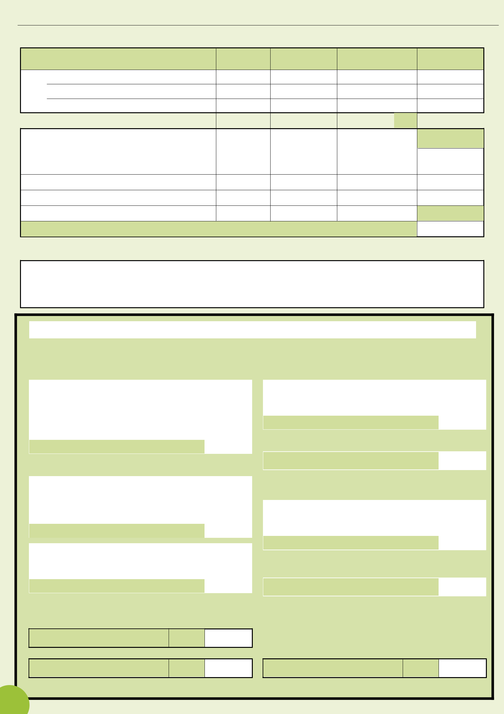
ASSETS: (continued from page 2)

LAND & PROPERTY

Arable (ha) Grassland (ha) TOTAL AREA (ha) | VALUE £

Owned (i)

(ii)

(iii)

TOTALS | 201

ANNUAL RENT £

Rented (i) Agricultural tenancy

(ii) Seasonally

TOTALS

GRAND TOTAL

BUILDINGS & FIXTURES 202

GUARANTEES; SURETIES

Details

Balance Sheet as at: | 20

ASSETS

Fixed Assets

 | Land & Property | 201
 | Buildings & Fixtures | 202
 | Machinery | 203
 | Long Term Crops | 204
 | Breeding Livestock | 205
 | Total Fixed Assets | 207
Current Assets
Physical: | Other Livestock | 208
 | Harvested Crops | 209
 | Growing Crops & Tillages | 210
 | Goods in Store | 211
 | Sub Total | 212
Liquid: | Debtors & Prepayments | 213
 | Bank Balance & Deposits | 214
 | Cash In Hand | 215
 | Sub Total | 216

LIABILITIES

Current Liabilities

Creditors (including HP outstanding) | 370
Tax Owed | 371
Bank Overdraft | 372
Total Current Liabilities | 373
Net Assets (218 -373) | 375
Long Term Liabilities
Mortgages & Bank Loans | 377
Private Loans | 378
Other Long Term Loans | 379
Total Long Term Liabilities | 380
Net Worth (375 - 380) | 385

Total Current Assets (212 +216) 217

Total Assets (207 +217) 218

Total Liabilities (373+380+385) 390

4

