1


Property inspection checklist


Item | Comments
Item | (Size & layout, décor, need for renovations? List as many pro’s and con’s as you can see.)

Address of property

Time & date inspected

Name of real estate agent

Contact details


Details of property

Kitchen

Living / lounge room

Dinning room

Bedroom # 1

Bedroom # 2

Bedroom # 3

Bedroom # 4

Bathroom #1

Bathroom #2

Bathroom #3

Laundry

Out door areas

Cupboard space

Inbuilt wardrobes

Garage

Appearance of building

Appearance of grounds

Easy access to the property

2


General considerations

Internal décor & appearance

Need for renovations?

Air flow

Air conditioning

Insulation

Brightness

Nth, East. Sth, West position

Stairs

Security

Solar panels

Rain water tank

Fencing

Noise from neighbours

Noise from traffic

Railway / aircraft noise

Neighbouring facilities

Visitor parking

Other
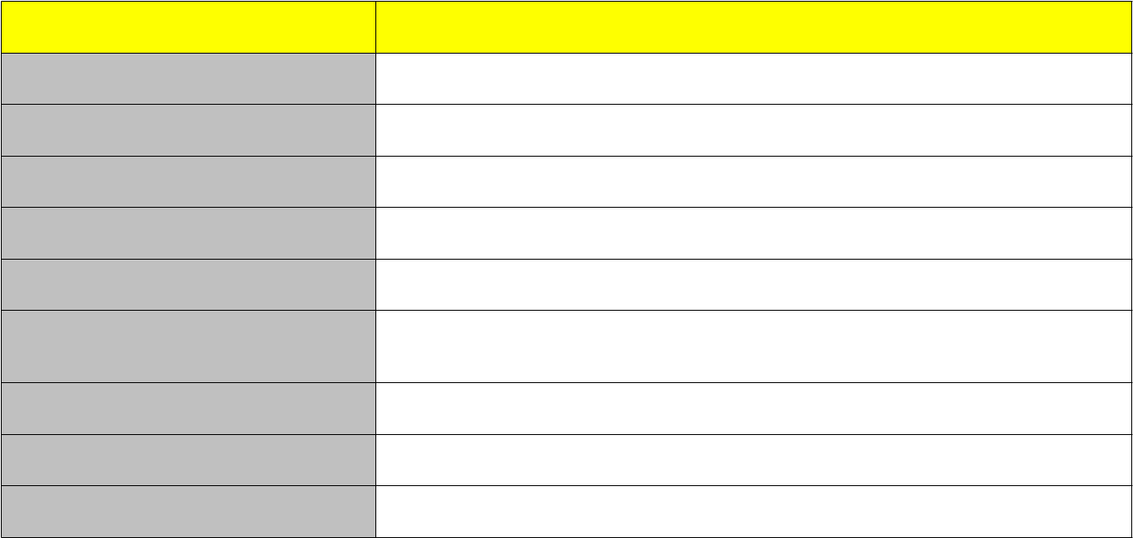

Professional Inspections

Building Inspection

- Foundations

- Structural soundness

- cracks in walls & floors

- leaks in roof or walls

- exposed perimeters on concrete floors

- mildew

- rising damp

- dry rot
3


- ventilation under dwelling

- locks on windows & doors

- general condiiton

- weatherboard sag/rot

- mortar quality

- roof condition

  - guttering

  - flues

  - chimneys

  - flashings

  - water staining on eaves

- plumbing

- water pressure

- Root damage from trees

- water tightness in garage

- dampness in bathrooms

Pest Inspection

- white ants / termites

- black ants

- spiders

- borers

- cockroach infestations

- flees

- rats & mice

- possums

- signs of past pest activity

Electrical & gas inspection

- wiring

- power points & switches
4


- safety overload switches

- fire alarm

- gas piping / leaks

- oven / stove quality

- water system & pressure

Other


Other things to check

General:

RTA / state & Fed. Gov. for

infrastructure plans

Water Rates

Land taxes

Crime Rate

Fire & flood risk

Units & townhouses:

Management Committee details

Body corporate regulations

Minutes from body corporate

meetings

Insurances

Cost of levies

Level of funds for maintenance

Deeds

Policy on pets

Other

