Vanderbilt Journal of Transnational Law
Volume 50 | Article 3
Issue 1 January 2017 | Article 3
2017
Expanding the Boundaries of Boundary Dispute Settlement:
International Law and Critical Geography at the Crossroads
Michal Saliternik

Follow this and additional works at: https://scholarship.law.vanderbilt.edu/vjtl  Part of the International Law Commons

Recommended Citation

Michal Saliternik, Expanding the Boundaries of Boundary Dispute Settlement: International Law and Critical Geography at the Crossroads, 50 Vanderbilt Law Review 113 (2021)

Available at: https://scholarship.law.vanderbilt.edu/vjtl/vol50/iss1/3

This Article is brought to you for free and open access by Scholarship@Vanderbilt Law. It has been accepted for inclusion in Vanderbilt Journal of Transnational Law by an authorized editor of Scholarship@Vanderbilt Law. For more information, please contact mark.j.williams@vanderbilt.edu.

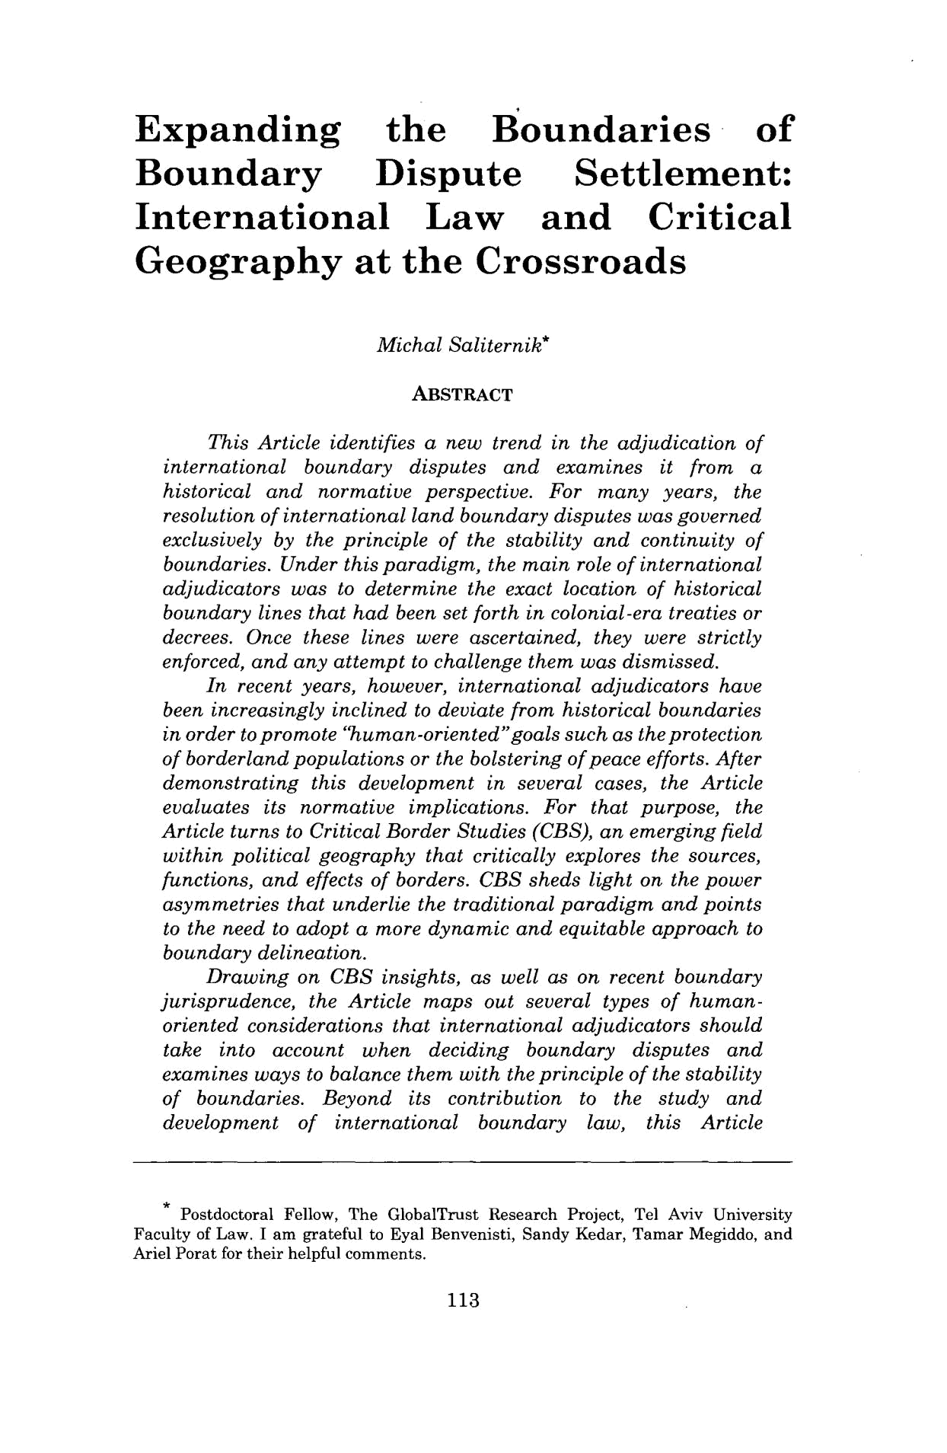
Expanding the Boundaries of

Boundary Dispute Settlement:

International Law and Critical Geography at the Crossroads

Michal Saliternik*

ABSTRACT

This Article identifies a new trend in the adjudication of international boundary disputes and examines it from a historical and normative perspective. For many years, the resolution of internationalland boundary disputes was governed exclusively by the principle of the stability and continuity of boundaries. Under this paradigm, the main role of international adjudicators was to determine the exact location of historical boundary lines that had been set forth in colonial-era treaties or decrees. Once these lines were ascertained, they were strictly enforced, and any attempt to challenge them was dismissed.

In recent years, however, international adjudicators have been increasingly inclined to deviate from historical boundaries

in order to promote "human-oriented"goalssuch as the protection of borderlandpopulations or the bolstering of peace efforts. After demonstrating this development in several cases, the Article evaluates its normative implications. For that purpose, the Article turns to CriticalBorder Studies (CBS), an emerging field within political geography that critically explores the sources, functions, and effects of borders. CBS sheds light on the power asymmetries that underlie the traditionalparadigm and points to the need to adopt a more dynamic and equitable approach to boundary delineation.

Drawing on CBS insights, as well as on recent boundary jurisprudence, the Article maps out several types of human-oriented considerations that international adjudicators should take into account when deciding boundary disputes and examines ways to balance them with the principle of the stability of boundaries. Beyond its contribution to the study and development of international boundary law, this Article

Postdoctoral Fellow, The GlobalTrust Research Project, Tel Aviv University Faculty of Law. I am grateful to Eyal Benvenisti, Sandy Kedar, Tamar Megiddo, and Ariel Porat for their helpful comments.

113

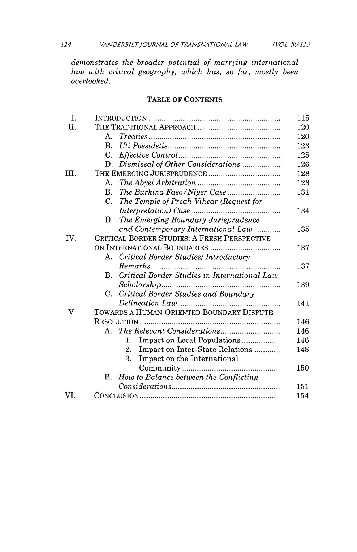
1.14 VANDERBILTjOURNAL OF TRANSNATIONAL LAW [VOL. 501,13

demonstrates the broader potential of marrying international law with critical geography, which has, so far, mostly been overlooked.

 |  | TABLE OF CONTENTS
I. | INTRODUCTION...................................... |  |  | 115
II. | THE TRADITIONAL APPROACH |  | .......................... | 120
 | A. | Treaties | .................................. | 120
 | B. | Uti Possidetis.............................. |  | 123
 | C. | Effective Control.. | ......................... | 125
 | D. | Dismissal of Other Considerations............ |  | 126
III. | THE EMERGING JURISPRUDENCE |  | ...................... | 128
 | A. | The Abyei Arbitration | ....................... | 128
 | B. | The Burkina Faso/NigerCase............... |  | 131
 | C. | The Temple of Preah Vihear (Request for
 |  | Interpretation)Case ...... | .................. | 134
 | D. | The Emerging Boundary Jurisprudence
 |  | and Contemporary InternationalLaw............. |  | 135
IV. | CRITICAL BORDER STUDIES: A FRESH PERSPECTIVE
 | ON INTERNATIONAL BOUNDARIES |  | ..................... | 137
 | A. | CriticalBorder Studies: Introductory
 |  | Remarks................................. |  | 137
 | B. | CriticalBorder Studies in International Law
 |  | Scholarship........... | ................. | 139
 | C. | CriticalBorder Studies and Boundary
 |  | DelineationLaw ........................... |  | 141

- TOWARDS A HUMAN-ORIENTED BOUNDARY DISPUTE

 | RESOLUTION |  | ........................................ | 146
 | A. | The Relevant Considerations................. |  | 146
 |  | 1. | Impact on Local Populations ............. | 146
 |  | 2. | Impact on Inter-State Relations ............ | 148
 |  | 3. | Impact on the International
 |  |  | Community.......................... | 150
 | B. | How to Balance between the Conflicting
 |  | Considerations............................. |  | 151
VI. | CONCLUSION........................................ |  |  | 154

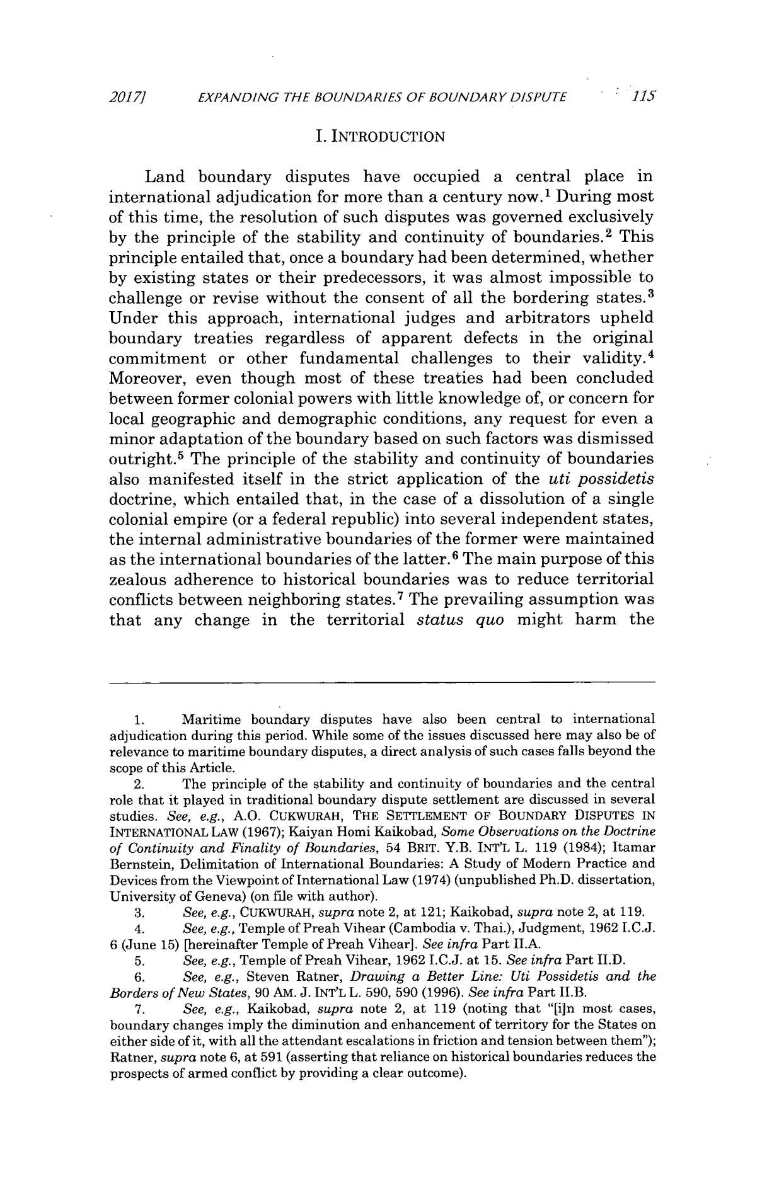
2017] EXPANDING THE BOUNDARIES OF BOUNDARY DISPUTE 115

I. INTRODUCTION

Land boundary disputes have occupied a central place in international adjudication for more than a century now.¹ During most of this time, the resolution of such disputes was governed exclusively by the principle of the stability and continuity of boundaries. ² This principle entailed that, once a boundary had been determined, whether by existing states or their predecessors, it was almost impossible to challenge or revise without the consent of all the bordering states.³ Under this approach, international judges and arbitrators upheld boundary treaties regardless of apparent defects in the original commitment or other fundamental challenges to their validity.⁴ Moreover, even though most of these treaties had been concluded between former colonial powers with little knowledge of, or concern for local geographic and demographic conditions, any request for even a minor adaptation of the boundary based on such factors was dismissed outright.⁵ The principle of the stability and continuity of boundaries also manifested itself in the strict application of the uti possidetis doctrine, which entailed that, in the case of a dissolution of a single colonial empire (or a federal republic) into several independent states, the internal administrative boundaries of the former were maintained as the international boundaries of the latter. ⁶ The main purpose of this zealous adherence to historical boundaries was to reduce territorial conflicts between neighboring states.⁷ The prevailing assumption was that any change in the territorial status quo might harm the

- Maritime boundary disputes have also been central to international adjudication during this period. While some of the issues discussed here may also be of relevance to maritime boundary disputes, a direct analysis of such cases falls beyond the scope of this Article.

- The principle of the stability and continuity of boundaries and the central role that it played in traditional boundary dispute settlement are discussed in several studies. See, e.g., A.O. CUKWURAH, THE SETTLEMENT OF BOUNDARY DISPUTES IN

INTERNATIONAL LAW (1967); Kaiyan Homi Kaikobad, Some Observationson the Doctrine of Continuity and Finality of Boundaries, 54 BRIT. Y.B. INT'L L. 119 (1984); Itamar Bernstein, Delimitation of International Boundaries: A Study of Modern Practice and Devices from the Viewpoint of International Law (1974) (unpublished Ph.D. dissertation, University of Geneva) (on file with author).

- See, e.g., CUKWURAH, supra note 2, at 121; Kaikobad, supra note 2, at 119.

- See, e.g., Temple of Preah Vihear (Cambodia v. Thai.), Judgment, 1962 I.C.J. 6 (June 15) [hereinafter Temple of Preah Vihear]. See infra Part II.A.
- See, e.g., Temple of Preah Vihear, 1962 I.C.J. at 15. See infra Part II.D.

- See, e.g., Steven Ratner, Drawing a Better Line: Uti Possidetis and the Borders of New States, 90 AM. J. INT'L L. 590, 590 (1996). See infra Part II.B.

- See, e.g., Kaikobad, supra note 2, at 119 (noting that "[iun most cases, boundary changes imply the diminution and enhancement of territory for the States on either side of it, with all the attendant escalations in friction and tension between them"); Ratner, supra note 6, at 591 (asserting that reliance on historical boundaries reduces the prospects of armed conflict by providing a clear outcome).
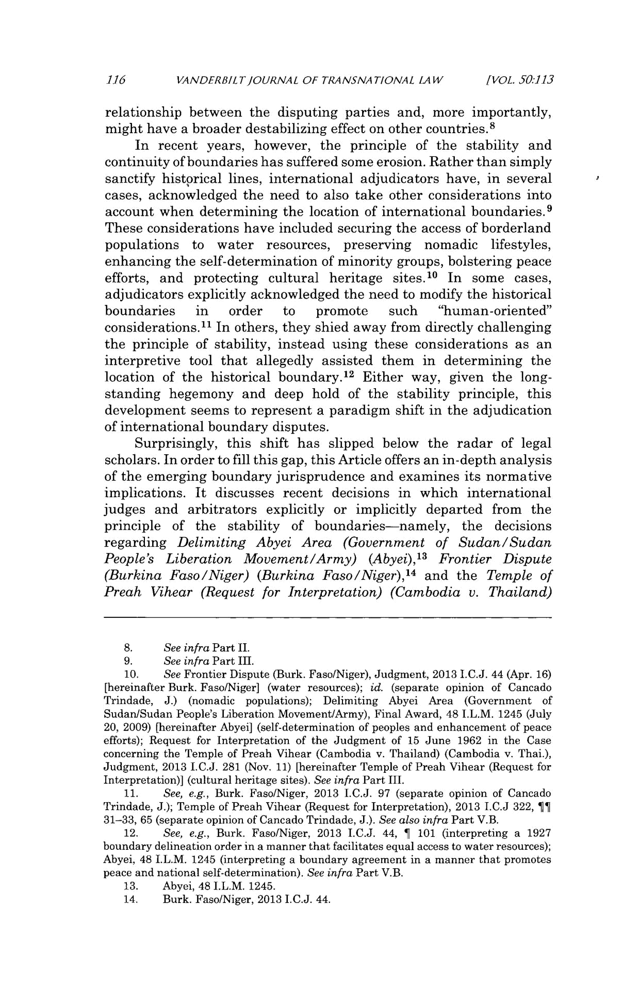
116 VANDFRBILTJOURNAL OF TRANSNATIONAL LAW [VOL. 50:113

relationship between the disputing parties and, more importantly, might have a broader destabilizing effect on other countries.⁸

In recent years, however, the principle of the stability and continuity of boundaries has suffered some erosion. Rather than simply sanctify historical lines, international adjudicators have, in several cases, acknowledged the need to also take other considerations into account when determining the location of international boundaries.⁹ These considerations have included securing the access of borderland populations to water resources, preserving nomadic lifestyles, enhancing the self-determination of minority groups, bolstering peace efforts, and protecting cultural heritage sites.¹⁰ In some cases, adjudicators explicitly acknowledged the need to modify the historical

boundaries in order to promote such "human-oriented" considerations.¹¹ In others, they shied away from directly challenging the principle of stability, instead using these considerations as an interpretive tool that allegedly assisted them in determining the location of the historical boundary. ¹² Either way, given the long-standing hegemony and deep hold of the stability principle, this development seems to represent a paradigm shift in the adjudication of international boundary disputes.

Surprisingly, this shift has slipped below the radar of legal scholars. In order to fill this gap, this Article offers an in-depth analysis of the emerging boundary jurisprudence and examines its normative implications. It discusses recent decisions in which international judges and arbitrators explicitly or implicitly departed from the principle of the stability of boundaries-namely, the decisions regarding Delimiting Abyei Area (Government of Sudan/Sudan

People's Liberation Movement/Army) (Abyei), ¹³ Frontier Dispute
14
(Burkina Faso/Niger) (Burkina Faso/Niger), and the Temple of Preah Vihear (Request for Interpretation) (Cambodia v. Thailand)

- See infra Part II.

- See infra Part III.

  - See Frontier Dispute (Burk. Faso/Niger), Judgment, 2013 I.C.J. 44 (Apr. 16) [hereinafter Burk. Faso/Niger] (water resources); id. (separate opinion of Cancado Trindade, J.) (nomadic populations); Delimiting Abyei Area (Government of Sudan/Sudan People's Liberation Movement/Army), Final Award, 48 I.L.M. 1245 (July 20, 2009) [hereinafter Abyei] (self-determination of peoples and enhancement of peace efforts); Request for Interpretation of the Judgment of 15 June 1962 in the Case concerning the Temple of Preah Vihear (Cambodia v. Thailand) (Cambodia v. Thai.), Judgment, 2013 J.C.J. 281 (Nov. 11) [hereinafter Temple of Preah Vihear (Request for Interpretation)] (cultural heritage sites). See infra Part III.

- See, e.g., Burk. Faso/Niger, 2013 I.C.J. 97 (separate opinion of Cancado Trindade, J.); Temple of Preah Vihear (Request for Interpretation), 2013 I.C.J 322, ]f 31-33, 65 (separate opinion of Cancado Trindade, J.). See also infra Part V.B.

- See, e.g., Burk. Faso/Niger, 2013 I.C.J. 44, } 101 (interpreting a 1927 boundary delineation order in a manner that facilitates equal access to water resources); Abyei, 48 I.L.M. 1245 (interpreting a boundary agreement in a manner that promotes peace and national self-determination). See infra Part V.B.

- Abyei, 48 I.L.M. 1245.

- Burk. Faso/Niger, 2013 I.C.J. 44.
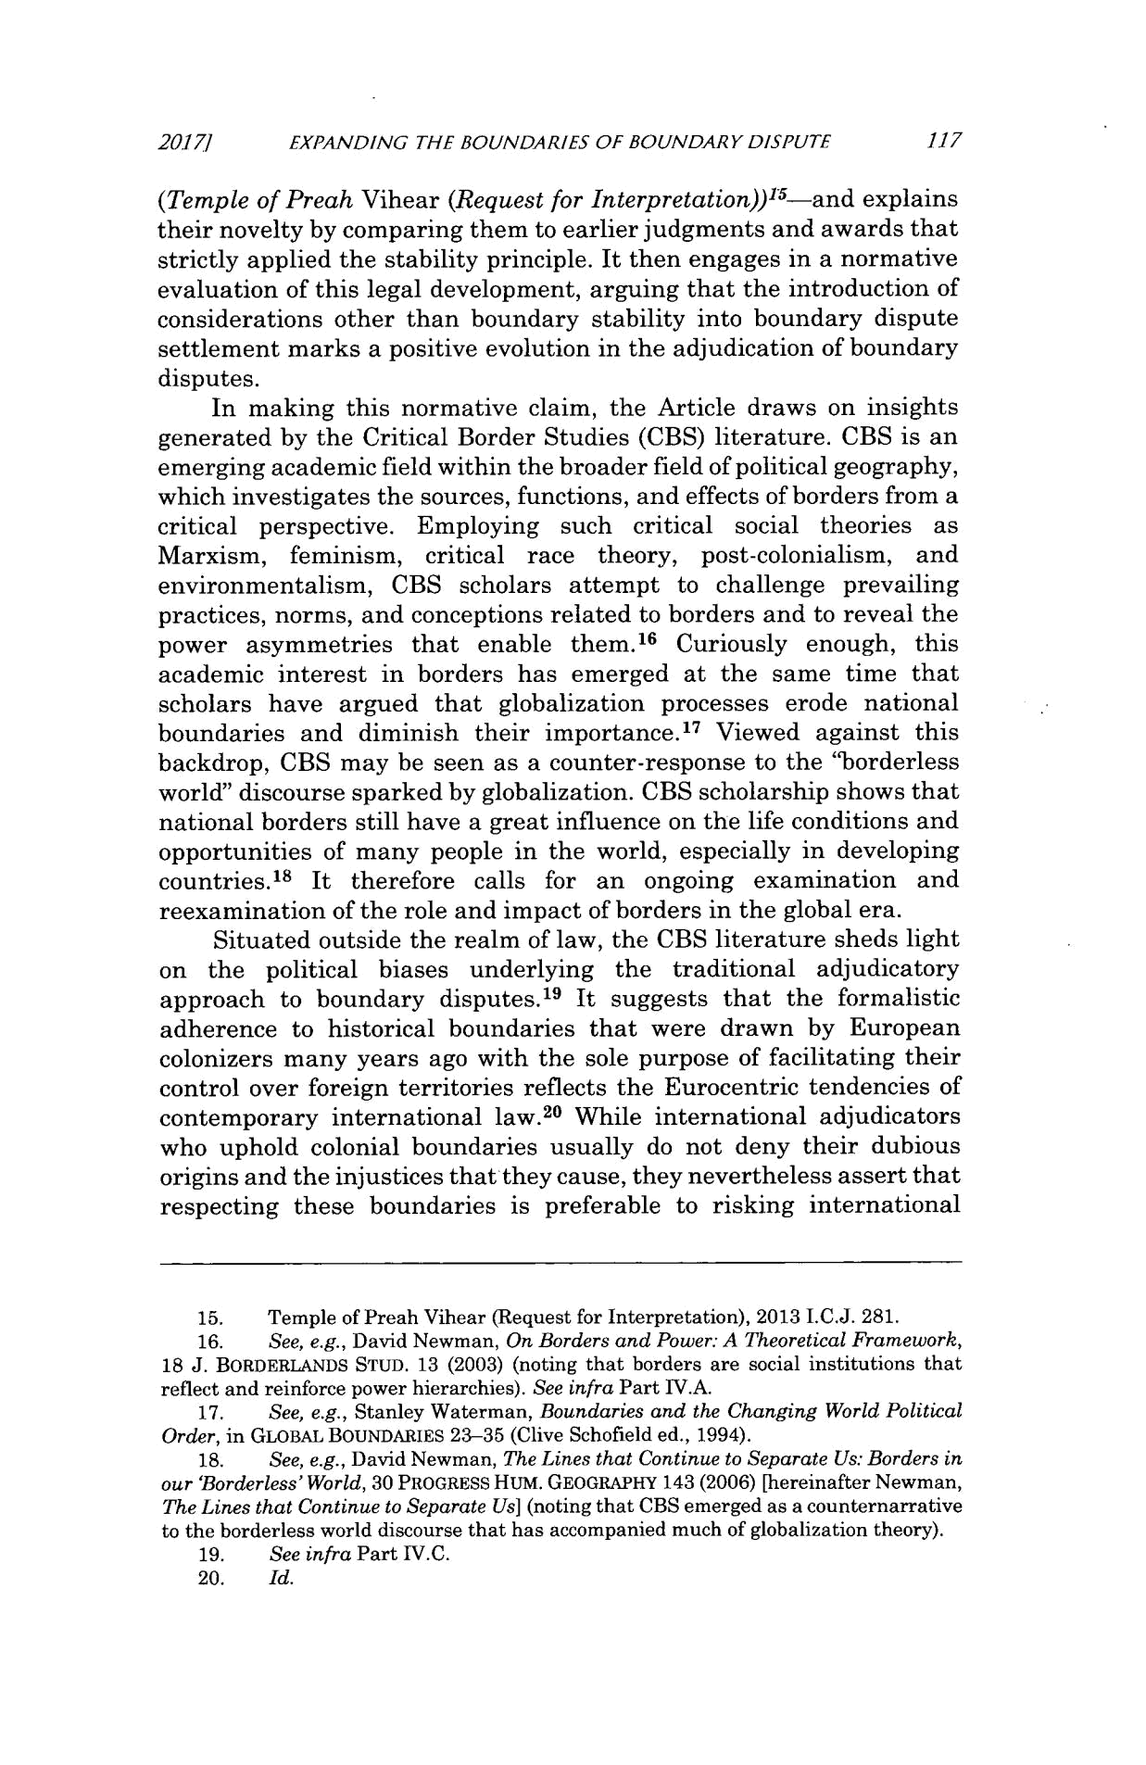
2017/1 EXPANDING THE BOUNDARIES OF BOUNDARY DISPUTE 117
¹5-and explains
(Temple of Preah Vihear (Request for Interpretation))

their novelty by comparing them to earlier judgments and awards that strictly applied the stability principle. It then engages in a normative evaluation of this legal development, arguing that the introduction of considerations other than boundary stability into boundary dispute settlement marks a positive evolution in the adjudication of boundary disputes.

In making this normative claim, the Article draws on insights generated by the Critical Border Studies (CBS) literature. CBS is an emerging academic field within the broader field of political geography, which investigates the sources, functions, and effects of borders from a critical perspective. Employing such critical social theories as Marxism, feminism, critical race theory, post-colonialism, and environmentalism, CBS scholars attempt to challenge prevailing practices, norms, and conceptions related to borders and to reveal the power asymmetries that enable them. ¹⁶ Curiously enough, this academic interest in borders has emerged at the same time that scholars have argued that globalization processes erode national boundaries and diminish their importance.¹ ⁷ Viewed against this backdrop, CBS may be seen as a counter-response to the "borderless world" discourse sparked by globalization. CBS scholarship shows that national borders still have a great influence on the life conditions and opportunities of many people in the world, especially in developing countries.18 It therefore calls for an ongoing examination and reexamination of the role and impact of borders in the global era.

Situated outside the realm of law, the CBS literature sheds light on the political biases underlying the traditional adjudicatory approach to boundary disputes.'⁹ It suggests that the formalistic adherence to historical boundaries that were drawn by European colonizers many years ago with the sole purpose of facilitating their control over foreign territories reflects the Eurocentric tendencies of contemporary international law. ²⁰ While international adjudicators who uphold colonial boundaries usually do not deny their dubious origins and the injustices that they cause, they nevertheless assert that respecting these boundaries is preferable to risking international

- Temple of Preah Vihear (Request for Interpretation), 2013 I.C.J. 281.

- See, e.g., David Newman, On Borders and Power: A Theoretical Framework, 18 J. BORDERLANDS STUD. 13 (2003) (noting that borders are social institutions that reflect and reinforce power hierarchies). See infra Part IVA.

  - See, e.g., Stanley Waterman, Boundaries and the Changing World Political Order, in GLOBAL BOUNDARIES 23-35 (Clive Schofield ed., 1994).

  - See, e.g., David Newman, The Lines that Continue to Separate Us: Borders in our 'Borderless'World, 30 PROGRESS HUM. GEOGRAPHY 143 (2006) [hereinafter Newman, The Lines that Continue to Separate Us] (noting that CBS emerged as a counternarrative to the borderless world discourse that has accompanied much of globalization theory).
  - See infra Part IV.C.

  - Id.
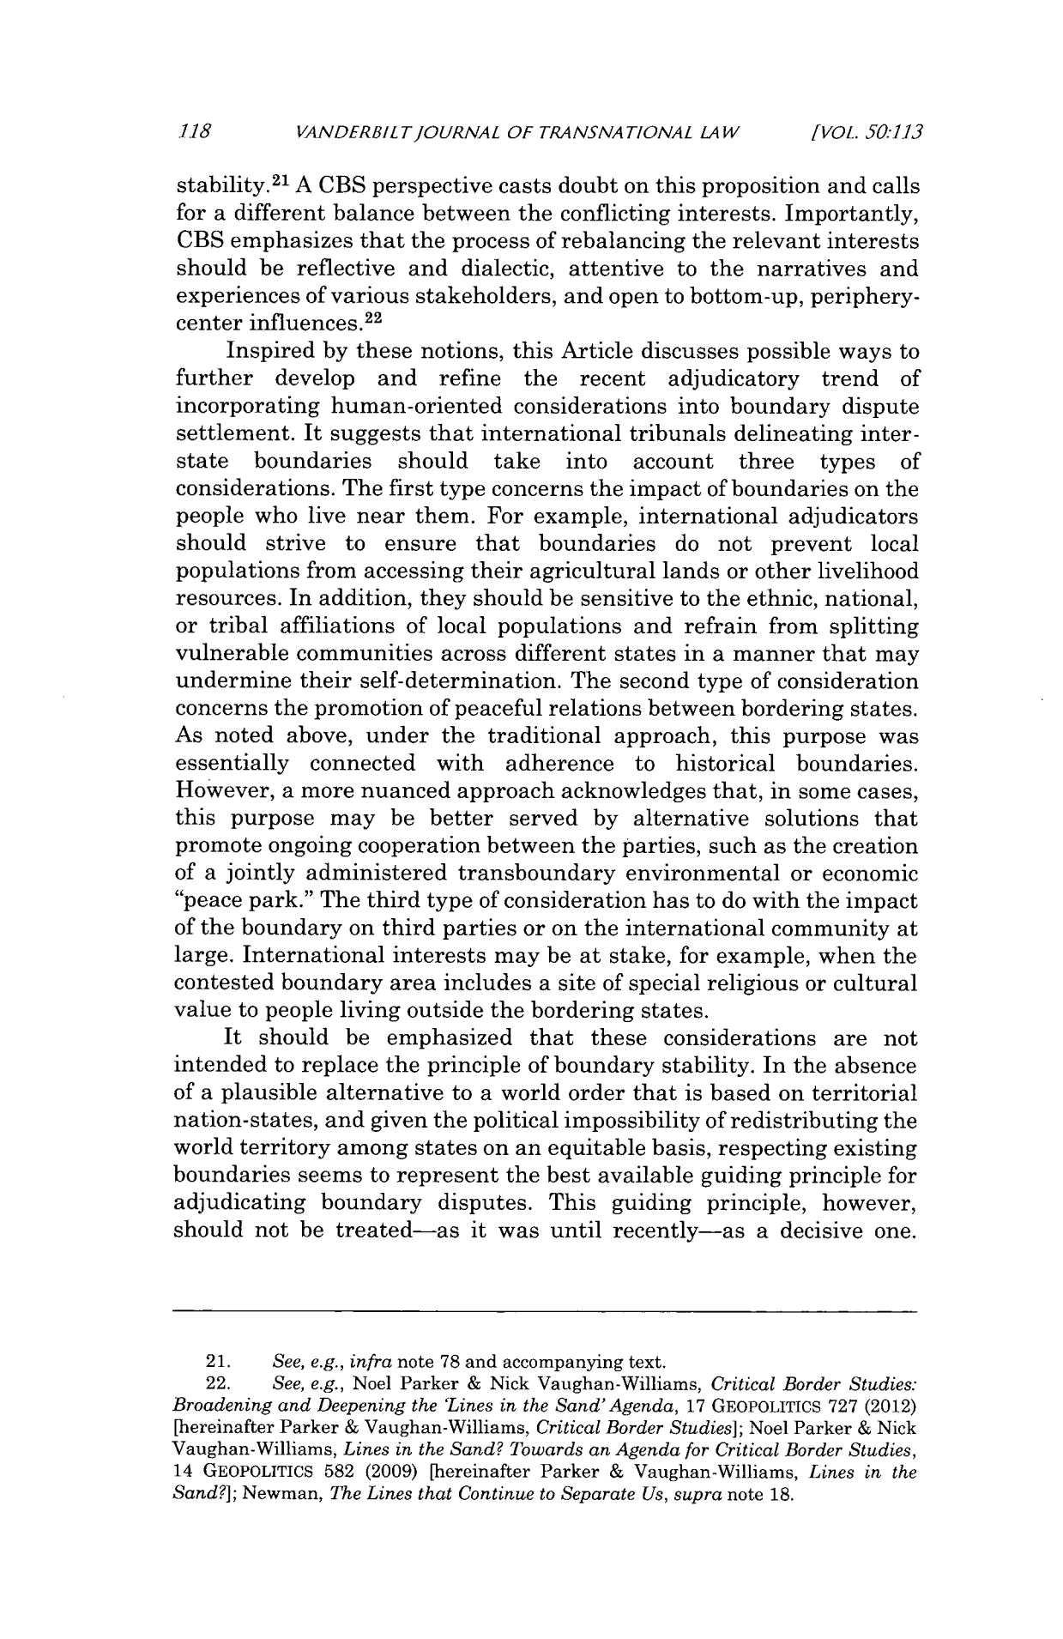
118 ANDERBILTJOURNAL OF TRANSNATIONAL LAW [VOL. 50:113

stability.²1 A CBS perspective casts doubt on this proposition and calls for a different balance between the conflicting interests. Importantly, CBS emphasizes that the process of rebalancing the relevant interests should be reflective and dialectic, attentive to the narratives and experiences of various stakeholders, and open to bottom-up, periphery-center influences. ²²

Inspired by these notions, this Article discusses possible ways to further develop and refine the recent adjudicatory trend of incorporating human-oriented considerations into boundary dispute settlement. It suggests that international tribunals delineating inter-state boundaries should take into account three types of considerations. The first type concerns the impact of boundaries on the people who live near them. For example, international adjudicators should strive to ensure that boundaries do not prevent local populations from accessing their agricultural lands or other livelihood resources. In addition, they should be sensitive to the ethnic, national, or tribal affiliations of local populations and refrain from splitting vulnerable communities across different states in a manner that may undermine their self-determination. The second type of consideration concerns the promotion of peaceful relations between bordering states. As noted above, under the traditional approach, this purpose was essentially connected with adherence to historical boundaries. However, a more nuanced approach acknowledges that, in some cases, this purpose may be better served by alternative solutions that promote ongoing cooperation between the parties, such as the creation of a jointly administered transboundary environmental or economic "peace park." The third type of consideration has to do with the impact of the boundary on third parties or on the international community at large. International interests may be at stake, for example, when the contested boundary area includes a site of special religious or cultural value to people living outside the bordering states.

It should be emphasized that these considerations are not intended to replace the principle of boundary stability. In the absence of a plausible alternative to a world order that is based on territorial nation-states, and given the political impossibility of redistributing the world territory among states on an equitable basis, respecting existing boundaries seems to represent the best available guiding principle for adjudicating boundary disputes. This guiding principle, however, should not be treated-as it was until recently-as a decisive one.

- See, e.g., infra note 78 and accompanying text.

- See, e.g., Noel Parker & Nick Vaughan-Williams, Critical Border Studies: Broadening and Deepening the 'Lines in the Sand'Agenda, 17 GEOPOLITICS 727 (2012) [hereinafter Parker & Vaughan-Williams, CriticalBorder Studies]; Noel Parker & Nick Vaughan-Williams, Lines in the Sand? Towards an Agenda for Critical Border Studies, 14 GEOPOLITICS 582 (2009) [hereinafter Parker & Vaughan-Williams, Lines in the Sand?]; Newman, The Lines that Continue to Separate Us, supra note 18.
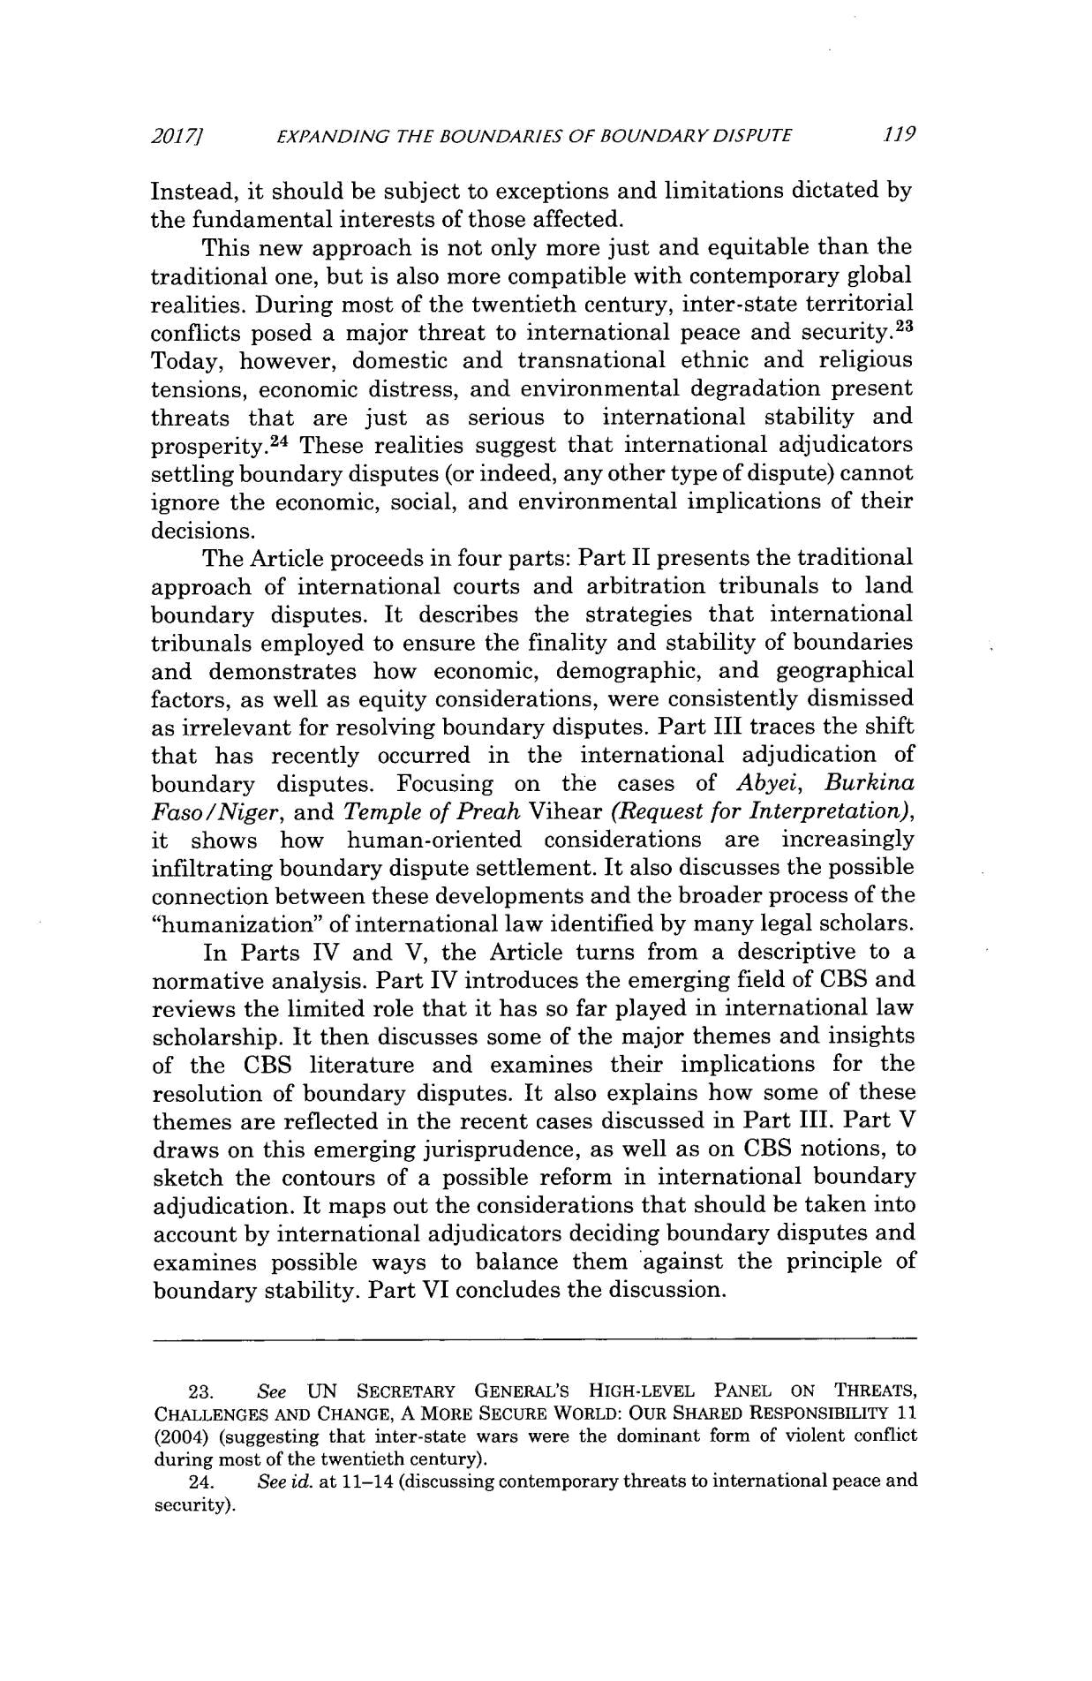
2017] EXPANDING THE BOUNDARIES OF BOUNDARY DISPUTE .119

Instead, it should be subject to exceptions and limitations dictated by the fundamental interests of those affected.

This new approach is not only more just and equitable than the traditional one, but is also more compatible with contemporary global realities. During most of the twentieth century, inter-state territorial conflicts posed a major threat to international peace and security.²³ Today, however, domestic and transnational ethnic and religious tensions, economic distress, and environmental degradation present threats that are just as serious to international stability and prosperity. ²⁴ These realities suggest that international adjudicators settling boundary disputes (or indeed, any other type of dispute) cannot ignore the economic, social, and environmental implications of their decisions.

The Article proceeds in four parts: Part II presents the traditional approach of international courts and arbitration tribunals to land boundary disputes. It describes the strategies that international tribunals employed to ensure the finality and stability of boundaries and demonstrates how economic, demographic, and geographical factors, as well as equity considerations, were consistently dismissed as irrelevant for resolving boundary disputes. Part III traces the shift that has recently occurred in the international adjudication of boundary disputes. Focusing on the cases of Abyei, Burkina Faso /Niger, and Temple of Preah Vihear (Request for Interpretation), it shows how human-oriented considerations are increasingly infiltrating boundary dispute settlement. It also discusses the possible connection between these developments and the broader process of the "humanization" of international law identified by many legal scholars.

In Parts IV and V, the Article turns from a descriptive to a normative analysis. Part IV introduces the emerging field of CBS and reviews the limited role that it has so far played in international law scholarship. It then discusses some of the major themes and insights of the CBS literature and examines their implications for the resolution of boundary disputes. It also explains how some of these themes are reflected in the recent cases discussed in Part III. Part V draws on this emerging jurisprudence, as well as on CBS notions, to sketch the contours of a possible reform in international boundary adjudication. It maps out the considerations that should be taken into account by international adjudicators deciding boundary disputes and examines possible ways to balance them against the principle of boundary stability. Part VI concludes the discussion.

23. See UN SECRETARY GENERAL'S HIGH-LEVEL PANEL ON THREATS, CHALLENGES AND CHANGE, A MORE SECURE WORLD: OUR SHARED RESPONSIBILITY 11 (2004) (suggesting that inter-state wars were the dominant form of violent conflict

during most of the twentieth century).

- See id. at 11-14 (discussing contemporary threats to international peace and

security).
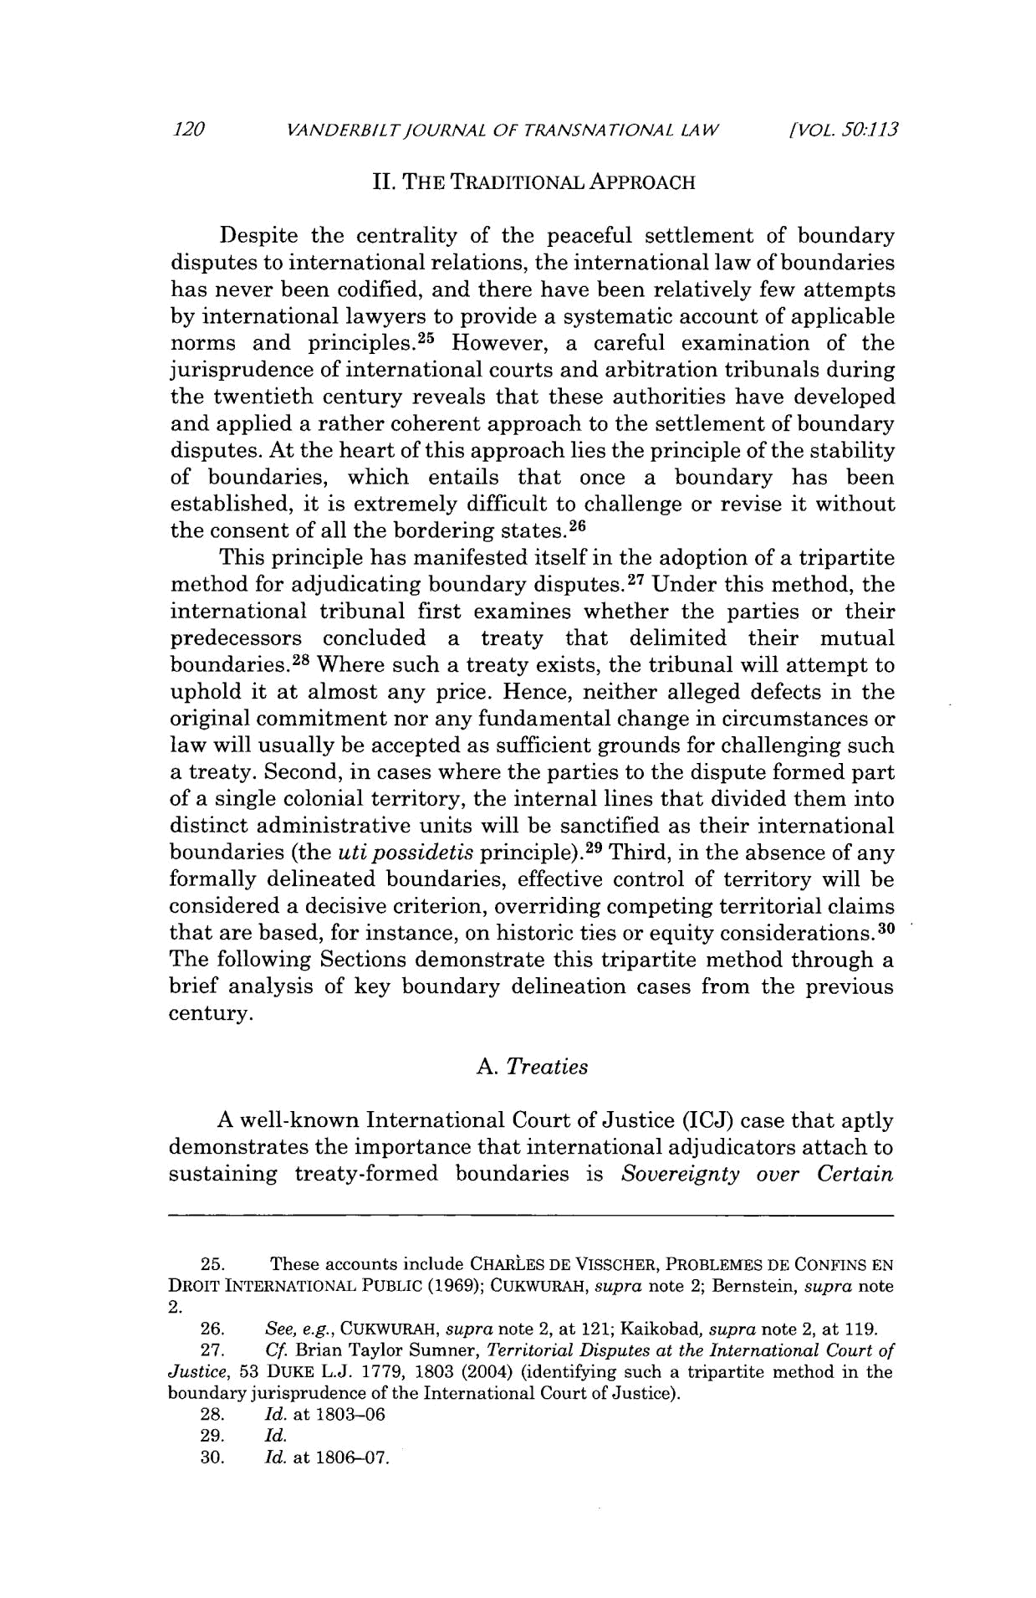
120 VANDERBILT/OURNAL OF TRANSNATIONAL LAW [VOL. 50:113

- THE TRADITIONAL APPROACH

Despite the centrality of the peaceful settlement of boundary disputes to international relations, the international law of boundaries has never been codified, and there have been relatively few attempts by international lawyers to provide a systematic account of applicable norms and principles. ² ⁵ However, a careful examination of the jurisprudence of international courts and arbitration tribunals during the twentieth century reveals that these authorities have developed and applied a rather coherent approach to the settlement of boundary disputes. At the heart of this approach lies the principle of the stability of boundaries, which entails that once a boundary has been established, it is extremely difficult to challenge or revise it without the consent of all the bordering states.² ⁶

This principle has manifested itself in the adoption of a tripartite method for adjudicating boundary disputes.27 Under this method, the international tribunal first examines whether the parties or their predecessors concluded a treaty that delimited their mutual boundaries.² ⁸ Where such a treaty exists, the tribunal will attempt to uphold it at almost any price. Hence, neither alleged defects in the original commitment nor any fundamental change in circumstances or law will usually be accepted as sufficient grounds for challenging such a treaty. Second, in cases where the parties to the dispute formed part of a single colonial territory, the internal lines that divided them into distinct administrative units will be sanctified as their international boundaries (the uti possidetis principle).²⁹ Third, in the absence of any formally delineated boundaries, effective control of territory will be considered a decisive criterion, overriding competing territorial claims that are based, for instance, on historic ties or equity considerations.³ ⁰ The following Sections demonstrate this tripartite method through a brief analysis of key boundary delineation cases from the previous century.

- Treaties

A well-known International Court of Justice (ICJ) case that aptly demonstrates the importance that international adjudicators attach to sustaining treaty-formed boundaries is Sovereignty over Certain

- These accounts include CHARLES DE VISSCHER, PROBLEMES DE CONFINS EN DROIT INTERNATIONAL PUBLIC (1969); CUKWURAH, supra note 2; Bernstein, supra note 2.

- See, e.g., CUKWURAH, supra note 2, at 121; Kaikobad, supra note 2, at 119.

- Cf. Brian Taylor Sumner, TerritorialDisputes at the International Court of Justice, 53 DUKE L.J. 1779, 1803 (2004) (identifying such a tripartite method in the boundary jurisprudence of the International Court of Justice).
- Id. at 1803-06

- Id.

- Id. at 1806-07.
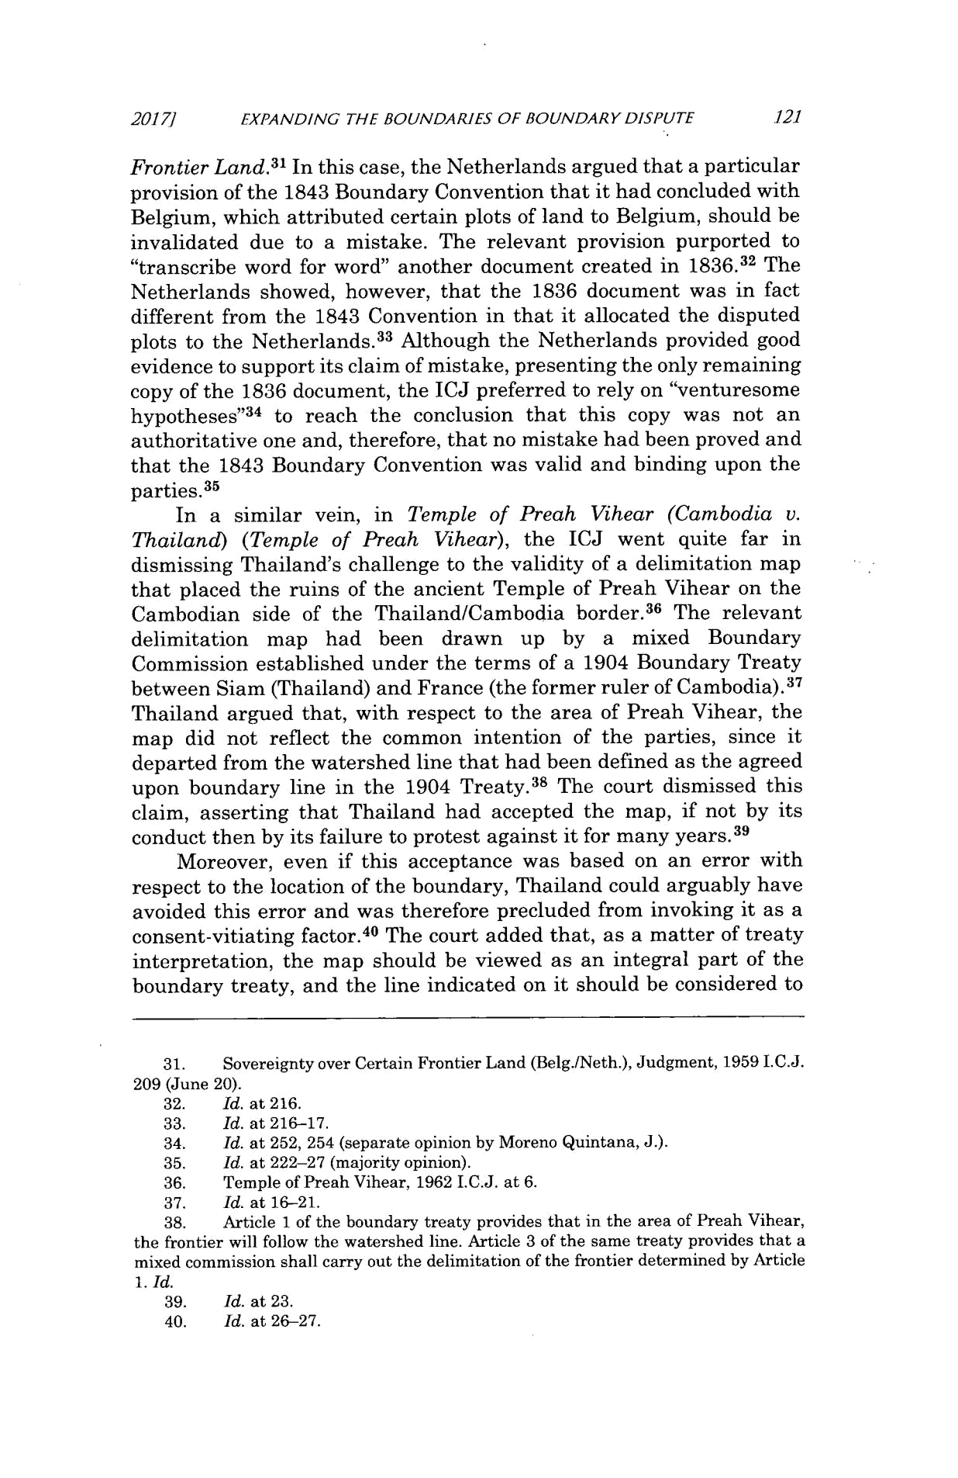
20171 EXPANDING THE BOUNDARIES OF BOUNDARY DISPUTE 121

FrontierLand.³ ' In this case, the Netherlands argued that a particular provision of the 1843 Boundary Convention that it had concluded with Belgium, which attributed certain plots of land to Belgium, should be invalidated due to a mistake. The relevant provision purported to "transcribe word for word" another document created in 1836.32 The Netherlands showed, however, that the 1836 document was in fact different from the 1843 Convention in that it allocated the disputed plots to the Netherlands.³ ³ Although the Netherlands provided good evidence to support its claim of mistake, presenting the only remaining copy of the 1836 document, the ICJ preferred to rely on "venturesome hypotheses" ³⁴ to reach the conclusion that this copy was not an authoritative one and, therefore, that no mistake had been proved and that the 1843 Boundary Convention was valid and binding upon the parties.³ ⁵

In a similar vein, in Temple of Preah Vihear (Cambodia v. Thailand) (Temple of Preah Vihear), the ICJ went quite far in dismissing Thailand's challenge to the validity of a delimitation map that placed the ruins of the ancient Temple of Preah Vihear on the Cambodian side of the Thailand/Cambodia border.³⁶ The relevant delimitation map had been drawn up by a mixed Boundary Commission established under the terms of a 1904 Boundary Treaty between Siam (Thailand) and France (the former ruler of Cambodia).³ ⁷ Thailand argued that, with respect to the area of Preah Vihear, the map did not reflect the common intention of the parties, since it departed from the watershed line that had been defined as the agreed upon boundary line in the 1904 Treaty.³⁸ The court dismissed this claim, asserting that Thailand had accepted the map, if not by its conduct then by its failure to protest against it for many years.3

Moreover, even if this acceptance was based on an error with respect to the location of the boundary, Thailand could arguably have avoided this error and was therefore precluded from invoking it as a consent-vitiating factor. ⁴⁰ The court added that, as a matter of treaty interpretation, the map should be viewed as an integral part of the boundary treaty, and the line indicated on it should be considered to

  - Sovereignty over Certain Frontier Land (Belg./Neth.), Judgment, 1959 I.C.J. 209 (June 20).
  - Id. at 216.

  - Id. at 216-17.

  - Id. at 252, 254 (separate opinion by Moreno Quintana, J.).

  - Id. at 222-27 (majority opinion).

  - Temple of Preah Vihear, 1962 I.C.J. at 6.

    - Id. at 16-21.

    - Article 1 of the boundary treaty provides that in the area of Preah Vihear, the frontier will follow the watershed line. Article 3 of the same treaty provides that a mixed commission shall carry out the delimitation of the frontier determined by Article

- Id.
    - Id. at 23.

    - Id. at 26-27.
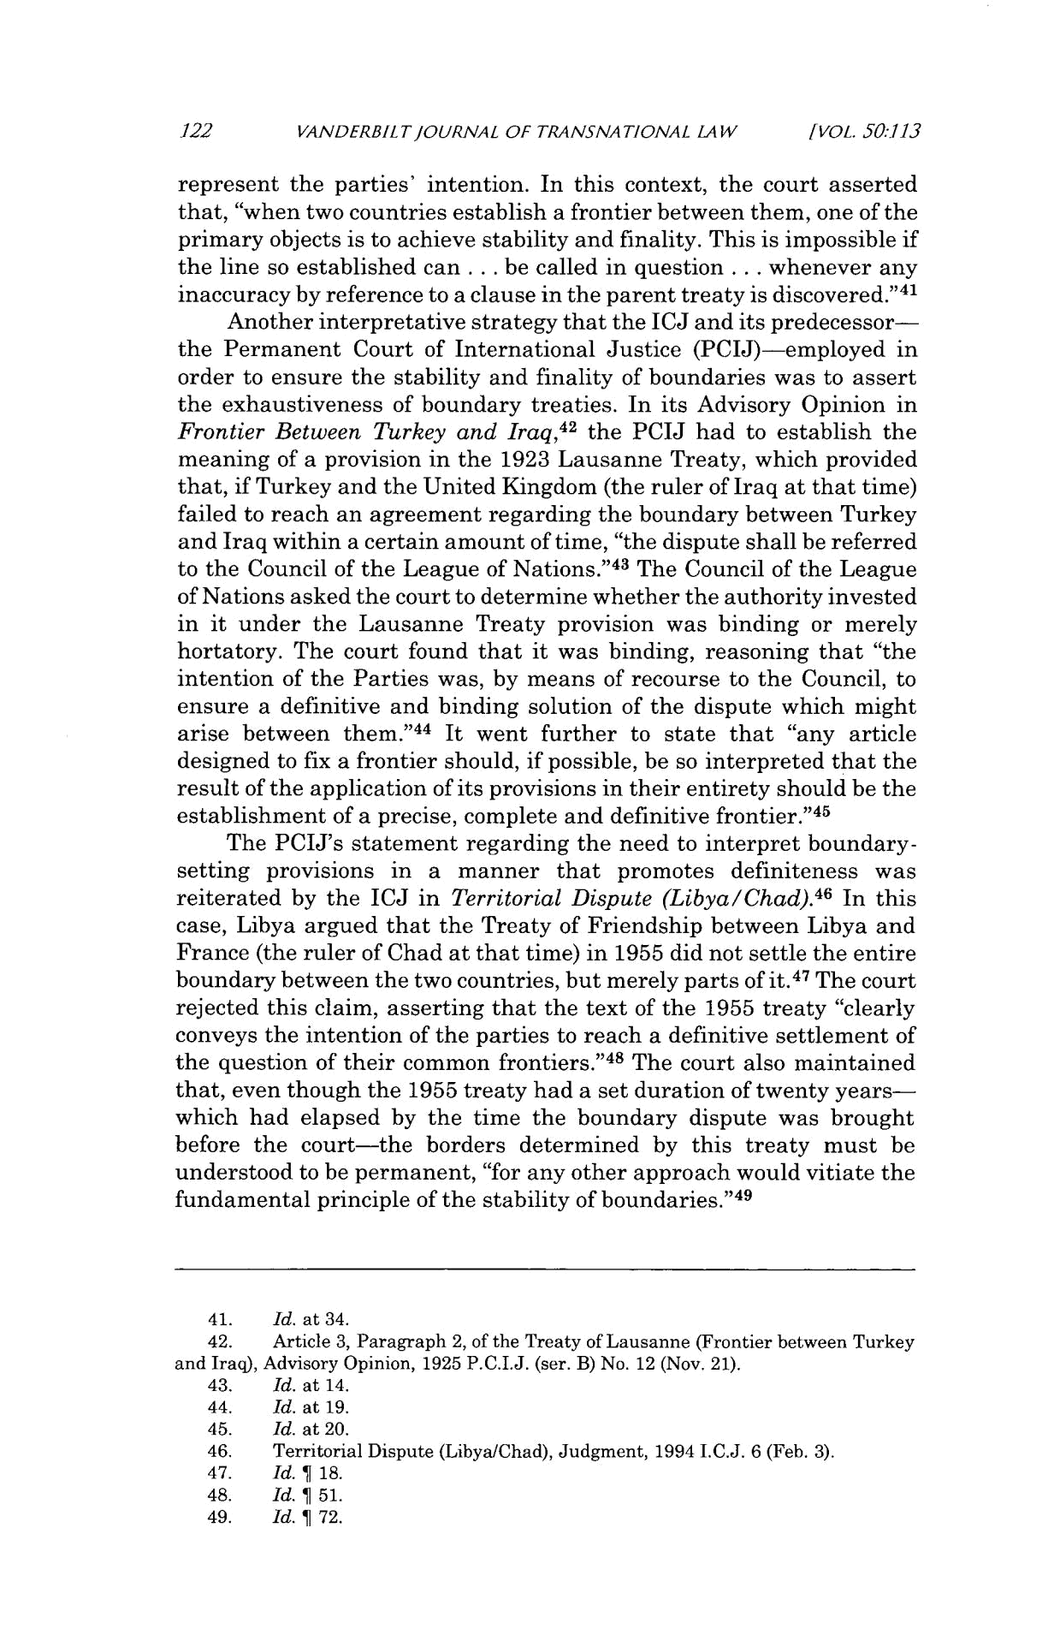
122 VANDERBILT/OURNAL OF TRANSNATIONAL LAW [VOL. 50:113

represent the parties' intention. In this context, the court asserted that, "when two countries establish a frontier between them, one of the primary objects is to achieve stability and finality. This is impossible if the line so established can . . . be called in question . . . whenever any inaccuracy by reference to a clause in the parent treaty is discovered." ⁴ ¹

Another interpretative strategy that the ICJ and its predecessor-the Permanent Court of International Justice (PCIJ)-employed in order to ensure the stability and finality of boundaries was to assert the exhaustiveness of boundary treaties. In its Advisory Opinion in FrontierBetween Turkey and Iraq,⁴² the PCIJ had to establish the meaning of a provision in the 1923 Lausanne Treaty, which provided that, if Turkey and the United Kingdom (the ruler of Iraq at that time) failed to reach an agreement regarding the boundary between Turkey and Iraq within a certain amount of time, "the dispute shall be referred to the Council of the League of Nations."⁴ ³ The Council of the League of Nations asked the court to determine whether the authority invested in it under the Lausanne Treaty provision was binding or merely hortatory. The court found that it was binding, reasoning that "the intention of the Parties was, by means of recourse to the Council, to ensure a definitive and binding solution of the dispute which might arise between them." ⁴⁴ It went further to state that "any article designed to fix a frontier should, if possible, be so interpreted that the result of the application of its provisions in their entirety should be the establishment of a precise, complete and definitive frontier."⁴⁵

The PCIJ's statement regarding the need to interpret boundary-setting provisions in a manner that promotes definiteness was
reiterated ⁴ ⁶
by the ICJ in Territorial Dispute (Libya/Chad). In this case, Libya argued that the Treaty of Friendship between Libya and France (the ruler of Chad at that time) in 1955 did not settle the entire boundary between the two countries, but merely parts of it. ⁴⁷ The court rejected this claim, asserting that the text of the 1955 treaty "clearly conveys the intention of the parties to reach a definitive settlement of the question of their common frontiers." ⁴⁸ The court also maintained that, even though the 1955 treaty had a set duration of twenty years-which had elapsed by the time the boundary dispute was brought before the court-the borders determined by this treaty must be understood to be permanent, "for any other approach would vitiate the fundamental principle of the stability of boundaries." ⁴⁹

- Id. at 34.

- Article 3, Paragraph 2, of the Treaty of Lausanne (Frontier between Turkey and Iraq), Advisory Opinion, 1925 P.C.I.J. (ser. B) No. 12 (Nov. 21).
- Id. at 14.

- Id. at 19.

- Id. at 20.

- Territorial Dispute (Libya/Chad), Judgment, 1994 I.C.J. 6 (Feb. 3).

- Id. ¶ 18.
- Id. ¶ 51.
- Id. ¶ 72.
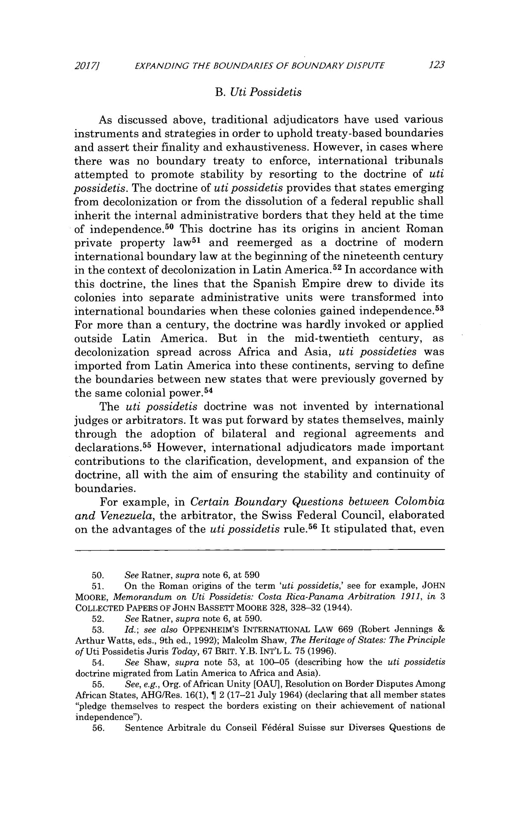
2017/ EXPANDING THE BOUNDARIES OF BOUNDARY DISPUTE 123

- Uti Possidetis

As discussed above, traditional adjudicators have used various instruments and strategies in order to uphold treaty-based boundaries and assert their finality and exhaustiveness. However, in cases where there was no boundary treaty to enforce, international tribunals attempted to promote stability by resorting to the doctrine of uti possidetis. The doctrine of uti possidetis provides that states emerging from decolonization or from the dissolution of a federal republic shall inherit the internal administrative borders that they held at the time of independence.⁵ ⁰ This doctrine has its origins in ancient Roman private property law⁵ ¹ and reemerged as a doctrine of modern international boundary law at the beginning of the nineteenth century in the context of decolonization in Latin America. ⁵² In accordance with this doctrine, the lines that the Spanish Empire drew to divide its colonies into separate administrative units were transformed into international boundaries when these colonies gained independence.⁵ ³ For more than a century, the doctrine was hardly invoked or applied outside Latin America. But in the mid-twentieth century, as decolonization spread across Africa and Asia, uti possideties was imported from Latin America into these continents, serving to define the boundaries between new states that were previously governed by the same colonial power. ⁵⁴

The uti possidetis doctrine was not invented by international judges or arbitrators. It was put forward by states themselves, mainly through the adoption of bilateral and regional agreements and declarations.⁵ ⁵ However, international adjudicators made important contributions to the clarification, development, and expansion of the doctrine, all with the aim of ensuring the stability and continuity of boundaries.

For example, in Certain Boundary Questions between Colombia and Venezuela, the arbitrator, the Swiss Federal Council, elaborated
on the advantages of the uti possidetis rule. ⁵ ⁶ It stipulated that, even

- See Ratner, supra note 6, at 590

- On the Roman origins of the term 'uti possidetis,' see for example, JOHN MOORE, Memorandum on Uti Possidetis: Costa Rica-PanamaArbitration 1911, in 3

COLLECTED PAPERS OF JOHN BASSETT MOORE 328, 328-32 (1944).

- See Ratner, supra note 6, at 590.

- Id.; see also OPPENHEIM'S INTERNATIONAL LAW 669 (Robert Jennings

Arthur Watts, eds., 9th ed., 1992); Malcolm Shaw, The Heritage of States: The Principle of Uti Possidetis Juris Today, 67 BRIT. Y.B. INT'L L. 75 (1996).
- See Shaw, supra note 53, at 100-05 (describing how the uti possidetis doctrine migrated from Latin America to Africa and Asia).
- See, e.g., Org. of African Unity [OAU], Resolution on Border Disputes Among African States, AHG/Res. 16(1), 1 2 (17-21 July 1964) (declaring that all member states "pledge themselves to respect the borders existing on their achievement of national independence").

- Sentence Arbitrale du Conseil F6d6ral Suisse sur Diverses Questions de
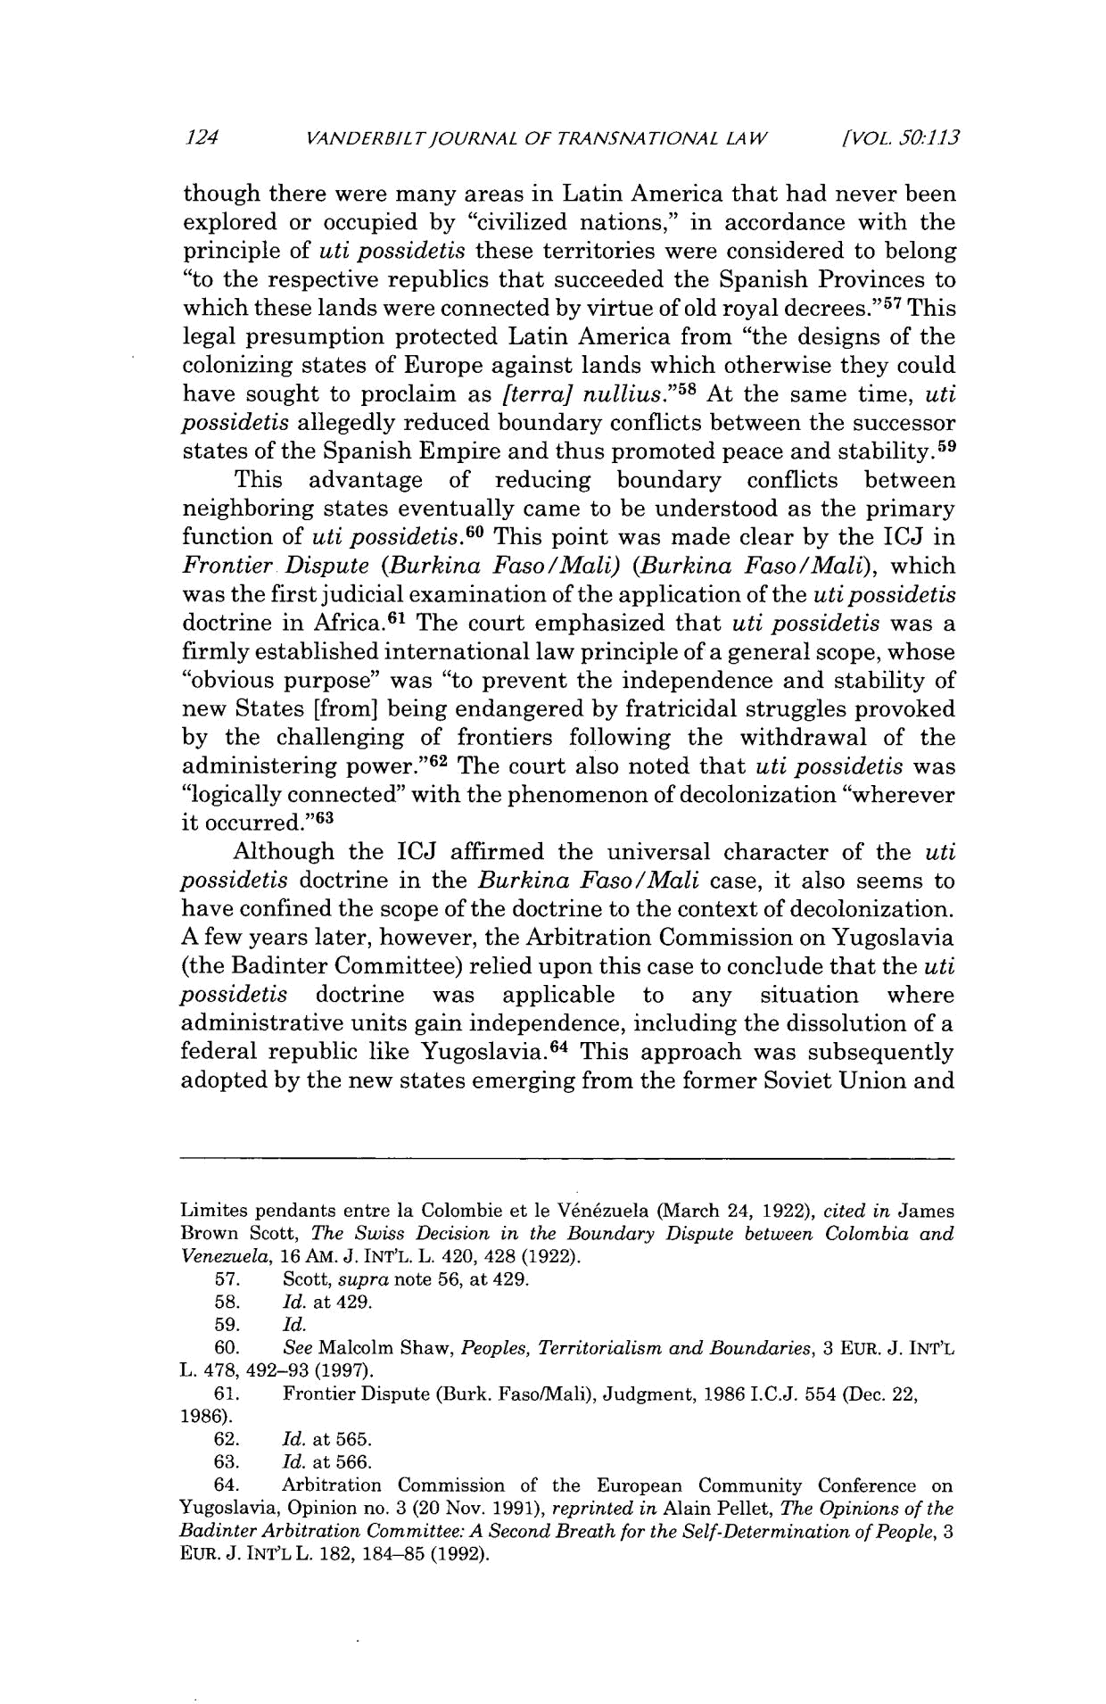
124 VANDERBILTJOURNAL OF TRANSNATIONAL LAW [VOL. 50:1.13

though there were many areas in Latin America that had never been explored or occupied by "civilized nations," in accordance with the principle of uti possidetis these territories were considered to belong "to the respective republics that succeeded the Spanish Provinces to which these lands were connected by virtue of old royal decrees."⁵⁷ This legal presumption protected Latin America from "the designs of the colonizing states of Europe against lands which otherwise they could
5 8
have sought to proclaim as [terra] nullius." At the same time, uti possidetis allegedly reduced boundary conflicts between the successor
states of the Spanish Empire and thus promoted peace and stability.⁵ ⁹
This advantage of reducing boundary conflicts between neighboring states eventually came to be understood as the primary function of uti possidetis.⁶⁰ This point was made clear by the ICJ in Frontier Dispute (Burkina Faso/Mali) (Burkina Faso/Mali), which was the first judicial examination of the application of the uti possidetis doctrine in Africa. ⁶ ¹ The court emphasized that uti possidetis was a firmly established international law principle of a general scope, whose "obvious purpose" was "to prevent the independence and stability of new States [from] being endangered by fratricidal struggles provoked by the challenging of frontiers following the withdrawal of the administering power." ⁶² The court also noted that uti possidetis was "logically connected" with the phenomenon of decolonization "wherever it occurred."⁶³

Although the ICJ affirmed the universal character of the uti possidetis doctrine in the Burkina Faso/Mali case, it also seems to have confined the scope of the doctrine to the context of decolonization. A few years later, however, the Arbitration Commission on Yugoslavia (the Badinter Committee) relied upon this case to conclude that the uti possidetis doctrine was applicable to any situation where administrative units gain independence, including the dissolution of a federal republic like Yugoslavia. ⁶⁴ This approach was subsequently adopted by the new states emerging from the former Soviet Union and

Limites pendants entre la Colombie et le V6nizuela (March 24, 1922), cited in James Brown Scott, The Swiss Decision in the Boundary Dispute between Colombia and Venezuela, 16 AM. J. INT'L. L. 420, 428 (1922).

    - Scott, supra note 56, at 429.

  - Id. at 429.

  - Id.

  - See Malcolm Shaw, Peoples, Territorialism and Boundaries, 3 EUR. J. INT'L L. 478, 492-93 (1997).

  - Frontier Dispute (Burk. Faso/Mali), Judgment, 1986 I.C.J. 554 (Dec. 22,

1986).

  - Id. at 565.

  - Id. at 566.

  - Arbitration Commission of the European Community Conference on Yugoslavia, Opinion no. 3 (20 Nov. 1991), reprinted in Alain Pellet, The Opinions of the BadinterArbitrationCommittee: A Second Breath for the Self-Determination ofPeople, 3 EUR. J. INT'L L. 182, 184-85 (1992).
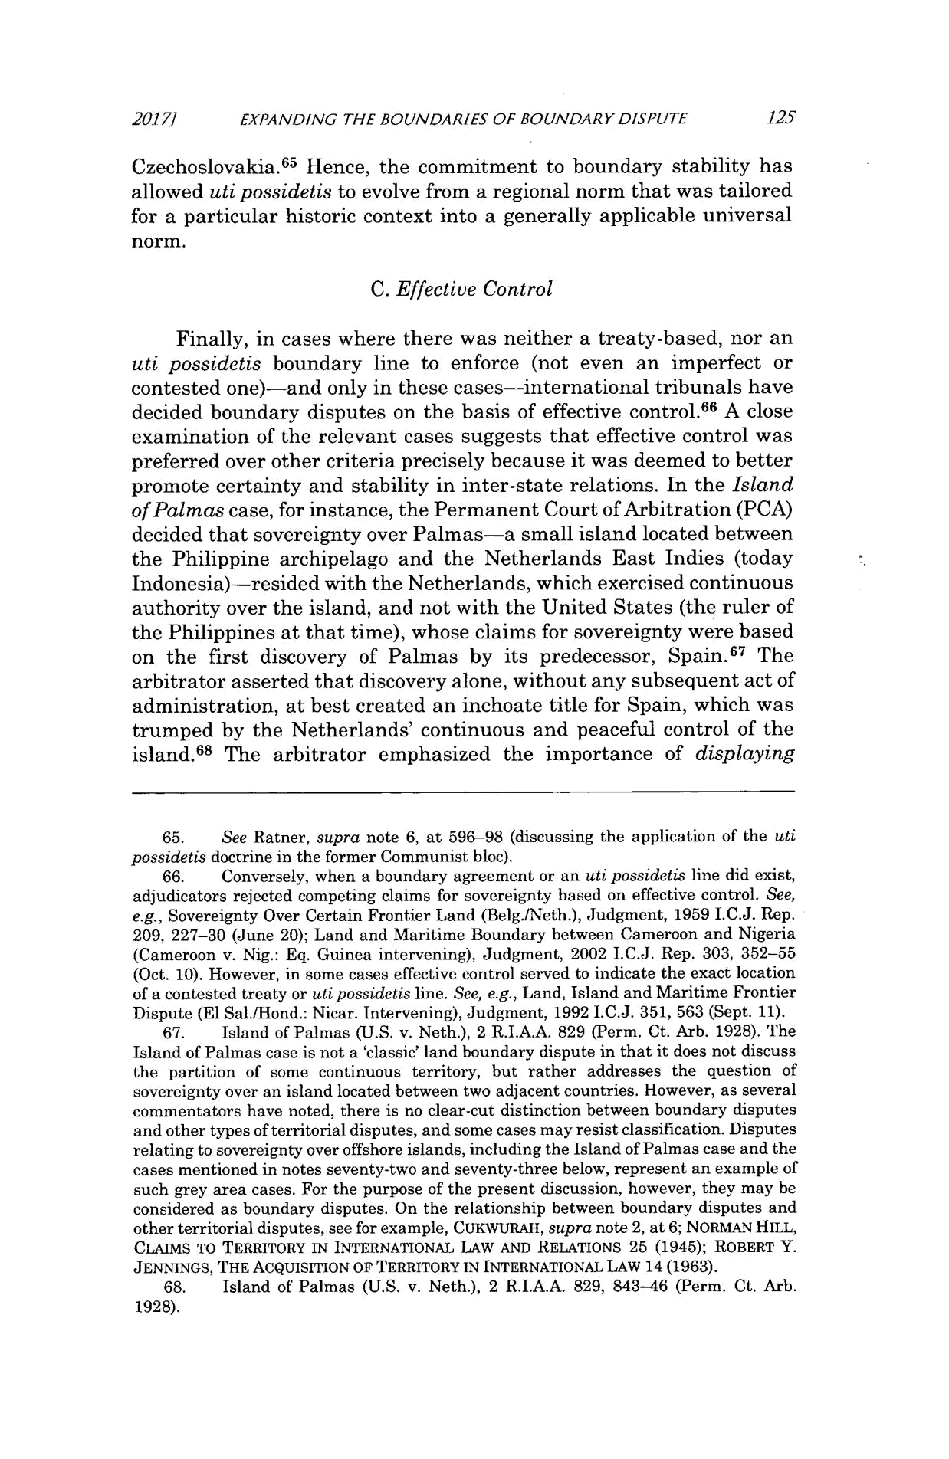
20171 EXPANDING THE BOUNDARIES OF BOUNDARY DISPUTE 125

Czechoslovakia. ⁶⁵ Hence, the commitment to boundary stability has allowed uti possidetis to evolve from a regional norm that was tailored for a particular historic context into a generally applicable universal norm.

C. Effective Control

Finally, in cases where there was neither a treaty-based, nor an uti possidetis boundary line to enforce (not even an imperfect or contested one)-and only in these cases-international tribunals have decided boundary disputes on the basis of effective control. ⁶⁶ A close examination of the relevant cases suggests that effective control was preferred over other criteria precisely because it was deemed to better promote certainty and stability in inter-state relations. In the Island of Palmascase, for instance, the Permanent Court of Arbitration (PCA) decided that sovereignty over Palmas-a small island located between the Philippine archipelago and the Netherlands East Indies (today Indonesia)-resided with the Netherlands, which exercised continuous authority over the island, and not with the United States (the ruler of the Philippines at that time), whose claims for sovereignty were based on the first discovery of Palmas by its predecessor, Spain. ⁶⁷ The arbitrator asserted that discovery alone, without any subsequent act of administration, at best created an inchoate title for Spain, which was trumped by the Netherlands' continuous and peaceful control of the island.⁶⁸ The arbitrator emphasized the importance of displaying

- See Ratner, supra note 6, at 596-98 (discussing the application of the uti possidetis doctrine in the former Communist bloc).

- Conversely, when a boundary agreement or an uti possidetis line did exist, adjudicators rejected competing claims for sovereignty based on effective control. See, e.g., Sovereignty Over Certain Frontier Land (Belg./Neth.), Judgment, 1959 I.C.J. Rep. 209, 227-30 (June 20); Land and Maritime Boundary between Cameroon and Nigeria (Cameroon v. Nig.: Eq. Guinea intervening), Judgment, 2002 I.C.J. Rep. 303, 352-55 (Oct. 10). However, in some cases effective control served to indicate the exact location of a contested treaty or uti possidetis line. See, e.g., Land, Island and Maritime Frontier Dispute (El Sal./Hond.: Nicar. Intervening), Judgment, 1992 I.C.J. 351, 563 (Sept. 11).

- Island of Palmas (U.S. v. Neth.), 2 R.I.A.A. 829 (Perm. Ct. Arb. 1928). The Island of Palmas case is not a 'classic' land boundary dispute in that it does not discuss the partition of some continuous territory, but rather addresses the question of sovereignty over an island located between two adjacent countries. However, as several commentators have noted, there is no clear-cut distinction between boundary disputes and other types of territorial disputes, and some cases may resist classification. Disputes relating to sovereignty over offshore islands, including the Island of Palmas case and the cases mentioned in notes seventy-two and seventy-three below, represent an example of such grey area cases. For the purpose of the present discussion, however, they may be considered as boundary disputes. On the relationship between boundary disputes and other territorial disputes, see for example, CUKWURAH, supra note 2, at 6; NORMAN HILL,

CLAIMS TO TERRITORY IN INTERNATIONAL LAW AND RELATIONS 25 (1945); ROBERT Y. JENNINGS, THE AcQUISITION OF TERRITORY IN INTERNATIONAL LAW 14 (1963).
- Island of Palmas (U.S. v. Neth.), 2 R.I.A.A. 829, 843-46 (Perm. Ct. Arb.

1928).

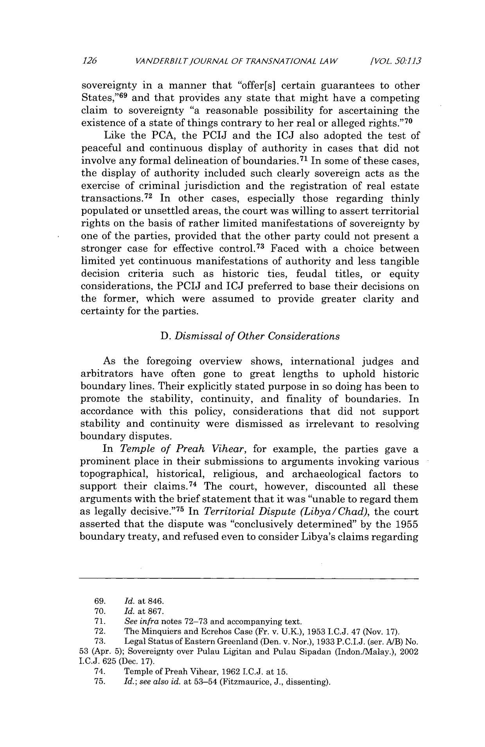
126 VANDERBILTJOURNAL OF TRANSNATIONAL LAW [VOL. 50:1.13

sovereignty in a manner that "offer[s] certain guarantees to other States,"⁶⁹ and that provides any state that might have a competing claim to sovereignty "a reasonable possibility for ascertaining the existence of a state of things contrary to her real or alleged rights."⁷⁰

Like the PCA, the PCIJ and the ICJ also adopted the test of peaceful and continuous display of authority in cases that did not involve any formal delineation of boundaries. ⁷ ' In some of these cases, the display of authority included such clearly sovereign acts as the exercise of criminal jurisdiction and the registration of real estate transactions. ⁷² In other cases, especially those regarding thinly populated or unsettled areas, the court was willing to assert territorial rights on the basis of rather limited manifestations of sovereignty by one of the parties, provided that the other party could not present a stronger case for effective control.⁷ ³ Faced with a choice between limited yet continuous manifestations of authority and less tangible decision criteria such as historic ties, feudal titles, or equity considerations, the PCIJ and ICJ preferred to base their decisions on the former, which were assumed to provide greater clarity and certainty for the parties.

- Dismissal of Other Considerations

As the foregoing overview shows, international judges and arbitrators have often gone to great lengths to uphold historic boundary lines. Their explicitly stated purpose in so doing has been to promote the stability, continuity, and finality of boundaries. In accordance with this policy, considerations that did not support stability and continuity were dismissed as irrelevant to resolving boundary disputes.

In Temple of Preah Vihear, for example, the parties gave a prominent place in their submissions to arguments invoking various topographical, historical, religious, and archaeological factors to support their claims. ⁷⁴ The court, however, discounted all these arguments with the brief statement that it was "unable to regard them as legally decisive."⁷ ⁵ In TerritorialDispute (Libya/Chad), the court asserted that the dispute was "conclusively determined" by the 1955 boundary treaty, and refused even to consider Libya's claims regarding

  - Id. at 846.

  - Id. at 867.

  - See infra notes 72-73 and accompanying text.

  - The Minquiers and Ecrehos Case (Fr. v. U.K.), 1953 I.C.J. 47 (Nov. 17).

  - Legal Status of Eastern Greenland (Den. v. Nor.), 1933 P.C.I.J. (ser. A/B) No. 53 (Apr. 5); Sovereignty over Pulau Ligitan and Pulau Sipadan (Indon.[Malay.), 2002 I.C.J. 625 (Dec. 17).

  - Temple of Preah Vihear, 1962 I.C.J. at 15.

- Id.; see also id. at 53-54 (Fitzmaurice, J., dissenting).
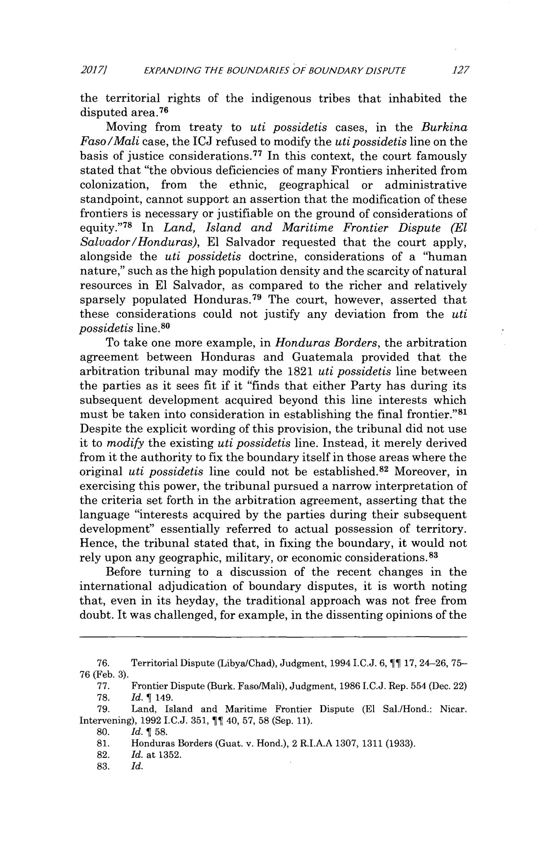
2017] EXPANDING THE BOUNDARIES OF BOUNDARY DISPUTE 127

the territorial rights of the indigenous tribes that inhabited the disputed area. ⁷⁶

Moving from treaty to uti possidetis cases, in the Burkina Faso/Malicase, the ICJ refused to modify the uti possidetis line on the basis of justice considerations.⁷ ⁷ In this context, the court famously stated that "the obvious deficiencies of many Frontiers inherited from colonization, from the ethnic, geographical or administrative standpoint, cannot support an assertion that the modification of these frontiers is necessary or justifiable on the ground of considerations of equity."⁷ ⁸ In Land, Island and Maritime Frontier Dispute (El Salvador/Honduras), El Salvador requested that the court apply, alongside the uti possidetis doctrine, considerations of a "human nature," such as the high population density and the scarcity of natural resources in El Salvador, as compared to the richer and relatively sparsely populated Honduras.⁷ ⁹ The court, however, asserted that these considerations could not justify any deviation from the uti possidetis line.⁸ ⁰

To take one more example, in Honduras Borders, the arbitration agreement between Honduras and Guatemala provided that the arbitration tribunal may modify the 1821 uti possidetis line between the parties as it sees fit if it "finds that either Party has during its subsequent development acquired beyond this line interests which must be taken into consideration in establishing the final frontier." ⁸ Despite the explicit wording of this provision, the tribunal did not use it to modify the existing uti possidetis line. Instead, it merely derived from it the authority to fix the boundary itself in those areas where the original uti possidetis line could not be established. ⁸² Moreover, in exercising this power, the tribunal pursued a narrow interpretation of the criteria set forth in the arbitration agreement, asserting that the language "interests acquired by the parties during their subsequent development" essentially referred to actual possession of territory. Hence, the tribunal stated that, in fixing the boundary, it would not rely upon any geographic, military, or economic considerations.⁸ ³

Before turning to a discussion of the recent changes in the international adjudication of boundary disputes, it is worth noting that, even in its heyday, the traditional approach was not free from doubt. It was challenged, for example, in the dissenting opinions of the

- Territorial Dispute (Libya/Chad), Judgment, 1994 I.C.J. 6, 11 17, 24-26, 75-
76 (Feb. 3).

- Frontier Dispute (Burk. FasofMali), Judgment, 1986 I.C.J. Rep. 554 (Dec. 22)
- Id. 1 149.

- Land, Island and Maritime Frontier Dispute (El Sal./Hond.: Nicar. Intervening), 1992 I.C.J. 351, IT 40, 57, 58 (Sep. 11).
- Id. ¶ 58.
- Honduras Borders (Guat. v. Hond.), 2 R.I.A.A 1307, 1311 (1933).

- Id. at 1352.

- Id.
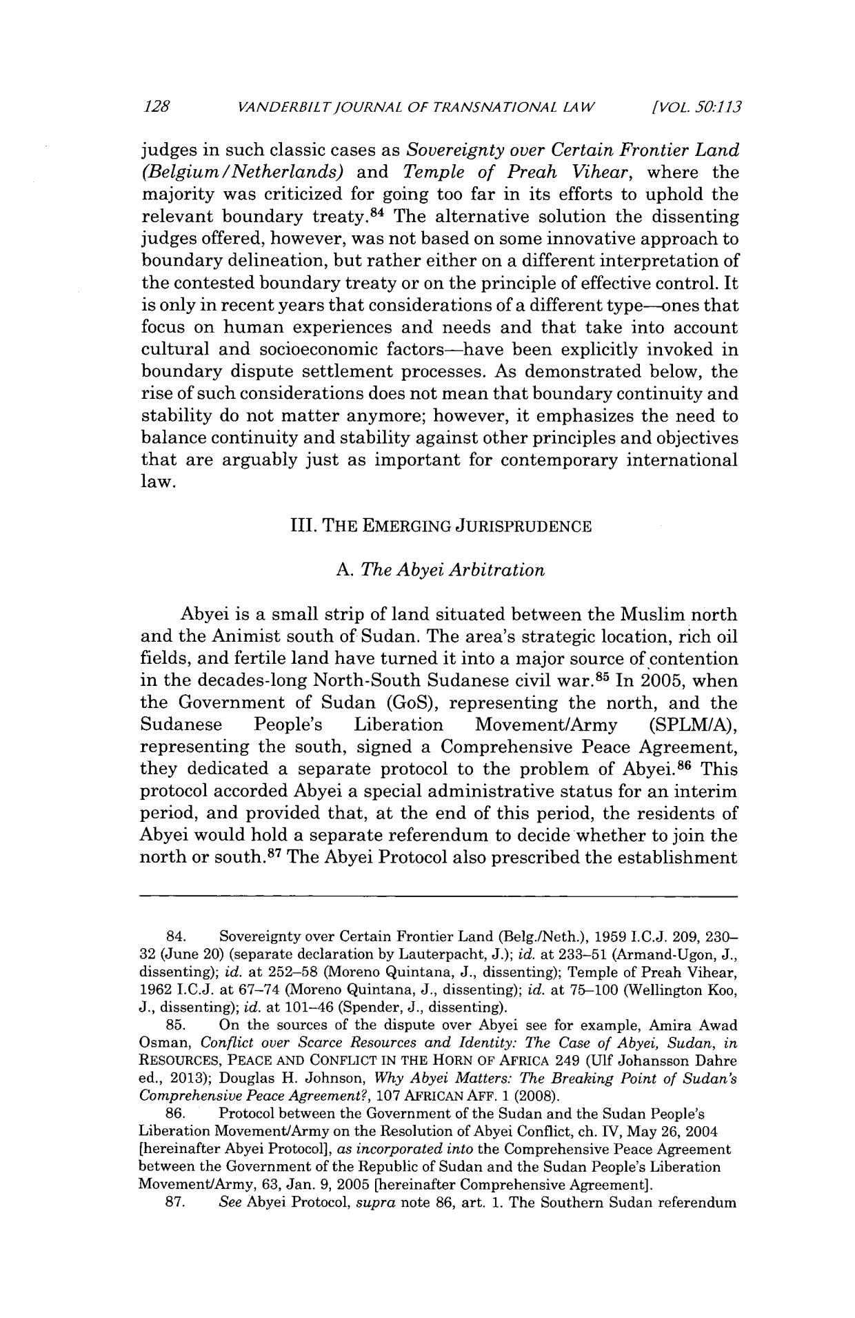
128 VANDERBILT/OURNAL OF TRANSNATIONAL LAW [VOL. 50:113

judges in such classic cases as Sovereignty over Certain FrontierLand (Belgium/Netherlands) and Temple of Preah Vihear, where the majority was criticized for going too far in its efforts to uphold the relevant boundary treaty. ⁸⁴ The alternative solution the dissenting judges offered, however, was not based on some innovative approach to boundary delineation, but rather either on a different interpretation of the contested boundary treaty or on the principle of effective control. It is only in recent years that considerations of a different type-ones that focus on human experiences and needs and that take into account cultural and socioeconomic factors-have been explicitly invoked in boundary dispute settlement processes. As demonstrated below, the rise of such considerations does not mean that boundary continuity and stability do not matter anymore; however, it emphasizes the need to balance continuity and stability against other principles and objectives that are arguably just as important for contemporary international law.

- THE EMERGING JURISPRUDENCE

A. The Abyei Arbitration

Abyei is a small strip of land situated between the Muslim north and the Animist south of Sudan. The area's strategic location, rich oil fields, and fertile land have turned it into a major source of contention in the decades-long North-South Sudanese civil war. ⁸⁵ In 2005, when the Government of Sudan (GoS), representing the north, and the

Sudanese People's Liberation Movement/Army (SPLM/A), representing the south, signed a Comprehensive Peace Agreement, they dedicated a separate protocol to the problem of Abyei. ⁸⁶ This protocol accorded Abyei a special administrative status for an interim period, and provided that, at the end of this period, the residents of Abyei would hold a separate referendum to decide whether to join the north or south.⁸⁷ The Abyei Protocol also prescribed the establishment

- Sovereignty over Certain Frontier Land (Belg./Neth.), 1959 I.C.J. 209, 230-

32 (June 20) (separate declaration by Lauterpacht, J.); id. at 233-51 (Armand-Ugon, J., dissenting); id. at 252-58 (Moreno Quintana, J., dissenting); Temple of Preah Vihear, 1962 I.C.J. at 67-74 (Moreno Quintana, J., dissenting); id. at 75-100 (Wellington Koo, J., dissenting); id. at 101-46 (Spender, J., dissenting).

- On the sources of the dispute over Abyei see for example, Amira Awad Osman, Conflict over Scarce Resources and Identity: The Case of Abyei, Sudan, in

RESOURCES, PEACE AND CONFLICT IN THE HORN OF AFRICA 249 (Ulf Johansson Dahre ed., 2013); Douglas H. Johnson, Why Abyei Matters: The Breaking Point of Sudan's

Comprehensive Peace Agreement?, 107 AFRICAN AFF. 1 (2008).

- Protocol between the Government of the Sudan and the Sudan People's Liberation Movement/Army on the Resolution of Abyei Conflict, ch. IV, May 26, 2004 [hereinafter Abyei Protocol], as incorporatedinto the Comprehensive Peace Agreement between the Government of the Republic of Sudan and the Sudan People's Liberation Movement/Army, 63, Jan. 9, 2005 [hereinafter Comprehensive Agreement].

- See Abyei Protocol, supra note 86, art. 1. The Southern Sudan referendum
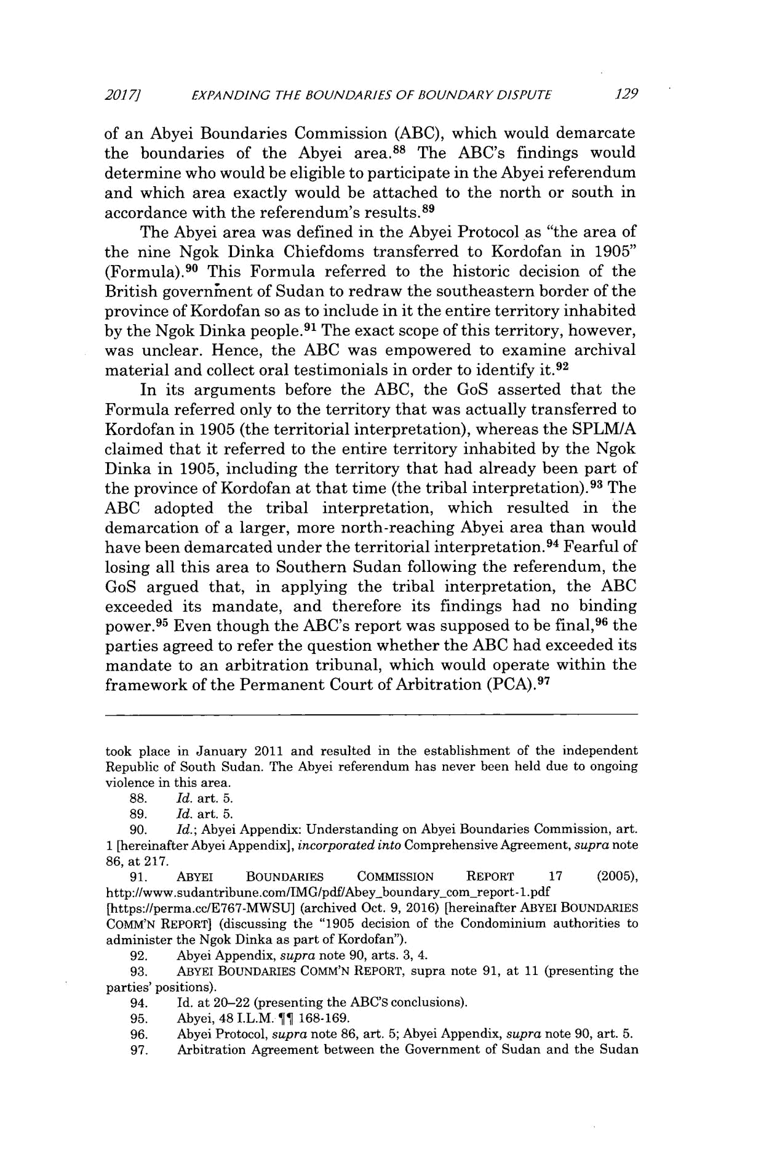
2017] EXPANDING THE BOUNDARIES OF BOUNDARY DISPUTE 129

of an Abyei Boundaries Commission (ABC), which would demarcate the boundaries of the Abyei area.⁸⁸ The ABC's findings would determine who would be eligible to participate in the Abyei referendum and which area exactly would be attached to the north or south in accordance with the referendum's results.⁸⁹

The Abyei area was defined in the Abyei Protocol as "the area of the nine Ngok Dinka Chiefdoms transferred to Kordofan in 1905" (Formula).⁹ ⁰ This Formula referred to the historic decision of the British governinent of Sudan to redraw the southeastern border of the province of Kordofan so as to include in it the entire territory inhabited by the Ngok Dinka people.⁹ ¹ The exact scope of this territory, however, was unclear. Hence, the ABC was empowered to examine archival material and collect oral testimonials in order to identify it.⁹ ²

In its arguments before the ABC, the GoS asserted that the Formula referred only to the territory that was actually transferred to Kordofan in 1905 (the territorial interpretation), whereas the SPLM/A claimed that it referred to the entire territory inhabited by the Ngok Dinka in 1905, including the territory that had already been part of the province of Kordofan at that time (the tribal interpretation).⁹ ³ The ABC adopted the tribal interpretation, which resulted in the demarcation of a larger, more north-reaching Abyei area than would have been demarcated under the territorial interpretation. ⁹⁴ Fearful of losing all this area to Southern Sudan following the referendum, the GoS argued that, in applying the tribal interpretation, the ABC exceeded its mandate, and therefore its findings had no binding power.⁹⁵ Even though the ABC's report was supposed to be final,⁹⁶ the parties agreed to refer the question whether the ABC had exceeded its mandate to an arbitration tribunal, which would operate within the framework of the Permanent Court of Arbitration (PCA).⁹ ⁷

took place in January 2011 and resulted in the establishment of the independent Republic of South Sudan. The Abyei referendum has never been held due to ongoing violence in this area.

- Id. art. 5.

- Id. art. 5.

- Id.; Abyei Appendix: Understanding on Abyei Boundaries Commission, art. 1 [hereinafter Abyei Appendix], incorporatedinto Comprehensive Agreement, supra note 86, at 217.

- ABYEl BOUNDARIES COMMISSION REPORT 17 (2005), http://www.sudantribune.com/IMG/pdf/Abey-boundary-com-report-1.pdf [https://perma.cc/E767-MWSU] (archived Oct. 9, 2016) [hereinafter ABYEI BOUNDARIES COMM'N REPORT] (discussing the "1905 decision of the Condominium authorities to administer the Ngok Dinka as part of Kordofan").

- Abyei Appendix, supra note 90, arts. 3, 4.

  - ABYEi BOUNDARIES COMM'N REPORT, supra note 91, at 11 (presenting the parties' positions).

  - Id. at 20-22 (presenting the ABC's conclusions).

  - Abyei, 48 I.L.M. ¶j 168-169.
  - Abyei Protocol, supra note 86, art. 5; Abyei Appendix, supra note 90, art. 5.

  - Arbitration Agreement between the Government of Sudan and the Sudan
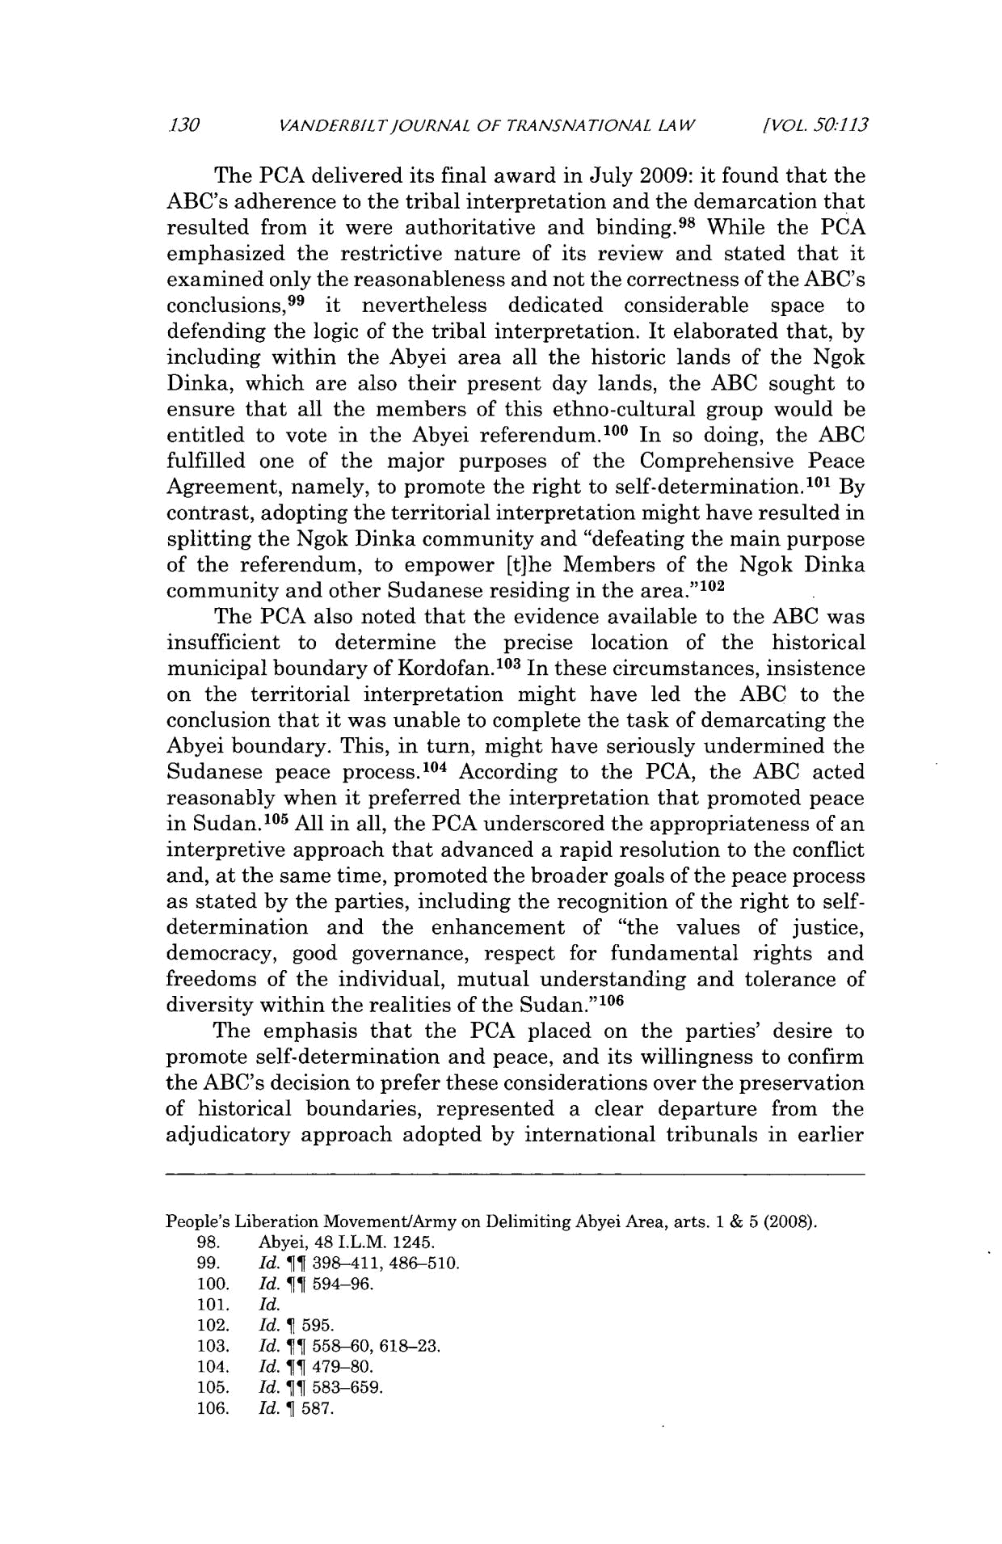
.130 VANDERBILTJOURNAL OF TRANSNATIONAL LAW [VOL. SO:113

The PCA delivered its final award in July 2009: it found that the ABC's adherence to the tribal interpretation and the demarcation that resulted from it were authoritative and binding.⁹ ⁸ While the PCA emphasized the restrictive nature of its review and stated that it examined only the reasonableness and not the correctness of the ABC's conclusions," it nevertheless dedicated considerable space to defending the logic of the tribal interpretation. It elaborated that, by including within the Abyei area all the historic lands of the Ngok Dinka, which are also their present day lands, the ABC sought to ensure that all the members of this ethno-cultural group would be entitled to vote in the Abyei referendum.¹ ⁰ ⁰ In so doing, the ABC fulfilled one of the major purposes of the Comprehensive Peace Agreement, namely, to promote the right to self-determination. ¹⁰ ¹ By contrast, adopting the territorial interpretation might have resulted in splitting the Ngok Dinka community and "defeating the main purpose of the referendum, to empower [t]he Members of the Ngok Dinka community and other Sudanese residing in the area."1 ⁰²

The PCA also noted that the evidence available to the ABC was insufficient to determine the precise location of the historical municipal boundary of Kordofan. ⁰ ³ In these circumstances, insistence on the territorial interpretation might have led the ABC to the conclusion that it was unable to complete the task of demarcating the Abyei boundary. This, in turn, might have seriously undermined the Sudanese peace process.1 ⁰⁴ According to the PCA, the ABC acted reasonably when it preferred the interpretation that promoted peace in Sudan. 105 All in all, the PCA underscored the appropriateness of an interpretive approach that advanced a rapid resolution to the conflict and, at the same time, promoted the broader goals of the peace process as stated by the parties, including the recognition of the right to self-determination and the enhancement of "the values of justice, democracy, good governance, respect for fundamental rights and freedoms of the individual, mutual understanding and tolerance of diversity within the realities of the Sudan."1 ⁰⁶

The emphasis that the PCA placed on the parties' desire to promote self-determination and peace, and its willingness to confirm the ABC's decision to prefer these considerations over the preservation of historical boundaries, represented a clear departure from the adjudicatory approach adopted by international tribunals in earlier

People's Liberation Movement/Army on Delimiting Abyei Area, arts. 1 & 5 (2008).

- Abyei, 48 I.L.M. 1245.

- Id. if 398-411, 486-510.
- Id. ¶¶ 594-96.
- Id.
- Id. 1 595.
- Id. ¶¶ 558-60, 618-23.
- Id. ¶T 479-80.
- Id. ¶} 583-659.
- Id. 1 587.
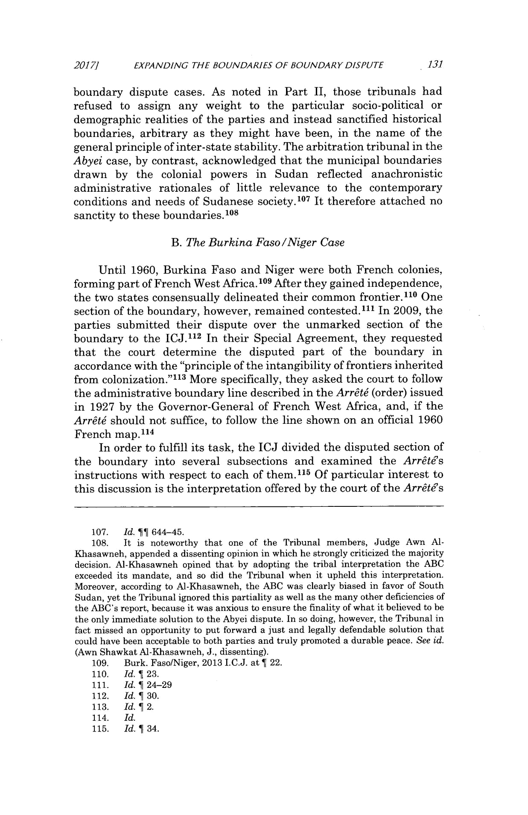
_{2017]} EXPANDING THE BOUNDARIES OF BOUNDARY DISPUTE 131

boundary dispute cases. As noted in Part II, those tribunals had refused to assign any weight to the particular socio-political or demographic realities of the parties and instead sanctified historical boundaries, arbitrary as they might have been, in the name of the general principle of inter-state stability. The arbitration tribunal in the Abyei case, by contrast, acknowledged that the municipal boundaries drawn by the colonial powers in Sudan reflected anachronistic administrative rationales of little relevance to the contemporary conditions and needs of Sudanese society. 107 It therefore attached no sanctity to these boundaries.108

B. The Burkina Faso/Niger Case

Until 1960, Burkina Faso and Niger were both French colonies, forming part of French West Africa.¹ ⁰⁹ After they gained independence, the two states consensually delineated their common frontier.¹¹ ⁰ One section of the boundary, however, remained contested.¹¹¹ In 2009, the parties submitted their dispute over the unmarked section of the boundary to the ICJ.11² In their Special Agreement, they requested that the court determine the disputed part of the boundary in accordance with the "principle of the intangibility of frontiers inherited from colonization."1 ³ More specifically, they asked the court to follow the administrative boundary line described in the Arrt4 (order) issued in 1927 by the Governor-General of French West Africa, and, if the Arrtd should not suffice, to follow the line shown on an official 1960 French map. ¹¹⁴

In order to fulfill its task, the ICJ divided the disputed section of the boundary into several subsections and examined the Arr&6's instructions with respect to each of them.11 ⁵ Of particular interest to this discussion is the interpretation offered by the court of the Arrt's

- Id. ?1 644-45.
- It is noteworthy that one of the Tribunal members, Judge Awn Al-Khasawneh, appended a dissenting opinion in which he strongly criticized the majority decision. Al-Khasawneh opined that by adopting the tribal interpretation the ABC exceeded its mandate, and so did the Tribunal when it upheld this interpretation. Moreover, according to Al-Khasawneh, the ABC was clearly biased in favor of South Sudan, yet the Tribunal ignored this partiality as well as the many other deficiencies of the ABC's report, because it was anxious to ensure the finality of what it believed to be the only immediate solution to the Abyei dispute. In so doing, however, the Tribunal in fact missed an opportunity to put forward a just and legally defendable solution that could have been acceptable to both parties and truly promoted a durable peace. See id. (Awn Shawkat Al-Khasawneh, J., dissenting).

- Burk. Faso/Niger, 2013 I.C.J. at ¶ 22.
- Id. ¶ 23.
- Id. ¶ 24-29
- Id. ¶ 30.
- Id. ¶ 2.
- Id.
- Id. ¶ 34.
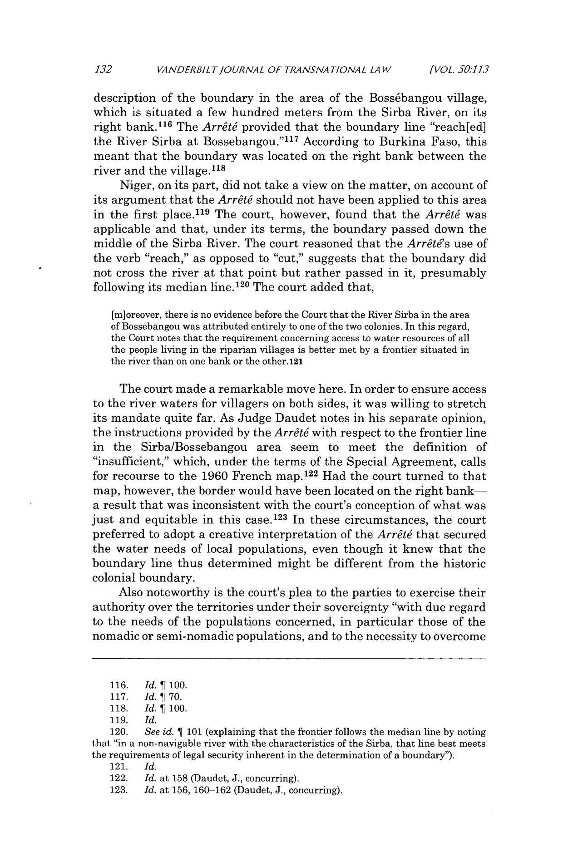
132 VANDERBIL TJOURNAL OF TRANSNATIONAL LAW [VOL, 50:113

description of the boundary in the area of the Boss6bangou village, which is situated a few hundred meters from the Sirba River, on its right bank. ¹¹⁶ The Arr& provided that the boundary line "reach[ed] the River Sirba at Bossebangou."'" According to Burkina Faso, this meant that the boundary was located on the right bank between the river and the village. ¹¹⁸

Niger, on its part, did not take a view on the matter, on account of its argument that the Arr&t should not have been applied to this area in the first place.¹¹ ⁹ The court, however, found that the Arrt4 was applicable and that, under its terms, the boundary passed down the middle of the Sirba River. The court reasoned that the Arrat6's use of the verb "reach," as opposed to "cut," suggests that the boundary did not cross the river at that point but rather passed in it, presumably following its median line.1 ²⁰ The court added that,

[m]oreover, there is no evidence before the Court that the River Sirba in the area of Bossebangou was attributed entirely to one of the two colonies. In this regard, the Court notes that the requirement concerning access to water resources of all the people living in the riparian villages is better met by a frontier situated in the river than on one bank or the other.121

The court made a remarkable move here. In order to ensure access to the river waters for villagers on both sides, it was willing to stretch its mandate quite far. As Judge Daudet notes in his separate opinion, the instructions provided by the Arrtd with respect to the frontier line in the Sirba/Bossebangou area seem to meet the definition of "insufficient," which, under the terms of the Special Agreement, calls for recourse to the 1960 French map.1 ²² Had the court turned to that map, however, the border would have been located on the right bank-a result that was inconsistent with the court's conception of what was just and equitable in this case.1 ²³ In these circumstances, the court preferred to adopt a creative interpretation of the Arrt6 that secured the water needs of local populations, even though it knew that the boundary line thus determined might be different from the historic colonial boundary.

Also noteworthy is the court's plea to the parties to exercise their authority over the territories under their sovereignty "with due regard to the needs of the populations concerned, in particular those of the nomadic or semi-nomadic populations, and to the necessity to overcome

- Id. ¶ 100.
- Id. ¶ 70.
- Id. 1 100.
- Id.

- See id. ¶ 101 (explaining that the frontier follows the median line by noting that "in a non-navigable river with the characteristics of the Sirba, that line best meets the requirements of legal security inherent in the determination of a boundary").

- Id.

- Id. at 158 (Daudet, J., concurring).

- Id. at 156, 160-162 (Daudet, J., concurring).
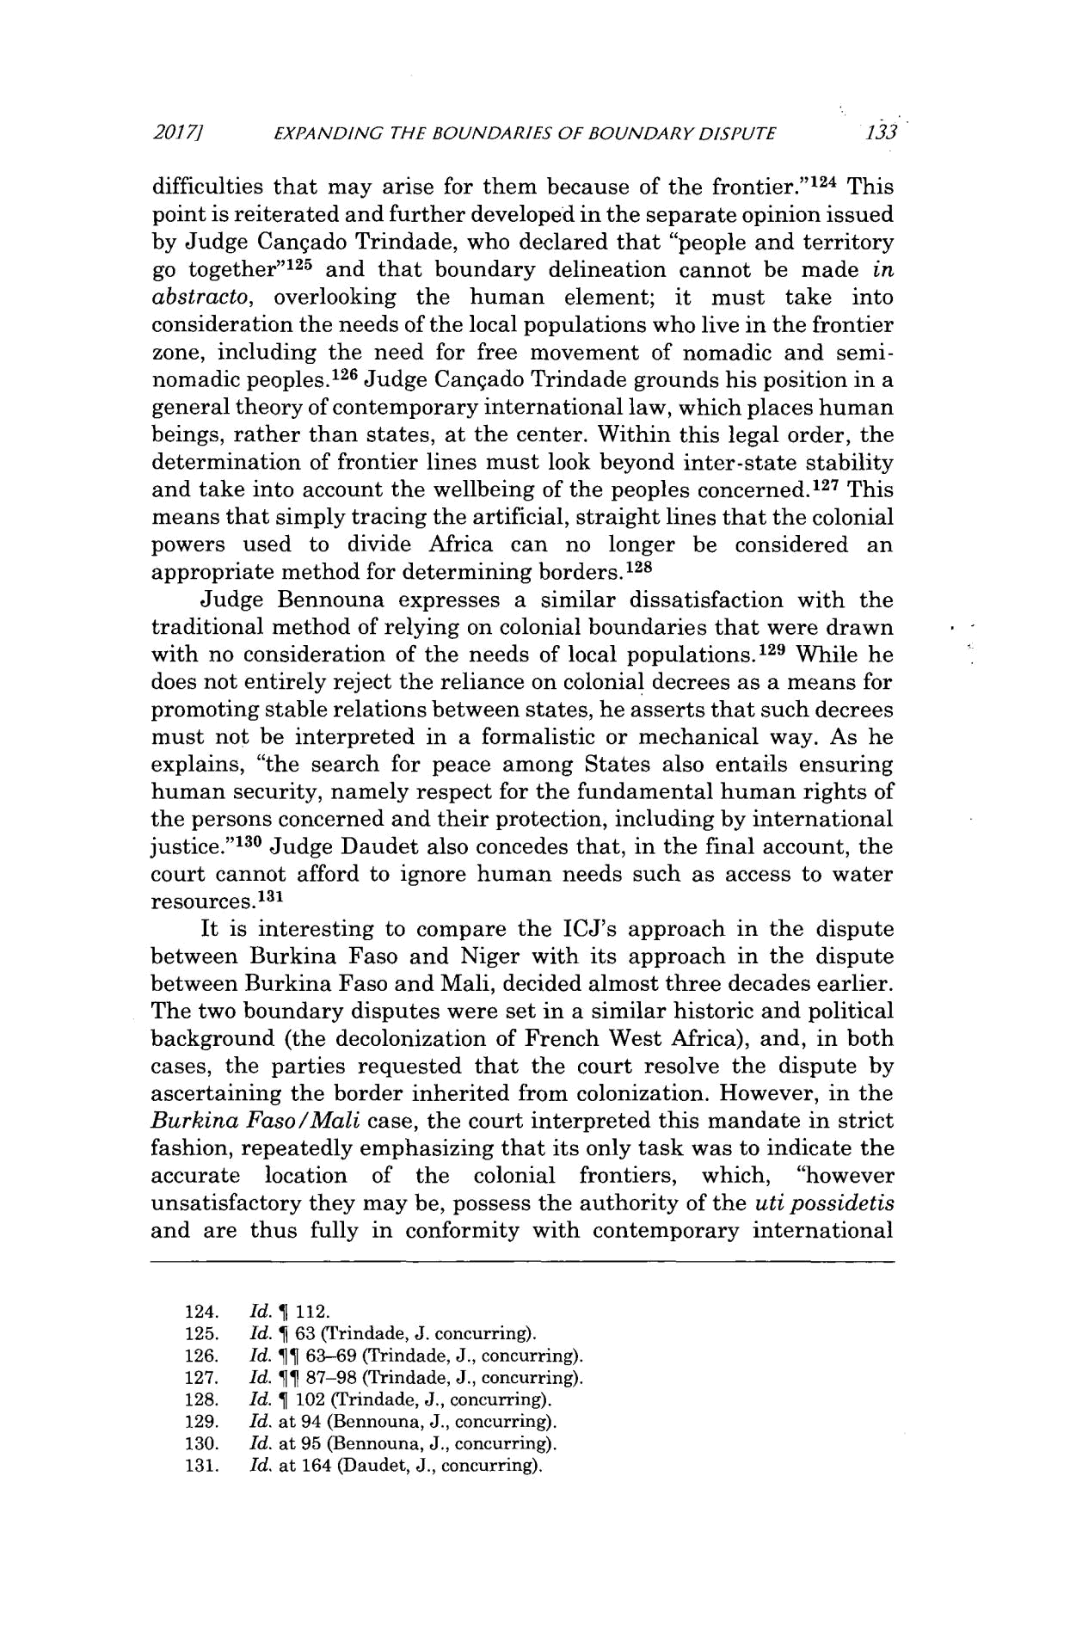
2017/1 EXPANDING THE BOUNDARIES OF BOUNDARY DISPUTE 133

difficulties that may arise for them because of the frontier." ¹²⁴ This point is reiterated and further developed in the separate opinion issued by Judge Canqado Trindade, who declared that "people and territory go together" ¹²⁵ and that boundary delineation cannot be made in abstracto, overlooking the human element; it must take into consideration the needs of the local populations who live in the frontier zone, including the need for free movement of nomadic and semi-nomadic peoples.1 ²⁶ Judge Cangado Trindade grounds his position in a general theory of contemporary international law, which places human beings, rather than states, at the center. Within this legal order, the determination of frontier lines must look beyond inter-state stability and take into account the wellbeing of the peoples concerned.127 This means that simply tracing the artificial, straight lines that the colonial powers used to divide Africa can no longer be considered an appropriate method for determining borders.1 ²⁸

Judge Bennouna expresses a similar dissatisfaction with the traditional method of relying on colonial boundaries that were drawn with no consideration of the needs of local populations.1 ²⁹ While he does not entirely reject the reliance on colonial decrees as a means for promoting stable relations between states, he asserts that such decrees must not be interpreted in a formalistic or mechanical way. As he explains, "the search for peace among States also entails ensuring human security, namely respect for the fundamental human rights of the persons concerned and their protection, including by international
1 30

justice." Judge Daudet also concedes that, in the final account, the court cannot afford to ignore human needs such as access to water resources.¹ ³

It is interesting to compare the ICJ's approach in the dispute between Burkina Faso and Niger with its approach in the dispute between Burkina Faso and Mali, decided almost three decades earlier. The two boundary disputes were set in a similar historic and political background (the decolonization of French West Africa), and, in both cases, the parties requested that the court resolve the dispute by ascertaining the border inherited from colonization. However, in the Burkina Faso/Mali case, the court interpreted this mandate in strict fashion, repeatedly emphasizing that its only task was to indicate the accurate location of the colonial frontiers, which, "however unsatisfactory they may be, possess the authority of the uti possidetis and are thus fully in conformity with contemporary international

- Id. 1 112.
- Id. 1 63 (Trindade, J. concurring).
- Id. Jf 63-69 (Trindade, J., concurring).

- Id. 11 87-98 (Trindade, J., concurring).
- Id. a 102 (Trindade, J., concurring).

- Id. at 94 (Bennouna, J., concurring).

- Id. at 95 (Bennouna, J., concurring).

- Id. at 164 (Daudet, J., concurring).

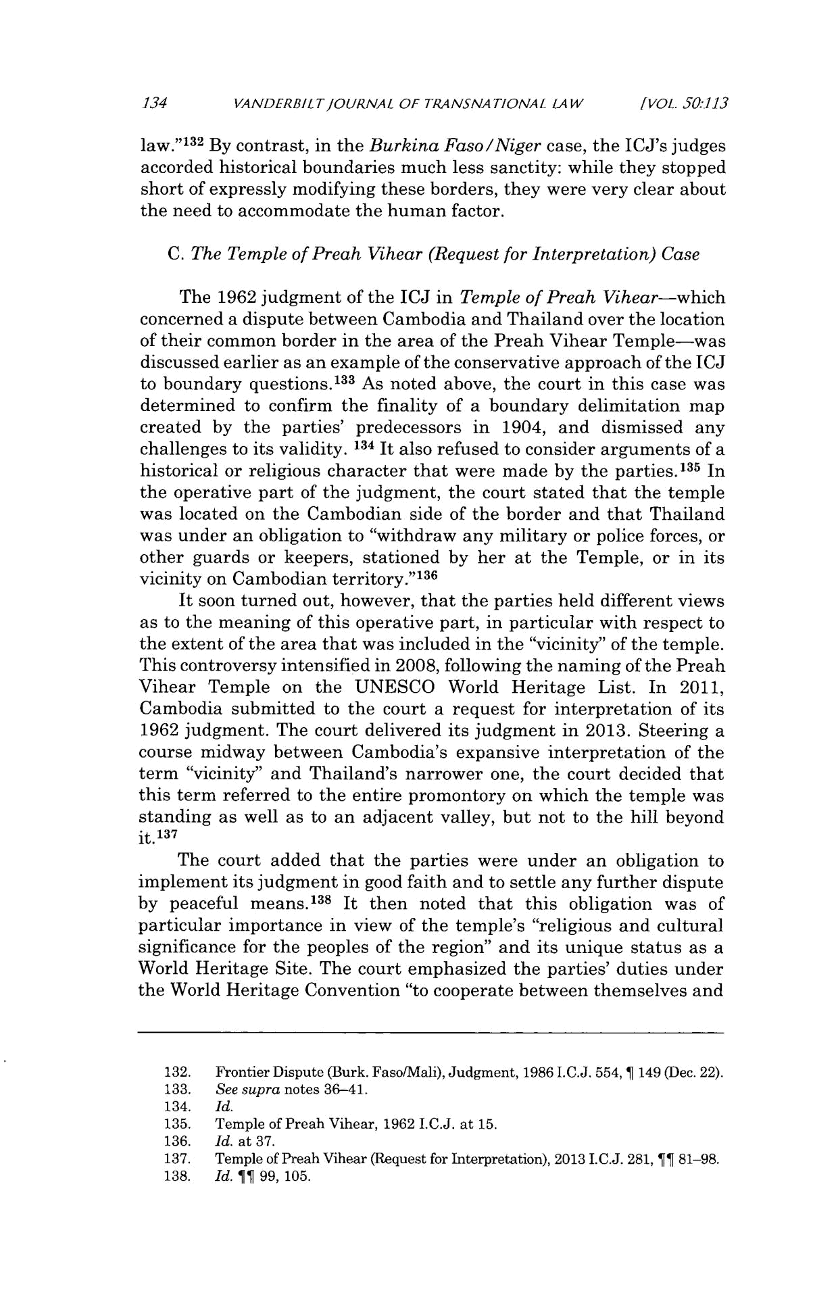
- VANDERBILTJOURNAL OF TRANSNATIONAL LAW

[VOL. 50:.113

law."¹ ³ ² By contrast, in the Burkina Faso/Niger case, the ICJ's judges accorded historical boundaries much less sanctity: while they stopped short of expressly modifying these borders, they were very clear about the need to accommodate the human factor.

- The Temple of Preah Vihear (Request for Interpretation)Case

The 1962 judgment of the ICJ in Temple of Preah Vihear-which concerned a dispute between Cambodia and Thailand over the location of their common border in the area of the Preah Vihear Temple-was discussed earlier as an example of the conservative approach of the ICJ to boundary questions.¹³ ³ As noted above, the court in this case was determined to confirm the finality of a boundary delimitation map created by the parties' predecessors in 1904, and dismissed any challenges to its validity. 134 It also refused to consider arguments of a historical or religious character that were made by the parties.¹³ ⁵ In the operative part of the judgment, the court stated that the temple was located on the Cambodian side of the border and that Thailand was under an obligation to "withdraw any military or police forces, or other guards or keepers, stationed by her at the Temple, or in its vicinity on Cambodian territory."¹³ ⁶

It soon turned out, however, that the parties held different views as to the meaning of this operative part, in particular with respect to the extent of the area that was included in the "vicinity" of the temple. This controversy intensified in 2008, following the naming of the Preah Vihear Temple on the UNESCO World Heritage List. In 2011, Cambodia submitted to the court a request for interpretation of its 1962 judgment. The court delivered its judgment in 2013. Steering a course midway between Cambodia's expansive interpretation of the term "vicinity" and Thailand's narrower one, the court decided that this term referred to the entire promontory on which the temple was standing as well as to an adjacent valley, but not to the hill beyond

it.'³ ⁷
The court added that the parties were under an obligation to implement its judgment in good faith and to settle any further dispute by peaceful means.¹ ³⁸ It then noted that this obligation was of particular importance in view of the temple's "religious and cultural significance for the peoples of the region" and its unique status as a World Heritage Site. The court emphasized the parties' duties under the World Heritage Convention "to cooperate between themselves and

  - Frontier Dispute (Burk. Faso/Mali), Judgment, 1986 I.C.J. 554, T 149 (Dec. 22).
  - See supra notes 36-41.

- Id.

- Temple of Preah Vihear, 1962 I.C.J. at 15.

- Id. at 37.
- Temple of Preah Vihear (Request for Interpretation), 2013 I.C.J. 281, ¶¶ 81-98.
- Id. 11 99, 105.

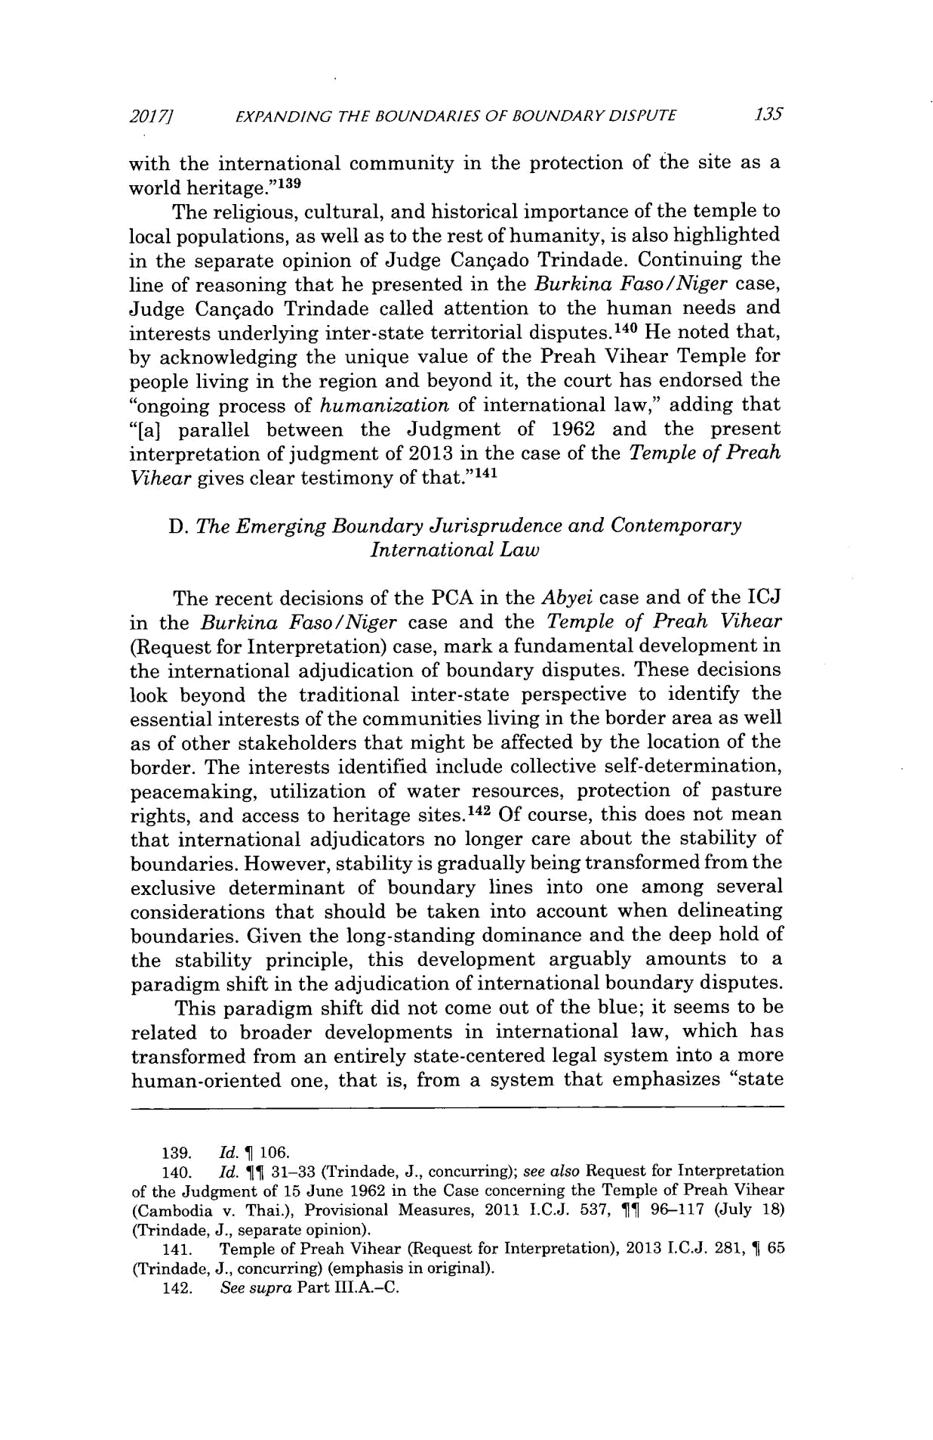
2017/1 EXPANDING THE BOUNDARIES OF BOUNDARY DISPUTE 135

with the international community in the protection of the site as a world heritage."¹³ ⁹

The religious, cultural, and historical importance of the temple to local populations, as well as to the rest of humanity, is also highlighted in the separate opinion of Judge Cangado Trindade. Continuing the line of reasoning that he presented in the Burkina Faso/Niger case, Judge Cangado Trindade called attention to the human needs and interests underlying inter-state territorial disputes. ¹⁴⁰ He noted that, by acknowledging the unique value of the Preah Vihear Temple for people living in the region and beyond it, the court has endorsed the "ongoing process of humanization of international law," adding that "[a] parallel between the Judgment of 1962 and the present interpretation of judgment of 2013 in the case of the Temple of Preah Vihear gives clear testimony of that."¹⁴¹

- The Emerging Boundary Jurisprudenceand Contemporary InternationalLaw

The recent decisions of the PCA in the Abyei case and of the ICJ in the Burkina Faso/Niger case and the Temple of Preah Vihear (Request for Interpretation) case, mark a fundamental development in the international adjudication of boundary disputes. These decisions look beyond the traditional inter-state perspective to identify the essential interests of the communities living in the border area as well as of other stakeholders that might be affected by the location of the border. The interests identified include collective self-determination, peacemaking, utilization of water resources, protection of pasture rights, and access to heritage sites. ¹⁴² Of course, this does not mean that international adjudicators no longer care about the stability of boundaries. However, stability is gradually being transformed from the exclusive determinant of boundary lines into one among several considerations that should be taken into account when delineating boundaries. Given the long-standing dominance and the deep hold of the stability principle, this development arguably amounts to a paradigm shift in the adjudication of international boundary disputes.

This paradigm shift did not come out of the blue; it seems to be related to broader developments in international law, which has transformed from an entirely state-centered legal system into a more human-oriented one, that is, from a system that emphasizes "state

- Id. 1 106.
- Id. 11 31-33 (Trindade, J., concurring); see also Request for Interpretation of the Judgment of 15 June 1962 in the Case concerning the Temple of Preah Vihear (Cambodia v. Thai.), Provisional Measures, 2011 I.C.J. 537, 11 96-117 (July 18) (Trindade, J., separate opinion).

- Temple of Preah Vihear (Request for Interpretation), 2013 I.C.J. 281, 1 65 (Trindade, J., concurring) (emphasis in original).
- See supra Part III.A.-C.
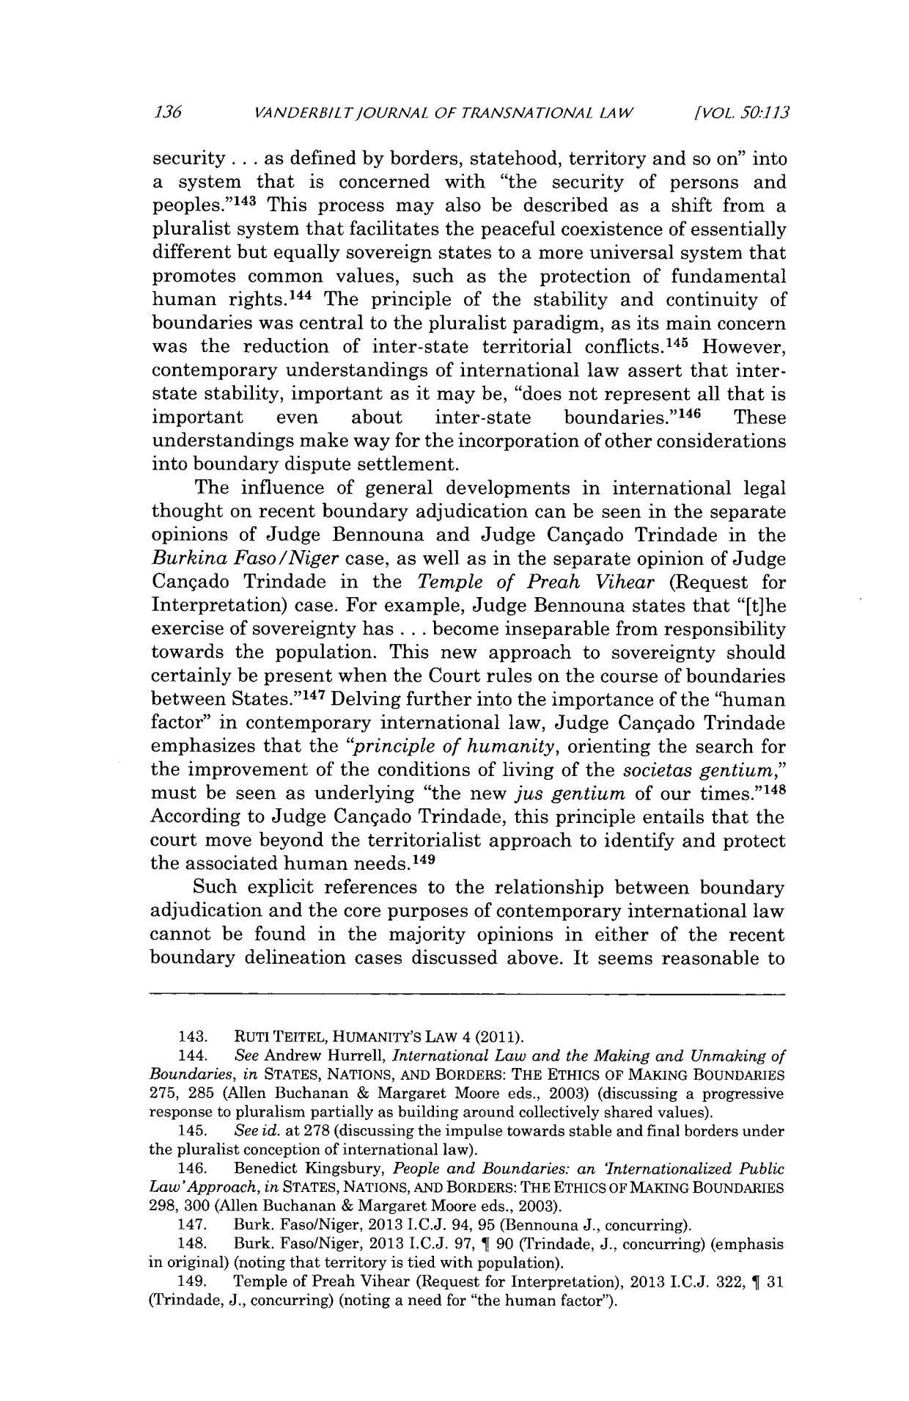
136 VANDERBILTIOURNAL OF TRANSNATIONAL LAW [VOL. 50:113

security ... as defined by borders, statehood, territory and so on" into a system that is concerned with "the security of persons and
1 4 3
peoples." This process may also be described as a shift from a

pluralist system that facilitates the peaceful coexistence of essentially different but equally sovereign states to a more universal system that promotes common values, such as the protection of fundamental human rights. ¹⁴⁴ The principle of the stability and continuity of boundaries was central to the pluralist paradigm, as its main concern was the reduction of inter-state territorial conflicts. ¹⁴⁵ However, contemporary understandings of international law assert that inter-state stability, important as it may be, "does not represent all that is

important even about inter-state boundaries." ¹⁴⁶ These understandings make way for the incorporation of other considerations into boundary dispute settlement.

The influence of general developments in international legal thought on recent boundary adjudication can be seen in the separate opinions of Judge Bennouna and Judge Cangado Trindade in the Burkina Faso/Nigercase, as well as in the separate opinion of Judge Canqado Trindade in the Temple of Preah Vihear (Request for Interpretation) case. For example, Judge Bennouna states that "[t]he

exercise of sovereignty has . . . become inseparable from responsibility

towards the population. This new approach to sovereignty should certainly be present when the Court rules on the course of boundaries between States." ¹⁴⁷ Delving further into the importance of the "human factor" in contemporary international law, Judge Cangado Trindade emphasizes that the "principle of humanity, orienting the search for the improvement of the conditions of living of the societas gentium," must be seen as underlying "the new jus gentium of our times."¹⁴⁸ According to Judge Cangado Trindade, this principle entails that the court move beyond the territorialist approach to identify and protect the associated human needs. ¹⁴⁹

Such explicit references to the relationship between boundary adjudication and the core purposes of contemporary international law cannot be found in the majority opinions in either of the recent boundary delineation cases discussed above. It seems reasonable to

  - RUTI TEITEL, HUMANITY'S LAW 4 (2011).

  - See Andrew Hurrell, InternationalLaw and the Making and Unmaking of

Boundaries, in STATES, NATIONS, AND BORDERS: THE ETHICS OF MAKING BOUNDARIES

275, 285 (Allen Buchanan & Margaret Moore eds., 2003) (discussing a progressive response to pluralism partially as building around collectively shared values).
- See id. at 278 (discussing the impulse towards stable and final borders under the pluralist conception of international law).
- Benedict Kingsbury, People and Boundaries: an 'InternationalizedPublic

Law'Approach, in STATES, NATIONS, AND BORDERS: THE ETHICS OF MAKING BOUNDARIES

298, 300 (Allen Buchanan & Margaret Moore eds., 2003).

- Burk. Faso/Niger, 2013 I.C.J. 94, 95 (Bennouna J., concurring).

- Burk. Faso/Niger, 2013 I.C.J. 97, ¶ 90 (Trindade, J., concurring) (emphasis in original) (noting that territory is tied with population).
- Temple of Preah Vihear (Request for Interpretation), 2013 I.C.J. 322, 1 31 (Trindade, J., concurring) (noting a need for "the human factor").
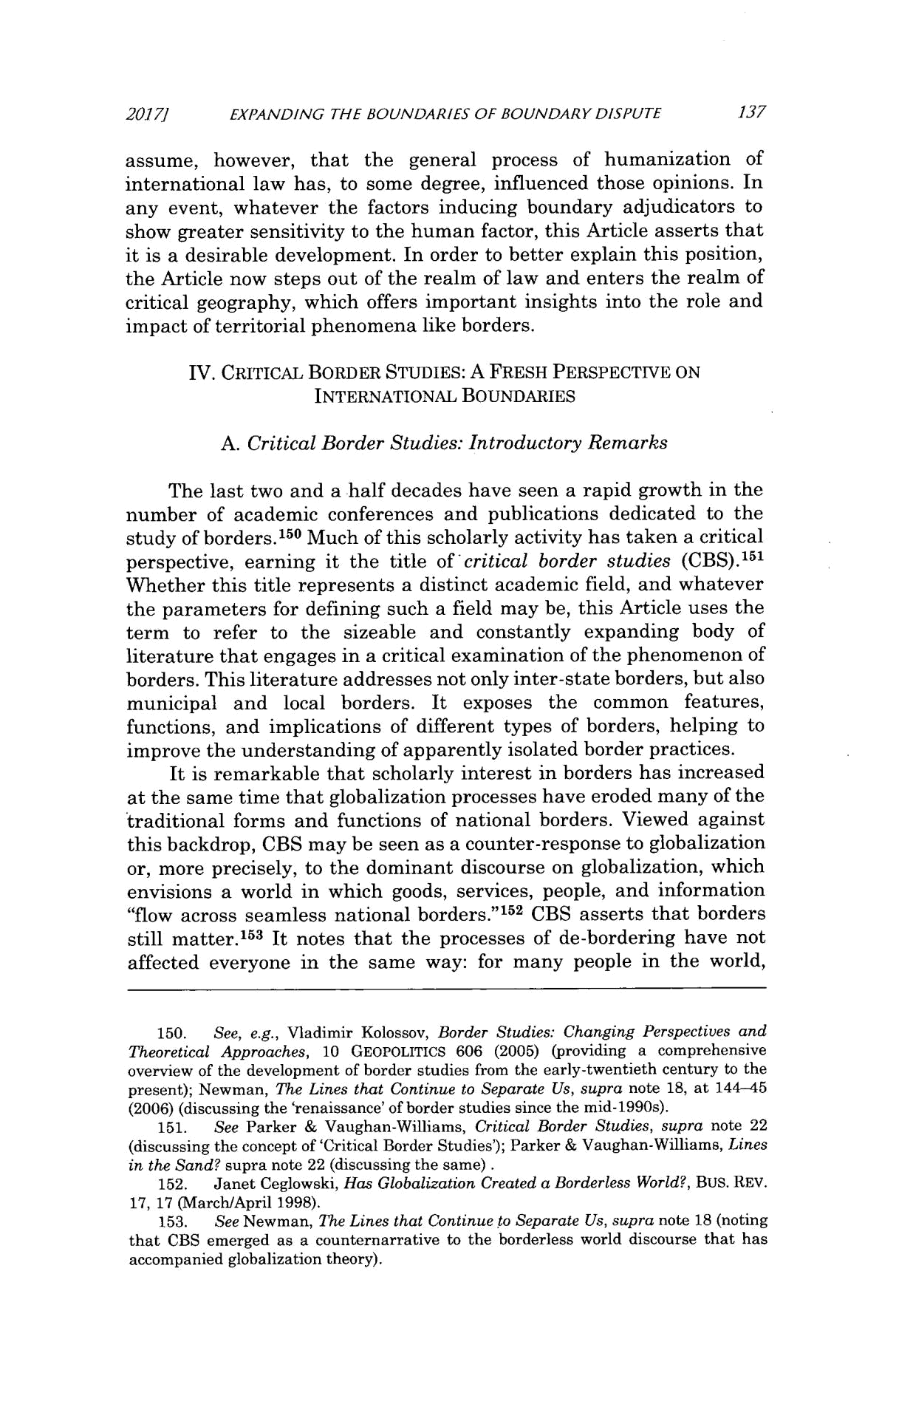
2017] EXPANDING THE BOUNDARIES OF BOUNDARY DISPUTE 137

assume, however, that the general process of humanization of international law has, to some degree, influenced those opinions. In any event, whatever the factors inducing boundary adjudicators to show greater sensitivity to the human factor, this Article asserts that it is a desirable development. In order to better explain this position, the Article now steps out of the realm of law and enters the realm of critical geography, which offers important insights into the role and impact of territorial phenomena like borders.

IV. CRITICAL BORDER STUDIES: A FRESH PERSPECTIVE ON

INTERNATIONAL BOUNDARIES

- CriticalBorder Studies: Introductory Remarks

The last two and a half decades have seen a rapid growth in the number of academic conferences and publications dedicated to the study of borders.1⁵ ⁰ Much of this scholarly activity has taken a critical perspective, earning it the title of critical border studies (CBS).' ⁵ Whether this title represents a distinct academic field, and whatever the parameters for defining such a field may be, this Article uses the term to refer to the sizeable and constantly expanding body of literature that engages in a critical examination of the phenomenon of borders. This literature addresses not only inter-state borders, but also municipal and local borders. It exposes the common features, functions, and implications of different types of borders, helping to improve the understanding of apparently isolated border practices.

It is remarkable that scholarly interest in borders has increased at the same time that globalization processes have eroded many of the traditional forms and functions of national borders. Viewed against this backdrop, CBS may be seen as a counter-response to globalization or, more precisely, to the dominant discourse on globalization, which envisions a world in which goods, services, people, and information "flow across seamless national borders."i ⁵ ² CBS asserts that borders still matter.¹⁵³ It notes that the processes of de-bordering have not affected everyone in the same way: for many people in the world,

- See, e.g., Vladimir Kolossov, Border Studies: Changing Perspectives and Theoretical Approaches, 10 GEOPOLITICS 606 (2005) (providing a comprehensive overview of the development of border studies from the early-twentieth century to the present); Newman, The Lines that Continue to Separate Us, supra note 18, at 144-45 (2006) (discussing the 'renaissance' of border studies since the mid-1990s).

  - See Parker & Vaughan-Williams, Critical Border Studies, supra note 22 (discussing the concept of 'Critical Border Studies'); Parker & Vaughan-Williams, Lines in the Sand? supra note 22 (discussing the same)
  - Janet Ceglowski, Has Globalization Created a Borderless World?, BUS. REV. 17, 17 (1VarchlApril 1998).
  - See Newman, The Lines that Continue to Separate Us, supra note 18 (noting that CBS emerged as a counternarrative to the borderless world discourse that has accompanied globalization theory).

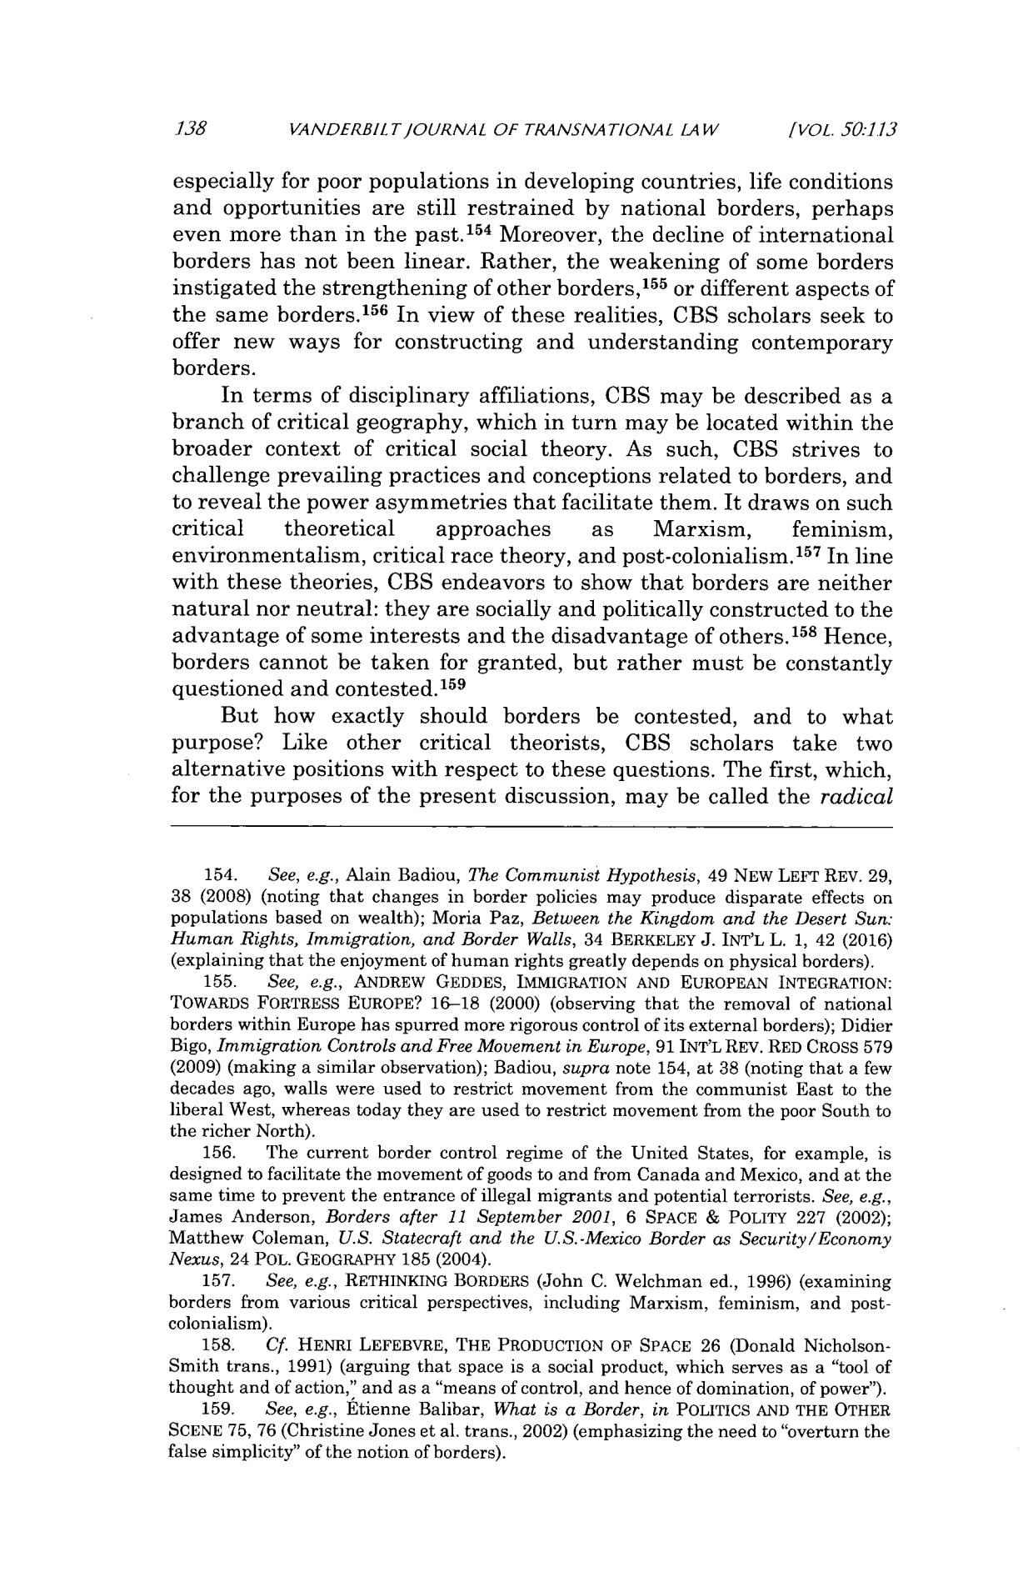
.138 VANDERBILTJOURNAL OF TRANSNATIONAL LAW

[VOL. 50:1.13

especially for poor populations in developing countries, life conditions and opportunities are still restrained by national borders, perhaps even more than in the past.1 ⁵⁴ Moreover, the decline of international borders has not been linear. Rather, the weakening of some borders instigated the strengthening of other borders,1⁵⁵ or different aspects of the same borders. ¹⁵⁶ In view of these realities, CBS scholars seek to offer new ways for constructing and understanding contemporary borders.

In terms of disciplinary affiliations, CBS may be described as a branch of critical geography, which in turn may be located within the broader context of critical social theory. As such, CBS strives to challenge prevailing practices and conceptions related to borders, and to reveal the power asymmetries that facilitate them. It draws on such

critical theoretical approaches as Marxism, feminism, environmentalism, critical race theory, and post-colonialism.' ⁵ ⁷ In line with these theories, CBS endeavors to show that borders are neither natural nor neutral: they are socially and politically constructed to the advantage of some interests and the disadvantage of others.'⁵ ⁸ Hence, borders cannot be taken for granted, but rather must be constantly questioned and contested. ⁵ ⁹

But how exactly should borders be contested, and to what purpose? Like other critical theorists, CBS scholars take two alternative positions with respect to these questions. The first, which, for the purposes of the present discussion, may be called the radical

  - See, e.g., Alain Badiou, The Communist Hypothesis, 49 NEW LEFT REV. 29, 38 (2008) (noting that changes in border policies may produce disparate effects on populations based on wealth); Moria Paz, Between the Kingdom and the Desert Sun: Human Rights, Immigration, and Border Walls, 34 BERKELEY J. INT'L L. 1, 42 (2016) (explaining that the enjoyment of human rights greatly depends on physical borders).

  - See, e.g., ANDREW GEDDES, IMMIGRATION AND EUROPEAN INTEGRATION: TOWARDS FORTRESS EUROPE? 16--18 (2000) (observing that the removal of national borders within Europe has spurred more rigorous control of its external borders); Didier Bigo, Immigration Controlsand Free Movement in Europe, 91 INT'L REV. RED CROSS 579 (2009) (making a similar observation); Badiou, supra note 154, at 38 (noting that a few decades ago, walls were used to restrict movement from the communist East to the liberal West, whereas today they are used to restrict movement from the poor South to the richer North).

  - The current border control regime of the United States, for example, is designed to facilitate the movement of goods to and from Canada and Mexico, and at the same time to prevent the entrance of illegal migrants and potential terrorists. See, e.g., James Anderson, Borders after 11 September 2001, 6 SPACE & POLITY 227 (2002); Matthew Coleman, U.S. Statecraft and the U.S.-Mexico Border as Security/Economy Nexus, 24 POL. GEOGRAPHY 185 (2004).

- See, e.g., RETHINKING BORDERS (John C. Welchman ed., 1996) (examining borders from various critical perspectives, including Marxism, feminism, and post-colonialism).

- Cf. HENRI LEFEBVRE, THE PRODUCTION OF SPACE 26 (Donald Nicholson-

Smith trans., 1991) (arguing that space is a social product, which serves as a "tool of thought and of action," and as a "means of control, and hence of domination, of power").

- See, e.g., ttienne Balibar, What is a Border, in POLITICS AND THE OTHER SCENE 75, 76 (Christine Jones et al. trans., 2002) (emphasizing the need to "overturn the false simplicity" of the notion of borders).

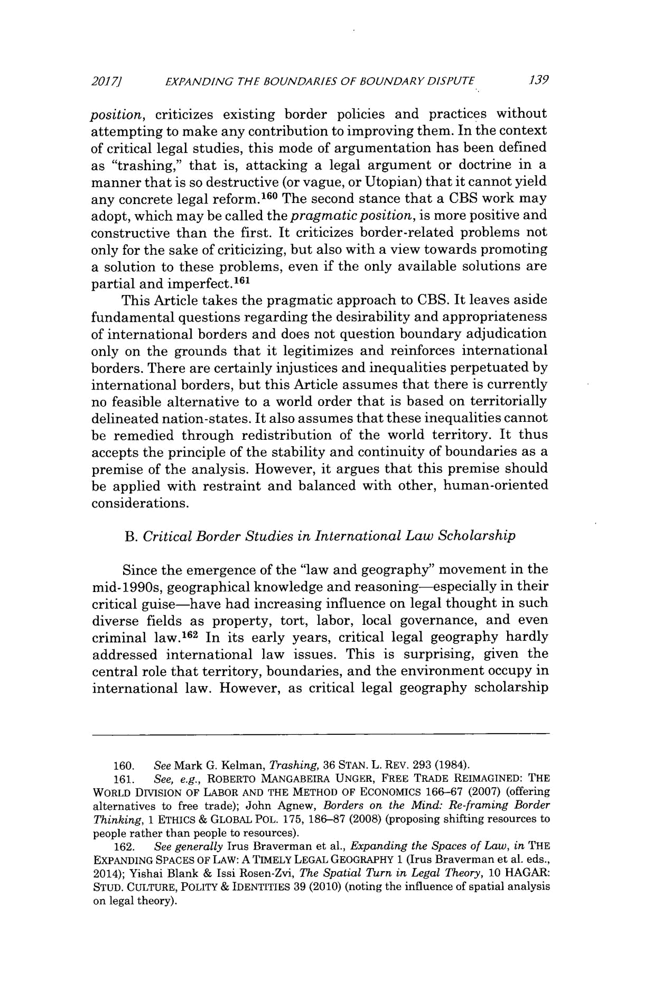
20171 EXPANDING THE BOUNDARIES OF BOUNDARY DISPUTE .139

position, criticizes existing border policies and practices without attempting to make any contribution to improving them. In the context of critical legal studies, this mode of argumentation has been defined as "trashing," that is, attacking a legal argument or doctrine in a manner that is so destructive (or vague, or Utopian) that it cannot yield any concrete legal reform. ¹⁶⁰ The second stance that a CBS work may adopt, which may be called the pragmaticposition, is more positive and constructive than the first. It criticizes border-related problems not only for the sake of criticizing, but also with a view towards promoting a solution to these problems, even if the only available solutions are partial and imperfect.¹⁶ ¹

This Article takes the pragmatic approach to CBS. It leaves aside fundamental questions regarding the desirability and appropriateness of international borders and does not question boundary adjudication only on the grounds that it legitimizes and reinforces international borders. There are certainly injustices and inequalities perpetuated by international borders, but this Article assumes that there is currently no feasible alternative to a world order that is based on territorially delineated nation-states. It also assumes that these inequalities cannot be remedied through redistribution of the world territory. It thus accepts the principle of the stability and continuity of boundaries as a premise of the analysis. However, it argues that this premise should be applied with restraint and balanced with other, human-oriented considerations.

- CriticalBorder Studies in InternationalLaw Scholarship

Since the emergence of the "law and geography" movement in the mid-1990s, geographical knowledge and reasoning-especially in their critical guise-have had increasing influence on legal thought in such diverse fields as property, tort, labor, local governance, and even criminal law.1 ⁶² In its early years, critical legal geography hardly addressed international law issues. This is surprising, given the central role that territory, boundaries, and the environment occupy in international law. However, as critical legal geography scholarship

- See Mark G. Kelman, Trashing, 36 STAN. L. REV. 293 (1984).

- See, e.g., ROBERTO MANGABEIRA UNGER, FREE TRADE REIMAGINED: THE WORLD DIVISION OF LABOR AND THE METHOD OF ECONOMICS 166-67 (2007) (offering alternatives to free trade); John Agnew, Borders on the Mind: Re-framing Border Thinking, 1 ETHICS & GLOBAL POL. 175, 186-87 (2008) (proposing shifting resources to people rather than people to resources).

- See generally Irus Braverman et al., Expanding the Spaces of Law, in THE

EXPANDING SPACES OF LAw: A TIMELY LEGAL GEOGRAPHY 1 (Irus Braverman et al. eds.,

2014); Yishai Blank & Issi Rosen-Zvi, The Spatial Turn in Legal Theory, 10 HAGAR: STUD. CULTURE, POLITY & IDENTITIES 39 (2010) (noting the influence of spatial analysis on legal theory).
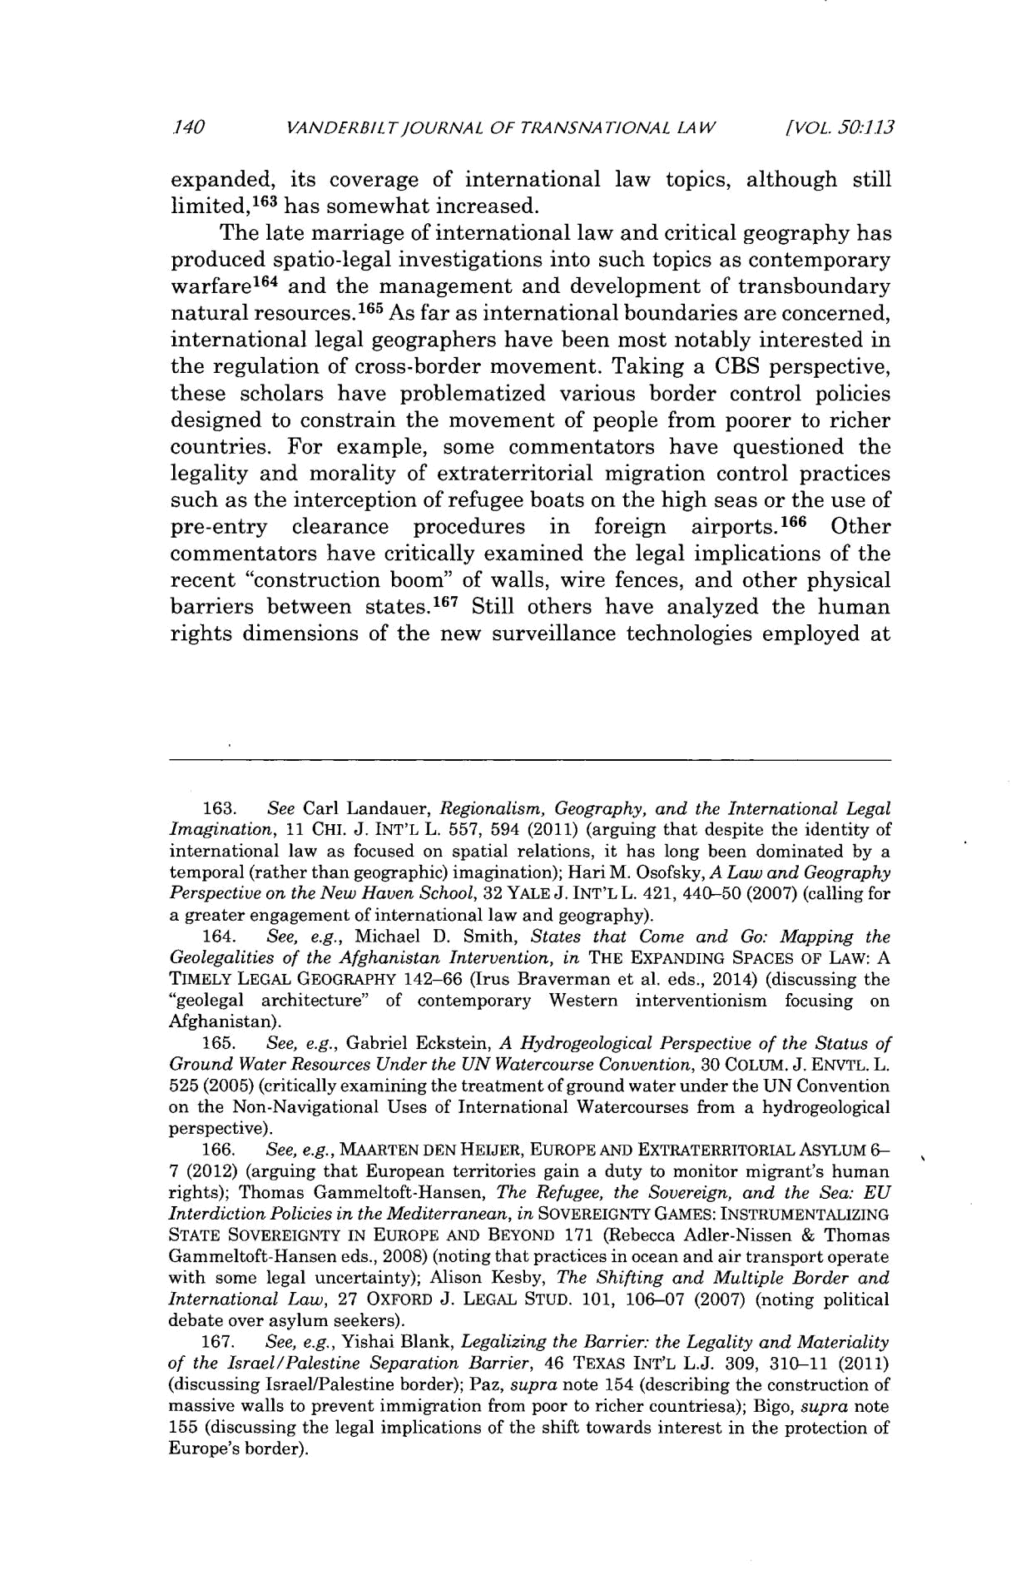
140 VANDERBIL T]OURNAL OF TRANSNA TIONAL LAW [VOL, 50:1.13

expanded, its coverage of international law topics, although still limited,¹ ⁶³ has somewhat increased.

The late marriage of international law and critical geography has produced spatio-legal investigations into such topics as contemporary warfare¹ ⁶⁴ and the management and development of transboundary natural resources. 165 As far as international boundaries are concerned, international legal geographers have been most notably interested in the regulation of cross-border movement. Taking a CBS perspective, these scholars have problematized various border control policies designed to constrain the movement of people from poorer to richer countries. For example, some commentators have questioned the legality and morality of extraterritorial migration control practices such as the interception of refugee boats on the high seas or the use of pre-entry clearance procedures in foreign airports.166 Other commentators have critically examined the legal implications of the recent "construction boom" of walls, wire fences, and other physical barriers between states.¹⁶ ⁷ Still others have analyzed the human rights dimensions of the new surveillance technologies employed at

  - See Carl Landauer, Regionalism, Geography, and the International Legal Imagination, 11 CHI. J. INT'L L. 557, 594 (2011) (arguing that despite the identity of international law as focused on spatial relations, it has long been dominated by a temporal (rather than geographic) imagination); Hari M. Osofsky, A Law and Geography Perspective on the New Haven School, 32 YALE J. INT'L L. 421, 440-50 (2007) (calling for a greater engagement of international law and geography).

  - See, e.g., Michael D. Smith, States that Come and Go: Mapping the Geolegalities of the Afghanistan Intervention, in THE EXPANDING SPACES OF LAW: A TIMELY LEGAL GEOGRAPHY 142-66 (Irus Braverman et al. eds., 2014) (discussing the "geolegal architecture" of contemporary Western interventionism focusing on Afghanistan).

- See, e.g., Gabriel Eckstein, A Hydrogeological Perspective of the Status of Ground Water Resources Under the UN Watercourse Convention, 30 COLUM. J. ENVTL. L. 525 (2005) (critically examining the treatment of ground water under the UN Convention on the Non-Navigational Uses of International Watercourses from a hydrogeological perspective).

- See, e.g., MAARTEN DEN HEIJER, EUROPE AND EXTRATERRITORIAL ASYLUM 6-

7 (2012) (arguing that European territories gain a duty to monitor migrant's human rights); Thomas Gammeltoft-Hansen, The Refugee, the Sovereign, and the Sea: EU

InterdictionPolicies in the Mediterranean, in SOVEREIGNTY GAMES: INSTRUMENTALIZING

STATE SOVEREIGNTY IN EUROPE AND BEYOND 171 (Rebecca Adler-Nissen & Thomas

Gammeltoft-Hansen eds., 2008) (noting that practices in ocean and air transport operate with some legal uncertainty); Alison Kesby, The Shifting and Multiple Border and International Law, 27 OXFORD J. LEGAL STUD. 101, 106-07 (2007) (noting political debate over asylum seekers).

- See, e.g., Yishai Blank, Legalizing the Barrier: the Legality and Materiality of the Israel/Palestine Separation Barrier, 46 TEXAS INT'L L.J. 309, 310-11 (2011) (discussing Israel/Palestine border); Paz, supra note 154 (describing the construction of massive walls to prevent immigration from poor to richer countriesa); Bigo, supra note 155 (discussing the legal implications of the shift towards interest in the protection of Europe's border).
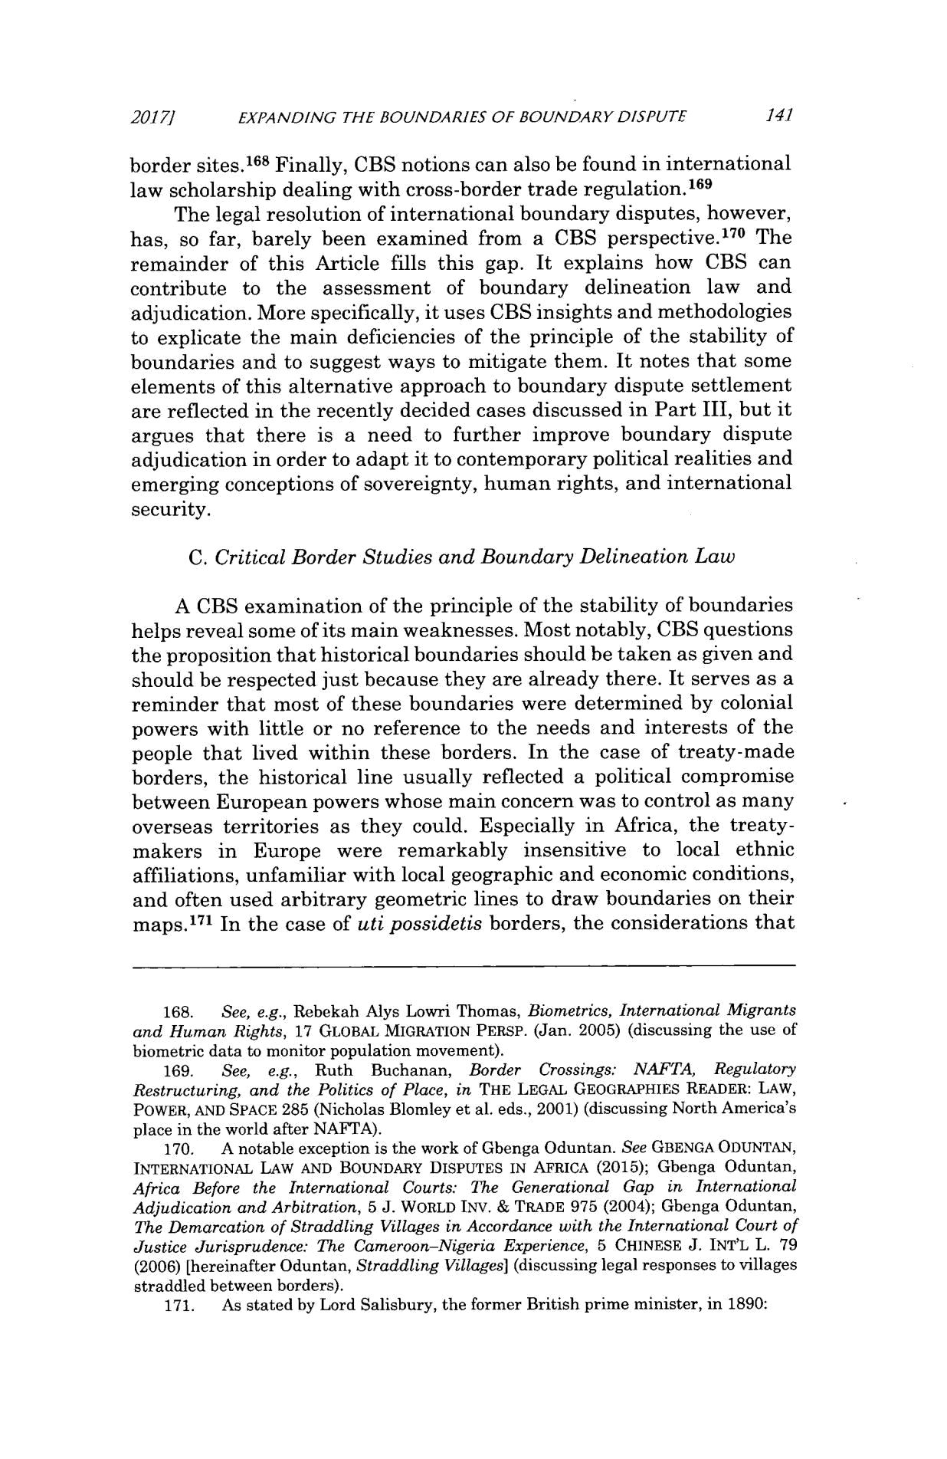
20177 EXPANDING THE BOUNDARIES OF BOUNDARY DISPUTE 141

border sites.¹⁶⁸ Finally, CBS notions can also be found in international law scholarship dealing with cross-border trade regulation. ¹⁶⁹

The legal resolution of international boundary disputes, however, has, so far, barely been examined from a CBS perspective.17 ⁰ The remainder of this Article fills this gap. It explains how CBS can contribute to the assessment of boundary delineation law and adjudication. More specifically, it uses CBS insights and methodologies to explicate the main deficiencies of the principle of the stability of boundaries and to suggest ways to mitigate them. It notes that some elements of this alternative approach to boundary dispute settlement are reflected in the recently decided cases discussed in Part III, but it argues that there is a need to further improve boundary dispute adjudication in order to adapt it to contemporary political realities and emerging conceptions of sovereignty, human rights, and international security.

- CriticalBorder Studies and Boundary DelineationLaw

A CBS examination of the principle of the stability of boundaries helps reveal some of its main weaknesses. Most notably, CBS questions the proposition that historical boundaries should be taken as given and should be respected just because they are already there. It serves as a reminder that most of these boundaries were determined by colonial powers with little or no reference to the needs and interests of the people that lived within these borders. In the case of treaty-made borders, the historical line usually reflected a political compromise between European powers whose main concern was to control as many overseas territories as they could. Especially in Africa, the treaty-makers in Europe were remarkably insensitive to local ethnic affiliations, unfamiliar with local geographic and economic conditions, and often used arbitrary geometric lines to draw boundaries on their maps.1⁷ ¹ In the case of uti possidetis borders, the considerations that

- See, e.g., Rebekah Alys Lowri Thomas, Biometrics, International Migrants and Human Rights, 17 GLOBAL MIGRATION PERSP. (Jan. 2005) (discussing the use of biometric data to monitor population movement).

- See, e.g., Ruth Buchanan, Border Crossings: NAFTA,Regulatory

Restructuring, and the Politics of Place, in THE LEGAL GEOGRAPHIES READER: LAW,

POWER, AND SPACE 285 (Nicholas Blomley et al. eds., 2001) (discussing North America's place in the world after NAFTA).

- A notable exception is the work of Gbenga Oduntan. See GBENGA ODUNTAN,

INTERNATIONAL LAW AND BOUNDARY DISPUTES IN AFRICA (2015); Gbenga Oduntan,

Africa Before the International Courts: The Generational Gap in International Adjudication and Arbitration, 5 J. WORLD INV. & TRADE 975 (2004); Gbenga Oduntan, The Demarcation of Straddling Villages in Accordance with the International Court of Justice Jurisprudence: The Cameroon-NigeriaExperience, 5 CHINESE J. INT'L L. 79 (2006) [hereinafter Oduntan, Straddling Villages] (discussing legal responses to villages straddled between borders).

- As stated by Lord Salisbury, the former British prime minister, in 1890:
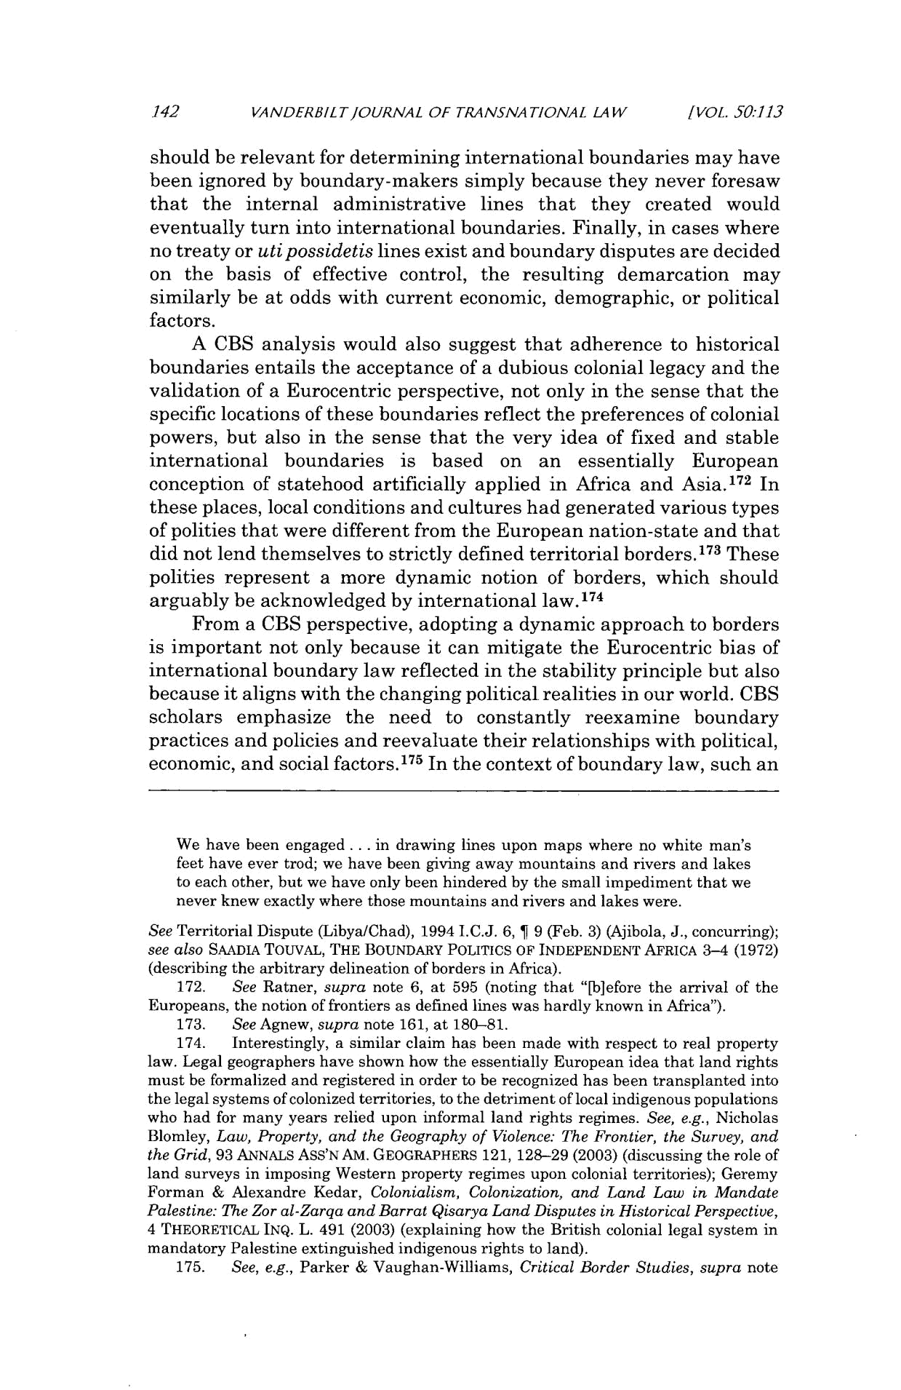
.142 VANDERBILT/OURNAL OF TRANSNATIONAL LAW /VOL. 50:113

should be relevant for determining international boundaries may have been ignored by boundary-makers simply because they never foresaw that the internal administrative lines that they created would eventually turn into international boundaries. Finally, in cases where no treaty or uti possidetis lines exist and boundary disputes are decided on the basis of effective control, the resulting demarcation may similarly be at odds with current economic, demographic, or political factors.

A CBS analysis would also suggest that adherence to historical boundaries entails the acceptance of a dubious colonial legacy and the validation of a Eurocentric perspective, not only in the sense that the specific locations of these boundaries reflect the preferences of colonial powers, but also in the sense that the very idea of fixed and stable international boundaries is based on an essentially European conception of statehood artificially applied in Africa and Asia.1 ⁷² In these places, local conditions and cultures had generated various types of polities that were different from the European nation-state and that did not lend themselves to strictly defined territorial borders.1⁷ ³ These polities represent a more dynamic notion of borders, which should arguably be acknowledged by international law.1 ⁷⁴

From a CBS perspective, adopting a dynamic approach to borders is important not only because it can mitigate the Eurocentric bias of international boundary law reflected in the stability principle but also because it aligns with the changing political realities in our world. CBS scholars emphasize the need to constantly reexamine boundary practices and policies and reevaluate their relationships with political, economic, and social factors.1⁷⁵ In the context of boundary law, such an

We have been engaged ... in drawing lines upon maps where no white man's feet have ever trod; we have been giving away mountains and rivers and lakes to each other, but we have only been hindered by the small impediment that we never knew exactly where those mountains and rivers and lakes were.

See Territorial Dispute (Libya/Chad), 1994 I.C.J. 6, ¶ 9 (Feb. 3) (Ajibola, J., concurring);

see also SAADIA TOUVAL, THE BOUNDARY POLITICS OF INDEPENDENT AFRICA 3-4 (1972)

(describing the arbitrary delineation of borders in Africa).

  - See Ratner, supra note 6, at 595 (noting that "[bjefore the arrival of the Europeans, the notion of frontiers as defined lines was hardly known in Africa").

- See Agnew, supra note 161, at 180-81.

- Interestingly, a similar claim has been made with respect to real property law. Legal geographers have shown how the essentially European idea that land rights must be formalized and registered in order to be recognized has been transplanted into the legal systems of colonized territories, to the detriment of local indigenous populations who had for many years relied upon informal land rights regimes. See, e.g., Nicholas Blomley, Law, Property, and the Geography of Violence: The Frontier, the Survey, and the Grid, 93 ANNALS ASS'N Am. GEOGRAPHERS 121, 128-29 (2003) (discussing the role of land surveys in imposing Western property regimes upon colonial territories); Geremy Forman & Alexandre Kedar, Colonialism, Colonization, and Land Law in Mandate Palestine: The Zor al-Zarqaand Barrat Qisarya Land Disputes in HistoricalPerspective, 4 THEORETICAL INQ. L. 491 (2003) (explaining how the British colonial legal system in mandatory Palestine extinguished indigenous rights to land).

- See, e.g., Parker & Vaughan-Williams, Critical Border Studies, supra note
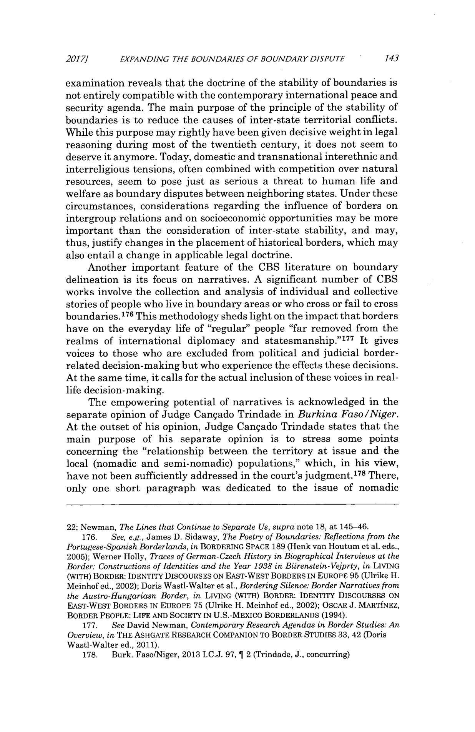
2017] EXPANDING THE BOUNDARIES OF BOUNDARY DISPUTE 143

examination reveals that the doctrine of the stability of boundaries is not entirely compatible with the contemporary international peace and security agenda. The main purpose of the principle of the stability of boundaries is to reduce the causes of inter-state territorial conflicts. While this purpose may rightly have been given decisive weight in legal reasoning during most of the twentieth century, it does not seem to deserve it anymore. Today, domestic and transnational interethnic and interreligious tensions, often combined with competition over natural resources, seem to pose just as serious a threat to human life and welfare as boundary disputes between neighboring states. Under these circumstances, considerations regarding the influence of borders on intergroup relations and on socioeconomic opportunities may be more important than the consideration of inter-state stability, and may, thus, justify changes in the placement of historical borders, which may also entail a change in applicable legal doctrine.

Another important feature of the CBS literature on boundary delineation is its focus on narratives. A significant number of CBS works involve the collection and analysis of individual and collective stories of people who live in boundary areas or who cross or fail to cross boundaries. ¹⁷⁶ This methodology sheds light on the impact that borders have on the everyday life of "regular" people "far removed from the realms of international diplomacy and statesmanship."1 ⁷ It gives voices to those who are excluded from political and judicial border-related decision-making but who experience the effects these decisions. At the same time, it calls for the actual inclusion of these voices in real-life decision-making.

The empowering potential of narratives is acknowledged in the separate opinion of Judge Cangado Trindade in Burkina Faso/Niger. At the outset of his opinion, Judge Cangado Trindade states that the main purpose of his separate opinion is to stress some points concerning the "relationship between the territory at issue and the local (nomadic and semi-nomadic) populations," which, in his view, have not been sufficiently addressed in the court's judgment.¹⁷ ⁸ There, only one short paragraph was dedicated to the issue of nomadic

22; Newman, The Lines that Continue to Separate Us, supra note 18, at 145-46.

- See, e.g., James D. Sidaway, The Poetry of Boundaries: Reflections from the Portugese-SpanishBorderlands, in BORDERING SPACE 189 (Henk van Houtum et al. eds., 2005); Werner Holly, Traces of German-Czech History in Biographical Interviews at the Border: Constructions of Identities and the Year 1938 in Biirenstein-Vejprty, in LIVING

(WITH) BORDER: IDENTITY DISCOURSES ON EAST-WEST BORDERS IN EUROPE 95 (Ulrike H.

Meinhof ed., 2002); Doris Wastl-Walter et al., Bordering Silence: Border Narrativesfrom

the Austro-Hungariasn Border, in LIVING (WITH) BORDER: IDENTITY DISCOURSES ON EAST-WEST BORDERS IN EUROPE 75 (Ulrike H. Meinhof ed., 2002); OSCAR J. MARTINEZ, BORDER PEOPLE: LIFE AND SOCIETY IN U.S.-MEXICO BORDERLANDS (1994).
  - See David Newman, Contemporary Research Agendas in Border Studies: An

Overview, in THE ASHGATE RESEARCH COMPANION TO BORDER STUDIES 33, 42 (Doris

Wastl-Walter ed., 2011).
  - Burk. Faso/Niger, 2013 I.C.J. 97, T 2 (Trindade, J., concurring)
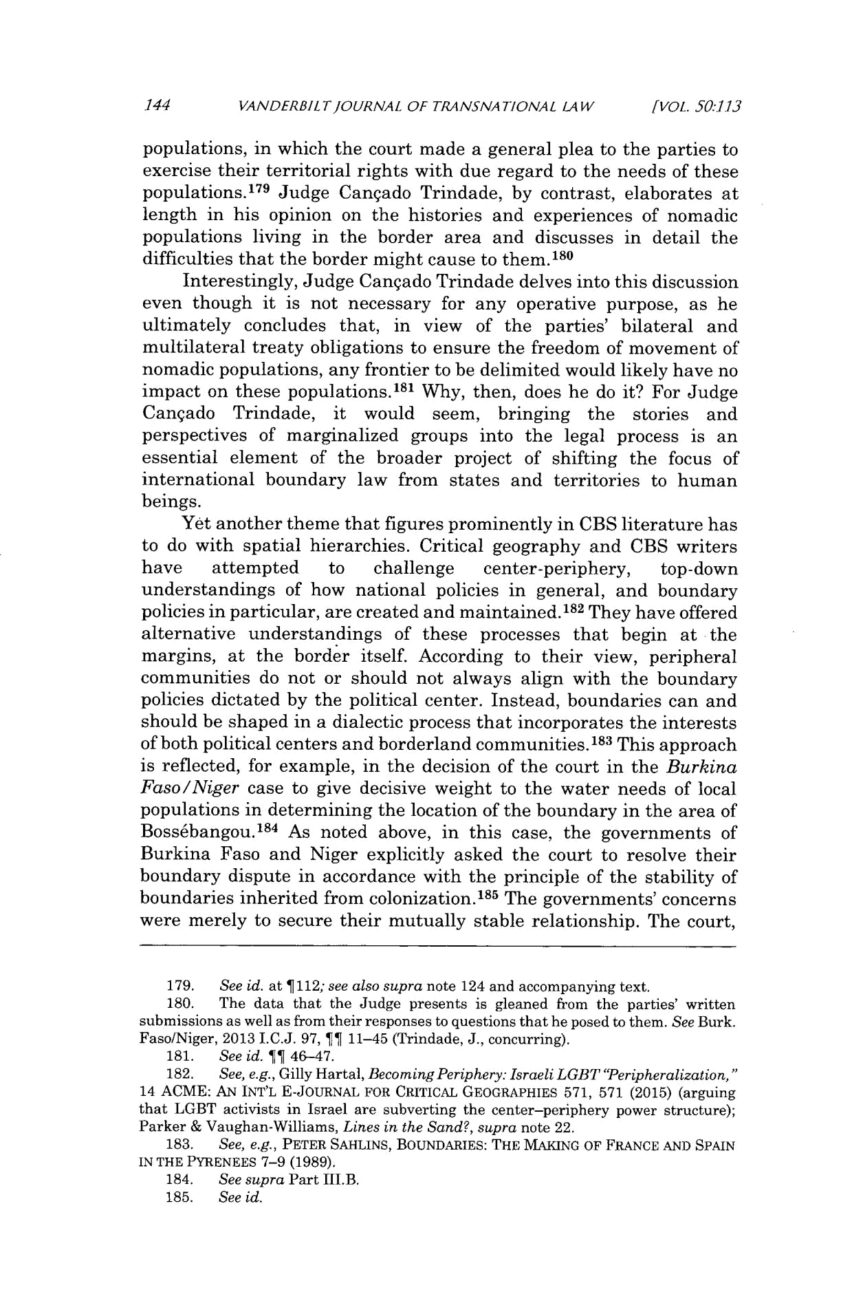
144 VANDERBILTJOURNAL OF TRANSNATIONAL LAW [VOL. 50:1.13

populations, in which the court made a general plea to the parties to exercise their territorial rights with due regard to the needs of these populations.¹ ⁷⁹ Judge Cangado Trindade, by contrast, elaborates at length in his opinion on the histories and experiences of nomadic populations living in the border area and discusses in detail the difficulties that the border might cause to them.1 ⁸⁰

Interestingly, Judge Cangado Trindade delves into this discussion even though it is not necessary for any operative purpose, as he ultimately concludes that, in view of the parties' bilateral and multilateral treaty obligations to ensure the freedom of movement of nomadic populations, any frontier to be delimited would likely have no impact on these populations.¹⁸ ¹ Why, then, does he do it? For Judge Cangado Trindade, it would seem, bringing the stories and perspectives of marginalized groups into the legal process is an essential element of the broader project of shifting the focus of international boundary law from states and territories to human beings.

Yet another theme that figures prominently in CBS literature has to do with spatial hierarchies. Critical geography and CBS writers
have attempted to challenge center-periphery, top-down understandings of how national policies in general, and boundary policies in particular, are created and maintained.1 ⁸² They have offered alternative understandings of these processes that begin at the margins, at the border itself. According to their view, peripheral communities do not or should not always align with the boundary policies dictated by the political center. Instead, boundaries can and should be shaped in a dialectic process that incorporates the interests of both political centers and borderland communities.' ⁸ ³ This approach is reflected, for example, in the decision of the court in the Burkina Faso/Niger case to give decisive weight to the water needs of local populations in determining the location of the boundary in the area of Boss6bangou.1 ⁸⁴ As noted above, in this case, the governments of Burkina Faso and Niger explicitly asked the court to resolve their boundary dispute in accordance with the principle of the stability of boundaries inherited from colonization.1⁸ ⁵ The governments' concerns were merely to secure their mutually stable relationship. The _{court,}

- See id. at T 112; see also supra note 124 and accompanying text.

- The data that the Judge presents is gleaned from the parties' written submissions as well as from their responses to questions that he posed to them. See Burk. Faso/Niger, 2013 I.C.J. 97, ¶¶ 11-45 (Trindade, J., concurring).
- See id. ¶¶ 46-47.

- See, e.g., Gilly Hartal, Becoming Periphery:Israeli LGBT "Peripheralization,"

14 ACME: AN INT'L E-JOURNAL FOR CRITICAL GEOGRAPHIES 571, 571 (2015) (arguing that LGBT activists in Israel are subverting the center-periphery power structure); Parker & Vaughan-Williams, Lines in the Sand?, supra note 22.

- See, e.g., PETER SAHLINS, BOUNDARIES: THE MAKING OF FRANCE AND SPAIN IN THE PYRENEES 7-9 (1989).
- See supra Part III.B.

- See id.

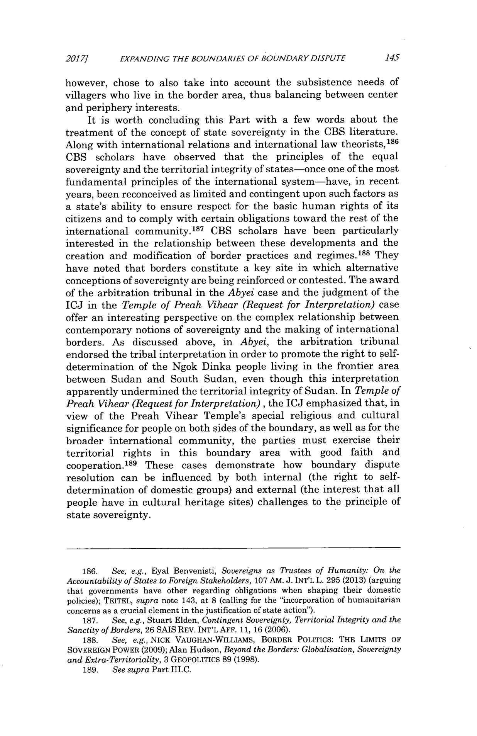
2017] EXPANDING THE BOUNDARIES OF BOUNDARY DISPUTE 145

however, chose to also take into account the subsistence needs of villagers who live in the border area, thus balancing between center and periphery interests.

It is worth concluding this Part with a few words about the treatment of the concept of state sovereignty in the CBS literature. Along with international relations and international law theorists, ¹⁸⁶ CBS scholars have observed that the principles of the equal sovereignty and the territorial integrity of states-once one of the most fundamental principles of the international system-have, in recent years, been reconceived as limited and contingent upon such factors as a state's ability to ensure respect for the basic human rights of its citizens and to comply with certain obligations toward the rest of the international community.'⁸⁷ CBS scholars have been particularly interested in the relationship between these developments and the creation and modification of border practices and regimes.' ⁸⁸ They have noted that borders constitute a key site in which alternative conceptions of sovereignty are being reinforced or contested. The award of the arbitration tribunal in the Abyei case and the judgment of the ICJ in the Temple of Preah Vihear (Request for Interpretation) case offer an interesting perspective on the complex relationship between contemporary notions of sovereignty and the making of international borders. As discussed above, in Abyei, the arbitration tribunal endorsed the tribal interpretation in order to promote the right to self-determination of the Ngok Dinka people living in the frontier area between Sudan and South Sudan, even though this interpretation apparently undermined the territorial integrity of Sudan. In Temple of Preah Vihear (Request for Interpretation), the ICJ emphasized that, in view of the Preah Vihear Temple's special religious and cultural significance for people on both sides of the boundary, as well as for the broader international community, the parties must exercise their territorial rights in this boundary area with good faith and cooperation.1⁸ ⁹ These cases demonstrate how boundary dispute resolution can be influenced by both internal (the right to self-determination of domestic groups) and external (the interest that all people have in cultural heritage sites) challenges to the principle of state sovereignty.

- See, e.g., Eyal Benvenisti, Sovereigns as Trustees of Humanity: On the Accountability of States to Foreign Stakeholders, 107 AM. J. INT'L L. 295 (2013) (arguing that governments have other regarding obligations when shaping their domestic policies); TEITEL, supra note 143, at 8 (calling for the "incorporation of humanitarian concerns as a crucial element in the justification of state action").

  - See, e.g., Stuart Elden, Contingent Sovereignty, TerritorialIntegrity and the Sanctity of Borders, 26 SAIS REV. INT'L AFF. 11, 16 (2006).

  - See, e.g., NICK VAUGHAN-WILLIAMS, BORDER POLITICS: THE LIMITS OF

SOVEREIGN POWER (2009); Alan Hudson, Beyond the Borders: Globalisation,Sovereignty and Extra-Territoriality,3 GEOPOLITICS 89 (1998).
  - See supra Part III.C.
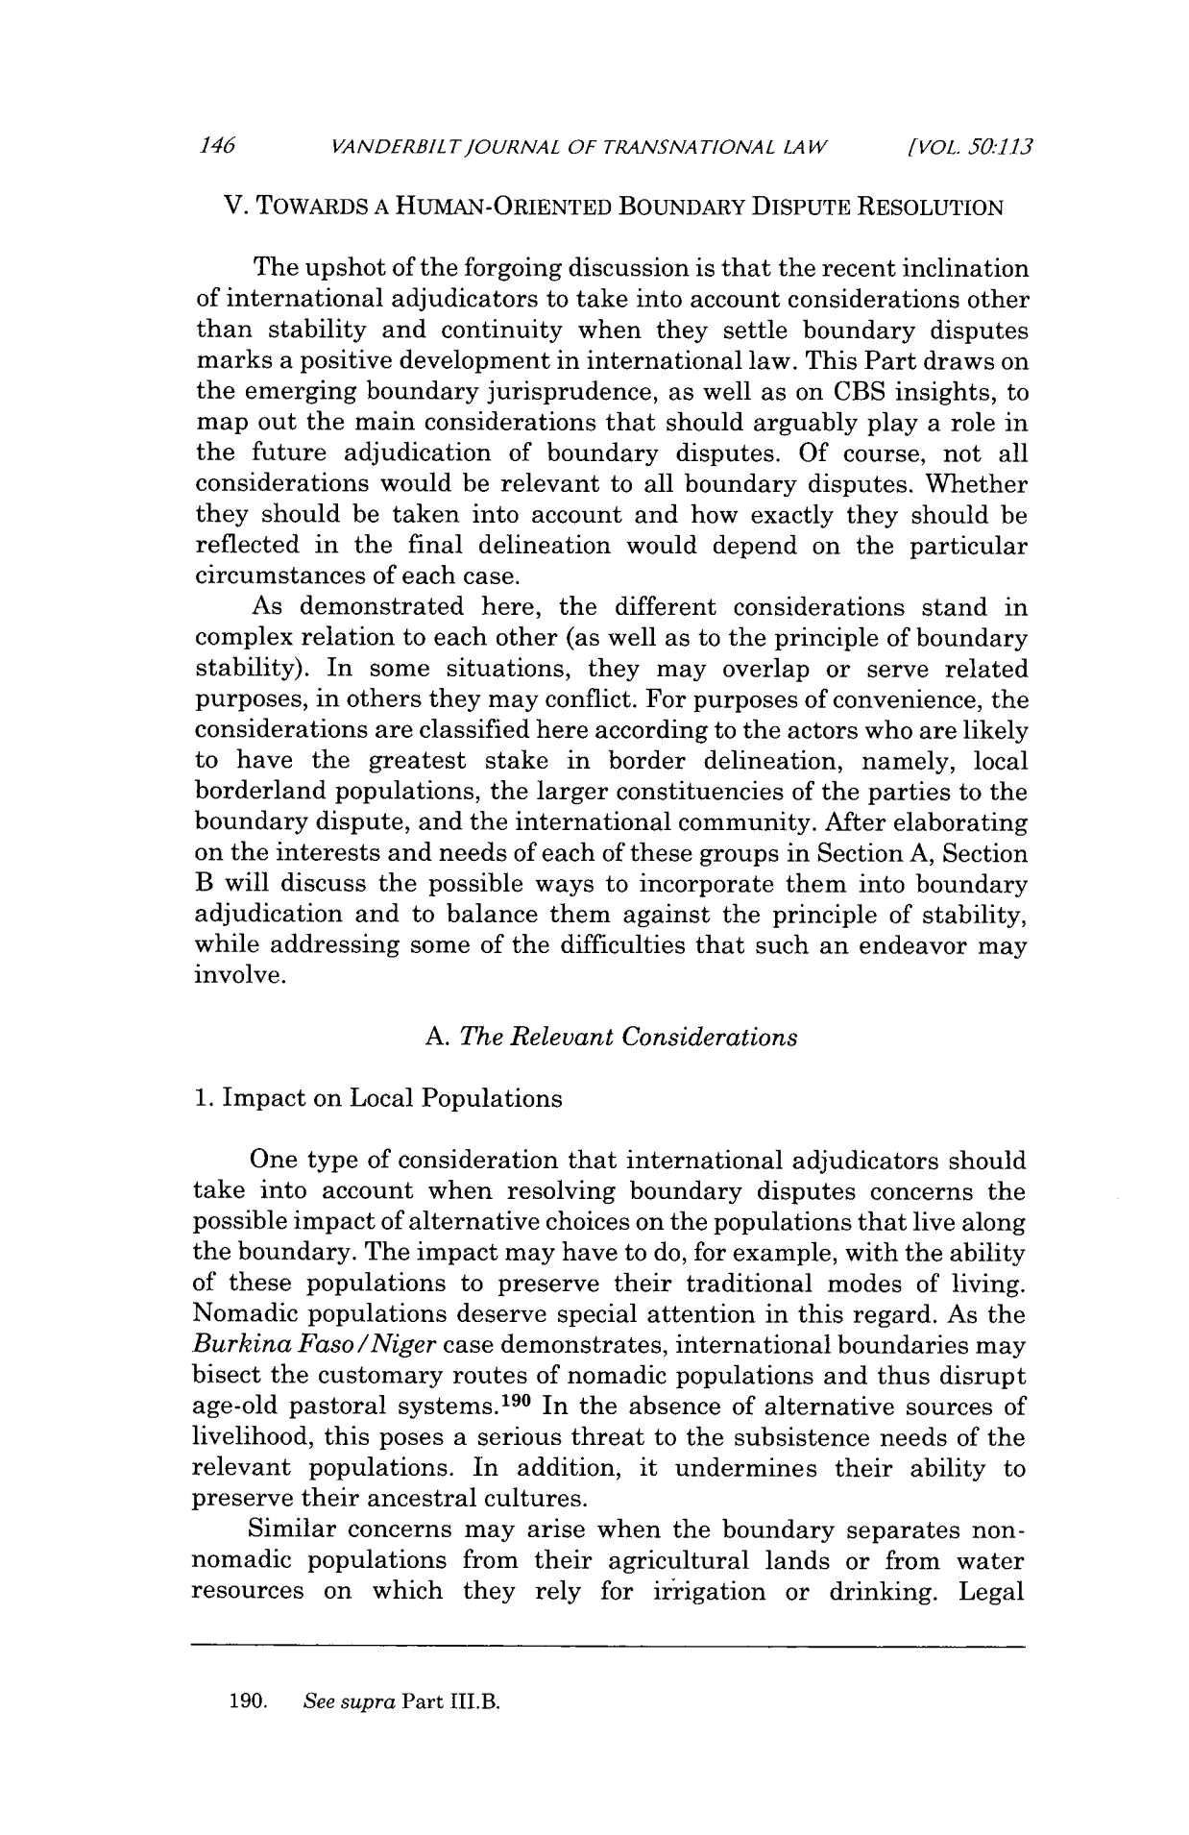
146 VANDERBILT/OURNAL OF TRANSNATIONAL LAW [VOL. 50:1.13

V. TOWARDS A HUMAN-ORIENTED BOUNDARY DISPUTE RESOLUTION

The upshot of the forgoing discussion is that the recent inclination of international adjudicators to take into account considerations other than stability and continuity when they settle boundary disputes marks a positive development in international law. This Part draws on the emerging boundary jurisprudence, as well as on CBS insights, to map out the main considerations that should arguably play a role in the future adjudication of boundary disputes. Of course, not all considerations would be relevant to all boundary disputes. Whether they should be taken into account and how exactly they should be reflected in the final delineation would depend on the particular circumstances of each case.

As demonstrated here, the different considerations stand in complex relation to each other (as well as to the principle of boundary stability). In some situations, they may overlap or serve related purposes, in others they may conflict. For purposes of convenience, the considerations are classified here according to the actors who are likely to have the greatest stake in border delineation, namely, local borderland populations, the larger constituencies of the parties to the boundary dispute, and the international community. After elaborating on the interests and needs of each of these groups in Section A, Section B will discuss the possible ways to incorporate them into boundary adjudication and to balance them against the principle of stability, while addressing some of the difficulties that such an endeavor may involve.

  - The Relevant Considerations

- Impact on Local Populations

One type of consideration that international adjudicators should take into account when resolving boundary disputes concerns the possible impact of alternative choices on the populations that live along the boundary. The impact may have to do, for example, with the ability of these populations to preserve their traditional modes of living. Nomadic populations deserve special attention in this regard. As the Burkina Faso/Nigercase demonstrates, international boundaries may bisect the customary routes of nomadic populations and thus disrupt age-old pastoral systems. ¹⁹ ⁰ In the absence of alternative sources of livelihood, this poses a serious threat to the subsistence needs of the relevant populations. In addition, it undermines their ability to preserve their ancestral cultures.

Similar concerns may arise when the boundary separates non-nomadic populations from their agricultural lands or from water resources on which they rely for irrigation or drinking. Legal

- See supra Part III.B.

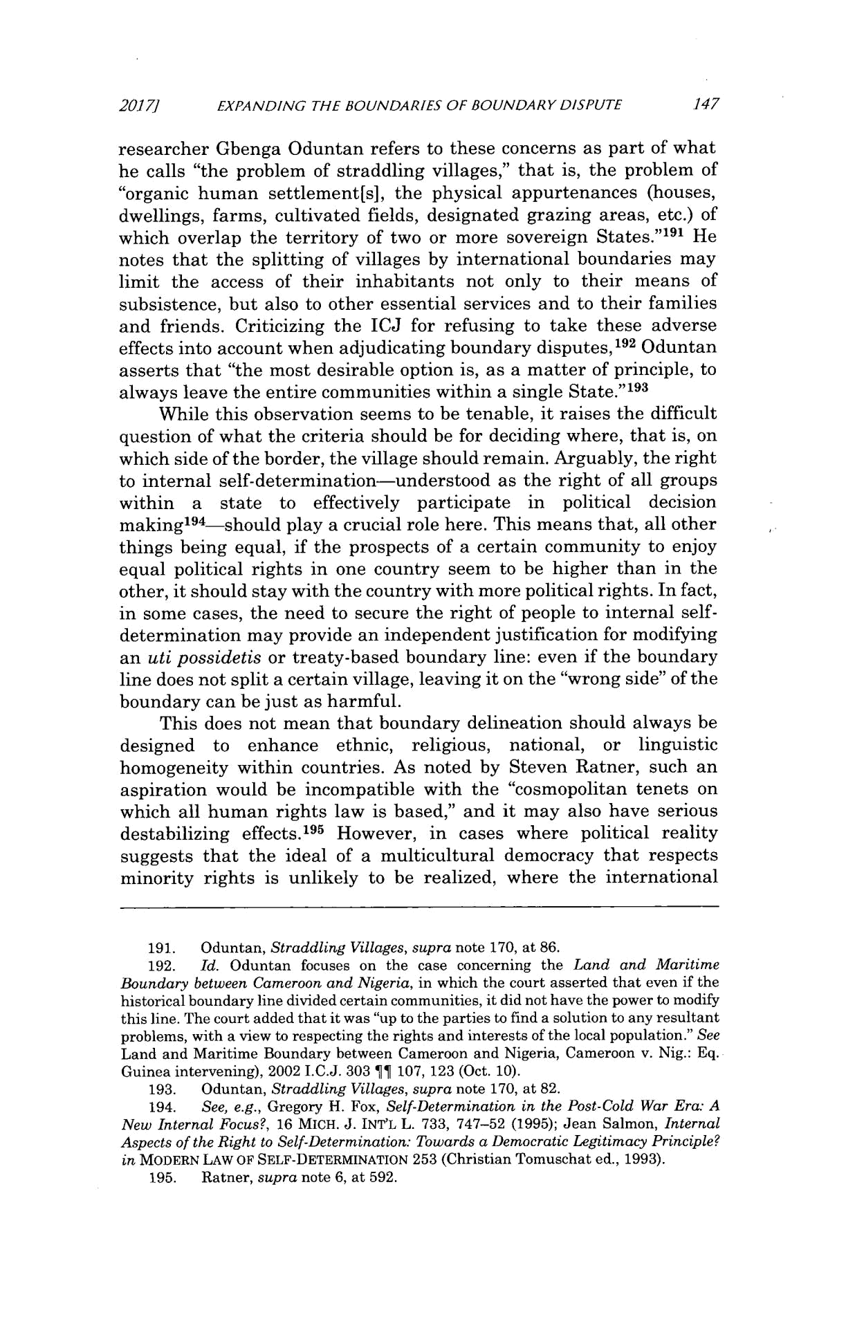
₂₀₁₇₁ EXPANDING THE BOUNDARIES OF BOUNDARY DISPUTE 147

researcher Gbenga Oduntan refers to these concerns as part of what he calls "the problem of straddling villages," that is, the problem of "organic human settlement[s], the physical appurtenances (houses, dwellings, farms, cultivated fields, designated grazing areas, etc.) of which overlap the territory of two or more sovereign States."¹ ⁹¹ He notes that the splitting of villages by international boundaries may limit the access of their inhabitants not only to their means of subsistence, but also to other essential services and to their families and friends. Criticizing the ICJ for refusing to take these adverse effects into account when adjudicating boundary disputes,1 ⁹² Oduntan asserts that "the most desirable option is, as a matter of principle, to always leave the entire communities within a single State." ⁹ ³

While this observation seems to be tenable, it raises the difficult question of what the criteria should be for deciding where, that is, on which side of the border, the village should remain. Arguably, the right to internal self-determination-understood as the right of all groups within a state to effectively participate in political decision making' ⁹⁴-should play a crucial role here. This means that, all other things being equal, if the prospects of a certain community to enjoy equal political rights in one country seem to be higher than in the other, it should stay with the country with more political rights. In fact, in some cases, the need to secure the right of people to internal self-determination may provide an independent justification for modifying an uti possidetis or treaty-based boundary line: even if the boundary line does not split a certain village, leaving it on the "wrong side" of the boundary can be just as harmful.

This does not mean that boundary delineation should always be designed to enhance ethnic, religious, national, or linguistic homogeneity within countries. As noted by Steven Ratner, such an aspiration would be incompatible with the "cosmopolitan tenets on which all human rights law is based," and it may also have serious destabilizing effects.'⁹ ⁵ However, in cases where political reality suggests that the ideal of a multicultural democracy that respects minority rights is unlikely to be realized, where the international

- Oduntan, Straddling Villages, supra note 170, at 86.

- Id. Oduntan focuses on the case concerning the Land and Maritime Boundary between Cameroon and Nigeria, in which the court asserted that even if the historical boundary line divided certain communities, it did not have the power to modify this line. The court added that it was "up to the parties to find a solution to any resultant problems, with a view to respecting the rights and interests of the local population." See Land and Maritime Boundary between Cameroon and Nigeria, Cameroon v. Nig.: Eq. Guinea intervening), 2002 I.C.J. 303 11 107, 123 (Oct. 10).

- Oduntan, Straddling Villages, supra note 170, at 82.

- See, e.g., Gregory H. Fox, Self-Determination in the Post-Cold War Era: A New Internal Focus?, 16 MICH. J. INT'L L. 733, 747-52 (1995); Jean Salmon, Internal Aspects of the Right to Self-Determination: Towards a Democratic Legitimacy Principle? in MODERN LAW OF SELF-DETERMINATION 253 (Christian Tomuschat ed., 1993).

- Ratner, supra note 6, at 592.

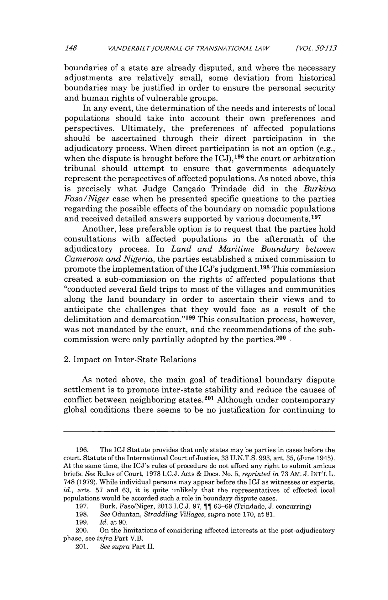
148 VANDERBILTJOURNAL OF TRANSNATIONAL LAW [VOL. 50:1.13

boundaries of a state are already disputed, and where the necessary adjustments are relatively small, some deviation from historical boundaries may be justified in order to ensure the personal security and human rights of vulnerable groups.

In any event, the determination of the needs and interests of local populations should take into account their own preferences and perspectives. Ultimately, the preferences of affected populations should be ascertained through their direct participation in the adjudicatory process. When direct participation is not an option (e.g.,

9 6

when the dispute is brought before the ICJ),1 the court or arbitration tribunal should attempt to ensure that governments adequately represent the perspectives of affected populations. As noted above, this is precisely what Judge Cangado Trindade did in the Burkina Faso/Niger case when he presented specific questions to the parties regarding the possible effects of the boundary on nomadic populations and received detailed answers supported by various documents.¹ ⁹⁷

Another, less preferable option is to request that the parties hold consultations with affected populations in the aftermath of the adjudicatory process. In Land and Maritime Boundary between Cameroon and Nigeria, the parties established a mixed commission to promote the implementation of the ICJ's judgment.1⁹⁸ This commission created a sub-commission on the rights of affected populations that "conducted several field trips to most of the villages and communities along the land boundary in order to ascertain their views and to anticipate the challenges that they would face as a result of the delimitation and demarcation."' ⁹⁹ This consultation process, however, was not mandated by the court, and the recommendations of the sub-commission were only partially adopted by the parties. ²⁰ ⁰

2. Impact on Inter-State Relations

As noted above, the main goal of traditional boundary dispute settlement is to promote inter-state stability and reduce the causes of conflict between neighboring states. ²⁰1 Although under contemporary global conditions there seems to be no justification for continuing to

- The ICJ Statute provides that only states may be parties in cases before the court. Statute of the International Court of Justice, 33 U.N.T.S. 993, art. 35, (June 1945). At the same time, the ICJ's rules of procedure do not afford any right to submit amicus briefs. See Rules of Court, 1978 I.C.J. Acts & Does. No. 5, reprinted in 73 AM. J. INT'L L. 748 (1979). While individual persons may appear before the ICJ as witnesses or experts, id., arts. 57 and 63, it is quite unlikely that the representatives of effected local populations would be accorded such a role in boundary dispute cases.

- Burk. Faso/Niger, 2013 LC. 97, ¶f 63-69 (Trindade, J. concurring)

- See Oduntan, Straddling Villages, supra note 170, at 81.

- Id. at 90.

- On the limitations of considering affected interests at the post-adjudicatory phase, see infra Part V.B.

- See supra Part II.
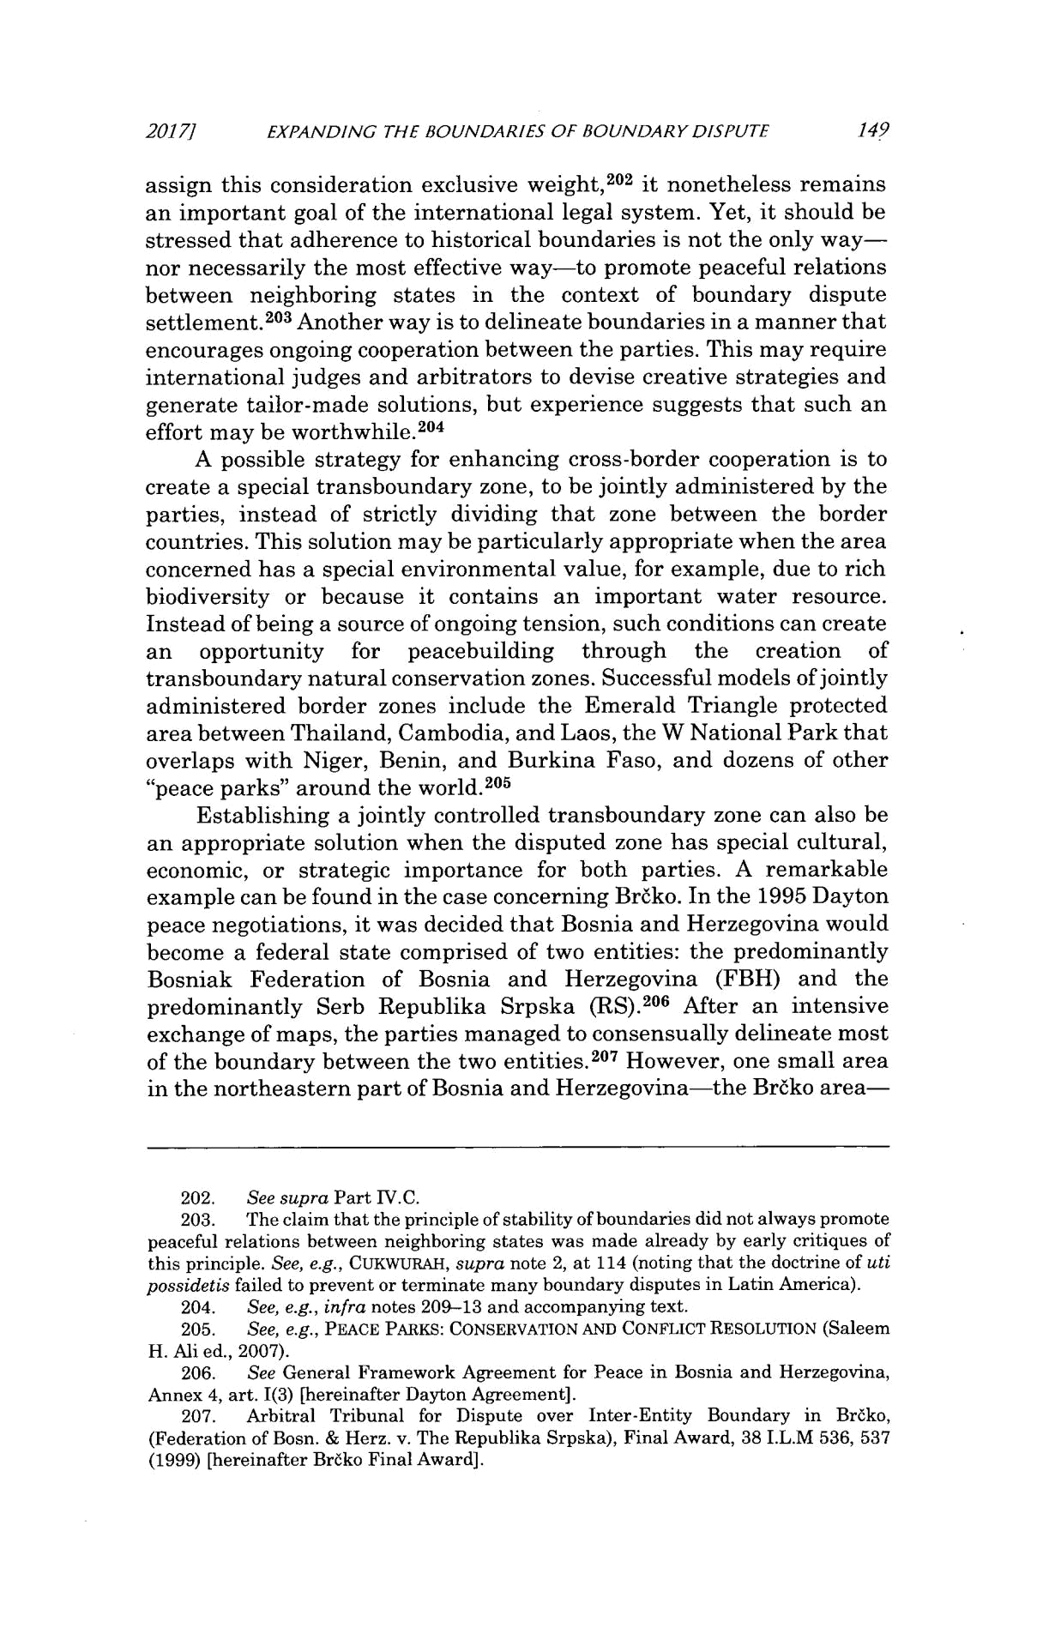
2017} EXPANDING THE BOUNDARIES OF BOUNDARY DISPUTE 149

assign this consideration exclusive weight,² ⁰² it nonetheless remains an important goal of the international legal system. Yet, it should be stressed that adherence to historical boundaries is not the only way-nor necessarily the most effective way-to promote peaceful relations between neighboring states in the context of boundary dispute settlement.²⁰ ³ Another way is to delineate boundaries in a manner that encourages ongoing cooperation between the parties. This may require international judges and arbitrators to devise creative strategies and generate tailor-made solutions, but experience suggests that such an effort may be worthwhile. ²⁰⁴

A possible strategy for enhancing cross-border cooperation is to create a special transboundary zone, to be jointly administered by the parties, instead of strictly dividing that zone between the border countries. This solution may be particularly appropriate when the area concerned has a special environmental value, for example, due to rich biodiversity or because it contains an important water resource. Instead of being a source of ongoing tension, such conditions can create an opportunity for peacebuilding through the creation of transboundary natural conservation zones. Successful models of jointly administered border zones include the Emerald Triangle protected area between Thailand, Cambodia, and Laos, the W National Park that overlaps with Niger, Benin, and Burkina Faso, and dozens of other "peace parks" around the world.² ⁰⁵

Establishing a jointly controlled transboundary zone can also be an appropriate solution when the disputed zone has special cultural, economic, or strategic importance for both parties. A remarkable example can be found in the case concerning Brako. In the 1995 Dayton peace negotiations, it was decided that Bosnia and Herzegovina would become a federal state comprised of two entities: the predominantly Bosniak Federation of Bosnia and Herzegovina (FBH) and the predominantly Serb Republika Srpska (RS). ²⁰⁶ After an intensive exchange of maps, the parties managed to consensually delineate most of the boundary between the two entities. 207 However, one small area in the northeastern part of Bosnia and Herzegovina-the Briko area-

  - See supra Part IV.C.
  - The claim that the principle of stability of boundaries did not always promote peaceful relations between neighboring states was made already by early critiques of this principle. See, e.g., CUKWURAH, supra note 2, at 114 (noting that the doctrine of uti possidetis failed to prevent or terminate many boundary disputes in Latin America).

  - See, e.g., infra notes 209-13 and accompanying text.

  - See, e.g., PEACE PARKS: CONSERVATION AND CONFLICT RESOLUTION (Saleem

H. Ali ed., 2007).

  - See General Framework Agreement for Peace in Bosnia and Herzegovina, Annex 4, art. 1(3) [hereinafter Dayton Agreement].

    - Arbitral Tribunal for Dispute over Inter-Entity Boundary in Brako, (Federation of Bosn. & Herz. v. The Republika Srpska), Final Award, 38 I.L.M 536, 537 (1999) [hereinafter Brako Final Award].
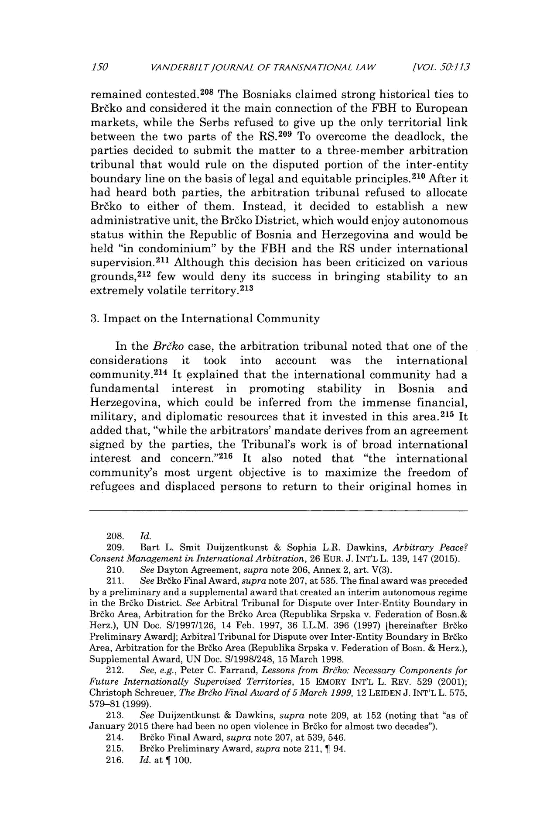
150 VANDERBIL TJOURNAL OF TRANSNA TIONAL LAW [VOL. 50:.113

remained contested. ²⁰⁸ The Bosniaks claimed strong historical ties to Br6ko and considered it the main connection of the FBH to European markets, while the Serbs refused to give up the only territorial link between the two parts of the RS.²⁰ ⁹ To overcome the deadlock, the parties decided to submit the matter to a three-member arbitration tribunal that would rule on the disputed portion of the inter-entity boundary line on the basis of legal and equitable principles. ² ¹⁰ After it had heard both parties, the arbitration tribunal refused to allocate Brdko to either of them. Instead, it decided to establish a new administrative unit, the Br6ko District, which would enjoy autonomous status within the Republic of Bosnia and Herzegovina and would be held "in condominium" by the FBH and the RS under international supervision.² ¹¹ Although this decision has been criticized on various grounds, ²¹² few would deny its success in bringing stability to an extremely volatile territory.² ¹³

- Impact on the International Community

In the Brtko case, the arbitration tribunal noted that one of the considerations it took into account was the international community.² ¹⁴ It 'explained that the international community had a fundamental interest in promoting stability in Bosnia and

Herzegovina, which could be inferred from the immense financial, military, and diplomatic resources that it invested in this area. ²¹⁵ It

added that, "while the arbitrators' mandate derives from an agreement signed by the parties, the Tribunal's work is of broad international interest and concern."² ¹⁶ It also noted that "the international community's most urgent objective is to maximize the freedom of refugees and displaced persons to return to their original homes in

  - Id.

  - Bart L. Smit Duijzentkunst & Sophia L.R. Dawkins, Arbitrary Peace? Consent Management in InternationalArbitration, 26 EUR. J. INT'L L. 139, 147 (2015).
  - See Dayton Agreement, supra note 206, Annex 2, art. V(3).

  - See Brako Final Award, supra note 207, at 535. The final award was preceded by a preliminary and a supplemental award that created an interim autonomous regime in the Brako District. See Arbitral Tribunal for Dispute over Inter-Entity Boundary in Brdko Area, Arbitration for the Brako Area (Republika Srpska v. Federation of Bosn.& Herz.), UN Doc. S/1997/126, 14 Feb. 1997, 36 I.L.M. 396 (1997) [hereinafter Broko Preliminary Award]; Arbitral Tribunal for Dispute over Inter-Entity Boundary in Brtko Area, Arbitration for the Brako Area (Republika Srpska v. Federation of Bosn. & Herz.), Supplemental Award, UN Doc. S/1998/248, 15 March 1998.

- See, e.g., Peter C. Farrand, Lessons from Brjko: Necessary Components for Future Internationally Supervised Territories, 15 EMORY INT'L L. REV. 529 (2001); Christoph Schreuer, The Brdko Final Award of 5 March 1999, 12 LEIDEN J. INT'L L. 575, 579-81 (1999).

- See Duijzentkunst & Dawkins, supra note 209, at 152 (noting that "as of January 2015 there had been no open violence in Brako for almost two decades").

- Brako Final Award, supra note 207, at 539, 546.
- Brako Preliminary Award, supra note 211, 1 94.
- Id. at ¶ 100.
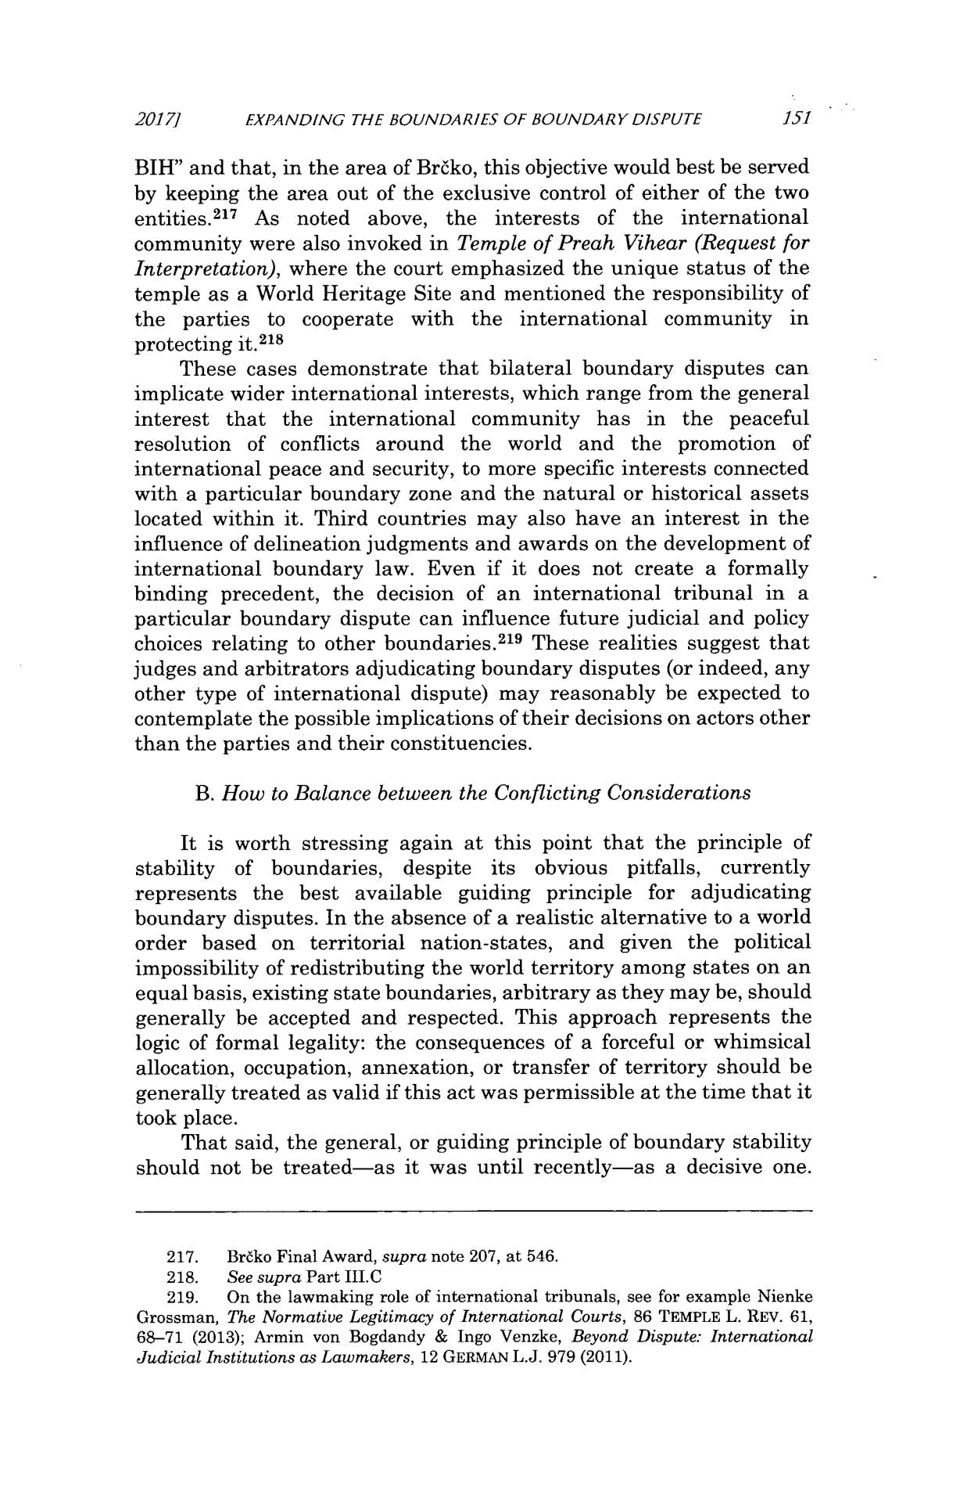
₂₀₁₇ EXPANDING THE BOUNDARIES OF BOUNDARY DISPUTE 15I

BIH" and that, in the area of Brako, this objective would best be served by keeping the area out of the exclusive control of either of the two entities.² ¹⁷ As noted above, the interests of the international community were also invoked in Temple of Preah Vihear (Request for Interpretation), where the court emphasized the unique status of the temple as a World Heritage Site and mentioned the responsibility of the parties to cooperate with the international community in protecting it. ² ¹⁸

These cases demonstrate that bilateral boundary disputes can implicate wider international interests, which range from the general interest that the international community has in the peaceful resolution of conflicts around the world and the promotion of international peace and security, to more specific interests connected with a particular boundary zone and the natural or historical assets located within it. Third countries may also have an interest in the influence of delineation judgments and awards on the development of international boundary law. Even if it does not create a formally binding precedent, the decision of an international tribunal in a particular boundary dispute can influence future judicial and policy choices relating to other boundaries. ²¹⁹ These realities suggest that judges and arbitrators adjudicating boundary disputes (or indeed, any other type of international dispute) may reasonably be expected to contemplate the possible implications of their decisions on actors other than the parties and their constituencies.

B. How to Balance between the Conflicting Considerations

It is worth stressing again at this point that the principle of stability of boundaries, despite its obvious pitfalls, currently represents the best available guiding principle for adjudicating boundary disputes. In the absence of a realistic alternative to a world order based on territorial nation-states, and given the political impossibility of redistributing the world territory among states on an equal basis, existing state boundaries, arbitrary as they may be, should generally be accepted and respected. This approach represents the logic of formal legality: the consequences of a forceful or whimsical allocation, occupation, annexation, or transfer of territory should be generally treated as valid if this act was permissible at the time that it took place.

That said, the general, or guiding principle of boundary stability should not be treated-as it was until recently-as a decisive one.

- Br6ko Final Award, supra note 207, at 546.

- See supra Part III.C

- On the lawmaking role of international tribunals, see for example Nienke Grossman, The Normative Legitimacy of International Courts, 86 TEMPLE L. REV. 61, 68-71 (2013); Armin von Bogdandy & Ingo Venzke, Beyond Dispute: International JudicialInstitutions as Lawmakers, 12 GERMAN L.J. 979 (2011).
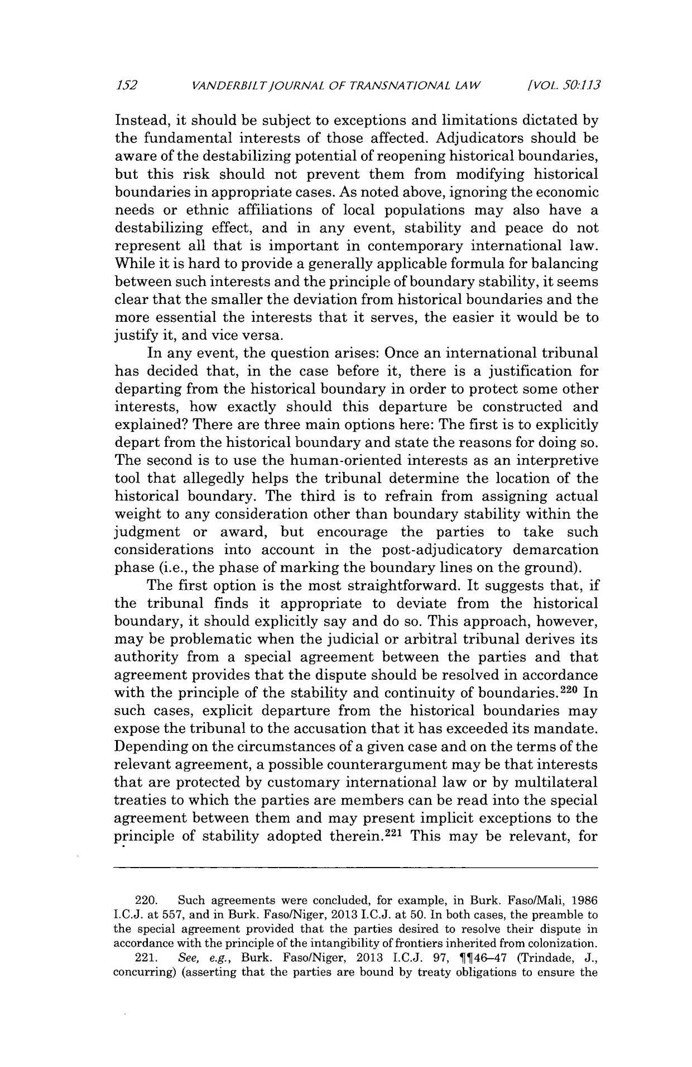
152 VANDERBILTJOURNAL OF TRANSNATIONAL LAW [VOL. SO:1.13

Instead, it should be subject to exceptions and limitations dictated by the fundamental interests of those affected. Adjudicators should be aware of the destabilizing potential of reopening historical boundaries, but this risk should not prevent them from modifying historical boundaries in appropriate cases. As noted above, ignoring the economic needs or ethnic affiliations of local populations may also have a destabilizing effect, and in any event, stability and peace do not represent all that is important in contemporary international law. While it is hard to provide a generally applicable formula for balancing between such interests and the principle of boundary stability, it seems clear that the smaller the deviation from historical boundaries and the more essential the interests that it serves, the easier it would be to justify it, and vice versa.

In any event, the question arises: Once an international tribunal has decided that, in the case before it, there is a justification for departing from the historical boundary in order to protect some other interests, how exactly should this departure be constructed and explained? There are three main options here: The first is to explicitly depart from the historical boundary and state the reasons for doing so. The second is to use the human-oriented interests as an interpretive tool that allegedly helps the tribunal determine the location of the historical boundary. The third is to refrain from assigning actual weight to any consideration other than boundary stability within the judgment or award, but encourage the parties to take such considerations into account in the post-adjudicatory demarcation phase (i.e., the phase of marking the boundary lines on the ground).

The first option is the most straightforward. It suggests that, if the tribunal finds it appropriate to deviate from the historical boundary, it should explicitly say and do so. This approach, however, may be problematic when the judicial or arbitral tribunal derives its authority from a special agreement between the parties and that agreement provides that the dispute should be resolved in accordance with the principle of the stability and continuity of boundaries. ²²⁰ In such cases, explicit departure from the historical boundaries may expose the tribunal to the accusation that it has exceeded its mandate. Depending on the circumstances of a given case and on the terms of the relevant agreement, a possible counterargument may be that interests that are protected by customary international law or by multilateral treaties to which the parties are members can be read into the special agreement between them and may present implicit exceptions to the principle of stability adopted therein. ²²1 This may be relevant, for

- Such agreements were concluded, for example, in Burk. FasolMali, 1986 I.C.J. at 557, and in Burk. Faso/Niger, 2013 I.C.J. at 50. In both cases, the preamble to the special agreement provided that the parties desired to resolve their dispute in accordance with the principle of the intangibility of frontiers inherited from colonization.

- See, e.g., Burk. Faso/Niger, 2013 I.C.J. 97, I¶46-47 (Trindade, J., concurring) (asserting that the parties are bound by treaty obligations to ensure the
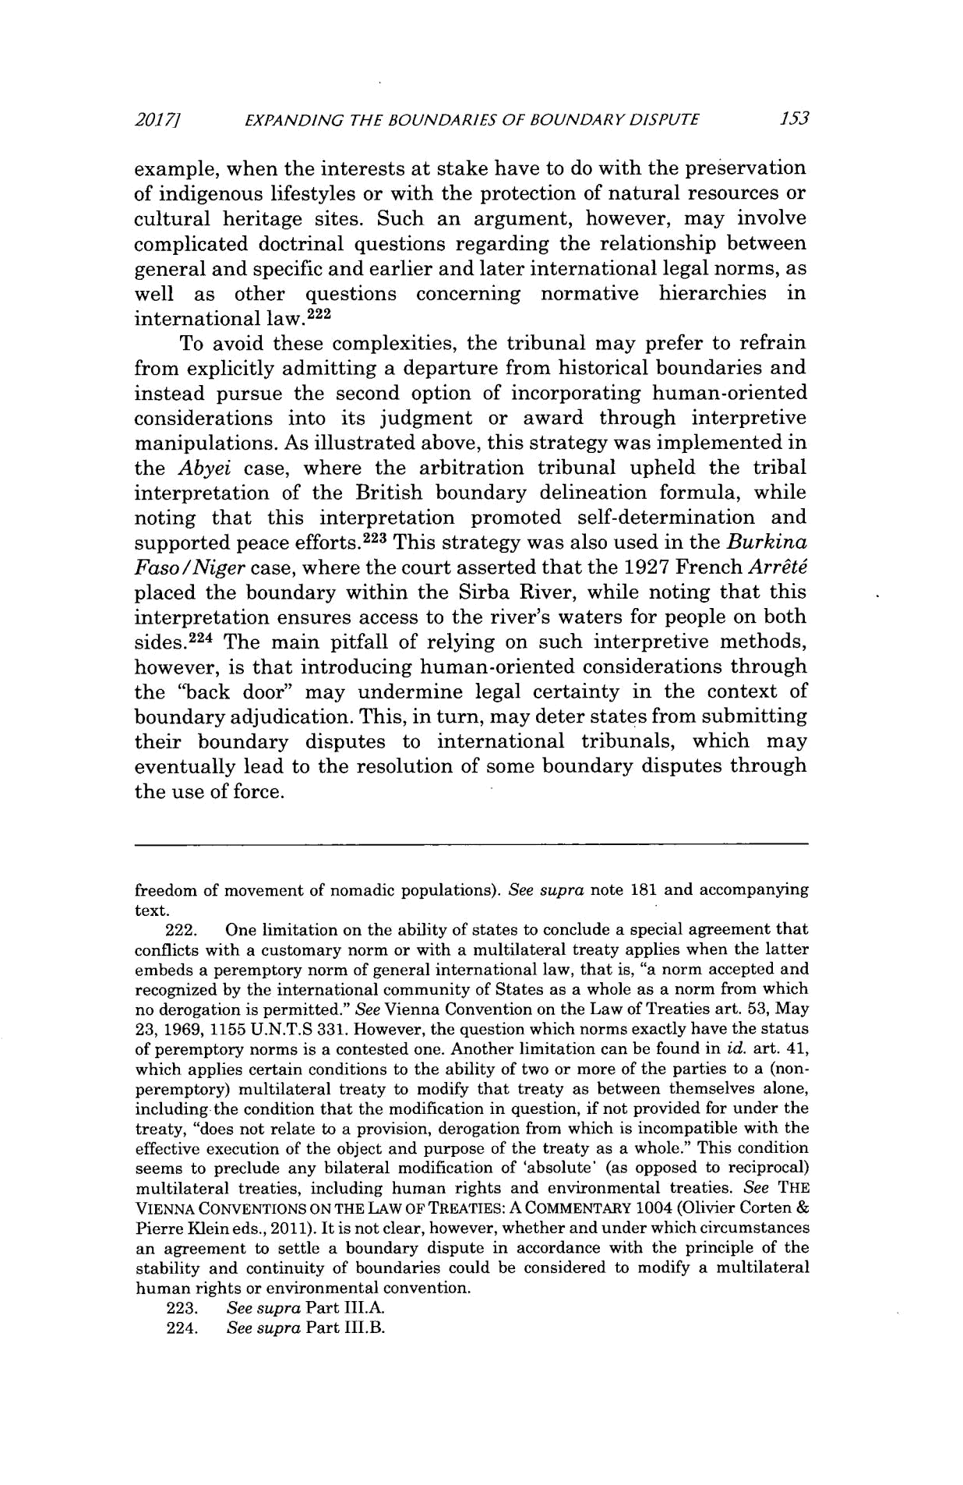
20171 EXPANDING THE BOUNDARIES OF BOUNDARY DISPUTE 153

example, when the interests at stake have to do with the preservation of indigenous lifestyles or with the protection of natural resources or cultural heritage sites. Such an argument, however, may involve complicated doctrinal questions regarding the relationship between general and specific and earlier and later international legal norms, as well as other questions concerning normative hierarchies in
international law. ² ² ²

To avoid these complexities, the tribunal may prefer to refrain from explicitly admitting a departure from historical boundaries and instead pursue the second option of incorporating human-oriented considerations into its judgment or award through interpretive manipulations. As illustrated above, this strategy was implemented in the Abyei case, where the arbitration tribunal upheld the tribal interpretation of the British boundary delineation formula, while noting that this interpretation promoted self-determination and supported peace efforts. ²²³ This strategy was also used in the Burkina Faso/Nigercase, where the court asserted that the 1927 French Arrt6 placed the boundary within the Sirba River, while noting that this interpretation ensures access to the river's waters for people on both sides. ²²⁴ The main pitfall of relying on such interpretive methods, however, is that introducing human-oriented considerations through the "back door" may undermine legal certainty in the context of boundary adjudication. This, in turn, may deter states from submitting their boundary disputes to international tribunals, which may eventually lead to the resolution of some boundary disputes through the use of force.

freedom of movement of nomadic populations). See supra note 181 and accompanying text.

- One limitation on the ability of states to conclude a special agreement that conflicts with a customary norm or with a multilateral treaty applies when the latter embeds a peremptory norm of general international law, that is, "a norm accepted and recognized by the international community of States as a whole as a norm from which no derogation is permitted." See Vienna Convention on the Law of Treaties art. 53, May 23, 1969, 1155 U.N.T.S 331. However, the question which norms exactly have the status of peremptory norms is a contested one. Another limitation can be found in id. art. 41, which applies certain conditions to the ability of two or more of the parties to a (non-peremptory) multilateral treaty to modify that treaty as between themselves alone, including the condition that the modification in question, if not provided for under the treaty, "does not relate to a provision, derogation from which is incompatible with the effective execution of the object and purpose of the treaty as a whole." This condition seems to preclude any bilateral modification of 'absolute' (as opposed to reciprocal) multilateral treaties, including human rights and environmental treaties. See THE

VIENNA CONVENTIONS ON THE LAW OF TREATIES: A COMMENTARY 1004 (Olivier Corten

Pierre Klein eds., 2011). It is not clear, however, whether and under which circumstances an agreement to settle a boundary dispute in accordance with the principle of the stability and continuity of boundaries could be considered to modify a multilateral human rights or environmental convention.
- See supra Part III.A.

- See supra Part IJI.B.
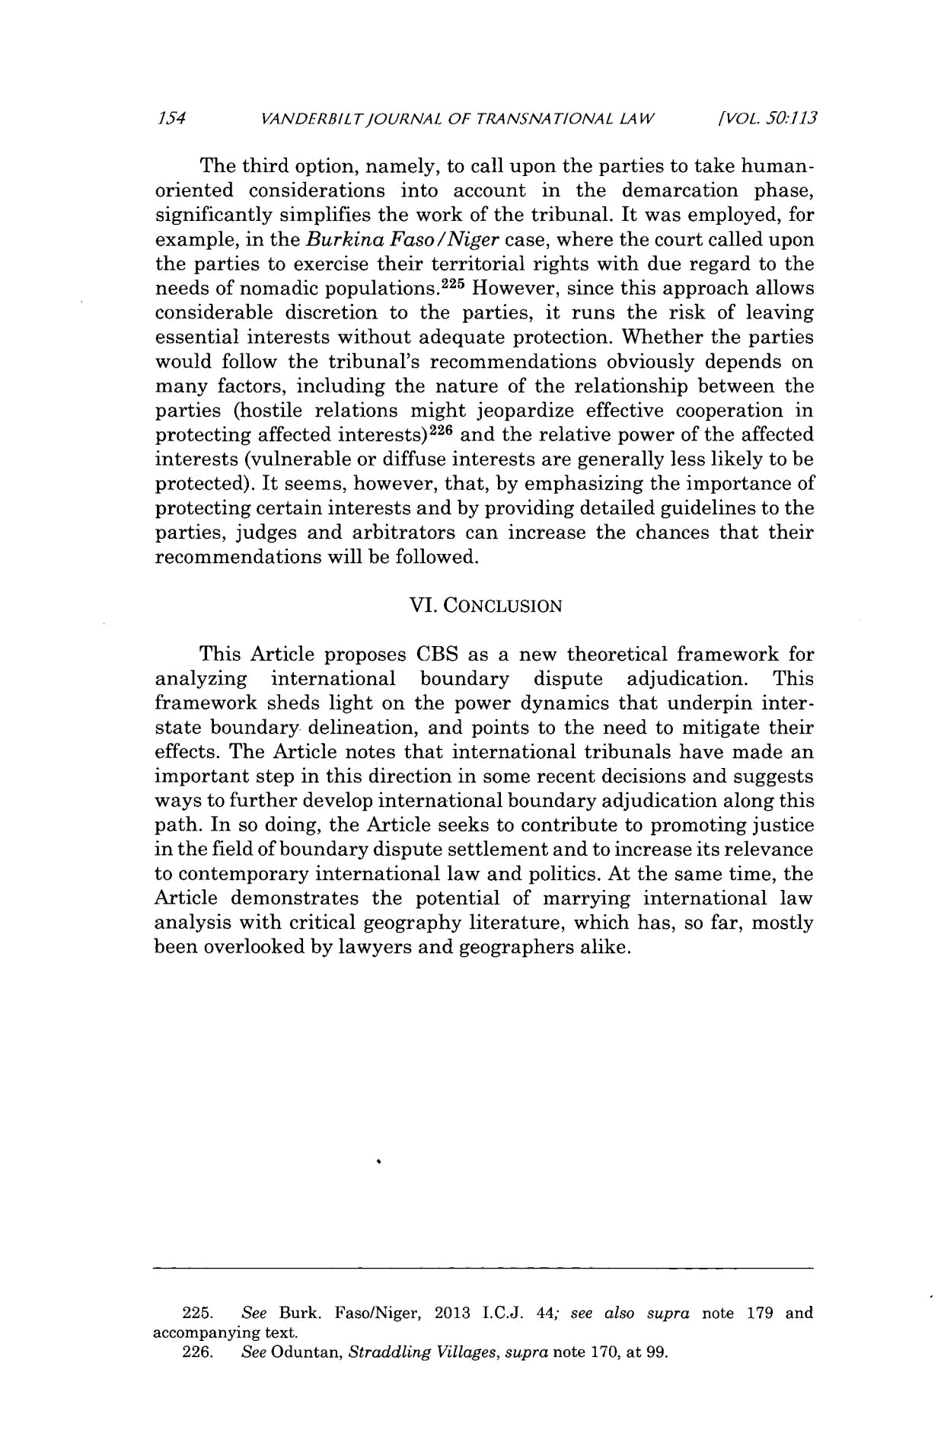
154 VANDERBILTJOURNAL OF TRANSNATIONAL LAW [VOL. 50:113

The third option, namely, to call upon the parties to take human-oriented considerations into account in the demarcation phase, significantly simplifies the work of the tribunal. It was employed, for example, in the Burkina Faso/Nigercase, where the court called upon the parties to exercise their territorial rights with due regard to the needs of nomadic populations. ²²⁵ However, since this approach allows considerable discretion to the parties, it runs the risk of leaving essential interests without adequate protection. Whether the parties would follow the tribunal's recommendations obviously depends on many factors, including the nature of the relationship between the parties (hostile relations might jeopardize effective cooperation in

protecting affected interests) ²²⁶ and the relative power of the affected
interests (vulnerable or diffuse interests are generally less likely to be protected). It seems, however, that, by emphasizing the importance of protecting certain interests and by providing detailed guidelines to the parties, judges and arbitrators can increase the chances that their recommendations will be followed.

VI. CONCLUSION

This Article proposes CBS as a new theoretical framework for analyzing international boundary dispute adjudication. This framework sheds light on the power dynamics that underpin inter-state boundary delineation, and points to the need to mitigate their effects. The Article notes that international tribunals have made an important step in this direction in some recent decisions and suggests ways to further develop international boundary adjudication along this path. In so doing, the Article seeks to contribute to promoting justice in the field of boundary dispute settlement and to increase its relevance to contemporary international law and politics. At the same time, the Article demonstrates the potential of marrying international law analysis with critical geography literature, which has, so far, mostly been overlooked by lawyers and geographers alike.

- See Burk. Faso/Niger, 2013 I.C.J. 44; see also supra note 179 and accompanying text.

- See Oduntan, Straddling Villages, supra note 170, at 99.

