 |  | Structured Settlements
Electronic Direct Deposit Application
Information About You
1 Payee Name:________________________________________ | Payee Social Security Number*:________________
 | *While the information is optional, we encourage you to provide it so
 | we can properly identify the contract.
Payee Address:____________________________________________________________________________________
Certificate Number:_________________________________________________________________________________
Group Annuity Contract Number:________________________ | Payee Phone Number:________________________
- Banking Information

The financial institution (bank, savings and loan or credit union) you elect to receive electronic deposits must be a member of the Automated Clearing House (“ACH”) Network. Please contact your financial institution if you are unsure that it is a part of the ACH Network.

Checking account. Please attach a copy of your voided check. Deposit slips and starter checks are not accepted. The voided check must be in the name of the Payee. If you do not have a voided check, please include a letter from your financial institution as described below.
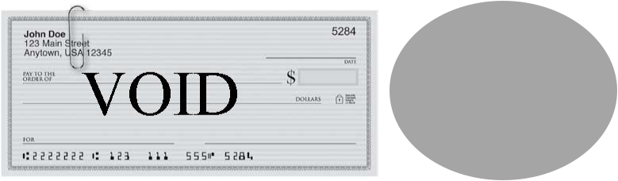

IMPORTANT: We cannot send funds to any bank account with a POA, Guardian, Conservator, or other fiduciary included in the bank registration unless there is an indication of their fiduciary pre-printed on the check from the bank. Example: Jane Smith, POA

Savings account.

………………………………………………………………………………………………………………………….......................

IMPORTANT:

Please include a letter from your financial institution(on their letterhead) that indicates the following information: the routing/ABA number, the account number, the account type (checking or savings), and the owner(s) of the bank account. The letter must be signed by an authorized party at the financial institution along with the Payee(s) to certify that the information provided is correct.

Please also complete the information below:

Bank: ___________________________________________ | Routing/ABA Number: _______________________
Account Number: _________________________________ | Account Name: _____________________________

If the savings account has check writing privileges, please attach a copy of your voided check. Deposit slips and starter checks are not accepted.

IMPORTANT: This form will not be processed unless you return both pages AND Page 2 has been properly signed and dated.

SSEFTFM (4/16) Page 1 of 2

3 | Authorization
3 | I hereby authorize John Hancock Life Insurance Company (U.S.A.)(“John Hancock”) to deposit annuity payments directly
 | to my bank, savings and loan, or credit union (“financial institution”) account, as indicated above. I authorize the financial
 | institution identified above to accept such credit entries from John Hancock, and to credit my account at that financial
 | institution in accordance with those credit entries. If an amount should be credited to my account in error (including any
 | overpayment to my account), or after my death or ineligibility, I authorize and direct the financial institution designated on
 | this form to debit my account and refund such amount to John Hancock. I agree to direct my joint account owners,
 | executors, administrators, or assignees to refund to John Hancock any payments that are made following my death so that
 | they may be redistributed to my beneficiary(ies) or contingent annuitant(s), if applicable.
 | I agree to hold John Hancock harmless for any failure by my financial institution to credit my account or for any delay by my
 | financial institution in crediting funds to my account. I agree that this arrangement is made for my convenience, and that
 | any payments directly received by me, rather than credited to my bank account, as a result of mistake or otherwise, shall
 | not subject John Hancock to any liability in excess of that owed to me under the applicable annuity contract. I understand
 | that John Hancock is relying on the information that I have provided on this form, and further understand that John
 | Hancock will not be liable for any losses or charges due to incorrect, outdated or incomplete information that has been
 | provided on this form.
 | If the financial institution account identified above is jointly owned, this authorization will not be effective without the
 | signature of the joint account owner below.
 | This authorization will remain in effect until John Hancock receives a written notice from me stating otherwise and until
 | John Hancock has had a reasonable chance to act upon such notice.
 | Payee Signature:_____________________________________________________ Date:____/_____/_______
 | I agree to notify John Hancock upon the death of the Participant and I agree to refund John Hancock any payments that
 | are made to the financial institution account identified above following the Participant’s death or ineligibility. I understand
 | that I may be personally liable, both individually and as a joint owner of the account identified above, for the amount of all
 | benefit or survivor benefit payments with due dates after the death of the Participant. If I am entitled to any benefit from
 | the applicable annuity contract as a beneficiary or contingent annuitant of the Participant, the amount of my liabilities may
 | be deducted from the amount payable to me.
 | Joint Bank Account Owner Signature:___________________________________ Date:____/_____/_______
 | Electronic transfer will begin when verification has been established with your bank. Allow at least 10 days after
 | we receive this form for banking instructions to become active.

4 Contact Information

Mail this form to: | Overnight address: | Fax this form to:
Fixed Products Administration | Fixed Products Administration | 1-617-572-0355
PO Box 55446 | 30 Dan Road, STE 55446 | Questions:
Boston, MA 02205-5446 | Canton, MA 02021-2809 | 866-275-5477

Issuer: John Hancock Life Insurance Company (U.S.A.), Lansing, MI (not licensed in New York)

Issuer in NY: John Hancock Life Insurance Company of New York, Valhalla, NY

SSEFTFM (4/16) Page 2 of 2

