
Direct Deposit Authorization Form


TD Bank makes setting up direct deposit easy with this convenient, pre-filled form. There are two types of direct deposit enrollment available: Federal Government Benefit Compensation and Payroll Compensation. Steps to enroll for each are outlined below.
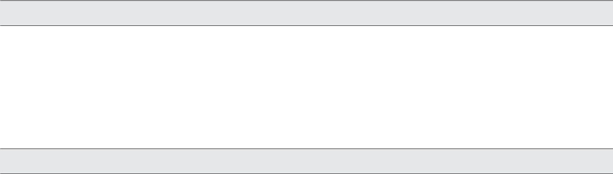

1. Federal Government Benefit Compensation:

To sign up for direct deposit of your federal benefit payments such as Social Security, SSI or VA Compensation and Pension Payment

- Go to the U.S. Department of the Treasury website: www.godirect.org, or

- Enroll by phone by calling the U. S. Department of the Treasury toll free at: 1-800-333-1795

You’ll need your:
• Social security number or claim number | • TD Bank’s routing transit number:
• 12-digit federal benefit check number | • TD Bank account number:
• Amount of most recent federal benefit check | • Type of account (checking or savings):

2. Payroll Compensation

Complete and sign this direct deposit form and give it to your employer’s payroll representative – it’s that easy!

Employee name and address:

Employee phone number:

Employee ID:

(if applicable)

Employee social security number:

Please begin directly depositing my payroll and/or dividend or annuity check into my account at TD Bank.

Direct deposit the following:

Total net check amount

The set amount of $_____________________________ of my net check each period.

Bank name: | TD Bank, N.A.
Address: | 32 Chestnut St.
 | P.O. Box 1377
 | Lewiston, ME 04243-1377
TD Bank routing transit number:
TD Bank account number:
Type of account: | Checking Savings

Employee signature Date

11440C-CHK (03/16)

