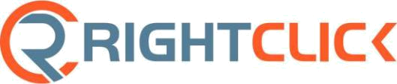

Direct Deposit Agreement Form

Authorization Agreement

I hereby authorize RightClick to initiate automatic deposits to my account at the financial institution named below. I also authorize RightClick to make withdrawals from this account in the event that a credit entry is made in error.

Further, I agree not to hold RightClick responsible for any delay or loss of funds due to incorrect or incomplete information supplied by me or by my financial institution or due to an error on the part of my financial institution in depositing funds to my account.

This agreement will remain in effect until RightClick receives a written notice of cancellation from me or my financial institution, or until I submit a new direct deposit form to the Payroll Department.

Account Information

Name of Financial Institution:

Routing Number:

Account Number: ☐ Checking | ☐ Savings

Signature

Authorized Signature (Primary): |  |  |  | Date:
Authorized Signature (Joint): |  |  |  | Date:

Please attach a voided check and return this form to the RightClick Payroll Department.

taylor.tomack@rightclickrecruiting.com

Fax: 203-588-9508

