The Internet & Surveillance - Research Paper Series

Edited by the Unified Theory of Information Research Group,

Vienna, Austria (http://www.uti.at)

ISSN 2219-603X

Title: Research Design & Data Analysis, Presentation, and Interpretation:
Part One

Author: Thomas Allmer

Research Paper Number #12

Date of Publication: August 21, 2012

Author Institution: Unified Theory of Information Research Group

Author Address: Steinbrechergasse 15, 1220 Vienna, Austria

Author e-Mail: thomas.allmer@uti.at

Author URL: http://www.allmer.uti.at

Acknowledgement: The research presented in this paper was conducted in the project “Social Network-ing Sites in the Surveillance Society” (http://www.sns3.uti.at), funded by the Austrian Science Fund (FWF): project number P 22445-G17. Project co-ordination: Prof. Christian Fuchs




Research Design & Data Analysis, Presentation, and Inter-pretation: Part One

Thomas Allmer

Keywords: Research Design, Usage of Social Networking Sites, Greatest Advantages and Concerns of Social Networking Sites, Communication, Surveillance, Extrinsic and Intrinsic Values of Privacy, Priva-‐ cy Value Index, Control and Access Theories of Privacy,Privacy Theory Index

Short biography of the author: Thomas studied Media and Communication at the University of Salz-‐ burg and the Victoria University of Melbourne. Currently, he is a PhD candidate at the University of Salzburg (Austria) and research associate in the project “Social Networking Sites in the Surveillance Society”, funded by the Austrian Science Fund (FWF). He is a member of the Unified Theory of Infor-‐ mation Research Group (Austria) and participate in the working group “Living in the Surveillance Age” of the EU COST Action “Living in Surveillance Societies“ (LiSS). In addition, he is a member of the edito-‐ rial team and reviewer of tripleC: Cognition, Communication, Co-‐operation. Recent publication: To-‐ wards a Critical Theory of Surveillance in Informational Capitalism(Peter Lang, 2012).
The Internet & Surveillance - Research Paper Series: 2012 | 1

A research design is the basic plan for an empirical study, connects research ques-‐ tions to data, and should provide answers to four questions, namely (Punch 2005, 63):

- “Following what strategy?

- Within what framework?

- From whom?

- How?”

Based on these assumptions, the following figure can be outlined:
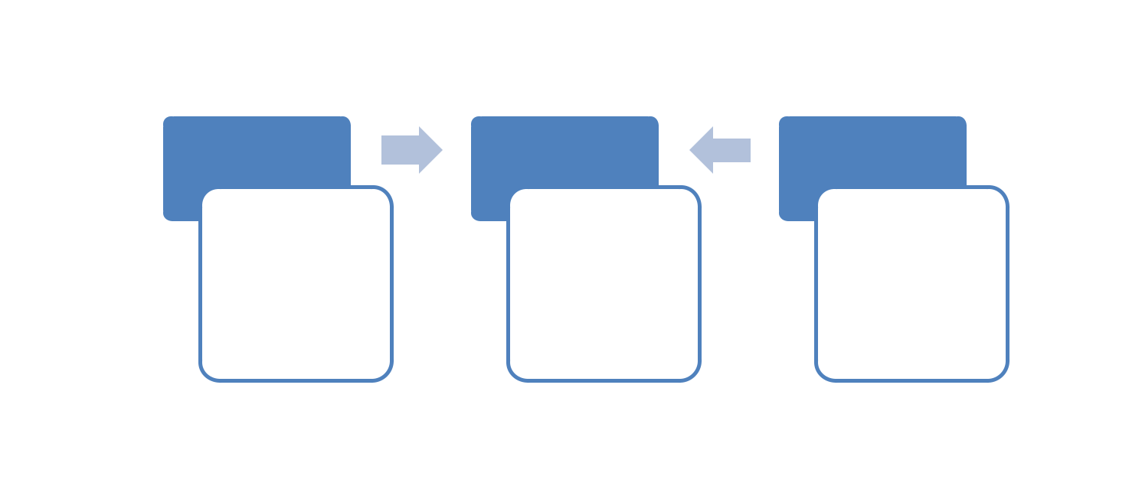

Research | Research Design |  |  | Data
Questions
 | •Following |  |  | •Data | Collection
 | what strategy? |  |  | •Data | Analysis,
 | •Within |  | what | Presentation,
 | framework? |  |  | and
 | •From | whom? |  | Interpretation
 | •How?

Figure 1: A research design connects research questions to data (Punch 2005, 63)

In order to answer the questions of the research design, we will introduce the con-‐ text of the empirical study, list the research questions and identify the hypotheses (Following what strategy?), try to conceptualize and operationalize the empirical study (Within what framework?), we will describe the research methods (How?), the population and the sampling (From whom?) (Babbie 2010, 112-‐119), and we will fi-‐ nally provide the data analysis, presentation, and interpretation. The following main points of this research report can be listed:

- Context of the empirical study

- Research questions

- Hypotheses

- Survey questions (conceptualization and operationalization)

- Research methods

- Population and sampling
2 Thomas Allmer

7-‐10. Data analysis, presentation, and interpretation

The following sections are structured according to this distinction.

1. Context of the Empirical Study

Surveillance has notably increased in the last decades of modern society. Surveil-‐ lance studies scholars like Lyon (1994) or Norris and Armstrong (1999) stress that we live in a surveillance society. Although there are a lot of other features in contem-‐ porary society such as information, neoliberalism, globalization, etc., surveillance in general and Internet surveillance in particular are crucial phenomena. In addition, there is much public talk about privacy. The following collected news clips indicate this development:

“Not Me Dot Com: Want an Internet that doesn't know your pant size? A guide to re-‐ gain your privacy” (The Wall Street Journal, June 18, 2011)

“Facebook tool shows location. Millions of Facebook users have been warned to check their privacy settings after the social network launched a tool to let friends reveal your location.” (The Sun, September 17, 2010)

“Twitter gives users more privacy controls: Twitter Inc, the micro-‐blogging service, added tools that give users more control over how data is shared with third-‐party ap-‐ plications.“ (The Times of India, May 19, 2011)

These examples point out how important the topic of privacy has become for the media and for our daily lives. The media often alert that privacy seems to be under attack and vanishing especially caused by the emergence of new information and communication technologies such as the Internet or the mobile phone. Web 2.0 activi-‐ ties such as creating profiles and sharing ideas, announcing personal messages, up-‐ loading or watching videos, and writing personal entries, enable the collection, analy-‐ sis, and sale of personal data by commercial web platforms. The fact that one can find web 2.0 platforms such as Facebook (rank 2), YouTube (rank 3), Twitter (rank 10), and LinkedIn (rank 16) among the most frequently accessed websites worldwide, indicates the enormous popularity of these sites (Top 500 web sites, alexa.com, ac-‐ cessed on December 19, 2011). In Austria, websites that allow social networking, such as Facebook (rank 2), XING (rank 23), or LinkedIn (rank 38) are among the most popular web sites (Top 100 sites in Austria, alexa.com, accessed on March 23, 2011). With single exceptions (e.g. Albrechtslund 2008; Fuchs 2009; Fuchs et al. 2012), there are no studies that combine surveillance and privacy in the context of web 2.0. The overall aim of this research project is to study electronic surveillance on social net-‐ working sites that are used by Austrian students.
The Internet & Surveillance - Research Paper Series: 2012 | 3

Social networking sites users are primarily young and educated people. So for ex-‐ ample, 44% of the users of Myspace are aged 18-‐34, 42% of the users of Facebook are aged 18-‐34, 53% of Facebook users have attended college or graduate school (all da-‐ ta: quantcast.com, accessed on December 19, 2011). Therefore we can assume that young people are early adopters of new technologies. It is therefore important to study their usage behaviour because they might anticipate future trends. Due to their education standards, students tend to be very sensitive towards new issues that con-‐ front society. Given that students are early adopters and sensitive citizens, we find it important to study their usage of SNS in the context of the issue of surveillance.

The project focuses on the combination of three research topics, namely surveil-‐ lance, privacy, and web 2.0/social networking sites. Therefore, it must be situated in the context of the state of art in these three fields:

Since Foucault has published his book Surveiller et punir in French in 1975 and in English in 1977, the amount of literature on surveillance has increased enormously and represents a diffuse and complex field of research: Giddens (1995, 169) defines surveillance as “symbolic material that can be stored by an agency or collectivity” and as “the supervision of the activities of subordinates”. For Gandy (1993, 15), surveil-‐ lance is a “complex technology that involves the collection, processing, and sharing of information about individuals and groups that is generated through their daily lives as citizens, employees, and consumers and is used to co-‐ ordinate and control their access to the goods and services that define life in the modern capitalist economy”. Further authors such as Rule (1973; 2007), Marx (1988; 2002), Lyon (1994; 2001), Baudrillard (2006; 2007), Deleuze (1988; 1992), Poster (1990), Webster and Robins (1993), and Fiske (1998; 1999) have developed important contributions to surveil-‐ lance studies. Nevertheless, there is no common ground about how surveillance should be defined. Some use a neutral and general notion of surveillance, whereas others consider surveillance to be negative and being connected to coercion, repres-‐ sion, discipline, power, and domination.

Although surveillance and privacy are overlapping areas to a certain extent, an own privacy study field has been developed: Some understand privacy as a specific social structure, a moral or legal right, which is used to enable someone’s ability to limit or restrict others from access to persons or information (restricted access definition of privacy). For instance, this approach is represented by Warren and Brandeis (1890), Gavison (1980), Allen (1988), Bok (1983), Parent (1983a; 1983b), Prosser (1960), Schoeman (1984; 1992), and Scanlon (1975). Others focus on the individual and un-‐ derstand privacy as control over information about oneself (limited control definition of privacy); for example, representatives are Westin (1967), Shils (1966), Fried (1968; 1990), Gerstein (1970; 1978), Froomkin (2000), Miller (1971), Rachels (1975), Murphy (1964), Posner (1978; 1981), Gerety (1977), and DeCew (1986). In-‐ tegrative approaches of studying privacy try to combine different notions into one concept; for instance, they are represented by Reiman (1976), Moor (1997), and Ta-‐ vani (2007; 2008). Nevertheless, many authors have advanced critique of the concept
4 Thomas Allmer

of privacy as being a modern concept of liberal democracy (Gouldner 1976; Lyon 1994; Gilliom 2001; Etzioni 1999; Ogura 2006; Fuchs 2010a).

Many authors argue that the Internet has been transformed from a system that is mainly oriented towards informational elements into a system that is more oriented on enabling communication and co-‐operation (Alby 2007; Beer and Burrows 2007; boyd and Ellison 2007; Burg 2003; 2004; Fuchs 2010b; Kolbitsch and Maurer 2006; O’Reilly 2005; Saveri, Rheingold and Vian 2005; Shirky 2008). The notions of “web 2.0”, “social software”, “social media”, and “social network(ing) sites” (SNS) have emerged in this context. Most approaches see the active involvement of users in the production of content as the main characteristic of web 2.0. Regardless whether someone agrees that these transformations of the Internet have taken place, it is clear that web 2.0 activities such as creating profiles and sharing ideas on Facebook, an-‐ nouncing personal messages on Twitter, uploading or watching videos on YouTube, and writing personal entries on Blogger, enable the vast collection, analysis, and sale of personal data by commercial web platforms.

2. Research Questions

The following general research question is addressed in this study:

Which major advantages and disadvantages of social networking platforms do Austrian students see?

The specific research questions are:

  - What is the role of surveillance for users in the context of social networking sites?

  - What are the disadvantages and advantages that are seen by users in relation by decreased privacy?

  - Concerning the disadvantages, do they see more individual disadvantages or disadvantages for society?

  - Is privacy considered as rather an intrinsic or rather as extrinsic value?

  - Are disadvantages in relation to privacy described as rather intrinsic or extrin-‐ sic?

  - Are privacy reduction and surveillance seen as legitimate if in return there is free access to platforms and to certain Internet services?

- Hypotheses

Based on these research questions, we have identified the following hypotheses that have been tested.

Hypothesis 5: Maintaining existing relationships over spatio-‐temporal dis-‐ tances and creating new social relationships is considered as the main ad-‐ vantage of SNS.
The Internet & Surveillance - Research Paper Series: 2012 | 5

SNS such as Myspace, Facebook, Friendster, and LinkedIn are Internet-‐based com-‐ munication platforms that allow people for instance creating profiles and sharing ide-‐ as, announcing personal messages, uploading or watching videos, and writing per-‐ sonal entries. Social networking sites primarily enable the maintenance of existing social relationships and the establishment of new relationships over spatio-‐temporal distances (Fuchs 2010a; Beer and Burrows 2007).

Several empirical studies found out that for young people maintaining existing con-‐ tacts and/or creating new social contacts is considered as the main advantage of SNS: For example, Acquisti and Gross (2006, 37) conducted an online survey (N=294) at a US academic institution in order to study privacy concerns as well as usage, knowledge, and attitudes towards Facebook (FB). According to Acquisti and Gross (2006, 47), “members claim that the FB is very useful to them for learning about and finding classmates (4.93 mean on a 7-‐point Likert scale) and for making it more con-‐ venient for people to get in touch with them (4.92), but deny any usefulness for other activities”. boyd (2007) collected ethnographic data of young Myspace users with the help of participant observation and content analysis of profiles and conducted quali-‐ tative interviews with US-‐based teenagers (N=unknown) in order to investigate how youth experience social life online. boyd (2007, 126) concludes: “When I ask teenag-‐

ers why they joined Myspace, the answer is simple: ‘Cuz that’s where my friends are.’” She furthermore states that “the popularity of Myspace is deeply rooted in how the site supports sociality amongst pre-‐existing friend groups. Teens join Myspace to maintain connections with their friends” (boyd 2007, 126). In the Greater London area, Livingstone (2008) conducted qualitative interviews with 16 teenagers, who use social networking sites. Similar to Acquisti and Gross and boyd, Livingstone (2008,

- found out that teenagers see the maintenance of old and the establishment of new friendships as a central opportunity of social networking sites. As part of a larger empirical survey study, Fuchs (2010b) asked students in Salzburg, Austria, about the main advantages of social networking sites (N=557). The majority of the respondents mentioned maintaining existing contacts and establishing new social contacts as main advantages of social networking sites (Fuchs 2010b, 29). These empirical studies share the common notion that young people list social relationship management as central benefit of SNS.

Based on these theoretical foundations and empirical findings, we assume that in our study maintaining existing relationships and creating new social relationships is considered as the main advantage of SNS.

Most studies that cover the issue of privacy and SNS are focusing on individual pri-‐ vacy concerns and individual privacy-‐related behaviour on SNS. The issue of surveil-‐ lance is more a macro-‐topic that requires that usage behaviour is framed by societal context variables such as state surveillance, economic surveillance, and modernity. The analysis of surveillance and SNS therefore is in need of a research approach that takes into account political contexts (Beer 2008). Surveillance has thus far, with sin-‐ gle exceptions, been rather ignored as a topic in SNS studies (Fuchs et al. 2012; An-‐ drejevic 2010.). The existing studies show that there is much more focus on the priva-‐
6 Thomas Allmer

cy topic than on surveillance. Advertising mechanisms and the connection between surveillance and privacy attitudes on the one hand and SNS advertising settings on the other hand have thus far hardly been studied. This is a task for the proposed pro-‐ ject that is still missing in the state of the art.

Hypothesis 6: The surveillance threat is considered as the major disad-‐ vantage of SNS.

There is much public talk about privacy and surveillance threats in the context of web 2.0. The following collected news clips indicate this development:

- “EU Seeks Tougher Online Code In Bid to Safeguard Private Data. The Europe-‐ an Union proposed new privacy rights for citizens sharing personal data with websites such as Facebook and Google.” (The Wall Street Journal, November 5, 2010)

- “Facebook tool shows location. Millions of Facebook users have been warned to check their privacy settings after the social network launched a tool to let friends reveal your location.” (The Sun, September 17, 2010)

- “Google accepts privacy leaks. Google Inc. admitted for the first time its Street View cars around the world accidentally collected more personal data than previously disclosed – including complete emails and passwords – potentially breathing new life into probes in various countries.” (The Times of India, Oc-‐ tober 23, 2010)

These examples point out how important the topics of privacy and surveillance has become for the media and for our daily lives. The media often alert that privacy seems to be under attack and vanishing especially caused by the emergence of new infor-‐ mation and communication technologies such as social networking sites. The princi-‐ ple of web 2.0 platforms is the massive provision and storage of personal(ly) (identi-‐ fiable) data that are systematically evaluated, marketed, and used for targeted adver-‐ tising (Fuchs 2012; Andrejevic 2010; Fernback and Papacharissi 2007; Sandoval 2012; Scholz 2008). Web 2.0 applications and social software sites threaten users’ privacy and surveil the users by collecting personal data about behaviour, prefer-‐ ences, and interests with the help of systematic and automated computer processes (Fuchs 2012, Andrejevic 2010).

Some empirical studies analysed that for young people privacy and surveillance threats are considered as the major disadvantages of SNS: Livingstone (2008, 406) discovered that teenagers are concerned about privacy threats on SNS (N=16): “When asked whether they would like to change anything about social networking, the oper-‐ ation of privacy settings and provision of private messaging on the sites are teenag-‐ ers’ top priorities, along with elimination of spam and chain messages – both intru-‐ sions of their privacy”. Dwyer, Hiltz, and Passerini (2007) and Dwyer et al. (2010) conducted quantitative online surveys with 115 Myspace and 107 Facebook users in the US and with 388 studiVZ (a German based social networking site) users in the
The Internet & Surveillance - Research Paper Series: 2012 | 7

German-‐speaking world in order to study the influence of trust and privacy concerns on the use of social networking sites for social interaction. Similar to Livingstone’s findings, one result of the surveys was that users of social networking sites are on average highly aware of privacy threats and familiar with privacy settings (Dwyer et al. 2010, 2975). Fuchs (2010b) also asked students about the main disadvantages of SNS (N=542). The majority said that “surveillance as a result of data abuse, data for-‐ warding, or a lack of data protection is a major threat of such platforms” (Fuchs 2010b, 29). These empirical studies share the common ground that for young people risks of surveillance and reduced privacy are considered as the general drawbacks of social networking sites.

In view of the facts that social software sites threaten users’ privacy, that there is much public talk about privacy and surveillance in the context of web 2.0, that stu-‐ dents tend to be very sensitive towards new issues that confront society (based on their education standards), and that several empirical studies analysed that for young people risks of surveillance are seen as a general problem, we hypothesize that in our empirical study the surveillance threat is considered as the major disadvantage of SNS.

Hypothesis 7: Privacy is rather considered as extrinsic than as intrinsic value and as based on the control theory.

Several privacy studies scholars distinguish between privacy as instrumen-‐ tal/functionalist (extrinsic) and intrinsic value (Schoeman 1984, 5-‐6; Tavani 2008, 132-‐133, 156-‐157; Moor 1997, 28).

If privacy is considered as extrinsic value, then this includes the following assump-‐ tions:

- Privacy is an instrumental/functionalist value for providing means in order to achieve some end(s).

- Privacy as derivative concept that is derived from more fundamental concepts such as security, liberty, and property.

- Privacy serves/leads to other values.

- The value of privacy as means.

For example, if a student provides publicly visible information about his political attitudes and interests on web 2.0 platforms such as Facebook and if it comes into conflict with the aims and scopes of the company he is applying for, then the student risks that the employer might be reluctant to hire him. In order to avoid such direct and immediate political discrimination, the student will probably use privacy settings and conceal such information. Privacy can in this case be considered as instrumental and extrinsic value, because it serves as a means in order to be employed and guaran-‐ tee financial security as end. Privacy offers protection against that harm.

If privacy is seen as intrinsic value, then this involves the following assumptions:
8 Thomas Allmer

- Privacy is a unitary value for its own sake.

- Privacy as basic concept standing on its own.

- Privacy is valuable in itself.

- Attaining privacy as important political goal.

For example, if an individual is interested in obtaining privacy online, because s/he understands privacy as a necessary condition for protecting private life, one’s right to one’s own person, inviolate personality, human dignity, intimacy, or for the mainte-‐ nance and establishment of different forms of social relationships, privacy can be considered as intrinsic notion, where the unitary value of privacy serves as end for its own sake (Schoeman 1984, 6). In this instance, a person understands online privacy as fundamental concept that stands on its own.

A list of the values privacy has been associated with can be provided: autonomy, counterculture, creativity, democracy, eccentricity, dignity, freedom, freedom of thought, friendship, human relationships, imagination, independence, individuality, intimacy, psychological well-‐being, reputation, self-‐development, emotional release, individual integrity, love, personality, pluralism, self-‐determination, respect, toler-‐ ance, self-‐evaluation, trust (Fuchs 2011, 225).

According to Tavani (2008, 157), “it is difficult to interpret and defend privacy as something that has intrinsic value, it would seem that, by default, privacy must be viewed as an instrumental [extrinsic; TA] value”. In addition, “almost everyone would agree that privacy has instrumental [extrinsic; TA] value. This is its most common justification” (Moor 1997, 28). We thus suppose that in our study privacy is consid-‐ ered rather as extrinsic than as intrinsic value.

The control theory of privacy focuses on the individual and understands privacy as control over information about oneself (Tavani 2008). Control definitions of privacy make one or more of the following assumptions (Allmer 2011, 85):

- Privacy is a personal interest (interest-‐based conception of privacy).

- Privacy includes freedom from external interference in one’s personal choices, decisions, and plans (non-‐interference).

- The degree of personal choice indicates how much privacy an individual has.

- Restrictions of privacy are losses.

- Privacy should be defined in a descriptive way.

- Full privacy is given as long the individual is able to choose him-‐/herself which personal information is disclosed.

The control theory of privacy suggests that the more the individual has control over his/her information, the more privacy s/he enjoys. The control theory primarily un-‐ derstands privacy as self-‐determination and focuses on individual behaviour.
The Internet & Surveillance - Research Paper Series: 2012 | 9

In comparison, the access theory of privacy understands privacy as a specific social structure, a moral or legal right, which is used to enable someone’s ability to limit or restrict others from access to persons or information (Tavani 2008). Restricted ac-‐ cess definitions of privacy make one or more of the following assumptions (Allmer 2011, 85-‐86):

- Privacy is a (moral and/or legal) right (rights-‐based conception of privacy).

- Privacy includes the freedom from unwarranted intrusion (non-‐intrusion).

- Privacy should be protected; for example, by law or certain “zones”.

- Restrictions of privacy are violations.

- Privacy should be defined in a normative way.

- Full privacy can only be reached if there is no contact to other social actors.

To a certain extent, the access theory of privacy suggests that the more access to people or information is limited or restricted by a social structure such as the law, the more privacy people have.

Finally, the restricted access/limited control theory (RALC) tries to combine the control and access theory into one concept. RALC-‐definitions do not only understand privacy as a right that is worth protecting, they also treat individual control as an im-‐ portant aspect (Tavani 2007; 2008; Allmer 2011, 86).

Privacy is a modern concept of liberal democracy and is used in order to justify lib-‐ erty from public intervention (Lyon 1994, 185). In the liberal understanding of priva-‐ cy, the sovereign individual should have freedom to seek his/her own interests with-‐ out interference and those interests are primarily interpreted as property interests and private ownership rights (Fuchs 2010a, 174; Lyon 1994, 186-‐188). Therefore, the concept of privacy fits neatly into the concept of private property (Fuchs 2010a, 174; Lyon 1994, 186; Ogura 2006, 278). The debate of privacy advances the idea of pos-‐ sessive and self-‐protective individualism (Gouldner 1976, 103; Lyon 2001, 21). Pos-‐ sessive individualism means that the individual is proprietor of his/her own person, capabilities, potentialities, and capacities (Macpherson 1990, 3). In the understanding of possessive individualism, the nature of the human being is that everyone is the owner of himself/herself and that the individual is not part of a larger social whole. The human essence is considered as being the proprietorship of himself/herself and the overall aim of society in liberal democracy is considered as being the protection of private property (Macpherson 1990, 3). In addition, individuals are seen as being re-‐ lated as proprietors and therefore society is considered as consisting of relations of proprietors. The idea of possessive individualism can be summarized with the follow-‐ ing propositions:

- “(i) What makes a man human is freedom from dependence on the wills of others.
10 Thomas Allmer

- (ii) Freedom from dependence on others means freedom from any relations with others except those relations which the individual enters voluntarily with a view to his own interest.

- (iii) The individual is essentially the proprietor of his own person and capaci-‐ ties, for which he owes nothing to society. …

- (iv) Although the individual cannot alienate the whole of his property in his own person, he may alienate his capacity to labour.

- (v) Human society consists of a series of market relations. …

- (vi) Since freedom from the wills of others is what makes a man human, each individual’s freedom can rightfully be limited only by such obligations and rules as are necessary to secure the same freedom for others.

- (vii) Political society is a human contrivance for the protection of the individu-‐ al’s property in his person and goods, and (therefore) for the maintenance of orderly relations of exchange between individuals regarded as proprietors of themselves.” (Macpherson 1990, 263-‐264)

This means that in modern society the idea of a self-‐protective individualism is ad-‐ vanced and liberty is justified from public intervention, where everyone is the owner of himself/herself. We therefore assume that privacy is rather considered as based on a theory that understands privacy as self-‐determination and focuses on individual behaviour, than on a theory that is based on political limitations and restrictions by law.

Livingstone’s (2008, 404) empirical findings confirm this theoretical assumption (N=16): “The question of what you show to others and what you keep private was often the liveliest part of the interviews, suggesting an intense interest in privacy. Teenagers described thoughtful decisions about what, how and to whom they reveal personal information, drawing their own boundaries about what information to post and what to keep off the site, making deliberate choices that match their mode of communication (and its particular affordances) to particular communicative content. This suggests a definition of privacy not tied to the disclosure of certain types of in-‐ formation, rather a definition centred on having control over who knows what about you”.

In summary, we thus hypothesize that privacy is rather considered as based on the control theory.

4. Survey Questions

In order to test if maintaining existing relationships over spatio-‐temporal distances and creating new social relationships is considered as the main advantage of SNS (Hypothesis 5), we asked students what in their opinion the greatest advantages of social networking sites such as Facebook and Myspace are (open question):
The Internet & Surveillance - Research Paper Series: 2012 | 11

- Was sind für dich die größten Vorteile von Social Networking Plattformen wie Facebook, Myspace, LinkedIn, etc? [What are the greatest advantages of so-‐ cial networking platforms such as Facebook, Myspace, LinkedIn, etc. for you?]

For analysing whether the surveillance threat is considered as the major disad-‐ vantage of SNS (Hypothesis 6), we asked what the greatest concerns of social net-‐ working sites such as Facebook and Myspace are (open question):

- Was sind deine größten Besorgnisse über Social Networking Plattformen wie Facebook, Myspace, LinkedIn, etc? [What are your greatest concerns of so-‐ cial networking platforms such as Facebook, Myspace, LinkedIn, etc?]

If privacy is rather considered as extrinsic than as intrinsic value (Hypothesis 7) was measured with the help of an index that was calculated based on the answers given to three single choice questions that tested such consideration (interpretation in parenthesis):

- Sollte deine Handynummer auf Facebook für alle Menschen sichtbar sein oder nicht? Was ist der wichtigste Grund, der dafür bzw. dagegen spricht? [Should your mobile phone number be visible to all people on Facebook, or not? What is the most important reason for or against it?]

- Ja, Facebook ist wie ein Telefonbuch. Ich bin froh, wenn Menschen, die mich suchen auch finden können, um mich zu kontaktieren. [Yes, Facebook is like a tele-‐ phone book. I am pleased if people who are looking for me also can find me in order to contact me.] (no value)

- Ja, ich bin froh, wenn ich unterschiedliche Informationen über die Welt, wie zum Beispiel Werbung, bekomme (z.B. per SMS). [Yes, I am pleased if I get different infor-‐ mation about the world such as advertising (e.g. via SMS).] (no value)

- Nein, ich habe Angst, dass meine Telefonnummer für Werbung missbraucht wird. [No, I am afraid that my phone number will be misused for advertising.] (extrinsic value)

- Nein, ich habe Angst, dass ich belästigt oder bedroht werde. [No, I am afraid that I will be harassed or threatened.] (extrinsic value)

- Nein, das würde meine Privatsphäre verletzen und Privatsphäre ist etwas ganz wichtiges für mich. [No, that would violate my privacy and privacy is something very important for me.] (intrinsic value)

- Andere Meinung: [Other opinion:]

- Ist es für dich ein Problem, wenn Fotos von dir, auf denen du betrunken bist und bei deren Betrachtung dies auch deutlich zu merken ist, auf Facebook öffentlich sichtbar sind? Was ist der wichtigste Grund, der dafür bzw. dagegen
12 Thomas Allmer

spricht? [Do you mind if photos on which you are obviously drunk are publicly visible on Facebook. What is the most important reason for or against it?]

- Ja. Wenn solche Fotos von mir in der Öffentlichkeit auftauchen, dann ist das pein-‐ lich und ich schäme mich dafür. [Yes. If such photos are published it is embarrassing and I feel ashamed.] (extrinsic value)

- Ja. Ich habe Angst, dass mein Arbeitgeber oder ein zukünftiger Arbeitgeber diese Fotos sieht und ich dann Probleme in der Arbeit bekomme oder einen Job bei einem Bewerbungsgespräch nicht bekomme. [Yes. I am afraid that my employer or my fu-‐ ture employer sees these photos and that I then get problems at work or will not get the job at an employment interview.] (extrinsic value)

- Ja. Das ist etwas Privates und Privatsphäre ist etwas ganz wichtiges für mich. [Yes. That is something private and privacy is something very important for me.] (in-‐ trinsic value)

- Nein. Ich habe kein Problem damit, auch Spaß muss sein im Leben und jeder ist mal betrunken, das ist völlig normal, man braucht so einen Umstand nicht zu ver-‐ heimlichen. [No. I do not mind, there is no harm in a joke and everyone is drunk once in a time. This is completely normal. One does not need to conceal such a circum-‐ stance.] (no value)

- Nein. Ich habe keine Angst mich so zu zeigen, wie ich bin. Selbst bei einem Bew-‐ erbungsgespräch kann das von Vorteil sein, da die Menschen sehen, dass man ein umgänglicher Mensch ist, der Spaß am Leben hat. [No. I am not afraid to show myself as I am. Even in an interview it can be a benefit, because people see that you are a so-‐ ciable person who has fun in his/her life.] (no value)

- Andere Antwort: [Other opinion:]

- Würdest du jemals Bilder von dir, auf denen du nackt zu sehen bist, auf einem Social Networking Site Profil öffentlich machen? Was ist der wichtigste Grund, der dafür bzw. dagegen spricht? [Would you ever publish pictures, where you are shown naked, on a social networking site profile? What is the most important reason for or against it?]

- Ja, warum nicht. Ich geniere mich nicht nackt vor anderen Menschen, auch nicht im Internet. [Yes, why not. I am not embarrassed being naked in front of other people, also not on the Internet.] (no value)

- Nein. Das wäre ein Eingriff in meine Intimsphäre. Intimität ist einer der wichtig-‐ sten Werte und muss geschützt werden. [No. That would be a violation of my privacy. Intimacy is one of the most important values and has to be protected.] (extrinsic val-‐ ue)

- Nein. Das ist zu privat und alle privaten Daten sollten privat bleiben und nicht öffentlich gemacht werden. [No. That is too private and all private data should be kept private and not be made public.] (intrinsic value)
The Internet & Surveillance - Research Paper Series: 2012 | 13

0. Andere Antwort: [Other opinion:]

The following table summarizes the questions on which the privacy value index is based:

Values of Privacy


Should your mobile phone number be visible to all people on Facebook, or not? What is the most important reason for or against it?


Do you mind if photos on which you are ob-‐ viously drunk are publicly visible on Face-‐ book. What is the most important reason for or against it?


Would you ever publishpictures, where you are shown naked, on a social networking site profile? What is the most important reason for or against it?


Extrinsic Intrinsic No Value


Value Value


Other Opinion

Table 1: Questions on which the privacy value index is based

The index can be calculated with the following formula:

- 3 x extrinsic/intrinsic/no value: Privacy is considered as extrin-‐ sic/intrinsic/no important value.

- 2 x extrinsic/intrinsic/no value: Privacy is rather considered as extrin-‐ sic/intrinsic/no important value.

- 1 x extrinsic/intrinsic/no value/other opinion: No valid assessment possible.

If privacy is rather considered as based on the control theory than on the access theory (Hypothesis 7) was measured with the help of an index that was calculated based on the answers given to three multiple choice questions that tested such con-‐ sideration (interpretation in parenthesis):

- Social Networking Plattformen wie etwa Facebook oder Myspace zeich-‐ nen das Nutzungsverhalten ihrer User für Werbezwecke auf. Wie denkst du darüber? (Mehrfachnennung möglich) [Social networking platforms such as Facebook or Myspace record the usage behaviour of their users for purposes of advertising. How do you think about this circumstance? (multiple responses possible)]

14 Thomas Allmer

- Das stellt für mich kein Problem dar. [I do not mind.] (no theory)

- Ich finde das schlecht und möchte selbst bestimmen können, welche Daten von mir aufgezeichnet werden. [I find that bad and I would prefer to decide for myself, which data are recorded about me.] (control theory)

- Ich finde das schlecht und denke, dass auf einer politischen Ebene Regeln ge-‐ funden werden sollten (z. B. Internationale Datenschutzregulierungen), die bestimmte Datensammlungen rechtlich unterbinden. [I find that bad and think that regulations should be established on a political level (e.g. international da-‐ ta protection regulations) in order to legally hinder the collection of certain data.] (access theory)

- Andere Meinung: [Other opinion:]

- In Österreich müssen Anbieter von Telekommunikationsdiensten (z.B. Internet Service Provider) elektronische Kommunikationsvorgänge ihrer Kunden auf Verlangen an die Polizei weitergeben. Siehst du darin ein Problem und wenn ja, wie könnte dem entgegengesteuert werden? (Mehrfachnennung möglich) [In Austria, telecommunication service providers (e.g. Internet service providers) have to pass on electronic communication activities of their custom-‐ ers to the police if the latter demands so. Do you mind about it? If yes, how could this circumstance be counteracted? (multiple responses possible)]

- Nein, das stellt für mich kein Problem dar. [No, I do not mind.] (no theory)

- Ja, ich sehe das problematisch und würde gerne selbst bestimmen können, welche Kommunikationsvorgänge von mir weitergegeben werden. [Yes, I find that problematic and I would prefer to decide for myself, which communica-‐ tion activities of me can be passed on to the police.] (control theory)

- Ja, ich sehe das problematisch und denke, dass auf einer politischen, recht-‐ lichen oder gesellschaftlichen Ebene Regeln gefunden werden sollten, die pri-‐ vate Informationen schützen und niemand anderem zugänglich sind. [Yes, I find that problematic and I think that regulations should be established on a political, legal, or societal level in order to protect private information so that they are not accessible to someone else.] (access theory)

- Andere Meinung: [Other opinion:]

- Angenommen, du wirst auf Facebook von einer fremden Person wieder-‐ holt belästigt und du fühlst dich von diesem Menschen beobachtet (Stalking). Siehst du darin ein Problem und wenn ja, wie könnte eine derartige Situation gelöst werden? (Mehrfachnennung möglich) [Suppose you are repeatedly har-‐ assed by a stranger on Facebook and you feel surveilled by this person (stalk-‐ ing). Do you mind about it? If yes, how could such a situation be handled? (mul-‐ tiple responses possible)]
The Internet & Surveillance - Research Paper Series: 2012 | 15

- Nein, das stellt für mich kein Problem dar. (No, I do not mind.] (no theory)

- Ja, das stellt für mich ein Problem dar. Ich würde dieses Problem auf einer in-‐ dividuellen Ebene lösen, indem ich dieser Person den Zugang zu meinem Fa-‐ cebook Profil verwehre. [Yes, I mind. I would solve this problem on an individ-‐ ual level by denying this person access to my Facebook profile.] (control theo-‐ ry)

- Ja, das stellt für mich ein Problem dar. Ich würde mir wünschen, dass auf einer politischen, rechtlichen oder gesellschaftlichen Ebene Regeln gefunden werden könnten, die private Daten vor jedem Zugriff durch Andere schützen. [Yes, I mind. I wish that regulations could be established on a political, legal, or societal level in order to protect the access to private data.] (access theory)

- Andere Meinung: [Other opinion:]

The following table summarizes the questions on which the privacy theory index is based:

Theories of Privacy


Control Access

Theory Theory

RALC


Theory

 | No The-‐ |  |  |  | Other
 | ory |  |  |  | Opinion

Social networking platforms such

as Facebook or Myspace record the
usage behaviour of their users for

purposes of advertising. How do

you think about this circumstance?

In Austria, telecommunication

service providers (e.g. Internet

service providers) have to pass on
electronic communication activi-‐

ties of their customers to the police

if the latter demands so. Do you

mind about it? If yes, how could

this circumstance be counteracted?

Suppose you are repeatedly har-‐

assed by a stranger on Facebook

and you feel surveilled by this per-‐

son (stalking). Do you mind about

it? If yes, how could such a situa-‐

tion be handled?

Table 2: Questions on which the privacy theory index is based

The index can be calculated with the following formula:

- (59): control theory + access theory: RALC theory; (60): control theory + ac-‐

cess theory: RALC theory; (61): control theory + access theory: RALC theory.

16 Thomas Allmer

  - 3 x control/access/RALC/no theory: Privacy is considered as based on the control/access/RALC/no theory.

  - 2 x control/access/RALC/no theory: Privacy is rather considered as based on the control/access/RALC/no theory.

  - 1 x control/access/RALC/no theory/other opinion: No valid assessment pos-‐ sible.

  - (59): control theory and/or access theory + no theory: No valid assessment

possible; (60): control theory and/or access theory + no theory: No valid as-‐

sessment possible; (61): control theory and/or access theory + no theory: No valid assessment possible.

- Research Methods

We conducted an online survey (Batinic, Reips, and Bosnjak 2002; Johns, Chen, and Hall 2004; Couper 2000; Schmidt 1997; Sills and Song 2002; Zhang 2000; Hewson, Laurent, and Vogel 1996) that was focusing on Austrian students. We identified how important students consider the topic of surveillance in relation to SNS by analysing their answers to our questions with the help of PASW Statistics 18 (formerly SPSS Statistics) for the quantitative data (Field 2009) and SPSS Text Analytics for Surveys 4 for the open questions. Our questions focused on the most frequently used SNS in Austria, namely Facebook (Top 100 sites in Austria, alexa.com, accessed on March 23, 2011).

We constructed a questionnaire that consisted of single and multiple choice, open-‐ ended, interval-‐scaled, matrix, and contingency questions. The survey was conducted in German, but the questionnaire was translated for the analysis into English (see An-‐ nex A). Depending on the contingency level, students had to answer at least three questions, but no more than 78 questions. Filling out the whole questionnaire lasted about 20 minutes. The participants were asked if they agree to allow that their data being used for purposes of research, as well as that the results of the survey – in com-‐ pliance with the protection of anonymity – may be published. The questionnaire was thematically grouped into different subsections. Some questions required special in-‐ structions to facilitate proper answering. For questions about personal settings on Facebook, we asked the participants if they could log in to their Facebook profile (if any) for checking their settings. In order to help the respondents to find the right set-‐ tings quickly, we furthermore implemented Facebook screen shots including short instructions into the survey.

We conducted the survey as part of the project “Social Networking Sites in the Sur-‐ veillance Society” that is funded by the Austrian Science Fund (FWF). We strived to achieve two main objectives in the survey: On the one hand, we tried to figure out which major advantages and disadvantages of social networking platforms Austrians students see and if privacy is rather considered as extrinsic value and based on the control theory (part one). On the other hand, we made an effort to find out if
The Internet & Surveillance - Research Paper Series: 2012 | 17

knowledge and attitudes towards surveillance and privacy of Austrian students and their information behaviour on social networking platforms are connected (part two). Although the survey was undertaken as one combined questionnaire, my colleague, Verena Kreilinger, focused in her work on the analysis of part two and I elaborated the first part.

We asked open-‐ended questions about what students perceive as the major ad-‐ vantages and disadvantages of social networking sites. By asking students about ben-‐ efits and concerns of SNS, we used open-‐ended instead of closed-‐ended questions, because “the researcher’s structuring of responses may overlook some important responses” and a “checklist of issues might omit certain issues that respondents would have said were important” (Babbie 2010, 256-‐257). This allowed us to conduct a quantifying qualitative analysis of the answers given. For reasons of impartiality, we put the open-‐ended questions about advantages and disadvantages of social network-‐ ing sites at the very beginning of the survey. If privacy is rather considered as extrin-‐ sic value and as based on the control theory was measured with the help of indicies that were calculated based on the answers given to single and multiple choice ques-‐ tions that tested such considerations. In the last part of the questionnaire, we collect-‐ ed data on socio-‐demographic factors (gender, age, number of studied semesters, lev-‐ el of study, and field of study), socio-‐economic status (monthly income, highest edu-‐ cation achievement of parents, and main occupation of parents), and the respondents’ usage of social networking sites. All in all, we tried to make the questionnaire inter-‐ esting and exciting, but kept the items short and clear and made an effort to avoid double-‐barreled questions, negative items, and biased terms (Babbie 2010, 255-‐262).

In order to evaluate the competency of the poll, to estimate the length of or time to take the survey, and to determine the quality of the surveyor, we also performed a pretest of the survey (Babbie 2010, 267; Gräf 2002, 63-‐67; Presser and Blair 1994; Beatty and Willis 2007). We had two different levels of pretesting. On the first level, we randomly asked five students if they are willing to fill out the questionnaire on our computers in Salzburg, Austria (N=5). After completion, we interviewed the students with the following questions in mind:

- Do the respondents understand the survey’s objective?

- Do the respondents feel comfortable answering the questions?

- Is the wording of the survey clear?

- Are the answer choices compatible with the respondents’ experience in the matter?

- Do any of the items require the respondent to think too long or hard before re-‐ sponding? Which ones?

- Which items produce irritation, embarrassment, or confusion?

- Do any of the questions generate response bias? Which ones?

- Do the answers collected reflect what you want in regards to the purpose of the survey?
18 Thomas Allmer

- Is there enough diversity in the answers received?

- Is the survey too long?

- According to your test audience, have any other important issues been over-‐ looked?

Based on the results of level one of the pretest, the research team revised some questions. Here are the main points of the revision:

- Some categories were not completely exhaustive or mutually exclusive.

- The questionnaire included a single answer to a question that actually had multiple parts (double-‐barreled question).

- Some items were created too long and complicated.

- Obviously, the introductory instruction to one part of the questionnaire was not clear enough.

- One question turned out as unclear and ambiguous.

- We tried to structure the survey more in detail by dividing the questionnaire into more subsections.

On a second level, we could encourage ten students (male and female, different universities and faculties, undergraduate, graduate, and doctoral students) for pre-‐ testing by emailing and providing the poll URL (N=10). We asked those participants the same questions as mentioned above. Again, the research team revised some sec-‐ tions of the questionnaire in the end. In the following, the main points of the revision are listed:

- We provided more space for answering the open questions.

- In some cases, the German umlauts ä/Ä, ö/Ö, ü/Ü were not displayed correct-‐ ly.

- At one multiple choice question, the pretesters could not mark two or more answers.

- By answering the question how many semesters someone has already studied, it was not clear if the respondent should count the current semester.

- A technical problem emerged when answering the last two questions.

After we had fixed all problems, the survey started. The questionnaire was imple-‐ mented as an electronic survey with the help of the online survey tool SurveyMonkey (Gordon 2002; Babbie 2010, 286). The research was carried out from June 20 to No-‐ vember 23, 2011. The survey was available for five months to the students. The poll could be reached by clicking the following SSL-‐cryptographic link: https://www.surveymonkey.com/s/social_networking_sites (the survey is not avail-‐ able any more). The questionnaire operated in all commonly used web browsers such
The Internet & Surveillance - Research Paper Series: 2012 | 19

as Internet Explorer, Mozilla Firefox, Google Chrome, Safari, and Opera. No further special technical requirements such as Java were necessary to open the online poll. In order to convey the progress of the task, a dynamic progress bar was integrated into the survey and was shown at the top of each site. By clicking the next button after having answered all questions on one particular site, the next site appeared. No more than eight questions were shown at once. In order to avoid double responses from one person, the poll could only filled out once from each computer. It was possible to interrupt the survey and to continue at a later time.

A typical critique on web surveys is that a sampling error could arise insofar that those without Internet or Web access are underrepresented in the survey sample and that the Internet is not appropriate for empirical research due to the fact that the group of nonadopters may remain significantly too large to the new technology (Bab-‐ bie 2010, 284). “The primary drawback of using the Web to collect survey data is the presence of sample bias. The population of individuals with access to the Web is small as compared to those with mail addresses and telephones.” (Tuten, Urban, and Bos-‐ njak 2002, 17)

In our survey, the respondents were students at Austrian universities. It is a com-‐ mon habit of Austrian students’ education that they immediately attend university after having finished high school and that most students are therefore young people aged under 30 years (Austrian Federal Ministry for Science and Research 2011). Ac-‐ cording to the Federal Institute Statistics Austria (2011), 95,2% of people aged 16-‐24 years and 91,8% of people aged 25-‐34 had had Internet access within the last three months before the point in time they were interviewed. Due to the fact that students are early adopters of new technologies and that the Internet has become an integral part for research and teaching at universities (for example, many Austrian universi-‐ ties such as the University of Salzburg and the University of Vienna have implemented e-‐learning platforms in recent years), we can assume that the Internet usage rate of students at Austrian universities is even higher as the Federal Institute Statistics Aus-‐ tria (2011) claims for young people in general. We therefore think conducting an online survey with a group where such a technology is frequently used, popular, and well widespread is an appropriate way for empirical research. A dynamic and interac-‐ tive online survey offers enormous opportunities for self-‐administered surveys using a wide variety of multimedia material (sound, images, video, etc.), delivers the inclu-‐ sion of different design features (for example: customization of wording, real-‐time editing), may increase respondent motivation, may reduce the effect of social desira-‐ bility on sensitive data (such as privacy topics), and provides large-‐scale data collec-‐ tion (which used to be to a large extent restricted to powerful political and economic actors such as governments and large corporations) and helps thereby democratizing the survey-‐taking process (Couper 2000, 476-‐477; Schmidt 1997, 274-‐275; Brenner 2002, 93; Babbie 2010, 283-‐285; Johnston and Christopher 1995).
20 Thomas Allmer

6. Population and Sampling

Our potential respondents were male and female students at all Austrian universi-‐ ties (see table 3).

Students at Austrian Universities


 | University |  |  |  | Female |  |  |  | Male |  |  |  | Total |  |  |  | Female |  |  |  | Male
 |  |  |  |  | Students |  |  |  | Students |  |  |  |  |  |  |  | Students |  |  |  | Students
 |  |  |  |  |  |  |  |  |  |  |  |  |  |  |  |  | in % |  |  |  | in %
 | Universität Wien [Uni-‐ |  |  |  | 56310 |  |  |  | 31714 |  |  |  | 88024 |  |  |  | 64.0% |  |  |  | 36.0%
 | versity of Vienna]
 | Universität Graz [Uni-‐ |  |  |  | 17067 |  |  |  | 10456 |  |  |  | 27523 |  |  |  | 62.0% |  |  |  | 38.0%
 | versity of Graz]
 | Universität Innsbruck |  |  |  | 14305 |  |  |  | 12611 |  |  |  | 26916 |  |  |  | 53.1% |  |  |  | 46.9%
 | [University of Inns-‐
 | bruck]
 | Medizinische Universi-‐ |  |  |  | 3345 |  |  |  | 3516 |  |  |  | 6861 |  |  |  | 48.8% |  |  |  | 51.2%
 | tät Wien [Medical Uni-‐
 | versity of Vienna]
 | Medizinische Universi-‐ |  |  |  | 2069 |  |  |  | 1642 |  |  |  | 3711 |  |  |  | 55.8% |  |  |  | 44.2%
 | tät Graz [Medical Uni-‐
 | versity of Graz]
 | Medizinische Universi-‐ |  |  |  | 1324 |  |  |  | 1364 |  |  |  | 2688 |  |  |  | 49.3% |  |  |  | 50.7%
 | tät Innsbruck [Inns-‐
 | bruck Medical Univer-‐
 | sity]
 | Universität Salzburg |  |  |  | 9208 |  |  |  | 5694 |  |  |  | 14902 |  |  |  | 61.8% |  |  |  | 38.2%
 | [University of Salz-‐
 | burg]
 | Technische Universi-‐ |  |  |  | 6851 |  |  |  | 18987 |  |  |  | 25838 |  |  |  | 26.5% |  |  |  | 73.5%
 | tät Wien [Vienna Uni-‐
 | versity of Technology]
 | Technische Universi-‐ |  |  |  | 2614 |  |  |  | 9500 |  |  |  | 12114 |  |  |  | 21.6% |  |  |  | 78.4%
 | tät Graz [Graz Univer-‐
 | sity of Technology]
 | Montanuniversität |  |  |  | 703 |  |  |  | 2259 |  |  |  | 2962 |  |  |  | 23.7% |  |  |  | 76.3%
 | Leoben [Montan Uni-‐
 | versity of Leoben]

The Internet & Surveillance - Research Paper Series: 2012 21


Universität für Boden-‐ |  | 4795 |  | 5320 |  | 10115 |  | 47.4% |  | 52.6%
kultur Wien [Universi-‐
ty of Natural Re-‐
sources and Life Sci-‐
ences, Vienna]
Veterinärmedizinische |  | 1669 |  | 390 |  | 2059 |  | 81.1% |  | 18.9%
Universität Wien [Uni-‐
versity of Veterinary
Medicine Vienna]
Wirtschaftsuniversität |  | 11564 |  | 12501 |  | 24065 |  | 48.1% |  | 51.9%
Wien [Vienna Univer-‐
sity of Economics and
Business]
Universität Linz [Uni-‐ |  | 8022 |  | 8917 |  | 16939 |  | 47.4% |  | 52.6%
versity of Linz]
Universität Klagenfurt |  | 5523 |  | 3185 |  | 8708 |  | 63.4% |  | 36.6%
[University of Klagen-‐
furt]
Universität für an-‐ |  | 905 |  | 645 |  | 1550 |  | 58.4% |  | 41.6%
gewandte Kunst Wien
[University of Applied
Arts Vienna]


Universität für Musik und darstellende Kunst Wien [Universi-‐ ty of Music and Per-‐ forming Arts, Vienna]


Universität Mozar-‐ teum Salzburg [Mozar-‐ teum University of Salzburg]


1430 | 1151 |  | 2581 | 55.4% |  | 44.6%

930 |  | 517 |  | 1447 |  | 64.3% |  | 35.7%


Universität für Musik |  | 738 |  | 828 |  | 1566 |  | 47.1% |  | 52.9%
und darstellende
Kunst Graz [University
of Music and Perform-‐
ing Arts, Graz]
Universität für kün-‐ |  | 675 |  | 414 |  | 1089 |  | 62.0% |  | 38.0%
stlerische und indus-‐
trielle Gestaltung Linz
[University of Arts and

22 Thomas Allmer

Industrial Design Linz]


Akademie der bildenden Künste Wien [Academy of Fi-‐ ne Arts Vienna]

800

500


1300

61.5%

38.5%


Total (adjusted)


 | 145402 |  |  |  | 126767 |  |  |  | 272169 |  |  |  | 53.4% |  |  |  | 46.6%


Table 3: Students at Austrian universities in the winter term 2011/2012 (Austrian Federal Ministry for Science and Research 2012)

According to the Austrian Federal Ministry for Science and Research (2012), there are in total 272169 students (53.4% women, 46.6% men) at 21 public Austrian uni-‐ versities¹. We included national and international people who have been matriculated in one of Austria’s universities. We focused on part-‐time and full-‐time as well as short-‐term and long-‐term undergraduate, graduate, and doctoral students of all age groups and in all fields of studies.

Cook, Heath, and Thompson (2000) conducted a meta-‐analysis of response rates in web-‐based surveys by analysing 68 surveys mainly published in “Public Opinion Quarterly”, “Journal of Marketing Research”, and “American Sociological Review”. They found out that salience of an empirical study to the sampled population has a strong positive correlation with response rate (Cook, Heath, and Thompson 2000, 832). In order to reach students at Austrian universities, we therefore asked vice-‐ chancellor’s offices, offices of public relations at universities, and student unions to send out electronically our invitation to participate to their students. We asked those agencies via email, telephone, and personal meetings between June 20 to 24, 2011. As an incentive, we had offered university-‐specified data analyses in print to the univer-‐ sity administrations after the poll was completed. We sent out two reminders to all vice-‐chancellor’s offices, offices of public relations at universities, and student unions for promoting the survey.

Our invitation consisted of a short introduction, that the survey is conducted by the Unified Theory of Information Research Group, the URL of the survey, how long it does take to fill out the questionnaire, that all date are treated confidentially and anonymously, that we give away Amazon vouchers among those who complete the survey, and that we publish research reports about the survey after having finished analysing the data. In addition, our postal address, a link to our website, and an email address of our research group were listed. By following the link of the website of the Unified Theory of Information Research Group, one could get further information about the people who are conducting the survey. We provided the following email

- The universities of applied sciences (“Fachhochschulen“, 39276 students in 2011 [Austrian Federal Ministry for Science and Research 2012]) and the private universities (6301 students in 2010 [Austri-‐ an Federal Ministry for Science and Research 2012]) were not included in our survey.

The Internet & Surveillance - Research Paper Series: 2012 | 23

address for further assistance and help for filling out the questionnaire: sur-‐ vey@uti.at. We responded to emails within one working day.

Göritz (2006) conducted a meta-‐analysis of 58 empirical online studies (N in to-‐ tal=219883) concerning effectiveness of incentives in Web studies. She found out that “incentives motivate people to start a Web survey” and that “once people have ac-‐ cessed a survey for whatever reasons, they are more likely to finish if an incentive is offered” (Göritz 2006, 58). As an incentive for participation, we therefore gave away Amazon vouchers in total of 1000 Euros (1x500€, 2x100€, 30x10€) among those who completed the survey. A pilot study on SNS usage by students in Salzburg that was conducted by Fuchs (2009) has shown that a combined method of advertising a survey is very successful: 679 students in Salzburg completed the survey that was conducted in October and November 2008 (there was a total of approximately 15 000 students in Salzburg). Especially raffling Amazon vouchers among those who fully completed the survey, proved successful in order to attract a large number of survey participants. This method was therefore repeated in our project.

Those who wanted to take part in the raffle or wished to have been updated about upcoming research papers could fill in their email address at the end of the question-‐ naire. It was also possible to complete the survey without giving away any email ad-‐ dress. The email addresses were collected separately. After we had closed the poll, we randomly chose 33 people from the email list for the Amazon vouchers (1x500€, 2x100€, 30x10€). We informed those people via email. In the following, the data analysis, presentation, and interpretation will be provided.

7. General Characteristics of the Respondents

5213 respondents participated in the survey. 1655 datasets were deleted from the dataset, because the respondents had not completed the survey, had not agreed to allow that their data will be used for purposes of research, as well as that the results of the survey may be published, had not used social networking sites (and the study focuses on the usage of social networking sites), or had not studied at one of Austria’s universities (and the study focuses on students in Austria). The remaining N=3558 datasets were analyzed (these are 1.31% of the Austrian student population). We col-‐ lected data on socio-‐demographic factors (gender, age, number of studied semesters, level of study, and field of study), socio-‐economic status (monthly income, highest education achievement of parents, and main occupation of parents), and the respond-‐ ents’ usage of social networking sites. These general characteristics of our survey par-‐ ticipants will be presented. Figure 2 shows the gender distribution of the data:
24 Thomas Allmer
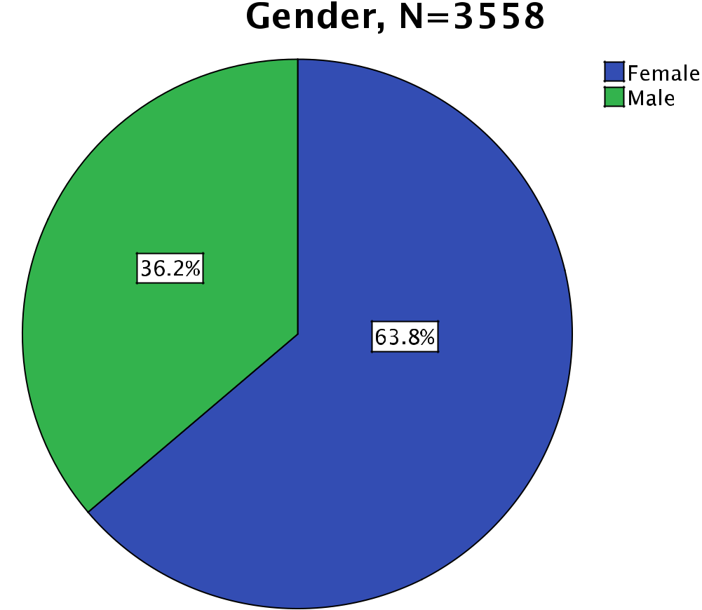

Figure 2: Gender distribution of the data

There were 63.8% female and 36.2% male respondents. This reflects very well the overall gender distribution of students in Austria, although women were slightly overrepresented in the survey. According to the Austrian Federal Ministry for Science and Research (2012), there were 53,4% female and 46,6% male students at Austrian universities in the winter term 2011/2012.

The mean age of our respondents is 24.3 years and the mean number of studied semesters is 6.6 (including summer term 2011). The next figure demonstrates the level of study of our survey participants:
The Internet & Surveillance - Research Paper Series: 2012 |  |  |  |  | 25
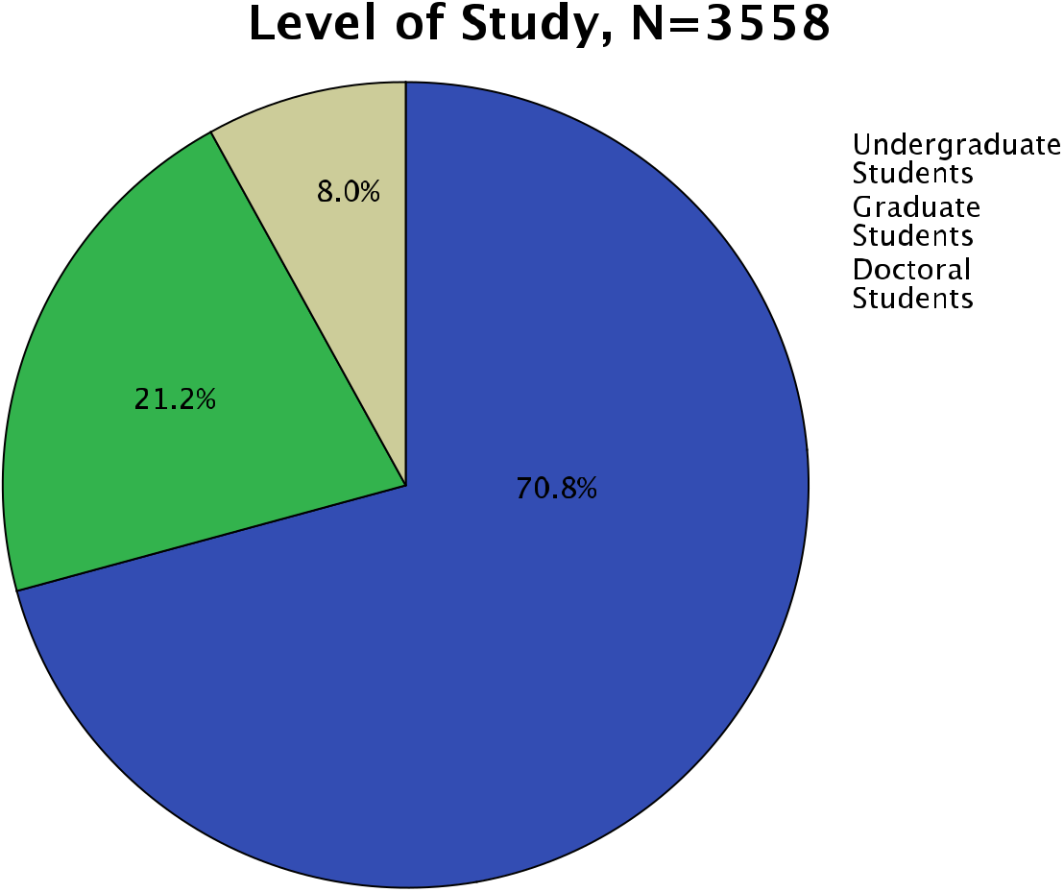

Figure 3: Respondents’ level of study

More than two thirds of the respondents (70.8%) are undergraduate students and 8% of the students are doctoral students. Note that bachelor and diploma-‐students (so-‐called Magister-‐studies, a discontinuing type of study at Austrian universities) are counted as undergraduate students, master students as graduate students, and PhD students as doctoral students.

Figure 4 provides the share of different fields of study in the sample and at Austrian universities:
26 Thomas Allmer
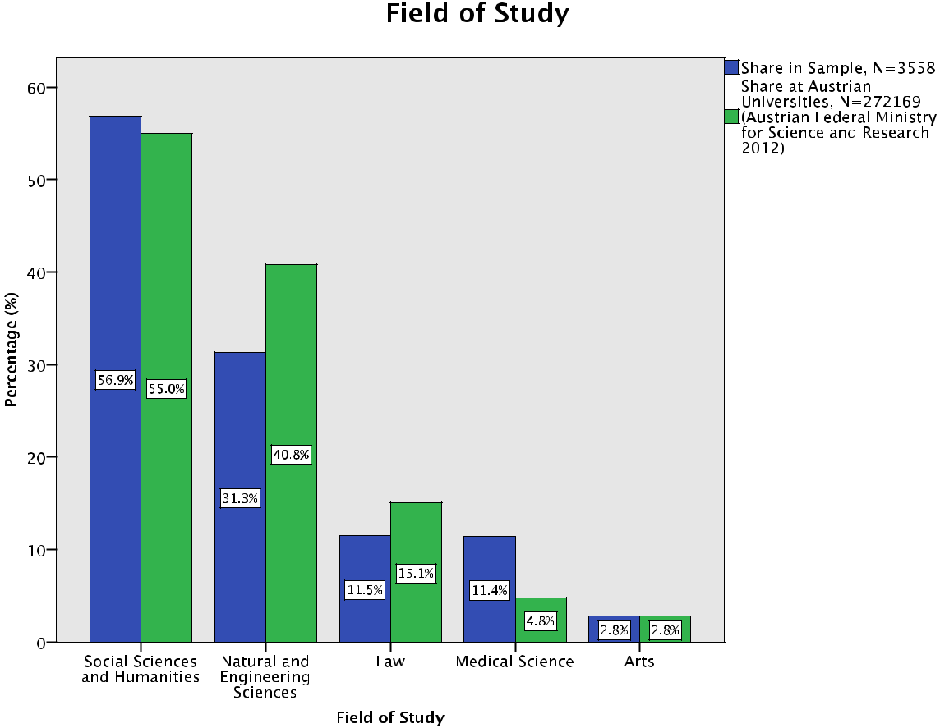

Figure 4: Share in sample and at Austrian universities of fields of study

More than half of the respondents (56.9%) study social sciences and humanities and nearly a third (31.3%) are students of natural and engineering sciences. Accord-‐ ing to the Austrian Federal Ministry for Science and Research (2012), there were 55.0% students of social sciences and humanities, 40.8% students of natural and en-‐ gineering sciences, 15.1% students of law, 4.8% students of medical science, and 2.8% students of arts at Austrian universities in the winter term 2011/2012. By com-‐ paring the share in our study with the share at Austrian universities, one can see that our dataset reflects very well the distribution of fields of study in Austria. Please note: There are 113.9% at the sample and 118.5% at Austrian universities in total, because multiple responses were possible for people enrolled in more than one field of study. Social sciences and humanities include social sciences, economics, humanities and cultural studies, and theology. Natural and engineering sciences consist of natural sciences, technical sciences, engineering, agricultural sciences and forestry, veteri-‐ nary medicine, and sport science.²

- The UNESCO Institute for Statistics has developed the International Standard Classification of Educa-‐ tion (ISCED) and suggests nine groups of fields of education: education, humanities and arts, social sciences, business and law, science, engineering, manufacturing and construction, agriculture, health and welfare, and services (UNESCO Institute for Statistics 2012). Although this classification seems
The Internet & Surveillance - Research Paper Series: 2012 | 27

The following table shows the monthly income of our respondents:

Monthly Income (in Euro), N=3558

 |  |  |  |  |  | Cumulative
 |  |  | Frequency | Percent | Valid Percent | Percent
Valid | 0-400 |  | 783 | 22.0 | 22.0 | 22.0
 | 401 - 600 |  | 940 | 26.4 | 26.5 | 48.5
 | 601 - 800 |  | 720 | 20.2 | 20.3 | 68.8
 | 801 - 1000 |  | 384 | 10.8 | 10.8 | 79.6
 | 1001 | - 1200 | 244 | 6.9 | 6.9 | 86.4
 | 1201 | - 1400 | 154 | 4.3 | 4.3 | 90.8
 | 1401 | - 1600 | 105 | 3.0 | 3.0 | 93.7
 | 1601 | - 1800 | 61 | 1.7 | 1.7 | 95.4
 | 1801 | - 2000 | 51 | 1.4 | 1.4 | 96.9
 | 2000 | - | 111 | 3.1 | 3.1 | 100.0
 | Total |  | 3553 | 99.9 | 100.0
Missing | System |  | 5 | .1
Total |  |  | 3558 | 100.0
Table 4: Monthly income of respondents

3558 students were asked what their average monthly income is (including receiv-‐ ing subsidies by parents, the state, or grants, etc.). Table 4 demonstrates that the in-‐ come of more than two thirds of the students (68.8%) is less than or of 800 Euro per month. Due to the fact that the minimum level of monthly income deemed adequate in Austria is 994 Euro (Statistical Office of the European Union 2012), one can argue that more than two thirds of our respondents live below the poverty line. This indi-‐ cates the low economic status of the participants and Austrian students in general.

The next figure presents the educational achievement of the respondents’ parents:

appropriate in order to facilitatee comparisons of education statistics across countries, we have ap-‐ plied a more simplified classification with five broad groups in our study in order to present the data in a manageable form (Babbie 2010, 433).

28 Thomas Allmer


Figure 5: Highest educational achievement of respondents’ parents

On the one hand, the majority of the respondents’ parents (mother: 55.8%, father: 52.3%) have only achieved compulsory school or college. On the other hand, almost a third of the respondents’ parents (mother 27.5%, father: 31.7%) have completed an academic education. Please note: In order to present the data in a manageable form (Babbie 2010, 433), some answer options of the questionnaire appear as a combined category in the bar chart.

Figure 6 deals with the occupation of the respondents’ parents:
The Internet & Surveillance - Research Paper Series: 2012 |  |  |  |  |  |  |  |  |  |  |  |  |  |  |  |  |  |  |  |  |  |  |  |  |  |  |  |  |  |  |  |  |  |  |  |  |  |  |  |  |  |  |  |  |  |  |  |  | 29


Figure 6: Main occupation of respondents’ parents

The majority of the respondents’ parents (mother 63.3%, father 56.9%) are white-‐ collar workers or civil servants. Furthermore, only 0.2% of the students’ fathers are unemployed. Please note: In order to present the data in a manageable form (Babbie 2010, 433), some answer options of the questionnaire appear as a combined category in the bar chart.

The following figure shows the respondents’ usage of social networking sites:
30 Thomas Allmer
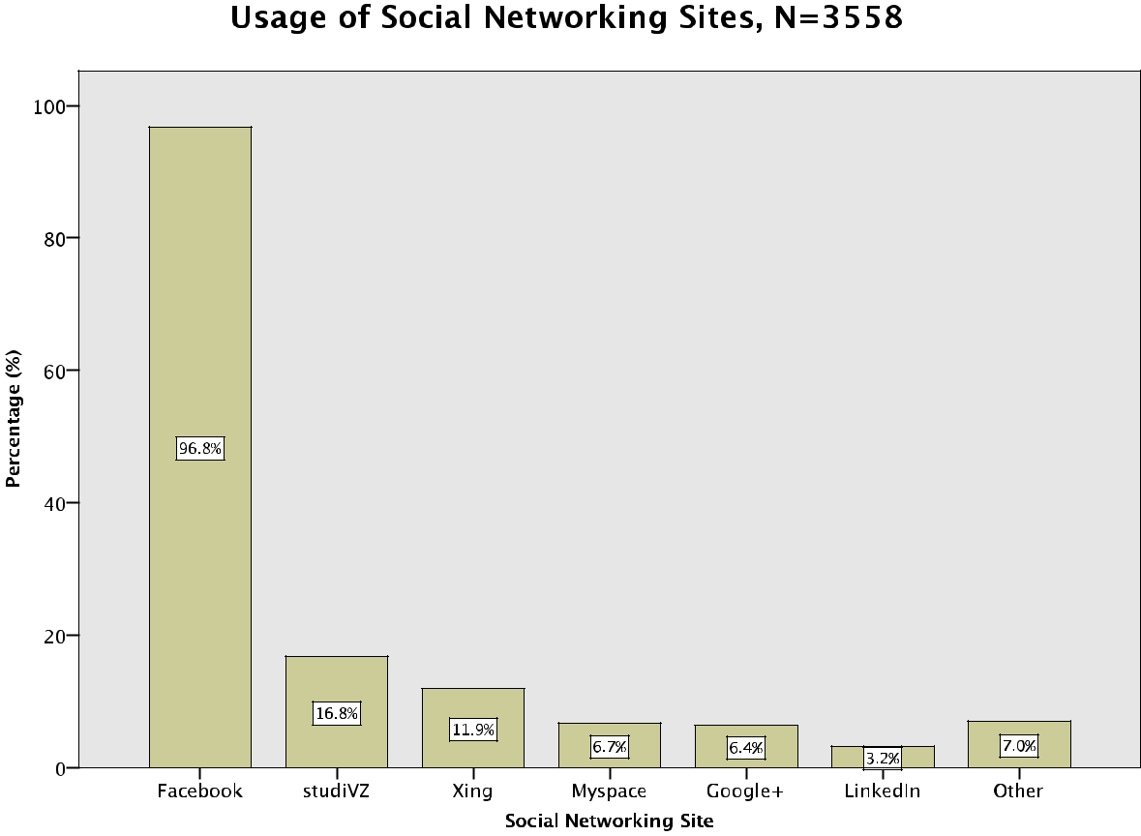

Figure 7: Respondents’ usage of social networking sites

3558 students were asked which social networking sites they use. The vast majori-‐ ty of the respondents (96.8%) use Facebook. This reflects very well the popularity of this site in Austria. Facebook is the second most popular web site in Austria (Top 100 sites in Austria, alexa.com, accessed on March 6, 2012). Only 6.4% of the respondents use Google+. Google+ was opened to everyone without the need for an invitation on September 2011. Our research was carried out from June to November 2011. It there-‐ fore can be assumed that the usage rate of Google+ by Austrian students is much higher now as it was during our survey period. Also worth mentioning is the fact that 7% of the survey participants indicated that they use other social networking sites; mentioned examples are Diaspora (0.3%), Orkut, Szene 1 (an Austrian social net-‐ working site), and Lokalisten (a German social networking site). Please note: There are more than 100% in total, because multiple responses were possible. 553 non-‐ social-‐networking-‐site-‐users were deleted from the dataset, because the study focus-‐ es on the usage of social networking sites. Google+ was not separately listed in the answer options, but 6.4% of the respondents mentioned it in the answer option “oth-‐ er” and appears therefore in the bar chart separately.

8. Perceived Advantages and Disadvantages of Social Networking Sites
The Internet & Surveillance - Research Paper Series: 2012 | 31

Hypothesis 5: Maintaining existing relationships over spatio-‐temporal dis-‐ tances and creating new social relationships is considered as the main ad-‐ vantage of SNS.

In order to test if maintaining existing relationships over spatio-‐temporal distances and creating new social relationships are considered as the main advantages of SNS (Hypothesis 5), we asked the students what in their opinion the greatest advantages of social networking sites such as Facebook and Myspace are (open question). We received N=3531 qualitative answer texts to the question that addressed advantages. We identified 17 categories for the advantages and analyzed the answers to the ques-‐ tions by content analysis (Krippendorff 2004; Berg 2001). On the one hand, the cate-‐ gories were adopted from theoretical and empirical studies about social networking sites (Fuchs 2010b; Acquisti and Gross 2006) and were revised and expanded regard-‐ ing the provided answers by summarizing, paraphrasing, abstracting, and generaliz-‐ ing groups of answer texts to categories on the other hand; that is, a combination of inductive and deductive methods (Berg 2001, 248-‐249; Babbie 2010, 339). Our re-‐ spondents tended to list more than one major advantage. Many answers are therefore mapped with more than one category (Berg 2001, 247-‐248). The next figure presents the major advantages of social networking sites that our respondents mentioned:
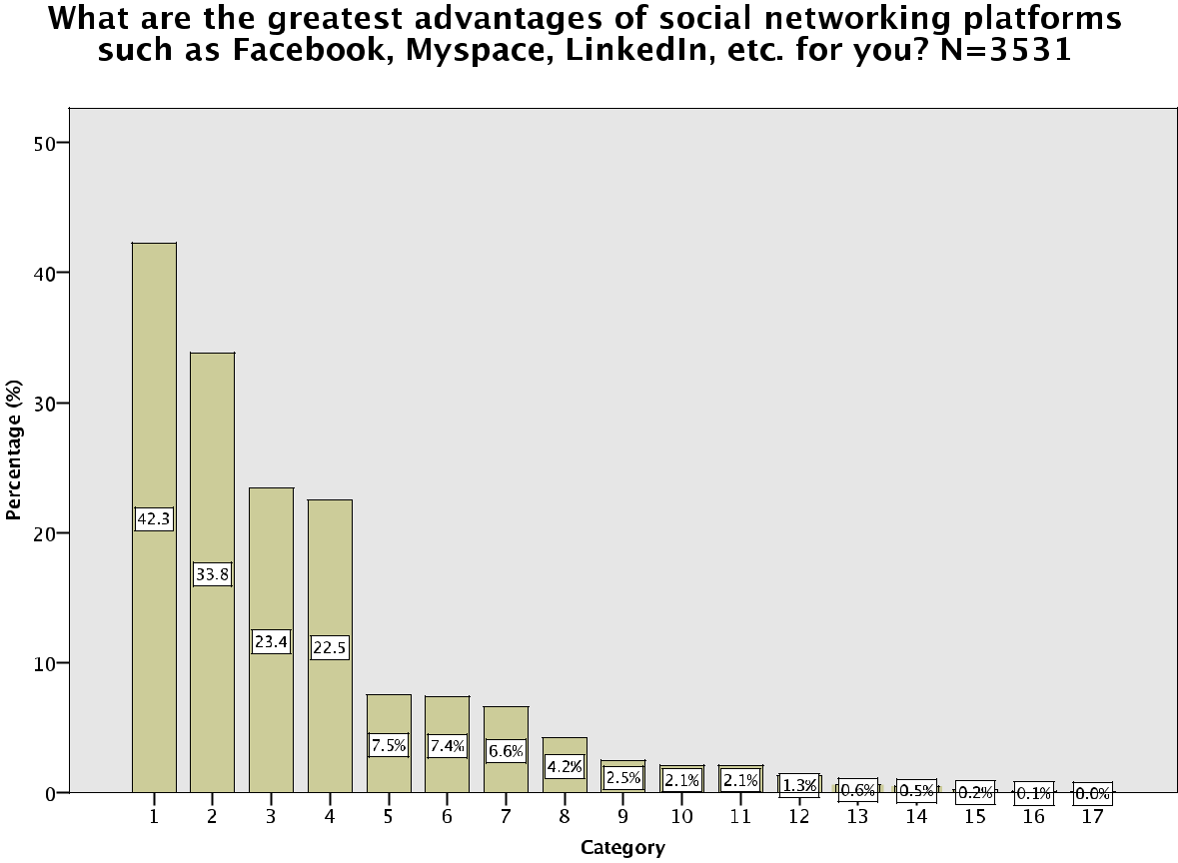

Figure 8: Greatest perceived advantages of social networking platforms
32 Thomas Allmer

No. Category

- Maintaining existing contacts, friendships, family relations, etc.
- Communication and contacts over spatial distances (national and international)

- Medium of information and news 4 Finding and renewing old contacts
- Free communication that saves money

- Sharing and accessing photos, music, videos



- Establishing new contacts with unknown people or with people whom one hard-‐ ly knows and can easier contact online
- Communication and contacts in general (no further specification)

- Communication in political groups and interest groups 10 Mobility, access from anywhere

11 Entertainment, fun, pastime, amusement

12 Overview and reminder of birthdays

13 Self-‐presentation to others (for non-‐business reasons)

14 I see no advantages

15 Business communication, finding jobs, self-‐presentation for potential employers 16 Browsing other profiles, “spying” on others

17 Flirting, sex, love

Table 5: Identified categories of greatest perceived advantages of social networking platforms

Figure 8 shows that maintaining existing relationships and communication over distances are considered as the greatest advantage of social networking sites. More than 40% of our respondents stress the maintenance of existing contacts, friendships, and family relations as major opportunity of SNS. A third (33.8%) say that social rela-‐ tionships over spatial distances are very important. Almost a quarter (23.4%) see social networking platforms as a medium of information and news and 22.5% men-‐ tion finding and renewing old contacts as major benefit. 7.5% of the participants state that an important aspect of a social networking site is that it enables free communica-‐ tion that saves money. In addition, 7.4% mention sharing photos and other media with friends and accessing such media as major opportunity and 6.6% of the students say that establishing new contacts is very important. 4.2% list communication and contacts in general with no further specification as greatest advantage. Also interest-‐ ing is that only 0.04% of our respondents mention flirting, sex, and love as important aspects of social media, which could be caused by social desirability. As a result, the hypothesis that maintaining existing relationships (category 1) and communication over spatio-‐temporal distances (category 2) is considered as the main advantage of SNS can be verified, but creating new social relationships (category 7) is not indicated as greatest opportunity.

Here are some characteristic examples of answers that were given to the question of what the major advantages of social networking platforms are (one or two exam-‐ ples for each category):
The Internet & Surveillance - Research Paper Series: 2012 | 33

Respondent ID


 | Answer (German) |  | Answer (English) |  | Categories



1560377386

1568235826

Kontakt mit Freunden

Aufrechterhaltung der Kon-‐ takte, neue Freunde finden, Echtzeit-‐Kommunikation, Globale Verbindung aller Menschen, Schnelle Na-‐ chrichtenverbreitung
Contact with friends

Maintaining contacts, finding new friends, real-‐time commu-‐ nication, global connection of all people, fast spreading of news
1


1,2,3,7,8

1560016493


1580232644


internationale Kontakte |  | International contacts |  | 2
Man kann auch mit Freunden |  | You are able to stay in contact |  | 1,2,4
aus dem Ausland leicht in Kon-‐ |  | with friends from abroad easily.
takt bleiben. Man kann Freunde |  | You are able to find old friends
von früher wieder finden. |  | again.


1568268592

1479119303


Neuigkeiten erfahren

man wird ständig über neuigkeiten informiert

ich nutze es oft um mich mit klassenkameraden über schulisches auszutauschen man kann mit freunden und verwandten die weit entfernt wohnen den kontakt aufrecht erhalten

Getting news


You get permanently informed about news

I often use it to communicate with classmates about school matters

You are able to maintain con-‐ tacts with friends and relatives, who live far away

3


1,2,3

1567786081


1572592810


Leute von früher finden.


Es ist leichter geworden Kon-‐ takt mit Freunden aus aller Welt aufrecht zu erhalten. Kon-‐ takte zu knüpfen ist für im normalen Leben schüchterne Leute keine so große Hürde mehr. Man kann Freunde von früher, mit denen man sich aus den Augen verloren hat, wieder ausfindig machen. Kurz gesagt, man kann sein Freunde-‐ bzw. Bekanntennetzwerk schnell vergrößern.

To find people from former times.

It has become easier to main-‐ tain contact with friends from all around the world. It is not any longer a major obstacle for normally shy people to estab-‐ lish contacts. You are able to catch up with friends from former times, whom you have lost contact. In short, you are able to expand your network of friends quickly.

4


1,2,4,7

1551285273

1567739679


Kontakt mit Freunden ohne |  | Contact with friends at no costs |  | 1, 5
Kosten
gratis Kommunikation mit |  | Communication for free with |  | 1,2,5,7
Freunden, Bekannten, Ver-‐ |  | friends, relatives, even if they
wandten, auch wenn diese in |  | are from other countries
anderen Ländern sind |  | Meeting new people (also from
neue Leute (auch aus dem |  | abroad)
Ausland) kennenlernen


34 Thomas Allmer


1557035103

1550759823


1566170073


Teilen von Fotos, Infor-‐ mationsaustausch


Austausch mit menschen, die man nicht mehr so oft sieht. Gleichzeitig das Ansehen von Bildern, Videos usw.

Neue Leute kennenzulernen, soziale Kontakte!

Sharing photos, exchange of |  | 3, 6
information
Exchange with people, who you |  | 4, 6
just see rarely. Viewing pic-‐
tures, videos etc. simultaneous-‐
ly
Meeting new people, social |  | 7, 8
contacts!



1559706248


lernt neue Freunde kennen, findet eventuell alte Freundschaften wieder, kann seine Gedanken mit anderen teilen, eignet sich gut um Veranstaltungen zu planen, organisieren

Meeting new friends, possibly finding old friendships again, you are able to share your thoughts with others, suitable for planning and organizing events

4,7,8,9

1564705747


Kommunikation |  | Communication |  | 8


1559810724


1567625028


Einfache Kontaktaufnahme und Newsaustausch

Einfaches Aufrechterhalten des Kontakts mit FreundInnen, die auf einem anderen Kontinent leben

Demonstrationen können leichter organisiert werden.

Easy making of contact and exchange of news


Maintaining contact with friends easily, who are living on another continent

To organize demonstrations easily.

3, 8

1,2,9

The Internet & Surveillance - Research Paper Series: 2012 | 35

1580667756


ich kann viele menschen er-‐ reichen...meine sta-‐ tusmeldungen sind meistens botschaften und zitate, um leuten eine positive sicht auf die welt zu geben (beispiel: “man sieht nur mit dem herzen gut”). ich hoffe damit ein lächeln auf manche gesichter meiner freunde zu zaubern. auch für manche politische zwecke ist es hilfreich: Uni-‐ brennt


I am able to reach a lot of peo-‐ ple…my status messages are at the most time good news and quotes in order to give people a positive view of the world (ex-‐ ample: “you only see good with your heart”). I hope with it that some of my friends’ faces will be in smiles. It is also helpful for political purposes: Uni-‐ brennt³


3, 9


15655455

1566262210

1559714377

leichte Erreichbarkeit

Schnelle Information, ständige Erreichbarkeit

Unterhaltung, Kontake knüpfen, Ablenkung

Simple accessibility


Quick information, permanent accessibility


Entertainment, establishing contacts, diversion

10


3, 10

7, 11

1549540851


Nehme etwas Teil am Leben von Freunden& Familie in an-‐ deren Städten, Ländern, Konti-‐ nenten. Kann mit Freunden zuhause chatten, wenn ich mal weg bin. Organisatorisches lässt sich auch ganz praktisch erledigen. Unterhaltung. Klatsch

To take part in life of friends and family, who live in other cities, countries, continents. To be able to chat with friends at home if I am gone. To carry out organizational matters easily. Entertainment. Gossip.

1, 2, 8, 11

1559724915


1558332265

1556033638


um Kontakt mit Freun-‐ |  | To maintain contact with |  | 1, 3, 12
den/Bekannten zu halten |  | friends
Veranstaltungen, Geburtstage |  | Events, overview of birthdays
im Überblick
Aufrechterhalten von Kon-‐ |  | Maintaining contacts, network-‐ |  | 1, 8, 9, 12
takten, Vernetzung, Erin-‐ |  | ing, reminder of birthdays, an
nerungen an Geburtstage, |  | easy possibility of planning
leichte Planungsmöglichkeiten |  | collective activities.
für gemeinschaftliche Ak-‐
tivitäten.
Kommunikation: viele Freun-‐ |  | Communication: to reach many |  | 1, 13
de/Bekannte sind einfach und |  | friends in a simple and straight-‐
unkompliziert über eine Platt-‐ |  | forward way by means of a
form zu erreichen |  | platform
Selbstdarstellung |  | Self-‐presentation


- Unibrennt was an Austrian student protest in 2009 against the commodification of higher education and the undemocratic decision-‐making structures at universities, where many universities’ lecture halls and rooms were occupied. The protest spread to othercountries such as Germany and Switzer-‐ land. Unibrennt used social media such as Facebook, Twitter, and YouTube for organizing and com-‐ municating the protest (see: unibrennt.at, accessed on April 22, 2012).

36 Thomas Allmer


1565685686



1560098106


1572561434


1573341562

1565038921


In Verbindung treten und in Verbindung bleiben mit an-‐ deren Social Platform Usern, Selbstdarstellung, Nutzung zur späteren Kundenakquise für Grafikdesign, kultureller Aus-‐ tausch, ...


Keine

Sehe ich keine.


Arbeitskontakte

Facebook hat reinen persönli-‐ chen Zweck; finden von alten Bekannten, in Kontakt bleiben mit Freunden, Bekannten aus dem Ausland

LinkedIn und MySpace haben rein professionellen Nutzen, zum finden und suchen von Jobs und professionelle Kon-‐ takte

Contacting and staying in touch |  | 1, 7, 9, 13, 15
with other social platform us-‐
ers, Self-‐presentation, Usage for
prospective customer acquisi-‐
tion for graphic design, cultural
exchange, …
none |  | 14
I do not see any. |  | 14
Business contacts |  | 15
Facebook is only for personal |  | 1, 2, 4, 15
purposes; meeting old friends,
stay in contact with friends
from abroad
LinkedIn and MySpace do have
professional benefits, to find
and search jobs and profes-‐
sional contacts

1558232492

1559729071

1565035091


Spionage

in Kontakt zu bleiben

man kann Menschen ausfindig machen und etwas über sie erfahren wenn sie das im Profil nicht gesperrt haben (kurz: stalken)


Leichtigkeit mit Freunden Sa-‐ chen zu teilen. Events Infos. Subscriptions von Produkten, VIPs etc.

Mädels aufreißen

Espionage


To keep in touch

You are able to locate people and to get informed about them, if they haven’t blocked that on their profile (in short: stalking)


Simplicity to share stuff with
friends. Information about

events. Subscriptions of prod-‐

ucts, VIP etc.

Pulling girls

16


1, 16


3, 17

Table 6: Examples for advantages respondents listed

The minimum amount of a received answer text consisted of one word, the maxi-‐ mum amount was 184 words. Please note that the survey was conducted in German, but the questionnaire was translated for the analysis into English.

The Internet & Surveillance - Research Paper Series: 2012 | 37

The next three figures display the results of the greatest perceived advantages of social networking platforms (N=3531) in comparison with gender, level of study, and field of study:
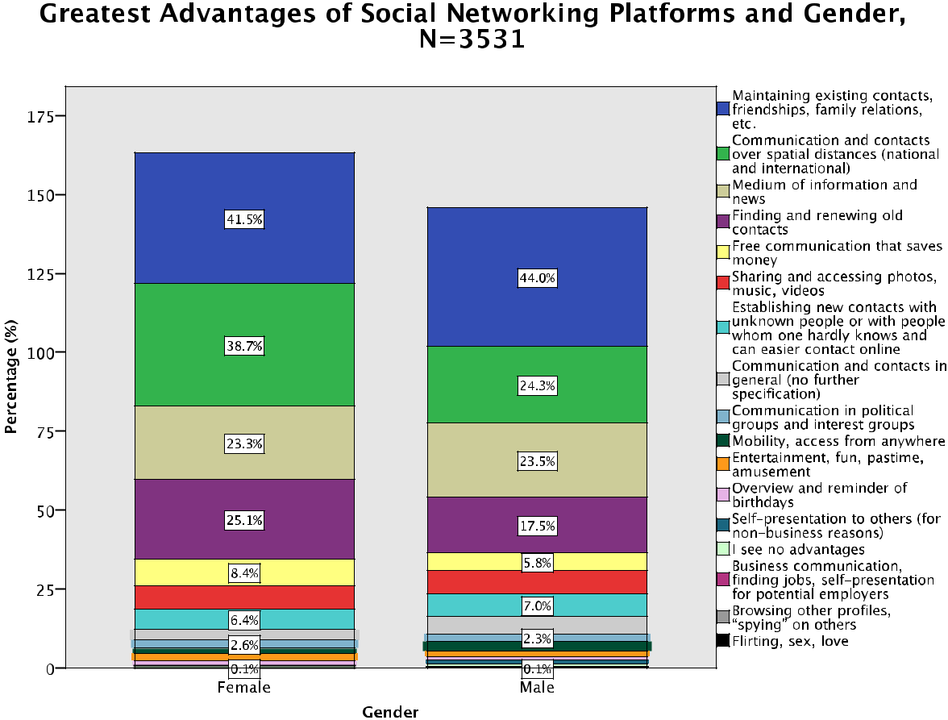

Figure 9: Greatest perceived advantages of social networking platforms and gender

41.5% of the female and 44.0% of the male respondents stress the maintenance of existing contacts, friendships, and family relations as major opportunity of social networking sites. Moreover, 38.7% of women and 24.3% of men indicate that social relationships over spatial distances are the greatest advantage and 23.3% of the fe-‐ male and 23.5% of the male students consider social networking platforms as a me-‐ dium of information and news. 25.1% of women and 17.5% of men mention finding and renewing old contacts as major benefit.
38 Thomas Allmer
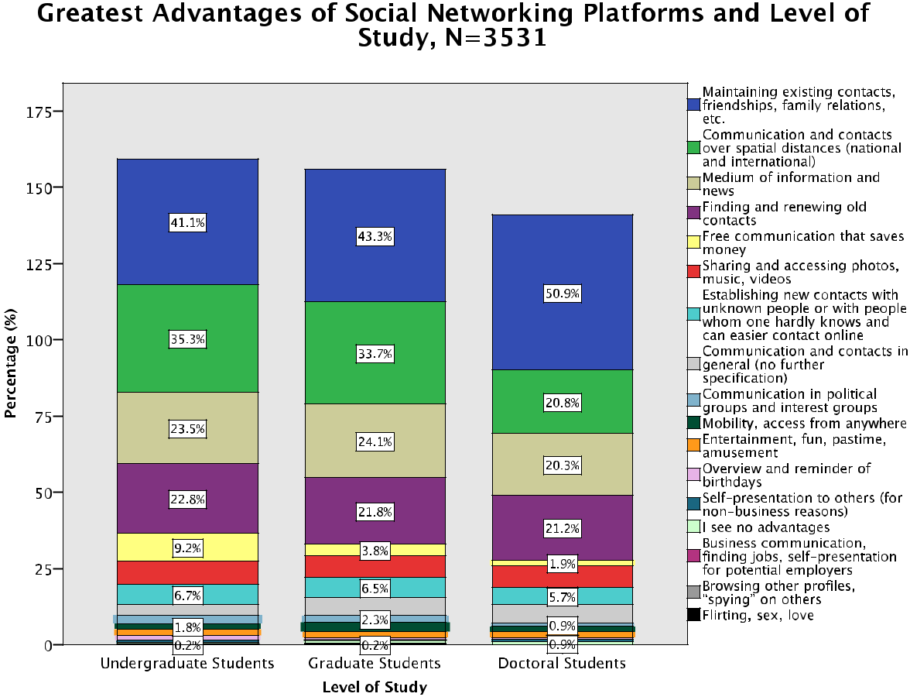

Figure 10: Greatest perceived advantages of social networking platforms and level of study

41.1% of the undergraduate, 43.3% of the graduate, and 50.9% of the doctoral stu-‐ dents stress the maintenance of existing contacts, friendships, and family relations as major opportunity of social networking sites. 35.3% of undergraduates, 33.7% of graduates, and 20.8% of postgraduates indicate that social relationships over spatial distances are the greatest advantage. In addition, 23.5% of the undergraduate, 24.1% of the graduate, and 20.3% of the PhD students consider social networking platforms as a medium of information and news.
The Internet & Surveillance - Research Paper Series: 2012 |  |  |  |  |  |  |  |  |  |  |  |  |  |  |  |  |  |  |  |  |  |  |  |  |  |  | 39

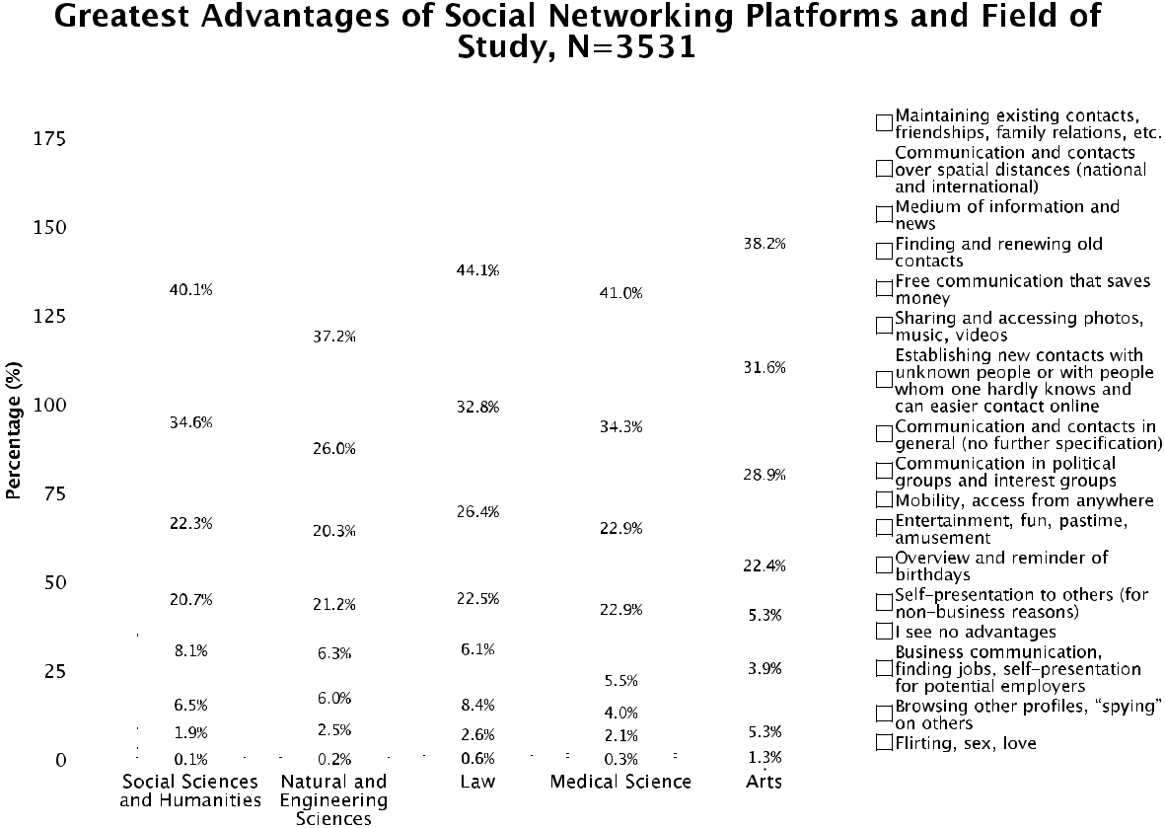

Figure 11: Greatest perceived advantages of social networking platforms and field of study

40.1% of the students of social sciences and humanities, 37.2% of the students of natural and engineering sciences, 44.1% of the students of law, 41.0% of the students of medical science, and 38.2% of the students of arts stress the maintenance of exist-‐ ing contacts, friendships, and family relations as major opportunity of social network-‐ ing sites. Besides, 34.6% of the students of social sciences and humanities, 26.0% of the students of natural and engineering sciences, 32.8% of the students of law, 34.3% of the students of medical science, and 31.6% of the students of arts indicate that so-‐ cial relationships over spatial distances are the greatest advantage.

Hypothesis 6: The surveillance threat is considered as the major disad-‐ vantage of SNS.

For analysing whether the surveillance threat is considered as the major disad-‐ vantage of SNS (Hypothesis 6), we asked what the greatest concerns of social net-‐ working sites such as Facebook and Myspace are (open question). We received N=3534 qualitative answer texts to the question that addressed disadvantages. We identified 14 categories for the concerns and analyzed the answers to the questions by content analysis (Krippendorff 2004; Berg 2001). The categories were adopted from theoretical and empirical studies about social networking sites (Fuchs 2010b; Livingstone 2008) on the one hand and were revised and expanded regarding the
40 Thomas Allmer

provided answers by summarizing, paraphrasing, abstracting, and generalizing groups of answer texts to categories on the other hand; that is, a combination of in-‐ ductive and deductive methods (Berg 2001, 248-‐249; Babbie 2010, 339). Our re-‐ spondents tended to list more than one major disadvantage. Many answers are there-‐ fore mapped with more than one category (Berg 2001, 247-‐248). The next figure shows the major concerns of social networking sites that our respondents mentioned:
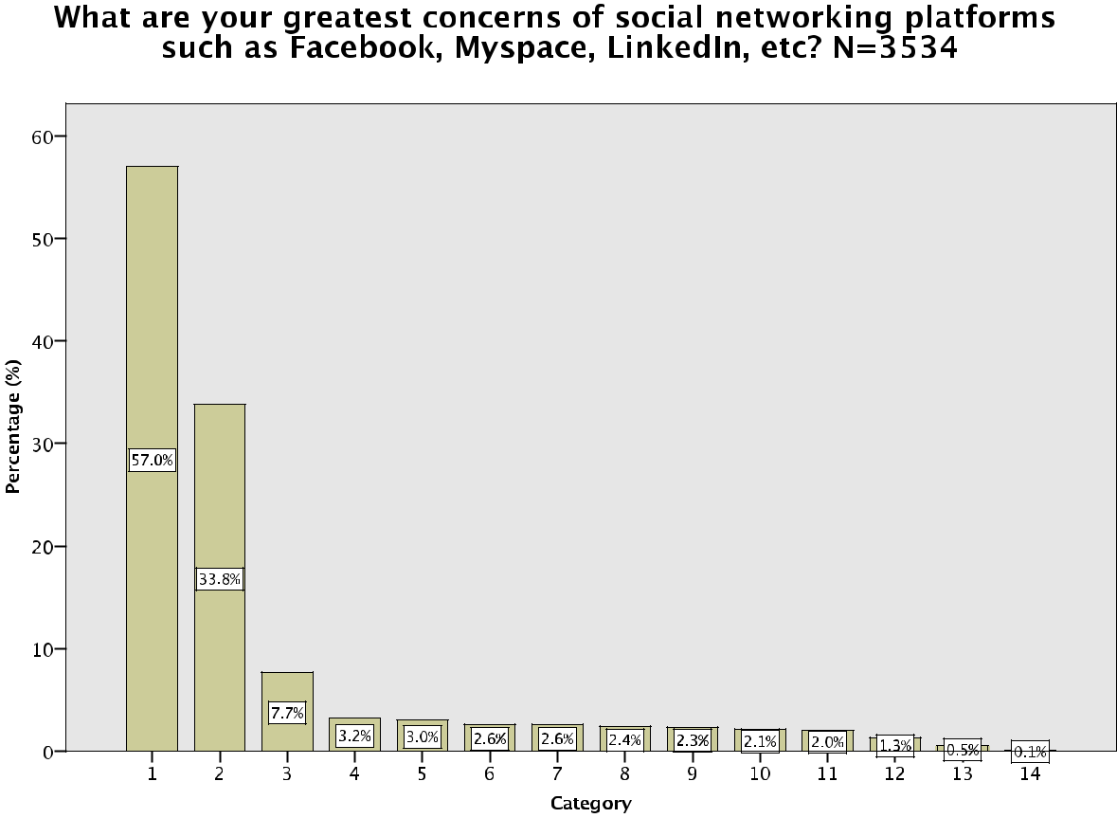

Figure 12: Greatest perceived concerns of social networking platforms

No. Category

- Data abuse, data forwarding or lack of data protection that lead to surveillance 2 Private affairs become public and result in a lack of privacy and privacy control 3 Personal profile data (images, etc.) are accessed by employers or potential em-‐ ployers and result in job-‐related disadvantages (such as losing a job or not get-‐
ting hired)
4 Internet addiction

- Data and identity theft

- Receiving advertising or spam
- I see no disadvantages

- Stalking, harassment, becoming a victim of crime
- Commercial selling of personal data
The Internet & Surveillance - Research Paper Series: 2012 | 41

10


11


12


13


14

Lack or loss of personal contacts, superficial communication and contacts, im-‐ poverishment of social relations


Virus, hacking and defacing of profiles, data integrity It is a waste of time
Unrealistic, exaggerated self-‐presentation, competition for best self-‐presentation Disadvantages at university because professors can access profiles
Table 7: Identified categories of greatest perceived concerns of social networking platforms

Figure 12 shows that surveillance is considered as the greatest concern of social networking sites. Almost 60% of our respondents stress that surveillance as a result of data abuse, data forwarding, or a lack of data protection is the main threat of SNS. A third (33.8%) say it is problematic that personal affairs that should better be kept private and should not be known to others tend to become public. 7.7% state it is a danger that also current and potential employers can access profiles, which could result in job-‐related disadvantages. In addition, 3.2% mention Internet addiction, and 3.0% of the participants stress data and identity theft as greatest risks of social media.

2.6% express concerns about advertising or spam. Also interesting is that 2.6% of the students do not see disadvantages in the usage of commercial social networking plat-‐ forms. As a result, the hypothesis that the surveillance threat (category 1) is consid-‐ ered as the major disadvantage of SNS can be verified.

Here are some characteristic examples of answers that were given to the question of what the major disadvantages of social networking platforms are (one or two ex-‐ amples for each category):


 | Respondent ID |  |  | Answer (German) |  | Answer (English) |  | Categories
 | 1567657160 |  |  | Missbrauch der Daten |  | Data abuse |  | 1
 | 1569094635
 | 1569094635 |  |  | Speicherung bzw. Aufzeich-‐ |  | Storage resp. recording of all |  | 1
 |  |  |  | nungen aller Handlungen auf |  | actions on Facebook, absence of
 |  |  |  | Facebook, Das nicht Bestehen |  | the possibility to delete stored
 |  |  |  | der Möglichkeit seine Hand-‐ |  | actions completely, Facebook’s
 |  |  |  | lungen komplett zu löschen, |  | data abuse (publication)
 |  |  |  | Datenmissbrauch (Veröffen-‐
 |  |  |  | tlichung) durch Facebook

1564258061


1567625679


1519050546


Ende der Privatsphäre


Die Öffentlichkeit, vor allem die Zugänglichkeit von persönlichen Daten und Informationen


Dass Arbeitgeber private Infor-‐ mationen erhalten könnten.

End of privacy

The public, especially accessibil-‐ ity of personal data and infor-‐ mation


That employers are able to re-‐ ceive private information.

2


2


3

42 Thomas Allmer

1567729690


1559723549

1566733372


dass Bilder, Kommentare etc. |  | That pictures, comments etc. are |  | 2, 3
von Leuten gesehen werden, |  | seen by people, who should not
welche diese nicht sehen sollten. |  | see them. e.g. employer. -‐-‐> dif-‐
z.B Arbeitgeber. -‐-‐> |  | ficulties in finding a job
Schwierigkeiten bei der
Jobsuche
Süchtig zu warden |  | To become addicted |  | 4
Abhängigkeit, das Gefühl, jeden |  | Addiction, feeling to have to be |  | 1,2,4
Tag online sein zu müssen, |  | online every day, aspects such
Aspekte wie Datenschutz und |  | as data protection and privacy;
Privatsphäre;


1557650353


1559750909


Datendiebstahl, Identitätsdieb-‐ stahl


Privatsphäre; Identitätsdieb-‐ stahl, Risiko der Belästigung und Begegnung mit Online-‐ Verbrechern; veröffentlichten Inhalte können in der ganzen Welt gesehen werden;

Data theft, identity theft

Privacy; identity theft, risk of harassment and encounter with online-‐criminals; published content can be viewed all over the world;

5


2,5,8

1559706802


Unrechtliche Nutzung der Daten, Weitergabe, Personalisierte Werbung, Gesichtserkennung-‐ salgorithmus, Entfremdung des Wortes “Freund”, Grup-‐ penzwang und mittlerweile sozialer Druck bei sowas mitzumachen.


Unlawful usage of data, forward-‐ 1, 7, 10 ing, personalized advertising, algorithm of face recognition, alienation of the term “friend”, meanwhile group pressure and social pressure to join in.


 | 1559719051 |  |  |  | Das persönliche Informationen, |  |  |  | That personal information, |  |  |  | 2, 7
 |  |  |  |  | die ich oft auch unbewusst über |  |  |  | which I often expose uncon-‐
 |  |  |  |  | mich selbst Preis gebe, gegen |  |  |  | sciously, is used against me.
 |  |  |  |  | mich verwendet werden. |  |  |  | Besides I am annoyed of per-‐
 |  |  |  |  | Außerdem nervt mich personal-‐ |  |  |  | sonalized advertising.
 |  |  |  |  | isierte Werbung.
 | 1557047480 |  |  |  | Keine |  |  |  | None |  |  |  | 6
 | 1550525803 |  |  |  | eigentlich keine |  |  |  | Actually none |  |  |  | 6
 | 1564999544 |  |  |  | cyber stalking |  |  |  | Cyber-‐stalking |  |  |  | 8
 | 1559760035 |  |  |  | * Leute die ich nicht kenne seh-‐ |  |  |  | * Unknown people are able to |  |  |  | 2,3,8
 |  |  |  |  | en mein Profil (z.B.: Kriminelle, |  |  |  | view my profil (e.g. criminals,
 |  |  |  |  | Arbeitgeber) |  |  |  | employers)
 |  |  |  |  | * FB verändert sich andauernd |  |  |  | * Facebook is always changing
 |  |  |  |  | -‐-‐> mann muss die |  |  |  | -‐-‐> one has always to adjust the
 |  |  |  |  | Privatsphäreeinstellungen im-‐ |  |  |  | privacy settings
 |  |  |  |  | mer anpassen


The Internet & Surveillance - Research Paper Series: 2012 | 43

1566130533

1525388777


Gläserner Mensch, kommerzielle Nutzung von UserInnendaten


...die (zukünftig gewiss) stärker werdende Verwendung aller gesammelten Daten, Nutze-‐ rangaben zur Marktforschung dh. Profitmaximierung. ...ein weiterer Schritt in Richtung “globaler Überwachungsstaat”, über welchen tatsächlich bald nicht mehr die Völker/die Poli-‐ tiker herrschen werden, sondern Konzerne und Lobbies

...untrasparent, benutzerun-‐ freundliche Privatsphäre-‐ Einstellungen


Transparent individual, com-‐ mercial usage of user data

…(prospective) increasing usage of all collected data, user details for market research; that is prof-‐ it maximization. …a further step towards “global police state”, which not the people/politicians will rule any longer, but corpo-‐ rations and lobbies …opaque, non-‐user-‐friendly privacy set-‐ tings

2, 9


1,2,9

 | 1561084176 |  |  | sehr oberflächliche konversa-‐ |  | Very superficial conversations, |  | 2, 10
 |  |  |  | tionen, zu leichtsinniges teilen |  | too careless sharing of infor-‐
 |  |  |  | von informationen |  | mation
 | 1565288593 |  |  | Datenschutz, Vereinsamung, |  | Data protection, loneliness, mis-‐ |  | 1, 10
 |  |  |  | falsche Vorstellungen von der |  | conception of reality, normal
 |  |  |  | Realität, normale Gespräche mit |  | conversations with a guy -‐ you
 |  |  |  | dem Gegenüber -‐ man weiß ja eh |  | already know all stuff, because
 |  |  |  | schon alles, denn es wird ja von |  | some people post “all”
 |  |  |  | manchen “alles” gepostet
 | 1561247966 |  |  | Hacker |  | Hackers |  | 11
 | 1567638641
 | 1567638641 |  |  | Das es Hecker gibt, die in |  | That there are hackers, who |  | 11
 |  |  |  | meinem Namen, meine Seite |  | “deface” my site in the name of
 |  |  |  | “verunstalten” |  | me

1559785387

1567639535

1560127276


Zeitverschwendung |  | Waste of time |  | 12
Privatsphäre, Zeitverschwen-‐ |  | Privacy, waste of time (people |  | 2, 12
dung (Leute schreiben zu viel |  | write too much into it that does
rein, was mich nicht interessiert; |  | not interest me; inquiries of
Spieleanfragen nerven) |  | games annoy)
dass diese Plattformen zur |  | That this platforms are used as |  | 13
reinen Selbstinszenierung ver-‐ |  | pure self-‐presentation;
wendet werden;


1550551373


datenschutz, „stasi auf freiwil-‐ liger basis“, wenn das system kippt sind die leute leicht ein-‐ zuteilen nach politischen inter-‐ essen, ect. , falsche selbstdarstel-‐ lung der nutzer -‐> oft will man sich profilieren

Data protection, “stasi on a vol-‐ untary basis”, if the system over-‐ turns, it is easy to classify people according political interests, etc.

- false description of oneself -‐> often one wants to show off oneself

1, 13


44 Thomas Allmer

1565224564

- Die Privatsphäre ist sehr an-‐ gegriffen, da Freunde oft Fotos hochladen, in denen man ver-‐ linkt wird (und sichtbar ist)...

- Die Pflege sozialer Netzwerke „im real life“ könnte ver-‐ nachlässigt werden.

- V.a. junge Leute sind sich der Auswirkungen ständiger (eig. privater) Status-‐Erneuerungen nicht bewusst, bzw. des Um-‐ standes, dass diese auch Profes-‐ soren und zukünftige Vorgesetz-‐ te etc. lesen könnten.


* Privacy is violated, because | 2, 10, 14

friends often upload photos, where you are linked (and visi-‐ ble)…

- Cultivation of social networks “in real life” could be neglected.

- Especially young people are not aware of the consequences of permanent (actually private) status changing, resp. the fact that this could also read profes-‐ sors and prospective superiors etc.

Table 8: Examples for concerns respondents listed

The minimum amount of a received answer text consisted of one word, the maxi-‐ mum amount was 229 words. Please note that the survey was conducted in German, but the questionnaire was translated for the analysis into English.

The next three figures show the results of the greatest perceived concerns of social networking platforms (N=3534) in comparison with gender, level of study, and field of study:
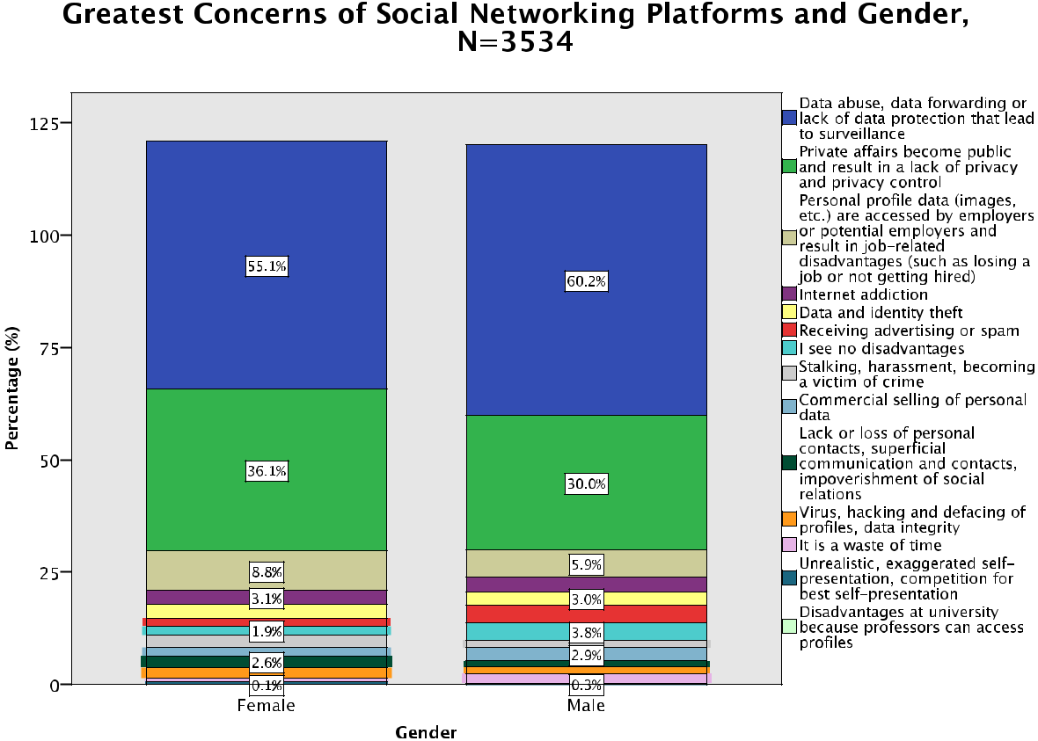

Figure 13: Greatest perceived concerns of social networking platforms and gender

The Internet & Surveillance - Research Paper Series: 2012 | 45

55.1% of the female and 60.2% of the male respondents stress that data abuse, data forwarding, or a lack of data protection is the greatest concern of social networking platforms. Moreover, 36.1% of women and 30.0% of men indicate it is problematic that personal affairs tend to become public and 8.8% of the female and 5.9% of the male students state it is a danger that also current and potential employers can access profiles. 3.3% of women and 3.1% of men mention Internet addiction as main risk of social media.
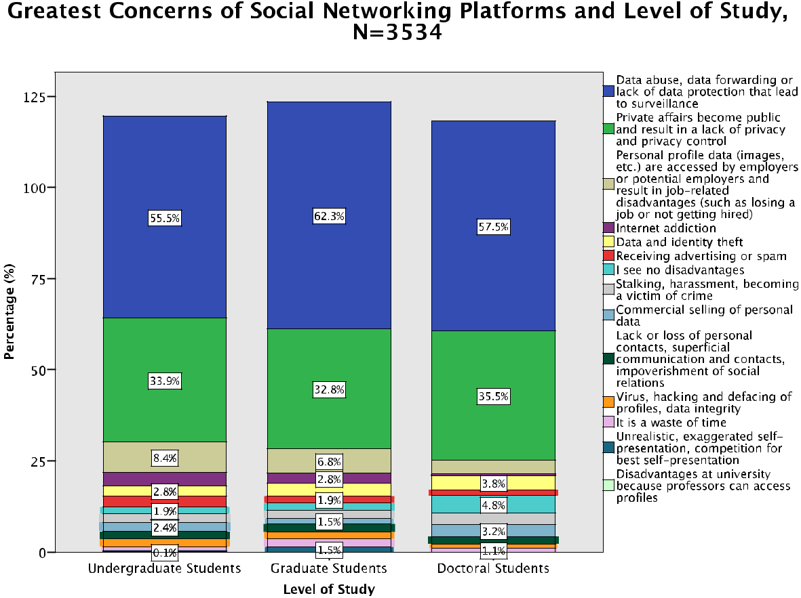

Figure 14: Greatest perceived concerns of social networking platforms and level of study

55.5% of the undergraduate, 62.3% of the graduate, and 57.5% of the doctoral stu-‐ dents stress that data abuse, data forwarding, or a lack of data protection is the great-‐ est concern of social networking platforms. 33.9% of undergraduates, 32.8% of grad-‐ uates, and 35.5% of postgraduates indicate it is problematic that personal affairs tend to become public. In addition, 8.4% of the undergraduate, 6.8% of the graduate, and 3.8% of the PhD students state it is a danger that also current and potential employ-‐ ers can access profiles.
46 Thomas Allmer
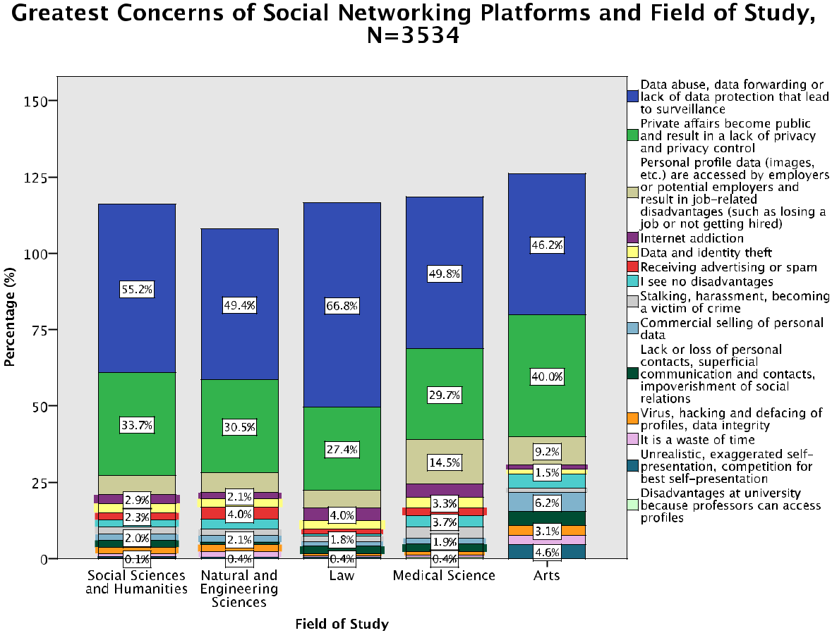

Figure 15: Greatest perceived concerns of social networking platforms and field of study

55.2% of the students of social sciences and humanities, 49.4% of the students of natural and engineering sciences, 66.8% of the students of law, 49.8% of the students of medical science, and 46.2% of the students of arts stress that data abuse, data for-‐ warding, or a lack of data protection is the greatest concern of social networking plat-‐ forms. Besides, 33.7% of the students of social sciences and humanities, 30.5% of the students of natural and engineering sciences, 27.4% of the students of law, 29.7% of the students of medical science, and 40.0% of the students of arts indicate it is prob-‐ lematic that personal affairs tend to become public. By comparing the greatest con-‐ cerns with the field of study, one can see that a high amount of the students of law (two thirds) stress data abuse, data forwarding, or a lack of data protection as the greatest drawback. One reason that one can imagine is that jurists tend to learn more about rights, are more frequently confronted with unwarranted intrusions and viola-‐ tions, and are also interested in legal protection. For example, the group “europe-‐v-‐ facebook” was founded by a group of Austrian students of law in order to fight against Facebook’s policy in terms of personal data abuse and forwarding (Objectives, eu-‐ rope-‐v-‐facebook.org, accessed on April 20, 2012). It could therefore be an outcome
The Internet & Surveillance - Research Paper Series: 2012 | 47

that Austrian students of jurisprudence are more concerned about data abuse and data forwarding.

9. Value of Privacy

Hypothesis 7: Privacy is rather considered as extrinsic than as intrinsic value and as based on the control theory.

If privacy is rather considered as extrinsic than as intrinsic value (Hypothesis 7) was measured with the help of an index that was calculated based on the answers given to three single choice questions that tested such consideration (interpretation in parenthesis). The next three tables report the results of these questions (non-‐ Facebook-‐users were not taken into consideration, because these questions focus on the usage of Facebook, N=3444):

Value of Privacy 1: Should your mobile phone number be visible to all people on Facebook, or not? What is the most important reason for or against it? N=3444
 |  |  |  |  |  | Cumulative
 |  |  | Frequency | Percent | Valid Percent | Percent
 | Valid Yes, Facebook is like a |  | 48 | 1.4 | 1.4 | 6.0
 |  | telephone book. I am
 |  | pleased if people who
 |  | are looking for me also
 |  | can find me in order to
 |  | contact me. (no value)
 |  | Yes, I am pleased if I get | 16 | .5 | .5 | 6.4
 |  | different information
 |  | about the world such as
 |  | advertising (e.g. via
 |  | SMS). (no value)
 |  | No, I am afraid that my | 409 | 11.9 | 11.9 | 18.3
 |  | phone number will be
 |  | misused for advertising.
 |  | (extrinsic value)
 |  | No, I am afraid that I will | 518 | 15.0 | 15.0 | 33.4
 |  | be harassed or threat-
 |  | ened. (extrinsic value)
48 Thomas Allmer


No, that would violate my privacy and privacy is something very important for me. (intrinsic value)

Other opinion:

Total

2295

158

3444

66.6

4.6

100.0

66.6

4.6

100.0

100.0

4.6

Table 9: Value of privacy 1

3444 students were asked if their mobile phone number should be visible to all people on Facebook, or not. Two thirds of the respondents (66.6%) stated that it would violate their privacy and that privacy is something very important for them (intrinsic value). Only 6.4% of the participants think that their mobile phone number should be visible to all people on Facebook and therefore consider privacy as no im-‐ portant value.

Value of Privacy 2: Do you mind if photos on which you are obviously drunk are publicly visible on Facebook. What is the most important reason for or against it? N=3444
 |  |  |  |  | Cumulative
 |  | Frequency | Percent | Valid Percent | Percent
Valid Yes. If such photos are |  | 297 | 8.6 | 8.6 | 14.5
 | published it is embar-
 | rassing and I feel
 | ashamed. (extrinsic val-
 | ue)
 | Yes. I am afraid that my | 1230 | 35.7 | 35.7 | 50.3
 | employer or my future
 | employer sees these
 | photos and that I then
 | get problems at work or
 | will not get the job at an
 | employment interview.
 | (extrinsic value)

The Internet & Surveillance - Research Paper Series: 2012 | 49


Yes. That is something private and privacy is something very important for me. (intrinsic value)

No. I do not mind, there is no harm in a joke and everyone is drunk once in a time. This is com-pletely normal. One does not need to conceal such
- circumstance. (no val-ue)

No. I am not afraid to show myself as I am. Even in an interview it can be a benefit, be-cause people see that you are a sociable per-son who has fun in his/her life. (no value)

Other opinion:

Total

1481

159

73

204

3444

43.0

4.6

2.1

5.9

100.0

43.0

4.6

2.1

5.9

100.0

93.3

97.9

100.0

5.9

Table 10: Value of privacy 2

The respondents were interviewed if they mind when photos on which they are obviously drunk are publicly visible on Facebook. Half of the students (50.3%) do mind for extrinsic reasons and over 40% agree that it is something private and priva-‐ cy is very important for them (intrinsic value). Only 6.7% do not mind (no value).

Value of Privacy 3: Would you ever publish pictures, where you are shown na-ked, on a social networking site profile? What is the most important reason for or against it? N=3444

Frequency

Percent

Valid Percent

Cumulative

Percent

50 Thomas Allmer


Valid Yes, why not. I am not embarrassed being na-ked in front of other peo-ple, also not on the Inter-net. (no value)

No. That would be a vio-lation of my privacy. Inti-macy is one of the most important values and has to be protected. (extrinsic value)

No. That is too private and all private data should be kept private and not be made public. (intrinsic value)

Other opinion:

Total

19

1442

1863

120

3444

.6

41.9

54.1

3.5

100.0

.6

41.9

54.1

3.5

100.0

4.0

45.9

100.0

3.5

Table 11: Value of privacy 3

3444 students were asked if they would ever publish pictures, where they are shown naked, on a social networking site profile. Overall, more than half of the partic-‐ ipants (54.1%) stated that it is too private and all private data should be kept private and not be made public (intrinsic value). More than 40% consider privacy as extrinsic value. Only 19 students claim that they would publish such pictures on a social net-‐ working site (no value). If we combine the results of these three questions (value of privacy 1-‐3), an overall privacy value index can be calculated. The index can be calcu-‐ lated with the following formula (for the definition of this index see the survey ques-‐ tions section in the research report):

- 3 x extrinsic/intrinsic/no value: Privacy is considered as extrin-‐ sic/intrinsic/no value.

- 2 x extrinsic/intrinsic/no value: Privacy is rather considered as extrin-‐ sic/intrinsic/no value.

- 1 x extrinsic/intrinsic/no value/other opinion: No valid assessment possible.

The next figure shows the privacy value index:

The Internet & Surveillance - Research Paper Series: 2012 |  |  |  |  |  |  |  |  |  |  |  |  |  |  |  |  |  |  |  |  |  |  |  |  |  | 51
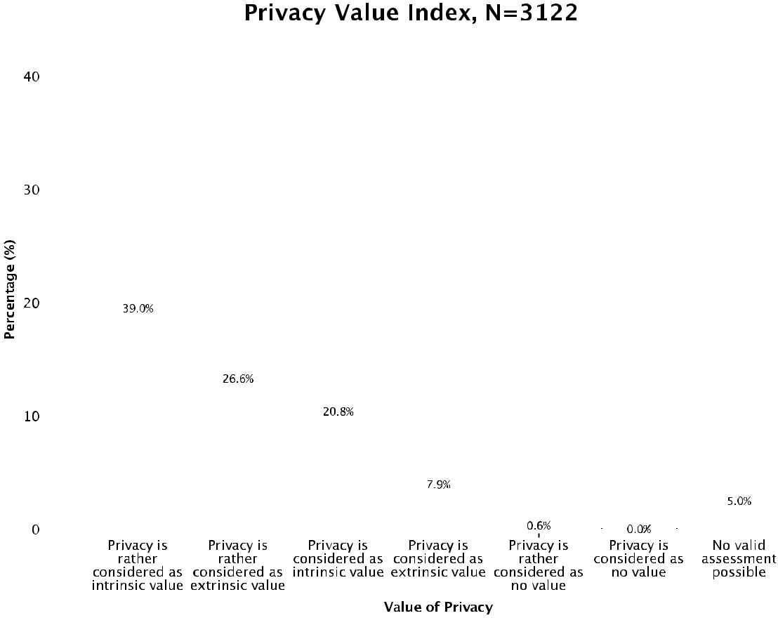

Figure 16: Privacy value index (based on value of privacy 1-‐3)

This index shows that most of the students do have an intrinsic understanding of privacy in mind. Almost 60% of the respondents consider or rather consider privacy as intrinsic value (2-‐3 x intrinsic value), a third (34.5%) consider or rather consider privacy as extrinsic value (2-‐3 x extrinsic value), and 0.6% of the students consider (0.03%) or rather consider privacy as no important value (2-‐3 x no value). The hy-‐ pothesis that privacy is rather considered as extrinsic than as intrinsic value can therefore not be verified, but it shows that privacy seems to be a very important value for students in daily life. Please note: 1 x extrinsic/intrinsic/no value/other opinion: No valid assessment possible. Privacy is considered as no value (0.03%). 2-‐3 x other opinion were not taken into consideration, N=3122.

The next three figures display the results of the privacy value index (N=3122) in comparison with gender, level of study, and field of study:
52 Thomas Allmer
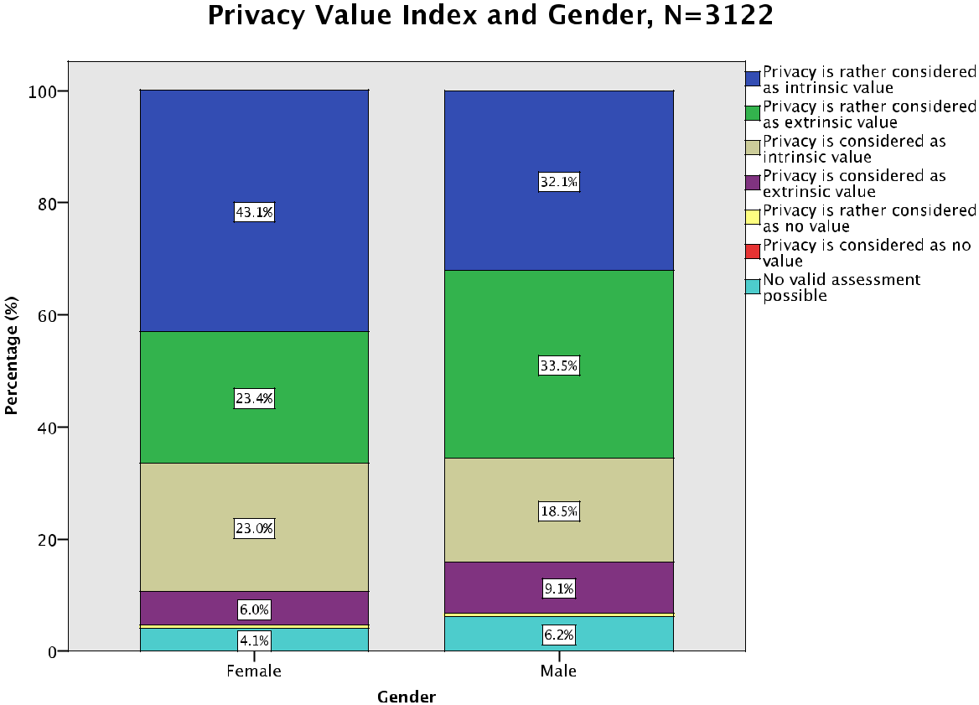

Figure 17: Privacy value index and gender

66.1% of the female and 50.6% of the male respondents consider or rather consid-‐ er privacy as intrinsic value. Moreover, 29.4% of women and 42.6% of men (rather) consider privacy as extrinsic value and 0.5% of the female and 0.6% of the male stu-‐ dents consider or rather consider privacy as no important value. This shows that more women than men tend to consider privacy as intrinsic value and that more men than women tend to consider privacy as extrinsic value. A reason for this tendency could be patriarchal societal structures that construct women as being irrational, emotional, intuitive, weak, and lovely and men as being rational, powerful, structured, and thinking logically (Davis 1998, 163-‐164). It could be an outcome of these struc-‐ tures that more male students consider privacy as extrinsic value, which is a more rational and functionalist approach where privacy is seen as an instrumental value for providing means in order to achieve some end(s), and that more female students consider privacy as intrinsic value, which is a more intuitive and subjective approach where privacy is considered as a unitary value for its own sake and valuable in itself.
The Internet & Surveillance - Research Paper Series: 2012 |  |  |  |  |  |  |  |  |  |  |  |  |  |  |  |  |  |  |  |  |  |  |  |  | 53
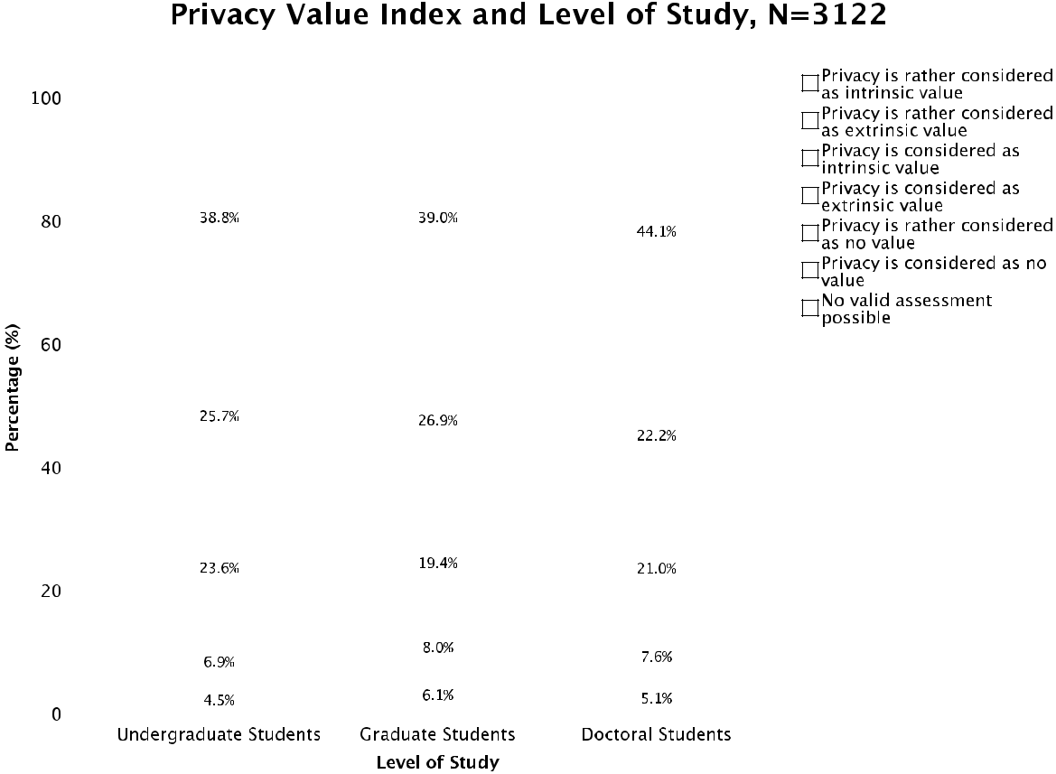

Figure 18: Privacy value index and level of study

62.4% of the undergraduate, 58.4% of the graduate, and 65.1% of the doctoral stu-‐ dents consider or rather consider privacy as intrinsic value. 32.6% of undergraduates, 34.9% of graduates, and 29.9% of postgraduates (rather) consider privacy as extrin-‐ sic value. In addition, 0.5% of the undergraduate, 0.7% of the graduate, and 0.4% of the PhD students consider or rather consider privacy as no important value.
54 Thomas Allmer
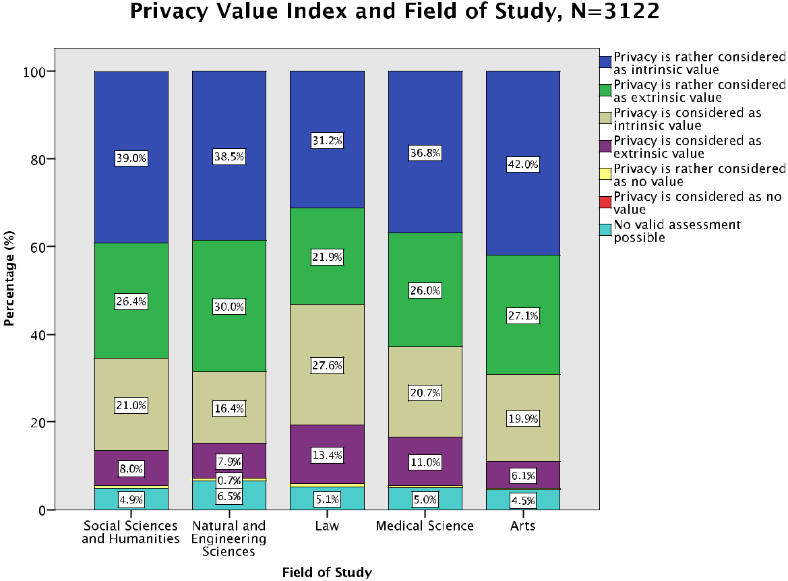

Figure 19: Privacy value index and field of study

60.0% of the students of social sciences and humanities, 54.9% of the students of natural and engineering sciences, 58.8% of the students of law, 57.5% of the students of medical science, and 61.9% of the students of arts consider or rather consider pri-‐ vacy as intrinsic value. Besides, 34.4% of the students of social sciences and humani-‐ ties, 43.4% of the students of natural and engineering sciences, 35.3% of the students of law, 37.0% of the students of medical science, and 33.2% of the students of arts (rather) consider privacy as extrinsic value.

- Theory of Privacy

Hypothesis 7: Privacy is rather considered as extrinsic than as intrinsic value and as based on the control theory.

If privacy is rather considered as based on the control theory than on the access theory (Hypothesis 7) was measured with the help of an index that was calculated based on the answers given to three multiple choice questions that tested such con-‐ siderations (interpretation in parenthesis). The next three tables show the results of these questions (non-‐Facebook-‐users were not taken into consideration, because the-‐ se questions focus on the usage of Facebook, N=3444, there are more than 100% in total, because multiple responses were possible):
The Internet & Surveillance - Research Paper Series: 2012 | 55

Theory of Privacy 1: Social networking platforms such as Facebook or

Myspace record the usage behaviour of their users for purposes of advertis-ing. How do you think about this circumstance? (multiple responses possi-ble), N=3444
 |  |  | Responses
 |  | N |  | Percent | Percent of Cases
set1ª | I do not mind. (no theory) |  | 311 | 6.8% | 9.0%
 | I find that bad and I would pre- |  | 2312 | 50.4% | 67.1%
 | fer to decide for myself, which
 | data are recorded about me.
 | (control theory)
 | I find that bad and think that |  | 1844 | 40.2% | 53.5%
 | regulations should be estab-
 | lished on a political level (e.g.
 | international data protection
 | regulations) in order to legally
 | hinder the collection of certain
 | data. (access theory)
 | Other opinion: |  | 120 | 2.6% | 3.5%
Total |  |  | 4587 | 100.0% | 133.2%

a. Dichotomy group tabulated at value 1.

Table 12: Theory of privacy 1

3444 students were asked how they think about the circumstance that social net-‐ working platforms record the usage behaviour of their users for purposes of advertis-‐ ing. Most importantly, half of the respondents (50.4%) find that bad and would prefer to decide for themselves, which data are recorded about them (control theory). Over 40% consider privacy as based on the access theory and only 311 survey participants do not mind. This indicates that the vast majority of the students find this form of economic surveillance problematic.

Theory of Privacy 2: In Austria, telecommunication service providers (e.g. Internet service providers) have to pass on electronic communication activi-ties of their customers to the police if the latter demands so. Do you mind about it? If yes, how could this circumstance be counteracted? (multiple re-sponses possible), N=3444
56 Thomas Allmer

 |  |  | Responses
 |  | N |  |  | Percent | Percent of Cases
set2ª | No, I do not mind. (no theory) |  | 1463 |  | 37.2% | 42.5%
 | Yes, I find that problematic and |  | 1058 |  | 26.9% | 30.7%
 | I would prefer to decide for my-
 | self, which communication ac-
 | tivities of me can be passed on
 | to the police. (control theory)
 | Yes, I find that problematic and |  | 1167 |  | 29.7% | 33.9%
 | I think that regulations should
 | be established on a political,
 | legal, or societal level in order
 | to protect private information
 | so that they are not accessible
 | to someone else. (access theo-
 | ry)
 | Other opinion: |  | 245 |  | 6.2% | 7.1%
Total |  |  | 3933 |  | 100.0% | 114.2%
a. Dichotomy group tabulated at value 1.
 | Table 13: Theory of privacy 2

The respondents were interviewed if they mind that telecommunication service providers have to pass on electronic communication activities of their customers to the police if the latter demands so. Worth mentioning is the fact that 37.2% of the participants do not mind about this circumstance. Almost 40% of the students do not mind about this kind of political surveillance.

Theory of Privacy 3: Suppose you are repeatedly harassed by a stranger on Facebook and you feel surveilled by this person (stalking). Do you mind about it? If yes, how could such a situation be handled? (multiple responses possible), N=3444
 |  |  | Responses
 |  | N |  | Percent | Percent of Cases
set3ª | No, I do not mind. (no theory) |  | 103 | 2.4% | 3.0%

The Internet & Surveillance - Research Paper Series: 2012 | 57

 | Yes, I mind. I would solve this | 2729 |  | 64.8% | 79.2%
 | problem on an individual level
 | by denying this person access
 | to my Facebook profile. (control
 | theory)
 | Yes, I mind. I wish that regula- | 1267 |  | 30.1% | 36.8%
 | tions could be established on a
 | political, legal, or societal level
 | in order to protect the access to
 | private data. (access theory)
 | Other opinion: | 112 |  | 2.7% | 3.3%
Total |  | 4211 |  | 100.0% | 122.3%
a. Dichotomy group tabulated at value 1.
 | Table 14: Theory of privacy 3

3444 students were asked if they mind when they are repeatedly harassed by a stranger on Facebook and they feel surveilled by this person. Overall, almost two thirds of the respondents (64.8%) would solve this problem on an individual level by denying this person access to their Facebook profile (control theory). About 30% consider privacy as based on the access theory and only 103 participants do not mind. This indicates that most of the students find this shape of personal surveillance problematic. By comparing the results of these three questions (theory of privacy 1-‐ 3), we can see that in the context of the expressed circumstances the vast majority of the students find economic and personal surveillance problematic, whereas many of our respondents do not mind about political surveillance. This could be an indication that social networking site users are more concerned about economic surveillance than political surveillance. One reason one can imagine is that there is much public talk about privacy threats of commercial web platforms such as Facebook and Google. The following collected news clips are an indicator of this development:

“Selling You on Facebook: Many popular Facebook apps obtain sensitive information about users—and users' friends” (The Wall Street Journal, April 7, 2012)

“Snoopers who track your online browsing: Computer users are being spied on as big business tries to work out how best to target adverts at them.” (The Sun, March 3, 2012)

“’Facebook is a surveillance engine, not friend’” (The Times of India, February 7, 2012)

58 Thomas Allmer

These examples point out how important the topic of commercial privacy threats has become for the media and for our daily lives. The media often alert that privacy seems to be under attack and vanishing especially caused by commercial websites. For instance, Web 2.0 activities such as creating profiles and sharing ideas on Face-‐ book, announcing personal messages on Twitter, uploading or watching videos on YouTube, and writing personal entries on Blogger, enable the collection, analyses, and sale of personal data by profit-‐oriented web platforms. Obviously, our respondents are more concerned about this form of surveillance.

If we combine the results of these three questions (theory of privacy 1-‐3), an over-‐ all privacy theory index can be computed. The index can be calculated with the fol-‐ lowing formula (for the definition of this index see the survey questions section in the research report):

- control theory + access theory: RALC theory

- 3 x control/access/RALC/no theory: Privacy is considered as based on the control/access/RALC/no theory.

- 2 x control/access/RALC/no theory: Privacy is rather considered as based on the control/access/RALC/no theory.

- 1 x control/access/RALC/no theory/other opinion: No valid assessment pos-‐ sible.

- control theory and/or access theory + no theory: No valid assessment possible.

The next figure presents the privacy theory index:
The Internet & Surveillance - Research Paper Series: 2012 |  |  |  |  |  |  |  |  |  |  |  |  |  |  |  |  |  |  |  |  |  |  |  |  |  |  |  |  |  |  |  |  |  |  |  |  |  |  |  |  | 59
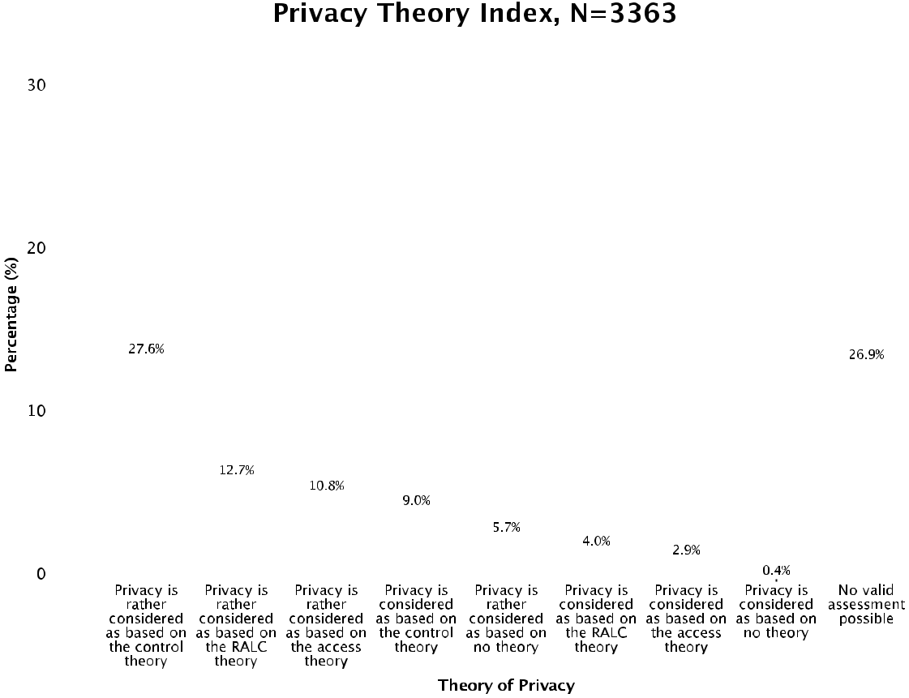

Figure 20: Privacy theory index (based on theory of privacy 1-‐3)

This index indicates that most of the students contemplate privacy in the context of the control theory. More than a third of the respondents (36.6%) consider or rather consider privacy as based on the control theory (2-‐3 x control theory), 16.7% consid-‐ er or rather consider privacy as based on the RALC theory (2-‐3 x RALC theory), 13.7% consider or rather consider privacy as based on the access theory (2-‐3 x access theo-‐ ry), and 6.1% of the students consider or rather consider privacy as based on no the-‐ ory (2-‐3 x no theory). The hypothesis that privacy is rather considered as based on the control theory can consequently be verified. These results furthermore indicate that privacy seems to be a very important value for students in daily life. Please note: Control theory + access theory: RALC theory. 1 x control/access/RALC/no theo-‐ ry/other opinion: No valid assessment possible. Control theory and/or access theory

- no theory: No valid assessment possible. 2-‐3 x other opinion were not taken into consideration, N=3363.

The next three figures show the results of the privacy theory index (N=3363) in comparison with gender, level of study, and field of study:
60 Thomas Allmer
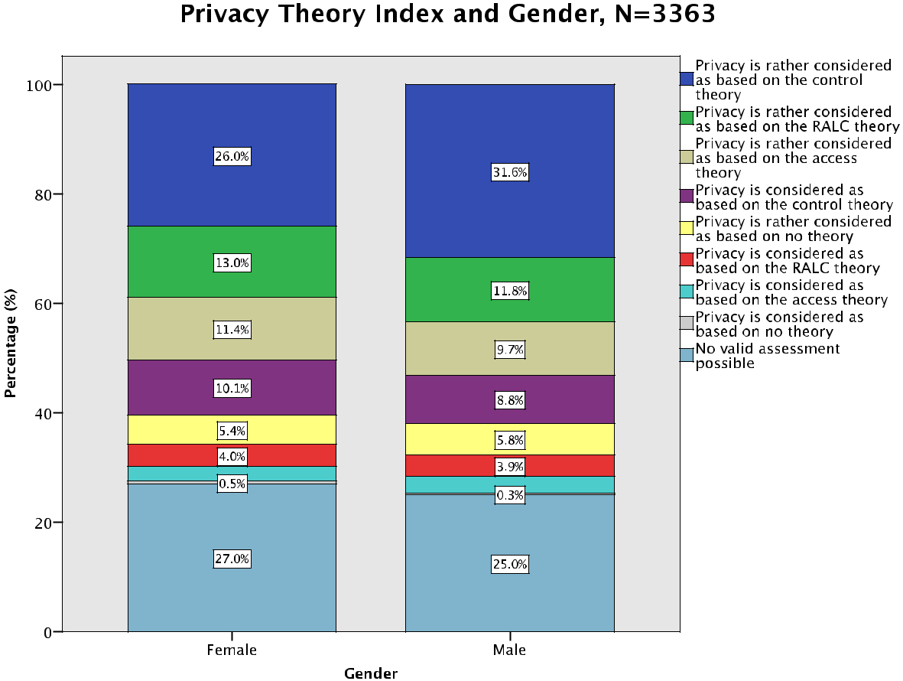

Figure 21: Privacy theory index and gender

36.1% of the female and 40.4% of the male respondents consider or rather consid-‐ er privacy as based on the control theory. Moreover, 17.0% of women and 15.7% of men (rather) consider privacy as based on the RALC theory and 14.1% of the female and 12.8% of the male students consider or rather consider privacy as based on the access theory. 5.9% of women and 6.1% of men (rather) consider privacy as based on no theory.
The Internet & Surveillance - Research Paper Series: 2012 |  |  |  |  |  |  |  |  |  |  |  |  |  |  |  |  |  | 61
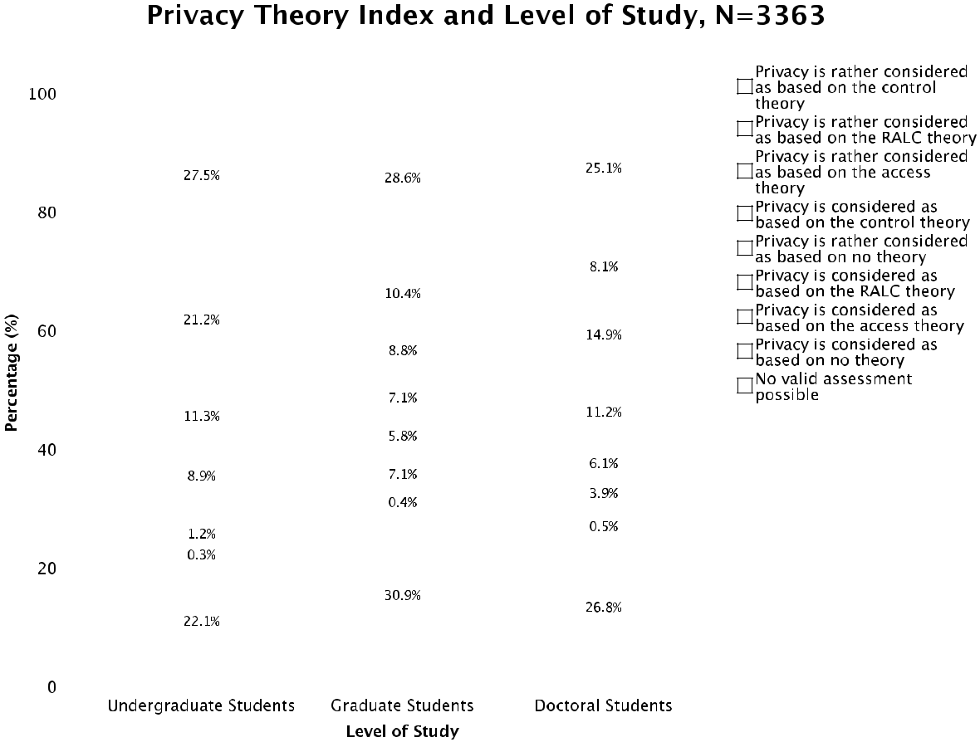

Figure 22: Privacy theory index and level of study

36.4% of the undergraduate, 35.7% of the graduate, and 36.3% of the doctoral stu-‐ dents consider or rather consider privacy as based on the control theory. 22.3% of undergraduates, 17.5% of graduates, and 12.0% of postgraduates (rather) consider privacy as based on the RALC theory. In addition, 14.1% of the undergraduate, 9.8% of the graduate, and 18.3% of the PhD students consider or rather consider privacy as based on the access theory.
62 Thomas Allmer
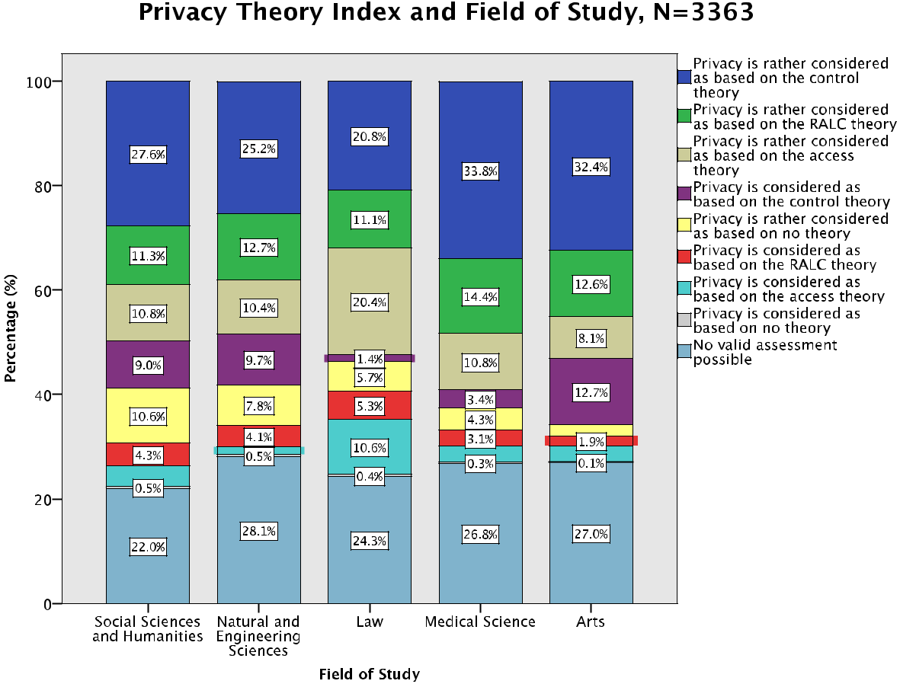

Figure 23: Privacy theory index and field of study

36.6% of the students of social sciences and humanities, 34.9% of the students of natural and engineering sciences, 22.2% of the students of law, 37.2% of the students of medical science, and 45.1% of the students of arts consider or rather consider pri-‐ vacy as based on the control theory. Besides, 14.7% of the students of social sciences and humanities, 11.8% of the students of natural and engineering sciences, 31.0% of the students of law, 13.8% of the students of medical science, and 11.2% of the stu-‐ dents of arts (rather) consider privacy as based on the access theory. These results show that the students of law consider privacy different compared to the other stu-‐ dents. Only a fifth consider privacy as based on the control theory, but nearly a third consider privacy as based on the access theory. One reason could be that jurists tend to learn more about laws and are more frequently confronted with rights. They there-‐ fore consider privacy as based on the access theory to a certain extent, which is more a rights-‐based and objective conception of privacy, whereas the control theory is more of a subjective theory oriented on choice independent of law. It seems as stu-‐ dents of law find the protection of privacy important in order to guarantee the “right to be let alone” (Warren and Brandeis 1890, 193).
The Internet & Surveillance - Research Paper Series: 2012 | 63

References

Acquisti, Alessandro, and Ralph Gross. 2006. “Imagined Communities: Awareness, Information Sharing, and Privacy on the Facebook.” In Proceedings of 6th Work-‐ shop on Privacy Enhancing Technologies, edited by Phillipe Golle and George

Danezis, 36-‐58. Cambridge: Robinson College.

Albrechtslund, Anders. 2008. “Online Social Networking as Participatory Surveil-‐ lance.” First Monday 13 (3). Accessed January 11, 2011.

http://firstmonday.org/htbin/cgiwrap/bin/ojs/index.php/fm/article/view/21 42/1949.

Alby, Tom. 2007. Web 2.0: Konzepte, Anwendungen, Technologien. München: Hanser.

Allen, Anita. 1988. Uneasy Access: Privacy for Women in a Free Society. Totowa: Row-‐

man & Littlefield.

Allmer, Thomas. 2011. “A Critical Contribution to Theoretical Foundations of Privacy Studies.” Journal of Information, Communication & Ethics in Society 9 (2): 83-‐

101.

Andrejevic, Mark. 2010. “Social Network Exploitation.” In A Networked Self: Identity, Community, and Culture on Social Network Sites, edited by Zizi Papacharissi, 82-‐
101. New York: Routledge.

Austrian Federal Ministry for Science and Research. 2012. “Uni:Data -‐ Datawarehouse Hochschulbereich des Bundesministeriums für Wissenschaft und Forschung.”

Accessed March 5. https://eportal.bmbwk.gv.at.

Babbie, Earl. 2010. The Practice of Social Research. 12th ed. Belmont: Wadsworth Cengage Learning.
Batinic, Bernad, Ulf-‐Dietrich Reips, and Michael Bosnjak, eds. 2002. Online Social Sci-‐ ences. Seattle: Hogrefe & Huber.

Baudrillard, Jean. 2006. Simulacra and Simulation. 15th ed. Michigan: University of Michigan.

Baudrillard, Jean. 2007. Forget Foucault. Los Angeles: Semiotext(e).

Beatty, Paul, and Gordon Willis. 2011. “Research Synthesis: The Practice of Cognitive

Interviewing.” Public Opinion Quarterly 71 (2): 287-‐311.

Beer, David, and Roger Burrows. 2007. “Sociology and, of and in Web 2.0: Some Initial Considerations.” Sociological Research Online 12 (5).

Beer, David. 2008. “Social Network(ing) Sites Revisiting the Story So Far: A Response to danah boyd & Nicole Ellison.” Journal of Computer-‐Mediated Communication 13 (2): 516-‐529.

Berg, Bruce. 2001. Qualitative Research Methods for the Social Sciences. 4th ed. Boston:

Allyn & Bacon.

Bok, Sissela. 1983. Secrets: On the Ethics of Concealment and Revelation. New York:

Pantheon Books.

boyd, danah. 2007. “Why Youth (Heart) Social Network Sites: The Role of Networked Publics in Teenage Social Life.” In Youth, Identity, and Digital Media, edited by David Buckingham, 119-‐142. Cambridge: MIT Press.
64 Thomas Allmer

boyd, danah, and Nicole Ellison. 2007. “Social Networking Sites: Definition, History, and Scholarship.” Journal of Computer-‐Mediated Communication 13 (1).

boyd, danah, and Eszter Hargittai. 2010. “Facebook Privacy Settings: Who Cares?” First Monday 15 (8). Accessed December 16, 2010.

http://firstmonday.org/htbin/cgiwrap/bin/ojs/index.php/fm/article/view/30 86/2589.

Brenner, Viktor. 2002. “Generalizability Issues in Internet-‐Based Survey Research: Implications for the Internet Addiction Controversy.” In Online Social Sciences, edited by Bernad Batinic, Ulf-‐Dietrich Reips, and Michael Bosnjak, 93-‐114. Seat-‐
tle: Hogrefe & Huber.

Bryman, Alan. 2008. Social Research Methods. Oxford: Oxford University Press.

Burg, Thomas, ed. 2003. BlogTalks. Norderstedt: Books on Demand.

Burg, Thomas, ed. 2004. BlogTalks 2.0. Norderstedt: Books on Demand.

Christofides, Emily, Amy Muise, and Serge Desmarais. 2009. “Information Disclosure and Control on Facebook: Are They Two Sides of the Same Coin or Two Differ-‐ ent Processes?” CyberPsychology & Behavior 12 (3): 341-‐345.

Cook, Colleen, Fred Heath, and Russel Thompson. 2000. “A Meta-‐Analysis of Response Rates in Web-‐ or Internet-‐Based Surveys.” Educational and Psychological Meas-‐ urement 60 (6): 821-‐836.

Couper, Mick. 2000. “Web Surveys: A Review of Issues and Approaches.” Public Opin-‐

ion Quarterly 64 (4): 464-‐494.

Davis, Angela. 1998. “Women and Capitalism: Dialectics of Oppression and Libera-‐ tion.” In The Angela Davis Reader, edited by Joy James, 161-‐192. Malden: Black-‐ well.

Debatin, Bernhard, Jennette Lovejoy, Ann-‐Kathrin Horn, and Brittany Hughes. 2009. “Facebook and Online Privacy: Attitudes, Behaviors, and Unintended Conse-‐

quences.” Journal of Computer-‐Mediated Communication 15 (1): 83-‐108.

DeCew, Judith. 1986. “The Scope of Privacy in Law and Ethics.” Law and Philosophy 5

(2): 145-‐173.

Deleuze, Gilles. 1988. Foucault. Minneapolis: University of Minnesota Press.

Deleuze, Gilles. 1992. “Postscript on the Societies of Control.” October (59): 3-‐7. Dwyer, Catherine, Starr Hiltz, and Katia Passerini. 2007. "Trust and Privacy Concern

within Social Networking Sites: A Comparison of Facebook and Myspace." In Proceedings of the 13th Americas Conference on Information Systems. Keystone:

Association for Information Systems.

Dwyer, Catherine, Starr Hiltz, Marshall Poole, Julia Gussner, Felicitas Hennig, Sebas-‐ tian Osswald, Sandra Schliesslberger, and Birgit Warth. 2010. “Developing Reli-‐ able Measures of Privacy Management within Social Networking Sites.” In Pro-‐ ceedings of the 43rd Hawaii International Conference on System Sciences, 2968-‐ 2977. Los Alamitos: IEEE Computer Society.

Ellison, Nicole, Charles Steinfield, and Cliff Lampe. 2007. “The Benefits of Facebook “Friends:” Social Capital and College Students’ Use of Online Social Network Sites.” Journal of Computer-‐Mediated Communication 12 (4): 1143-‐1168.
The Internet & Surveillance - Research Paper Series: 2012 | 65

Etzioni, Amitai. 1999. The Limits of Privacy. New York: Basic Books.

Federal Institute Statistics Austria. 2011. “ICT Usage in Households in 2010.” Ac-‐

cessed March 27.

http://www.statistik.at/web_de/statistiken/informationsgesellschaft/ikt-‐ einsatz_in_haushalten/index.html.

Fernback, Jan, and Zizi Papacharissi. 2007. “Online Privacy as Legal Safeguard: The Relationship among Consumer, Online Portal, and Privacy Policies.” New Media

- Society 9 (5): 715-‐734.

Field, Andy. 2009. Discovering Statistics Using SPSS. 3rd ed. London: SAGE Publica-‐ tions.
Fiske, John. 1998. “Surveilling the City: Whiteness, the Black Man and Democratic To-‐

talitarianism.” Theory Culture Society 15 (2): 67-‐88.

Fiske, John. 1999. Media Matters: Race and Gender in U.S. Politics. 3rd ed. Minneapolis:

University of Minnesota Press.

Fogel, Joshua, and Elham Nehmad. 2009. “Internet Social Network Communities: Risk Taking, Trust, and Privacy Concerns.” Computers in Human Behavior 25 (1): 153-‐160.

Foucault, Michel. 1995. Discipline and Punish: The Birth of the Prison. 2nd ed. New

York: Vintage Books.

Fried, Charles. 1968. “Privacy.” The Yale Law Journal 77 (3): 475-‐493.

Froomkin, Michael. 2000. “The Death of Privacy?” Stanford Law Review 52 (5): 1461-‐ 1543.

Fuchs, Christian. 2009. Social Networking Sites and the Surveillance Society: A Critical Case Study of the Usage of Studivz, Facebook, and Myspace by Students in Salz-‐ burg in the Context of Electronic Surveillance. Salzburg: Research Group Unified
Theory of Information.

Fuchs, Christian. 2010a. “studiVZ: Social Networking in the Surveillance Society.” Eth-‐

ics and Information Technology 12 (2): 171-‐185.

Fuchs, Christian. 2010b. “Social Networking Sites and Complex Technology Assess-‐ ment.“ International Journal of E-‐Politics 1 (3): 19-‐38.

Fuchs, Christian. 2011. “Towards an Alternative Concept of Privacy.” Journal of Infor-‐ mation, Communication and Ethics in Society 9 (4): 220-‐237.

Fuchs, Christian. 2012. “Critique of the Political Economy of Web 2.0 Surveillance.” In Internet and Surveillance: The Challenge of Web 2.0 and Social Media, edited by

Christian Fuchs, Kees Boersma, Anders Albrechtslund, and Marisol Sandoval, 31-‐70. New York: Routledge.

Fuchs, Christian, Kees Boersma, Anders Albrechtslund, and Marisol Sandoval, eds. 2012. Internet and Surveillance: The Challenges of Web 2.0 and Social Media. New

York: Routledge.

Gandy, Oscar. 1993. The Panoptic Sort: A Political Economy of Personal Information.

Boulder: Westview Press.

Gavison, Ruth. 1980. “Privacy and the Limits of Law.” Yale Law Journal 89 (3): 421-‐

471.

66 Thomas Allmer

Gerety, Tom. 1977. “Redefining Privacy.” Harvard Civil Rights-‐Civil Liberties Law Re-‐ view 12 (2): 233-‐296.

Gerstein, Robert. 1970. “Privacy and Self-‐Incrimination.” Ethics 80 (2): 87-‐101.

Gerstein, Robert. 1978. “Intimacy and Privacy.” Ethics 89 (1): 76-‐81.

Giddens, Anthony. 1995. A Contemporary Critique of Historical Materialism. 2nd ed.

Stanford: Stanford University Press.

Gilliom, John. 2001. Overseers of the Poor: Surveillance, Resistance, and the Limits of

Privacy. Chicago: University of Chicago Press.

Gordon, Alan. 2002. “Surveymonkey.Com—Web-‐Based Survey and Evaluation Sys-‐ tem.” Internet and Higher Education 5: 83-‐87.

Göritz, Anja. 2006. “Incentives in Web Studies: Methodological Issues and a Review.”

International Journal of Internet Science 1 (1): 58-‐70.

Gouldner, Alvin. 1976. The Dialectic of Ideology and Technology: The Origins, Gram-‐

mar, and Future of Ideology. New York: Seabury Press.

Hewson, Claire, Dianna Laurent, and Carl Vogel. 1996. “Proper Methodologies for Psy-‐ chological and Sociological Studies Conducted Via the Internet.” Behavior Re-‐ search Methods, Instruments, & Computers 28: 186-‐191.

Hinduja, Sameer, and Justin Patchin. 2008. “Personal Information of Adolescents on the Internet: A Quantitative Content Analysis of Myspace.” Journal of Adoles-‐ cence 31 (1): 125-‐146.

Johns, Mark, Shing-‐Ling Chen, and Jon Hall, eds. 2004. Online Social Research. New York: Peter Lang.

Johnston, Jerome, and Christopher Walton. 1995. “Reducing Response Effects for Sen-‐ sitive Questions: A Computer-‐Assisted Self Interview with Audio.” Social Science Computer Review 13 (3): 304-‐319.

Kolbitsch, Josef, and Hermann Maurer. 2006. “The Transformation of the Web: How Emerging Communities Shape the Information We Consume.” Journal of Univer-‐ sal Computer Science 12 (2): 187-‐213.

Krippendorff, Klaus. 2004. Content Analysis: An Introduction to Its Methodology. 2nd

ed. Thousand Oaks: SAGE Publications.

Lewis, Kevin, Jason Kaufman, and Nicholas Christakis. 2008. “The Taste for Privacy: An Analysis of College Student Privacy Settings in an Online Social Network.” Journal of Computer-‐Mediated Communication 14 (1): 79-‐100.

Livingstone, Sonia. 2008. “Taking Risky Opportunities in Youthful Content Creation:

Teenagers' Use of Social Networking Sites for Intimacy, Privacy and Self-‐ Expression.” New Media & Society 10 (3): 393-‐411.

Lyon, David. 1994. The Electronic Eye: The Rise of Surveillance Society. Minneapolis:

University of Minnesota Press.

Lyon, David. 2001. Surveillance Society: Monitoring Everyday Life: Issues in Society.

Maidenhead: Open University Press.

Macpherson, Crawford. 1990. The Political Theory of Possessive Individualism: Hobbes

to Locke. 13th ed. Oxford: Oxford University Press.
The Internet & Surveillance - Research Paper Series: 2012 | 67

Marx, Gary. 1988. Undercover: Police Surveillance in America. Berkeley: University of

California Press.

Marx, Gary. 2002. “What’s New About the ‘New Surveillance’? Classifying for Change and Continuity.” Surveillance & Society 1 (1): 8-‐29.

May, Tim. 1997. Social Research: Issues, Methods and Process. Buckingham: Open Uni-‐

versity Press.

Miller, Arthur. 1971. The Assault on Privacy: Computers, Data Banks, and Dossiers. Ann

Arbor: University of Michigan Press.

Moor, James. 1997. “Towards a Theory of Privacy in the Information Age.” Computers and Society 27 (3): 27-‐32.

Murphy, Robert. 1964. “Social Distance and the Veil.” American Anthropologist 66 (6):

1257-‐1274.

Norris, Clive, and Gary Armstrong. 1999. The Maximum Surveillance Society: The Rise

of CCTV. Oxford: Berg.

O’Reilly, Tim 2005. “What Is Web 2.0?” Accessed January 11, 2011:

http://www.oreillynet.com/pub/a/oreilly/tim/news/2005/09/30/what-‐is-‐ web-‐20.html?page=1

Ogura, Toshimaru. 2006. “Electronic Government and Surveillance-‐Oriented Society.” In Theorizing Surveillance: The Panopticon and Behind, edited by David Lyon,
270-‐295. Portland: Willan Publishing.

Parent, William. 1983a. “Privacy, Morality, and the Law.” Philosophy & Public Affairs 12 (4): 269-‐288.
Parent, William. 1983b. “A New Definition of Privacy for the Law.” Law and Philosophy 2 (3): 305-‐338.
Posner, Richard. 1978. “An Economic Theory of Privacy.” Regulations (May-‐June): 19-‐ 26.
Posner, Richard. 1981. “The Economics of Privacy.” The American Economic Review 71

(2): 405-‐409.

Poster, Mark. 1990. The Mode of Information: Poststructuralism and Social Context.

Cambridge: Polity Press, 1993.

Presser, Stanley, and Johnny Blair. 1994. “Survey Pretesting: Do Different Produce Different Results.” In Sociological Methodology, edited by Peter Marsden, 73-‐

104. San Francisco: Jossey-‐Bass.

Prosser, William. 1960. “Privacy.” California Law Review 48 (3): 383-‐423.

Punch, Keith. 2005. Introduction to Social Research: Quantitative and Qualitative Ap-‐

proaches. London: Sage.

Rachels, James. 1975. “Why Privacy Is Important.” Philosophy and Public Affairs 4 (4):

323-‐333.

Reiman, Jeffrey. 1976. “Privacy, Intimacy, and Personhood.” Philosophy and Public Affairs 6 (1): 26-‐44.

Rule, James. 1973. Private Lives and Public Surveillance: Social Control in the Computer

Age. New York: Schocken Books.
68 Thomas Allmer

Rule, James. 2007. Privacy in Peril: How We Are Sacrificing a Fundamental Right in

Exchange for Security and Convenience. Oxford: Oxford University Press.

Sandoval, Marisol. 2012. “A Critical Empirical Case Study of Consumer Surveillance on Web 2.0.” In Internet and Surveillance: The Challenge of Web 2.0 and Social Me-‐ dia, edited by Christian Fuchs, Kees Boersma, Anders Albrechtslund, and Mari-‐

sol Sandoval, 147-‐169. New York: Routledge.

Saveri, Andrea, Howard Rheingold, and Kathi Vian. 2005. Technologies of Cooperation.

Palo Altho: Institute for the Future.

Scanlon, Thomas. 1975. “Thomson on Privacy.” Philosophy & Public Affairs 4 (4): 315-‐ 322.

Schmidt, William. 1997. “World-‐Wide Web Survey Research: Benefits, Potential Prob-‐ lems, and Solutions.” Behavior Research Methods Instruments & Computers 29
(2): 274-‐279.

Schoeman, Ferdinand David. 1984. Philosophical Dimensions of Privacy: An Anthology.

Cambridge: Cambridge University Press.

Schoeman, Ferdinand. 1992. Privacy and Social Freedom. Cambridge: Cambridge Uni-‐ versity Press.
Scholz, Trebor. 2008. “Market Ideology and the Myths of Web 2.0.” First Monday 13

(3). Accessed February 7, 2011. http://firstmonday.org/htbin/cgiwrap/bin/ojs/index.php/fm/article/view/21 38/1945.

Shils, Edward. 1966. “Privacy: Its Constitution and Vicissitudes.” Law and Contempo-‐

rary Problems 31 (2): 281-‐306.

Shirky, Clay. 2008. Here Comes Everybody: The Power of Organizing without Organiza-‐

tions. London: Penguin.

Sills, Stephen, and Chunyan Song. 2002. “Innovations in Survey Research: An Applica-‐

tion of Web-‐Based Surveys.” Social Science Computer Review 20 (1): 22-‐30.

Statistical Office of the European Union. 2012. “Eurostat.” Accessed March 28, 2012.

http://epp.eurostat.ec.europa.eu/portal/page/portal/eurostat/home

Tavani, Herman. 2007. “Philosophical Theories of Privacy: Implications for an Ade-‐

quate Online Privacy Policy.” Metaphilosophy 38 (1): 1-‐22.

Tavani, Herman. 2008. “Informational Privacy: Concepts, Theories, and Controver-‐ sies.” In The Handbook of Information and Computer Ethics, edited by Kenneth Himma and Herman Tavani, 131-‐164. Hoboken: Wiley.

Tuten, Tracy, David Urban, and Michael Bosnjak. 2002. “Internet Surveys and Data Quality: A Review.” In Online Social Sciences, edited by Bernad Batinic, Ulf-‐

Dietrich Reips, and Michael Bosnjak, 7-‐26. Seattle: Hogrefe & Huber.

UNESCO Institute for Statistics. 2012. “ISCED: International Standard Classification of

Education.” Accessed April 12, 2012.

http://www.uis.unesco.org/Education/Pages/international-‐standard-‐ classification-‐of-‐education.aspx

Warren, Samuel, and Louis Brandeis. 1890. “The Right to Privacy.” Harvard Law Re-‐ view 4 (5): 193-‐220.
The Internet & Surveillance - Research Paper Series: 2012 | 69

Webster, Frank, and Kevin Robins. 1993. “’I’ll Be Watching You’: Comment on Sewell

and Wilkinson.” Sociology 27 (2): 243-‐252.

Westin, Alan. 1967. Privacy and Freedom. New York: Atheneum.

Zhang, Yin. 2000. “Using the Internet for Survey Research: A Case Study.” Journal of

the American Society for Information Science 51 (1): 57-‐68.

