OMB Approved No. 2900-0564
Respondent Burden: 15 Minutes
Expiration Date: 02/28/2019
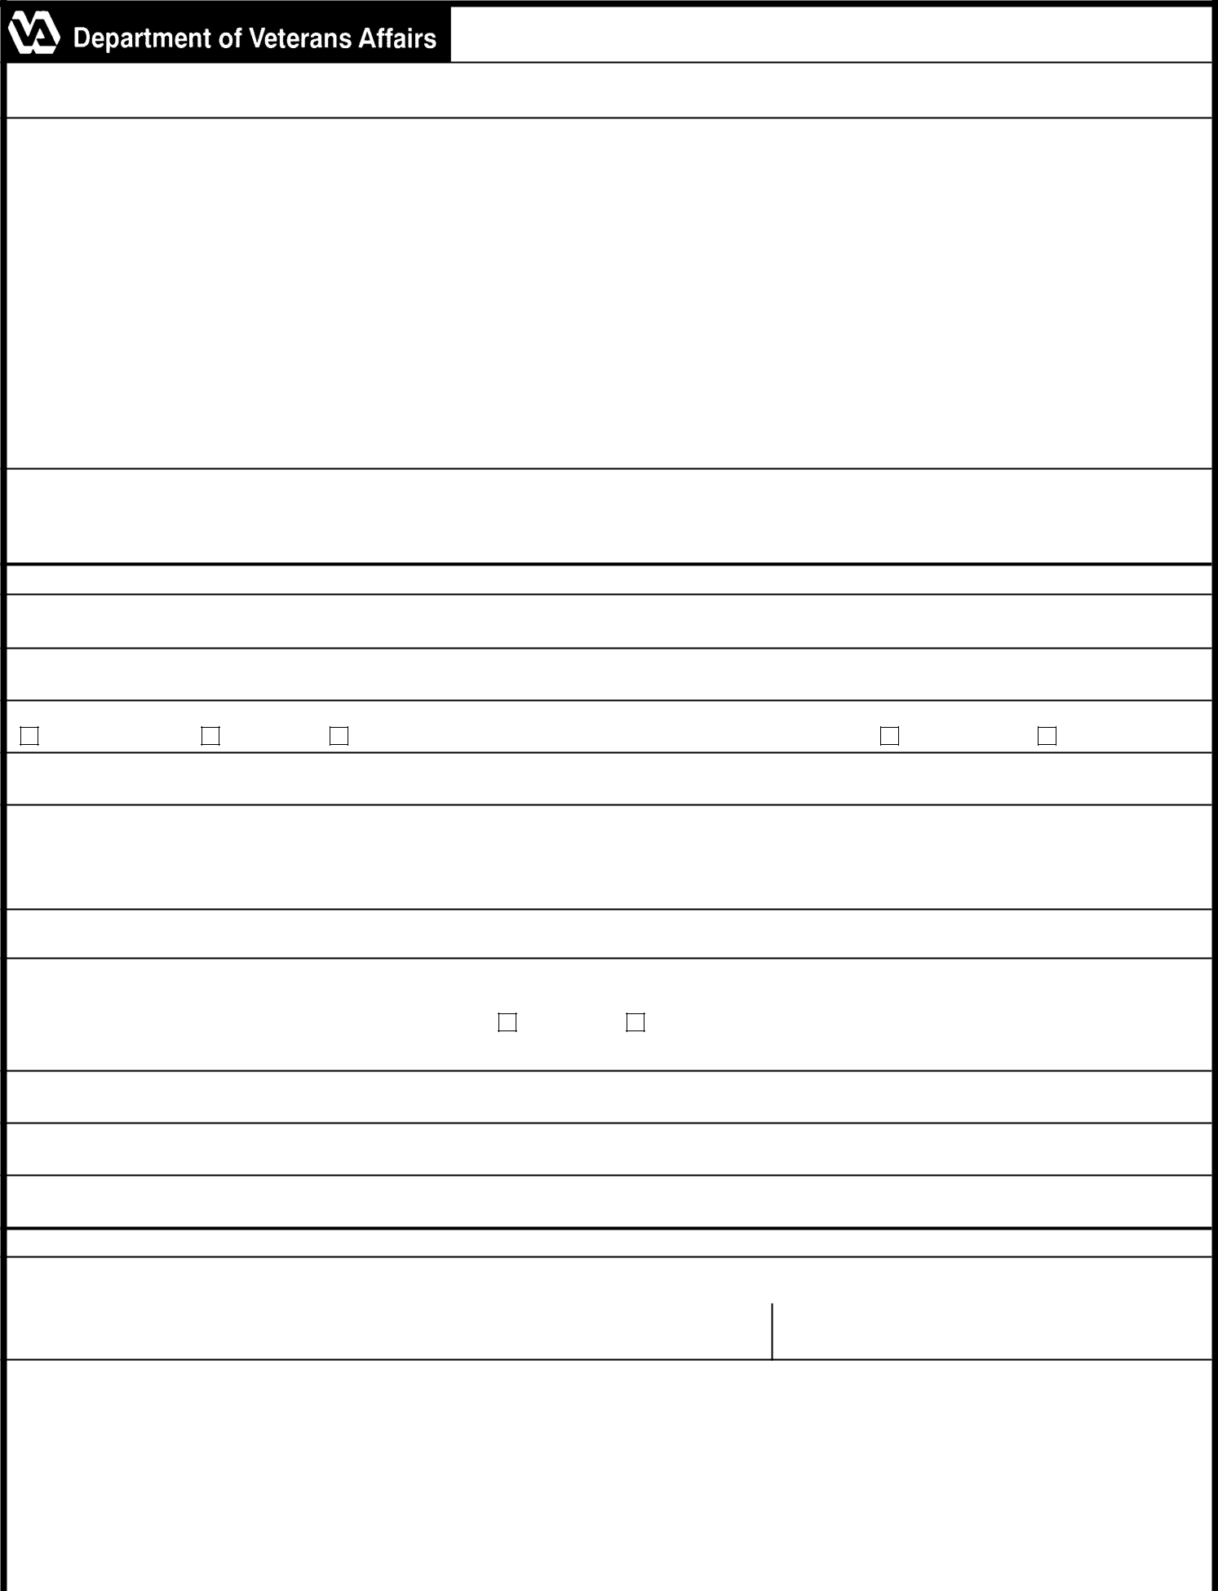

DIRECT DEPOSIT ENROLLMENT

IMPORTANT: You can use this form to enroll in Direct Deposit or to make a change to an existing direct deposit account. Please read the Privacy Act and Respondent Burden information shown below.
ATTENTION VA BENEFICIARY!
WE'VE MADE ENROLLING IN DIRECT DEPOSIT EASIER THAN EVER!
CALL TOLL FREE - 1-877-838-2778

or TDD 1-800-829-4833 (Telephone Device for the Hearing Impaired)

Direct Deposit is the safest, fastest and most cost efficient method to receive your payment. In addition, you no longer have to worry about your check being late, lost, or stolen. NOTE: The "Debt Collection Improvement Act of 1996" which was signed into law on April 26, 1996 required all Federal payments to be made by Electronic Fund Transfer (EFT or Direct Deposit) beginning January 1, 1999. Waivers will be available where the conversion from paper checks imposes a hardship. Write to the address shown below for more information concerning a waiver. To have your VA compensation, pension, education, or spina bifida payment deposited into your account right away with Direct Deposit just call VA's toll-free number above or complete this form and mail to:
Department of Veterans Affairs
125 S. Main Street Suite B
Muskogee OK 74401-7004

When you call, be sure to have a personal check or bank statement available as well as your VA Claim Number or Social Security Number. The VA representative will ask for information from these documents to start your Direct Deposit. If you prefer to enroll by mail, just complete the information below, and attach a voided personal check from your checking account or call your Financial Institution and verify the information requested below for a savings account.

SECTION I - VA BENEFICIARY INFORMATION

NAME OF BENEFICIARY (Last, First, MI) (Please Print)

BENEFICIARY CLAIM NUMBER

TYPE OF BENEFIT COMPENSATION

PENSION

EDUCATION (CHAPTERS 30, 33, 1606,1607 & National Call to Service)

CHAPTER 18

CHAPTER 31

VA CLAIM NUMBER OR SOCIAL SECURITY NUMBER

TELEPHONE NUMBER (PLEASE PROVIDE YOUR TELEPHONE NUMBER IN THE EVENT THAT WE NEED TO CONTACT YOU) (INCLUDE AREA CODE)

DAYTIME TELEPHONE NUMBER | EVENING TELEPHONE NUMBER

SECTION II - FINANCIAL INSTITUTION INFORMATION

PLEASE ATTACH A VOIDED PERSONAL CHECK AND SKIP TO SECTION III OR CALL YOUR FINANCIAL INSTITUTION FOR THE FOLLOWING INFORMATION:

ROUTING TRANSIT NUMBER

ACCOUNT NUMBER (PLEASE CHECK THE APPROPRIATE BOX |  | CHECKING |  | SAVINGS)

NAME OF FINANCIAL INSTITUTION

ADDRESS OF FINANCIAL INSTITUTION

TELEPHONE NUMBER OF FINANCIAL INSTITUTION (Include Area Code)

SECTION III - PAYEE CERTIFICATION

I CERTIFY THAT I am entitled to the payment above, and that I have read and understand this form. In signing this form, I authorize my payment to be sent to the financial institution named above, to be deposited to the designated account.
SIGNATURE OF PAYEE (Do NOT print) | DATE SIGNED

Privacy Act Notice: VA will not disclose information collected on this form to any source other than what has been authorized under the Privacy Act of 1974 or Title 38, Code of Federal Regulations 1.576 for routine uses as identified in the VA system of records, 58VA21/22/28, Compensation, Pension, Education, Vocational Rehabilitation and Employment Records - VA, published in the Federal Register. Your obligation to respond is voluntary. The information solicited under authority of Title 31 Code of Federal Regulations, Section 210.4 will be used to process the payment data from VA to your account at the designated financial institution. Giving us your Social Security Number (SSN) is mandatory. Applicants are required to provide their SSN under Title 38, U.S.C. 5101 (c) (1). VA will not deny an individual benefits for refusing to provide his or her SSN unless the disclosure of the SSN is required by a Federal Statute of law in effect prior to January 1, 1975, and still in effect. The requested information is considered relevant and necessary to determine maximum benefits provided by law. The responses you submit are considered confidential (38 U.S.C. 5701).

Respondent Burden: We need this information to ensure proper transmission of your funds via electronic transfer to your financial institution (31 CFR 208.3 and 210.4). Title 38, United States Code, allows us to ask for this information. We estimate that you will need an average of 15 minutes to review the instructions, find the information, and complete this form. VA cannot conduct or sponsor a collection of information unless a valid OMB control number is displayed. You are not required to respond to a collection of information if this number is not displayed. Valid OMB control numbers can be located on the OMB Internet Page at www.reginfo.gov/public/do/PRAMain. If desired, you can call 1-800-827-1000 to get information on where to send comments or suggestions about this form.

VA FORM | 24-0296 | SUPERSEDES VA FORM 24-0296, NOV 2009,
MAY 2016 | 24-0296 | WHICH WILL NOT BE USED.

