COMMERCIAL PROPERTY INSPECTION CHECKLIST 

 |  | SITE NAME / ADDRESS
 | PREPARED BY | DATE
 | TASK / ITEM | CONDITION / COMMENTS
RECEPTION / ENTRY
 | WALLS
 | TRIM
 | WAINSCOT
 | PAINT
 | PAPER
 | FLOORS
 | BASEBOARD
 | WINDOWS
 | GLASS
 | DOORS
 | LOCKS / HARDWARE
 | CEILING
 | LIGHTING
 | LIGHTING SWITCHES
 | ELECTRICAL OUTLETS
 | PHONE JACKS
 | INTERNET PORT
 | MAIL DROP
 | SIGNAGE
 | EMERGENCY / INSTRUCTIONAL SIGNAGE
 | DIRECTORY
 | BUILT-INS
 | ELEVATOR SWITCHES
 | ELEVATOR ENTRY

 | TASK / ITEM | CONDITION / COMMENTS
RESTROOMS
 | WALLS
 | TRIM
 | WAINSCOT
 | PAINT
 | PAPER
 | FLOORS
 | BASEBOARD
 | WINDOWS
 | GLASS
 | MIRRORS
 | DOORS
 | LOCKS / HARDWARE
 | CEILING
 | LIGHTING
 | LIGHTING SWITCHES
 | ELECTRICAL OUTLETS
 | VENTILATION
 | SINKS
 | RUNNING WATER
 | TOILETS
 | URINALS
 | PLUMBING
 | DIVIDERS
 | WASTEBASKETS
 | VANITY / SHELF
 | SOAP DISPENSER
 | SANITIZER DISPENSER
 | TOWEL DISPENSER
 | HAND DRYING UNIT
 | PRODUCT DISPENSER
 | CHANGING TABLE / UNIT
 | SIGNAGE
 | BUILT-INS

 | TASK / ITEM | CONDITION / COMMENTS
GENERAL OFFICE AREA
 | WALLS
 | TRIM
 | WAINSCOT
 | PAINT
 | PAPER
 | FLOORS
 | BASEBOARD
 | WINDOWS
 | GLASS
 | DOORS
 | LOCKS / HARDWARE
 | CEILING
 | LIGHTING
 | LIGHTING SWITCHES
 | ELECTRICAL OUTLETS
 | PHONE JACKS
 | INTERNET PORT
 | CABINETRY
 | SIGNAGE
 | EMERGENCY / INSTRUCTIONAL SIGNAGE
 | BUILT-INS
 | CLOSETS / COAT HOOKS
 | HEAT
 | A/C
 | VENTILATION
 | TASK / ITEM | CONDITION / COMMENTS
CORRIDORS / HALLWAYS
 | WALLS
 | TRIM
 | WAINSCOT
 | PAINT
 | PAPER
 | FLOORS

 | BASEBOARD
 | WINDOWS
 | GLASS
 | CABINETRY
 | DOORS
 | LOCKS / HARDWARE
 | CEILING
 | LIGHTING
 | LIGHTING SWITCHES
 | ELECTRICAL OUTLETS
 | VENTILATION
 | BUILT-INS
 | WASTEBASKETS
 | FIRE ALARM
 | FIRE EXTINGUISHER
 | THRESHOLDS
 | SIGNAGE
 | EMERGENCY / INSTRUCTIONAL SIGNAGE
 | TASK / ITEM | CONDITION / COMMENTS
OFFICE / ROOM 1
 | WALLS
 | TRIM
 | WAINSCOT
 | PAINT
 | PAPER
 | FLOORS
 | BASEBOARD
 | WINDOWS
 | GLASS
 | DOORS
 | LOCKS / HARDWARE
 | CEILING
 | LIGHTING
 | LIGHTING SWITCHES

 | ELECTRICAL OUTLETS
 | PHONE JACKS
 | INTERNET PORT
 | CABINETRY
 | SIGNAGE
 | BUILT-INS
 | TASK / ITEM | CONDITION / COMMENTS
OFFICE / ROOM 2
 | WALLS
 | TRIM
 | WAINSCOT
 | PAINT
 | PAPER
 | FLOORS
 | BASEBOARD
 | WINDOWS
 | GLASS
 | DOORS
 | LOCKS / HARDWARE
 | CEILING
 | LIGHTING
 | LIGHTING SWITCHES
 | ELECTRICAL OUTLETS
 | PHONE JACKS
 | INTERNET PORT
 | CABINETRY
 | SIGNAGE
 | BUILT-INS

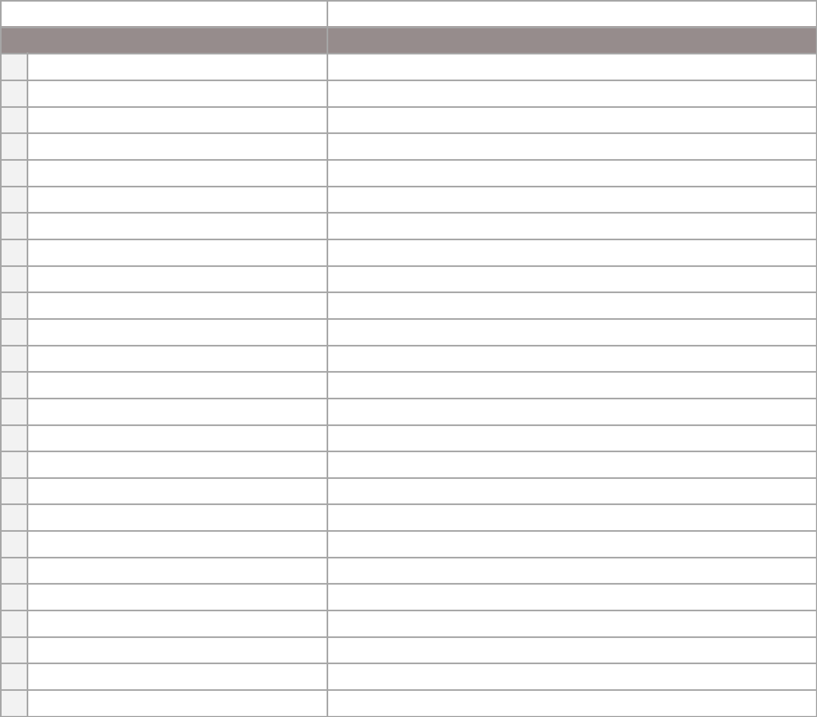  TASK / ITEM | CONDITION / COMMENTS

MISCELLANEOUS


ADDITIONAL COMMENTS

TENANT

INSPECTOR

DISCLAIMER

Any articles, templates, or information provided by Smartsheet on the website are for reference only. While we strive to keep the information up to date and correct, we make no representations or warranties of any kind, express or implied, about the completeness, accuracy, reliability, suitability, or availability with respect to the website or the information, articles, templates, or related graphics contained on the website. Any reliance you place on such information is therefore strictly at your own risk.

