
Commercial Property Building Inspection Checklist

Inspector(s): Date:

Location YES NO N/A COMMENTS

Is the property’s address clearly visible from the roadway?

Is the parking lot properly striped?

Are there an appropriate number of handicapped spots in the parking lot?

Are there designated spots for hybrids/compact cars?

Is there proper lighting in the parking lot?

Are there cracks in the pavement that need to be repaired?

Are unloading zones clearly marked?

Are there wheelchair-accessible ramps leading up to the main entrance?

Are there handrails leading up to the main entrance?

Are there any obstructions in front of fire hydrants?

Is there a trash dumpster on-site?

Are ash trays available near entrances? Or are no-smoking signs posted?

Are utility/cable boxes properly marked?

Is the property shovelled and/or plowed during the winter?

Building Exterior YES NO N/A COMMENTS

Are exit doors unlocked during business hours?

Are all entrances and exits properly marked?

Is the company’s name clearly visible?

Is the building’s roof in good shape?

Are windows and doors in need of a washing?

Is the exterior siding in good shape?

This checklist is merely a guideline. It is neither meant to be exhaustive nor meant to be construed as legal advice. It does not address all potential compliance issues with federal, provincial or local standards. Consult your licenced commercial property and casualty representative at Schill Insurance Brokers Ltd or legal counsel to address possible compliance requirements. © 2006, 2012, 2014 Zywave, Inc. All rights reserved.
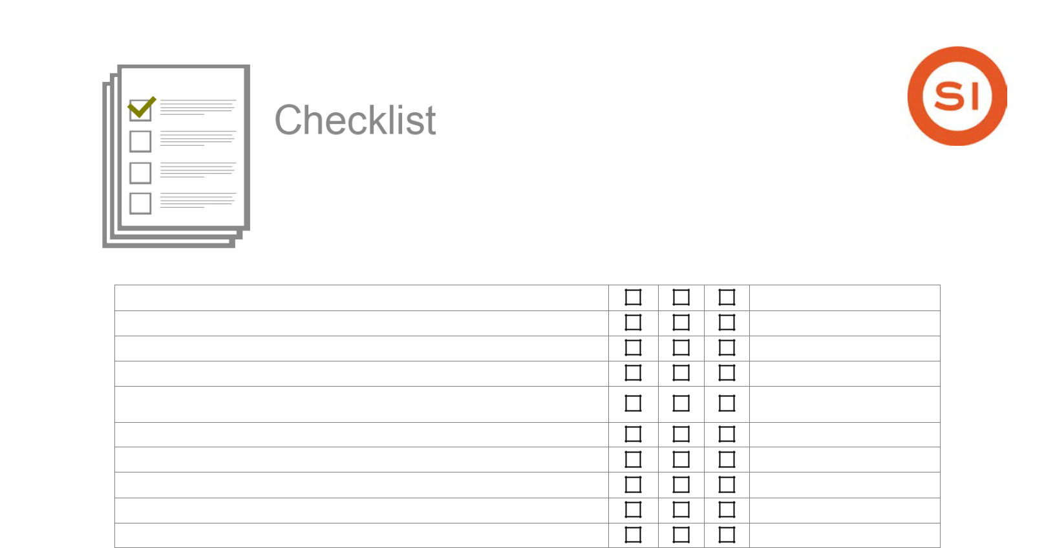
Commercial Property Building Inspection Checklist

Is the building free of vandalism?

Are “No Smoking” signs posted?

Are emergency exits clearly marked and free of obstructions?

Is there sufficient lighting on the building’s exterior?

Is the rooftop elevator penthouse properly ventilated and cleaned regularly?
Are there any cracks in the building’s exterior walls?

Are combustible materials kept away from the building?

Are there signs of weather damage?

Is the parking structure properly maintained?

Are the gutters free of debris?

Landscaping YES NO N/A COMMENTS

Does the landscaping interfere with any utility boxes?

Are there any dead trees on the property?

Are there shade-providing trees on the property?

Are there any areas with dead grass?

Is an irrigation system in place?

Are sprinklers placed far away from walkways?

Are planters properly mulched?

Is grass mowed weekly?

Are mowers/trimmers kept on-site in a locked storage building?

Are insecticides regularly applied to plants?

Are flower beds weeded regularly?

Is grass fertilized regularly?

Electrical Systems YES NO N/A COMMENTS

Are all electrical boxes, outlets and switches properly covered?

Are electrical panels properly covered and latched?

Are electrical panels free of obstructions?

Are extension cords used for temporary uses only?

Do any extension cords run through walls, ceilings or doors?

Do all electrical outlets have covers?

This checklist is merely a guideline. It is neither meant to be exhaustive nor meant to be construed as legal advice. It does not address all potential compliance issues with federal, provincial or local standards. Consult your licenced commercial property and casualty representative at Schill Insurance Brokers Ltd or legal counsel to address possible compliance requirements. © 2006, 2012, 2014 Zywave, Inc. All rights reserved.
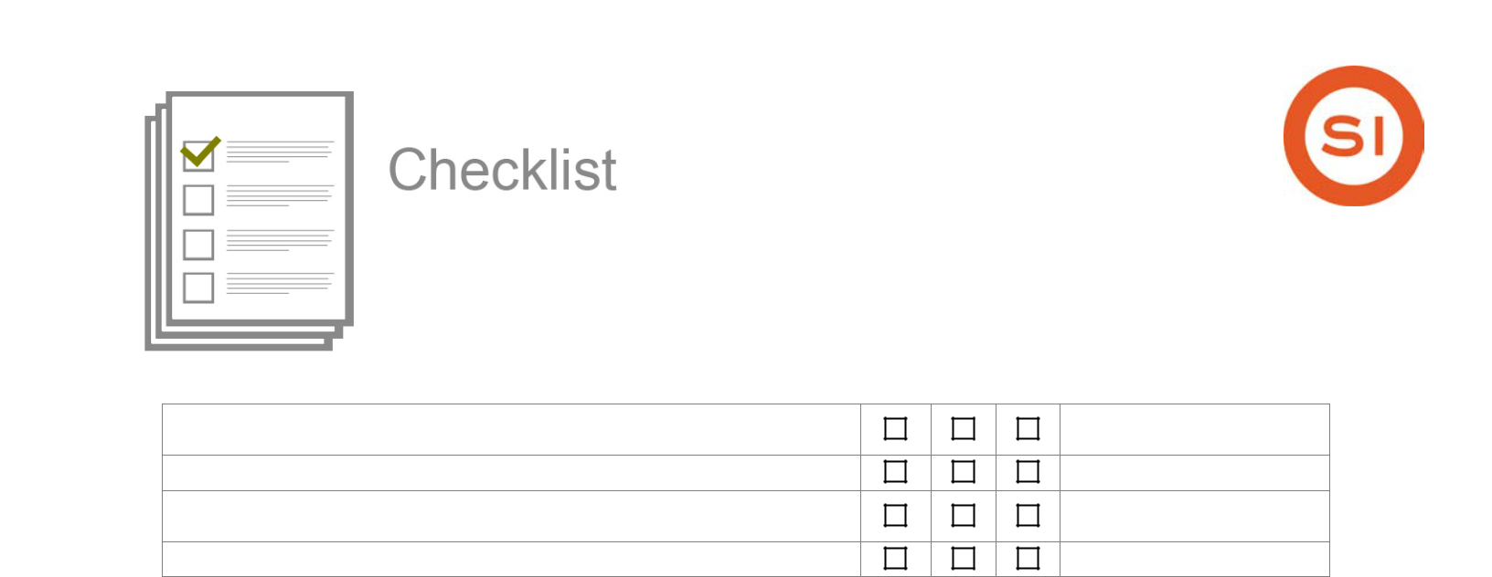
Commercial Property Building Inspection Checklist

Is equipment that requires higher voltage plugged into the proper outlets?

Are there any frayed wires in the building?

Do all outlets located within two metres of sinks and exterior doors include Ground-Fault Circuit Interrupters (GFCIs)?
Is there a lockout procedure in place?

Fire Protection YES NO N/A COMMENTS

Are there any combustibles stored in the boiler room?

Are all smoke alarms functional?

Are smoke alarms tested regularly?

Is smoking prohibited in the building?

Does the building have a sprinkler system?

Is the sprinkler system inspected annually?

Is all storage at least 45 cm below the sprinklers?

Are portable fire extinguishers readily available?

Are fire extinguishers inspected regularly?

Are fire evacuation diagrams posted throughout the building?

Are there “EXIT” signs posted above exterior doors?

Are flammable and combustible liquids properly tagged and stored?

If smoking is allowed, are smoking areas properly identified?

Heating/Cooling System YES NO N/A COMMENTS

Is the boiler room kept locked?

Are there any combustible objects kept near heaters?

Is the building’s thermostat kept at a comfortable temperature?

Are filters replaced regularly?

Are heating and cooling ducts free of obstructions?

Is the heating/cooling system set back when the building is

unoccupied?

Housekeeping YES NO N/A COMMENTS

Is trash removed from the building daily? And from site weekly?

This checklist is merely a guideline. It is neither meant to be exhaustive nor meant to be construed as legal advice. It does not address all potential compliance issues with federal, provincial or local standards. Consult your licenced commercial property and casualty representative at Schill Insurance Brokers Ltd or legal counsel to address possible compliance requirements. © 2006, 2012, 2014 Zywave, Inc. All rights reserved.
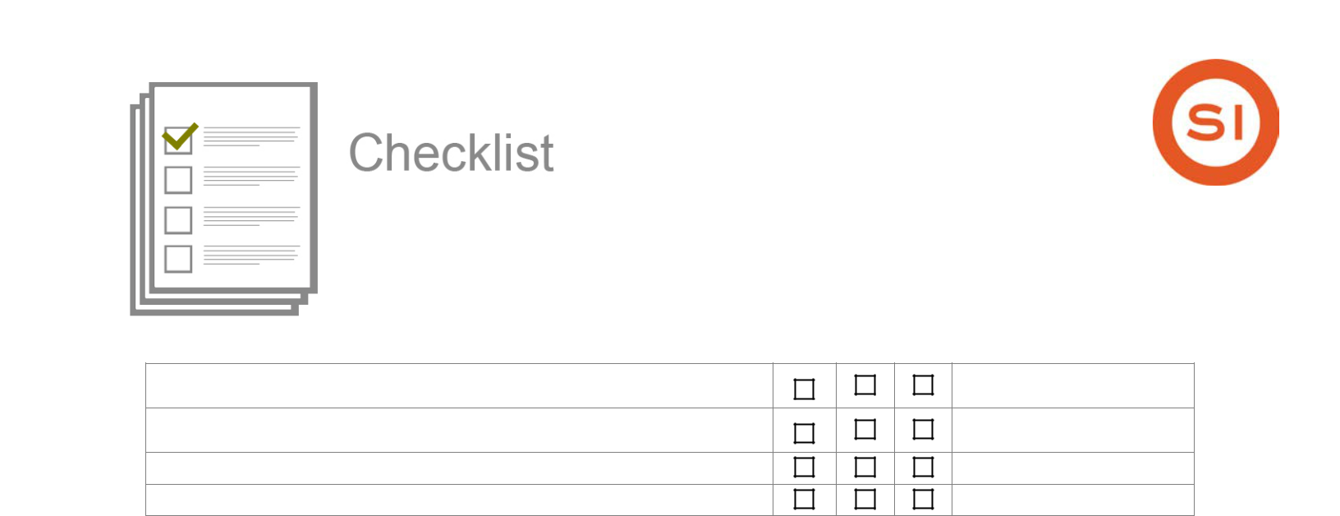
Commercial Property Building Inspection Checklist

Are bathrooms cleaned daily?

Are windows cleaned regularly?

Does the company have a recycling policy?

Are refrigerators emptied and cleaned monthly?

Storage YES NO N/A COMMENTS

Are all combustible and flammable liquids stored properly?

Is there any combustible storage in unprotected attics or crawl spaces?

Are cabinets and containers containing chemicals properly labelled?

Are spill-containment materials readily available in case of a spill?

Are Safety Data Sheets (SDS) available for hazardous substances?

This checklist is merely a guideline. It is neither meant to be exhaustive nor meant to be construed as legal advice. It does not address all potential compliance issues with federal, provincial or local standards. Consult your licenced commercial property and casualty representative at Schill Insurance Brokers Ltd or legal counsel to address possible compliance requirements. © 2006, 2012, 2014 Zywave, Inc. All rights reserved.

