Chapter 5: Finance

________________________________________________________________________

Chapter 5: Finance

Most adults have to deal with the financial topics in this chapter regardless of their job or income. Understanding these topics helps us to make wise decisions in our private lives as well as in any business situations.

Section 5.1: Basic Budgeting

Budgeting is an important step in managing your money and spending habits. To create a budget you need to identify how much money you are spending. Some expenses to keep in mind when creating a budget are rent, car payment, fuel, auto insurance, utilities, groceries, cell phone, personal, gym membership, entertainment, gifts, dining out, medical expenses, etc.

There are several apps out there that can help you budget your money. Just a few examples are Mint, Manilla, and Check. These are all free apps that help you keep track of bills and your accounts. Your bank also keeps track of your spending and what categories each item falls under. Log into your bank account online and look for “Track Spending” or a similar item. Many banks give you a pie chart showing you how much you spent in each category in the last month. You can edit your categories, change the number of months, and sometimes even set a budget goal.

Table 5.1.1: Example of Budget in Excel

When you are creating a monthly budget, many experts say if you want to have control of your money, you should know where every dollar is going. In order to keep track of this, a written budget is essential. Below is one example of a budget in Excel. This was a free template from the “Life After College” blog. There are hundreds of free templates out there so you should find the template that suits you the best – or create your own Excel budget!

________________________________________________________________________
Page 167

Chapter 5: Finance
________________________________________________________________________
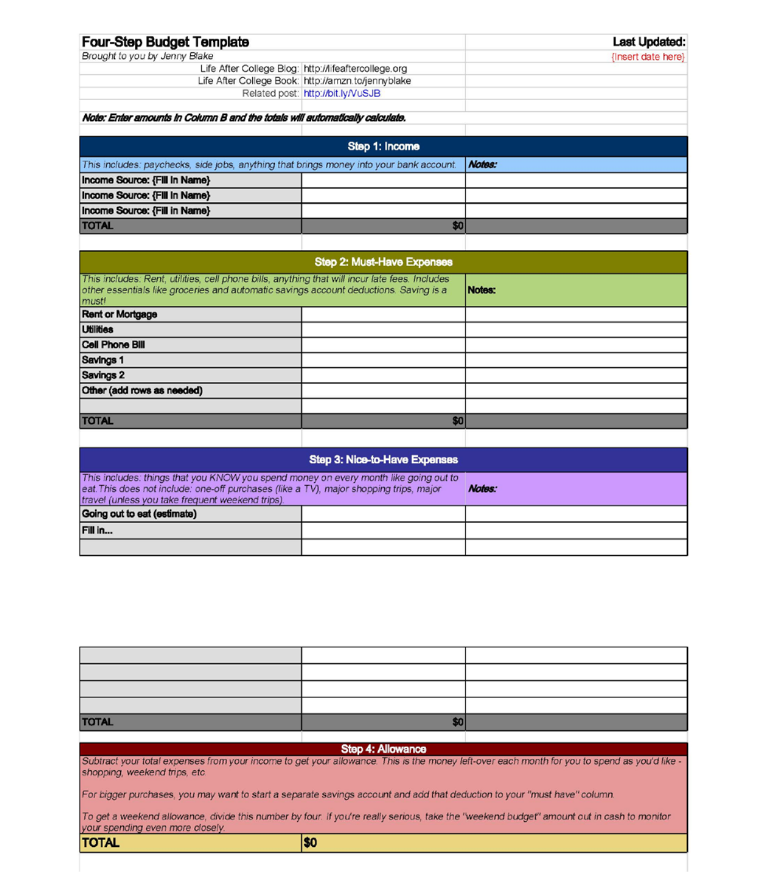

(“Four-Step Budget Template,” n.d.)

________________________________________________________________________
Page 168

Chapter 5: Finance

________________________________________________________________________

Example 5.1.1: Budgeting

You make $32,000 a year and want to save 10% of your income every year. How much should you put into savings every month?
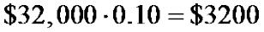

You want to save $3200 a year.
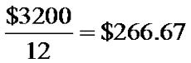

You should be saving $266.67 a month or $133.33 a paycheck if you are paid biweekly.

Section 5.2: Simple Interest

Money is not free to borrow! We will refer to money in terms of present value P, which is an amount of money at the present time, and future value F, which is an amount of money in the future. Usually, if someone loans money to another person in present value, and are promised to be paid back in future value, then the person who loaned the money would like the future value to be more than the present value. That is because the value of money declines over time due to inflation. Therefore, when a person loans money, they will charge interest. They hope that the interest will be enough to beat inflation and make the future value more than the present value.

Simple interest is interest that is only calculated on the initial amount of the loan. This means you are paying the same amount of interest every year. An example of simple interest is when someone purchases a U.S. Treasury Bond.

Simple Interest: Interest that is only paid on the principal.

Simple Interest Formula: 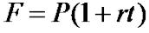

where,

F = Future value

P = Present value

r = Annual percentage rate (APR) changed to a decimal t = Number of years

________________________________________________________________________
Page 169
Chapter 5: Finance
________________________________________________________________________

Example 5.2.1: Simple Interest—Using a Table

Sue borrows $2000 at 5% annual simple interest from her bank. How much does she owe after five years?

Table 5.2.1: Simple Interest Using a Table

Year | Interest Earned | Total Balance Owed
1 | $2000*.05 = $100 | $2000 + $100 = $2100
2 | $2000*.05 = $100 | $2100 + $100 = $2200
3 | $2000*.05 = $100 | $2200 + $100 = $2300
4 | $2000*.05 = $100 | $2300 + $100 = $2400
5 | $2000*.05 = $100 | $2400 + $100 = $2500

After 5 years, Sue owes $2500.

Example 5.2.2: Simple Interest—Using the Formula

Chad got a student loan for $10,000 at 8% annual simple interest. How much does he owe after one year? How much interest will he pay for that one year?

P = $10,000, r = 0.08, t = 1
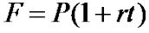

- = 10000(1 + 0.08(1)) = $10,800

Chad owes $10,800 after one year. He will pay $10800 - $10000 = $800 in interest.

Example 5.2.3: Simple Interest—Finding Time

Ben wants to buy a used car. He has $3000 but wants $3500 to spend. He invests his $3000 into an account earning 6% annual simple interest. How long will he need to leave his money in the account to accumulate the $3500 he wants?

F = $3500, P = $3000, r = 0.06

3500 = 3000 (1 + 0.06t )

³⁵⁰⁰₃₀₀₀ = 1 + 0.06t

________________________________________________________________________
Page 170

Chapter 5: Finance

________________________________________________________________________

³⁵⁰⁰₃₀₀₀ − 1 = 0.06t

3500 ₋₁
3000 _{= t}

0.06

Figure 5.2.2: Calculation to Find t on a TI 83/84 Calculator
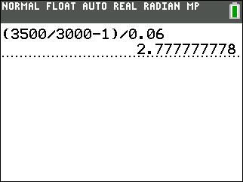

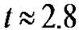 years

Ben would need to invest his $3000 for about 2.8 years until he would have $3500 to spend on a used car.

Note: As shown above, wait to round your answer until the very last step so you get the most accurate answer.

Section 5.3: Compound Interest

Most banks, loans, credit cards, etc. charge you compound interest, not simple interest. Compound interest is interest paid both on the original principal and on all interest that has been added to the original principal. Interest on a mortgage or auto loan is compounded monthly. Interest on a savings account can be compounded quarterly (four times a year). Interest on a credit card can be compounded weekly or daily!

________________________________________________________________________
Page 171

Chapter 5: Finance
________________________________________________________________________

Table 5.3.1: Compounding Periods

Compounding type | Number of compounding periods per year
Annually | 1
Semiannually | 2
Quarterly | 4
Monthly | 12
Daily | 365

Compound Interest: Interest paid on the principal AND the interest accrued.

Example 5.3.1: Compound Interest—Using a Table

Suppose you invest $3000 into an account that pays you 7% interest per year for four years. Using compound interest, after the interest is calculated at the end of each year, then that amount is added to the total amount of the investment. Then the following year, the interest is calculated using the new total of the loan.

Table 5.3.2: Compound Interest Using a Table

Year | Interest Earned | Total of Loan
1 | $3000*0.07 = $210 | $3000 | + $210 = $3210
2 | $3210 *0.07 = $224.70 | $3210 | + $224.70 = $3434.70
3 | $3434.70*0.07 = $240.43 | $3434.70 + $240.43 = $3675.13
4 | $3675.13 *0.07 = $257.26 | $3675.13 + $257.26 = $3932.39
Total | $932.39

So, after four years, you have earned $932.39 in interest for a total of $3932.39.

Compound Interest Formula: |  | _{r} n ⋅t
Compound Interest Formula: | F=P 1+ |  |  | where,
 |  | n

F = Future value

P = Present value

r = Annual percentage rate (APR) changed into a decimal t = Number of years

n = Number of compounding periods per year

________________________________________________________________________
Page 172

Chapter 5: Finance

________________________________________________________________________

Example 5.3.2: Comparing Simple Interest versus Compound Interest

Let’s compare a savings plan that pays 6% simple interest versus another plan that pays 6% annual interest compounded quarterly. If we deposit $8,000 into each savings account, how much money will we have in each account after three years?

6% Simple Interest: P = $8,000, r = 0.06, t = 3

F = P (1+ rt )

- = 8000(1+ 0.06⋅3)

- = 9440

Thus, we have $9440.00 in the simple interest account after three years.

6% Interest Compounded Quarterly: P = $8,000, r = 0.06, t = 3, n=4

- _{= P 1+} r ^{n} ^{⋅t} n

- ₌ ₈₀₀₀ ₁₊ 0.06 ^{4⋅3}

₄

- ₌ ₈₀₀₀ ₁₊ 0.06 ¹²

₄

Figure 5.3.3: Calculation for F for Example 5.3.2
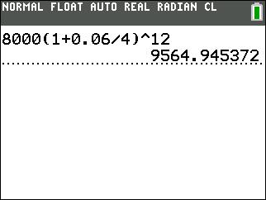

- = 9564.95

So, we have $9564.95 in the compounded quarterly account after three years.

________________________________________________________________________
Page 173

Chapter 5: Finance
________________________________________________________________________

With simple interest we earn $1440.00 on our investment, while with compound interest we earn $1564.95.

Example 5.3.3: Compound Interest—Compounded Monthly

In comparison with Example 5.3.2 consider another account with 6% interest compounded monthly. If we invest $8000 in this account, how much will there be in the account after three years?

P = $8,000, r = 0.06, t = 3, n = 12

- _{= P 1+} r ^{n} ^{⋅t} n

F = 8000 |  |  | 0.06 | 12⋅3
F = 8000 | 1 | +
F = 8000 | 1 | + | 12
- ₌ ₈₀₀₀ ₁₊ 0.06 ³⁶
₁₂

Figure 5.3.4: Calculation for F for Example 5.3.3
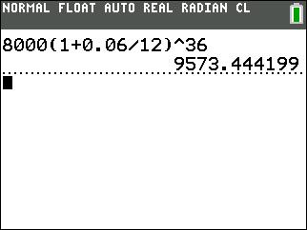

- = 9573.44

Thus, we will have $9573.44 in the compounded monthly account after three years.

Interest compounded monthly earns you $9573.44 - $9564.95 = $8.49 more than interest compounded quarterly.

________________________________________________________________________
Page 174

Chapter 5: Finance

________________________________________________________________________

Example 5.3.4: Compound Interest—Savings Bond

Sophia’s grandparents bought her a savings bond for $200 when she was born. The interest rate was 3.28% compounded semiannually, and the bond would mature in 30 years. How much will Sophia’s bond be worth when she turns 30?

P = $200, r = 0.0328, t = 30, n = 2

- _{= P 1+} r ^{n} ^{⋅t} n

F =200 |  |  | 0.0328 | 2⋅30
F =200 | ¹ | +
F =200 | ¹ | + | 2
- ₌ ₂₀₀ ₁₊ 0.0328 ⁶⁰

₂

Figure 5.3.5: Calculation for F for Example 5.3.4
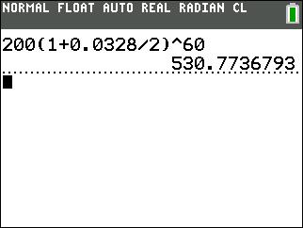

Sophia’s savings bond will be worth $530.77 after 30 years.

Continuous Compounding: Interest is compounded infinitely many times per year.

Continuous Compounding Interest Formula: 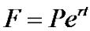 where,

F = Future value

P = Present value

r = Annual percentage rate (APR) changed into a decimal t = Number of years

________________________________________________________________________
Page 175
Chapter 5: Finance
________________________________________________________________________

Example 5.3.5: Continuous Compounding Interest

Isabel invested her inheritance of $100,000 into an account earning 5.7% interest compounded continuously for 20 years. What will her balance be after 20 years?

P = $100,000, r = 0.057, t = 20

- = 100000e^{0.057} ⋅ ²⁰

- = 100000e^{1.14}

Figure 5.3.6: Calculation for F for Example 5.3.5
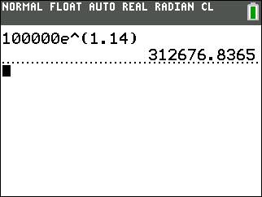

- = 312, 676.84

Isabel’s balance will be $312,676.84 after 20 years.

Annual Percentage Yield (APY): the actual percentage by which a balance increases in one year.

Example 5.3.6: Annual Percentage Yield (APY)

Find the Annual Percentage Yield for an investment account with a. 7.7% interest compounded monthly b. 7.7% interest compounded daily

c. 7.7% interest compounded continuously.

To find APY, it is easiest to examine an investment of $1 for one year.

________________________________________________________________________
Page 176
Chapter 5: Finance

________________________________________________________________________

a. P = $1, r = 0.077, t = 1, n = 12

 | 0.077 | 12⋅1
F=11+ |  |  | = 1.079776
F=11+ | 12 |  | = 1.079776

The percentage the $1 was increased was 7.9776%. The APY is 7.9776%.

b. P = $1, r = 0.077, t = 1, n = 365

 | 0.077 | 365⋅1
F=11+ |  |  | = 1.080033
F=11+ | 365 |  | = 1.080033

The percentage the $1 was increased was 8.0033%. The APY is 8.0033%.

- P = $1, r = 0.077, t = 1 F = 1e^{0.0077} ^{⋅1} = 1.080042

The percentage the $1 was increased was 8.0042%. The APY is 8.0042%.

Section 5.4: Savings Plans

Sometimes it makes better financial sense to put small amounts of money away over time to purchase a large item instead of taking out a loan with a high interest rate. When looking at depositing money into a savings account on a periodic basis we need to use the savings plan formula.

 |  | r ^{nt}
 | 1+ |  |  |  |  | −1
Savings Plan Formula: F = PMT |  | n
Savings Plan Formula: F = PMT |  |  | r
 |  |  | n
where,
F = Future value
PMT = Periodic payment
r = Annual percentage rate (APR) changed to a decimal t = Number of years

n = Number of payments made per year

________________________________________________________________________
Page 177

Chapter 5: Finance
________________________________________________________________________

Example 5.4.1: Savings Plan—Vacation

Henry decides to save up for a big vacation by depositing $100 every month into an account earning 4% per year. How much money will he have at the end of two years? PMT = $100, r = .04, t = 2, n = 12

 |  |  |  |  |  |  |  | r |  |  | nt
 |  |  | ¹ | + |  |  |  |  |  |  |  |  |  |  |  |  |  |  | −1
 |  |  | ¹ |  |  |  |  | n
F=PMT
 |  |  |  |  |  |  |  |  | r
 |  |  |  |  |  |  |  |  | n
 |  |  |  | 0.04 ^{12⋅} ²
 |  | 1+ |  |  |  |  |  |  |  |  |  |  |  |  |  |  |  |  |  | −1
 |  |  |  | 12
F =100
F =100 |  |  |  |  |  |  | 0.04
 |  |  |  |  |  |  | 12

Figure 5.4.1: Calculation for F for Example 5.4.1
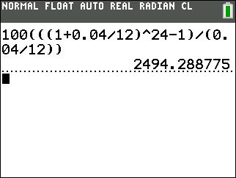

- = 2494.29

Henry will have $2,494.29 for his vacation.

For some problems, you will have to find the payment instead of the future value. In that case, it is helpful to just solve the savings plan formula for PMT. Since PMT is multiplied by a fraction, to solve for PMT, you can just multiply both sides of the formula by that fraction. You should just think of the savings plan formula in two different forms, one solving for future value, F, and one solving for payment, PMT.

________________________________________________________________________
Page 178

Chapter 5: Finance

________________________________________________________________________

 |  |  |  |  |  |  |  |  |  |  |  |  |  |  |  |  |  |  |  | r ^{nt}
 |  |  |  |  |  |  |  | 1+ |  |  |  |  |  |  |  |  |  |  |  |  |  |  |  |  |  |  |  |  |  |  |  |  |  | −1
F=PMT |  |  |  |  |  |  |  |  |  |  |  |  |  |  |  |  |  |  |  | n
 |  |  |  |  |  |  |  |  |  |  |  |  |  |  |  |  |  |  |  |  | r
 |  |  |  |  |  |  |  |  |  |  |  |  |  |  |  |  |  |  |  |  | n
 |  |  |  | r |  |  |  |  |  |  |  |  |  |  |  |  |  |  |  |  |  |  |  |  |  |  |  |  |  |  |  |  |  |  |  |  |  |  |  |  |  |  |  |  |  | r ^{nt} |  |  |  |  |  |  |  |  |  |  |  |  |  |  |  | r
 |  |  |  |  |  |  |  |  |  |  |  |  |  |  |  |  |  |  |  |  |  |  |  |  |  |  |  |  |  |  |  |  |  |  |  |  |  |  |  |  |  |  |  | 1+ |  |  |  |  |  |  |  |  |  | −1
 |  |  |  | n |  |  |  |  |  |  |  |  |  |  |  |  |  |  |  |  |  |  |  |  |  |  |  |  |  |  |  |  |  |  |  |  |  |  |  |  |  |  |  |  |  |  |  |  |  |  |  |  |  |  |  |  |  |  |  |  |  | n
F • |  |  |  |  |  |  |  |  |  |  |  |  |  |  |  |  |  |  |  |  |  |  |  |  |  |  |  | = |  |  |  |  |  | PMT |  |  |  |  |  |  |  |  |  |  |  | n |  |  |  |  |  |  |  |  |  | •
F • |  |  | r ^{nt} |  |  |  |  |  |  |  |  |  |  |  |  |  |  |  |  |  |  |  |  |  |  |  |  |  |  |  |  |  |  |  |  |  |  |  |  |  |  |  |  |  |  |  |  | r |  |  |  |  |  |  |  |  |  |  |  | r ^{nt}
 | 1+ |  |  |  |  |  |  |  |  |  |  |  |  |  |  |  |  | −1 |  |  |  |  |  |  |  |  |  |  |  |  |  |  |  |  |  |  |  |  |  |  |  |  |  |  |  |  |  | n |  |  |  |  |  |  |  |  |  | 1+ |  |  |  |  |  |  |  |  |  | −1
 | 1+ |  | n
 |  |  |  |  |  |  |  |  |  |  |  |  |  |  |  |  |  |  |  |  |  |  |  |  |  |  |  |  |  |  |  |  |  |  |  |  |  |  |  |  |  |  |  |  |  |  |  |  |  |  |  |  |  |  |  |  |  |  |  | n
 |  |  |  | r
 |  |  |  | n
F • |  |  |  |  |  |  |  |  |  |  |  |  |  |  |  |  |  |  |  |  |  |  |  |  |  |  |  | = |  |  |  |  |  | PMT
F • |  |  | r ^{nt}
 | 1+ |  |  |  |  |  |  |  |  |  |  |  |  |  |  |  |  | −1
 | 1+ |  | n
 |  |  |  |  |  |  |  |  |  |  |  |  |  |  |  |  |  |  |  |  |  |  |  |  |  | r
 |  |  |  |  |  |  |  |  |  |  |  |  |  |  |  |  |  |  |  |  |  |  |  |  |  | n
PMT =F•
 |  |  |  |  |  |  |  |  |  |  |  |  |  |  |  |  |  |  |  |  |  |  |  |  | r |  |  |  |  | nt
 |  |  |  |  |  |  |  |  |  |  |  |  |  |  |  | ¹ |  |  | + |  |  |  |  |  |  |  |  |  |  |  |  |  |  |  |  | −1
 |  |  |  |  |  |  |  |  |  |  |  |  |  |  |  |  |  |  |  |  |  |  |  |  | n

Example 5.4.2: Savings Plan—Finding Payment

Joe wants to buy a pop-up trailer that costs $9,000. He wants to pay in cash so he wants to make monthly deposits into an account earning 3.2% APR. How much should his monthly payments be to save up the $9,000 in 3 years?

F = $9,000, r = .032, t = 3, n = 12

 |  |  |  |  | r
 |  |  |  |  | n
PMT =F•
 |  |  |  | r |  |  | nt
 | 1+ |  |  |  |  |  |  |  |  |  |  |  | −1
 |  |  |  | n
 |  |  |  |  |  |  |  |  |  |  |  |  |  | 0.032
 |  |  |  |  |  |  |  |  |  |  |  |  | 12
PMT = 9,000 •
 |  |  |  |  |  |  |  |  |  |  | 0.032 ^{12⋅3}
 |  |  | ¹ |  |  |  | + |  |  |  |  |  |  |  |  |  |  |  |  |  | −1
 |  |  |  |  |  |  |  |  |  |  |  |  | 12

________________________________________________________________________
Page 179
Chapter 5: Finance
________________________________________________________________________

Figure 5.4.2: Calculation for PMT for Example 5.4.2
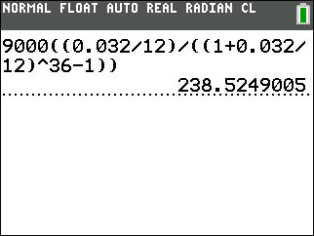

PMT = 238.52

Joe has to make monthly payments of $238.52 for 3 years to save up the $9,000. Example 5.4.3: Savings Plan—Finding Time

Sara has $300 a month she can deposit into an account earning 6.8% APR. How long will it take her to save up the $10,000 she needs?

F = $10,000, PMT = $300, r = 0.068, n = 12

Note: We will use the original savings plan formula which solves for the future value, F to solve this problem.

 |  |  |  | r ^{nt}
 | 1+ |  |  |  |  |  |  |  | −1
F=PMT |  |  |  | n
F=PMT |  |  |  |  | r
 |  |  |  |  | n
 |  |  |  |  |  |  |  | 0.068 ^{12t}
 |  |  | 1+ |  |  |  |  |  |  |  |  |  | −1
 |  |  |  |  |  |  |  | 12
10,000 = 300
 |  |  |  |  |  |  |  | 0.068
 |  |  |  |  |  |  |  | 12
10,000 = 300 |  |  | (1.005667)^{12t} −1
 |  |  |  | 0.005667

________________________________________________________________________
Page 180
Chapter 5: Finance

________________________________________________________________________

_{33.333333 =} (1.005667 )^{12t} −1
0.005667

0.188900 = (1.005667 )^{12t} −1

1.188900 = (1.005667)^{12t}

To solve for time you have to take the logarithm (log) of both sides. You can then use the “Power Rule” of logs, which states log x ^{r} = r log x , when x > 0 , as stated in section 4.3.

log1.188900 = log (1.005667)^{12t}

log1.188900 = 12t log (1.005667)

- = _{12log1.005667}^{log1.188900}

Figure 5.4.3: Calculation for t for Example 5.4.3
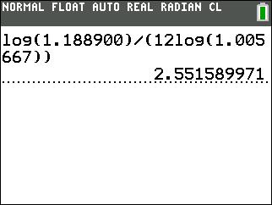

t = 2.55

It will take Sara about 2.6 years to save up the $10,000.

Example 5.4.4: Savings Plan—Two-Part Savings Problem

At the end of each quarter a 50-year old woman puts $1200 in a retirement account that pays 7% interest compounded quarterly. When she reaches age 60, she withdraws the entire amount and places it into a mutual fund that pays 9% interest compounded monthly. From then on she deposits $300 in the mutual fund at the end of each month. How much is in the account when she reaches age 65?

________________________________________________________________________
Page 181
Chapter 5: Finance
________________________________________________________________________

First, she deposits $1200 quarterly at 7% for 10 years.

PMT = $1200, r = 0.07, t = 10, n = 4

 |  |  |  |  | r ^{nt}
 |  |  | 1+ |  |  |  |  |  |  | −1
F=PMT |  |  |  |  | n
 |  |  |  |  |  | r
 |  |  |  |  |  | n
 |  |  |  | 0.07 ^{4⋅10}
 |  | 1+ |  |  |  |  |  |  |  |  |  |  | −1
 |  |  |  | 4
F = 1200
F = 1200 |  |  |  | 0.07
 |  |  |  | 4

Figure 5.4.4: Calculation for F for Part One of Example 5.4.4
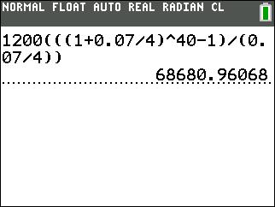

- = 68, 680.96

Second, she puts this lump sum plus $300 a month for 5 years at 9%. Think of the lump sum and the new monthly deposits as separate things. The lump sum just sits there earning interest so use the compound interest formula. The monthly payments are a new payment plan, so use the savings plan formula again.

Total = (lump sum + interest) + (new deposits + interest)

 |  |  |  |  |  |  | 0.09 |  |  | 12⋅5
 |  | 0.09 | 12⋅5 |  |  | 1+ |  |  |  |  |  | −1
 |  | 0.09 | 12⋅5 |  |  | 1+ | 12
68,680.96 | 1+ |  |  | + 300
68,680.96 | 1+ | 12 |  | + 300 |  |  | 0.09
 |  |  |  |  |  |  | 12

________________________________________________________________________
Page 182
Chapter 5: Finance

________________________________________________________________________

Figure 5.4.5: Calculation for the Lump Sum Plus Interest
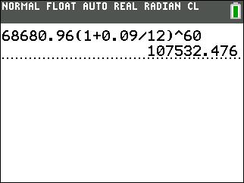

Figure 5.4.6: Calculation for the New Deposits Plus Interest
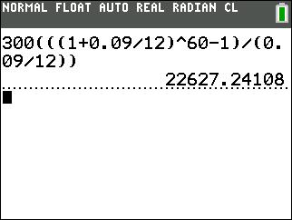

Total = 107,532.48 + 22, 627.24 = 130,159.72

She will have $130,159.72 when she reaches age 65.

Section 5.5: Loans

It is a good idea to try to save up money to buy large items or find 0% interest deals so you are not paying interest. However, this is not always possible, especially when buying a house or car. That is when it is important to understand how much interest you will be charged on your loan.

________________________________________________________________________
Page 183
Chapter 5: Finance
________________________________________________________________________

 |  |  |  |  | r ⁻ ^{nt}
1 |  | − 1+
Loan Payment Formula: P = PMT |  |  |  |  | n
Loan Payment Formula: P = PMT |  |  | r
 |  |  | n

where,

P = Present value (Principal)

PMT = Payment

r = Annual percentage rate (APR) changed to a decimal t = Number of years

n = Number of payments made per year

Example 5.5.1: Loan Payment Formula:

Ed buys an iPad from a rent-to-own business with a credit plan with payments of $30 a month for four years at 14.5% APR compounded monthly. If Ed had bought the iPad from Best Buy or Amazon it would have cost $500. What is the price that Ed paid for his iPad at the rent-to-own business? How much interest did he pay?

PMT = $30, r = 0.145, t = 4, n = 12

 |  |  |  |  |  |  |  |  |  |  | r |  | ^{− nt}
 |  | 1− 1 |  |  |  |  | +
 |  |  |  |  |  |  |  |  |  |  | n
P=PMT
 |  |  |  |  |  |  |  | r
 |  |  |  |  |  |  |  | n
 |  |  |  |  |  | 0.145 ^{−12⋅} ⁴
 | 1− |  | 1 | +
 |  |  | 1 |  |  |  | 12
P=30
P=30 |  |  |  | 0.145
 |  |  |  |  |  | 12

________________________________________________________________________
Page 184

Chapter 5: Finance

________________________________________________________________________

Figure 5.5.1: Calculation of P for Example 5.5.1
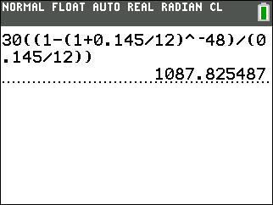

- = 1087.83

The price Ed paid for the iPad was $1,087.83. That’s a lot more that $500!

Also, the total amount he paid over the course of the loan was

$30 × 12 × 4 = $1440 . Therefore, the total amount of interest he paid over the course of the loan was $1440 - $1087.83 = $352.17.

For some problems, you will have to find the payment instead of the present value. In that case, it is helpful to just solve the loan payment formula for PMT. Since PMT is multiplied by a fraction, to solve for PMT, you can just multiply both sides of the formula by that fraction. You should just think of the loan payment formula in two different forms, one solving for present value, P, and one solving for payment, PMT.

 |  |  |  |  |  |  |  |  |  |  |  |  | r ⁻ ^{nt}
 |  | 1 |  |  |  | − 1+
P=PMT |  |  |  |  |  |  |  |  |  |  |  |  | n
 |  |  |  |  |  |  |  |  | r
 |  |  |  |  |  |  |  |  | n
 |  |  | r |  |  |  |  |  |  |  |  |  |  |  |  |  |  |  |  |  |  | _{r} − nt
 |  |  |  |  |  |  |  |  |  |  |  |  |  |  | 1 |  | − 1 | +
 |  |  | n
P • |  |  |  |  |  |  |  |  |  |  |  | = PMT |  |  |  |  |  |  |  |  |  | n
P • |  |  |  |  |  |  |  |  |  |  |  |  |  |  |  |  |  |  | r
 |  |  |  |  |  | r ⁻ ^{nt} |  |  |  |  |  |  |  |  |  |  |  |  | r
1 |  | − 1+ |  |  |  |  |  |  |  |  |  |  |  |  |  |  |  |  | n
 |  |  |  |  |  | n

 |  |  |  | r
 |  |  |  | n
 | • |  |  | n
 |  |  |  |  |  | r ⁻ ^{nt}
 | 1 |  | − 1+
 |  |  |  |  |  | n

________________________________________________________________________
Page 185

Chapter 5: Finance
________________________________________________________________________

 |  |  | r
 |  |  | n
PMT = P• |  |  | n
 |  |  |  |  | r ⁻ ^{nt}
1 |  | − 1+
 |  |  |  |  | n

Example 5.5.2: Loan Formula—Finding Payment

Jack goes to a car dealer to buy a new car for $18,000 at 2% APR with a five-year loan. The dealer quotes him a monthly payment of $425. What should the monthly payment on this loan be?

P = $18,000, r = 0.02, n = 12, t = 5

 |  |  |  |  | r
 |  |  |  |  | n
PMT = P• |  |  |  |  | n
 |  |  |  |  |  |  | r ⁻ ^{nt}
1− 1+
 |  |  |  |  |  |  | n
 |  |  |  |  |  |  |  |  |  | 0.02
 |  |  |  |  |  |  |  |  |  |  |  | 12
PMT = 18,000 |  | •
 |  | • |  |  |  |  |  |  |  |  |  | 0.02 |  |  |  | −12⋅5
 |  |  | 1− 1 |  |  |  |  |  |  | +
 |  |  |  |  |  |  |  |  |  |  |  | 12

Figure 5.5.2: Calculation for PMT for Example 5.5.2
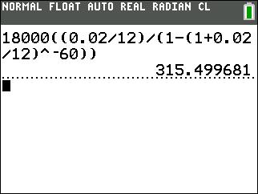

PMT = 315.50

Jack should have a monthly payment of $315.50, not $425.

________________________________________________________________________
Page 186

Chapter 5: Finance

________________________________________________________________________

Now, let’s find out how much the dealer is trying to get Jack to pay for the car.

$425 × 12 × 5 = $25,500

The dealer is trying to sell Jack the car for a total of $25,500 with principal and interest. What should the total principal and interest be with the $315.50 monthly payment?

$315.50 × 12 × 5 = $18,930

Therefore, the dealer is trying to get Jack to pay $25,500 - $18,930 = $6,570 in additional principal and interest charges. This means that the quoted rate of 2% APR is not accurate, or the quoted price of $18,000 is not accurate, or both.

Example 5.5.3: Loan Formula—Mortgage

Morgan is going to buy a house for $290,000 with a 30-year mortgage at 5% APR. What is the monthly payment for this house?

P = $290,000, r = 0.05, n = 12, t = 30

PMT

PMT

 |  |  |  | r
 |  |  |  | n
= P •
 |  |  |  |  |  |  | r ⁻ ^{nt}
1 |  | − 1 | +
 |  |  |  |  |  |  | n
 |  |  |  |  |  |  |  |  |  | 0.05
 |  |  |  |  |  |  |  |  |  |  |  |  | 12
= 290,000 • |  |  |  |  |  |  |  |  |  |  |  |  | 12
 |  |  |  |  |  |  |  |  |  |  |  |  | 0.05 |  | −12⋅30
 |  |  | 1 |  |  |  |  | − 1 |  | +
 |  |  |  |  |  |  |  |  |  |  |  |  | 12

Figure 5.5.3: Calculation for PMT for Example 5.5.3
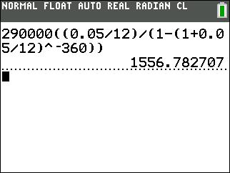

________________________________________________________________________
Page 187

Chapter 5: Finance
________________________________________________________________________

PMT = 1556.78

The monthly payment for this mortgage should be $1556.78.

It is also very interesting to figure out how much Morgan will end up paying overall to buy this house. It is rather easy to calculate this

$1556.78 × 12 × 30 = $560, 440.80

Therefore, Morgan will pay $560,440.80 in principal and interest which means that Morgan will pay $290,000 for the principal of the loan and $560,440.80 - $290,000 = $270,440.80 in interest. This is enough to buy another comparable home. Interest charges add up quickly.

Example 5.5.4: Loan Formula—Refinance Mortgage

If Morgan refinanced the $290,000 at 3.25% APR what would her monthly payments be?

P = $290,000, r = 0.0325, n = 12, t = 30

PMT

PMT

 |  |  |  | r
 |  |  |  | n
= P •
 |  |  |  |  |  |  | r ⁻ ^{nt}
1 |  | − 1+
 |  |  |  |  |  |  | n
 |  |  |  |  |  |  |  |  |  | 0.0325
 |  |  |  |  |  |  |  |  |  |  |  |  | 12
= 290,000 • |  |  |  |  |  |  |  |  |  |  |  |  | 12
 |  |  |  |  |  |  |  |  |  |  |  |  | 0.0325 |  | −12⋅30
 |  |  | 1 |  |  |  |  | − 1 |  | +
 |  |  |  |  |  |  |  |  |  |  |  |  | 12

Figure 5.5.4: Calculation for PMT for Example 5.5.4
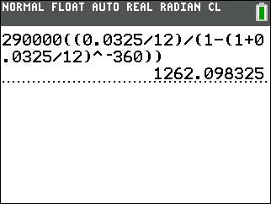

PMT = 1262.10

________________________________________________________________________
Page 188

Chapter 5: Finance

________________________________________________________________________

If Morgan refinanced the mortgage at 3.25% APR, the monthly payment would now be $1262.10 instead of $1556.78.

How much money would Morgan save over the life of the loan at the new payment amount?

$1262.10 × 12 × 30 = $454,356

Then, subtract $560,440.80 - $454,356 = $106,084.80.

Morgan would save $106,084.80 in interest because of refinancing the loan at 3.25% APR.

Example 5.5.5: Loan Formula—Mortgage Comparison

With a fixed rate mortgage, you are guaranteed that the interest rate will not change over the life of the loan. Suppose you need $250,000 to buy a new home. The mortgage company offers you two choices: a 30-year loan with an APR of 6% or a 15-year loan with an APR of 5.5%. Compare your monthly payments and total loan cost to decide which loan you should take. Assume no difference in closing costs.

Option 1: First calculate the monthly payment:

PMT

PMT

 |  |  |  |  |  | r
 |  |  |  | n
= P •
= P • |  |  |  |  |  |  |  |  | _{r} − nt
1 |  | − | 1+
 |  |  |  |  |  |  |  |  | n
 |  |  |  |  |  |  | 0.06
 |  |  |  |  |  |  |  |  |  |  |  | 12
= 250000 •
 |  |  |  |  |  |  |  |  |  |  |  |  | _{0.06} −12⋅30
 |  |  | 1 |  |  |  | − 1+
 |  |  |  |  |  |  |  |  |  |  |  | 12

________________________________________________________________________
Page 189

Chapter 5: Finance
________________________________________________________________________

Figure 5.5.5: Calculation for PMT for Example 5.5.5, Option 1
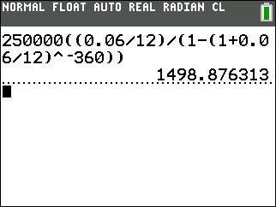

PMT = 1498.88

The monthly payment for a 30-year loan at 6% interest is $1498.88.

Now calculate the total cost of the loan over the 30 years:

$1498.88 × 12 × 30 = $539,596.80

The monthly payments are $1498.88 and the total cost of the loan is $539,596.80.

Option 2: First calculate the monthly payment:

PMT

PMT

 |  |  |  |  | r
 |  |  | n
= P •
= P • |  |  |  |  |  |  |  | _{r} − nt
1− |  | 1+
 |  |  |  |  |  |  |  | n
 |  |  |  |  |  | 0.055
 |  |  |  |  |  |  |  |  |  |  | 12
= 250000 |  | •
 |  |  |  |  |  |  |  |  |  |  |  | 0.055 ^{−12⋅15}
 |  | 1 |  |  |  | − 1+
 |  |  |  |  |  |  |  |  |  |  | 12

________________________________________________________________________
Page 190

Chapter 5: Finance

________________________________________________________________________

Figure 5.5.6: Calculate PMT for Example 5.5.5, Option 2
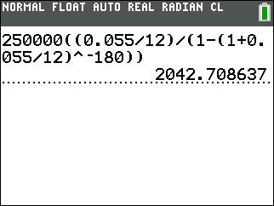

PMT = 2042.71

The monthly payment for a 15-year loan at 5.5% interest is $2042.71.

Now calculate the total cost of the loan over the 15 years:

$2042.71 × 12 × 15 = $367, 687.80

The monthly payments are $2042.71 and the total cost of the loan is $367,687.80.

Therefore, the monthly payments are higher with the 15-year loan, but you spend a lot less money overall.

________________________________________________________________________
Page 191

Chapter 5: Finance
________________________________________________________________________

Chapter 5 Homework

- Find a budget template or make up your own in Microsoft Excel. Then create a monthly budget that tracks every dollar you earn and where that money goes.

- If you make $38,000 per year and want to save 15% of your income, how much should you save every month?

- Suzy got a U.S. Treasury Bond for $8,000 at 5.2% annual simple interest. Create a table showing how much money Suzy will have each year for seven years. Graph this data and identify the type of growth that is shown.

- Referring to Problem #3, how much would Suzy’s Bond be worth after 20 years?

- Geneva wants to save $12,000 to buy a new car. She just received an $8,000 bonus and plans to invest it in an account earning 7% annual simple interest. How long will she need to leave her money in the account to accumulate the $12,000 she needs?

- Suppose you take out a payday loan for $400 that charges $13 for every $100 loaned. The term of the loan is 15 days. Find the APR charged on this loan.

- Sue got a student loan for $12,000 at 5.4% annual simple interest. How much does she owe after one year? How much interest will she pay?

- If I put $1500 into my savings account and earned $180 of interest at 4% annual simple interest, how long was my money in the bank?

- Derek invested $1000. What would that money grow to in 18 months at a 5.55% annual simple interest rate?

________________________________________________________________________
Page 192

Chapter 5: Finance

________________________________________________________________________

- You borrow $500 for a trip at 11% annual simple interest for two years.

  - Find the interest you will pay on the loan.

  - How much will you have to pay the bank at the end of the two years?

- Jewel deposited $4000 into an account that earns 8% APR compounded annually. Create a table showing how much money Jewel will have each year for seven years. Graph this data and identify the type of growth that is shown.

- Amira deposited $1,000 into a savings account earning 4.6% APR compounded quarterly. How much will she have in her account after 15 years?

- Matt invested $1,000,000 into an account earning 5.5% APR compounded monthly. What will his balance be after two years?

- Matt invested $1,000,000 into an account earning 5.5% APR compounded continuously. What will his balance be after two years?

- Find the Annual Percentage Yield (APY) for an investment account with:

  - 8.2% APR compounded monthly

  - 8.2% APR compounded daily

  - 8.2% APR compounded continuously

- A bank quotes you an APR of 4.3% for a home loan. The interest is compounded monthly. What is the APY?

- Suppose you need $1230 to purchase a new T.V. in three years. If the interest rate of a savings account is compounded monthly at 3.8% APR, how much do you need to deposit in the savings account today?

- What was the principal for a continuously compounded account earning 3.8% APR for 15 years that now has a balance of $2,500,000?

________________________________________________________________________
Page 193
Chapter 5: Finance
________________________________________________________________________

- You have saved change throughout the year and now have $712. You can choose from two bank offers for investing this money. The first is 5.4% APR compounded continuously for seven years. The second is 6% APR compounded quarterly for six years. Which account will yield the most money? What is the dollar amount difference between the accounts at the end of their terms?

- You deposit $25,000 in an account that earns 5.2% APR compounded semiannually. Find the balance in the account at the end of five years, at the end of 10 years, and at the end of 20 years.

- You gave your friend a short term three-year loan of $35,000 at 2.5% compounded annually. What will be your total return?

- Isaac is saving his $50 monthly allowance by putting it into an account earning

4.5% APR per year. How much money will he have at the end of five years? Ten years?

- Sue wants to save up $2500 to buy a new laptop. She wants to pay in cash so is making monthly deposits into a savings account earning 3.8% APR. How much do her monthly payments need to be to be able to save up the $2500 in two years?

- Business Enterprises is depositing $450 a month into an account earning 7.2% APR to save up the $15,000 they need to expand. How long will it take them to save up the $15,000 they need?

- Dan has $200 a month he can deposit into an account earning 3.8% APR. How long will it take him to save up the $12,000 he needs?

- At age 30, Suzy starts an IRA to save for retirement. She deposits $100 at the end of each month. If she can count on an APR of 6%, how much will she have when she retires 35 years later at age 65?

________________________________________________________________________
Page 194
Chapter 5: Finance

________________________________________________________________________

- You want to save $100,000 in 18 years for a college fund for your child by making regular, monthly deposits. Assuming an APR of 7%, calculate how much you should deposit monthly. How much comes from the actual deposits and how much from interest?

- You would like to have $35,000 to spend on a new car in five years. You open a savings account with an APR of 4%. How much must you deposit each quarter to reach this goal?

- At the age of 35 you decide to start investing for retirement. You put away $2000 in a retirement account that pays 6.5% APR compounded monthly. When you reach age 55, you withdraw the entire amount and place it in a new savings account that pays 8% APR compounded monthly. From then on you deposit $400 in the new savings account at the end of each month. How much is in your account when you reach age 65?

- Gene bought a washing machine for his rental property with a credit plan of $35 a month for three years at 12.5% APR. What was the purchase price of the washing machine? How much interest will Gene have paid at the end of the three years?

- You go to a car dealer and ask to buy a new car listed at $23,000 at 1.9% APR with a five-year loan. The dealer quotes you a monthly payment of $475. What should the monthly payment on this loan be?

- Gina buys her first house for $230,000 at 5.5% APR with a 30-year mortgage. Find her monthly mortgage payment. How much principal and interest will she end up paying for her house?

- If Gina (in problem 32) refinanced the $230,000 at 3.8% APR what would her monthly payments be? How much principal and interest would she end up paying for her house?

________________________________________________________________________
Page 195

Chapter 5: Finance
________________________________________________________________________

- Your bank offers you two choices for your new home loan of $320,000. Your choices are a 30-year loan with an APR of 4.25% or a 15-year loan with an APR of 3.8%. Compare your monthly payments and total loan cost to decide which loan you should take.

- Lou purchases a home for $575,000. He makes a down payment of 15% and finances the remaining amount with a 30-year mortgage with an annual percentage rate of 5.25%. Find his monthly mortgage payment. How much principal and interest will he end up paying for his house?

- You have decided to refinance your home mortgage to a 15-year loan at 4.0% APR. The outstanding balance on your loan is $150,000. Under your current loan, your monthly mortgage payment is $1610, which you must continue to pay for the next 20 years if you do not refinance.
  - What is the new monthly payment if you refinance?

  - How much will you save by refinancing?

  - How much interest will you pay on this new loan?

________________________________________________________________________
Page 196

