BUSINESS CREDIT APPLICATION
CITIZENS BANK

APPLICANT:

BUSINESS NAME(Exactly as it appears on Partnership Agreement or Corporation Papers)

TAXPAYER ID# OR SOCIAL SECURITY #

MAILING ADDRESS:

STREET

CITY

STATE

ZIP

PHONE #

BUSINESS LOCATIONS:
STREET | CITY | STATE | ZIP
STREET | CITY | STATE | ZIP

What does your business do?____________________________________________________________________________
____________________________________________________________________________________________________

Number of employees: ____________Full-Time ____________ Part-Time

COMPANY OFFICIAL OR ACCOUNTANT TO CONTACT FOR FURTHER INFORMATION:

NAME

TITLE

ADDRESS

PHONE #

Number of years your company has been in business? _________________________________________________________

Number of years principal has been in this line of business? ___________________________________________________

Number of years principal has owned this business? __________________________________________________________

Was the company’s most recent fiscal year-end profitable? _____Yes _____no

If no, please explain reasons for loss:___________________________________________________________

 |  | This Fiscal Year | Next Fiscal Year
What are your projections for: Sales |  | $____________ | $_____________
 | Profit before Tax | $____________ | $_____________
HOW IS YOUR BUSINESS ORGANIZED?
Partnership | Corporation | Individual | Other
__General | __S (Sub Chapter S) | __Sole Proprietorship | __Non-Profit Organization
__Limited | __C (General Corporation)
 | __Professional Association
 | __Limited Liability Corp.

In addition to the reason for this loan request, do you anticipate significant capital expenditures?

(i.e. equipment purchase, site expansion) within the next 12 months? ___Yes ___No

If yes, describe nature, amount and anticipated purchase date:_____________________________________________________________

1

CREDIT REQUEST
 | Requested Amount | Requested Term
Type of Loan: Term | $_______________ | _______________Months
Revolving | $_______________ | _______________Months
Real Estate | $_______________ | _______________Months
TOTAL | $_______________

How will funds be used?

___ Carry Receivables (provide accurate aging or account receivable report for existing receivables)

___ Purchase Equipment (if possible, attach copy of purchase order/invoice)

Purchase Price $__________________________
Description of Equipment(New/Used, Brand/Model, Year, etc)___________________________________________
_____________________________________________________________________________________________

___ Purchase Inventory
Purchase Price $___________________________
Description of Inventory__________________________________________________________________________
Reason for Purchase (e.g. seasonal buildup, permanent buildup, addition of new product line,etc.)______________

_____________________________________________________________________________________________

___Make business property improvements or building expansion Cost $___________________________________

Description:_____________________________________________________________________________________

______________________________________________________________________________________________
_____________________________________________________________________________________________
Amount and source of downpayment? ______________________________________________________________
_____________________________________________________________________________________________

Additional information will be needed if financing will be secured by a real estate mortgage.

___ Other- please describe completely (refinance, payoff other creditors, taxes, etc.)___________________________
_________________________________________________________________________________________________

****************************************************************************************************

What will be the primary source of repayment for this loan?__________________________________________
__________________________________________________________________________________________

What are other sources of repayment? __________________________________________________________

__________________________________________________________________________________________

Are you presently applying for credit from any other source? Who? ___________________________________

2

COLLATERAL INFORMATION

In addition to the business equipment, inventory and accounts receivable, is there other collateral, either business or personal that may be considered to secure this loan?

___________________________________________________________________________________________________

Is your business already pledging any accounts receivable, equipment, inventory, or other assets for a loan or lease NOT listed on the financial statement? ___YES ___NO

If yes, please explain___________________________________________________________________________

INFORMATION ABOUT ALL OWNERS (AND OTHER GUARANTOR, IF ANY):
NAME | TITLE |  | % OWNERSHIP |  | SOCIAL SECURITY #
 |  |  | 0.00%
ADDRESS |  | STATE |  | ZIP | PHONE #
NAME | TITLE |  | % OWNERSHIP |  | SOCIAL SECURITY #
 |  |  | 0.00%
ADDRESS |  | STATE |  | ZIP | PHONE #
NAME | TITLE |  | % OWNERSHIP |  | SOCIAL SECURITY #
 |  |  | 0.00%
ADDRESS |  | STATE |  | ZIP | PHONE #

BANKING RELATIONSHIPS

Does your company have a current borrowing relationship with Citizens Bank? ____YES ____NO

Type of accounts_______________________________________________________________________________________

Have you applied for credit at Citizens Bank in the past 12 months? _____YES _____NO Which Location?_____________

Do any officers or owners of your company have personal or other business loans with Citizens Bank?
_____YES ____NO Explain: ________________________________________________________________________

Which bank do you consider your primary bank? _____________________________________________________________

For your business accounts, please provide the following:
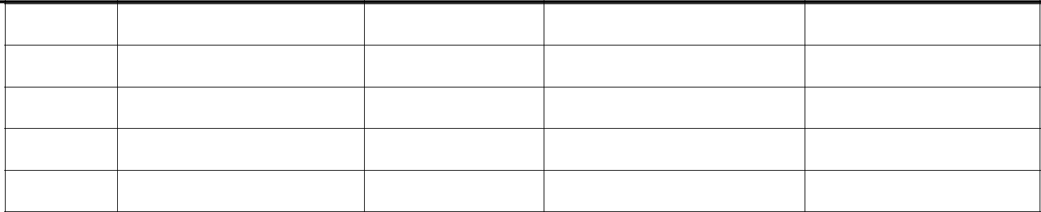

Bank Name | Account # | Current Balance | Time Overdrawn

Checking

Checking

Savings

Savings

Please list all loans or leases (including contingent liabilities) that your business has (include Citizens Bank loans)
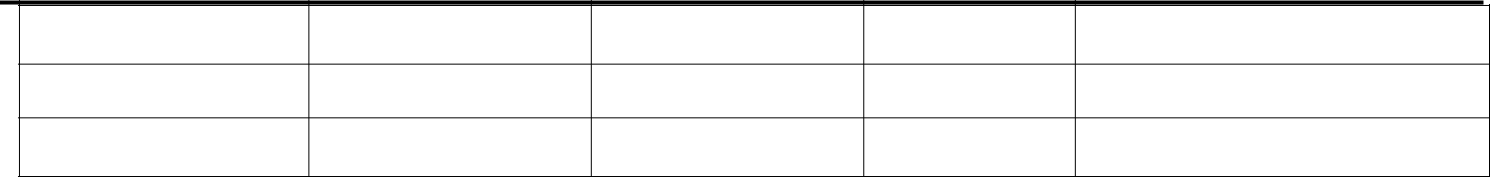

NAME OF CREDITOR TYPE OF LOAN/LEASE

ORIGINAL LOAN AMOUNT

BALANCE
OWING

MONTHLY | MATURITY DATE
PAYMENTS

3

BUSINESS TRADE REFERENCES (PLEASE PROVIDE 2 TRADE REFERENCES)

 | COMPANY |  | COMPANY CONTACT
 | STREET | CITY |  | STATE | ZIP | PHONE #
 | COMPANY |  | COMPANY CONTACT
 | STREET | CITY |  | STATE | ZIP | PHONE #

Usual terms of sale offered by suppliers?____________________________________________________________________

ACCOUNTS RECEIVABLE

What is the average sale per customer? $____________________

How much of your annual sales are attributable to your top 3 customers? __________________%

Are your sales seasonal? _____YES _____NO If yes, please complete the following:
High receivable: Amount $____________ Months affected_______________________
Low receivable: Amount $____________ Months affected_______________________

Please provide your company’s accounts receivable aging.

Have you had any significant accounts receivable charge-offs in the past 3 years? _____YES _____NO
If yes, explain:_________________________________________________________________________________________

Do you extend any special terms regarding the dating of accounts receivable to your customers? _____YES _____NO

If yes, explain:_________________________________________________________________________________________

Usual terms of sale offered to customers:___________________________________________________________________

MISCELLANEOUS

Does your company own or lease the property that your business occupies?
______Own __________Lease
$_________Monthly Rental # Years remaining on lease _____________________

Is our company a party to any claim or lawsuit? _____YES _____NO
If yes, explain:_________________________________________________________________________________________

Are there any State or Federal Tax Liens filed against your business? _____YES _____NO
If yes, explain amount and reason:_________________________________________________________________________

Has the business ever declared bankruptcy or defaulted on any debts? _____YES _____NO
If yes, explain:_________________________________________________________________________________________

4

SIGNATURES/DATE
By signing below, you acknowledge and agree to each of the following:

- To the best of your knowledge and belief, all answers to the questions in this application and all information in the financial statements are true and complete.
- Citizens Bank has the right to verify the accuracy of the information provided in this application.
- Citizens Bank is authorized to check each owner’s and/or guarantor’s credit rating.
- You are authorized to apply for this loan on behalf of the Applicant.

- That all supporting documentation included in this application remains the property of Citizens Bank.

- That all information provided will be kept confidential by Citizens Bank and will be used only for the purposes of considering this loan request. If the Bank provides you credit, it is authorized to provide others with information concerning any applicant or guarantor.

______________________________ | __________ | ______________________________ | __________
Signature | Date | Signature | Date
______________________________ | __________ | _______________________________ | __________
Print Name | Title | Print Name | Title

5

