Building Inspection checklist
!
Property Inspection
!

This checklist is to be used as a tool for a potential buyer of a home to complete a visual non-professional check of a residential property . it is not expected to replace a Pre-Purchase Building Inspection by a qualified Building Inspection Professional.

This checklist can be used to highlight issues for a qualified inspector to look at more closely.
!

Property:

Date of Inspection:
!

!

!

!

STATE code explanation: S = satisfactory, N = needs attention – detailed action required

ENTRANCE / HALL | STATE | ACTION REQUIRED
Walls/Ceiling/Woodwork
Floor/Coverings
Curtains/Blinds
Light Fittings/Power points
Windows/Doors/Screens
Comments/Other
LOUNGE | STATE | ACTION REQUIRED
Walls/Ceiling/Woodwork
Floor/Coverings
Curtains/Blinds
Light Fittings/Power points
Windows/Doors/Screens
Comments/Other
DINING ROOM | STATE | ACTION REQUIRED
Walls/Ceiling/Woodwork
Floor/Coverings


Absolute Building Inspections www.absolutebuildinginspections.co.nz

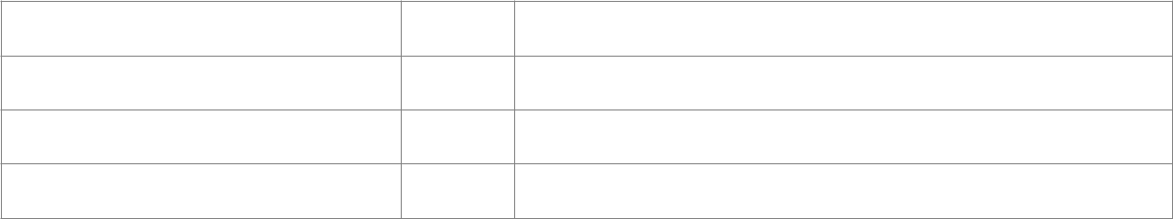
Curtains/Blinds

Light Fittings/Power points

Windows/Doors/Screens

Comments/Other

Absolute Building Inspections www.absolutebuildinginspections.co.nz

KITCHEN | STATE |  | ACTION REQUIRED
Walls/Ceiling/Woodwork
Floor/Coverings
Curtains/Blinds
Light Fittings/Power points
Windows/Doors/Screens
Cupboards/Drawers
Bench tops/Tiling
Sink/Disposal Unit
Taps
Stove
Exhaust Fan
Comments/Other
BEDROOM 1 | STATE |  | ACTION REQUIRED
Walls/Ceiling/Woodwork
Floor/Coverings
Curtains/Blinds
Light Fittings/Power points
Windows/Doors/Screens
Comments/Other
BEDROOM 2 | STATE |  | ACTION REQUIRED
Walls/Ceiling/Woodwork
Floor/Coverings
Curtains/Blinds
Light Fittings/Power points
Windows/Doors/Screens
Comments/Other
BEDROOM 3 | STATE |  | ACTION REQUIRED
Walls/Ceiling/Woodwork
Floor/Coverings
Curtains/Blinds
Light Fittings/Power points
Windows/Doors/Screens
Absolute Building Inspections |  | www.absolutebuildinginspections.co.nz
Comments/Other

BATHROOM 1 |  | STATE | ACTION REQUIRED
Walls/Ceiling/Woodwork
Floor/Coverings
Curtains/Blinds
Light Fittings/Power points
Windows/Doors/Screens
Bath
Shower
Shower Screen
Wash Basin
Tiling
Mirror/Cabinet
Towel rail
Toilet
Comments/Other
LAUNDRY |  | STATE | ACTION REQUIRED
Walls/Ceiling/Woodwork
Floor/Coverings
Curtains/Blinds
Light Fittings/Power points
Windows/Doors/Screens
Wash Tubs
Comments/Other
EXTERIOR |  | STATE | ACTION REQUIRED
Exterior Walls / Cladding /
Window frames
Lawns/Gardens
Roof/Gutters
Garage/Carport/Driveway
Clothes Line
Fences/Gates
Mailbox
Absolute Building Inspections |  | www.absolutebuildinginspections.co.nz
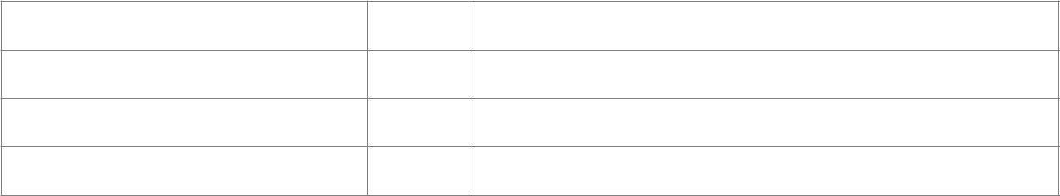
Balcony/ Veranda/Porch

Outside lights

Doorbell/Security System
!Comments/Other
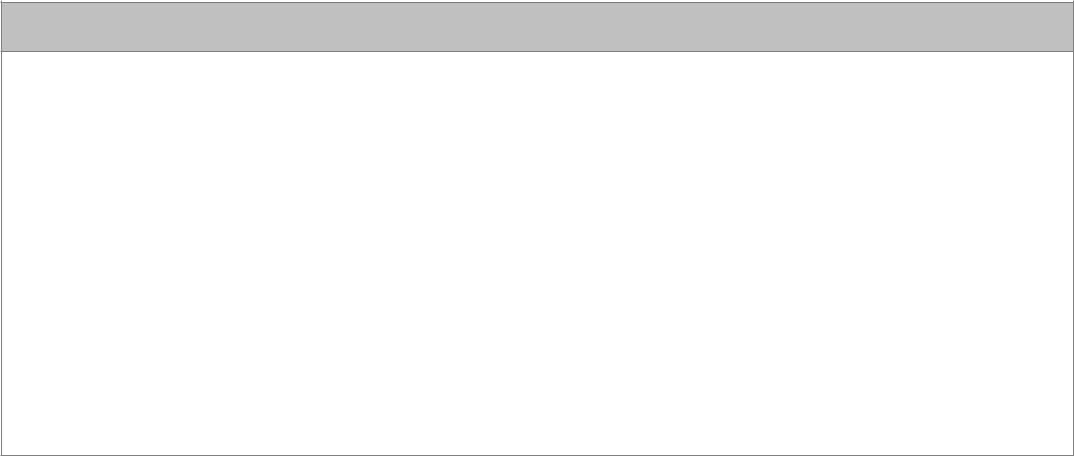
OTHER COMMENTS
!
!
!
!
!
!
!
!
!

!
!
!

Absolute Building Inspections www.absolutebuildinginspections.co.nz

