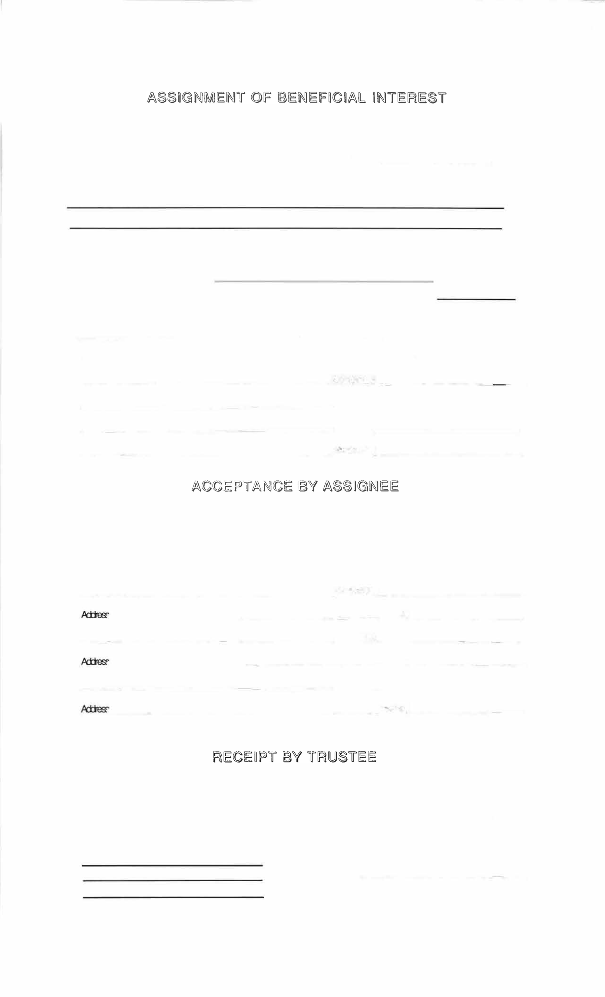

DATE: --------

FOR VALUE RECEIVED, the undersigned assignor(s) hereby sell, assign transfer and set over unto

assignee(s) all of the assignor's rights, powers, privileges, and beneficial interest in and to that

certain trust agreement dated | day of
and known as | MARQUETTE BANK under Trust #

including all interest in the property held subject to said trust agreement.

The real property constituting the corpus of the land trust is located in the municipality (ies) of
_____ __ In the county (ies of __________ Illinois.

SIGNATURES OF ASSIGNORS---------INCLUDE SS# OR EMPLOYERS I.D.#

___________________SS#OOE.W.

_

___________________SS#OOEI#___________

___________________SS#OOEI#___________

___________________SS#OOEI#__________

_

The undersigned assignee(s) accept the foregoing assignment subject to all the provisions of said trust agreement.

SIGNATURE OF ASSIGNEE(S)-----INCLUDE SS# OR El#

___________________SS#CBB#.

,...._ __________ Alre#.

_

_

___________________SS#OOEI#___________

,______________________ Pt-ere#. _

___________________SS#OOB#___________

,_____________________ Pt-ere#. _

RECEIVED A DUPLICATE OF THE FOREGOING ASSIGNMENT AND ACCEPTANCE.

[)AJE,...___________ MARQUETTE BANK

TI-US INSTRUMENT WAS PREPARED BY:

f/n/a Marquette National Bank

BY____________

TRUST OFFICER

