

Apartment Turnover Checklist
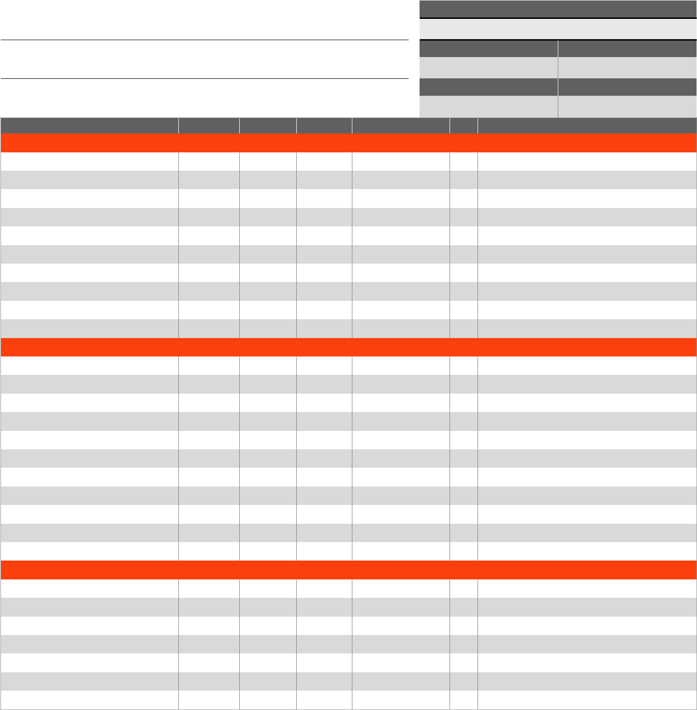

UNIT NUMBER

Sales Professional Name:

NUMBER OF BEDROOMS

NUMBER OF BATHROOMS

Sales Professional Mobile:

INSPECTION DATE

Sales Professional Email:

INSPECTED BY

ITEM

ENTRYWAY

Deadbolt

Doorstop/Hinges/Closer

Door Sweep/Weather Strip

Exterior Door

Exterior Lights

House/Unit Number

Locks

Peephole/Door Knocker

Screen/Security Door

Threshold

LIVING ROOM

Blinds

Ceiling Fan

Ceiling Fan Light Kit

Crown Molding

Flooring

Light Fixtures

Smoke/CO₂ Alarm

Wall Base/Base Trim

Wall Plates

Walls

Window Screens

DINING ROOM

Blinds

Ceiling Fan

Crown Molding

Flooring

Light Fixtures

Smoke/CO2 Alarm

Wall Base/Base Trim

INSPECTED

REPAIRED

REPLACED PART NO. FOR ORDER


QTY.

NOTES

Shop Online at HomeDepotPro.com/Multifamily

Please visit us online to view our terms and conditions

800.345.3000

En Español: 1.800.355.3335

MPM-11593


UNIT NUMBER

ITEM | INSPECTED | REPAIRED | REPLACED | PART NO. FOR ORDER QTY. NOTES
DINING ROOM (con’t)
Wall Plates
Walls
Window Screens
KITCHEN
Broiler Pan
Cabinet & Drawer Pulls
Cabinet Door Hinges
Cabinets & Drawers
Countertops
Crown Molding
Drip Pans
Faucet/Aerator/Handles
Fire Extinguisher (5 lbs.)
Firestop
Flooring
Garbage Disposer
GFCI
Ice Cube Trays
Ice Maker
Light Fixtures
Microwave
Microwave Plate
Oven Racks
Range
Range Elements
Range Hood
Refrigerator
Sink
Sink Basket/Strainer
Smoke/CO₂ Alarms
Supply Lines
Wall Base/Base Trim
Wall Plates
PATIO/BALCONY
Door Sweep/Weather Strip
Exterior Door
Exterior Light Fixtures
Locks
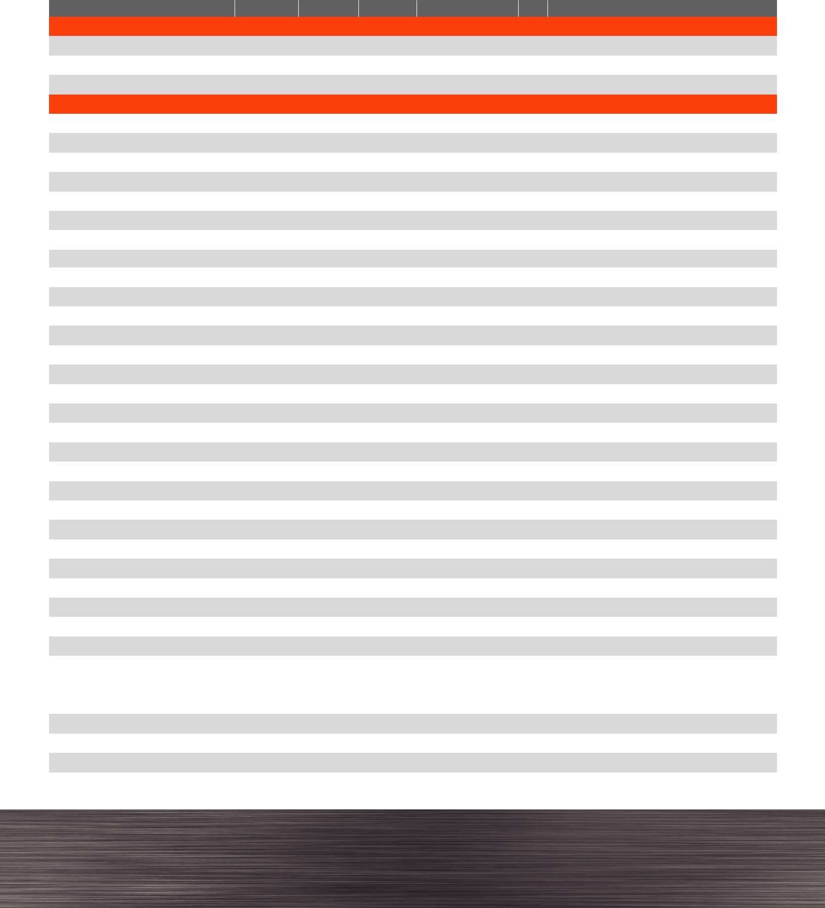

Shop Online at HomeDepotPro.com/Multifamily

Please visit us online to view our terms and conditions

800.345.3000
En Español: 1.800.355.3335

MPM-11593

UNIT NUMBER

ITEM | INSPECTED | REPAIRED | REPLACED | PART NO. FOR ORDER QTY. NOTES
Screen/Security Door
Threshold
BEDROOM(S)
Blinds
Bypass Door/Bifold Door
Ceiling Fan
Ceiling Fan Light Kit
Closet Rod/Racks
Closet/Drawer Knobs
Crown Molding
Doorstop/Hinges/Closer
Flooring
Light Fixtures
Privacy Lockset
Smoke/CO₂ Alarms
Wall Base/Base Trim
Wall Plates
Window Screens
BATHROOM(S)
Angle Stop
Bath Hardware - End Brackets/Soap
Holder/Toilet Paper Holder/Towel Holder(s)
Cabinet & Drawer Pulls
Cabinet Door Hinges
Cabinets & Drawers
Countertops
Doorstop/Hinges/Closer
Exhaust Fan
Faucet/Pop-Ups
Flooring
GFCI
Handles & Index Buttons
Heat Lamp
Interior Slab Door
Light Fixtures
Medicine Cabinet
Mirror/Clips
P-Trap
Privacy Lockset
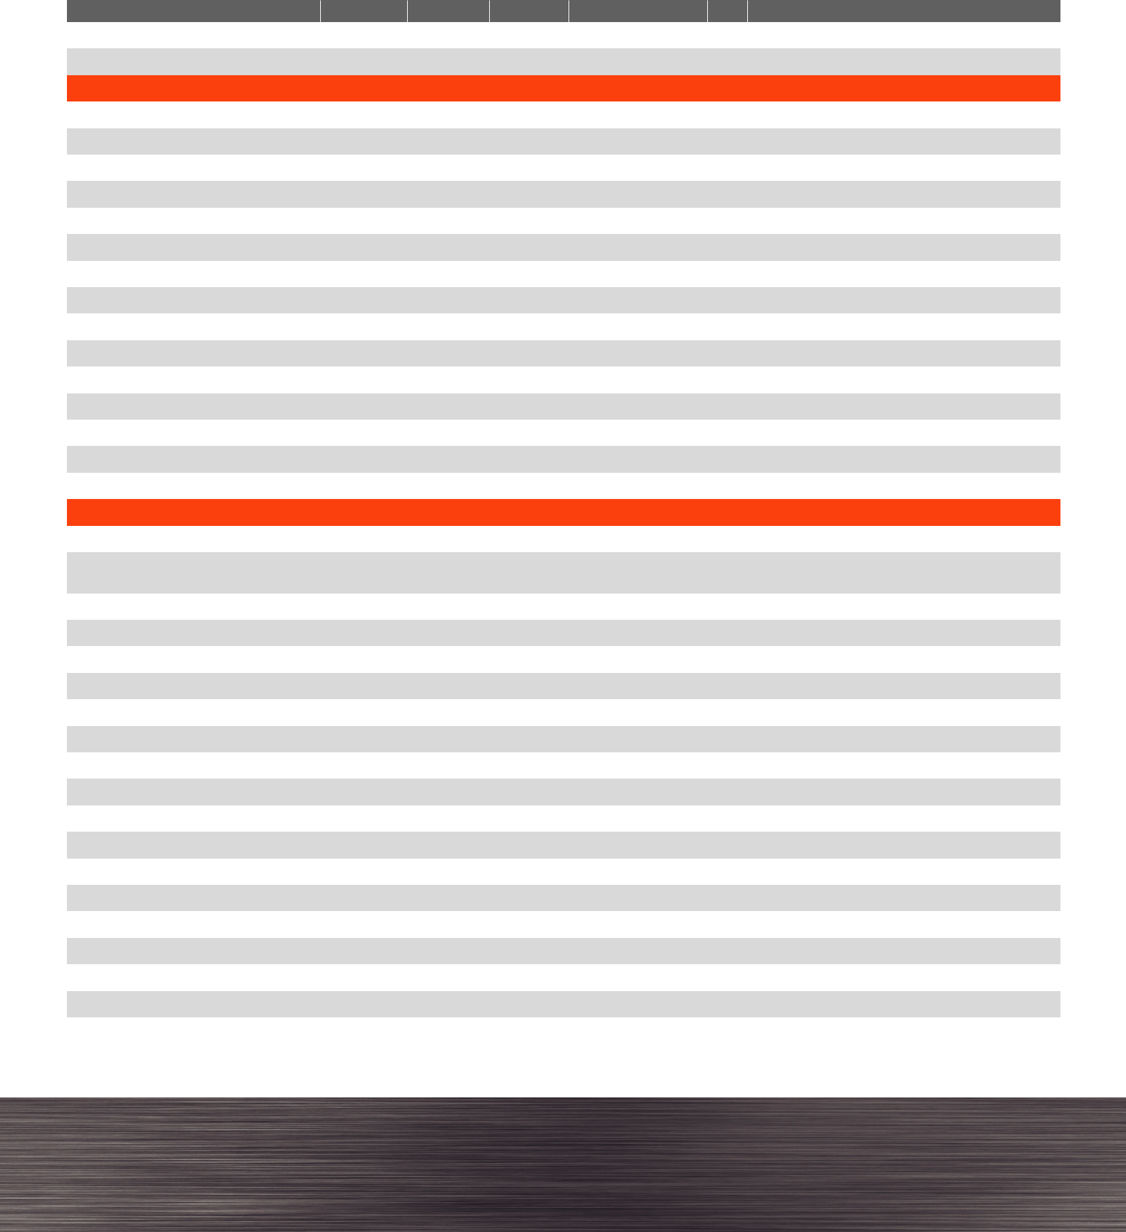

Shop Online at HomeDepotPro.com/Multifamily

Please visit us online to view our terms and conditions

800.345.3000
En Español: 1.800.355.3335

MPM-11593

UNIT NUMBER

ITEM


BATHROOM(S) (con’t)

Shower Door

Showerhead

Sink

Supply Lines

Toilet

Toilet Seat

Tub Spout

Tub Surround

Wall Base/Base Trim

Wall Plates

INSPECTED


REPAIRED


REPLACED PART NO. FOR ORDER QTY.
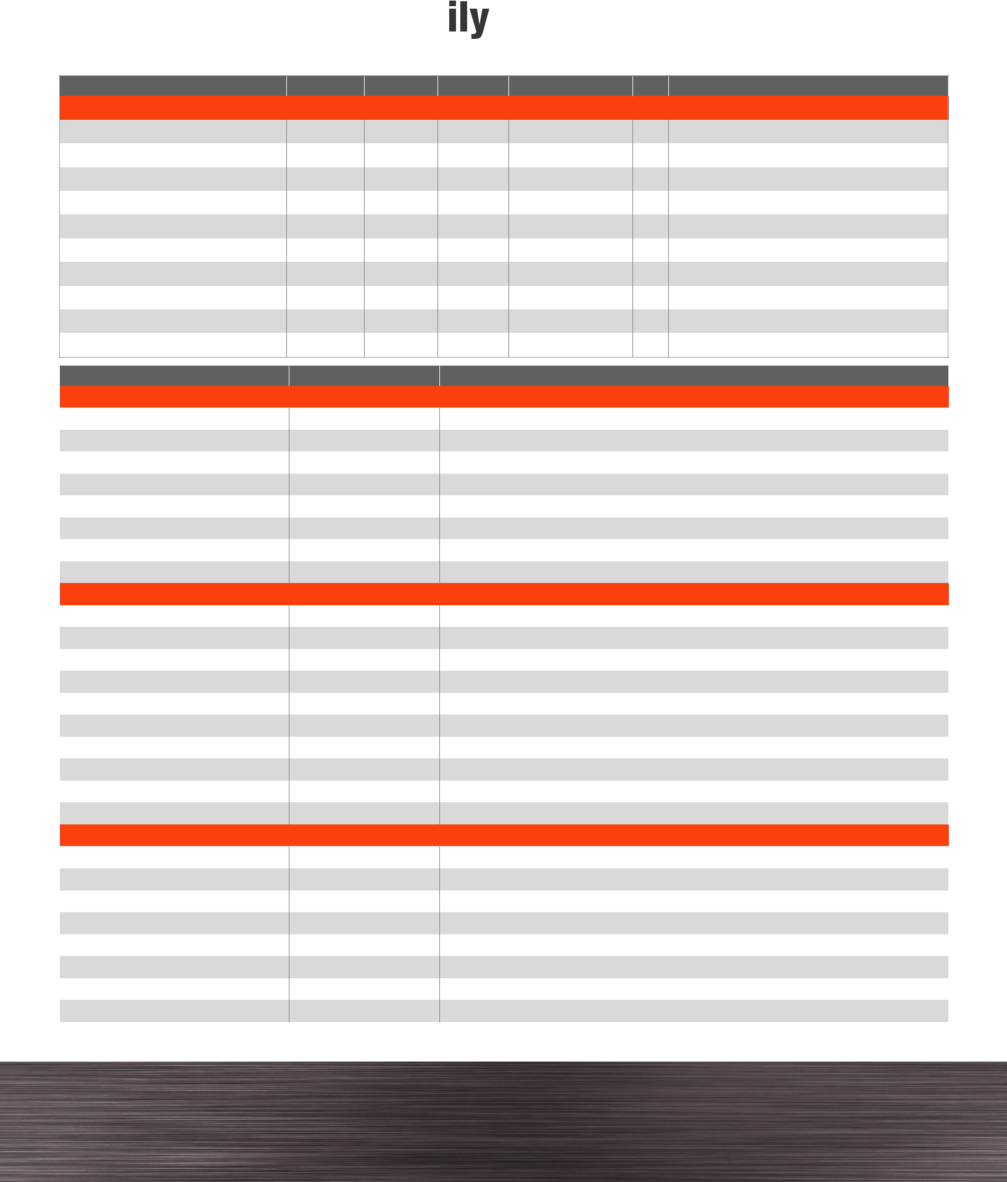


NOTES

ITEM

Clean & Freshen Up

Apply Tub & Tile Caulk

Clean Carpets

Deoderize Carpets

Paint & Patch Walls

Replace Registers

Replace Wall Plates

Spot Treat Carpets

Upgrade Cabinet & Drawer Pulls Preventative Maintenance Apply Drain Openers Audit Fire Extinguisher

Inspect Air Conditioner/Heat Pump (outside)

Inspect Air Handler (inside) Inspect Garage Entry Door Inspect Water Heater Replace Air Filter Replace Light Bulbs

Replace Smoke/CO₂ Detector or Batteries Replace Water Filters
Upgrades

Electronic Locks

LED Lighting

Low-Flow Plumbing Self-Adhesive Decorative Wall Tiles Smart Thermostat USB Receptacles

Video Doorbells

Vinyl Plank Flooring

COMPLETE

NOTES

Shop Online at HomeDepotPro.com/Multifamily

Please visit us online to view our terms and conditions

800.345.3000

En Español: 1.800.355.3335

MPM-11593

