ACT360 Media Ltd.

Advanced Accent Training in BPO Centers

1

Overview

A good call center manager knows the importance of strong English skills.


Technical knowledge and interpersonal skills are of little value if inbound callers cannot understand what call agents are saying. Some operators have strong accents, speak too quickly, or use inappropriate vocabulary – especially when they are stressed by difficult inbound calls.

ACT360 Media Ltd. and voice coach Andy Krieger have a solution.

Accent Training Solutions

This three-part program for call centers and business process outsourcing (BPO) organizations includes:

- Online Speaking Diagnostic Tool
- Task-Specific Accent Training
- Accent Audit and Monitoring
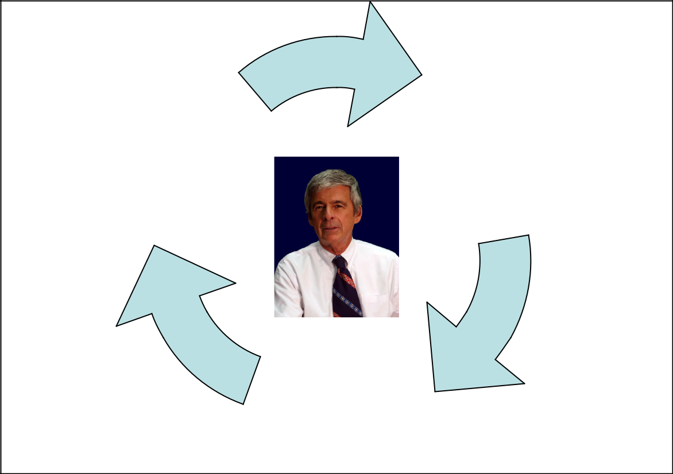

3. Accent Audit and 1. TestDEN.com

Monitoring Diagnostic Test

- Task Specific Accent Training

Andy Krieger BPO Process Quality Cycle

ACT360 Media Ltd. 2

Advanced Accent Training in BPO Centers

1. Online Speaking Diagnostic Tool

This 15-minute test helps call centers and BPO organizations to screen the English skills of new job applicants. Prospective operators record their voices online and the recordings are graded by ACT360 Media staff in Canada.

Each candidate is rated on the Speech Intelligibility Index:

Level Description

- Speech is unintelligible; only an occasional word or phrase can be recognized.

- Speech is largely unintelligible; much effort is required from the listener; constant repetition and verifications are required.

Impact on Communication

Accent prevents oral

communication.

Accent causes severe interference with oral communication.

Communicative Threshold A

- Speech is reasonably intelligible, but significant listener effort is required because of the speaker’s pronunciation or grammatical errors; there is ongoing need for repetition and verification.

Accent causes frequent interference with communication due to mispronunciation and the variant speech pattern.

- Speech is largely intelligible, although sound, rhythm, and intonation from the native language are obvious; listeners can understand if they concentrate on the message.

Communicative Threshold B

Accent causes distraction; the listener’s attention is often diverted away from the content to focus instead on the novelty of the speech pattern.

5

6

Speech is fully intelligible; occasional sound, rhythm, and intonation from the native language are present but not seriously distracting to the listener.

Speech is near-native; only minor differences can be detected.

Accent causes little interference; speech is fully functional for effective communication.

Accent is virtually non-existent.

ACT360 Media Ltd. 3

Advanced Accent Training in BPO Centers

Task-Specific Accent Training

Groups and individuals improve their pronunciation using Andy Krieger’s K-Method, which includes:

Full-day accent training workshops with Andy Krieger in classes of 10 trainees

Accent Reduction Review and Practice Booklet

3.5 hour companion DVD for post workshop review

90-day access to TestDEN.com online accent reduction course – featuring Accent Terminator video technology with custom modules on each BPO / call center role.


Accent Audit and Monitoring

ACT360 will perform an accent audit to measure the improvement in operator speech at the end of the 90-day online access. It includes:

Random sampling of inbound calls to each operator

Recording of each call for playback and evaluation by Andy Krieger

A written assessment for each operator along with suggestions for further improvement based on the Speech Intelligibility Index

A summary report for BPO/ call center management


For more information about how ACT360 Media can help your organization improve service and support, visit our website at www.testden.com/accent

