Merit Scholarships and Incentives for Academic Performance

Paper presented at the annual conference of the Association for the Study of Higher Education

Portland, OR

November, 2003

Donald E. Heller

Associate Professor and Senior Research Associate
Kimberly R. Rogers
Graduate Research Assistant

Center for the Study of Higher Education

The Pennsylvania State University
400 Rackley Building
University Park, PA 16802
814-865-9756
dheller@psu.edu

© 2003, Donald E. Heller and Kimberly R. Rogers

Introduction

Since the 1993 creation of Georgia’s Helping Outstanding Students Educationally (HOPE) Scholarship program – one of the nation’s first broad-based state merit aid programs – this form of financial assistance to students has spread to a number of other states. Twelve states have implemented broad-based merit scholarship programs for undergraduate students that do not use financial need in determining eligibility.¹ These states awarded a combined $1.05 billion in merit awards during the 2001- 02 academic year, almost three times the $341 million provided in need-based aid by those states (National Association of State Student Grant and Aid Programs, 2002). Nationally, the share of state spending on merit based programs has grown from less than 10 percent of the total (need and merit combined) in 1993 to almost 25 percent in 2001.

States have articulated three primary motivations for the creation of these programs:

- to promote college access and attainment. The Michigan law that established that state’s award program, for example, stated as a goal that the program would “increase access to postsecondary education and reward Michigan high school graduates who have demonstrated academic achievement” (“Michigan Merit Award Scholarship Act,” 1999).

- to stanch the “brain drain” of the best and brightest students and encourage them to attend college in the state. As the University of Alaska web site states, “The UA Scholars Program is designed to help reduce the number of Alaska’s high school graduates who leave the state for education and jobs elsewhere” (Hamilton, 2002).

- to encourage and/or reward students who work hard academically. The Florida statute creating its program states that it was created “to reward any Florida high school graduate who merits recognition of high academic achievement” (“Florida Bright Futures Scholarship Program,” 1999). The web site for West Virginia’s PROMISE scholarship, meanwhile, cites other states’ experience as evidence that the program has a motivational effect: “Several other states have found that the quickest and most effective way to motivate students to study harder and to achieve in school is to offer good students the opportunity to attend college tuition free” (PROMISE facts, 2003).

There has been a fair amount of research in recent years on the first goal of promoting college access (Cornwell, Mustard, & Sridhar, 2003; Dynarski, 2000; Heller & Marin, 2002). There has been much less research on the second and third goals of these programs, however. While programs like Georgia HOPE have been found to be influential on the college choice decisions of high-achieving students (Bugler & Henry, 1998; Cornwell & Mustard, 2002, Dynarski, 2002), there is little evidence that these students actually stay in the state after they graduate from college and contribute to the state’s economy.

- The Georgia HOPE program had an income eligibility cap of $66,000 (more than twice the median income in the state) in its first year of operation. The cap was raised to $100,000 the second year, and it was subsequently eliminated.

Merit Scholarships and Incentives for Academic Performance Heller and Rogers

Our study adds to the limited understanding of the incentive effects of merit scholarships – the third purpose described above – by examining the academic achievement of the first three cohorts of students eligible for the Michigan Merit Award Scholarship Program, the nation’s fourth largest merit aid program. As described earlier, the legislation that created the program had a stated goal “to increase access to postsecondary education and reward Michigan high school graduates who have demonstrated academic achievement” (“Michigan Merit Award Scholarship Act,” 1999). First awarded to the high school graduating class of 2000, the awards provide a one-time $2,500 college scholarship ($ 1,000 for students attending out-of-state institutions) to students who achieve a minimum score on all four sections of the Michigan Educational Assessment Program (MEAP) 11th grade test, the statewide curricular framework test. Because the program uses state test scores rather than high school grades as the award criterion, the effects of grade inflation can be discounted.

Literature Review

Some critics have charged that unlike most industrialized, and many developing, societies, American society is beset by a low level of student academic effort and achievement. The fundamental cause of the low effort level of American students “is the absence of good signals of effort and learning in high school and a consequent lack of rewards for effort and learning” (Bishop, 1990, p.25). Powell (1996) proffers that the American commitment to mass schooling and postsecondary education, unprecedented in the global community, “provides relatively weak incentives for students to learn” ( p.21). American student achievement will lag behind that of the world until teachers, administrators, policymakers or parents discover exceptional motivating forces or incentives for students.

For generations, many American parents have “paid” their children for their academic achievement, as signaled by good grades. In recent years, many private individuals and philanthropic organizations have entered into agreements to pay for students’ educational expenses if they maintained a certain level of academic performance. For example, in New York, “one of the most prominent dropout prevention programs, the I Have a Dream Foundation established by businessman Eugene Lang, provides significant guaranteed college scholarship assistance to those who finish high school” (Powell, 1996, p. 40). Students chosen to participate in such programs not only receive financial assistance with the cost of attendance, but generally have access to a variety of other programs, such as tutoring and other academic preparation services (Henry & Rubenstein, 2002) . However, we now find ourselves in an era where states are paying for grades through the use of public resources, not parents.

The state of Georgia changed the rules of the postsecondary education finance game when it implemented a new approach to improve the academic achievement and college attendance of state residents. The issues surrounding academic performance in the past have been about the underperformance of schools, students, and teachers. Public policy addressed these problems by sanctioning the poor performers, such as mandatory summer school for students or more state/local intervention in school affairs for poor-performing teachers and schools (Henry & Rubenstein, 2002). Public policy interventions now advocate “the establishment of extrinsic

2

Merit Scholarships and Incentives for Academic Performance Heller and Rogers

incentives with far-reaching economic and social consequences for individual students” (Powell, 1996, p. 22). Rather than reward high-performing schools and districts at the macro-level, Georgia policymakers chose, instead, to reward students directly with monetary awards. Merit aid awards function as a direct fiscal incentive to students to allocate more of their time to academic endeavors in order to improve their academic performance and achievement (Stampen & Hansen, 1999).

It has been a decade since their introduction of the HOPE Scholarship program in Georgia in 1993, and large-scale merit aid programs are still being touted by supporters as an efficient mechanism for ameliorating the academic performance and achievement of state residents. More than one dozen states currently have merit aid programs, and the eligibility criteria for these awards differ by state (Heller, 2002). Depending upon the state, such measures as high school (or college) grade point average (GPA), standardized test scores (SAT or ACT tests), class rank, and state curricular frameworks tests are used solely or in combination for the awarding of these scholarships. Many states which have only a GPA requirement for a merit award publicize statistics that demonstrate an increase in the number of merit-aid eligible students due to a greater proportion of students with the minimum GPA. Ostensibly, an increase in the mean GPA or in the number of students who pass the threshold required to receive a scholarship is evidence of increased academic ability. However, Bugler, Henry and Rubenstein (1999) caution against the use of grade point average of varying cohorts of students as an absolute indicator of improved academic achievement in states that have merit aid programs. While the mere existence of such a program may boost students’ incentives for, and performance in, academic work through the provision of financial rewards for better grades, teachers could also boost grades to increase student access to college (p.3), as well as to meet the demands of students and parents. Standardized tests such as the SAT serve as a better judge of student ability and achievement because of their supposed objectivity (Bugler, Henry & Rubenstein, 1999, p.5).

Researchers examining the relationship between academic incentives and standardized test scores in Georgia have found evidence that Georgia high school graduates have achieved higher high school grades and higher SAT scores since the advent of the HOPE Scholarship program (Henry and Rubenstein, 2002; Bugler, Henry & Rubenstein, 1999). From 1988 to 1998, encompassing both pre-HOPE and post-HOPE student cohorts, Bugler, Henry and Rubenstein found that Georgia students experienced an increase in the aggregate SAT scores that totals 13 points. However, nationally, both the mean verbal and math scores of students with an average grade of A decreased by 23 points and 4 points respectively during the same period (the verbal score fell from 582 in 1988 to 569 in 1998, while math scores fell from 586 to 582). A similar decline was noted for students with a B average. If standardized test scores, not GPA, are indeed an accurate measure of academic achievement, nationally, students were less well academically prepared in 1998 as compared to 1988, while Georgia students improved their academic performance.

Further evidence concerning the increase in SAT scores exists in the case of Georgia. In a 2002 study, Henry and Rubenstein present evidence that GPA and SAT scores were higher for entering freshmen in the University System of Georgia (USG) institutions after the introduction of the HOPE program. Even if some of the GPA increase (from 2.71 in 1989 to 2.98 in 1999) may be attributed to grade inflation or less challenging academic work, the SAT increase is very real (from 979 to 1009) and cannot be linked in any way to grade inflation. However, since the

3

Merit Scholarships and Incentives for Academic Performance Heller and Rogers

students studied included only those attending USG, the increase in average GPA and test scores could also be caused by the changing mix of students attending the System rather than private institutions in the state or out-of-state institutions. While the authors discount the effect this could have on their results, their methodology does not control fully for the potential effect of the changing credentials of the students entering USG.

Another study of the impact of Georgia HOPE found that once students enrolled in college, the incentive effects of the scholarship were responsible for both 1) lowering the average course load taken by students, and 2) increasing the number of students who withdrew from courses after beginning them (Cornwell, Lee, & Mustard, 2002). Both of these behaviors can lead to increases in the time it takes students to earn degrees. Similar results were found in a study of the New Mexico Lottery Success Scholarships (Binder, Ganderton, & Hutchens, 2002). That program was found to result in a lower average number of credit hours taken by students enrolled in their first year at the University of New Mexico; in addition, the retention rate of students from the first to second semester dropped after implementation of the scholarship program.

In Florida, evidence partially supports the assertion that the Bright Futures program, instituted in 1997, has improved the high school academic preparation of students. Florida students took more of the required Bright Futures courses, and more rigorous courses overall. The percentage of high school graduates taking required Bright Futures courses increased from 54 percent in 1997 to 65 percent in 2001, while 30 percent of all high school graduates qualified for Bright Futures scholarships in 2001, up from 26 percent in 1997 (Office of Program Policy Analysis and Government Accountability, 2003). Yet, the OPPAGA admits that while GPA and rigorous course taking have improved, test scores show little change, unlike in Georgia. In fact, the SAT, ACT, and College Placement test scores of students actually declined from 1996-97 to 2000-01. This finding led the authors of the study to conclude that

There are two likely explanations for the increase in GPA. On the one hand, students may work harder to get the required grades for a Bright Futures scholarship. On the other hand, grade inflation is a legitimate concern when merit-based programs award scholarships, at least in part, on the basis of GPA. Evidence suggests that both factors account for the increases in grades.… The

higher grades without a corresponding increase in exam scores also indicates that grade inflation may account for some of the change in grades. This can occur if parents and students pressure teachers to give students higher grades that do not match classroom performance in order to qualify the students for scholarships. An analysis of college entrance exam scores indicates that grade inflation has occurred and that it primarily affects students who were at or near the Bright Futures GPA cutoff points (p. 7).

The relationship between financial incentives and academic achievement, as measured by standardized test scores, is unproven. The few studies that exist do little more than correlate the two measures; there is no clear evidence of causality. McPherson and Schapiro (1998) criticize merit awards because of the unverified effects on student achievement. According to these researchers, “…the presence of merit awards may induce students to improve their performance both in strictly academic pursuits and in those kinds of extracurricular activities that college

4

Merit Scholarships and Incentives for Academic Performance Heller and Rogers

admissions committees seem to care about…We know of no evidence that would help in assessing the size of such effects” (p.111). Merit aid rewards higher academic qualifications while doing nothing to improve academic performance.

It is important to note that the mixed evidence about the positive effects of financial incentives on academic performance has not prevented a dozen states from adopting some variation of Georgia’s HOPE scholarship. In reality, linking merit awards to academic performance could in fact lower educational achievement if lower grading standards are implemented to maximize a student’s chances of obtaining an award (Henry & Rubenstein, 2002; Betts, 1997).

Research Design

Data on the 2000, 2001, and 2002 graduating classes in Michigan was obtained from the Michigan Merit Award Office (2003). The data include all high school students, public and private, who took the MEAP test at least once; over 100,000 students are in each cohort. Data on the characteristics of high schools in the state were obtained from the Michigan Department of Education (2003) and were merged with the student datasets.

Bivariate analyses of the data were conducted to examine the trends among the three cohorts in scholarship qualification rates for different populations of students in each cohort, including racial/ethnic groups, and schools with varying levels of free/reduced lunch eligible students. In addition, we analyzed the trend in standardized test scores (ACT and SAT) in the state to compare them with changes in the scholarship qualification rates.

Results

Scholarship Qualification

To qualify for the Michigan Merit Award Scholarships, students must pass two thresholds. First, they must take all four sections of the MEAP 11th grade test to be considered for the scholarships.² The second step in scholarship qualification is to score at a performance level of 1 or 2 (on a four point scale) on all four of the test sections. Students may also qualify for the scholarships by taking all four sections, scoring a 1 or 2 on at least two of the sections, and scoring in the top quartile nationally on the SAT or ACT test. For the classes of 2000 through 2002, the qualifying SAT score was 1170 and composite ACT score was 24.

- While the tests are normally administered to 11th graders in the spring of that year, students are able to retake the test in the fall and spring of their senior year if they choose.

5

Merit Scholarships and Incentives for Academic Performance Heller and Rogers

Before examining the trend in MEAP test results and standardized test scores, it is important to understand the timing of the development of the Michigan Merit Award Scholarship program. Governor John Engler of Michigan announced in his 1999 State of the State Address that he would introduce legislation to create the Michigan Merit Award, “for all Michigan high school graduates who master reading, writing, math and science” (Engler, 1999). Engler proposed that the program be funded from a portion of the state’s share of tobacco settlement funds. The bill quickly passed both houses of the Michigan legislature and the Michigan Merit Award Scholarship Act was signed into law by Engler on June 30, 1999.

The argument can be made that the incentive of the scholarship should have had little impact on the graduating class of 2000, which would have taken the MEAP tests in April of 1999, before the legislation had been enacted. Even though the proposal had received some coverage in the press, the details of the program were not hammered out until after these students took the test. Once enacted, the program received even more publicity – including information about how students could qualify for the scholarships – and thus, it would reasonably have been expected to have the largest impact on the class of 2001.

For all 106,000 students in the baseline year (graduating class of 2000) who took at least one MEAP section, 86 percent took all four sections. Large differences were found in the rates at which students in different racial groups took the four sections, however (figure 1). For example, in the baseline year (graduating class of 2000), while 90 percent of white students took

Native American |  |  |  |  |  |  |  |  |  |  |  |  |  |  |  |  |  |  |  |  |  |  |  |  |  |  |  |  |  |  |  |  | 1,118
Asian/Pacific Islander |  |  |  |  |  |  |  |  |  |  |  |  |  |  |  |  |  |  |  |  |  |  |  |  |  |  |  |  |  |  |  |  | 2,704
African American |  |  |  |  |  |  |  |  |  |  |  |  |  |  |  |  |  |  |  |  |  |  |  |  |  |  |  |  |  |  |  |  | 2,704
 |  |  |  |  |  |  |  |  |  |  |  |  |  |  |  |  |  |  |  |  |  |  |  |  |  |  |  |  |  |  |  | 13,182
Hispanic |  |  |  |  |  |  |  |  |  |  |  |  |  |  |  |  |  |  |  |  |  |  |  |  |  |  |  |  |  |  |  |  | 2,935
White |  |  |  |  |  |  |  |  |  |  |  |  |  |  |  |  |  |  |  |  |  |  |  |  |  |  |  |  |  |  |  | 83,165
Other* |  |  |  |  |  |  |  |  |  |  |  |  |  |  |  |  |  |  |  |  |  |  |  |  |  |  |  |  |  |  |  | 10,655
All Students |  |  |  |  |  |  |  |  |  |  |  |  |  |  |  |  |  |  |  |  |  |  |  |  |  |  |  |  |  |  |  | 113,759
0% |  |  | 10% |  | 20% |  | 30% |  |  |  | 40% |  |  | 50% |  |  | 60% |  |  | 70% |  |  |  | 80% |  |  |  |  | 90% |  |  |  | 100%
 |  |  |  |  |  |  |  |  |  | 2000 |  |  | 2001 |  |  |  | 2002

- Includes students of unknown race, other race, and multiracial Note: The number of students in each group in 2002 is shown at right.

Figure 1: Percentage of students taking all four MEAP sections

6

Merit Scholarships and Incentives for Academic Performance Heller and Rogers

all four tests, only 71 percent of African Americans and 80 percent of Hispanics achieved this first threshold. In the second year, the rate at which all students took the four sections decreased to 85 percent, due largely to a drop in the rate for white and other students.

The third year saw a continued drop off in the proportion of students taking all the sections, with the total decreasing another half percentage point. While some of the racial groups saw small increases from the first year to the second year, all saw a decline from the second to the third year so that by 2002 a small proportion of all groups took all four tests (with the exception of African Americans) than in the baseline year.

Figure 2 shows the proportion of students in each racial group who qualified for the scholarships, of those who took all four MEAP sections. Overall, the proportion of students qualifying for the scholarships (of those who took all four sections) increased from 47 percent in the first year to 54 percent in the second year, and then decreased 0.2 percentage points in the third year. For Native American, African American, Hispanic, and other students, this pattern was repeated – a relatively large gain from year one to year two, followed by a slight drop-off in year three. White and Asian American students saw a large gain in the second year, followed by a much smaller gain (less than one percentage point) in the third year.
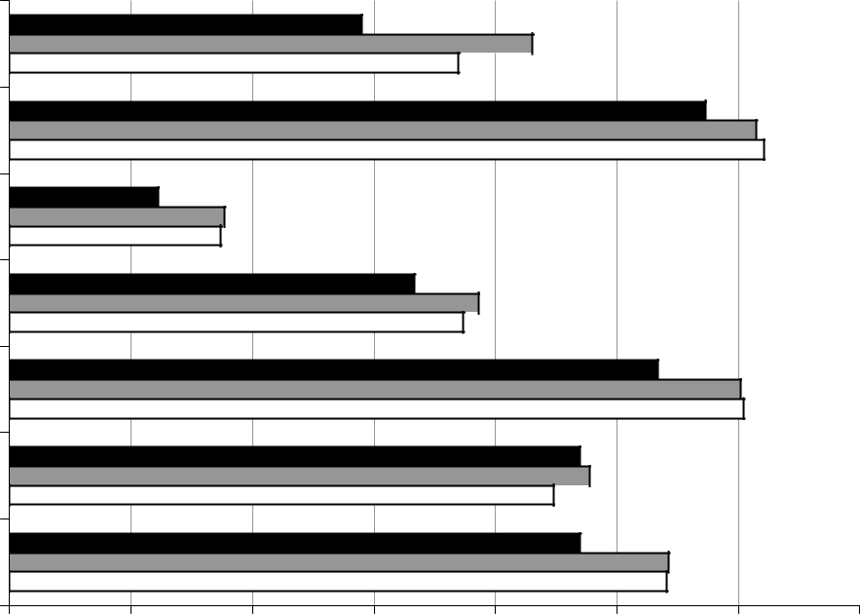

Native American

Asian/Pacific Islander

African American

Hispanic

White

Other*

All Students

0% 10% 20% 30% 40% 50% 60% 70%

2000 2001 2002

* Includes students of unknown race, other race, and multiracial

Figure 2: Scholarship qualification rates for students taking all four MEAP sections

7

Merit Scholarships and Incentives for Academic Performance Heller and Rogers

Figure 3 combines the data from the two steps necessary to qualify for the scholarships. In the graduating class of 2000, 40% of all students who took at least one section of the MEAP test qualified for a scholarship. This proportion increased to 46 percent in 2001, and then dropped slightly to 45 percent the following year. Similar patterns were seen for all groups, with the exception of other race students.³
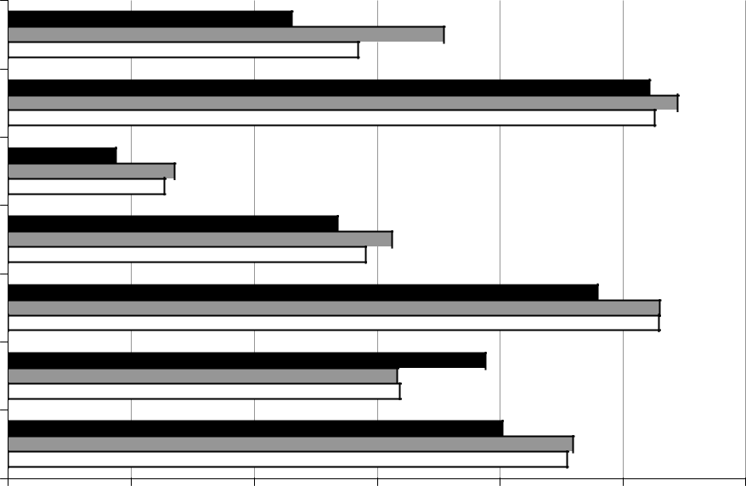

Native American

Asian/Pacific Islander

African American

Hispanic

White

Other*

All Students

0% 10% 20% 30% 40% 50% 60%

2000 2001 2002

* Includes students of unknown race, other race, and multiracial

Figure 3: Scholarship qualification rates for all students taking at least one MEAP section

Data from the Michigan Department of Education were used to calculate the percentage of students on free or reduced lunch in each high school, which is used as a proxy for the proportion of low-income students attending each school. The free/reduced lunch data were combined with the MEAP data to look at the scholarship qualification rates for students attending schools in five quintiles. Schools in the first quintile had the lowest proportion of students receiving free or reduced lunch; schools in the fifth quintile had the highest proportion. Figure 4 shows the scholarship qualification rates for all students taking at least one MEAP section, by the high school’s quintile ranking of students on free or reduced lunch.

Two patterns are evident in figure 4. The first is the initial jump in qualification rates for all students from the first year to the second year, followed by a smaller increase or a slight decline in the third year. The second pattern is the declining proportion of students qualifying for the

- The rate for white students decreased from 53.0 percent in 2001 to 52.9 percent in 2002.

8

Merit Scholarships and Incentives for Academic Performance Heller and Rogers

scholarships as the ratio of students on free or reduced lunch increases. In 2002, for example, in the first quintile – those schools with on average the wealthiest school populations – saw 59 percent of students qualifying for the scholarships. In contrast, the schools with the largest number of poor students, those in the fifth quintile, saw less than half as many students (24 percent) qualify for the scholarships.⁴
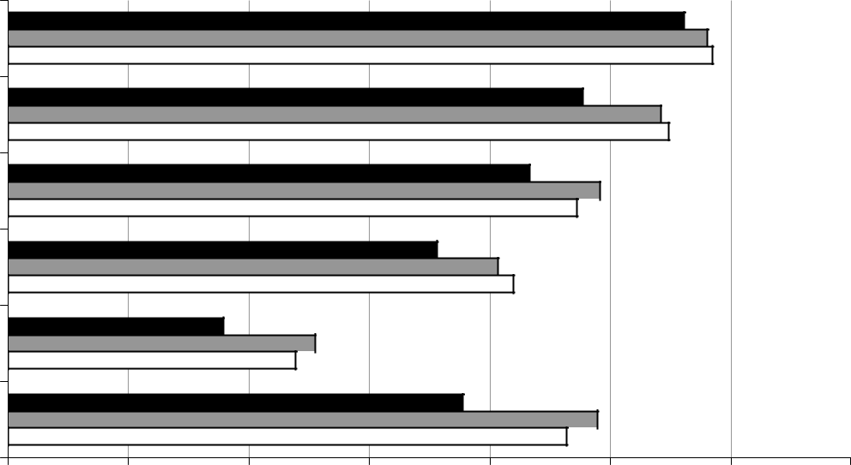

1 (lowest %)

2

3

4

5 (highest %)

Missing

0% 10% 20% 30% 40% 50% 60% 70%

2000 2001 2002

Figure 4: Scholarship qualification rates for all students taking at least one MEAP section, by school free/reduced lunch quintile

Standardized Test Scores in Michigan

Michigan is primarily an ACT state. In the school year ending in 2002, while 69 percent of the graduating students had taken the ACT test, only 11 percent took the SAT test (ACT, Inc., 2003; Center for Educational Performance and Information, 2003; The College Board, 2002a). Table 1 compares the mean ACT and SAT scores in Michigan and nationally from 1999 to 2003.

- Students with missing free/reduced lunch quintile are largely students in private schools and home schooled students.

9

Merit Scholarships and Incentives for Academic Performance Heller and Rogers

Table 1: Michigan and United States mean ACT and SAT scores

 |  | Michigan | United States |  | Michigan | United States
ACT Composite |  | All Students |  |  | Core Course Completers
1999 | 21.3 |  | 21.0 |  | 22.6 | 22.0
2000 | 21.3 |  | 21.0 |  | 22.5 | 22.0
2001 | 21.3 |  | 21.0 |  | 22.5 | 21.9
2002 | 21.3 |  | 20.8 |  | 22.5 | 21.8
2003 | 21.3 |  | 20.8 |  | 22.5 | 21.8
Change, 1999 to 2003 |  | 0.0 points | –0.2 points |  | –0.1 points | –0.2 points
SAT Combined |  | All Students |  |  | Students with A− or Better GPA
1999 | 1122 |  | 1016 |  | 1209 | 1141
2000 | 1126 |  | 1019 |  | 1211 | 1141
2001 | 1130 |  | 1020 |  | 1215 | 1139
2002 | 1133 |  | 1020 |  | 1207 | 1138
2003 | 1140 |  | 1026 |  | 1211 | 1138
Change, 1999 to 2003 |  | 18 points | 10 points |  | 2 points | –3 points

Source: ACT, Inc. (various years); The College Board (various years(a),(b)).

The mean composite ACT score did not change in Michigan from 1999 (the cohort graduating the year before the scholarship program was implemented) to 2003, while nationally composite ACT scores declined 0.2 points. ACT also provides the scores of students who completed a core curriculum in high school – consisting of four years of English and three years each of mathematics, sciences, and social sciences – compared to those not completing the core. Students who had completed a core curriculum, those students who arguably had taken an important step to prepare themselves for entry into a four-year college, saw virtually no change in their average composite ACT scores between 1999 and 2003. In Michigan the average score for this group was 22.6 in 1999, then dropped to 22.5 in 2000 and stayed at that level through 2003. Nationally, students who completed the core curriculum saw the same 0.2 point decline in the average score as did all students taking the ACT.

Average SAT scores for all students in Michigan increased 18 points during the same period, compared to an increase of 10 points nationally. It is not surprising that the Michigan SAT scores are substantively much higher than the national scores, as compared to the relationship between Michigan and national ACT scores. Since far fewer Michigan students take the SAT, and many of those are likely applying to selective out-of-state institutions, one would expect these students to be stronger academically than the broader pool of ACT test takers. For example, while nationally the mean high school GPA of all SAT test takers was 3.29 in 2002, in Michigan the average GPA was 3.55; while 42 percent of the students nationally reported that their high school GPA was A- or better, 64 percent of the Michigan students reported a GPA this

10

Merit Scholarships and Incentives for Academic Performance Heller and Rogers

high (The College Board, 2003a, 2003b). Among this group with higher GPAs, the Michigan students saw an increase of two points from 1999 to 20003, while nationally this pool (representing a much smaller proportion of all SAT takers, as noted above) saw a decrease of three points in their average SAT score.

Discussion

The results of this study indicate that while there was an initial gain in performance in scholarship qualification from the first year to the second year, there was no similar gain by the third cohort of students. One possible explanation for this result is that the initial gain was the result of the publicizing of the program. Most of the students in the first cohort took the 11th grade MEAP exam before the program had been finalized and information distributed to schools, students, and parents. Students in the second cohort were more likely aware of the program before they first attempted the MEAP test, and thus, may have been persuaded to work hard at scoring the required level on the exam (there were no other individual-level stakes attached to the tests). Once information about the program was saturated among high school students, there may have been little further gain in performance to be seen by the third cohort.

The pattern among the three cohorts was not the same when you examine students in different racial groups. Minority students who have been underrepresented in college participation in Michigan (Heller & Rasmussen, 2002) – African Americans, Native Americans, and Hispanics – had the largest drop-off in qualification rates from the second to the third cohorts of students.

The gains in scholarships qualification in the second year – scholarships which are awarded based on a score on the state’s curricular frameworks tests – were not mirrored in gains in average scores on the ACT test, a nationally-normed test designed to measure general knowledge as well as students’ ability to perform in college.

Two additional limitations of this research should be noted. First, the MEAP test is designed to measure the knowledge students acquired through roughly first three years of high school. Thus, there may not yet have been enough time for students to significantly increase their learning behaviors through their high school careers in order to change their performance on the MEAP exam. It is difficult to separate the incentive effects of the Michigan scholarships from the potential effect of the changing test-taking pool in each year. A larger percentage of students took all four MEAP sections, a step required to qualify for the scholarships, in the second cohort than in the first cohort. If academically stronger students were induced into taking all four tests the second year, because of the potential inducement of winning the scholarship, than the higher qualification rate in the second year may have been due at least in part to the changing mix of test-takers, rather than induced academic performance.

Secondly, the $2,500 one-time scholarship may not provide enough of an incentive – as compared to programs, such as Georgia HOPE, that provide full-tuition scholarships for four or more years – to students to improve their academic performance. It may not be realistic to expect such a small inducement to encourage students to study harder and achieve higher scores on the curricular framework tests. While $2,500 would have provided more than the cost of

11

Merit Scholarships and Incentives for Academic Performance Heller and Rogers

tuition for one year at a community college in the state (Washington Higher Education Coordinating Board, 2003), it may not have been a large enough incentive to create a measurable change in behavior. As data on additional cohorts of students become available, we will be continuing to examine these effects.

The results of this study lead us to conclude that policymakers should be careful in implementing merit scholarship programs as a mechanism for encouraging higher levels of academic performance among high school (or college) students. While the results of research on other state programs, such as Georgia HOPE, indicate that there may be an incentive effect, there are still a number of unanswered questions. How large does the incentive need to be? What is the lag time required between when the incentive is put in place and when students can reasonably be expected to change their behavior? Are there ways to target the incentive at students who have more marginal academic performance, and would thus benefit from improving their performance in preparing for college, rather than simply awarding it to all students?

12

Merit Scholarships and Incentives for Academic Performance Heller and Rogers

References

ACT, Inc. (2003). 2002 ACT average composite scores by state (http://www.act.org/news/data/ 02/states.html). Iowa City, IA: Author.

ACT, Inc. (various years). ACT average composite scores by state. Iowa City, IA: Author.

Betts, J. (1997). Do grading standards affect the incentive to learn? San Diego: University of

California, San Diego, Department of Economics Discussion Paper No. 97-22.

Binder, M., Ganderton, P. T., & Hutchens, K. (2002). Incentive effects of New Mexico's merit-based state scholarship program: Who responds and how? In D. E. Heller & P. Marin (Eds.), Who should we help? The negative social consequences of merit scholarships (pp. 41-56). Cambridge, MA: Harvard Civil Rights Project.

Bishop, J. (1990). Incentives to study: Why American high school students compare so poorly to

their counterparts overseas. In D. Crawford and L. Bassi (eds.), Research in labor economics, Vol. 11 (17-51). Greenwich, CT: JAI Press.

Bugler, D. T., & Henry, G. T. (1998). An evaluation of Georgia's HOPE Scholarship Program: Impact on college attendance and performance. Atlanta, GA: Georgia State University, Council for School Performance.

Center for Educational Performance and Information (2003). 2001-2002 pupil headcount data (http:// http://michigan.gov/documents/SHEADG02_49846_7.DBF). Lansing: State of Michigan.

The College Board (2003a). 2003 college-bound seniors: A profile of SAT program test takers.

Michigan report. New York: Author.

The College Board (2003b). 2003 college-bound seniors: A profile of SAT program test takers.

Total group report. New York: Author.

The College Board (various years(a)). College-bound seniors: A profile of SAT program test

takers. Michigan report. New York: Author.

The College Board (various years(b)). College-bound seniors: A profile of SAT program test

takers. Total group report. New York: Author.

Cornwell, C., & Mustard, D. (2002) . Race and the effects of Georgia's HOPE scholarship. In D. E. Heller & P. Marin (Eds.), Who should we help? The negative social consequences of merit scholarships (pp. 57-72). Cambridge, MA: Harvard Civil Rights Project.

13

Merit Scholarships and Incentives for Academic Performance Heller and Rogers

Cornwell, C. M., Lee, K. H., & Mustard, D. B. (2002). The effects of merit-based financial aid on academic choices in college. Athens, GA: University of Georgia, Terry College of Business.

Cornwell, C. M., Mustard, D. B., & Sridhar, D. J. (2003). The enrollment effects of merit-based financial aid: Evidence from Georgia's HOPE scholarship. Athens, GA: University of Georgia, Terry College of Business.

Dynarski, S. (2000). Hope for whom? Financial aid for the middle class and its impact on college attendance. National Tax Journal, 53(3 [Part 2]), 629-661.

Dynarski, S. (2002) . Race, income, and the impact of merit aid. In D. E. Heller & P. Marin (Eds.), Who should we help? The negative social consequences of merit scholarships (pp. 73-91). Cambridge, MA: Harvard Civil Rights Project.

Engler, J. (1999). 1999 State of the state address. Lansing: State of Michigan, Governor's Office.

Florida Bright Futures Scholarship Program, 240.40201 (1999).

Hamilton, M. (2002). UA Scholars Program (http://www.alaska.edu/scholars/booklet.html).

Anchorage: University of Alaska.

Heller, D. E., & Marin, P. (Eds.). (2002). Who should we help? The negative social consequences of merit scholarships. Cambridge, MA: Harvard Civil Rights Project.

Heller, D. E., & Rasmussen, C. J. (2002). Merit scholarships and college access: Evidence from Florida and Michigan. In D. E. Heller & P. Marin (Eds.), Who should we help? The negative social consequences of merit scholarships (pp. 25-40). Cambridge, MA: Harvard Civil Rights Project.

Henry, G. T., & Rubenstein, R. (2002). Paying for grades: Impact of merit-based financial aid on educational quality. Journal of Policy Analysis and Management, 21(1), 93-109.

McPherson, M. S., & Schapiro, M. O. (1998). The student aid game: Meeting need and rewarding talent in American higher education. Princeton, NJ: Princeton University Press.

Michigan Department of Education (2003). Michigan school report. Lansing: Author.

Michigan Merit Award Office (2003). MEAP anonymous pupil file. Lansing: Michigan Department of Treasury.

Michigan Merit Award Scholarship Act, 390.1451 (1999).

National Association of State Student Grant and Aid Programs. (2003). 33rd Annual Survey Report on State- Sponsored Student Financial Aid 2001-2002 Academic Year. Albany: New York State Higher Education Services Corporation.

14

Merit Scholarships and Incentives for Academic Performance Heller and Rogers

Office of Program Policy Analysis and Government Accountability. (2003). Bright Futures contributes to improved college preparation, affordability, and enrollment (03-17). Tallahassee: Florida Legislature.

Powell, A. (1996). Motivating students to learn: An American dilemma. In S. Fuhrman & J.

O’Day (Eds.), Rewards and reform: Creating educational incentives that work. San
Francisco: Jossey-Bass. pp.19-59.

PROMISE facts (2003). PROMISE Scholarship Program (http://www.promisescholarships.org/ facts.asp). Charleston, WV: Promise Scholarship Program.

Stampen, J. and Hansen, W. (1999). Improving higher education access and persistence: New directions from a systems perspective. Educational Evaluation and Policy Analysis, 21(4), 417-426.

Washington Higher Education Coordinating Board. (2003). 2002-03 Washington state tuition and fee report. Olympia: Author.

15

