THE PERCEPTION OF THE THIRD YEAR BACHELOR OF SECONDARY EDUCATION MAJOR IN ENGLISH STUDENTS OF THE DAVAO ORIENTAL STATE COLLEGE OF SCIENCE AND TECHNOLOGY ON CHEATING

A RESEARCH PAPER IN LINE WITH THE REQUIREMENT OF ENG 5, BASIC RESEARCH

BY

GRACE ANDOYO

JOVANNIE MALINTAD

LEAH ROSE NIETES

JONAVELLE RAMOS

CHRISTOPHER ROSALES

MAY, 2014
TABLE OF CONTENTS

- Introduction

Rationale of the Study ----------------------------------------------------------- 1

Objectives of the Study ----------------------------------------------------------- 1

Conceptual Framework ----------------------------------------------------------- 2

Operational Definition of Variables and Other Terms -------------------------------- 3

Significance and Importance of the Study ----------------------------------------- 3

Scope and Limitation of the Study -------------------------------------------------- 4

II. Review of Related Literature -------------------------------------------------- 5

- Methodology

Research Design ----------------------------------------------------------- 10

Target Population and Sampling Procedures ---------------------------------------- 10

Data Collection ------------------------------------------------- 10

Findings and Discussion ---------------------------------------------------------- 13

Conclusion ---------------------------------------------------------- 22

IV. Bibliography ------------------------------------------------------------------- 23

V. Appendix

Survey Questionnaire ------------------------------------------------------------------- 28

Interview ------------------------------------------------------------------- 29

Coding Manual ------------------------------------------------------------------- 30

Coding Sheet ------------------------------------------------------------------- 31
LIST OF GRAPHS

Graph 1. Distribution of Respondents According to Age ----------------------------------------- 11

Graph 2. Distribution of Respondents According to Sex ----------------------------------------- 11

Graph 3. Distribution of Frequent Time Study of Respondents -------------------------------- 12

Graph 4. Distribution of Frequent Time the Respondent Cheat -------------------------------- 12

Graph 5. Distribution of the Feeling of Respondents When Cheating ----------------------- 13

Graph 6. Distribution of Respondents Caught in Action of Cheating ----------------------- 13

Graph 7. Distribution of Respondents Who Gets Answers from Cheating ----------------------- 14

Graph 8. Distribution of Respondents Who Claims or Submits Academic Works of Others

as Their Own ----------------------------------------- 14

Graph 9. Distribution of Respondents Who Pays Someone for Paper Works/Assignments ----- 15

Graph 10. Distribution of Respondents Who Provides False Information ----------------------- 15

Graph 11. Distribution of Respondents Who Threatens Someone to Do the Favor -------------- 16

Graph 12. Distribution of Respondents Who Use Cheat Sheets -------------------------------- 16

Graph 13. Distribution of Respondents Who Allow Others to Cheat -------------------------------- 17

Graph 14. Positivity and Negativity of Cheating -------------------------------------------------- 17

Graph 15. Distribution of Respondents’ Reasons Why They Cheat -------------------------------- 18

Graph 16. Distribution of Respondents’ Reaction When They See Someone Cheating --------- 19

LIST OF TABLE

Table 1. Table of Specifications ----------------------------------------------------------------- 12
CHAPTER I

INTRODUCTION

A. Rationale

The purpose of this paper is to present and interpret the perception of third year Bachelor of Secondary Education Major in English students on cheating. It is important to know the perception of students on cheating because most of the students cheat. This serves as an evaluation of their deed. The first thing to recognize about cheating is that vast majority of students believe that cheating is bad, yet, there are still many who practice it. Cheating in school is called academic dishonesty. There are types of academic dishonesty according to D. Stuber-McEwen (2009). This includes fabrication, plagiarism, multiple submissions, and abuse of academic materials, deception and misrepresentation, electronic dishonesty and carelessness. According to American Counselling Association (2005), among current college students, 75% admit to cheating on tests, quizzes, and homework. Students cheat because of a grade-focused environment (Anderman, 1998). This occurs when students give more emphasis on earning good grades instead of learning. When students cheat, their sense of determination between right and wrong changes, in other words, the more one cheats, the easier it becomes to rationalize one’s behavior and cheat again which Shu, Gino,and Bazerman (2011) were pointing out. Cheating has been on the rise in recent years, according to a 2010 study from Josephson Institute of Ethics. As to DOSCST’s Code of Honor states /ought a student not to lie, to cheat, or to steal in any academic endeavours. If caught, invalidation of the answer sheet/examination paper is the minor punishment. The researchers were alarmed to this noticeable circumstance. So, the researchers are encouraged to conduct a study about this. In the process of doing the study, the researchers were able to define cheating, pinpoint the reason(s) behind cheating, identify whether cheating is a product of laziness or some other circumstances, and determine the ways on how students cheat. It is desired that the bottom line of this study would contribute to the understanding of the students’ behavior towards studying.

B. Objectives of the Study

This study will be conducted to determine the perception of the third year Bachelor of Secondary Education major in English students on cheating.
Specifically, this study aims to:

  - define what is cheating to them;

  - pinpoint the reason why cheating is done;

  - identify whether cheating is a product of laziness or some other circumstance; and

    - determine the ways on how they cheat.

C. Conceptual Framework

Educational institutions such as schools and universities aim to develop the academic potential, knowledge, skills, and abilities among its students and instil in them values and conduct that will mold their character and must be upheld. However, for many years, the unceasing issue of cheating and other forms of academic dishonesty linked to the increasing population of students engaging in academic misconduct. Despite of knowing that cheating is an unethical behavior, still, more and more students involve themselves on it and had enumerated a list of reasons why they had done it so.

In this study, the perception of the students (as the independent variable) affects their reason/s why they cheat (reasons as the dependent variable). If the student perceives cheating as unethical and a bad doing, then he/she has less/no reason at all to cheat. Otherwise, if he/she sees cheating as a good thing to do then, he/she has a lot of reasons to count why the act has been done. However, there are intervening variables to be considered such as social or external factors and demographic characteristics of the student which can influence them as to how they perceive cheating differently.
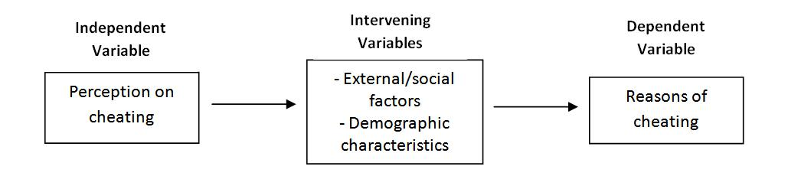
D. Operational Definition of Variables and Other Terms

In order to have an easy and better understanding for the readers, the researchers define the following terminologies according to how it is used in this research:

Academic dishonesty is defined as “a violation of an institution’s policy on honesty” (Weaver, 1991).

Cheating is an act of obtaining of property from one another by an intentional active distortion of truth.

Cynicism is a state of being distrustful.

Demographic characteristics are traits related to statistical population of human.

Fabrication is the process of falsification of information or any data.

Ethical defined as involving or expressing moral approval or disapproval; conforming to accepted standards of conduct.

Multiple Submissions are papers with exactly the same content being passed.

Neutralization is denial of responsibility for improper action because of the improper action of others (Haines et al., 1986).

Perception is the awareness; understanding; consciousness; observation of concepts and things.

Social factors defined as agents interacting between individual and the group or welfare of human as members of society.

E. Significance of the Study

The fundamental purpose of this study is to expose the perception of the third year Bachelor of Secondary Education Major in English students of Davao Oriental State College of Science and Technology on cheating and to determine their ways and reasons why they cheat. Thus, this

study will help the faculty to be aware on the increasing population of students engaging themselves in academic dishonesty.

This study will serve as basis for future pedagogical plans of the school administrators for appropriate actions to be done in order to diminish the act of cheating and to let complete and balanced education come into being.

Finally, this will help them have insights about the nature of the problem to respond for a remedy. The success in implementing the solution would be a great help to bring the institution’s standing in the higher level.

F. Scope and Limitation of the Study

This research was limited to be aware about the perception of the third year Bachelor of Secondary Education Major in English students on cheating. Particularly, this was concerned to determine the demographic characteristics of the students as to how it influence them to cheat; to know the diverse causes why they cheat; to identify the reasons of doing the said academic dishonesty and the effects of external or social factors of cheating on the respondents; and, to know the different ways on how cheating is done.

Furthermore, the respondents of the study were those recorded officially enrolled students of Davao Oriental State College of Science and Technology by the registrar as of second semester of academic year 2013-2014.

The Davao Oriental State College of Science and Technology English major students, as the primary target respondent of the study, are the main source of information needed to get the desired output; they are to answer questions through the use of the questionnaire given by the researchers and the interview conducted by the researchers to some of the third year English major students.
CHAPTER II

REVIEW OF RELATED LITERATURE

The literature review of this study, addressing academic dishonesty, includes varied scopes to be discussed in order to understand more the problem regarding academic cheating. In this chapter, varied definitions of cheating and other forms of academic dishonesty were discussed from different authors. Reasons and ways are enumerated to assess the perception of students and what other factors could have been influenced the learners to cheat.

Educational institutions offer and provide high quality education for their students aiming to produce well-competitive and effective bona fide graduates. Tests and examinations were given to evaluate the learning knowledge and acquired skills of the learners. The evaluation became the standard basis of the teachers and faculties in identifying whether the students must pass the subject or the course taken. Cheating diminishes the value and validity of the results of the assessment of tainted data (Athanasou & Olasehinde, 2002). Acing the examinations or at least passing the test became the priority of most students rather than learning the context of the subject matter itself. Students who take forbidden shortcuts with their homework will just end up cheating themselves since they don’t derive any intellectual benefits from doing the assignment (Khon 2006). Students who are desperate to pass the evaluation test without stressing out too much of them resolve to the most confiding yet imperilling act of cheating. Cheating has been an inevitable and a common undying impediment among schools and universities. McCabe (1992) surveyed a sample of 6,097 students and found out that 67 percent of the target sample admitted cheating. Cheating, as a form of academic dishonesty, had become a widespread culture among students in either private or public institutions. Among college students, percentage of cheating ranges from 9 percent (Davis et al., 1992) to 95 percent (McCabe & Trevino, 2002). Symaco and Marcelo (2003) pointed out that academic dishonesty is an unceasing problem despite of the efforts the institution put to get rid of it.

Weaver, Davis, Look, Buzzanga, and Neal (1991, p. 302) defined academic dishonesty as “a violation of an institution’s policy on honesty”. William L. Kibler defined academic dishonesty as “forms of cheating and plagiarism that involve students giving or receiving unauthorized assistance in an academic exercise or receiving credit for work that is not their

own.” Burke (1999) said that cheating is “intentionally using or attempting to use unauthorized materials, information, or study aids in any academic exercise”, and plagiarism is “intentionally or knowingly representing the word of another as one’s own in any academic exercise”. Earl Babbie noted that “presenting someone else’s words or ideas as your own – in any form – constitutes plagiarism”. Cizek (2003) states that cheating behavior falls under three categories:

- “giving, taking or receiving information”, (2) using any prohibited materials” and, (3) “capitalizing on the weaknesses of persons, procedures or processes to gain an advantage”. In

1993, in a study conducted by Who’s Who Among High School Students among high achievers found out that “nearly 80% admitted to some form of dishonesty, such as copying someone else’s homework or cheating on an exam”.

According to Murdock and Stephens (2007), one who copies tend to consider their behavior acceptable is when they see others copy and cheat regularly and does not take the action seriously. Von Dran, Callahan, & Taylor (2001) wrote that academic dishonesty “is defined in the literature as intentionally unethical behavior.” Regardless of the fact that it is unethical, more and more students still engage themselves in cheating. Though students know that cheating is against the rules, they realized that cheating is acceptable and can be “peer pressure” to copy (McCabe et al., 1999). Also, one of the aspects of neutralizing cheating behavior is that “everyone copies” (Pulvers & Diekhoff, 1999). Variety of reason why students engage in cheating is because of competitiveness of their major, course difficulty, the need for professional success, cynicism and that other students cheat (Chop & Silva, 1991; Davis, 1992; Fass, 1986; Mixon, 1996; Simpson, 1989). According to Russell, Roberts and Radziejowska (2011) on their journal Dishonesty in the MRCP (UK) Part 1 and Part 2 Written Examinations, stress and pressure for good grades are the given reason for cheating and cheating is seldom detected and when it is, action is rarely taken. In connection to desiring good grades (McCabe & Trevino, 1997; Singhal, 1982), the need to keep a scholarship (Diekhoff et al., 1996) is another reason for cheating. The reasons student justify in cheating are: poverty, lack of time, careless instructors, laziness, peer pressure, poor role model, and fear of failure (Robert, 2002). Also, heavy workloads, and teacher-centered reasons – such as poor instruction, confusing lectures, etc. (Baird, 1980; Generaux, 1995) – ignorance, uncertainty or confusion regarding what the behavior comprises (Davis et al., 1992) can be added on the list.

Demographic characteristics of students who cheat and do not are also to be in great consideration (Haines et al., 1986; Stevens & Stevens, 1987). Gender influences perception of students in academic dishonesty for men generally reported having higher percentage of cheating than women (Aiken, 1991; McCabe et al., 2002). Women cheat when it is an opportunity to help another student whereas, men is for personal advantage (Calabrese & Cochran, 1989). Age is another factor to be considered. Cheating declines with age (Sheard et al., 2003). Younger students cheat more frequently than older students (Antion & Michael, 1983), though not at all times (Hilbert, 1985; Tang & Zuo, 1997) for seniors cheat more often than freshmen (Mofatt, 1990), younger students are more immature both in personality and age (Haines et al., 1986). Middle high school classrooms are more likely to engage in cheating than elementary school classrooms because they are more focused on grades and ability than in case in elementary school (Anderman and Turner 2004). Also, students who cheat earlier are likely to continue this behavior until college (Davis & Ludvigson, 1995). Grade point average (GPA) is also linked to academic dishonesty. Students with lower GPAs are more likely to cheat than those who have higher (Bunn, Caudill, & Gropper, 1992), it is because they have “less to lose and more to gain” (Leming, 1980). Another factor linked in academic dishonesty is the involvement in extracurricular activities. Varsity players have higher risk in academic cheating compared to students who are not (Diekhoff et al., 1996; Haines et al., 1986) and those who are involved in fraternities or sororities (Baird, 1980; Diekhoff et al., 1996; Haines et al., 1986). Students involved in extracurricular activities have lesser time to allocate for their academics and in studying (McCabe & Trevino, 1997) and there may be social pressures from the group (Baird, 1980, Diekhoff et al., 1996; Haines et al., 1986). Dishonesty is learned from peers and cheating creates an atmosphere where honesty is a drawback (Dichtl, 2003). Also, situational factor in the school or classroom environment ease academic dishonesty among students (Symaco & Marcelo, 2003). Students tend to cheat due to competitive educational setting (Anderman and Midgley

2004). Students who are motivated to learn are less able to copy than those performance-based learners (Jordan, 2001; Newstead et al., 1996). Cole and Kiss (2000) remarked, “Students are more likely to use academic dishonesty practices when they think their assignments are meaningless and they are less likely to cheat when they admire and respect their teachers and are excited about what they are learning.” Zimmerman (2009) concluded that cheating prevalence was significantly correlated with the institutions’ inconsistent responses to student cheating and

lack of diligence among instructors at catching cheaters. A study on the teacher fairness showed that 25% of the students are more likely to cheat if the teacher is being unfair (Graham et al., 1994). Other situational factors include: unproctored tests, penalty systems, and teaching styles (Kibler, 1993). The use of sanction and punishment could lessen the occurrence of cheating (Haines et al., 1986; Davis et al., 1992). “Group mentality” o f cheating or students who live together in dormitories are more likely to engage in cheating (Dawkins, 2004). And student from larger institutions have greater percentage to cheat compared to those in small private institutions (Brown & Emett, 2001). The rate of cheating falls as the quantity and quality of study time rises up (Norton et al., 2001). Students who procrastinate more are most to be involved in cheating than those students who plan and study ahead of time (Roig & DeTommaso, 1995).

Students have developed new techniques of cheating (Johnson & Martin, 2005) though old techniques were still used in time. Academic dishonesty includes, lying, cheating on exams, copying of test responses from a classmate, taking exams for other people, altering or forging documents, buying papers, plagiarism, altering research results and making up sources and failure to cite other people’s work, breaking into the office to access test or answer key and a lot more (Arent, 1991; Moore, 1988; Paacker, 1990; Pratt & McLaughlin, 1989; Petress, 2003). Four areas of academic dishonesty: 1) cheating with the use of unauthorized materials, 2) fabrication or making up of information, references or results, 3) plagiarism, and 4) engaging other students in academic dishonesty (Pavela, 1978). In today’s generation, technology became a port for student to find new tool for cheating. Students use cellphones to communicate with others outside the exam room to obtain answers and get information and searching on the web during examinations became a dispute on the educators of new generation (Johnson and Martin, 2005). On the research conducted by Donald L. McCabe (2003), internet plagiarism ascends. According to Lehman and DuFrene (2011), “The Internet has made plagiarism more common due to the ease of copying and pasting the work of others and claiming it as one’s own” (p.328). Copying text from the Internet is so easy (Howard & Davies, 2009) and access to information is one click away (Miniwatts Marketing Group, 2011). This cheating method became viral (Netter, 2010).

In Bouville’s (2010) publication, “Why is Cheating Wrong?” he stated reasons on why cheaters must not practice academic dishonesty. Grades determine the competency, knowledge and skills of a student. Also, it predicts on whether a student will be successful or not in the

future. As Passow et al (2006) noted that “acts of academic dishonesty undermine the validity of the measure of learning”. Academic dishonesty jeopardizes the name of the student and especially of the school as well as its credibility to uphold integrity and ethical values among its students and produce well-grounded graduates. School administrators and teachers must emboss character formation to students and be liable for their misconduct (Storm & Storm, 2007). At the end, it is all up to the administrators and faculty of the institutions on how they dealt with intolerance and penalty among students who indulge in cheating.
CHAPTER III

METHODOLOGY

A. Research Design

This descriptive study uses survey method to obtain the needed data and to determine the perception of third year English major students regarding with cheating problem. This is to get the general perception of the said group. This is to figure out what is/are the reason/s of the third year English major students on why they are cheating during examinations and quizzes, how often they do the said act and, distinguish whether it is a positive or negative doing of the students. Students from said majors were asked to fill in a survey questionnaire in order to determine the factors and their reason behind why cheating is done whether it is a product of laziness and/or some other circumstances. Also, an interview was conducted to Bachelor of Secondary Education major in English students to represent the group as to how they define cheating in their own words and how they perceive the activity as a boon or a bane to them as students.

B. Target Population and Sampling Procedures

There are 35 respondents of the third year English major students, each of them were given survey questionnaire and were asked different types of questions: how they rate themselves with the choices always, very often, often, sometimes and never; what ways they cheat or use in cheating; their opinions about cheating; what comes to their mind when they see someone cheating; and, if they see cheating as positive or negative act. This is to determine how they feel about cheating as one of the means in achieving one’s goal. All appropriately fulfilled questionnaires were retrieved, prepared, organized, and compiled for analysis of data.

C. Data Collection

The procedures for collection of data are described in this section. Included are the descriptions of:
- Data collection technique

  - Direct Survey Questionnaires

-This is a kind of method that was used during the gathering of data.

- Instruments

  - Survey questionnaires were used during the conduct of the gathering of data.

  - Interviews conducted by the researchers. Perceptions of the 10 respondents were heard.

Table 1. Table of Specifications

 |  |  |  |  |  |  | Indicator/s
 | Objective |  |  | Variables |  |  | Operational |  |  | Items
 |  |  |  |  |  |  | definition
1. To define what |  |  |  | Perception of third |  |  | Awareness and |  |  | BSED-English
 | cheating is to |  |  | year BSED-English |  |  | consciousness of |  |  | students’ definition of
 | BSED-English |  |  | students on cheating. |  |  | BSED-English |  |  | cheating.
 | students. |  |  |  |  |  | students on cheating.
2. To pinpoint the |  |  |  | Reasons of cheating |  |  | Causes why the |  |  | Reasons on why third
reason(s) why |  |  |  |  |  |  | students cheat |  |  | year BSED-English
cheating is done. |  |  |  |  |  |  |  |  |  | students cheat

3. To identify whether | External/Social | Agents interacting | Peer Pressure
cheating is a product | Factors | between individual
of laziness or some |  | and the group or | School Environment
other circumstance. |  | welfare of human as
 |  | members of society | Teacher Factor
 |  | Traits that are related | Age
 | Demographic | to statistical
 | Characteristics | population of human | Gender
4. To determine the | Ways of cheating | Means on how | Cheating methods of
ways on how they |  | students cheat | cheating
cheat.

FINDINGS AND DISCUSSION

The respondents were third year English major students studying at Davao Oriental State College of Science and Technology. There were 35 respondents, 10 (29%) of the respondents were 17 years old, 21 (60 %) of the respondents were 18 years old, and 4 (11%) of the respondents were 19 years old.

Graph 1. Distribution of Respondents According to Age
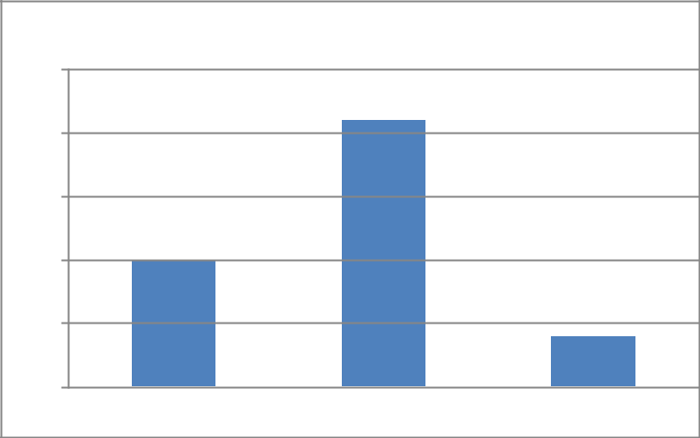

25

20

15

10

5

0

60%

29%
11%

17 years old 18 years old 19 years old

Among 35 respondents, there were 6 (37%) males and 29 (63%) females.

Graph 2. Distribution of Respondents According to Sex
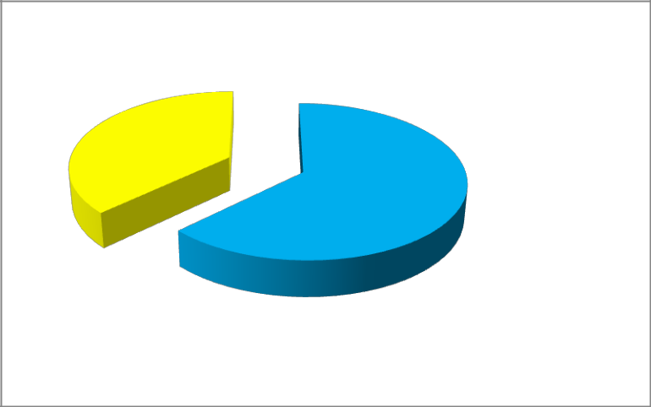

37%

Female
63%
Male

The graph below shows the frequency of study time of respondents and that 13 (37%) answered sometimes, 12 (34%) answered very often, 10 (29%) answered often and none (0%) answered always and never.

Graph 3. Distribution Frequent Time Study of Respondents

14

12

10

8

6

4

2

0

37%
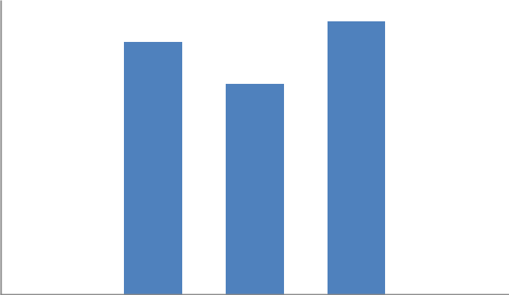
34%

29%

Always Very Often Often Sometimes Never

The graph below shows that there were 17 (48%) respondents who sometimes cheat, 9 (26%) respondents who cheat often, 7 (20%) respondents who cheat very often, 2 (6%) of them cheat always, and none (0%) who never cheats.

Graph 4. Distribution of Frequent Time the Respondents Cheat

18

16

14

12

10

8

6

4

2

0

48%
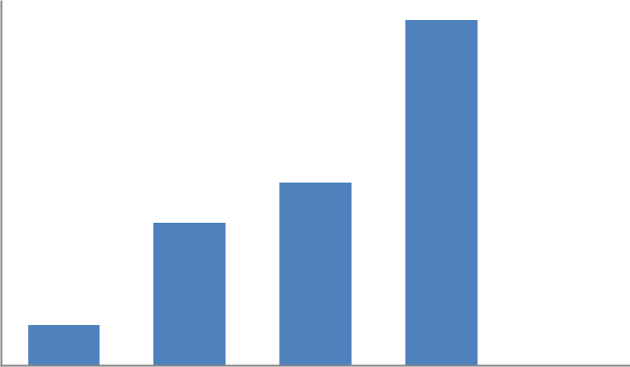

25%

20%

6%

Always Very Often Often Sometimes Never

Graph 5 shows the feeling of the respondents when cheating. There were 17 (49%) who felt guilty in doing cheating, 11 (31%) who felt happy, 9 (14%) felt upset and 2 (5%) felt bad for doing so. This just shows that guilt is ruling over the conscience of the respondents.

Graph 5. Distribution of the Feeling of Respondents When Cheating
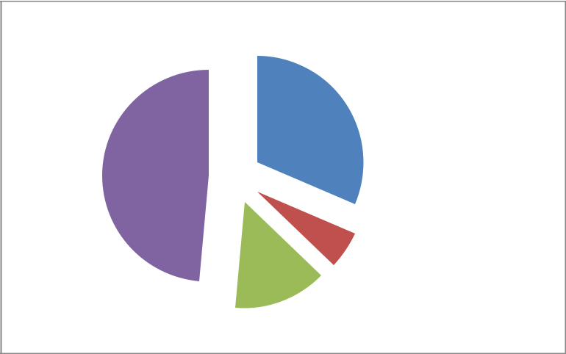

31% |  | Happy
49% |  | Bad
 |  | Upset
 |  | Guilt

14%

6%

Among 35 respondents, there were 25 (71%) who proudly said that they were not caught by their instructors and there were 10 (29%) who admits that they have been caught in action of cheating.

Graph 6. Distribution of Respondents Caught in Action of Cheating

Yes No
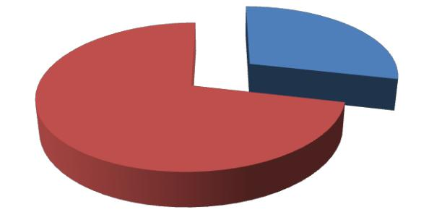

29%

71%

Based on the answers of the 35 respondents, 27 (77%) said yes that they had gotten answers from students who have already taken the exam while 8 (23%) said no.

Graph 7. Distribution of Respondents Who Gets Answers from Students
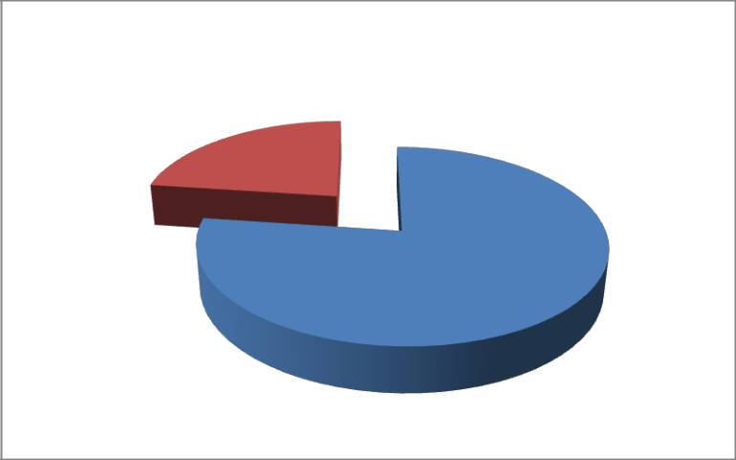

Yes No

23%

77%

There were 4 (11%) respondents who claimed or submitted academic works of others while there were 31 (89%) who do not among 35 respondents.

Graph 8. Distribution of Respondents Who Claims or Submits Academic Works of

Others

Number of Respondents

35

30

25

20

15

10

5

0

89%
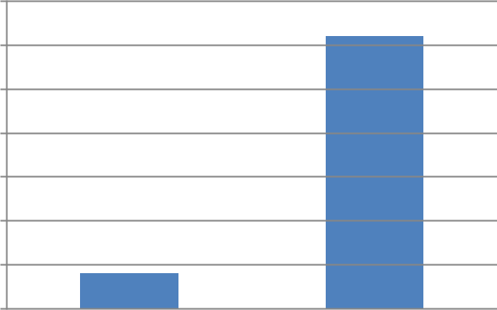

11%

Yes No

The respondents were asked if they have ever paid someone to answer their assignment or paper works. 34 (97%) said no and 1 (3%) said yes.

Graph 9. Distribution of Respondents Who Pays Someone for Paper Works/

40

35

30

25

20

15

10

5

0

Assignments
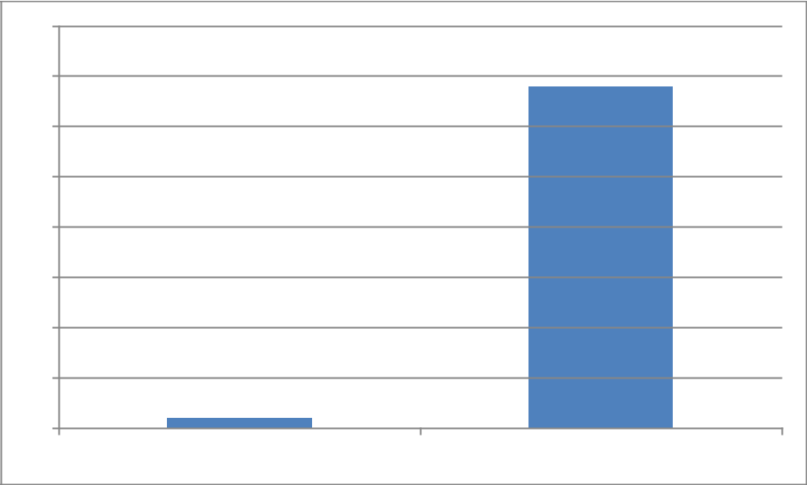

97%

3%

Yes No

Among 35 respondents, there were 25 (71%) answered yes that they provide false information to others while there were 10 (29%) respondents who answered no.

Graph 10. Distribution of Respondents who Provides False Information
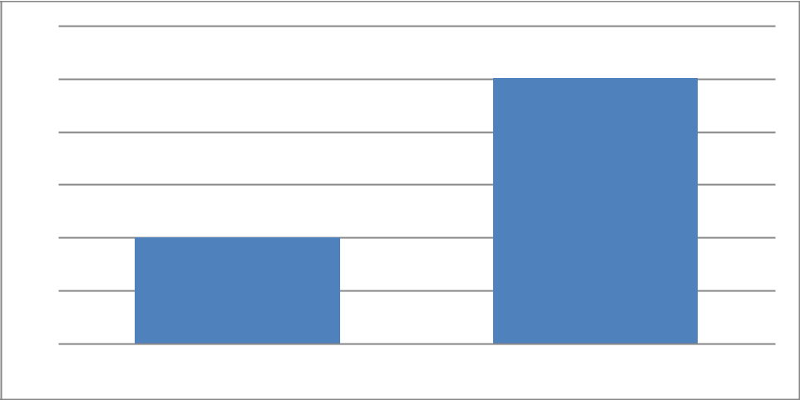

30
₂₅ 71%

20

15
₁₀ 29%

5

0

Yes No

The graph below shows how many respondents who threaten (physically) someone to do them the favor. 32 (91%) answered yes and 3 (9%) answered no.

Graph 11. Distribution of Respondents Who Threatens Someone to Do the Favor
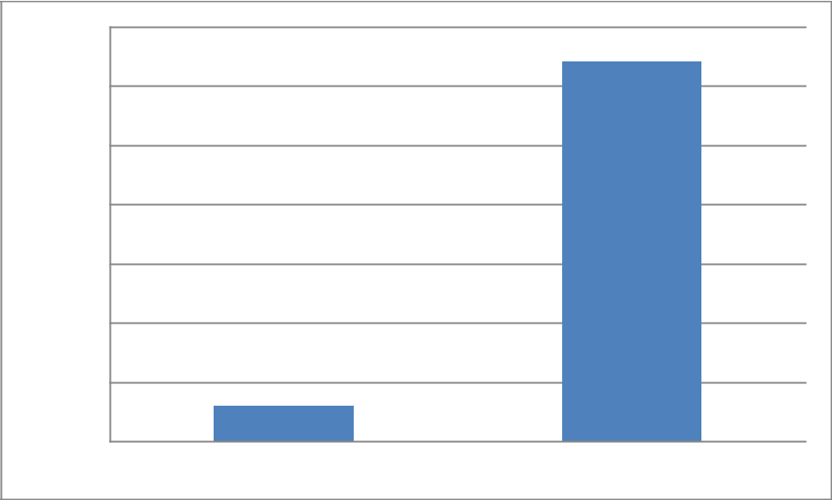

Number of Respondents

35

30

25

20

15

10

5

0

91%

9%

Yes No

The pie graph below illustrates how many among 35 respondents had used cheat sheets.

18 (51%) answered yes they had used it and 17 (49%) answered no they have not.

Graph 12. Distribution of Respondents Who Use Cheat Sheets

49% | 51% |  | Yes
 |  |  | No
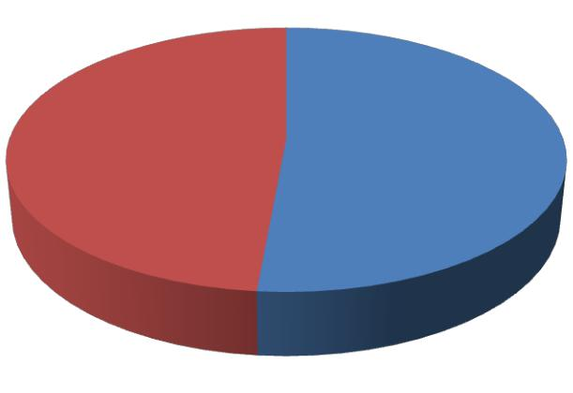

Among 35 respondents, all 35 (100%) said yes they allow others to cheat and no one (0%) said no.

Graph 13. Distribution of Respondents Who Allow Others to Cheat
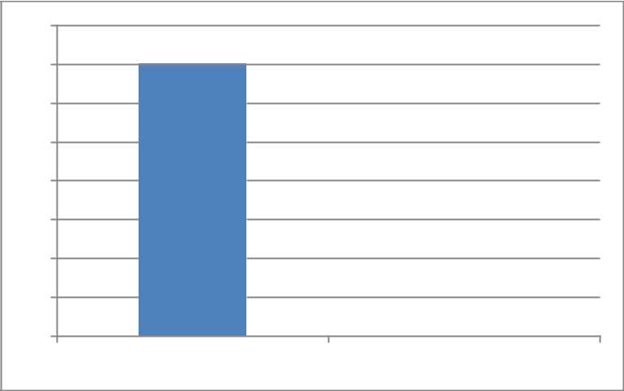

40
35 | 100 %
30
25
20
15
10
5 |  | 0 %
0
 | Yes | No

The graph below shows the perception of the 35 respondents on cheating whether it is positive or negative. There were 27 (77%) who believed that cheating is negative because it is a form of stealing—a crime, it is against the law, a sin committed, students became dependent to others eventually being a ‘parasite’ , the loss of a need in working by own and most likely, if caught, it will destroy you while there were 8 (23%) who believed that cheating is a positive act because it leads to cooperation and teamwork, a tool in order to pass, no sweat in studying the lessons, and a stress-free job.

Graph 14. The Positivity and Negativity of Cheating
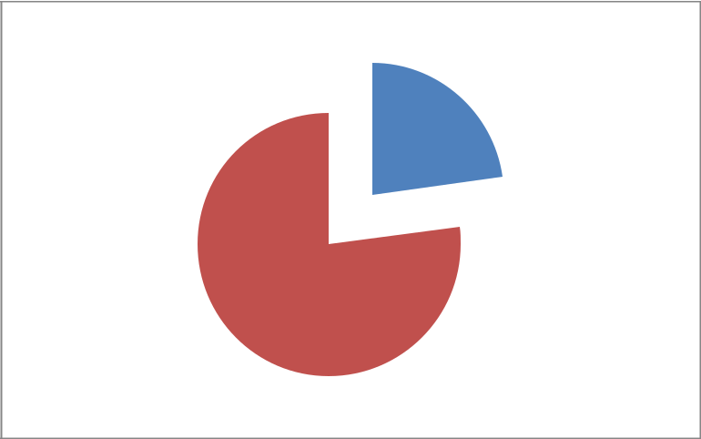

Positive

23%

Negative

77%

The graph below answers the question why they cheat. There were 15 (43%) respondents who cheat because they are eager to pass or prevent from failing, 8 (23%) respondents cheat because there is uncertainty of their answers, 12 (6%) respondents tends to cheat because of laziness towards studying , 3 (9%) aims to get good grades, 2 (6%) respondents cheat because of peer pressure, 2 (6%) respondents to be part of the trend or just simply loving doing so and 1(3%) said that it is easier to cheat.

Graph 14. Distribution of the Reasons of the Respondents on Why They Cheat
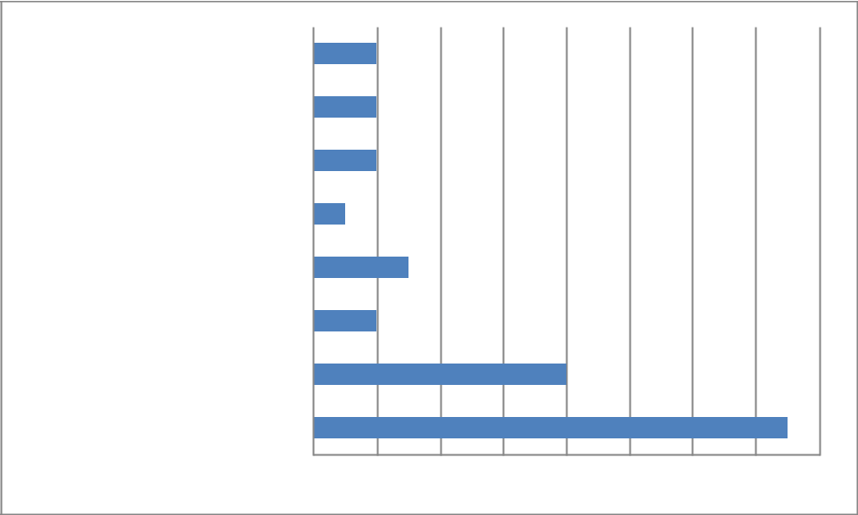

trend/ simply loving it

laziness towards studying

needed/beneficial

easier

to get high scores

peer pressure

uncertainty of answers

to pass/ prevent from failing

6%

6%

6%

3%

9%

6%

23%

43%

0 2 4 6 8 10 12 14 16

Among 35 respondents, there were 7 (20%) respondents answered everybody does it, 4 (11%) answered it is dangerous to cheat, 3 (9%) answered a crime, 3 (9%) answered feel bad about it, 3 (9%) answered hopeful for them not to be caught, 2 (6%) answered no effort in studying, 2 (6%) answered unfair, 2 (6%) answered call him/her ‘dawlimps”, 2 (6%) answered guilty, 2 (6%) answered “dawat2x lang”/ good for him/her, 2(6%) answered natural/part of students’ life, 2 (^%) answered nothing, and 1 (3%) answered proud to be a student when they were asked what comes in to their mind when they see someone cheating.

Graph 15. Distribution of the Respondents’ Perception When They See Someone

Cheating
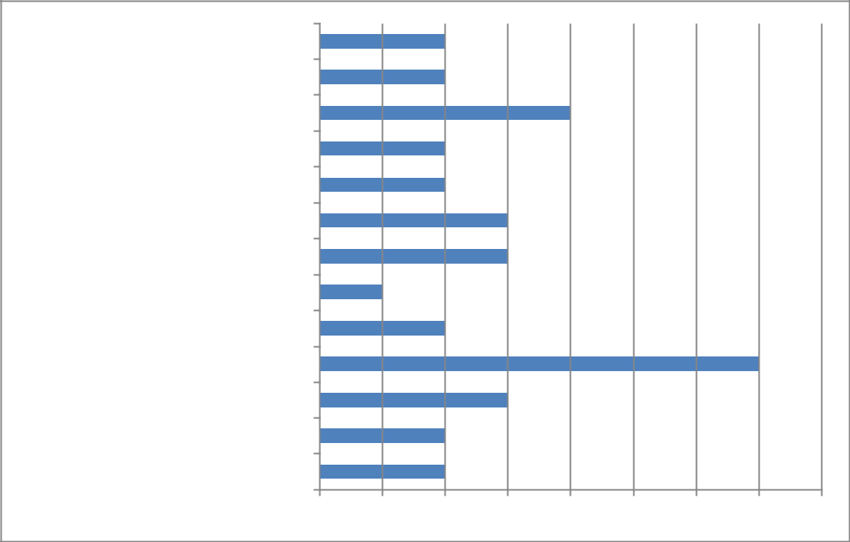

no effort in studying

unfair

it is dangerous to cheat

call him/her a "dawlimps"

guilty

hopeful for them not to be caught

feel bad about it

proud to be a student

dawat2 lang'/ good for him/her

everybody does it

- crime natural/part of student's life

nothing

0 1 2 3 4 5 6 7 8

CONCLUSION

The researchers conclude that they are successful in doing the study because they were able to meet the objectives set for the said study.

The researchers found out that third year English major students find cheating as teamwork, cooperation and be able to help those who are failing and it’s a stress free and no sweat in attaining higher grades while others said that it is a becoming of a parasite and they became dependent on others, it can destroy one’s self and it is against the law.

According to the data gathered by the researchers, most of the respondents’ reasons of cheating are: uncertainty answers, they want to prevent from failing, to get good grades, peer pressure, and simply because they just love doing it. These reasons are the presented remarks of the respondents. These just prove that there are various reasons on why students cheat.

Based on the survey that the researchers conducted, there are 3 (6%) respondents who tends to cheat because of laziness. Some circumstances come its way. There were 15 (43%) respondents who cheat because they are eager to pass or prevent from failing, 8 (23%) respondents cheat because there is uncertainty of their answers, 3 (9%) aims to get good grades, 2 (6%) respondents cheat because of peer pressure, 2 (6%) respondents to be part of the trend or just simply loving doing so and 1(3%) said that it is easier to cheat.

One of the most used techniques by the respondents is by using cheat sheets. These are small papers which contains information and possible answers for the given questions during examinations and quizzes. In our own dialect, it is called “kodigo”.

The researchers concluded that the third year English major students felt guilty about cheating but still they continue doing it.
BIBLIOGRAPHY

Aiken, L. R. (1991). Detecting, understanding, and controlling for cheating on tests. Research in Higher Education, 32, 725-736.

Anderman, E. M., Griesinger, T., & Westerfield, G. (1998). Motivation and cheating during early adolescence. Journal of Educational Psychology, 90, 84–93.

Antion, D. L. & Michael, W. B. (1983). Short-term predictive validity of demographic, affective, personal, and cognitive variables in relation to 2 criterion measures of cheating behaviors. Educational and Psychological Measurement, 43, 467-483.

Arent, R. (1991). To tell the truth. Learning, 19 (6), 72-73.

Athanasou, J. A., & Olasehinde, O. (2002). Male and female differences in self-report cheating. Practical Assessment, Research, & Evaluation, 8(5). Retrieved February 3, 2005 from http://PAREonline.net/getvn.asp?v=8&n=5.

Baird, J. S. (1980). Current trends in college cheating. Psychology in Schools, 17, 515-622.

Bouville, M. (2010). Why is Cheating Wrong?. Studies In Philosophy & Education, 29(1), 67-76. doi:10.1007/s11217-009-9148-0

Brown, B. S., & Emett, D. (2002). Explaining variations in the level of academic dishonesty in studies of college students.: Some new evidence. College Student Journal, 35, 529-538.

Bunn, D., Caudill, S., & Gropper, D. (1992). Crime in the classroom: An economic analysis of undergraduate student cheating behavior. Research in Economic Education, 23, 197-207.

Burke, J. (1999), “Faculty Perceptions of and Attitudes toward Dishonesty at a Two-year College.”

Calabrese, R.L. and Cochran, J.T., “The relationship of alienation to cheating among a sample of American adolescents,” Journal of Research and Development in Education, 23(2), 65-71, 1989.

Chop, R., & Silva, M. (1991). Scientific fraud: Definitions, policies, and implications for nursing research. Journal of Professional Nursing, 7 (3), 166-171.
Ciek, G. J. (2003). Detecting aand preventing classroom cheating: Promoting integrity in

assessment. Thousand Oaks; CA: Corwin Press.

Cole, S., & Kiss, E. (2000). What can we do about student cheating? About Campus, 5, 5–12 Davis et al., "Academic dishonesty: One-time offenders or habitual criminals?" (presentation at

the Annual Meeting of the American Psychological Association, Washington,DC, August 14-18, 1992).

Davis, S. (1992). Academic dishonesty: Prevalence, determinants, techniques, and punishments. Teaching of Psychology, 19, 16-20.

Dichtl, J. (2003). Teaching Integrity. History Teacher, 36(3), 367.

Diekhoff, G. M., LaBeff, E. E., Clark, R. E., Williams, L. E., Francis, B., & Haines, V. J.

(1996). College cheating: Ten years later. Research in Higher Education, 37, 487-502.

Donald L. McCabe and Linda Klebe Trevino, "Honor codes and other contextual influences" Journal of Higher Education (In press).

Fass, R. (1986). By honor bound: Encouraging academic honesty. Educational Record, 67 (4), 32-36.

Generaux, R.L. & McLeod, B.A., “Circumstances surrounding cheating: A questionnaire study of college students”, Research in Higher Education, 36(6), 687-704, 1995.

Graham, M. A., Monday, J., O’Brien, K., & Steffen, S. (1994). Cheating at small colleges: An examination of student and faculty attitudes and behaviors. Journal of College Student Development, 35, 255-260.

Haines, V. J., Kiefhoff, G. M., LaBeff, E. E., & Clark, R. (1986). College cheating: Immaturity, lack of commitment, and neutralizing attitude. Research in Higher Education, 25,342-354.

Hilbert, G. A. (1985). Involvement of nursing students in unethical classroom and clinical behaviors. Journal of Professional Nursing, 1, 230-234.

Howard, R. M., & Davies, L. J. (2009). Plagiarism in the Internet age. Educational Leadership, 66(6), 64-67.

Johnson, S., & Martin, M. (2005). Academic Dishonesty: A New Twist to an Old Problem.

Athletic Therapy Today, 10(4), 48-50.

Jordan, A. (2001). College student cheating: The role of motivation, perceived norms, attitudes, and knowledge of institutional policy. Ethics and Behavior, 11, 233–247.

Kibler, W. (1993), “Academic Dishonesty: A Student Development Dilemma,” NASPA Journal

30 (summer 1993): 253.

Lehman, C. M., & DuFrene, D. (2011). Business communication (16th ed.). Mason, OH: South-Western/Cengage Learning.

Leming, J. S. (1980). Cheating behavior, subject variables, and components of the internal-external scale under high and low risk conditions. Journal of Educational Research, 74,83-87.

McCabe, D. L. (1999). Academic dishonesty among high school students. Adolescence, 34(136), 681-687.

McCabe, D. L., & Trevino, L. K. (1997). Individual and contextual influences on academic dishonesty: A multicampus investigation. Research in Higher Education, 38, 379-396.

McCabe, Donald L. (1992), "Faculty responses to academic dishonesty: The influence of student

honor codes." Research in Higher Education. (In Press).

McCabe, Donald L., Linda Klebe Trevino, and K.D. Butterfield (2002). Honor codes and other contextual influences on academic integrity." Research in Higher Education, 433, 357-378.

Miniwatts Marketing Group. (2011). Internet usage and population statistics for North America. In Usage and population statistics: Internet world stats. Retrieved from http://www.internetworldstats.com/stats14.htm#north

Mixon, F. (1996). Crime in the classroom: An extension. Journal of Economic Education, 27, pp.195-200.

Moffatt, M., Undergraduate Cheating, New Brunswick, N.J.: Rutgers University Press, 1990. Moore, T. (1988). Colleges try new ways to thwart companies that sell term papers. Chronicle

of Higher Education, 25 (11), A1, 36.

Murdock, T. B., & Stephens, J. M. (2007). Is cheating wrong? Students' reasoning about academic dishonesty. In E. M. Anderman & T. B. Murdock (Eds.), Psychology of academic cheating (pp. 229–253). Burlington, MA: Elsevier.
Netter, S. (2010, December 13). Confessions of a ghostwriter: Man’s career thrives helping

students cheat [Online video]. Retrieved from

http://abcnews.go.com/US/confessionsghostwriterman-builds-career-helping-students-

cheat/story?id=12381763&page=1

Newstead, S. E., Franklyn-Stokes, A., & Arrnstead, P. (1996). Individual differences in student cheating. Journal of Educational Psychology, 88, 229-241.

Packer, S. (1990). Students’ ethics require new ways to cope with cheating. Journalism Educator, 44 (4), 57-59.

Passow, H. J., Mayhew, M. J., Finelli, C. J., Harding, T. S., & Carpenter, D. D. (2006). Factors influencing engineering students’ decisions to cheat by type of assessment. Research in Higher Education, 47,643–684.

Pavela, G. (1978). Judicial review of academic decision-making after Horowitz. School Law Journal, 55, 55-75.

Petress, K. C. (2003). Academic dishonesty: A plague on our profession. Education, 123(3), 624. Pratt, C., & McLaughlin, G. (1989). An analysis of predictors of students’ ethical

inclinations. Research in Higher Education, 30, 195-219.

Pulvers, K. and Diekhoff, G.M. (1999). The relationship between academic dishonesty and college classroom environment. Research in Higher Education, 40, 4, 487-498.

Roberts, E. (2002). "Strategies for promoting academic integrity in CS Courses," vol. 3 32nd Annual Frontiers in Education.

Roig, M., & DeTommaso, L. (1995). Are college cheating and plagiarism related to academic procrastination? Psychological Reports, 77, 6911-698.

Russell, A., Roberts, T. & Radziejowska R. (2011). Dishonesty in the MRCP(UK) Part 1 and Part 2 written examinations: prevention, detection and possible remediation. Clinical Medicine, 11(3), 239-241.

Shu, L., Gino, F., & Bazerman, M. (2011). Dishonest deed, clear conscience: When cheating leads to moral disengagement and motivated forgetting. Personality and Social Psychology Bulletin, 37, 330-349.

Simpson, D. (1989). Medical students’ perceptions of cheating. Academic Medicine, 64, 221-222.

Singhal, A. C. (1982). Factors in student’s dishonesty. Psychological Reports, 51, 775-780.

Stephen F. Davis, Cathy A. Grover, Angela H. Becker, and Loretta N. McGregor, "Academic Dishonesty: Prevalence, Determinants, Techniques, and Punishments," Teaching of Psychology 19, no. 1 (1992a): 16-20.

Stevens, G. E., & Stevens, F. W. (1987). Ethical inclinations of tomorrow’s managers revisited:

How and why students cheat. Journal of Education for Business, October, 24-29.

Strom, P. and Strom, R. (2007, Winter). Cheating in middle school and high school. Forum, 71, 105

Symaco, L. P. & Marcelo, E. (2003). Faculty perception on student academic honesty. College Student Journal, 37(3), 327-333.

Tang, S., & Zuo, J. (1997). Profile of college examination cheaters. College Student Journal, 31, 340-346.

Von Dran, G. M., Callahan, E. S., & Taylor, H. V. (2001). Can students’ academic integrity be improved? Attitudes and behaviors before and after implementation of an academic integrity policy. Teaching Business Ethics, 5, 35-58.

Weaver, K. A., Davis, S. F., Look, C., Buzzanga, V. L., & Neal, L. (1991). Examining academic dishonesty policies. College Student Journal, 23, 302-305.

Whitley, B. E. (1998). Factors associated with cheating among college students: A review. Research in Higher Education, 39, 235-274.

Zimmerman, J. (1999). Academic dishonesty attitudes and self-reported behaviors in a university population. Dissertation Abstracts International, Section A: Humanities & Social Sciences, 59, 11-A.
APPENDIX A
SURVEY QUESTIONNAIRE

Topic: Perception of the BSEDE-III Students on Cheating

Name (Optional): ____________________________ Age: _________ Gender: ______

Instruction: Please answer the questions below with all honesty. Rest assured of your identity’s confidentiality.

1. | How frequent do you study your lesson?
 | _ Always | _ Very Often | _ Often |  | _ Sometimes | _ Never
2. | How frequent do you cheat?
3. | _ Always | _ Very Often | _ Often |  | _ Sometimes | _ Never
4. | How do you feel when you cheat?
 | _ Happy | _ Bad | _ Upset | _ Guilty
5. | Have you ever been caught by your instructor/teacher while cheating?
 | _ Yes | _ No

- Have you get questions/answers from the students who have already taken the exam or quiz you are about to take to?

 | _ Yes | _ No
7. | Have you claim or submit academic work of another as your own?
8. | _ Yes | _ No
9. | Have you paid someone to answer your assignment or paper work?
 | _ Yes | _ No
10. | Have you provide false information fo the purpose of gaining for your own beneficial?
 | _ Yes | _ No
11. | Have you threaten (physically) someone to do you a favor?
 | _ Yes | _ No
12. | Have you taken a cheat sheet into a test?
 | _ Yes | _ No
13. | Have you ever allowed someone to cheat on your exam paper?
 | _ Yes | _ No

- Why do you cheat?

________________________________________________________________________

- If you see another student cheating, what comes in your mind?

________________________________________________________________________

- As a student, how do you find cheating?

Is it positive? Why?_______________________________________________________

Is it negative? Why? ______________________________________________________
THANK YOU!
By: Andoyo, Malintad, Nietes, Ramos, and Rosales
APPENDIX B

INTERVIEW

The researchers conducted an interview among 10 English major students to let them define cheating on their own perception. Below are their responses:

Respondent 1: Cheating is communicating with your seatmate (during exam or quiz) in a very different way.

Respondent 2: Cheating is an instrument in attaining one’s goal in a positive (way) because cheating is a form of teamwork.

Respondent 3: Cheating is a process where people have conjugal sharing of ideas. In a CPOV (cheater’s point of view), cheating is a crime as well as teamwork. Respondent 4: It is a trendy stuff for students.

Respondent 5: A way of getting answer to question you can’t answer.

Respondent 6: Cheating is learning from one another.

Respondent 7: It is an alternative way in having good grades.

Respondent 8: Cheating is copying someone’s idea orf answer to have good record.

Respondent 9: Cheating means not trusting one’s self.

Respondent 10: Cheating is a negative way and the most dirtiest monkey business a student does in his life.

