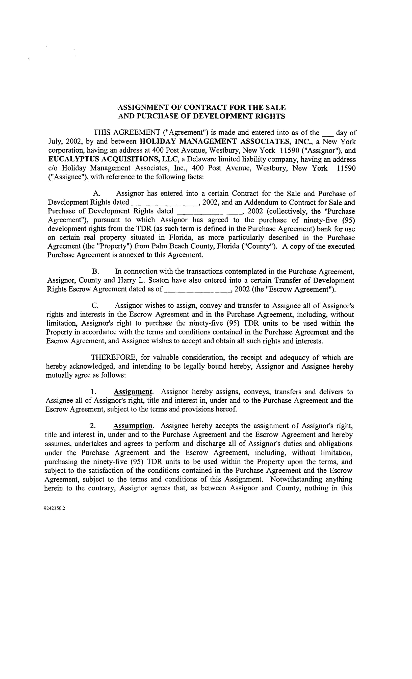

ASSIGNMENT OF CONTRACT FOR THE SALE

AND PURCHASE OF DEVELOPMENT RIGHTS

THIS AGREEMENT ("Agreement") is made and entered into as of the _ day of July, 2002, by and between HOLIDAY MANAGEMENT ASSOCIATES, INC., a New York corporation, having an address at 400 Post Avenue, Westbury, New York 11590 ("Assignor"), and EUCALYPTUS ACQUISITIONS, LLC, a Delaware limited liability company, having an address c/o Holiday Management Associates, Inc., 400 Post Avenue, Westbury, New York 11590 ("Assignee"), with reference to the following facts:

- Assignor has entered into a certain Contract for the Sale and Purchase of

Development Rights dated , 2002, and an Addendum to Contract for Sale and Purchase of Development Rights dated __, 2002 (collectively, the "Purchase

Agreement"), pursuant to which Assignor has agreed to the purchase of ninety-five (95) development rights from the TDR (as such term is defined in the Purchase Agreement) bank for use on certain real property situated in Florida, as more particularly described in the Purchase Agreement (the "Property") from Palm Beach County, Florida ("County"). A copy of the executed Purchase Agreement is annexed to this Agreement.

- In connection with the transactions contemplated in the Purchase Agreement, Assignor, County and Harry L. Seaton have also entered into a certain Transfer of Development

Rights Escrow Agreement dated as of , 2002 (the "Escrow Agreement").

- Assignor wishes to assign, convey and transfer to Assignee all of Assignor's rights and interests in the Escrow Agreement and in the Purchase Agreement, including, without limitation, Assignor's right to purchase the ninety-five (95) TDR units to be used within the Property in accordance with the terms and conditions contained in the Purchase Agreement and the Escrow Agreement, and Assignee wishes to accept and obtain all such rights and interests.

THEREFORE, for valuable consideration, the receipt and adequacy of which are hereby acknowledged, and intending to be legally bound hereby, Assignor and Assignee hereby mutually agree as follows:

  - Assignment. Assignor hereby assigns, conveys, transfers and delivers to Assignee all of Assignor's right, title and interest in, under and to the Purchase Agreement and the Escrow Agreement, subject to the terms and provisions hereof.

- Assumption. Assignee hereby accepts the assignment of Assignor's right, title and interest in, under and to the Purchase Agreement and the Escrow Agreement and hereby assumes, undertakes and agrees to perform and discharge all of Assignor's duties and obligations under the Purchase Agreement and the Escrow Agreement, including, without limitation, purchasing the ninety-five (95) TDR units to be used within the Property upon the terms, and subject to the satisfaction of the conditions contained in the Purchase Agreement and the Escrow Agreement, subject to the terms and conditions of this Assignment. Notwithstanding anything herein to the contrary, Assignor agrees that, as between Assignor and County, nothing in this

9242350.2
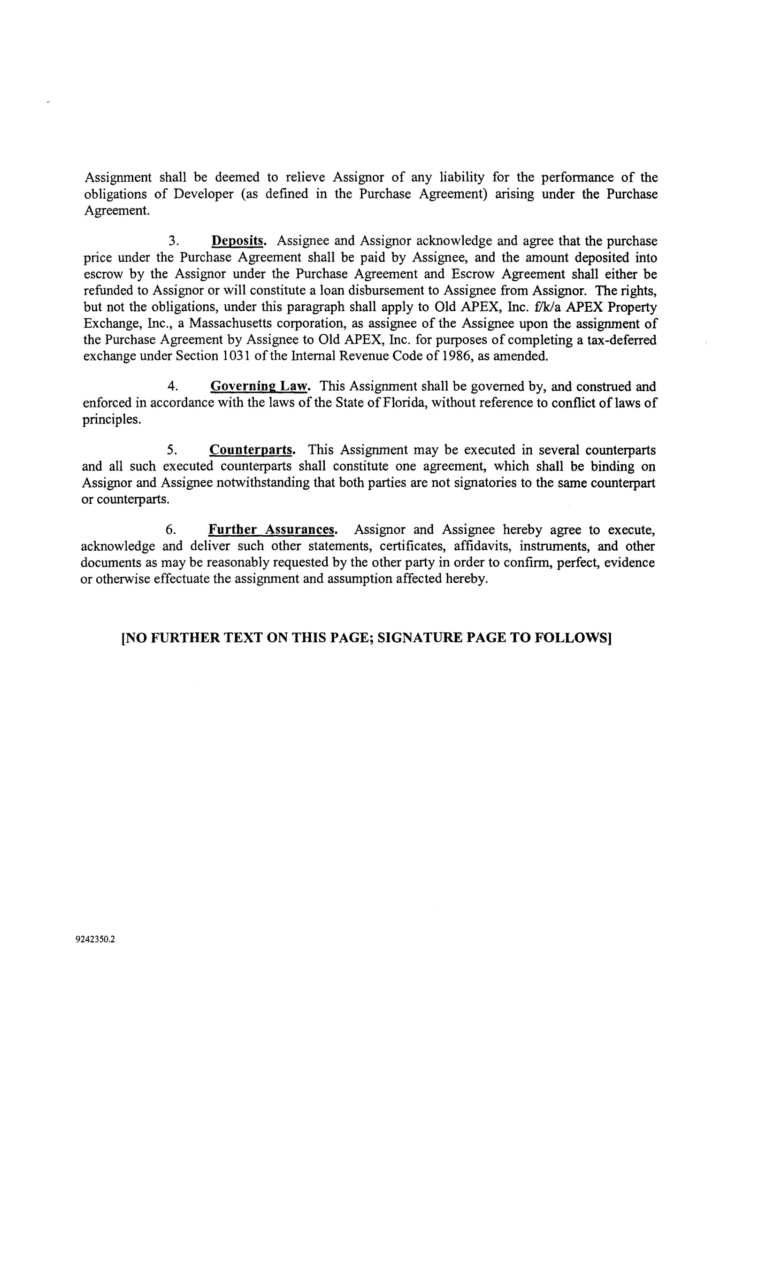

Assignment shall be deemed to relieve Assignor of any liability for the performance of the obligations of Developer (as defined in the Purchase Agreement) arising under the Purchase Agreement.

    - Deposits. Assignee and Assignor acknowledge and agree that the purchase price under the Purchase Agreement shall be paid by Assignee, and the amount deposited into escrow by the Assignor under the Purchase Agreement and Escrow Agreement shall either be refunded to Assignor or will constitute a loan disbursement to Assignee from Assignor. The rights, but not the obligations, under this paragraph shall apply to Old APEX, Inc. :£IkIa APEX Property Exchange, Inc., a Massachusetts corporation, as assignee of the Assignee upon the assignment of the Purchase Agreement by Assignee to Old APEX, Inc. for purposes of completing a tax-deferred exchange under Section 1031 of the Internal Revenue Code of 1986, as amended.

  - Governing Law. This Assignment shall be governed by, and construed and enforced in accordance with the laws of the State of Florida, without reference to conflict oflaws of principles.

  - Counterparts. This Assignment may be executed in several counterparts and all such executed counterparts shall constitute one agreement, which shall be binding on Assignor and Assignee notwithstanding that both parties are not signatories to the same counterpart or counterparts.

- Further Assurances. Assignor and Assignee hereby agree to execute, acknowledge and deliver such other statements, certificates, affidavits, instruments, and other documents as may be reasonably requested by the other party in order to confirm, perfect, evidence or otherwise effectuate the assignment and assumption affected hereby.

[NO FURTHER TEXT ON THIS PAGE; SIGNATURE PAGE TO FOLLOWS]

9242350.2
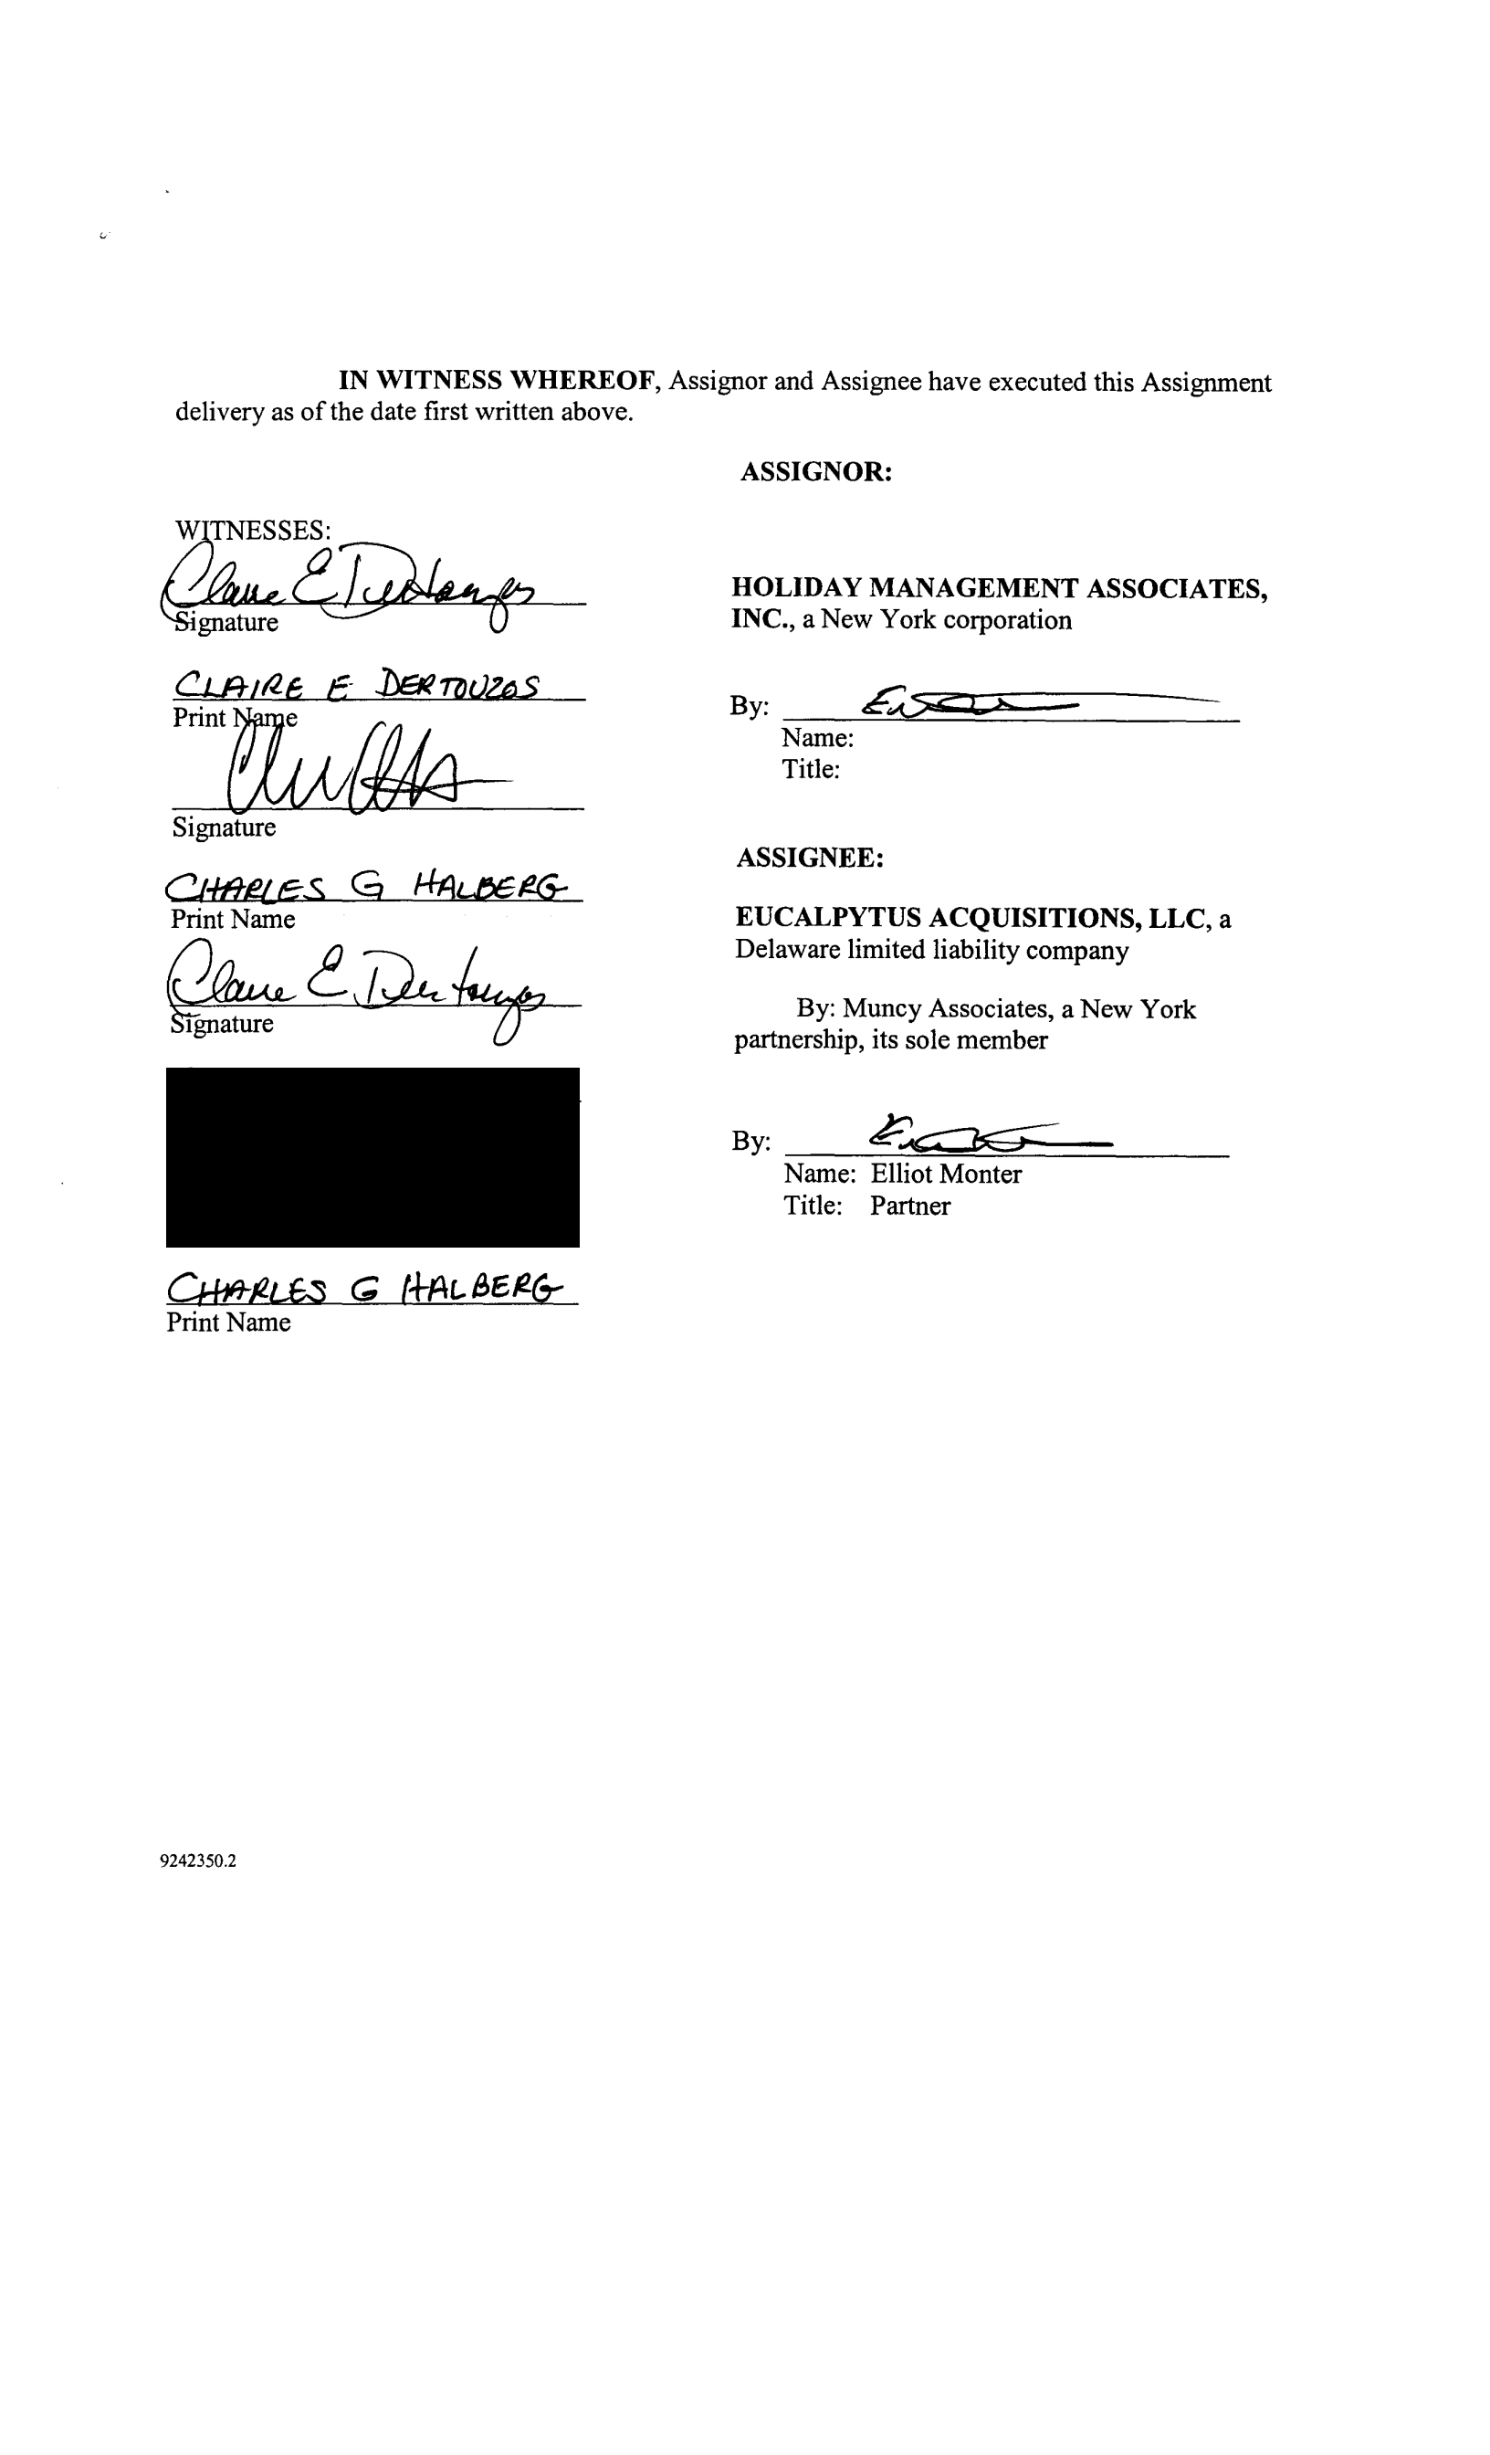

IN WITNESS WHEREOF, Assignor and Assignee have executed this Assignment delivery as of the date first written above,

'QTNESSES:
~~
'gnature

Signature

CJ-t8ef..e:s. G H-AL(;61!6=
Print Name

~~\TA~

ASSIGNOR:

HOLIDAY MANAGEMENT ASSOCIATES, INC., a New York corporation

By: Ev<>< ! ,.,

Name:

Title:

ASSIGNEE:

EUCALPYTUS ACQUISITIONS, LLC, a Delaware limited liability company

By: Muncy Associates, a New York partnership, its sole member

By: p~

Name: Elliot Monter

Title: Partner

Oftt&L6S C; (+Prt. e,e~6:
Print Name

9242350.2

County hereby consents to consents to any re-assignment by Assignee under the Purchase Agreement.

the Assignment described above. County further to Assignor or Assignor's designee of Assignee's rights


WITNESSES: | PALM BEACH COUNTY, FLORIDA
 | BY ITS BOARD OF COUNTY
Signature | COMMISSIONERS
 | By: __________________________
Print Name | Name:
 | Title:
Signature
Print Name

9242350.2



ACCEPTED AND AGREED:

WITNESSES:

Signature

Print Name

Signature

Print Name

9242350.2

