® | Name:
 |  | Date:


Percents Are Fractions | WAP 1
Instructions: For these percentages and their fraction form, fill in whichever number is missing.
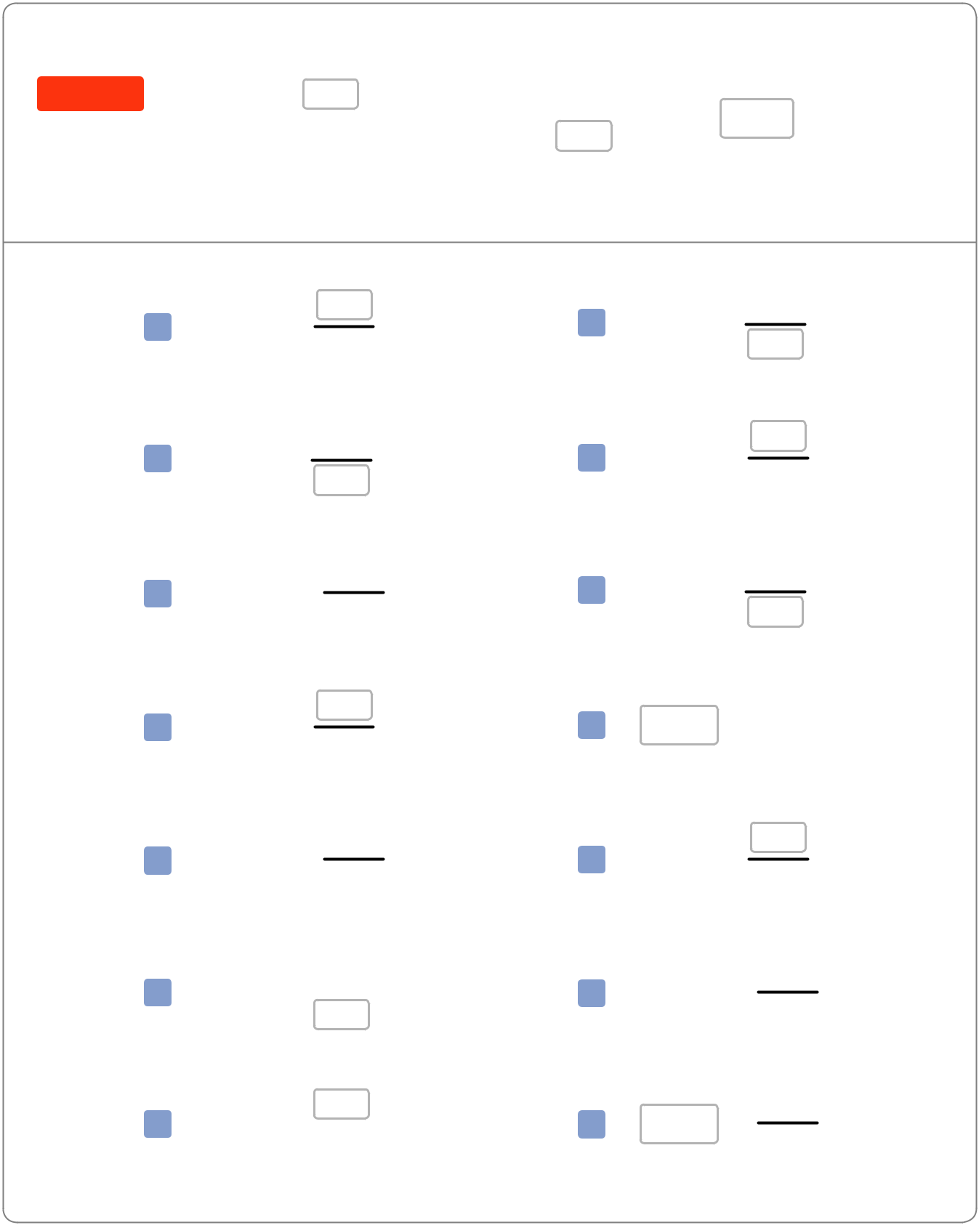

Examples |  | 25 |  | 7 |  |  | 105
Examples | 25% | = |  | 7% = |  |  | 105% =
 | 25% | = | 100 | 7% = | 100 |  | 105% = | 100
 | Missing Top |  |  | Missing Bottom |  |  | Missing Percent

- 32% = ₁₀₀

- 14% = ¹⁴

-  = ₁₀₀⁴

- 70% = ₁₀₀

- = ₁₀₀⁵⁵

- 134%= ¹³⁴

13 | 29% = | 100

- 8%= ⁸

- 215% = ₁₀₀

- 33% = ³³

8 | = | 150
 |  | 100

- 17% = ₁₀₀

- = ₁₀₀⁶⁴

14 | = | 82
 |  | 100

 What Are Percentages? • mathantics.com ^{© 2013 Math Plus Motion,} LLC

® | Name:
 |  | Date:
Decimal Form of a Percent |  | WAP 2
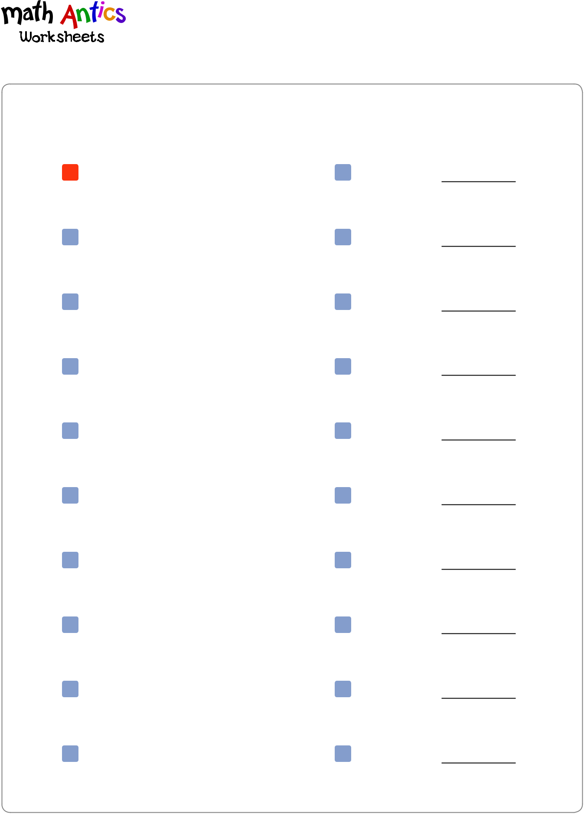

Instructions: Write these percent in their decimal form by moving the decimal point two places to the left.

1 | 25% | = 0.25 |  | 2 | 10% | =
3 | 14% | = |  | 4 | 75% | =
5 | 30% | = |  | 6 | 100% | =
7 | 67% | = |  | 8 | 135% | =
9 | 82% | = |  | 10 | 8% | =
11 | 50% | = |  | 12 | 47% | =
13 | 33% | = |  | 14 | 250% | =
15 | 5% | = |  | 16 | 21% | =
17 | 7% | = |  | 18 | 327% | =
19 | 99% | = |  | 20 | 109% | =

What Are Percentages? • mathantics.com ^{© 2013 Math Plus Motion, LLC}

® Name:


Date:

Converting Decimals to Percents
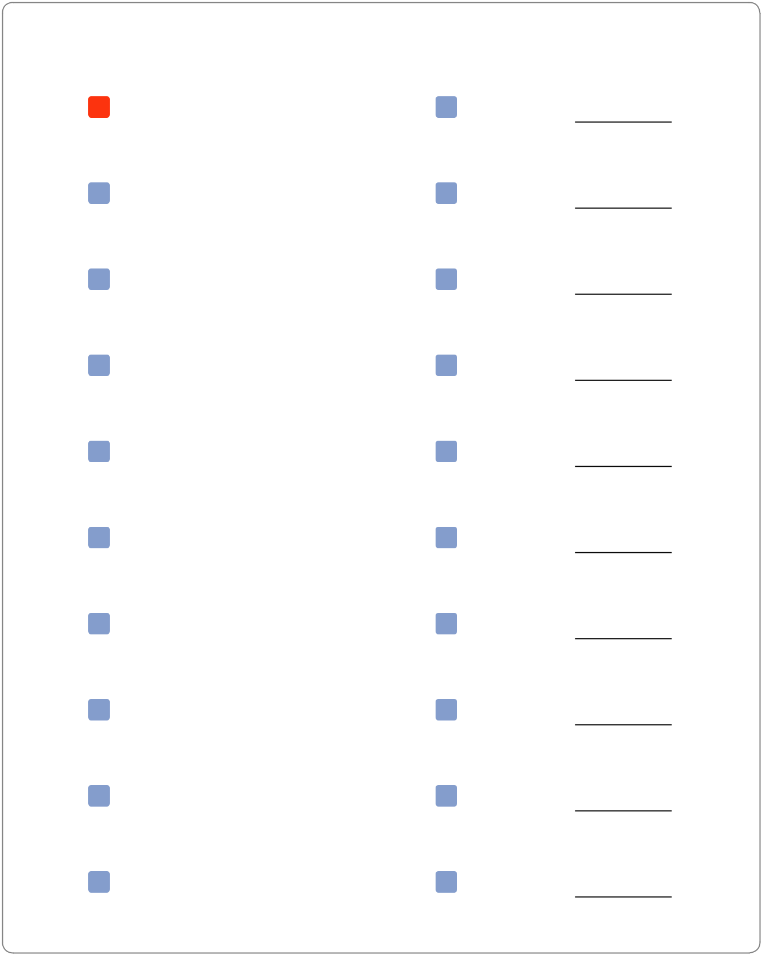

WAP 3

Instructions: Re-write the decimal number in percent form by moving the decimal two places to the right and then using the percent symbol.

1 | 0.25 | = 25% |  | 2 | 0.10 | =
3 | 0.09 | = |  | 4 | 0.70 | =
5 | 0.32 | = |  | 6 | 2.65 | =
7 | 0.46 | = |  | 8 | 0.11 | =
9 | 0.03 | = |  | 10 | 0.5 | =
11 | 0.87 | = |  | 12 | 1.01 | =
13 | 1.00 | = |  | 14 | 0.99 | =
15 | 1.15 | = |  | 16 | 0.61 | =
17 | 0.75 | = |  | 18 | 0.2 | =
19 | 0.20 | = |  | 20 | 0.38 | =

What Are Percentages? • mathantics.com ^{© 2013 Math Plus Motion,} LLC

® | Name:
 |  | Date:
Fraction Form OR Decimal Form |  | WAP 4
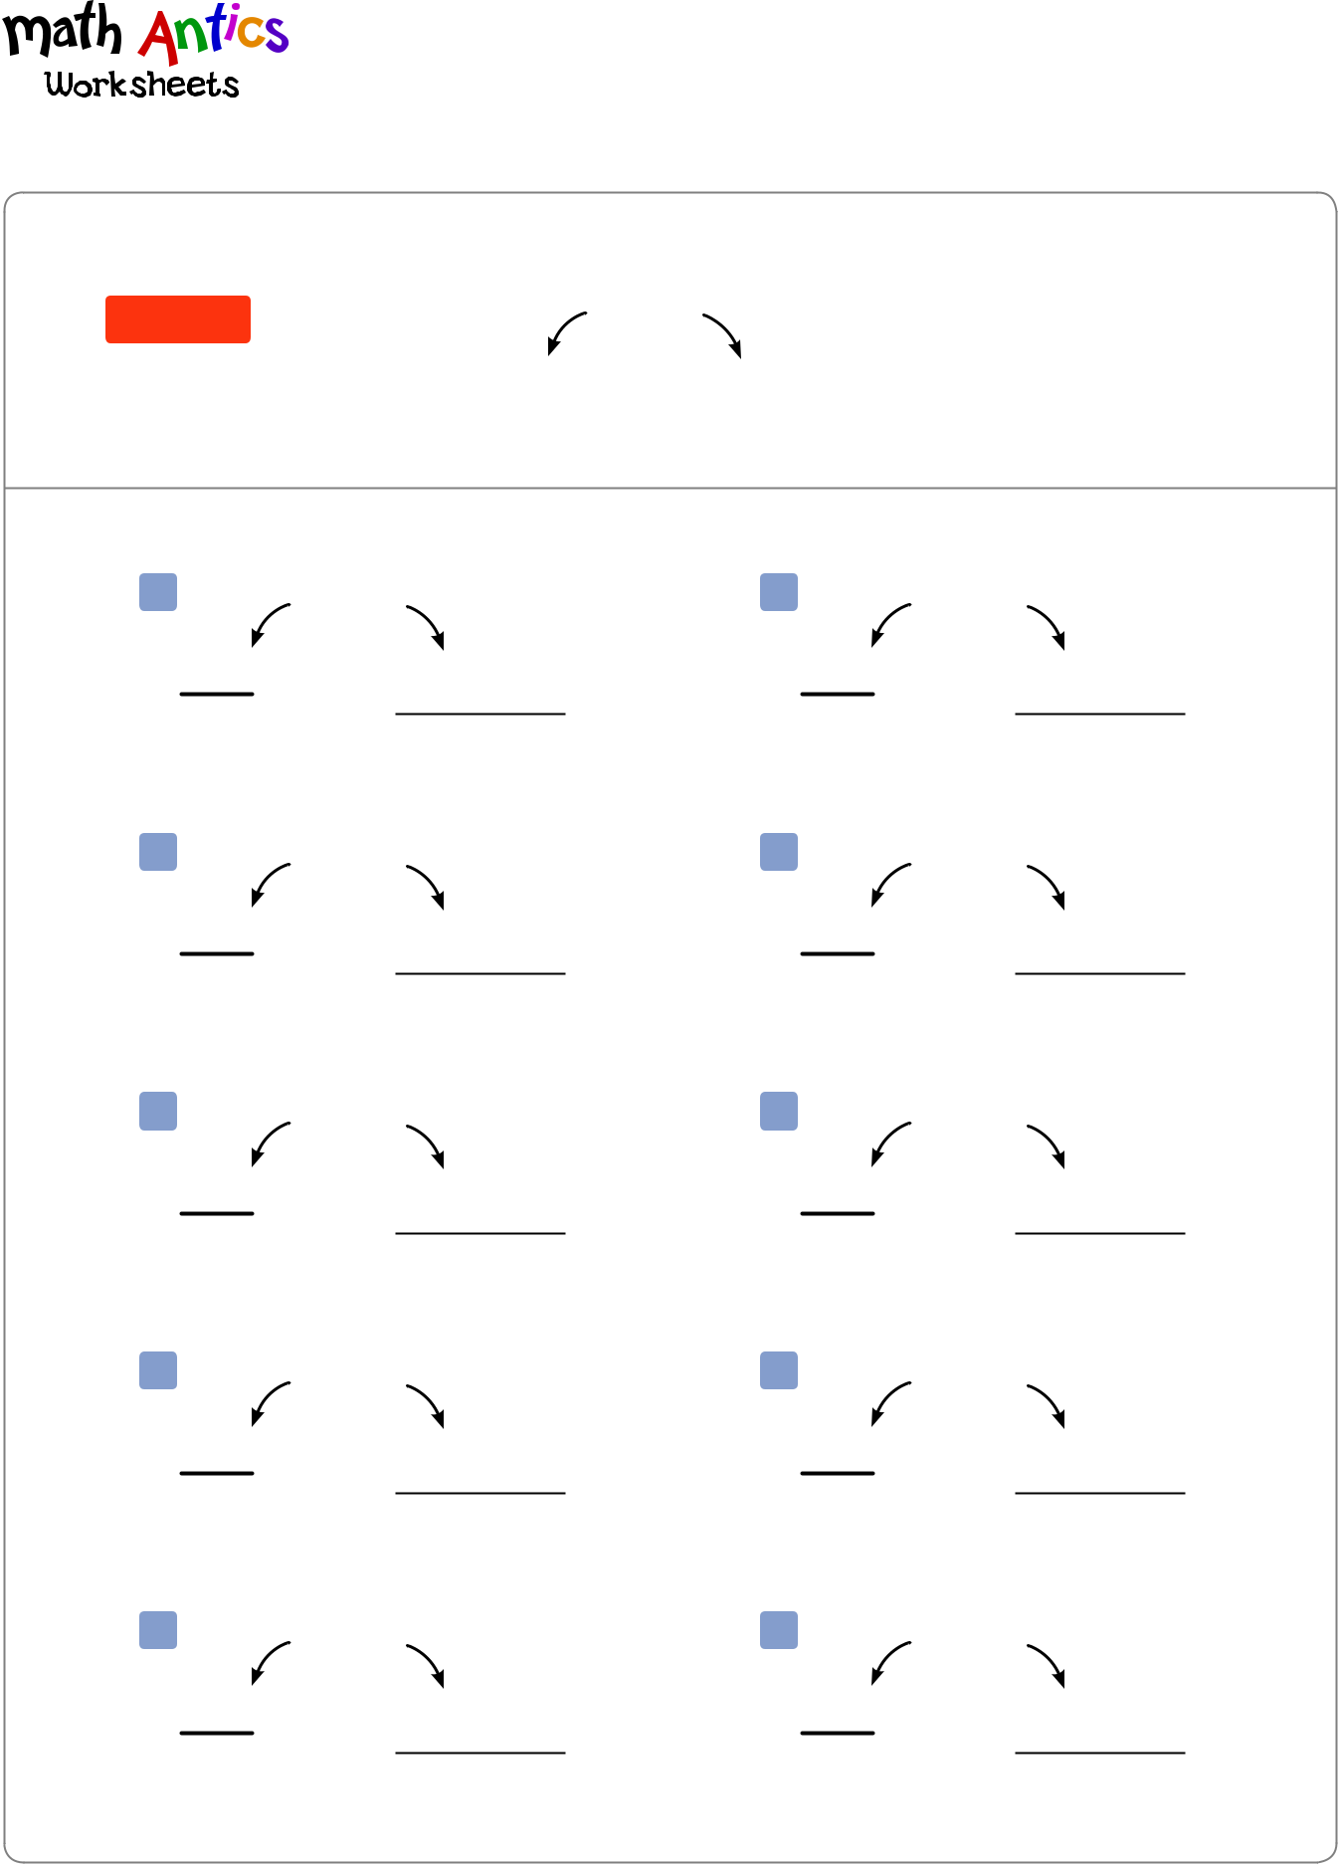

Instructions: Write the fraction form and decimal form of each percent.

Example

Fraction
Form

16%

16 |  | 0.16 | Decimal
100 |  | 0.16 | Decimal
100 |  |  | Form

1 28% 2 41%

3 54% 4 2%

5 4% 6 95%

7 80% 8 164%

9 73% 10 233%

What Are Percentages? • mathantics.com ^{© 2013 Math Plus Motion, LLC}

® Name:

Date:

Percents That Are Also Decimals
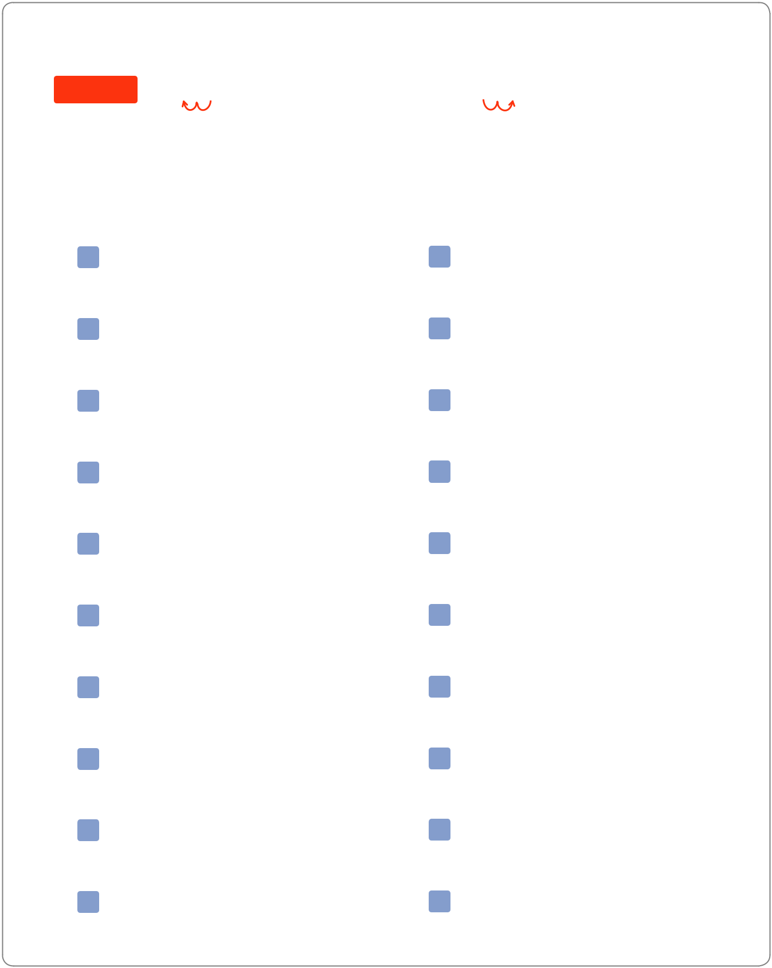

WAP 5

Instructions: The rules for percents and decimals apply the same way even if the numbers are already decimals. Convert each percent to decimal form and convert each decimal to percent form.

Example |  | 35.2% = 0.352 |  |  |  |  |  |  | 0.045 = | 4.5%
 |  | Move the decimal two places to |  |  |  |  |  | Move the decimal two places to
 |  | the left to get the decimal form |  |  |  |  |  | the right to turn a decimal into a
 |  |  | of a percent. |  |  |  |  |  | percent.
1 |  | 22.5% | = |  |  |  |  | 2 | 0.185 | =
3 |  | 10.6% | = |  |  |  |  | 4 | 0.757 | =
5 |  | 5.1% | = |  |  |  |  | 6 | 0.025 | =
7 |  | 56.3% | = |  |  |  |  | 8 | 0.012 | =
9 |  | 85.5% | = |  |  |  |  | 10 | 1.548 | =
11 |  | 6.4% | = |  |  |  |  | 12 | 0.499 | =
13 | 125.8% |  | = |  |  |  |  | 14 | 0.081 | =
15 | 100.5% |  | = |  |  |  |  | 16 | 0.1065 | =
17 | 30.25% |  | = |  |  |  |  | 18 | 2.253 | =
19 |  | 4.33% | = |  |  |  |  | 20 | 1.354 | =

What Are Percentages? • mathantics.com ^{© 2013 Math Plus Motion, LLC}

