Project Work Contract

□ Computer Science □ IT Product Development

Title: _______________________________________________________________________

□ 5ECTS □ 10 ECTS

Year and Semester/Quarter: ___________________________

Starting date: ___________________________

Finishing date*: ___________________________

- Project report must be handed in to supervisor 2 weeks before the oral exam that takes place no later than finishing date.

Supervisor

Main

Supervisor

Project

Supervisor

Name

Date & Signature

Participants

Student

Number Name

Education Committee

Date & Signature
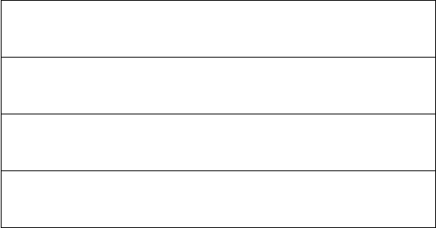


Uddannelsesansvarlig

Date & Signature

