State Bar of Wisconsin Form 1-2003

WARRANTY DEED

Document Number | Document Name

THIS DEED, made between

(“Grantor,” whether one or more),
and

(“Grantee,” whether one or more).

Grantor, for a valuable consideration, conveys to Grantee the following described real estate, together with the rents, profits, fixtures and other appurtenant interests, in

County, State of Wisconsin (“Property”) (if more space is needed, please attach addendum):

Recording Area

Name and Return Address
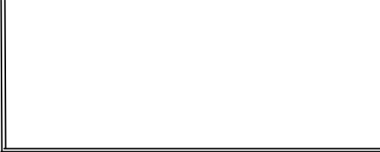

 | Parcel Identification Number (PIN)
This |  | homestead property.
 | (is) (is not)

Grantor warrants that the title to the Property is good, indefeasible in fee simple and free and clear of encumbrances except:

Dated |  |  |  |  |  |  |  |  | .
 |  |  |  |  |  |  | (SEAL) |  |  |  |  |  |  |  |  |  |  |  |  |  |  |  | (SEAL)
* |  |  |  |  |  |  |  |  |  |  |  |  |  | *
 |  |  |  |  |  |  | (SEAL) |  |  |  |  |  |  |  |  |  |  |  |  |  |  |  | (SEAL)
* |  |  |  |  |  |  |  |  |  |  |  |  |  | *
 |  |  |  | AUTHENTICATION |  |  |  |  |  |  |  |  |  |  |  | ACKNOWLEDGMENT
Signature(s) |  |  |  |  |  |  |  |  |  |  |  |  |  | STATE OF WISCONSIN |  |  |  |  |  |  | )
authenticated on |  |  |  |  |  |  |  |  |  |  | . |  |  |  |  |  |  |  |  |  | ) ss.
 |  |  |  |  |  |  |  |  |  |  |  |  |  |  |  |  |  |  | COUNTY |  | )
 |  |  |  |  |  |  |  |  |  |  |  |  | Personally came before me on |  |  |  |  |  |  |  |  |  |  | ,
*
* |  |  |  |  |  |  |  |  |  |  |  |  |  | the above-named
TITLE: MEMBER STATE BAR OF WISCONSIN
 |  | (If not,
 |  |  |  |  |  |  |  |  |  |  |  |  |  | to me known to be the person(s) who executed the foregoing
 |  | authorized by Wis. Stat. § 706.06)
 |  |  |  |  |  |  |  |  |  |  |  |  |  | instrument and acknowledged the same.
THIS INSTRUMENT DRAFTED BY:
 |  |  |  |  |  |  |  |  |  |  |  |  | *
 |  |  |  |  |  |  |  |  |  |  |  |  | Notary Public, State of Wisconsin
 |  |  |  |  |  |  |  |  |  |  |  |  | My Commission (is permanent) (expires: |  |  |  |  |  |  |  |  |  |  |  | )
 |  |  |  |  | (Signatures may be authenticated or acknowledged. Both are not necessary.)
 |  |  | NOTE: THIS IS A STANDARD FORM. ANY MODIFICATIONS TO THIS FORM SHOULD BE CLEARLY IDENTIFIED.
WARRANTY DEED |  |  |  |  |  | © 2003 STATE BAR OF WISCONSIN |  |  |  |  |  |  |  |  |  |  |  |  |  |  | FORM NO. 1-2003
* Type name below signatures.

